
Web Plus
Training Manual for
Central Registry Administrators
Version 3.5.0
(Based on Web Plus Version 3.5.0, NAACCR v15)
Centers for Disease Control and Prevention
National Center for Chronic Disease Prevention and Health Promotion
Division of Cancer Prevention and Control
National Program of Cancer Registries
Registry Plus™ Software for Cancer Registries

Table of Contents
Chapter 1: Introduction 3
Overall Learning Objectives 3
Overview of the Web Plus Central Registry Administrator Training Manual 3
Web Plus Features 3
Web Plus User Roles 4
Requirements for Web Access 5
Chapter 2: The Basics 6
Learning Objectives 6
Overview 6
Log In 6
Changing Your Password 8
Log Out 9
Web Plus Version Information 9
Questions 9
Chapter 3: Web Plus Configuration 10
Learning Objectives 10
Overview 10
Selecting System Preferences 10
Reinitialize Application 26
Display Types 26
Creating a Display Type 26
Adding a New Display Type 26
Copying a Display Type 28
Five Steps for Building a Display Type 31
Step 1: Select Fields 32
Adding Section Headings 33
Creating a New Section Heading 33
Deleting a Section Heading 34
Adding Fields 34
Assigning Property Values to Individual Fields 36
Assigning Other Property Values 38
Activity 1 – Adding Properties to Display Type Fields 39
Printing a Copy of Display Type Fields 39
Step 2: Select Critical Fields 40
Buttons on Manage Display Type Pages 42
Step 3: Select Edit Sets 42
Step 4: Select Individual Edit Options 44
Step 5: Select Collaborative Staging Preference 45
Viewing the Display Type 46
Questions 49
Activity 2 – Adding Fields to a Display Type 49
Activity 3 – Adding a Heading and Fields 49
Deleting a Display Type 50
Chapter 4: Managing Facilities and Users 51
Learning Objectives 51
Overview 51
Managing Facilities 51
Adding a Facility 51
Editing a Facility Record 55
Activity 4 – Creating a Facility Record 55
Deleting a Facility Record 56
Managing User Accounts 56
Adding Users 56
Editing a User Account 61
Activity 5 – Create a User Account 62
Deleting a User Account 62
Reset Password 63
Locking Out Users 63
Current User Activities 64
Viewing Current User Activities 64
Clear Log Status 65
Questions 66
Activity 6 – Create a New Facility and User and Unlock an Account 66
Activity 7 – Create a Central Registry Abstractor/Reviewer Account 66
Chapter 5: Managing Abstracts 69
Learning Objectives 69
Overview 69
Assigning Abstracts for Review 69
Reassigning an Abstract 71
Finding and Viewing an Abstract 73
Exporting Abstracts 76
Questions 76
Chapter 6: Bundle Submissions 77
Learning Objectives 77
Overview 77
Viewing List of Abstracts and Reports for an Uploaded File 77
Viewing Abstracts in a File 79
Viewing the Edit Error Report 80
Viewing the Data Quality Indicator Report 81
Deleting an Uploaded File 84
Exporting Uploaded Files 84
Posting of Files for Facility Download 84
Managing Files Posted for Facility Download 86
View Facilities 87
Download 88
Delete a Posted File 89
Chapter 7: Reports 91
Learning Objective 91
Overview 91
Opening Reports 91
Central Registry Reports 92
Changing the Date Range of a Report 93
Follow-back Reports 94
Misc. Management Reports 96
Web Plus Facility Account Management Report 96
Web Plus User Account Management Report 97
Web Plus Display Type Facility List 99
Web Plus User Display Type Detail Report 100
Facility Reports 102
Abstracts Submitted Sorted by Abstractor Report 103
Abstracts Accessed Sorted by Patient Name Report 104
Descriptive Statistics on Released Abstracts Report 105
Activity Report 109
Questions 109
Chapter 8: Web Plus Administration Tool 111
Learning Objectives 111
Overview 111
Installing the Web Plus Administration Tool 111
Logging In to the Web Plus Administration Tool 112
Exporting Abstracts out of Web Plus 113
Exporting Uploaded Files 116
Exported Filenames 118
Appendix A: Answers 123

Introduction

Overall Learning Objectives
These are the overall learning objectives for this Web Plus training manual for Central Registry Administrators:
- Learn the major functions of the Administrator role within Web Plus
- Configure system preferences, display types, and edit sets
- Manage facilities
- Manage user accounts
- Assign abstracts to central registry staff
- View information regarding bundled files (file uploads)
- Post files for download by facilities, and manage the files that have been posted for download
- Generate and view Web Plus reports

Overview of the Web Plus Central Registry Administrator Training Manual
The Web Plus Central Registry Administrator Training Manual provides you with the information to understand and use this web application. This manual describes the functions available to the Web Plus Administrator of a central cancer registry. The major sections include setting system preferences, configuring display types for use by facilities, generating and maintaining facility records and user accounts, managing the assignment of abstracts to central registry abstractors, working with file uploads from facilities and files posted for download by facilities, and viewing central and facility-level reports. Also, each chapter contains questions that test your knowledge of Web Plus and activities that allow you to practice your new skills on your own.

Web Plus Features
Web Plus is a secure web-based application that is used to collect cancer data over the Internet. The Web Plus application is hosted on a secure web-server. The communication between the client and the server is encrypted using Secure Socket Layer (SSL) technology. The data is stored in a secure database behind the hosting institutions firewall. The hosting institution manages facility and user rights to ensure that data is only accessible to the hosting institution and the institution submitting the data. Web Plus is for use by central registries for all electronic reporting needs.
Web Plus supports three main functions; online abstracting, file upload/download, and follow-back efforts. The online abstracting capability of Web Plus is used for reporting from physicians’ offices and other low-volume reporting sources. The Web Plus file upload feature can be used to upload NAACCR-formatted files, as well as supporting documents in any file format. Web Plus can also be used to post files of any type for secure download by facilities. Web Plus allows for editing of uploaded NAACCR formatted records as well as records abstracted online.
The Web Plus follow-back features enable upload of partial abstracts generated from death certificate and pathology lab files, and subsequent notification to physicians or facilities via e-mail to log in and update the abstracts. The features also allow for the tracking of follow-back abstracts to ensure their resolution.

Web Plus User Roles
The results from the design staff and usability testing have identified these types of Web Plus users:
Users | Description
Facility Abstractor | Works in a facility or doctor’s office and handles patients’ medical records and paperwork. When a patient is diagnosed with cancer, the Facility Abstractor reports the case to the state’s central cancer registry. The Facility Abstractor also completes and submits any follow-back abstracts that the central registry has posted for their facility.
File Uploader | Uploads either files of abstracts in the appropriate NAACCR format that were not abstracted using Web Plus or non-NAACCR files in any format, views EDITS error report and cleans, or works with abstractors to clean, errors on rejected abstracts prior to resubmitting, downloads files posted by the central registry, and views reports.
Local Administrator | Manages local users of a facility.
Central Registry Administrator | Sets up facilities with access to the Web Plus software to report their data, manages facility accounts and users at both the central registry and facilities, configures display types, edit sets and system preferences, manages assignment of abstracts to central registry staff, exports data, and views reports.
Follow-back Supervisor | Uploads files of partially-filled follow-back abstracts, manually adds follow-back abstracts online, tracks follow-back abstracts by uploaded file or by facility, and generates and views Web Plus follow-back reports.
Follow-back Monitor | Tracks follow-back abstracts by assigned facility, generates and views Web Plus follow-back reports.
File Upload Supervisor | Monitors upload of files to the central registry; tracks file uploads and rejected abstracts by facility, communicates with facility to ensure resubmission of rejected abstracts, and views reports.
Central Registry Abstractor/Reviewer | Reviews abstracts submitted to the central registry for completeness and accuracy and may abstract additional data items from submitted text; also abstracts new cases.

Requirements for Web Access
Web Plus requires Microsoft Internet Explorer version 9.0 or later to operate the system fully. Although Web Plus may work at 800 X 600 resolution you may have trouble with some features; it can be best viewed at 1024 X 768 or higher resolution. It is highly recommended that you change your resolution to 1024 X 768 or higher when using the Web Plus application.

The Basics

Learning Objectives
In this chapter, you will learn to:
- Log in to Web Plus
- Identify Web Plus menu options
- Change your password
- Log out of Web Plus

Overview
This chapter covers the basics of the Web Plus Central Registry Administrator role. It includes a description of the Web Plus menu options available to the Central Registry Administrator, how to change your password, and the means of logging in and out of Web Plus.

Log In
To log in, complete the following steps:
- Open your Internet Explorer browser and type your registry’s Web Plus web address (URL) in the Address field.
- Press Enter.
Result: The Web Plus main Log in page is displayed
- Type in your Administrator User ID and password into the User ID and Password fields. For testing purposes, you can use the User ID of Administrator, and the password of admin1.
- Click Log in.
Result: The Web Plus home page opens. As an administrator, you will see a hyperlink for the “Central Registry Administrator”
The Web Plus home page is unique to each user, and includes links to the role or roles that have been assigned to the user. In the example shown above, the user has been assigned the roles of Central Registry Administrator, Follow-back Supervisor, and File Upload Supervisor.

- Click the Central Registry Administrator link.

Central Registry Administrator Menu Options
After you log in, the Web Plus Central Registry Administrator home page is displayed:
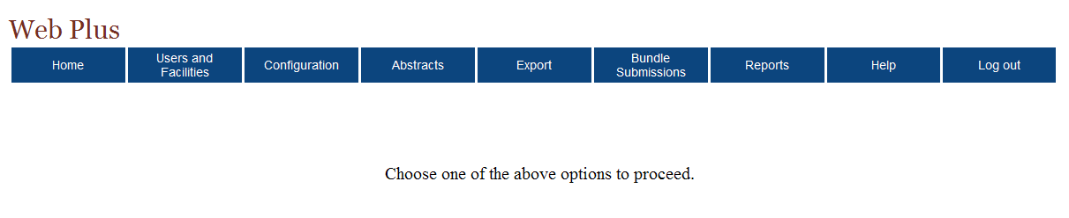
From this page you can access the main menu options of Web Plus. Click on a menu option to open the page for the option. The below table describes the menu options on the home page, and provides a page reference within this manual for more information about the menu option:
Menu option | Sub-option |  | Opens web page to . . . | Refer to page . . .
Home |  |  | Display links to assigned roles in Web Plus | 8
 |  |  | Change password | 11
 |  |  | Log out of Web Plus | 11
Users and Facilities | Manage Facilities |  | add, update, or delete facilities | 53
Users and Facilities | Manage Users |  | add, update, lock/unlock user account, delete users and reset passwords | 58
Users and Facilities | Current User Activities |  | monitor currently authenticated user actions | 66
Configuration | Manage Display Types |  | create a new display type, or update, copy, rename or delete existing display types | 28
Configuration | Manage System Preferences |  | Specify hosting registry and contact information, set user account security and password preferences, logging preferences, edits preferences for uploaded files, follow back functionality preferences, delete abstract preferences, system email options, and login system message | 12
 | Reinitialize Application |  | allows to reset the Web Plus application | 28
Abstracts | Assign Released Abstracts |  | assign released abstracts to central registry abstractor/reviewers for review | 71
Abstracts | View/Change Assignments |  | view abstract assignments or reassign abstracts to another central registry abstractor/reviewer | 73
Abstracts | Find Abstracts |  | search for released abstracts | 75
Export |  |  | view reminder that the Web Plus Administration Tool is used to export abstracts and bundle submissions from Web Plus for incorporation into the central registry | 78
Bundle Submissions |  | Track File Uploads | view a listing of abstracts included in uploaded bundled file, view edit errors report, view data quality report for each uploaded bundled file, and delete uploaded bundled files | 79
 |  | Post File for Download by Facilities | post files to Web Plus to be downloaded by specified facility(ies) | 86
 |  | Manage Files Posted for Download by Facilities | download posted files, remove files from the facility download page, or add/remove facilities for which a file is posted | 88
Reports |  |  | view central registry reports and facility reports | 93
Help |  | About | view Web Plus, NAACCR, Collaborative Staging Algorithm Version, Edits Metafile and Edits Record Layout | 11
Log out |  |  | log out of Web Plus and open the Log in page | 11

Changing Your Password
To change your password, complete these steps:
- On the Home page menu, click Change Password.
Result: The Change Password page opens.
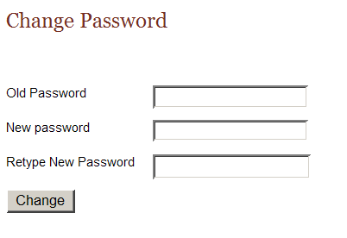
- Type your current password in the old password field, and your new password in both of the new password fields.
- Click Change.
Result: Your password is successfully changed.

Log Out
To log out of Web Plus, click Log out on either the Home page or from the Administrator menu.
Result: The system logs you out of Web Plus, and the Log in page opens.

Web Plus Version Information
To view your current Web Plus Version Information, point to Help and click About.
Result: The About Web Plus page opens.

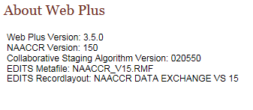

Questions
Answer these questions about the basics of Web Plus (the answers are in Appendix A, page 132):

- Which menu option opens the page where you can add user accounts?
- How do you log out?
- Which menu option do you use to begin creating a display type?

Web Plus Configuration

Learning Objectives
In this chapter you learn:
- How to set system preferences
- About the follow-back features in Web Plus
- What a display type is
- About the five main steps used to build a display type
- How to select fields and section headings into a display type
- How to set field properties for individual data items in a display type
- How to select an edit set and edit options for a display type
- How to set Collaborative Staging calculation preferences for a display type

Overview
In this chapter you learn how to configure the Web Plus application, including how to set system preferences and to create display types. A display type is basically the user interface where the abstractor will enter the data, and consists of an ordered subset of standard NAACCR and local data items collected by your central registry, an edit set with associated options specified, and Collaborative Staging calculation preferences.

Selecting System Preferences
On the System Preference page, you can set the parameters for Web Plus that users will have.
To set system preferences, complete these steps:
- On the Web Plus menu, point to Configuration, then click Manage System Preferences.
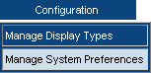
Result: The Manage System Preferences page opens.

The Manage System Preferences page contains these fields:
Section | Field | Description
Hosting Agency | Agency Name | Name of the hosting central cancer registry as it will appear within the Facility Abstractor and file uploader pages of the Web Plus application (at the top right-hand corner of every page) and in report titles
Hosting Agency | Registry ID | A unique code that identifies the hosting central cancer registry
Hosting Agency | Street Address | Street address of the hosting central cancer registry as it will appear on HIPPA and other reports
Hosting Agency | City | City of the hosting central cancer registry as it will appear on HIPPA and other reports
Hosting Agency | State | State of the hosting central registry
Hosting Agency | Zip code | Zip code of the hosting central cancer registry as it will appear on HIPPA and other reports
Contact Information to be Listed on Web Site | Name | The text entered into this field will be displayed as an e-mail link at the top of each of the Facility Abstractor and file uploader pages of the Web Plus application.  This link is available for the user to click when having difficulties or questions (the actual e-mail address to be used is entered in the E-mail field below).
Contact Information to be Listed on Web Site | Phone | Enter a phone number for your state registry’s Web Plus technical contact
Contact Information to be Listed on Web Site | E-mail | E-mail address of your state registry’s Web Plus technical contact
Contact Information to be Listed on Web Site | System E-mail | E-mail address that you would like in the from field of all out-going Web Plus e-mails
User Account  Security | Maximum Invalid Logins | Number of times a user can attempt to log in with an incorrect user name or password
User Account  Security | Lockout Reset Interval | The amount of time in seconds that a user will be locked out of the system until Administrator restores access to user
User Account  Security | Session Timeout Interval | The amount of time in seconds that a session can last without user activity
User Account  Security | Ask challenge questions for login | Additional security feature; when enabled, Web Plus allows the Administrator to enter a series of challenge questions into Web Plus to be answered by the user, and used upon user login to validate the user’s identity
User Account  Security | Require PIN for login | Additional security feature to accommodate requirement of two-factor authentication of users upon login to Web Plus; when enabled, Web Plus allows the Administrator to randomly generate a unique Web Plus PIN Matrix for every Web Plus user; upon each login, the user must then enter a 4 digit PIN based on coordinates from their Web Plus PIN Matrix (Note: coordinates are provided upon login; matrices must be mailed to users)
Password Policy | Keep passwords in history | The number of passwords to keep historically for each user
Password Policy | Passwords expire every ___ days | The number of days after which a user’s Web Plus password will expire; upon expiration, Web Plus will prompt the user to create a new password
Password Policy | Enforce Strong Passwords | This option will place restrictions on user passwords; by default this option requires users to enter passwords that are between 8 to 20 characters, contain at least one digit and one alphabetic character, and must not contain any special characters
Password Policy | Force Password Change After First Successful Logon | This option will force a user to change his password after his account has been created, or his password is reset by the Administrator, and he logs onto Web Plus using the new password for the first time
Logging Preferences | Log Updates | These options indicate whether updates to, searches for, opening of, or deletion of an abstract should be recorded in the database
Logging Preferences | Log Searches
Logging Preferences | Log Opens
Logging Preferences | Log Deletes
Edits Preference for Bundled Submissions | Error Percent Threshold | This option enables rejection of entire bundles if they contain a greater percent of overall errors than the specified error percent threshold
Edits Preference for Bundled Submissions | Rejection of Individual Records  Please note this option has not been tested use with NAACCR versions 12.x, 13, 14 or 15 software and should not be used until notification is issued by CDC | This option enables rejection of individual errant records from uploaded files; selection of this option also activates:  - Error rejection tracking features, including an automatically updated error rejection tracking page and e-mail notification capabilities  - Enhanced file upload and abstract submission monitoring, including robust search capabilities
Edits Preference for Bundled Submissions | Defer Edits | Select this option to prevent Web Plus from editing the abstracts in a file when it is uploaded from a facility; the Web Plus Administration Tool can be used to manually run edits on these files
Follow-back Functionalities | Death Certificate Follow-back | Allows assignment of system-wide initial, facility, and central registry display types for death certificate follow-back efforts
Follow-back Functionalities | Pathology Laboratory Follow-back | Allows assignment of system-wide initial, facility, and central registry display types for pathology laboratory follow-back efforts
Delete Abstract Options | Allow central abstractor role to delete abstracts released by facilities | Allows the Central Abstractor/Reviewer role to delete individual online abstracts that have been released to the central registry
Delete Abstract Options | Allow central administrator role to delete abstracts released by facilities | Allows the Central Registry Administrator role to delete individual online abstracts that have been released to the central registry
Email Options | Email system generated user password on new user creation | Select this option to enable Web Plus to automatically send an e-mail to users containing the system-generated password for their Web Plus account upon the creation of a new user account
Email Options | Email user password reset by central administrator | Select this option to enable Web Plus to automatically send an e-mail to users with their new password upon the resetting of their password by the Central Registry Administrator
Email Options | Email managing central abstractor upon release of abstracts by facilities | Select this option to enable Web Plus to automatically send an e-mail to the Central Registry Abstractor/Reviewer upon release of abstracts by facilities assigned to them
Email Options | Email managing central abstractor upon file upload by facilities | Select this option to enable Web Plus to automatically send an e-mail to the Central Registry Abstractor/Reviewer upon upload of a file by facilities assigned to them (please note that this option will be changed in the future to e-mail the File Upload Supervisor role upon file upload)
Log-in System Message | Area to enter a message that is displayed for all users on the Web Plus log in page; a default message is included and can be modified
- Hosting Agency:
- In the Agency Name field, enter the name of your central cancer registry as you would like it to appear within the Facility Abstractor and file uploader pages of the Web Plus application (at the top right-hand corner of every page) and in various report titles.
- In the Registry ID field enter the Registry ID number for your central registry. This number can be found in the REDID.DBF table in Appendix B of the NAACCR Volume II: Data Standards and Data Dictionary.
- In the Street Address field, enter the street address for your central registry.
- In the City field, enter the city in which your registry is located.
- In the State field enter the state of your registry.
- In the Zip code field, enter the zip code in which your registry is located.
- Contact Information to be Listed on Web Site:
- In the Name field, enter the text you would like displayed as an e-mail link at the top of each page of the Facility Abstractor and file uploader pages of the Web Plus application. This could be an e-mail address, a name, or some other label. This link is available for the user to click when having difficulties or questions (the actual e-mail address to be used is entered in the E-mail field below).
- In the Phone and Email fields, enter a phone number and e-mail address for your state registry’s Web Plus technical contact.
- In the System Email field, enter the e-mail address that you would like listed in the From field of all out-going Web Plus e-mails.
- User Account Security:
- In the Maximum Invalid Logins field, enter the number of incorrect log in attempts (incorrect user name or password) you would like to allow a user before the system locks them out.
- In the Lockout Reset Interval field, enter the amount of time (in seconds) that you would like a user to be locked out of the system until their access is restored. The user will be locked out for specified number of seconds if he has exceeded the allowed limit for number of invalid logins. After the specified reset interval, the user can once again attempt to logon to the system.
The Web Plus Administrator can override the specified reset interval for locked out users and can let them back into the system earlier.
- In the Session Timeout Interval field, enter the amount of time (in seconds) that you would like to allow a user session to be inactive before the system locks the user out.
- Check the Ask challenge questions for login checkbox, if you wish to enable the challenge questions security feature. When enabled, Web Plus allows the Administrator to enter a series of challenge questions into Web Plus, to be answered by the user, and used upon user login to validate the user’s identity. To enable the challenge questions security feature, complete the following steps:
  - Check the Ask challenge questions for login checkbox.
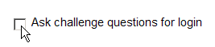
Result: The Challenge questions… button appears.
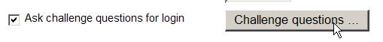
  - Click challenge questions…
Result: The Challenge Question Maintenance window opens.
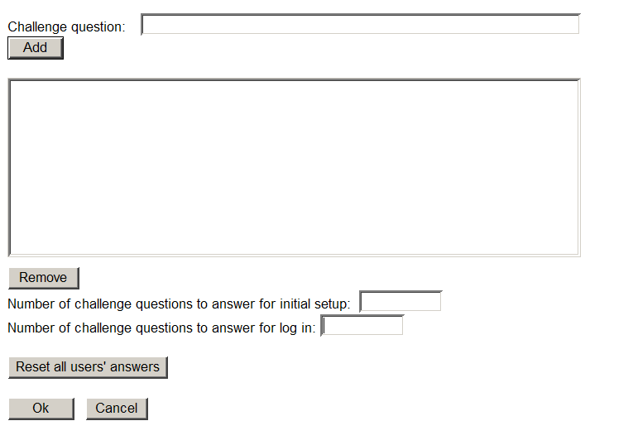
  - Enter a list of challenge questions that you would like presented to Web Plus users. To enter a challenge question, enter the question in the Challenge question box, and click Add.
Result: The question gets added to the list of challenge questions.
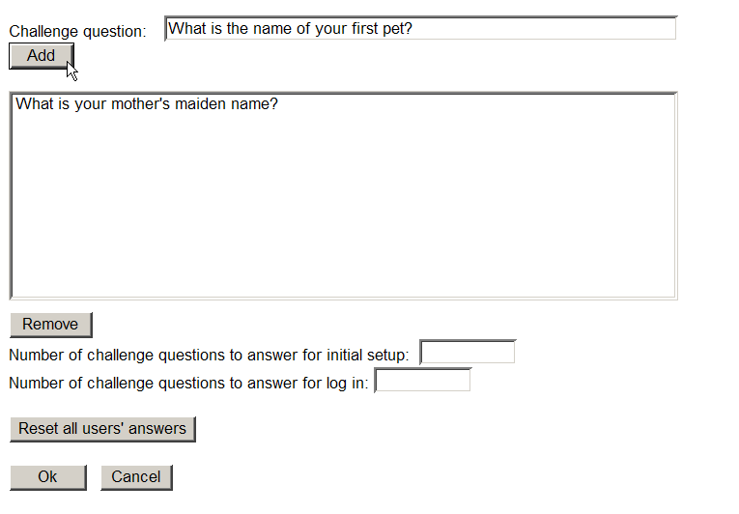
  - Keep entering challenge questions until you have completed the list of challenge questions that you would like presented to Web Plus users. To remove a question that has been added to the list, select the question, and click Remove.
  - In the Number of challenge questions to answer for initial setup field, enter the number of questions that you would like the user to have to answer upon initial setup of the challenge question feature. The first time the user logs in after this feature has been enabled, Web Plus will require the user to answer, and will store the answers to, the number of questions specified in the Number of challenge questions to answer for initial setup field.
  - In the Number of challenge questions to answer for login field, enter the number of challenge questions that you would like the user to have to answer upon each login. Web Plus will randomly pick this number of questions from the available challenge questions list, and will present the questions to the user upon user login. The user will have to answer each question correctly (i.e., as they did upon initial setup, i.e., first login after the challenge question feature was enabled.
  - Click Reset all users’ answers whenever you would like to force all users to reselect their challenge questions upon their next login to the Web Plus system:
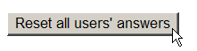
  - To save your selections, click OK, and return to the Systems Preference page.
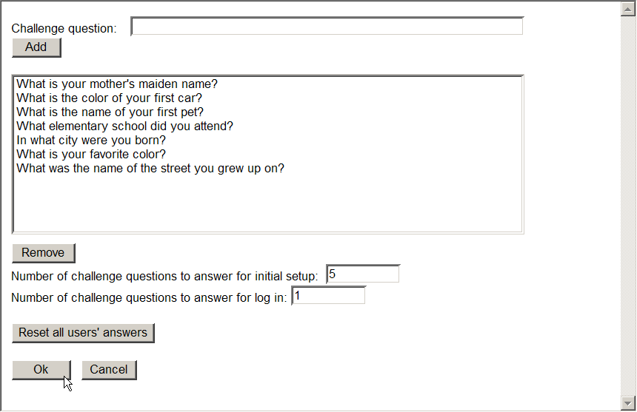
  - You must click Save on the Systems Preferences page in order for the feature to be enabled.
  - The first time the user logs in after the challenge question feature has been enabled, the user will be prompted to answer the number of challenge questions specified in the Number of challenge questions to answer for initial setup field, and will save the user’s answers for subsequent logins.
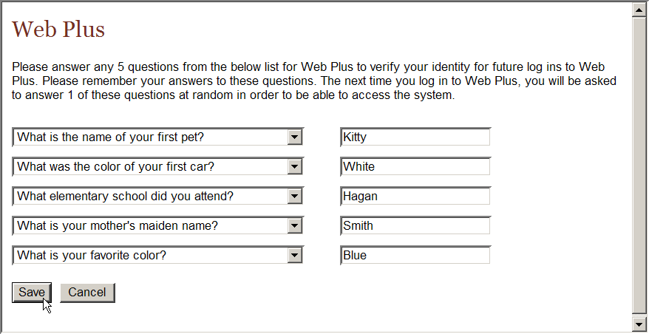
  - The next time the user logs in, and thereafter, the user will be prompted to answer the number of challenge questions specified in the Number of challenge questions to answer for login field. Web Plus will randomly pick this number of questions from the list of challenge questions answered by the user upon initial setup, and will present the questions to the user upon user login. The user will have to answer each question correctly (i.e., as they did upon initial setup, i.e., first login after the challenge question feature was enabled.
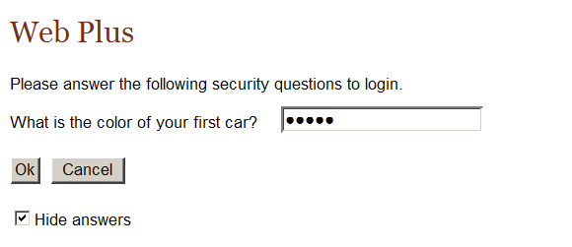
- Check the Require PIN for login checkbox, if you wish to enable the PIN Entry security feature. The PIN entry security feature accommodates requirement of two-factor authentication of users to validate a user’s identity upon login to Web Plus. When enabled, Web Plus allows the Administrator to randomly generate a unique Web Plus PIN Matrix for every Web Plus user, which must then be printed out from the users’ User Account pages and physically mailed to the users. Upon each login, the user must then enter a 4 digit PIN based on coordinates (provided at login) from their Web Plus PIN Matrix.
To enable the PIN Entry security feature, complete the following steps:
  - Check the Require PIN for login checkbox, and click Generate Matrices for All Users.
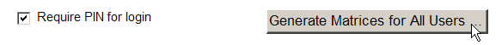
Result: Web Plus issues a warning that random PIN Matrices will be generated for all users.
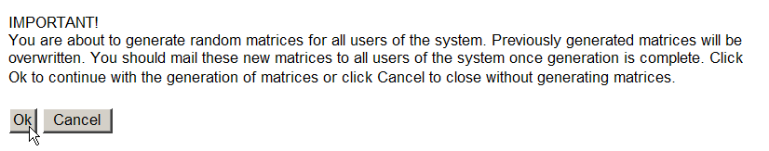
  - Click OK.
Result: The system issues a message to let you know that the PIN Matrices have been generated.
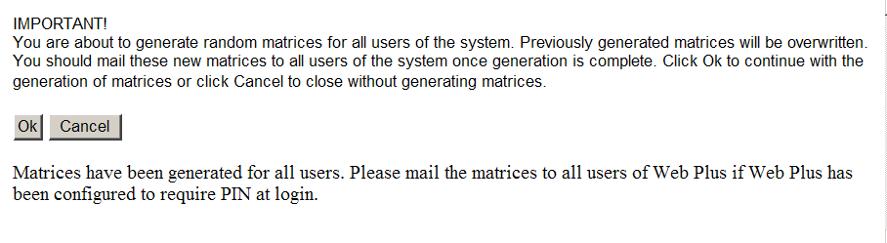
  - Click Cancel to return to the System Preferences page.
  - You must click Save on the Systems Preferences page in order for the feature to be enabled.
  - The PIN matrices must now be printed out and physically mailed to all users. Matrices can be printed from the from the users’ account pages. Please Note: Matrices can be generated for individual users from within the user’s account page (only visible if “Require a PIN” is selected in the system preferences).
    - On the Web Plus menu, point to Users and Facilities, then click Manage Users.
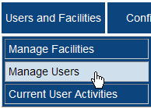
Result: the Manage Users page opens.
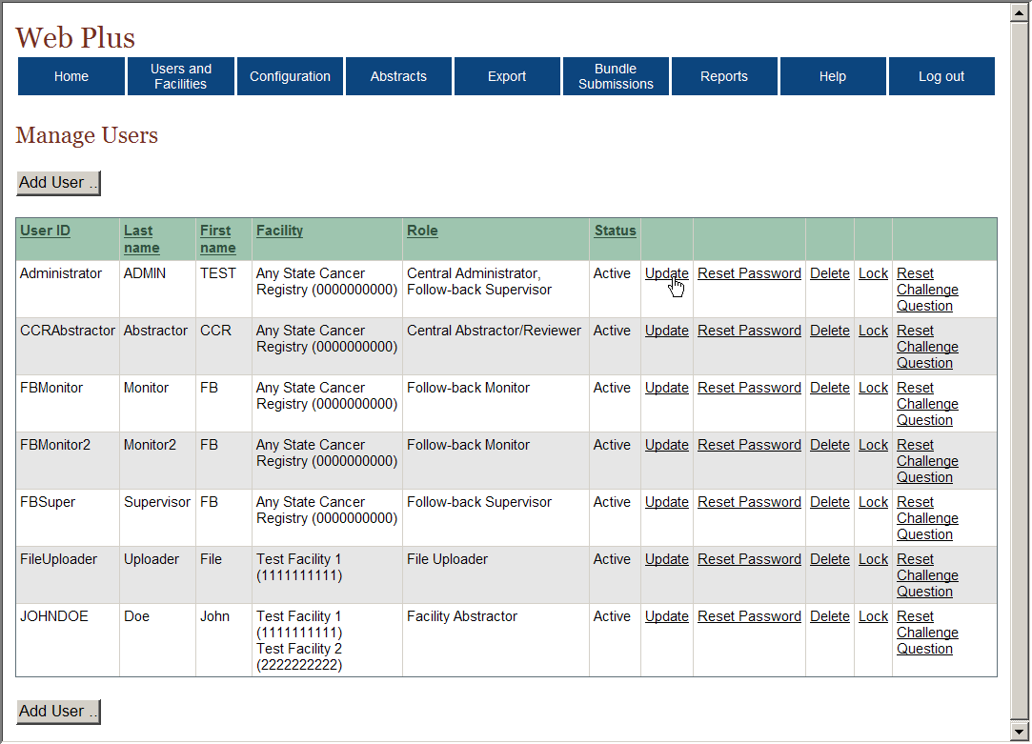
    - Locate the user whose matrix you would like to print, and click Update.
Result: The Add/Edit User Account page opens.
    - Scroll to the bottom of the user account page, and locate the Matrix section. Click Print.
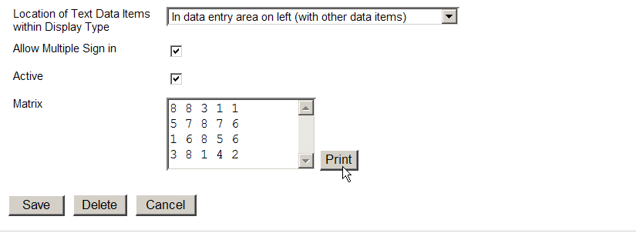
Result: The Web Plus PIN Matrix report opens for printing. This report must be physically mailed to the Web Plus user.
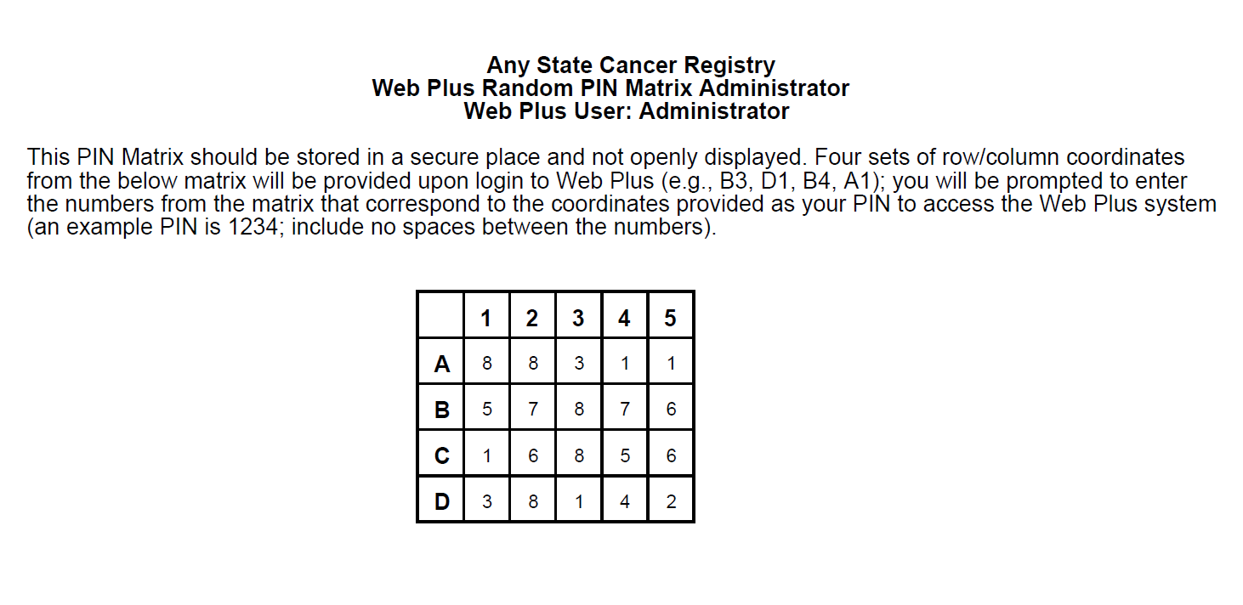
  - The next time the user logs in, and thereafter, the user will be prompted to enter a 4 digit PIN from their Web Plus PIN Matrix, based on the coordinates provided.
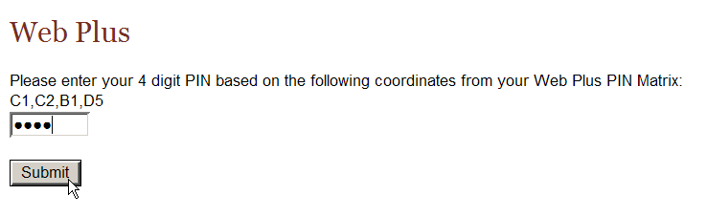
- Password Policy:
  - In the Keep passwords in history field, enter the number of historical passwords you would like for Web Plus to keep for each user. Users will not be able to change their passwords to any password that has been saved previously.
  - In the Passwords expire every ___ days field enter the number of days after which you would like a user’s Web Plus password to expire.
  - Click the Enforce Strong Passwords check box if you would like to place restrictions on the passwords that users can generate for themselves.
Result: The Build/View Regular Expression button appears.
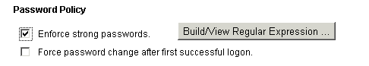
This button is invisible if “Enforce strong password” is not checked.
By default the Enforce strong passwords option requires users to enter passwords that are 8 to 20 characters in length, contain at least one digit and one alphabetic character, and must not contain any special characters. A regular expression (Regex) specifies what types of passwords are acceptable.
- Click Build/View Regular Expression.
Result: The Password Regular Expression Builder box opens.
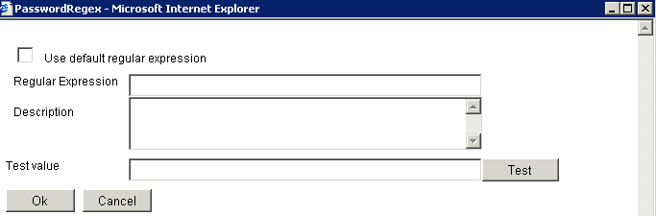
- Click on the Use default regular expression check box.
Result: The default regular expression appears, along with a description of its function.
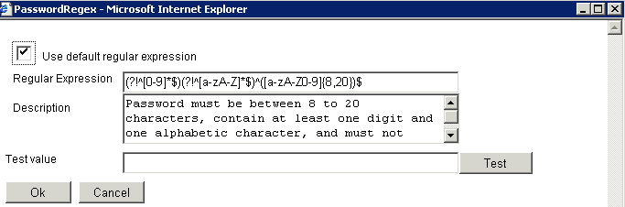

You can implement other or additional password restrictions by editing the regular expression. Always be sure to test any new expression entered to make sure it is functioning properly.
 | If you are not very comfortable writing regular expressions it is recommended that you do not make any change to the default value.
- Click Ok if you would like to use the Enforce strong passwords option with the default regular expression, or the Cancel button if you do not want to use any password restrictions.
Result: You are returned to the Manage System Preferences page.
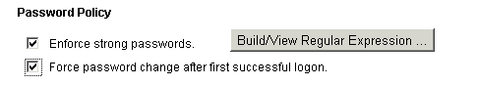
 | If you leave both options unchecked there will be no restriction on passwords. For increased security it is highly recommended that you check both the options.
- Logging Preferences:
  - Click the check boxes of the logging preferences of your choice. Until you get used to using your Web Plus system, it is recommended that you click all of these options for now.
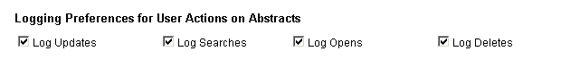
- Edits Preference for Bundled Submissions:
  - Click the Error Percent Threshold option if you would like Web Plus to reject entire bundles if they contain a greater percent of overall errors than the specified error percent threshold. Note: Error percent Thresholds are facility-specific and are set on the Manage Facility Account page for each individual facility.
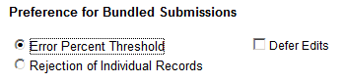
  - Click the Rejection of Individual Records option if you would like Web Plus to reject only records with errors from file uploads. Selection of this option also activates:
    - Error rejection tracking features, including an automatically updated error rejection tracking page and e-mail notification capabilities
    - Enhanced file upload and abstract submission monitoring, including robust search capabilities
Please note that the Rejection of Individual Records option has not been tested for use with NAACCR versions 12.x, 13, 14 or 15-based software and should not be used until CDC notifies states using Web Plus that this option is fully functional.
  - Click the Defer Edits check box only if you would like no edits to be applied to files of abstracts submitted via the file uploader pages of the Web Plus application. Unless you have a large file or heavy upload conditions, it is recommended that you leave this check box unchecked, and administer edits on uploaded files using your display types.
If you click the Defer Edits option, you can still run edits on uploaded files using the Web Plus Administration Tool.
- Follow-back Functionalities:
Follow-back Overview: Web Plus follow-back features enable a central registry to pre-fill online abstracts with known information from death certificates or pathology lab reports, and have the reporter log on to update the information and complete the abstract. The end result is a completed abstract in NAACCR file format, an electronic report of a previously unreported tumor, without the use of paper forms or redundant recording of information. In addition, the follow-back tracking features of Web Plus allow the central registry to closely and electronically track the status of each follow-back abstract to ensure that it gets completed.
The follow-back process in Web Plus takes advantage of the existing online abstracting feature to enable physicians and Facility Abstractors to complete partially-filled abstracts online. The abstractor can save their work at any time and return their work at a later time. They release an abstract to the central registry only after they have completed it, and eliminated any errors it may contain.
Notification to facility via e-mail
Facility corrects errors
Facility completes abstract
Facility releases abstract
Facility updates abstract
Facility rejects abstract
FB Supervisor reroutes abstract
FB Supervisor deletes abstract
FB Supervisor uploads file of partial abstracts or manually enters abstracts online

The Web Plus follow-back process includes the following steps:
- The Follow-back Supervisor (FB Supervisor) uploads files of partially-filled abstracts generated with information from death certificate and pathology lab files into Web Plus, or manually enters individual abstracts online.
Records for follow-back need to be prepared outside of Web Plus and should be in NAACCR record format for upload into the Web Plus database.
- Notification to facilities/physicians to log in and update the follow-back abstracts is sent via e-mail.
- Once posted for facilities/physicians to complete, follow-back abstracts are processed via the regular Web Plus record flow; with the exception that follow-back abstracts can be rejected by the facility/physician with a justifying comment back to the central registry, where the Follow-back Supervisor can either re-route the abstract to a new facility/physician, or delete the abstract from the follow-back process.
- Once completed by the facility/physician, the follow-back abstracts are released to the central registry, where they are reviewed and released by the Central Registry Abstractor/Reviewer, and subsequently exported out of the Web Plus database by the Central Registry Administrator.
Throughout the follow-back process, the Follow-back Supervisor and Follow-back Monitors use the follow-back reports and tracking features to communicate with the cancer reporters via e-mail, and track follow-back abstracts to ensure their resolution.
A display type is the user interface where the Facility Abstractor enters data. Display types are highly customizable, and are configured by the Central Registry Administrator. You will need to coordinate with your Follow-back Supervisor to generate system-wide, or facility-specific, display types for the three phases of the follow-back process (to learn more about display types, click here):
1) Initial---to accommodate registries that do not have access to their death certificate and/or pathology laboratory information in electronic format (and thus cannot generate and upload a file of partially-filled abstracts), Web Plus allows the Follow-back Supervisor to begin individual follow-back abstracts online, which can then be released to the facility for completion. The display type for initial data entry is the display type used to begin these follow-back abstracts.
2) Facility abstracting---the display type for facilities is the display type used by Facility Abstractors to complete the follow-back abstracts posted to their facility.
3) Central registry abstracting/review---the display type for Central Abstractor/Reviewer is the display type used by the Central Registry Abstractor/Reviewers to review and/or update the completed follow-back abstracts that have been released from facilities.
  - Death Certificate Follow-back, use the pull-down menus to select the display types that you would like to use for initial data entry, facility abstracting, and central registry reviewing/abstracting for your registry’s death certificate follow-back efforts.
  - Pathology Laboratory Follow-back, use the pull-down menus to select the display types that you would like to use for initial data entry, facility abstracting, and central registry reviewing/abstracting for your registry’s death certificate follow-back efforts.
Please note that these follow-back display types need not be set upon initial system configuration. You do not have to select follow-back display types unless you are using the Web Plus follow-back features.
- Delete Abstract Options:
  - Click the Allow central abstractor role to delete abstracts released by facilities check box if you would like Web Plus to allow the Central Abstractor/Reviewer role to delete individual online abstracts that have been released to the central registry.
  - Click the Allow central administrator role to delete abstracts released by facilities check box if you would like Web Plus to allow the Central Registry Administrator role to delete individual online abstracts that have been released to the central registry.
- Email Options:
  - Click the Email system generated user password on new user creation check box if you would like Web Plus to automatically send an e-mail to users containing the system-generated password for their Web Plus account upon the creation of a new user account.
  - Click the Email user password reset by central administrator check box if you would like Web Plus to automatically send an e-mail to users with their new password upon the resetting of their password by the Central Registry Administrator.
  - Click the Email managing central abstractor upon release of abstracts by facilities check box if you would like Web Plus to automatically send an e-mail to the Central Registry Abstractor/Reviewer upon release of abstracts by facilities assigned to them.
  - Click the Email managing central abstractor upon file upload by facilities check box if you would like Web Plus to automatically send an e-mail to the Central Registry Abstractor/Reviewer upon upload of a file by facilities assigned to them.
  - Click the Email file upload supervisor upon file upload by facility check box if you would like Web Plus to automatically send an e-mail to the File Upload Supervisor upon file upload by facilities.
- In the Log-in System Message box, enter a message that is displayed for all users on the Web Plus log in page. Note that a default message is included and can be modified
- Click Save to save all system configuration changes.
Result: A confirmation message appears on the System Preference page.
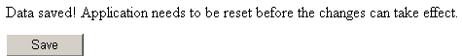
The change of certain system preferences, such as Logging options, and some options under User Account Security do not take effect until the application is restarted. However, changes to system preferences such as contact information and edits preferences will take effect immediately, and do not require resetting of the application.

Reinitialize Application
There are times that the Web Plus application will need to be reset. Web Plus allows the Administrator to reinitialize the application. To reinitialize the application, login as the Web Plus Administrator, select “Configuration” → “Reinitialize Application” → “Reset”. Please note that any user that is logged into Web Plus at the time the application is reinitialized will be booted out of Web Plus and lose any un-saved work.

Display Types
A display type is the user interface where the Facility Abstractor enters data. Display types are highly customizable, and are configured by the Central Registry Administrator. Display types include information regarding fields collected, required fields (i.e., can’t be blank), edit sets, individual edit options, and Collaborative Staging preferences. Any standard data items and state-specific fields can be included in a display type, and can be assigned customized labels, ordered into sections, and have various properties that can be set such as default values.
Web Plus allows assignment of multiple display types to an individual facility, and different display types and edits for different facilities and types of cancer reporters. Because display types are assigned by facility your set-up can vary from facility to facility.

Creating a Display Type
You can create different display types for different facilities and types of cancer reporters. Abstracts are entered and edited using the display type and edit set assigned to the facility where they are abstracted. To generate a display type, you first create it and then go through five main steps to build the display type:
- Select Fields
- Select Critical Fields
- Select Edit Set
- Select Individual Edit Options
- Select Collaborative Staging Preference.
You can create a display type in one of two ways. You can start from scratch by adding a new display type or you can copy an existing display type and revise it. Either way you create a display type, you can customize it for your own needs.

Adding a New Display Type
One way to create a display type is to add a new one.
To add a new display type, complete these steps:
- Log in to Web Plus. For details, see “Login”, page 8.
Result: The Web Plus home page opens.
- On the Web Plus menu, point to Configuration, then click Manage Display Types.
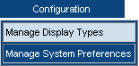
Result: The Manage Display Types page opens.

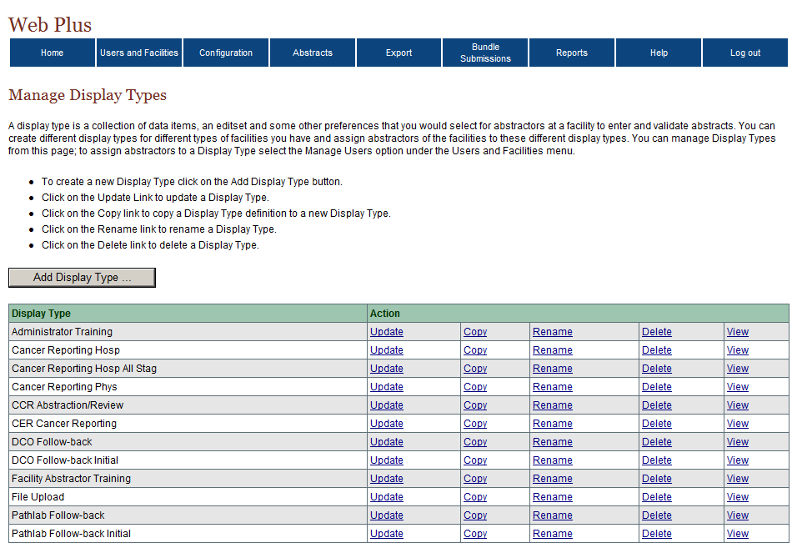
- On the bottom left of the page, click Add Display Type.
Result: The Add Display Type window opens.
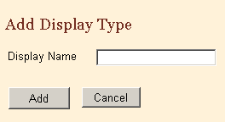
- In the Display Name field, type MD Office. (The field has 12-character limit.)
- Click Add.
Result: The new display type named MD Office is added to the display type list.
To continue building a display type, click Update on the Manage Display Type page to open the update pages. You add fields to this display type in “Activity 2 – Adding Fields to a Display Type54.

Copying a Display Type
Another way to create a new display type is to copy an existing display type and revise it to meet your needs.
To create a display by copying, complete these steps:
- Log in Web Plus. For details, see “Log In”, page 8.
Result: The Web Plus home page opens.
- On the Web Plus menu, point to Configuration, then click Manage Display Types.
Result: The Manage Display Types page opens.
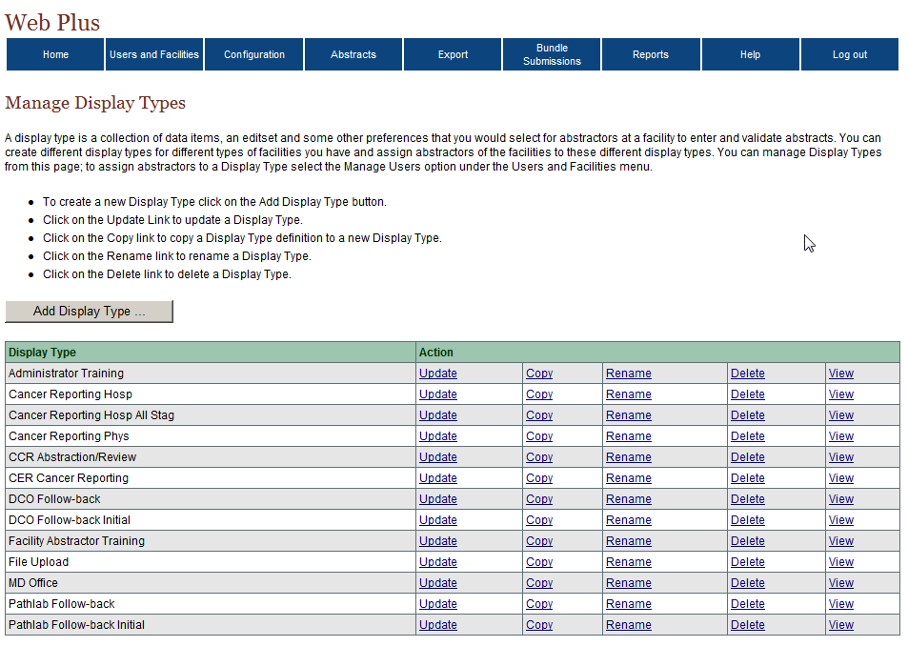
Several example display types are included in Web Plus, named for their respective purposes. Any of the example display types can be copied and used as a starting point for your own registry’s display types. The example display types are intended for use as follows:
Display Type | Recommended Use
Administrator Training | Partially completed display type to be used in conjunction with the Web Plus Central Registry Administrator training manual; In this training manual, the Administrator Training display type is copied and then completed
Cancer Reporting Hosp | General cancer reporting from a hospital; meets minimum reporting requirements for NPCR
Cancer Reporting Hosp All Stag | General cancer reporting from a hospital; meets minimum reporting requirements for NPCR and additionally collects and derives all Collaborative Staging fields
Cancer Reporting Phys | General cancer reporting from a physician’s office
CCR Abstraction/Review | For review of abstracts released from facilities and abstracting of new abstracts at the central registry by the Central Registry Abstractor; for CRS Plus users, this display matches the display of abstracts within Prep Plus and CRS Plus
CER Cancer Reporting | Example display for data collection efforts for the CDC Comparative Effectiveness Research (CER) Project (NOTE: this example display type is only included for registries that are participating in the CDC CER project)
DCO Follow-back | Display type to be assigned for facility DCO follow-back abstraction (assigned by the Web Plus Central Registry Administrator: Configuration →Manage System Preferences)
DCO Follow-back Initial | Display type to be assigned for facility DCO follow-back abstraction, i.e., used by facility to complete posted DCO follow-back abstracts (Follow-back Supervisors can manually add follow-back abstract online if a follow-back file cannot be generated, this is the display type that would be used for that initial entry (assigned by the Web Plus Central Registry Administrator: Configuration →Manage System Preferences)
Facility Abstractor Training | Display type to be used in conjunction with the Web Plus Facility Abstractor training manual---the Facility Abstractor Training display type is assigned to the sample facility named Test Facility1, and the John Doe Facility Abstractor test user is assigned to the Test Facility1; As a result, when logged in to the Web Plus application as John Doe, it is the Facility Abstractor Training display type that is being viewed
File Upload | Display Type that can be assigned to facilities that use Web Plus solely for the purposes of uploading files; this display type has the Central: Vs12 .1 State Example--Incoming Abstracts edit set assigned to it
Pathlab Follow-back | Display type to be assigned for facility pathlab follow-back abstraction, i.e., used by facility to complete posted Pathlab follow-back abstracts (assigned by the Web Plus Central Registry Administrator: Configuration →Manage System Preferences)
Pathlab Follow-back Initial | Display type to be assigned for central registry initial abstraction for a pathlab follow-back abstract (Follow-back Supervisors can manually add follow-back abstract online if a follow-back file cannot be generated, this is the display type that would be used for that initial entry (assigned by the Web Plus Central Registry Administrator: Configuration →Manage System Preferences)

Because the Facility Abstractor and Administrator Training display types are designed to be used with training manuals containing specific instructions and activities, it is very important that these display types are left in their original state. If you want to experiment or begin to build your own display types, copy a display type and save the copy under a new name.
- Locate the Administrator Training display type and click Copy.
Result: The Copy Display Type window opens.
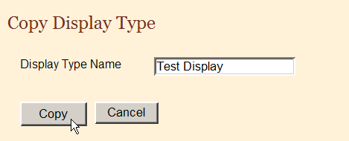
- In the Display Type Name field, type Test Display for the new display type, and then click Copy.
Result: The window closes and the Manage Display Type page opens with the Test Display display type added to the list.
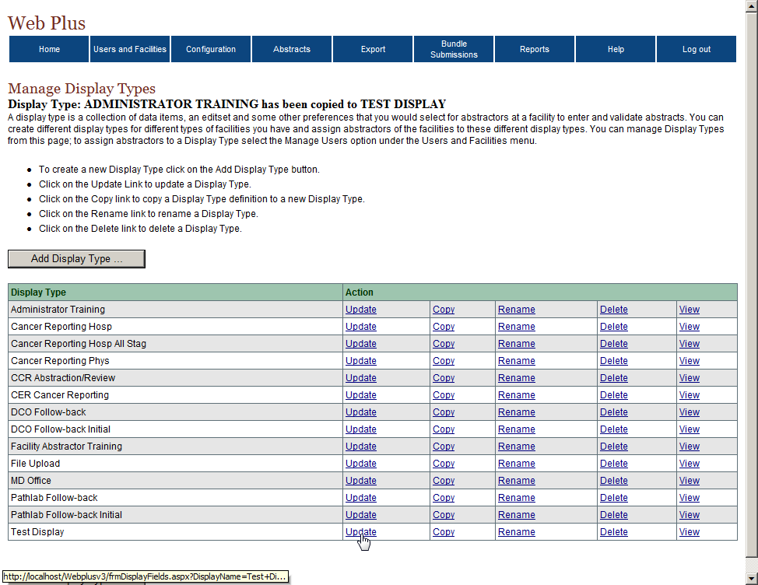

Five Steps for Building a Display Type
After you have created a display type, there are five steps you will need to go through to build the display type. You do not have to use the options in all five steps. When you click Update for a display type on the Manage Display Types page, the system opens the first of a series of update pages that take you through the five main steps to build or update the display type. This table describes the main steps:
In this step . . . | You select the . . .
- Select Fields | fields that are used in your display type, set properties for individual fields, and group fields into sections if desired.
- Select Critical Fields | fields that must contain information to complete an abstract (required fields).
- Select Edit Set | edit set for your display type (determines how the system edits the abstracted data), and set edit set execution options.
- Select Individual Edit Options | edit set execution options for individual edits, over-riding the options selected for the edit set.
- Select Collaborative Staging Preference | Collaborative Staging calculation options.

When setting up a display type for a facility for which there will be only a file uploader (i.e., no online abstracting, just file upload), the only steps necessary are to select a single field into the display type (any field), and do Step 3 – Select an Edit Set. It is NOT necessary to select any other fields, or set critical fields, individual edit options or Collaborative Staging preference. When files are uploaded, the edit set and individual edit options are the only information drawn upon from the display type assigned to the facility of the file uploader.

Step 1: Select Fields
After adding a new or copying an existing display type to create a new display type, you modify your display type. The first step is to select section headings and data fields for your display type. Section headings, such as Hospital Specific and Demographic, can vary, and are used to organize the fields for clearer viewing and to facilitate data entry by the abstractor.
To add section headings and fields:
- On the Web Plus menu, point to Configuration, then click Manage Display Types.
Result: The Manage Display Types page opens.
- On the Test Display row, click Update.
Result: The Select Fields page opens.
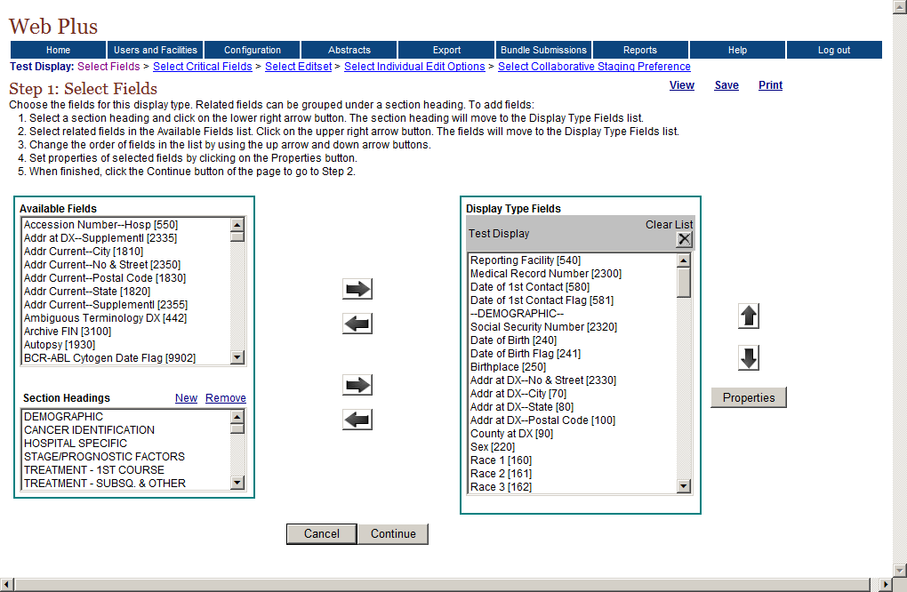
Move Fields
Move Headings
Re-order Data Items
On this page you select the fields for which you want the abstractor to supply information, and group the fields into sections if desired. Using the left and right arrow buttons, you move the fields and section headings from the lists on the left to the list on the right to include them in the display type you are creating. You can use the up and down arrow buttons to re-order the fields once you have added them.

Adding Section Headings
Section headings are added to a display type to organize the fields in the display type into logical groups of related fields.
- In the Section Headings list, select HOSPITAL SPECIFIC.
- Click the lower right arrow to move the heading into the display type.
Result: The section heading moves to the Display Type Fields list.
- In the Display Type field list, select HOSPITAL SPECIFIC and click the up arrow to move the heading to the first position on the list.

Creating a New Section Heading
To create a new section heading, complete these steps:
- On the Select Fields page under Section Headings, click New.
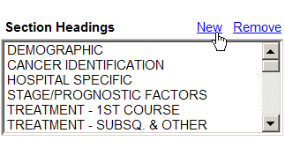
Result: The Add Display Section window opens.
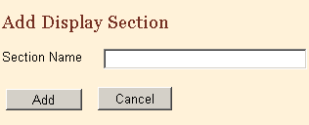
- In the Section Name field, type Miscellaneous.
- Click Add.
Result: The Add Display Section window closes and the system displays the section heading in the Section Headings list.

Deleting a Section Heading
To delete a section heading, complete these steps:
- On the Select Fields page under Section Headings, select Miscellaneous.
- Click Remove.
Result: The Delete Section window opens.
- Click Delete.
Result: The system deletes the section heading from the list.

Adding Fields
After adding section headings to the Display Type Fields lists, add the fields.
- In the Display Type Fields list, select the section heading of DEMOGRAPHIC.
When you move the available fields into the display type, the system places the fields under the section heading or field that you have selected in the Display Type Field list. If you have not selected a section heading or field then the system places the fields at the bottom of the Display Type Field list.
- In the Available Fields list, select these fields:
- Name–First
- Name–Last
- Name–Middle
Selecting  Fields | To select one field, click the name of the field.  To select a group of fields together, click the first field, press and hold the SHIFT key, and then click the last field in the group.  To select multiple fields that are not in order, press and hold the CTRL key and click each field
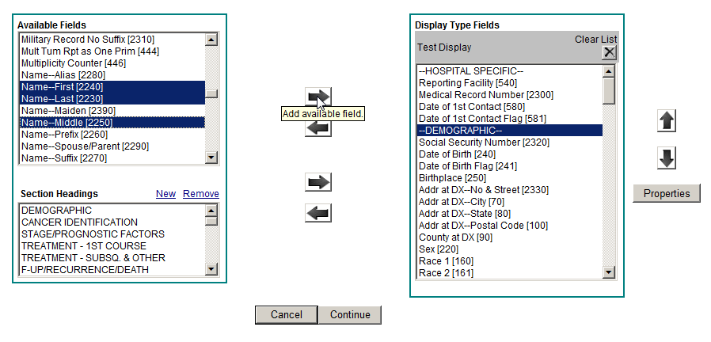
- Click the right arrow beside the Available Fields list and move the selected fields into the Display Type Fields list.
Result: The selected fields are added to the Display Type Fields list on the right.
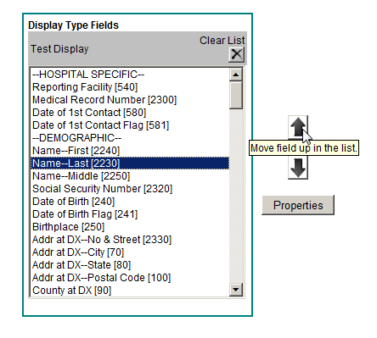
- In the Display Type Fields list, select Name–Last and click the up arrow to move the field to the first position under the heading.
Result: The selected field is ordered as specified in the Display Type Fields list.



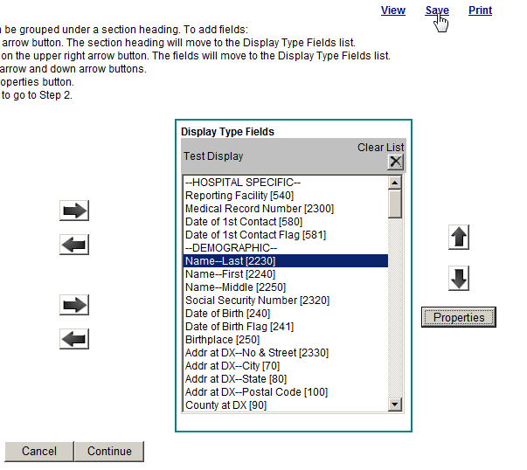
- Click the Save Fields link located in the upper right-hand corner of the screen.
You can save updates to the fields either by clicking Save Fields or the Continue button, which saves updates and opens the next page, Step 2, Select Critical Fields.

Assigning Property Values to Individual Fields
On the Select Fields page, you can also assign special properties to individual fields. To assign property values to a field, complete these steps:
- In the Display Type Fields list scroll down, locate, and select the NAACCR Record Version field.
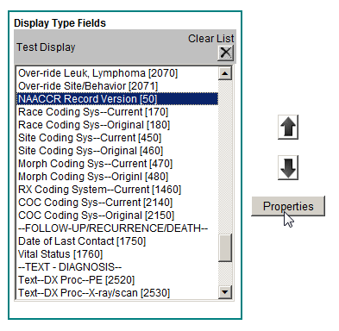
- Click the Properties button.
Result: The Properties window opens.
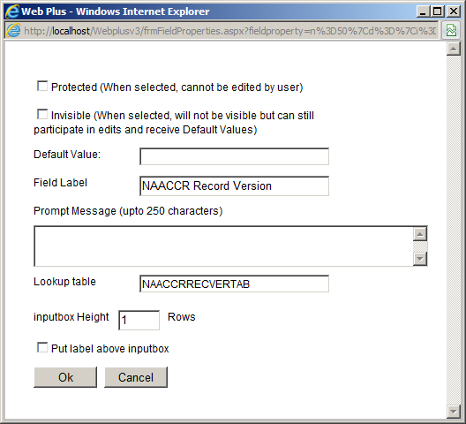
These are the fields in the Properties window:
Property | Description
Protected | When check box is checked, value of field cannot be edited by user.
Invisible | When check box is checked, the field is not visible to user, but the defaulted value is edited and transmitted with the abstract.
Default Value | Value that is initially displayed in the field.
Field Label | User-specified label for the field  Note: Try to restrict the label to 25 characters. If a label is more than 25 characters the label “wraps” to the next line. Use the Put label above the input box property for longer titles (see below).
Prompt Message | Information entered for the Prompt Message property appears in a text box that pops up when the abstractor places the cursor in the field; for example, a reminder regarding the format of a date field entry.
Lookup table | Associate a lookup table with the data item
Inputbox Height | Sets the height of data entry input box for the field in rows. The default value is 1. You may want to change it to a higher value for text fields.
Put label above inputbox | When check box is checked, the label for the field is placed above the input box for the field, rather than to the left of the field. This option is generally used for long field labels, and labels for text fields.
- Click the Protected check box.
- Click the Invisible check box.
- In the Default Value field, type 150, for NAACCR Record Version 15.0.
- Click OK.
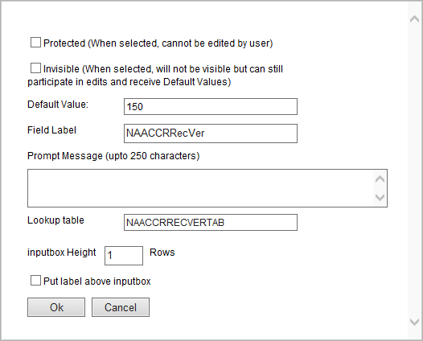
Result: The Properties window closes and the system saves the properties.

Assigning Other Property Values
To assign other property values to other fields, complete these steps:
- In the Display Type Fields list, locate and select Date of 1st Contact Flag.
- Click Properties.
- In the Field Label box, type Date of First Contact Flag. This is an example of a long label that will wrap-around when you view this display type.
- Click OK.
Result: The system saves the property and closes the window.
- In the Display Type Fields list, select Addr at DX–No & Street.
- Click Properties.
- In the Field Label box, type Address at Diagnosis, Street Address.
- Select the check box for Put label above inputbox.
- Click OK.
Result: The system saves the property and closes the window.
- Click Save Fields.

Activity 1 – Adding Properties to Display Type Fields
In this activity, you add properties for the fields for your display type.
- Add this prompt message to the properties for Text–DxProc–PE:
Please be concise and include all relevant information.
- For the field, RX Text–Other, enter 5 in the Inputbox Height field property.
- Click Save Fields.
For each field, select the field and click Properties. Set the desired properties and click OK.

Printing a Copy of Display Type Fields
To print a copy of the display type fields, follow these steps:
- Click the Print link located in the upper right-hand corner of the page.
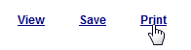
Result: A separate window opens with a printable report listing the display fields you have selected, along with select properties that were set.
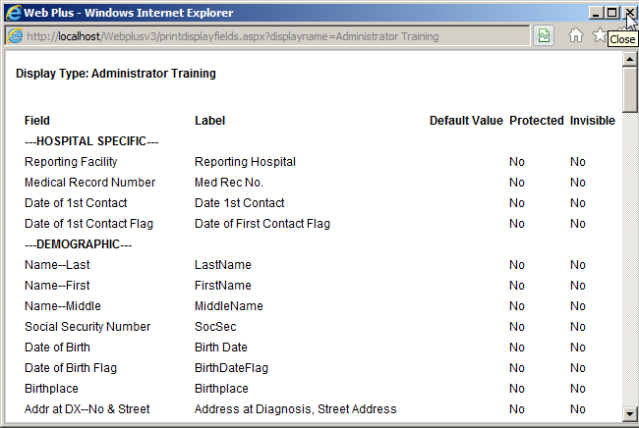
The window contains these column headings:
Column | Description
Field | Default name of field
Label | User-specified name for field
Default value | The initial value in a field
Protected | Value of field cannot be edited by user
Invisible | Value of field is not visible to user but the value is edited
- If you would like, you can print the report using your browser’s printer.
- Close the print window.

Step 2: Select Critical Fields
Critical fields, or required fields, are fields that must contain information in order to complete and release an abstract. In step 2, the system displays the fields that you selected in the first step in the Available Fields list. To designate a field as critical, move an available field to the Critical Fields list. Critical fields are indicated to the abstractor within the display type with an asterisk (*) to the right of the field label.
To designate critical fields, complete these steps:
- On the Web Plus menu, point to Configuration, then click Manage Display Types.
Result: The Manage Display Types page opens.
- Click Update for the display type Test Display.
Result: The Select Fields page opens with the links to all selection steps.
- Click the Select Critical Fields link.
Result: The Select Critical Fields page opens.
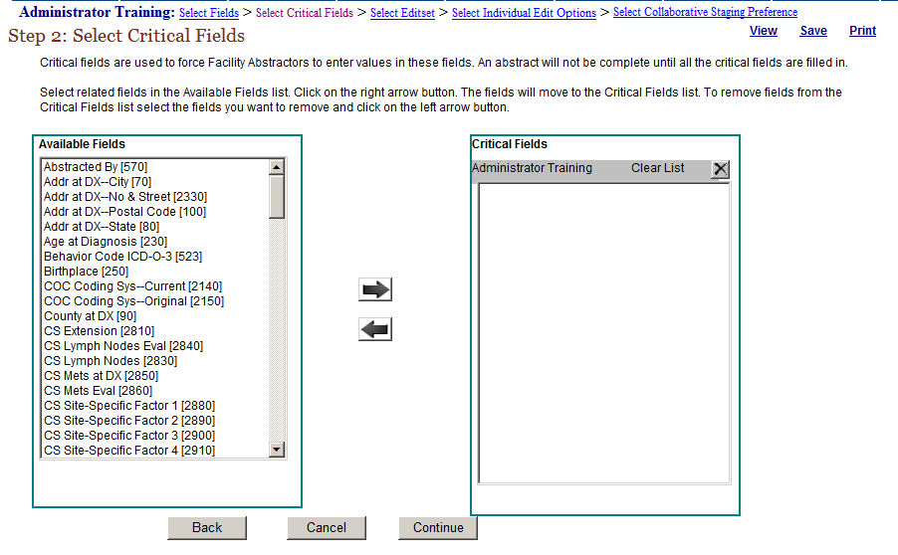
- Select the following fields from the Available Fields list on the left and move them to the Critical Fields list on the right by clicking the right arrow .
- Addr at DX–Postal Code
- Name–Last
- Text–DX Proc–Op
- Text–Histology Title
- Text–Primary Site Title
Result: The selected fields are added to the Critical Fields list.
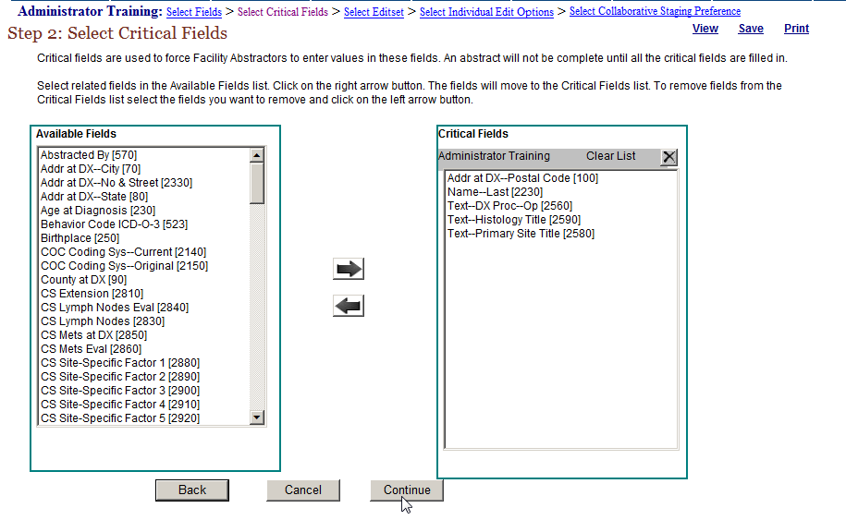
- Click Continue.
You can also save your work by clicking the Save link to retain your updates. Clicking Clear Fields will remove all fields from the Critical Fields list.

Buttons on Manage Display Type Pages
These are the buttons are on the pages that build the display types:
Click this button . . . | To . . .
Back | Open the previous step page; for example, from Step 2 to Step 1
Cancel | Open (return to) the Manage Display Type page
Continue | Save information on the current page and open the page for the next step

Step 3: Select Edit Sets
In this step, you choose the edit set for your display type. To ensure that the information contained within an abstract makes sense and codes are coded correctly, both individually and in relation to one another, data quality "Edits" are applied to each abstract as it is saved.
An edit set contains a collection of individual edits. If there are errors when an abstract is saved, the Web Plus application displays those errors so the abstractor can correct them. An abstract cannot be completed and released to the central registry until all errors have been resolved.
To select an edit set, complete these steps:
- The Select Edit Set page should already be opened because you clicked Continue in the previous step. If the page is not open, click the Select Editset link
Result: The Select Edit Set page opens.
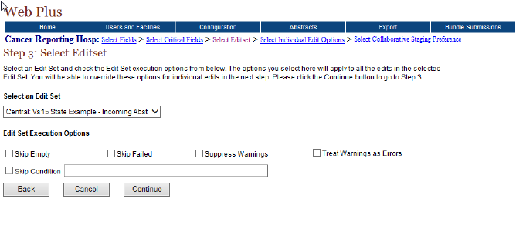
From the Select an Edit Set drop-down list, select the Central: Vs15 State Example-Incoming Abstracts edit set:
In addition to selecting an edit set, you may choose to set certain global Edit Set Execution Options. These are the Edit Set Execution Options on the Select Edit Set page:
Option | Description
Skip Empty | Prevents an edit from running if any of the fields that it edits are blank.
Skip Failed | Prevents a multi-field edit from executing if any field in its list has failed its single field edit.
Suppress Warnings | Prevents the return of warning messages by converting the return value to pass.
Treat Warnings as Errors | Makes the application treat edit warnings as edit errors, i.e., the Facility Abstractor must resolve all edits errors and warning in order to complete an abstract.
Skip Condition | Prevents edits from running when specified Skip Condition is met. The skip condition syntax includes the NAACCR Data Item Number for the field being referred to for the skip condition. An example of the skip condition statement syntax:  To suppress an edit when date of diagnosis is prior to 2003 enter: Item[390] < '20030101'.  You can combine several conditions by using the AND and OR Boolean connectors.
- Click Continue.
Result: The system saves the edit set selection and opens the next step page.

Step 4: Select Individual Edit Options
In this step, for any individual edit in the set you can over-ride the edit set execution options chosen in step 3 for the entire edit set. You would select individual edit options when an available edit set meets your needs with the exception of a few edits. When you choose the individual edit options, you override the edit set options. The setting of individual edit options requires a thorough understanding of the edit set itself.
To select individual edit options, follow these steps:
- The Select Individual Edit Options page should already be opened because you clicked Continue in the previous step. If it is not open, click the Select Individual Edit Options link.
Result: The Select Individual Edit Options page opens.
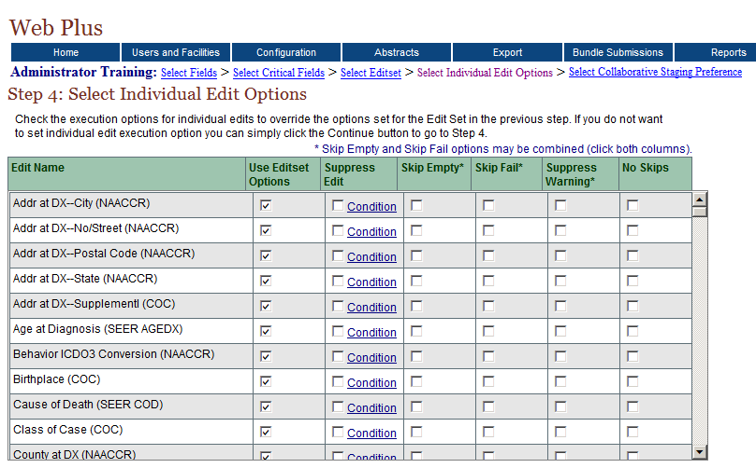
The Select Individual Edit Options page includes these options:
Option | Description
Suppress Edit | Prevents the individual edit from executing when the edit set is run upon saving an abstract.  This option has an additional Condition feature which allows you to selectively skip the edit when the specified condition is met. To enable a skip condition, check the Suppress Edit check box and click the Condition link. The syntax for the condition statement is the same as for the global Skip Condition edit set execution option
Skip Empty | Prevents the individual edit from executing if any of the fields that it edits are blank.
Skip Fail | Prevents an individual multi-field edit from executing if any field in its list has failed its single field edit.
Suppress Warning | Prevents the return of any warning messages by the edit.
No Skips | Edit runs for the field, over-riding any Skip Empty or Skip Fail options that may be set for the edit set

To select any of the individual edit options, locate the edit for which you would like to set options, and click the check box in the columns of the desired options. Note that the Skip Empty and Skip Fail options may be combined for an edit by clicking the check boxes in both columns.
- Scroll the list of edits to see the edits included in the set, but don’t select any of the options.
Edit Sets | Before you select an edit set, you should be aware of all of the edits in the set and how they edit the data.  To get a detailed view of the edit set and individual edits, you must use the EditWriter software.  To quickly view the edits in an edit set, select the edit set in step 3, and view its contents in step 4.
- Click Continue.
Result: The system opens the next step page.

Step 5: Select Collaborative Staging Preference
The Web Plus application can calculate stage according to three separate systems: SEER Summary Stage 77, SEER Summary Stage 2000, and AJCC Stage Group. In step 5 you have the option to select among these three Collaborative Staging (CS) preferences. You can select a single or multiple staging systems, depending on what CS fields you are collecting, and what derived CS fields you would like to store in your central registry.

To select your Collaborative Staging preference, follow these steps:
- The Select Collaborative Staging Preference page should already be opened because you clicked Continue on the previous page. If it is not open, click the Select Collaborative Staging Preference link.
Result: The Select Collaborative Staging Preference page opens.
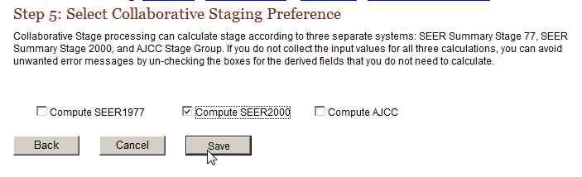
These are the staging preferences:
Process | Description
Compute SEER1977 | From the Collaborative Staging fields collected, the derived SEER Summary Stage 1977 is calculated
Compute SEER2000 | From the Collaborative Staging fields collected, the derived SEER Summary Stage 2000 is calculated
Compute AJCC | From the Collaborative Staging fields collected, the derived AJCC Stage Group fields are calculated
- Select Compute SEER2000.
- Click Save.
Result: The Manage Display Types page opens with a confirmation that the display type has been updated.

Viewing the Display Type
As you go through the 5 steps to generate a display type, in particular when adding fields and specifying field properties such as field labels, you will want to view the display type in order to ascertain exactly what the Facility Abstractor will be seeing when they log into Web Plus and use the display type to abstract cases.
To view a display type, follow these steps:
- On any of the Manage Display Type pages click View in the upper right-hand corner of the page.
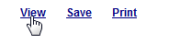
Result: A separate window opens with the display type displayed.
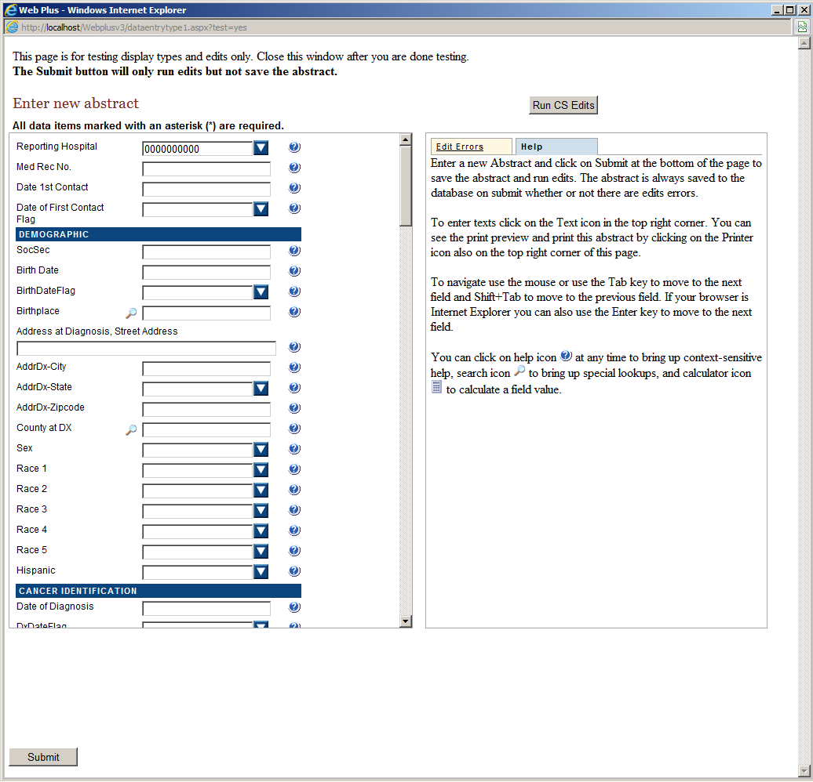
When viewing a display type from within the Administrator pages of Web Plus, you can see exactly what will be displayed to the end user. You can also test the display type by entering values and clicking Submit, or Run CS Edits.

Submit
Clicking Submit will apply the requirements that you selected in Step 2: Select Critical Fields. Recall that fields specified as critical must contain information to complete an abstract. In addition the edit set that you selected in Step 3: Select Edit Sets will run. By clicking Submit, you can simulate the Facility Abstractor experience with the display type in terms of collected fields and data editing requirements. You can also ensure that all of the fields that you want to collect are included in the display type and correctly ordered; field labels are of the correct length, are spelled correctly, and are displayed either to the left of the data entry box or above it as specified; data input boxes are the correct height (i.e., the correct number of rows are displayed); and that specified field properties are accurate.

Run CS Edits
To facilitate the abstraction of Collaborative Staging (CS) Site-specific Factors (SSFs), Web Plus automatically defaults all CS SSFs to a value of 988 when the first of any of the CS input field look-ups is activated by clicking the magnifying glass to the left of the CS input field. This will save the Facility Abstractor a good deal of time when abstracting CS SSFs, as the value of 988 will need to be entered for most of the SSFs for the majority of schemas.
In order to determine which of the CS SSF fields needs to be revised from the defaulted value of 988 to a more specific value Web Plus has a special Run CS Edits button to run any CS-specific edits in your specified edit set to identify required CS fields.
Clicking Submit or Run CS Edits will only run edits and apply critical fields to the values that have been entered while testing the display type. An abstract is not created, and no values are actually saved to the database.
- For the Test Display display type, view the fields that you have created, assigned property values, or designated as critical (required):
Locate … | To see …
Date 1st Contact | a default prompt
Date of First Contact Flag | a wrapping label (label continues to next line)
Address at DX | a long label above the input box
The Over-Rides/  Conversion/System Admin Section | that the NAACCR Record Version and other coding system variables are invisible (they also contain the default values entered for them)
Text–DxProc–PE | a user-generated prompt
RX Text–Other | An input box with a height of five lines
Name–Last  Addr at DX–Postal Code  Text–Histology Title  Text–Primary Site Title  Text–DX Proc–Op | Asterisk designating a critical, or required field
- Enter a few values and click Submit. Edit Errors will automatically be displayed on the Edit Errors tab in the box on the right-hand side of the page. Verify that the Central: Vs15.0 State Example-Incoming Abstracts edit set is being run.
- You can verify your Collaborative Staging requirements by entering a few CS input fields to activate the automatic defaulting of the CS SSFs and then clicking Run CS edits.

Questions
Answer these questions about configuring a display type (the answers are in Appendix A, 132):
- What is the difference between selecting an edit set and selecting individual edit options?
- How can you protect a field from being edited by an abstractor?
- What are the two ways to create a new display type?
- What are section headings?

Activity 2 – Adding Fields to a Display Type
In this activity, you add and move the fields for your display type, MD Office (created in “Adding a New Display Type”, page 29). Complete these steps to add fields:
- Add these fields to the display type:

- Name–Prefix
- Name–Suffix
- Name–Spouse/Parent
- Social Security Number
- Telephone
- County at DX
- Race 1
- Sex
- Marital Status at DX

- Move the fields up and down until they are in this order:

- Name–Last
- Name–First
- Name–Middle
- Name–Maiden
- Name–Prefix
- Name–Suffix
- Name–Spouse/Parent
- Addr at DX–No & Street
- Addr at DX–City
- Addr at DX–Supplementl
- Addr at DX–State
- Addr At DX–Postal Code
- County at DX
- Social Security Number
- Telephone
- Race 1
- Sex
- Marital Status at DX
- Birth Date
- Birthplace

- Save your work.

Activity 3 – Adding a Heading and Fields
In this activity you add a heading to the MD Office display type and more fields that relate to it. Follow these steps:
- Add a heading, Cancer Identification, to the bottom of the Display Type list
- Under this heading, add these fields:
- Date of diagnosis
- Primary Site
- Laterality
- Histologic Type ICD-O-3
- Behavior Code ICD-O-3
- Save your work.

Deleting a Display Type
To delete display type, complete these steps:
- On the Web Plus menu, point to Configuration, then click Manage Display Types.
Result: The Manage Display Types page opens.
- Find MD Office, and on that row click Delete.
Result: The Delete Display window opens.
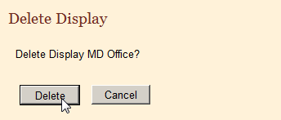
- Click Delete.
Result: The Delete Display window closes and system displays a message on the Manage Display Types page indicating that the selected display types has been deleted.
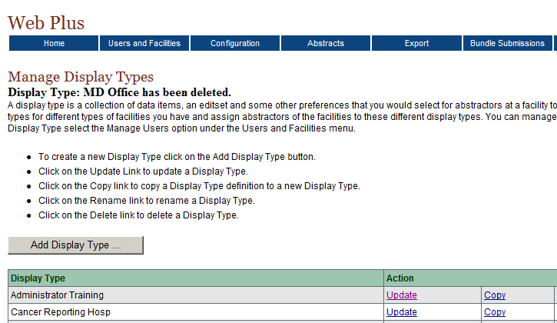

Managing Facilities and Users

Learning Objectives
In this chapter you learn to:
- Manage facilities by adding, editing, and deleting facility records
- Manage user accounts by adding, editing, and deleting user accounts
- Reset user passwords
- Lock and unlock user accounts
- View the user activities log
- View a display type as a Facility Abstractor
- Create central registry users

Overview
This chapter covers the procedures to manage the facilities and users of your state registry Web Plus application. As an Administrator, you can add, edit, and delete facilities and user accounts. In addition, you can reset passwords for individual users.

Managing Facilities
An Administrator manages the records of facilities or offices from which users will generate and release abstracts and upload files. You can add, update, and delete facilities in Web Plus.

Adding a Facility
To add a facility, complete these steps:
- Log in to Web Plus. For details, see “Log In”, page 8.
Result: The Web Plus home page opens.
- On the Web Plus menu, point to Users and Facilities, then click Manage Facilities.
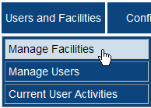
Result: The Manage Facilities page opens.
Three example facilities, named Any State Cancer Registry, Test Facility1, and Test Facility2 are included in the application.
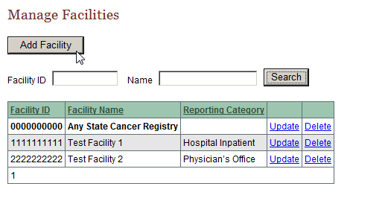
- Click Add Facility.
Result: The Add/Update Facility page opens.
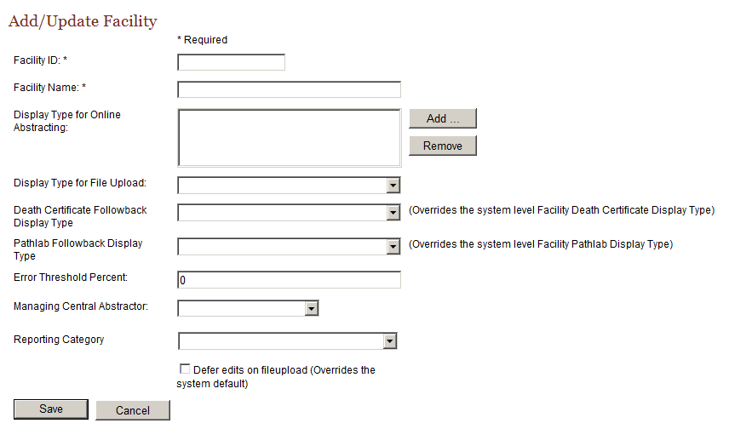
The Add/Update Facility page contains the following fields (fields marked with an asterisk [*] require information to be entered into them):
Field | Description
Facility ID* | 10-digit identification number for the facility
Facility Name* | Name of the facility or office
Display Type For Online Abstracting | Name of the display type assigned to the facility for the purposes of online abstracting
Display Type For File Upload | Name of the display type assigned to the facility for the purposes of file upload (can vary from that assigned for online abstracting)
Death Certificate Followback Display Type | Display type to be used for facility DCO follow-back abstraction, i.e., used by facility to complete posted DCO follow-back abstracts (the display type you select for this option for a specific facility will override the display type selected for the system-level DCO follow-back display type option on the Manage System Preferences page)
Pathlab Followback Display Type | Display type to be used for facility pathlab follow-back abstraction, i.e., used by facility to complete posted Pathlab follow-back abstracts (the display type you select for this option for a specific facility will override the display type selected for the system-level Pathlab display type option on the Manage System Preferences page)
Error Threshold Percent | Limit for the percentage of errors allowed in an uploaded file of abstracts
Managing Central Abstractor | The Central Registry Abstractor/Reviewer who will review the facility’s released abstracts
Reporting Category | Optional reporting category label for the facility to allow for the labeling, grouping, and sorting of reporting facilities into standard reporting category types based on the following NAACCR field of Type of Reporting Source [item #500] values:  1 = Hospital Inpatient  2 = RT or Medical Oncology Centers  3 = Pathology Laboratory  4 = Physician’s Office  5 = Nursing Home/Hospice  8 = Other Outpatient/Surgery Centers
Defer edits on file upload | Select this option to prevent Web Plus from editing the abstracts in a file when it is uploaded from the facility; a facility; this option overrides the Defer Edits option specified on the Manage System Preferences page (the Web Plus Administration Tool can be used to manually run edits on these files)
- Enter 9123456789 in the Facility ID field.
- Enter Doctors Clinic in the Facility Name field.
- Click Add to the right of the Display Type for Online Abstracting box.
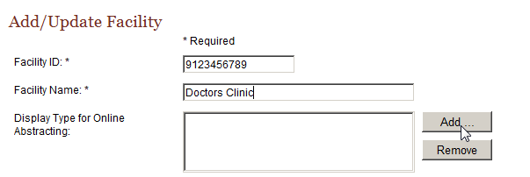
Result: The Select a display type to add window opens.
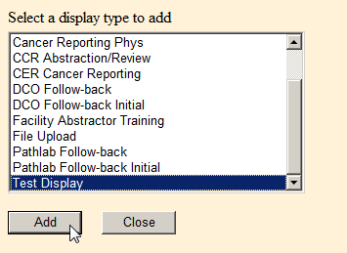
- Scroll down and Select Test Display, click Add, then click Close.
Result: You are returned to the Add/Update Facility page, with the selected display type added to the Display Type for Online Abstracting.
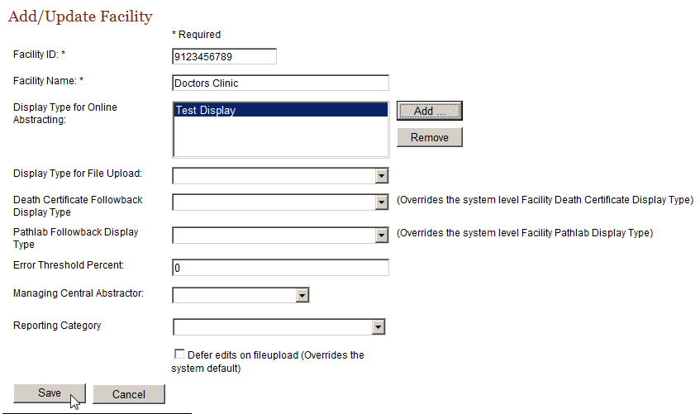
- Click Save.
Clicking Cancel instead of save would close the Add Facility window and return you to the Manage Facilities page without saving any changes.
Result: The Doctors Clinic facility is added to the facilities list on the Manage Facilities page.
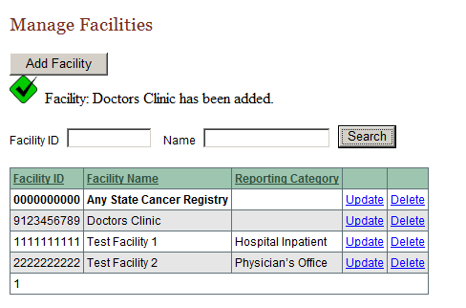

Editing a Facility Record
After creating a facility record, you can update the record.
To edit a facility record, complete these steps:
- On the Web Plus menu, point to Users and Facilities, then click Manage Facilities.
Result: The Manage Facilities page opens.
- On the Doctors Clinic row, click Update.
Result: The Add/Update Facility page opens.
- In the Error Threshold Percent field, type 5.
- In the Managing Central Abstractor list, select CCRAbstractor.
- Click Save.
Result: The system saves the changes, closes the Add/Update Facility page, and returns to the Manage Facilities page.

Activity 4 – Creating a Facility Record
Using the information in the following table, create a facility named New Hospital. Follow the steps in “Adding a Facility”, page 58, making sure you save your work.
Field | Value
Facility ID | 8912345678
Facility Name | New Hospital
Display Type | Test Display

Deleting a Facility Record
To delete a facility record, complete these steps:
- On the Web Plus menu, point to Users and Facilities, then click Manage Facilities.
Result: The Manage Facilities page opens.
- On the New Hospital row, click Delete.
Result: The system asks you to confirm that you would like to delete the facility record.
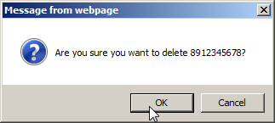
- Click OK.
Result: The system removes the facility from the Facility list.
You can click Cancel to close the Confirm Delete window and return to the Manage Facilities page without deleting a facility record.

Managing User Accounts
This section describes how an Administrator can manage user accounts by adding, updating, and deleting user accounts in Web Plus.

Adding Users
To add a user, complete these steps:
- If you are not already, log in to Web Plus. For details, see “Log In”, page 8.
Result: The Web Plus home page opens.
- On the Web Plus menu, point to Users and Facilities, then click Manage Users.
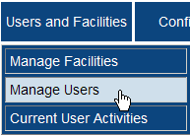
Result: The Manage Users page opens.
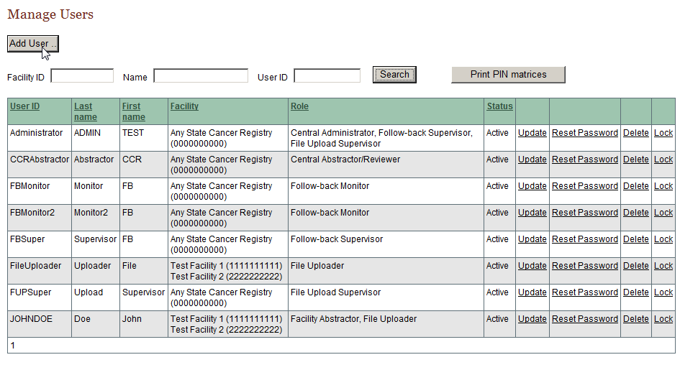
The Manage Users page allows the Administrator to search user accounts by Facility ID, Name, or User ID. From this page you can also print PIN Matrices for all users at once if you have enabled the PIN Entry security feature on the Manage System Preferences page.
Eight example users, one for each of the roles (except no Local Administrator and 2 Follow-back Monitors are included) are included in the application. To log in to Web Plus as any of these users, enter the User ID and password in the following table for the desired role:
Web Plus Role of Test User | User ID | Password | Assigned Facility
Central Registry Administrator | Administrator | admin1 | Any State Cancer Registry
Central Registry Abstractor | CCRAbstractor | abstract1 | Any State Cancer Registry
Follow-back Supervisor | FBSuper | super1 | Any State Cancer Registry
Follow-back Monitor | FBMonitor | monitor1 | Any State Cancer Registry
Follow-back Monitor | FBMonitor2 | monitor1 | Any State Cancer Registry
File Upload Supervisor | FUPSuper | super1 | Any State Cancer Registry
Facility Abstractor | johndoe | abstract1 | Test Facility 1, Test Facility 2
File Uploader | FileUploader | upload1 | Test Facility 1
- Click Add User.
Result: The Add/Edit User Account page opens.
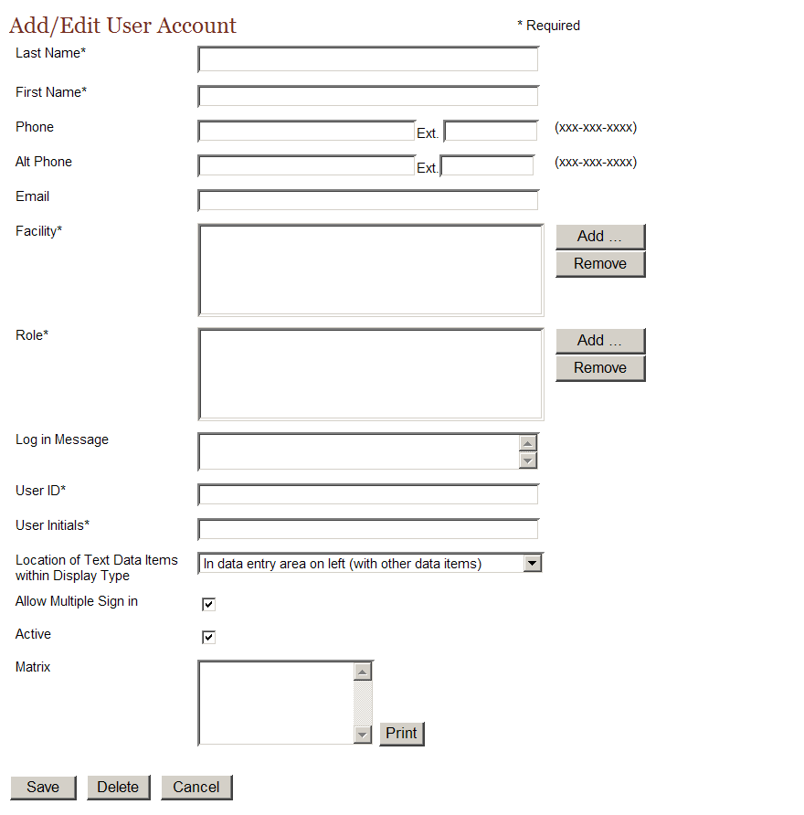
The User Account page contains these fields (fields marked with an asterisk [*] require information to be entered into them):
Field | Description
Last Name* | Last name of user
First Name* | First name of user
Phone | Main phone number of user
Alt Phone | An alternate phone number of user
Email | Email address of user
Facility* | The name of the user’s facility or office
Role* | The Web Plus role of the user
Log in Message | Message displayed for the user at log in
User ID* | The User ID of the user, containing at least five characters
User Initials* | Initials of the user
Location of Text Data Items within Display Type | This field designates the location of Text data items within the Display Type when viewed by the user;  In data entry area on left (with other data items): Text data items will be located in the data entry area on the left side of the screen with the other data items; this view facilitates the abstraction of the text data items, and allows requirement of Text fields to be clearly seen by the user  Under Text Fields tab in box on right (with Edit Errors and Help tabs): Text data items will be located under a Text Fields tab in the box on the right side of the screen, with the Edit Errors and Help tabs; this view can help facilitate the review of coded values within released abstracts
Allow Multiple Sign in | Enables user to log in to Web Plus at more than one location at the same time
Active | Enables Administrator to activate (by checking check box) or de-activate (by un-checking check box) the user account
Matrix | Will display the user’s PIN Matrix if the PIN Entry security feature is enabled on the Manage System Preferences page; Upon each login, the user will be required to enter a 4 digit PIN based on coordinates (provided at login) from their Web Plus PIN Matrix
- Enter this information into the following fields:
Field | Information
Last Name | Sullivan
First Name | Dorothy
User ID | Dsullivan
User Initials | Das
Location of Text Data Items within Display Type | In data entry area on left (with other data items)
- At the Facility field, click Add.
Result: The Select a Facility to Add window opens.
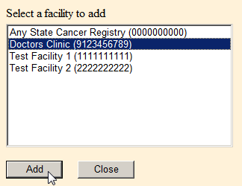
- Select Doctors Clinic and click Add.
Result: The facility is added to the user account.
The Select a Facility to Add window remains open so that you can add more than one facility to the user account.
- Click Close to close the Select a Facility to Add window.
- At the Role field, click Add.
Result: The Select functions from below window opens.
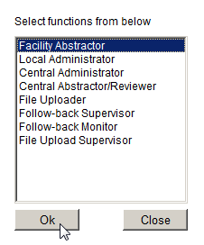
- Select Facility Abstractor and click OK.
Result: The role is added to the user account.
The Select functions from below window remains open so that you can add more than one role to the user account.
- Click Close to close the Select functions from below window.
- On the Add/Edit User Account page, click Save.
Click Cancel to close the Add/Edit User Account window and return to the Manage User Accounts page without saving any changes.
Result: The system adds the new user to the list of users, and sends an e-mail to the user with the User ID and initial password.
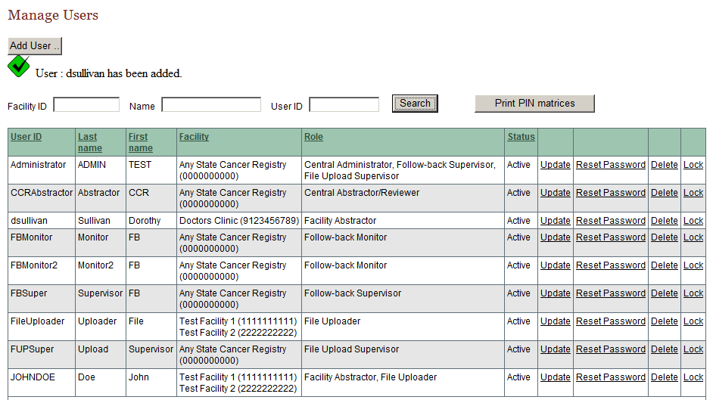

Editing a User Account
To change a user record, complete these steps:
- On the Web Plus menu, point to Users and Facilities, then click Manage Users.
Result: The Manage Users page opens.
- Find the row for Dorothy Sullivan and click the Edit link.
Result: The Add/Edit User Account page opens.
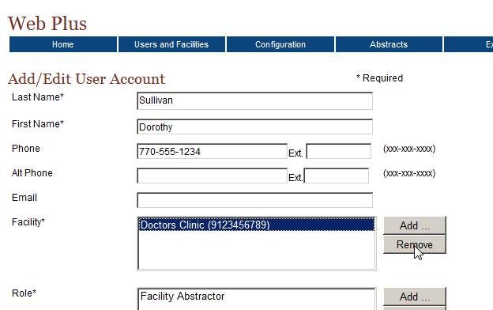
- In the Phone field, type 770-555-1234.
- In the Facility field, select Doctors Clinic and click Remove.
Result: The system removes the facility from the user account.
- Click Add.
Result: The Add Facility window opens.
- Select Test Facility and click Add.
Result: The system adds the new facility for the user.
- Close the Add Facility window.
- Click Save.
Result: On the Manage Users page, a message shows that the account has been updated.
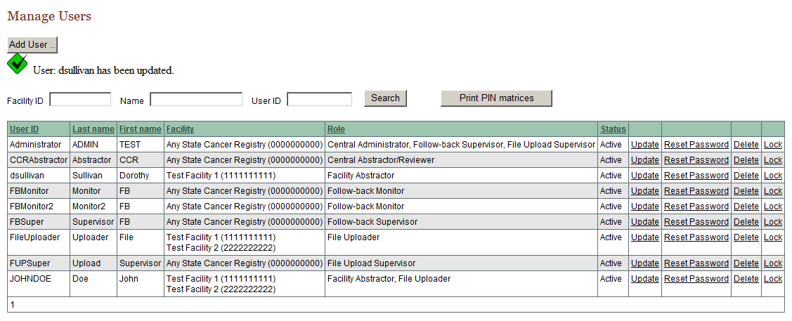

Activity 5 – Create a User Account
Using the information in the following table, create and save a user account for a Facility Abstractor named Jennifer Davies. Follow the steps in “Adding Users”, page 63.
Field | Information
Role | Facility Abstractor
User ID | Jdavies
User Initials | Jrd

Deleting a User Account
To delete a user account, complete these steps:
- Log in to Web Plus. For details, see “Log In”, page 8.
Result: The Web Plus home page opens.
- On the Web Plus menu, point to Users and Facilities, then click Manage Users.
Result: The Manage Users page opens.
- Find Jennifer Davies on the users list and click Delete.
Result: The confirmation window opens.
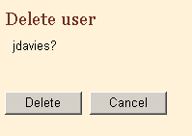
- Click Delete.
Result: The window closes and the system eliminates the user from the list.

Reset Password
The Central Registry Administrator can reset the password for any user. To reset a user’s password, complete these steps:
- On the Web Plus menu, point to Users and Facilities, then click Manage Users.
Result: The Manage Users page opens.
- Find Dorothy Sullivan on the users list and click Reset Password.
Result: The Reset Password window opens.
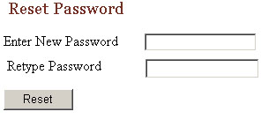
- Type Password1 into both fields.
- Click Reset. The user’s password is reset to the specified password.

Locking Out Users
An Administrator can temporarily deny a user access to Web Plus. (To permanently deny access to user, an Administrator can delete the user account. For more information on deleting user accounts, see page 69.)
To lock a user out of Web Plus, complete these steps:
- Log in to Web Plus. For details, see “Log In”, page 8.
Result: The Web Plus home page opens.
- On the Web Plus menu, point to Users and Facilities, then click Manage Users and then click Lock/Unlock next to the user id that you wish to lock/unlock.
Result: The user is not allowed to log in to Web Plus until the Administrator unlocks the account.

Current User Activities
Web Plus enables an Administrator to view a log of the current activities of the systems’ users. The Current User Activity page displays information about the users who are logged in or have failed to login and the users’ Internet addresses that have been locked out. You can also reset the log status of users, if necessary.

Viewing Current User Activities
To view current user activities:
- On the Web Plus menu, point to Users and Facilities, then click Current User Activities.
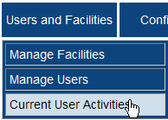
Result: The Current User Activity page opens.

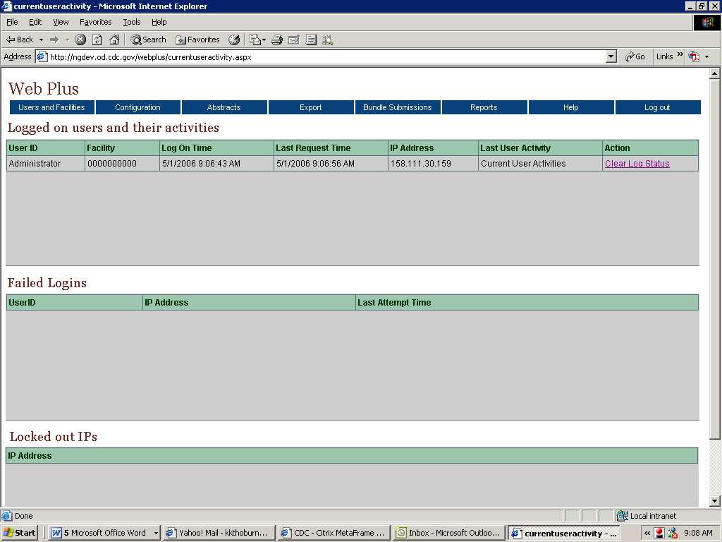
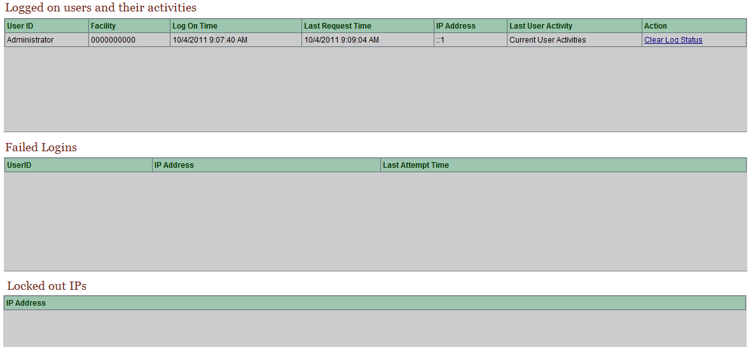
The Current User Activity page contains three tables of information containing details about the activities of users that are currently logged into the system:
Table | Columns | Description
Logged on users and their activities | User ID | Log in identifier of user
Logged on users and their activities | Facility | Facility of user
Logged on users and their activities | Log On Time | Date and time when user logged on
Logged on users and their activities | Last Request Time | Date and time that user made a request
Logged on users and their activities | IP Address | Internet Protocol address of user’s computer
Logged on users and their activities | Last User Activity | Description of user activity
Logged on users and their activities | Action | Clear Log Status link: click this link to clear a user’s logon status so that the user can logon again.
Failed Logins | User ID | Login identifier of user
Failed Logins | IP Address | Internet Protocol address of user’s computer
Failed Logins | Last Attempt Time | Date and time that user last attempted to logon
Locked out IPs |  | Internet Protocol addresses of users that are locked out of Web Plus
- In the Logged on users and their activities table, you can see that you are currently the only active user of the system.

Clear Log Status
To clear a user’s log status, complete these steps:
- On the Web Plus menu, point to Users and Facilities then click Current User Activity.
- In the Logged on users and their activities table, find a user and click Clear Log Status.
Result: The Clear Log Status window opens.
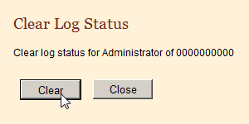
Click Clear.
Result: A confirmation message appears on the Clear Log Status window.
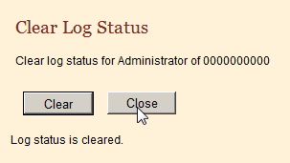
- Click Close.
Result: The window closes and the system clears the user log status for the user.

Questions
Answer these questions about managing facilities and user accounts (the answers are in Appendix A, on page 132 ):
- Are display types assigned to facilities or users?
- What is the menu option where you can add a new facility?
- How do you lock out a user from Web Plus?

Activity 6 – Create a New Facility and User and Unlock an Account
In this activity, you create a new facility, a new user account, and unlock a user.
- Create a new facility. Follow the steps as described in “Adding a Facility”, page 58.
- Create a new user account. Follow the steps as described in “Adding Users”, page 63.
- Unlock the user account for Dorothy Sullivan:
- On the Web Plus menu, point to Users and Facilities, then click Manage Users.
- On the users list, find the facility name for Dorothy Sullivan.
- On the Web Plus menu, point to Users and Facilities, then click Manage Users →Lock/Unlock next to the user id you wish to lock/unlock.

Activity 7 – Create a Central Registry Abstractor/Reviewer Account
Create a Central Registry Abstractor/Reviewer user account:
- Log in to Web Plus as Central Registry Administrator. For details, see “Log In”, page 8.
Result: The Web Plus home page opens.
- On the Web Plus menu, point to Users and Facilities, then click Manage Users.
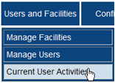
Result: The Manage Users page opens.
- Click Add User.
Result: The Add/Edit User Account page opens.
- Enter this information into these fields:
Field | Information
Last Name | Smith
First Name | Adam
Role | Central Abstractor/Reviewer
User ID | asmith
User Initials | AXS
Location of Text Data Items within Display Type | Under Text Fields tab in box on right (with Edit Errors and Help tabs)
- At the Facility field, click Add.
Result: The Add Facility to User window opens.
- Select Any State Cancer Registry and click Add.
Result: The facility is added to the user account.
- Click Cancel to close the Add Facility to User window.
- On the Add/Edit User Account page, click Save.
Result: The system adds the new user to the list of users.
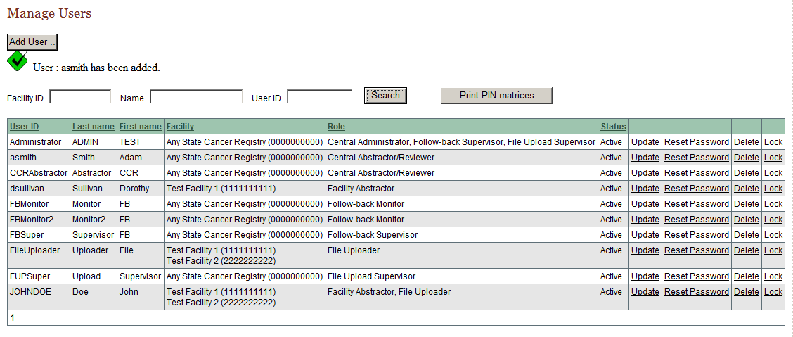

It is important not to assign both central registry-level roles and facility-level roles for the same user as this will result in problems using Web Plus.
Central Registry Roles: Central Registry Administrator, Central Abstractor/Reviewer, Follow-back Supervisor, Follow-back Monitor, File Upload Supervisor
All central registry user accounts must be assigned to the facility account for the Central Registry.

Facility Roles: Facility Abstractor, File Uploader, Local Administrator
You will need to create 2 user accounts for an individual that needs both central-level and facility-level access to the system; one for their central registry roles and the other for their facility-level roles.

Managing Abstracts

Learning Objectives
In this chapter you will learn to:
- Assign released abstracts to a central registry abstractor/reviewer
- How to reassign previously assigned abstracts to a different central abstractor/reviewer
- Find and view released abstracts

Overview
The Central Registry Administrator is responsible for assigning released abstracts to central registry abstractor/reviewers for review. The Administrator can also view abstracts at any point once they have been released to the central registry.

Assigning Abstracts for Review
Administrators assign released abstracts to Central Abstractor/Reviewers on the Assign Released Abstracts page. This page lists the abstracts released from each facility reporting to the central registry and the Central Abstractor/Reviewers available to review the abstracts.
To assign abstracts:
- Log in to Web Plus. For further details, see “Log In”, page 8.
- On the Web Plus menu, point to Abstracts, then click Assign Released Abstracts.
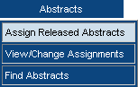
Result: The Assign Abstracts page opens.

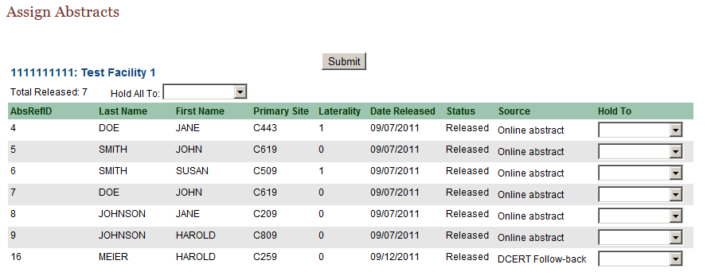
The Assign Abstract page includes these fields and column headings:
Field/Column Heading | Description
Hold All To | Select an abstractor/reviewer to review all the abstracts released by the specific facility
AbsRefID | A unique, system-generated number identifying the abstract
Last Name | Patient’s last name
First Name | Patient’s first name
Primary Site | The ICD-O-3 primary site code of the tumor being reported
Laterality | The laterality code for the tumor being reported
Date Released | Date that the facility released the completed abstract to the central registry
Status | Status of the abstract:
  Status | Description
  Released | Abstract has been released to the central registry
  Held | Abstract has been assigned to a Central Abstractor/Reviewer for review
  Review | Abstract is under review by a central abstractor/reviewer
  Review Released | Abstract has been reviewed by the Central Abstractor/Reviewer and released for export
Source | System module Source of the abstract:
  Status | Description
  Online abstract | Abstract has been released from the online abstracting module of Web Plus
  DCERT Follow-back | Abstract has been released from the Death Certificate Follow-back module of Web Plus
  PATHLAB Follow-back | Abstract has been released from the Pathology Lab Follow-back module of Web Plus
Hold To | Select a Central Abstractor/Reviewer to assign the abstract to
- Locate the released abstract for John Smith, and select asmith from the list in the Hold To column to assign the abstract to the Central Abstractor/Reviewer named Adam Smith.
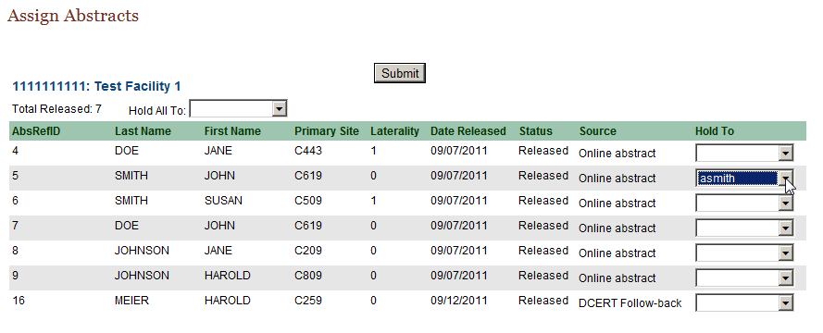
- Click Submit to assign the abstract to Adam Smith.
Result: The system lets you know that you have assigned the abstract, and assigns the abstract to the Central Abstractor/Reviewer, who can now accept it into their work queue when they next login to Web Plus.
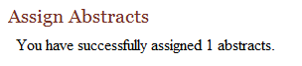

Reassigning an Abstract
The Central Registry Administrator can change the review assignment of an abstract already assigned to a Central Abstractor/Reviewer to another Central Abstractor/Reviewer.
To change an abstract assignment, complete these steps:
- On the Web Plus menu, point to Abstracts, then click View/Change Assignments.
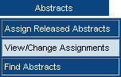
Result: The View/Change Assignments page opens.
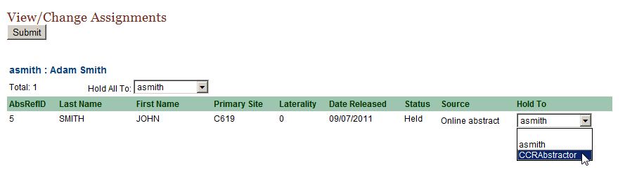
The list of assignments contains these column headings, and is grouped by abstractor:
Heading | Description
Last Name | Patient’s last name
First Name | Patient’s first name
Primary Site | The ICD-O-3 primary site code of the tumor being reported
Laterality | The laterality code for the tumor being reported
Date Released | Date that the facility sent the completed abstract to the central registry
Status | Status of the abstract:
  Status | Description
  Released | Abstract has been released to the central registry
  Held | Abstract has been assigned to a Central Abstractor/Reviewer for review
  Review | Abstract is under review by a central abstractor/reviewer
  Review Released | Abstract has been reviewed by the Central Abstractor/Reviewer and released for export
Hold To | List of central abstractor/reviewers to which abstract can be assigned
- On the row for the John Smith abstract, click the drop-down list in the Hold To column to view the different central abstractor/reviewers.
- Click on CCRAbstractor to reassign the John Smith abstract from the Central Abstractor/Reviewer named Adam Smith to the test Central Abstractor/Reviewer named CCRAbstractor.
- Click Submit.
Result: The system reassigns the abstract to the CCR Abstractor Central Abstractor/Reviewer.
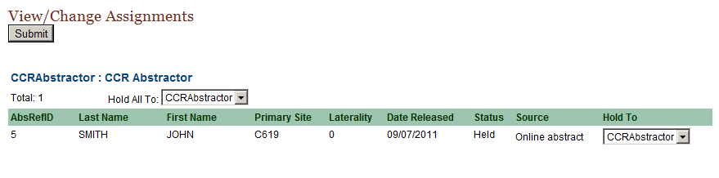
After creating user accounts for your Central Registry Abstractor/Reviewers, you can re-assign these released test cases to them for training purposes.

Finding and Viewing an Abstract
You can search for and view abstracts at any point after they have been released from facilities on the Find Abstracts page. You can use a variety of criteria to search for the abstracts you wish to view.
To find an abstract:
- On the Web Plus menu, point to Abstracts, then click Find Abstracts.
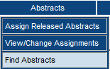
Result: The Find Abstract page opens.
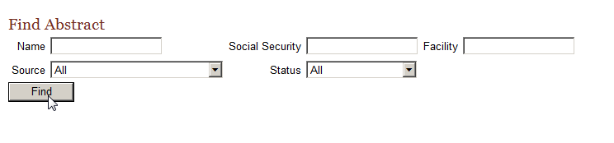

The Find Abstract page contains these search criteria fields:
Field | Description
Name | Name of patient
Facility | Name of facility where abstract is created
Social Security | Social Security number of patient
Source | The name of the display type that was used to abstract the abstract
Status | The statuses of the abstracts that you can select to view are:
  Status | Abstract…
  Released | has been sent to the central registry
  Held | has been assigned to an abstractor but not reviewed yet
  Review | is being reviewed by a central registry abstractor/reviewer
  Review Released | has been reviewed by the Central Abstractor/Reviewer and released for export
  Exported | has been exported from Web Plus
  Rejected | Has been rejected by the Facility Abstractor from within one of the follow-back modules

To find a specific abstract you can type in a name or a social security number or just a partial name or number. You can also leave the default search criteria to obtain a listing of all abstracts.
- Click Find (without altering default search criteria).
Result: The system displays the 9 example abstracts that come with the Web Plus installation, which have been released or rejected from Test Facility (1111111111).

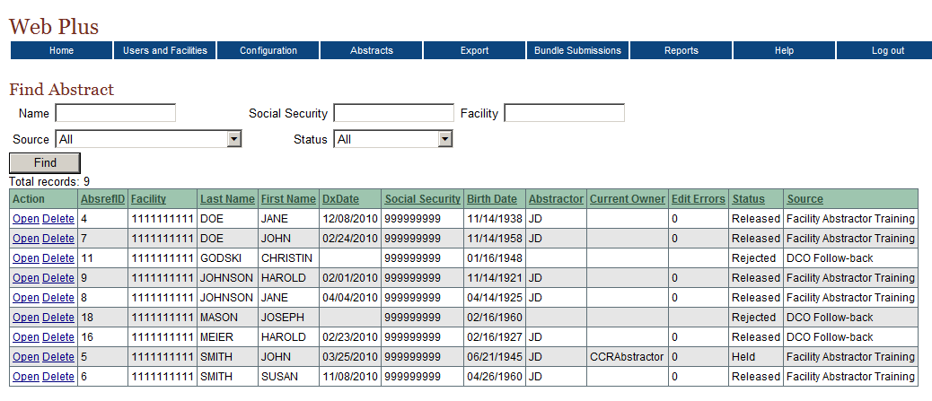
The list of abstracts has ten columns. This table describes the columns:
Column Head | Description
Action | Click the Open link to open the abstract and view its contents; information may not be edited  Click the Delete link to delete the abstract from the Web Plus system
AbsRefID | A unique, system-generated number identifying the abstract
Facility | Facility ID of the facility from which the abstract was released/rejected
Last Name | Last name of patient
First Name | First name of patient
DxDate | Diagnosis date of tumor being reported
Social Security | Patient’s social security number
Birth Date | Patient’s date of birth
Abstractor | Initials of the abstractor
Current Owner | Name of Central Abstractor/Reviewer to whom the abstract is currently assigned
Edit Errors | The number of edit errors currently in the abstract
Status | Web Plus has these statuses:
  Status | Description
  Released | has been sent to the central registry
  Held | has been assigned to an abstractor but not reviewed yet
  Review | is being reviewed by a central registry abstractor/reviewer
  Review Released | has been reviewed by the Central Abstractor/Reviewer and released for export
  Exported | has been exported from Web Plus
  Rejected | Has been rejected by the Facility Abstractor from within one of the follow-back modules
Actions | Click on the open link to open the abstract and view its contents; information may not be edited

- Click Open in the Action column of one of the abstracts.
Result: The Data Entry page for the selected abstract opens with the display type it was abstracted with so that you can view the abstract. The information in the fields cannot be revised at this point.

Exporting Abstracts
To export abstracts from the Web Plus application, the Web Plus Administration Tool is used. Abstracts are exported only after being released following central registry review. Centrally-released abstracts are exported to a file in the NAACCR layout, for import into your central registry database.
Prior to export, centrally-released abstracts may be viewed from within the Central Registry Administrator pages of the Web Plus application.

Questions
Answer these questions about managing abstracts (the answers are in Appendix A, on page 133):
- How can you assign abstracts to another abstractor/reviewer?
- What is the Held status of an abstract?
- How do you export abstracts from the Web Plus application?

Bundle Submissions

Learning Objectives
In this chapter you will learn to:
- View abstracts in an uploaded file
- View the edit error report for an uploaded file of abstracts
- View the data quality indicator report for an uploaded file of abstracts
- Delete an uploaded file
- Post a file for download by facilities
- Manage files that have been posted for download by facilities

Overview
Central registry Administrators can view information for bundle submissions, or file uploads. In addition, uploaded file submissions can be deleted. Central Registry Administrators can also post files for download by facilities, and manage the files that have been posted.

Viewing List of Abstracts and Reports for an Uploaded File
In addition to creating abstracts in Web Plus, facilities can also upload NAACCR-formatted files or files of any type to the central registry using Web Plus. Web Plus runs edits on submitted NAACCR files and generates both an edit error report showing all of the edit errors found in the file and a data quality indicators report that includes indicators of the overall quality and timeliness of a facility’s cancer reporting. Central Registry Administrators can view these reports. The Central Registry Administrator can also view limited fields for an abstract from the list of the abstracts contained in an uploaded file, but they cannot update the abstract.
To view information for an uploaded file, complete these steps:
- On the Web Plus menu, point to Bundle Submissions, then click Track File Uploads.
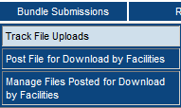
Result: The Bundle Submissions page opens.

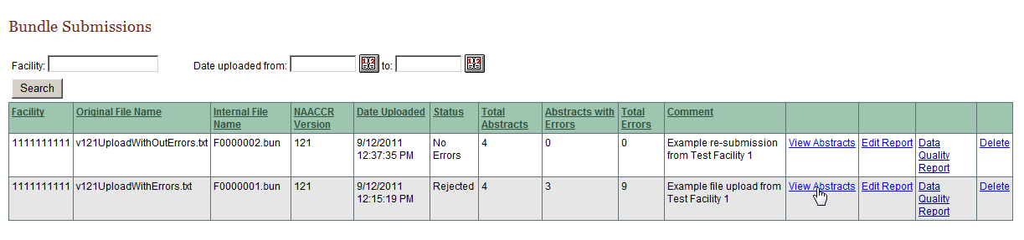
The Bundle Submissions page contains these column headings:
Column Heading | Description
Facility | Facility ID Number
Original File Name | Name of uploaded file
Internal File Name | Name of file within the Web Plus application
NAACCR Version | Version of the NAACCR record layout of the uploaded file (if in the NAACCR file format)
Date Uploaded | Date that the file was uploaded
Status
  Status | Description
  Reject | File rejected because it contained a greater percent of errors than specified in the Error Threshold Percent field for the facility that uploaded the file
  No Errors | File contained no errors when edits were run upon upload
  Bundle Uploaded | File has been uploaded, however, the Defer Edits option has been selected on the System Preferences page, so edits have not yet been run on the file; to run batch edits on such a file, use the Web Plus Administration Tool
  Acceptable Errors | File contained an acceptable percent of errors when edits were run upon upload
Total Abstracts | Total number of abstracts in the file
Abstracts with Errors | Number of abstracts that have errors
Total Errors | Total number of errors in the file
Comment | Comment that file uploader may have entered to be transmitted with the file
Action
  Action | Description
  View Abstracts | View a list of the abstracts in the file
  Edit Report | View the edit error report for the file
  Data Quality Report | View the data quality indicators report for the file
  Delete Bundle | Delete the file

Viewing Abstracts in a File
To view the abstracts in a file uploaded in the NAACCR file format, complete the following steps:
- On the Bundle Submissions page, locate the row for the uploaded file named v121UploadWithErrors.txt, and click the View Abstracts link.
Result: The View Abstracts in Bundle page opens.
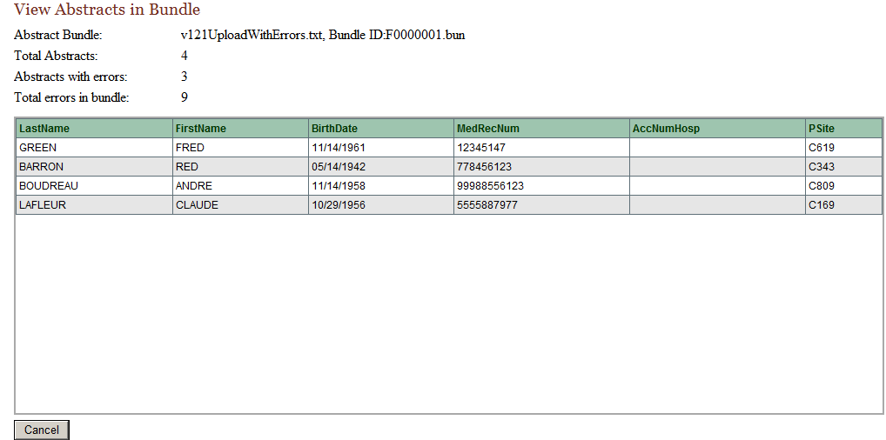
The View Abstracts in Bundle page contains these column headings:
Column Heading | Description
LastName | Last name of patient
FirstName | First name of patient
BirthDate | Birth date of patient
MedRecNum | Medical record number of patient
AccNumHosp | The patient’s accession number at the facility
PSite | The ICD-O-3 topography code for the primary site of the tumor being reported
- Click Cancel to close the View Abstracts in Bundle page and return to the Bundle Submissions page again.

Viewing the Edit Error Report
To view the edit error report for a file uploaded in the NAACCR file format, complete the following steps:
- On the Bundle Submissions page, locate the row for the uploaded file named v121UploadWithErrors.txt, and click the
- Locate the row for the uploaded file named v121UploadWithErrors.txt, and click the Edit Report link.
Result: The Edit Report opens.
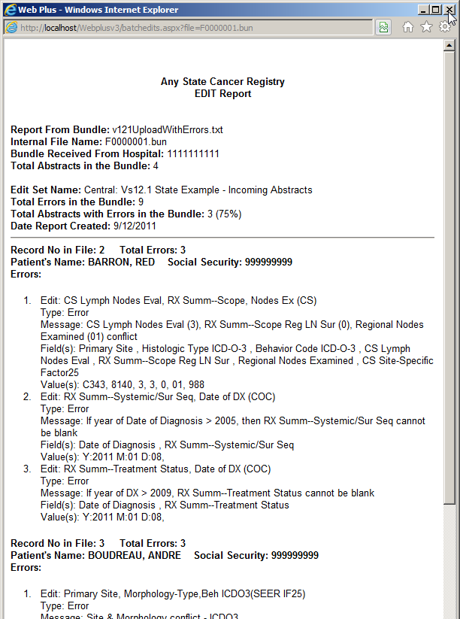
These are the summary fields in the Edit report regarding the file that was uploaded:
Field | Description
Report from Bundle | Name of uploaded file
Internal File Name | Name of file in the Web Plus application
Bundle Received from Hospital | Facility ID Number for the facility that uploaded the file
Total Abstracts in Bundle | Total number of abstracts in the file
Edit Set Name | Name of edit set that was run on the file
Total Errors in Bundle | Total number of errors in the file
Total Abstracts with Errors in Bundle | Total number of abstracts with errors in the file
Date Report Created | Date that the report was created
These are the identifiers for the individual abstracts listed in the Edit report:
Field | Description
Record Number in File | The record number of the abstract in the file
Total errors | Total number of errors in the abstract
Patient’s Name | Name of patient for the abstract
Social Security | Social security number of patient for the abstract
Errors | An itemized list of errors in the abstract
- Close the Edit Report and return to the Bundle Submissions page.

Viewing the Data Quality Indicator Report
To view the data quality indicators report for a file uploaded in the NAACCR file format, complete the following steps:
- On the Bundle Submissions page, locate the row for the uploaded file named v121UploadWithErrors.txt, and click the Data Quality Report link.
Result: The Data Quality Indicators Report for the file upload opens in a separate window.
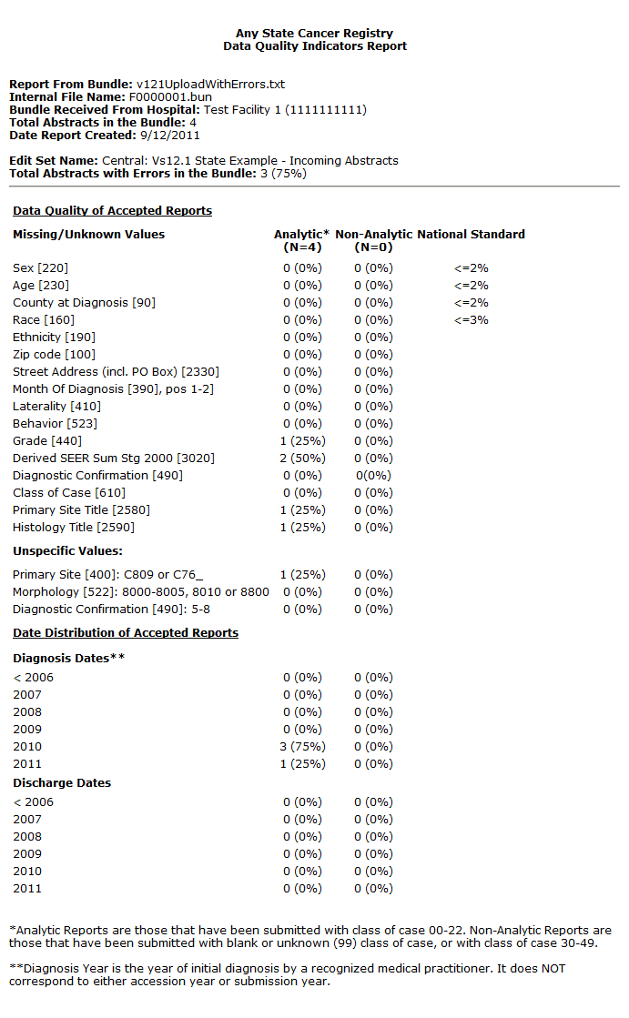
The Data Quality Report is helpful for monitoring the overall quality and timeliness of a facility’s cancer reporting, and for identifying any potential reporting problem areas or areas in need of improvement. For the purposes of the Data Quality Report, accepted abstracts are separated into “Analytic” and Non-Analytic” categories, based on the class of case that was submitted on the abstract. Analytic cases are defined as cases that were first diagnosed and/or received all or part of their first course of treatment, or had treatment planned at the reporting facility, and are reported with a class of case of 00-22. Non-analytic cases are those cases that were first diagnosed and received their entire first course of treatment at a facility other than the reporting facility or that were diagnosed at autopsy, and are reported with a class of case of 30-49. Accepted abstracts submitted with blank or unknown class of case are considered non-analytic.
As non-analytic cases of cancer generally contain less specific information and information of lesser quality than analytic reports, examining the quality of analytic reports separately from non-analytic reports will provide a more precise accounting of the overall data quality and completeness of the cases reported by a facility.
The Data Quality Report is divided into three sections, and contains the following information:
Section | Value | Description
Report Header | Report From Bundle | Name and path of uploaded file
Report Header | Internal File Name | Name of file within the Web Plus application
Report Header | Bundle Received From Hospital | Name and Facility ID of facility for which file was uploaded
Report Header | Total Abstracts in the Bundle | Total number of abstracts in the uploaded file
Report Header | Date Report Created | Date edits were run and the error report created
Report Header | Edit Set Name | Name of edit set run on uploaded file
Report Header | Total Abstracts with Errors in the Bundle | Total number of abstracts containing edit errors
Data Quality of Accepted Reports | For abstracts that have no errors and are accepted upon file upload, the number and percent of missing or unknown values submitted in selected fields is listed, broken down by analytic and non-analytic status of the abstracts; the percents listed in this section of the report are calculated utilizing all accepted analytic abstracts and all accepted non-analytic abstracts as denominators respectively
Date Distribution of Accepted Reports | For abstracts that have no errors and are accepted upon file upload, the distribution (number and percent) across diagnosis and discharge dates is listed, broken down by analytic and non-analytic status of the abstracts; the percents listed in this section of the report are calculated utilizing all accepted analytic abstracts and all accepted non-analytic abstracts as denominators respectively
- Close the Data Quality Report window to return to the Bundle Submissions page.

Deleting an Uploaded File
To delete an uploaded file, complete these steps:
- On the Bundle Submissions page locate the file you would like to delete, and click the Delete link.
Result: The file is deleted from the database.

Exporting Uploaded Files
To export bundled submissions from the Web Plus application, the Web Plus Administration Tool is used. Files that were uploaded in the NAACCR file format are exported to a file in the NAACCR layout, for subsequent import into your central registry database. Files uploaded in all other formats are exported in the same format in which they were uploaded.

Posting of Files for Facility Download
The Web Plus Central Registry Administrator can post files for download by facilities, and specify the facilities for which a file should be posted.
- As Central Registry Administrator, on the Web Plus menu, point to Bundle Submissions, then click Post File for Download by Facilities.
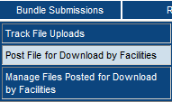
Result: The Post File for Download by Facilities window opens.
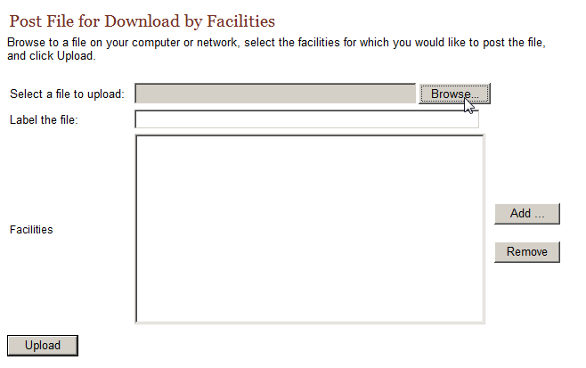
- Click Browse to locate the file that you would like to post on your PC or network.
- Enter a Label for the file. This label will appear in as a comment for the file when it is posted on the facility file download page.
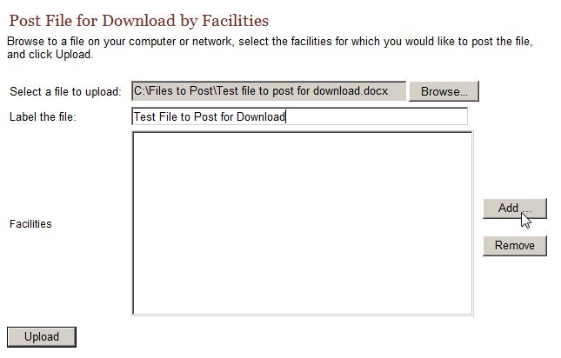
- Select one or more facilities for which you would like to post the file by clicking Add (Facilities may be removed from the list by selecting the facility in the list and clicking Remove).
Result: The Select a Facility to Add window opens.
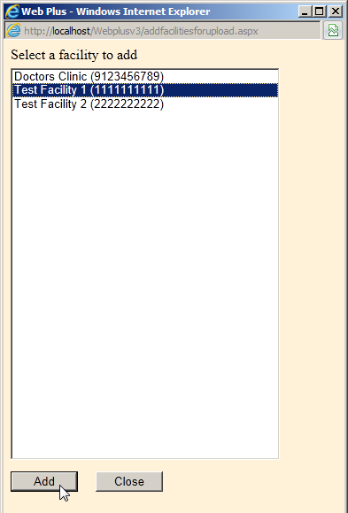
- Select the facility for which you would like to post the file, and click Add. Multiple facilities may be selected by using the CTRL-Shift keys on your keyboard.
- Click Close when you are done adding facilities to the list of facilities for which the file will be posted for download. This will return you to the Post File For Download by Facilities page.
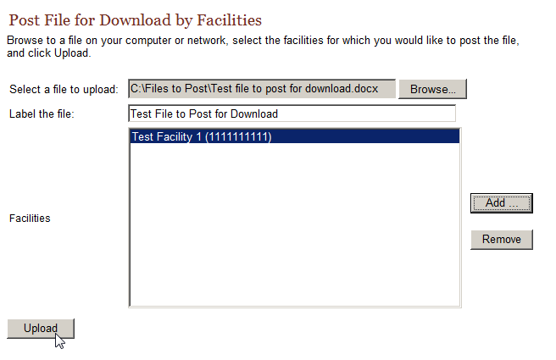
- Click Upload.
Result: The file will now be posted for download by the specified facilities.
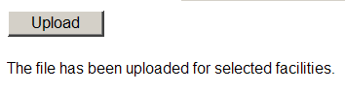

Managing Files Posted for Facility Download
Files that have been posted for facility download can also be managed. The Central Registry Administrator can add or remove facilities for which a file is posted and can remove a file from the facility download page. The Administrator can also download any of the posted files.
- As Central Registry Administrator, on the Web Plus menu, point to Bundle Submissions, then click Manage Files Posted for Download by Facilities.
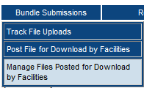
Result: The Manage Files Posted for Download by Facilities page opens.
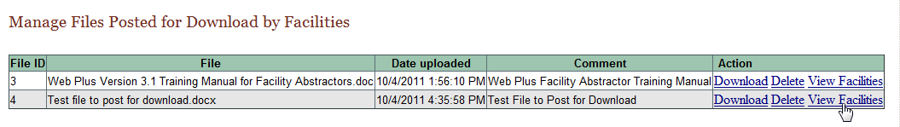
The Manage Files Posted for Download by Facilities page includes the following columns:
Column | Description
File ID | A unique, system-generated number identifying the file
File | The name of the file to be downloaded
Date Uploaded | The date the file was posted to Web Plus for download
Comment | Central registry-designated comment or label for the file
Action
  Action | Description
  Download | Download the file
  Delete | Remove the file from the facility download page
  View Facilities | Add or remove facilities for which a file is posted

View Facilities
Once a file has been posted for download by certain facilities, the specified facilities may be modified. The Central Registry Administrator can add or remove facilities to or from the list of facilities for which a particular file has been posted.
To add or remove facilities to or from the list of facilities for a posted file, complete these steps:
- On the Manage Files Posted for Download by Facilities page, locate the file of interest, and click the View Facilities link in the Action column.
Result: The Facilities Selected for Download page opens.
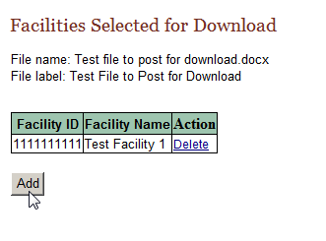
The Facilities Selected for Download page lists the Facility ID and name of the facilities for which the file has been posted.
- To add one or more facilities to the list of facilities for which you would like to post the file, click Add.
Result: The Select a Facility to Add window opens.
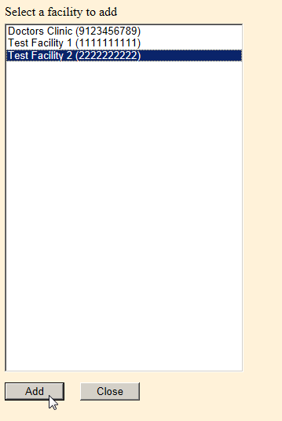
- Select the facility for which you would like to post the file, and click Add. Multiple facilities may be selected by using the CTRL-Shift keys on your keyboard.
Result: You are returned to the Facilities Selected for Download page, where the selected facility has been added to the list for facilities for which the file is posted.
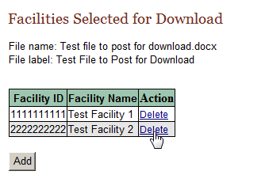
- Facilities may be removed from the list by selecting the facility in the list and clicking Delete.

Download
Once a file has been posted for download by certain facilities, the Central Registry Administrator may also download the posted file.
To download a posted file, complete these steps:
- On the Manage Files Posted for Download by Facilities page, locate the file you would like to download, and click the Download link in the Action column.
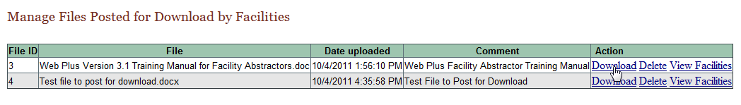
Result: The File Download dialog window opens.
- If you would like to open the file, click Open; to save the file, click Save As.
Result: The Save As dialog window opens.
- Browse to the location on your computer or network where you would like to save the file, and click Save.
Result: The file will be downloaded to the specified location on your computer or network, and the dialog window will automatically close, returning you to the Download File page.
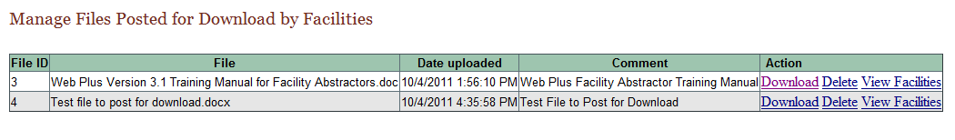

Delete a Posted File
Once a file has been posted for download by certain facilities, the Central Registry Administrator can delete the file, and remove it from the facilities’ download pages.
To delete a posted file, complete these steps:
- On the Manage Files Posted for Download by Facilities page, locate the file you would like to download, and click the Delete link in the Action column.
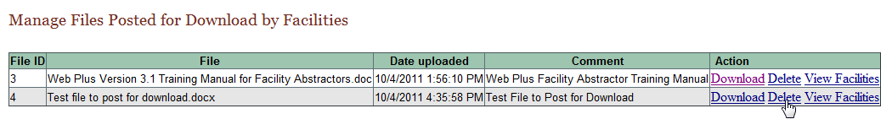
Result: Web Plus confirms that you would like to delete the selected file.
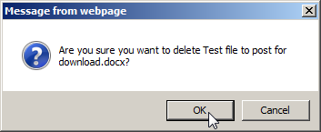
- Click OK.
Result: You are returned to the Manage Files Posted for Download by Facilities. When this page is refreshed, the deleted file will no longer be listed among the files posted for download by facilities.
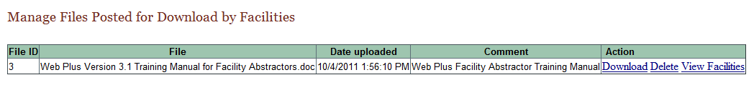

Questions
Answer these questions about bundled submissions (the answers are in Appendix A, on page 133):
- How do you view a listing of abstracts in a bundled submission file that has been uploaded?
- How do you view the edit error report for an uploaded file of abstracts?
- How do you export an uploaded file from the Web Plus application?
- How do you post a file for download by facilities?

Reports

Learning Objective
In this chapter, you will learn:
- To open a report
- About the various reports available to the Central Registry Administrator in Web Plus
- To set a date range for a report

Overview
Web Plus provides reports for the Central Registry Administrator at both the central registry and facility level. The central registry-level reports show the logs of system logins and abstract activities in Web Plus, document the progress of follow-back efforts for the central registry, and also include miscellaneous management reports that help the Administrator manage user and facility accounts and display types in Web Plus. The facility-level reports allow an Administrator to view the activities on abstracts from specific facilities, such as when the abstracts were released. You can view, print, and set the date ranges (when appropriate) for all of these reports.

Opening Reports
To open a report after you have logged in, complete these steps:
- On the Web Plus menu, click Reports.
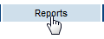
Result: Web Plus displays a list of reports available to you.
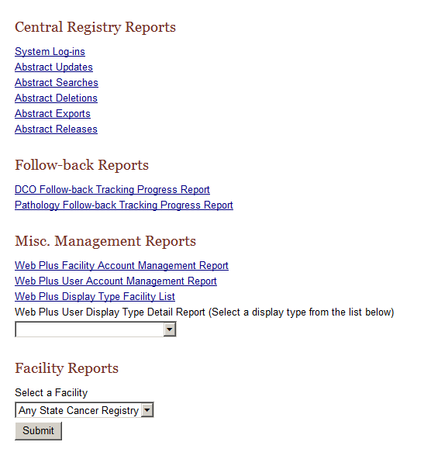

Central Registry Reports
This table describes the central registry reports available for viewing by the Central Registry Administrator. Clicking the name of the report opens a separate window displaying the report.
This Report . . . | Lists . . .
System Log-ins | the facility, user, date, and time of all system log-ins and log outs in Web Plus within a selected date range
Abstract Updates | the user, facility, date, and time of all abstract updates
Abstract Searches | the user, facility, date, and time of all abstract searches
Abstract Deletions | the user, facility, date, and time of all abstract deletions
Abstract Releases | information about abstract releases including release time and date, abstractor, and facility
- Click System Log-ins.
Result: The Login Audit Report page opens.
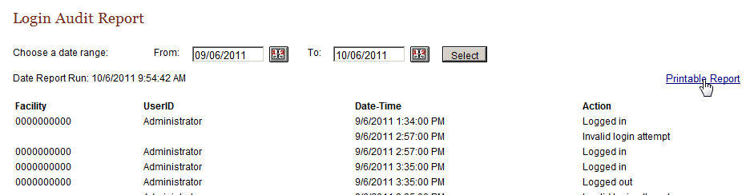
The report contains these column headings:
Column Heading | Description
Facility | Facility ID Number of user’s facility
UserID | User ID of the user
Date-Time | Date and time of the log in/out
Action | Indicates the user activity being logged:  - Logged in  - Logged out  - Invalid log in attempt
- To print the report, click on the Printable Report link.
Result: A page opens with a printable version of the report.
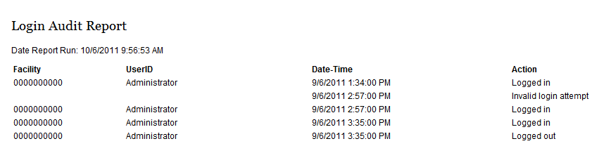
For optimum printing results, print Web Plus reports in landscape mode. To print in landscape, click on File→Page Setup, and click on Landscape.
In addition, if you wish to remove the internal report name from the upper left-hand corner of the printed report, remove the &w&b from the header field. If you wish to remove the URL listing from the bottom of the report, remove the information in the footer field (the date prints on the report already).
- Close the report window.
- On the Reports page under Central Registry Reports, click Abstract Updates.
Result: The Abstract Update Log report page opens.
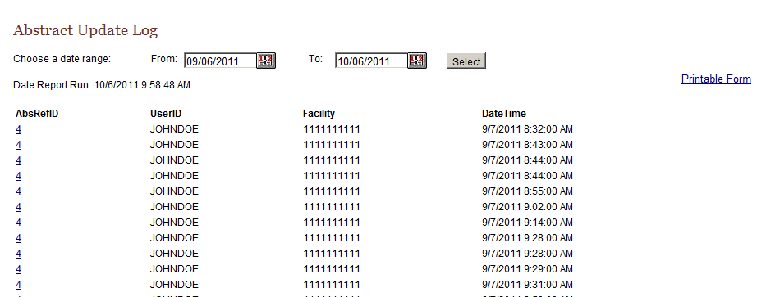
The Abstract Update Log report contains these column headings:
Column Heading | Description
AbsRefID | A unique, system-generated number identifying the abstract
UserID | User ID of the abstractor
Facility | Number of facility that sent the abstract
Date-Time | Date and time of the action
The remaining central registry reports contain the same column headings and information as the Abstract Update Log for their specific user activities:
  - Abstract Searches
  - Abstract Deletions
  - Abstract Exports
  - Abstract Releases

Changing the Date Range of a Report
To change the date range of a report, complete these steps:
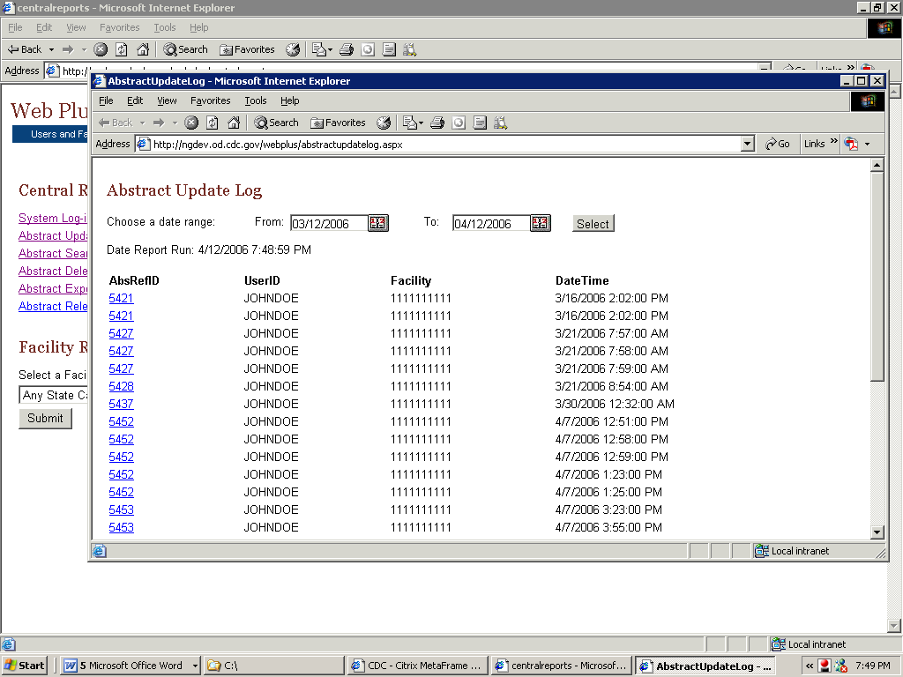
- On any opened report page, click the calendar icon beside the From date field.
Result: The calendar window opens.
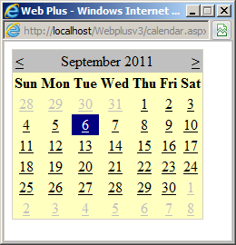
- Double-click the date you want. The system inserts the date in the field and closes the calendar window.
You can also type the date in the window by using the mm/dd/yyyy format, such as 09/01/2011 for September 1, 2011. The date calendar and format are the same for both the From and To date fields.
- Repeat steps 1 and 2 for the To date field.
- Click Select.
Result: The report is displayed with the information restricted to the date range selected.

Follow-back Reports
The Reports section of the Central Registry Administrator pages of Web Plus includes summary reports on Death Certificate Only and Pathology Laboratory follow-back activities. The DCO Follow-back Tracking Progress and Pathology Follow-back Tracking Progress Reports can be used to quickly assess where you are in your follow-back efforts. These reports display a graph which shows the overall progress of the follow-back effort for the particular follow-back type, and lists the total number of follow-back abstracts that have been resolved, the total number remaining, and how many follow-back abstracts were resolved by week for an eight week period; either the past eight weeks (by default), or any date range that you specify. As a result, the Follow-back Tracking Progress Reports can be used to view the resolution rate and progress of present or past follow-back efforts.
To open a Follow-back Tracking Progress Report, complete these steps:
- On the Web Plus menu, click Reports.
Result: Web Plus displays a list of available reports.
- Click on either the DCO Follow-back Tracking Progress Report or Pathology Follow-back Tracking Progress Report link. In the example shown the DCO Follow-back Tracking Progress Report is opened.
Result: The Follow-back Tracking Progress Report for the particular follow-back type opens in a separate window. In the example shown, the DCO Follow-back Tracking Progress Report has been opened.
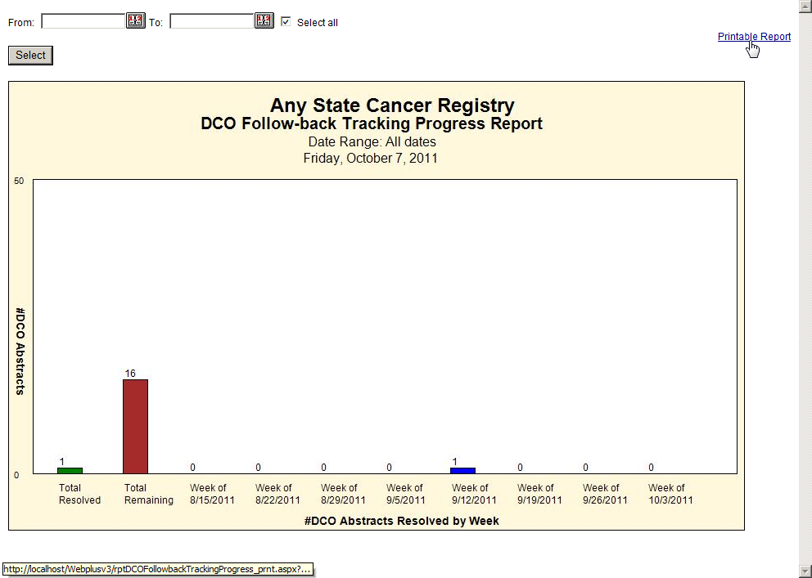
By default, the Select all checkbox is clicked, and the Follow-back Tracking Progress Report will display data for all follow-back abstracts of the particular follow-back type, regardless of when they were added to the Web Plus follow-back system. For your initial follow-back effort, you would leave the Select All check box clicked. However, for subsequent follow-back efforts, you will need to enter a date range to capture the correct data for the graph, to exclude follow-back abstracts from past follow-back efforts.
- To enter a date range, unclick the Select All checkbox.
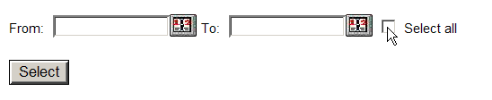
- Enter a From date and To date. For instructions on setting the date range for a follow-back report click here.
The From date will be the upload date for the follow-back file containing the follow-back abstracts for the follow-back effort of interest, or the date that you entered the first online follow-back abstract for the follow-back effort. The To date will be the current date (for present follow-back efforts), or the date a prior follow-back effort ended.
Result: You are returned to the Follow-back Tracking Progress Report window, with the specified dates entered into the From and To date fields.
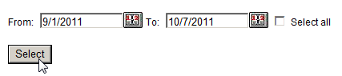
- Click Select.
Result: The Follow-back Tracking Progress Report is displayed with the information restricted to the date range (or follow-back effort) specified.
The Total Resolved and Total Remaining bars displayed on the graph will reflect current progress on a present follow-back effort, or for a past follow-back effort, can be used to calculate the resolution rate for that follow-back effort. The # of Abstracts Resolved by Week bars will represent the number of follow-back abstracts released by facilities per week for eight business weeks prior to, and including, the week of the specified End Date.
- To print the report, click on the Printable Report link, or close the report window to return to the Reports page.

Misc. Management Reports
The Reports section of the Central Registry Administrator pages of Web Plus includes miscellaneous management reports that help the Administrator manage user and facility accounts and display types in Web Plus.
To view Miscellaneous Management Reports, complete the following steps:
- On the Web Plus menu, click Reports.
This table describes the Miscellaneous Management reports available for viewing by the Central Registry Administrator. Clicking the name of the report opens a separate window displaying the report.
This Report . . . | Lists . . .
Web Plus Facility Account Management Report | the facility, display type(s) assigned to the facility, the error threshold (if any) specified for the facility, and the managing Central Registry Abstractor/Reviewer (if any) assigned to the facility for each facility account in Web Plus
Web Plus User Account Management Report | Users assigned to each facility, along with information from each user account
Web Plus Display Type Facility List | the total number of facilities assigned to each display type followed by a list of which facilities are assigned to the display type
Web Plus User Display Type Detail Report | the field properties specified for and the critical/required status of each field included in the display type

Web Plus Facility Account Management Report
The Web Plus Facility Account Management Report provides an at-a-glance overview of various assignments made for existing facility accounts in Web Plus, in particular, what display type(s) have been assigned for online abstracting.
To open the Web Plus Facility Account Management Report, complete the following steps:
- On the Web Plus menu, click Reports.
- Under Misc. Management Reports, click Web Plus Facility Account Management Report.
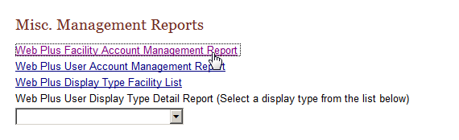
Result: The Web Plus Facility Account Management Report page opens in a separate window.
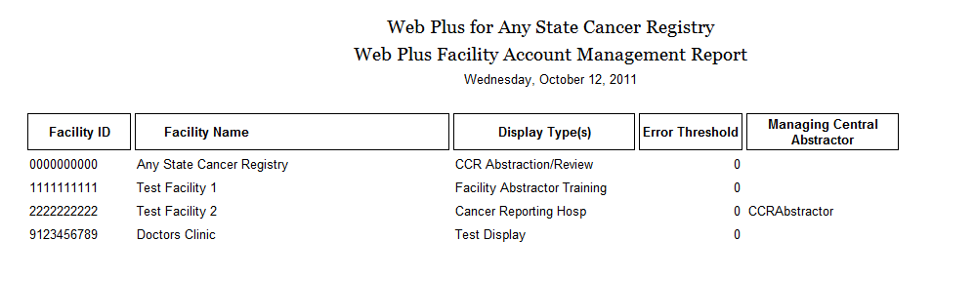
The Web Plus Facility Account Management Report contains these columns for each facility in the Web Plus system:
Column Heading | Description
Facility ID | 10-digit identification number for the facility
Facility Name | Name of the facility or office
Display Type(s) | Name of the display type(s) assigned to the facility for the purposes of online abstracting
Error Threshold | The percent error threshold specified for the facility
Managing Central Abstractor | The Central Registry Abstractor/Reviewer (if any) who has been assigned to review the facility’s released abstracts
- Close the report window.

Web Plus User Account Management Report
The Web Plus User Account Management Report provides a listing of users assigned to each facility in Web Plus, and includes an at-a-glance overview of information for each user.
To open the Web Plus Facility Account Management Report, follow these steps:
- On the Web Plus menu, click Reports.
- Under Misc. Management Reports, click Web Plus User Account Management Report.
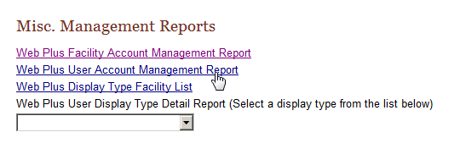
Result: The Web Plus User Account Management Report page opens in a separate window.
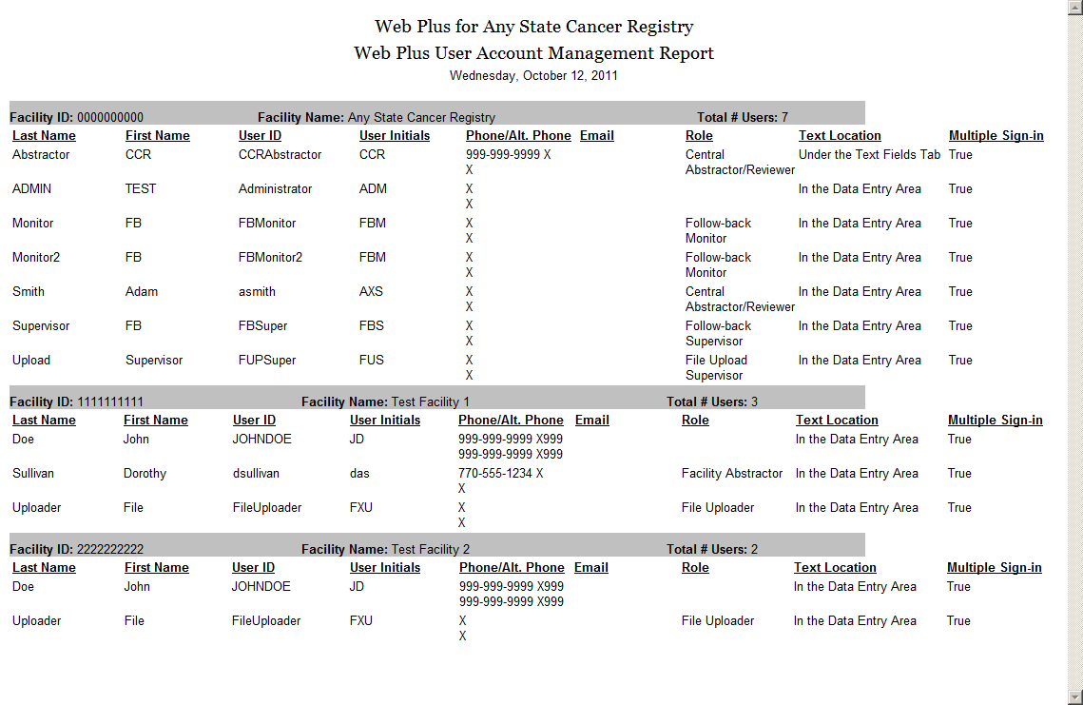
The Web Plus User Account Management Report contains these columns for each facility in the Web Plus system:
Field | Description
Last Name | Last name of user
First Name | First name of user
User ID | The User ID assigned to the user
User Initials | Initials of the user
Phone | Main phone number entered for the user
Alt Phone | An alternate phone number entered for the user
Email | Email address entered for the user
Role | The Web Plus role(s) assigned to the user
Text Location | The location of the Text data items assigned to the user for viewing text data items within display types
Allow Multiple Sign in | The Multiple Sign-in option assigned to the user
- Close the report window.

Web Plus Display Type Facility List
The Web Plus Display Type Facility List is a simple listing that includes the total number of facilities assigned to each display type followed by a list of which facilities are assigned to the display type.
To open the Web Plus Display Type Facility List, complete the following steps:
- On the Web Plus menu, click Reports.
- Under Misc. Management Reports, click Display Type Facility List.
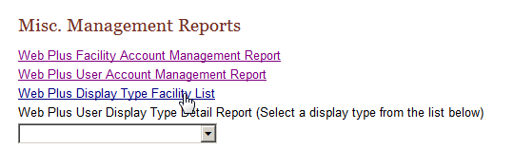
Result: The Display Type Facility List page opens in a separate window.
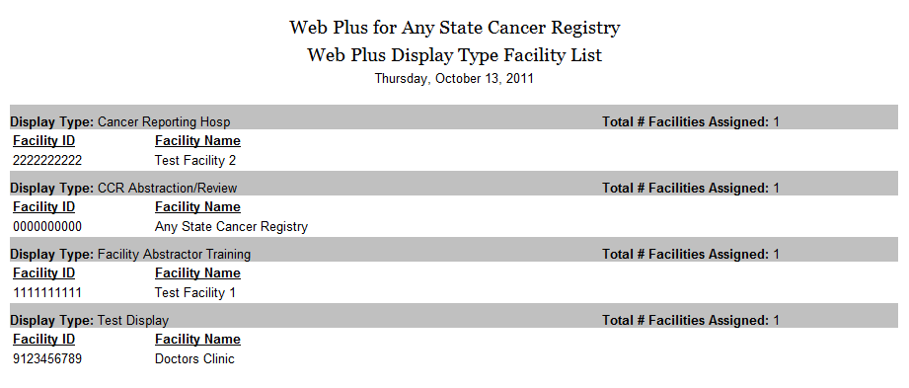
Display types that have been created but not assigned to any facility are not included in the Display Type Facility List.
- Close the report window.

Web Plus User Display Type Detail Report
The Web Plus User Display Type Detail Report includes an at-a-glance overview of information for a particular display type and lists the field properties specified for and the critical/required status of each field included in the display type.
To open the Web Plus User Display Type Detail Report, complete the following steps:
- On the Web Plus menu, click Reports.
- Under Misc. Management Reports, under Web Plus User Display Type Detail Report, use the pull-down menu to select a display type. In the example shown, the Cancer Reporting Hosp display type is selected.
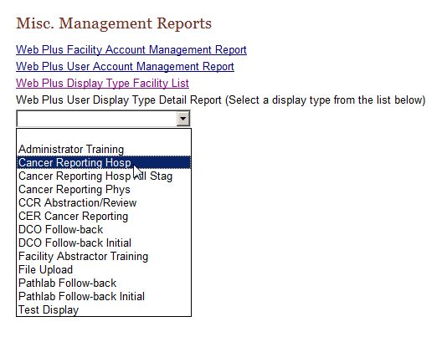
Result: The Web Plus User Display Type Detail Report for the selected display type opens in a separate window.
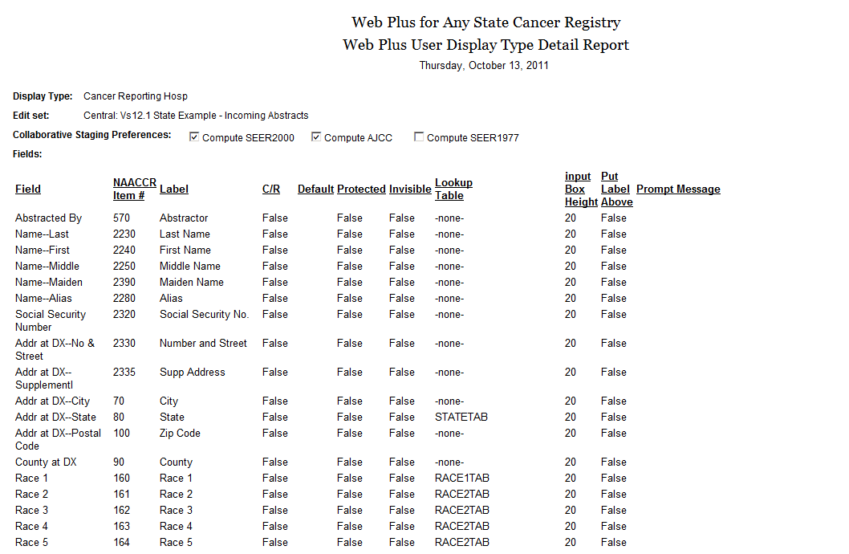
The Web Plus User Display Type Detail Report contains these columns for each field included in the selected display type:
Field | Description
Field | The standard NAACCR data item name for the field
NAACCR Item # | The standard NAACCR data item number for the field
Label | The customized, user-specified label (if any) for the field
C/R | Denotes whether the field was specified as a critical/required field
Default | The user-specified default value (if any) that is initially displayed in the field
Protected | Denotes whether the field was specified as protected (i.e., value of field cannot be edited by user)
Invisible | Denotes whether the field was specified as invisible (i.e., included in the display type but not visible to the Abstractor)
Lookup Table | The look-up table (if any) associated with the field
Input Box Height | The height of data entry input box for the field in pixels, one row-20 pixels
Prompt message | The prompt message (if any) specified for the field

You can print the report using your bower’s print function, or you can right-click on the report, click Select All, and copy and paste into an Excel spreadsheet.
- Close the report window.

Facility Reports
The Facility Reports section of the Central Registry Administrator pages of Web Plus include reports on facility activities and descriptive statistics on released abstracts from facilities.
To open a Facility Report, complete the following steps:
- On the Web Plus menu, click Reports.
- Under Facility Reports, use the pull-down menu to select a facility. In the example shown Test Facility is selected.
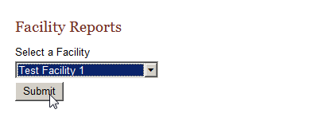
- Click Submit.
Result: The Facility Reports page opens for the selected facility.
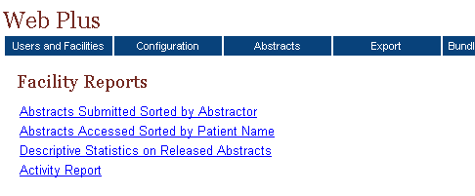
These facility reports are available to the Central Registry Administrator:
This report . . . | Lists . . .
Abstracts Submitted  Sorted by Abstractor | all abstracts that a facility has released for a user-specified time range; the abstracts are sorted first by the name of the abstractor and then by patient name
Abstracts Accessed  Sorted by Patient Name | all abstracts that a facility has released for a user-specified time range sorted in order of patient name
Descriptive Statistics on Released Abstracts | descriptive statistics on released abstracts such as demographics and site group
Activity Report | the numbers of cases released and unreleased abstracts by month or year (depending on the length of the date range specified)

Abstracts Submitted Sorted by Abstractor Report
The Abstracts Submitted Sorted by Abstractor report provides the history of the abstract: when it was created, completed, and submitted to the central registry.
To access the Abstracts Submitted Sorted by Abstractor report, follow these steps:
- On the Facility Reports page for a selected facility, click the Abstracts Submitted Sorted by Abstractor link.
Result: The Abstracts Submitted Sorted by Abstractor report page opens in a separate window.
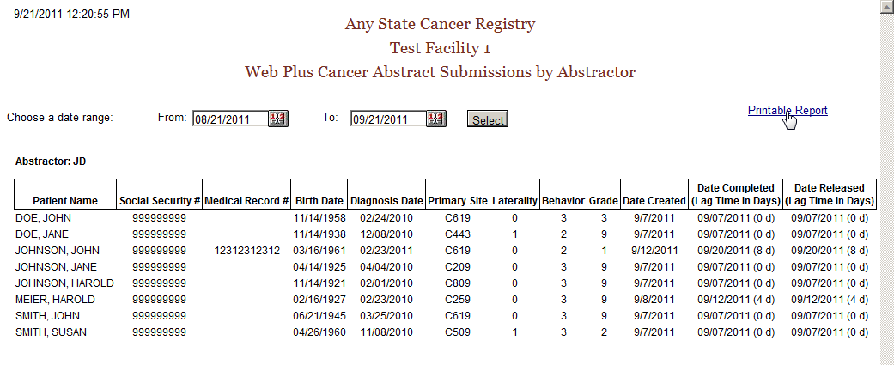
The report contains these columns for each abstract released by the facility, and the abstracts are grouped by abstractor initials:
Column Heading | Description
Patient Name | Name of patient on abstract
Social Security # | Patient’s social security number
Medical Record # | Patient’s medical record number
Birth Date | Patient’s birth date
Diagnosis Date | Diagnosis date of the tumor being reported
Primary Site | ICD-O-3 topography code for the primary site of the tumor being reported
Laterality | Laterality code for the tumor being reported
Behavior | ICD-O-3 behavior code for the tumor being reported
Grade | ICD-O-3 grade/differentiation code for the tumor being reported
Date Created | Date the abstract was created
Date Completed | Date the abstract was completed, with the lag time (in days) between date of creation and completion in parentheses
Date Released | Date the abstract was released to the central registry, with the lag time (in days) between date of completion and release in parentheses

The date range can be modified for the Abstracts Submitted Sorted by Abstractor report.
If you would like to print the report, click on the Printable Report link, and print the report in landscape mode using your browser’s printer.
- Close the report window.

Abstracts Accessed Sorted by Patient Name Report
The Abstracts Accessed Sorted by Patient Name report provides the dates and times that an abstract is opened and the reason why it was opened.
To access the Abstracts Accessed Sorted by Patient Name report, follow these steps
- On the Facility Reports page for a selected facility, click the Abstracts Accessed Sorted by Patient Name link.
Result: The Abstracts Accessed Sorted by Patient Name report page opens in a separate window.
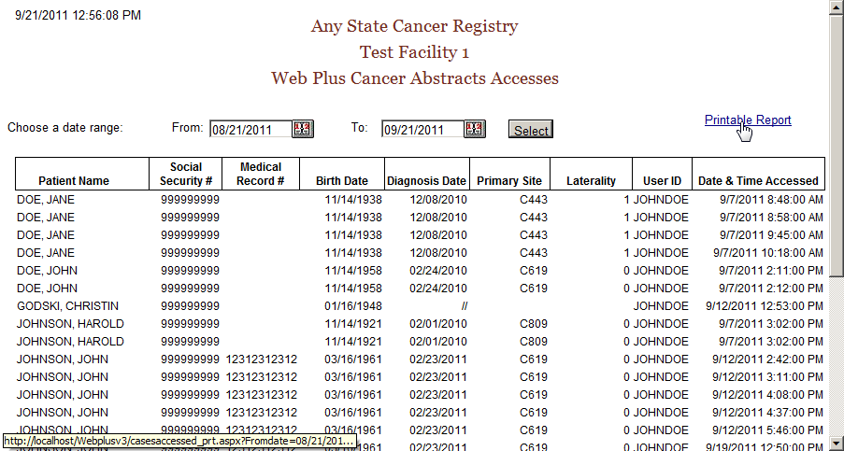
The Abstracts Accessed Sorted by Patient Name report contains these fields:
Field/Headings | Description
Patient Name | Name of patient on abstract
Social Security # | Patient’s social security number
Medical Record # | Patient’s medical record number
Birth Date | Patient’s birth date
Diagnosis Date | Diagnosis date of the tumor being reported
Primary Site | ICD-O-3 topography code for the primary site of the tumor being reported
Laterality | Laterality code for the tumor being reported
User ID | User ID of the abstractor
Date & Time Accessed | Date and time that the abstractor opened the abstract

The date range can be modified for the Abstracts Accessed Sorted by Patient Name report.
If you would like to print the report, click on the Printable Report link, and print the report in landscape mode using your browser’s printer.
- Close the report window.

Descriptive Statistics on Released Abstracts Report
The Descriptive Statistics on Released Abstracts report includes a series of tables consisting of the number and percent of released abstracts broken down by the following: county of residence, zip code of residence, sex and race, age group, site group, and treatment group.
To run and/or modify the report for Descriptive Statistics on Released Abstracts complete these steps:
- On the Facility Reports page for a selected facility, click the Descriptive Statistics on Released Abstracts link.
Result: The Descriptive Statistics on Released Abstracts report page opens.
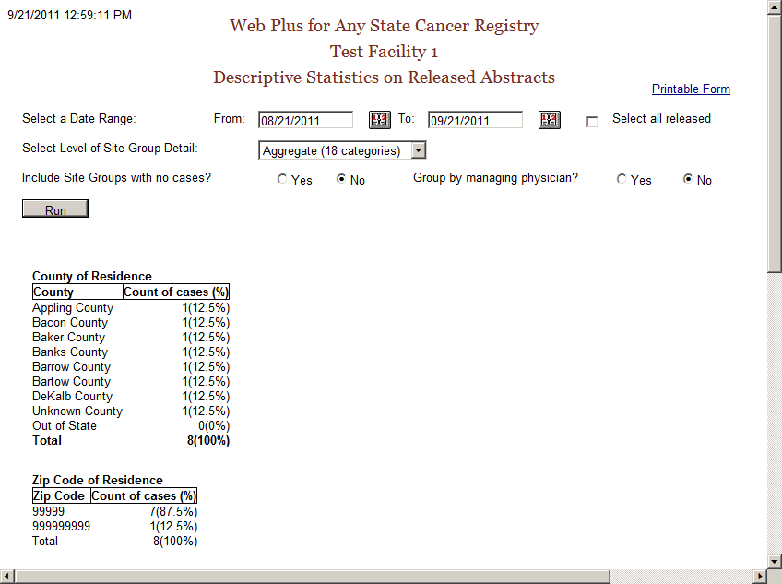
The descriptive statistics provided are broken down as follows:
Grouping Variable(s) | Groupings by…
County of Residence | individual county of residence at diagnosis
Zip Code of Residence | individual zip code of residence at diagnosis
Sex and Race | patient sex (male/female) by race (white/black/other)
Age Group | ten age groups (0-9, 10-19,….90+)
Site Group | three levels of primary site grouping:
  Grouping Level | Description
  Aggregate | 18 categories
  Subaggregate | 60 categories
  Recode | 78 groups
Treatment Group | type of summary treatment (RX Summ) recorded:  Surgery of Primary Site  Chemotherapy  Hormone  BRM  Other  Rad-Regional RX Modality  Transplant/Endocrine
The following options are available to modify the Descriptive Statistics on Released Abstracts report:
Option | Description
Date Range | Includes only those abstracts that were released within the specified date range
Select all released | When clicked, all abstracts released by the facility will be included, regardless of date released
Select Level of Site Group Detail | Specifies what level of primary site grouping to use for the report; the default grouping is 18 categories
Include site groups with no cases | When Yes is clicked, the primary site distribution will show all site groups for the level of detail chosen, whether or not abstracts were released containing each of the site groups  When No is clicked, only those primary site groups contained in the released abstracts released will appear on the report
Group by managing physician | When Yes is clicked, the records in the report will be grouped into sections by managing physician, displaying the descriptive statistics for abstracts released by each managing physician
- Next to Include Site Groups with no cases, click on Yes.
- Click Run.
Result: Web Plus displays the report again with all 18 site groupings displayed.
- Click on the Printable Form link.
Result: A separate window opens with the report formatted for printing.
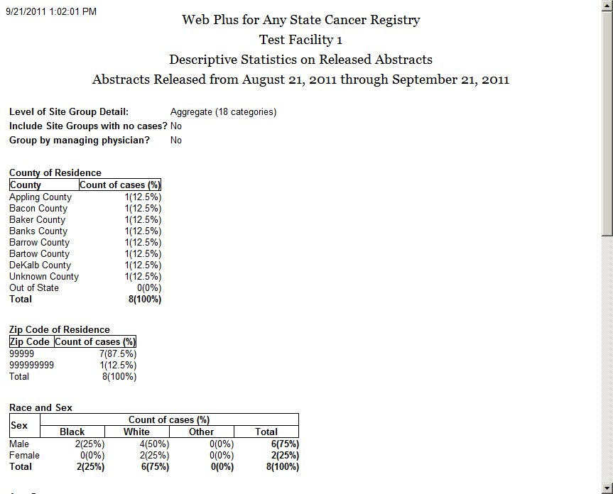
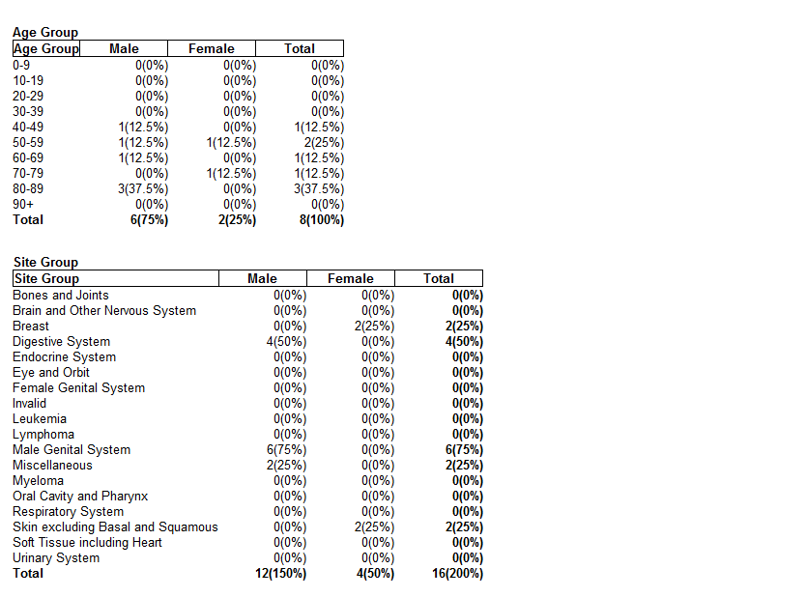
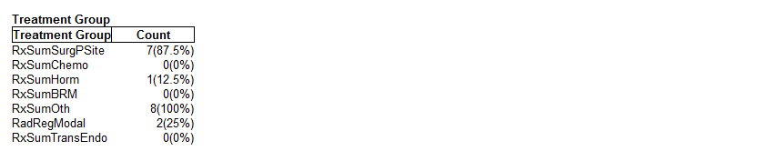
- Close the printable report window and then close the report window to return to the Facility Reports page.

Activity Report
The Activity report provides information on the abstracting activity at a facility, in terms of the number of released and unreleased abstracts. Viewing the Activity report is a good way to monitor submissions from individual facilities or doctors’ offices.
To open the Activity report:
- On the Facility Reports page for a selected facility, click the Activity Report link.
Result: The Activity Report window opens.
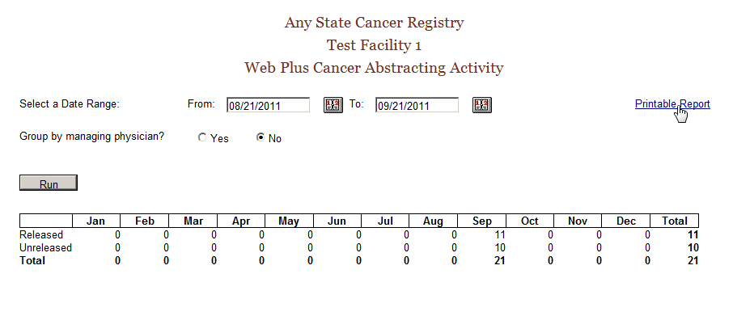
- If desired, enter a date range for the Activity report. If the specified date range spans more than one year, the report will display the number of released and unreleased cases for each year rather than each month.
- You can also group the information in the Activity report by managing physician; just click on Yes next to Group by managing physician, and click Run.
- If you would like to print the report, click on the Printable Report link, and print the report in landscape mode using your browser’s printer.
The default From date is one month prior to the current date and the default To date is the current day.
If the specified date range spans more than one year, the report will display the number of released and unreleased cases for each year rather than each month.
To modify the Activity report:
- Set the date range.
- Specify whether or not you would like the data in the report grouped by managing physician by clicking on Yes or No.
- Click Run to create the modified report.
- Close the report window.

Questions
Answer these questions about Web Plus reports (the answers are in Appendix A, on page 133 ):
- What are the four main types of reports available to the Central Registry Administrator?
- Where can you find the Descriptive Statistics on Released Cases report?
- Which report helps the Central Registry Administrator manage user accounts?

Web Plus Administration Tool

Learning Objectives
In this chapter you will learn:
- About the major purpose and functions of the Web Plus Administration Tool
- How to install the Web Plus Administration Tool
- How to log into the Web Plus Administration Tool
- Use the Web Plus Administration Tool to export abstracts and uploaded files out of Web Plus
- Use the Web Plus Administration Tool to run automated edits on files in the current NAACCR version of Web Plus
- Use the Web Plus Administration Tool to run edits manually on an uploaded NAACCR file

Overview
One way security is ensured within the Web Plus application is to have separate locations for data entry/file upload, and storage of the completed abstracts/uploaded files. Web Plus runs on a web server that sits outside the internal firewall. Abstracts that are entered, completed and released via Web Plus are stored in the SQL database which resides inside the internal firewall. Files of abstracts that are uploaded via Web Plus are also stored in the SQL database. Abstracts, after being reviewed by central registry abstractors, need to be exported out of the SQL database so that they can be imported into the central cancer registry database. Uploaded files (bundle submissions) also need to be exported for import into the central cancer registry database.
However, because the Web Plus application is located on the web server outside the internal firewall, it does not have direct access to the storage areas (network drives) on the internal local area network (LAN), and cannot export to these storage areas. As a result, the export of abstracts and files must be accomplished using a windows application called the Web Plus Administration Tool, which can be run on any PC on the internal network. In addition to exporting abstracts and uploaded files this tool can also be used to run scheduled, batch edits on uploaded files, as well as to manually run edits on any uploaded file in NAACCR file format.

Installing the Web Plus Administration Tool
To install the Web Plus Administration Tool on the Central Registry Administrator’s PC (installer must have administrative rights to the PC):
- Download the Web Plus Administration Tool install program from the CDC ftp site. You should have received the folder and the name of the latest install file in an email.
- Double-click on the install program file to begin the installation process, and follow the screen prompts to complete the install. The install program will create a menu entry called “Web Plus Administration” under the Start-->All Programs menu.
- Obtain the SQL Server name, database, User ID (SQL Server Login), and password; this information will need to be entered when the Administrator launches the Web Plus Administration Tool in order for it to initially connect to the SQL server. This information is only required the first time this application is run. For subsequent runs only the Central Registry Administrator username and password are required to log in.

Logging In to the Web Plus Administration Tool
- To launch the Web Plus Administration Tool, click on Start––>All Programs––>Web Plus Administration––>Batch Processing.
- This brings up the Log In dialog box:

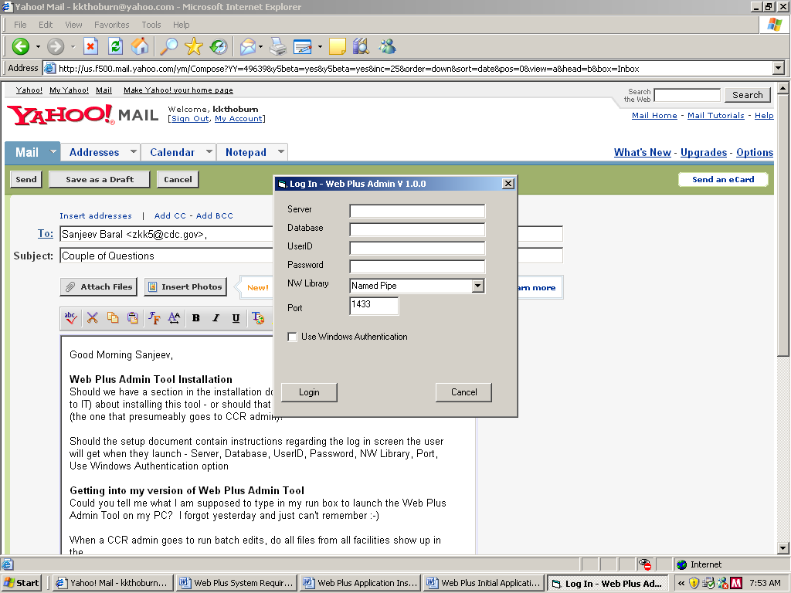

Log In Field | What to Enter
Server | Name or IP address of SQL Server
Database | Name of SQL database
UserID | SQL Server Login ID
Password | Password for SQL Server
NW Library | Select a network library to use (Named Pipe or TCP/IP)
Port | Enter Port number SQL Server listens on (1433 is the default)
Use Windows Authentication Option | Check this if using windows authentication for log on. There is no need to enter the UserID and password if this is checked.

- Upon initial login, you will need to obtain the above information from your SQL database administrator. Fill in the fields and click on the Login button to launch the Web Plus Administration Tool.
- Once you have entered the above information once, upon future logins, you need only enter your Central Registry Administrator username and password to log into the Web Plus Administration Tool.
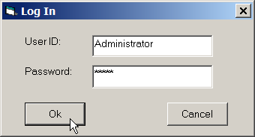

Your IT staff may have already entered the initial log in information for you. Just enter the information that the Web Plus Tool asks for.

Exporting Abstracts out of Web Plus
- Log in to the Web Plus Administration Tool, click on the File menu option, and select Export Released Abstracts.
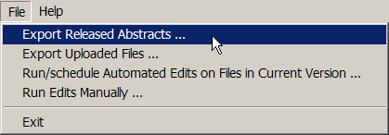
Result: The Export Released Abstracts window opens.
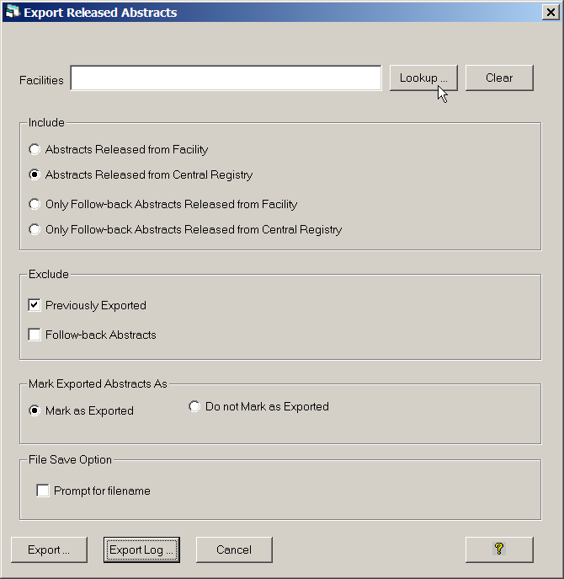
For the facilities selected, export options can be set for the export of abstracts submitted by those facilities. The Export Released Abstracts window contains these export options:
Export Option | Sub Option | Function When Checked or Clicked
Include | Abstracts Released from Facility | Selects all abstracts that have been released from the facility (includes abstracts under review by a central abstractor); Use this option if you are not suing Web Plus to centrally review abstracts released by facilities
Include | Abstracts Released from Central Registry | Selects all abstracts that have been released by central registry
Include | Only Follow-back Abstracts Released from Facility | Selects only follow-back abstracts have been released from the facility (includes follow-back abstracts under review by a central abstractor)
Include | Only Follow-back Abstracts Released from Central Registry | Selects only follow-back abstracts that have been released by central registry
Exclude | Previously Exported | Excludes previously exported abstracts (default is checked); When unchecked will select either all facility and/or all central registry-released depending upon what options are selected under the Include group
Exclude | Follow-back Abstracts | Excludes follow-back abstracts
Mark Exported Abstracts As | Mark as Exported | Updates export status upon export; default is clicked
Mark Exported Abstracts As | Do Not Mark as Exported | When clicked, exported abstracts do not get marked as exported, i.e., export status does not change upon export; may want to use when testing
File Save Option | Prompt for filename | When clicked, user is prompted for a filename for the generated file of exported abstracts; when left un-clicked, Web Plus names the files using the naming convention of wpxxxxxxxxxx_yy.dat, where the x’s represent the reporting facility ID, and the y’s represent a sequential number assigned to each file uploaded from that facility (e.g., wp1111111111_11.dat)
- Click Lookup… to the right of the Facilities box.
Result: The Select Facility window opens.
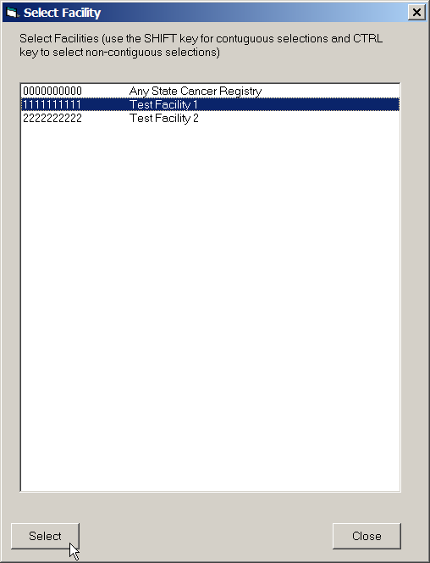
- Select the facility or facilities for which you would like to export abstracts, and click Select, then Close.
Result: You are returned to the Release Exported Abstracts window, with the selected facilities listed in the Facilities box.
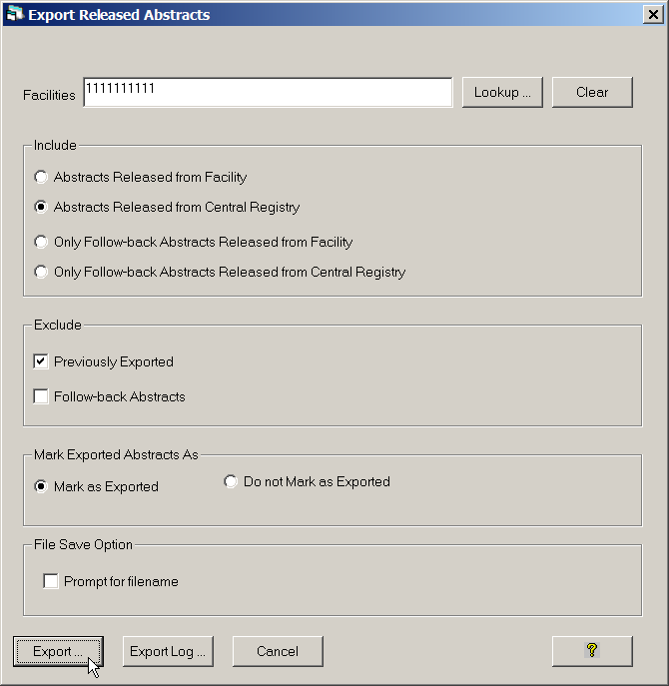
- Click Export.
- Choose a location on your PC or shared network folder where you would like to save the file of exported abstracts.
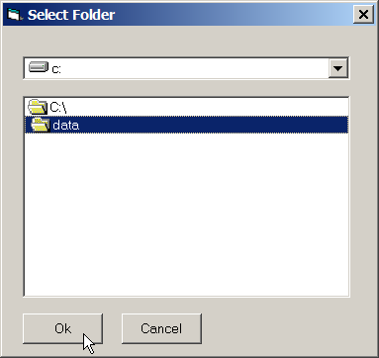
- Click Ok.
Under File Save Option, if the Prompt for filename option is left un-checked, Web Plus names the files using the naming convention of wpxxxxxxxxxx_yy.dat, where the x’s represent the reporting facility ID, and the y’s represent a sequential number assigned to each file uploaded from that facility (e.g., wp1111111111_11.dat). If the Prompt for filename option is checked, upon export, you will be prompted to overwrite the default filename provided by Web Plus.
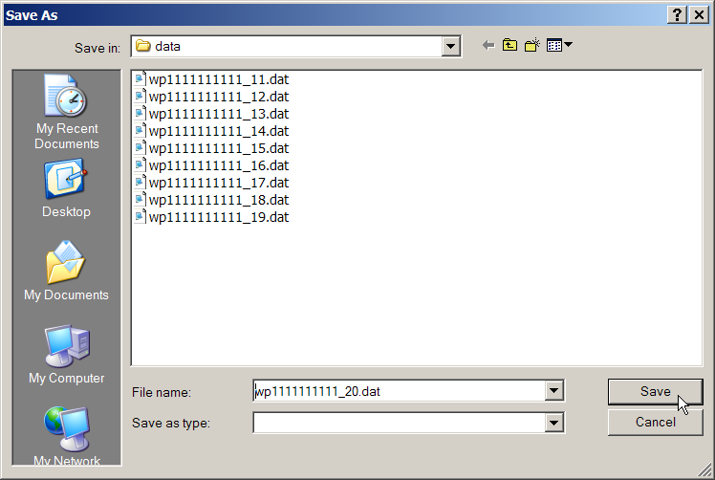

Exporting Uploaded Files
To export files (NAACCR and non-NAACCR) out of Web Plus:
- Log in to the Web Plus Administration Tool, click on the File menu option, and select Export Uploaded Files.
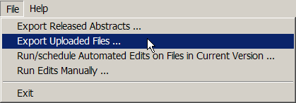
Result: The Export uploaded files window opens.
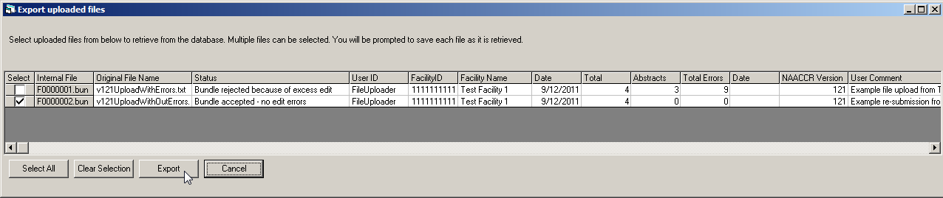
- Select the uploaded file that you wish to export by clicking a check into the Select column on the row of the file. For each uploaded file, the Web Plus Administration Tool lists the internal filename, original filename, file status, User ID and facility ID and name of the File Uploader who uploaded the file, the date the file was uploaded, the number of abstracts, the number of abstracts containing errors, and the total number of errors in the uploaded file, as well as the date exported, NAACCR version, and any comments uploaded with the file.
- Click Export.
Both NAACCR and non-NAACCR files may be exported. A NAACCR file rejected due to edit errors may also be exported.
- Choose a location on your PC or shared network folder where you would like to save the file of exported abstracts.
- Accept or overwrite the default filename for exported file, and click OK.

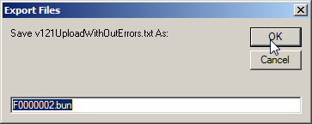
- The file is exported to the specified directory with the specified filename.

Exported Filenames
Note that when you export a file out of Web Plus the name of the exported file can be either the Web Plus internal filename (e.g., F0000002.bun), or the original filename of the file that was uploaded (e.g., v121UploadWithOutErrors.txt). The file naming convention is specified in the WebPlus.ini file that is located in the C:\Windows folder.
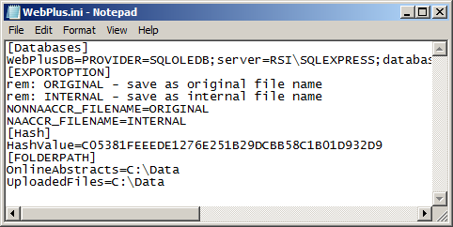
This preference is specified in the EXPORTOPTION section of the WebPlus.ini file as shown below:
[EXPORTOPTION]
rem: ORIGINAL - save as original file name
rem: INTERNAL - save as internal file name
NONNAACCR_FILENAME=ORIGINAL
NAACCR_FILENAME=INTERNAL
If you would like the original filename of an uploaded NAACCR file to be preserved upon export, then you would specify: NAACCR_FILENAME=ORIGINAL. If you would like the Web Plus internal filename as the name of the exported file you would specify: NAACCR_FILENAME=INTERNAL.
Prior to export, abstracts in a uploaded file, as well as the error report for an uploaded file of abstracts, may be viewed, from within the Administrator pages of the Web Plus application. Reviewing the abstracts and edit errors is recommended prior to exporting an uploaded NAACCR file, especially one that has been rejected.

Running Automated Edits on Files in Current Version
When large files are being uploaded, or when many files are being uploaded at one time, the edits may take some time to run. To prevent bottlenecking of uploaded files due to the time it takes to run the edits, an option for offline, batch running of edits is available.
Batch edits can be run on uploaded files when the Defer Edits option is clicked on Manage Systems Preferences page of the Web Plus application, or when the Defer edits on file upload (Overrides the system default) option is clicked for any individual facility account. When files of abstracts are uploaded via Web Plus, they are stored on the SQL server. When either of the Defer Edits options is turned on, no edits are run on the files when they are uploaded. Instead, the Web Plus Administration Tool can be used to schedule the running of batch edits at a later, specified time. When batch edits are run at the specified time, edits are run on the files stored on the SQL server, an edit report is created, and an e-mail is sent out to the Central Registry Administrator and the File Uploader notifying them that the edits have run, and the error report will be available for viewing when they next login to Web Plus. All files edited using the Run/schedule Automated Edits on Files in Current Version option will be edited using the edit set assigned to the display type selected for file upload for each facility on the facility’s account page in Web Plus.
To run or schedule automated edits on files uploaded in the current NAACCR version (i.e., the NAACCR version that your Web Plus applications is based on) using the Web Plus Administration Tool:
- Log in to the Web Plus Administration Tool, click on the File menu option, and select Run/schedule Automated Edits on Files in Current Version.
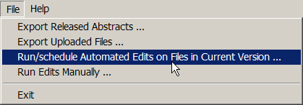
Result: The Run/schedule automated edits on files in current version window opens.
At the top of the window is a listing of all NAACCR files that that been submitted in the current NAACCR version (i.e., the NAACCR version that your Web Plus application is based on), but that had the running of edits deferred.
- Select the files for which you would like to schedule the running of edits by clicking either Select All, or by clicking the Select checkbox for the individual file(s) of interest.
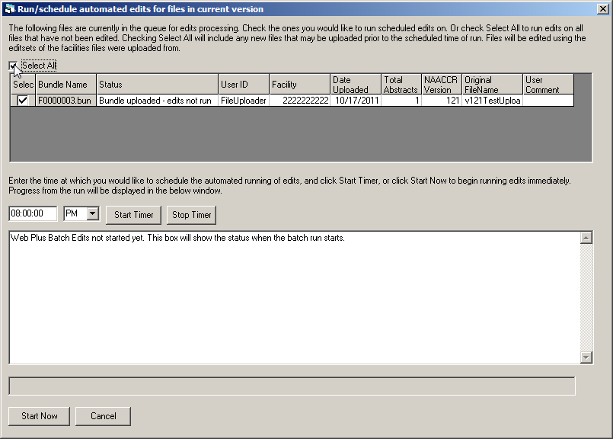
- The scheduling of the edits run is done in the lower half of the Run/schedule automated edits on files in current version window. Enter the time at which you would like the edits to run. This can be a time after you have left for the day (just leave your PC running).
- Click Start Timer. The edits will run at the specified time, an error report will be generated and posted to the Web Plus application, and the notifying e-mails will be sent. The display area will show the status of the batch run once it has begun.
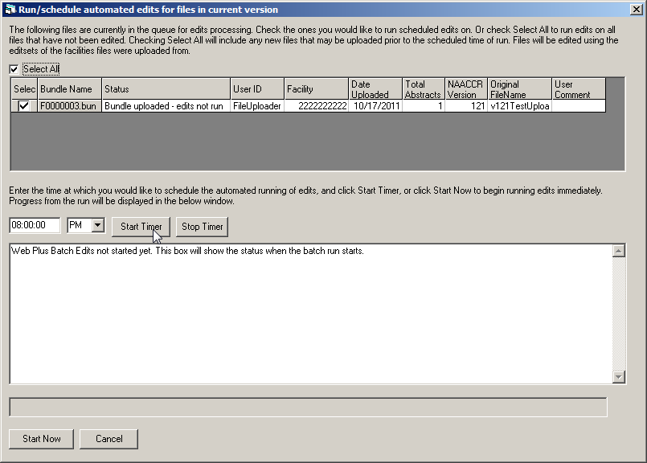
If you would like to run the batch edits right away (i.e., not at a later specified time), you can leave the time fields blank, and just click Start Now.

Running Edits Manually
A registry may defer the running of edits in Web Plus for several reasons. The registry may want to defer edits for a facility because they would like to run a different edit set than that currently assigned to the facility’s display type in Web Plus. Or, there are often times when a central registry must accept submissions in multiple NAACCR versions, in particular when a new NAACCR version is being implemented. For example, when NAACCR version 15.0 is implemented, many central registries will have a mix of NAACCR version 14.0 and NAACCR version 15.0 files being uploaded, until all reporting facilities have been converted to version 15.0. When accepting multiple NAACCR versions in file uploads, the registry must be able to differentially run multiple corresponding versions of the NAACCR edits metafiles on these files.
Web Plus automatically runs edits on files uploaded in the NAACCR version on which the Web Plus application is based, and automatically defers the running of edits on files uploaded in other NAACCR versions. For example, if a registry’s Web Plus application is based on NAACCR version 15.0, and a NAACCR version 14.0 file is uploaded, the running of edits will automatically be deferred for the file.
In order to accommodate the running of central registry version-specific metafiles on uploaded files, Web Plus offers a Defer edits on file upload option for any individual facility. The registry may choose to automatically run, for example, a NAACCR version 15.0 metafile in their Web Plus application, and let this metafile run automatically in Web Plus (i.e., (leave the defer edits check boxes un-checked for the facilities submitting NAACCR version 15.0). Or the registry may choose to defer the running of edits, and run the edits manually using the Web Plus Administration Tool.
The Web Plus Administration Tool Run Edits Manually feature allows for the selection of the uploaded file for which edits was deferred, and then selection of the metafile and edit set that you would like to run on the file. The Web Plus Administration Tool interacts with Web Plus. When edits are run manually on an uploaded file using the Web Plus Administration Tool, edits are run on the files stored on the SQL server, an edit report is created, an e-mail is sent out to the Central Registry Administrator and the File Uploader notifying them that the edits have run, and the error report will be available for viewing when they next login to Web Plus.
To manually run edits on files for which the running of edits was deferred upon upload:
- Log in to the Web Plus Administration Tool, click on the File menu option, and select Run Edits Manually.
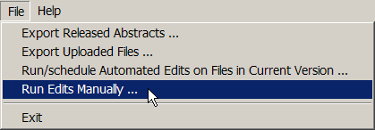
Result: The Run Edits Manually window opens.
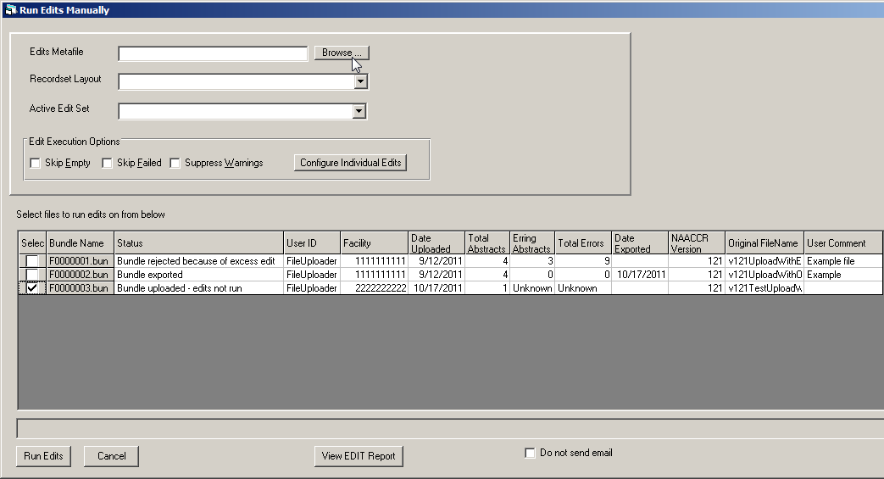
- At the top left of the window, browse on your computer and select the edits metafile that you would like to use, and then select the appropriate record layout and edit set.
- Select any Edit Execution Options, if appropriate.
- Select the uploaded file(s) for which you would like to run edits by clicking the Select column of the row of the file(s).
- Click Run Edits.
Result: The specific edit set will be run on the specified file(s), an error report created, an e-mail is sent out to the Central Registry Administrator and the File Uploader notifying them that the edits have run, and the error report will be available for viewing when they next login to Web Plus.
- To view the error report immediately, click View EDIT Report.
By default, the Do not send e-mail option is left un-checked, so that when edits are manually run on a file(s), and e-mail will automatically be sent to the Central Registry Administrator and the File Uploader notifying them that the edits have run. However, you can choose not to send an e-mail upon the running of the edits by clicking the Do not send e-mail option.

Appendix A: Answers
Chapter 2: The Basics
These are the answers to the questions (page 8) about the basics of Web Plus:
- To add a user account, click the Users and Facilities menu option, and click on Manage Users.
- To log out, click Log Out on the Web Plus menu.
- To begin creating a display type, click the Configuration menu option, and click on Manage Display Types.

Chapter 3: Web Plus Configuration
These are the answers to the questions (page 52) about configuring a display type:
- When you select an edit set, you are selecting a set of edits that will all be applied to the abstract in the same way; i.e., using the same Edit Set execution options (Skip Empty, Skip Failed and Suppress Warnings) for all the edits in the selected Edit Set. When you select individual edit options, you can override Edit Set execution options for any individual edit, or choose to suppress an individual edit, preventing it from running when the edit set is run.
- To protect a field from being edited by the abstractor, once you have selected the data item for your display type, click on the Properties button, enter a default value for the data item, and then click on the box next to Protected.
- You can create a new display type by either starting from scratch by adding a new display type, or by copying an existing display type and revising it.
- Section headings are used to group fields in a display type for clearer viewing and to facilitate data entry by the abstractor.

Chapter 4: Managing Facilities and Users
These are the answers to the questions (page 69) about managing facilities and user accounts:
- Display types are assigned to facilities, and data are abstracted by the user using the display type assigned to their facility.
- To add a new facility, click the Users and Facilities menu option, and click on Manage Facilities.
- To lock out a user from Web Plus, point to the Users and Facilities menu option, click Lock/Unlock Users, enter the facility and user and click on the Lock out button.

Chapter 5: Managing Abstracts
These are the answers to the questions (page 79) about managing abstracts:
- To assign abstracts to another abstractor/reviewer, point to Abstracts on the Web Plus menu, click on View/Change Assignments, and re-assign the abstracts to the desired central registry abstractor/reviewer.
- The Held status means that the abstract is assigned to a central registry abstractor/reviewer but has not been reviewed yet.
- To export centrally-released abstracts from the Web Plus application, the Web Plus Administration Tool is used.

Chapter 6: Bundle Submissions
These are the answers to the questions (page 93) about bundle submissions:
- To view a listing of abstracts in a bundled submission file that has been uploaded, click on Bundle Submissions on the Web Plus menu, and select Track File Uploads. Locate the file for which you would like to view abstracts, and click on the View Abstracts link.
- To view an edit error report for a bundled submission file that has been uploaded, click on Bundle Submissions on the Web Plus menu, and select Track File Uploads. Locate the file for which you would like the edit report and click the Edit Report link.
- To export an uploaded file from the Web Plus application, the Web Plus Administration Tool is used.
- To post a file for download by facilities, click on Bundle Submissions on the Web Plus menu, then click Post File for Download by Facilities. Click Browse to locate the file that you would like to post on your PC or network and enter a Label for the file. Select one or more facilities for which you would like to post the file by clicking Add and selecting the facility for which you would like to post the file. Return you to the Post File for Download by Facilities page, and click Upload.

Chapter 7: Reports
These are the answers to the questions (page 113) about reports:
- The four main types of reports on the Central Registry Administrator pages of Web Plus are Central Registry Reports, Follow-back Reports, Miscellaneous Manage Reports, and Facility Reports.
- You can find the Descriptive Statistics on Released Cases report by clicking on Reports on the Web Plus menu, selecting a facility, clicking the Submit button, and then clicking on the Descriptive Statistics on Released Cases link.
- The Web Plus User Account Management Report provides a listing of users assigned to each facility in Web Plus, and includes an at-a-glance overview of information for each user.

