wEB PLUS
naaccr VERSION 16 to version 18 Upgrade
  - 9.30.2019

OVERVIEW & iNSTALLATION PREREQUISITES

Overview
Upgrading to Web Plus Version 18 consists of running scripts on the database, upgrading the web application, and updating application configurations/settings for V18.
Note: Please make sure to backup the WebPlus database.

Prerequisites
SQL Server Compatibility Mode
The compatibility of your SQL Server should be at a minimum 100 with SQL Server 2008.
Product | Database Engine Version | Compatibility Level Designation | Supported Compatibility Level Values
SQL Server 2008 R2 | 10.5 | 100 | 100, 90, 80
SQL Server 2008 | 10 | 100 | 100, 90, 80

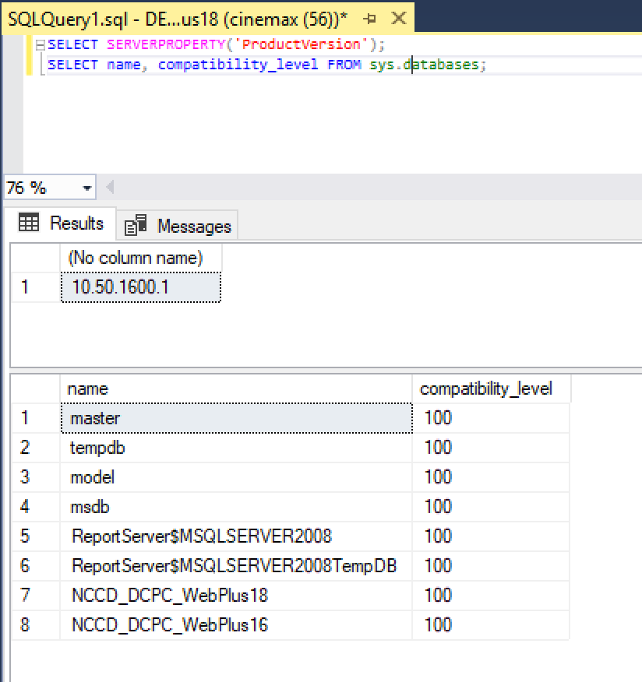

STEP 1: DATABASE UPGRADE
- Backup the WebPlus database
- Download database scripts from ftp://sftp.cdc.gov/WebPlus_NAACCRV18/V16_V18_DBScripts/
- Run scripts in the numbered order
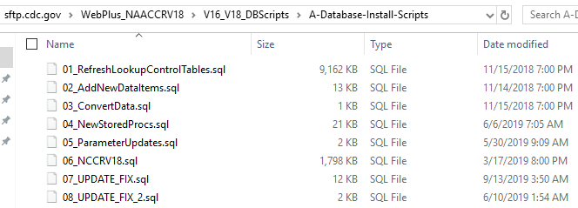
- Install version 18 sample abstracts (optional)
Note: Any case that was started and not completed in Web Plus v16 will continue to be associated with the same display type it was started with even after the upgrade. If you are going to utilize the sample displays, they will be for NEW cases only. It is suggested that users update the displays from v16 to include the new v18 fields after upgrade.
ftp://sftp.cdc.gov/WebPlus_NAACCRV18/V16_V18_DBScripts/B-Install-Sample-Abstract/
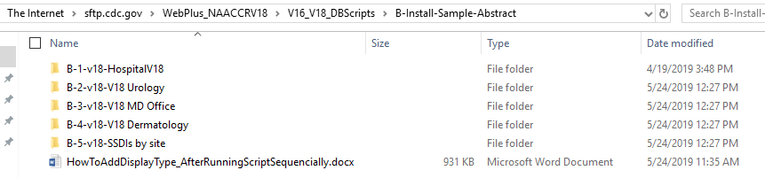

STEP 2: UPGRADE THE APPLICATION
- Download WebPlusV18.zip from ftp://sftp.cdc.gov/WebPlus_NAACCRV18/Application/ and unzip to a temporary folder.
- On the web server that has the current version of Web Plus installed, backup the current WebPlus folder that under Inetpub\wwwroot.
- Stop IIS
- Delete all the contents of the current WebPlus folder.
- Copy into Inetpub\wwwroot\WebPlus all files and folders from the temporary folder where you unzipped the downloaded zipped file.
- Verify that the following dlls are in the windows\SysWOW64 folder: Cstage0205.dll, EDITS50.dll, CsdllVB.dll
- Open web.config file in Inetpub\wwwroot\WebPlus folder and update the connection string to the database to point to your Web Plus database.
- Start IIS and visit the start page (https://your_web_server_address/WebPlus/Logonen.aspx) and make sure the log in page comes up without any error. Then have an admin user log in the application. If log in is successful have the admin user log out.

STEP 3: CONFIGURE THE APPLICATION

- Adding/removing new data items in existing display types or creating new display types altogether
- Updating default values of items included in display types.
- Selecting right edit sets from the V18 metafile in all display types
- In displays, use Section Heading ‘SSDI’ in order to have dynamic SSDI behavior.
NOTE: the standard NAACCR metafile is included in the application upgrade package and Web Plus is already configured to use that metafile

