Setup Web Plus 3.6.0 in IIS

The following steps explain how to setup Web Plus 3.6.0 to use .NET framework 4.5 in IIS. This applies only to Windows 2008 Server or Windows 2012 Server.
- Open Internet Information Services (IIS) Manager. To Open IIS Manager, type “IIS” in the search box.

- Right click on “Application Pools” and click “Add Application Pool”.
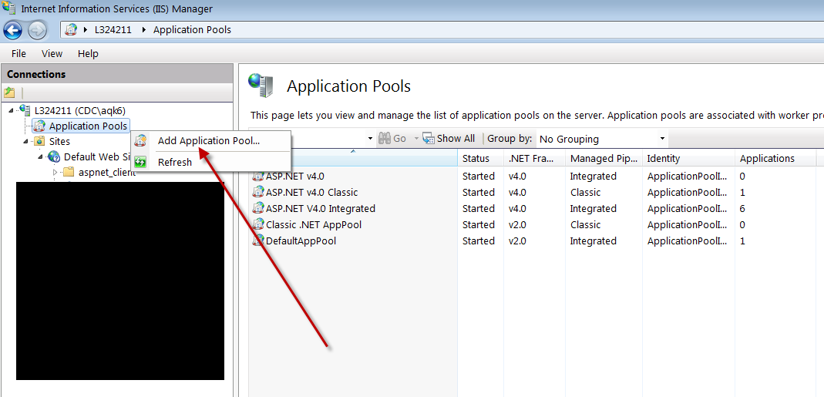

- Add a name to the new application pool and select the options as stated below:
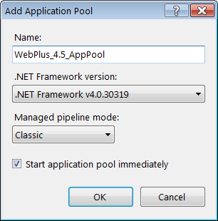

- Right click on the new application pool and select “Advanced Settings”.
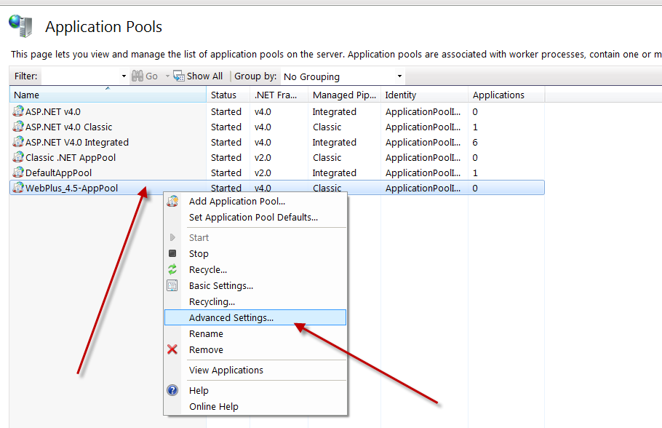

- Change the value of “Enable 32-Bit Applications to “True” and click “OK”.
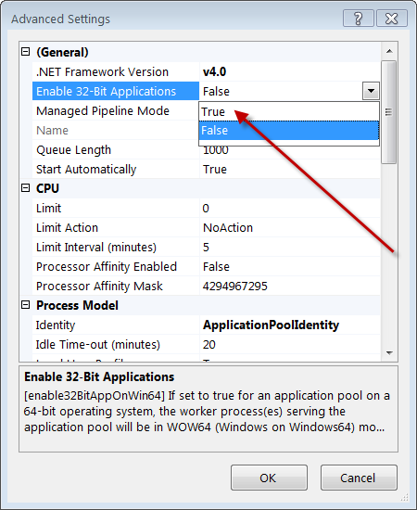

- Select the new WebPlus folder (3.5.0 folder) under “Sites” and click “Basic Settings”.
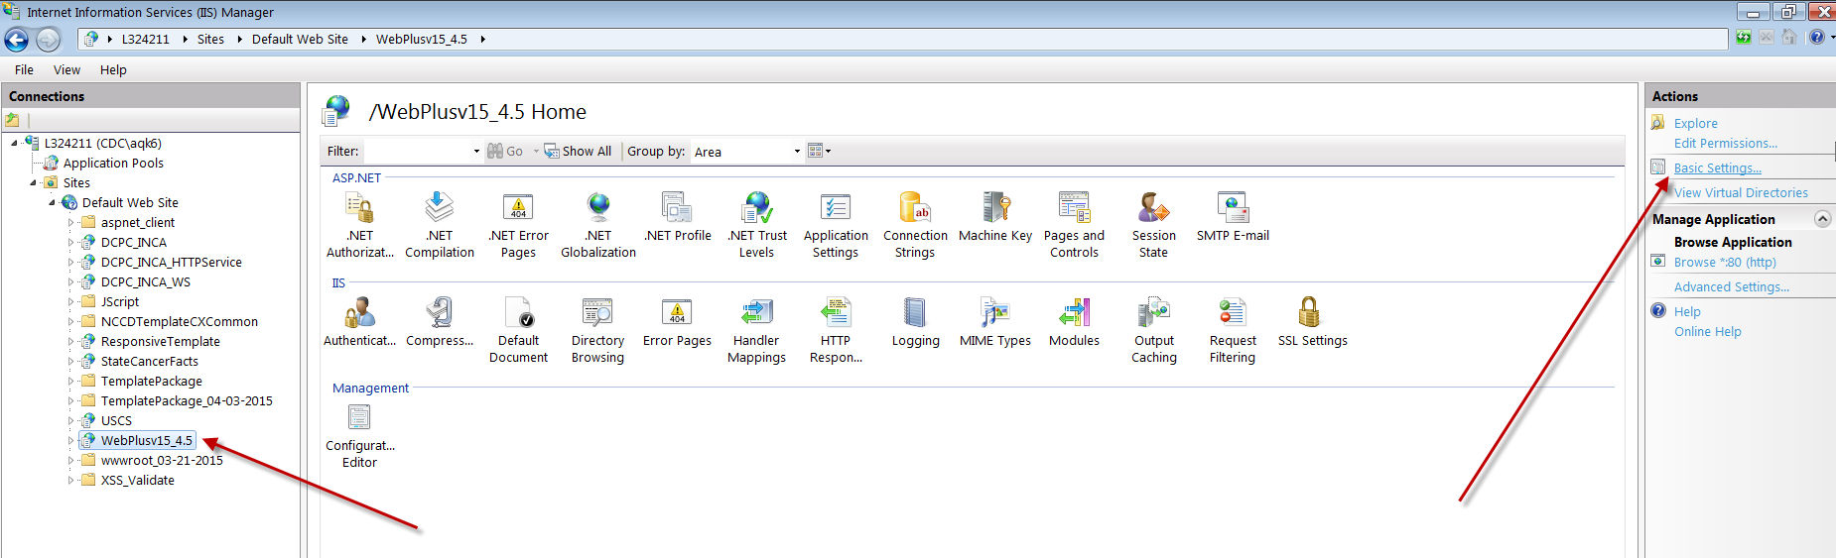

- Click “Select” button and select the newly created application from the list and click “OK”.
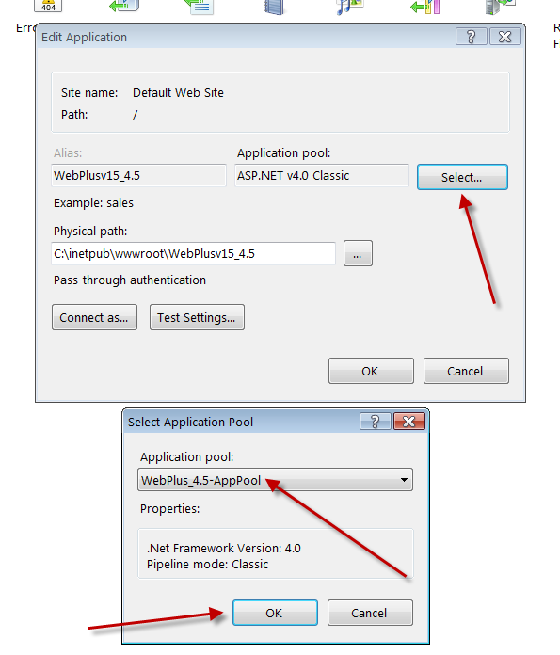

- Click “OK” in the “Basic Settings” window to complete the WebPlus setup in IIS.

