New Installation of Web Plus Database
PRE-INSTALL
WebPlus is dependent on some dll that will need to be installed on the local drive
Note: Web Administrator will have to refresh application pool and Web Plus user will have to restart their pc.
- cstage0205.dll
Location: C:\Windows\SysWOW64
If this file is not present, the following error below will occur:
- EDITS50.dll
Location: C:\Windows\SysWOW64
If this file is not present, the following error below will occur:
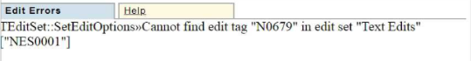

- CsdllVB.dll
Location: C:\Windows\SysWOW64

Install Guide
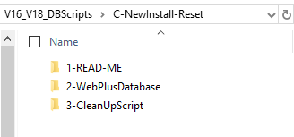
- Restore WebPlus Database

- Please go to folder : 2-WebPlusDatabase
- Copy the compressed folder to local drive then uncompressing the folder to get content
- Restore WebPlus Database using the following file NCCD_DCPC_WebPlus18_121318.bak
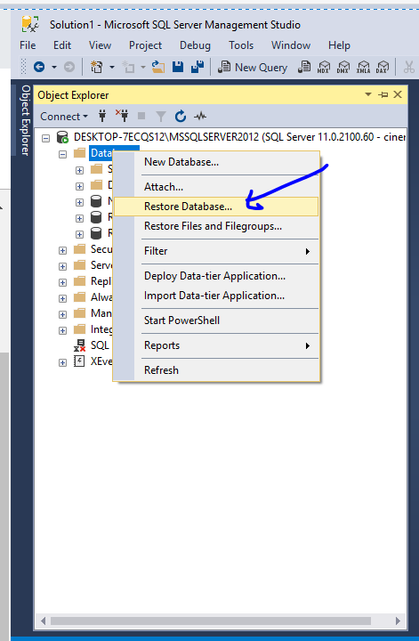

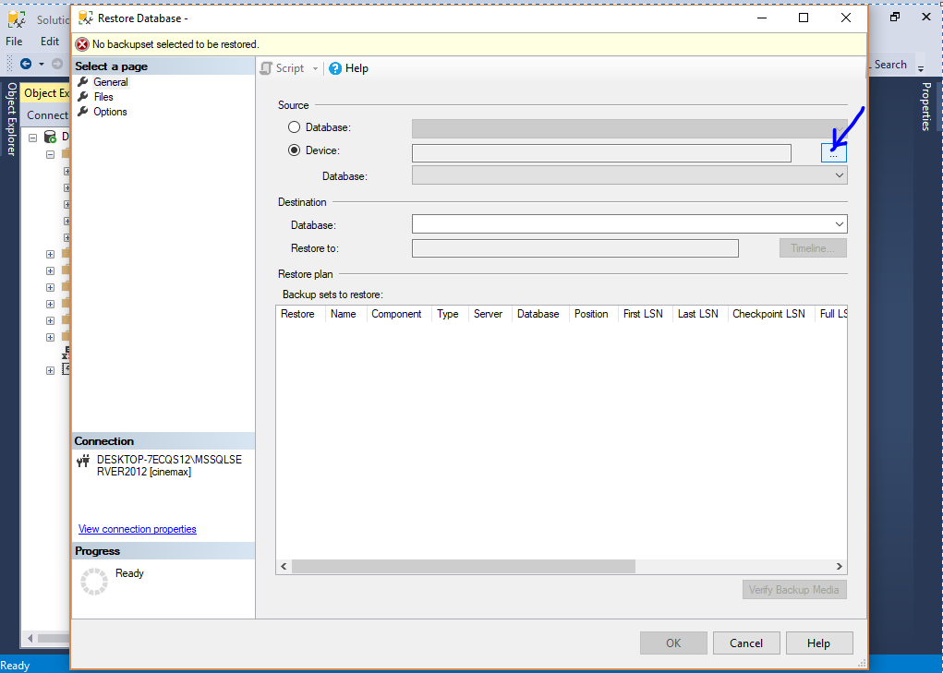

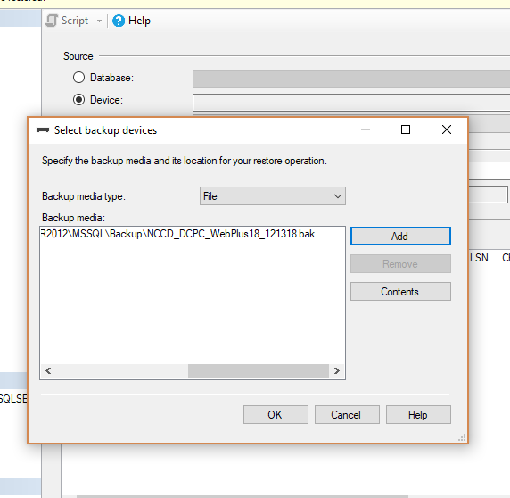
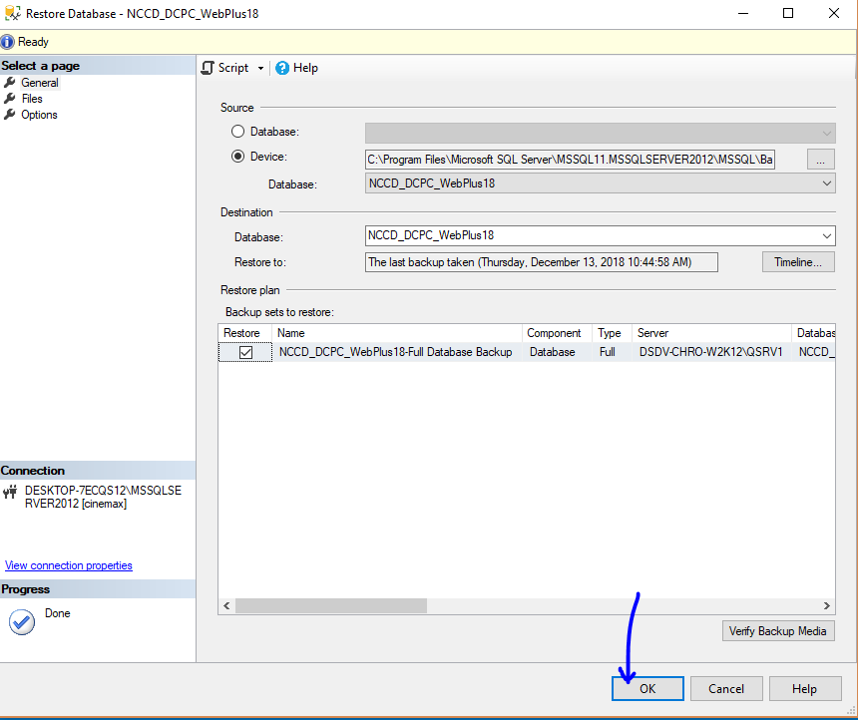

- Run the following SQL Script And Point to the right Database
Note: This will clean up the pointed database. Please understand that this script is intended only for new installation of WebPlus
- Please select the right Database
- Please go to the folder : 3-CleanUpScript
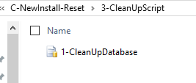
- Run the following entire script :
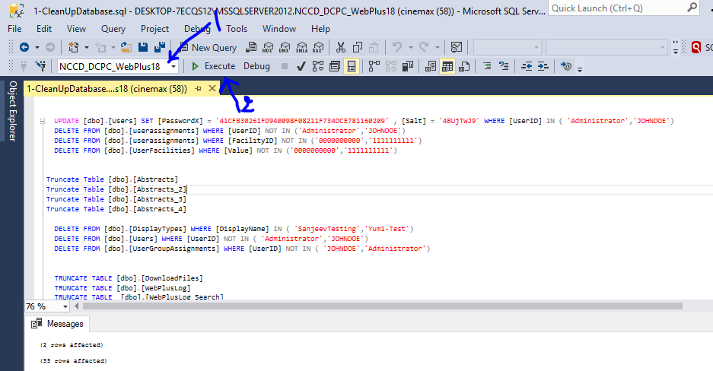

- Login Information
WebPlus Login
------------------
User1 Id Administrator
User1 password admin

User2 Id JOHNDOE
User2 password admin

