Web Plus NAACCR Version 18 Upgrade Instruction
Upgrading to Web Plus Version 18 consists of running scripts on the database, upgrading the web application, and updating application configurations/settings for V18.
Please Backup the WebPlus database
Prerequisite
- SQL Server Compatibility Mode
The compatibility of your SQL Server should be at a minimum 100 with SQL Server 2008.
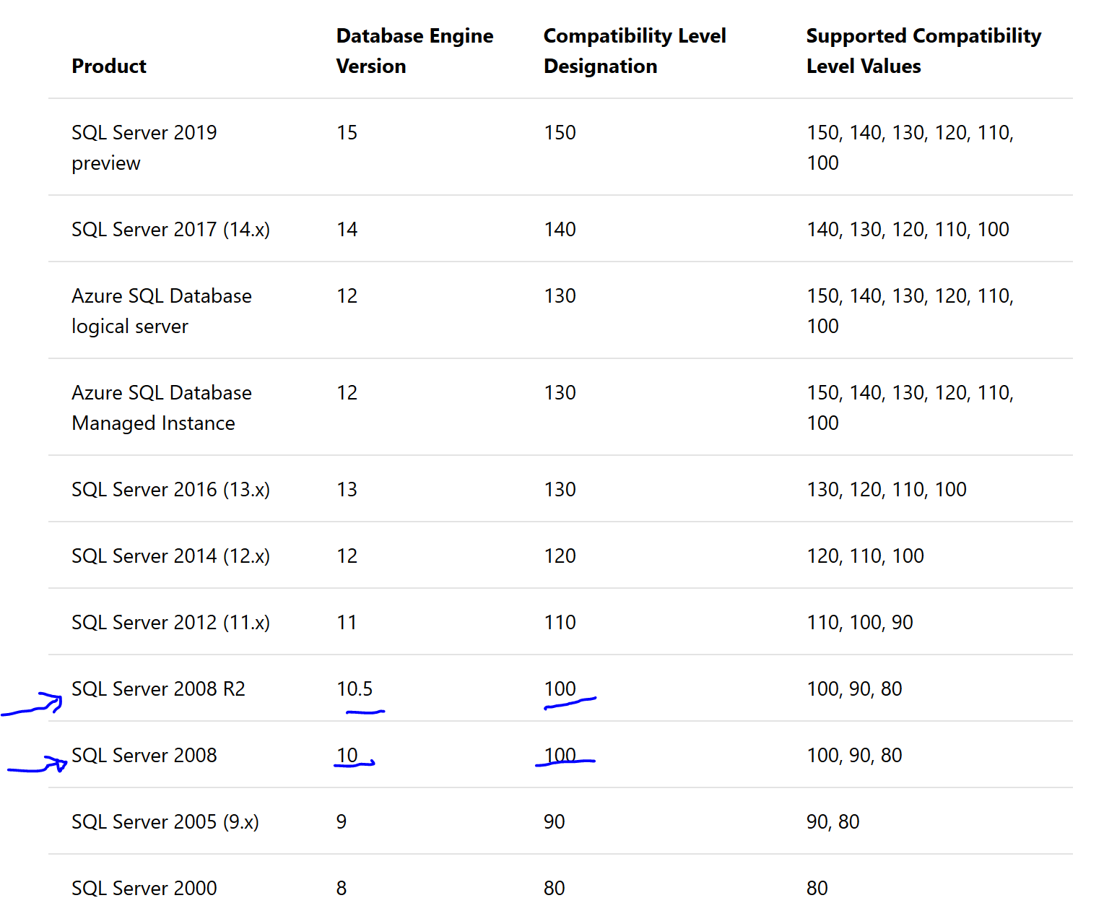
If compatibility mode is not at 100 with SQL Server, please follow steps below
Please run the following query below.

SELECT SERVERPROPERTY('ProductVersion');
SELECT name, compatibility_level FROM sys.databases;
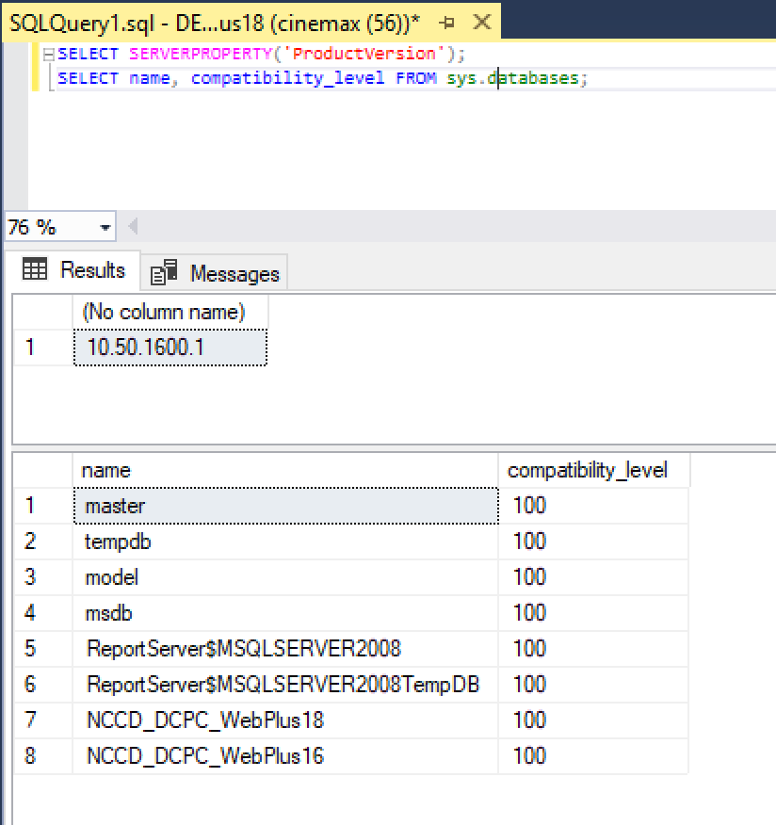
If the compatibility level is less than 100, please run the query below:

ALTER DATABASE database_name
SET COMPATIBILITY_LEVEL = 100

Step 1: Database Upgrade –
1. Download database scripts from ftp://sftp.cdc.gov/WebPlus_NAACCRV18/V16_V18_DBScripts/
2. Backup the WebPlus database
3. Run scripts in the numbered order
3.1 Install WebPlus database version 18 Update
Run scripts below in sequential order
ftp://sftp.cdc.gov/WebPlus_NAACCRV18/V16_V18_DBScripts/A-Database-Install-Scripts 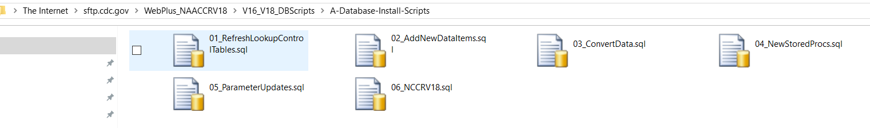
3.2 Install WebPlus database version 18 Sample abstract (Optional)
Run scripts below in sequential order then follow word document for additional direction
ftp://sftp.cdc.gov/WebPlus_NAACCRV18/V16_V18_DBScripts/B-Install-Sample-V18-Abstract/
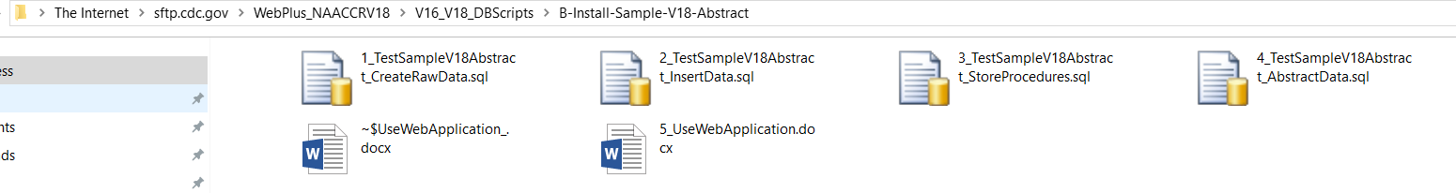
Step 2: Upgrade the application –
1. Download WebPlusV18.zip from ftp://sftp.cdc.gov/WebPlus_NAACCRV18/Application/ and unzip to a temporary folder.
2. On the web server that has the current version of Web Plus installed, backup the current WebPlus folder that under Inetpub\wwwroot.
3. Stop IIS
4. Delete all the contents of the current WebPlus folder.
5. Copy into Inetpub\wwwroot\WebPlus all files and folders from the temporary folder where you unzipped the downloaded zipped file.
6. Open web.config file in Inetpub\wwwroot\WebPlus folder and update the connection string to the database to point to your Web Plus database.
7. Start IIS and visit the start page (https://your_web_server_address/WebPlus/Logonen.aspx) and make sure the log in page comes up without any error. Then have an admin user log in the application. If log in is successful have the admin user log out.

Step 3: Configure the application -
1. Have an admin user log in the application and update display types for V18 – updates may include
a. adding/removing new data items in existing display types or creating new display types altogether
b. updating default values of items included in display types.
c. selecting right edit sets from the V18 metafile in all display types
NOTE: the standard NAACCR metafile is included in the application upgrade package and Web Plus is already configured to use that metafile

