+++++First Time WebPlus User with WebPlus2016 Upgrade to 2018
To Know
To run visual studio you must delete the hidden file just once
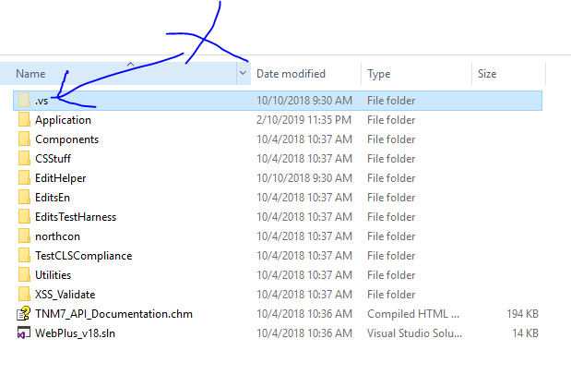

- Database Upgrade
(A-1) Determine WebPlus Database Version
Can I upgrade my database to version 2018 ?
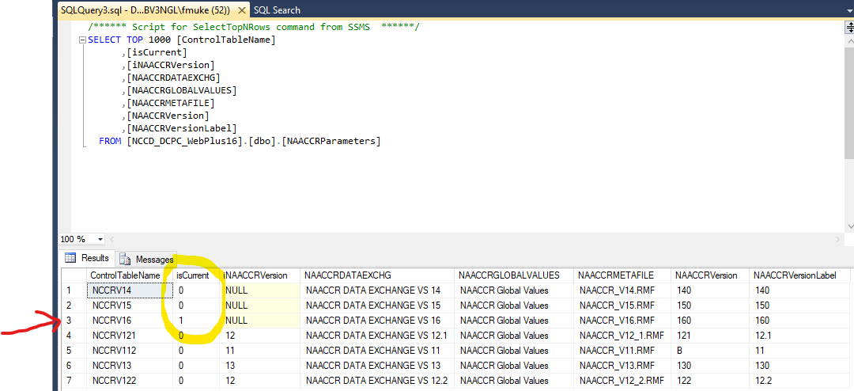
Yes. Since you currently have version 2018
(A-2) Run the scripts sequentially
Continue following the install documentation
- Web Upgrade
(B-1) Install IIS Properly
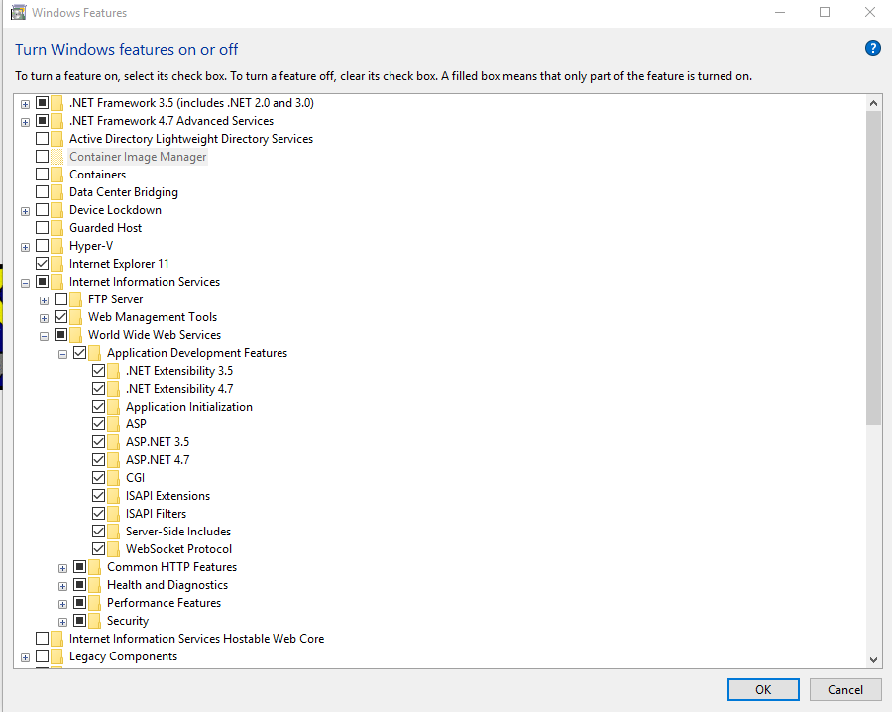
Follow the install documentation
(B-2) dll necessary locally
WebPlus is dependent on some dll that will need to be installed on the local drive

- cstage0205.dll
Location: C:\Windows\SysWOW64
If this file is not present, the following error below will occur:

- EDITS50.dll
Location: C:\Windows\SysWOW64
- CsdllVB.dll
Location: C:\Windows\SysWOW64

(B-3) Observation after Install Completed
Login
UserID | PasswordX | salt
Administrator | 41CFB30261FD940098F08211F734DCE781160209 | 4BUjTWJ9

!!!!! ONLY FOR TESTING !!!!!!
UPDATE [dbo].[Users] SET [PasswordX]= '41CFB30261FD940098F08211F734DCE781160209', [SALT]= '4BUjTWJ9' WHERE [UserID] IN ( 'Administrator','JOHNDOE')

UPDATE [dbo].[Users] SET [PasswordX]= '41CFB30261FD940098F08211F734DCE781160209', [SALT]= '4BUjTWJ9'

!!!!! ONLY FOR TESTING !!!!!!

Password -> admin

(B-3-1) Database Set to Version 2018 GOOD
Note
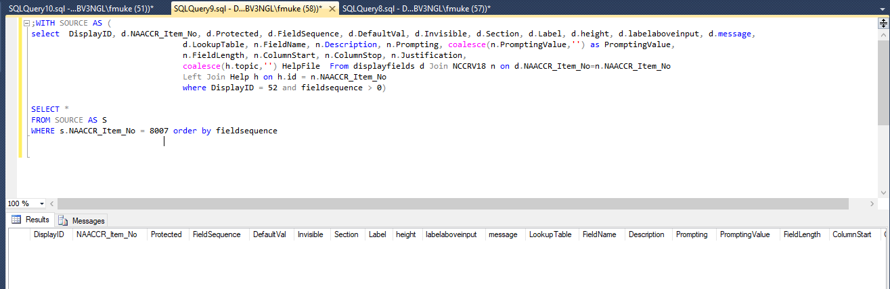
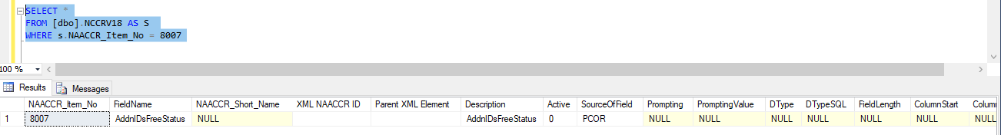
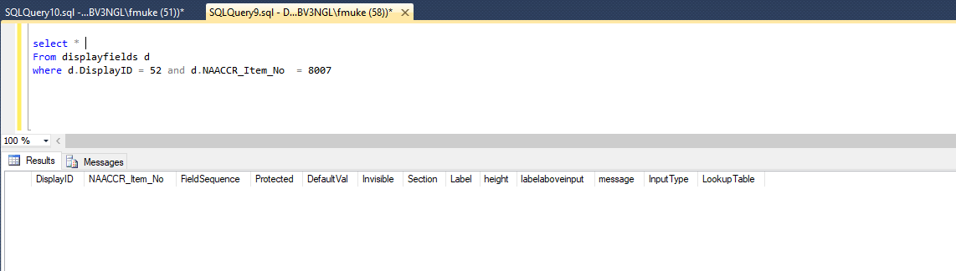

(B-3-2) Database set to 2018 through conversion from 2016 ERROR
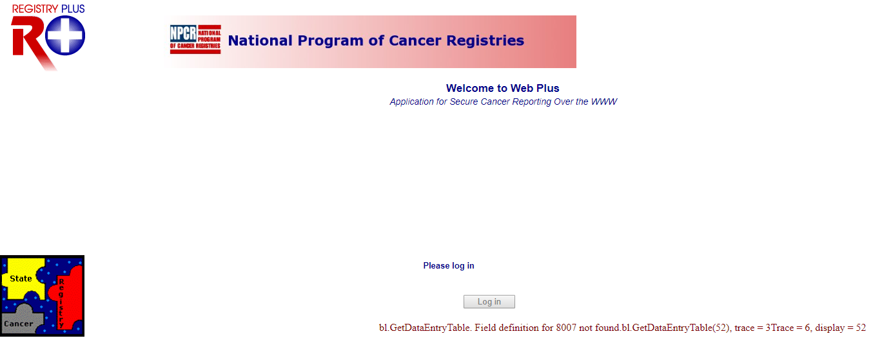
NOTE:
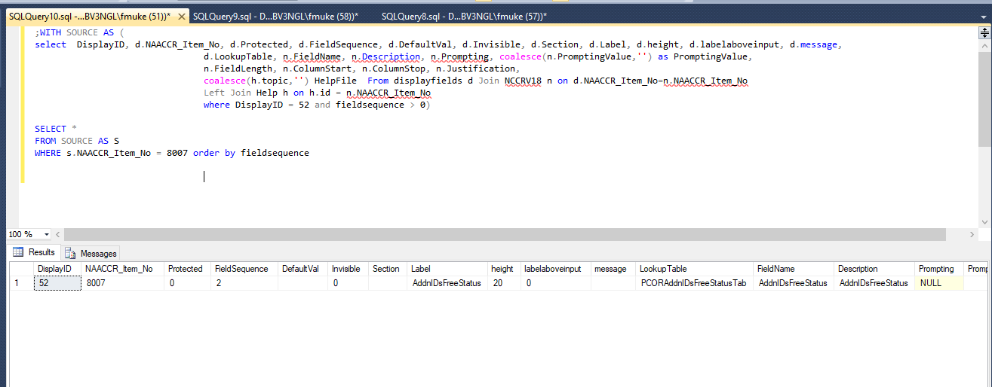
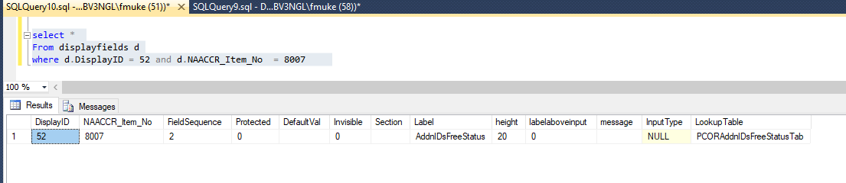
SOLUTION
-- BAD SOLUTION
--SELECT *
--FROM [dbo].[displayfields] as A
--WHERE a.DisplayID = 52 and a.NAACCR_Item_No = 8007

--SELECT *
--FROM [dbo].[displayfields] as A
--WHERE a.NAACCR_Item_No = 8007

--DELETE FROM [dbo].[displayfields] WHERE [NAACCR_Item_No] = 8007
--DELETE FROM [dbo].[displayfields] WHERE [NAACCR_Item_No] = 8000
--DELETE FROM [dbo].[displayfields] WHERE [NAACCR_Item_No] = 8009
--DELETE FROM [dbo].[displayfields] WHERE [NAACCR_Item_No] = 9902
--DELETE FROM [dbo].[displayfields] WHERE [NAACCR_Item_No] = 9901
--DELETE FROM [dbo].[displayfields] WHERE [NAACCR_Item_No] = 9900
--DELETE FROM [dbo].[displayfields] WHERE [NAACCR_Item_No] = 9905
--DELETE FROM [dbo].[displayfields] WHERE [NAACCR_Item_No] = 9904
--DELETE FROM [dbo].[displayfields] WHERE [NAACCR_Item_No] = 9903
--DELETE FROM [dbo].[displayfields] WHERE [NAACCR_Item_No] = 9907
--DELETE FROM [dbo].[displayfields] WHERE [NAACCR_Item_No] = 9908
--DELETE FROM [dbo].[displayfields] WHERE [NAACCR_Item_No] = 9906
--DELETE FROM [dbo].[displayfields] WHERE [NAACCR_Item_No] = 9911

Bad solution as the column active is messed up
Update store procedure [dbo].[GetDataEntryTable] as below

select DisplayID, d.NAACCR_Item_No, d.Protected, d.FieldSequence, d.DefaultVal, d.Invisible, d.Section, d.Label, d.height, d.labelaboveinput, d.message,
d.LookupTable, n.FieldName, n.Description, n.Prompting, coalesce(n.PromptingValue,'') as PromptingValue,
n.FieldLength, n.ColumnStart, n.ColumnStop, n.Justification,
coalesce(h.topic,'') HelpFile
From displayfields d Join NCCRV18 n on d.NAACCR_Item_No=n.NAACCR_Item_No
Left Join (SELECT DISTINCT *
FROM Help )as h on h.id = n.NAACCR_Item_No
where N.[Active] = 1 AND DisplayID = 52 and fieldsequence > 0
order by fieldsequence

- Good SOLUTION as I define a non actice column
select *
from @temptTable AS a
right join @temp AS B
on a.id = B.naaccr_item_no
WHERE B.naaccr_item_no NOT IN (
SELECT a.[NAACCR_Item_No]
FROM [dbo].[NCCRV18] AS A
WHERE (A.ColumnStart IS NULL OR A.ColumnStop IS NULL )
)
order by B.fieldsequence

- Need to Look into the fact that
V18 TO SHOW ALL ELEMENT when doing a conversion
For some reson…
Case-1-from16-18---dataentry.aspx
Case-2-18---dataentry1.aspx
