***New Installation of Web Plus Database***

<ftp://sftp.cdc.gov/WebPlus_NAACCRV18/V16_V18_DBScripts/C-NewInstall-Reset/1-READ-ME/>

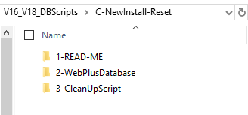

1. Restore WebPlus Database

* Please go to folder : <ftp://sftp.cdc.gov/WebPlus_NAACCRV18/V16_V18_DBScripts/C-NewInstall-Reset/2-WebPlusDatabase/>
* Restore WebPlus Database using the following file **NCCD_DCPC_WebPlus18_121318.bak**

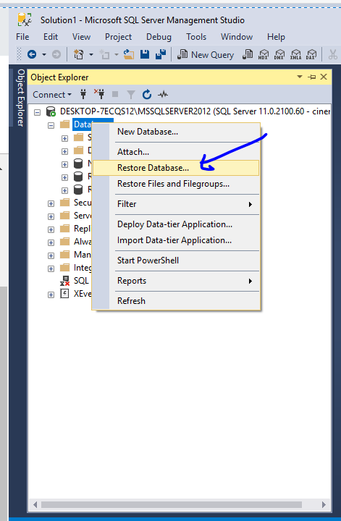

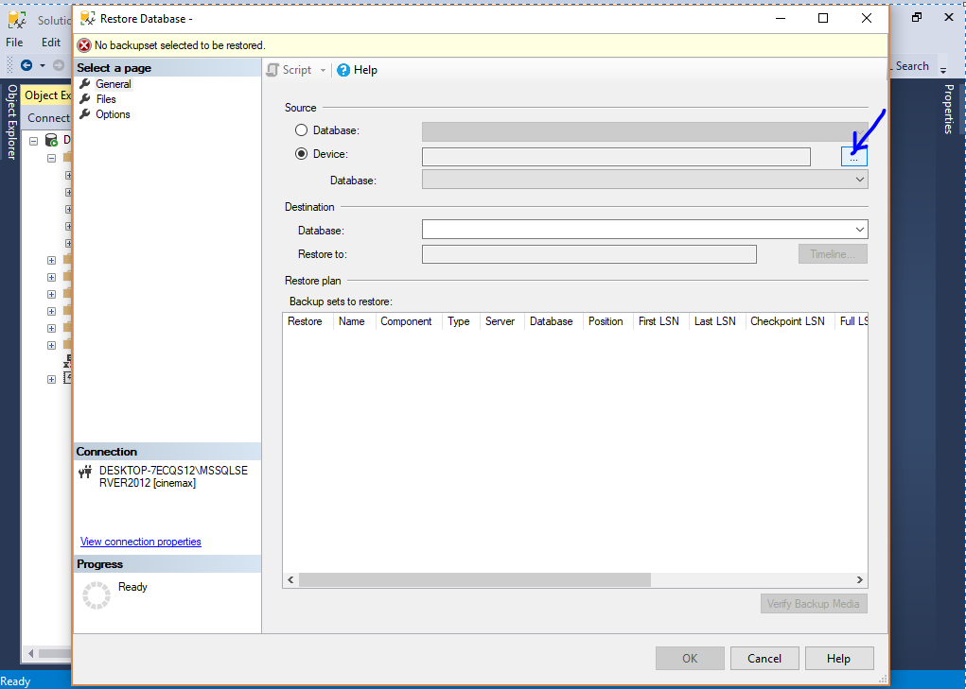

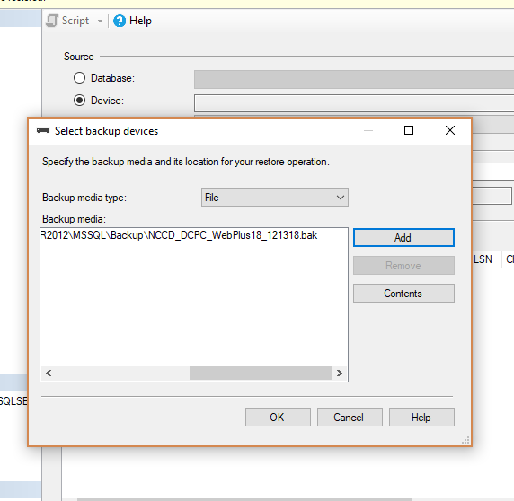

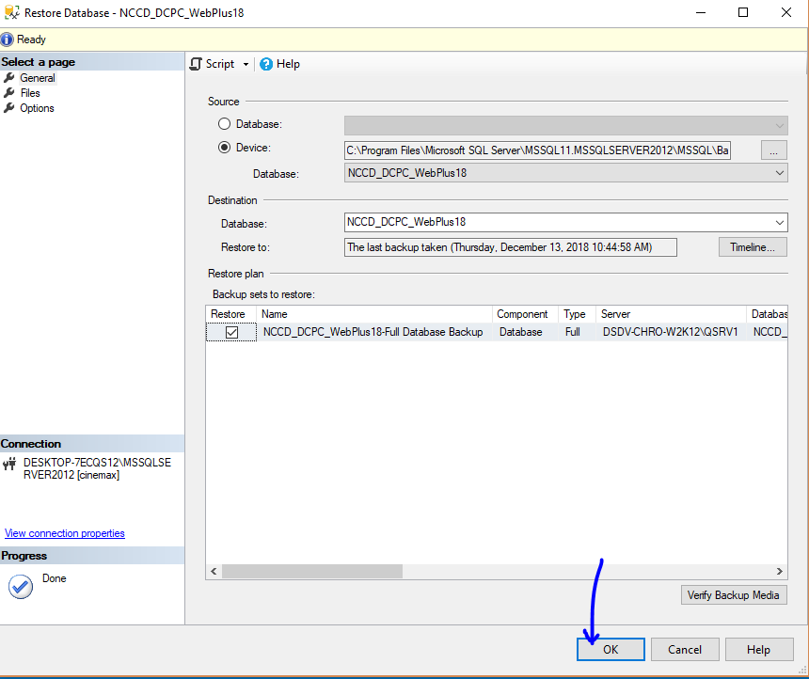

1. Run the following SQL Script And Point to the right Database

Note : This will clean up the pointed database. Please understand that this script is intended only for new installation of WebPlus

* Please select the right Database
* Please go to the folder : <ftp://sftp.cdc.gov/WebPlus_NAACCRV18/V16_V18_DBScripts/C-NewInstall-Reset/3-CleanUpScript/>

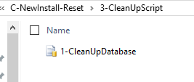

* Run the following entire script :

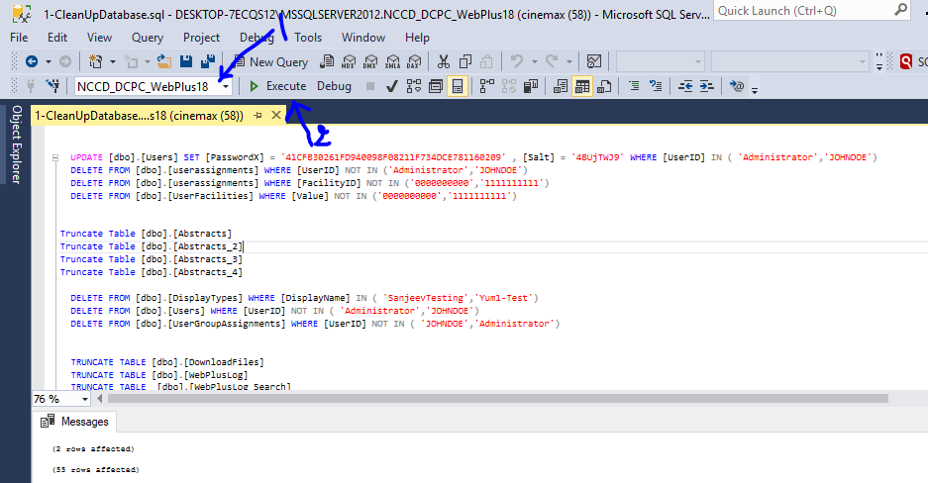

1. **Login Information**

WebPlus Login

------------------

User1 Id 🡪 Administrator

User1 password 🡪 admin

User2 Id 🡪 JOHNDOE

User2 password 🡪 admin