Mapper Plus Program Version 1.0.1

Introduction

Mapper Plus program reads HL7 version 2.3.1 ORU^01 message batch files, parses messages and stores various HL7 data elements as discrete field values into tables in the PATHLAB database. In a typical setting, PHIN Messaging System is used to send HL7 batch files from a laboratory to a cancer registry or some other agency working in cancer registry’s behalf. Mapper Plus program sits at a workstation at a cancer registry and polls the worker queue of the PHIN MS receiver for any new incoming files. Once a new file arrives in the queue the application will pick up the file and process it and go back in waiting mode for the arrival of a new file. Mapper Plus can also be used in an interactive mode where the user can manually select a file to parse and import into the PATHLAB database.

During import, depending upon user settings in Configuration, the messages are checked for any cancer terms contained in the OBX-5 texts of the messages and the positive terms are highlighted in red and negative terms are highlighted in blue in an HTML report that will be available for viewing by the user after the import is complete. Mapper Plus uses the NEGEX algorithm to find negated terms.

PATHLAB Database

Mapper Plus imports HL7 batch files, parses the messages and stores HL7 data elements of interest to tables in the PATHLAB database. A mapping table, called DATAMAP, contains the mapping definition of HL7 data elements to fields of tables (refer to Local Customization section below to see how individual states can use this table to select additional data items for storage). There are 7 data tables, MSH, PV1, PID, ORC, OBR, OBX, and OBXCOMBINEDTEXT, the first 6 of which correspond to the 6 segments of the ORU^01 message. Data elements can be stored at the field, component or sub-component level. The hierarchical relationships among segments are maintained in the database.

To simplify processing and use of data, in addition to the OBX table which stores data elements of individual OBX segments as separate records, the text field (OBX-5) of all OBX segments that belong to (are children of) an OBR segment are combined and inserted as one row in the OBXCOMBINEDTEXT table. This table has 8 fields to store texts of the OBX segments. Depending on the LOINC code that exists in the OBX-3 field the text of OBX-5 will go into one of these 8 text fields. If OBX-5 texts from multiple OBX segments are mapped to one field they will be concatenated.

Raw HL7 messages are also stored in the HL7MESSAGES table.

Supported database types: Mapper Plus was developed in Microsoft SQL Server environment but has been adapted for Oracle and Sybase SQL Anywhere also.

E-path Data Flow Diagram

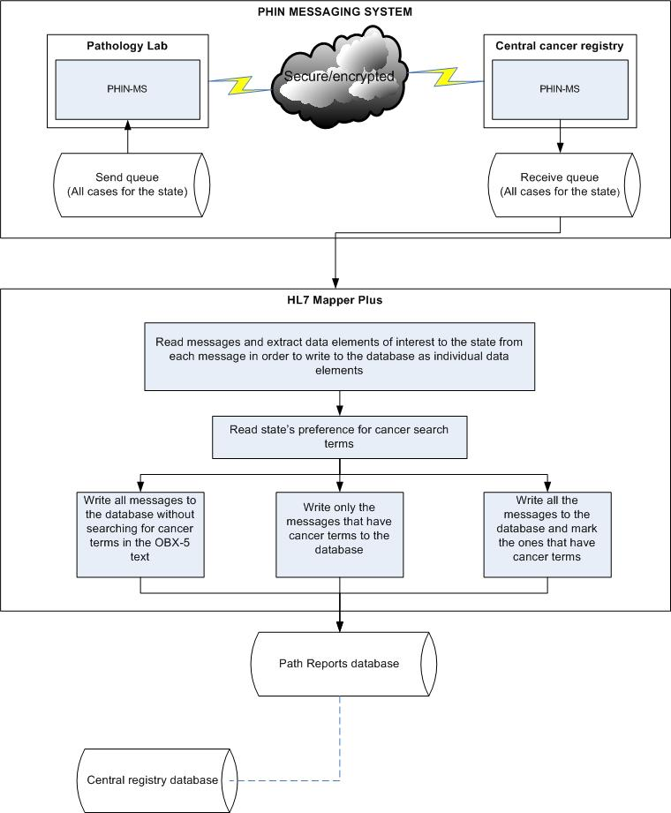
How this linkage works is still to be determined

Installing Mapper Plus

Double-click on the Mapper Plus install file to run the install. Mapper Plus program requires that Microsoft .NET Framework 2.0 or above be installed on the computer. If you are using database other than Microsoft SQL Server or Access you may need to install client connectivity software also. After both HL7Mapper Plus and .NET Framework are installed you can start the program by going to the Start menu, then clicking on All Programs->Registry Plus->Mapper Plus->Mapper Plus.

Configuring Mapper Plus

Before using HL7Mapper Plus you have to configure it to point to the right database(s), PHINMS queue, and set your preferences. You can use HL7Mapper Plus to either import HL7 batch files manually or to poll a PHINMS queue for HL7 batch files. To set configuration select System Configuration under the Administration menu. The Configuration dialog comes up. Fill out the following:

1. Pathology Reports Database Connection String: OLEDB connection string to the Pathology Reports database. This is the main database that will store imported messages and parsed data values from messages. This database also contains the DATAMAP table, and other user preferences table. The default value is pointing to an Access database, Pathlab.mdb, which is included in the install. This database can be any OLEDB compliant database, e.g., MS SQL Server, Oracle, etc.

To find the OLEDB connection string to a particular kind of database please refer to the database resources. Here are some examples:

MS SQL Server: PROVIDER=SQLOLEDB;SERVER=servername;DATABASE=pathdb;UID=pathdb;PWD=****;
Oracle: Data Source=XE;User Id=phinuser;Password=*****;
MS Access: Provider=Microsoft.Jet.OLEDB.4.0;Data Source=c:\hl7mapperplus\pathlab.mdb;User Id=admin;Password=;Mode=Share Deny None;

Important: If you are using a database other than Microsoft Access you should import all the tables from Pathlab.mdb into your database.

2. PHIN Worker Queue Connection String: This database is where the PHIN MS worker queue is located. This database can also be any OLEDB complaint database. By default, it is pointing to an Access database, called Phinms.mdb, included in the install. Pathology Reports and PHIN Worker Queue can be the same database, in which case both the connection strings will be the same.

To find the OLEDB connection string to a particular kind of database please refer to the database resources. Here are some examples:
MS SQL Server:
PROVIDER=SQLOLEDB;SERVER=servername;DATABASE=pathdb;UID=pathdbursPWD=****;
Oracle: Data Source=XE;User Id=phinuser;Password=*****;
MS Access: Provider=Microsoft.Jet.OLEDB.4.0;Data Source=c:\hl7mapperplus\pathlab.mdb;User Id=admin;Password=;Mode=Share Deny None;

3. Worker Queue Name: Enter the PHIN MS Worker Queue name, e.g., ELRWorker Queue

4. PHIN MS File Receive Folder Path: If your PHIN MS receiver has been configured to put received files to a disk folder, enter the folder path where the received files will be stored. The preferred setting in the PHIN MS Receiver is not to store the file on a disk folder but to leave the file in the database in the message queue table.

5. Read File from the PHIN MS Queue: This is the default option. Selecting this option will make the mapper program to read the incoming file from the message queue.

6. Service Code: Service code to identify the file in the PHIN MS message queue, e.g., ELR_HL7231.

7. Archive Folder: HL7Mapper Plus copies the imported file to this folder before processing it.

8. Cancer Terms Search Options

- Write all reports to the database without searching for cancer terms: selecting this option will write all messages to the database without searching for cancer terms in the OBX texts of the messages.
- Write all reports to the database and mark reports that have cancer terms: selecting this option will write all the messages to the database after marking the ones that have cancer terms in their OBX texts.
- Write only the reports that have cancer terms: selecting this option will exclude any messages that do not have cancer terms in their OBX texts.

Using Mapper Plus

Mapper Plus can be used in two modes - manual and automated. In the manual mode you pick a HL7 batch file to import messages in the database in an interactive manner. In the automated mode HL7Mapper Plus polls the PHIN MS message queue for any new incoming batch files and imports them in the database. In both the modes files are processed the same way. Messages contained in the file are parsed and HL7 data elements are stored in the fields of 7 different data tables. The actual messages in the HL7 format are also stored in HL7Messages table. During import, depending upon user settings in Configuration, the messages are checked for any cancer terms contained in the OBX texts of the messages and the terms are highlighted in a rich-text formatted report that will be available for viewing by the user after the import is complete.

You can also use the HL7Mapper program to check for missing required data items.

Manual Import
To import a batch file manually select “Import pathology reports batch manually” under the File menu. Then in the file picker dialog select the file you want to import and click on Open. File will start importing; you will see a window showing you the progress of import.

Automated Import
To import automatically from the PHIN MS queue, select “Poll and Import HL7 Batch File from PHIN MS Queue” under the File menu. You will see a window that says it is polling for import. When it finds a new file to import you will see the progress of import similar to the one using manual import. After importing any new files it goes back to poll for more new files without any user intervention.

Check for Missing Required Data Items
Select “Test HL7 Message for missing required data items” under the File menu. In the window that comes up click the Browse button to select the message file to test and click Open. Then click on the Test button to run the test. You will see a formatted report of the message in the text box on this window. To view the result of the test, click on the View Log button.

View Imported Messages
To view imported messages select “Open pathology reports batch” under the File menu. You will see a list of batch files that have been imported into the database. Double-click on one of them to see the individual messages in that batch; workbench window will show up with the first message in the batch. The workbench window is divided into two parts; the left half shows the pathology report and the right half shows the abstracting section.

Local Customizations

Mapper Plus can be customized locally by states to change the data items that are stored as discrete fields in the database and to change the optionality (Required vs. Optional) of data items.

DATAMAP table: HL7Mapper Plus program looks to this table to find which HL7 data elements will be stored in which fields of data tables. There are several fields in this table and many of them are just for documentation purpose. For site-specific configuration the following fields are used:

DataTableName: Write the table name where HL7 data element will be stored. MSH, PV1, PID, ORC, OBR, and OBX are valid values.
DataFieldName: Write the field name where HL7 data element will be stored. The field name should exist in the table.
NAACCROpt_xxxx: Optionality column; defines whether data elements are required (R), required when available (R*), or optional (O). You can have a separate optionality column for each laboratory that your site receives messages from. Use Preferences table to show which laboratory will use which optionality column.

For example, if you decide to store PID.3.4 as a separate entity in the database follow these steps:
- Open datamap table and locate PID.3.4 under HL7Element.
- Enter PID under DataTableName
- Enter AssigningAuthority (or any other name that is meaningful to you) under DataFieldName
- Update the optionality column for each laboratory if required to change the default value
- Open PID table in the design view and add a field called AssigningAuthority to this table with datatype text (or varchar depending on the database you are using) and appropriate field length.

Preferences table: This table shows a mapping of laboratories and optionality columns in DATAMAP table. DATAMAP table can contain multiple "optionality" columns, one for each laboratory that a site can receive messages from.

