Pacific Regional Central
Cancer Registry
Policy &
Procedure Manual
Pacific Regional
Central Cancer Registry

Updated March 2016
Table of Contents

1 | Policy and Procedure Maintenance |  | 3
2 | General Registry Information |  | 5
3 | Enacting Legislation |  | 19
 |  | United States of America | 19
 |  | Territory of American Samoa | 25
 |  | Commonwealth of the Northern Mariana Islands | 28
 |  | Federated States of Micronesia (States of Chuuk, Kosrae, Pohnpei and Yap) | 33
 |  | Territory of Guam | 40
 |  | Republic of the Marshall Islands | 47
 |  | Republic of Palau | 53
4 | Cancer Registry Programs and Associations |  | 56
5 | Office Management |  | 59
6 | Hardware and Software: Registry Operating System and Data Management |  | 61
7 | Data Processing Operations |  | 76
8 | Death Clearance |  | 85
9 | Case-Sharing Agreements |  | 90
10 | Quality Control |  | 92
11 | Follow-up |  | 95
12 | Data Usage and Reports |  | 96
13 | Confidentiality |  | 99
14 | References and BRIEF REFRESHER (from IARC Manual) |  | 106
15 | Acknowledgements |  | 132

Section 1.
POLICY & PROCEDURE MAINTENANCE
Policy & Procedure Manual
There will be an electronic copy of the Pacific Regional Central Cancer Registry Policy and Procedure Manual located in the regional office on Oahu as well as in each jurisdictions registry office. In the central office on Oahu, the master file will be kept on a secure JABSOM shared drive; the active file will be kept on the shared Google Drive and will also be place on the PRCCR section on the pacificcancer.org website. http://pacificcancer.org/programs/pacific-regional-central-cancer-registry.html
Staff position responsible for coordinating and reviewing all policy and procedure updates
The Pacific Regional Central Cancer Registry Principal Investigator (PI) and Program Manager (PM) will be responsible for maintaining the schedule of review to ensure that procedures are reviewed and updated.
Staff position responsible for writing and updating each section of policies and procedures
The Pacific Regional Central Cancer Registry PI and PM will be responsible for writing each of the administrative policies and procedures. The PRCCR Central Registrar (in Guam) will provide additional input on data processing. Each jurisdiction registrar will be responsible for maintaining all policies and procedures related to their reporting sources, key contact information for their jurisdiction, personnel and local advisory boards.
Staff position responsible for approving and signing all policies and procedures
The Pacific Regional Central Cancer Registry PI is responsible for reviewing, approving, and signing off on all updates and new policies and procedures.
Schedule for review and update of policies and procedures
All policies and procedures will be reviewed and updated as necessary, but reviewed not less than biannually. New policies and procedures will be written as needed. Given the dispersed nature of the PRCCR, relevant updates by NPCR and NAACCR will be distributed electronically and may not necessarily be included in this manual.
Method of distribution
All new employees and jurisdiction registrars will receive a copy of the electronic files and asked to review the policy and procedure manual.

Assurance of use
To ensure that current staff are utilizing approved procedures and that all new employees have reviewed policies and procedures that apply to their jobs, they will be asked to review the Pacific Regional Central Cancer Registry Policy and Procedure Manual and then sign a document of understanding.

Section 2.
GENERAL REGISTRY INFORMATION
Pacific Regional Central Cancer Registry (PRCCR)
Talofa, Hafa Adai, Tirow, Iakwe, Alii, Ran Annim, Len Wo, Kaselehlia, Mogethin, Hello!
The U.S.-Affiliated Pacific Islands (USAPI) consists of three Flag Territories and three Freely Associated States (FAS). The Flag Territories are American Samoa, Guam and the Commonwealth of the Northern Mariana Islands (CNMI); the Freely Associated States are the Federated States of Micronesia (FSM; comprised of the states of Yap, Pohnpei, Kosrae and Chuuk), the Republic of the Marshall Islands (RMI), and the Republic of Belau (also known as Palau; ROB). The total population of the USAPI is approximately 460,000 people with 182,000 of the inhabitants living in the FAS. The expanse of the USAPI is almost twice the size of the continental United States, crosses five time zones and the International Date Line.
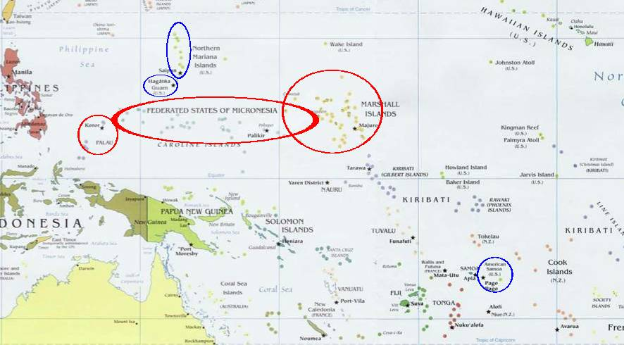
The health care infrastructure and capacity vary widely among each jurisdiction. This diversity is, in part, due to the different histories and socio-economic-political development of each jurisdiction. The ethnic, linguistic and cultural make-up of the USAPI population contributes to great diversity. In some of the remote islands and atolls, primary health care is almost non-existent and many must rely on small motorized boats to travel to the urban centers. The ability of each jurisdiction to respond to the health needs of the region is dependent upon the health infrastructure, financial resources, and the size and level of training of the health workforce. The health care budget expressed as a per capita expenditure of each jurisdiction ranges 6 to 50 times less than the U.S. per capita expenditure on health.
THE NEED FOR DATA
Historically, the USAPIN has been challenged with developing relevant and accurate health information systems since before the Trust Territories management in the 1960s. The technology, resources and complexity have been difficult to maintain, especially when superimposed on inadequately trained health workers. There were no cancer registries in the USAPIN until 1997, whereas several South Pacific non-US associated Pacific nations had functional cancer registries since the 1970s. The 1998 Institute of Medicine Report, a 1998-99 RMI Nuclear Claims Tribunal-funded study attempting to determine the epidemiology of cancer in Micronesia, and the 2002-03 Pacific Cancer Initiative needs assessments all confirmed major challenges with policy, reporting structures and no cancer surveillance system in place in the USAPIN. Additionally, limitations in tissue-diagnosis of cancer (in the FSM especially) hamper accurate recording in the medical record and on the death certificates. The numbers of cases and deaths noted in the 2002-03 assessments is generally felt to be under-reported because of challenges with diagnosis and financing to send specimens off-island for interpretation.
In response to the lack of systematic and accurate collection of cancer data in the region, the US Affiliated Pacific Island (USAPI) Pacific Regional Central Cancer Registry (PRCCR) was conceived and initiated through the Cancer Council of the Pacific Islands (CCPI) in 2003.
The primary tasks and responsibilities of the Pacific Regional Central Cancer Registry are:
- To develop cancer registries where the data is controlled and owned by each individual jurisdiction and to ensure the data are useful for local program planning and evaluation as well as monitoring local cancer trends over time
- To develop the systems and policies which insure proper identification, reporting and recording of all cancers in each USAPI jurisdiction
- To develop the capacity and infrastructure for each of the USAPI jurisdiction to manage the rigorous data collection and entry required of a cancer registry
- To develop a cancer registration system that is sophisticated, yet flexible and sustainable, i.e. takes into account the relative case load of cancers in each USAPI, the availability of trained personnel and the local ability to support such a system
- To link the individual USAPI cancer registries, comprehensive cancer control efforts, related non-communicable disease (NCD) efforts and public health system strengthening efforts in a manner which allows for economies of scale, standardized reporting and “speaking with one voice” for the USAPI

The Cancer Council of the Pacific Islands, as the Advisory Board to the PRCCR, has included data items within the cancer registry database to capture additional information on prevention, screening and other NCD risk factors. By doing so, the USAPI will be able to better monitor cancer burden and some health system responses to the current epidemic of NCDs which plague the USAPI.
Pacific Regional Central Cancer Registry (PRCCR) Contacts
Official correspondence:
Pacific Regional Central Cancer Registry Program
c/o Department of Family Medicine and Community Health
John A. Burns School of Medicine, University of Hawaii
677 Ala Moana Blvd, Suite 815
Honolulu, HI 96813

Phone: 808-692-0853 Fax: 808-586-3099 email: pcregistry@gmail.com

Principal Investigator/Project Director:
Lee Buenconsejo-Lum, MD, FAAFP lbuencon@hawaii.edu

Program Manager:
Patricia Eidsmoe-Torris, MPA eidsmoe@gmail.com

Founding Principal Investigator / Overall Project Director of all Pacific Cancer Programs:
Neal A. Palafox, MD, MPH npalafox@hawaii.edu

PRCCR Central Registrar / Quality Control (housed at University of Guam):
Melani Montano mmontano@triton.uog.edu
Cancer Research Center Guam (CRCG)
House #7 Deans Circle, Mangilao, Guam 96923
671-735-2988

Technical Assistance and Training are provided primarily by the Hawaii Tumor Registry staff at the University of Hawaii Cancer Center:
Eileen Elido, MD, CTR HTR Data Quality Associate EElido@cc.hawaii.edu
Raymond Elido, MD, CTR HTR Data Quality Associate RElido@cc.hawaii.edu
Michael Green, CTR HTP Programs/Operations Manager michael@cc.hawaii.edu
Catherine Grafel-Anderson HTR Database Systems and Tech Specialist cganderson@cc.hawaii.edu
Alan Mogi, HTR IT Specialist amogi@cc.hawaii.edu

Data analysis and statistical support is provided by:
Youngju Jeong, MA Pacific Cancer Programs Evaluation specialist youngju@hawaii.edu
Brenda Hernandez, PhD, MPH Epidemiologist and PI, Hawaii Tumor Registry brenda@cc.hawaii.edu

USAPI Jurisdiction Registrars (as of December 2015)
JURISDICTION | CONTACT NAME | EMAIL ADDRESS
American Samoa | Pine Semisi | ascancer.registry684@gmail.com  psemisi@gmail.com
CNMI | Joanne Ogo | jogoncdb@gmail.com
FSM National (FSMN) | Evel “Felix” Pelep | epelep@fsmhealth.fm
Chuuk State | Turay Setik | ttsetik@gmail.com
Kosrae State | Robina Waguk | rwaguk2@fsmhealth.fm
Pohnpei State | Mary Rose Johnny | mjohnny@fsmhealth.fm
Yap State | Cecilia Leechugen | cleechugen@fsmhealth.fm
Guam | Renata Bordallo, CTR  Roslynne Ebeo (asst) | renatab@uguam.uog.edu  renatauog@gmail.com  rebeo@uguamlive.uog.edu  roslynne.ebeo@gmail.com
Palau | Irish Tutii  Adeline Santos (asst) | irish.tutii@gmail.com  melil_santos@yahoo.com
RMI | Suzanne Philippo | lisuzy@gmail.com
PRCCR (Pacific Regional Central Cancer Registry) | Melani Montano  Glen Meno (asst) | mmontano@triton.uog.edu  lani.lani88@gmail.com  menog@triton.uog.edu

Registry Information
The Pacific Regional Central Cancer Registry (PRCCR) is a population-based registry covering the USAPI region and 6 USAPI jurisdictions, with an estimated population of 450 – 460,000. Please refer to the beginning of Section II for additional detail about the USAPI.

The CDC National Program of Cancer Registries (NPCR) funding is award to the University of Hawaii, who then administers subawards to each of the USAPI except for CNMI and American Samoa). The CNMI and American Samoa registrars are direct employees of the University of Hawaii. The other jurisdiction’s Department or Ministry of Health employs their own registrar. The Guam Cancer Registry is operated by the University of Guam Cancer Research Center Guam, under a memorandum of agreement between the Guam Department of Health and Social Services and the University of Guam.

Each jurisdiction noted above does their own data collection, abstraction, editing (AbsPlus using standard NPCR edits, in addition to PRCCR-specific inter-record edits), death clearance and follow-back. They report their cases to the Central Registries via WebPlus. The four FSM States upload their cases to the FSM National WebPlus, where the Registrar does additional visual editing and consolidation. Once any issues are resolved, the FSMN registrar transmits the PrepPlus bundles to the PRCCR registrar. The rest of the USAPI registrars transmit their case bundles directly to the PRCCR via the PRCCR WebPlus. Reporting to the CDC is done by the PRCCR. However, as it is imperative that each jurisdiction own and control their own data, the CDC created a few custom reports in AbsPlus for enhanced reporting functionality. Each jurisdictions’ registry and cancer program staff receives periodic training on data use and reporting.

Reference date: January 1, 2007. Cases diagnosed on or after the reference date must be included. Note. Most jurisdictions have data prior to 2007. This can be submitted to the PRCCR at any time for further analysis and case consolidation. However, the PRCCR is mandated under the CDC NPCR to submit cases diagnosed on or after the reference date.
Approximate number of cases processed annually: 650 (2014 and beyond)

Number of annual unduplicated incident cases:

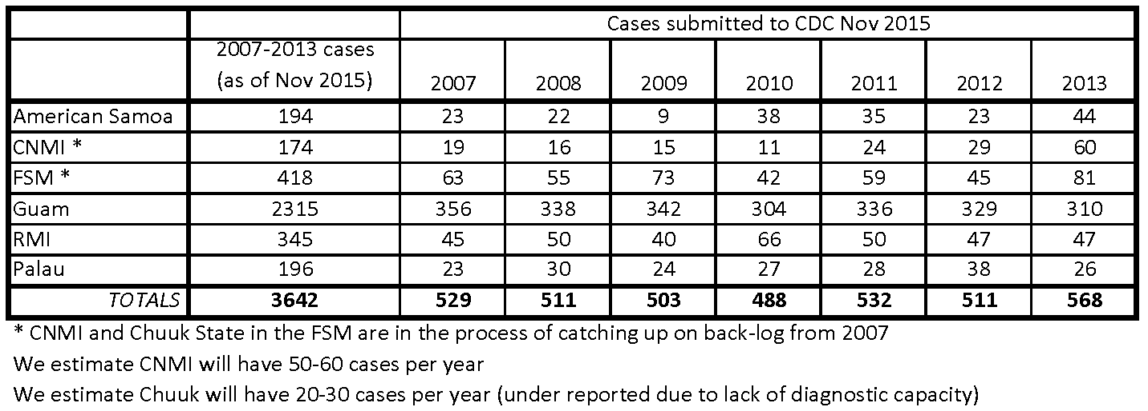

Number of annual unduplicated in-situ cases: 50

Estimated completeness percentage: Relatively new registrars and assistant registrars are in American Samoa, CNMI, Chuuk State, Guam (new assistant) and Palau (new assistant). CNMI and Chuuk are in the process of catching up on backlog. Guam also has some backlog cases to complete and are now better staffed as of October 2015. Concurrently, increased efforts are being made to diagnose incident cases in most jurisdictions. We anticipate that by diagnosis year 2015, the numbers will be more stabilized.

Completeness estimates (expected cases) for American Samoa, RMI and Palau will be calculated based on the 3 year average 2011-2013.
American Samoa: 2011-2013 average = 34
RMI: 2011-2013 average = 48
Palau: 2011-2013 average = 31
Guam will be based on 2011-2012 averages = 332
CNMI will be based on 2012-13 averages = 45
Completeness estimates (expected cases) for FSM States will be based on
Chuuk State: 2007-13 average = 14; 2013 cases = 19
Kosrae State: 2007-13 average = 6
Pohnpei State: 2007-13 average = 25
Yap State: 2007-13 average = 15

Funding sources: As of 2015, NPCR funds 100% of personnel and training costs for all jurisdictions except Guam Cancer Registry. NPCR funds training costs for the Guam Cancer Registry. Local funding supports space, phone, Internet, (limited) IT support in all jurisdictions.

Pacific Regional Central Cancer Registry (PRCCR)
University of Hawaii Cancer Center / Hawaii Tumor Registry (SEER DMS)
Technical assistance and training for abstracting, CRSPlus / LinkPlus / WebPlus installation; Epi support
NCI U54 Minority Institution/Cancer Center Partnership grant
University of Guam
Cancer Research Center Guam
Chuuk State AbsPlus
Kosrae State AbsPlus
Pohnpei State AbsPlus
Yap State AbsPlus
Federated States of Micronesia (National) FSMN
AbsPlus
Republic of the Marshall Islands
AbsPlus
American Samoa
AbsPlus
Commonwealth of the Northern Marianas Islands
AbsPlus
Republic of Palau
AbsPlus
Ebeye Hospital
University of Hawaii Department of Family Medicine & Community Health
(Administrative & TA office in Honolulu)
QC/data cleaning and stats support
Verify data submission, other CDC reporting
TA for: AbsPlus maint & upgrades, IT, Data Viz & report writing, accurate data use
Data Analysis / Reports (Surveillance, other) / Grants / USAPI Regional CCC Program / Program Eval
Partnerships with UHCC, HTR, PIHOA, UH TASI, PBTRC, CDC (NCCDPHP, DCPC, Immuniz, STI), HHS Region IX
Cancer Council of the Pacific Islands (CCPI) & Pacific Cancer Coalition
(Advisory Committee for PRCCR and Pacific Regional CCC Program)
(Advisory Committee)
Guam Cancer Registry
AbsPlus
USAPI Pacific Regional
Central Cancer Registry (NPCR)

Regional Registrar & RegistryPlus Databases in Guam (University of Guam)
100% Visual Editing / QC / Data Submission
CDC National Program of Cancer Registries (NPCR)
Tinian Hlth Ctr
Rota Hlth Ctr
WebPlus
All jurisdiction registrars do direct data collection at their hospital & other clinical sites. FSMN de-duplicates prior to transmission to PRCCR
DATA FLOW AND REPORTING CHART

Administration

The University of Hawaii, via PRCCR Principal Investigator, has the ultimate responsibility to ensure that terms and deliverables for the NPCR cooperative agreement is met. The Program Manager is responsible for daily management, communication with and tracking of registrars’ case reporting, participation in technical assistance and training opportunities and completion of various training modules. The Program Manager also supervises (by distance) the directly hired American Samoa and CNMI Registrars, as well as the registrars from the other jurisdictions.

Local supervision and collaboration: With the exception of the Guam Cancer Registry, the rest of the registries and registrars are housed within their respective Departments or Ministries of Health, Division of Public Health, Non-Communicable Disease Bureau or Branch. The terms of each subaward and job description for each registrar is to work in close collaboration with their local CDC-funded comprehensive cancer control (CCC), breast and cervical cancer program (BCCEDP) (if applicable) and non-communicable disease data teams. Therefore, each registrar has their own local supervisor and/or team, in addition to being supervised remotely by the PRCCR Program Manager and Principal Investigator.

Performance measures: In addition to the NPCR requirements, each jurisdiction should report pre-cancerous human papillomavirus (HPV)-related cases (i.e., CIN, VIN, AIN) to the PRCCR. Registrars should track the number of responses to inquiries and number and types of reports generated. The Registrars are also primarily responsible for preparing local reports needed by their cancer and NCD programs. They should work with their local epidemiologist, epi-tech or highest-trained statistics person to prepare the final report. The PRCCR requires a monthly reporting form and case tracking log from each Registrar.

Confidentiality: Each legislation has a definition of confidentiality. Additionally, HIPAA applies to American Samoa, CNMI and Guam. Each jurisdiction’s Department or Ministry of Health or the University of Guam requires employees to sign their confidentiality policy. Each jurisdiction has their own procedures for releasing cancer registry data. The Guam Cancer Registry / University of Guam and the Pacific Regional Central Cancer Registry have a specific data release form (see Section 13). Data requests for jurisdiction-level data other than for usual public health reporting, public health grants, public health outreach & education must be approved by the Minister or Director of Health.

Training: All jurisdiction registrars (abstractors) utilize a PIJ-specific version of NPCR Abstract Plus. All registrars are required to complete the online AJCC TNM Self-Instruction modules to improve their accuracy with directly coded summary stage 2000. These concepts are also reinforced and expanded upon in-person at the annual training. Each year, all registrars come to Honolulu for additional training on abstracting, staging, documentation, MPH rules or other difficult areas (not necessarily on the AbsPlus software). The Hawaii Tumor Registry also holds several training calls per year (for all registrars) to focus on topic areas determined by quality reviews done by either the PRCCR central registrar, the Principal Investigator, the CDC NPCR program and/or based on questions asked to the HTR or PRCCR staff.

Training for new jurisdiction registrars (or refreshers as needed) includes a variety of CDC, NCRA, NAACCR, SEER and AJCC TNM modules and materials from prior PRCCR annual trainings. New registrars complete the Fundamentals of Registry Operations modules. New registrars will come several days ahead of the main training for a mini “boot camp” that is based on April Fritz’s Volume 1 and II Cancer Registry CASEbooks and customized materials put together by Hawaii Tumor Registry and PRCCR staff. Additional case-based training by distance is provided by Hawaii Tumor Registry staff and supplemented by more experienced PIJ registrars. Many of the links to the Fundamentals of Registry Operations, various SEER self-instruction manuals, Site-Specific Schema and the SEER Coding and Staging manuals are available for download on the pacificcancer.org/programs/pacific-regional-central-cancer-registry.html site

Training on Central Registry software (WebPlus, PrepPlus, CRS Plus) is provided in person (usually in Atlanta) by CDC staff. Registrars also participate in NCRA courses as supplemental training and/or to fulfill pre-requisites to sit for the CTR exam.

As funding allows, some Registrars may receive travel budget to attend NCRA every 2-3 years in order to develop additional skills and maintain continuing education requirement for the CTR. Central registrars (PRCCR and FSM National) may be granted funding to attend NAACCR and pre-conference workshops, as training and operations needs and funding allows.

Travel Requirements: All jurisdiction registrars must travel periodically within their jurisdiction to do direct case abstracting or data collection / case ascertainment (i.e., from vital statistics, private offices, free-standing radiation oncology or surgicenters, the hospital(s)). They must have access to a car and have a valid driver’s license in their jurisdiction. The RMI registrar will also travel to Ebeye Hospital/Kwajalein Atoll Health Bureau at least once a year to abstract cases from that facility. The more experienced registrars within the Federated States of Micronesia may periodically travel to another FSM State to assist with backlog, training and/or technical assistance. Budget for travel, including the annual training to Honolulu, is included in the jurisdiction subcontracts. For American Samoa and CNMI, travel is processed directly by the UH Program Manager in accordance with UH rules and regulations. The PRCCR Registrar attends the CDC NPCR Annual Workshop for Education and Training Coordinators. Depending on availability of funding and program needs, the PRCCR or central UH staff may travel to the NAACCR Annual Conference.

Specific Responsibilities: In general, all jurisdiction registrars have the following major roles and responsibilities:
45% 1. Maintains the jurisdiction Cancer Registry. Prepares direct abstracting, entering existing case and mortality data into Abstract Plus. Collaborates with jurisdiction CCC Program, PRCCR and CDC National Program of Cancer Registries to maintain a cancer registry in jurisdiction/region and ensure that the registry complies with US national standards and objectives.

25% 2. Maintains contacts and relationships with Vital Statistics, hospital, off-island referral office/sources, private physicians and clinics and other sources to obtain data needed for the registry. Schedules and coordinates all activities with the Pacific Registry coordinators and other Pacific partners. Transmits required information to the Pacific Regional Central Cancer Registry (PRCCR) and UH according to PRCCR timelines.

15% 3. Participates in regional planning, technical assistance, training and annual meetings.

5% 4. Acts as primary point of contact/advocate for different legislative initiatives, policies, procedures and data exchange agreements that are developed.

5% 5. Works directly with the CDC National Program of Cancer Registries staff for all registry software implementation, trouble shooting and technical assistance issues.

The PRCCR Central Registrar has the following major roles and responsibilities:
The Central Cancer Registrar must be a self-directed, analytical, detail-oriented individual with proficient knowledge of medical terminology, human anatomy, and oncology terminology. This person must have good interpersonal skills, be able to sit for extended periods of time and have the ability to lift 25 pounds. The Central Cancer Registrar must have sufficient skills, knowledge and initiative to work independently in executing the following tasks with accuracy and timeliness: a) receive and process cancer abstracts from the other jurisdiction cancer registries, b) perform quality control checks, c) provide feedback and d) perform follow-up with the jurisdiction registrars in order to achieve high quality cancer abstracts within prescribed timelines for the Pacific Regional Central Cancer Registry (PRCCR) and Centers for Disease Control and Prevention (CDC). The Central Cancer Registrar will serve as the first-line technical resource for the other jurisdiction registrars and will work closely with the Hawaii Tumor Registry (HTR) and the University of Hawaii Department of Family Medicine & Community Health PRCCR staff to further develop personal skills in quality control and other aspects of central cancer registry management. The Central Cancer Registrar will participate in technical assistance and training activities with all of the USAPI cancer registrars and Hawaii Tumor Registry. Additionally, the Central Cancer Registrar will participate in other on-site, distance, or off-island training to further develop knowledge and skills. The Central Cancer Registrar should obtain CTR-certification within 2 years of hire (if they are not already a CTR). The Central Cancer Registrar may provide technical assistance and/or quality control audits to CNMI and other jurisdictions as skills and knowledge develop and as funding allows. The Central Cancer Registrar will learn to extract and report information from the PRCCR databases for the purposes of generating reports for PRCCR, the Pacific Islands Health Officers Association, Cancer Council of the Pacific Islands and other interested parties. The Central Cancer Registrar will work with the Centers for Disease Control and Prevention staff and contractors to maintain certain elements of the Abstract Plus database (such as the listing of physicians, facilities or villages). The Central Cancer Registrar will work with the University of Guam IT, CDC and others to routinely upgrade and maintain the PRCCR software and databases. The Central Cancer Registrar will maintain instructions on software upgrades and develop a software guide book for the office to use as a reference (tracking emails, phone calls with software instructions, screen shots, etc.). This position includes required travel to the NPCR Education and Training Coordinator Annual Conference and USAPI PRCCR training. Other travel may include the National Cancer Registrar’s Association (NCRA), North American Association of Central Cancer Registries (NAACCR) meetings and travel to one of the USAPI Cancer Registries (CNMI, Am Samoa, Palau, Chuuk, Yap, Kosrae, Pohnpei or RMI) to assist in training and QA audits. Because this position is still evolving, the Central Cancer Registrar must be willing to perform other duties as assigned.

The technical advisors from the Hawaii Tumor Registry will work with the central UH PRCCR staff and the regional registrar to identify training needs and implement workshops based on quality reviews, changing national standards, questions that arise individually or during group calls or other sources that would guide curriculum development (i.e., internal or external chart audits, challenges identified on monthly or other reporting to PRCCR).

Reporting Sources

Also see Section 7. Case Ascertainment for more details. The main reporting source (>90%) for each jurisdiction will be their hospital (including their hospital lab, radiology, medical records and cervical cancer screening programs managed by the Department/Ministry of Health). Pohnpei and Guam have additional civilian hospitals that may also have a very small number of cases (<5%). The off-island referral office is another major potential source of cases and/or information to complete a case that was partially diagnosed or treated at the hospital. In Guam, approximately 20% of the cases (or information to complete an abstract) will come from one of two free-standing radiation oncology centers or a surgicenter. With the exception of Guam, there are no dermatologists, urologists, gastroenterologists, hematologists, medical oncologists, radiation oncologists or independent surgeons that would diagnose/treat a case outside of the jurisdiction hospital. Guam Cancer Registry has active reporting by their radiation oncology centers and surgicenter (they upload PDFs to the secure WebPlus housed at the University of Guam).

Reporting Source Facility Information

Each jurisdiction registrar will send updated contact information on any new clinics or physicians who would treat a cancer patient (i.e., surgeons, OB-Gyns) to the PRCCR administrative office in Honolulu. This list is maintained in an Excel spreadsheet that is used to periodically update the relevant DOCTORQUERY or HOSPCODES tables in the AbsPlus software. These specific changes will only be made just prior to a major software upgrade by CDC. The PRCCR PI will ensure those files are up-to-date. As capacity develops at the University of Guam / PRCCR, then PRCCR staff in Guam will become responsible for updating those files. Reporting source facility information at the Central level (and for the AbsPlus / Registry Plus databases) will include the facility name and address. Each jurisdiction registrar is expected to maintain close collaborations and communication with the head of medical records at each hospital, the laboratory and radiology manager, the Vital statistician, the main clerk at the off-island medical referral office and with key contacts at the other reporting source facilities.

Signature Authority

The PRCCR Principal Investigator maintains signature authority on all registry correspondence, reports, travel and purchases that are directly funded by the University of Hawaii. The authorized organizational representative from the University of Hawaii is the Office of Research Services Contracts and Grants specialist. Each jurisdiction registrar must follow their jurisdiction-specific travel policies, including approval to travel to Honolulu or other registry-related travel. Jurisdiction invoices (generally for personnel and travel costs) that are required as part of the subawards from the University of Hawaii will be signed by their local fiscal authority and/or Director of Health and then acknowledged by the UH PRCCR PI upon receipt of the required supporting documentation.

Budget Oversight

The PRCCR Principal Investigator has oversight and final responsibility for the overall PRCCR budget, including the amount and scope of work for the jurisdiction subawards. The Program Manager has daily management responsibilities and will meet at least monthly with the Principal Investigator to review the current status of the budget, anticipate needed changes and adjustments and develops any preliminary budget requests for CDC Prior Approval (i.e., carryforward or other requests).

Legislation – refer to Section 3 and the pacificancer.org website for the enabling legislation for each of the 6 USAPI jurisdictions.

Registry data collection and coding manuals

Since the PRCCR reference year is 2007, all site and histology codes are coded based on ICD-O-3. Additional manuals include the current version of the FORDS 2010, Multiple Primary and Histology Coding Rules Manual, SEER Summary Stage 2000 and AJCC TNM Staging Manual, 7th edition. Cases diagnosed in 2007-2013 used both SEER Summary Stage and Collaborative Staging v2. Because of the limited site-specific factors available for most of the PRCCR cases, the PRCCR registries have been primarily using Directly Coded Summary Stage for 2013 and later cases. When possible, hard copies of the core coding and staging manuals are purchased for each Registrar. Otherwise, the electronic copy is made available if it is not already included in the AbsPlus software (Registry Plus online help).

Advisory Boards

At the regional level, the Cancer Council of the Pacific Islands (CCPI) is the Advisory Board to the PRCCR. The CCPI is comprised of key physician leaders, public health administrators and comprehensive cancer control program coordinators. The University of Hawaii PRCCR program staff and Hawaii Tumor Registry staff also serve as technical advisors to the CCPI. The CCPI had major input into the PIJ-specific customizations (fields, reports, edits) in order to better tailor the AbsPlus software and data reporting needs to the USAPI.

At the jurisdiction level, the local cancer program coordinator, CCPI Director (usually the clinician lead – often the Chief of Staff of the hospital or Chief Surgeon), cancer coalition leadership and public health leadership comprise a local advisory board. If the jurisdiction registrar needs assistance in obtaining cooperation from a physician (regarding documentation clarification, etc.) or additional assistance gaining stakeholder / partner support (i.e., from the off-island referral office or vital statistics), then the registrar will work with the appropriate advisory board member and/or the Director / Minister of Health to gain the needed support.

External Liaisons

The University of Hawaii John A. Burns School of Medicine and the University of Hawaii Cancer Center / Hawaii Tumor Registry are the administrators and technical advisors (PI and HTR staff) for PRCCR operations, training and data analysis. See the beginning of Section II and the Organizational / Data Flow chart for additional details. The Pacific Islands Health Officers Association (PIHOA) is the regional health policy organization comprised of the senior-ranking health official from each USAPI jurisdiction. The UH/PRCCR works closely with PIHOA on non-communicable disease (NCD) surveillance efforts and synergizes capacity-building efforts for surveillance, data reporting and mortality reporting. Other major regional partners include the Pacific Basin Medical Association (physicians) and Pacific Islands Primary Care Association (community health centers) to increase understanding and provide venues for training physicians on documentation, mortality reporting and other topics relevant to cancer registration.

The University of Guam/Cancer Research Center Guam primarily assists the Guam Cancer Registry (provides personnel, space, most equipment and IT support), including data analysis. The American Cancer Society is only active in Guam and works more directly with the Guam Cancer Coalition to support survivorship and outreach activities. At the jurisdiction level, the Cancer registries also work with their local physician organizations to enhance understanding of and support for registry activities.

Personnel
More detailed descriptions of the major roles and responsibilities for the central UH staff (PI, Program Manager, Evaluation specialist) and Hawaii Tumor Registry training/technical advisors can be found in the grant application budget narrative. Job descriptions for the jurisdiction and central registrars were described above “Specific Responsibilities.” At the jurisdiction level, there is just one registrar who functions as the case abstractor, liaison with the cancer program, breast / cervical cancer screening programs, NCD data / surveillance team and the cancer coalitions. New very part-time staff is being trained in Palau and Guam to assist with case ascertainment and, eventually, entry of abstracts into AbsPlus. New part-time staff at PRCCR in Guam is being trained to help with database and IT management and elements of quality review.

If there is a job vacancy or if the registrar’s performance does not meet minimum standards, then the UH PRCCR Program Manager and PI should be promptly notified so that the appropriate personnel action can be done with concurrence of the jurisdiction’s health leadership (i.e., Director / Minister of Health). UH provides the job description and suggested interview questions and also participates as part of the interview committee. Jurisdiction human resources processes are followed when applicable. Research Corporation of the University of Hawaii human resources policies and procedures govern filling any job vacancy for the American Samoa or CNMI cancer registrars.

Training / career development is important for sustainability efforts. As funds allow, the UH will pay for additional training modules and/or classes – some of which are pre-requisites for the CTR. As mentioned earlier in Section II, all registrars attend the annual in-person training in Honolulu, as well as other distance training/ TA phone calls and webinars.

Performance Evaluations. The American Samoa and CNMI registrars are directly evaluated by the Program Manager and Principal Investigator based on their fulfillment of their duties and responsibilities, including performance management review (case tracking, quality reports, timeliness of response to PRCCR registrar, etc.). The other jurisdiction registrars are also subject to the same performance management review. Any concerns are shared with the jurisdiction CCPI Director and Comprehensive Cancer Control Program coordinator (who serve as local supervisors). The CCPI and CCC Program Coordinators are provided with at least annual updates on their registrars’ performance from the PRCCR perspective.

Section3

CANCER REGISTRY LEGISLATION AND RELATED POLICIES

THE US CANCER REGISTRY AMENDMENT ACT

Public Law 102-515
October 24, 1992

An Act
Entitled the “Cancer Registries Amendment Act”.

Be it enacted by the Senate and House of Representatives of the United States of America in Congress assembled,

SECTION 1. SHORT TITLE.
This Act may be cited as the “Cancer Registries Amendment Act”.

SEC. 2. FINDINGS AND PURPOSE.
FINDINGS.—Congress finds that—

(1) cancer control efforts, including prevention and early
detection, are best addressed locally by State health departments that can identify unique needs;

(2) cancer control programs and existing statewide population-based cancer registries have identified cancer incidence and cancer mortality rates that indicate the burden of cancer for Americans is substantial and varies widely by geographic location and by ethnicity;

(3) statewide cancer incidence and cancer mortality data, can be used to identify cancer trends, patterns, and variation for directing cancer control intervention;

(4) the American Association of Central Cancer Registries (AACCR) cites that of the 50 States, approximately 38 have established cancer registries, many are not statewide and 10 have no cancer registry; and

(5) AACCR also cites that of the 50 States, 39 collect data on less than 100 percent of their population, and less than half have adequate resources for insuring minimum standards for
quality and for completeness of case information.

PURPOSE.—It is the purpose of this Act to establish a national program of cancer registries.

SEC. 3. NATIONAL PROGRAM OF CANCER REGISTRIES.
Title III of the Public Health Service Act (42 U.S.C. 241 et seq.) is amended by adding at the end the following new part:

“PART M—NATIONAL PROGRAM OF CANCER REGISTRIES

“SEC. 399H. NATIONAL PROGRAM OF CANCER REGISTRIES.

“(a) IN GENERAL.—The Secretary, acting through the Director of the Centers for Disease Control, may make grants to States, or may make grants or enter into contracts with academic or nonprofit organizations designated by the State to operate the State’s cancer registry in lieu of making a grant directly to the State, to support the operation of population-based, statewide cancer registries in
order to collect, for each form of in-situ and invasive cancer (with the exception of basal cell and squamous cell carcinoma of the skin), data concerning—

“(1) demographic information about each case of cancer;

“(2) information on the industrial or occupational history of the individuals with the cancers, to the extent such information is available from the same record;

“(3) administrative information, including date of diagnosis and source of information;

“(4) pathological data characterizing the cancer, including the cancer site, stage of disease (pursuant to Staging Guide), incidence, and type of treatment; and

“(5) other elements determined appropriate by the Secretary.

“(b) MATCHING FUNDS.—
“(1) IN GENERAL.—The Secretary may make a grant under subsection (a) only if the State, or the academic or nonprofit private organization designated by the State to operate the cancer
registry of the State, involved agrees, with respect to the costs of the program, to make available (directly or through donations from public or private entities) non-Federal contributions toward such costs in an amount that is not less than 25 percent of such costs or $1 for every $3 of Federal funds provided in the grant.

“(2) DETERMINATION OF AMOUNT OF NON-FEDERAL CONTRIBUTION; MAINTENANCE OF EFFORT.—

“(A) Non-Federal contributions required in paragraph (1) may be in cash or in kind, fairly evaluated, including plant, equipment, or services. Amounts provided by the Federal Government, or services assisted or subsidized to any significant extent by the Federal Government, may not be included in determining the amount of such non-Federal contributions.

“(B) With respect to a State in which the purpose described in subsection (a) is to be carried out, the Secretary, in making a determination of the amount of non-Federal contributions provided under paragraph (1), may include only such contributions as are in excess of the amount of such contributions made by the State toward the collection of data on cancer for the fiscal year preceding the first year for which a grant under subsection (a) is made with respect to the State. The Secretary may decrease the amount of non-Federal contributions that otherwise would have been required by this subsection in those cases in which the State can demonstrate that decreasing such amount is appropriate because of financial hardship.

“(c) ELIGIBILITY FOR GRANTS.—

“(1) IN GENERAL.—No grant shall be made by the Secretary under subsection (a) unless an application has been submitted to, and approved by, the Secretary. Such application shall be in such form, submitted in such a manner, and be accompanied by such information, as the Secretary may specify. No such application may be approved unless it contains assurances that the applicant will use the funds provided only for the purposes specified in the approved application and in accordance with the requirements of this section, that the application will establish such fiscal control and fund accounting procedures as may be necessary to assure proper disbursement and accounting of Federal funds paid to the applicant under subsection (a) of this section, and that the applicant will comply with the peer review requirements under sections 491 and 492.

“(2) ASSURANCES.—Each applicant, prior to receiving Federal funds under subsection (a), shall provide assurances satisfactory to the Secretary that the applicant will—

“(A) provide for the establishment of a registry in accordance with subsection (a);

“(B) comply with appropriate standards of completeness, timeliness, and quality of population-based cancer registry data;

“(C) provide for the annual publication of reports of cancer data under subsection (a); and

“(D) provide for the authorization under State law of the statewide cancer registry, including promulgation of regulations providing—

“(i) a means to assure complete reporting of cancer cases (as described in subsection (a)) to the statewide cancer registry by hospitals or other facilities providing screening, diagnostic or therapeutic services to patients with respect to cancer;

“(ii) a means to assure the complete reporting of cancer
cases (as defined in subsection (a)) to the statewide cancer registry by physicians, surgeons, and all other health care practitioners diagnosing or providing treatment for cancer patients, except for cases directly referred to or previously admitted to a hospital or other facility providing screening, diagnostic or therapeutic services to patients in that State and reported by those facilities;

“(iii) a means for the statewide cancer registry to access all records of physicians and surgeons, hospitals, outpatient clinics, nursing homes, and all other facilities,
individuals, or agencies providing such services to patients which would identify cases of cancer or would establish characteristics of the cancer, treatment of the
cancer, or medical status of any identified patient;

“(iv) for the reporting of cancer case data to the statewide cancer registry in such a format, with such data elements, and in accordance with such standards of quality timeliness and completeness, as may be established by the Secretary;

“(v) for the protection of the confidentiality of all cancer case data reported to the statewide cancer registry, including a prohibition on disclosure to any person of information reported to the statewide cancer registry that identifies, or could lead to the identification of, an individual cancer patient, except for disclosure to other
State cancer registries and local and State health officers;

“(vi) for a means by which confidential case data may in accordance with State law be disclosed to cancer researchers for the purposes of cancer prevention, control and research;

“(vii) for the authorization or the conduct, by the statewide cancer registry or other persons and organizations, of studies utilizing statewide cancer registry data, including studies of the sources and causes of cancer, evaluations of the cost, quality, efficacy, and appropriateness of diagnostic, therapeutic, rehabilitative, and preventative services and programs relating to cancer, and
any other clinical, epidemiological, or other cancer research; and

“(viii) for protection for individuals complying with the law, including provisions specifying that no person shall be held liable in any civil action with respect to a
cancer case report provided to the statewide cancer registry, or with respect to access to cancer case information provided to the statewide cancer registry.

“(d) RELATIONSHIP TO CERTAIN PROGRAMS.—

“(1) IN GENERAL.—This section may not be construed to act as a replacement for or diminishment of the program carried out by the Director of the National Cancer Institute and designated by such Director as the Surveillance, Epidemiology, and End Results Program (SEER).

“(2) SUPPLANTING OF ACTIVITIES.—In areas where both such programs exist, the Secretary shall ensure that SEER support is not supplanted and that any additional activities are consistent with the guidelines provided for in subsection (c)(2) (C) and (D) and are appropriately coordinated with the existing SEER program.

“(3) TRANSFER OF RESPONSIBILITY.—The Secretary may not transfer administration responsibility for such SEER program from such Director.

“(4) COORDINATION.—To encourage the greatest possible efficiency and effectiveness of Federally supported efforts with respect to the activities described in this subsection, the Secretary shall take steps to assure the appropriate coordination of programs supported under this part with existing Federally supported cancer registry programs.

“(e) REQUIREMENT REGARDING CERTAIN STUDY ON BREAST
CANCER.—In the case of a grant under subsection (a) to any State specified in section 399K(b), the Secretary may establish such conditions regarding the receipt of the grant as the Secretary determines
are necessary to facilitate the collection of data for the study carried out under section 399C.

“SEC. 399I. PLANNING GRANTS REGARDING REGISTRIES.

“(a) IN GENERAL.—

“(1) STATES.—The Secretary, acting through the Director of the Centers for Disease Control, may make grants to States for the purpose of developing plans that meet the assurances required by the Secretary under section 399B(c)(2).

“(2) OTHER ENTITIES.—For the purpose described in paragraph (1), the Secretary may make grants to public entities other than States and to nonprofit private entities. Such a grant may be made to an entity only if the State in which the purpose is to be carried out has certified that the State approves the entity as qualified to carry out the purpose.

“(b) APPLICATION.—The Secretary may make a grant under subsection (a) only if an application for the grant is submitted to the Secretary, the application contains the certification required in subsection (a)(2) (if the application is for a grant under such subsection-42) and the application in such form, is made in such manner, and contains such agreements, assurances, and information as the Secretary determines to be necessary to carry out this section.

“SEC. 399J. TECHNICAL ASSISTANCE IN OPERATIONS OF STATEWIDE CANCER REGISTRIES.

“The Secretary, acting through the Director of the Centers for Disease Control, may, directly or through grants and contracts, or both, provide technical assistance to the States in the establishment and operation of statewide registries, including assistance in the development of model legislation for statewide cancer registries and assistance in establishing a computerized reporting and data processing system.

“SEC. 399K. STUDY IN CERTAIN STATES TO DETERMINE THE FACTORS CONTRIBUTING TO THE ELEVATED BREAST CANCER MORTALITY RATES.

“(a) IN GENERAL.—Subject to subsections (c) and (d), the Secretary, acting through the Director of the National Cancer Institute, shall conduct a study for the purpose of determining the factors
contributing to the fact that breast cancer mortality rates in the States specified in subsection (b) are elevated compared to rates in other States.
“(b) RELEVANT STATES.—The States referred to in subsection (a) are Connecticut, Delaware, Maryland, Massachusetts, New Hampshire, New Jersey, New York, Rhode Island, Vermont, and the District of Columbia.

“(c) COOPERATION OF STATE.—The Secretary may conduct the study required in subsection (a) in a State only if the State agrees to cooperate with the Secretary in the conduct of the study, including providing information from any registry operated by the State pursuant to section 399H(a).

“(d) PLANNING, COMMENCEMENT, AND DURATION.—The Secretary shall, during each of the fiscal years 1993 and 1994, develop a plan for conducting the study required in subsection (a). The study shall be initiated by the Secretary not later than fiscal year 1994, and the collection of data under the study may continue through fiscal year 1998.

“(e) REPORT.—Not later than September 30, 1999, the Secretary shall complete the study required in subsection (a) and submit to the Committee on Energy and Commerce of the House of Representatives, and to the Committee on Labor and Human Resources of the Senate, a report describing the findings and recommendations made as a result of the study.

“SEC. 399L. AUTHORIZATION OF APPROPRIATIONS.

“(a) REGISTRIES.—For the purpose of carrying out this part, the Secretary may use $30,000,000 for each of the fiscal years 1993 through 1997. Out of any amounts used for any such fiscal year, the Secretary may obligate not more than 25 percent for carrying out section 399I, and not more than 10 percent may be expended for assessing the accuracy, completeness and quality of data collected, and not more than 10 percent of which is to be expended under subsection 399J.

“(b) BREAST CANCER STUDY.—Of the amounts appropriated for the National Cancer Institute under subpart 1 of part C of title IV for any fiscal year in which the study required in section 399K is being carried out, the Secretary shall expend not less than $1,000,000 for the study.”

Approved October 24, 1992.

American Samoa Registry Act
Chapter 04

CANCER REGISTRY
Sections:
13.0401 Establishment.
13.0402 Cancer registry data and confidentiality.
13.0403 Promulgation of rules.

13.0401 Establishment.
A population-based, Territory-wide cancer registry is hereby established. The Department of Health shall administer and maintain the cancer registry established under this section.

History: 1998, PL 25-22.

13.0402 Cancer registry data and confidentiality.
The Department of Health shall collect, for each form of in-situ and invasive cancer (with the exception of basal cell and squamous cell carcinoma of the skin), data concerning:
(1) demographic information about each case of cancer;
(2) information on the industrial or occupational history of the individuals with the cancers, to the extent such information is available from the same record;
(3) administrative information, including date of diagnosis and source of information;
(4) pathological data characterizing the cancer, including the cancer site, stage of disease, incidence, and type treatment; and
(5) other elements determined by the Department of Health.
All data collected under this section shall be considered confidential as to the names of persons or physicians concerned, except that researchers may use the names of such persons when requesting additional information for research studies when such studies have been approved by the Director of Health.
History: 1998, PL 25-22.

13.0403 Promulgation of rules.
The Department of Health shall develop rules necessary to:
(1) ensure complete reporting by hospitals, laboratories, physicians and other health care practitioners diagnosing, or providing treatment for cancer patients;
(2) ensure access to all records that would identify cases of cancer or establish characteristics of the cancer, treatment of the cancer, or medical status of the individual patient;
(3) protect the confidentiality of all cancer data reported to the registry;
(4) establish the format, quality requirements, completeness, and timeliness of required data;
(5) and protect individuals complying with the law including provisions specifying that no person shall be held liable in any civil action with respect to a cancer case report provided to the cancer registry."
History: 1998, PL 25-22.
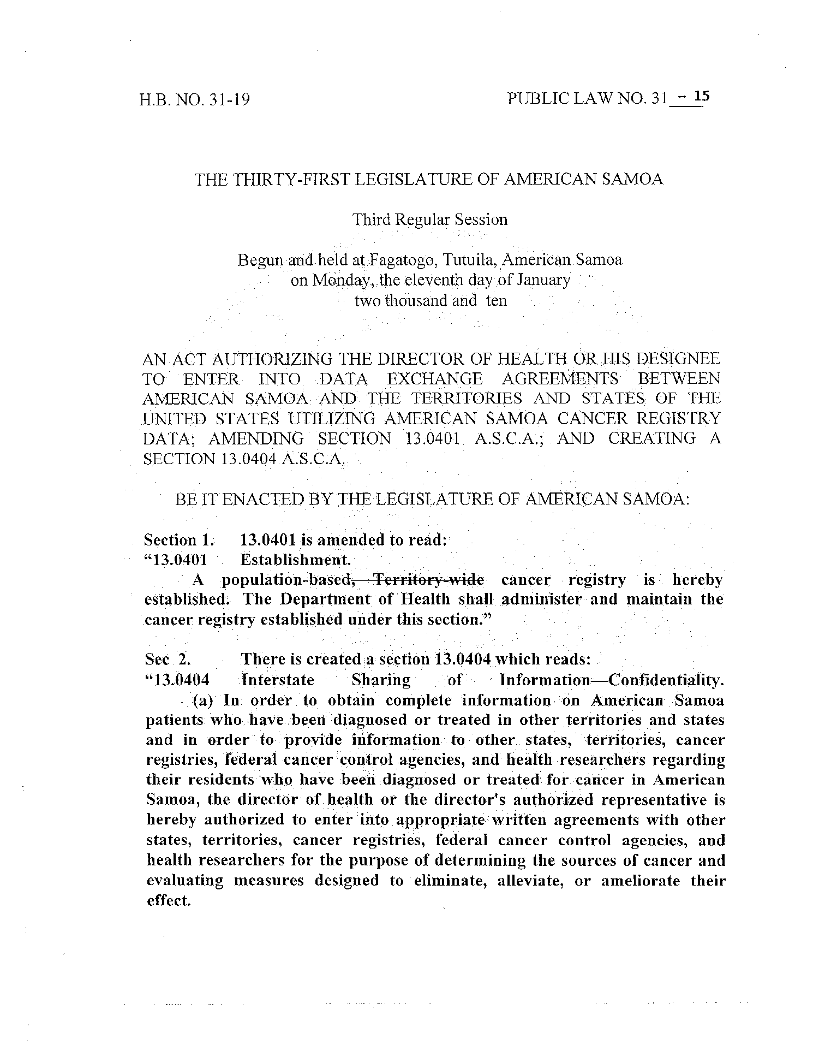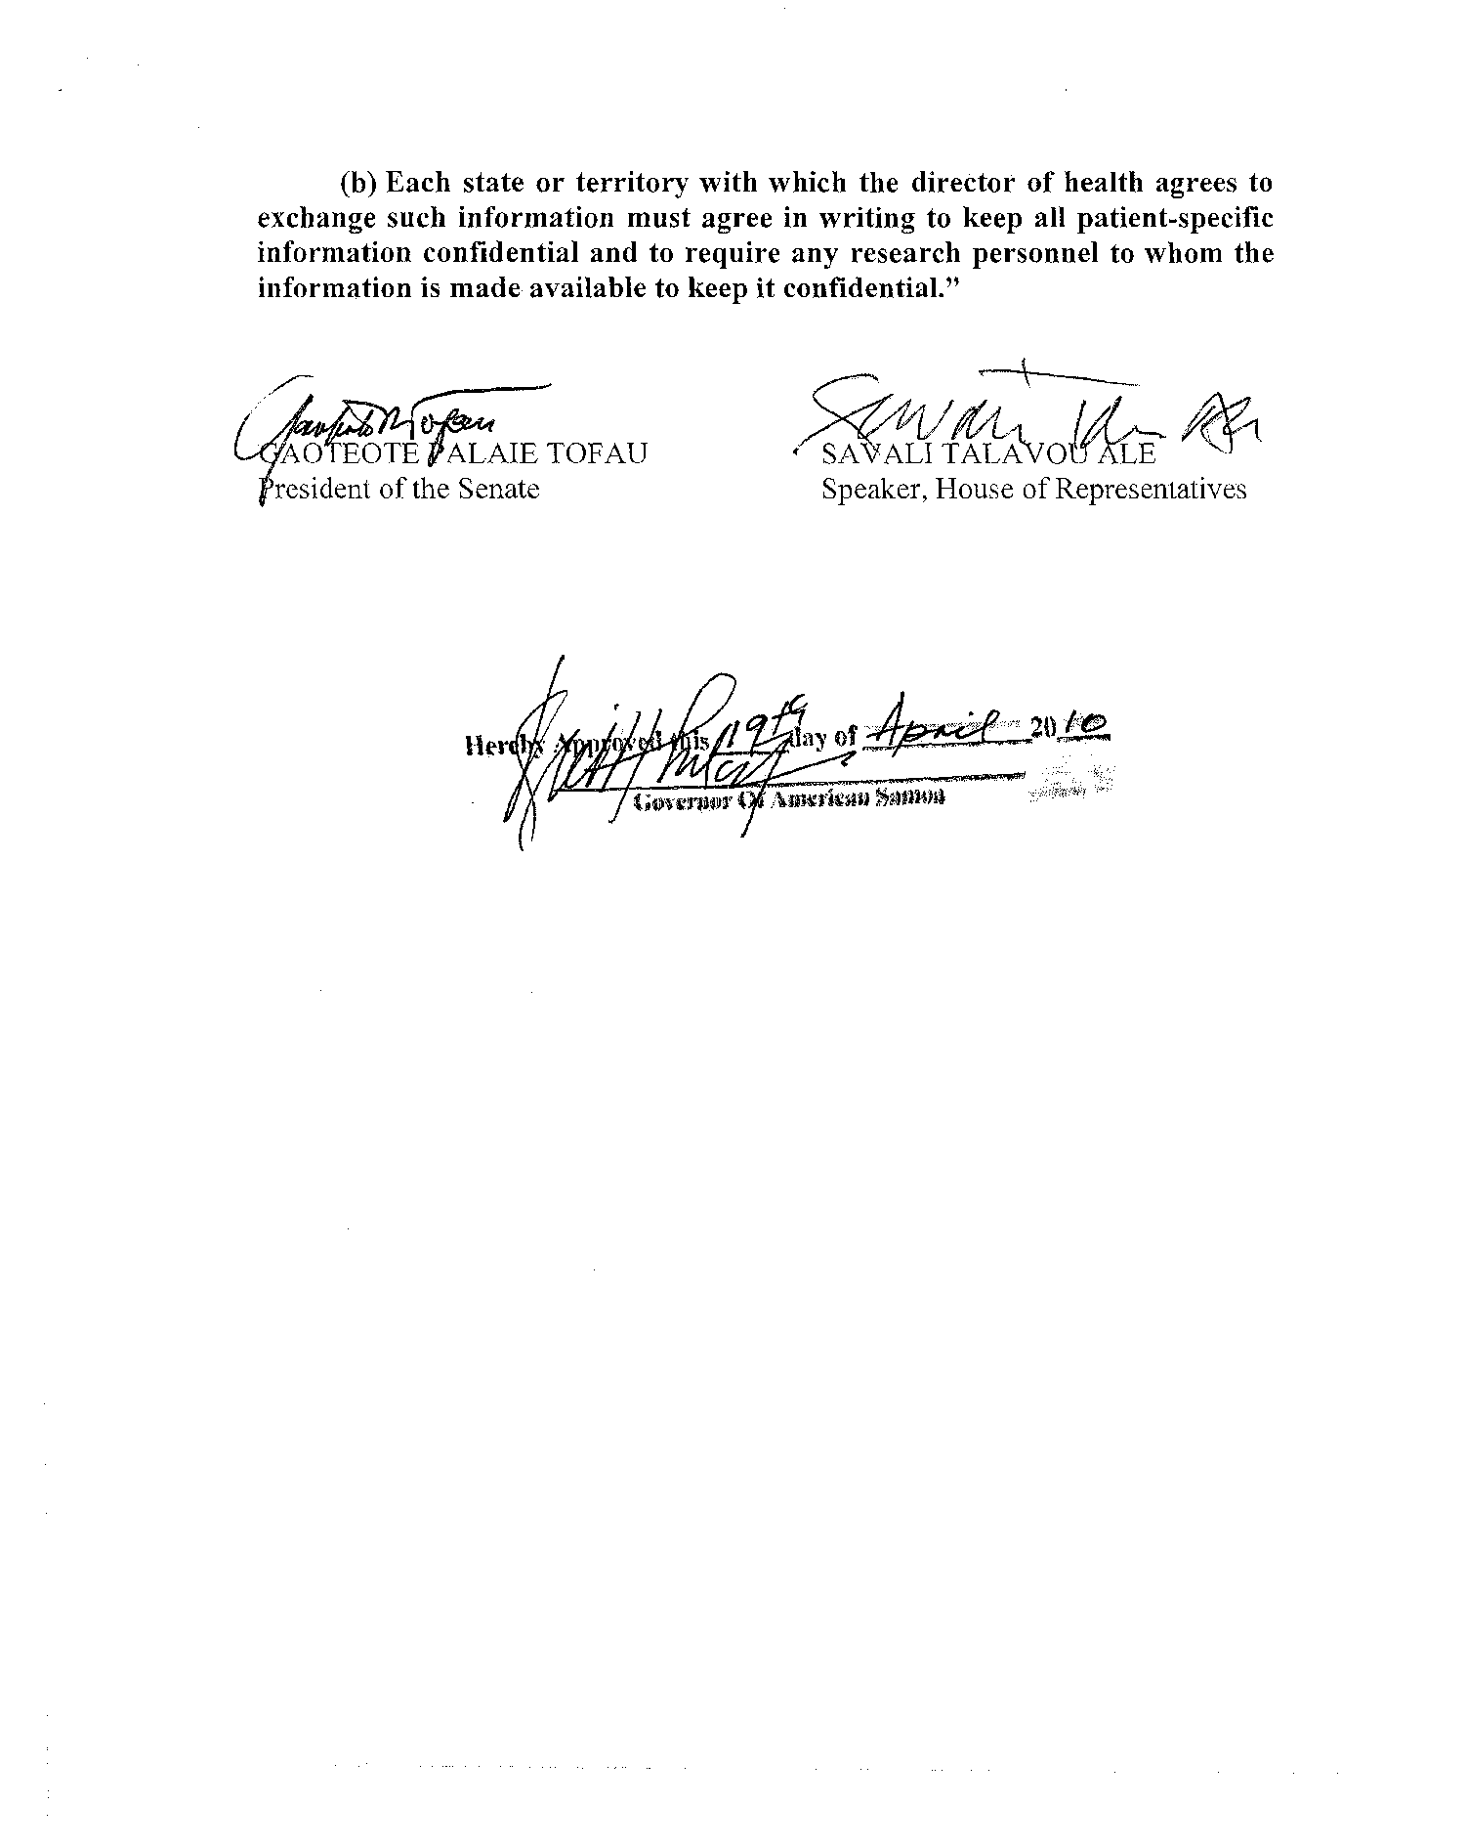

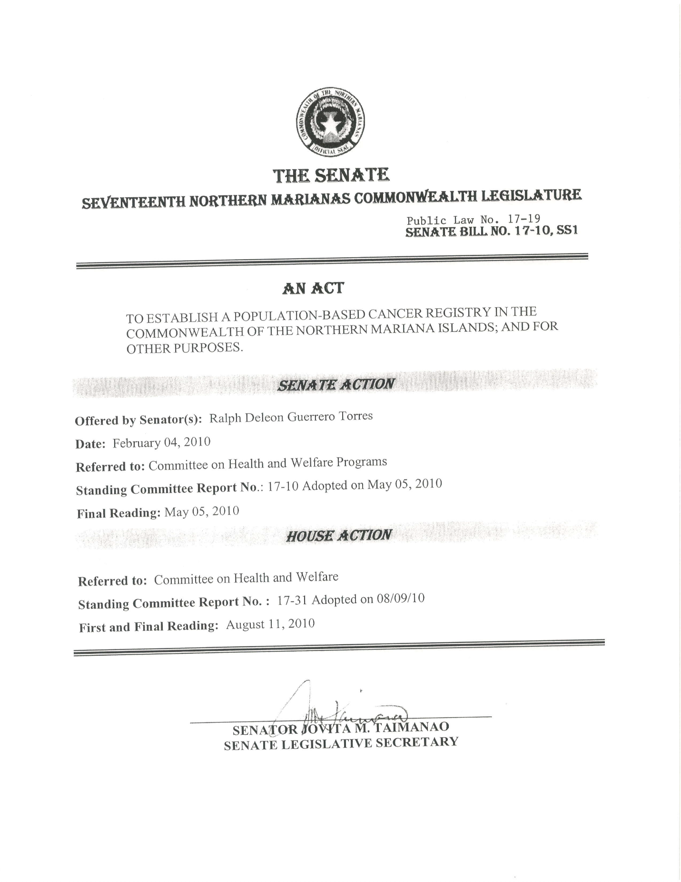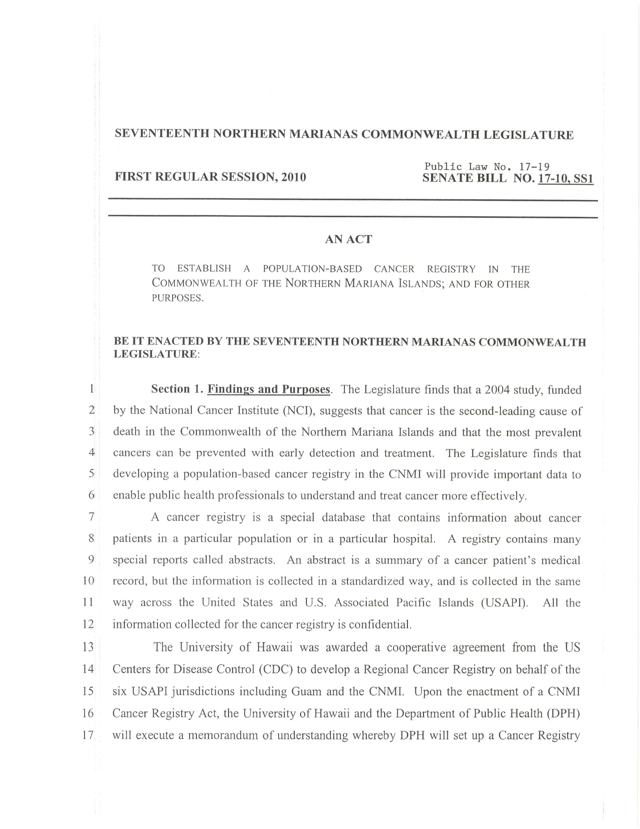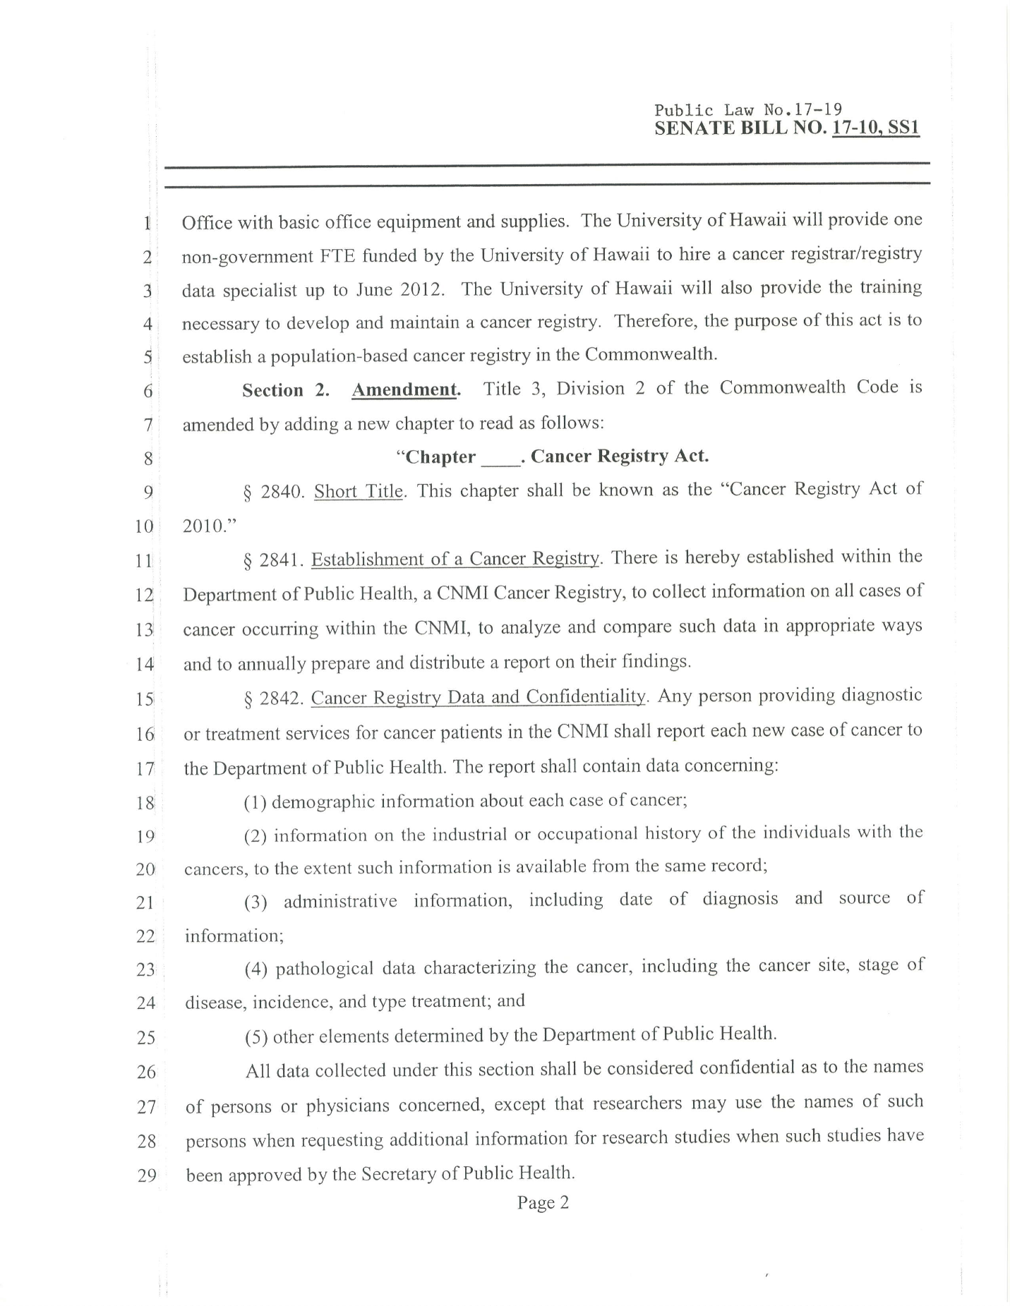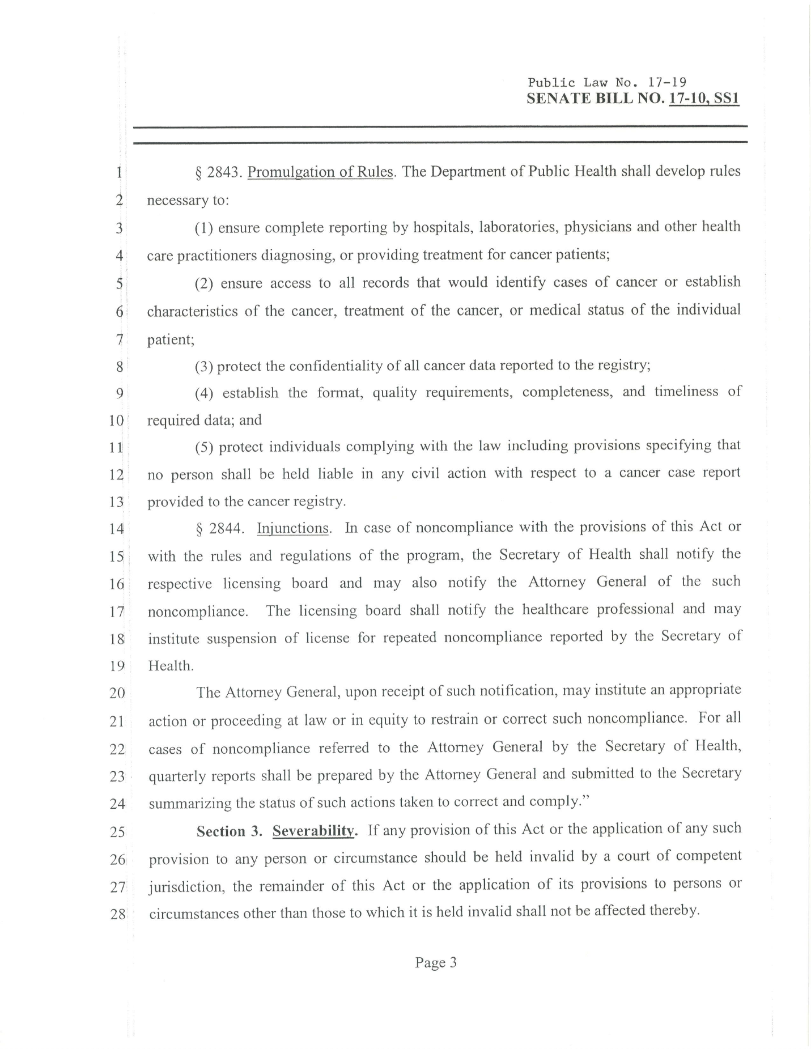
Commonwealth of the Northern Marina Islands
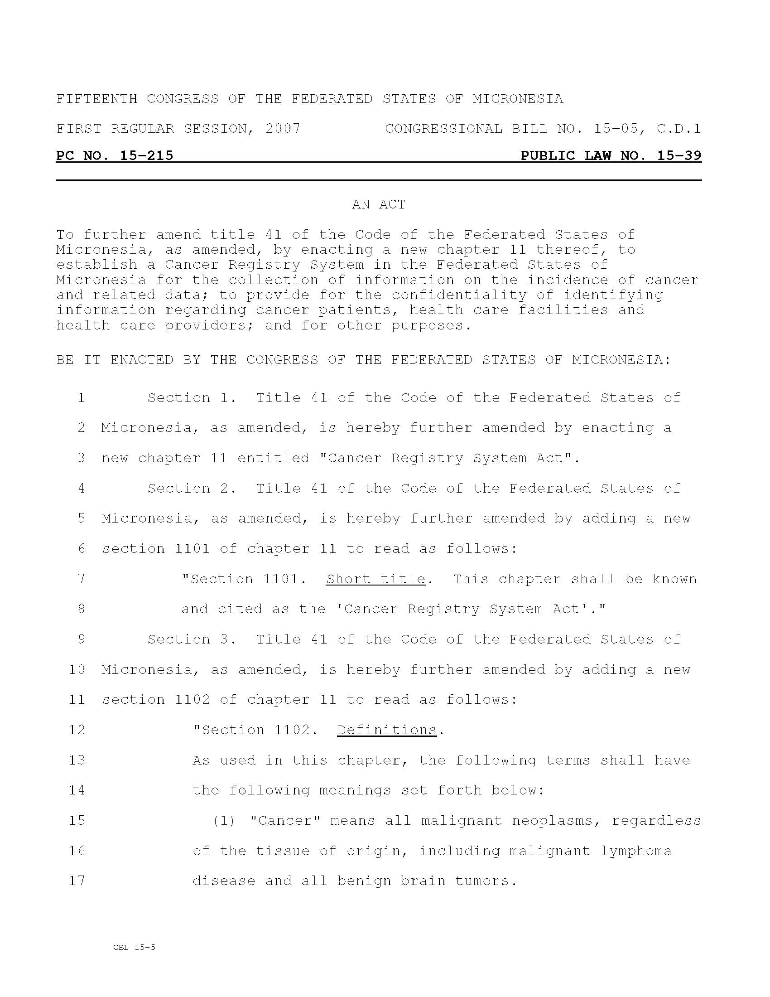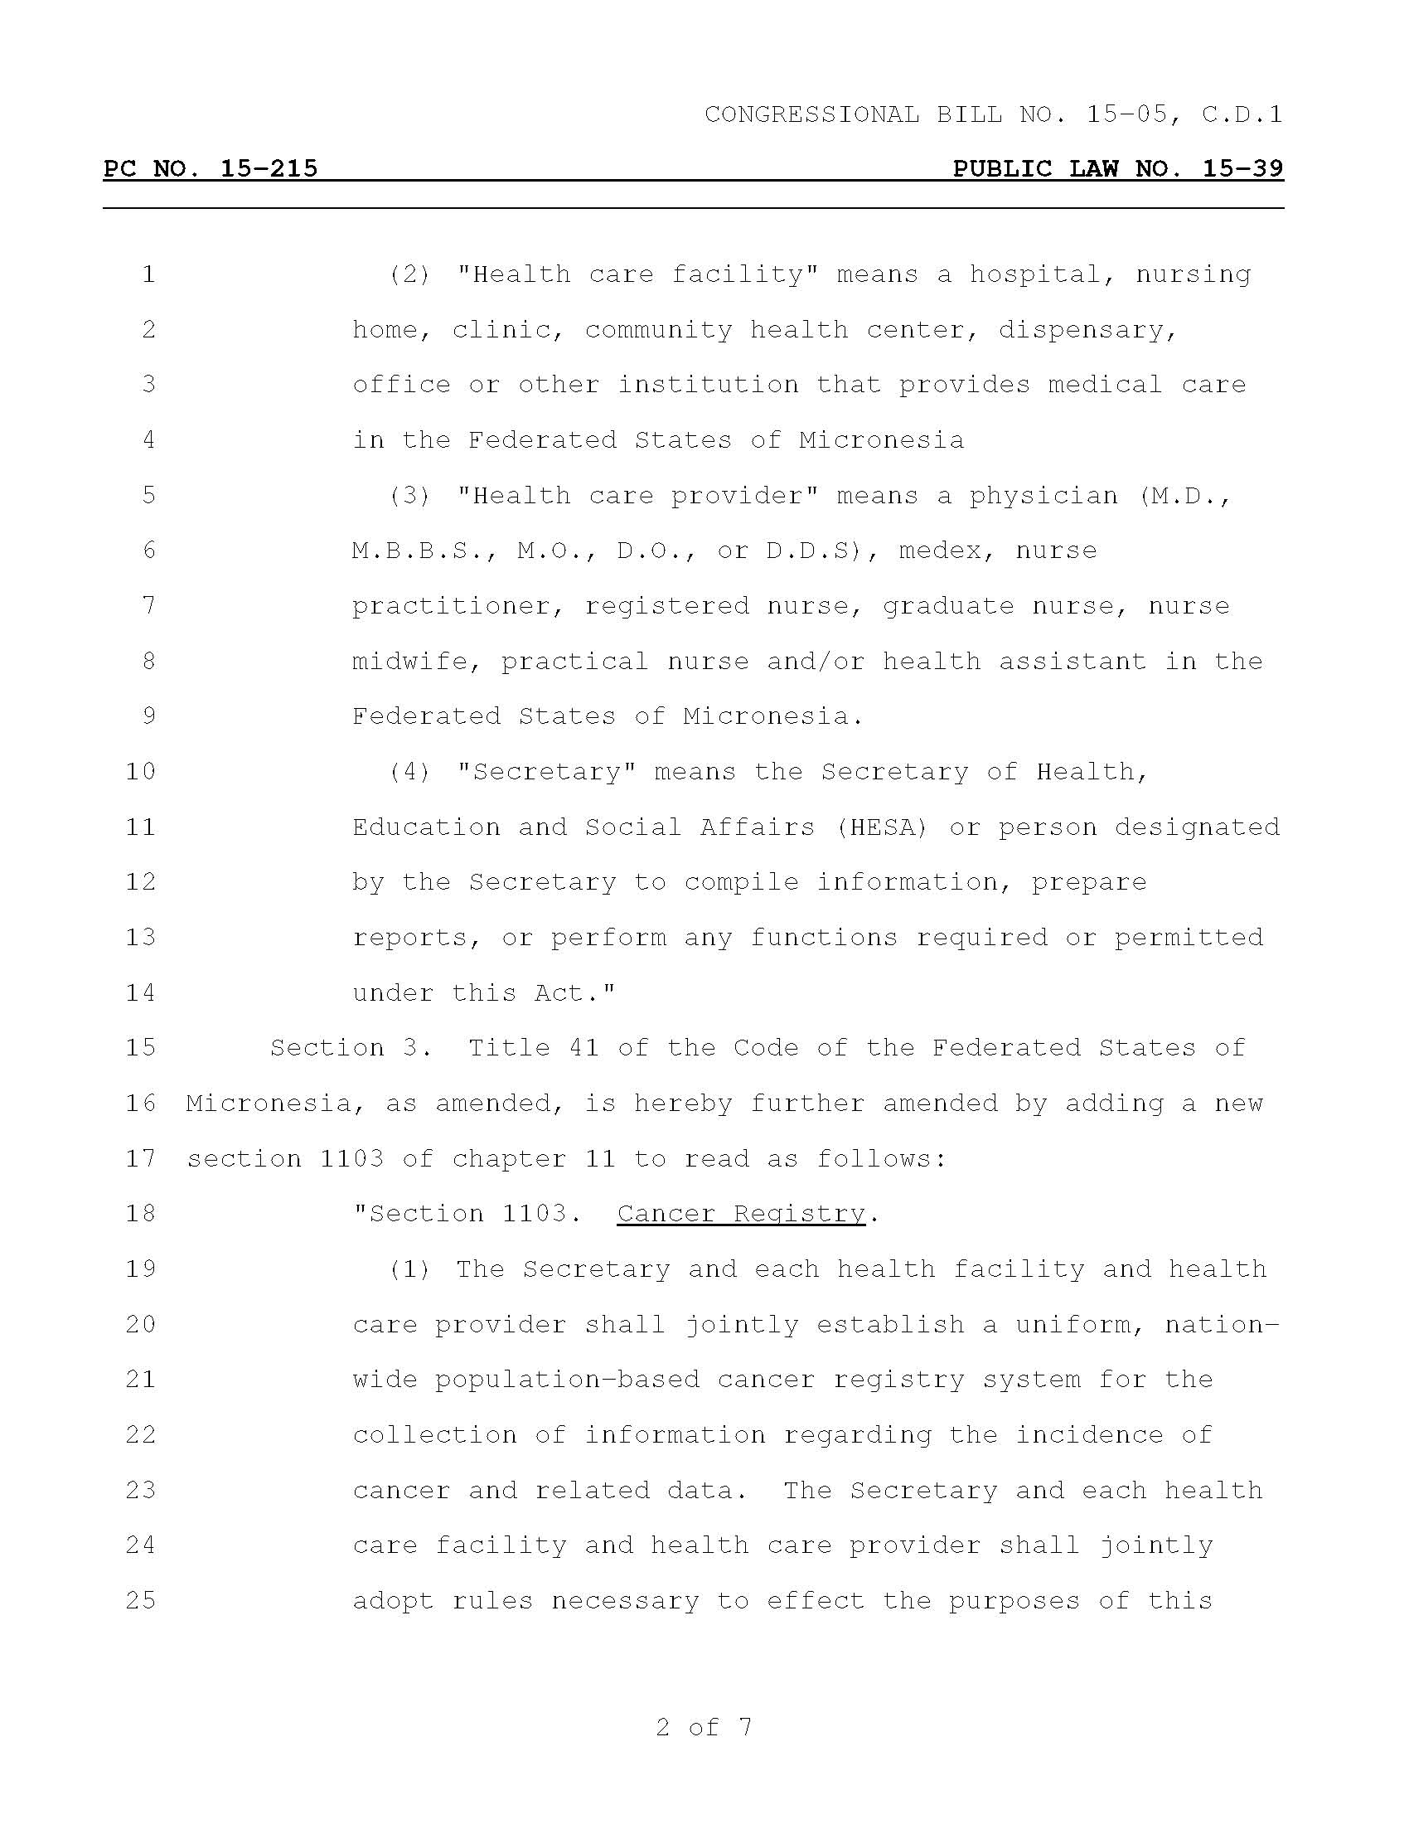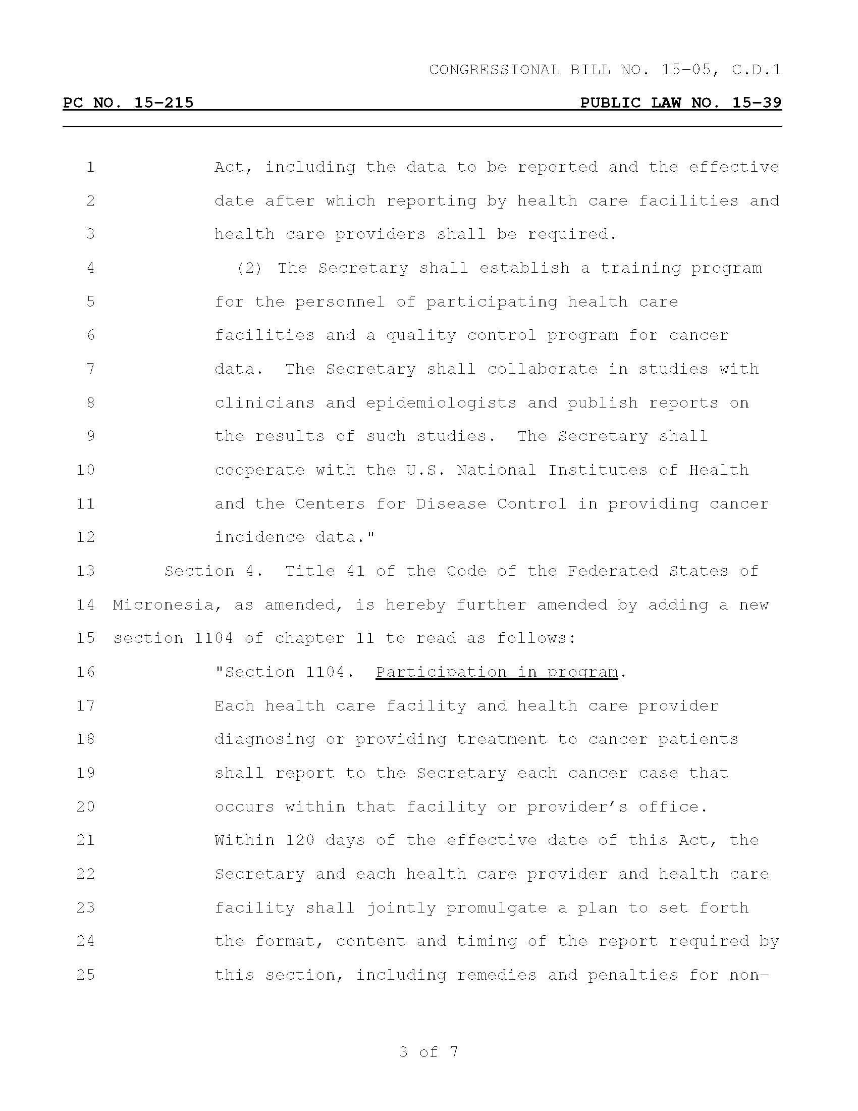
Federated States of Micronesia
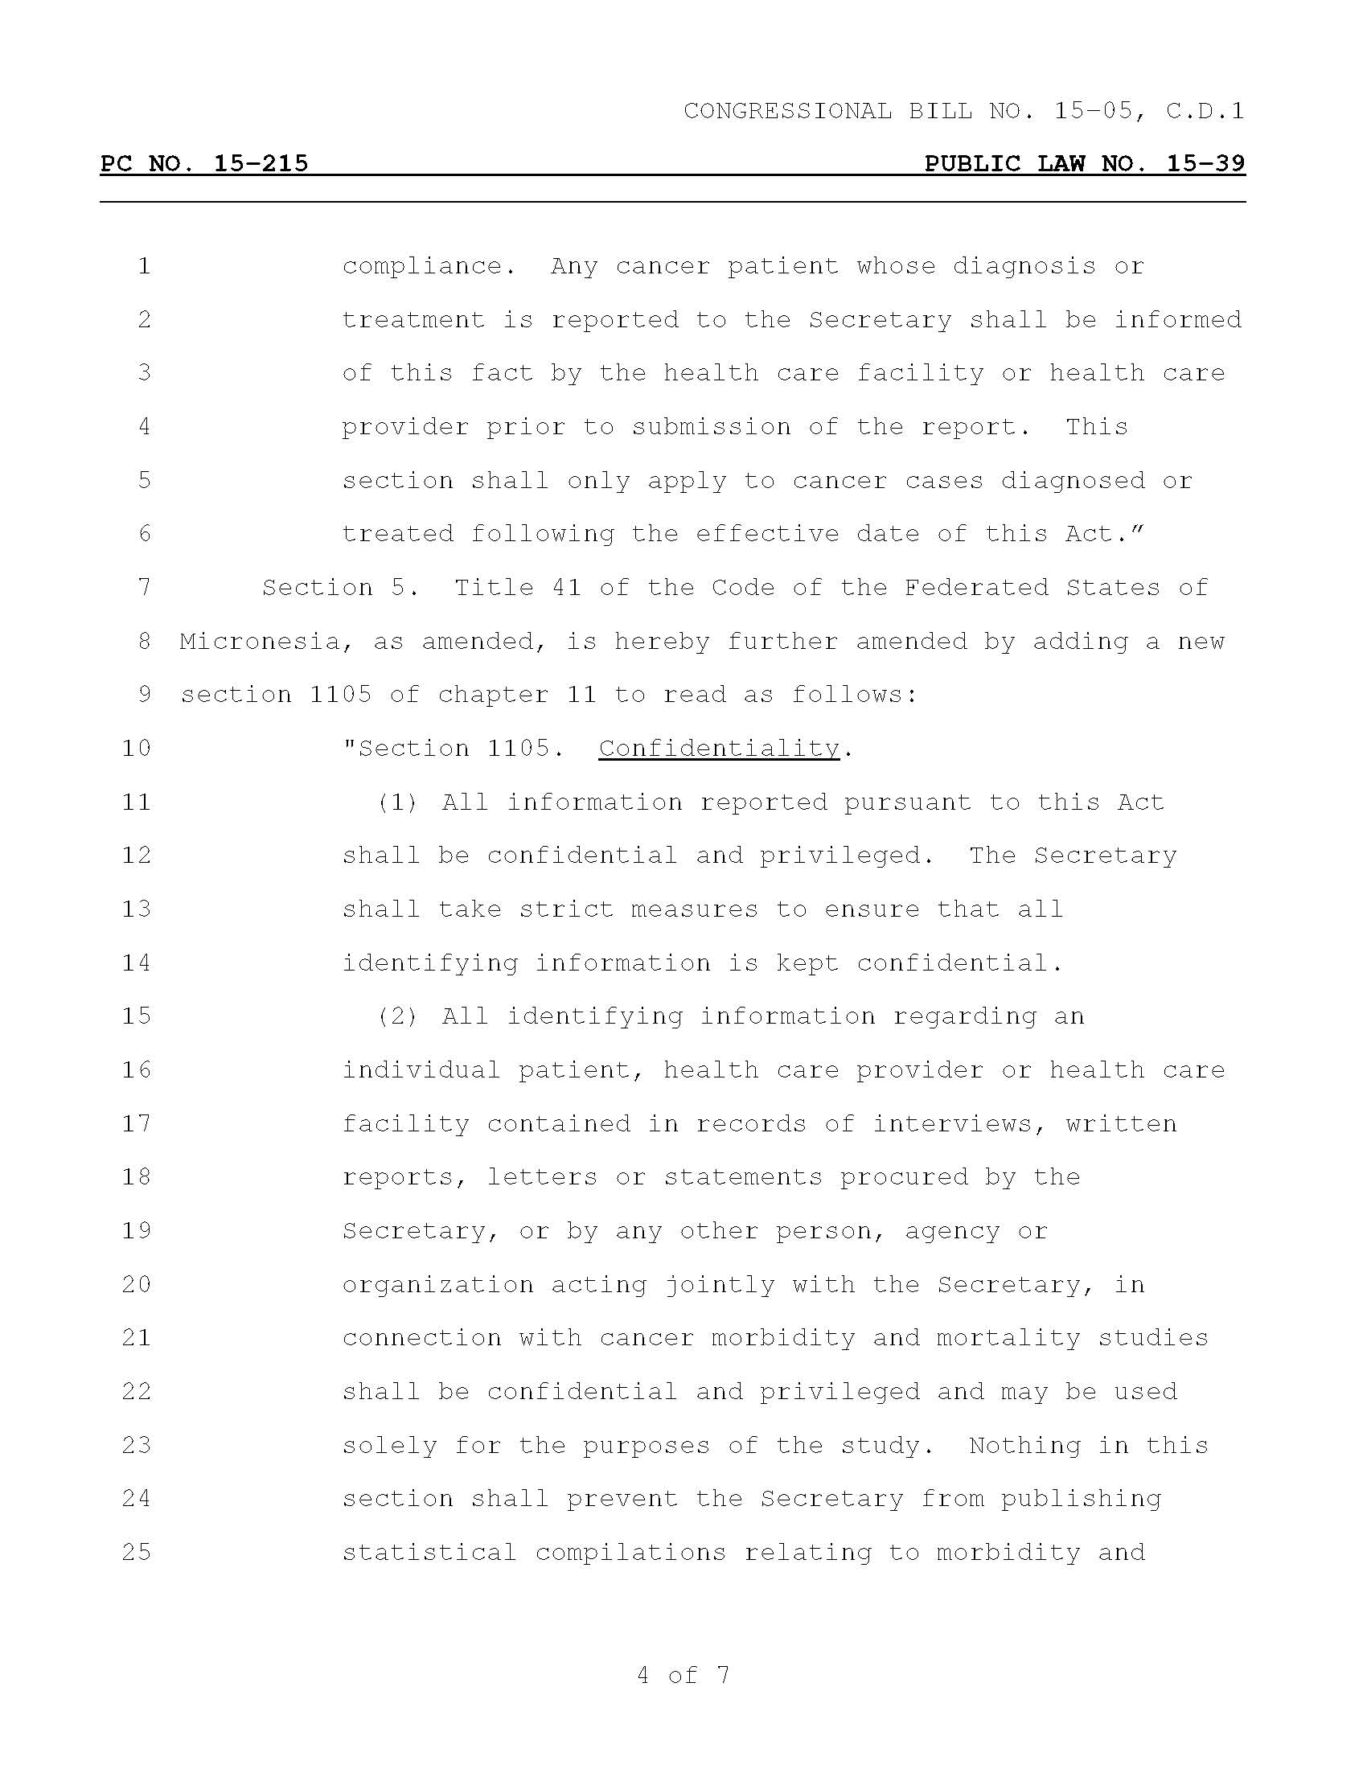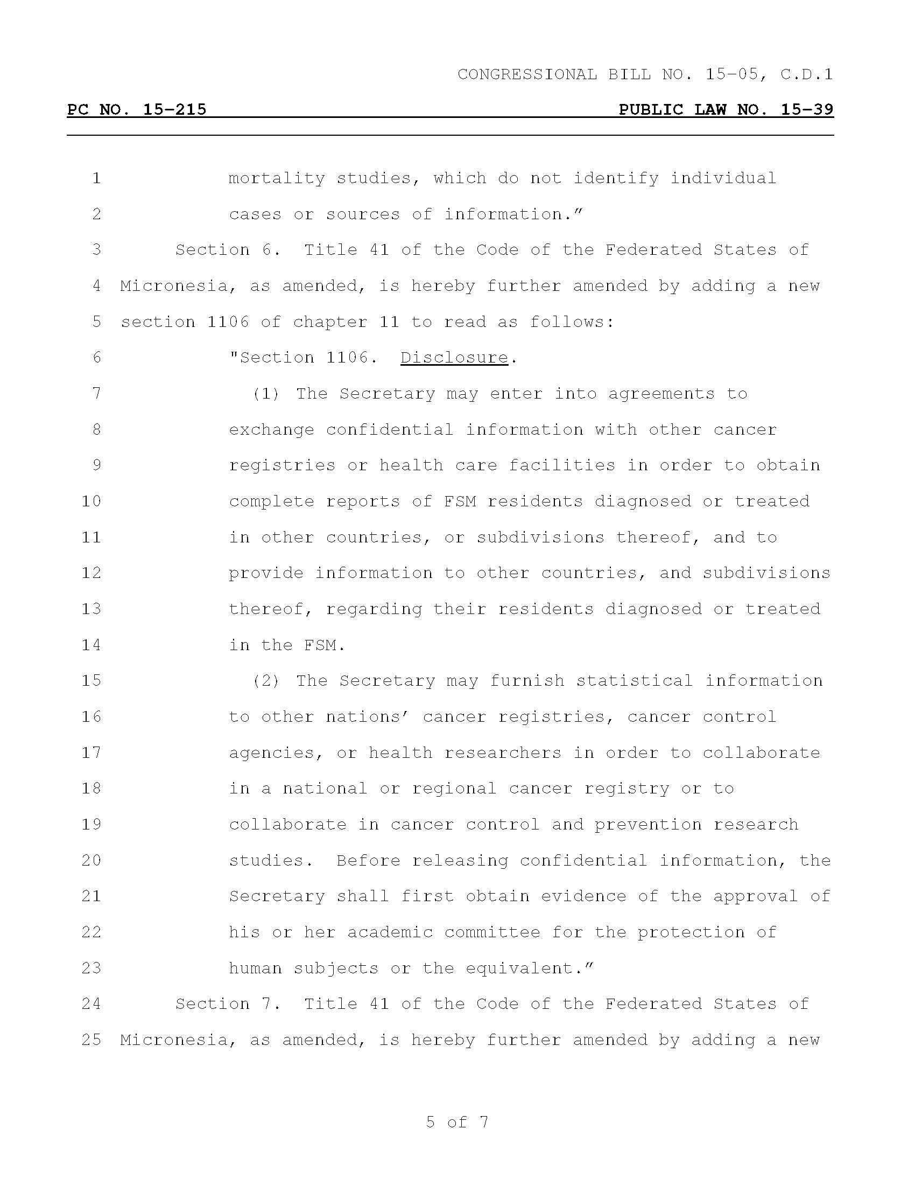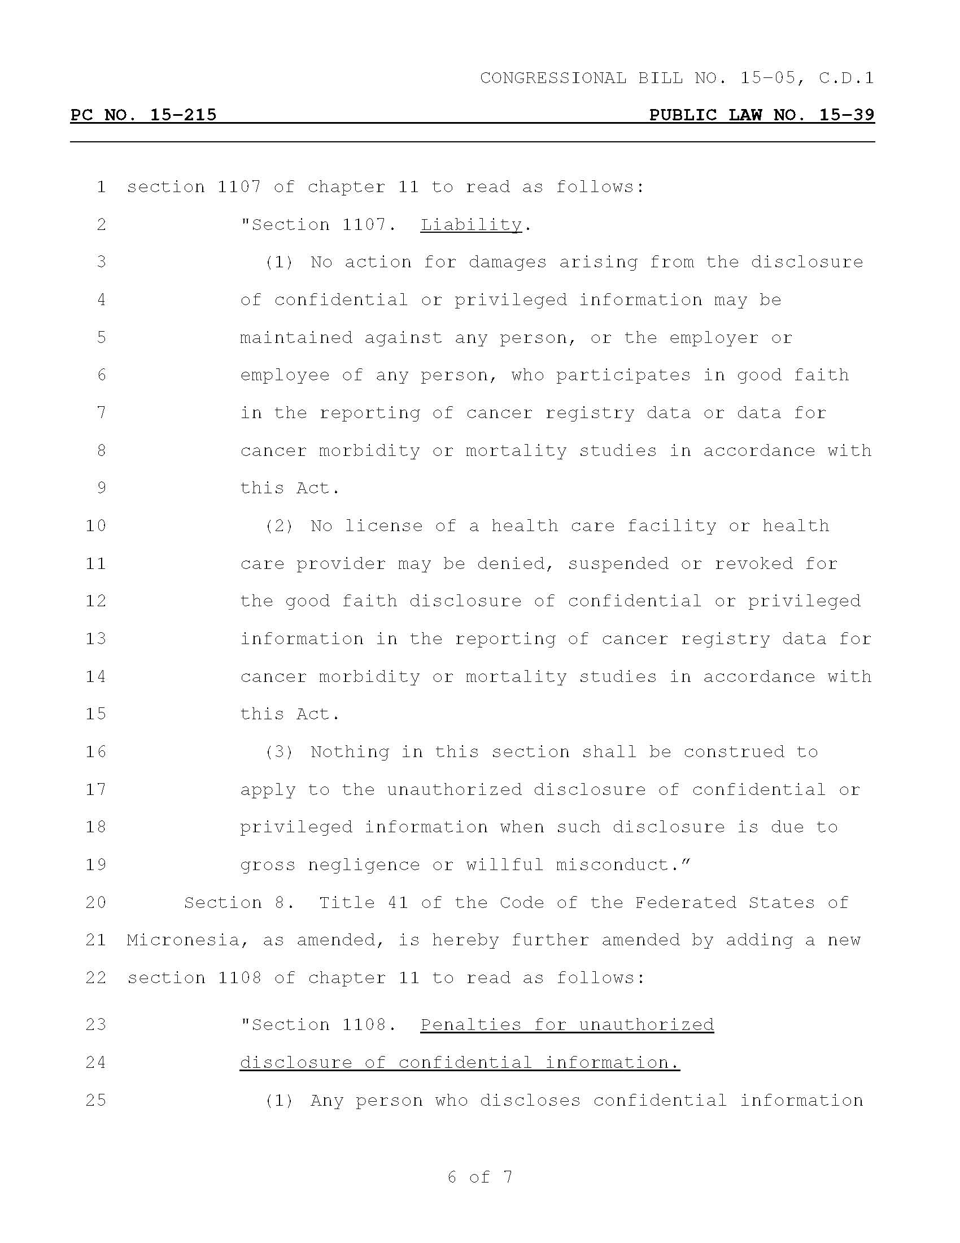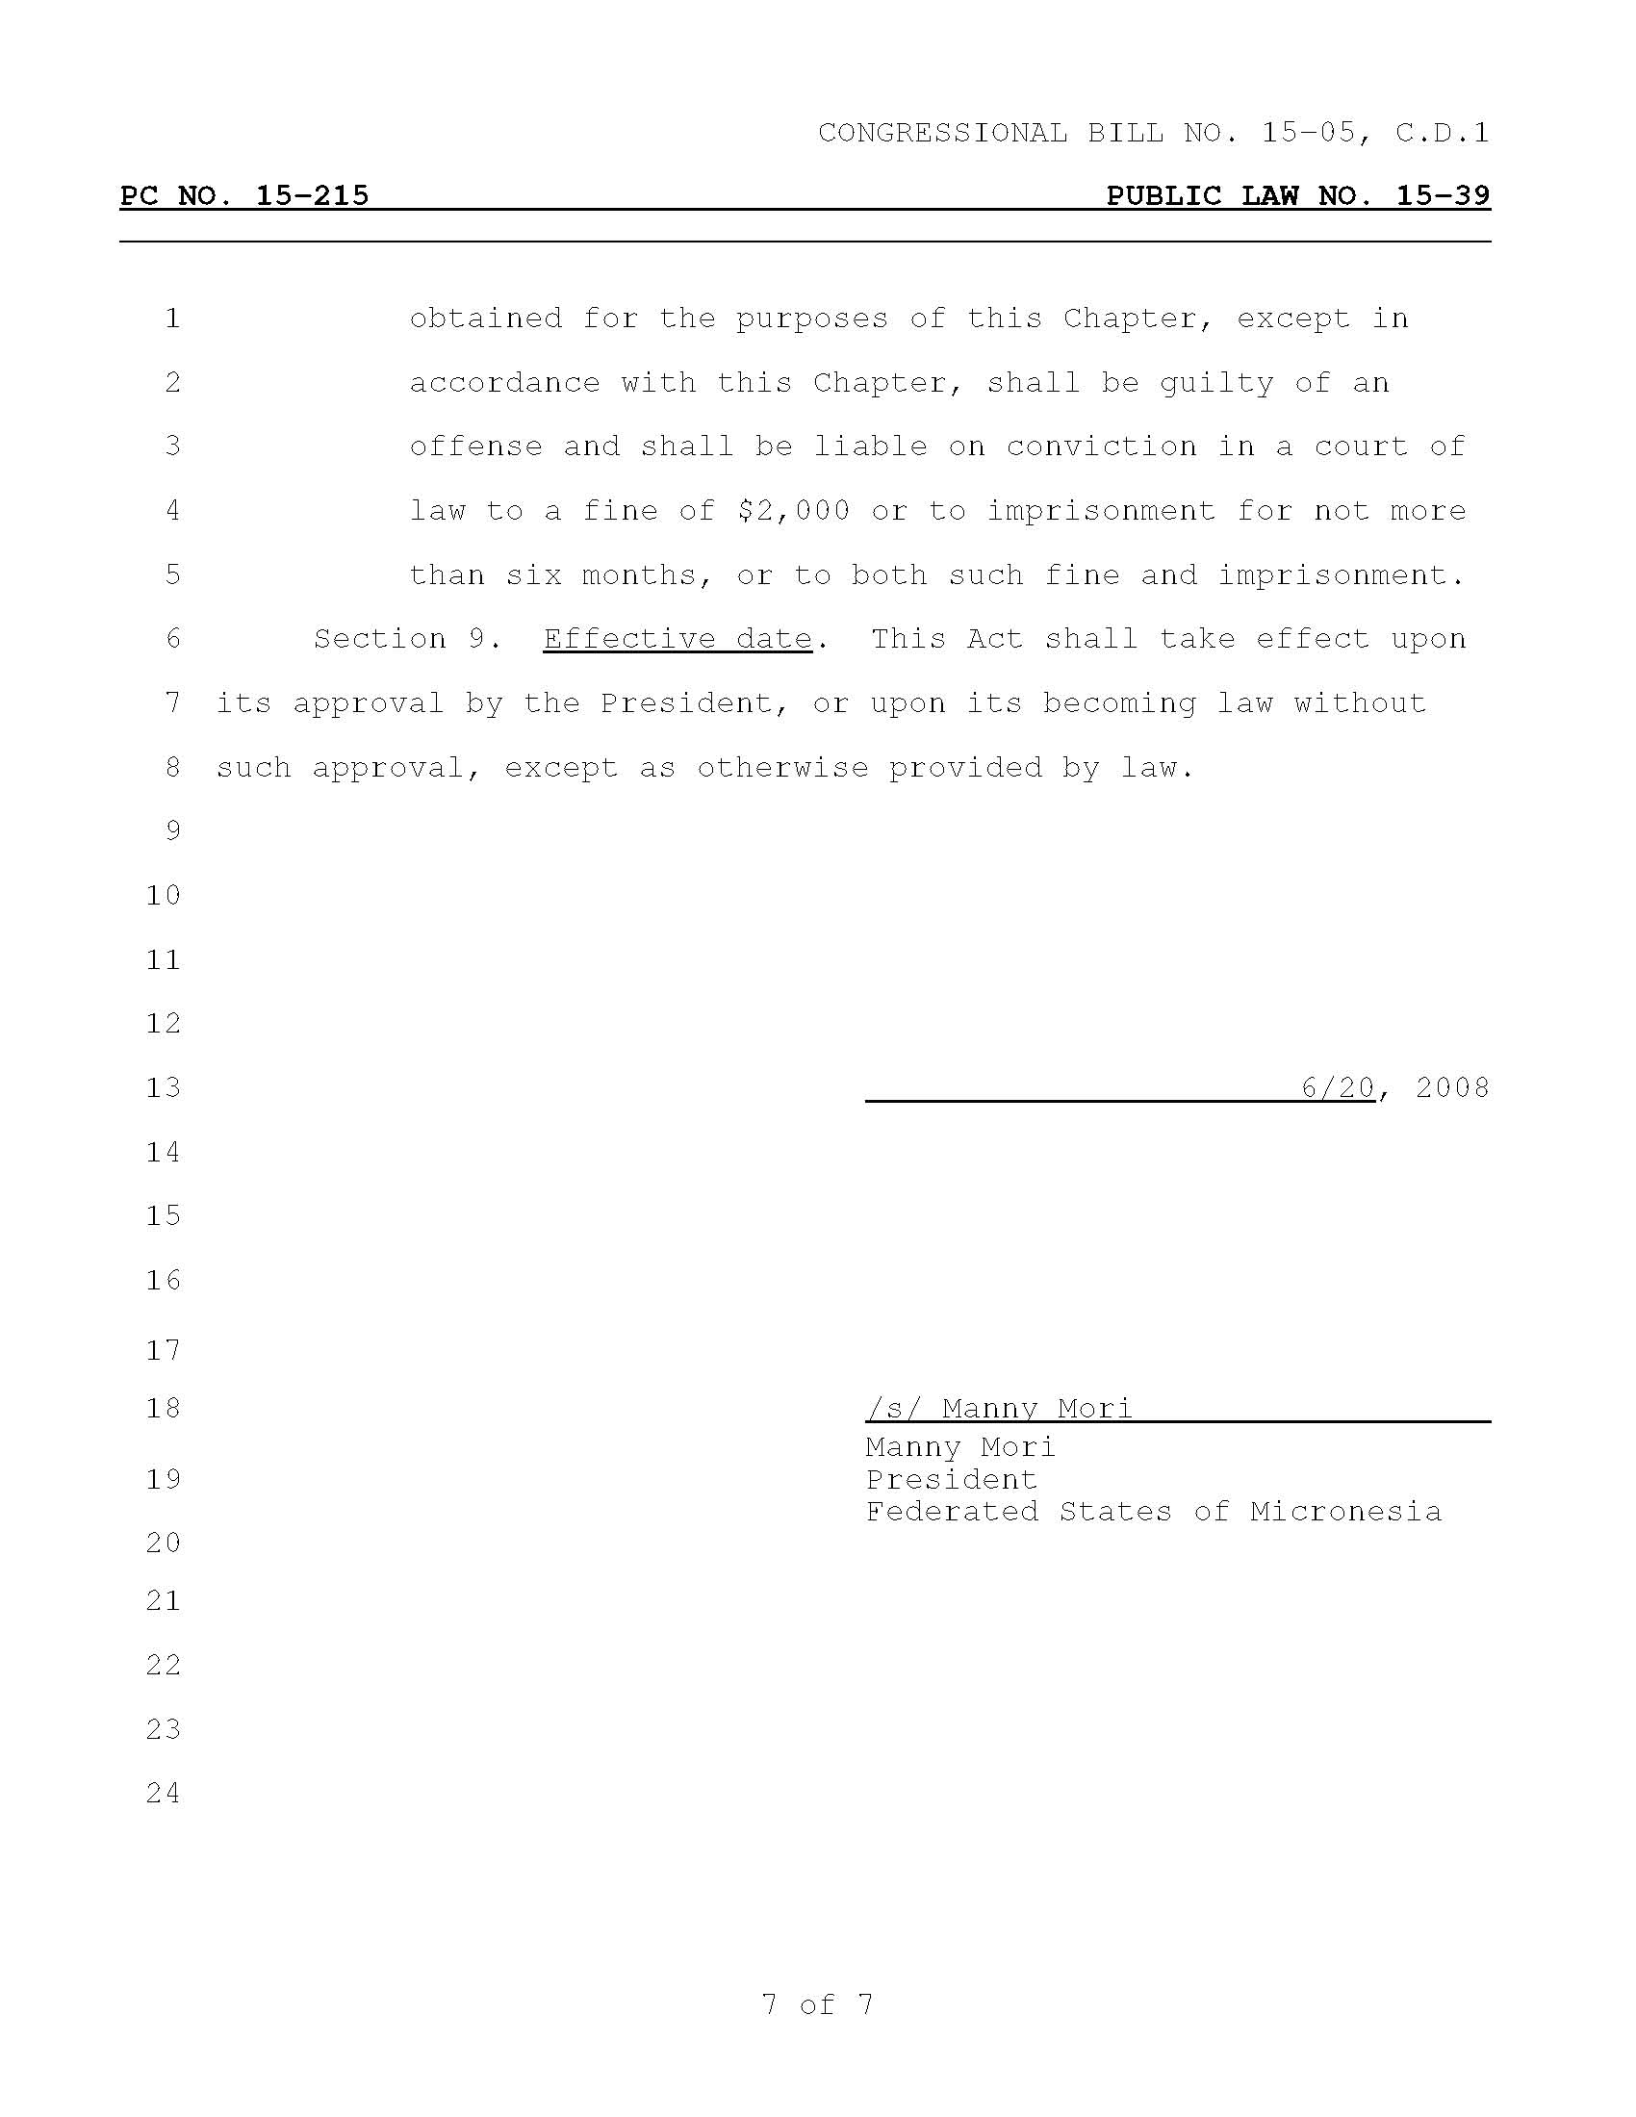
Guam Cancer Registry Act, Rules And Regulations
Public Law 24 -198 MINA’BENTE KUATTRO NA LIHESLATURAN GUAHAN 1998 (SECOND) Regular Session
Bill No. 596 (COR)
As amended by the Author and amended on the Floor.
Introduced by: E. J. Cruz, J. C. Salas, L. F. Kasperbauer, Felix P. Camacho, T. C. Ada,
F. B. Aguon, Jr., A. C. Blaz, J. M.S. Brown, Francisco P. Camacho, M. C. Charfauros,
W. B.S.M. Flores, Mark Forbes, A. C. Lamorena, V, C. A. Leon Guerrero, L. Leon Guerrero,
V. C. Pangelinan, A. L.G. Santos, F. E. Santos, A. R. Unpingco, J. Won Pat-Borja,
An act to add §3201.1 AND TO REPEAL and REENACT §80113.1, BOTH OF TITLE 10 OF THE GUAM CODE ANNOTATED, relative to reestablishing the Guam Cancer Registry within the Department of Public health and Social services.
BE IT ENACTED BY THE PEOPLE OF GUAM:
Section 1. Legislative Findings and Intent. I Liheslaturan Guahan finds that according to the latest annual report issued by the Office of Vital Statistics, Department of Public Health and Social Services, cancer is the second leading cause of death on Guam, exceeded only by diseases of the heart. I Liheslaturan Guahan also finds that response to this threat to the health of our people can be improved. Public Law Number 17-81:4, codified as 10 GCA §80113.1, established a Guam Cancer Registry within the Laboratory Section of the Guam Memorial Hospital, and requires the registry to collect information on all cases of cancer occurring within Guam, to analyze and compare such data in appropriate ways and to annually prepare and distribute a report on their findings. Consequently, it is the intent of the I Liheslaturan Guahan to insure that the availability of timely data on the incidence of cancer on Guam is essential to the development of appropriate programs to more effectively attack this disease. Therefore, it is the intent of I Liheslaturan Guahan to remedy this situation by reestablishing the Guam Cancer Registry within the Department of Public Health and Social Services.
Section 2. Section 3201.1 is hereby added to article 2, Chapter 3, Division 1, Part 1 of Title 10 of the Guam Code Annotated to read as follows:
"Section 3201.1. Guam Cancer Registry. (a) There is hereby established within the Department of Public Health and Social Services (‘DPHSS’) a Guam Cancer Registry, which shall operate under the supervision of the Division of Public Health, Office of Epidemiology and Research, to collect information on all cases of cancer occurring within Guam, to analyze and compare such data in appropriate ways and to annually prepare and distribute a report on their findings. The Guam Epidemiologist shall be a Guam-licensed physician or a licensed veterinarian.
(b) Injunctions. In case of noncompliance with the provisions of this Act or with the rules and regulations of the program, the Director shall notify the respective licensing Board and may also notify the Attorney General of such noncompliance. The licensing Board shall notify the healthcare professional and may institute suspension of license for repeated noncompliance reported by the Director of DPHSS.
The Attorney General, upon receipt of such notification, may institute an appropriate action or proceeding at law or in equity to restrain, correct such noncompliance. For all cases of noncompliance referred to the Attorney General by the Director of DPHSS, quarterly reports shall be prepared by the Attorney General and submitted to the Director summarizing the status of actions taken to correct and comply."
Section 3. Repeal and Reenact. Section 80113.1 of Chapter 80, Division 4, Part 2 of Title 10 of the Guam Code Annotated is hereby repealed and reenacted to read as follows:
"Section 80113.1. Cancer Data Collection. The Guam Memorial Hospital Authority (‘GMHA’) and the GMHA Medical Staff shall continue to collect information regarding cancer cases with relevant data for the Cancer Registry as established by the Department of Public Health and Social Services. GMHA shall provide DPHSS cancer information semiannually."

Section 4. Regulations. The Director is authorized to promulgate rules and regulations as may be necessary for the purpose of carrying out the provisions of this Act in accordance with the Administrative Adjudication Law.

GOVERNMENT OF GUAM
DEPARTMENT OF PUBLIC HEALTH AND SOCIAL SERVICES

GUAM CANCER REGISTRY
REGULATIONS

Authority. Public Law 24-198
Purpose. The purpose of the Guam Cancer Registry is to aid in the reduction of cancer morbidity and mortality on Guam by providing basic island-wide population-based cancer incidence data for the facilitation of cancer research and the evaluation of cancer control programs.
Definitions.
(A) "Cancer" means any primary malignant neoplasm with the exception of superficial basal and squamous cell carcinoma of the skin.
(B) "Department" means the Guam Department of Public Health and Social Services.
(C) "Director" means the director of the Guam Department of Public Health and Social Services.
(D) "Health care provider" means any person providing diagnostic or treatment services for a cancer patient on Guam.

(E) "Person" means any individual, firm, partnership, professional association, corporation, government or public service agency providing diagnostic or treatment services for cancer patients on Guam, either directly or by third party payment for services.
(F) "Registry" means the Guam Cancer Registry.
Responsibility for reporting.
(A) Any person providing diagnostic or treatment services for cancer patients on Guam shall report each new case of cancer to the Registry on forms specified by the Registry or in such other manner as may be approved by the Registry. The report shall contain information regarding the patient which includes, but is not necessarily limited to, the following:
(1) Last name of patient;
(2) First name of patient;
(3) Middle name(s) of patient;
(4) Social security number of patient;
(5) Village of residence at time of diagnosis;
(6) Street address at time of diagnosis;

(7) Zip code at time of diagnosis:
(8) Birth date;
(9) Where born;
(10) Length of time patient lived on Guam;
(11) Death date (if applicable);
(12) Sex;
(13) Ethnicity;
(14) Marital status;
(15) Usual occupation;
(16) Date of cancer diagnosis;
(17) Basis of diagnosis;
(18) Anatomical site of the cancer (topography);
(19) Cell-type of the cancer (histology);
(20) Tumor behavior;
(21) Tumor grade;
(22) Tumor stage (TNM);
(23) Treatment type;
(24) Hospital/clinic treating patient;
(25) Name of physician treating patient;
(26) Patient's medical record number;
(27) Name of person preparing report;
(28) Name of contact for additional patient information (relative of patient);
(29) Telephone number and mailing address of contact.
(B) Cases of cancer diagnosed on or after January first of each calendar year but before July first of the same calendar year shall be reported no later than December thirty-first of that year. Cases of cancer diagnosed on or after July first of each calendar year but before January first of the next calendar year shall be reported no later than June thirtieth of the next calendar year.
(C) Any person providing diagnostic or treatment services to patients with cancer shall grant to the Registry or its authorized representative access to all records that identify cases of cancer or establish characteristics of cancer, the treatment of cancer, the medical status of identified cancer patients or the demographic characteristics of cancer patients.
(D) This rule does not affect the authority of any person providing diagnostic or treatment services to patients with cancer to maintain facility-based tumor registries, in addition to complying with the reporting requirements of this regulation.
(E) Cases of cancer known by a health care provider to have been diagnosed at a health care facility or previously admitted to a health care facility for the diagnosis or treatment of the same cancer need not be reported by the health care provider treating such patients.
Confidentiality.
Any information, data, and reports with respect to a case of cancer which are furnished to, or procured by the registry shall be confidential and shall be used only for statistical, scientific, and medical research purposes. The Director shall take reasonable measures to ensure that all individual identifying information is kept under secure conditions.

Research.
(A) Although information concerning individual cancer patients obtained by the registry is for the confidential use of the Department, individuals conducting bonafide medical research may be given access to confidential information if all the following conditions are met:
(1) The person conducting the research provides written information about the purpose of the research project, the nature of the data to be collected and how the researcher intends to analyze it, the records the researcher seeks to review, and the safeguards the researcher will take to protect the identity of patients whose records the researcher will be reviewing;
(2) The person conducting the research submits verification of his credentials and of the credentials of other individuals involved in conducting the research;
(3) In the view of the Director, the proposed safeguards are adequate to protect the identity of each patient whose records will be reviewed. Safeguards for the protection of the identity of patients shall include, but are not limited to, provisions to limit access to identifying data to only those individuals who, during the course of the project, need access to such information for research purposes and provisions for the maintenance of the confidentiality of identifying information after the termination of the project;
(4) The research project has clearly defined goals that pertain to cancer prevention and control;
(5) For case control studies, the research design used in the medical research project involves a sufficiently large sample size that any meaningful difference between cases and controls will be statistically significant. For other studies, the research project will provide enough cases for meaningful analysis of the data, for identification of potential risk factors and intervention strategies for cancer prevention and control; and
(6) The research project will be conducted at a university, hospital, or other medical research institution by competent researchers who have the ability to analyze and interpret data;
(7) An agreement is executed between the Department and the researcher that specifies the terms of the researcher's use of the records and prohibits the publication or release of the names of individual cancer patients or any facts tending to lead to the identification of individual cancer patients.

(B) Notwithstanding any other provisions of this rule, a researcher may, with the approval of the Department, use the names of individual cancer patients when requesting additional information for research purposes or soliciting a patient's participation in a research project. If a researcher requests additional information or a cancer patient's participation in a research project, the researcher shall first obtain the oral or written consent of the patient's attending physician. If the consent of the patient's attending physician is obtained, the researcher shall obtain the patient's written consent by having the patient complete a release of confidential information form.
(C) Notwithstanding any other provisions of this rule, the Registry may release confidential information concerning individual cancer patients to physicians for diagnostic and treatment purposes if the patient's attending physician and the patient give written consent by completing a release of confidential information form.
(D) Notwithstanding any other provisions of this rule, the Registry may release confidential information concerning individual cancer patients to a cancer registry of another state, if such registry has entered into a reciprocal agreement with the Department and the agreement provides that such registry will comply with this section and that information identifying a patient will not be released to any person without the written consent of the patient.
(E) Nothing in this rule shall prevent the release to any person of aggregated epidemiological data that does not identify individual cancer patients.
Freedom from liability.
No person furnishing any information, data, or report to the Registry in fulfillment of the provisions of this regulation shall, by reason of such furnishing, be deemed to have violated any confidential relationship, or be held liable in damages, or be held to answer for willful betrayal of a professional confidence within the meaning and intent of relevant sections of the Government Code of Guam.
These regulations became effective June 15, 1999

DEPARTMENT OF PUBLIC HEALTH AND SOCIAL SERVICES
GOVERNMENT OF GUAM
GUAM LAW CONCERNING REPORTING OF CANCER
Article 2, Chapter 3, Division 1, Part 1 of Title 10, Guam Code:
Section 3201.1. Guam Cancer Registry.
(a) There is hereby established within the Department of Public Health and Social Services ('DPHSS') a Guam Cancer Registry, which shall operate under the supervision of the Division of Public Health, Office of Epidemiology and Research, to collect information on all cases of cancer occurring within Guam, to analyze and compare such data in appropriate ways and to annually prepare and distribute a report on their findings. The Guam Epidemiologist shall be a Guam-licensed physician or a licensed veterinarian.
(b) Injunctions. In case of noncompliance with the provisions of this Act or with the rules and regulations of the program, the Director shall notify the respective licensing Board and may also notify the Attorney General of such noncompliance. The licensing Board shall notify the healthcare professional and may institute suspension of license for repeated noncompliance reported by the Director of DPHSS.
The Attorney General, upon receipt of such notification, may institute an appropriate action or proceeding at law or in equity to restrain, correct such noncompliance. For all cases of noncompliance referred to the Attorney General by the Director of DPHSS, quarterly reports shall be prepared by the Attorney General and submitted to the Director summarizing the status of actions taken to correct and comply.
Section 3201.2. Regulations. The Director is authorized to promulgate rules and regulations as may be necessary for the purpose of carrying out the provisions of this Act in accordance with the Administrative Adjudication Law.

SOURCE: Added by P.L. 24-198:2,4.

Republic of the Marshall Islands Registry Act
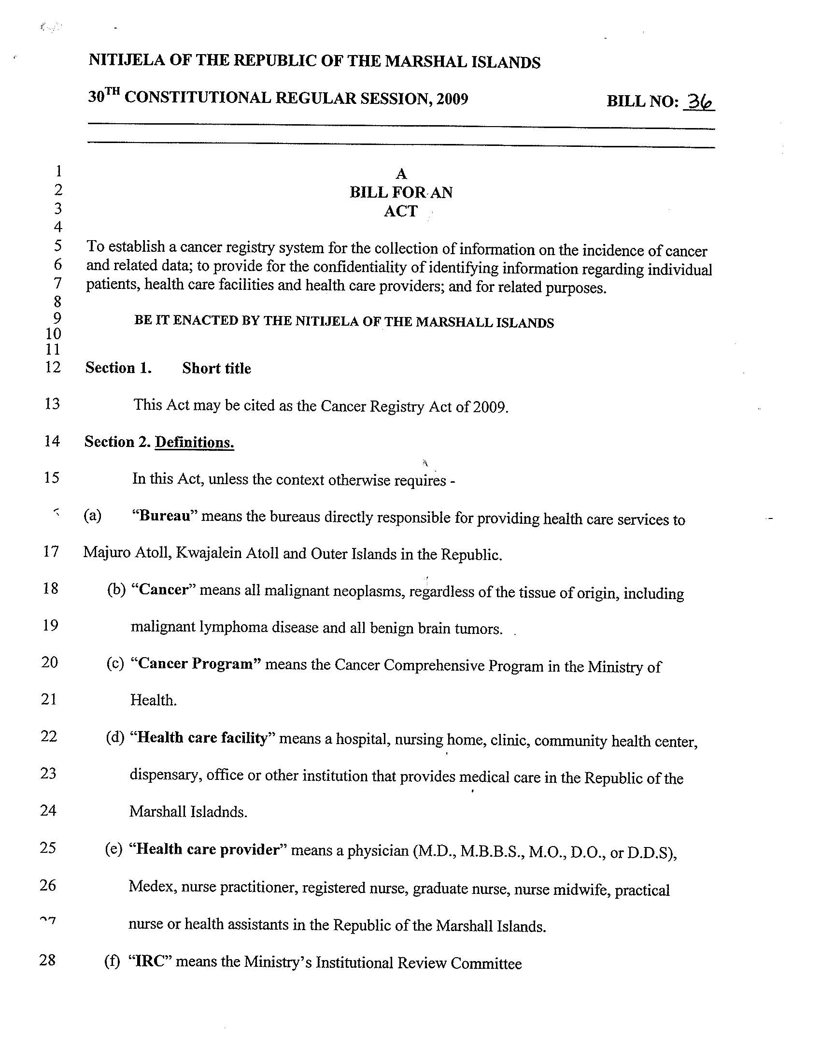

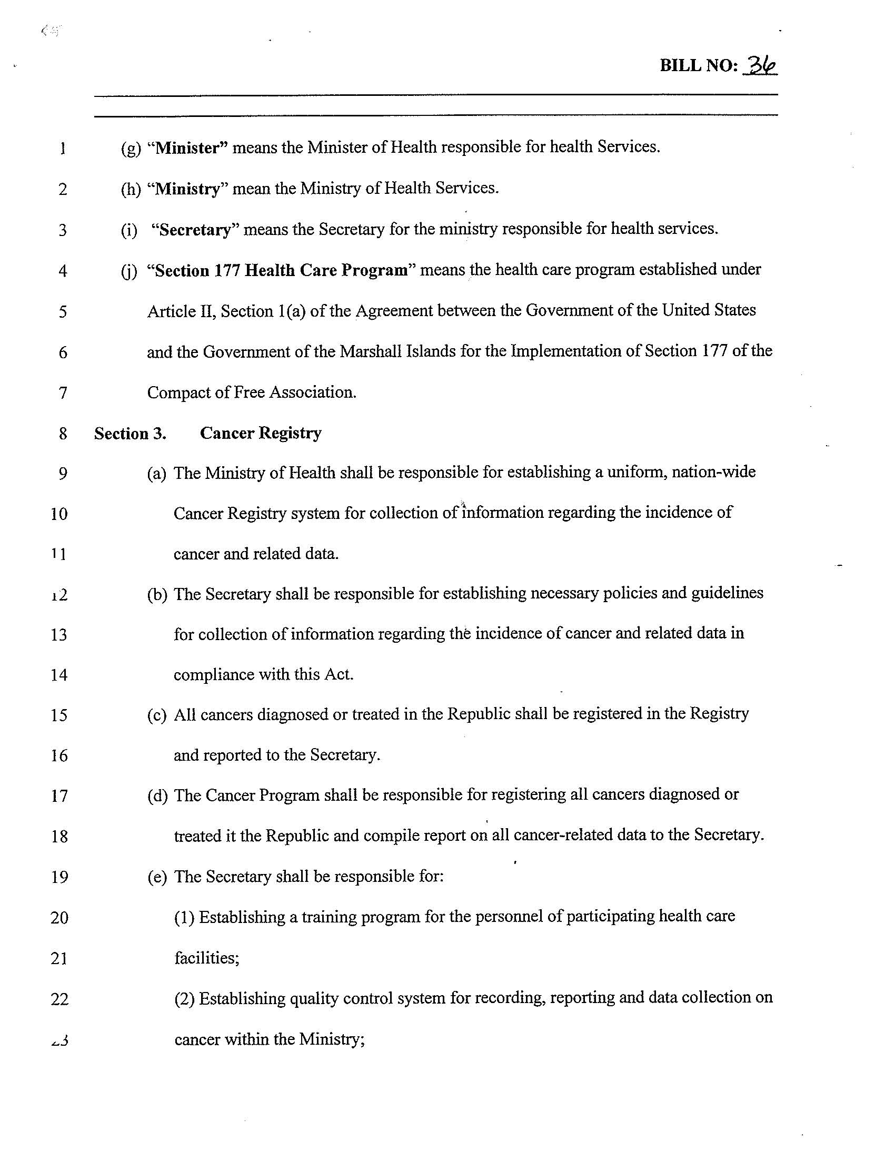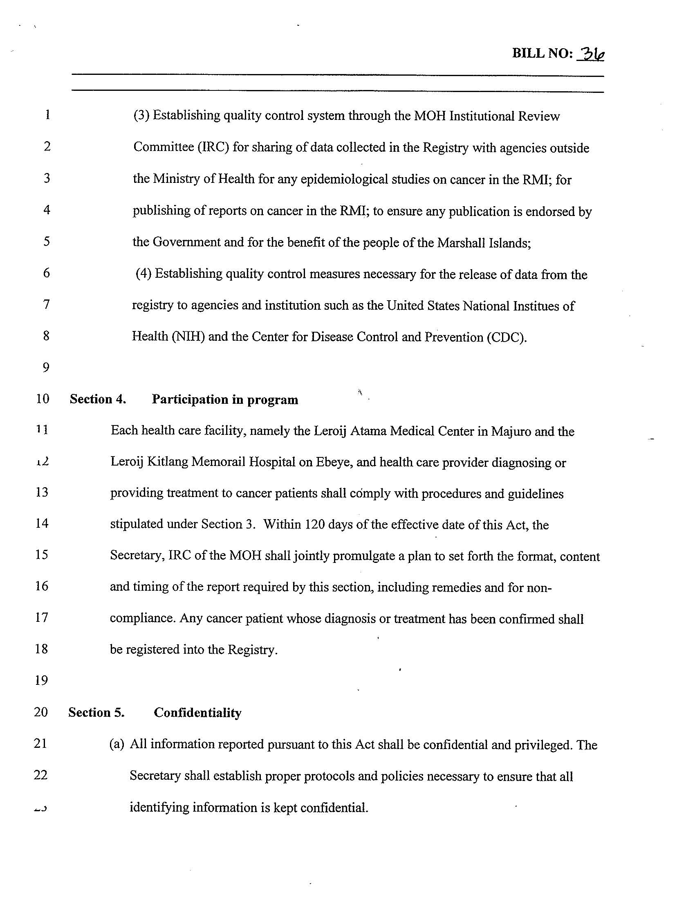

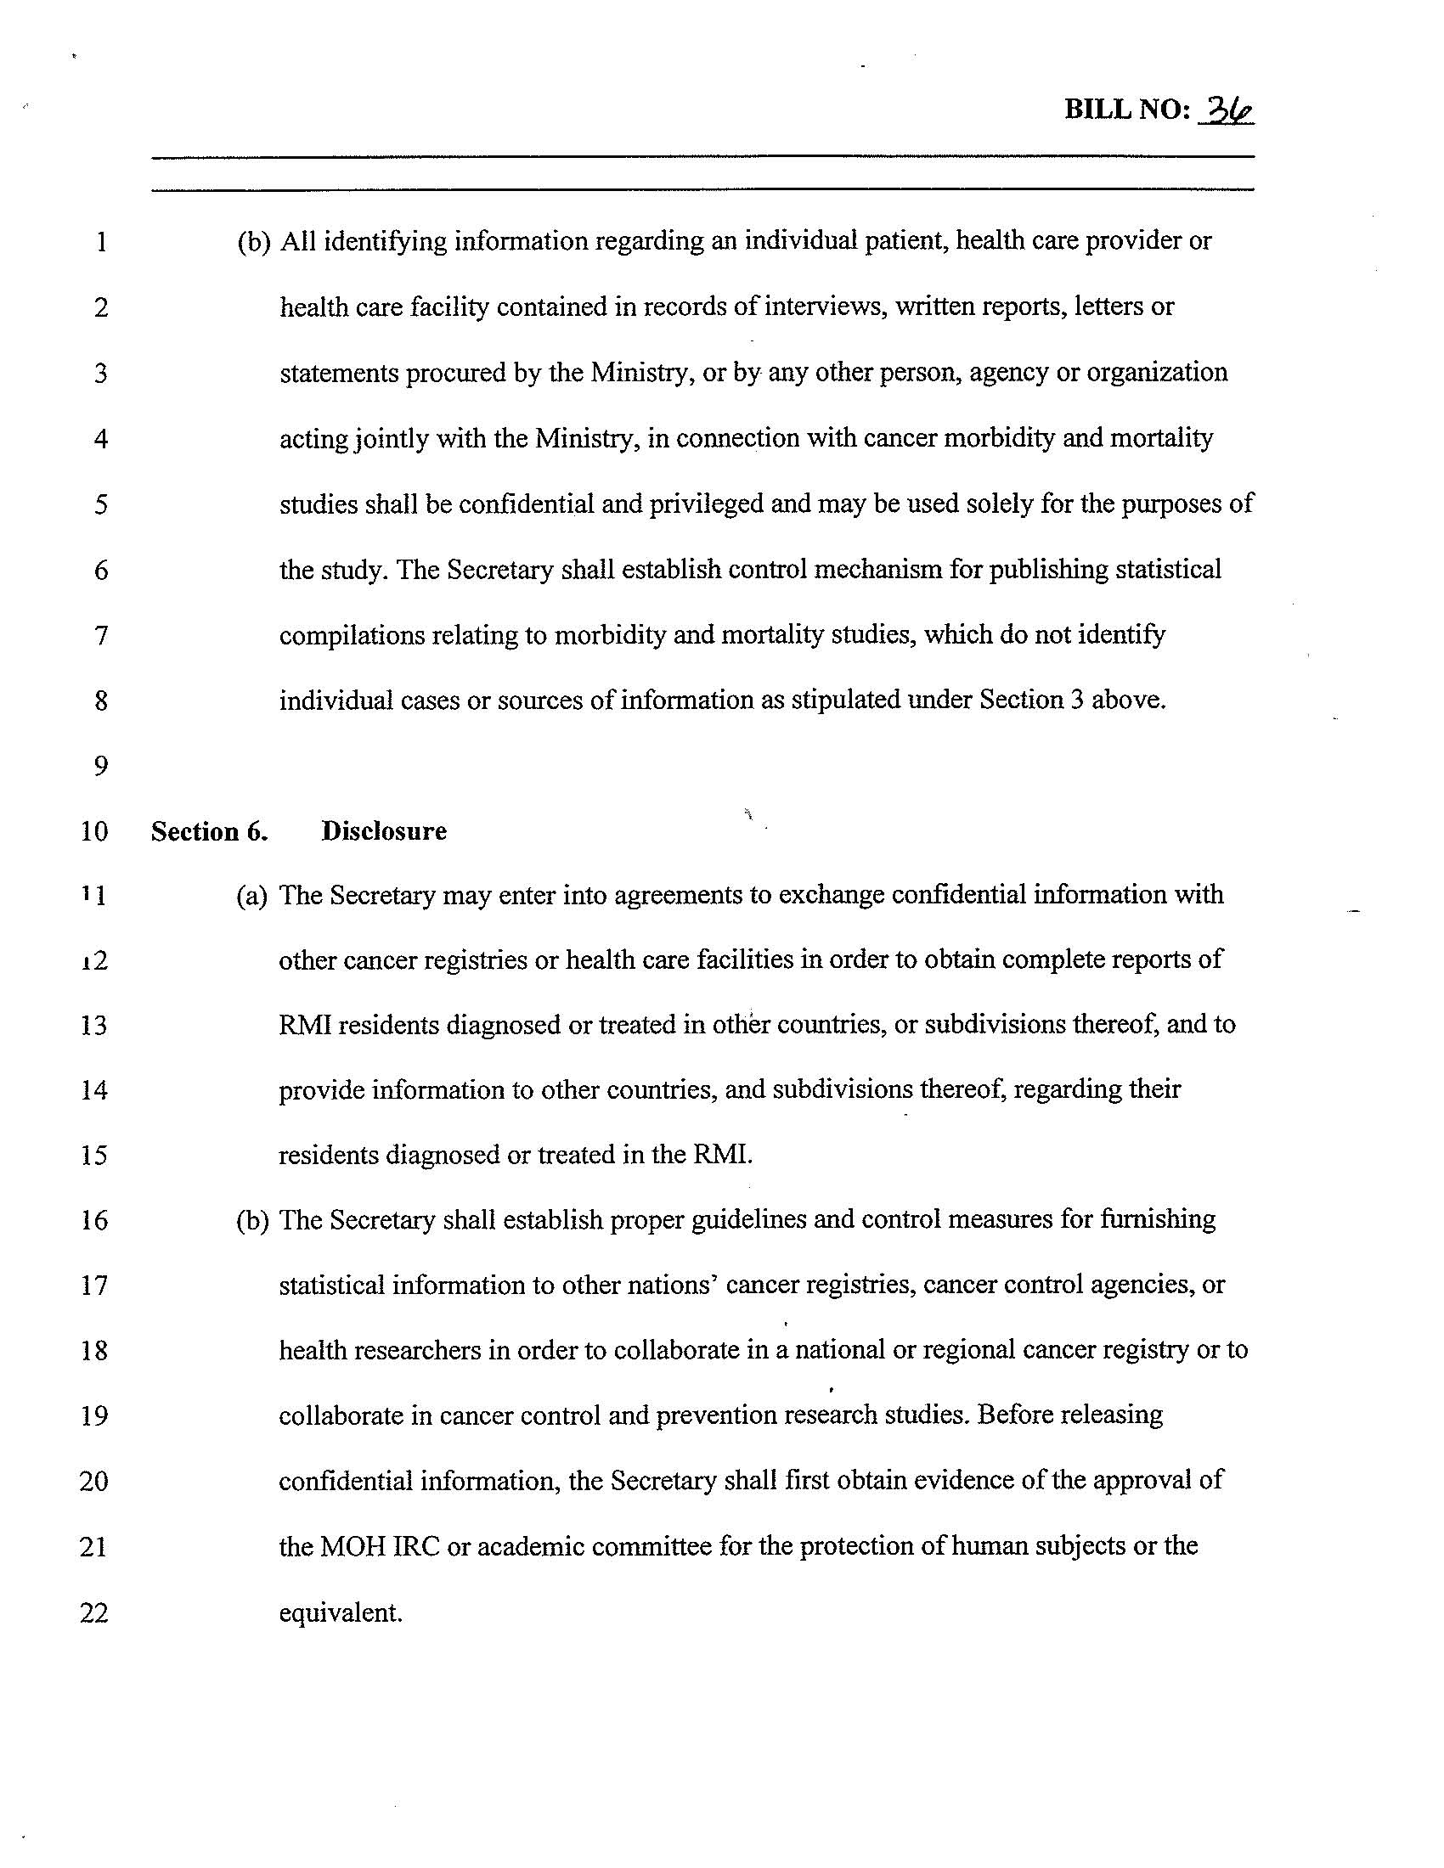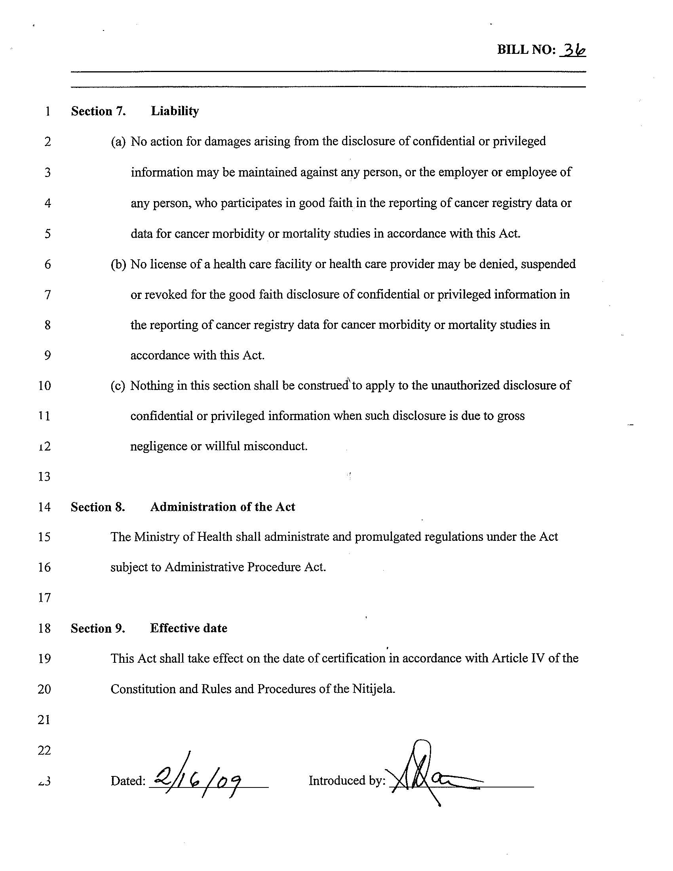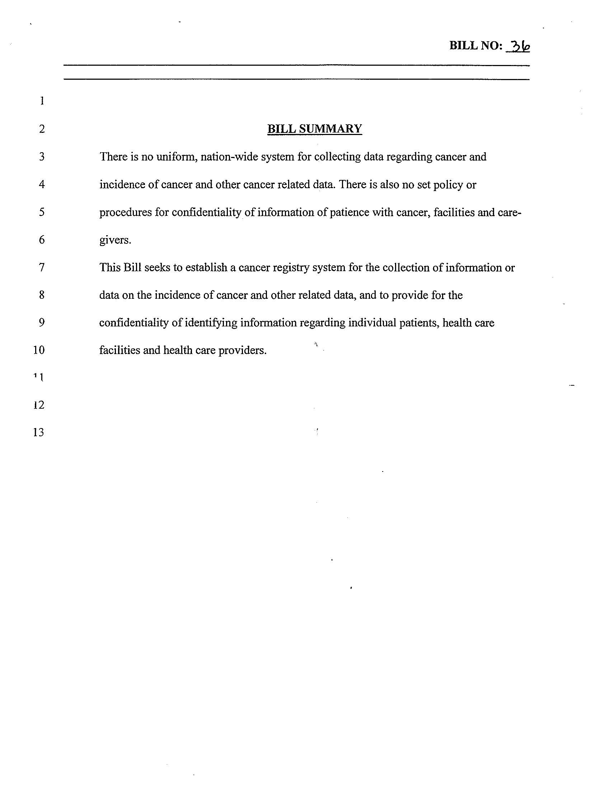
PALAU CANCER REGISTRY ACT

On August 4, 1999, RPPL No. 5-33 was signed by President Kuniwo Nakamura to “establish a cancer registry system for the collection of information on the incidence of cancer and related data; to provide for the confidentiality of identifying information regarding individual patients, health care facilities and health care providers; and for related purposes.”

The RPPL 5-33 is also known as “Cancer Registry Act”
Section 1. “Short title.” This Act may be cited as the “Cancer Registry Act.”
Section 2. “Definitions.” As used in this Act

(a) “Cancer.” means all malignant neoplasms, regardless of the tissue of origin, including malignant lymphoma disease.
(b) “Health care facility.” means hospital, nursing home or other institution that provides medical care in the Republic of Palau.
(c) “Health care provider.” means a physician (M.D., M.B.B.S., M.O., D.O., D.D.S), medex, nurse practitioner, registered nurse, nurse midwife, practical nurse or health assistant licensed in the Republic of Palau.
(d) “Minister.” means the Minister of Health or person designated by the Minister to compile information, prepare reports, and performs any functions required or permitted under this act.
Section 3. Cancer Registry
- The Minister of Health and each health care facility and health care providers shall jointly establish a uniform, nation-wide population-based cancer registry system for the collection of information regarding the incidence of cancer and related data. The Minister and each health care facility and health care providers shall jointly adopt rules necessary to effect the purposes of this Act, including the data to be reported and the effective date after which reporting by health care facilities and health care providers shall be required.
- All cancers diagnosed or treated in the Republic shall be reported to the Minister to compile cancer related data.
- The Minister shall establish a training program for the personnel of participating health care facilities and a quality control program for cancer data. The Minister shall collaborate in studies with clinicians and epidemiologists and publish reports on the results of studies. The Minister shall cooperate with the U.S. National Institutes of Health and the Center for Disease Control in providing cancer incidence data.

Section 4. Participation in Program
Each health care facility and health care provider diagnosing or providing treatment to cancer patients shall report to the Minister each cancer case that occurs within the facility or provider’s office. Within 120 days of the effective date of this Act, the Minister and each health care provider and health care facility shall jointly promulgate a plan to set forth the format, content, and timing of the report required by this section, including remedies and penalties for noncompliance. Any cancer patient whose diagnosis or treatment is reported to the Minister shall be informed of this fact by the health care facility or health care provider prior to submission of the report. This section shall only apply to cancer cases diagnosed or treated following the effective date of this Act.

Section 5. Confidentiality
- All information reported pursuant to this Act shall be confidential and privileged. The Minister shall take strict measures to ensure that all identifying information is kept confidential.
- All identifying information regarding an individual patient, health care provider or health care facility contained in records of interviews, written reports and statements procured by the Minister, or by any other person, agency or organization acting jointly with the Minister, in connection with cancer morbidity and mortality studied shall be confidential and privileged and may be used solely for the purpose of the study. Nothing in this section shall prevent the Minister from publishing statistical compilation relating to morbidity and mortality studies, which do not identify individual cases or source of information.

Section 6. Disclosure
- The Minister may enter into agreements to exchange confidential information with other cancer registries in order to obtain complete reports of Palau residents diagnosed or treated in other countries, subdivisions thereof, and to provide information to other countries, and subdivision thereof, regarding their residents diagnosed or treated in the Republic of Palau.
- The Minister may furnish statistical information to other nation’s cancer registries, cancer control agencies, or health researchers in order to collaborate in a national cancer registry or to collaborate in cancer control and prevention research studies. Before releasing confidential information, the Minister shall first obtain from such national registry, agency or researcher, a written agreement to keep the identifying information confidential and privileged. In the case of researchers, the Minister shall first obtain evidence of the approval of his or her academic committee for the protection of human subjects or the equivalent.

Section 7. Liability
(a) No action for damages arising from the disclosure of confidential or privileged information may be maintained against any person, or the employer or employee of any person, who participates in good faith in the reporting of cancer registry data or data for cancer morbidity or mortality studies in accordance with this Act.

(b) No license of a health care facility or health care provider may be denied, suspended or revoked for the good faith disclosure of confidential or privileged information in the reporting of cancer registry data for cancer morbidity or mortality studies in accordance with this Act.
- Nothing in this section shall be construed to apply to the unauthorized disclosure of confidential or privileged information when such disclosure is due to gross negligence or willful misconduct.

Section 8. This Act shall take effect upon its approval by the President, or upon its becoming law without such approval, except as otherwise provide by law.

Approved on the 4th day of August 1999.

Section 4

CANCER REGISTRY PROGRAMS AND ASSOCIATIONS

CENTER FOR DISEASE CONTROL (CDC)
The Centers for Disease Control and Prevention (CDC) is recognized as the lead U.S. Federal agency for protecting the health and safety of people - at home and abroad, providing credible information to enhance health decisions, and promoting health through strong partnerships. CDC serves as the national focus for developing and applying disease prevention and control, environmental health, and health promotion and education activities designed to improve the health of the people of the United States.
The formal mission of CDC is:
To promote health and quality of life by preventing and controlling disease, injury, and disability.
Through the Congressional mandate Public Law (1998 Code), authorizes the Centers for Disease Control and Prevention (CDC) to provide funds to states and territories
- to improve existing cancer registries
- to plan and implement registries where they do not exist
- to develop model legislation and regulations for states to enhance the viability of registry operations
- to set standards for data completeness, timeliness, and quality
- to provide training for registry personnel, and
- to help establish a computerized reporting and data-processing system.

CDC and National Cancer Institute (NCI) have signed a Memorandum of Understanding to formalize collaboration between NCI’s Surveillance, Epidemiology, and End Results (SEER) and CDC’s National Program of Cancer Registries (NPCR). This will allow a more coordinated national cancer surveillance effort that builds upon and strengthens the existing infrastructure, improves the availability of high quality data for measuring the nation’s cancer burden, and advances the capacity for surveillance research.
CDC and NCI also collaborate by working together on various committees of the North American Association of Central Cancer Registries (NAACCR). NAACCR is a collaborative umbrella organization for cancer registries, governmental agencies, professional associations, and private groups in North America interested in improving the quality and use of cancer registry data. NAACCR provides forums through its committees for discussion and consensus.

THE NATIONAL PROGRAM OF CANCER REGISTRIES (NPCR)
US Congress established the National Program of Cancer Registries (NPCR) in 1992 by enacting the Cancer Registries Amendment Act, Public Law 102-515, a Congressional mandate that reauthorized the National Program of Cancer Registries PUBLIC LAW (1998 CODE).
Before NPCR was established, 10 states had no registry and most states with registries lacked the resources and legislative support needed to gather complete data. With fiscal year 2002 funding of approximately $40 million, CDC's NPCR supported central registries and promoted the use of registry data in 45 states, the District of Columbia, and the territories of Puerto Rico, the Republic of Palau, and the Virgin Islands. CDC also developed special research projects such as studies to examine patterns of cancer care in specific populations. CDC's goal is for all states to maintain registries that provide high-quality data on cancer and cancer care.
NPCR complements NCI's Surveillance, Epidemiology, and End Results (SEER) registry program. Together, NPCR and the SEER program collect cancer data for the entire U.S. population. The SEER program gathers in-depth data on cancer cases diagnosed in Connecticut, Hawaii, Iowa, New Mexico, and Utah, as well as in six metropolitan areas and several rural/special population areas. The six metropolitan SEER registries and some of the rural/special population registries submit data to NPCR's state registries. In 2001, SEER began providing additional support to four NPCR-supported state registries (California, Kentucky, Louisiana, and New Jersey).
The current version of the NPCR Program Standards 2012-2017 was distributed (soft copy) to each registrar in 2013. Additionally, the current version can be downloaded from http://www.cdc.gov/cancer/npcr/pdf/npcr_standards.pdf
SURVEILLANCE, EPIDEMIOLOGY, AND END RESULTS (SEER)
The Surveillance, Epidemiology, and End Results (SEER) Program of the National Cancer Institute is an authoritative source of information on cancer incidence and survival in the United States. SEER began collecting data on cases on January 1, 1973, in the states of Connecticut, Iowa, New Mexico, Utah, and Hawaii and the metropolitan areas of Detroit and San Francisco-Oakland. In 1974-1975, the metropolitan area of Atlanta and the 13-county Seattle-Puget Sound area were added. In 1978, 10 predominantly black rural counties in Georgia were added, followed in 1980 by the addition of American Indians residing in Arizona. Three additional geographic areas participated in the SEER program prior to 1990: New Orleans, Louisiana (1974-1977, rejoined 2001); New Jersey (1979-1989, rejoined 2001); and Puerto Rico (1973-1989). The National Cancer Institute also funds a cancer registry that, with technical assistance from SEER, collects information on cancer cases among Alaska Native populations residing in Alaska. In 1992, the SEER Program was expanded to increase coverage of minority populations, especially Hispanics, by adding Los Angeles County and four counties in the San Jose-Monterey area south of San Francisco. In 2001, the SEER Program expanded coverage to include Kentucky and Greater California; in addition, New Jersey and Louisiana once again became participants.
The SEER Program currently collects and publishes cancer incidence and survival data from 14 population-based cancer registries and three supplemental registries covering approximately 26 percent of the US population. Information on more than 3 million in situ and invasive cancer cases is included in the SEER database, and approximately 170,000 new cases are added each year within the SEER coverage areas. The SEER Registries routinely collect data on patient demographics, primary tumor site, morphology, stage at diagnosis, first course of treatment, and follow-up for vital status. The SEER Program is the only comprehensive source of population-based information in the United States that includes stage of cancer at the time of diagnosis and survival rates within each stage. The mortality data reported by SEER are provided by the National Center for Health Statistics (NCHS).
NORTH AMERICAN ASSOCIATION OF CENTRAL CANCER REGISTRIES (NAACCR)
Established in 1987, NAACCR, Inc. is a collaborative umbrella organization for cancer registries, governmental agencies, professional associations, and private groups in North America interested in enhancing the quality and use of cancer registry data. All central cancer registries in the United States and Canada are members. The Pacific Regional Central Cancer Registry (PRCCR) is an active member of the North American Association of Central Cancer Registries (NAACCR).
The formal mission of NAACCR, Inc. is:
The North American Association of Central Cancer Registries, Inc. (NAACCR, Inc.), is a professional organization that develops and promotes uniform data standards for cancer registration; provides education and training; certifies population-based registries; aggregates and publishes data from central cancer registries; and promotes the use of cancer surveillance data and systems for cancer control and epidemiologic research, public health programs, and patient care to reduce the burden of cancer in North America.

Section 5
OFFICE MANAGEMENT

File Management
Personnel files are kept in accordance with UH, UOG and/or each jurisdictions’ human resources polices and procedures.
The Registrars are responsible to keep detailed tracking logs of cases submitted to the FSM National or PRCCR registries. They should also keep internal files regarding cases that are still pending completion. The AbsPlus and CRSPlus databases should be routinely backed up to a removable drive and stored in a secure location.
Correspondence
Jurisdiction registrars or the PRCCR registrar or the Program Manager and/or Principal Investigator (PI) will field all calls and inquiries regarding the jurisdiction or regional registry. If they have difficulty answering the questions, then the jurisdiction supervisor (i.e., Cancer Program Manager or Director/Minister of Health or designee) should be asked to field the inquiry. Depending on the nature of the inquiry, questions may be referred to the PI of the PRCCR.
Time and attendance
The American Samoa and CNMI Registrars are University of Hawaii employees and therefore subject to University of Hawaii RCUH HR policies. Any special requests should be discussed with the Program Manager and approved by the Principal Investigator.
Jurisdiction registrars are subject to their employer’s policies and procedures. However, it is expected that they communicate with the Program Manager for any sick leave, vacation or extenuating circumstances that may impact their work completion.
Travel
Travel expenses to the annual registry training in Honolulu are included in the jurisdiction subaward budgets. Letters of invitation addressed to the Director/Minister of Health and draft agendas are sent no later than 40 days in advance, in order to comply with each jurisdiction’s specific travel policies and protocols. Travel authorization, completion and reimbursement of expenses are done in accordance with their local travel policies. In general, the registrar will share a double room at the conference hotel. The central UH budget provides ground transportation to/from the hotel to training venue. Airfare, ground transportation to/from hotel and airport, shared lodging, meals, incidental expenses are covered by the jurisdiction subawards. UH staff (American Samoa and CNMI registrars) adhere to UH policies and procedures.
Standard administrative reports
The PRCCR expects monthly submission of detailed tracking sheets and monthly reports by each jurisdiction and central registrar.
The PRCCR participates in CDC NPCR Cancer Surveillance System data submission according to the NPCR deadlines for the National Data Quality Standard and the Advanced National Data Quality Standard.
The PRCCR also participates in other NPCR studies (performance evaluation, cost, data quality evaluation, etc.) as directed.
Grant responsibility
The central UH staff (PI and Program Manager) have primary responsibility for monitoring, reporting and garnering successful renewal of the NPCR Cooperative Agreement, as well as any other external funding source that might be used to supplement registry activities. Jurisdiction and Regional registrars will be responsive to requests for additional information and/or specific data extracts that might be needed for these grants.
Purchasing supplies and equipment
With rare exception, the jurisdiction subawards do not contain sufficient funds for basic office supplies or computers. If a registrar needs a specific piece of software or computer, they must make a request to the Program Manager. Requests for general office supplies should first be made to their local supervisor, then to the Program Manager if their jurisdiction has insufficient funds for the purchase.
Publications and Reports
The jurisdiction registrars, in conjunction with local epidemiology or statistical support (if available) and their cancer program staff, are responsible for providing information used in local information, educational and/or communication materials, as well as numerous reports for public health reporting purposes. They should provide a soft copy of these reports (newsletters, formal reports) to the central UH staff.
The central UH PRCCR staff, along with the PRCCR registrar, has prime responsibility for updating the “Cancer in the Pacific” monograph at least every other year, for providing annual summary sheets (by region and by jurisdiction) to the CCPI and Cancer Program Staff [who should in turn share it with their jurisdiction leadership]. All formal reports and presentations should include the required CDC grant disclosures and disclaimers as specified in the most recent notice of award.

Section 6
HARDWARE AND SOFTWARE: REGISTRY OPERATING SYSTEM AND DATA MANAGEMENT

HARDWARE

In most jurisdictions, the desktops and laptops used by the registrars were purchased with NPCR Program funding in the 2007-2011 time frame. As needed and depending on local funding, replacement desktops may be purchased by PRCCR. All desktops are wired to the local secure LAN within the Department/Ministry of Health or the University of Guam. Desktops and laptops run Windows XP Professional or Windows 7 or later and are configured by local IT support to be registered on their secure network and receive regular software updates and scans for malware. All desktops and laptops should have a minimum of 4GB of RAM and 250GB hard drive and run at least an Intel Core i3 processor or equivalent.

Laptops should be encrypted using True Crypt.

Internet access is provided by the local Department/Ministry of Health or the University of Guam and accessible through a secure LAN. As natural disasters such as hurricanes/typhoons often occur, registrars are permitted to use Internet at their homes (if available) for communication. However, all uploads of abstract bundles should be done from the secure work internet.

The file size for the registry databases are small. Regular back-up of files occurs upon exiting AbsPlus. Additionally, registrars should make a copy of the back-up files at least once a week to a secured external hard drive, CD-ROM/DVD or secured thumb drive. These should be placed in a locked cabinet separate from the desktop area.

The desktops are connected to a local and occasionally a network printer, depending on the resources and configuration of the jurisdiction’s cancer registry office.

SOFTWARE

Abstract Plus
Abstract Plus is an abstracting tool used to summarize the medical record into an electronic report of cancer diagnosis and treatment by abstractors and other individuals or groups who work with cancer data. This software was developed at the Centers for Disease Control and Prevention (CDC), Division of Cancer Prevention and Control (DCPC), in support of CDC's National Program of Cancer Registries (NPCR). All data items in national standard data sets, including text, are supported. PIJ-specific data items and edits are incorporated by CDC NPCR staff prior to AbsPlus version upgrades. Standard NPCR Edits are incorporated into the PIJ AbsPlus. Geocoding capabilities are not available or utilized.

Central Registry Software (CRS Plus)
Central Registry Software (CRS Plus) is the main central registry database program used in both FSM National and the PRCCR. CRS Plus supports the linkage of incoming abstracts against the existing database, with software–assisted consolidation into patient, cancer, and facility tables. CRS Plus allows side–by–side displays and automated comparisons of incoming and stored data. CRS Plus updates the tracking system with processing milestones for each abstract. Other features of CRS Plus include management reports and the ability to export records in North American Association of Central Cancer Registries (NAACCR) format. Preparation of files for national calls for data is automated. Geocoding capabilities are not available or utilized.

Web Plus
Web Plus is a Web-based application to collect and/or transmit cancer data securely over the Internet. The PRCCR Web Plus (https://www.prccr.org/webplus ) is hosted on a secure Web server that has a digital certificate installed; the communication between the client and the server is encrypted with Secure Socket Layer (SSL) technology. The FSM Web Plus is located on their secure intranet. For the PRCCR, exported cases from Abstract Plus will be transmitted from the jurisdiction registry to the PRCCR via Web Plus. NO DIRECT ABSTRACTING will occur on the PRCCR or FSM Web Plus.

PrepPlus
PrepPlus is used by the FSM National and PRCCR registrars who receive abstract bundles in NAACCR record format from the jurisdictions. PrepPlus logs and tracks incoming abstracts, runs standard NAACCR edit checks, allows for visual inspection and error correction, produced edit reports which are reported back to the jurisdictions and used to guide additional training.

Utility Programs
Several utility programs made available on the NPCR-CSS doc server are used to convert records layout (Northcon) and prepare the data submission files according to the call for data (Gen Edits, etc).

Registry Plus Online Help (RPOH)
Registry Plus Online Help provides standard coding instructions from multiple sources to abstractors and other individuals or groups who work with cancer data in a single, integrated, user-friendly online help system for Windows computers. Registry Plus Online Help was developed at CDC's Division of Cancer Prevention and Control in support of CDC's National Program of Cancer Registries (NPCR). Registry Plus Online Help includes a collection of standard coding manuals, cross-referenced, indexed, and context-linked to minimize the need for reference to printed manuals during abstracting. The manuals are reformatted for online viewing. RPOH contains the latest version of the following manuals

- NAACCR’s Data Standards and Data Dictionary
- FORDS (Facility Oncology Registry Data Standards)
- Collaborative Staging Manual version 02.05
- ICD-O-3: (International Classification of Diseases for Oncology, 3rd ed.)
- SEER Program Coding and Staging Manual
- SEER Program Code Manual (for pre-2004 cases)
- SEER Extent of Disease (for pre-2004 cases)
- ROADS Manual (Registry Operations and Data Standards), Selected entries, for historic cases
- Abstract Plus Users Guide

SEER*Rx - Interactive Antineoplastic Drugs Database
Version 1.2.0 released September 14, 2007

SEER*Rx was developed as a one-step lookup for coding oncology drug and regimen treatment categories in cancer registries. The program is free and can be downloaded from the SEER site. Version 1.2.0 was also provided to Jurisdiction registry staff in March 2009 at the PRCCR training in Honolulu. The databases are scheduled to be updated annually. The information in this database is effective for cancer diagnoses made on January 1, 2005 and after. Review and recoding of drugs from previous years is not required or recommended. Registrars are encouraged to use this reference if they have questions about a drug.

SEER Summary Staging Manual 2000
The rules of the SEER Summary staging manual are incorporated into Abstract Plus (and Registry Plus online help). The executable program was distributed to jurisdiction registry staff in March 2009 at the PRCCR training in Honolulu. The PDF of the manual is also available from the PRCCR website and is periodically distributed to the registrars.

Microsoft Excel
In preparation for data analysis, extract files are prepared into a Microsoft Excel spreadsheet. Additional columns are added to facilitate analysis by SEER site recoding groups as well as other PIJ-specific analyses. Frequencies and percentages are calculated. Age-adjusted incidence, as well as crude rates are also calculated in Excel. Most of the data analysis for report writing at the jurisdiction and regional level are done using Excel.

SEER*Stat
The SEER*Stat statistical software provides a convenient, intuitive mechanism for the analysis of SEER and other cancer-related databases. It can be used to view individual cancer records and to produce frequency, rate, and survival statistics. These statistics are useful in studying the impact of cancer on a population. As more data accrues and is complete, SEER*Stat will be used to calculate simple survival statistics.

SEER*Prep
The SEER*Prep software converts ASCII text data files to the SEER*Stat database format, allowing you to analyze your cancer data using SEER*Stat. SEER*Prep performs two main functions: it converts text data to the specific binary format required by SEER*Stat, and it creates the SEER*Stat data dictionary. SEER*Stat 5.2 or later is required to analyze any database generated with SEER*Prep 2.3.2. SEER*Prep can be used to convert incidence, mortality, expected survival, and standard population data stored in one of the formats listed below. The Input File Formats section contains more specific information about these file formats and general rules that must be followed when creating input data files.

SPSS
SPSS for Windows provides a powerful statistical analysis and data management system in a graphical environment, using descriptive menus and simple dialog boxes to do most of the work for you. Most tasks can be accomplished simply by pointing and clicking the mouse. SPSS is one of the available tools that can be used by Registry staff for data analysis and report writing.

Record linkages
Because NONE of the USAPI hospitals or reporting facilities utilize fully functional electronic health records, Meaningful Use does NOT currently apply in any of the USAPI and because the vital statistics databases are rudimentary, no linkage software is used. Manual linkages occur in the 4 jurisdictions with CDC-funded Breast and Cervical Cancer Early Detection Programs [American Samoa, CNMI, Guam, Palau]. Manual linkages occur in each jurisdiction at least once a year with vital statistics for death clearance.

Data Edits
The standard NAACCR metafile is used for all central registry edits. At the jurisdiction level, the standard edits for AbsPlus, as well as PIJ-specific inter-record edits are used. These edits generally do not change. If an edit needs to be changed, the PI will discuss with the CDC Program Consultant and/or the AbsPlus (or CRSPlus) subject matter experts.

Office Management
Microsoft Office (2007 or later) is used for word processing, newsletter and report writing, simple graphics and spreadsheets.

DATA SECURITY

Physical security: All medical records rooms/departments should be locked and not accessible to the general public. Any fax machine used to transmit patient information should be in a private office (somewhere not accessible to the general public).

Computer security: Each jurisdiction and the PRCCR office at the University of Guam has dedicated desktop for the cancer registry, which resides on a secured LAN. Each computer has a unique user based log-in and is password protected. The AbsPlus software is also password protected with a user based log in. AbsPlus abstract bundles are exported from the software and upload to the PRCCR or FSM National Web Plus (which has user based log in);. Web Plus is utilized for transmission of files in NAACCR and non-NAACCR layouts (i.e., PDF or image files of supporting documentation that might be needed to verify text entry). The PRCCR WebPlus sits outside the main University of Guam firewall. The CRS Plus data server sits behind the University of Guam firewall and communicates with the PRCCR Web Plus. The FSM Web Plus and CRS Plus databases sit behind the secured fsmhealth.fm LAN. Laptops are encrypted with TrueCrypt and should also have a required unique user based log-in.

DATA ITEMS

The PRCCR collects all standard NAACCR / NPCR data items in addition to PIJ-specific data elements. (see below). A complete listing of the standard NAACCR / NPCR data items can be found in the NPCR Call for Data packet (Attachment 2a in the 2015 call for data packet). Updates are periodically sent to the registrars. Major updates and changes are reviewed in the annual in-person training. A detailed grid with definitions of the standard data items was developed in 2009 and given to the registrars. Additional help can be found in the Registry Plus Online Help that is built into AbsPlus.

PIJ-specific data elements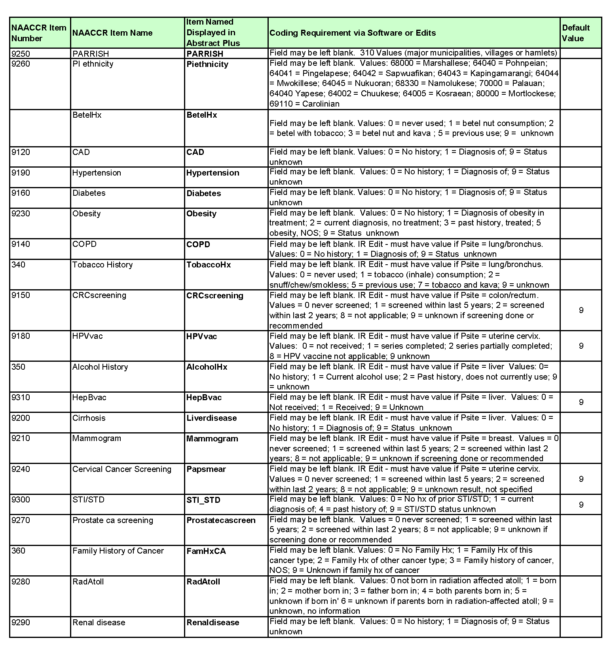

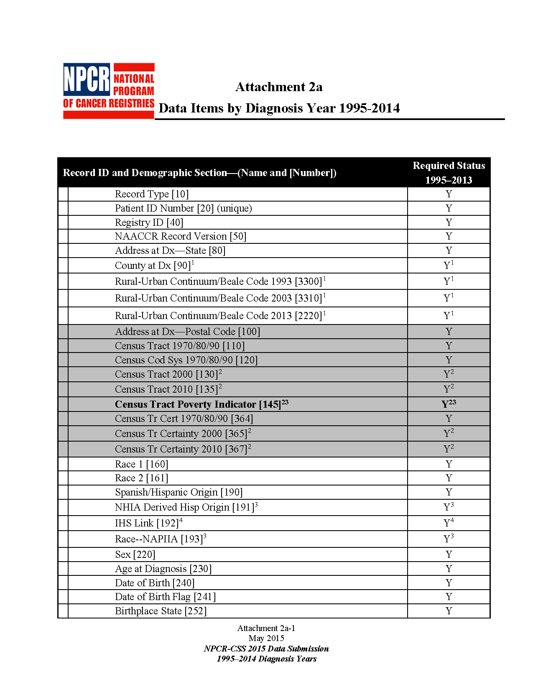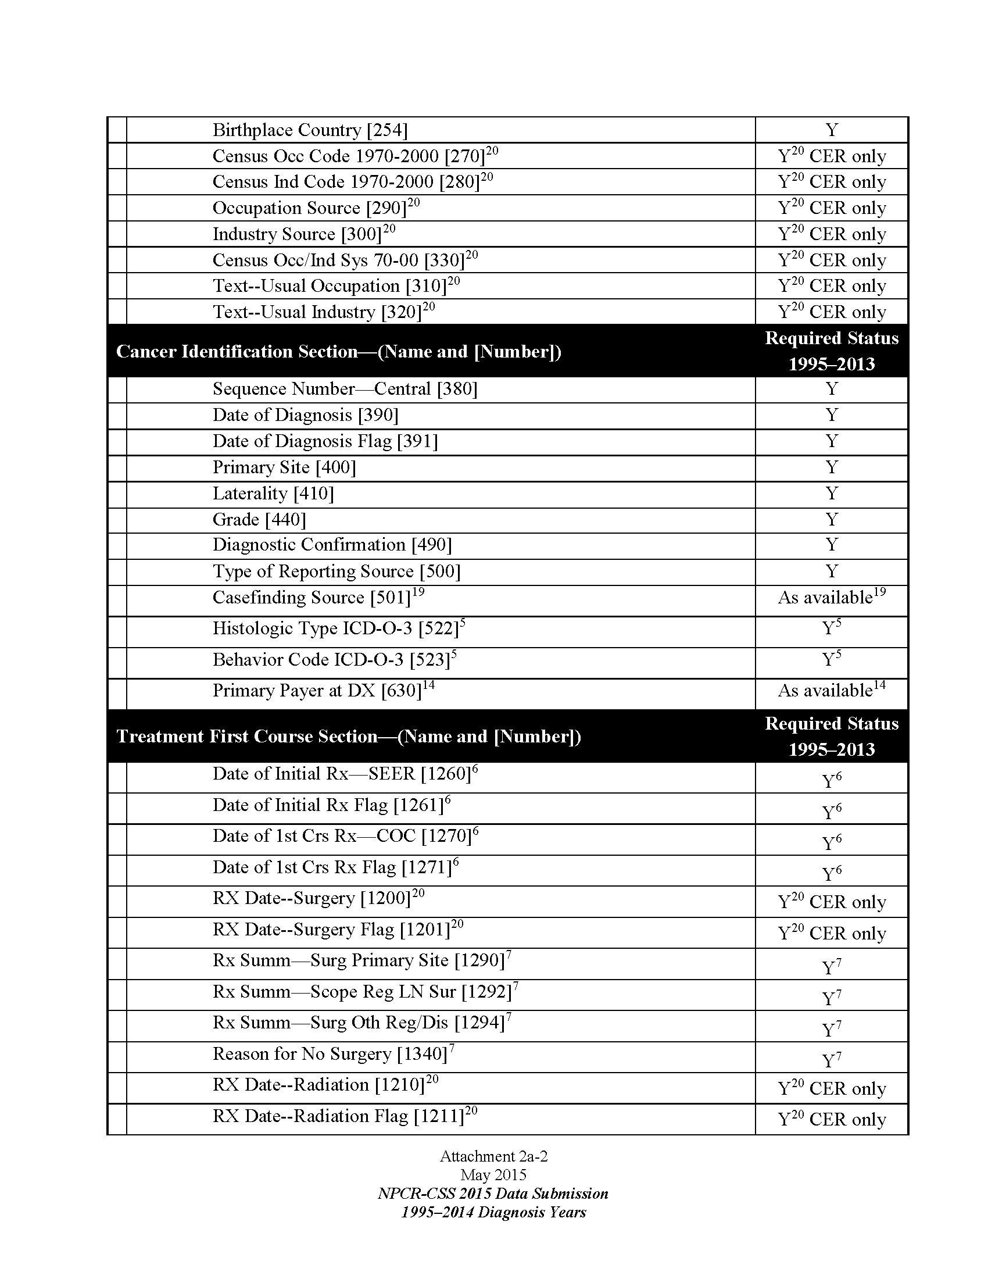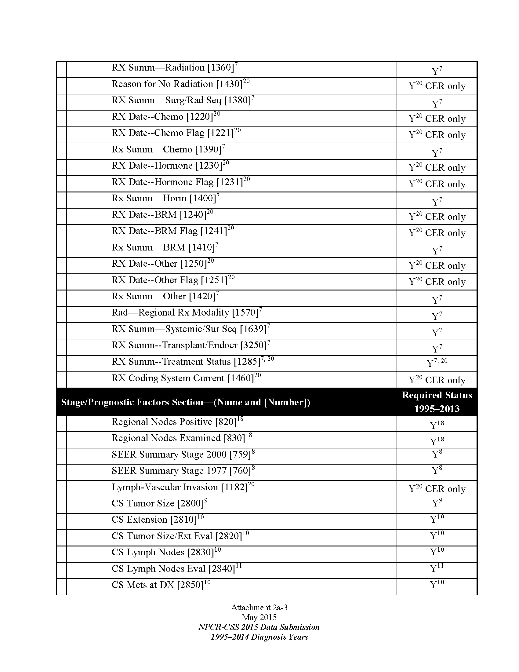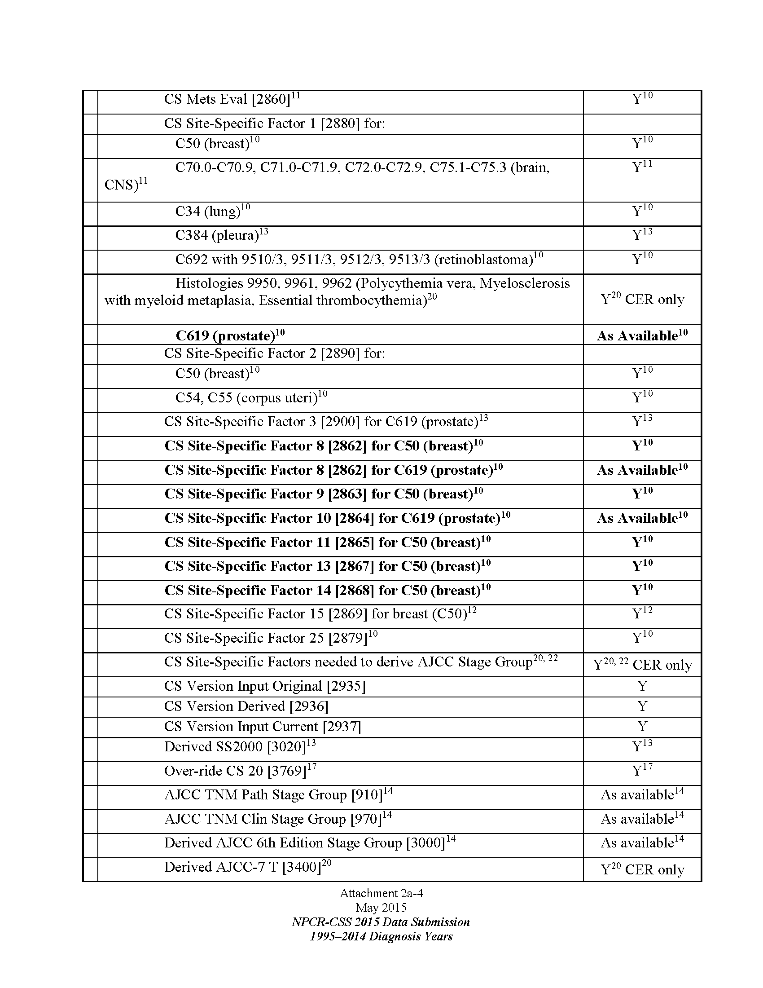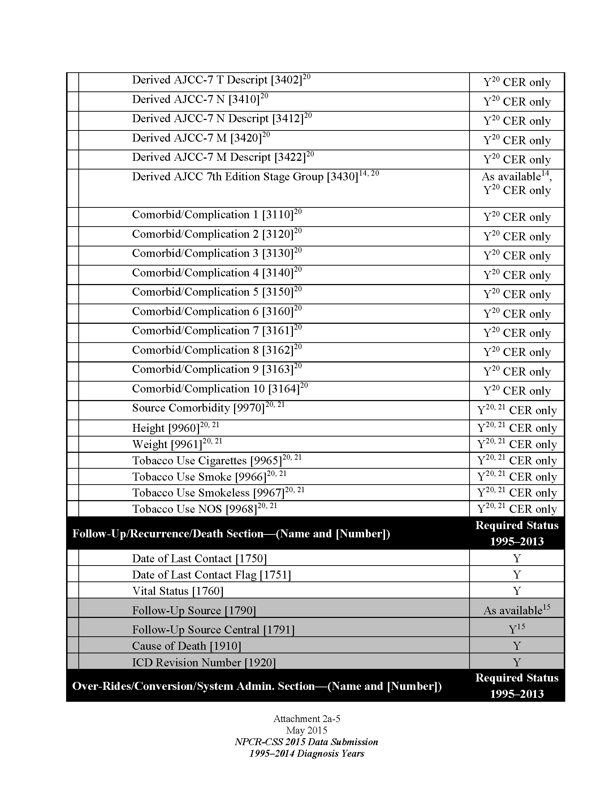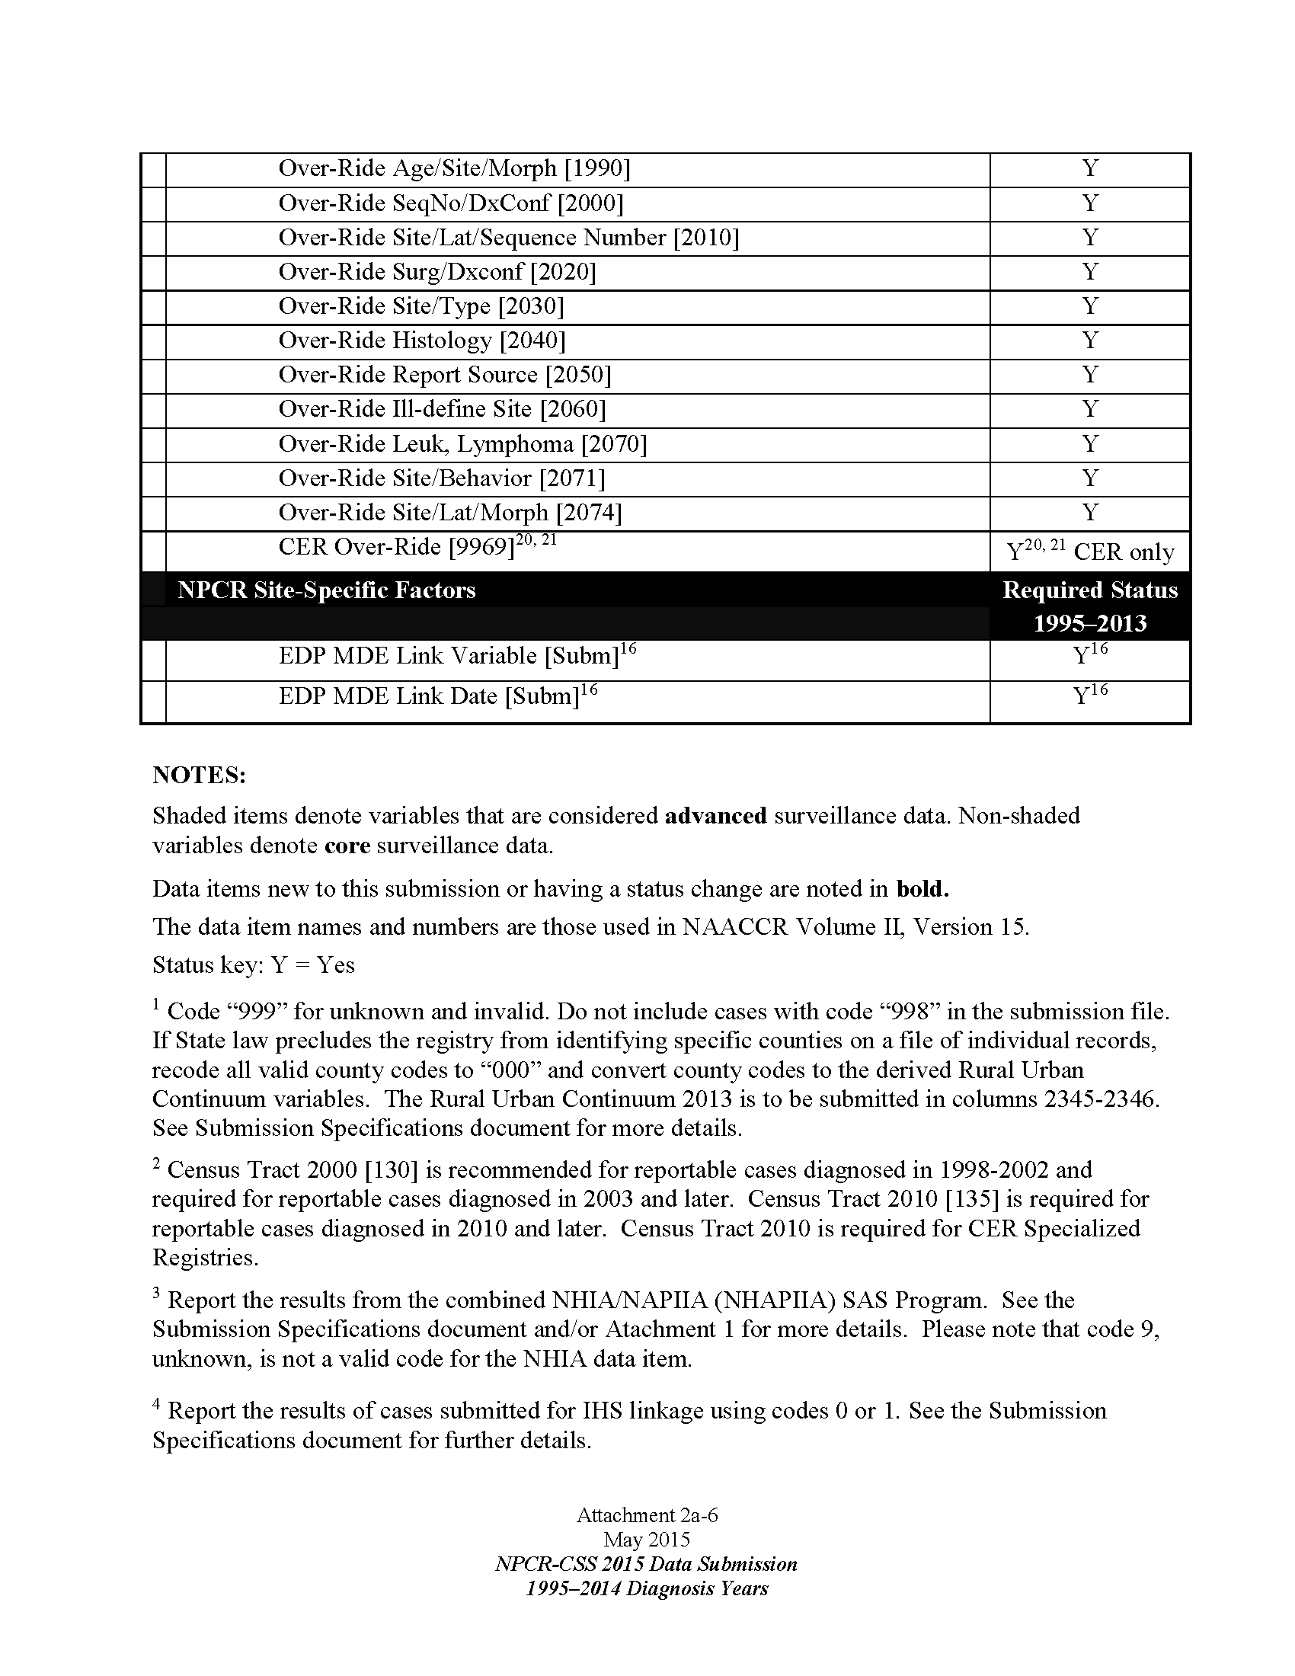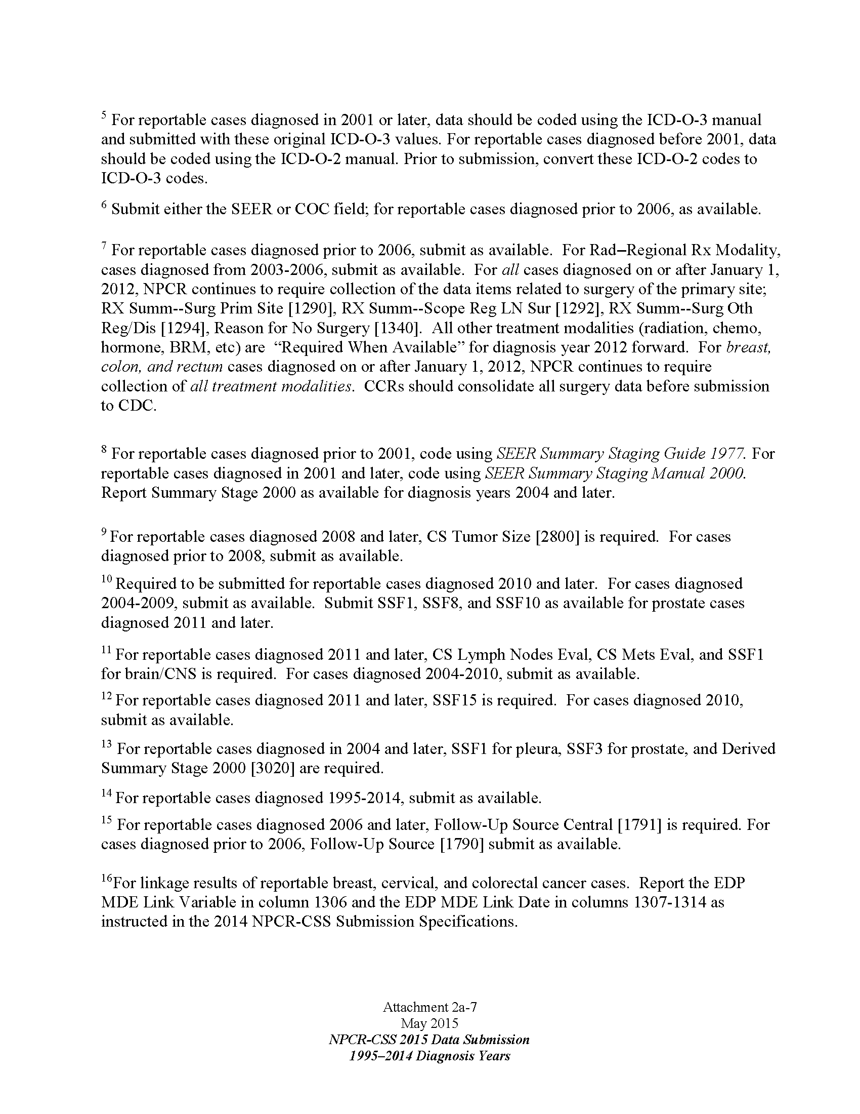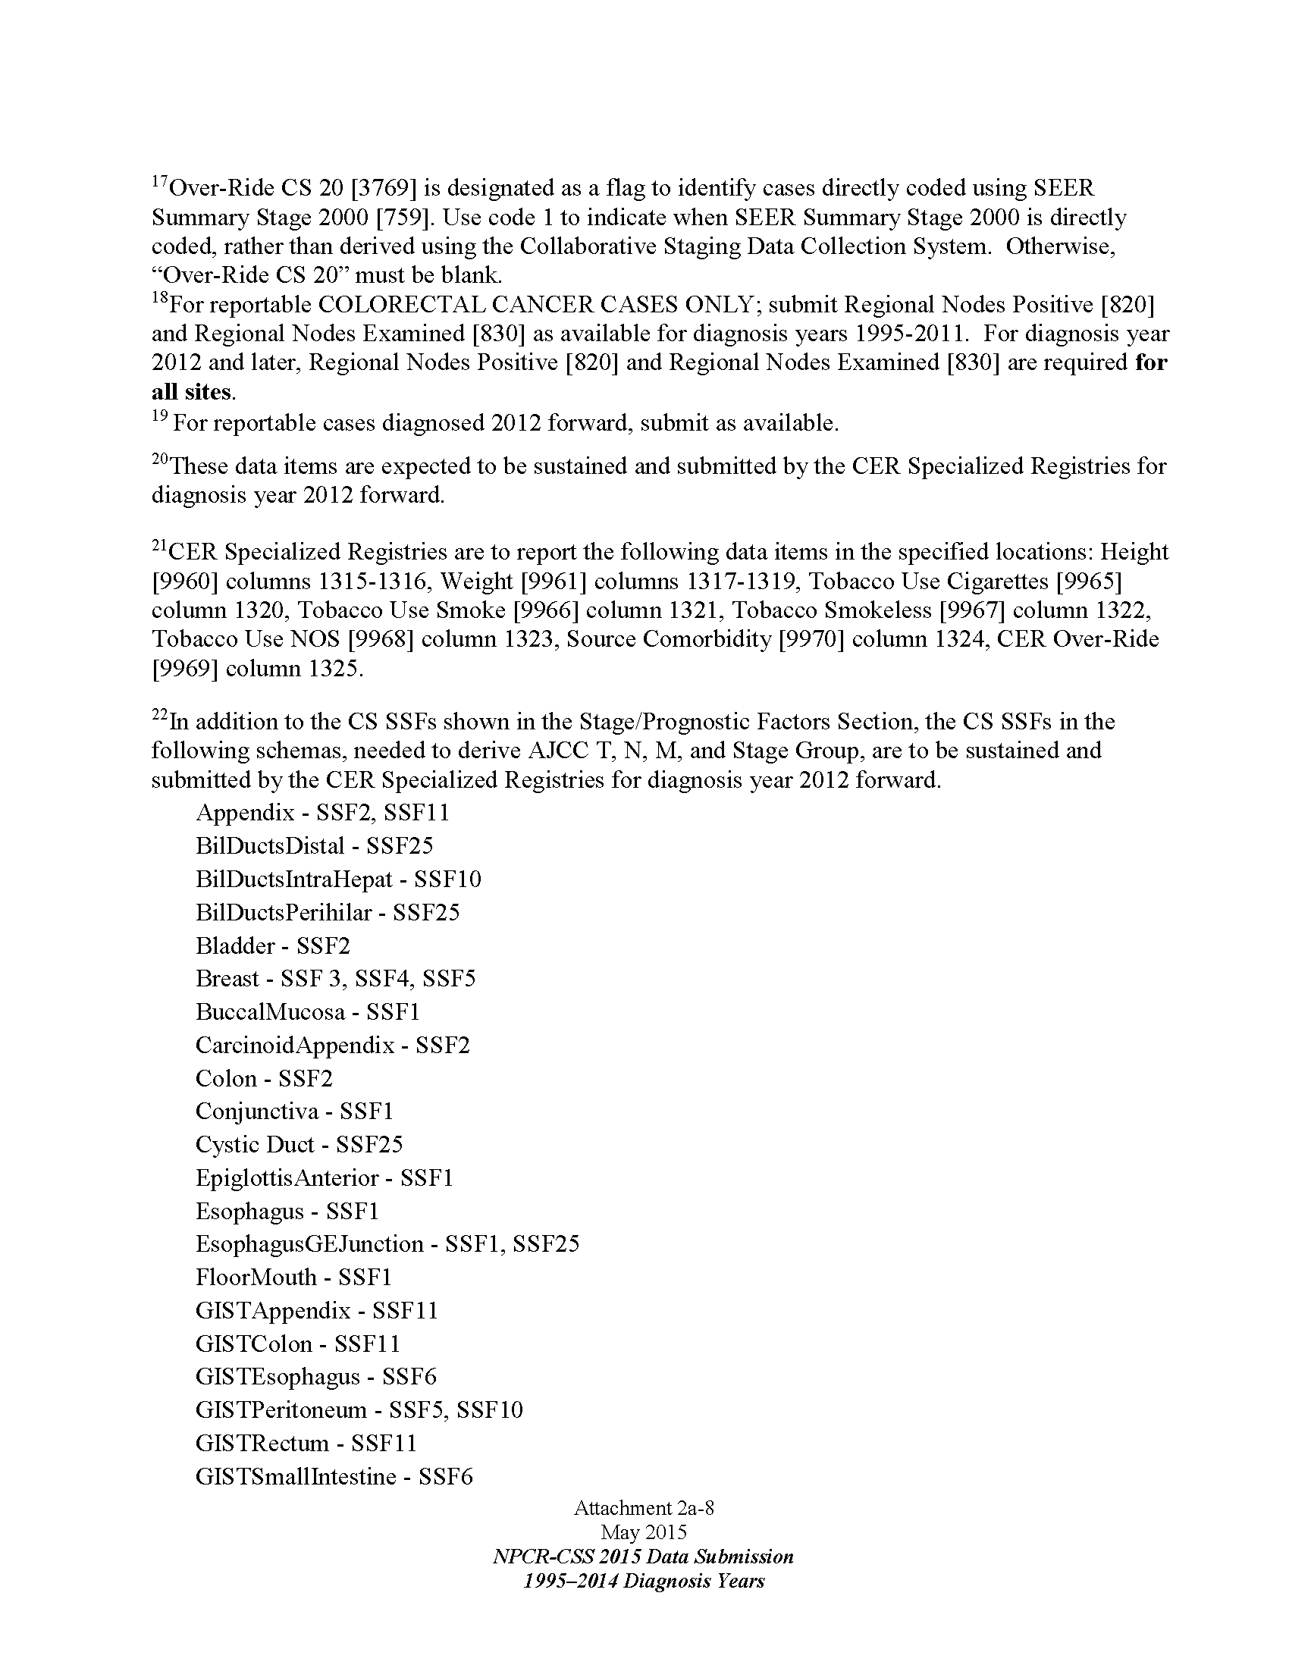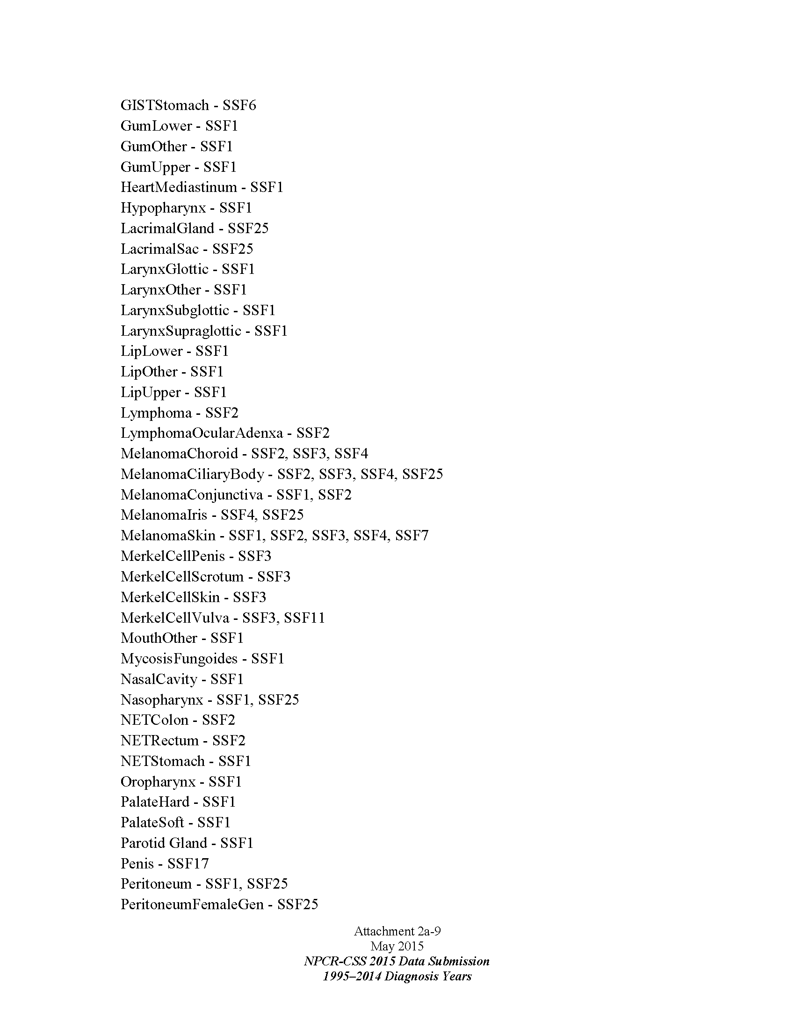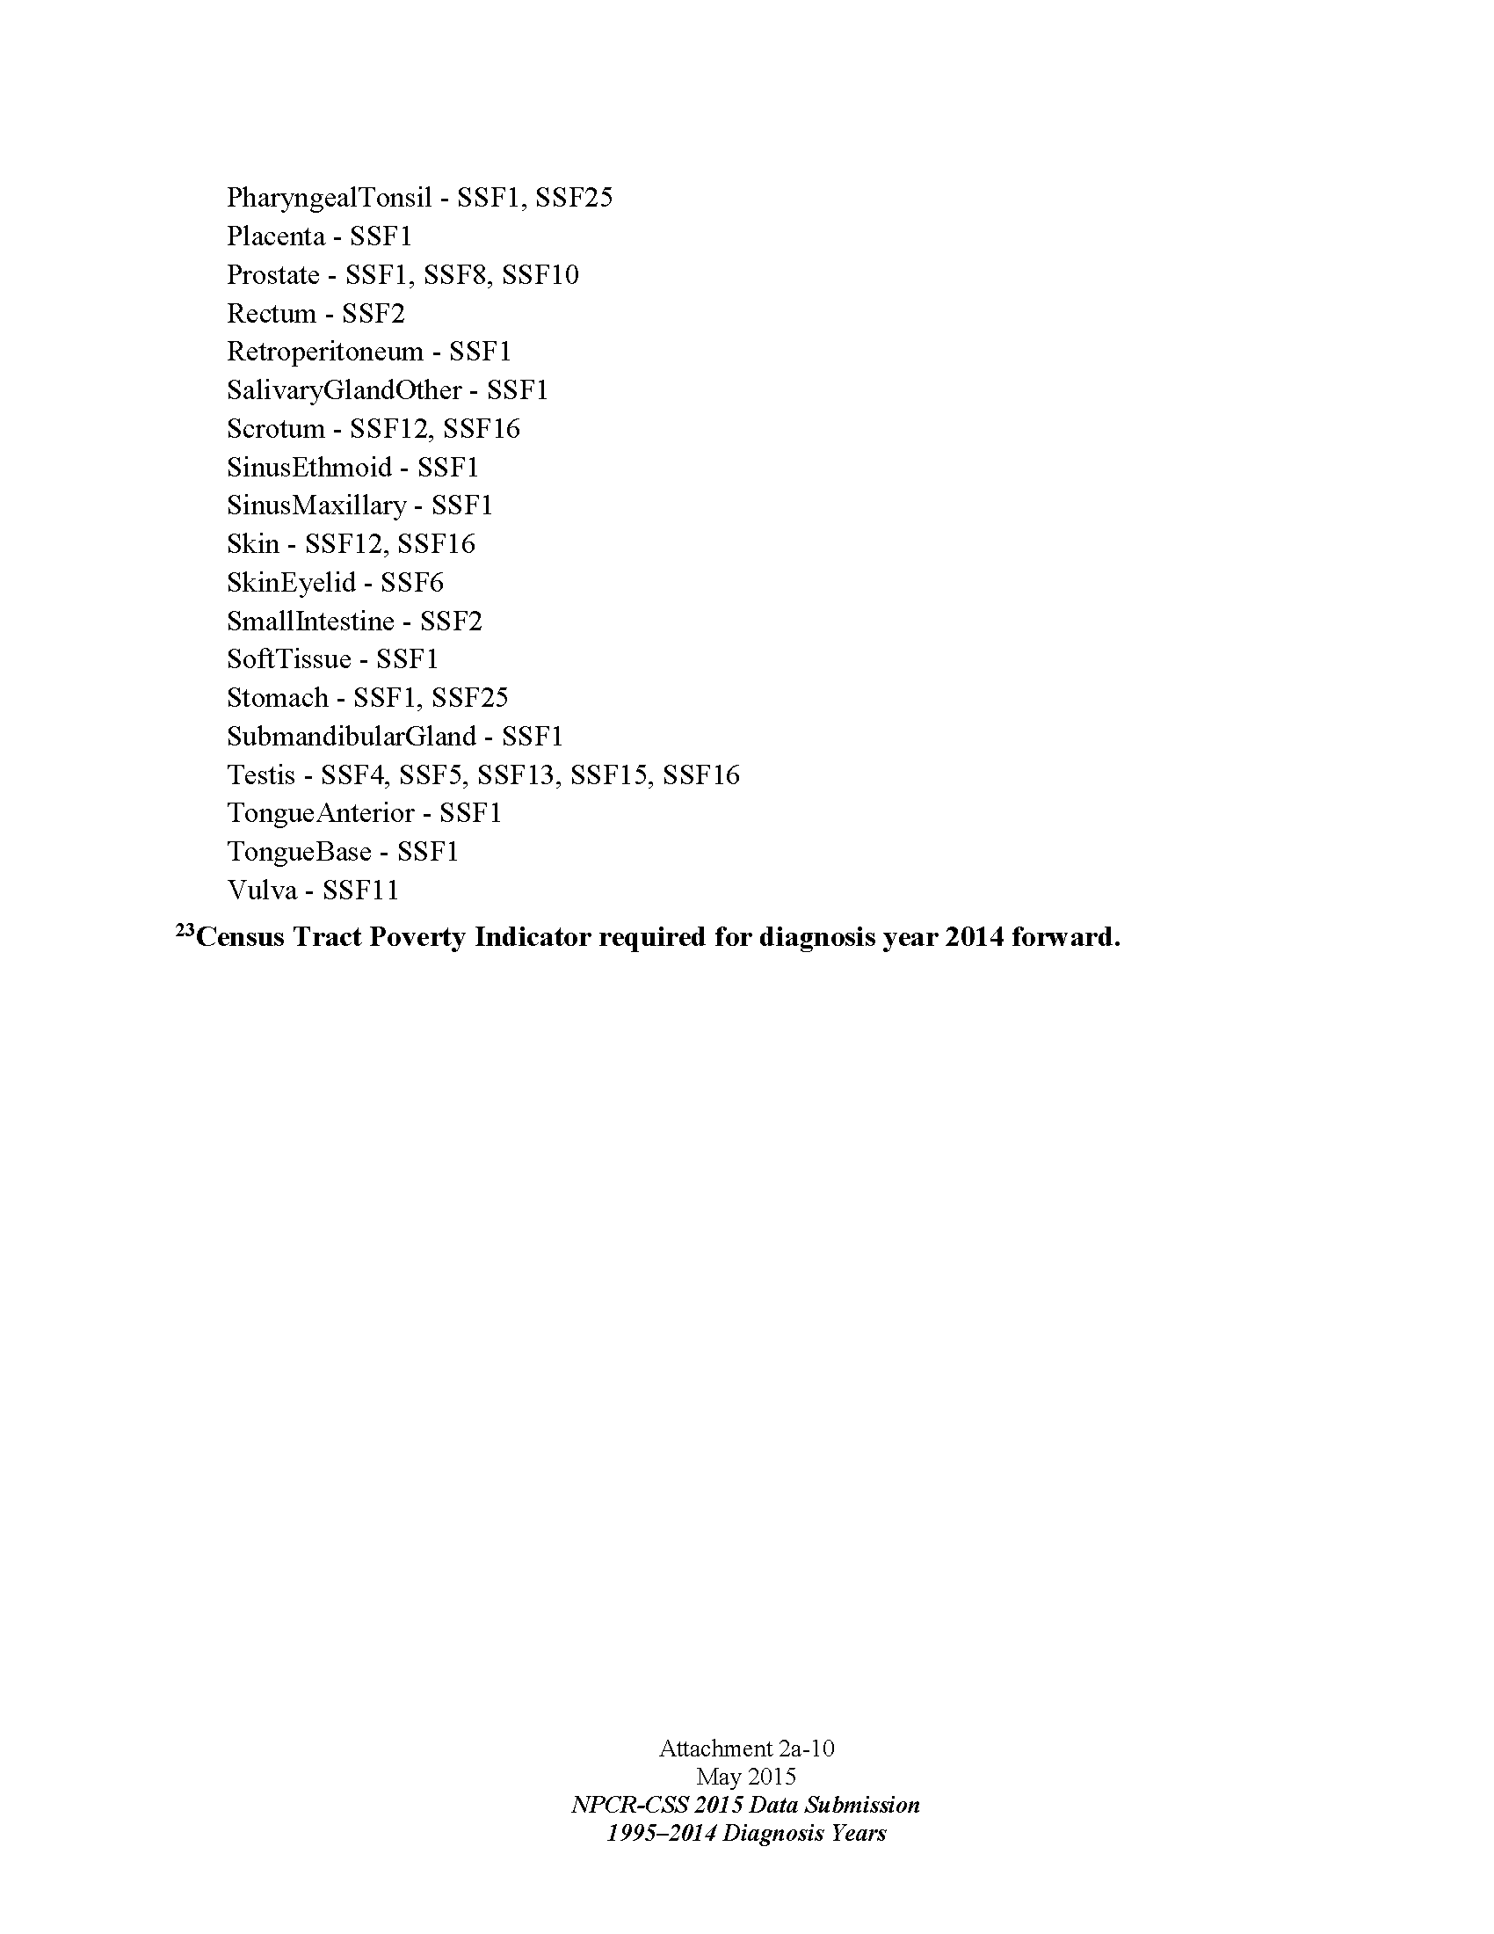

Section 7.

DATA PROCESSING OPERATIONS

Reporting Requirements

U.S. Public Law 102-515 and all jurisdiction “Cancer Registry Acts” defines “cancer” as “all malignant neoplasm, regardless of the tissue of origin, including malignant lymphoma disease.” COC, NPCR, and SEER require the inclusion of all neoplasms in the International Classification of Disease for Oncology, Third Edition (ICD-O-3) with a behavior code of 2 or 3 (in-situ or malignant), with the exception of squamous cell and basal cell carcinoma of the skin, prostatic intraepithelial neoplasia (PIN) III, carcinoma in situ (CIS) of the cervix, and squamous intraepithelial neoplasia III of the anus, cervix, vagina and vulva. Code M9421 (juvenile astrocytoma, pilocytic astrocytoma, or piloid astrocytoma), with behavior code of 1 (borderline) in ICD-O-3, is reportable. Additionally, non-malignant primary intracranial/CNS tumor, with behavior code 0 or 1 are reportable to CDC.

In the best interest of the USAPI jurisdictions, because of the availability and implementation of the Human Papillomavirus (HPV) vaccine and long term desire to use the cancer registries as a way to evaluate efficacy and impact of the HPV vaccination programs, the all jurisdiction cancer registries should also abstracting cases of carcinoma in situ (CIS) of the cervix, cervical intraepithelial neoplasia (CIN) III, vaginal carcinoma in situ (VIS), vaginal intraepithelial neoplasia (VIN), anal carcinoma in situ (AIS) and anal intraepithelial neoplasia (AIN) and report them to the PRCCR. These are not reportable to the CDC.

The PRCCR submits all reportable cases and data items to the CDC, as specified in their Annual Call for Data. As CDC updates their reportable diagnoses, this information will be shared with the registrars in lieu of listing them in this manual.

Multiple Primary and Histology and Ambiguous Terminology. The methods used for counting tumors affect the comparability of cancer rates among registries. It is important that identical rules have been used for counting multiple tumors in the patient whether in the same organ, or opposite sides of paired organs, in different sites or subsites and whether they were diagnosed at the same or different times. Currently, NPCR follows SEER rules for multiple primaries, and so does the Pacific Regional Central Cancer Registry. Please see the “SEER Program Coding and Staging Manual 2012” for more details. All jurisdiction registries have a hard copy of this manual.

DATA CODING

Currently, the Registry is involved in three forms of classification for diseases. (1) the International Classification of Disease (ICD-9), (2) the International Classification of Disease (ICD-10), (3) and the International Classification of Diseases for Oncology, (ICD-O-3). As a minimum, the Registry should classify tumors as to:

- their primary site or anatomical location,
- their histological type or morphology, and
- behavior

Case Ascertainment

Reporting facilities
The main reporting source (>90%) for each jurisdiction will be their hospital (including their hospital lab, radiology, medical records and cervical cancer screening programs managed by the Department/Ministry of Health). Pohnpei and Guam have additional civilian hospitals that may also have a very small number of cases (<5%). The off-island referral office is another major potential source of cases and/or information to complete a case that was partially diagnosed or treated at the hospital. In Guam, approximately 20% of the cases (or information to complete an abstract) will come from one of two free-standing radiation oncology centers or a surgicenter. Guam Cancer Registry has active reporting by their radiation oncology centers and surgicenter (they upload PDFs to the secure WebPlus housed at the University of Guam).
Hospitals: 1 Government hospital each in RMI, Kosrae, Chuuk, Yap, Palau, CNMI, American Samoa. 2 in Pohnpei (Pohnpei State Hospital and Genesis (private). 2 in Guam (Guam Memorial Hospital and Regional Medical City (private)). NONE OF THE USAPI HOSPITALS HAVE AN ACOS-COC Cancer Program
Ambulatory surgical treatment centers: 1 in Guam (they report to Guam Cancer Registry)
Freestanding radiation treatment centers: 2 in Guam (they report to Guam Cancer Registry)
Private Pathology Laboratories: 0. There is a Diagnostic Laboratory Services in Guam, but pathology services are done at the Guam Memorial Hospital (government). There is a pathologist in the government hospitals in American Samoa, RMI and Palau. The FSM and CNMI must send all of their biopsies off-island for reading. Reports come back to the respective medical records department, which is where the cancer registrar obtains the report for case abstraction.
Physicians: There is 1 oncologist in Guam, 1 endocrinologist in Guam, 3 radiation oncologists. There are no dermatologists, urologists, gastroenterologists, hematologists or other physicians who would treat cancer cases in their offices or provide care completely outside of a jurisdiction hospital. For the purposes of NPCR reporting, there are no private physicians who serve as their own ‘reporting facility.’

Case-finding

Case finding is the system used for locating every new cases of cancer that comes from the area covered by the registry, and which is diagnosed and/or treated on or after the registry’s reference date January 1, 2007. Case finding procedures are performed before actual abstracting of data. The main sources of information on cancer cases includes hospital medical records, the Off-Island Referral Program Logs, MOH/DOH Public Health Databases, Doctors’ Logs, HIS Database, BCCEDP Database, Death Certificates File & Database, Laboratory Logs, and X-Ray Logs, and private clinics. In the RMI, additional information is gathered from the 177 Program and, once the MOU is in place, with the Nuclear Claims Tribunal. Because of the small number of reporting facilities, lack of electronic transmission capacity and rudimentary medical records systems, each jurisdiction registrar actively finds and abstracts all cases in the jurisdiction.

Following details specific procedures for each case-finding source.

    - Referral Program Logs. Involves reviewing the Referral program logbooks for possible off-island referral.. Referral may be for diagnosis, treatment, or follow-up of cancer. Registry personnel should work closely with the Referral Coordinator to make sure additional information regarding cancer referrals is reported to the Registry on a monthly basis.

    - HIS Database. The Health Information System (HIS) Database is the main source of information to the Registry. This requires querying the HIS Database to get specific reports on patients who are diagnosed with cancer or working with HIS/IT staff to generate a report of patients with reportable diagnoses. The SEER Casefinding list is sent to the registrars periodically to facilitate case finding from the HIS database / medical records. Currently, the jurisdiction registry has access to their respective Health Information System databases in Palau, RMI, FSM and CNMI. In American Samoa and Guam, the Registrar meets regularly with HIS staff at the hospitals to obtain a listing of cancer patients.

    - BCCEDP Database (Palau, Guam, CNMI, American Samoa). Requires working with BCCEDP program staff to obtain a list of patients diagnosed with breast or cervical cancer. Registrars are expected to manually exchange diagnostic, staging and treatment information with the BCCEDP programs for their required reporting. Because of the relatively small numbers of breast and cervical cancer cases, lack of IT capacity and close working relationship within the same Ministry or Department of Health, data exchange between the registry and BCCEDP program are done manually via lists or Microsoft Excel files.

    - Vital Statistics Death Certificates. Involves review of hard copy of death certificate file for a given year. This file is available either at the vital statistics departments for registry staff to review. In FSM National, the registrar will also review the national databases and communicate with State registrars to ensure that vital status and cause of death information is recorded correctly in the cancer registries. The Health Information System database can also be used for vital status verification. In Palau, modules for this type of verification are available in the Registry’s computers that are connected to the local area network.

    - Laboratory Logs or Laboratory Information System. This requires the registry personnel to review the laboratory logbooks for elevated tumor markers, pathology reports for reportable diagnoses, abnormal pap smears and biopsies sent off-island. A list of patients with abnormal results should be generated monthly and checked against the Registry database. If elevated tumor markers are part of follow-up procedures, they are used to update the laboratory information section of the patients’ record in the Registry database. The result is also checked to make sure it does not suggest another primary site for that patient. For all other patients with elevated tumor markers, Registry personnel will crosscheck with medical records to see if they yield possible new cases. If so the name will be part of the master list to be abstracted. If there is no indication that the abnormality yields a diagnosis of cancer the name is taken off the list.

    - X-Ray Logs. X-Ray logbook is another method for determining the extent of the disease. Many logbooks (in the various jurisdictions) do not show useful information that can be used to assess disease stage. However, Registry personnel can use radiology reports found in patient’s medical record to verify if the imaging was done as part of cancer screening, staging or diagnosis.

    - Private Clinics. In most cases, Registry personnel will need to make in-person contact with the lead physician or office manager to obtain a listing of patients diagnosed with cancer and/or additional information needed to complete the abstract. Physicians/Office staff are encouraged to use a case reporting form, but each jurisdiction has slightly different processes. Abstracting is often done on-site at the private clinics. This comprises a very small percentage of cases in each jurisdiction (<2%).

    - Pathology Reports. Laboratory staff should send copies of the pathology reports to the patient’s medical record/chart. Medical records/HIS staff should then notify the Registrar of a new report. The Registry staff also contacts the off-island referral office at least monthly to see if new information has arrived on a suspected or confirmed cancer patient. Ultimately, off-island referral reports, which can include diagnostic or staging information, consultation notes, pathology reports and treatment summaries should be kept in the patient’s medical record in the hospital.

Methods used to establish expected numbers

Because the quality of medical records is quite poor and scattered in most of the USAPI jurisdictions and because medical records staff who are able to query the HIS databases against the reportable list have varied capacity, the expected cases per year are based on a historical reporting average over the past 4-5 years.

Estimated completeness percentage: Relatively new registrars and assistant registrars are in American Samoa, CNMI, Chuuk State, Guam (new assistant) and Palau (new assistant). CNMI and Chuuk are in the process of catching up on backlog. Guam also has some backlog cases to complete and are now better staffed as of October 2015. Concurrently, increased efforts are being made to diagnose incident cases in most jurisdictions. We anticipate that by diagnosis year 2015, the numbers will be more stabilized.

Expected cases for American Samoa, RMI and Palau will be calculated based on the 3 year average 2011-2013.
American Samoa: 2011-2013 average = 34
RMI: 2011-2013 average = 48
Palau: 2011-2013 average = 31
Guam will be based on 2011-2012 averages = 332
CNMI will be based on 2012-2013 averages = 45
Expected cases) for FSM States will be based on
Chuuk State: 2007-12 average = 14; 2013 cases = 19
Kosrae State: 2007-13 average = 6
Pohnpei State: 2007-13 average = 25
Yap State: 2007-13 average = 15

Case completeness will be monitored by looking at the annual reported (observed) versus expected cases (based on historical averages above). When the PRCCR publishes the “Cancer in the Pacific” report, the PI will look grossly at the incidence rates in comparison to the US and Hawaii rates, as well as any known risk factor rates (obesity, smoking, hepatitis B endemicity). Given that the data from some jurisdictions is known to be incomplete, no case completeness rate is calculated. Especially in Chuuk State in the FSM with very low health care expenditures per capita, there is suspected to be under-reporting due to inadequate resources to either get patients to the main island for examination and/or to have those patients or their tissue biopsies sent off-island for referral. In most jurisdictions, there still remains cultural stigma around the diagnosis of cancer, so the comprehensive cancer control programs continue to work on increasing awareness of risk and encouraging medical care for screening or if there is any abnormality perceived by the patient.

Death Certificate Only cases are tracked and reported back to each jurisdiction registrar at least annually after the CDC runs the quality reports on the November data submission. This is a quality focus area for PRCCR which, unfortunately, is difficult to resolve in most jurisdictions whose old medical records might have been ‘lost’, lost in a fire (RMI), typhoon (American Samoa) or in general disarray (all FSM States and CNMI). The goal is to comply with national standards for percent of DCO cases.

The PRCCR / USAPI jurisdictions do not have any private pathology laboratories, so we do not expect cases reporting only by a pathology laboratory.

Case finding audits This is not applicable to the PRCCR as it is located in Guam and financially not feasible to send PRCCR staff to the jurisdictions to do audits. Additionally, each jurisdiction registry is like a mini-central registry in that each registrar actively abstracts cases from all potential data sources in their jurisdiction.

Timeliness The PRCCR goal is to adhere to NPCR timeliness standards. The former 24-month reporting is done in November each year. The former 12-month reporting is done in January each year. Because of the quality of medical records and significant lag in getting off-island referral information back to the central medical record, in June 2015 the PI has instructed the registrars to (a) Use of rapid case ascertainment procedures for all cases and (b) use a 3 month cut off to wait for additional documentation related to complete coding of the treatment and staging fields. In other words, registrars should focus on the incidence data and well as if treatment was done and submit to PRCCR. As the other documentation arrives, then they can go back to update that abstract and re-transmit to PRCCR for inclusion in future data submissions.

The central PRCCR Program Manager and PRCCR registrar have established a tracking worksheet and monthly reporting systems which measures incremental reporting to the PRCCR. These are monitored closely and if a registrar seems to be falling behind, then a more thorough inquiry is started to determine contributing factors.

Data Abstracting

Each jurisdiction registrar actively abstracts cases from all potential data sources in their jurisdiction. They abstract information into the PIJ Abstract Plus. Part-time staff in Palau and Guam will help abstract demographic, vital status and other information as their knowledge and skills increase.

Performance measures are based on their general job descriptions noted in Section 1. Priority is given to quantity, quality and timeliness of case completion, as well as responsiveness to communication, participation in trainings and meaningful, collaborative interaction with their jurisdiction cancer program and NCD staff.

Confidentiality All registrars must sign their jurisdiction-specific confidentiality policies.

Standard Report Requirements Standard reports are built into the Abstract Plus software, in addition to a few customized reports so that the registrars can utilize their data more readily. They are also expected to utilize the PRCCR Tracking sheet.

Training and Travel This is described more fully in section 2, pages 14 – 15. The registrars come to Honolulu for an annual in-person training. The main trainers are the CTRs of the Hawaii Tumor Registry. To supplement the in-person training, group phone conferences are attempted several times a year (bandwidth and telecommunications permitting), covering relevant topics, updates and to answer questions. For the newer registrars, the HTR staff arranges individual phone conferences to review, for example, site-specific coding and staging. Depending on the results of the quality control audits (error reports on tracking sheets, PrepPlus error reports, CDC data quality audits), specific individual and/or group training will be arranged. Other training topics include quality control topics, ensuring text supports the codes, death clearance, administrative processes (tracking, fiscal management / invoicing) and data usage. Registrars also participate in relevant free online training made available by NCRA or NCI. When possible, the registrars also participate in the meetings with the Cancer Council of the Pacific Islands (CCPI), who is the Advisory Board for the PRCCR. This allows for improved communication, sharing and collaboration since the CCPI members often include the lead physician and/or public health administrator to whom the registrar would ask for help, clarification or guidance.

As the jurisdiction registrars develop their skills, we will make additional coursework available so that they meet the prerequisites needed to apply for CTR and sit for the exam.

Additional detailed data input procedures for jurisdiction registries

Hospital Medical Records. When Registry personnel are ready to abstract details from medical records, the medical records supervisor or designee is notified and a list is furnished to her so she can start pulling records. It is recommended that active records be abstracted within the vicinity of medical records, as active records should be readily available in medical records section at all times, in case patient pays visit to the hospital. However, due to space availability in the Medical Records office, active medical records may be brought to the Cancer Registry office for abstraction. Death records can be taken to Cancer Program’s office for abstraction but all policies in regards to confidentiality should be enforced. In some instances, active medical records may be brought to the Cancer Registry office to be abstracted. This may only happen due to lack of office space or if the process interferes with daily operations of the medical records department. Registrars should follow their hospital’s policies and procedures when handling or checking out medical records. In American Samoa and CNMI, there is limited access to the electronic health record. The jurisdiction’s Department of Health should work with the hospital to ensure the registrar has the appropriate access codes and privileges. If possible, remote access should be allowed since active workspace in the medical records department is quite limited in American Samoa and CNMI.

Private Clinic’s Medical Records. Registry personnel should work out a schedule with each private clinic before going in. Additional information may also be obtained at the hospital Medical Records department. All abstracting activities will be performed strictly within each clinic. The registrars may use their laptops for case abstraction ‘in the field’, but should transfer these cases to the main database in the Cancer Registry office (desktop) upon their return to the office.

Guam Surgicenter or Radiation Center. Each of these facilities sends relevant portions of the medical record to the Guam Cancer Registry via the PRCCR WebPlus. The Guam Cancer Registry staff will review the information and if additional information is required, they will contact the staff of the reporting facility to obtain additional information, if it exists.

Registration of a new patient. When a new patient is identified and the case is determined to be reportable, a new record is created on the database. Once a record is created, all information relating to that particular patient are entered and saved.

Second Primary. If a new primary tumor is identified in an individual who is already registered in the database, a new registration has to be created. That means a new record in the database. It is important that the new registration be assigned a sequenced number in order to identify multiple primaries. The registry follows SEER rules when coding multiple primaries.

Updating records. The Registry updates its database whenever information is available. New information could come from vital statistics, a follow-up visit, or records of patients treated off-island.

Editing. The PIJ Abstract Plus contains all of the standard NPCR inter-record edits, in addition to a few customized edits to ensure completeness and consistency. Examples of edits include site-specific related risk factors or co-morbidities such as liver cancer must have an entry for the Hepatitis B and alcohol use fields. Registry personnel should correct all edits prior to submitting the cases. Additionally, they should double check the derived and directly coded stage information against the supporting text.

Data entry

The jurisdiction registrars perform direct / active abstracting of cases into their cancer registry. The exception is Guam, where the one surgicenter and 2 radiation treatment centers submit information (PDF files) to the Guam Cancer Registry via the PRCCR WebPlus. When the files are retrieved by the Guam Cancer Registry, the GCR administrative assistant will notify the reporting facilities that the information was received. Source documents from the three Guam non-hospital reporting facilities is kept on the WebPlus server and also copied to the main Guam Cancer Registry hard drive. All data entry is done manually. Because of the state of medical records, low health budgets and non-applicability of the Affordable Care Act to FSM, Palau and RMI and current non-applicability of Meaningful Use requirements to electronic health records in Guam, CNMI and American Samoa, there is no direct electronic transmission of information to any of the jurisdiction or PRCCR registries.

Once an abstract has passed the NPCR and PIJ-specific edits at the jurisdiction level, the cases are then exported in small bundles, named appropriately and uploaded to the PRCCR WebPlus. The jurisdiction registrars then send an email to the PRCCR Registrar, Program Manager and PI that bundles have been uploaded. Registrars should also keep track of the bundle names, submission date, date of confirmation receipt and any feedback (error correction) given by the central registrar, as well as the date of re-submission or correction.

The central registrars in FSMN and PRCCR will download the bundles from WebPlus and run them through Prep Plus. For FSMN, once the cases are consolidated, de-duplicated and deemed error free, the FSMN registrar will upload those PrepPlus bundles to PRCCR. At PRCCR, if there are no major errors in PrepPlus, then the registrar will process the cases in CRS Plus. If there are major errors in Prep Plus, the central registrar will work directly with the jurisdiction registrar on any needed clarification or corrections. If corrections are minor, the PRCCR registrar will manually make the change and advise the jurisdiction registrar to update their database. If the corrections are major (i.e., insufficient text to support the assigned code), then the case will be rejected and returned to the jurisdiction registrar.

Internal Matching and Linkage

All potential cases and abstract information is manually matched based on patient name, date of birth, hospital ID number, social security number, primary site and date of diagnosis. Cases must be an absolute match.

Consolidation

Record consolidation is an important function of central cancer registries. It ensures that all submitted tumor
records are counted only once. When records are not consolidated, over-counting of cancer incidence occurs. Consolidation of cases is done at the FSM National Registry (for cases from the FSM States: Chuuk, Kosrae, Pohnpei and Yap) and at PRCCR in Guam. Both registries use Prep Plus. Only PRCCR uses CRS Plus with the standard consolidation requirements and edit sets. Both central registrars do almost 100% visual review of cases, to ensure high quality data with appropriate supporting text. PRCCR as a whole uses the standard required NPCR / NAACCR data items.

Process Management Reports

The PRCCR system has developed a case tracking excel spreadsheet, which is used as a bilateral communication and tracking tool. The jurisdictions enter all of their bundles / cases into the sheet and send the sheet to the PRCCR Program Manager and the PRCCR Registrar (or FSMN Registrar, for the FSM States). The PRCCR / FSMN Registrar, after review of the cases, would then notate if the case was accepted or rejected and if rejected, state the reason why. The tracking sheet serves as a record of productivity, timely response to corrections and gives us guidance on needed areas for training / reinforcement (based on the types and frequency of errors).

The PRCCR registrar also runs and shares back the PrepPlus reports to the jurisdiction registrars and the PRCCR Program Manager. This information is used at the regional level to guide training or specific technical assistance.

SECTION 8.
DEATH CLEARANCE

Death clearance processes should generally follow the 2008 NAACCR Standards for Cancer Registries, (Vol. III) Standards for Completeness, Quality, Analysis, and Management of Data, Chapter 2, Section 2.2.8 which starts on page 17. The jurisdiction registrars, with the assistance of their Cancer Council of the Pacific Islands Director and/or their Director of Health, should establish relationships with the Vital Statistics personnel.

The Vital Statistics databases vary in the USAPI. In the Territories and Commonwealth, their death certificates are sent to Research Triangle, National Center for Health Statistics to be coded. They are then sent back, but because the process is not electronic, in can take over a year to get back a coded death certificate. In the FSM, RMI and Palau, their national government staff is responsible for coding the cause of death. Their vital statistics databases are electronic, but case matching is done manually with the Registrar giving the Vital Statistician a listing of cancer patients in the AbsPlus database. In the ideal situation, the hospital / physicians and/or the Vital Statistician will notify the cancer registrar when there is a cancer listed on a death certificate. Unfortunately, many of the death certificates are not coded in ICD-10 or are not available (not all jurisdictions require a full death certification). Because of this and because of the relatively small number of cases, we recommend that manual death clearance be done twice a year. If the registry finds that a death certificate is available not coded via ICD-10, then they should enter the 7797 value in the “DthCause” field (i.e., death certificate available, but cause of death not coded). If there is enough supporting text in the medical records that suggests a cancer cause of death, the registrar would preliminarily select an appropriate ICD-10 cause of death code, but will then seek confirmation by the attending physician. After physician confirmation, then registrar will enter the code and then make a notation that the cause of death was determined by the physician (as opposed to the coded death certificate).

Frequency, method of linkage and linkage criteria Manual linkages with the vital statistics databases should be done at least annually, but ideally twice yearly for the reasons noted above. Ideally, the linkages should occur in January and June, so that appropriate followback and data entry can be complete by September of each year. This will give enough time for the jurisdictions to complete their cases, submit to FSMN or PRCCR so that the data submission processes can occur on time. All current and past year cases should be run for the purposes of updating the cancer abstract. If there is a match, the registrars will get a paper copy of the death certificate from which to compare and update data in the abstract. Registrars should verify the identity of the patient using name, date of birth, place of birth and/or social security number. Tumor linkage comparisons should also occur for concurrence or to resolve discrepancies. The date of death should be entered into the AbsPlus database per protocol. Vital status should also be updated in the AbsPlus database. All paper copies of death certificates should be placed into the patient’s medical records (if it is not already there) and treated with the same confidentiality precautions as the rest of the medical record.

Formal agreements – only exist for American Samoa as the Vital Statistics office falls under the Department of Homeland Security. All of the other jurisdictions’ Vital Statistics records fall under the auspices of the Department or Ministry of Health, where the registrar is also located.

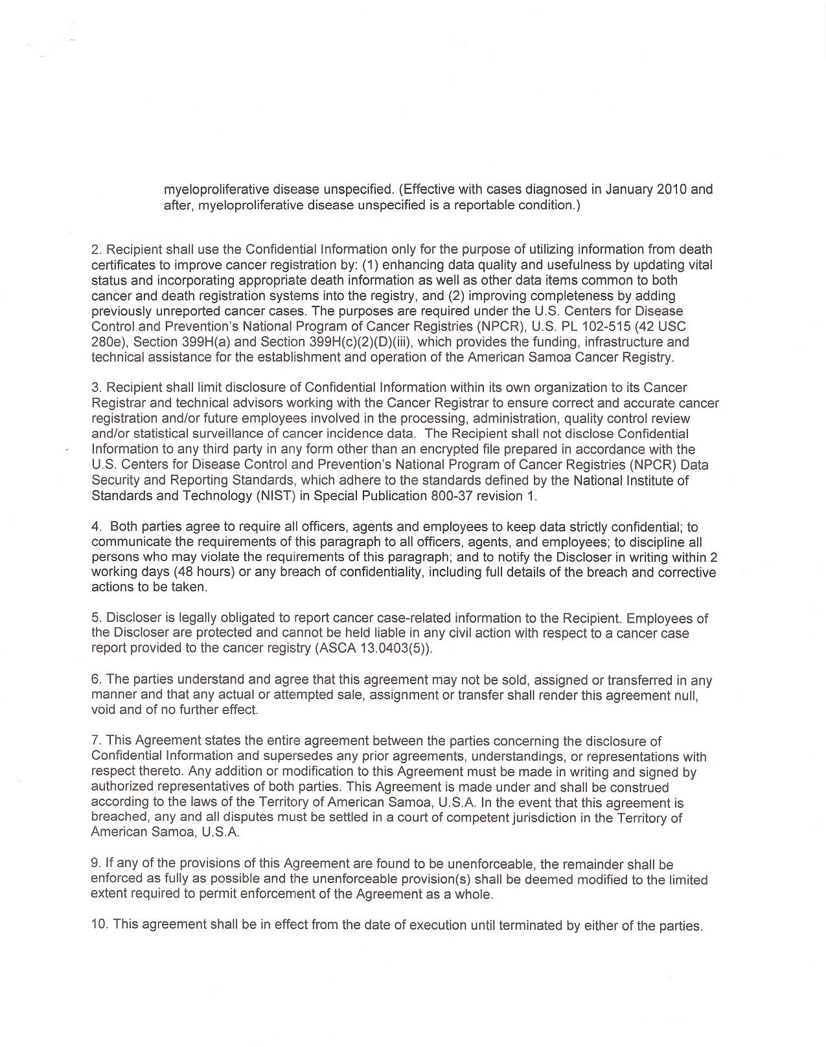
Replacement of unknown values or conflicting information If, during the manual review of the death certificate, the registrar finds additional demographic information that was previously missing from the AbsPlus database, the registrar should use the information from the death certificate to make the abstract more complete. If there is conflicting information, such as birthplace, the registrar should discuss the case as needed with the medical records supervisor and/or vital statistician in order to resolve the conflict. Given the current poor reliability of the death certifications in most of the USAPI, data informing multiple primary sites should come from the medical record (including any off-island referral reports) rather than from the death certificate. If the death certificate specifies a primary cancer site that is more specific than that available in the medical record, the registrar should use the death certificate information for the cancer abstract.

Follow-back All death certificates that have a documented or ‘suspected’ cancer cause of death should be followed back to the patient’s medical record to ensure accuracy and completion of the cancer abstract. If there are additional questions, the registrar should contact the attending physician directly. Followback should be done at least twice a year. The registrar should keep a log of all items requiring follow-up, including death certificates, off-island referral documents or any diagnostic tests sent out by the hospital lab that are still pending.

Death certificate information from other states At present, the PRCCR is not matching with the National Death Index due to technical issues and limited on-island staffing to assist with file preparation. Because the citizens of the FSM, RMI and Palau do not have US Social Security numbers, matching may be difficult.

Death Certificate Only cases The registrars should try to resolve all DCO cases by contacting medical records at the hospital or the physician office. However for those few remaining, the registrar will abstract them with the minimal data available. Abstracting should ideally be done in the same year of death or as soon as the death certificate is available. The goal for DCO cases is < 3% per jurisdiction registry, per NPCR Standards. The DCO percentage is calculated using the standard formula: Numerator is the number of denominator with Type of Reporting Source = 7. The Denominator is the Number malignant plus Number in situ bladder plus Number benign brain. Jurisdiction with DCO cases > 3% (noted in the November data submission) will develop an action plan with the PRCCR Principal Investigator and Program Manager to improve.

Section 9.
Case Sharing Agreements

All jurisdiction cancer registries, the University of Guam/Pacific Regional Central Cancer Registry and the State of Hawaii/Hawaii Tumor Registry have entered into an Interstate/Interjurisdictional Data Exchange for Diagnosed Records. An electronic copy of the executed agreement is kept on file at the PRCCR Program Office on Oahu, Hawaii and at each signators’ Registry. Currently, only Hawaii Tumor Registry exchanges cases back to the other jurisdictions via secure WebPlus, in the current NAACCR record layout. A few cases from Guam are shared back with CNMI through encrypted email. The main purpose of case sharing is to get more accurate incidence counts / rates. Although a fair number of patients from the FSM, RMI and Palau may receive a portion of their care in the Philippines or elsewhere, almost all initial biopsies and diagnoses are done within the jurisdiction. There may be future need to explore a case sharing agreement with the major referral hospitals in the Philippines if receiving complete off-island referral records continues to be a challenge.

The cancer registries of the registration areas of the United States Territories (American Samoa and Guam) and Commonwealth of the Northern Mariana Islands and Countries in Free Association with the United States (Federated States of Micronesia, Republic of Palau and Republic of the Marshall Islands) and the State of Hawaii hereby agree:
1. To provide cancer registry records and information concerning cancer patients that occurred to non-residents contained in the central cancer registry to the registration jurisdiction of usual residence.
2. That information be provided electronically in the most recent North American Association of Central Cancer Registries (NAACCR) data exchange record layout, instead of paper copies or printouts, shall contain sufficient information to be used for statistical and administrative purposes, and shall be transmitted through a secure Internet-based, FTP, or encrypted e-mail mechanism.
3. That information or copies provided under this agreement may be used by the State Public Health Department or other receiving agency for:
a. Aggregated statistical tabulations and analyses.
b. Linking with appropriate databases [i.e., death certificates, hospital discharge databases].
c. Research conducted or approved by the receiving agency as long as the identity of the individual, names, or other personal identifiers are not released nor is there any release of information which would inescapably have the same result.
d. Sharing of de-identified information with local and/or national public health agencies, including the National Program of Cancer Registries Cancer Surveillance System annual call for data, for the support of public health programs.
e. In all cases, agreeing to use of cancer registry records for program purposes in a recipient state agency does not imply permission for any secondary release of those records containing identifiable information by that program without specific approval from the state of origin other than specified in this agreement.
4. The parties understand and agree that any and all data which may lead to the identification of any patient, research subject, physician, other person, or reporting facility is strictly privileged and confidential, and agree to keep all such data strictly confidential.
5. The parties understand and agree to restrict access to cancer incidence data or identifiable information on a cancer patient or health care provider that was supplied under the terms of this agreement from being released to anyone not employed in the direct operation of the recipient registry. Employees may include those involved in the processing, administration, quality control review, and the statistical surveillance of cancer incidence data.
6. The parties further agree to require all officers, agents, and employees to keep all such data strictly confidential; to communicate the requirements of this section to all officers, agents, and employees; to discipline all persons who may violate the requirements of this section; and to notify the originating party in writing within 2 working days (48 hours) of any violation of this section, including full details of the violation and corrective actions to be taken.
7. The parties understand and agree to notify the exchange registry if, in the conduct of approved research or other activities, there is release of a cancer patient’s identifying information. Should such a release take place, the receiving registry will notify the exchanging registry in writing within 2 working days (48 hours) of the release of the data.
8. That any other use of records or information from records provided in accordance with this agreement requires the written permission of the registration area where the record is officially registered or filed.
9. In the event that either party receives a subpoena or other court order compelling disclosure of confidential data, the parties agree to notify the registry that initially provided the data within 2 working days (48 hours) of receipt of the subpoena or court order. Additionally, the parties agree that, should they receive such a subpoena, they shall take all legal steps reasonably necessary to oppose the subpoena.
9. That all transmittals of cancer registry records are to be made no later than 120 days following the date case report received. To ensure optimum utilization of the records, special efforts will be made at the beginning of a new calendar year to meet this deadline. All transmitted data shall be in accordance with CDC NPCR’s Program Standards for data exchange.
10. Such agreement shall remain in effect from the date of execution unless notified of a change by the appropriate state official.
11. All notices required or desired to be made to this agreement shall be sent by certified mail to the following respective addresses.

Section 10.
QUALITY CONTROL

Quality assurance plan Several activities are done at the jurisdiction and regional registries to monitor quality.

At the jurisdiction level, the registrars are not to export cases until they have passed all of the standard NPCR edits and PIJ-specific edits for each record. The jurisdiction registrars should also do their own ‘editing’ to ensure the supporting text matches the assigned code and that the text supports the staging information. They also enter each case onto a tracking sheet and receive feedback from the regional registrar if their case was accepted (i.e., error free in PrepPlus or CRS Plus) or if they need to provide additional information, missing information, clarify discrepancies. In some cases, the abstracts are rejected for lack of sufficient supporting text documentation. Jurisdiction registrars also receive PrepPlus error reports for additional information and learning.

For case ascertainment, the registrars should actively followup with with medical records, the lab, off-island referral offices (and the radiation oncology and surgicenter facility in Guam) monthly to ensure all cases are captured.

Registrars should use the MP/H rules and other coding manuals/rules to resolve any discrepancies. They should contact the regional registrar and/or Hawaii Tumor Registry technical assistance staff if they have any questions about an abstract.

At the regional levels (both FSM National and at the PRCCR), the registrars utilize PrepPlus for the initial review and feedback to the jurisdictions. The FSM Registrar will also review the text documentation to ensure it supports the assigned codes. If there are discrepancies or need for additional information, the case is rejected and returned to the appropriate registrar. At the PRCCR, using CRS Plus, the registrar does a 100% visual review of all cases. Besides reviewing all text fields to ensure the documentation matches the selected code, the following fields are specifically evaluated for quality and/or because these have been identified areas for improvement and training:
Date of Initial RX – SEER
Date of Initial Rx Flag
Reason for No Surgery
RX Summ-Radiation
RX Summ-Surg/Rad Seq
RX Summ-Chemo
RX Summ-Horm
Date of last contact
Vital Status
Follow-up Source

Initial abstract processing The tracking sheets at the jurisdiction and regional levels are on Excel files. The FSMN and Regional Registrar receive all cases using WebPlus and use the WebPlus Manager to access the files. The jurisdictions are instructed to upload small bundles of cases (1-5), given bandwidth issues. Basic information is entered manually into the tracking sheet.
BUN File Name
Total number of cases in the BUN file
Abstract Plus ID
Patient Initials
Date case submitted to central registry (CR)
Date case was received by the central registry
Date notified by CR that case was accepted or rejected
Why case was rejected
Date (the corrected) case was returned to CR (goal is within 1 week of being rejected)
Statement by jurisdiction registrar of what changes were made to the case
Date the case was received by CR
Date notified by CR that case was accepted or rejected
Why the case was rejected again (if applicable)

When the central registrar downloads the bundles, they notify the jurisdiction registrar by email.
The cases are first run through PrepPlus. Any discrepancies are clarified and corrected before moving the record into CRS Plus.
100% of cases are visually reviewed in CRS Plus. Standard CRS Plus edits (that correspond to the PIJ Abstract Plus) are run. All text fields are reviewed and if there is discrepancy between the selected code and text, those clarifications / corrections are made.
Cases are not accepted into the database unless all corrections or clarifications have been made.

Computer edits
The PIJ Abstract Plus contains the standard NPCR EDITS as well as PIJ-specific (State specific) edits. Most of the State specific edits are related to presence of codes on fields relating to a risk factor and/or screening test or immunization status that is related to a primary site. For example,
If PSite is liver, the fields for Hepatitis B status, immunization, alcohol use must be completed
If PSite is lung, the fields for tobacco must be completed
If PSite is any oral cavity, then tobacco and betel nut fields must be completed
If PSite is cervical, then Pap screening, HPV immunization fields must be completed
If PSite is breast, then mammography screening field must be completed

At the Central Registry level, the standard CRS Plus edits (that correspond to the PIJ Abstract Plus) are run on each case. 100% visual review also occurs. If the discrepancy is simple, the central registrar will resolve it after confirmation by the jurisdiction registrar (i.e., a transposed date). If the edits are extensive and/or if there is insufficient text to support the case, the case is rejected and returned to the registrar. No cases with inadequate text are submitted to CDC during data submission.

For data submission, the PRCCR uses the standard GenEDITS Plus with the specific year’s NPCR-CSS Edits Metafile.

Batch and Detailed individual error reports are generated by PrepPlus (as well as the tracking sheet) and shared back to each jurisdiction as soon as the cases are run through PrepPlus. As mentioned above, a case does not move from PrepPlus to CRSPlus until all issues are resolved.
Visual editing and reconciliation 100% of cases are reviewed by the regional registrar. Particular attention is paid to fields with high error / non-compliance rates noted by CDC review of the submitted data or fields where registrars have historically had difficulty. The listing is noted below. Additionally, all text is reviewed to ensure it matches the specified codes.
Date of Initial RX – SEER
Date of Initial Rx Flag
Reason for No Surgery
RX Summ-Radiation
RX Summ-Surg/Rad Seq
RX Summ-Chemo
RX Summ-Horm
Date of last contact
Vital Status
Follow-up Source

If the central registrar is able to easily resolve errors (i.e., automatic correction rules), they will do so. The jurisdiction registrars are notified of any edits. They are also contacted by email or skype to discuss any discrepancies. Errors / reasons for the case rejection is also noted on the tracking form and sent back to the jurisdictions. In rare cases, the jurisdiction registrar is asked to reabstract the case and send the new file back to PRCCR.

Consolidation In the FSM, the National registrar first receives all the cases from the FSM States. He will then do a consolidation and also resolve any duplicates since he has easier contact with the FSM State registrars and also has access to the National Health Information System and Vital Statistics database. Any issues or questions are resolved before he sends the case to the PRCCR.

At the PRCCR, consolidation is performed using CRS Plus. Any inconsistencies or questions are followed back right away with the jurisdiction registrar who abstracted the case.

Section 11.
FOLLOW-UP

All jurisdiction registrars are responsible for active follow-up of all cases and potential case finding sources (i.e., hospital medical records, lab, radiology, BCCEDP and other cervical cancer screening programs (Maternal-Child Health, Family Planning / Reproductive Health, Community Health Centers), off-island referral offices, vital statistics, Governor’s office (in Guam)). In Guam and Palau, the new assistants will be primarily responsible for ensuring good follow-up from the different sources (radiation oncology facilities, surgicenter, any private clinics). The administrative assistant in Guam is also tasked with obtaining records to clear DCO cases.

Because medical records are quite scattered, follow-up should be done monthly with all potential case finding sources. Follow-up / manual linkages with the BCCEDP funded program should occur at least annually and should include all HSIL / CIN 3 / CIS cases as those are being monitored by PRCCR for evaluation of long-term impact of HPV vaccination programs. Those bases are not submitted to CDC. Follow-up / manual linkages with vital statistics should occur at least twice a year, preferably in January and June so that any corrections or additions to the cancer abstract can be completed prior to submitting their cases to PRCCR (end of September deadline).

Follow-up of any incomplete case should be done monthly until the case is completed. However, if 3 months pass before receiving treatment summaries, for example, then the jurisdiction registrar should submit their case with the demographics, incidence and diagnosis data. When the additional information comes in, then the registrar can update the abstract and resend that file to the central registry.

Section 12.
DATA USAGE AND REPORTS

Standards for reports
Denominator population data is based on 2010 Census reports since that is the commonly available data for all jurisdictions. This is used to calculate the incidence and crude rates.
CDC suppression rules are utilized. For those jurisdictions with less than 16 cases, only the counts and crude rates are published.

The more comprehensive regional reports will not be produced until there is at least 5 years of data in the registry. Those reports will include the following information:
- Background and health capacity context for the USAPI jurisdictions
- Simplified descriptions or definitions of what is cancer, which are preventable, staging, incidence and mortality rates
- Data table of all adult incident cancers, with comparison US and Hawaii rates – all, male and female
- Pie chart of percent distribution of incident cancers (Top 10-15)
- Brief 1 page narrative (signs and symptoms, risk factors, early detection, treatment, survival) and overview table of available screening / on-island treatment and barriers and crude and age-standardized incidence rates for each major site (breast, cervix, colorectal, HPV-related cancers, liver, lung & bronchus, leukemia, oral cavity & pharynx and thyroid)
- Top 10 cancer sites by jurisdiction, which also includes a snapshot of selected demographic, economic and health care capacity information for each jurisdiction.

Given the relatively small numbers of annual cases reported regionally, we anticipate major updates to the “Cancer in the USAPI” to be done every 2-3 years. These reports are uploaded to the website. PDF copies are also sent to each jurisdiction’s Minister/Secretary/Director of Health, CCPI members, cancer program staff, CDC Program consultants, the Pacific Island Health Officers Association (PIHOA) (regional healthy policy making body comprised of the senior ranking health official in each jurisdiction), WHO and other key partners. PIHOA is free to disseminate the report to the key legislators, Pacific Islands Forum, Heads of State and other stakeholders. The CCPI and cancer program staff are encouraged to share the report with their local legislators, coalition members and Executive leadership, as well as other NCD Program staff.

Abbreviated regional reports, containing updated data table and percent distribution / top 10-15 cancers are published to the website annually and also provided annually at the Cancer Council of the Pacific Islands (Advisory Body) meetings.

The regional registry also produces jurisdiction reports listing their top 10 adult cases, but also showing what percent of their cases are attributable to tobacco, betel nut, obesity or have evidence-based screening methods or could have been detected by a thorough history and physical examination (i.e., breast, many gynecologic cancers, tumors on extremities, scalp, most head and neck, external sites). Presentation of data in this way provides more useful information for the jurisdiction cancer and non-communicable disease programs and is easier to convert into culturally-appropriate health outreach and educational materials. PDF copies are also sent to each jurisdiction’s Minister/Secretary/Director of Health, CCPI members, cancer program staff. CCPI and cancer program staff are encouraged to share the report with their local legislators, coalition members and Executive leadership, as well as other NCD Program staff.

Jurisdiction reports (facility reports) To facilitate local control of data and more efficient data usage, CDC technical staff developed custom reports for the PIJ AbsPlus. These reports are to be used for jurisdiction-level reporting for public health purposes. The custom reports include ability to generate the following:
- Primary Site by Gender by Race & Ethnicity*
- Primary Site by Year of Diagnosis*
- Primary Site by Cause of Death
- Primary Site by Parrish by Gender*
- Age (5 year intervals) by Primary Site by Gender*
- Stage by Diagnosis by Year
- Primary Site by Behavior Code
- Origin of Stage by Year
- Vital Status by Primary Site*
- Diagnostic confirmation by year*
- Tobacco use by year
- Stage by primary site by Diagnosis year
- Sex by Diagnosis year

The ones with asterisks (*) are more widely used. Some jurisdictions also have local capacity and expertise in simple statistics; others have local epidemiologists. As the data is owned by the jurisdictions, they are able to generate their own local reports. We do strongly advise to use CDC suppression rules and/or to do reporting based in at least 5 year increments so that the data is more stable.

If the jurisdiction is asked for reports from their legislators or coalition and it contains more than the data provided by PRCCR or simple summary data (case counts by year), we ask that they first clear the data and report with their local epidemiologist or statistician.

Data uses
Jurisdiction and/or regional data is used for comprehensive cancer control (CCC) plans, non-communicable disease (NCD), community outreach, advocacy and awareness (legislation, health system improvements, national standards, organizational policy, systems and environmental changes) and grant applications. In the FSM, RMI, and Palau, they have additional cancer reporting requirements to the WHO and Secretariat of Pacific Communities. The cancer data for screenable cancers are used for program planning and evaluation. Some data are used to prioritize survivorship programs, screening or prevention programs. Some of the quality data (especially the lack of coded death certificates and/or inaccuracies in the certification) is used to drive quality improvement initiatives in mortality reporting.

Cervical cancer data is used for regional efforts to improve cancer screening.

Cancer data is also used for long-term evaluation of the following:
  - Changes in incidence of tobacco-, obesity-related, screenable and those able to be detected at Stage 1 or 2 by good history and physical examination
  - Changes in proportion of stage 1 vs. later stage cancers
  - Changes in proportion of persons dead within 5 years of diagnosis (not necessarily cancer mortality)
  - Changes in proportion of cervical pre-cancer, Stage 1, Stage 2+ cervical cancers as HPV vaccination becomes more widespread and screening improves

Section 13.
CONFIDENTIALITY

Confidentiality forms All registry staff must sign their jurisdiction’s Ministry/Department of Health (or University of Guam) confidentiality policies upon hire. Additionally, basic HIPAA training is required for the registrars in Guam, CNMI and American Samoa (HIPAA does not apply in FSM, RMI, Palau).

Confidential data includes any protected health information as defined by HIPAA. This is applicable to all jurisdictions. The jurisdiction registrars must comply with their respective Ministry/Department policies and procedures related to confidential data.

The following procedures should be followed in order to adhere to all Confidentiality sections noted in the jurisdiction Cancer Registry Acts or Rules and Regulations:

Physical security-all desktops used by cancer registrars must be in a locked room. Faxes receiving confidential data should be in a secured location, with access limited to cancer registry and medical records staff (as applicable). Medical records that are taken from the medical records room back to the registrar’s office should be properly signed out according to local hospital policy and should be returned at the end of the day or as soon as possible. Any patient records should be placed in a locked cabinet in the registrar’s office.

Data Collection- Most jurisdictions utilize a laptop computer for the initial case ascertainment from outlying clinics, offices or free standing cancer centers (separate from the main hospital), medical referral or insurance offices. All laptops should have a user-based log in and password. These laptops should have their hard drives encrypted using TrueCrypt or similar encryption software. All data is entered into a secure software program called AbstractPlus, which also requires a user name and password. The contents of data gathered and reports should not be disclosed to other parties than the data source and the registry. Since most data are collected actively, it is the responsibility of the registry staff to preserve the confidentiality of information on cancer cases or anything of a personal or confidential nature seen or heard at the source. Data should not be left at a place where an unauthorized person(s) can gain access. Laptops should never leave the possession of the user or be left in the car. Upon return to the Registry, information should be transferred into the main Registry computer housing the master database.

Data access-In the jurisdiction registries, all information is maintained or backed-up to a secure desktop computer. Many jurisdictions utilize a laptop computer for the initial case ascertainment. These laptops should have their hard drives encrypted using TrueCrypt or similar encryption software. The Pacific Regional Central Cancer Registry maintains a master database on a secure data server. Access to the data is protected by the use of password to Windows and user name and password to each component of the NPCR Registry Plus suite of software (including, but not limited to AbstractPlus, CRSPlus, PrepPlus, Links Plus and WebPlus). In all jurisdictions, access is limited to fewer than three people, generally the Registry Coordinator, a Registry Technician and perhaps the Medical Records supervisor. Additional measures are taken to ensure confidentiality of information in the medical record and other paper files. These measures are detailed separately in each jurisdictions’ Ministry or Department of Health Policies and Procedures.

Jurisdiction data transmission-transmission of data to the Pacific Regional Central Cancer Registry via Internet goes through a detailed process. First, the computer-based database (AbstractPlus) requires user identification and a password. When the cases are complete according to the AbstractPlus software, these files are converted into extracts in a specified NAACCR record layout. These extracted cases are then prepped for transmission in Abstract Plus and in WebPlus, the NPCR-provided secure software system used to transmit information between the jurisdiction and PRCCR. Access to WebPlus requires a special user identification, password and authentication process. Download of extracted files from the jurisdictions to the PRCCR database also requires a user authentication process. After the PRCCR further links, edits and/or consolidates cases, the file is prepped for submission to the NPCR. NPCR requires that no identifying information must be included in the annual data submission. Each year, NPCR issues a Call for Data, which includes specific rules and edit sets. Annual data submission to the NPCR is via a secure web portal and process.

Data requests (other than for public health purposes)
Jurisdiction Data Use and Release-Please refer to the “Cancer Registry Act” Section 2 for each jurisdictions’ specific language. Any request for information from parties other than the Ministry/Department of Health’s Cancer Program, Non-Communicable Disease Program or Minister/Secretary/Director of Health must be done in writing, utilizing a data request form. The data request form should be used regardless if the request is for aggregated, de-identified data or information containing patient identifiers and/or Protected health information. The data request form for Jurisdiction Registry information should be first reviewed by the Registry personnel, then by the Minister/Secretary or Director of Health, Institutional Review Committee/Board or their designate. Jurisdiction Registry personnel will produce the requested reports only upon receipt of the signed approval form. This process helps to ensure data is free of identifying information before being disclosed and ensures that the Secretary/Director of Health is aware of the various requests for uses of cancer information. Information requested should be used solely for the purpose as stated on the request form. Other use of the data is strictly forbidden unless otherwise authorized by the Minister/Secretary/Director of Health.

Regional Data Use and Release- Any requests for Regional data from parties other than the CDC, NCI, NAACCR, NCHS, WHO / IACR, PIHOA or jurisdiction Ministry/Department of Health must be done in writing, utilizing a data request form. The data request should be first reviewed by the Principal Investigator of the NPCR Cooperative Agreement, then by the Registry personnel and the PRCCR Program Manager. Members of the PRCCR Advisory Committee (the Cancer Council of the Pacific Islands) will be informed of the data request. Depending on the nature of the request, additional approval may be sought by the Advisory Committee or the Pacific Island Health Officers Association (PIHOA) Board (comprised of the most Senior ranking health official in each USAPI jurisdiction). Regional Registry personnel will produce the requested reports only upon receipt of the signed approval form. This process helps to ensure data is free of identifying information before being disclosed and ensures that necessary parties are aware of the various requests for uses of cancer information. Information requested should be used solely for the purpose as stated on the request form. Other use of the data is strictly forbidden unless otherwise specified.

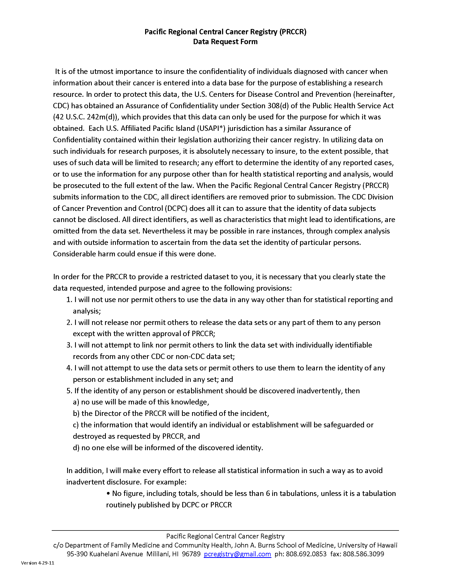
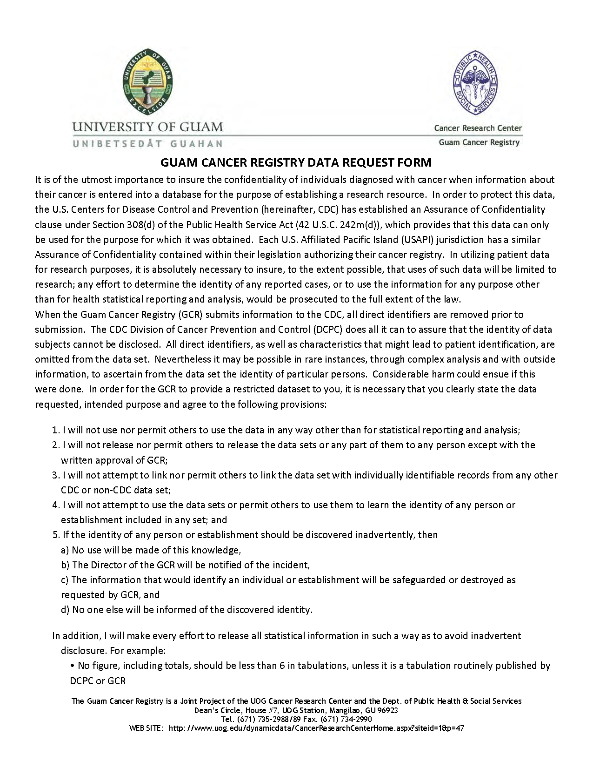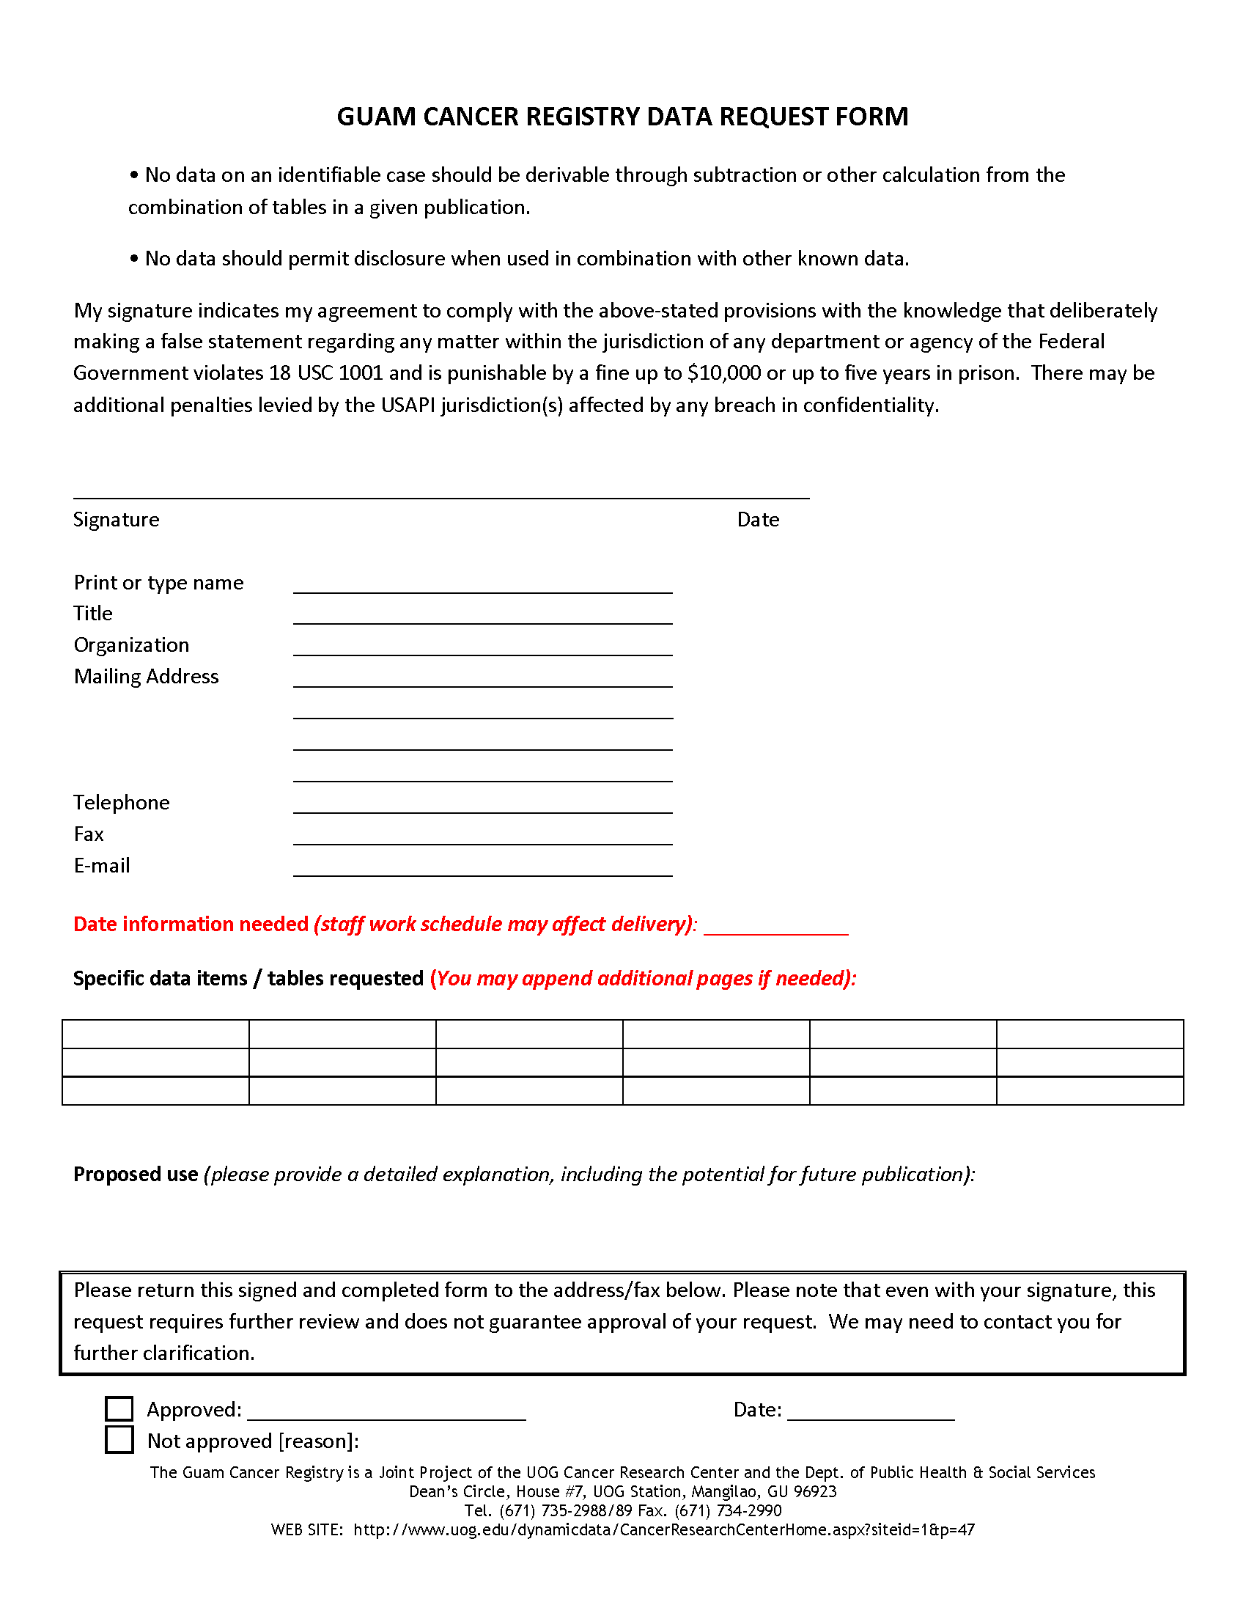
Section 14.
REFERENCES

NAACCR Policy and Procedure Manual template, 2001
Palau Cancer Registry. Policy and Procedure Manual. February 2005.
NPCR Program Standards 2012-2017
IACR Manual for Cancer Registry Personnel by D. Esteban, S. Whelan, A. Laudico & D.M. Parkin
O’Leary MJ. Health data systems in Micronesia: Past and Future. Pacific Hlth Dialog 1995;2(1):126-32.
Katz AR, Palafox NA, Johnson DB, Yamada S, Ou AC, Minami JS. Cancer epidemiology in the freely associated U.S. Pacific Island Jurisdictions: challenges and methodologic issues. Pacific Hlth Dialog 11(2): 84-87. 2004

BRIEF REFRESHER (from IARC Manual)
(REFER TO THE April Fritz CASEBooks and other hard copy manuals for additional detail)

The Diagnosis & Treatment
(This section is adopted by the IACR Manual for Cancer Registry Personnel by D. Esteban, S. Whelan, A. Laudico & D.M. Parkin)
In the day-to-day operations of the registry, the cancer registry personnel deal mostly with cases of cancer. They will encounter various terms that refer to symptoms or signs of the illness, describe the tumor and refer to the site of origin, as well as the methods and results of diagnosis and treatment. The Registry personnel should be able to decide whether these terms relate to the diagnosis or treatment of cancer, or whether they are used to describe the site or type of tumor. This section provides general information on symptoms of cancer, methods of detection and forms of treatment. Common medical terms are presented and defined. Registry personnel should seek clarification of terms, confirmation that a case is cancerous from their local Cancer Council of the Pacific Islands clinician member, another physician or the Pacific Regional Central Cancer Registry staff.

Word Roots, Suffixes and Prefixes
Following terms do not have to be memorized by the registry workers. However, it is important that they learn the meaning of the more common word roots (or origins), prefixes (beginnings) and suffixes (endings) the parts of words which are combined to make up medical terms) to help in understanding difficult terms. Most medical terms are derived from languages such as Latin, Greek, French or German. As an example, the word arthralgia, which is based on the Greek word arthron (joint) as a root, and the suffix (ending)-algia, which is derived from the Greek, word algo (pain). Thus arthralgia means pain in the joint.
The root, also known as stem, of a medical term is usually the main part of the word and refers to the organ or place where the illness originated. It is generally derived from a Greek or Latin noun or verb. The root may be found:
        - at the beginning , as in: osteoma, lingual, leukaemia
        - in the middle: intercostals, hyperchromatic, prognosis
        - at the end: anuria, neoplasm, hypogastric, mesoderm

The meaning of a medical term is modified by the addition of a prefix (at the beginning) or a suffix (at the end). The prefix is often a preposition or an adverb and it consists of one or two syllables added in front of the root of the word which alters it's meaning. Examples are given below:

Medical term | Prefix | Definitions of prefix
Submandibular | Sub- | Below
Hypogastric | Hypo- | beneath, under, deficient
Aphonia | a- | Without
Anencephalic | An- | Without
Endocardium | Endo- | Inside
Bilateral | Bi- | Two
Contralateral | Contra- | against, opposite

A suffix refers to a syllable or groups of syllables attached to the end of the root to modify its meaning. Suffixes, as prefixes, modify the meaning of a root element. Examples are:

Medical term | Suffix | Definition of suffix
Appendicities | -itis | Inflammation
Histology | -ology | study of
Leukopenia | -penia | Deficiency
Carcinoid | -oid | form, resembling
Ovoid | -oid | form, like, resembling
Hepatomegaly | -megaly | Enlargement
Hepatic | -ic | Condition of
Erythrocytosis | -osis | Abnormal increase, disease morbid status
Nephropathy | -pathy | Morbid condition (non-inflammatory)

Often, a root will be combined with a suffix and put after another root, so forming the word ending, for example:

        - Leukaemia-Root (aem = blood) + suffix (-ia = condition), added to another root (leuk- = white), to form the word leukaemia.
        - Carcinogenic – Genic is composed of a root (gen = forming, producing) + a suffix (-ic = condition of).

In summary, the basic forms of medical terms are:

Root plus suffix:

        - Hepatoma: (heap = liver) + (-oma = tumour).
        - Leukorrhea: (leuko = white) + (-rrhea = flow).

Prefix plus root:

        - Neoplasm: (neo- = new) + (plasm = fluid substance of cells)
        - Biology: (bio- = life, living) + (logy = study of)
        - Pathology: (patho- = relating to disease) + (logy = study of)

Prefix plus root plus suffix:

        - Epigastric: (epi- = on or upon) + (gastr = stomach) = (-ic = condition of), relates to the epigastrium at the upper middle region of the abdomen.
        - Dyspneic: (dys- = difficult) + (pne = breathing) + (-ic = condition of) describes difficulty in breathing.
        - Tachycardic: (tachy- = rapid) + (card = heart) + (-ic = condition of), describes rapid heart rate.

Two roots:

        - Carcinogen: (carcin(o) = cancer, crab) + (gen = forming).
        - Scleroderma: (sclera(o) = hard) + (derma = skin)The vowel is in brackets because it has been introduced to combine the two root words.

Tumor Formation and Pathology

The human body is composed of millions of microscopic units called cells. These are of different types and are arranged in different ways. A typical cell is enclosed in a cell membrane and contains a nucleus and cytoplasm. Groups of cells performing the same function form tissues. The epithelial tissue or epithelium lines the body cavities and provide protection and lubrication; connective tissue supports and holds other tissues together; muscle tissue is for movement and nervous tissue carries messages between the brain and spinal cord and the rest of the body. Several tissues operating together form organs, such as the heart, lungs liver, stomach, colon and kidneys. Different organs work together in a unit called an organ system each of which has a particular function in sustaining life.

Since the cell is the basic structural unit of the human body, any abnormality in the cell can result in abnormalities being carried through-out the tissues , organs and organ systems and may ultimately result in the malfunction of any or all of these. Tumour formation begins at the cellular level. Most cells are able to reproduce themselves in order to grow and to replace worn-out or injured cells: the exception is the cells of the brain. Tissues normally grow by increasing the number of cells through a process of cell division or mitosis.

The process of tissue growth is normally controlled by the body. In some persons, however, this normal life process gets out of control and the cells proliferate rapidly and uncontrollably, in a haphazard way, forming a ‘neoplasm’ ‘new growth’ or ‘tumor’ which serves no useful purpose for the body. The term ‘tumor’ and ‘neoplasm’ are often used inter-changeably. There are two general types of tumors or neoplasm’s: benign (non-cancerous) and malignant (cancerous) tumors.

Symptoms

Among cancer patients, the presenting signs and symptoms vary with the different organs involved. The most pressing complaints which prompted the patient to seek medical attention are always recorded on a patients record. To facilitate abstracting of the medical record, the Registry personnel should learn some medical terms describing symptomatology. In the list below are some symptoms, which may be indicative of malignancy.

- Unusual bleeding-This may occur in the digestive tract, respiratory system, genitourinary tract or elsewhere. In the digestive or alimentary tract, unusual bleeding may occur as: Haematemesit: (haema- = blood) + (emesis = to vomit) = vomiting of blood. Melena: derived from the Greek word “melas”, a root meaning black; this is defined as the passage of black, tarry stools, one of the sidns of bleeding from the upper alimentary tract. In the respiratory system, bleeding may occur as: Epistaxis: (epi- = upon, over, in addition) + (staxis = haemorrhage) from the nose or Haemoptysis: (haemo- = blood) + (pty + saliva) + (-sis = condition of), a condition characterized by spitting up or coughing up of blood. In the genitor-urinary tract, unusual bleeding may occur as: Haematuria: (haemat- = blood) + (ur = urine) + (-ia = condition of) = a condition characterized by blood in the urine. Menorrhagia: (meno = menstruation) + (-rrhagia = excessive flow), an excessive menstrual flow. Metrorhagia: (metro = uterus) + (-rrhagia = excessive flow) = uterine bleeding. Unusual bleeding may also occur in the form of haematoma, haematoperitoneum, and haemothorax.

- Unusual discharge-The suffix used to indicate discharge is “-rrhea”. This is attached to different words roots to indicate the site where this occurs, or the type of discharge. Galactorrhea: (galact(o) = milk) = (-rrhea = flow, discharge), an excessive or spontaneous milk flow. Rhinorrhea: (rhino = nose) + (-rrhea = flow, discharge), a watery nasal discharge. Bronchorrhea: (broncho = windpipe) = (-rrhea = flow, discharge), a discharge of mucus from the bronchi. Leukorrhea: (leuko = white) + (-rrhea = flow, discharge), the whiteis discharge from vagina or the uterine cavity.

- Changes in bowel habits-This is usually indicates disease in the gastrointestinal tract, particularly the colon and rectum, and may occur in the form of: Diarrhea: (dia = across, through) + (-rrhea = flow, discharge), abnormal frequency and loose-ness of bowel movements. Constipation: infrequent or difficult evacuation of faeces.

4. Change in urinary habits-This usually indicates disease in the genito-urinary system. It may occur in the form of: Dysuria: (dys- = difficult, painful)+ (ur = urine) + (-ia = condition of), a condition characterized by painful or difficult urination. Polyuria: (poly- = many) + (ur = urine) + (-ia = condition of), an excessive secretion of urine or increased frequency in urination. Another term for this is 'frequent urination". Urgency: a compelling desire to urinate. Oliguria: (olig- = scant) + (ur = urine) + (-ia = condition of), a condition characterized by diminished urine secretion. Anuria: (an- = without) + (ur = urine) + (-ia = condition of), a condition characterized by no urine formation. Nocturia: (noct- = night) + (ur = urine) + (-ia = condition of), increased frequency of urination during the night.

- Indigestion or difficulty in swallowing-This may indicate disease in the upper digestive tract, and may occur in the form of: Dysphagia: (dys- = difficult, pain-ful) + (phag = eat) + (-ia = condition of), difficulty or pain in swallowing. Nausea: a sensation referred to the epigastrium or abdomen, with tendency to vomit. Vomiting or emesis: the forcible ejection of contents of the stomach through the mouth ('throwing up'). Hyperemesis: (hyper- = excessive) + (emesis = vomiting), intractable or excessive vomiting. Dyspepsia: (dys- = difficult) + (peps = digest) + (-ia = condition of), epigastric discomfort after meals, more commonly referred to as 'wind' or 'indigestion'. Anorexia: (an- = without) + (orexia = appetite), lack of appetite.

- Cough or hoarseness of voice- This may indicate disease in the larynx or the respiratory system. A change in voice or difficulty in speaking is a condition also termed dyspho-nia: (dys- = difficult) + (phon = sound) + (-ia = condition of). Aphonia: (a- = without) + (phon = sound) + (-ia = condition of), the inability to produce vocal sounds. Dyspnea: (dys- == difficult) + (pne = breath) + (-a = condition of), a condition characterized by difficulty in breathing. Orthopnea: (ortho- = upright) + (pne = breath) + (-a = condition of), a condition characterized by difficulty in breathing except in the upright position. Tachypnea: (tachy- = rapid) + (pne = breath) + (a- = condition of), very rapid respiration. Apnea: (a- = absent) + (pne = breath) + (-a = condition of), cessation of breathing.
- Change in a mole or wart-Moles or warts, which increase in size rapidly or change in color or become ulcerated or bleed, may be evolving into skin cancer.
- A sore that does not heal-In the skin or mucosa, this may be a sign of malignancy.

- A mass, lump or thickening-In the breast or elsewhere, this may be a tumor beginning in that organ or it may be a metastatic focus from another organ. The patient may complain of abdominal enlargement, which may be due to enlargement of organs such as the liver, spleen, kidney, ovaries or other organs.

- Unexplained anaemia-Anaemia: (a- = without) + (aem = will be recorded in the patient's medical blood) + (-ia = condition of) is a deficiency in the number of the red blood
cells or the quantity of haemoglobin in the blood, which may result from decreased formation of red blood cells, or increased destruction of these cells, or bleeding.
Patients with anemia complain of pallor or paleness of the skin. They also complain of dizziness, fainting spells fatigue and breathlessness. The formation or production of red blood cells or erythrocytes: (erythro- = red) + (cytes = cells), is known as erythropoiesis: (erythro- = red ) + (poie = make, produce) + (-sis = condition of). The destruction of red blood cells can result from the process of haemolysis being more marked than is usual.

11. Unexplained loss of weight- Cancer is often associated with loss of weight. This has been attributed to the effects of the tumor itself resulting in decreased nutrient intake. Prolonged periods of malnutrition may result in a generalized physical wasting of the body known as cachexia. Hence, in the absence of other symptoms, a patient with unexplained weight loss may be suspected of having cancer. Occasionally cancer may be diagnosed in patients who have no complaints (asymptomatic) – for example, in patients who undergo routine physical examination or who participate in screening programmes.

Physical Signs

These are the finding of the doctor during physical examination. The physical findings begin with a general description of the patient’s condition, for example, his nutritional status or development, whether he is able to walk (ambulatory) or is confined to bed. The physical examination often proceeds from the head, eyes, ears, nose, throat (HEENT), down to the neck, the breast, chest, lungs, heart, abdomen, genitalia, rectum, extremities, skin and lymph nodes as well as assessment of the musculo-skeletal system and the nervous system.

In the course of physical examination, the physician notes for example the presence of any masses or swelling; the presence of asymmetry (a dissimilarity in corresponding parts or organs on opposite sides of the body which are normally alike); the presence of sores or non-healing wounds; and abnormal discoloration of skin and mucous membranes; as well as impairment in motor (muscular function) or sensory functions (sensation).

In the list below are some of the physical findings which a tumor registrar may encounter while reviewing the medical records.

      - Changes in the color of skin and mucous membranes
        - Pallor: paleness of the skin or mucous membrane. This is noted in the presence of anemia especially following blood loss or hemorrhage: (haemo = blood) + (-rrhagia = excessive flow).
        - Icterus or jaundice: yellowish discoloration of skin and mucous membranes. This is seen in the presence of liver disease or those of the biliary tract, e.g., in blockage of the bile ducts that drain the bile from the liver to the intestine.
        - Cyanosis: bluish discoloration of the skin and mucous membrane due to the insufficient oxygen or high concentration of reduced hemoglobin in the blood. Cyanosis is derived from: (cyano = blue) + (-sis = condition of).

      - Presence of non-healing wound or ulceration in the skin or mucosal lining of an organ-
An ulceration in the skin or other organs of the body is often not due to malignancy. It may be inflammatory in nature or it may be due to impairment of circulation or poor nutrition. However, it can be secondary to a malignant process in the skin or to deeper organs with extension to the skin. The ulceration may be associated with a foul-smelling discharge, which may be purulent, sanguineous (bloody) or mixed (sanguine-purulent).

      - Presence of masses-Masses can occur in the skin, in the subcutaneous tissue, in the muscle, or in the bone or other organs of the body. Masses may be benign as in cysts or benign tumors; they can also be malignant. A small lump or thickening in the breast may be one of the early signs of breast cancer. A mass in neck, for example, may be a thyroid tumor or it may be an enlarged lymph node secondary to a primary nasopharyngeal malignancy or stomach cancer. A mass in abdomen may be due to enlarged organs such as the liver, the spleen, the ovaries, or uterus.

        - Hepatomegaly: (hepat- = liver_ + (megal = abnormal enlargement) + (-y = characterized by), enlargement of the liver.
        - Splenomegaly: (spleen- = abnormal enlargement) + (-y = characterized by), enlargement of the spleen.

The mass may be enlarged lymph nodes or groups of lymph nodes. This is also known as lymphadenopathy (lympho- referring to the lymphatic system) + (adeno = gland) + (-pathy = disease), disease of the lymph node. Lymph node enlargements due to cancer are usually secondary as in regional lymph node involvement or distant lymph node metastasis, with the primary site of the tumor occurring elsewhere (see section 2.1.2). Malignancy, however, may originate in lymph nodes, as in lymphomas like Hodgkin’s disease and non-Hodgkin lymphoma. An abdominal mass may also be secondary to dilatation of the stomach or the colon, as a result of obstruction to the digestive tract. It may also be due to a distended bladder. The physician may be able to indicate which is most likely.

- Accumulation of fluid in some portions of the body

        - Ascites: accumulation of fluid in the abdominal or peritoneal cavity. If the fluid in the peritoneal cavity is bloody, this is known as haemoperitoneuim (peritoneum is the membrane lining the abdominal cavity).
        - Pleural effusion: accumulation of fluid in the pleural cavity, also know as hydrothorax. If the fluid in the pleural cavity is bloody, this is known as haemothorax.
        - Oedema: abnormal accumulation of fluid in connective tissue or serous cavity.

- Obstruction in the circulatory system

        - Venous obstruction: signs of venous obstruction include dilated or distended veins or swelling of the face or the extremities. For example, if there is and obstruction in the superior vena cava (the main vein returning blood format eh upper body to the heart) this is manifested by dilated veins over the neck and chest associated with puffiness or oedema of the face and arms.
        - Arterial obstruction-Obstruction of an arterial blood supply results in a diminished or absent blood supply from the heart to the tissues or cells supplied by the blocked artery. The affected cells die from lack of oxygen and food, resulting in a condition know as necrosis: derived from the Greek word root “necro-“ meaning death and the suffix “-sis” meaning a condition of. Necrosis refers to death or decay of cells or tissues in a part of the body.

- Assessment of motor function, the ability of the patient to move his/her limbs or other parts of the body-Paralysis: refers to the loss or impairment of motor function in a part of the body due to neural (nerve) or muscular mechanism. Another term for paralysis is palsy. Example: paralysis of one side of the face due to a lesion in the facial nerve is known as Bell’s palsy. The suffix “-plegia” is used to indicate paralysis as in: Hemiplegia: (hemi- = half) + (plegia = paralysis), paralysis of one half or one side of the body. Quadriplegia: (quadr(i)- = four) + (plegia + paralysis), paralysis of all four limbs. Paraplegia: (para- = beside, beyond) + (plegia = paralysis), paralysis of the lower part of the body, including the legs. Paresis: derived from the Greek word ‘paresis’, meaning relaxation, refers to slight or incomplete paralysis. Hemiparesis: (hemi- = half) + (paresis = incomplete paralysis), muscular weakness affecting one half of the body. Paraperesis: (para- = beside, beyond) + (paresis + incomplete paralysis), muscular weakness or partial paralysis of the lower extremities.

- Assessment of sensory function or the ability of the patient to see, hear, smell, taste and feel (touch, pain, temperature). The word root “aesth(a)esi(o)”, which mean feeling, is used as in: Anaesthesia: (an- = without) + (aesthesis = feeling) + (-ia = condition of), loss of feeling or sensation, especially to pain. Hypoaesthesia: (hyp- = deficient) + (aesthesi = feeling + (-ia = condition of), decreased sensitivity to stimulation or decreased sensation. Hyperaesthesia: (hyper- = increased) + (aesthesi = feeling) + (ia = condition of), increased sensitivity to simulation or sensation. Paraesthesia: an abnormal sensation like tingling, burning or prickling. Dysaesthesia: an abnormal sensation resulting from a normal stimulus.

Diagnostic Method

In order to arrive at a diagnosis, a physician employs several methods. In the cancer registry, these are grouped into several categories, and the registrar is expected to be able to decide which were used. A common grouping is:

    - Non-microscopic methods

- Clinical only
- Clinical investigations
  - Laboratory examinations
  - Radiological examinations or x-rays
  - Ultrasound
  - Nuclear medicine
  - CT scan
  - Magnetic resonance imaging
  - Endoscopy

- Exploratory surgery/autopsy
- Specific biochemical and/ or immunological tests

B. Microscopic methods

- Cytology or hematology
- Histology of metastasis
- Histology of primary tumor
- Autopsy

Non-Microscopic methods-Non-microscopic methods of diagnosis, as the name implies, do not confirm the diagnosis by examining cells or tissues under the microscope. Diagnosis is arrived at through the following methods:

      - Clinical only-The diagnosis is based on the clinical history and physical examination. Example: A fungating mass almost involving the whole breast, associated with enlarged lymph nodes in both auxiliary regions and at the supra-clavicular region may be diagnosed as breast cancer based on this method.

      - Clinical investigations-The diagnosis is based on clinical history and physical examination, with the aid of ancillary procedures such as laboratory examinations, diagnostic radiology, scan, ultrasound and other imaging techniques.

        - Laboratory examinations-These includes liver function tests, serum calcium, and other blood chemistries. T and B cell marker studies and chromosome studies may also fall under this category. Example: A clinical impression of breast cancer, with bone metastases, is supported by the finding of an abnormal or elevated alkaline phosphatase in a blood test.

        - Diagnostic radiology: Cancer is detected by means of X-rays. Example: A clinical impression of breast cancer with lung metastasis is supported by the finding of multiple nodular densities representing metastasis of the cancer in both lungs on a chest x-ray. An x-ray examination, however, may require the taking of several pictures, the results of which are summarized in one report. Examples: A metastatic series, which involves taking x-rays of various parts of the body to determine whether or not cancer has spread to any of these parts. A skeletal survey, which involves taking a number of x-ray pictures of various parts of the body to rule out the presence of bone metastases.

There are different types of radiological examinations:
Body section radiography: this involves a series of x-ray taken at different depths in order to obtain defined images of specific areas. The image required is brought sharply into focus while the other areas are blurred out. These types of x-rays are used to locate lesions accurately in solid organs like the lungs and bones. They are also known as tomogram, laminograms or plano grams.

Radiological examinations using contrast media: a contrast medium is a radiopaque substance, which can be injected into the veins, arteries, lymphatic vessels or hollow cavities to obtain contrast with the surrounding tissues. The contrast medium does not permit X-rays to pass through it so that the structures containing it appear white on the X-ray film, thus delineating abnormal masses or growths and defining the contour of the body structures on X-ray. Some of the X-ray studies using contrast media are:

Angiography: (angio = vessel) + (-graphy = method of recording), the radiological study of the blood vessels (vascular system) or lymphatic vessels. Examples: cerebral angiogram: x-rays of the blood vessels of the brain. Cardiac angiogram: x-ray showing the blood vessels of the heart and the large blood vessels. Lymphangiogram: x-ray studies of the lymphatic vessels.

Bronchography: (broncho = windpipe) + (-graphy = method of recording), the radiological study of the airways (bronchi) of the lung. Bronchogram: x-ray of the bronchial system.

Cholecystography: (chole- = bile) + (cyst(0) = sac) + (-graphy = method of recording), the radiological study of the functions of the gallbladder and bile ducts after introduction of an opaque contrast medium. Cholecystogram: x-ray of the gallbladder.

Cholangiography: (chol(e)- = bile) + (angi(o) = vessel) + (-graphy = method of recording), the radiological study of the bile ducts. T-tube cholangiography: medium injected through a tube inserted during operation. Percutaneous transhepatic cholangiography (PTC): direct introduction of contrast medium through the liver into a bile duct usually carried out under television monitor. This procedure demonstrates the presence of obstruction either by a stone or by a mass as in a tumor.

Endoscopic retrograde cholangiopancreatography (ERCP): cannula into the opening of the bile duct, by using a flexible (fiberoptic duodenoscope. Contrast medium is introduced into the cannulated duct system and x-ray pictures are taken. As the cannula is withdrawn, more x-ray films are taken in various projections.
Operative cholangiography: surgical procedure of the gallbladder.

Upper GI Series (UGIS or barium swallow): the patient is asked to take barium (a contrast medium) orally, than a series of x-ray pictures is taken as the barium goes down from the pharynx to the esophagus, stomach and small intestines.

Lower GI series (Barium Enema): radiological studies of the rectum and colon following introduction of barium through the rectum.

Myelography: (myel(o) = spinal cord) + (-graphy = method of recording), radiological study of the spinal cord.

Sialography: (sial(o) = salivary gland) + (-graphy = method of recording), radiological study of the salivary ducts.

Urography: (uro = urine, urinary tract) + (-graphy + method of recording), radiological study of the urinary tract.

Cystography: x-ray of the urinary bladder.

Pyelography: x-ray of the kidneys, ureter with emphasis on the pelvis of the kidney and ureters.

Intravenous pyelography (IVP): contrast medium is injected intravenously and a series of x-rays is taken as the contrast medium quickly passes in to the urine.

Retrograde pyelography: a series of x-rays done after introduction of contrast medium through a catheter inserted into the ureter.

Other radiological procedures include: Fluoroscopy-a technique for producing a temporary image on a screen. The radiologist moves the screen up and down the patient’s body and observes what is happening within selected parts of the body. This is especially useful for identifying restricted or blocked passages in the hollow organs, especially with use of contrast material. Mammography- (mamm(o) = breast) + (-graphy = method of recording), a technique for detection of breast cancer. Several x-ray views are taken of one or both breasts and the x-ray films are later examined for the presence of lesion. Very small, early cancers of the breast cab be diagnosed using this technique, before they can be felt by physical examination. Xeroradiography: (xero- = dryness) + (radio = radiation) + (-graphy = method of recording), a technique using the same image producing process as the Xerox copier machines. The xeroradiography machine can produce either a positive or negative picture on specially coated white paper that can be read in any light. Today, this is used for x-rays of the skull, limbs and breast as well as the cervical spine. Thermography: (thermo = heat) + (-graphy = method of recording), a technique for detecting cancer by differentiating regions of hot and cold temperature in the body. The surface temperature (its infrared radiation) is photographically recorded. The thermogram is a mosaic of many thousand bits of temperature information displayed photographically in shades of gray. The (increased emission of heat); the darker tones indicate cool areas. Since cancer cells usually divide more rapidly than normal cells, they often give off more heat than normal surrounding cells.

        - Ultrasound: Diagnostic ultrasound is relatively new technique for visualizing internal structures of the body by recording the reflection of ultrasonic waves (high frequency sound waves) or echoes as they interact with various tissues of the body. Different densities in tissues can be distinguished from cystic masses and solid masses. The record produced is called an ultrasonogram or an echogram. Examples are: Pelvic ultrasound-to visualizes the uterus, fallopian tubes, ovaries and other pelvic organs. Ultrasound of the liver, gallbladder and pancreas. Ultrasound of the kidneys. Ultrasound of the breasts.

        - Diagnostic nuclear medicine-This is an imaging technique whereby a radioactive substance known as a radioisotope is administered to a patient to diagnose disease. As the radioisotope disintegrates, it emits gamma rays from within the body and these are photographically recorded by a scanner. The photographic record is referred to as a scan. This differs from x-ray procedures where the x-rays are passed through the body from an external source.

Sometimes non-radioactive compounds are labeled or tagged with a radioactive isotope and sometimes radioactive tracers (radioactive pharmaceuticals) are given by mouth or by vein. Some of the isotopes are selectively absorbed by tumors or by specific organs in the body. The concentrated radioisotopes outline the tumor or organ, making it visible on the scanner by emission of radioactive energy. The more common scans are: bone, kidney, thyroid, heart, lung, liver, spleen, brain, and total body scan.

        - Computerized tomography scan (CT scan): In this method, a picture is produced of all the structures in one plane (or slice) of the body. It is done by passing x-rays through the body in this plane and, from the readings; a computer constructs an image, which is displayed on a television screen where it can be photographed for a permanent record. The precision of the scanner permits a more accurate diagnosis of the extent of the disease than most other means. It can discover tumors at an early stage and pinpoint their exact location. CT scans can be used with or without the use of contrast media. Examples are: CT scan of head, lung and upper abdomen.

        - Magnetic resonance imaging: This is a non-invasive imaging technique which does not expose the patient to ionizing radiation and permits delineation of tissue without the use of contrast enhancing agents. The MRI scans do not visualize bone. Hence, the soft tissue adjacent to bone is easily viewed.

        - Endoscopy-This diagnostic procedure involves the use of specific instruments (scopes), which enable one to view the interior of the body. Endoscopes may be either rigid metal or flexible fibreoptic tubes. Diagnoses arrived at through endoscopy without microscopic confirmation will be included in the category of exploratory surgery, although not all such examinations require a surgical incision. If a lesion is noted, it is possible to remove tissue by biopsy (via the endoscope) for histological study. Typical endoscopy procedures include, bronchoscopy-examination of the bronchi with a scope; colonoscopy-examination of the colon and rectum by means of an elongated, flexible fiberscope. Colposcopy-examination of the cervix and vagina under magnification. Cystoscopy-direct visual examination of the interior of the urinary bladder. Oesophagoscopy-direct visualization of the interior of the esophagus. Gastroscopy-direct visual examination of the interior of the stomach. Laryngoscopy-examination of the interior wall of the larynx. Otoscopy-inspection of the inner ear. Proctoscopy-inspection of the rectum, with the aid of a tubular endoscope with appropriate illumination. Rhinoscopy-direct examination of the nasal passages either through the nostrils (anterior rhinoscopy) or through the nasopharynx (posterior rhinoscopy). Sigmoidoscopy- direct visual examination of the sigmoid colon by means of an instrument, which can visualize up to 25cm from the anal verge. Urethroscopy-visual inspection of the interior of the urethra. In all of the “-oscopies” described so far, the scope has been inserted through a natural opening in the body. However, in the following endoscopic examinations, an actual incision is made through which the instrument is inserted into the body space to be examined.

Mediastinoscopy: examination of the mediastinum by means of a tubular instrument permitting direct inspection of the area between the lungs.
Peritoneoscopy: examination of the peritoneal cavity by an instrument inserted through the abdominal wall.
Thoracoscopy-direct examination of the pleural cavity by means of an endoscope, which is inserted into the cavity through an intercostals space.

          - Exploratory surgery/autopsy-The diagnosis is based on findings during surgical exploration, by direct visual examination or palpation, or on the results of a post-mortem examination (autopsy), without microscopic confirmation (also called provisional anatomical diagnosis of malignancy or PAD). When suspected cancer of an internal organ has been located, exploratory surgery may be performed to determine the exact nature of the cancerous condition and the extent of the disease or the degree to which other organs or structures within the observed area are affected. In most instances, biopsies will be done and specimens examine microscopically, in which case the diagnostic method falls into group B, ‘Microscopic methods’.

4. Specific biochemical and/ or immunological test-There are substances, which can be measured in blood (or other body fluids), which may be helpful in the diagnosis of cancer.

a. Serum alpha-foeto protein (AFP) is a substance normally present in the tissues of the foetus and which disappears or is greatly reduced in amount after birth. High levels of AFP in the patient’s blood suggest the presence hepatocellular carcinoma or teratocarcinoma. AFP is synthesized by the tumor cells themselves and secreted by them in the blood. A drop in the AFP level indicates regression of the tumor. Hence, AFP is valuable for diagnosis as well as for monitoring response to treatment or the development of recurrence.
  - Beta-subunit of the human chorionic gonadotrophin (Beta-HCG) is a placental antigen, which is present in the serum of all patients with tumor arising in cells of the placenta (especially choriocarcinoma), in a majority of patients with germ cell tumors of the testis and ovary, and to some extent in patients with other cancers. Serial measurement of Beta-HCG is of importance in the diagnosis and follow-up of cases of choriocarcinoma. For example, a very high level of Beta-HCG in a patients points strongly to the presence of choriocarcinoma; if after chemotherapy the level of Beta-HCG goes down to normal, one can say that the patient responded to the treatment, and a later increase in the level of Beta-HCG is indicative of reactivation of the tumor. The normal value of Beta-HCG is 0-5 units/ml.
  - Serum acid phosphatase: elevated levels of acid phosphatase in the serum are noted in 85% of patients with cancer of the prostate with metastases to the bones, but in only about 20% of cases which remain localized in the prostate gland. Acid phosphatase determination can be used to determine whether prostate cancers are suitable for surgery. The normal value in the serum depend on the method used in determining the acid phophatase level, as in:

    - Bodansky: 0.5-2.0 units
    - King-Armstrong 1-5 units
    - Bessey-Lowry: 0.1-0.63 units
    - International units: 0.2-1.8 units/1

(NOTE: the normal values are given as guide. Registry clerks need not memorize these values but should be aware of the normal values in the hospital where they are working.

  - Serum alkaline phophatase: the levels of this enzyme in the blood increase when there is destruction of cells. It is produced in the liver and bones, and an elevated alkaline phosphatase is indicative of bone and liver abnormalities. The normal value depends on the method used in determining the alkaline phosphatase level such as:

Bodansky | Adults:
King-Armstrong | Adults:
International units | 21-91 u/1
Children | 5-14 units
Children | 15-20 units

e. Lactic acid dehydrogenase (LDH): this is an enzyme, which occurs in many body cells. An elevated LDH indicates increased cell destruction, possibly following metastasis.

- Carcinoembryonic antigen (CEA): this is a protein, which is normally present in endodermal tissues (the innermost of the primary germ layers of the embryo) during the first six months of fetal life. It was first noted to be present in colorectal cancer and was initially thought to be specific to cancers of the gastrointestinal tract. However, studies have shown that CEA is elevated not only in GI tract malignancies but in other malignancies and in non-malignancies and in non-malignant conditions. At present, it most useful application is in predicting the outcome of disease (prognosis) and in the follow-up of response to treatment, and checking for development of recurrence.

- Fetal sulfoglycoprotein antigen (FSA): this antigen is associated with gastric cancer. It is observed in a majority of patients with gastric cancer and in 3 to 7% of individuals aged 45 to 70 without gastric neoplasm.

- Pancreatic oncofoetal antigen (POA): this is an antigen associated with pancreatic cancer.

i. Human placental lactogen (HPL): this is polypeptide synthesized by cells of the human placenta. HPL is demonstrable in the sera of majority of patients with choriocarcinomas and in certain patients with germ cell tumors of the ovary and testis.

- Tissue or organ-associated antigens:

    - Cervical cancer antigens: associated with cancer of the cervix uteri;
    - Ovarian cancer antigen (CA 125): associated with carcinoma of the ovary;
    - Breast cyst fluid protein: associated with breast cancer;
    - Lung tumor antigen: associated lung cancer
    - Leukaemia-associated antigens: associated with acute leukaemia
    - Prostatic-specific antigen (PSA): associated with carcinoma of prostate.

- Ectopic hormones

    - calcitonin: associated with medullary carcinoma of thyroid gland
    - parathormone: associated with small cell lung cancer;
    - ‘big’ ACTH: associated with small cell lung cancer.

- Antigens of oncogenic viruses:

    - Human papilloma virus (HPV): certain types are associated with carcinoma of the cervix uteri;
    - Epstein-Barr virus: associated with Brukitt’s lymphoma and nasopharyngeal carcinoma;
    - Mouse mammary tumor virus: associated with breast cancer.

- Normal antigens or their variants:

    - ferritin: associated with breast cancer
    - casein: associated with breast cancer
    - ceruloplasmin: associated with a variety of cancers;
    - immunoglobulins: associated with multiple myeloma, Waldenstrom’s macroglobulinaemia;
    - blood group substances: associated with a variety of cancers;
    - lactoferrin: associated with lung cancer;
    - tissue polypeptide antigen (TPA): associated with a variety of cancers.

Microscopic Methods

The microsopic methods of diagnosis include:

Cytology: the microscopic examination of cells, usually contained in fluid which bathes a suspected cancer; and
Histology: the microscopic examination of tissues removed from the suspected cancer itself or from its spread (metastasis).

The purpose of micrscopic examination is to determine characteristics of the tissues and cells, to see whether they are indicative of a malignancy.

      - Cytology or hematology

- Cytology: (cyto = cells) + (-logy = study of), the study of cell structure, function and pathology. Cells are continuously being shed (exfoliated) from tissues that line body cavities and hollow organs of body. These exfoliated cells may float in the fluid or mucous material, which bathes or passes through these cavities. The microscopic examination of these cells to determine whether they are malignant or not and to determine their tissue of origin is known as exfoliative cytology.
There are some body cavities, which can be checked for fluid, such as the pleural cavity, and the peritoneal cavity. Normally, the fluid in these cavities is limited to an insignificant lubricating layer that cannot be aspirated. Therefore fluid in these cavities, which can be aspirated, indicates a pathological process such as malignancy or infection. Listed below are some of the sources of specimens for cytological examination:

-Sputum
-Bronchial washing or bronchial brushing
-Tracheal washing
-Pleural fluid
-Gastric fluid
-Spinal fluid
-Breast secretion
-Prostatic secretion
-Urine sediment
-Cervical and vaginal smears
-Bone marrow aspiration
-Peritoneal fluid

There are several procedures employed to obtain material for cytological examination, including the following

- Swabs: use of swab or similar device to obtain fluid and secretions, which can be used to make a smear. Example: cervical smear.
- Brushings: the lining of an organ is brushed for the purpose of obtaining cells. Example: gastric brushing; bronchial brushings
- Washings: instillation of fluid into a hollow organ or structure and removal of the fluid for the purpose of collecting any cells, which have been exfoliated in the fluid. Example: gastric washing
- Scrapings: the lining of s structure or organ is scraped with an instrument for the purpose of obtaining cells. Example: cervical smear, using an Ayre’s spatula or cerviscraper
- Punctures: insertion of a needle into a cavity or organ for the purpose of removing some portions of the content (fluid, bone marrow, tissue). Examples:

      - paracentesis: surgical puncture of a cavity for aspiration of fluid
      - paracentesis abdomini: puncture of the peritoneal cavity
      - thoracocentesis: puncture of the pleural cavity

  - Hematology: (haema- = blood) + (-logy = study of), the microscopic examination of the cells of the blood or blood-forming tissues (expecially bone marrow), looking for changes in these structures and/ or number of various types of blood cells, including immature cells.

There are three main types of blood cells:
-erythrocytes: (erythro = red) + (-cyte = cell), or red blood cells;
-leukocytes: (leuko = white) + (-cyte = cell), or white blood cells;
-thrombocytes: (thrombo = thrombus or clot) + (-cyte = cell), or platelets, the cells concerned with clotting of the blood.

- Red Blood Cells (RBC):
These contain haemoglobin, a blood protein responsible for the transport of oxygen from the lungs to the tissues and the transport of carbon dioxide from the tissues to the lungs.
There are several forms of immature or very young erythrocytes, namely:
-pronormoblast: the earliest precursor of red blood cells
-normoblast: nucleated red blood cell
-reticulocyte: a young erythrocyte (one-to two-day old red blood cell)
The reticulocyte count is a useful measure to determine whether anaemia is due to decreased production of red cells or due to increased destruction of red cells or due to increased desctruction of these cells. A significant increase in the number of reticulocytes in the blood cells from the bone marrow, usually suggestive of increased cell destruction or haemolysis: (haemo=blood) + (-lysis=destruction). In contrast, a failure to produce red blood cells is reflected in a very low reticulocyte count.
Anaemia: (an-=without) + (-aemia=blood), a deficiency in the number of red blood cells or deficiency in the haemoglobin content of the red cells. This is characterized by pallor of the skin and mucous membranes and may be associated with becoming tired easily, dizziness or fainting spells.

- White blood cells:
There are five types of circulating white blood cells:
-neutrophil
-eosinophil granular leukocytes
-basophil
-lymphocytes agranular leukocytes
-monocytes

Neutrophils: these white blood cells contain very small purplish granules in their cytoplasm. The mature form has segmented nuclei. Hence, this cell is also known as: polymorphonuclear leukocytes (‘polymorph’). The immature forms of a neutrophil are:
-stem cell
-myeloblast
-promyelocyte
-myelocyte
-metamyelocyte
-band or stab cells

Normally, neutrophils are not released to the peripheral blood unit they have matured beyond the metamyelocyte or ‘band’ stage. Neutrophils usually comprise about 40-60% of leukocytes in the peripheral blood.

Eosinophils: these are ganular leukocytes with large reddish granules in the cytoplasm. They develop in the bone marrow just like neutrophils. Eusonophils comprise about 1-3% of leukocytes.

Basophils: these granular leukocytes have large bluish granules in their cytoplasm. They mature in a similar fashion to the neutrophils. Basophils are the least common of leukocytes, comprising only about 0-1%.

Lymphocytes: these are agranular leukocytes with a small amount of bluish cytoplasm. They comprise about 20-40% of leukocytes. Analyses of these cells have shown that there are two types, the T and the B Cells.

Monocytes: these are granular leukocytes with phagocystic and bactericidal capacities. They comprise about 4-9% of all white blood cells.

- Platelets (throbocytes)
These are tiny cells or discs whose primary function is haemostasis (clotting of blood). Peripheral blood is circulating blood obtained from blood vessels or the extremities. This may be obtained through a finger prick or through a venipuncture (specimen taken directly from a peripheral vein). The common examinations for peripheral blood include: complete blood count (CBC), platelet count, reticulocyte count and peripheral smear.
In examination of the peripheral blood, the peripheral smear is the most important. Examination of the peripheral smear shows the size and color of the red blood cells, their variations in size known as anisocytosis: (an-=without) + (iso=equal-) + (cyto=cell) + (-osis = increase), or variation in shape referred to as poikilocytosis; (poikilo-=irregular) + ((cyto = cell) + (-osis = increased number), which are helpful in the diagnosis of specific anaemias. Normally, immature forms of leukocytes are not found in the peripheral blood. Hence, a markedly increased leukocyte count with a number of immature forms, especially ‘blasts’, alerts one to the possibility of leukemia.

Certain types of conditions associated with abnormality of the blood cells are:
Anaemia: deficiency in erythrocytes or haemoglobin
Aplastic anaemia: a form of anaemia in which there is lack of formation of blood cells in the bone marrow.
Leukaemia: a malignant disease of the blood and the blood-forming organs characterized by uncontrolled proliferation of leukocytes, which is diagnosed by microscopic detection of abnormal cells
Leukocytosis: increase in the number of leukocytes in the blood
Leukopaenia: reduction in the number of leukocytes in the blood
Polycythaemia: excessive number of erythrocytes
Thrombocytopaenia: decrease in the number of platelets
A table of normal values for blood examinations is given below. The registry personnel are not expected to memorize these values. They are given as a guide for abstracting haematological reports. The diagnosis of haematological malignancies by peripheral blood examinations is often based on an abnormal cell count (usually a markedly elevated white blood cell count (WBC) and the presence of immature cells in the smear. Registry personnel should have a basic knowledge of what is normally expected in complete blood count examinations and peripheral smears in order to be able to recognize values, which are abnormal.
Bone Marrow Studies are essential in the diagnosis of a wide variety of haematological disorders, especially leukaemias. The circulating blood cells are actively produced in the bone marrow. A bone marrow sample can be obtained by needle aspiration or by biopsy of bone marrow, and is considered as a histological examination (see 6/7 below)

Haematocrit | Men  Women | 42-52%  37-47%
Haemoglobin | Men  Women | 140-180 Gms/litre  120-160 Gms/litre
Erythrocytes (RBC) | Men  Women | 4.5-6.3 x 10¹²/ litre  4.2-5.4 x 10¹²/ litre
Reticulocyte count: |  | 0.5-2% of red blood cells  5 x 10⁹ – 10 x 10⁹/ litre
Leukocytes (WBC): |  | 0.5 -2% of red blood cells  5 x 10⁹ – 10x  10⁹/ litre
Neutrophils: |  | 40-60%
Band (stabs): |  | 0-5%
Juveniles: |  | 0-1%
Myelocytes: |  | 0%
Eosinophils: |  | 1-3%
Basophils |  | 0-1%
Lymphocytes |  | 20-40%
Monocytes: |  | 4-8%
Platelet count: |  | 200-500 x 10⁹/ litre

(6) Histology of metastasis
Histology: (histo = tissues) + (-logy = study of), the microscopic Examination of tissues removed from a site of spread (metastasis) of cancer. The examination may be made using tissue obtained from a biopsy (the removal and examination – both gross and microscopic – of tissues from a living body for the purpose of diagnosis), or from an operative or surgical procedure. If the source of the specimen is from a suspected metastatic site, it is known as histology of the metastasis.

(7) Histology of primary tumor
If the source of the specimen is from the suspected origin of the malignancy, it is known as histology of the primary.

(8) Autopsy
This refers to the examination of the body after death, and involves the removal and examination (gross and microscopic) of organs and tissues from the body, to establish the diagnosis or to determine the cause the death. It is also known as necropsy or post-mortem examination.
There are usually two types of reports made following autopsy:
        - the Provisional Anatomical Diagnosis (PAD), is arrived at through the gross (= macroscopic) examination findings at autopsy, not confirmed microscopically; and
        - the Final Anatomical Diagnosis (FAD) is arrived a through microscopic examinations of tissues removed at autopsy. This is the most important portion of the autopsy report. It could confirm the diagnosis of cancer made clinically. It can determine the origin of the cancer (primary site) and its histological type. It can also give an accurate assessment of the extent of spread of the malignancy.\

Treatment
Treatment for patients with cancer may either be cancer-directed or non-cancer directed.

- Cancer-directed treatment
Definitive cancer-directed treatment is a specific therapy which modifies, controls, removes or destroys cancer tissue. This may be directed towards a primary or towards a metastatic site. Treatment may be considered as definitive cancer-directed therapy, even if it is not considered curative for a particular patient because of the extent of disease, failure to complete treatment or lack of response. Definitive cancer-directed therapy may be either curative, adjuvant or palliative.
- Curative treatment is aimed at completely eradicating an existing disease.
Examples are:
- Total hysterectomy for early endometrial cancer:(hystero = uterus) + (-ectomy = surgical removal)
- Modified radical mastectomy for early breast cancer: (mas = breast) + (-ectomy = surgical removal)
- Total thyroidectomy for papillary cancer of thyroid: surgical removal of whole thyroid gland.
- Abdomino-perineal resection for rectal cancer: surgical removal of anus and rectum and creation of a permanent colostomy.
(b) Adjuvant treatment is given to enhance the effectiveness of another form (modality) of treatment.
- Adjuvant chemotherapy for breast cancer after mastectomy.
- Adjuvant radiotherapy for cervical cancer after hysterectomy.

(c) Palliative treatment may modify, control, remove or destroy cancer tissue but does not attempt to cure.
- Palliative resection of colorectal cancer.
- Palliative radiotherapy for advanced breast cancer
    - Palliative chemotherapy for advanced lung cancer.

(2) Non-cancer directed treatment
Non-cancer directed therapy may also be given to cancer patients to relieve symptoms and alleviate pain and distress but such therapy does not treat the cancer.
This includes palliative (non-cancer-directed) treatment, to relieve symptoms such as obstruction without attempting to cure. Examples are:
  - ‘By-pass’ operations to relieve obstruction by forming a connection (anastomosis) between two normally separate organs. Examples of this are gastro-jejunostomy (anastomosis of stomach and jeju-num) to relieve obstruction of the duodenum, and colostomy to short-circuit the gastro-intestinal tract when there is obstruction in the colon.
Surgical procedures to relieve pain are also included in this category:
  - Rhizotomy: (rhizo=root) + (-tomy = cut), interruption of the roots of the spinal nerves within the canal to relieve intractable pain.
Supportive treatment is directed to sustaining the strength of the patient.
  - Blood transfusion
  - Parenteral nutrition: nutrition not through the alimentary canal but through intravenous injection.
The different modalities of cancer-directed treatment are:
  - surgery
  - radiotherapy
  - chemotherapy
  - hormone therapy
  - immunotherapy

Surgery
This involves the total or partial removal of a primary tumor or its secondary site. It does not include incisional biopsy where a part of the tumor is removed for examination in order to establish the diagnosis.
- Cholecystectomy: (chole- = bile) + (cyst = sac) + (-ectomy = surgical removal), surgical removal of gallbladder.
  - Gastrectomy: (gastr = stomach) + (-ectomy = surgical removal).
  - Hysterectomy: (hyster(o) = uterus) + (-ectomy – surgical removal).
  - Mastectomy: (mast = breast) + (-ectomy – surgical removal).
  - Nephrectomy: (nephr (o) = kidney) + (-ectomy = surgical removal).
  - Oophorectomy: (oophor (o) = ovary) + (-ectomy = surgical removal).
  - Orchiectomy: (orchi = testis) + (-ectomy = surgical removal).
  - Pneumonectomy: (pneumo = lung) + (-ectomy = surgical removal).

Surgical treatment relevant to the cancer registry includes the following:
  - most “-ectomies”
  - excision biopsy or extirpation
  - biopsy, NOS, if there is no residual on further surgery
  - electrocautery
  - cryosurgery
  - laser surgery
  - conisation of cervical carcinoma-in-situ
- fulguration (destruction of tissue with the aid of electro-cautery) of bladder, rectrum or skin tumours (this is derived from the Latin word ‘fulgur’ meaning lightning)
Surgical treatment can be definitive or not definitive. Surgical procedures done mainly to establish diagnosis or to determine extent of disease are considered not definitive, and definitive surgery does not include the following:
  - bypass surgery
  - conisation of the cervix for microinvasive cancer of the cervix
  - exploratory laparatomy or thoracotomy with or without biopsy
  - excision of lymph nodes for diagnosis or staging
  - total removal of non-cancerous endocrine glands
  - paracentesis abdominis or thoracentesis
  - surgery to relieve pain
  - TUR without removal of tumor tissue

Radiotherapy
Ionizing radiation is delivered clinically in the following ways:
- External beam irradiation from sources at a distance from the body:
  - X-rays
  - Cobalt
  - Linear accelerator
  - Betatron
  - Neutron
  - Electron
- Brachytherapy: (brachy = short) + (-therapy = treatment), refers to local irradiation from sources in contact with or near target tissue:
  - introcavitary (e.g. radium insertion for cervical cancer)
  - interstitial (as in radon seed implants in breast cancer)
  - surface placement of radioactive isotopes in closed containers may be given via implants, moulds, seeds, needles, and applicators
- Internal or systematic irradiation from radioactive sources (131I or 32P) administered intravenously or parenterally. The radioisotopes used for radiotherapy are:
  - Gold (Au 198)
  - Cobalt (Co60
  - Radium (Ra 226)
  - Radon (Rn 222)
  - Caesium (Cs 137)
  - Iodine (I 131)
  - Iridium (Ir 192)
  - Phosphorus (P32)

Chemotherapy
This involves the use of any chemical or cytotoxic drug in the treatment of cancer. The cytotoxic effect is exerted directly on the tumor and does not result from a change in the hormonal balance (hormone therapy) nor a change in the host’s immune response (immunotherapy).
Chemotherapy may be:
  - curative: aims to achieve a cure
  - Palliative: aims to reduce the bulk of disease to relieve symptoms and to prolong life.
  - Adjuvant: aims to control microscopic spread of cancer following other forms of treatment such as surgery or radiotherapy
Some of the chemotherapeutic agents used are:

Actinomycin D | L-asparaginase
Bleomycin | Lomustine (CCNU)
Carboplatin | Melphalan
Carmustine (BCNU) | 6-Mercaptopurine (6-MP)
Chlorambucil | Methotrexate
Cisplatin | Mitomycin C
Cyclophosphamide (endoxan) | Mitoxantrone
Cytarabine | Nitrogen mustard
Daunorubicine | Procarbazine
Doxorubicin (adriamycine) | Semistine (Methyl-CCNU)
Etoposide (VP 16) | Thiotxepa
5-Fluorouracil (5FU) | Vinblastine
Hexamethylmelamine | Vincristine (oncovin)
Hydroxyurea | Vindesine
Ifosfamide

Notes:
The registry personnel are not required to memorize these chemotherapeutic agents. However, they should at least be acquainted with the drugs in order to recognize them as chemotherapeutic agents if they are encountered in the process of reviewing the medical records.
These are also some non-malignant conditions which are treated with chemotherapeutic agents, e.g., psoriasis with methotrexate, systemic lupus erythematosus (SLE) with cyclophosphamide.
Hormone therapy
This is defined as the use of any type of therapy, which achieves its effect on cancer tissue through a change in the hormonal balance of the patient. Hormone therapy may be either ablative or additive.
(1) Ablative
Removal of an endocrine organ in order to achieve a change in the hormonal balance of the patient. This may be done by surgical removal of the endocrine organ as in:
  - Oophorectomy: (oophor = ovary) + (-ectomy = surgical removal).
  - Adrenalectomy: (adrenal) + (-ectomy = surgical removal).
  - Hypophysectomy: (hypophysis) + (-ectomy = surgical removal)
  - Orchiectomy: (orchid = testis) + (-ectomy = surgical removal).
The first three procedures may be employed in the treatment of breast cancer. Radiation ablation of the ovaries for breast cancer is also considered as ablative therapy.
- Additive
Exemplified by the use of hormones, anti-hormones or steroids for hormonal effect on cancer tissues. Examples:
  - Interferon
  - Interleukines
  - Vitamin therapy
  - Vaccine therapy (e.g. BCG)

Immunotherapy
This refers to use of any type of therapy which exercise its effect on cancer tissue through a change in hosts

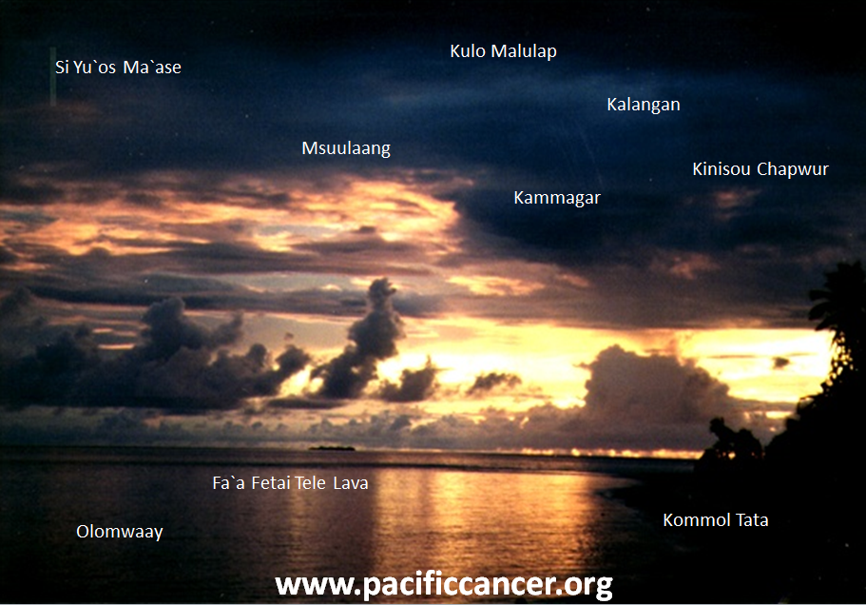

Acknowledgements

PRCCR Contact Information:

Department of Family Medicine and Community Health
Attn: Pacific Regional Central Cancer Registry
677 Ala Moana Blvd., Suite 815, Honolulu, HI 96813
pcregistry@gmail.com or lbuencon@hawaii.edu or eidsmoe@gmail.com
Phone: (808) 692-0853
Fax: (808) 586-3099

The Pacific Regional Central Cancer Registry is supported by
CDC U58 DP000976 and U58 DP003906

The contents are the sole responsibility of the authors and do not represent official views of the
Centers for Disease Control and Prevention or the Department of Health and Human Services

O’Leary MJ. Health data systems in Micronesia: Past and Future. Pacific Hlth Dialog 1995;2(1):126-32.
Katz AR, Palafox NA, Johnson DB, Yamada S, Ou AC, Minami JS. Cancer epidemiology in the freely associated U.S. Pacific Island Jurisdictions: challenges and methodologic issues. Pacific Hlth Dialog 11(2): 84-87. 2004

