Changing RVCT Form from 2009 to 2020 versions Updated 1/9/2020

2009 Question | What Changes | 2020 Question (based on 10/29/2019 version)
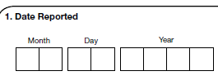 | None  Required with 2020 cases
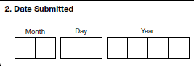 | Deleted
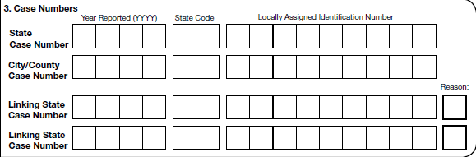 | No Change for State Case Number  Required with 2020 cases
 | Name Change from City/County to Local
 | Linking Case Numbers and Reason questions removed, and new question added to specifically distinguish transferred case number | 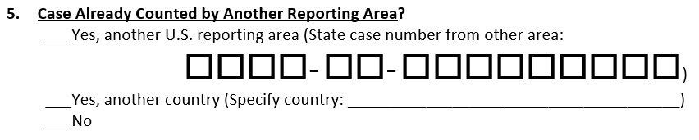
 | Linking Case Numbers and Reason questions removed, and new question added to specifically distinguish epi linked case numbers | 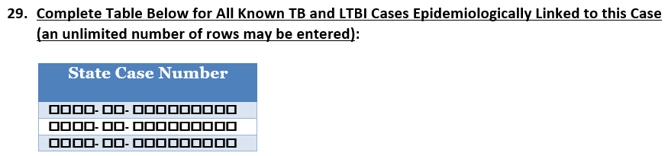
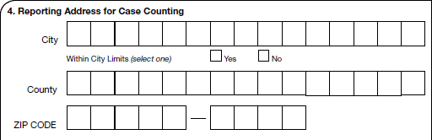 | City is now text and not GNIS coded. City Limits has added Unknown response. County and Zip no change. New Census Tract question added.  Required with 2020 cases – City, Within City Limits, County, Zip Code, but not Census Tract | 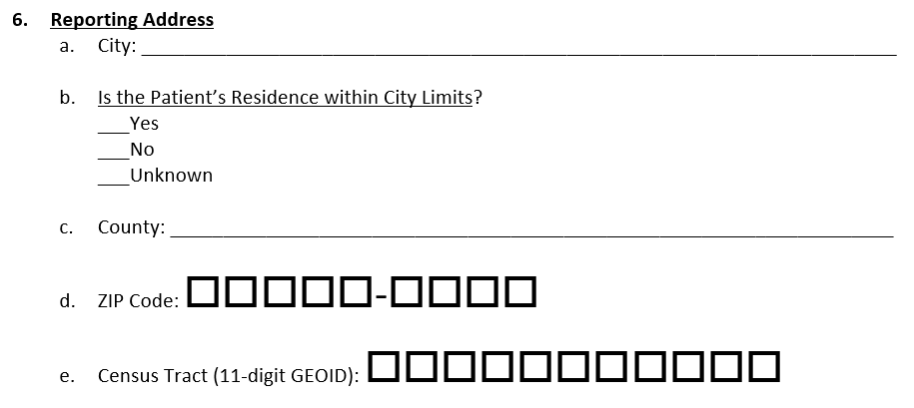
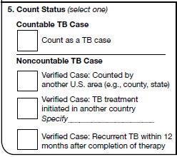 | Count Status has been replaced with a similar but reverse question to determine if case is counted elsewhere.  - Count as a TB Case => No  - Verified Case: counted by another US area => Yes, another US reporting area  - Verified Case: TB Treatment initiated in another country and Specify => Yes, another country and Specify  - Verified Case: Recurrent TB is removed  Required with 2020 cases
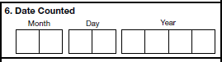 | Full Date Counted is replaced with only Week and Year of Count Date. The Week and Year are expected to follow current TB Counting rules for Date Counted and not MMWR assignment hierarchy.  Required with 2020 cases | 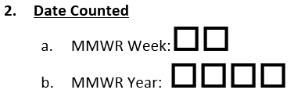
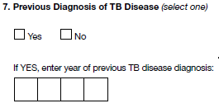 | Previous TB Disease has been expanded to include LTBI and added an Unknown response. Previous TB Disease Year has been expanded to include a full date for every TB diagnosis as well as new questions for Previous State Case ID and whether Completed Treatment. The additional information is also requested for any LTBI diagnosis. | 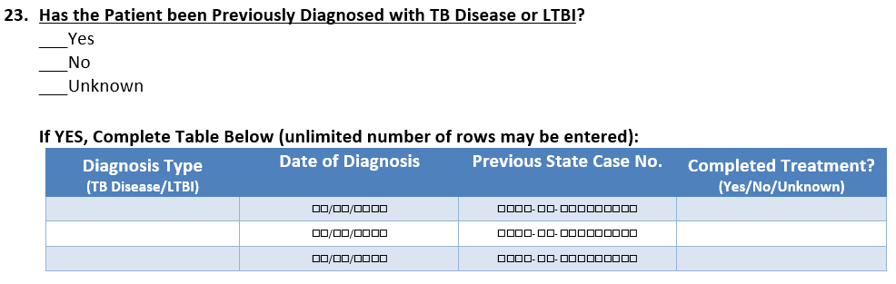
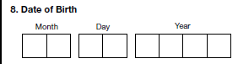 | No Change  Required with 2020 cases
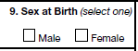 | Added Unknown response and a new question when female regarding pregnancy status.  Required with 2020 cases – Sex at Birth but not Pregnancy question | 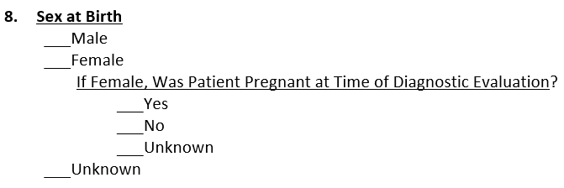
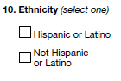 | Added Unknown response  Required with 2020 cases | 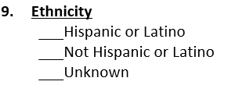
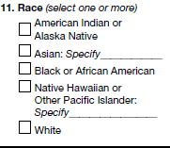 | Added Other Race with Specify and Unknown responses.  Required with 2020 cases | 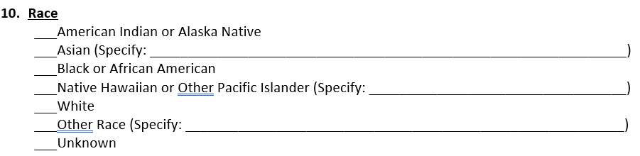
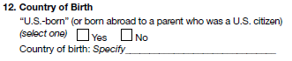 | No change for Country of Birth. Name change for US-born to Eligible for US Citizenship/Nationality at Birth and added Unknown response.  Required with 2020 cases | 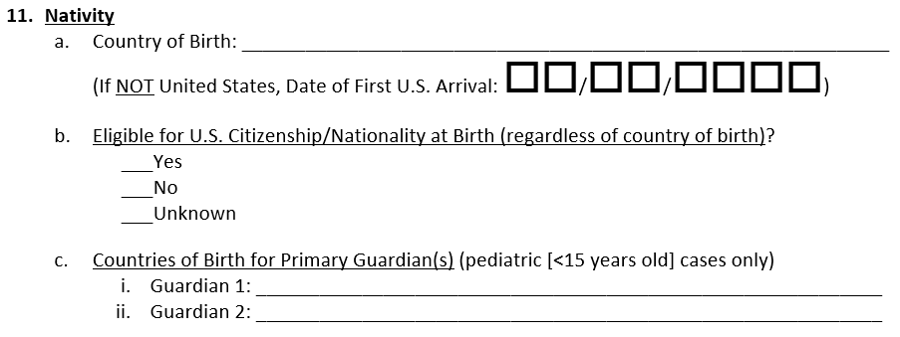
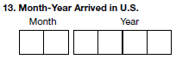 | Modified Month-Year Arrived in US to a full date. As with all dates provide what is known – YYYY, MM/YYYY, or MM/DD/YYYY.  Required with 2020 cases – at least month and year
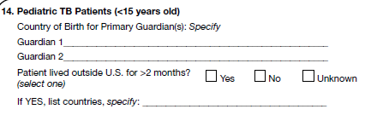 | Country of Birth for Guardians moved into Nativity question with no change. Patient lived outside US moved outside the pediatric limitation to a new question cases of all ages. Countries List is removed. | 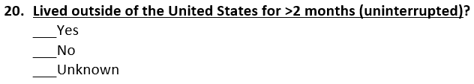
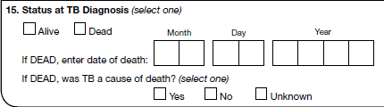 | No Change to Status at Diagnosis, but the two if DEAD questions are moved into a new question that expands the information to all cases that are known to have died.  Required with 2020 cases | 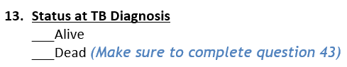  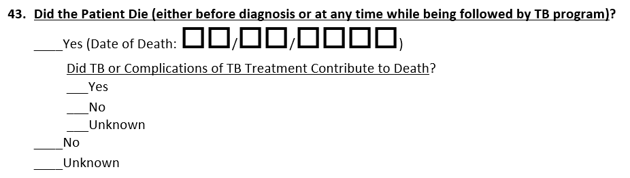
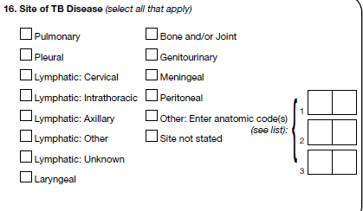 | No change.
Laboratory results have been consolidated into a more flexible repeatable block that will allow additional information when applicable. Please provide at least one response for each of the following test types like what is requested today
- culture,
- smear,
- pathology/cytology, pathology or cytology
- NAA,
- TST,
- IGRA-QFT, IGRA-TSpot or IGRA-Unknown
- HIV, CD4 Count expected when HIV = Positive (Qual Result is NA)
- If Diabetic (Hemoglobin A1c or Fasting Blood Glucose) – new testing results (Qual Result is NA)
If test was not done, please indicate so. Multiple results for a test can be provided but only one is expected.

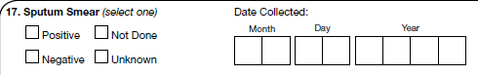 | Q17 has moved to the laboratory results as Smear Test Type with Specimen Source site as Sputum with Date Collected and Date Reported and Qualitative Result. If system collects and Quantitative Results those can be provided also.  Required with 2020 cases – 1 Smear for Sputum Specimen Source Site with Qualitative Result, Date Collected and Specimen Source Site | 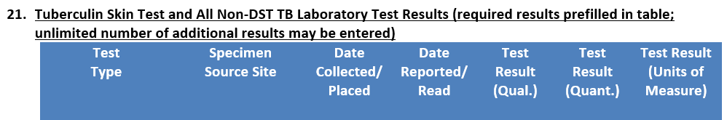
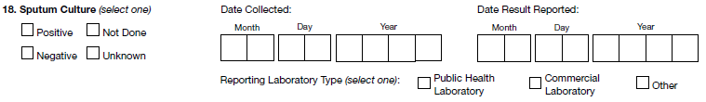 | Q18 has moved to the laboratory results as Culture Test Type with Specimen Source as Sputum with Date Collected and Date Reported and Qualitative Result. Quantitative Results are not applicable. Reporting Laboratory Type is removed.  Required with 2020 cases – 1 Culture for Sputum Specimen Source Site with Qualitative Result, Date Collected, Date Result Reported and Specimen Source Site
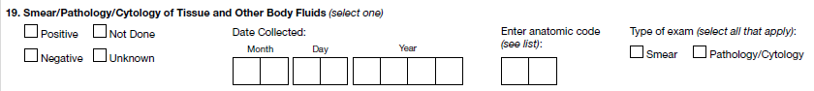 | Q19 has moved to the laboratory results as Smear or Pathology/Cytology or Pathology or Cytology Test Type to distinguish Type of Exam with Specimen Source Site as the anatomic code with the Date Collected, Date Reported and the Qualitative Result. If system collects Quantitative Results those can be provided also.  Required with 2020 cases – if performed then 1 Smear with non-sputum Specimen Source Site with Qualitative Result, Date Collected, Specimen Source Site
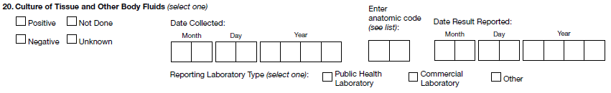 | Q20 has moved to the laboratory results as Culture Test Type with Specimen Source Site as the anatomic code with the Date Collected, Date Reported and the Qualitative Result. Quantitative Results are not applicable. Reporting Laboratory Type is removed.  Required with 2020 cases – if performed then 1 Culture with non-sputum Specimen Source Site with Qualitative Result, Date Collected, Date Reported and Specimen Source Site
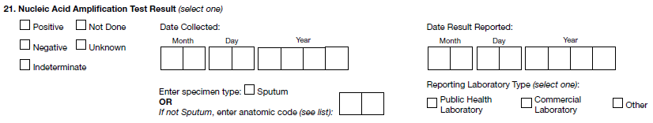 | Q21 has moved to the laboratory results as NAA Test Type with Specimen Source Site as the consolidated response from the specimen type section of either sputum or anatomic code as well as the Date Collected, Date Reported and Qualitative Results. Quantitative Results are not applicable. Reporting Laboratory Type is removed.  Required with 2020 cases –1 NAA with Qualitative Result, Date Collected, Date Reported and Specimen Source Site
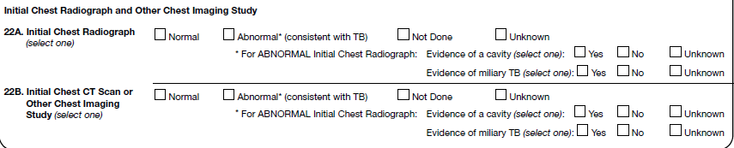 | Chest Studies have been consolidated into a flexible repeating block. Please provide at least one response for each of the main test types – Plain Radiograph and one of CT Scan, MRI, PET or Other. If test was not done, please indicate so. Multiple results can be provided; however only one of the two groups is expected. Answer response names slightly differ but meanings are the same:  - Normal => Not Consistent with TB  - Abnormal (consistent with TB) => Consistent with TB  No change with Miliary or Cavity. Date of Study is added if available in your system.  Required with 2020 cases – 1 Plain Chest Radiograph and 1 (any other type) with Qualitative Result, Cavity and Miliary | 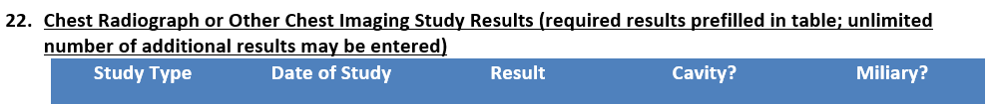
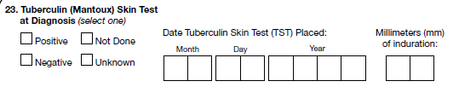 | Q23 has moved to the laboratory test results as TST Test Type, Specimen Source Site as Skin Structure, Qualitative Results, Date Placed, Date Read and Quantitative Result from MM of Induration and Units of Measure as MM.  Required with 2020 cases – 1 TST with Specimen Source Site, Qualitative Results, Date Placed, Quantitative Results and Unit of Measure
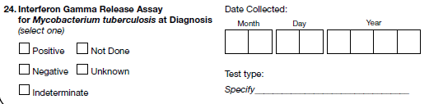 | Q24 has moved to the laboratory test results as one of the IGRA Test Types (IGRA-QFT, IGRA-TSpot, IGRA-Unknown) which replaces the Test Type Specify question. The test should report the Qualitative Result, Date Reported and Date Collected. If system collects Quantitative Results those can be provided also.  Required with 2020 cases – 1 IGRA with Qualitative Result and Date Collected
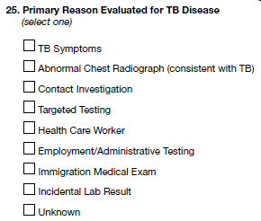 | Q25 Name has changed to Initial Reason Evaluated for TB and some responses have been consolidated into the Screening and Other categories.  - Screening consolidates Targeted Testing, Health Care Worker, Employment/Administrative Testing and Immigration Medical Exam.  - Other consolidates Abnormal Chest Radiograph (consistent with TB) and Incidental Lab Result  Required with 2020 cases | 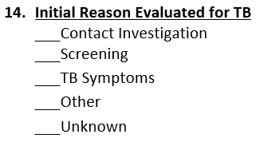
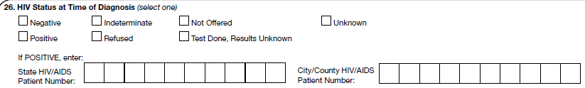 | Q26 has moved to the laboratory test results as HIV Test Type with Qualitative Results. Specimen Source Site would be Blood. If system collects Date Collected, Date Reported then those can be provided also. Quantitative Results is not applicable. The State HIV/AIDS Patient Number and City/County HIV/AIDS Patient Number questions have been removed.  Required with 2020 cases – 1 HIV Status with Qualitative Result
The Risk Factor repeating group consolidates all risk factor questions and only one response is expected for each risk factor (except Other). The following new questions have been added to the group:
- Homeless Ever (NOT Required with 2020 cases)
- Resident of Correctional Facility Ever (NOT Required with 2020 cases)
- Viral Hepatitis (B or C only) (NOT Required with 2020 cases)

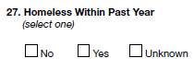 | Q27 has moved to the Risk Factors as the Homeless in the Past 12 Months Risk Factor.  Required with 2020 cases | 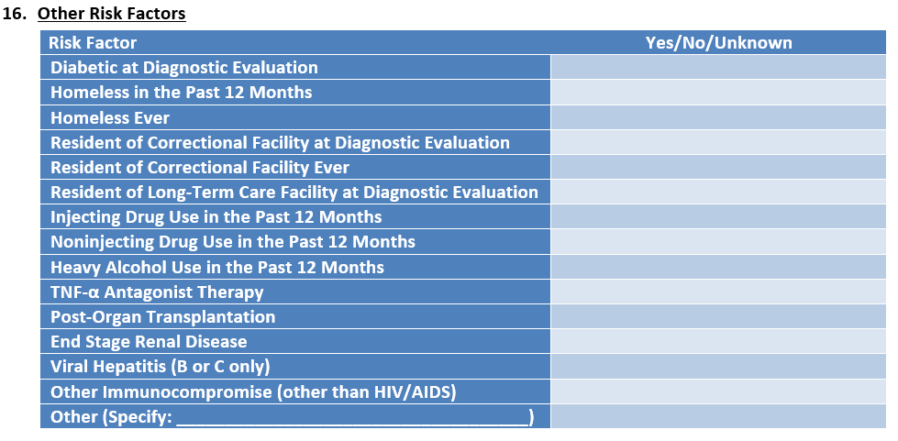
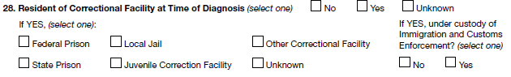 | Q28 has moved to the Risk Factors as the Resident of Correctional Facility at Diagnostic Evaluation Risk Factor. The If Yes, facility question has not changed and is a standalone question outside the Risk Factors group. If Yes, ICE custody question has been removed.  Required with 2020 cases – Risk Factor and Facility, but not ICE question | 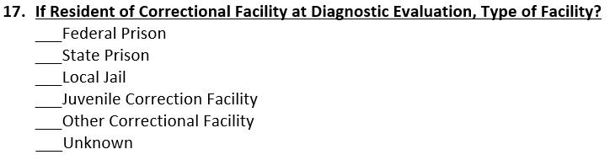
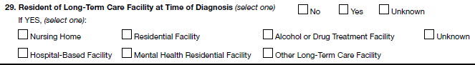 | Q29 has moved to the Risk Factors as the Resident of Long-Term Care Facility at Diagnostic Evaluation Risk Factor. The If Yes, facility question has not changed and is a standalone question outside the Risk Factors group.  Required with 2020 cases | 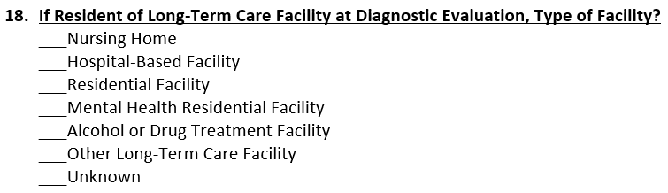
 | Q30 Primary Occupation has been removed and replaced with new Occupation Questions. The new Current Occupation and Industry question is expecting a text description response for each occupation/industry currently held. The standardized NIOCCS code may be provided in the message but it is optional.  Required with 2020 cases – Ever Worked Question only | 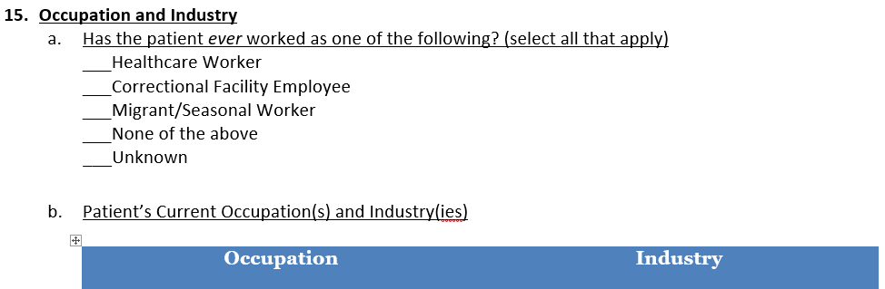
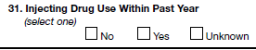 | Q31 has moved to the Risk Factors as the Injecting Drug Use in the Past 12 Months Risk Factor.  Required with 2020 cases
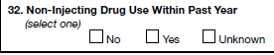 | Q32 has moved to the Risk Factors as the Noninjecting Drug Use in the Past 12 Months Risk Factor.  Required with 2020 cases
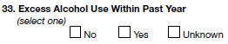 | Q33 has moved to the Risk Factors as the Heavy Alcohol Use in the Past 12 Months Risk Factor.  Required with 2020 cases
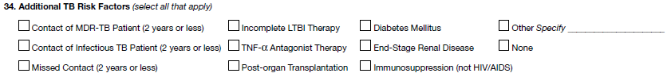 | Q34 has been moved to the Risk Factors as follows:  - Contact of MDR TB Patient => removed  - Contact of Infectious TB Patient => removed  - Missed Contact => removed  - Incomplete LTBI Therapy => removed  - TNF-α Antagonist Therapy => same  - Post-Organ Transplantation => same  - Diabetes Mellitus => Diabetic at Diagnostic Evaluation  - End-Stage Renal Disease => same  - Immunosuppression (not HIV/AIDS) => Other Immunocompromise (other than HIV/AIDS)  - Other and Specify => same  - None => removed  Required with 2020 cases – all except those removed factors
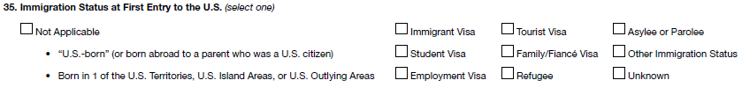 | Q35 Removed
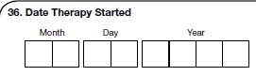 | Q36 No change  Required with 2020 cases
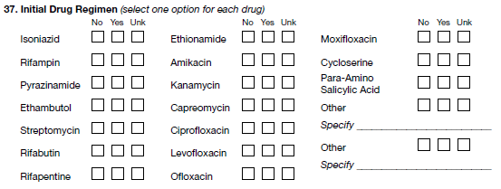 | Q37 has moved into a flexible repeating group for simplicity in reporting and the following new medications added:  - Linezolid  - Bedaquiline  - Delamanid  - Clofazamine  - Pretomanid  Every medication (except Other) should be responded to once. If it is not part of the initial regimen then it should be answered as No.  Required with 2020 cases – Response for each medication except new items listed | 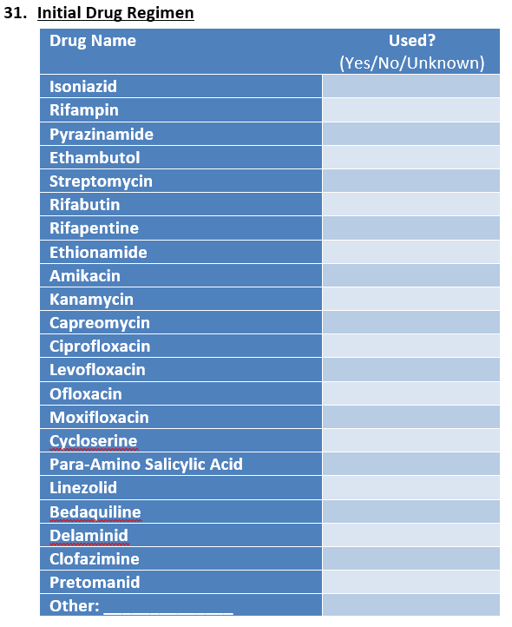
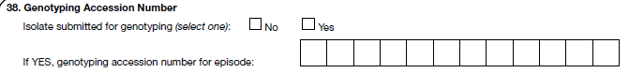 | Q38 No Change  Required with 2020 cases | 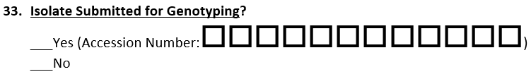
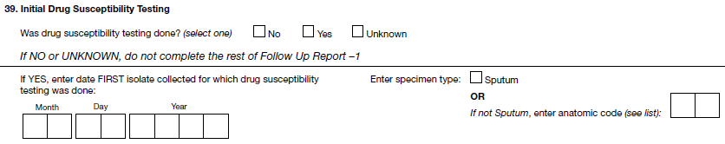 | Q39 No change to Was Susceptibility Testing Done. If yes, Date Collected and Specimen Type questions are now included with DST laboratory results repeating group and provided by test type.  Required with 2020 cases | 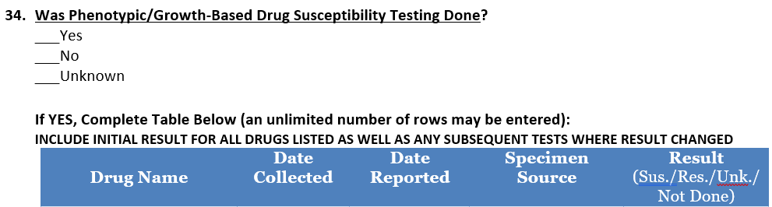
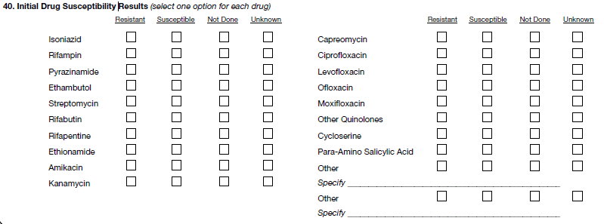 | Q40 has moved into a DST repeating group that includes Drug Tested and Result as well as adds for each drug the Date Collected, Date Reported and Specimen Source. The new group also adds the following new medications:  - Linezolid  - Bedaquiline  - Delamanid  - Clofazamine  - Pretomanid  One result per medication is expected for initial results and one result per medication for follow-up results (when performed). Those medications that are not tested should be reported as Not Done.  Required with 2020 cases – Qualitative Response, Specimen Source and Date Collected for each medication except new items listed
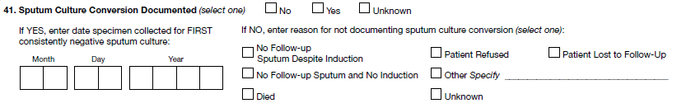 | Q41 No Change  Required with 2020 cases | 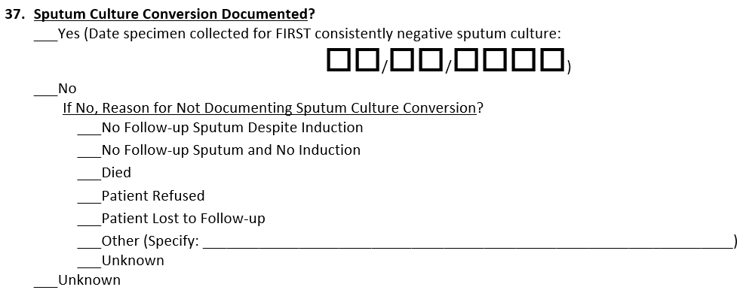
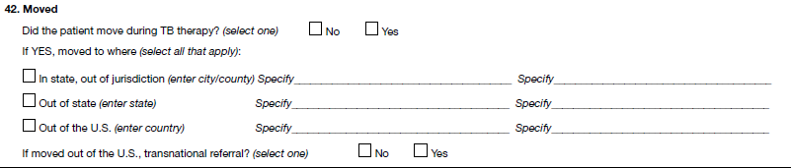 | Q42 Change adds Unknown response to both Moved During Therapy and Transnational Referral questions. Removed In state from Moved to Where question as well as the associated City and County move locations.  Required with 2020 cases | 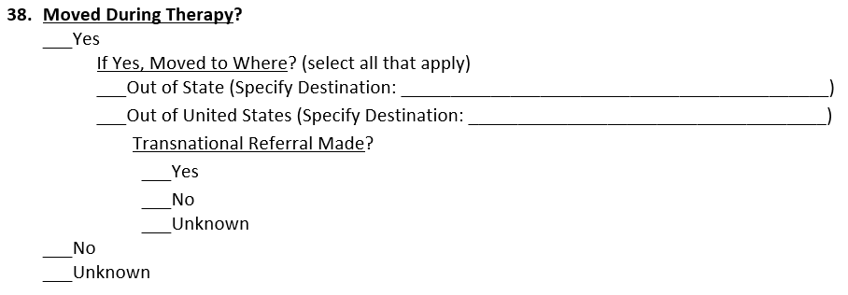
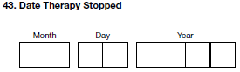 | Q43 No Change  Required with 2020 cases
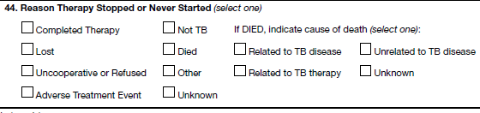 | Q44 Added a response for Dying and a Specify for Other. The If DEAD question is moved into a new question that expands the information to all cases that are known to have died.  Required with 2020 cases – All reasons for therapy stopped except Dying. If Died question should map into the Q43. | 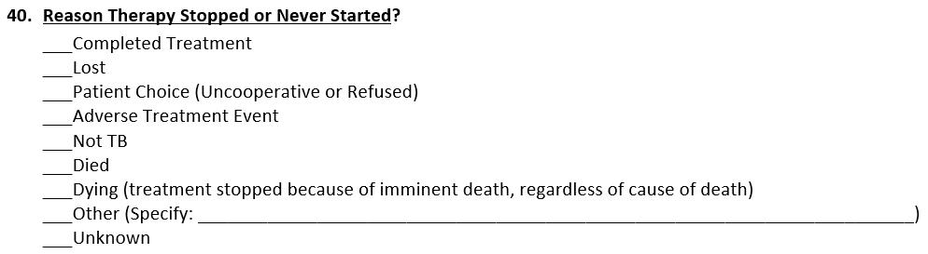  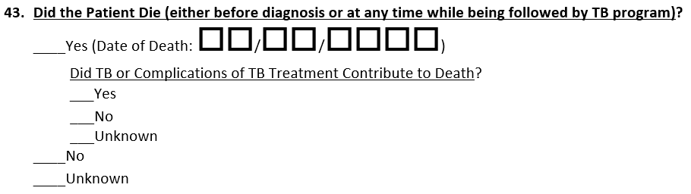
 | Q45 Rifampin Resistance response expanded to Inability to Use Rifampin (Resistance, Intolerance, etc.) and Unknown response added.  Required with 2020 cases | 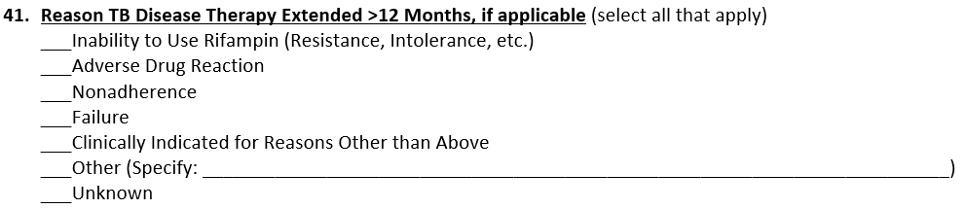
 | Q46 Removed
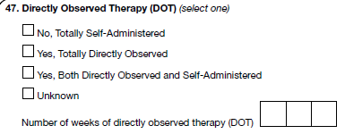 | Q47 Renamed and changed to a multi-select question with the type(s) of treatment to be selected – added a response for eDOT. Number of weeks question is removed.  Required with 2020 cases – SAT and DOT expect but eDOT is not required | 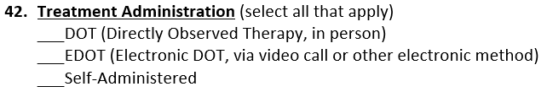
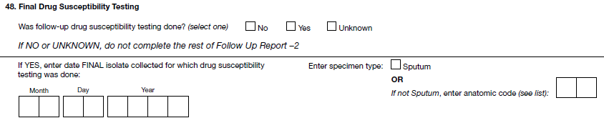 | Q48 The follow-up susceptibility question is removed, and all DST results are consolidated into the DST repeating group as outlined in Q39.  Required with 2020 cases
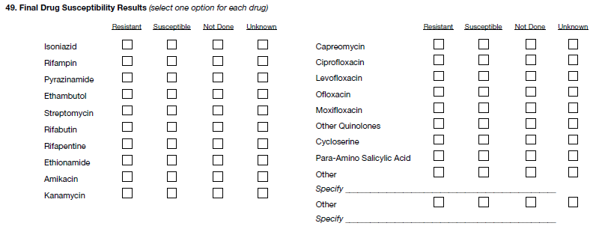 | Q49 DST results are consolidated into the DST repeating group as outlined in Q40.  Required with 2020 cases – Qualitative Response, Specimen Source and Date Collected for each medication except new items listed

New 2020 Questions (with no relationship to current questions)
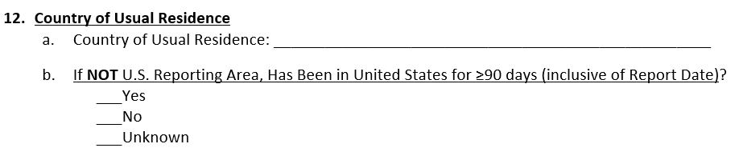
NOT Required with 2020 cases
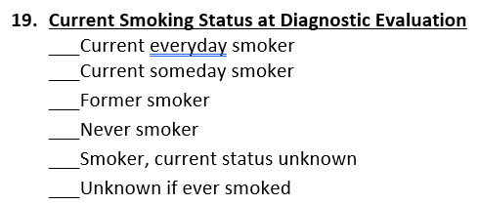
NOT Required with 2020 cases
NOT Required with 2020 cases
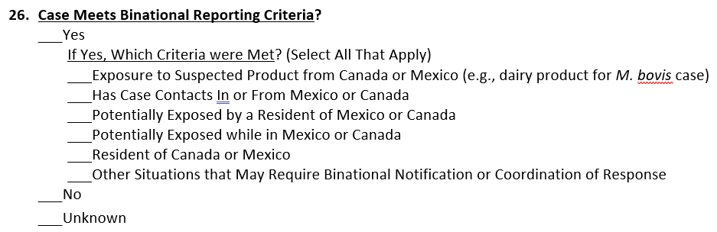
NOT Required with 2020 cases
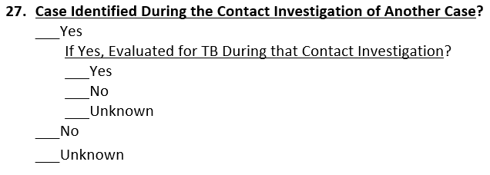
NOT Required with 2020 cases
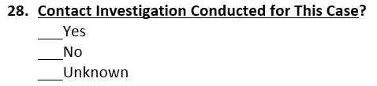
NOT Required with 2020 cases
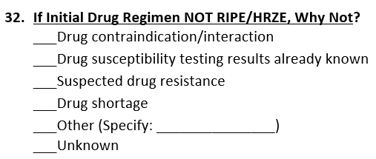
NOT Required with 2020 cases
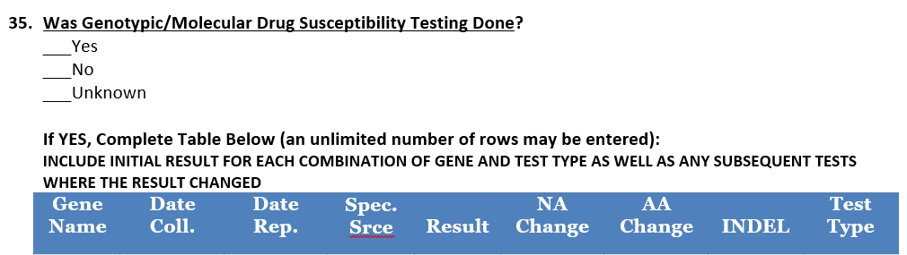
NOT Required with 2020 cases but can be reported with NTSSCR system
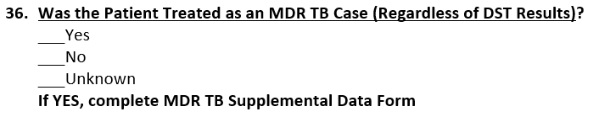
NOT Required with 2020 cases
All questions on the MDR TB Supplemental Surveillance Form are NEW.
NOT Required with 2020 cases, but can be reported with NTSSCR system

