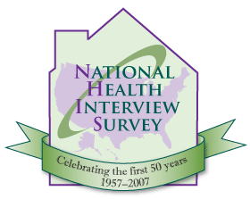
National Health Interview Survey
50th Anniversary Commemorative Conference
at the National Center for Health Statistics, Hyattsville, Maryland
Monday, June 25, 2007
Registration Form

Name (as you wish it to appear on your badge):
First name:
Last name:
Title:
Organization:
Street address:
City:
State:
Postal code:
Country:
Telephone:
Fax:
Email:
Important note to persons who are not U.S. citizens: Government regulations require you to obtain prior approval to enter the NCHS building. If you are not a U.S. citizen, please notify us of that and we will provide you with a request form to be filled out. The form should be returned to us at least 3 weeks before the conference.

Please return to Brenda LaRochelle by email, post or fax: BLaRochelle@cdc.gov
3311 Toledo Road, Room 2207, Hyattsville, Maryland 20782
Phone: (301) 458-4686, Fax: (301) 458-4035

There will be no registration fee for the conference. We are asking those who wish to attend to submit a registration form as space is limited, and this will also expedite entry to the NCHS building when you arrive.
Participants should register as soon as possible, as space is limited.

