CONFERENCE DRAFT:

DO NOT CITE WITHOUT PERMISSION OF THE AUTHORS

Racial Differences and Similarities Among Childless, Only-Child, and Multiple Children American Women, 1988-2002

Michelle J. Budig
Jennifer Hickes Lundquist

Social and Demographic Research Institute
and
The Department of Sociology
University of Massachusetts

October 6, 2006
Racial Differences and Similarities Among Childless, Only-Child, and Multiple Children American Women, 1988-2001

In this paper we explore the correlates of childlessness, only children, and two or more children among white and black women. Past research has either neglected racial differences among women with small completed family sizes, or attributed very low fertility to unique causes for black and white women. While white women’s childlessness has been attributed to greater educational and employment opportunities that conflict with family responsibilities, black women’s childlessness has been viewed as the result of inadequate health care, disease, and coercive sterilization. We re-evaluate these arguments with data from the three most recent waves of the National Survey of Family Growth (cycles 4, 5, and 6). Event history and survival analyses utilizing detailed fertility, adoption, marital, employment, and educational histories indicate striking similarities among white women and black women in how these factors relate to fertility patterns.

In recent years, very low fertility in industrialized nations has captured the attention of researchers and policy-makers. While fertility levels in the U.S. have not fallen to below-replacement levels as they have in some European countries, the growth in the proportion of American women who are remaining childless has sparked multiple investigations into the causes and consequences of this trend (Abma and Martinez 2006; Downs 2003; Heaton and Jacobsen 1999; Jacobsen and Heaton 1991; Jeffries and Konnert 2002; Mosher and Bachrach 1982; Park 2002). There is also evidence of a parallel increase in the proportion of only-child families in the U.S., although this trend has been less well investigated. Data from the Current Population Survey, presented in figure 1, reveal these trends toward reduced fertility. Among women aged 40-44, the percentage who were childless in 1976 was 10.2%, while the percentage who had only one child was 9.6%. By 2004 these percentages had risen to 19.3% and 17.4%, respectively (Dye 2005). These percentages are considerably higher when limited to women with a college degree or greater (Bachu 1995). Importantly, the rates of childlessness are highest for non-Hispanic black women (21.3%) and white women (20.0%), compared to other racial/ethnic groups (Dye 2005). While a few of these childless women in the 40-44 year age bracket might eventually become mothers, the first birth rate for this age group is extremely low, at 2.4 births per 1,000 women for non-Hispanic whites, and 4.7 among non-Hispanic blacks (Dye 2005). Thus, very low fertility seems to be a social phenomenon of growing relevance in the U.S., particularly so for white and black women.

The convergence in rates of childlessness among black and white women represents two trends: growing white childlessness and declining black childlessness. From 1940 until 1970, black ever-married women had higher rates of childlessness than their white peers, although this trend reversed in 1970 (Boyd 1989a). Historically, childlessness is not a new phenomenon for either group. Among women born in 1910 and entered their childbearing years during the Great Depression, rates of childlessness passed 20 percent (Morgan 1991). But the recent growth of childlessness during an era of comparative economic prosperity stands in stark contrast to historical trends. Understanding the growth of low fertility and childlessness is important for understanding demographic dynamics at the population level and family formation at the individual level. At the population level, very low fertility could lead to an imbalance of the age structure, unless immigration of young families with children counter-balances this trend. An imbalanced age structure could produce problems for the social and fiscal support of the elderly. This is particularly true if the current structure of old age social security systems (paid for by transferring wages from younger workers to retired workers) and privatized solutions to caring for the aged remain unchanged. At the individual level, low fertility may reflect, in part, the new opportunities for women in education and employment. However, not all of the low fertility may be voluntary. Because family building occurs during the same stage of life as career-building, and because American workplaces provide few incentives and supports to combine work with motherhood, some women may be delaying having children until they are finished with formal education and established in their careers. Delayed childbearing increases the risk of age-related infertility issues and raises the possibility of involuntary childlessness.

Understanding whether and how the causes and consequences of low-fertility may differ by racial group is critical because the social and economic experiences of families vary by race/ethnic background. Recent studies of childlessness treats it largely as a phenomenon occurring among white women and cast as a voluntary lifestyle choice attributed to the rising opportunities for women in education and employment, combined with the availability of effective contraception (Jacobsen and Heaton 1991). While quantitative analyses of only-child families are uncommon, anecdotal evidence and popular opinion tend to paint them similarly—as predominantly white and socio-economically advantaged. Attention to race in fertility studies almost always focuses on higher overall black fertility than whites, or on high nonmarital fertility levels. Little attention has been given to the role of race in assessing zero to low fertility, except historically. In contrast to the way childlessness among white women has been depicted, black childlessness historically has been framed as involuntary and attributed to the effects of poverty and discrimination, including poor health care, malnutrition, disease, and coercive sterilization (Farley 1970). One recent exception, however, by Boyd (1989b) argues that high-status black couples ought to be more likely to be voluntarily childless than their white peers, due to racist barriers to full integration into dominant societal institutions. The degree to which late twentieth-century childlessness is similar or different among black and white women has not been adequately explored in the literature. Our research attempts to fill this gap.

Little is known about the correlates of childlessness and only-child families largely because such completed fertility outcomes are still relatively rare events in the United States. As such, it is a challenge to locate fertility datasets with sufficiently large sample sizes of women past their reproductive years, much less ones with adequate numbers of African American women. We remedy this by utilizing the rich fertility information provided by the NSFG and combining the three most recent waves of data from 1988 (cycle 4), 1995 (cycle 5), and 2002 (cycle 6). We investigate differences and similarities between white and black women of varying levels of completed fertility. We focus on women aged 40 to 44 and investigate whether racialized theories of childlessness and low fertility adequately explain fertility trends among black and white women, whether the second demographic transition is affecting fertility among white and black women in the same way, and how racial differences in family structure and opportunities available to women relate to fertility outcomes. Specifically, we ask how marital history, human capital, employment history, reproductive health issues and other factors contribute to the persistence of childlessness and to the incidence of only-child families.

THE SECOND DEMOGRAPHIC TRANSITION

The past three decades have witnessed significant changes in the structure of American families. Some of these changes are attributed to the second demographic transition. While the first demographic transition is characterized as a reduction in marital fertility in response to declining mortality rates, the second demographic transition refers to a stage in industrialized societies where individual control over reproduction produces a level of fertility that fails to maintain replacement of current generations (van de Kaa 1987). Some reasons for the declining total fertility rate include the postponement of marriage, lower marital rates, increase in divorce rates, widespread availability of effective contraception and abortion, postponement of childbearing within marriage, and the decline of higher order births (van de Kaa 1994). A key factor related to all of these changes is the growing social, political, and economic emancipation of women.

While the native-born population growth in some European nations is nearing zero, total population growth is also affected by immigration, emigration, and migration. To the extent that the second demographic transition occurs unevenly across countries or within countries, the relative size of racial/ethnic groups, immigrant/native groups, and socioeconomic groups may also change.

RACIAL DIFFERENCES AND SIMILARITIES REGARDING THE CHANGING AMERICAN FAMILY STRUCTURE

Multiple factors may affect zero-to-low fertility. Some of these may have similar effects by race while others may affect black women’s and white women’s fertility patterns differently. Changes related to family structure that differ between non-Hispanic black women and non-Hispanic white women include the availability of marriageable men, the rising age at first marriage, the age at first birth, and the prevalence of non-marital fertility.

Particularly affecting black women is the reduced availability of marriageable black men due to the high unemployment, incarceration, and mortality rates suffered by this group. The ratio of single men to single women is dramatically different by racial group. In 2004, the ratio of single men to single women aged 20-29 was 92:100 for blacks and 120:100 for whites (U.S. Census 2006a). To the extent fertility decisions are influenced by marriage prospects, the relative lower availability of marriageable men may affect black fertility more than white fertility.

Both black and white women are experiencing rising ages at first marriage. In 1970 the median age at first marriage was 20.8 years among women. By 2005 this increased to 25.8 years and there is little difference by race in these trends (US Census 2006b). Higher ages at marriage may lead to smaller completed family size. However, while maternal ages at first birth have also risen for whites, black women have not experienced this change. Thus, significant differences have emerged in age at first birth between black and white women. In 1970 the median age at first birth was 20.0 for blacks and 22.3 for whites. By 2000 this had risen to 24.7 for whites but only to 21.8 for blacks (NCHS 1999). Increasing age at first birth is linked to the incidence of age-related infertility. While white women are more likely to delay motherhood, they are also likely to have access to financial resources to seek out and obtain infertility treatment.

These trends point to racial differences in the link between childrearing and marriage. For all races, but especially among blacks, there has been an increase in non-marital births. Between 1970 and 2004, non-marital births as a percentage of all births increased from 5.7% to 27% among white women and from 38% to 69% among black women (Ventura and Bachrach 2000). The growth of non-marital births indicates that older ages at marriage should impact low-low fertility less over time and less for blacks than for whites. Taken together, these trends imply that the timing of marriage should predict white women’s fertility and childlessness more strongly than black women’s.

Family structure may be changing in part due to the increased educational and employment opportunities for women. Enabling the growth of women’s educational attainment and employment participation during the 1970-2004 period is the increasing availability of contraception and legalized abortion. While increased access to birth control and abortion should reduce fertility, it is not obvious that effects would differ by race.

Between 1970-2004 the percentage of adult women earning at least a high school diploma rose from 58% to 86% among whites and dramatically rose from 35% to 81% among blacks. Similarly, the percentage completing at least a bachelor’s degree rose from 8.6% to 26% among white women and 4% to 19% among black women (CPS 2004). If women delay marriage and motherhood until they have completed full-time enrollment in educational institutions, then educational attainment should reduce overall fertility by increasing the age at marriage and at first birth.

Education is also linked to increasing employment opportunities for women. Between 1970 and 2005, among women aged 25 to 54, labor force participation grew, although this growth was more dramatic for white women (49% to 75%) than for black women (60% to 77%) (Bureau of Labor Statistics custom figures). Using event history analysis to examine women’s employment and fertility histories with longitudinal data, Budig (2003) has shown that both full-time and part-time employment decrease women’s likelihood of becoming pregnant. This implies that employment may contribute to rising rates of childlessness and only-child families.

DATA AND METHODS

We utilize retrospective fertility information by combining the three most recent waves of NSFG data from 1988 (cycle 4), 1995 (cycle 5), and 2002 (cycle 6). We restrict our sample to women at the oldest ages of the NSFG age range, years 40-44, under the assumption that most women have met their reproductive preferences by this point in their lives. The total sample size is 4267.

In the first set of analyses, we model the probability of childlessness by age 40-44. Using Cox Proportional Hazards regression, we predict the estimated hazard of time until first birth or adoption, focusing on the survivorship of those women who reach age 40-44 without having a child. In these models the risk of a first child begins for each woman upon the date of her first menses and continues until either a first birth/adoption occurs, or upon her right censorship at the end of the time period (for childless women). The second set of analyses measures the likelihood of having no more than one child by age 40-44 using the same methodology. The hazard of having a second child is predicted conditionally upon having had a first child, and in this model we focus on the survivorship of women who reach age 40-44 with no second child. Here risk begins following the date of the first birth/adoption and is measured in century months leading to a second birth/adoption or until the respondent reaches the end of the observation period.

Cox Proportional Hazards Regression, an especially useful approach for studying the timing of events, is a semi-parametric method that operates on an unspecified, arbitrary baseline hazard using maximum partial likelihood estimation (Allison, 1995). The hazard is multiplied by fixed and time-dependent covariates that are included in the model in a log linear form. Where events are tied, e.g. two or more observations share the same century month of occurrence, we use the Breslow method. We begin each set of analyses (childlessness and only-child) with an event history model that pools together white and black women and estimates race interactions. We then separate the models by race and include marital status interactions. We measure the effect of covariates under the assumption that women’s individual-level characteristics exert a proportional effect on the chances of having (or, more accurately, not having) the specified events. Since the outcomes of interest in each analysis are structurally defined as non-events, our discussion is oriented toward the independent variables and their inverse relationship to the event hazard. (Negative coefficients predict the likelihood of either childlessness or having an only child, depending on the model, while positive signs predict the likelihood of having either a first child or a second child.) To emphasize the inverse relationship in the models, we include a risk ratio column for childlessness/only child (nonevents) along side the event risk ratio columns (e.g. Exp(-1*B) and Exp(B)) in the following tables. As such, a risk ratio greater than one indicates a higher risk of the nonevent or event in question and risk ratios less than one indicate a lower risk.

We examine the effects of five groupings of variables: basic demographic characteristics, human capital, socioeconomic status background, family structure, and reproductive histories. These variables are described in detail below. After analyzing the effects of these variables on the likelihoods of differing completed family sizes, we test for significant interactions by racial group and marital status. We do this to see whether these factors operate in similar ways for black and white women, and for married and unmarried women.

The retrospective nature of the NSFG surveys ensures that many of our independent variables are sequenced in consecutive order leading up to the events we wish to predict. However, a drawback to merging three waves of NSFG interviews together is occasional variable inconsistency across the waves. Where one survey wave may have collected information on dates of occurrence, another may only have collected cross-sectional information as of the interview year. In such cases we have had to assume that certain variables, such as educational level, were time inconstant leading up to events—or time failure. This is a safer assumption for some measures than for others. One’s education level at age 40 is more likely, though not guaranteed, to reflect one’s education level at age 25 than is, for example, one’s employment characteristics at age 40. Whether one is employed full-time at time of interview for our sample members is more likely the result of one’s childbearing history than the cause. These are unfortunate shortcomings of some of the data we use as our covariates. We note below which measures were provided in century months of occurrence and which were available only as cross-sectional measures obtained at the time of the interview.

Basic demographic characteristics include age (measured as duration through risk interval), race/ethnicity, nativity, and date of survey. We include dummy variable=1 if black and dummy variable=0 if White, where Latinos may be of either race. If Latino, dummy variable=1, with non-Hispanic whites and non-Hispanic blacks as the reference groups. Nativity is a dummy variable =1 if born outside of the U.S., with native born serving as the reference group. Finally, variable indicating the date of survey measure controls for cohort differences ranging from 1988 through 2002.

Family structure indicators include marital and cohabitation histories. The dummy variable married=1 during all months in which the individual was married, with months unmarried (single, divorced, widowed) as the reference category. We created a similar variable for cohabiting, where cohabiting=1 during the intervals in which a cohabiting union was reported. There is some variation on how cohabitation histories were collected across the waves, however. As a result, cycle 4 respondents have dates reported only for their first cohabiting unions or current partners, while cycles 5 and 6 have full cohabiting histories.

Human capital variables include educational attainment and employment. Education is measured as a set of dummy variables indicating the respondent’s highest level of educational attainment. These include high school diploma, some college, or a college degree or more, with high school dropouts serving as the reference category. Unfortunately, NSFG Cycle 6 did not collect date of college completion and so we make the assumption that those with a college degree as of the interview date earned it four years following their high school graduation date. Employment is another cross-sectional variable, but making assumptions about its historical applicability during the risk period is more problematic. Labor histories were only collected in NSFG cycle 5 and so the other cycles only indicate whether the respondent was employed part-time (less than 35 hours weekly) or full-time (35+ hours weekly) at the time of the survey interview (not employed is the omitted category.) We acknowledge that reverse causality plays a likely role in the case of these employment measures, but we leave it in the models nevertheless so that we can get a crude indication of the relationship between employment and our fertility measures.

We examine poverty and income, religiosity, maternal education, and maternal employment for our socioeconomic characteristics. Religiosity is measured by frequency of church attendance at age 14. To capture family of origin socioeconomic class background, we included two dummy variables indicating whether the respondent’s mother was employed when respondent was age fourteen and whether the respondent’s mother had a college education. We used the respondent’s mother’s employment and education for two reasons. First, data on mothers tends to be more reliable, particularly in the event of divorce or separation. Secondly, we thought the respondent’s mother’s educational and labor force engagement might influence the respondent’s education and employment, and indirectly, fertility, more so than the father’s. We measure current poverty=1 if the respondent falls below 150% of the poverty line. We also include a dummy variable in some models indicating whether household income exceeds $75,000 annually. We recognize that these are post-event measures and should therefore be interpreted with caution.

Reproductive histories include time-varying dummy variables indicating timing of medical sterilization, past abortions, past miscarriages, if the respondent has had any infecundity issues, and, for the only-child models, age at first birth or adoption. We introduce the first two measures as loose controls for undesired fertility. (We plan to introduce the NSFG fertility intention variable in a later version of this paper to further isolate the slippery distinction between voluntary and involuntary childlessness/low fertility) Following the occurrence of a medical sterilization procedure, respondents are coded=1 for the sterilized variable. Respondents are likewise coded=1 for abortion following a reported pregnancy termination. The second two measures represent attempts to control for involuntary infecundity—whether permanent or age-related. We make the assumption that women aware of having had a miscarriage are more often attempting to carry a pregnancy to term. Respondents are coded 1=previous miscarriage in the intervals following a miscarriage. The infecundity issues variable combines the two variables, “ever sought medical help to become pregnant” and “ever had difficulty getting pregnant or carrying baby to term.” Unlike the rest of the variables in this section, this is another post-hoc question asked of the respondents when they were 40-44. Thus, it is possible that fertility assistance or difficult experiences becoming pregnant occurred in experiences subsequent to the first or second children that we measure in these models. Nevertheless, the variable is the closest we have to a control for secondary infertility. Finally, age at first birth/adoption in the only-child models controls for the duration from entry into risk period to either event exit or time failure.

RESULTS

Descriptive Analyses

Before we present the findings from our multivariate event history analyses, we show descriptive results for all variables used in the analysis. In addition, we summarize the unadjusted survival distributions of remaining childless, and of remaining a mother of an only-child. In all descriptive analyses, we test for significant differences by racial group in the distributions of measures and of survival curves.

Table 1 presents descriptive means and standard deviations for the variables used in the analyses. The first set of columns show the characteristics of white women in the sample and the second set of columns show those of black women. Although our analyses incorporate time-changing characteristics in person months, the characteristics shown here are cross-sectional according to the interview date when the women were between the ages of 40 and 44 for ease of presentation. Each group is divided by completed family size -- from zero children, to one child only, to two or more. The sample sizes for each grouping show among whites, 16 % are childless and 17% are singletons, compared to 13% and 23% respectively for black women; these racial differences are statistically significant. About 67% of whites have two children or more compared to 64% of blacks, indicating that zero to low fertility patterns among blacks are on par, or even lower, than among whites. Statistically significant differences in characteristics, within completed family sizes, and between racial groups, are bolded.

Among the family structure variables it is noteworthy that marriage is more common among whites at all parity levels, and that childless women (both black and white) have much lower percentages of ever being married than mothers. Cohabitation follows a similar pattern for blacks, where those without children are least likely to have cohabited, but the pattern is reversed for whites. Cohabitation for whites is more strongly linked to zero or low fertility than it is to having multiple children.

--------------------------TABLE 1 ABOUT HERE--------------------------------

Turning to reproductive history, the duration variables indicate how many person-months each group remained in the sample before having an event or time failure. As expected, childless women experienced the longest durations since they remained at risk throughout the entire observation period. Durations for the other two completed family sizes, singletons and multiples, show that those who have two or more children have their first child earlier than those who have only one. Racial differences in duration for these two groups show that whites delay their first child longer than do blacks. Accordingly, age at first birth or adoption is younger by an average of three years for blacks than for whites. Women with an only child have their child later on average, however, for both black and white respondents.

Only a small percentage of women formally adopt a child and there is no significant difference by race. Among whites, childless women have the highest abortion percentages, while among blacks childless women have the lowest, although the difference in abortion rates among the childless is not statistically significant by race. Higher abortion rates for blacks with singletons and 2+ child families are significantly different from those of whites. Miscarriages for all groups of women rise with family size, but childless black women report notably higher miscarriage percentages than childless white women. Among whites, infecundity issues are reported most often by mothers of only children (35%) whereas among blacks, infecundity it is reported most frequently by childless women (29%). Although infecundity issues are reported more frequently by white women than black women, the difference is not significant by race. Finally, and perhaps the most striking difference among the reproductive variables, is the variation in medical sterilization. The percentage of women sterilized increases by number of children, indicating that sterilization occurs following a number of births for all women; however, there is racial variation in levels. Among childless women 34% of black women had a sterilization procedure compared to only 21% of white women, and 37% of white women with an only child had been sterilized compared to 45% of black women. The gap is largest at higher parities, with 71% of black mothers of 2+ children reporting sterilization compared to 53% of white mothers.

Moving on to the human capital measures we see that educational level may be more determinative of childlessness for whites than for blacks. Forty-four percent of white childless women have college degrees compared to only twenty-seven percent of women with two or more children. While substantially more black childless women also have a college degree than black women with two or more children (twenty-five percent compared to only thirteen percent), the link to education does not appear to be as polarizing as for whites. There is not an obvious association between schooling and mothers of only children for either race. Finally, women with no or one child are more likely to be working full time by age 40-44 than mothers with 2+ children.

Looking at the socioeconomic indicators we see that maternal college education is more common among childless women, more strongly so for whites than for blacks. Maternal fulltime employment is associated with white childlessness and only children but makes little difference for blacks. Church attendance is unrelated to completed family size, but black women overall have higher frequencies. Poverty is positively correlated with parity for both blacks and whites, but at higher overall levels for blacks. Only 10% of white childless and singleton white women fall under 150% of the poverty line compared to 17% of 2+parity mothers. Similarly, 19% and 24% of black childless and singleton mothers fall below the poverty line compared to 40% of mothers with two or more children.

Demographic background measures show that age at interview varies little across parity or race, although the small difference between black and white childless groups is statistically significant. Hispanic whites are more likely to have family sizes of two or greater than only children and especially zero. There is no similar pattern among Hispanic blacks however. Finally, more foreign-born white women have higher parities than lower parities; there is not a similar trend among black foreign-born women.

How do black and white women compare in respective childlessness prior to the introduction of the above covariate controls? Figure 2 shows survival curves of childlessness for women beginning in century months upon their date at first menses until they turn ages 40-44. At the beginning of the time-period indicated by the leftmost end of the x-axis, all women are childless and, hence, the percentage “surviving” the risk of having a first child is 100%. Thereafter, individuals who have their first child leave the survival curve one by one, creating its downward trend. Black women are represented by the solid line and white women are represented by the dotted line as labeled on the chart. We see that the proportion of women remaining childless essentially converges by the end of the risk period at about 15% for black women and 18% for white women. However, the shape of the survival functions leading to convergence in childlessness differs significantly. The earlier drop of the survival curve for black women compared to white women indicates that first children tend to arrive at younger maternal ages. White women experience longer intervals before the arrival of first children.

--------------------------FIGURE 2 ABOUT HERE--------------------------------

Because there is well known racial heterogeneity in childbearing by marital status, the following two figures show the childless survival distribution further broken down into ever-married women and never-married women. As might be expected, Figure 3 shows that childlessness by the end of the risk period is much lower among women who have ever been married, at about 8% for black women and 10% for white women. The survival distribution is essentially unchanged from the conflated marital status model shown in Figure 2, with ever married black women more likely to have their first child sooner than ever married white women, but culminating in similar levels of childlessness by the end of the childbearing period. The survival curve for never married women, however, reveals patterns that were masked in the original distribution shown in Figure 2. Overall, Figure 4 shows that Women ages 40-44 who have never married are much more likely to be childless than women with a marital history. But unlike the ever-married survival distributions, there is no convergence in childlessness among the racial groups. The majority of never married white women (about 70%) do not have a first child while only about 30% of never married black women remain childless.

The childlessness survival curves show that marriage is clearly more normatively associated with childbearing for both groups of women, but much more strongly so with white women than black women. Thus, the generalized childlessness convergence depicted in the first survival curve may be largely driven by group differences in marriage behaviors. Comparatively fewer white women than black women have not married by age 40-44 (10% compared to 31%, CPS 2004), driving down overall childlessness for whites.

--------------------------FIGURE 3 and 4 ABOUT HERE--------------------------------

We next plot the only-child survival functions for black and white women who have one child but do not go on to have a second child before age interval 40-44. Black women are again represented by the solid line and white women by the dotted line. As expected, Figure 5 shows that intervals between first and second children are shorter overall than the interval before first child, but, unlike the previous survival curves, white women have shorter intervals than blacks. This is largely because they have had their first child later than blacks and are therefore compressed into shorter second child intervals than blacks (controlling for age at first child obviates proportionality assumptions of risk differences across groups in the multivariate models). Also unlike the childlessness curves, the trend in only children does not come back together for blacks and whites after the completion of the childbearing years. Black women, it appears, are less likely to have only children than white women (versus having a second child), although the difference is not huge. About 25% of black women have only children compared to about 20% of white women. The next two figures break the survival distributions of only-child mothers down by marital status.

--------------------------FIGURE 5 ABOUT HERE--------------------------------
Figure 6, which graphs the survival functions for ever married black and white mothers, follows the same basic patterns, except blacks are slightly less likely than before to have only children. Figure 7 indicates that individuals who have a first nonmarital birth are more likely to stop at parity one than to continue on to parity two, whereas Figure 6 shows that only children among the ever married is less common. About 35-40% of never married women have only children instead of two by age 40-44. The shape and level of the separate only child survival curves differ little by race.

--------------------------FIGURE 6 and 7 ABOUT HERE--------------------------------

Much of the data reported in Table 1 and through the preceding figures would seem to support theories concerning race and low fertility in the literature. To understand to what extent such trends hold in the face of multivariate controls, we turn next to the event history hazard analyses.

Findings

How do family characteristics, reproductive histories, socioeconomic characteristics and demographic factors shape the likelihoods of being childless, a singleton mother, or a mother of multiple children? Tables 2 through 6 summarize these findings. In our discussion, we will first examine how these factors shape family size outcomes for all women. Next, we discuss whether and how the effects of these factors differ by race and marital status.

General Correlates of Childlessness and Singleton Motherhood

Table 2 shows the results of the proportional hazards model predicting a having a first child versus remaining childless by age 40-44, prior to testing for race interactions. Coefficients (Bs) for each variable are shown in the leftmost column, followed by the risk ratio for becoming a mother (Exp(B)), and, lastly, the risk ratio for the nonevent, that is, childlessness (Exp(-1*B)). Risk ratios are only displayed if the coefficient is statistically significant.

-------------------------TABLE 2 ABOUT HERE-----------------------------------

Net of family structure, reproductive, human capital, socioeconomic and demographic controls, we see that black women are approximately 30% less likely to be childless than white women. After the expected strong effect of sterilization, by far the strongest predictor of childlessness in the model is having a college degree. College-educated women are three times more likely to be childless than women without a high school degree (the omitted category). The net effect of education is also strong at each of the other schooling levels; women with some college are 98% more likely to be childless and women with a high school degree are 71% more likely.

Married women are 33% less likely to remain childless than unmarried women, but cohabitation has no effect on fertility outcomes. Each year after menses is associated with a 10% decrease in the likelihood of remaining childless (tests for nonlinearity in the duration variable were not significant). Having had an abortion or miscarriage increased the risk of childlessness by 43% and 33% respectively. Infecundity Issues, reported at age 40-44, is also positively correlated with childlessness. Not surprisingly, full-time employment, another cross-sectional variable as of age 40-44, is also positively correlated with childlessness.

Background socioeconomic variables indicate that higher socioeconomic status is associated with childlessness. Having had a college-educated mother increases the hazard of childlessness by 8% and being above the 150% poverty line decreases the likelihood by 14%. Neither growing up with a mother who worked full-time nor church attendance at age 14 are correlated with childlessness.

Contrary to expectations, foreign born women are 16% more likely than native born women to be childless. Lastly, we see that each successive NSFG sample of women is 18% more likely than the last to be childless.

We next examine the hazard of stopping after a first child rather than going on to have a second to see whether the correlates involved differ from those associated with childlessness. Table 3 shows results from the proportional hazards model predicting having a second child by age 40-44, prior to testing for race interactions. The format used in Table 2 is replicated in Table 3.

------------------------TABLE 3 ABOUT HERE------------------------------------------

Table 3 indicates that black women are even less likely than white women to have only children than they were to be childless, with twice the odds of going on to have a second child than whites. Because black women enter the risk period in the model earlier than whites due to earlier first births, we interact age at first child with race to control for their longer period at risk. This indicates that black women have a greater hazard of having a second child upon each unit increase in the duration period. The correlates of singletons are similar to those of childlessness in a number of other ways as well. Marriage is again associated with higher fertility, while cohabitation has no effect. Having had an abortion, miscarriage, a sterilization procedure, and any infecundity issues reduce the likelihood of a second child. Younger cohorts of women with each successive NSFG wave are more likely to have only children than in the past.

An important difference, however, between childlessness and having only children is the reduced impact of human capital and socioeconomic indicators. Whereas childlessness was strongly associated with educational attainment, mothers of only children are not significantly more likely than mothers of multiple children to have a college degree or even some college. Nor is maternal education associated with having an only child like it was for having no children. Subsequent full-time employment and household income above poverty levels are, however, positively correlated with having had one child instead of more. Lastly, although foreign-born women were more likely to be childless in the previous model, this model indicates that those who do have children are more likely to have more than one.

In summary, it appears that previous findings regarding childlessness are substantiated here. After controlling for various confounding factors, childlessness is associated first and foremost with higher education and socioeconomic status. The incidence of only children is less strongly associated with these factors, but there is a mild connection. Notably, in the presence of covariate controls, zero to low fertility is more common among whites than blacks, despite similarities in descriptive data tabulations. In the next segment of the analyses, we evaluate how the above childless and only child outcomes are mediated by marital status and race.

Racial Components of Childlessness and Singleton

Given the striking difference in the bivariate data of marital structure among women with different numbers of children and of different racial groups, we next evaluate the interaction of each with the independent variables in the original models. We present results from models run separately by race. However, we first ran race interactions with covariates in the pooled models to identify whether racial differences in coefficients were significant. Within racial groups, we interact covariates with marital status to test for marriage interactions. We present these coefficients separately by marital status in the tables that follow. Fully specified models are provided in the Appendices. To begin, we present Table 4 to demonstrate how cohabitation and marital status differentially impact the risk ratios of zero to low fertility for black women compared to white women.

-------------------------------TABLE 4 ABOUT HERE-----------------------------

Table 4 indicates that marital status has no influence on black childlessness while negatively predicting childlessness for white women, reflecting documented racial differences in nonmarital childbearing. Being married reduces the odds of childlessness by 52% for white women. (Cohabitation is unrelated to childlessness for either group of women.) In assessing racial differences by union status as to the likelihood of moving from one to two children, however, being married matters for blacks and whites. Being married reduces the likelihood of remaining an only-child mother for black women by 23%; the same risk for white women falls by 39%. Whereas cohabitation makes no difference in predicting childlessness, for blacks it seems to play a similar role as marriage when it comes to multiple-child motherhood. Black singleton mothers in a cohabiting union are 27% less likely than those not in a cohabiting union to end childbearing with one child. There is no effect of cohabitation in this respect for white women.

Table 5 evaluates the interaction of race and marital status with the predictors of childlessness. The first two columns show how marital status varies along the correlates of childlessness within each race via risk ratios. The third and last column indicates whether the differences shown are significantly different across racial groups.

-------------------------------TABLE 5 ABOUT HERE-----------------------------

The effects on childlessness of a previous abortion or a previous miscarriage do not differ across marital statuses, but they do differ by race. Having had an abortion increases the hazard of childlessness for both groups, but more strongly so for whites than for blacks. The reverse pattern is true for the effect of miscarriage, increasing black women’s risk of childlessness more so than whites’. Infecundity issues increase the likelihood of childlessness for married whites by 31%, but there does not appear to be statistically discernible difference between blacks and whites in the overall effect of this variable on childlessness.

While human capital variables powerfully predict childlessness for all women, these variables have distinctly stronger effects for single women. Both racial groups are strongly impacted by education attainment in predicting childlessness, but the effect is stronger for whites than for blacks (this racial difference in magnitude is statistically significant for high school diploma and college degree, but not for some college). Unmarried whites with a college degree, for instance, are over ten times more likely to be childless than whites who are high school dropouts. Among unmarried college educated blacks, the hazard of childlessness is just over three times higher than for blacks without a high school degree. The effect of a college education is considerably lessened for married women, increasing the likelihood of childlessness by 227% for whites and 62% for blacks. Some college experience also strongly predicts childlessness for black and white women, but, again, particularly so for unmarried women.

Two other notable racial differences in childlessness correlates are the effect of household income, as measured by the poverty variable, and the changing incidence of childlessness over time, as indicated by the NSFG cycle variable. Black women who have had no children are 23% less likely to be below the poverty line by age 40-44. This relationship does not hold for whites. Finally, white childlessness within marriage increased between the 1988 and 2002 waves while decreasing among unmarried whites during the same period. Among black women, childlessness levels have remained constant for single women during the time span, but childlessness has become more common within black marriages.

Turning to race and marital status interactions in understanding the correlates associated with only children, Table 6 follows the same structure as Table 5.

-------------------------------TABLE 6 ABOUT HERE-----------------------------

Among only child mothers, the effect of education depends on marital status. For both married blacks and whites, higher education levels are either insignificant or have a negative correlation to only children parities. Married blacks and whites with college degrees, for instance, are more likely to have two or more children than an only child. But among unmarried women, a college degree makes women less likely to go from one to two children. The only significant difference between blacks and whites in the incidence of moving from one to two children is in the amount of difference having a college degree makes. Among married women, the effect of a college education on having a second child is slightly stronger for whites than for blacks. But among the unmarried, the odds of having a second child is more negatively predicted by a college education for whites than for blacks.

CONCLUSION
In this paper we aimed to describe zero to low fertility outcomes among American women who have completed their childbearing years. Importantly, we sought to examine whether and how the causes of low-fertility differed by racial group. We considered competing explanations of the rise of zero to low fertility in general, and race-specific theoretical arguments concerning black and white women. Our investigation compares three competing outcomes: childlessness, mothers with only-children, and mothers of multiple children. Overall, we find little evidence of great disparity between black and white women in the factors that predict childlessness. Moreover, we find little support for the race-specific theories of low fertility. Surprisingly, we do find differences in the factors that are associated with childlessness and only-child outcomes, particularly among married women. But as with childlessness, we find few differences by racial group in the correlates of only-child mothers. Below we discuss our findings in light of past research and theoretical arguments about low fertility trends and racial group differences in these trends.

First, let us consider the racially divided arguments regarding the causes of low fertility. Childlessness, particularly for white women, has been characterized as a phenomenon experienced by women with greater educational attainment and higher socioeconomic status. We find support for this characterization; however, it applies to both white and to black childless women. Educational attainment positively predicts the likelihood of remaining childless for all women, though effects are stronger among whites. That education is the strongest predictor of childlessness among blacks contradicts the argument that black childlessness arises from poverty, disease, and inadequate access to health care. The argument that poverty leads to low fertility outcomes among black women is also contradicted by our finding that poverty decreases the likelihood of childlessness for black women, while having no effect on white women’s likelihood. Thus, poverty among black women is associated with motherhood, not with childlessness. Moreover, poverty also negatively correlates with only-child motherhood: mothers of both races are more likely to have two or more children if their household income is below 150% of the poverty rate.

To further tap into the effects of reproductive health and medical intervention and how these factors might differently affect fertility outcomes for black and white women, we included measures of sterilization, miscarriage, and abortion in our analyses. Cross-sectional measures in Table 1 showed higher sterilization rates among 40-44 year old black women compared with white women, but the effects of sterilization on the likelihoods of childlessness and on only-child motherhood in the multivariate models do not vary by race. Because sterilization rates seem to increase with the number of children a woman has (per Table 1), if coercive sterilization can be said to occur, it is a more likely a limiter of fertility parities above the levels we measure in our models.

Difficulties becoming pregnant, or infecundity issues, positively predict childlessness and only-child motherhood only for white married women. Thus, infecundity issues do not appear linked to childlessness and low fertility for black women or single white women. Due to the construction of our infecundity measure, it is difficult to discern whether it results from inadequate treatment for sexually transmitted diseases, age-related infertility, or natural infertility. In any case, infecundity does not appear to explain low fertility outcomes among blacks. One exception is that miscarriage has a positive effect on childlessness and the effect is much stronger among blacks. This may provide some evidence of inadequate prenatal care increasing low fertility outcomes among blacks. On the other hand, given the strong association between education and childlessness among blacks, and given that highly educated women delay childbearing, the stronger effect of miscarriage among blacks could also indicate age-related infecundity. Future research should examine the relationship between the timing of miscarriage and age. In sum, however, there is no evidence that sterilization and infecundity issues are more central factors in childlessness and low fertility among blacks as compared to whites.

In addition to examining differences by race, we also considered how the correlates of low fertility outcomes differed by marital status. We found that marriage negatively affects the likelihood of childlessness only among white women. In other words, the likelihood of becoming a mother is not influenced by marital status for black women. How many children a mother has, however, is impacted by her marital status, and this is true for both racial groups. Being married reduces the likelihood that a woman will stop her childbearing with one child. While cohabitation has no effects on white women’s fertility outcomes, for black women cohabitation has the same effect as marriage on the number of children a mother has. Black women who are cohabiting are less likely to end childbearing with just one child.

Notably, we found that educational attainment positively affects the likelihood of childlessness across marital status, although effects are stronger among single women. That educational attainment predicts childlessness among single women fits with popular perceptions of highly skilled women emphasizing careers over families. What is surprising are the racial similarities in the effects of education. Contrary to common arguments of the cultural normativity of nonmarital childbearing among all black women, highly educated black women, just like highly educated white women, are more likely to remain childless, compared to their less educated peers.

That education so strongly predicts childlessness is a signal of the lessening centrality of childbearing for women. Even when married, highly educated women, regardless of race are more likely to remain childless. Again, this may point to highly skilled women’s emphasis on careers and the general incompatibility of careers with intensive family responsibilities. This cultural shift in gender roles is further supported by our finding that childlessness has increased over time among married women (and this trend is true for both races). In contrast, childlessness has decreased over time among single white women. This indicates the well-documented rise in nonmarital childbearing among single white women.

As for the correlates of having an only child (rather than moving on to a second), we were surprised to find that education does not positively predict only children among married women; in fact, having a college degree lowers the likelihood of only children. This is true for both black women and white women, contradicting popular notions of only child families as notably socio-economically selective. Among unmarried women, however, the relationship reverses itself, where women with higher education levels are more likely to end childbearing with one child. This relationship holds across the races but it stronger for whites than for blacks. Thus, arguments that human capital levels increase low fertility outcomes are more efficacious in predicting childlessness than in predicting singleton children. However, singleton children are not associated with poverty either, as both black and white women above the poverty line are more likely to have only children. It is possible that marital dissolution plays a part in the cutting short of intended family size, and we plan to investigate this further.

How are historical race arguments borne out in predicting only children for blacks? The story is about the same as that for childlessness. A history of miscarriage more strongly predicts singleton families for blacks than whites but, at the same time, reports of infecundity issues appear to limit parity only for whites. Thus, historical explanations situating low fertility for blacks as the result of sexually transmitted diseases and secondary sterility do not appear to contribute to the story we see in the results.

This paper bridges the sociological literature on zero to low fertility, which often focuses only on married white couples, to the literature on race and fertility, which often focuses only on why total fertility rates and nonmarital births are higher for blacks than whites. We introduce a new perspective by accounting for changing marital status and expanding our focus to the experience of black women in the US transition to low fertility. In future research we hope to build on these preliminary findings with the introduction of more nuanced indicators of fertility intentions. We also hope to take advantage of the NSFG wave 5 special segment on employment and income histories to further isolate the role of race and female employment on low fertility outcomes.

Bibliography
Abma, Joyce and Gladys Martinez. 2006. “Childlessness Among Older Women in the United States: Trends and Profiles.” Journal of Marriage and the Family Forthcoming.

Paul D. Allison. 1995. Survival Analysis Using the SAS System: A Practical Guide. Cary, NC: SAS Institute Inc.

Bachu, A. 1995. “Fertility of American Women: June 1994.” CPR P20-482. US Census Bureau, Washington, DC.

Boyd, Robert L. 1989a. “Racial Differences in Childlessness: A Centennial Review.” Sociological Perspectives 32(2):183-199.

-----. 1989b. “Minority Status and Childlessness.” Sociological Inquiry 59(3):331-343.

Budig, Michelle J. 2003. “Are Women’s Employment and Fertility Histories Interdependent? An Examination of Causal Order Using Event History Analysis.” Social Science Research Review 32(3):376-401.

Callan, Victor J. 1985. “Comparisons of Mothers of One Child by Choice with Mothers Wanting a Second Birth.” Journal of Marriage and the Family (Feb):155-164.
CPS (Current Population Survey) 2004. Table A-2. Percent of People 25 Years and Over Who Have Completed High School or College, by Race, Hispanic Origin and Sex: Selected Years 1940 to 2004. Accessed 6/20/06 at http://www.census.gov/population/www/socdemo/educ-attn.html
Downs, Barbara. 2003. “Fertility of American Women: June 2002.” CPR P20-548. US Census Bureau, Washington, DC.

Dye, Jane Lawler. 2005. “Fertility of American Women: June 2004.” CPR P20-555. US Census Bureau, Washington, DC.

Farley, Reynolds. 1970. The Growth of the Black Population. Chicago, IL: Markham.

Goldstein, J. and C. Kenney. (2001) “Marriage Delayed or Foregone? New Cohort Forecasts of First Marriage for US Women.” American Sociological Review 66: 506-519.

Heaton, Tim B. and Cardell K. Jacobsen. 1999. Persistence and Change in Decisions to Remain Childless.” Journal of Marriage and the Family 61(2):531-539.

Jacobsen, Cardell K. and Tim B. Heaton. 1991. “Voluntary Childlessness Among American Men and Women in the Late 1980s.” Social Biology 38:79-93.

Jeffries, Sherryl and Candace Konnert. 2002. “Regret and Psychological Well-Being Among Voluntarily and Involuntarily Childless Women and Mothers.” International Journal of Aging and Human Development 54(2):89-106.

Martin, Joyce A, Brady E. Hamilton, Paul D. Sutton, Stephanie J. Ventura, Fay Menacker, and Martha L. Munson. 2005. “Births: Final Data for 2003.” National Vital Statistics Reports 64(2). Hyattsville, MD: National Center for Health Statistics.

Morgan, S. Philip. 1991. “Late Nineteenth- and Early Twentieth-Century Childlessness.” American Journal of Sociology 97(3):779-808.

Mosher, WD, and C. Bachrach. 1982. “Childlessness in the United States: Estimates from the National Survey of Family Growth.” Journal of Family Issues 3 (4): 517-543.

NCHS (National Center for Health Statistics) 1999. Vital Statistics of the United States Volume I, Natality; Table 1-5. Median Age of Mother by Live-birth Order, According to Race and Hispanic Origin: United States, Selected Years 1940-99
accessed 6/20/06 at http://www.cdc.gov/nchs/datawh/statab/unpubd/natality/natab99.htm

Park, Kristin. 2002. “Stigma Management Among the Voluntarily Childless.” Sociological Perspectives 25:21-49.

U.S. Census Bureau. 2006a. “America’s Families and Living Arrangements: 2004.” Population Division, Fertility & Family Statistics Branch. Url: http://www.census.gov/population/www/socdemo/hh-fam/cps2004.html.

-----. 2006b. “Estimated Median Age at First Marriage, by Sex: 1890 to the Present.” Table MS-2, Current Population Survey, March and Annual Social and Economic Supplements. Url: http://www.census.gov/population/socdemo/hh-fam/ms2.pdf.

-----. 2005. “Detailed Table 1 - Marital History for People 15 Years Old and Over by Age, Sex, Race and Ethnicity: 2001.” Population Division, Fertility & Family Statistics Branch. Url: http://www.census.gov/population/www/socdemo/marr-div/p70-97-tab01.html

Van de Kaa, D. J. (1994). The Second Demographic Transition Revisited: Theories and Expectations. Pp. 81-126 in: G. C. N. Beets et al. (eds.). Population and Family in the Low Countries 1993. Lisse, Zwets and Zeitlinger.

Van de Kaa, D. J. (1987). Europe’s Second Demographic Transition. Population Bulletin, 42 (1), Washington, The Population Reference Bureau.

Ventura S.J., and Christine A. Bachrach. 2000. Nonmarital Childbearing in the United States, 1940–99. National Vital Statistics Reports; Vol 48 no 16. Hyattsville, Maryland: National Center for Health Statistics.

Figure 1. Completed Family Size (Childless, One-Child, and Multiple Children) of American Women Aged 40-44, 1976-2004

Note: Authors’ calculations using data from the Current Population Survey, 1976-2004.
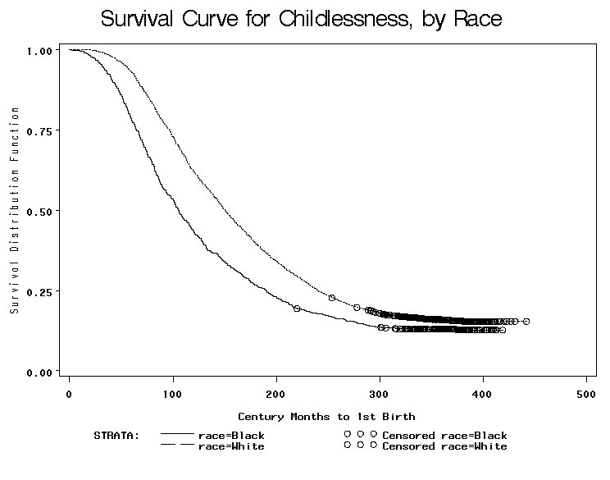
Blacks
Whites
FIGURE 2:

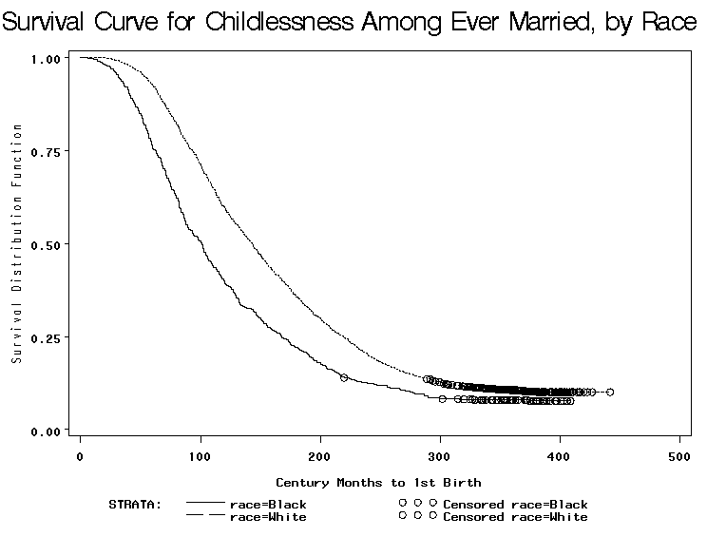
Blacks
Whites
FIGURE 3:

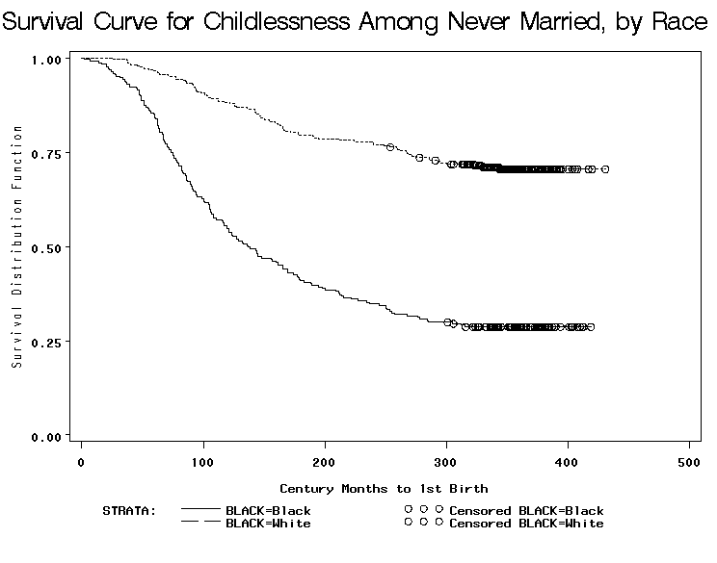
Blacks
Whites
FIGURE 4:

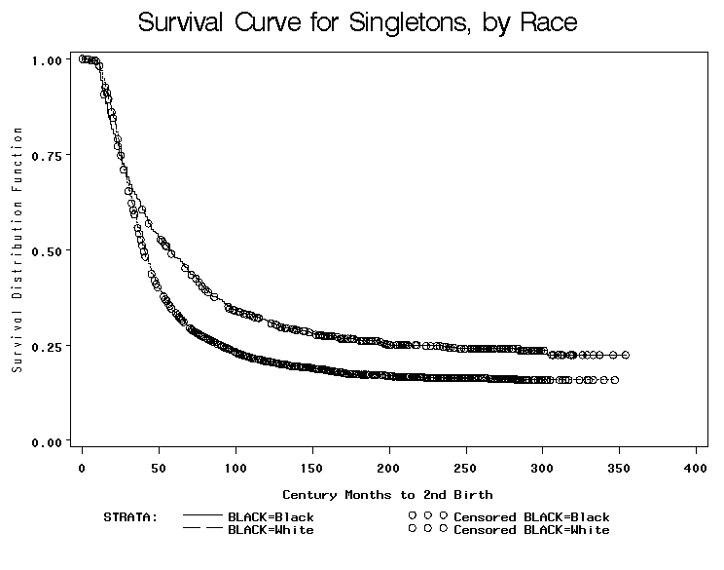
FIGURE 5:

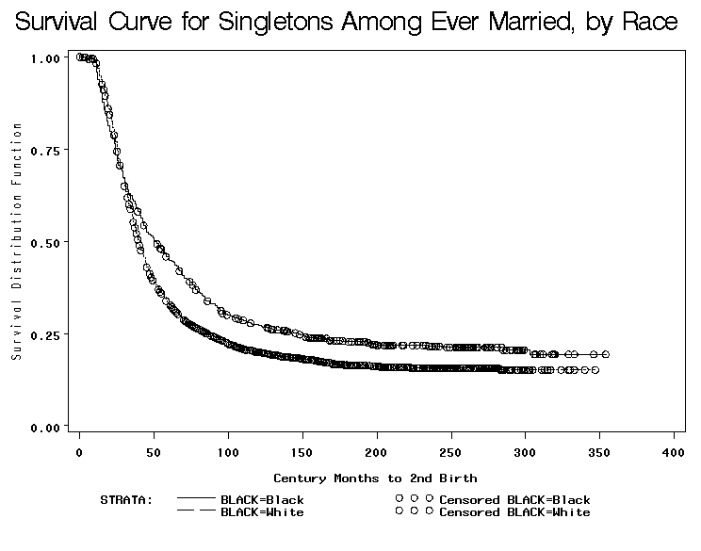
Blacks
Whites
FIGURE 6:

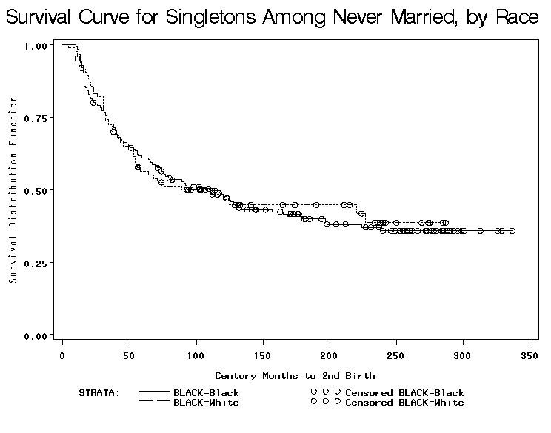
Blacks
Whites
Figure 7

Table 1. Characteristics of Women Aged 40-44 Years, by Fertility Status and Race
 |  | White |  |  | Black
 | Childless | Singleton | Multiple | Childless | Singleton | Multiple
 | N=521 | N=539 | N=2180 | N=133 | N=238 | N=656
 | Mean | Mean | Mean | Mean | Mean | Mean
 | (Std Dev) | (Std Dev) | (Std Dev) | (Std Dev) | (Std Dev) | (Std Dev)
Family Structure
Ever Married | 0.608 | 0.929 | 0.979 | 0.466 | 0.702 | 0.840
 | (0.489) | (0.256) | (0.144) | (0.501) | (0.458) | (0.367)
Ever Cohabited | 0.491 | 0.492 | 0.394 | 0.406 | 0.534 | 0.517
 | (0.500) | (0.500) | (0.489) | (0.493) | (0.500) | (0.500)
Reproductive History
Duration (months) from Menses to Child #1 or Censor | 357.131 | 186.823 | 131.950 | 361.374 | 151.848 | 94.361
 | (25.888) | (80.942) | (62.148) | (29.494) | (76.915) | (54.489)
Duration (months) from Child #1 to Child #2 or Censor |  | 170.269 | 43.019 |  | 206.349 | 50.683
 |  | (82.576) | (31.988) |  | (78.131) | (43.588)
Age at Menarche | 12.552 | 12.688 | 12.636 | 12.426 | 12.519 | 12.668
 | (1.563) | (1.648) | (1.588) | (2.111) | (1.647) | (1.805)
Age at First Birth or Adoption |  | 28.256 | 23.632 |  | 25.173 | 20.528
 |  | (6.692) | (5.025) |  | (6.424) | (4.265)
Ever Adopted |  | 0.032 | 0.027 |  | 0.017 | 0.014
 |  | (0.175) | (0.161) |  | (0.129) | (0.116)
Ever Had Abortion | 0.209 | 0.184 | 0.158 | 0.150 | 0.252 | 0.209
 | (0.407) | (0.388) | (0.365) | (0.359) | (0.435) | (0.407)
Ever Had Miscarriage | 0.140 | 0.282 | 0.318 | 0.241 | 0.277 | 0.311
 | (0.347) | (0.450) | (0.466) | (0.429) | (0.449) | (0.463)
Infecundity Issues | 0.274 | 0.347 | 0.228 | 0.293 | 0.277 | 0.206
 | (0.447) | (0.476) | (0.420) | (0.457) | (0.449) | (0.405)
Ever Sterilized | 0.211 | 0.365 | 0.537 | 0.338 | 0.450 | 0.713
 | (0.409) | (0.482) | (0.499) | (0.475) | (0.498) | (0.453)
Human Capital
High School Dropout | 0.052 | 0.098 | 0.172 | 0.135 | 0.130 | 0.282
 | (0.222) | (0.298) | (0.378) | (0.343) | (0.337) | (0.450)
High School Graduate | 0.271 | 0.349 | 0.333 | 0.338 | 0.349 | 0.375
 | (0.445) | (0.477) | (0.472) | (0.475) | (0.478) | (0.484)
Some College | 0.234 | 0.249 | 0.223 | 0.278 | 0.252 | 0.209
 | (0.424) | (0.433) | (0.417) | (0.450) | (0.435) | (0.407)
College Graduate | 0.443 | 0.304 | 0.271 | 0.248 | 0.269 | 0.134
 | (0.497) | (0.461) | (0.444) | (0.434) | (0.444) | (0.341)
Part-time Employment | 0.111 | 0.200 | 0.219 | 0.128 | 0.076 | 0.125
 | (0.315) | (0.401) | (0.414) | (0.335) | (0.265) | (0.331)
Full-time Employment | 0.737 | 0.584 | 0.517 | 0.714 | 0.739 | 0.596
 | (0.441) | (0.493) | (0.500) | (0.453) | (0.440) | (0.491)
Socioeconomic Characteristics
Mother Attended College | 0.317 | 0.230 | 0.210 | 0.180 | 0.168 | 0.130
 | (0.466) | (0.421) | (0.407) | (0.386) | (0.375) | (0.336)
Mother Worked Full-time | 0.338 | 0.328 | 0.286 | 0.496 | 0.500 | 0.498
 | (0.473) | (0.470) | (0.452) | (0.502) | (0.501) | (0.500)
Frequency of Church Attendance | 1.769 | 1.739 | 1.774 | 1.915 | 1.939 | 1.911
 | (0.467) | (0.503) | (0.493) | (0.292) | (0.248) | (0.308)
Below 150% of Poverty | 0.096 | 0.102 | 0.171 | 0.188 | 0.239 | 0.396
 | (0.295) | (0.303) | (0.376) | (0.392) | (0.428) | (0.490)
Income > $75,000 (2002 dollars) | 0.226 | 0.276 | 0.284 | 0.075 | 0.147 | 0.104
 | (0.419) | (0.448) | (0.451) | (0.265) | (0.355) | (0.305)
Demographic Variables
Age at Interview (in years) | 41.804 | 41.952 | 41.934 | 42.090 | 41.916 | 41.939
 | (1.399) | (1.420) | (1.421) | (1.417) | (1.465) | (1.389)
Latina | 0.077 | 0.121 | 0.147 | 0.023 | 0.042 | 0.027
 | (0.266) | (0.326) | (0.354) | (0.149) | (0.201) | (0.163)
Foreign Born | 0.083 | 0.119 | 0.144 | 0.045 | 0.080 | 0.075
 | (0.275) | (0.324) | (0.351) | (0.208) | (0.272) | (0.263)
Note: Data from Waves 4, 5, and 6 of the National Survey of Family Growth
Statistically significant differences by race across the parity grouping indicated in bold
Table 2. Effects of Selected Characteristics on the Likelihood of Becoming a Mother (vs. remaining childless)
 | Coefficient |  | Risk Ratio | Risk Ratio
 | (St. Err.) |  | Mother | Childless
Family Structure
Married | 0.407 | *** | 1.503 | 0.665
 | (0.043)
Cohabiting | 0.124
 | (0.098)
Reproductive History
Duration (from age at menarche) | 0.106 | *** | 1.112 | 0.900
 | (0.010)
Previous Abortion | -0.359 | *** | 0.699 | 1.431
 | (0.043)
Previous Miscarriage | -0.284 | *** | 0.752 | 1.329
 | (0.036)
Infecundity Issues | -0.130 | *** | 0.878 | 1.139
 | (0.040)
Sterilized | -2.549 | *** | 0.078 | 12.799
 | (0.215)
Human Capital
High School Graduate | -0.538 | *** | 0.584 | 1.712
 | (0.052)
Some College | -0.683 | *** | 0.505 | 1.980
 | (0.058)
College Graduate | -1.126 | *** | 0.324 | 3.083
 | (0.061)
Part-time Employment | -0.012
 | (0.051)
Full-time Employment | -0.072 | * | 0.931 | 1.074
 | (0.042)
Socioeconomic Characteristics
Mother College Graduate | -0.075 | * | 0.928 | 1.078
 | (0.045)
Mother Full-time Worker | 0.055
 | (0.036)
Below 150% poverty | 0.152 | *** | 1.164 | 0.859
 | (0.047)
Church Attendance | -0.043
 | (0.037)
Demographic Characteristics
Black | 0.344 | *** | 1.411 | 0.709
 | (0.042)
Latina | 0.079
 | (0.062)
Immigrant | -0.146 | ** | 0.864 | 1.157
 | (0.058)
NSFG Cycle | -0.162 | *** | 0.850 | 1.176
 | (0.023)
Notes: *** indicates p<.001, ** indicates p<.01, and * indicates p<.05, two-tailed tests.

Table 3. Effects of Selected Characteristics on the Likelihood of a Second Child (vs. remaining singleton)
 | Coefficient |  | Risk Ratio | Risk Ratio
 | (St. Err.) |  | 2nd Child | Singleton
Family Structure
Married | 0.384 | *** | 1.469 | 0.681
 | (0.059)
Cohabiting | 0.110
 | (0.110)
Reproductive History
Duration (from age at 1st birth) | -0.033 | *** | 0.968 | 1.034
 | (0.005)
Black*Duration (from age at 1st child) | -0.045 | *** | 0.956 | 1.046
 | (0.010)
Previous Abortion | -0.250 | *** | 0.778 | 1.285
 | (0.044)
Previous Miscarriage | -0.188 | *** | 0.828 | 1.207
 | (0.030)
Infecundity Issues | -0.099 | ** | 0.906 | 1.104
 | (0.046)
Sterilized | -1.021 | *** | 0.360 | 2.775
 | (0.069)
Human Capital
High School Graduate | -0.128 | ** | 0.880 | 1.136
 | (0.057)
Some College | -0.067
 | (0.064)
College Graduate | 0.017
 | (0.070)
Part-time Employment | 0.083
 | (0.057)
Full-time Employment | -0.160 | *** | 0.852 | 1.174
 | (0.046)
Socioeconomic Characteristics
Mother College Graduate | 0.083
 | (0.051)
Mother Full-time Worker | -0.050
 | (0.041)
Below 150% poverty | 0.240 | *** | 1.271 | 0.787
 | (0.051)
Church Attendance | 0.047
 | (0.041)
Demographic Characteristics
Black | 0.746 | *** | 2.109 | 0.474
 | (0.217)
Latina | -0.068
 | (0.069)
Immigrant | 0.111 | * | 1.117 | 0.895
 | (0.065)
NSFG Cycle | -0.130 | *** | 0.878 | 1.139
 | (0.027)
Notes: *** indicates p<.001, ** indicates p<.01, and * indicates p<.05, two-tailed tests.
Table 4. Effect of Marriage and Cohabitation on the Percent Change in the Likelihood of Remaining Childless (vs. becoming a mother) and in the Likelihood of Remaining a Singleton Mother (vs. having a 2nd Child), by Race
 | White | Black | Race Difference Significant?

Likelihood of Remaining Childless
Marriage | -52% | NS | Yes
Cohabiting | NS | NS | No

Likelihood of Remaining a Singleton Mother
Marriage | -39% | -23% | Yes
Cohabiting | NS | -27% | Yes
Notes: 1) Only significant coefficients shown.
2) Coefficients are from fully specified models controlling for all family structure, human capital,
socioeconomic background, and demographic characteristics included in table 2.
3) * Significant differences by race were determined from a pooled model testing race interactions.
Table 5. Percent Change in the Likelihood of Remaining Childless (vs. becoming a mother), by Race & Marriage
 | White |  | Black |  | Race Difference
 | Single | Married | Single | Married | Significant?*
Reproductive History
Duration (from age at menarche) | -11% | -11% | -12% | -12% | No
Previous Abortion | 55% | 55% | 19% | 19% | Yes
Previous Miscarriage | 22% | 22% | 71% | 71% | Yes
Infecundity Issues | NS | 31% | NS | NS | No
Sterilized | 1312% | 1312% | 894% | 894% | No
Human Capital
High School Graduate | 242% | 86% | 67% | 67% | Yes
Some College | 272% | 109% | 126% | 30% | No
College Degree | 1319% | 227% | 233% | 62% | Yes
Part-time Employment | NS | NS | 42% | 42% | Yes
Full-time Employment | NS | NS | NS | NS | No
Socioeconomic Characteristics
Mother College Graduate | 11% | 11% | NS | NS | No
Mother Full-time Worker | NS | NS | NS | NS | No
Below 150% Poverty | NS | NS | -23% | -23% | Yes
Church Attendance | NS | NS | NS | NS | No
Demographic Characteristics
Latina | -12% | -12% | NS | NS | No
Immigrant | 22% | 22% | NS | NS | No
NSFG Cycle | -22% | 64% | NS | 26% | Yes
Notes: Only significant coefficients shown. * Significant differences by race were determined from a pooled model testing race interactions.
Table 6. Percent Change in the Likelihood of Remaining a Singleton Mother (vs. 2nd Child), by Race and Marriage
 | White |  | Black |  | Race Difference
 | Single | Married | Single | Married | Significant?*
Reproductive History
Duration (from age at 1st child) | 4% | 4% | 7% | 7% | Yes
Previous Abortion | 22% | 22% | 38% | 38% | No
Previous Miscarriage | 17% | 17% | 41% | 41% | No
Infecundity Issues | 10% | 10% | NS | NS | No
Sterilized | 161% | 161% | 205% | 205% | No
Human Capital
High School Graduate | 75% | 6% | NS | NS | No
Some College | 126% | -6% | NS | NS | No
College Degree | 126% | -13% | 84% | -8% | Yes
Part-time Employment | NS | NS | NS | NS | No
Full-time Employment | 16% | 16% | NS | NS | No
Socioeconomic Characteristics
Mother College Graduate | -10% | -10% | NS | NS | No
Mother Full-time Worker | NS | NS | NS | NS | No
Below 150% Poverty | -19% | -19% | -26% | -26% | No
Church Attendance | NS | NS | NS | NS | No
Demographic Characteristics
Latina | NS | NS | NS | NS | No
Immigrant | NS | NS | -33% | -33% | No
NSFG Cycle | 15% | 15% | 11% | 11% | No
Notes: Only significant coefficients shown. * Significant differences by race were determined from a pooled model testing race interactions.
APPENDIX
Table A-1. Event History Coefficients, Standard Errors, and Risk Ratios for Selected Characteristics on the Risk of Becoming a Mother (vs. Remaining Childless), marriage interactions
 | WHITE |  |  |  | BLACK
 | Coefficient |  | Risk Ratio | Risk Ratio | Coefficient |  | Risk Ratio | Risk Ratio
 | Std. Err. |  | Mother | Childless | Std. Err. |  | Mother | Childless
Family Structure
Married | 3.075 | *** | 21.653 | 0.046 | 0.998 | ** | 2.712 | 0.369
 | (0.427) |  |  |  | (0.447)
Cohabiting | 0.065 |  |  |  | 0.116
 | (0.140) |  |  |  | (0.140)
Reproductive History
Duration (from age at menarche) | 0.116 | *** | 1.123 | 0.890 | 0.124 | *** | 1.131 | 0.884
 | (0.012) |  |  |  | (0.019)
Previous Abortion | -0.440 | *** | 0.644 | 1.553 | -0.176 | ** | 0.838 | 1.193
 | (0.050) |  |  |  | (0.086)
Previous Miscarriage | -0.202 | *** | 0.817 | 1.224 | -0.538 | *** | 0.584 | 1.713
 | (0.039) |  |  |  | (0.088)
Infecundity Issues | 0.229 |  |  |  | 0.050
 | (0.138) |  |  |  | (0.082)
Married*Infecundity Issues | -0.502 | *** | 0.605 | 1.653 | NS
 | (0.146)
Sterilized | -2.647 | *** | 0.071 | 14.118 | -2.297 | *** | 0.101 | 9.942
 | (0.290) |  |  |  | (0.321)
Human Capital
High School Graduate | -1.230 | *** | 0.292 | 3.421 | -0.515 | *** | 0.598 | 1.674
 | (0.137) |  |  |  | (0.114)
Married*High School Graduate | 0.609 | *** | 1.839 | 0.544 | 0.288
 | (0.150) |  |  |  | (0.196)
Some College | -1.313 | *** | 0.269 | 3.717 | -0.815 | *** | 0.443 | 2.258
 | (0.147) |  |  |  | (0.137)
Married*Some College | 0.578 | *** | 1.782 | 0.561 | 0.555 | *** | 1.741 | 0.574
 | (0.160) |  |  |  | (0.215)
College Degree | -2.702 | *** | 0.067 | 14.910 | -1.203 | *** | 0.300 | 3.331
 | (0.204) |  |  |  | (0.170)
Married*College Degree | 1.518 | *** | 4.561 | 0.219 | 0.721 | *** | 2.056 | 0.486
 | (0.210) |  |  |  | (0.233)
Part-time Employment | 0.087 |  |  |  | -0.349 | *** | 0.705 | 1.418
 | (0.057) |  |  |  | (0.124)
Full-time Employment | -0.042 |  |  |  | -0.009
 | (0.048) |  |  |  | (0.086)
Socioeconomic Characteristics
Mother College Graduate | -0.100 | ** | 0.905 | 1.105 | 0.026
 | (0.050) |  |  |  | (0.103)
Mother Full-time Worker | 0.048 |  |  |  | 0.074
 | (0.043) |  |  |  | (0.068)
Below 150% Poverty | 0.014 |  |  |  | 0.262 | *** | 1.299 | 0.770
 | (0.060) |  |  |  | (0.083)
Church Attendance | -0.060 |  |  |  | -0.036
 | (0.040) |  |  |  | (0.115)
Demographic Characteristics
Latina | 0.126 | * | 1.134 | 0.882 | -0.105
 | (0.068) |  |  |  | (0.199)
Immigrant | -0.199 | *** | 0.820 | 1.220 | -0.143
 | (0.066) |  |  |  | (0.133)
NSFG Cycle | 0.243 | *** | 1.276 | 0.784 | 0.063
 | (0.074) |  |  |  | (0.056)
Married*NSFG Cycle | -0.537 | *** | 0.584 | 1.711 | -0.296 | *** | 0.744 | 1.344
 | (0.079) |  |  |  | (0.088)
Notes: *** indicates p<.001, ** indicates p<.01, and * indicates p<.05, two-tailed tests.
Table A-2. Event History Coefficients, Standard Errors, and Risk Ratios for Selected Characteristics on the Risk of Having a Second Child (vs. Remaining Singleton)
 | WHITE |  |  |  | BLACK
 | Coefficient |  | Risk Ratio | Risk Ratio | Coefficient |  | Risk Ratio | Risk Ratio
 | Std. Err. |  | 2nd Child | Singleton | Std. Err. |  | 2nd Child | Singleton
Family Structure
Married | 0.024 |  | 1.024 | 0.976 | 0.221 | ** | 1.248 | 0.802
 | (0.132) |  |  |  | (0.093)
Cohabiting | -0.204 |  |  |  | 0.382 | *** | 1.466 | 0.682
 | (0.177) |  |  |  | (0.146)
Reproductive History
Duration (from age at 1st child) | -0.037 | *** | 0.964 | 1.038 | -0.071 | *** | 0.932 | 1.073
 | (0.005) |  |  |  | (0.010)
Previous Abortion | -0.196 | *** | 0.822 | 1.216 | -0.322 | *** | 0.724 | 1.380
 | (0.053) |  |  |  | (0.084)
Previous Miscarriage | -0.161 | *** | 0.851 | 1.175 | -0.340 | *** | 0.712 | 1.405
 | (0.032) |  |  |  | (0.080)
Infecundity Issues | -0.096 | * | 0.908 | 1.101 | -0.123
 | (0.052) |  |  |  | (0.098)
Sterilized | -0.958 | *** | 0.384 | 2.606 | -1.114 | *** | 0.328 | 3.047
 | (0.079) |  |  |  | (0.139)
Human Capital
High School Graduate | -0.557 | *** | 0.573 | 1.745 | -0.076
 | (0.187) |  |  |  | (0.104)
Married*High School Graduate | 0.494 | ** | 1.639 | 0.610 | NS
 | (0.198)
Some College | -0.814 | *** | 0.443 | 2.257 | -0.063
 | (0.211) |  |  |  | (0.125)
Married*Some College | 0.871 | *** | 2.390 | 0.418 | NS
 | (0.221)
College Degree | -0.817 | *** | 0.442 | 2.263 | -0.609 | ** | 0.544 | 1.838
 | (0.297) |  |  |  | (0.247)
Married*College Degree | 0.960 | *** | 2.611 | 0.383 | 0.693 | *** | 1.999 | 0.500
 | (0.302) |  |  |  | (0.268)
Part-time Employment | 0.085 |  |  |  | 0.157
 | (0.063) |  |  |  | (0.137)
Full-time Employment | -0.146 | *** | 0.864 | 1.158 | -0.146
 | (0.053) |  |  |  | (0.098)
Socioeconomic Characteristics
Mother College Graduate | 0.101 | * | 1.106 | 0.904 | 0.026
 | (0.056) |  |  |  | (0.123)
Mother Full-time Worker | -0.042 |  |  |  | -0.062
 | (0.048) |  |  |  | (0.080)
Below 150% Poverty | 0.209 | *** | 1.233 | 0.811 | 0.300 | *** | 1.350 | 0.741
 | (0.063) |  |  |  | (0.095)
Church Attendance | 0.046 |  |  |  | 0.021
 | (0.044) |  |  |  | (0.125)
Demographic Characteristics
Latina | -0.016 |  |  |  | -0.100
 | (0.073) |  |  |  | (0.254)
Immigrant | 0.037 |  |  |  | 0.393 | ** | 1.482 | 0.675
 | (0.072) |  |  |  | (0.160)
NSFG Cycle | -0.141 | *** | 0.869 | 1.151 | -0.100 | * | 0.905 | 1.106
 | (0.031) |  |  |  | (0.053)
Notes: *** indicates p<.001, ** indicates p<.01, and * indicates p<.05, two-tailed tests.

Authors’ names are listed alphabetically. Please direct correspondence to Michelle J. Budig and Jennifer Lundquist, Social and Demographic Research Institute, W34A Machmer Hall, 240 Hicks Way, University of Massachusetts, Amherst, MA 01003-9278. Email: budig@soc.umass.edu or lundquist@soc.umass.edu.
These rates compare to peak birth rates of 99.2 for white women aged 25 to 29 and 128.9 for black women aged 20 to 25 (Downs 2003).
Of course, a nontrivial number of women become mothers through adoption, perhaps in response to the rise of age-related infertility issues. A strength of our approach is that we include adoptive mothers in the analyses and do not count them as childless.
Although birth rates to women at older ages have risen in recent decades due to fertility delay and infertility treatments, the rates are still very low. Of all first births in 2003, for example, only 1% were to women ages 40-44 (Martin et al 2005). Higher parity births are slightly more common at these ages, but still relatively rare, at just under 2% (Martin et al 2005). We acknowledge therefore that our childlessness sample and only child sample may be slightly overestimated (more so in the latter case than the former case), but believe the effect to be negligible. There is an NSFG variable that collects intentions on future fertility plans, which we plan to incorporate into the next version of this paper. A drawback is that it is asked of all respondents for waves 4 and 6 but only of currently married respondents in wave 5.
Our dependent variable is defined in the first set of models as the date of first biological birth or formal adoption and in the second set of models as the date of second biological birth or formal adoption. We expand our definition from biological parenthood to social parenthood for the following reasons: for all intents and purposes a childless woman who adopts is no longer childless, and furthermore the presence of an adopted child may be just as likely as a biological child to influence individuals’ decisions to move from one parity to the next. Stepchildren or other nonbiological children who were not formally adopted are excluded because NSFG wave 4 collected information only on legal adoptions. Furthermore, without information regarding custodial arrangements it would be unclear whether stepchildren and others regularly resided with the respondent.
In this version of the paper, marital dissolution is taken into account only in so far as it relates to the time changing married =1 or =0 variable. Thus, it is conflated with never married status, and more rarely, widowhood. We acknowledge that marriage interrupted by divorce is a probable staller of fertility and should be entered into the analysis in its own right. The next version of this paper will incorporate a time changing variable for ever-divorced.
By reverse causality we mean it is just as likely that 1) the number of children a respondent has had influences her current employment situation, as it is likely that 2) her current employment situation indicates her past employment which, in turn, influenced fertility outcomes.
Current poverty may partially result from the number of children a woman has had, or current poverty may reflect historic poverty, which, in turn, influenced the number of children borne to a respondent.
We emphasize that this is an incomplete control in two ways—one, not all sterilization procedures are elected expressly to end fertility, and two, many, probably most, voluntarily childless individuals have neither abortions nor sterilization procedures in their lifetimes. Voluntary childlessness is a problematic definition to pin down because it is rarely a permanent “state” but rather a fluidly changing orientation that is highly dependent on context. It is difficult to discern between women who are “voluntarily childless” versus women who “choose” childlessness because they have delayed too long. Nor can we account for people who are naturally (nonmedically) sterile or subfecund but who never have cause to know this about themselves
While one might expect that sterilization would perfectly predict a non-event in the analyses that follow, there are some cases where sterilized individuals adopt.
Statistical differences in the bivariate data are subject to error because they are unweighted. We do not weight the data because we have combined three different waves, each with separate weighting parameters.
Significant covariance in all of the following survival functions is confirmed by both Wilcoxon and Log-Rank statistics tests.

