### Injury is a Leading Cause of Death in Children

Injuries are the leading cause of death for children (ages 1-5) in New York State. They are also a leading cause of death for babies less than one year old. Every year, more of New York’s children (ages 1-5) die from injuries than die from congenital anomalies and malignant neoplasms combined. In addition to deaths, nonfatal injuries among children can result in trips to the emergency department, hospital stays, and long term disability.

In 2010, 151 of New York’s children (ages 0-5) died from injuries. There were also 151,128 children who were treated at a hospital for injuries – 4,029 of them were injured severely enough to require inpatient treatment.

An injury affects more than just the child who was injured and may impact family members who are often called upon to care for the injured child. This can result in stress, time away from work, and lost income. The economic impact of injuries includes the costs associated with medical treatment and lost productivity, such as wages and accompanying fringe benefits, or the ability to perform one’s normal household responsibilities.

**Hospitalizations**

**Figure 1: Injuries among Children Ages 0-5 Years, New York State, 2010**

### Childhood Injury by Sex

Boys suffered more fatal and non-fatal injuries than girls. The rate of death (per 100,000 New Yorkers) was 19% higher for boys, at 12.3 compared with 10.3. This difference was even more dramatic with hospitalization and ED visits. The rate of hospitalization (per 100,000 New Yorkers) was 23% higher for boys, at 319.8 compared with 260.6. The rate of ED visits (per 100,000 New Yorkers) was 26% higher for boys, at 11,803.6 compared with girls at 9,379.6.

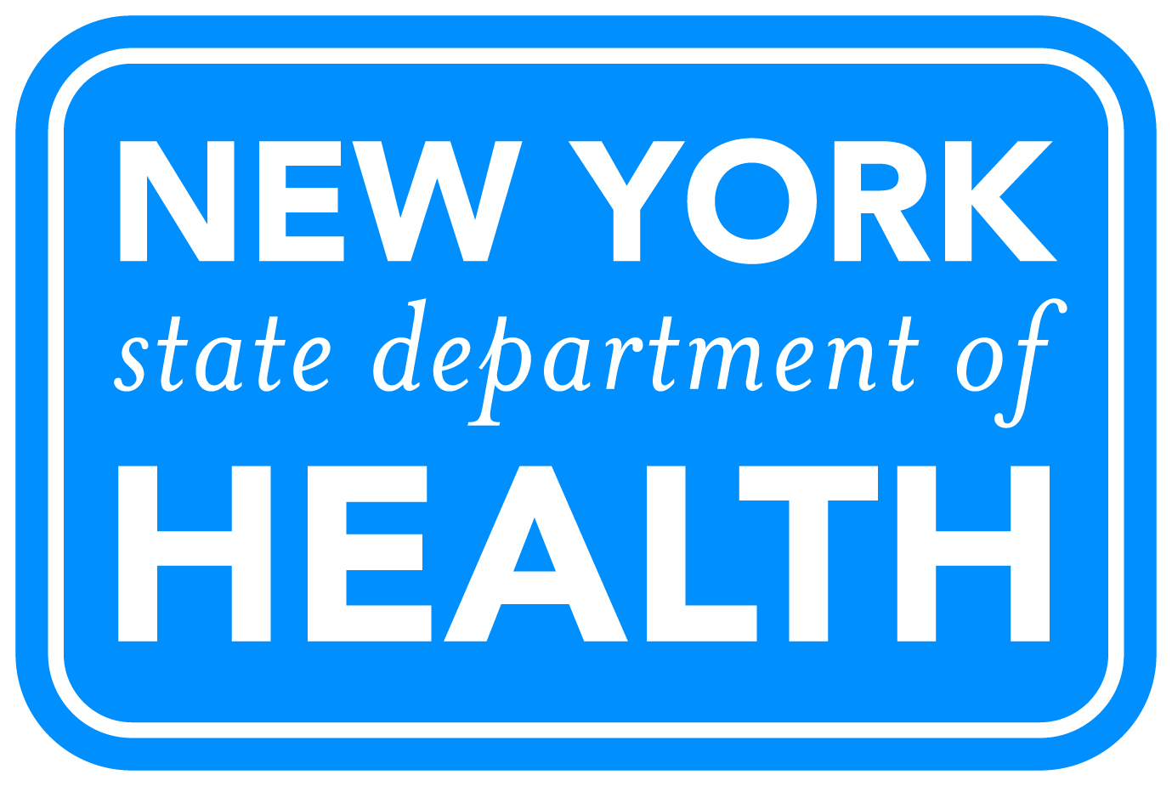

**Figure 2: Percent of Injury Deaths, Hospitalizations and Emergency Department Visits among Children Ages 0-5 Years, by Sex, New York State, 2010**

This document was produced in conjunction with CDC's Core Violence and Injury Prevention Program under Cooperative Agreement 11-1101.

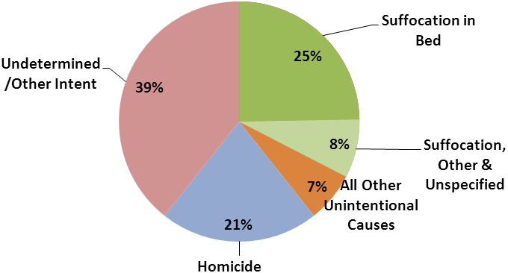

### Injury Deaths in Infants

* The rate of deaths (per 100,000 New Yorkers) due to injuries in infants (children under one year old) was 38.4.
* The leading causes of injury-related deaths, with determinable intent, in infants were suffocation in bed (25%) followed by homicide (21%).

**Figure 3: Injury Deaths among Infants Less than 1 Year, New York State, 2010**

### Injury Deaths in Young Children

* The rate of deaths (per 100,000 New Yorkers) due to injuries in young children (ages 1-5) was 5.4.
* The leading cause of death in young children was homicide (35%), followed by transportation related deaths (19%).
* Data based on frequencies of less than six are not reported (fire/burn and undetermined/other intent).

**Figure 4: Injury Deaths in Children Ages 1 – 5 Years, New York State, 2010**

**Injury-Related Hospitalizations**

**Figure 5: Injury-Related Hospital Discharges among Children Ages 0 – 5 Years, New York State, 2010**

* There were 878 hospitalizations of infants (under 1 years) and 3,151 hospitalizations of young children (ages 1-5 years) in New York State in 2010.
* The rate of injury related hospitalization (per 100,000 New Yorkers) was 39% higher for infants at 378.5 compared with 10.3 for children one-five years old.
* Injury related hospitalizations charges among children ages 0-5 totaled almost $74 million in 2010.
* The leading cause of injury-related hospitalizations among children ages 0-5 was falls (38%).
  + Falls from furniture were the most common type of fall leading to a hospital stay (32%).

### Injury-Related Emergency Department Visits

* There were 1,520 ED visits for infants (less than one) and 132,079 ED visits of young children (ages 1-5 years) in New York State in 2010.
* The rate of injury related ED visits (per 100,000 New Yorkers) was 77% higher for young children (ages 1-5) at 11,452.5 compared with 6,475.6 for infants.
* Injury related ED charges among children ages 0-5 totaled almost $144 million in 2010.
* The leading cause of injury-related ED visits among children ages 0-5 was falls (42%).
  + Falls from furniture were the most common type of fall leading to hospitalization (23%).

**Figure 6: Injury-Related Emergency Department Visits among Children Ages 0 – 5 Years, New York State, 2010**

**Table 1: Injury-Related Hospital Discharges and Emergency Department (ED) Visits among Children Ages 0 -5 Years, by Age Group, New York State, 2010**

|  |  |  |  |  |  |
| --- | --- | --- | --- | --- | --- |
|  | **Infants less than 1 Year** | |  | **Children Ages 1-5 Years** | |
|  | Hospital Discharges | ED Visits |  | Hospital Discharges | ED Visits |
| **Unintentional Injuries** | **766** | **14,752** |  | **3,031** | **131,024** |
| Cut/pierce | * | 364 |  | 43 | 5,755 |
| Drowning/submersion | 6 | * |  | 31 | 63 |
| Falls *(off/from):* | 391 | 7,824 |  | 1,150 | 54,683 |
| Furniture | 186 | 3,851 |  | 304 | 10,261 |
| Steps/stairs | 50 | 536 |  | 136 | 4,553 |
| With strike against object | 12 | 518 |  | 48 | 8,801 |
| Slipping/tripping/stumbling | 22 | 500 |  | 163 | 10,786 |
| Playground equipment | * | 29 |  | 167 | 2,437 |
| Building | * | * |  | 35 | 76 |
| Other fall from one level to another | 87 | 1,094 |  | 125 | 2,998 |
| Other/unspecified | 31 | 1,294 |  | 172 | 14,771 |
| Fire/Burn | 119 | 533 |  | 488 | 2,936 |
| Foreign Body | 51 | 680 |  | 266 | 6,968 |
| Natural and Environmental | 17 | 692 |  | 103 | 10,839 |
| Excessive heat | 0 | 9 |  | 0 | 37 |
| Dog bites | 6 | 73 |  | 58 | 1,892 |
| Other bites/stings/animal injury | * | 577 |  | 39 | 8,818 |
| All other natural/environmental | 9 | 33 |  | 6 | 92 |
| Poisoning | 39 | 408 |  | 406 | 3,636 |
| Struck-by/against object | 24 | 1,393 |  | 138 | 20,426 |
| Suffocation | 43 | 198 |  | 55 | 816 |
| Transport-related | 10 | 658 |  | 222 | 5,188 |
| Motor vehicle (MV)-occupant | 7 | 561 |  | 56 | 2,784 |
| Bicycle/tricycle (MV & non-MV) | 0 | * |  | 29 | 1,152 |
| Pedestrian (MV & non-MV) | * | 21 |  | 117 | 482 |
| Other transport | * | 74 |  | 20 | 770 |
| All other unintentional causes | 64 | 1,997 |  | 129 | 19,096 |
| **Assault/Abuse** | **86** | **104** |  | **61** | **617** |
| **Undetermined/Other Intent** | **25** | **163** |  | **49** | **1,055** |
| **Total Injury-Related Cases** | **878** | **15,020** |  | **3,151** | **132,079** |

*Data based on frequencies of less than six are not reported.

**New York Child Injury Prevention Activities**

Injuries are the leading cause of death for New Yorkers aged one through five years and a leading cause of death for babies less than one year old. Through surveillance and programs such as traffic safety, fall prevention, and traumatic brain injury prevention, the Bureau of Occupational Health and Injury Prevention works to reduce the burden of injuries among New York State’s children.

Notes: NYS Statewide Planning and Research Cooperative System (SPARCS), NYS Vital Statistics

There are cases who have injury diagnoses, but missing ECODES. These children are included in the total injury count, but not the subcategories. Their distribution is as follows: one case under a year and 10 cases for ages one – five for hospitalizations, and one case in each age group for ED visits.

All injuries are considered unintentional unless specified otherwise. Reference to any commercial entity or product or service on this page should not be construed as an endorsement by the Government of the company or its products or services.

**NEW YORK STATE DEPARTMENT OF HEALTH**

**http://www.health.ny.gov/prevention/injury_prevention/**

Released February 2013

**New York Maternal, Infant and Early Childhood Home Visiting Initiative**

**New York State (NYS) is working to improve the health and well-being of at-risk children and families through its new Maternal, Infant and Early Childhood Home Visiting (MIECHV) Initiative. The MIECHV initiative uses evidence-based home visiting programs (programs proven to be effective) to help improve outcomes for mothers and babies. The goals of the initiative are to:**

* **Improve birth outcomes for high-risk pregnant women and their babies.**
* **Improve children's health and development.**
* **Strengthen family functioning.**