Injury is a Leading Cause of Death in Children

Figure 1: Annual Injuries among Children Ages 0-5 Years, <State>, <Data Year(s)>

STATE-specific text such as:
- magnitude – overall
- counts and perhaps broken out by age groups (<1, 1-5).

Example:
For every child that died, xx children were hospitalized and xxxx were treated and released from an emergency department. Not included were children who received treatment in physician offices or at home.

Figure 2: Percent of Injury Deaths, Hospitalizations and Emergency Department Visits among Children Ages 0-5 Years, by Sex, <State>, <Data Year(s)>

Childhood Injury by Sex
STATE-specific text
- Sex differences for each data source.
- May include counts, percents, even rates if states want to calculate.
- Could also be broken down by <1 year olds and 1-5 year olds: counts, percents, rates.

Home Visitation LOGO
State Health Department LOGO

This document was produced in conjunction with CDC's Core Violence and Injury Prevention Program under Cooperative Agreement 11-1101.

Injury Deaths in Infants

STATE-specific details and/or footnote

Figure 3: Injury Deaths among Infants Less than 1 Year, <State>, <Data Year(s)>

Injury Deaths in Young Children

STATE-specific details and/or footnote

Figure 4: Injury Deaths in Children Ages 1 – 5 Years, <State>,
<Data Year(s)>

Injury-Related Hospitalizations

Figure 5: Injury-Related Hospital Discharges among Children Ages 0 – 5 Years, <State>, <Data Year(s)>

STATE-specific details and/or footnote
Footnote – Nonfatal

Figure 6: Injury-Related Emergency Department Visits among Children Ages 0 – 5 Years, <State>,
<Data Year(s)>

STATE-specific details and/or footnote
- Leading Causes, leading caused by age group and/or gender
Footnote – Nonfatal

Injury-Related Emergency Department Visits

Table 1: Injury-Related Hospital Discharges and Emergency Department (ED) Visits among Children Ages 0 -5 Years, by Age Group, <State>, <Data Year(s)>

 | Infants less than 1 Year |  |  | Children Ages 1-5 Years
 | Hospital Discharges | ED Visits |  | Hospital Discharges | ED Visits
Unintentional Injuries
Cut/pierce
Drowning/submersion
Falls (off/from):
Furniture
Steps/stairs
With strike against object
Slipping/tripping/stumbling
Playground equipment
Building
Other fall from one level to another
Other/unspecified
Fire/Burn
Foreign Body
Natural and Environmental
Excessive heat
Dog bites
Other bites/stings/animal injury
All other natural/environmental
Poisoning
Struck-by/against object
Suffocation
Transport-related
Motor vehicle (MV)-occupant
Bicycle/tricycle (MV & non-MV)
Pedestrian (MV & non-MV)
Other transport
All other unintentional causes
Assault/Abuse
Undetermined/Other Intent
Unknown
Total Injury-Related Cases

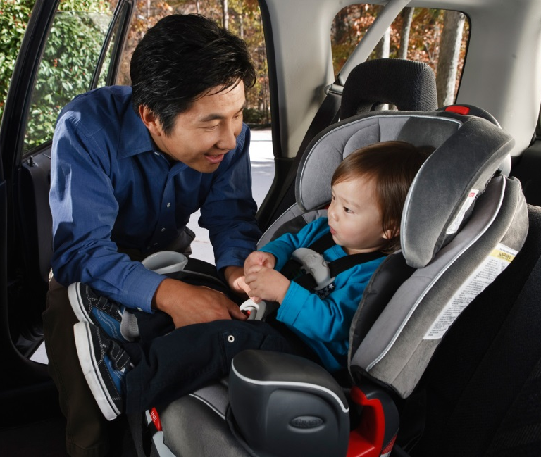
<STATE> Child Injury Prevention Activities
- Prevention
- Surveillance
- Partnerships
- Accomplishments/Successes

<State> Home Visiting Program (name)
Collaborate with State maternal, infant, and early childhood home visiting
program staff to draft:
- Description of home visiting program
- Benchmarks
- Outreach programs
- Selected communities, etc.

<State> Essentials for Childhood Activities
- Description of Essentials for Childhood program if present in the state
- Description of non-traditional and diversified partnerships
- Description of specific child maltreatment collaborations and activities
Notes: Data sources
All injuries are considered unintentional unless specified otherwise. Reference to any commercial entity or product or service on this page should not be construed as an endorsement by the Government of the company or its products or services.

STATE DEPARTMENT OF HEALTH
State DPH Injury Prevention Program Website
Released <Month, year>

