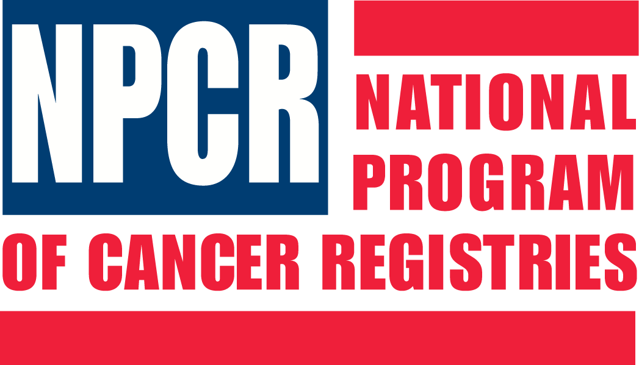

Centers for Disease Control and Prevention
National Program of Cancer Registries



Registry Plus

Central Registry Tools
Prep Plus & CRS Plus

Systems and IT Personnel Requirements
Contents
System Requirements for CRS Plus 3
System Requirements for Prep Plus 4
Installing CRS Plus and Prep Plus 4
IT Personnel Requirements and Recommended Availability to Support Registry Plus Central Registry Tools 5
Server Administration 5
General IT Support 6
Database Administration 6

System Requirements for CRS Plus
CRS Plus is a client-server application which has the registry database on a server computer and the client application running on individual workstations. As part of the installation package, CRS Plus comes with MS Access as the default database. In order to be fully functional, the registry database must be moved to an MS SQL Server prior to implementation of the production environment (please see Installing CRS Plus and Prep Plus below).
- Database Server
The table below lists specifications for the database server computer which is assumed to be installed within an existing, larger IT infrastructure with connectivity, security, and operational features established by local policy.
System Component | Database Server Computer
RAM | 2 GB, more memory will result in better performance
Hard Disk | RAID-5 for data, RAID-1 for log files
Size of data file | (3 * 7000 * estimated_number_of_cases) / 1048576 MB
Size of transaction log file | 25% of the data file size
System drive for caching | At least 20GB of free space
CPU | Dual processor with latest processor speed
OS | Windows Sever 2008 or higher (Server 2008 Enterprise will meet the NIST FIPS 140-2 standard)
Database server | SQL 2008 or higher
Note: The above specification is for a dedicated server only. If you have other services and applications running on this server, additional RAM and hard disk space may be required.

- Client PC
The table below lists specifications for the Client computer.
System Component | Client Computer
RAM | 2 GB or more
Hard Disk | 200 MB of free space
OS | Windows 7/Windows 10
Applications | MS Access 2010 or above, make sure scripts are permitted to execute

System Requirements for Prep Plus
Prep Plus can run in the file-server or client-server mode, and has a database to store tracking information. If running under the client-server mode, a database server is required to host the tracking database. Note that this database can be hosted on the same database server that has the CRS Plus database (no dedicated server required). If running in the file-server mode, the tracking database can be put on a shared network drive as a MS Access database.
- Database Server
The database server used for CRS Plus database can also be used for Prep Plus. There are some local temporary databases (MS Access databases) that can be located either on the client PCs or on a shared network drive. Some space is also required for storing text data files on the shared drive. The space required on the shared drive depends on the amount of data the central registry receives each year and how often the drives are archived.
- Client PC
The table below lists specifications for the Client computer.
System Component | Client Computer
RAM | 2 GB or more
Hard Disk | 200 MB of free space
OS | Windows 7/Windows 10
Applications | MS Access 2010 or above

Installing CRS Plus and Prep Plus
CRS Plus: Download the installation file from the FTP site. You should have received the FTP site and file information in an email from CDC. After downloading the installation file, double-click on it to start the installation wizard and then follow the screen prompts to complete the installation process. After installation, the CRS Plus program will be accessible through the Start->All Programs->Registry Plus->CRS Plus->CRS Plus menu.

To configure CRS Plus to work with SQL Server database:
- Prepare your database on MS SQL Server:
  - Create a database and database user account(s) on MS SQL Server; the user account should have both read and write access to the database.
  - Run CDC provided script to create database objects

- Modify the CRSPlus.ini file:

- Open CRSPlus.ini file in C:\Windows folder
Configure the connection string: There are two sample connection strings at the bottom of the CRSPlus.ini file to connect to the SQL Server database, one using the integrated security and the other using the SQL server authentication. Depending upon the practice of your organization:
  - Select the appropriate connection string type.
  - Modify the parameters to match your setting.
  - Remove the REM: from the connection string.
Prep Plus: After downloading the installation file, double-click on this file to start the installation wizard and then follow the screen prompts to complete the install. After installation, Prep Plus program will be accessible through the Start->All Programs->Registry Plus->Prep Plus->Prep Plus menu.

To use Prep Plus in a networked environment, modify PrepPlus.ini (in C:\Windows folder) to point several folder paths and databases to shared network drives instead of local drives. The PrepPlus.ini file includes comments about how to make changes to parameters.

If you have further questions about setting up either the CRS Plus or Prep Plus applications in a production environment, have your IT person contact us (e-mail: cdcinfo@cdc.gov).

IT Personnel Requirements and Recommended Availability to Support Registry Plus Central Registry Tools
The central registry will need one or more individuals with experience in one or more of the following areas to provide IT support for the Registry Plus central registry applications of Web Plus, eMaRC Plus, Prep Plus, and CRS Plus:
Server Administration
General IT Support
Database Administration
Network Security
Web Administration
In a typical setting, the following routine installation and support tasks will need to be carried out by the above-referenced IT support personnel:

Server Administration
Server Setup and Maintenance of Server
- Initial server setup (if necessary)
- Perform day-to-day management of the server operating system
- Test and deploy server equipment software and updates
- Profile and monitor assigned servers
- Maintain server performance
- Meet on-call expectations, including off-hour support
- Where applicable, the Server Administrator will assist in overseeing the physical security, integrity, and safety of the server environment.

Each registry must have access to server hardware and IT support personnel for the server. The above tasks are best left to an experienced server administrator; this person needs to be extensively involved during the initial setup of the server and will need to be initially involved in establishing application connectivity.
Ongoing: Number of hours locally determined depending on local infrastructure, policy, and server environment

General IT Support
Installation and Upgrade of Desktop Applications
- CRS Plus, Prep Plus, and eMaRC Plus are installed on workstations.
- The responsible IT personnel needs to have administrative rights to install applications on users’ computers and upgrade them as newer versions become available.
- Personnel should also be able to download installation files and upgrades from the CDC ftp site.
Running of CDC-provided Database Scripts/Performing Minor Database Modifications
- Some version changes to applications may require database changes; CDC/NPCR will send the scripts and procedures required to make these changes and the responsible IT personnel should be able to run the scripts and effect database changes by using the SQL Management Studio.
- Ideally, this person will also be able to write some simple SQL scripts to satisfy data requests from registry users.
Each registry must have access to IT personnel who can perform the above tasks. The IT personnel should be readily accessible, as these tasks may need to be performed on a more frequent basis. These tasks typically require approximately one half hour for each install/upgrade. Initial setup of the applications may take longer. One individual should be able perform the above tasks.

Start-up/conversion: 32 hours of General IT Support
Ongoing: 4 hours/month of General IT Support

Database Administration
Creation and Administration of Databases on the SQL Server
- For the initial setup, databases need to be created on an MS SQL Server and regular maintenance and backups need to be performed subsequently.
- The responsible IT personnel needs to be able to write SQL scripts to get counts, create specialized extracts, and perform direct updates to the database based on ad-hoc requests from registry users.
Each registry must have access to IT personnel who can perform the above tasks. The above tasks are best left to an experienced database administrator (DBA); this person needs to be extensively involved during the initial setup of the applications. Once the applications are set up, backups and database maintenance need to be performed on a regular basis following the practice of the local data processing center. More complicated SQL scripts for specialized extracts and reports can be written by the DBA or by some other advanced user of MS SQL Server.

Start-up/Conversion: 8 hours of Database Administrator Support
Ongoing: 4 hours/month of Database Administrator Support

Optional: Write Special Programs
If existing functionalities within CRS Plus and Prep Plus are not sufficient to meet the needs of the registry, the registry may require IT personnel staff to manipulate files and data and to create specialized reports. This may entail access to a programmer if the registry needs to perform special manipulation of files and data outside of the normal data flow in Prep Plus and CRS Plus.

Ongoing: Number of hours locally determined depending on tasks

Optional: Install and Administer Applications on the Terminal Server
The CRS Plus, Prep Plus, and eMaRC Plus applications can be installed in the terminal server environment (Windows terminal server or Citrix application server), which eliminates the need to install these applications on individual workstations. Because of reduced need for IT support, installing applications in the terminal server environment is recommended if such an environment is available.

If applications are installed on the terminal server, the IT personnel administering the server should be available for subsequent application upgrades and for maintenance of user accounts on the terminal server.

Start-up/Conversion: 8 hours of Terminal Server Administrator Support
Ongoing: 4 hours/month of Terminal Server Support

