


CRS Plus™
User’s Manual

May 8, 2018

Centers for Disease Control and Prevention

National Center for Chronic Disease Prevention and Health Promotion

Division of Cancer Prevention and Control

National Program of Cancer Registries

Registry Plus ™ Software for Cancer Registries

Version 4.0

Table of Contents

Table of Contents 2
Introduction 4
Overview of User’s Guide 4
Getting Started 5
Logging In 5
CRS Plus Main Window 5
The Menu Bar 6
The Icon Task Bar 8
Change Password 8
Unlock Cases\Abstract 9
Manage Import 9
Finding a Patient Record in CRS Plus 11
Customizing the Search Window 12
Viewing a Patient Record in CRS Plus 13
User Interface: General Display 13
Compare Function 14
Modifying a Patient Record in CRS Plus 15
Age Recalculation in Interactive Patient Update 15
Viewing/Modifying Notes for the Consolidated Record 15
Viewing/Modifying Text in Abstracts 16
Running EDITS 17
Data Interchange Function in Interactive Patient Update 18
Collaborative Stage Algorithm 19
Automated Collaborative Stage Calculation 19
TNM Calculation 21
Automated TNM Calculation 21
Void Abstracts 23
CRS Plus Data Flow 24
Status 2 Codes 25
Status2: Defines the Reason the Abstract was Sent to Pending 25
CRS Plus Flowchart 26
Processing Pending Abstracts 27
Accessing Pending Abstracts and Applying Filter Criteria 27
Pending Abstract Details 28
Procedure for Processing Pending Abstracts: New Patient Invalid Tumor Sequence 28
Procedure for Processing Pending Abstracts: Patient Linkage 30
Procedure for Processing Pending Abstracts: Tumor Linkage 34
Procedure for Processing Pending Abstracts: Tumor Sequence on New Tumor 37
Procedure for Processing Pending Abstracts: Data Item Consolidation 40
Accessing the Consolidation Log 43
Pending Abstract Reconsolidation 44
Procedure for Processing Pending Abstracts: Duplicate Abstracts 48
Voiding Abstract in Interactive Patient Update 50
Procedure for Processing Pending Abstracts: Pending Edits 51
Procedure for Processing Pending Abstracts: CS Calculation 53
Procedure for Processing Pending Abstracts: TNM Calculation 56
Procedure for Processing Pending Abstracts: TNM Stage Group Comparison 60
Procedure for Suspending Pending Abstracts 64
Unlinking Pending Abstracts 65

Introduction
The CRS (Central Registry System) Plus software is the Registry Plus application used to manage the central registry database. The program provides for automatic determination of multiple primary tumors and consolidation of data items from multiple abstracts into incidence records.

CRS Plus was initially written in Microsoft Visual Basic, version 6, and implemented in the first central cancer registry in 2001. CRS Plus was recently re-written in Microsoft .NET Framework and implemented in cancer registries in 2018.

CRS Plus supports the linkage of incoming abstracts against the existing database, with software-assisted consolidation into patient, cancer, and facility tables. CRS Plus allows side-by-side displays and automated comparisons of incoming and stored data. CRS Plus creates consolidated patient and tumor tables for the same person and tumor with the best values from multiple reporting sources.

Source records are retained and compared during consolidation. CRS Plus requires Prep Plus, software for editing and visual review, to prepare incoming facility abstracts for import into the central registry database. TLC (Tumor Linkage and Consolidation) Plus is the linkage and consolidation module within CRS Plus incorporating partially automated linkage and consolidation logic. The module provides automated support so manual review is not required for all linkage and consolidation decisions.

Abstracts proceed through a defined data flow - Patient Linkage, Sequence Number Check, Tumor Linkage, Data Item Consolidation, Duplicate Check, Collaborative Stage calculation, TNM Stage calculation, and Editing. At any point that the program is unable to reach a definitive linkage or consolidation decision, the abstract is assigned a pending status code in CRS Plus. All pending abstracts must then be manually reviewed.

Consolidation rules have been developed for patient items, cancer identification, staging and treatment. The consolidation rules can be modified or de-activated by central registries.

This manual presents the information required by users of the CRS Plus database software to process cancer data on a daily basis. The following chapters of this manual cover the subjects that enable you to:
- Log in to CRS Plus.
- Access the CRS Plus menu items.
- Find and Modify Existing Patients in the Database.
- Use the features of CRS Plus including importing data with automated support for tumor linkage and consolidation.
- Run EDITS in CRS Plus
- Calculate Collaborative Stage and TNM
- Process Pending Abstracts in CRS Plus

Overview of User’s Guide
Through this manual, users will be introduced to CRS Plus User functionalities and capabilities in a detailed step by step manner. This manual provides information on tasks to be performed by users for routine processing of data. For information regarding Administrative functions and detailed descriptions of Patient Linkage, Tumor Linkage, and Data Item Consolidation in CRS Plus, please see document “CRS Plus Administrator’s Manual”.

User Support
For technical support via e-mail, contact cancerinformatics@cdc.gov.

Getting Started

Logging In
To access CRS Plus, double click on the CRS Plus icon on your desktop.

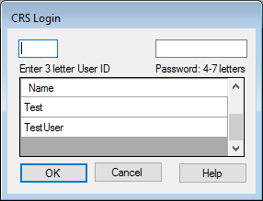

CRS Plus Login dialog box.
- Enter your CRS Plus User ID or select the name from the list of users.
- Enter your Password.
- Click on OK or hit the Enter button on the keyboard.
NOTE: Please contact a CRS Plus Administrator to set up a User name and password for initial login.

CRS Plus Main Window
When a user successfully logs in to CRS Plus, the main window will open.
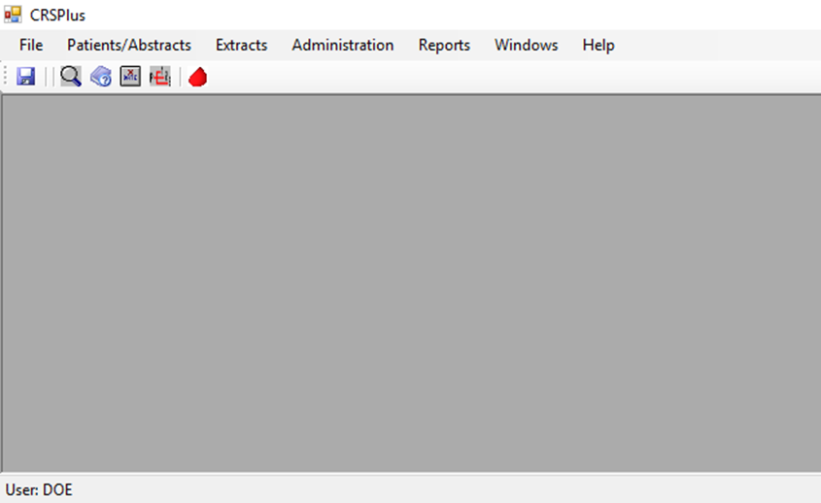

CRS Plus main window.

The Menu Bar
The menu bar contains the following options:

CRS Plus menu bar.
File
Exit is the only current function available in the File menu.

Patients/Abstracts
Contains options commonly performed by users assigned a role of “Consolidator” or “Editor” in CRS Plus.
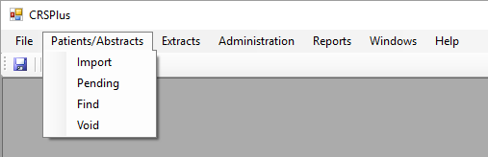

CRS Plus Patients/Abstracts menu.
Extracts
Contains standard extracts for routine file submission as well as tools to create SQL queries and to generate data files in multiple file formats including NAACCR record types and fixed width.
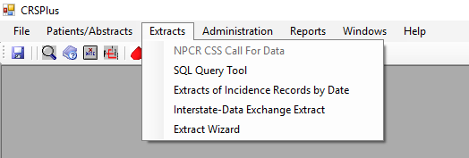

CRS Plus Extracts menu
Administration
Most of the options and functionalities in the Administration menu can only be performed when a user is assigned an “Administrator” role in CRS Plus. The items in the Administration menu are described in more detail in the CRS Plus Administrator’s Manual.
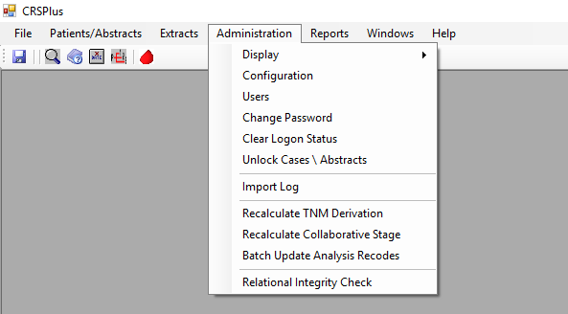

CRS Plus Administration menu.
Reports
Contains standard reports available to users for tracking and administrative analysis. All reports can be saved in the following formats: Excel, PDF, or Word.
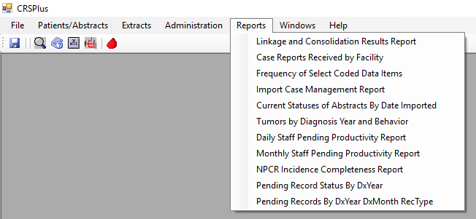

CRS Plus Reports menu.
Help
Provides access to the online help system and a dialog box that displays the CRS Plus version. Online Help will be added
at a later time.
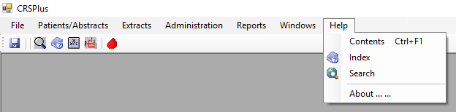

CRS Plus Help menu.
  - About: Opens the About dialog box to view the current version of CRS Plus.

The Icon Task Bar

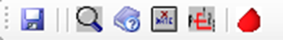

CRS Plus Icon Task Bar
The following functions are available via the icons:

Save Find Case/Abstract Help Void Abstract Compare SEER Heme DB

Change Password
To reset a user’s password within the CRS Plus application:

- From the Administration menu, select Change Password.
- The Change Password dialog box opens with the UserID defaulted.
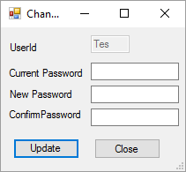

Change Password dialog box.
- Enter the current password.
- Enter the new password in both the New Password and Confirm Password fields.
- Click on the Update button.
NOTE: Each user has the ability to change their own password, regardless of role access granted. Only an Administrator can change the password of another user.

Unlock Cases\Abstracts
Records may become locked if there is an event such as a power outage or network issue and a user is working on a record at the time. To unlock a case or abstract:
1. From the Administration menu, select Unlock Cases\Abstracts.
2. The UnlockCasePatient window opens as displayed below.
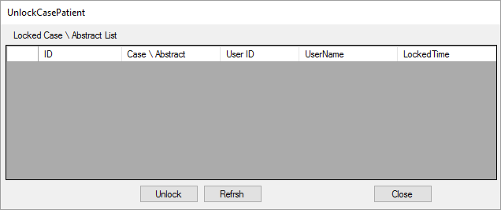

UnlockCasePatient window
3. If records appear in the list, select the record and click on Unlock.
- Once all records have been unlocked, Select Close.
NOTE: Only users designated as an Administrator can unlock cases. If a message appears stating: ‘You need to have the Administrator role to use this function’, see a user assigned as Administrator to unlock cases.

Manage Import
Files can be imported by a user with the Administrator role or Consolidator role if the setting is selected to Allow Consolidator to import abstracts in the Miscellaneous tab under the Administration menu in Configuration.

To import files into CRS Plus:
- From the Patients/Abstracts menu, select Import.
- The following Import Abstracts in NAACCR Format dialog will open.
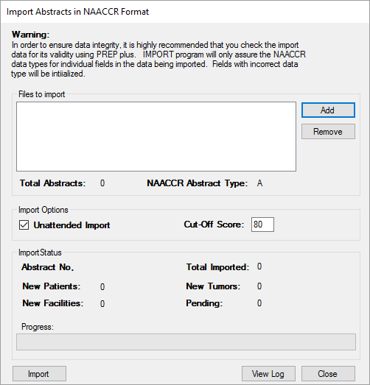

Import Abstracts in NAACCR Format dialog box
- Select Add to select a file for import.
- A file explorer window will open. For initial import, navigate to the appropriate file location for stored files awaiting import. For future imports, the directory will be defaulted to the folder accessed for the last import.
- Select the file to be imported from the list of files.
- Click on Open.
- To select more than one import file, follow the steps above to select additional files.
NOTE: The Unattended Import option is defaulted. This feature is helpful when there are multiples files being imported especially if overnight. When this feature is selected, manual intervention will not be needed in between import files. Once the first file is imported, it will move on to the remaining files selected for import as long as there is not a network connection issue.
- Once all files are selected, select one of the files to prioritize for import and the number of abstracts in the file will display in Total Abstracts.
- Click on Import.
- Once files are successfully imported, the following message will appear:

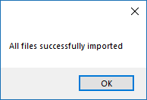

CRS Plus Message Indicating Successful Import
- The Import Case Management Report will automatically open providing a summary of records disposed directly to the database as well as a count of records sent to pending by pending type.
- All imported files are logged. The Import Log can be accessed by clicking on the View Log button in the Import Abstracts in NAACCR Format dialog or by selecting Import Log from the Administration menu.
- When selecting a file in the Import Log, details for each record in the file will display in the lower portion of the Import Log window. Files that do not import successfully will also be logged along with a message describing the import failure. The Import Log is described in more detail in the CRS Plus Administrator’s Log.

Finding a Patient Record in CRS Plus
To find a patient in the CRS Plus database:
- From the Patients/Abstracts menu, select Find.
- The following Search window will open.
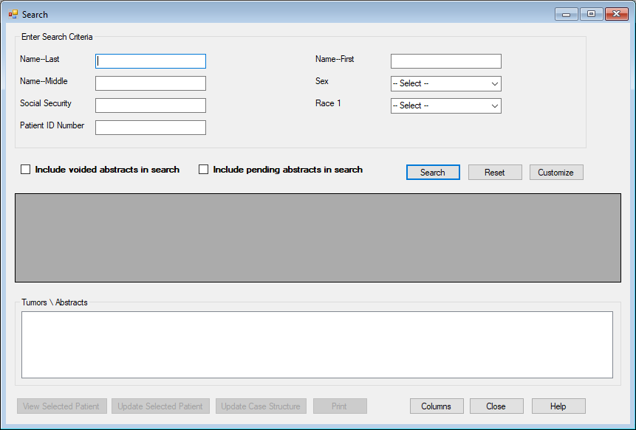

CRS Plus Search window
Several options are available for patient search.
- Enter as much information as available to narrow the search especially if searching for a patient with a very common name.
- Click on Search. A list of patients matching the search criteria will display in the middle section of the Search window.
- Select the patient in the list. The case outline will display in the lower section of the Search window under Tumors\Abstracts. All assigned tumors and facilities currently existing for the patient will be identified in the case outline.

Customizing the Search Window
To customize the search criteria in the Search Window:
- Click on the Customize button on the right in the middle of the Search window.
- The SearchColumns window will appear with a list of data items.

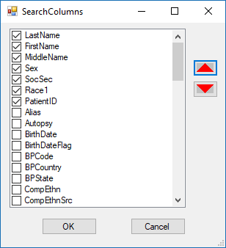

CRS Plus SearchColumns Window to Customize Search Criteria
- To select additional data items to include in the Search criteria, click to add a check mark in the box to the left of the desired data item. To remove data items from the Search criteria, remove the check mark from the box to the left of the desired data item.
- The display order of the data items in the Search window can be modified by using the red up and down arrows in the SearchColumns window.
- Once changes are made, click on OK.
- The SearchColumns window will close and the Search window will reflect the updates made to the Search Criteria.

Viewing a Patient Record in CRS Plus
- Once the patient is selected in the list and is displaying in the Tumor\Abstracts section, select View Selected Patient in the Search window to view all available data for the selected patient.
- The View Patient window will display.
NOTE: No modifications can be made in View mode. If modifications are needed, refer to the section: Modifying a Patient Record in CRS Plus.

User Interface: General Display
Once a record is opened in the Interactive Patient Update window or the View Patient window, the complete case outline is displayed in the upper left corner. The first line of the complete case outline contains patient information (Patient Last Name, First Name, and Patient ID). All tumors attached to the patient will display in the case outline and all associated abstracts attached to the tumors will display under each corresponding tumor in the case outline.

When Viewing or Updating a selected patient, the interface contains multiple grids which are described below:

Patient Grid -Patient (Demographic) Summary (grid header includes patient name (Last Name, First Name and PatientID)
Tumor Grid - Medical Summary of Tumor (grid header includes Primary Site, Date of Diagnosis, and Sequence Number Central)
Facility Grid - Hospital Abstract associated with tumor (grid header includes Reporting Facility number, AbsRefID and Sequence Number Hospital)

The first grid displayed will be defaulted to the Patient grid when a case is initially displayed.

If there are multiple tumors, the second grid defaults to the Tumor Summary for the first associated tumor when the case is initially displayed (tumor with earliest Date of Diagnosis).

NOTE: The consolidated record is a combination of the patient summary (grid) and a tumor summary (grid).

If there are multiple facility abstracts, the third grid defaults to first facility listed under the first associated tumor in the Complete Case Outline when the case is initially displayed in the Interactive Patient Update window.

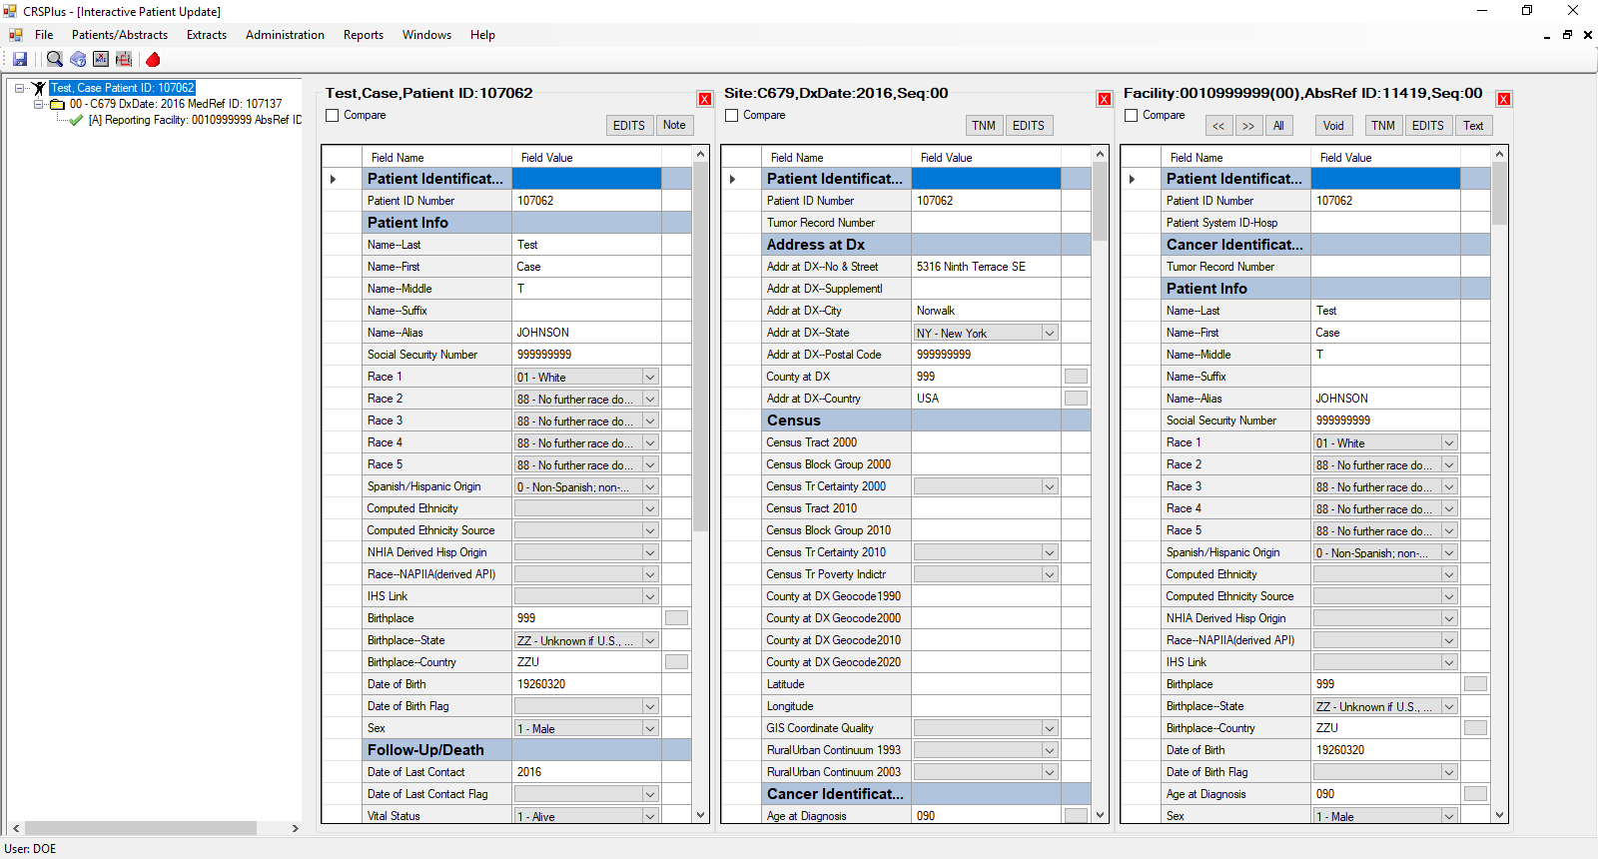

CRS Plus Interactive Patient Update window
While all three grids will initially be defaulted when each patient is opened, all three grids can be updated to display different segments and to make comparisons which is helpful when processing duplicate abstracts or reviewing multiple tumors or multiple abstracts.

The user may choose to display any tumor or abstract in the case outline if it is currently not displayed in one of the grids. To display additional tumors or abstracts from the case outline, double click on the tumor and/or abstract in the complete case outline. Multiple tumors and abstracts can be displayed and scroll bars will be available to scroll to the additional segments. More than three grids can be displayed at a time. Grids can also be closed by using the boxes with the red X in the top right corner of each grid.

Compare Function
Grid comparisons can be completed to quickly compare data contained in the grids. Only two grids can be compared at one time; otherwise, a message will appear stating only two grids can be selected for compare.

Mark the grids to be compared by adding a check to the Compare checkbox at the top of the grids.
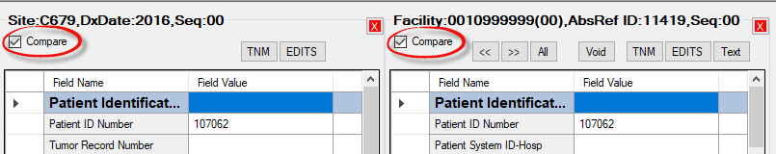

CRS Plus Interactive Patient Update window displaying Compare boxes above Medical Summary and Abstract grids
For example, to compare Tumor 00 to the associated Abstract 00:
Click in the Compare box above the two tumors so that checkmarks are added to the Compare boxes. Once the grids are marked for comparison, click on the Compare Abstracts icon on the icon tool bar.

The Compare window will open. Unmatched Items will be displayed in the top grid and Matched Items will be displayed on the bottom. By entering an X in the box to the left of Unmatched Only (below the Matched Items grid), only the unmatched items will be displayed in the Compare Results window.

Click on the Close button to close the Compare window once the review is complete. Different grids can be selected for Compare as needed.

Modifying a Patient Record in CRS Plus
- Once the patient is selected in the list and it is displaying in the Tumor\Abstracts section, select the Update Selected Patient button in the Search window to view and update data for the selected patient.
- The Interactive Patient Update window will display.
- Search for the data item to be modified by using the scroll bars within each grid.
NOTE: Data items with a limited number of field values will have drop down menus available for look-ups. Data items with a significant number of field values will have look-up buttons available in the column to the right of the Field Value column for specified data items.
- To modify a data item that does not have a drop-down menu or look-up table, double-click the value in the Field Value column so it is highlighted. The cursor can also be placed within the field to backspace or delete partial information.
- To modify a data item that has a drop-down menu, click on the drop-down menu arrow within the Field Value cell for the data item and the data item codes and associated code definitions will display.
- To modify a data item that has a look-up table, click on the look-up button in the column to the right of the Field Value column for the data item. The table will open displaying all applicable data item code values and associated code definitions for the data item.
NOTE: Data items that are protected such as the PatientID cannot be modified.

Age Recalculation in Interactive Patient Update
A recalculation button is available in the Interactive Patient Update window to recalculate age if a change is made to Date of Diagnosis or Date of Birth. Once a change is made, click on the calculation button to the right of the data item, Age at Diagnosis, in a tumor or abstract grid. The Age at Diagnosis value will automatically update.

NOTE: The Age recalculation function only runs against one grid at a time. If a change is made in an abstract and also in the consolidated record, the Age recalculation button must be initiated for each grid for the recalculation to run on both.

Viewing/Modifying Notes for the Consolidated Record
Notes for the consolidated record can be viewed and modified in the Interactive Patient Update window and in Pending.

- Click on the Note button above the Patient grid. A window similar to the following will display with the PatientID listed in the header of the Note window:
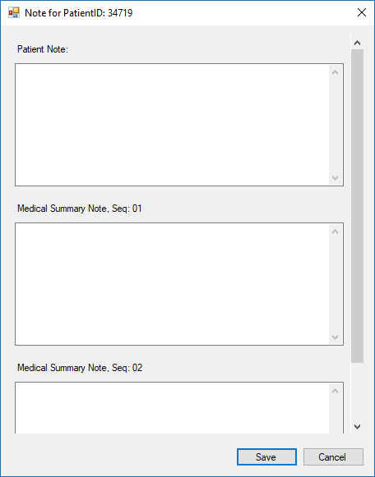

CRS Plus Note window for Consolidated Record
- Separate note sections are available within the Note window for the patient and the associated tumors.
- Enter notes in the appropriate note section.
NOTE: Notes can be deleted if accidentally entered by using backspace or highlighting and deleting the text. Copy/Cut/Paste features work as well.
- Click on the Save button at the bottom of the Note window to save the notes. Once Save is selected, the Note window will automatically close.
NOTE: The Cancel button can be used in the note window to cancel modifications and close the Note window.
- Cancel or Close can be used if no changes are made to the notes. Close the Note window by clicking on the X in the upper right corner of the Note window.

Viewing/Modifying Text in Abstracts
Text for the abstracts can be viewed and modified in the Interactive Patient Update window and in Pending.

- Click on the Text button above the Abstract grid. A window similar to the following will display with the AbsRefID number listed in the header of the Abstract Text window:
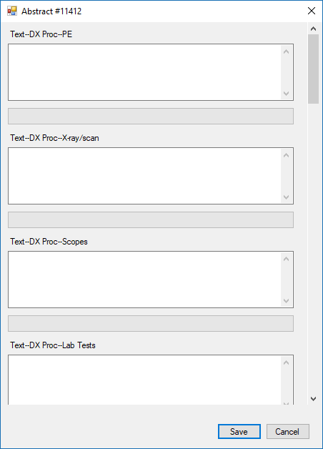

CRS Plus Text window for Abstracts
- Separate sections are available for each text data item defined by NAACCR, and the scroll bar is available on the right of the text window to scroll down to the additional text fields.
- Enter text in the appropriate text sections. If text is already entered in the text field, additional text can be added at the end of the previously documented text. The length for the text fields is limited to the field length assigned to the NAACCR text data items.
NOTE: Text can be deleted if accidentally entered by using backspace or highlighting and deleting the text. Copy/Cut/Paste features work as well.
- Once information is entered in the text fields, click on the Save button in the text window. Once Save is selected, the Abstract text window will automatically close.
NOTE: The Cancel button can be used in the text window to cancel modifications and close the Text window.
- Cancel or Close can be used if no changes are made to the Abstract text. Close the Text window by clicking on the X in the upper right corner of the Abstract text window.

Running EDITS
EDITS can be run for any grid. Buttons for EDITS will display above each grid. Two edit sets are used in CRS Plus, one edit set is applied to the consolidated record and another edit set is applied to the abstracts. The appropriate edit set will run based on the EDITS button selected. While abstracts are edited in Prep Plus to prepare for import into CRS Plus, the abstract edit set is available if updates are made to the abstracts. An example of an edit window is provided below:
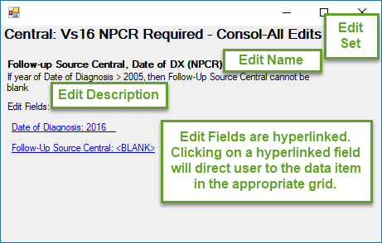

CRS Plus Edit Window

Data Interchange Function in Interactive Patient Update
Data interchange buttons are available above Abstract grids in the Interactive Patient Update window to copy information from one grid to another. This function allows exchange of data between grids without having to manually enter the updates into each grid.

The data interchange buttons allow modified data to be transferred from the Abstract to Patient Summary, Abstract to Medical Summary, or Abstract to Abstract. This is especially helpful when updating multiple fields such as Treatment data items. Data interchange from the Medical Summary to Abstracts is not allowed which is why data interchange buttons are not available above Patient or Medical Summary grids. The All button is available to copy field values to all grids displayed; however, the grid must contain the data item for the value to be copied.

NOTE: The grids must be next to each other for the data exchange to be successful. The grid placement can be modified by closing grids or double clicking on additional segments in the case outline to display additional grids.

The data interchange buttons are displayed in the print screen below:
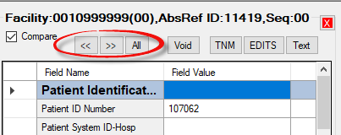

CRS Plus Interactive Patient Update window displaying data interchange buttons
For example, to exchange data from an Abstract to the Medical Summary, update a field value in the abstract. Verify the value is highlighted, then select the left interchange button . The field value will be copied from the data item in the Abstract to the consolidated Medical Summary. Message prompts such as the following will display if the interchange cannot be completed successfully. For this example, the Reporting Facility field is not a consolidated data item; therefore, the value in the Abstract cannot be copied to the Medical Summary of the consolidated record.
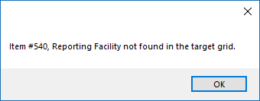

CRS Plus - Example of message received when data item not identified in target grid when using data interchange buttons

Collaborative Stage Algorithm
The Collaborative Staging (CS) System schemas consist of data input fields necessary to derive T, N, M, and Stage Group according to the AJCC Cancer Staging Manual; SEER Summary Stage 1977; and SEER Summary Stage 2000. Collaborative Staging applies to cases diagnosed January 1, 2004 through December 31, 2015. It is important for primary site to be coded correctly since most schemas are site-specific; although, there are a few schemas such as melanoma and lymphoma that are based on histologic type.

Once the CS data items are completed, the coded values are passed to a computer algorithm that generates the correct stage for the case in the following staging systems: AJCC TNM, 6th Edition, AJCC TNM 7th Edition, SEER Summary Stage 1977, and SEER Summary Stage 2000 based on the application settings in the Administration menu for Collaborative Stage Calculation Preferences. The program returns a set of output values or numeric codes to be stored in the record.

As part of the output of the CS Algorithm, three additional system fields, CS Version Input Original, CS Version Input Current, and CS Version Derived, are generated and stored. CS Version Input Original indicates the number of the version initially used to code CS data items. CS Version Input Current indicates the version of the CS input fields after they have been updated or recoded and is updated each time the CS Derived items are recalculated. CS Version Derived is recorded the first time the CS output items are derived and is updated to reflect the version number of the CS Algorithm used to derive the CS output fields and is updated automatically by the computer every time the CS Derived items are recalculated.

In CRS Plus, the CS Algorithm calculates the derived stage fields upon Save and on demand using calculation buttons.

Automated Collaborative Stage Calculation
Collaborative Stage Calculation runs upon import and also runs automatically upon Save. The calculation is completed automatically upon Save in the following ways:

In Pending
When clicking on Save in the Consolidated Patient and Tumor window, the CS Derived data items are recalculated based on the CS input values in the updated Consolidated record.

Save in Interactive Patient Update
When Date of Diagnosis, Histologic Type ICD-O-3, Primary Site, and/or a CS input item is updated, CRS Plus will automatically recalculate and re-populate the derived CS data items upon Save.

Close in Interactive Patient Update
When Date of Diagnosis, Histologic Type ICD-O-3, Primary Site, and/or a CS input item is updated, CRS Plus will automatically recalculate and re-populate the derived CS data items if Close is selected prior to Save. Once the Close button is selected, a message prompt will display stating case contents have been modified asking the user if they want to save contents before exiting. When Yes is selected, the derived CS data items are recalculated.

If the CS Algorithm recalculates the derived CS data items successfully upon Save or Close, the derived CS data items will automatically be updated. A message of successful recalculation will not appear; however, if there is a problem recalculating derived CS data items upon Save or Close, a message will be received stating there were errors in calculating derived stage and all derived stage data items will be blanked out until successful calculation. While this message will not include the data item causing the error, a message prompt will appear asking the user if they wish to open the CS calculation window. Once Yes is selected, a Collaborative Staging Result window similar to the example below will open providing details of the error message and fields in error.
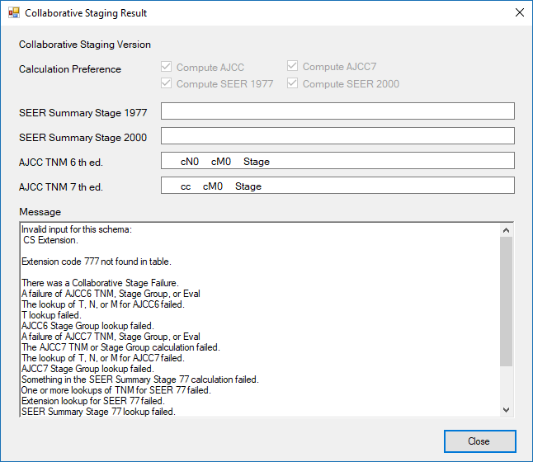

CRS Plus Collaborative Staging Result window
NOTE: When either Save or Close are initiated, the CS Algorithm will recalculate both the consolidated record and the abstract if updates were made in each.

Manual Collaborative Stage Calculation
In the Interactive Patient Update window, a manual feature is also available for the user to recalculate the derived CS data items. This function is referred to as “on demand” and it can be invoked in one of two ways: by either pressing the calculation button to the right of any CS derived data item in at tumor or abstract grid or by clicking on the CS button located at the top of a tumor or abstract grid for a case diagnosed between 01/01/2004 and 12/31/2015.

The manual functions only run against one grid at a time. Therefore, if a change is made in the abstract and also in the consolidated record, a CS derivation button or the CS button would need to be initiated for each grid for the manual calculation to run on both the abstract and the consolidated record. The Collaborative Staging Result window will display once a CS derivation button or the CS button is invoked.

TNM Calculation
The TNM Calculation takes the data input fields necessary to derive Stage Group and derives the NPCR Derived Clin Stg Grp (3650) and NPCR Derived Path Stg Grp (3655) using the TNM API for cases diagnosed in 2016 and 2017. It is important for primary site to be coded correctly since most schemas are site-specific; although, there are a few schemas such as melanoma and lymphoma that are based on histologic type.

In CRS Plus, the TNM Calculation derives the derived stage group data items upon Save and on demand using calculation buttons.

Automated TNM Calculation
TNM Calculation runs upon import and also runs automatically upon Save. Upon import, NPCR Derived Clin Stg Grp (3650) and NPCR Derived Path Stg Grp (3655) will be populated in the consolidated record if the derivation can run successfully. If the Diagnosis Date is within 2016 or 2017 and a New Patient or New Tumor is created and the incoming abstract is disposed directly to the database upon import, the values from NPCR Derived Clin Stg Grp (3650) and NPCR Derived Path Stg Grp (3655) within the abstract will be copied to the consolidated record. Upon import, an assumption is not made to calculate TNM if there are missing TNM staging elements; therefore, records with missing TNM staging elements may be disposed directly to the database and consolidated records created that do not have NPCR Derived Clin Stg Grp (3650) and NPCR Derived Path Stg Grp (3655) populated. A Batch TNM Derivation program is available within CRS Plus. Once this batch program is run, if there are any remaining records with missing TNM staging elements, the NPCR derived data items will be calculated and populated with 99. These records can be identified from the reports generated by the batch program and the missing TNM data elements can be reviewed and coded if known information is available. the NPCR derived data items can be recalculated if additional information is available at a later time.

The calculation is completed automatically upon Save in the following ways:

In Pending
When clicking on Save in the Consolidated Patient and Tumor window, NPCR Derived Clin Stg Grp (3650) and NPCR Derived Path Stg Grp (3655) are recalculated if any of the TNM data items defined for a schema are modified in the updated consolidated record or in any abstract updated in the Automated Consolidation window. This is only evident to the user if there is a TNM Calculation failure as a result of recalculation since messages will be displayed only if there is a failure or missing TNM staging elements.

Save in Interactive Patient Update
When any of the TNM data elements defined for a schema are modified, CRS Plus will automatically recalculate and re-populate NPCR Derived Clin Stg Grp (3650) and NPCR Derived Path Stg Grp (3655) upon Save.

Close in Interactive Patient Update
When any of the TNM data elements defined for a schema are modified, CRS Plus will automatically recalculate and re-populate NPCR Derived Clin Stg Grp (3650) and NPCR Derived Path Stg Grp (3655) if the Close (X) button is selected prior to Save as a safety feature to assure the derived fields are recalculated and consistent with the TNM data elements coded for the schema. Once the Close (X) button is selected, a message prompt will display stating case contents have been modified asking the user if they want to save changes before exiting. When Yes is selected, NPCR Derived Clin Stg Grp (3650) and NPCR Derived Path Stg Grp (3655) are recalculated and updated automatically.

If the TNM Calculation recalculates NPCR Derived Clin Stg Grp (3650) and NPCR Derived Path Stg Grp (3655) successfully upon Save or Close, the derived data items will automatically be updated. A message of successful recalculation will not appear; however, if there is a problem recalculating derived data items upon Save or Close, the TNM Staging Results window will display providing issues resulting from TNM Calculation. Invalid values must be corrected for successful calculation. if there are missing TNM staging elements, the Response Code sections in the TNM Staging Results window will indicate this and the user will be provided with the option to populate the NPCR derived data items with default values or the option to complete missing values. If the user chooses to complete missing values, the derived data items will be blanked out until successful calculation. An example of a TNM Staging Results window with an invalid value and missing TNM staging elements is provided below.

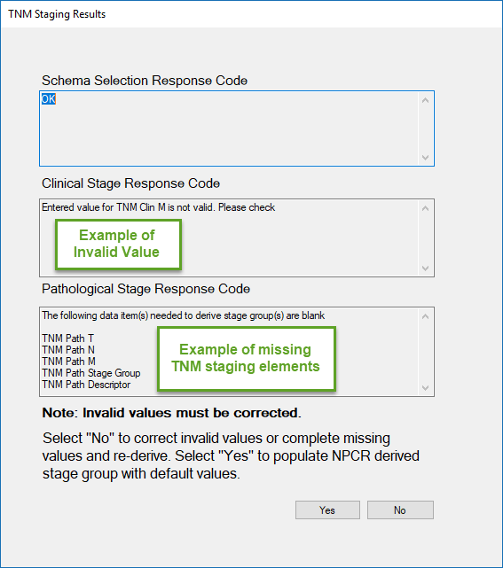

CRS Plus TNM Staging Results window
NOTE: When either Save or Close are initiated, the TNM Calculation will recalculate both the consolidated record and the abstract if updates were made in each.

Manual TNM Calculation
In the Interactive Patient Update window, a manual feature is also available for the user to recalculate NPCR Derived Clin Stg Grp (3650) and NPCR Derived Path Stg Grp (3655). This function is referred to as “on demand” and it can be invoked in one of two ways: by either pressing the calculation button to the right of either NPCR derived data item in a tumor or abstract grid or by clicking on the TNM button located at the top of a tumor or abstract grid for a case diagnosed in 2016 or 2017. If the button to the right of either NPCR derived data item is selected, the calculation only runs for the data item selected. If the TNM button located at the top of a tumor or abstract grid is selected, the calculation will run for both NPCR Derived Clin Stg Grp (3650) and NPCR Derived Path Stg Grp (3655).

The manual functions only run against one grid at a time. Therefore, if a change is made in the abstract and also in the consolidated record, a TNM derivation button or the TNM button would need to be initiated for each grid for the manual calculation to run on both the abstract and the consolidated record. If the TNM Calculation recalculates NPCR Derived Clin Stg Grp (3650) and NPCR Derived Path Stg Grp (3655) successfully when using the manual functions, the derived data items will automatically be updated. A message of successful recalculation will not appear; however, if there is a problem recalculating derived data items, the TNM Staging Results window will display describing issues resulting from TNM Calculation.

Void Abstracts
- From the Patients/Abstracts menu, select Void.
- The following VoidFilter window will open:
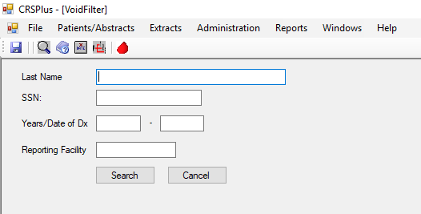

CRS Plus Void Filter window
- Enter filter criteria to find a voided abstract if there is a high volume of voided abstracts.
- Click on Search.

NOTE: Search can still be completed without filter criteria; however, the full list of voided abstracts will display.
- The VoidsList window will open similar to the print screen below.
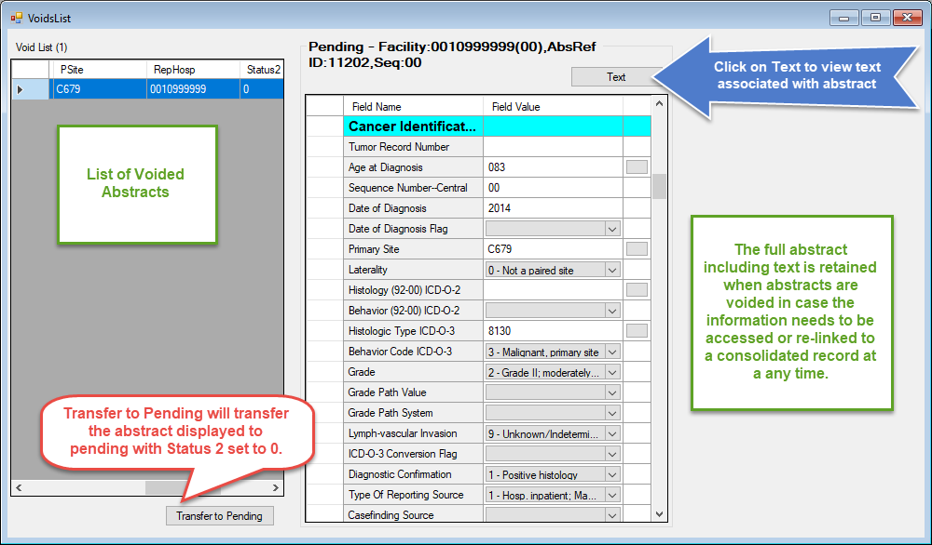

CRS Plus VoidsList window

- To view text for the voided abstract, click on the Text button above the abstract grid.
- If it is determined the voided abstract should be sent back to pending, click on the Transfer to Pending button below the Void List.

CRS Plus Data Flow
CRS Plus provides for automatic determination of multiple primary tumors and consolidation of data items from multiple facility abstracts into incidence records. CRS Plus supports the linkage of incoming abstracts against the existing database, with software-assisted consolidation into patient, tumor, and facility tables. CRS plus creates consolidated patient and tumor tables for the same person and tumor with the best values from multiple reporting sources.

Source records are retained and compared during data item consolidation. While the current consolidated value is not considered for the consolidated decision, the existing consolidated values are displayed for reference.

All incoming abstracts are processed through an automated tumor linkage and consolidation module, TLC Plus, which has been incorporated into the central registry software, CRS Plus. Abstracts proceed through a defined data flow upon import – Patient Linkage → Tumor Linkage→ Sequence Number Check → Data Item Consolidation → Duplicate Check → Collaborative Stage Calculation or TNM Stage Calculation → Edit Check.

TLC Plus provides automated support to reduce manual review for all linkage and consolidation decisions. At any point the program is unable to reach a definitive linkage or consolidation decision, the abstract is assigned a pending status code in CRS Plus. All pending abstracts require manual intervention.

Status 2 Codes

Status2: Defines the Reason the Abstract was Sent to Pending
The table below indicates the reason the abstract is in pending as well as the corresponding action:

Pending Status Code | Pending Status | Action
0 | Manually Sent Back to Pending | To be processed through the linkage and consolidation process again after being restructured
1 | New Patient Invalid Tumor Sequence | Does not link to patient in database; Seq > 00; Hospital Sequence Number other than 00, <blank>, 99 for first abstract on a new patient
2 | Patient Linkage | Potential Patient Match; match score was not high enough to be considered a true match or abstract matched on multiple patients
4 | Tumor Linkage | Potential Tumor Match; Automated tumor linkage determined that this case should be manually reviewed
8 | Data Item Consolidation | One or more data items requires manual review
9 | Duplicate Abstract | Based on Reporting Facility; the abstract is a duplicate (second abstract for the same tumor submitted by the same facility)
10 | Edit Error | Sent to Pending for Edit correction
11 | Collaborative Stage Calculation Error | Failed Collaborative Stage calculation– one or more CS items is invalid requiring correction
12 | Tumor Sequence on New Tumor | Potential New Tumor; Review Sequence Number
13 | Modification Record | Record is a NAACCR Type M record used to submit changes to originally reported abstracts electronically. All Type M Records are currently sent to Pending.
16 | TNM Calculation | Failed TNM Derived Stage Calculation – one or more TNM items is invalid or missing requiring correction or defaulting
18 | TNM Stage Group Comparison | Discrepancy between TNM directly-coded stage group compared to NPCR Derived Path Stage Group or the TNM directly-coded clinical stage group compared to NPCR Derived Clin Stage Group

CRS Plus Flowchart
The flowchart below visualizes the sequential logic for an incoming abstract going through TLC Plus. The process begins with Patient Linkage.

CRS Plus Import Flow Chart

Processing Pending Abstracts

Accessing Pending Abstracts and Applying Filter Criteria
- From the Patients/Abstracts menu, select Pending.
- The Pending Filter Criteria window will open. The Pending List can be filtered by Name fields, Patient ID, Years of Date of Diagnosis, Reporting Facility, SSN, Pending Status Code, or a combination of multiple filter criteria.
- The total number of pending abstracts will display at the top of the Pending Filter Criteria window.
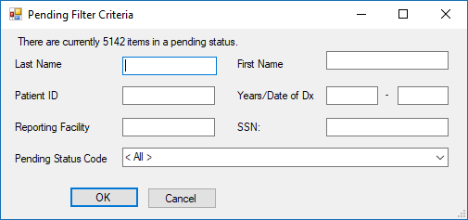

CRS Plus Pending Filter Criteria window
- Enter the desired criteria to filter the Pending List to manage the workload.
NOTE: Only 1000 rows will display in the Pending List at a time. If filter criteria are not specified or the filter still produces more than 1000 rows, only the first 1000 rows will be returned and displayed once the Pending List is opened.
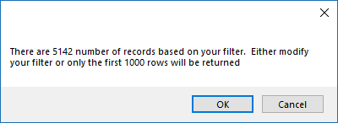

CRS Plus Pending List Display Maximum
- Click on OK.
- The Pending List will open and the number of pending abstracts included in the filtered list will display in parentheses.
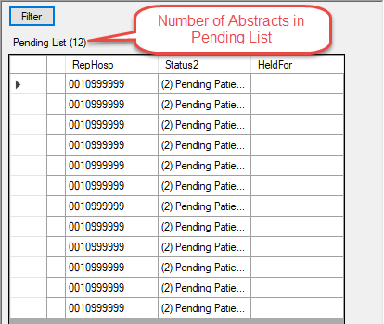

CRS Plus Pending List displaying count of filtered pending records
NOTE: User configured widths of items in the pending list are saved upon closing the pending list so the width settings are available the next time the pending list is opened. The width of each column in the pending list can be modified using the arrow that appears when hovering over the lines in between columns.

The number of abstracts in the Pending List will update as abstracts are fully processed and removed from the Pending List.
NOTE: Once the Pending List is opened, the filter can be re-applied by clicking on the Filter button at the top of the Pending List. The existing criteria will be defaulted once the filter is opened and can be modified to update the filter criteria.

Pending Abstract Details
A Pending Abstract Details pop-up message box will display when hovering over abstracts in the Pending List. All information displayed in the Pending List columns for the abstract will display in this box. It is another option to display the pending abstract details without using the scroll bar to view the values in each column.

Procedure for Processing Pending Abstracts: New Patient Invalid Tumor Sequence
Records in pending for New Patient Invalid Tumor Sequence are abstracts identified as new patients at the time of import but were sent to pending since the Sequence Number Central assigned by CRS Plus conflicts with the reported Sequence Number Hospital. The user must assign the appropriate Sequence Number Central and dispose as a New Patient. These records require manual intervention to ensure the Sequence Number Central accurately reflects the sequence of all reportable neoplasms over the lifetime of the patient.

When an abstract in pending for New Patient Invalid Tumor Sequence is opened in the PendingAbstracts window, patient linkage logic is repeated. Therefore, it is possible for an abstract in pending for this reason to have a potential matching record in the database if changes were made to the database via additional imports or through pending record processing after the abstract was imported. If this occurs, refer to the Procedure for Processing Pending Abstracts: Patient Linkage.

Step 1: Select an Abstract in the PendingAbstracts window for New Patient Invalid Tumor Sequence.
Select an abstract identified in black font for New Patient Invalid Tumor Sequence (Status2: 1 New Patient Invalid Tumor Sequence) by clicking on the record in the Pending List. Once the record is selected, the pending abstract will display to the right of the Pending List.

NOTE: The pending abstract is view only in the PendingAbstracts window. Modifications to the pending abstract will not be allowed in this window; however, the pending abstract will be able to be modified in the Consolidated Patient and Tumor window.

Step 2: View the Potential Patient Matches.
If there are potential patient matches, refer to the Procedure for Processing Pending Abstracts: Patient Linkage. If there are no potential patient matches, continue with this procedure.

Step 3: Select New Patient in Dispose Abstract As.
Select New Patient in the Dispose Pending Abstract As dialog in the bottom left of the PendingAbstracts window. The radial button to the left of New Patient should be selected.

Step 4: Determine Appropriate Sequence Number Central Assignment.
Review all available information such as Behavior, Sequence Number Hospital, and text.

NOTE: To view text, click on the pending abstract grid and then click on the Abstract Text button located above the grid.

Step 5: Enter Sequence Number Central.
Enter the Sequence Number Central in the box to the left of Assign Sequence Number Central in Dispose Abstract As below New Patient.

Step 6: Click on Save Disposition.
If a Sequence Number Central is not entered, the following message will appear: “Do you want to assign SeqNumCentr = 00 to this patient?” Select Yes if 00 is the correct SeqNumCentr, or select No and assign a valid Sequence Number.

The following message will appear if No is selected.
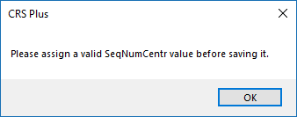

CRS Plus reminder to assign a valid SeqNumCentr
Click on OK and assign a valid Sequence Number.

NOTE: The TLC Plus button is grayed out when New Patient is selected since there are no linked abstracts.

Once SeqNumCentr is entered, click on Save Disposition.

A confirmation message will appear similar to the message below:
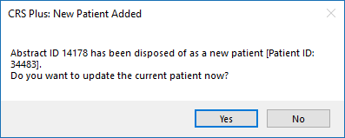

CRS Plus Confirmation Message when New Patient added to database
Step 7: Select No.
The abstract will be removed from the Pending List and added to the database. The PendingAbstracts window will remain open and the next abstract in the Pending List will be selected for processing.

NOTE: If potential data errors were identified upon review of the record, select Yes. The user will be re-directed to the Update Case window with the associated Patient ID record displayed. Refer to the procedure for Modifying a Patient Record in CRS Plus.

Procedure for Processing Pending Abstracts: Patient Linkage
Records in pending for Patient Linkage are cases that, at the time of import, matched to one or more existing patients in the database as a result of the scoring algorithm. The user will be able to dispose pending Patient Linkage abstracts as new patients or link the abstract to an existing patient in the database. The following outcomes when processing records designated as Patient Linkage in pending are:
New Patient
Linked Patient - record will then proceed to tumor linkage and data item consolidation.

Patient Linkage cases (identified by scoring) in pending should always be compared to all potential matched cases in the database. Patient Linkage cases are those where the match score(s) is in the range of 80-154 or one record has a match score of 155 and at least one other record is not more than 30 points lower. If the score is 155 or higher and any other match scores are greater than 30 points lower, CRS Plus will complete automated patient linkage. The low range value of 80 can be modified by individual registries. Contact CDC for assistance.

When a Patient Linkage case is opened in the PendingAbstracts window, patient linkage logic is repeated. Therefore, it is possible for a case in pending for Patient Linkage to complete automated patient linkage if changes were made to the database (via additional imports, pending record processing or modification record processing) after the record was imported. If this occurs refer to the Procedure for Processing Pending Abstracts: Tumor Linkage or Procedure for Processing Pending Abstracts: Data Item Consolidation, as applicable.

Step 1: Select an Abstract in the PendingAbstracts window for Patient Linkage.
Select an abstract identified in black font for Patient Linkage (Status2: 2 Patient Linkage) by clicking on the record in the Pending List. Once the record is selected, the pending abstract will display to the right of the Pending List.

NOTE: The pending abstract is view only in the PendingAbstracts window. Modifications to the pending abstract will not be allowed in this window; however, the pending abstract will be able to be modified in the Consolidated Patient and Tumor window.

Step 2: View the Potential Patient Matches.
View all potential patient matches in the Potential Matches section just below the Pending List on the left-hand side of the PendingAbstracts window as displayed in the print screen below.
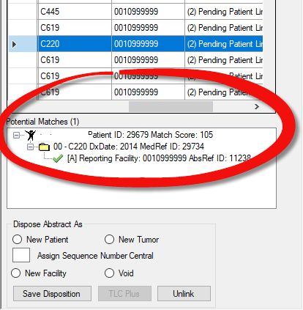

CRS Plus Pending Potential Match display
Step 3: Double Click on the Potential Patient Match to View the Record.
Double click on patient record in Matched Patient section to display the existing patient and tumor as well as associated abstracts. Once the potential match is selected, the patient, tumor, and first associated abstract will display to the right of the pending abstract.

Step 4: Compare the Pending Abstract to the Potential Patient Match(es).
Mark the grids to be compared by adding a check to Compare checkbox at the top of the grids. In the example below, checkmarks have been added to the Compare for the pending abstract and to the Patient grid of the potential patient match.

Once the grids are marked for comparison, click on the Compare Abstracts icon on the icon tool bar.

NOTE: Only two grids can be marked at one time for comparison; otherwise, a message will appear stating only two grids can be selected for compare.
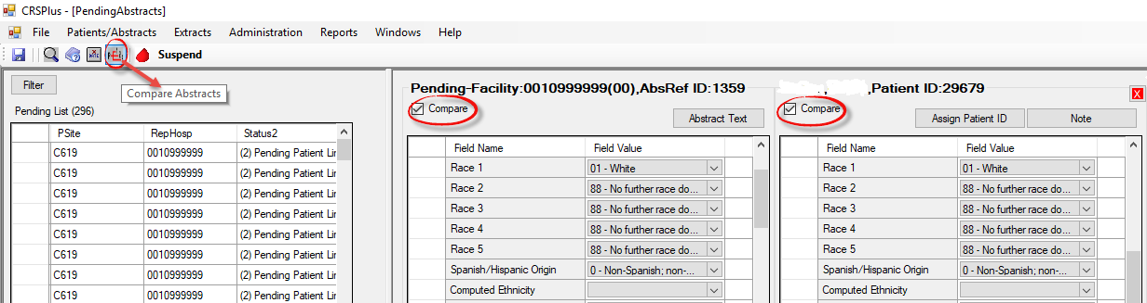

CRS Plus PendingAbtracts - Compare Abstracts Function
The Compare window will open. Unmatched Items will be displayed in the top grid and Matched Items will be displayed on the bottom. By entering an X in the box to the left of Unmatched Only (below the Matched Items grid), only the unmatched items will be displayed in the Compare window.

Step 5: Close the Compare Window.
Once the determination of patient match is determined, click on the Close button to close the Compare window.

Step 6: Repeat steps 3-5 if there is more than one potential match.
If a match is identified, refer to the Link to Existing Patient section. If no match is identified, refer to the Dispose as New Patient section.

Link to Existing Patient

Step 1: Assign Patient ID.
Once the linkage is confirmed, click on the Assign Patient ID button to link the pending abstract to the consolidated patient record. Patient ID # has been transferred will appear in red font above the pending abstract.

Step 2: Click on TLCPlus.
Click on the TLC Plus button to run tumor linkage.

One of the following messages will appear.

If the message appears stating, “This abstract requires manual tumor linkage”, go to the Procedure for Processing Pending Abstracts: Tumor Linkage to continue with manual tumor linkage.

If the message appears stating, “TLC Plus linked the Abstract to tumor ## (MedRefID = ##). Do you want to proceed with consolidation?”, automated tumor linkage has occurred. Select Yes and refer to the Procedure for Processing Pending Abstracts: Data Item Consolidation.

If the message appears stating, “TLC Plus Linkage disposition was: NEW TUMOR. Do you want to dispose of this abstract as a new tumor?” Select Yes. One of the following messages will appear:
If the message appears stating, “TLC Plus disposed the abstract as a new tumor ### (MedRefID: #####). Do you want to proceed with consolidation?” Select Yes and refer to the Procedure for Processing Pending Abstracts: Data Item Consolidation.

If the message appears stating, “Could not compute Sequence Number for the new tumor. Please dispose manually.” Click on OK and refer to the Procedure for Processing Pending Abstracts: Tumor Sequence on New Tumor.

Dispose as a New Patient

Step 1: Select New Patient.
Select New Patient in the Dispose Pending Abstract As window in the bottom left of the PendingAbstracts window. The radial button to the left of New Patient should be filled.

Step 2: Review SeqNumHosp Reported in Pending Abstract.
If SeqNumHosp is 00, enter 00 for SeqNumCentr. If SeqNumHosp is any other value, review all available information including text to determine SeqNumCentr.

NOTE: To view text, click on the pending abstract grid to highlight the grid, and then click on the Text button located above the grid.

CRS Plus will adjust the SeqNumCentr if additional primaries for the patient are subsequently imported.

Step 3: Enter the Sequence Number Central in the red box.

Step 4: Click on Save Disposition.
If there are multiple potential matches and not all are reviewed before disposing the abstract as a New Patient, the following message will appear: “You have chosen to dispose of this abstract as a new Patient without reviewing all potential matches. Do you want to review the remaining potential matches first?” Select Yes and return to the section for reviewing potential matches.

NOTE: If a Sequence Number Central was not entered, the following message will appear: “Do you want to assign SeqNumCentr = 00 to this case?” Select Yes if 00 is the correct SeqNumCentr, or select No and assign a valid Sequence Number Central.

The following message will appear if No is selected.

CRS Plus reminder for assigning SeqNumCentr
Click on OK and assign a valid Sequence Number Central.
NOTE: The TLC Plus button is grayed out when New Patient is selected since there are no linked abstracts.

Once SeqNumCentr is entered, click on Save Disposition.

A confirmation message indicating a new patient was added to the database will appear similar to the message below:

CRS Plus Confirmation Message Indicating New Patient Added to Database
Step 5: Select No.
The abstract will be removed from the Pending List and added to the database. The PendingAbstracts window will remain open and the next abstract in the Pending List will be selected for processing.

NOTE: If potential data errors were identified upon review of the record, select Yes. The user will be re-directed to the Update Case window with the associated Patient ID record displayed. Refer to the procedure for Modifying a Patient Record in CRS Plus.

Procedure for Processing Pending Abstracts: Tumor Linkage
Records in pending for Tumor Linkage are cases that have already been linked to an existing patient in the database; however, automated tumor linkage could not be determined. The record was sent to pending for manual tumor linkage determination. For records requiring manual tumor linkage, the following disposition outcomes are available: New Tumor or New Facility (links to an existing primary tumor in the database).

When an abstract in pending for Tumor Linkage is opened in the PendingAbstracts window and the TLC Plus button is selected, automated tumor linkage logic is repeated; therefore, it is possible for an abstract in pending for Tumor Linkage to complete automated tumor linkage after the abstract has been imported if changes were made to the database upon import or through processing other pending abstracts. If this occurs, refer to the Procedure for Processing Pending Abstracts: Data Item Consolidation.

Step 1: Select an Abstract in the PendingAbstracts window for Tumor Linkage.
Select an abstract identified by black font for Tumor Linkage (Status2: 4 Tumor Linkage) by clicking on the record in the Pending List. Once the record is selected, the pending abstract will display to the right of the Pending List.

NOTE: The pending abstract is view only in the PendingAbstracts window. Modifications to the pending abstract will not be allowed in this window; however, the pending abstract will be able to be modified in the Consolidated Patient and Tumor window.
Step 2: Click on TLCPlus.
Click on the TLCPlus button in the section labeled Dispose Abstract As in the lower left corner.

One of the following messages will appear.

If the message appears stating: "This abstract requires manual tumor linkage.” Go to step 3 to continue with manual tumor linkage.

If the message appears stating: "TLCPlus linked the abstract to tumor ## (MedRefID = #). Do you want to proceed with consolidation?” Automated tumor linkage has occurred. Select Yes and refer to the Procedure for Processing Pending Abstracts: Data Item Consolidation.

If the message appears stating: “TLC Linkage disposition was: NEW TUMOR. Do you want to dispose of this abstract as a new tumor?” Automated tumor linkage has occurred. Select Yes. One of the following messages will appear:

If the message appears stating: “TLC Plus disposed the abstract as a new tumor ## (MedRefID: #####). Do you want to proceed with consolidation?” Select Yes and refer to the Procedure for Processing Pending Abstracts: Data Item Consolidation.
If the message appears stating: “Could not compute Sequence Number for the new tumor. Please dispose manually.” Click on OK and refer to Dispose as a New Tumor.
Step 3: Click on OK.

Step 4: Review All Available Information for Manual Tumor Linkage.
Determine whether the pending abstract represents the same primary as an existing tumor in the database or a new primary tumor. Review all available information including text.

Double click on the Matched Patient to view the consolidated record for the existing patient in the PendingAbstracts window. The patient and tumor grids will display as well as the first abstract associated with the tumor. Additional grids can be selected for viewing by double clicking on the segments in the Potential Matches case outline.

NOTE: To view text, click on the pending abstract grid and then click on the Abstract Text button located above the pending abstract grid. To view text for the abstracts disposed to the database, click on the disposed abstract and then click on the Abstract Text button located above the disposed abstract grid.

Step 5: Compare the Pending Abstract to the Potential Tumor Match(es).
Mark the grids to be compared by adding a check to Compare checkbox at the top of the grids. Once the grids are marked for comparison, click on the Compare Abstracts icon on the icon tool bar.

NOTE: Only two grids can be marked at one time for comparison; otherwise, a message will appear stating only two grids can be selected for compare.

The Compare window will open. Unmatched Items will be displayed in the top grid and Matched Items will be displayed on the bottom. By entering an X in the box to the left of Unmatched Only (below the Matched Items grid), only the unmatched items will be displayed in the Compare window.

Step 6: Close the Compare Window.
Once the determination of tumor match is determined, click on the Close button to close the Compare window.

If the abstract is determined to be a new primary tumor, go to the Dispose as New Tumor section of this procedure. If the abstract is determined to be the same primary as an existing tumor in the database, refer to the Dispose as New Facility section of this procedure.

Dispose as a New Tumor

Step 1: Select New Tumor.
Select New Tumor in the Dispose Pending Abstract As section in the bottom left corner of the PendingAbstracts window. The radial button to the left of New Tumor should be filled.

Step 2: Review All Available Information to Determine Sequence Number—Central
Review the Sequence Number—Hospital reported in the pending abstract and review all available information including text.

Step 3: Enter the Sequence Number Central in the red box.

Step 4: Click on the Save Disposition button.
If a Sequence Number—Central was not entered or an invalid number was entered, an error message similar to the
message below will appear. Click on OK to exit the error and return to step 3.
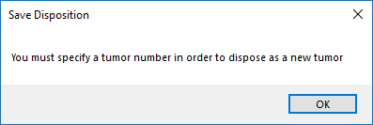

CRS Plus Save Disposition Reminder to Specify Sequence

Step 5: Confirmation for New Tumor.
A message will appear stating: “Abstract ID # has been disposed of as a new tumor for Patient ID #. Click OK to run
Consolidation.”

Step 6: Click on OK.
NOTE: Although the abstract is being disposed as a New Tumor, consolidation will run on patient data items.

One of the following messages will appear:

If the message appears stating: “Consolidation failed. Click Yes if you want to correct these errors now". Select Yes and refer to the Procedure for Processing Pending Abstracts: Data Item Consolidation to continue processing the abstract. If No is selected, the abstract will remain in pending for Data Item Consolidation.

If the message appears stating: “Consolidation completed successfully and database was updated. Click OK to view consolidation log.” Select Cancel and the abstract will move on to the next step in the processing flow.
NOTE: If OK is selected, the consolidation log will open. Refer to the Procedure for Processing Pending Abstracts: Data Item Consolidation to continue processing the abstract.

Dispose as a New Facility

Step 1: Select New Facility.
Select New Facility in the Dispose Pending Abstract As section in the bottom left corner of the PendingAbstracts window. The radial button to the left of New Facility should be filled.

Step 2: Enter the Sequence Number—Central.
Enter the Sequence Number—Central of the tumor to which the pending record should be linked in the red box.

Step 3: Click on the Save Disposition button.
If a Sequence Number Central was not entered, the following message may appear: “Do you want to assign SeqNumCentr = 00 to this case?” Select Yes if 00 is the correct SeqNumCentr, or select No and assign a valid Sequence Number.

If the consolidated record has multiple tumor summaries, select No and assign the appropriate Sequence Number. If an incorrect Sequence Number is assigned, an error message will appear labeled New facility assignment denied stating: “Patient ID #### does not have tumor sequence ##.” Click OK to close the message box and return to step 2.

Step 4: Confirmation for New Facility.
A message will appear stating: “Abstract ID # has been disposed of as a new facility for Patient ID #, tumor sequence #. Click OK to run tumor consolidation.”

Step 5: Click on OK.
One of the following messages will appear:

If the message appears stating: “Consolidation failed. Click Yes if you want to correct these errors now". Select Yes and refer to the Procedure for Processing Pending Abstracts: Data Item Consolidation to continue processing the abstract. If No is selected, the abstract will remain in pending for Data Item Consolidation.

If the message appears stating: “Consolidation completed successfully and database was updated. Click OK to view consolidation log.” Select Cancel and the abstract will move on to the next step in the processing flow.

NOTE: If OK is selected, the consolidation log will open. Refer to the Procedure for Processing Pending Abstracts: Data Item Consolidation to continue processing the abstract.

Procedure for Processing Pending Abstracts: Tumor Sequence on New Tumor
Abstracts in pending for Tumor Sequence on New Tumor are cases that have already been linked to an existing patient in the database and were determined to be a new primary tumor not already in the database at the time of import. Abstracts in pending for Tumor Sequence on New Tumor are sent to pending because the Sequence Number Central assigned by CRS Plus conflicts with the reported Sequence Number Hospital and manual review is needed to ensure the Sequence Number Central accurately reflects the sequence of all reportable neoplasms over the lifetime of the patient.

When an abstract in pending for Tumor Sequence on New Tumor is opened in the PendingAbstracts window and the TLC Plus button is selected, automated tumor linkage logic is repeated. The tumor linkage outcome may be different if changes were made to the database via additional imports or through pending record processing after the abstract was imported. The most likely linkage result will be an automated New Tumor decision that requires manual Sequence Number Central assignment. The user must assign the appropriate Sequence Number Central and dispose as a New Tumor. If tumor linkage results in a different outcome, refer to the appropriate procedure in this manual to process the abstract.

Step 1: Select an Abstract in the PendingAbstracts window for Tumor Sequence on New Tumor.
Select an abstract identified by black font for Tumor Sequence on New Tumor (Status2: 12) by clicking on the record in the Pending List. Once the record is selected, the pending abstract will display to the right of the Pending List.

NOTE: The pending abstract is view only in the PendingAbstracts window. Modifications to the pending abstract will not be allowed in this window; however, the pending abstract will be able to be modified in the Consolidated Patient and Tumor window.

Step 2: View the Existing Tumors.
View all potential tumor matches in the Matched Patient window just below the Pending List on the left-hand side of the PendingAbstracts window.

Step 3: Double Click on one of the Existing Tumors to View the Record.
Once the potential match is selected, the patient, tumor, and first associated abstract will display to the right of the pending abstract.

Step 4: Compare the Pending Abstract to the Existing Tumor(s).
The Sequence Number--Central is available for each tumor in the case outline in the Match Patient section and the Sequence Number--Hospital is displayed in the header for the pending abstract in parentheses after the Reporting Facility number.

Comparisons can also be completed to view the tumor data items including Date of Diagnosis. Mark the grids to be compared by adding a check to the Compare checkbox at the top of the grids. For tumor comparison, checkmarks should be added to the pending abstract and the consolidated tumor grids to compare the Pending Abstract to the Tumor grid.

Once the grids are marked for comparison, click on the Compare Abstracts icon on the icon tool bar.
NOTE: Only two grids can be marked at one time for comparison; otherwise, a message will appear stating only two grids can be selected for compare.

The Compare window will open. Unmatched Items will be displayed in the top grid and Matched Items will be displayed on the bottom. By entering an X in the box to the left of Unmatched Only (below the Matched Items grid), only the unmatched items will be displayed in the Compare window.

Step 5: Close the Compare Window.
Once the Sequence Number for the pending abstract is determined, click on the Close button to close the Compare window.

Step 6: Repeat steps 3-5 if there is more than one potential tumor match.
If the pending abstract is determined to be a New Tumor, refer to the Dispose as a New Tumor section. If the pending abstract matches an existing tumor, refer to the Dispose as a New Facility section.

Dispose as a New Tumor

Step 1: Select New Tumor.
Select New Tumor in the Dispose Pending Abstract As section in the bottom left corner of the PendingAbstracts window. The radial button to the left of New Tumor should be filled.

Step 2: Review All Available Information to Determine Sequence Number—Central
Review the Sequence Number—Hospital reported in the pending abstract and review all available information including text.

Step 3: Enter the Sequence Number Central in the red box.

Step 4: Click on the Save Disposition button.
If a Sequence Number—Central was not entered or an invalid number was entered, an error message similar to the message below will appear. Click on OK to exit the error and return to step 3.

CRS Plus Save Disposition Reminder to Specify Sequence Number Central

Step 5: Confirmation for New Tumor.
A message will appear stating: “Abstract ID # has been disposed of as a new tumor for Patient ID #. Click OK to run Consolidation.”

Step 6: Click on OK.
Note: Although the abstract is being disposed as a New Tumor, consolidation will run on patient data items.

One of the following messages will appear:

If the message appears stating: “Consolidation failed. Click Yes if you want to correct these errors now". Select Yes and refer to the Procedure for Processing Pending Abstracts: Data Item Consolidation to continue processing the abstract. If the user selects No, the abstract will remain in pending for Data Item Consolidation.

If the message appears stating: “Consolidation completed successfully and database was updated. Click OK to view consolidation log.” Select Cancel.

NOTE: If OK is selected, the consolidation log will open. Refer to the Procedure for Processing Pending Abstracts: Data Item Consolidation to continue processing the abstract.

Dispose as a New Facility

Step 1: Select New Facility.
Select New Facility in the Dispose Pending Abstract As section in the bottom left corner of the PendingAbstracts window. The radial button to the left of New Facility should be filled.

Step 2: Enter the Sequence Number—Central
Enter the Sequence Number—Central of the tumor to which the pending record should be linked in the red box.

Step 3: Click on the Save Disposition button.
If a Sequence Number Central was not entered, the following message may appear: “Do you want to assign SeqNumCentr = 00 to this case?” Select Yes if 00 is the correct SeqNumCentr, or select No and assign a valid Sequence Number.

If the consolidated record has multiple tumor summaries, select No and assign the appropriate Sequence Number. If an incorrect Sequence Number is assigned, an error message will appear labeled New facility assignment denied stating: “Patient ID #### does not have tumor sequence ##.” Click OK to close the message box and return to step 2.

Step 4: Confirmation for New Facility.
A message will appear stating: “Abstract ID # has been disposed of as a new facility for Patient ID #, tumor sequence #. Click OK to run tumor consolidation.”

Step 5: Click on OK.
One of the following messages will appear:

If the message appears stating: “Consolidation failed. Click Yes if you want to correct these errors now". Select Yes and refer to the Procedure for Processing Pending Abstracts: Data Item Consolidation to continue processing the abstract. If the user selects No, the abstract will remain in pending for Data Item Consolidation.

If the message appears stating: “Consolidation completed successfully and database was updated. Click OK to view consolidation log.” Select Cancel and the abstract will move on to the next step in the processing flow.

NOTE: If OK is selected, the consolidation log will open. Refer to the Procedure for Processing Pending Abstracts: Data Item Consolidation to continue processing the abstract.

Procedure for Processing Pending Abstracts: Data Item Consolidation
Data Item Consolidation abstracts in pending are abstracts that have already been linked to both a patient and tumor in the database. Consolidation of patient-specific or tumor-specific data could not be completed at the time of import. Since patient and tumor linkage has already taken place, abstracts in pending for Data Item Consolidation may not be disposed by the user as a New Patient, New Tumor, or New Facility.

When an abstract in pending for Data Item Consolidation is opened in the Pending Abstracts window and the TLCPlus button is selected, consolidation logic is repeated. Therefore, it is possible for the case to complete automated consolidation if changes were made to the database via import of additional abstracts for the same patient and tumor or pending record processing of abstracts linked to the same patient or tumor after the abstract was imported.

Step 1: Select an Abstract in the PendingAbstracts window for Data Item Consolidation.
Select an abstract identified by red font for Data Item Consolidation (Status2: 8 Pending Consolidation) by clicking on the record in the Pending List. Once the record is selected, the pending abstract will display to the right of the Pending List.

NOTE: The pending abstract is view only in the PendingAbstracts window. Modifications to the pending abstract will not be allowed in this window; however, the pending abstract will be able to be modified in the Consolidated Patient and Tumor window.

The following message will display:
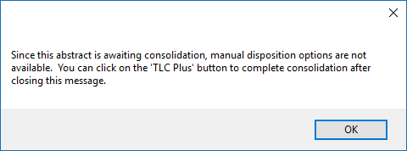
CRS Plus Message Received in Pending When Abstract is Awaiting Consolidation
Step 2: Click on TLCPlus.
Click on the TLCPlus button in the section labeled Dispose Abstract As in the lower left corner.

One of the following messages will appear:

If the message appears stating: "Consolidation completed successfully and database was updated. Click OK to view consolidation log." Select Cancel and the abstract will move on to the next step in the processing flow. The user can also choose to click OK to view the consolidation log.
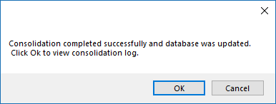
CRS Plus Message Indicating Consolidation Completed Successfully
If the message appears stating: “Collaborative Stage failed. Click Yes if you want to correct these errors now.” Select Yes and refer to the Procedure for Processing Pending Abstracts: CS Calculation. If No is selected, the abstract will remain in pending for Pending CS Calculation.

If the message appears stating: “TNM Stage Calculation failed. Click Yes if you want to correct these errors now.” Select Yes and refer to the Procedure for Processing Pending Abstracts: TNM Calculation to resolve TNM errors. If No is selected, the abstract will remain in pending for Pending TNM Calculation.

If the message appears stating: "Consolidation failed. Click Yes if you want to correct these errors now"
Select Yes. If the user selects No, the abstract will remain in pending for Data Item Consolidation.
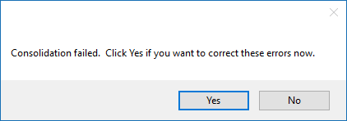
CRS Plus Message Indicating Consolidation Failed
Select Yes

Step 3: Review Consolidation.
The Pending Consolidation window will open displaying consolidation results for every data item in the consolidated record in the display order created under the Administration menu. A print screen of the Pending Consolidation window is provided below.
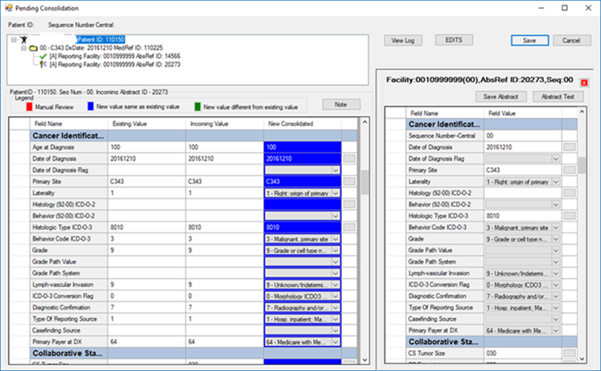
CRS Plus Pending Consolidation Window
The Legend in the Consolidation Review window designates the following results based on the consolidation directive for each data item:

Red – Manual Review (Manual decision required for consolidation)
Blue – New value same as existing value (Automated decision based on TLC Plus Directives)
Green – New value different from existing value (Automated decision based on TLC Plus Directives)

All values displayed in red font must be manually updated in order for successful consolidation and disposition of the abstract.

Step 4: Complete Manual Consolidation.
To enter values for all Manual Review (RED) decisions, use the scroll bar to the right of the data item list to scroll until you see <Review> in the New Consolidated column.

Click in the cell displaying <<Review>>. Review all available information to determine the best consolidated value.

Values for the selected data item (consolidated record and all source records) can be viewed in the Consolidation Log.

Accessing the Consolidation Log
To open the Consolidation Log, click to the left of the data item so the entire row is highlighted. Click on the View Log button in the upper right section of the Pending Consolidation window above the pending abstract. A Consolidation Log similar to the example displayed below will open.

The existing value for the consolidated record will display for the selected data item as well as values for all source records associated with the patient or tumor. Remember the values from the source records are considered for determining the New Consolidated value.
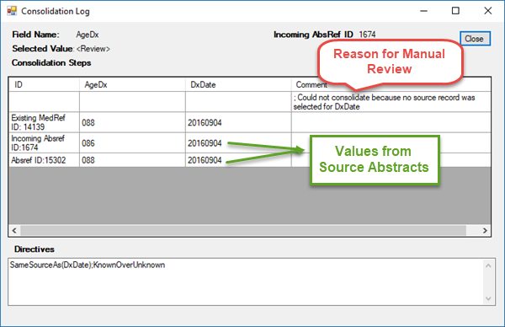
CRS Plus Consolidation Log Window
The pending abstract displays to the right of the consolidation. Text for the pending abstract can be viewed by clicking on the Abstract Text button above the pending abstract. A separate text window will open. Text can also be added to the pending abstract and saved.

Pending Abstract Reconsolidation
Pending abstract values as well as any other abstract values can be modified in the Pending Consolidation window by modifying the value within the abstract and clicking on the Save Abstract button in the Pending Consolidation window. The following message will appear:
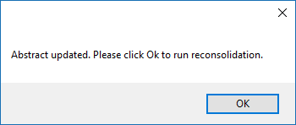
CRS Plus Message Confirming Abstract Modified
Select OK for automated reconsolidation. Consolidation will automatically run once OK is selected. The following message will appear if reconsolidation fails after abstract values have been modified.
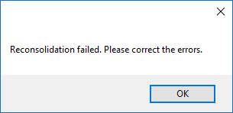
CRS Plus Message Indicating Reconsolidation Failed After Abstract Values Modified
Select OK. The field(s) failing consolidation will display in red highlight for manual review in the Pending Consolidation window.

To view the Consolidation Log for a data item, click to the left of the data item in the consolidation grid so the row is highlighted, then click on the View Log button to the left of the EDITS button in the upper mid portion of the Pending Consolidation window. The following print screen describes the Consolidation Log window:

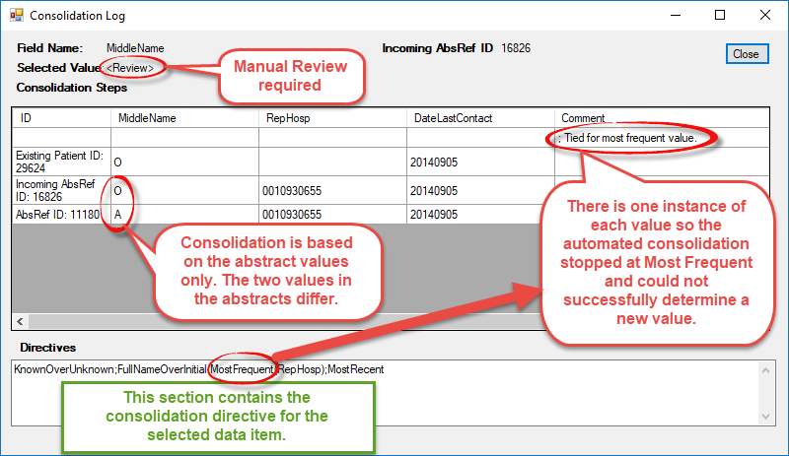
CRS Plus Consolidation Log Window
If the selected "best" value is displayed in the Existing Value or Incoming Value column, place the mouse pointer on the value and double click to transfer the value to the New Value column.

OR

Highlight <<Review>> and type in the value you determined to be the appropriate consolidated value for the data item. Hit the Enter key on your keyboard.

Step 5: Save Manual Consolidation Decisions.
Once manual decisions are entered, click on the Save button.
NOTE: Use the Save button to save changes to the consolidated record and not the Save Abstract button below the Save button (The Save Abstract button saves changes to the pending abstract).
If you click on Save without entering values for all <<Review>> items, the following message will appear:
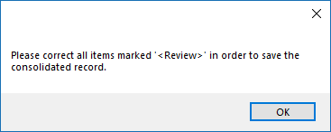
CRS Plus Reminder to Manually Consolidate All Items Marked As Review

Click OK to remain in the Pending Consolidation Window and complete manual consolidation. Previous consolidation decisions will be retained.

Once all manual decisions are entered, click on the Save button.

Step 6: Continue Processing Abstract to Remove from Pending.
One of the following messages will appear:

If the following message appears stating Edits failed, select Yes and refer to the Procedure for Processing Pending Abstracts: Pending Edits. If No is selected, the abstract will remain in pending for Pending Edits.
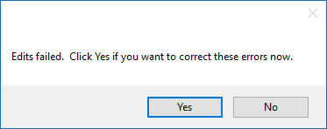
CRS Plus Message Indicating Edits Failed
If the message appears stating: "The incoming abstract (AbsRefID = #) is a duplicate of the existing abstract (AbsRefID = #, Reporting Hospital = #). How do you want to dispose?", refer to the Procedure for Processing Pending Abstracts: Duplicate Abstracts to complete processing the case.
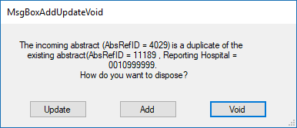
CRS Plus Message Indicating Duplicate Abstract with Options for Disposing
If the message appears stating: “Collaborative Stage failed. Click Yes if you want to correct these errors now.” Select Yes and refer to the Procedure for Processing Pending Abstracts: CS Calculation. If No is selected, the abstract will remain in pending for Pending CS Calculation.

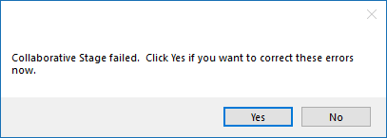

CRS Plus Message Indicating Collaborative Stage Failed

If the message appears stating: “TNM Stage Calculation failed. Click Yes if you want to correct these errors now.” Select Yes and refer to the Procedure for Processing Pending Abstracts: TNM Calculation to resolve TNM errors. If No is selected, the abstract will remain in pending for Pending TNM Calculation.

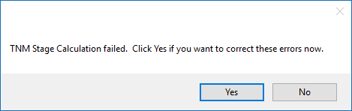

CRS Plus Message Indicating TNM Stage Calculation Failed

Procedure for Processing Pending Abstracts: Duplicate Abstracts

Duplicate records, identified in blue font, are abstracts linked to an existing patient and tumor in the database and are sent to pending at the time of import since an abstract from the same facility was previously disposed to the database for the tumor. Records in Pending for manual linkage or consolidation may also be identified as a Duplicate at a later point in processing.

CRS Plus allows abstracts to be voided in three different places: Interactive Patient Update window, Update Case Structure function, and in the PendingAbstracts window.

Users have the option to add the duplicate record to the database or void the duplicate record and retain only one source abstract per facility per tumor in the main CRS Plus database. If only one record is retained, Duplicates should be compared to the original abstract and the original abstract updated as appropriate before the Duplicate is voided.

Voided abstracts are never deleted and are stored in a table separate from the main database so that the data can be retrieved if voided by mistake.

Step 1: Select an Abstract in the PendingAbstracts window for Duplicate Abstract.
Select an abstract identified by blue font for Duplicate Abstract (Status2: 9 Duplicate Abstract) by clicking on the record in the Pending List. Once the record is selected, the pending abstract will display to the right of the Pending List.

Pending Duplicate records will be identified in the Matched Case Outline in the lower left of the pending window with a leading copy symbol.

NOTE: The pending abstract is view only in the PendingAbstracts window. Modifications to the pending abstract will not be allowed in this window; however, the pending abstract will be able to be modified in the Consolidated Patient and Tumor window.

Step 2: Click on TLCPlus.
Click on the TLCPlus button in the section labeled Dispose Abstract As in the lower left corner.

Since patient and tumor linkages have already been determined through automated logic and consolidation decisions completed, disposition options for New Patient, New Tumor, and New Facility have been grayed out in the Dispose Pending Abstract As dialog.

One of the following messages will appear.

If the message appears stating: "Consolidation failed. Click Yes if you want to correct these errors now"
Select Yes and refer to the Procedure for Processing Pending Abstracts: Data Item Consolidation to continue processing the abstract. If No is selected, the abstract will remain in pending for Data Item Consolidation.

If the message appears stating: "Consolidation completed successfully and database was updated. Click OK to view consolidation log." Select Cancel and the abstract will move on to the next step in the processing flow. The user can also choose to click OK to view the consolidation log.

If the message appears stating: “Edits failed. Click Yes if you want to correct these errors now.” Select Yes and refer to the Procedure for Processing Pending Abstracts: Pending Edits. If No is selected, the abstract will remain in pending for Pending Edits.

Step 3: Duplicate Abstract Message.
A message will appear stating: "The incoming abstract (AbsRefID = #) is a duplicate of the existing abstract (AbsRefID = #, Reporting Hospital = #). How do you want to dispose?"

CRS Plus Message Indicating Duplicate Abstract with Options for Disposing
The default option is Update; therefore, if Enter is selected, the user will automatically be directed to the Interactive Patient Update window so the original abstract can be updated and the duplicate abstract can be voided from the Interactive Patient Update window.

If the user chooses to Add, the facility record will be added to the database so at least two abstracts will be attached to the tumor in the database for the same patient from the same reporting source. If Void is selected, the facility record will be voided and not included in the database. Voided records are sent to the Void Abstracts section (Void is accessible from the Patients/Abstracts menu) and can be retrieved if accidentally voided.

If the Update option is chosen, the facility record is added to the database and the user is automatically re-directed to the Interactive Patient Update window to modify. The duplicate abstract will display in the Interactive Patient Update window along with the associated patient and tumor. Once all changes are made to the abstract that will be retained based on the most recent information, the duplicate record can be voided.

If there is only one tumor for the patient, the first two grids displayed will reflect the patient and tumor summaries respectively and the third grid will display the duplicate abstract processed from pending.

Additional segments can be displayed by double clicking on the specified segment in the case outline.

Step 4: Compare the Duplicate Abstract to the Abstract Disposed to the Database from the Same Facility
Mark the grids to be compared by adding a check to Compare checkbox at the top of the grids. Once the grids are marked for comparison, click on the Compare Abstracts icon on the icon tool bar.

NOTE: Only two grids can be marked at one time for comparison; otherwise, a message will appear stating only two grids can be selected for compare.

The Compare window will open. Unmatched Items will be displayed in the top grid and Matched Items will be displayed on the bottom. By entering an X in the box to the left of Unmatched Only (below the Matched Items grid), only the unmatched items will be displayed in the Compare window.

Once the determination of tumor match is determined, click on the Close button to close the Compare window.

The abstract with the earliest DateCaseReceived is typically retained for timeliness calculations. Any updated information reported in the duplicate abstract should be copied to this abstract.

After all updates are complete, Save the changes. Text can be added to the abstracts to support the updated information in the original abstract.

It is recommended EDITS are run when any modifications are made in the Interactive Patient Update window.

Voiding Abstract in Interactive Patient Update
After all updates are entered, select the abstract to be voided by clicking in the desired abstract grid.

Click on the Void button at the top of the abstract grid to be voided.

A confirmation message will appear asking: “Are you certain you want to void abstract (#####). Click OK to continue, otherwise click Cancel”.
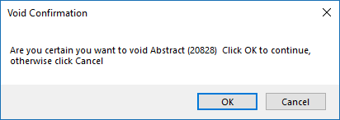

CRS Plus Void Confirmation Message
Select OK. The following message will appear to confirm the abstract has been voided.

NOTE: Select Cancel if you do not want to Void the abstract.
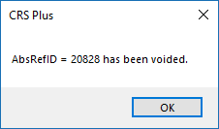

CRS Plus Voided Abstract Confirmation
Click on OK. The duplicate abstract will be removed and the case outline will refresh.

Procedure for Processing Pending Abstracts: Pending Edits

Prior to final disposition of pending abstracts, excluding duplicate abstracts, the consolidated record is edited using the CRS Consolidated edit set. When any edits fail the record is sent to pending for manual processing to correct edit errors.
This type of pending record is rare since most records will stop earlier in the flow at Data Item Consolidation.

Edit error abstracts in pending are already linked to both a patient and tumor in the database; and automated consolidation of patient-specific or tumor-specific data items completed at the time of import. Since patient and tumor linkages have already taken place, abstracts in pending for Edits may not be disposed by the user as a New Patient, New Tumor or New Facility.

When an abstract in pending for Pending Edits is opened in the PendingAbstracts window and the TLCPlus button is selected, the system repeats consolidation logic. Therefore, it is possible for the case to require manual data item consolidation or re-calculation for staging if changes were made to the database (via additional imports, pending record processing or modification record processing) after the record was imported. If this occurs refer to the respective Procedure for Processing Pending Abstracts: Data Item Consolidation, Procedure for Processing Pending Abstracts: CS Calculation, or Procedure for Processing Pending Abstracts: TNM Calculation.

Step 1: Select an Abstract in the PendingAbstracts window for Pending Edits.
Select an abstract identified by green font for Edit Errors (Status2: 10 Pending Edits) by clicking on the abstract in the Pending List. Once the record is selected, the pending abstract will display to the right of the Pending List.

NOTE: The pending abstract is view only in the PendingAbstracts window. Modifications to the pending abstract will not be allowed in this window; however, the pending abstract will be able to be modified in the Consolidated Patient and Tumor window.
Step 2: Click on TLCPlus.
Click on the TLCPlus button in the section labeled Dispose Abstract As in the lower left corner.
One of the following messages will appear.

If the message appears stating: "Consolidation failed. Click Yes if you want to correct these errors now"
Select Yes and refer to the Procedure for Processing Pending Abstracts: Data Item Consolidation to continue processing the abstract. If the user selects No, the abstract will remain in pending for Data Item Consolidation.

If the message appears stating: "Consolidation completed successfully and database was updated. Click OK to view consolidation log." Select Cancel and the abstract will move on to the next step in the processing flow. The user can also choose to click OK to view the consolidation log.

If the message appears stating: “Collaborative Stage failed. Click Yes if you want to correct these errors now.” Select Yes and refer to the Procedure for Processing Pending Abstracts: CS Calculation. If No is selected, the abstract will remain in pending for Pending CS Calculation.

If the message appears stating: “TNM Stage Calculation failed. Click Yes if you want to correct these errors now.” Select Yes and refer to the Procedure for Processing Pending Abstracts: TNM Calculation to resolve TNM errors. If No is selected, the abstract will remain in pending for Pending TNM Calculation.

Step 3: Click on the Save button.
Once the Consolidated Patient and Tumor window opens, click on the Save button in the upper-right corner of the window.
NOTE: Use the Save button and not the Save Abstract button below the Save button (The Save Abstract button saves changes to the pending abstract).

If Edits fail, the following message will appear:
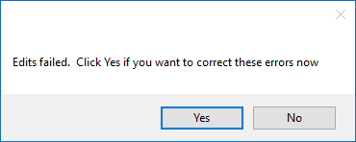
CRS Plus Message Indicating Edits Failed
Step 4: Select Yes to correct the errors.
If No is selected, the abstract will remain in pending for Pending Edits.

Step 5: The Edit dialog window will appear.
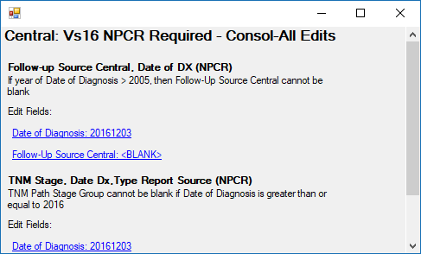
CRS Plus Edit Dialog Window Displaying Hyperlinked Data Items
NOTE: Only consolidated data items display in the Consolidated Patient and Tumor window; however, if Edits fail, the Consolidated Patient and Tumor window will refresh and will display all data items below the consolidated items in the event non-consolidated data items need to be corrected for edit errors.

Step 6: Correct all edit errors.

NOTE: The Edit Fields are hyperlinked. Clicking on one of the fields in the edit window will direct the user to the field in the New Consolidated column in the Consolidated Patient and Tumor window. The field will be outlined in yellow.

Step 7: Click on the Save button.
If any edit errors remain, the message stating ‘Edits failed. Click Yes if you want to correct these errors now’. If No is selected, the abstract will remain in pending for Pending Edits. Select Yes to correct the errors and then click on the Save button again.

If there are no additional errors, the abstract will move on to the next step in the process or will be successfully removed from pending and will be disposed to the database.

If the following message appears, the pending abstract was determined to be a duplicate of an existing abstract in the database. Refer to the Procedure for Processing Pending Abstracts: Duplicate Abstracts.
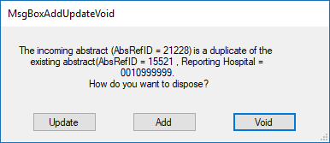
CRS Plus Message Indicating Duplicate Abstract with Options for Disposing

Procedure for Processing Pending Abstracts: CS Calculation
After data item consolidation, staging calculations are run based on Diagnosis Year. Collaborative Stage calculation runs for cases diagnosed from 2004 through 2015. If the CS algorithm cannot calculate CS, the record is sent to pending and labeled CS Calculation. Abstracts in pending for CS Calculation have already been linked by patient and tumor and automated consolidation of patient-specific and tumor-specific data was successful. Since patient and tumor linkages have already been determined, abstracts in pending for CS Calculation may not be disposed by the user as a New Patient, New Tumor, or New Facility.

When an abstract in pending for CS Calculation is opened in the PendingAbstracts window and the TLC Plus button is selected, consolidation is run in case any changes were made as the result of importing, updating records, or processing of other pending records; therefore, it is possible for the case to require manual data item consolidation if changes were made to the database after the abstract was imported. If this occurs, refer to the Procedure for Processing Pending Abstracts: Data Item Consolidation.

Step 1: Select an Abstract in the PendingAbstracts window for CS Calculation.
Select an abstract identified by pink font for CS Calculation (Status2: 11 CS Calculation) by clicking on the abstract in the Pending List. Once the record is selected, the pending abstract will display to the right of the Pending List.

Pending CS records will be identified in the Matched Case Outline in the lower left of the pending window with a leading CS symbol.
NOTE: The pending abstract is view only in the PendingAbstracts window. Modifications to the pending abstract will not be allowed in this window; however, the pending abstract will be able to be modified in the Consolidated Patient and Tumor window.
Step 2: Click on TLCPlus.
Click on the TLCPlus button in the section labeled Dispose Abstract As in the lower left corner.

One of the following messages will appear.

If the message appears stating: "Consolidation failed. Click Yes if you want to correct these errors now"
Select Yes and refer to the Procedure for Processing Pending Abstracts: Data Item Consolidation. If the user selects No, the abstract will remain in pending for Data Item Consolidation.
CRS Plus Message Indicating Consolidation Failed
If the message appears stating: "Consolidation completed successfully and database was updated. Click OK to view consolidation log." The user can also choose to click OK to view the consolidation log. Select Cancel to accept the automated consolidation decisions.

If the message appears stating: “Collaborative Stage failed. Click Yes if you want to correct these errors now.”
CRS Plus Message Indicating Collaborative Stage Failed
If No is selected, the abstract will remain in pending for CS Calculation.

If Yes is selected, the Consolidated Patient and Tumor window will open. Automated consolidation decisions can be reviewed and modified in the Consolidated Patient and Tumor window.

Step 3: Select Yes to open the Consolidated Patient and Tumor window.

Step 4: Click on Save.

Click on Save. The following message will appear:
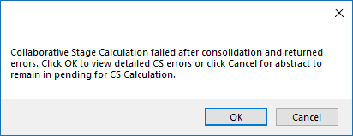
CRS Plus Message Indicating Collaborative Stage Calculation Failure
If Cancel is selected, the Consolidated Patient and Tumor window will close and the abstract will remain in pending for CS Calculation.

Step 5: Click on OK to view detailed CS Errors.
Click on OK to view the detailed CS errors. A message similar to the example below will display.
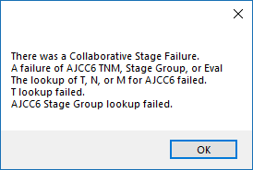
CRS Plus Message Including Details for Collaborative Stage Failure

Step 6: Click on OK.
Click on OK. The Consolidated Patient and Tumor window will remain open so the CS input items can be reviewed and updated in the New Consolidated column to correct the CS items and successfully calculate CS.

NOTE: The look-up buttons to the right of the CS data items in the New Consolidated column can be used to view the pick lists associated with the data items.
Modifications can also be made to the pending abstract and existing abstracts disposed to the database in the Consolidated Patient and Tumor window if necessary.

Step 7: Click on Save.
Once all CS input values are corrected, click on Save. If all CS calculation errors are resolved, the abstract will move on to the next step in the processing flow.

If the following message appears stating Edits failed, refer to the Procedure for Processing Pending Abstracts: Pending Edits.
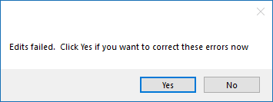
CRS Plus Message Indicating Edits Failed

Procedure for Processing Pending Abstracts: TNM Calculation
After data item consolidation, staging calculations are run based on Diagnosis Year. TNM calculation runs for cases diagnosed in 2016 and 2017. If the TNM algorithm cannot calculate NPCR Derived Clin Stg Grp (3650) or NPCR Derived Path Stg Grp (3655), the record is sent to pending and labeled TNM Calculation. Abstracts in pending for TNM Calculation have already been linked by patient and tumor and automated consolidation of patient-specific and tumor-specific data was successful. Since patient and tumor linkages have already been determined, abstracts in pending for TNM Calculation may not be disposed by the user as a New Patient, New Tumor, or New Facility.

When an abstract in pending for TNM Calculation is opened in the PendingAbstracts window and the TLC Plus button is selected, consolidation is run in case any changes were made as the result of importing, updating records, or processing of other pending records; therefore, it is possible for the case to require manual data item consolidation if changes were made to the database after the pending abstract was imported. If this occurs, refer to the Procedure for Processing Pending Abstracts: Data Item Consolidation.

Step 1: Select an Abstract in the PendingAbstracts window for TNM Calculation.
Select an abstract identified by black font for TNM Calculation (Status2: 16 TNM Calculation) by clicking on the abstract in the Pending List. Once the record is selected, the pending abstract will display to the right of the Pending List.

Pending TNM records will be identified in the Matched Case Outline in the lower left of the pending window with a leading T symbol.
NOTE: The pending abstract is view only in the PendingAbstracts window. Modifications to the pending abstract will not be allowed in this window; however, the pending abstract will be able to be modified in the Consolidated Patient and Tumor window.
Step 2: Click on TLCPlus.
Click on the TLCPlus button in the section labeled Dispose Abstract As in the lower left corner.

One of the following messages will appear.

If the message appears stating: "Consolidation failed. Click Yes if you want to correct these errors now"
Select Yes and refer to the Procedure for Processing Pending Abstracts: Data Item Consolidation. If the user selects No, the abstract will remain in pending for Data Item Consolidation.

CRS Plus Message Indicating Consolidation Failed
If the message appears stating: "Consolidation completed successfully and database was updated. Click OK to view consolidation log." The user can choose to select OK to view the consolidation log. Select Cancel to accept the automated consolidation decisions.

If the message appears stating: “TNM Stage Calculation failed. Click Yes if you want to correct these errors now.”
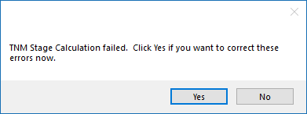

CRS Plus Message Indicating TNM Stage Calculation Failed
Select No and the abstract will remain in pending for TNM Calculation.

Select Yes and the Consolidated Patient and Tumor window will open. Automated consolidation decisions can be reviewed and modified in this Consolidated Patient and Tumor window.

Step 3: Click on the Save button.
Once the Consolidated Patient and Tumor window opens, click on the Save button in the upper-right corner of the window.
NOTE: Use the Save button and not the Save Abstract button below the Save button (The Save Abstract button saves changes to the pending abstract).

The following message will appear:
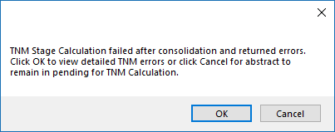

CRS Plus Message Indicating TNM Stage Calculation Failure
If Cancel is selected, the Consolidated Patient and Tumor window will close and the abstract will remain in pending for TNM Calculation.

Click on OK to view the detailed TNM errors.

Step 4: Review the TNM Staging Results
A TNM Staging Results window similar to the example below will display providing the results of the TNM calculation.
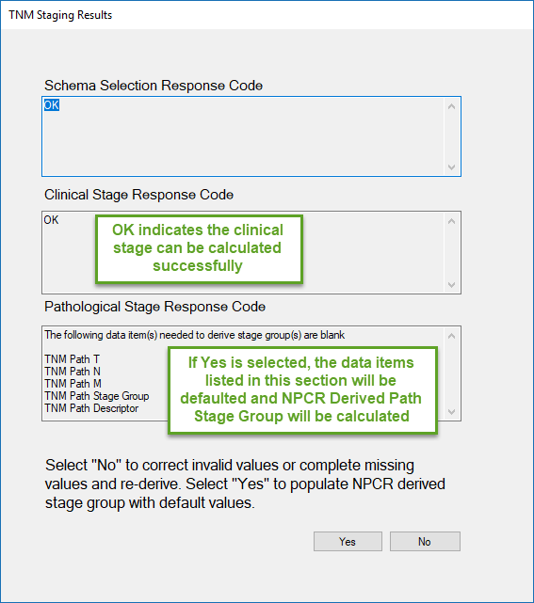

CRS Plus TNM Staging Results Window
Select Yes if no changes are necessary to TNM input items. NPCR Derived Clin Stg Grp (3650) and NPCR Derived Path Stg Grp (3655) will be populated with default values if applicable.

NOTE: NPCR Derived Clin Stg Grp (3650) and NPCR Derived Path Stg Grp (3655) will not be displayed in the Consolidated Patient and Tumor window since they are calculated and not consolidated; however, if Edits fail, the Consolidated Patient and Tumor window will refresh and will display all other data items below the consolidated items including the NPCR Derived Stage Group data items.

To update or review TNM input items, select No. The TNM Staging Results window will close and the Consolidated Patient and Tumor window will remain open so the TNM input items can be reviewed and updated in the New Consolidated column to correct the TNM items and successfully calculate NPCR Derived Clin Stg Grp (3650) and NPCR Derived Path Stg Grp (3655). Invalid values must be corrected for successful calculation.

NOTE: The look-up buttons to the right of the TNM data items in the New Consolidated column can be used to view the pick lists associated with the data items.

Modifications can also be made to the pending abstract and existing abstracts disposed to the database in the Consolidated Patient and Tumor window if necessary.

Step 5: Click on the Save button.
Once all TNM input values are corrected, click on Save. If all TNM calculation errors are resolved, the abstract will move on to the next step in the processing flow.

NOTE: Use the Save button and not the Save Abstract button below the Save button (The Save Abstract button saves changes to the pending abstract).

If the following message appears stating Edits failed, refer to the Procedure for Processing Pending Abstracts: Pending Edits.

CRS Plus Message Indicating Edits Failed

Procedure for Processing Pending Abstracts: TNM Stage Group Comparison
After data item consolidation, staging calculations are run based on Diagnosis Year. TNM calculation runs for cases diagnosed in 2016 and 2017. After successful TNM Calculation, the TNM directly-coded path stage group is compared to NPCR Derived Path Stg Grp (3655) and the TNM directly-coded clinical stage group is compared to NPCR Derived Clin Stg Grp (3650). If there is a discrepancy, the abstract will be sent to pending for TNM Stage Group Comparison.

Abstracts in pending for TNM Stage Group Comparison have already been linked by patient and tumor and automated consolidation of patient-specific and tumor-specific data was successful. Since patient and tumor linkages have already been determined, abstracts in pending for TNM Stage Group comparison may not be disposed by the user as a New Patient, New Tumor, or New Facility.

When an abstract in pending for TNM Stage Group Comparison is opened in the PendingAbstracts window and the TLC Plus button is selected, consolidation is run in case any changes were made as the result of importing, updating records, or processing of other pending records; therefore, it is possible for the case to require manual data item consolidation if changes were made to the database after the pending abstract was imported. If this occurs, refer to the Procedure for Processing Pending Abstracts: Data Item Consolidation.

Step 1: Select an Abstract in the PendingAbstracts window for TNM Stage Group Comparison.
Select an abstract identified by black font for TNM Calculation (Status2: 18 TNM Stage Group Comparison) by clicking on the abstract in the Pending List. Once the record is selected, the pending abstract will display to the right of the Pending List.

Pending TNM Stage Group Comparison records will be identified in the Matched Case Outline in the lower left of the pending window with a leading TG symbol.

NOTE: The pending abstract is view only in the PendingAbstracts window. Modifications to the pending abstract will not be allowed in this window; however, the pending abstract will be able to be modified in the Consolidated Patient and Tumor window.
Step 2: Click on TLCPlus.
Click on the TLCPlus button in the section labeled Dispose Abstract As in the lower left corner.

One of the following messages will appear.

If the message appears stating: "Consolidation failed. Click Yes if you want to correct these errors now"
Select Yes and refer to the Procedure for Processing Pending Abstracts: Data Item Consolidation. If the user selects No, the abstract will remain in pending for Data Item Consolidation.

CRS Plus Message Indicating Consolidation Failed
If the message appears stating: "Consolidation completed successfully and database was updated. Click OK to view consolidation log." The user can choose to click OK to view the consolidation log. Select Cancel to accept the automated consolidation decisions.

If the message appears stating: “TNM Stage Calculation failed. Click Yes if you want to correct these errors now.”

CRS Plus Message Indicating TNM Stage Calculation Failed

Select No and the abstract will be sent back to pending for TNM Calculation.

Select Yes and the Consolidated Patient and Tumor window will open. Automated consolidation decisions can be reviewed and modified in the Consolidated Patient and Tumor window.

Step 3: Click on the Save button.
Once the Consolidated Patient and Tumor window opens, click on the Save button in the upper-right corner of the window.
NOTE: Use the Save button and not the Save Abstract button below the Save button (The Save Abstract button saves changes to the pending abstract).

The following message will appear:

CRS Plus Message Indicating TNM Stage Calculation Failure
If Cancel is selected, the Consolidated Patient and Tumor window will close and the abstract will remain in pending for TNM Calculation.

Click on OK to view the detailed TNM errors.

Step 4: Review the TNM Staging Results
A TNM Staging Results window similar to the example below will display providing the results of the TNM calculation.

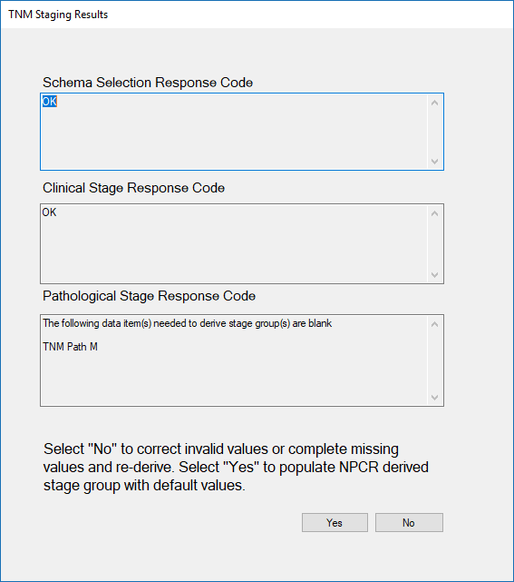

CRS Plus TNM Staging Results Window
Select Yes if no changes are necessary to TNM input items. NPCR Derived Clin Stg Grp (3650) and NPCR Derived Path Stg Grp (3655) will be populated with default values if applicable. To populate the NPCR derived stage group data item(s) due to a missing TNM input value, select Yes and the appropriate NPCR Derived Stage Group data item will be populated with 99.
NOTE: NPCR Derived Clin Stg Grp (3650) and NPCR Derived Path Stg Grp (3655) will not be displayed in the Consolidated Patient and Tumor window since they are calculated and not consolidated; however, if Edits fail, the Consolidated Patient and Tumor window will refresh and will display all other data items below the consolidated items including the NPCR Derived Stage Group data items.

To update or review TNM input items, select No. The TNM Staging Results window will close and the Consolidated Patient and Tumor window will remain open so the TNM input items can be reviewed and updated in the New Consolidated column to correct the TNM items and successfully calculate NPCR Derived Clin Stg Grp (3650) and NPCR Derived Path Stg Grp (3655). Invalid values must be corrected for successful calculation.
NOTE: The look-up buttons to the right of the TNM data items in the New Consolidated column can be used to view the pick lists associated with the data items.

Modifications can also be made to the pending abstract and existing abstracts disposed to the database in the Consolidated Patient and Tumor window if necessary.

Step 5: Click on the Save button.
Once all TNM input values are corrected, click on Save. If all TNM calculation errors are resolved, the abstract will move on to the next step in the processing flow.

NOTE: Use the Save button and not the Save Abstract button below the Save button (The Save Abstract button saves changes to the pending abstract).

Step 6: TNM Stage Group Comparison.
The following message will display when there is a difference between the TNM directly-coded path stage group compared to NPCR Derived Path Stg Grp (3655) or the TNM directly-coded clinical stage group compared to NPCR Derived Clin Stg Grp (3650).
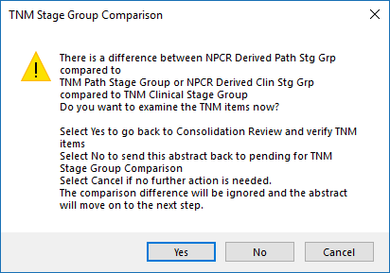

CRS Plus TNM Stage Group Comparison Message
If No is selected, the abstract will be sent back to pending for TNM Stage Group Comparison.

If Yes is selected, the TNM Stage Group Comparison window will close and the Consolidated Patient and Tumor window will remain open so the TNM input items can be reviewed and updated in the New Consolidated column modifications are needed.

If Cancel is selected, the comparison difference will be ignored and the TNM Stage Group Comparison window will close. The abstract will move on to the next step in the processing flow. It is possible to have a valid difference. The strict AJCC TNM rules were considered to develop the TNM API. If there are missing TNM input items, the NPCR Derived Path Stg Grp (3655) and/or the NPCR Derived Clin Stg Grp (3650) will be populated with 99.

Step 7: Click on the Save button.
Once all TNM input values are corrected, click on Save. If all TNM calculation errors are resolved, the abstract will move on to the next step in the processing flow.
NOTE: Use the Save button and not the Save Abstract button below the Save button (The Save Abstract button saves changes to the pending abstract).

If the following message appears stating Edits failed, refer to the Procedure for Processing Pending Abstracts: Pending Edits.

CRS Plus Message Indicating Edits Failed

Procedure for Suspending Pending Abstracts
Individual abstracts can be suspended or held to other users when it is determined a pending abstract should be held for review or to obtain additional information.

Step 1: Suspend Abstract
Select the abstract in the Pending List so it is highlighted and click on the Suspend button above the Pending List. The Suspend button is circled below in the print screen.
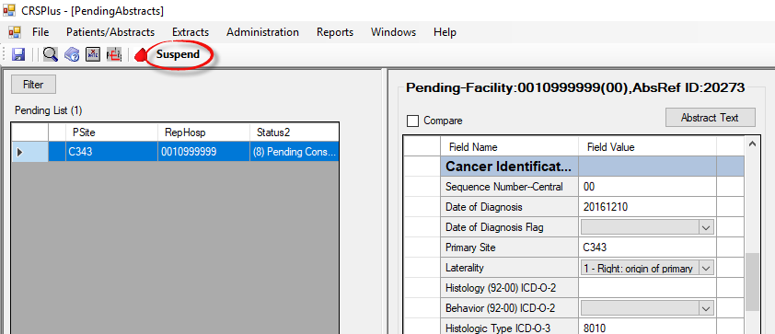

CRS Plus PendingAbstracts Suspend button
Step 2: Select User to Suspend Abstract To
The Suspend Pending Abstract window will open and will display the list of current users. Select the User so it is highlighted.
Step 3: Click on OK.
The Suspend Pending Abstract window will close and the HeldFor column in the Pending List will display the User ID for the suspended abstract.

Step 4: Suspend Option Changes to Unsuspend for Any Suspended Abstract in Pending List
The Unsuspend button is circled below in the print screen.
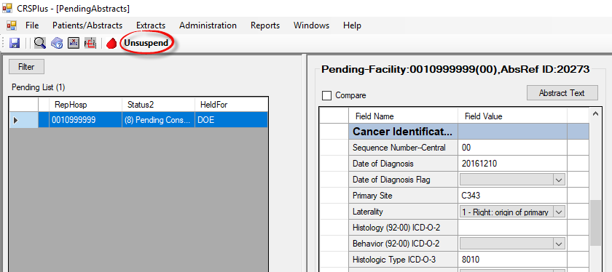

CRS Plus PendingAbstracts Unsuspend option
Step 5: Unsuspend Abstract
To unsuspend a pending abstract, click on the Unsuspend button above the Pending List for the selected suspended abstract.

Step 6: User ID Removed from HeldFor Column
The User ID will no longer display in the HeldFor column and the abstract will no longer be suspended.

Unlinking Pending Abstracts
Abstracts linked to a patient or tumor incorrectly in pending can be unlinked in the PendingAbstracts window by highlighting the pending abstract in the Matched Patient section and selecting the Unlink button in the Dispose Abstract As section below the Matched Patient.

A message similar to the one below will appear once the Unlink button has been selected.
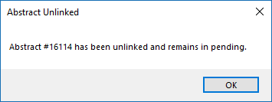

CRS Plus Abstract Unlinked confirmation message
Once OK is selected, the Pending List will refresh and the Status2 value will update to 0 (Not Set) for the unlinked pending abstract. The pending abstract will no longer be linked to the patient/tumor. Patient Linkage for potential matched patients will need to be completed manually.

A message prompt similar to the message below will appear if the user tries to unlink an abstract if it is the only abstract attached to the tumor. If additional restructuring is necessary, the Update Case Structure dialog will need to be accessed from the Patients/Abstracts menu - Find.
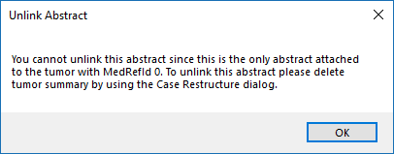

CRS Plus Unlink Abstract message received when unlinking abstracts cannot be successfully completed in pending
NOTE: Only the pending abstract can be unlinked in the PendingAbstracts window. All other restructuring options must be completed in the Update Case Structure dialog.

