Create an Azure App Service Mobile App
- Crate new Mobile App by clicking on: New -> Web + Mobile -> Mobile App
  - Remember "App Name" as it will be used by our Android app
  - Create a new Resource Group or choose from Existing
  - Choose App Service plan
  - Click on Create
  - Wait a few minutes; refresh your web browser
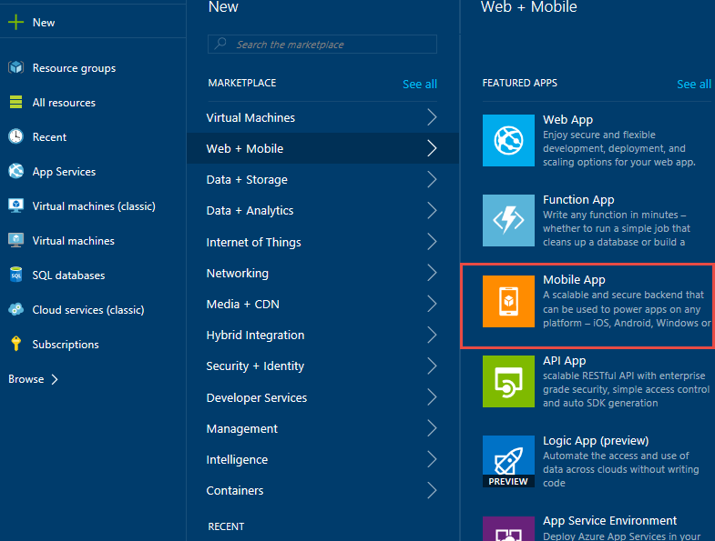

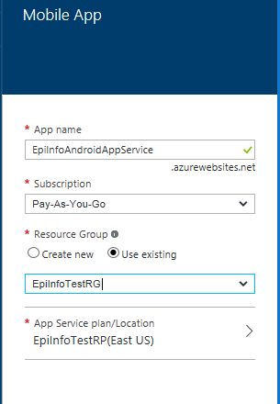

- Click the new icon that got created on the dashboard that looks like a tablet. If you don’t see the icon you can go to All resources and find the App Service you just created.

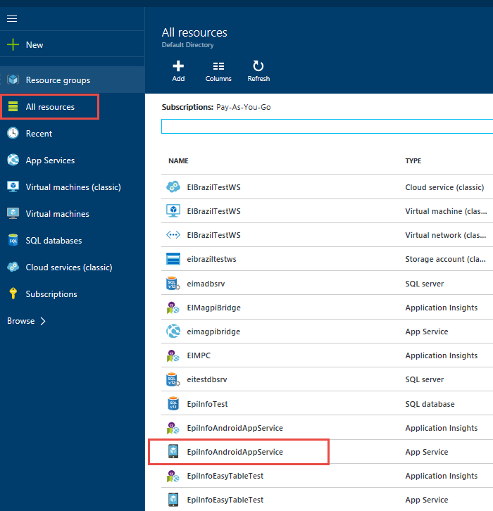
- Under Settings, Go to Mobile Section and click on Easy tables

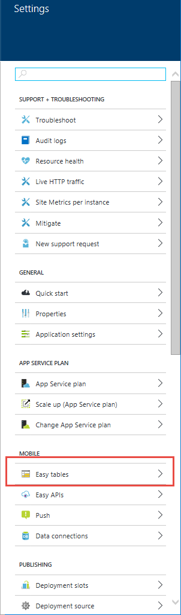

- Click on "Need to configure Easy Tables/Easy APIs - Click here to continue"

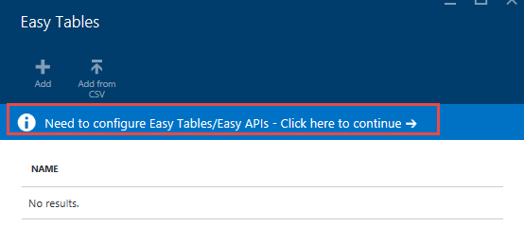

- Perform Step 1 Connect a database -> "Click here to create one"

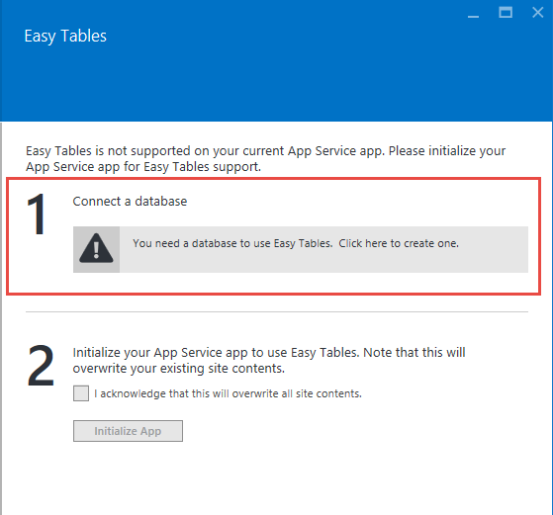

- In Data Connections blade click on Add

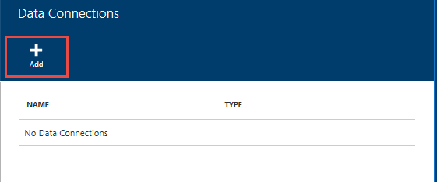

- In Add data connection blade click on "Configure required settings"
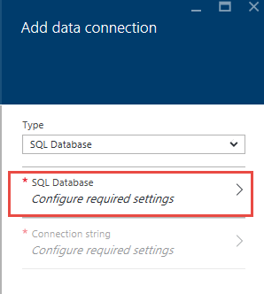

- Create a new database or set an existing database
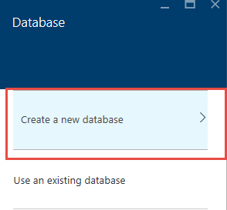
  - Provide Name for the database
  - Set pricing tier to Free or as per your need

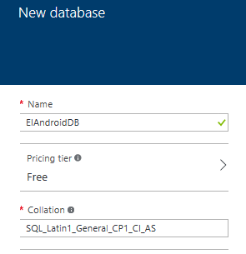

- Click on Configure required settings to configure database security setting

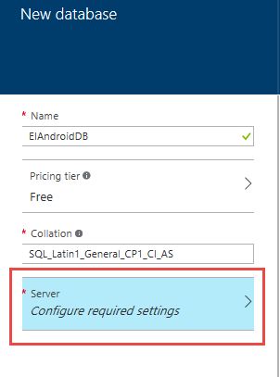

- In the New Server blade provide the Server name, Server admin login, Password, confirm password and choose the location of the server. Leave “Allow azure services to access server” checked. Click on OK

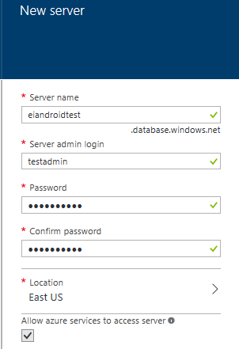

- Click OK on New Database blade
- Click OK in Add data connection blade
- Data connection creation process starts. Wait for the process to complete in Notification area. 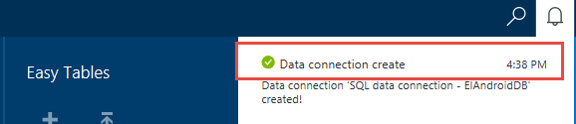

- Easy Tables -> "Need to configure Easy Tables/Easy APIs - Click here to continue" (yes, AGAIN!) -> Initialize app

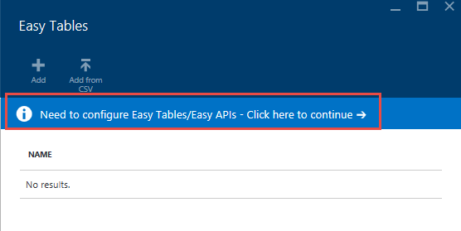

- In Easy Tables blade, perform Step 2 of Initialize app by clicking the acknowledgement check box

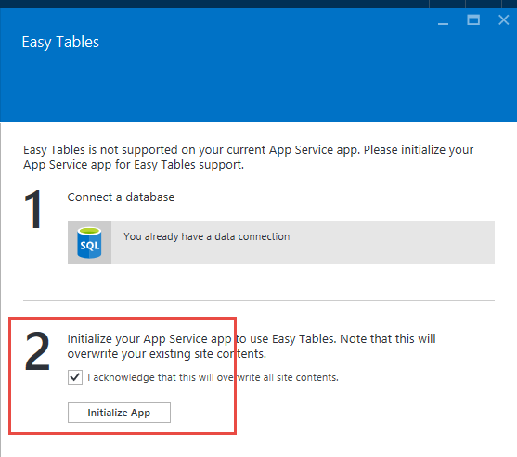

- Wait for the process to complete, watch the notification area for progress

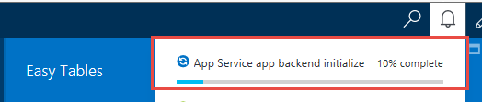

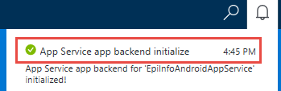

- In Easy Tables click on Add to add the table
  - The "Name" here needs to match your Epi Info form name. Table created for both Parent and child form have exactly same name as form name in Epi Info even though we append an underscore on the form name when copying to Android tablet.
  - Leave everything anonymous or disable certain functions (don't enable authentication). Click OK .

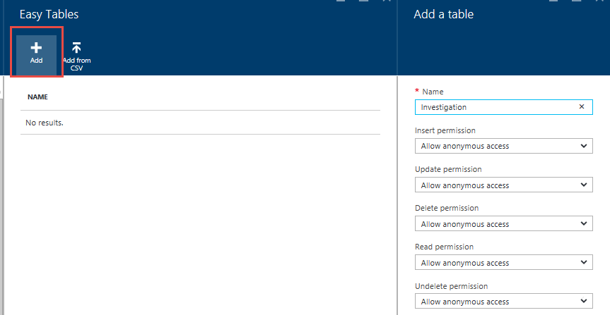

- Newly created table is available in the list of Easy Tables.
- Click the newly created table
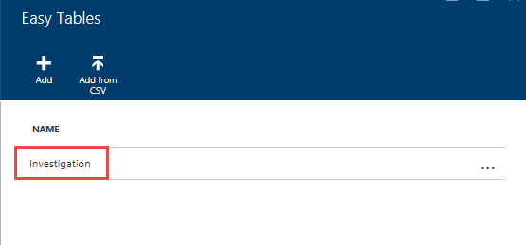

- In the blade for the table click on Edit Script

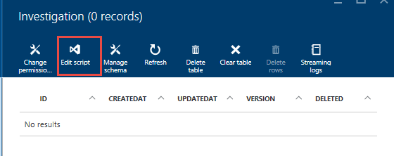

- Right-click on {your table name}.js and click on Delete in the context menu

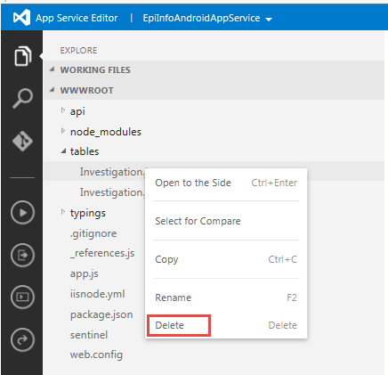

- Right-click on tables and click on Upload Files in the context menu

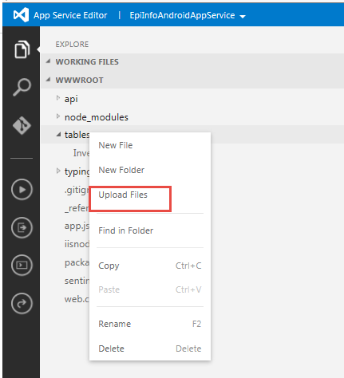

- Upload "easy_tables.js" file

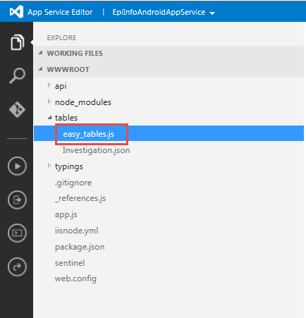

- In the javascript file for easy_tables.js file change the text that says "CHANGE ME" to a token that you will use on the Android app.

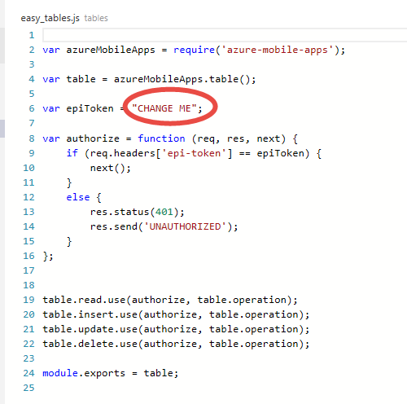

- Right-click on "easy_tables.js" and rename to {your table name}.js

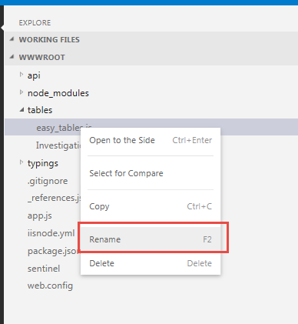

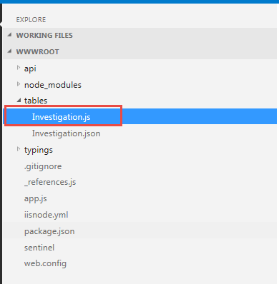

- Click {your table name}.json
  - Set "softDelete" to false

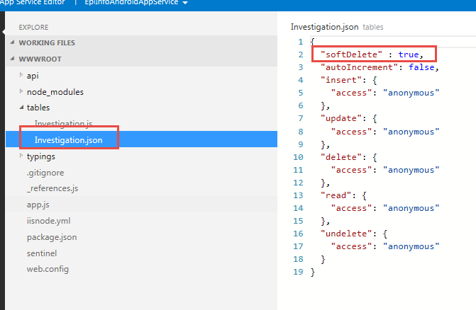

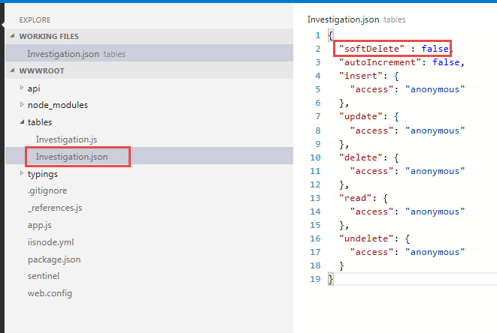

Information to be used by Epi Info Android application
- Mobile App name: This should be the name you gave to Mobile App. For example in the screenshot below the name of the Mobile App is “EpiInfoAndroidAppService”

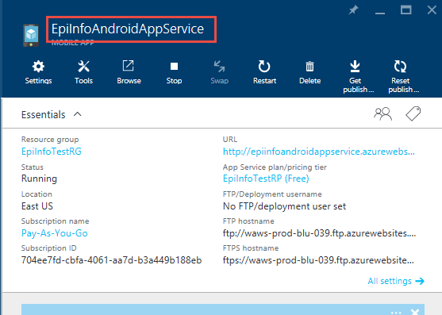

- The security token you typed in the JavaScript file for your table.

Epi Info Android Application Settings
Under Cloud Synchronization section under settings
- Turn off “Use Microsoft Azure classic services”
- Provide the name of Azure Mobile App in the Popup dialog
- Provide the value of Authorization token in the popup dialog for authorization token

