CDC Tuberculosis Surveillance Data Training

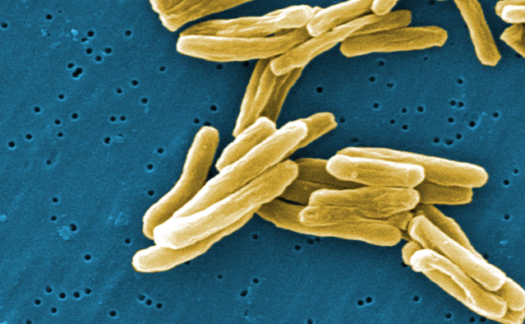
Mycobacterium tuberculosis

Report of Verified Case
of Tuberculosis (RVCT)

Self-Study Modules
Exercises (with Answers)

This document includes only the exercises used in the Self-Study Modules to practice completing the RVCT. It does not include the instructions for how to complete each item on the RVCT. The exercises have gone through an extensive review and field test process to make them accurate and reliable. However, the exercises can be used and adapted by local jurisdictions in their training courses.

June, 2009

 | U.S. Department of Health and Human Services  Centers for Disease Control and Prevention  National Center for HIV/AIDS, Viral Hepatitis, STD, and TB Prevention  Division of Tuberculosis Elimination | 

Module A – RVCT
(page 1 of 3)
Items 1 – 16

The RVCT report includes the first three pages of the RVCT data collection form. Pages 1, 2, and 3 of the RVCT report will be covered in Modules A, B, and C, respectively. Complete this report for all patients with a verified case of TB disease.

Module A provides instructions and exercises for completing page 1 of the RVCT report. This page includes data about patient demographics and site of disease.

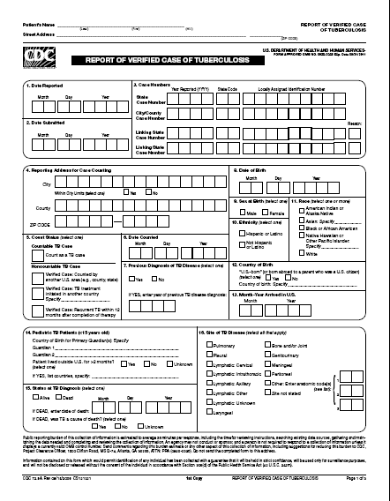

1. | Date Reported

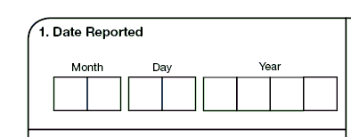

Exercise
1. | Date Reported

Note: Date Reported (item 1) is frequently confused with Date Submitted (item 2) and Date Counted (item 6). Read the instructions for each of the items to understand the differences. In the exercises for item 6, there is a study question and case study that involves all three items to help you learn the differences.

-+

For all questions in the Self-Study Modules, choose the one best answer.

1.1 | The Date Reported is the date that the health department …  (circle the one best answer)
 | A. | First suspects that the patient has TB
 | B. | Receives notification from a health care provider that the patient is  suspected of having TB
 | C. | Submits the RVCT to the reporting area
 | D. | A, B, and C are all correct
X | E. | Only A and B are correct

1.2 | How would January 3, 2009, be entered as the date for Date Reported?  (circle the one best answer)
 | A.
  Month |  |  | Day |  |  | Year
  J | A |  | 0 | 3 |  | 2 | 0 | 0 | 9
X | B.
  Month |  |  | Day |  |  | Year
  0 | 1 |  | 0 | 3 |  | 2 | 0 | 0 | 9

1.3 | How would February 2009 be entered as the date for Date Reported? The exact day of the month is not known.  (circle the one best answer)
X | A.
  Month |  |  | Day |  |  | Year
  0 | 2 |  | 9 | 9 |  | 2 | 0 | 0 | 9
 | B.
  Month |  |  | Day |  |  | Year
  0 | 2 |  | 0 | 0 |  | 2 | 0 | 0 | 9

Note for answer: For this item, the month and year always need to be entered. But if the exact day is not known, enter 99.

It is important to read the instructions for entering the dates for each item because they can vary from item to item. For some items enter “99” for the unknown month or day, and “9999” for the unknown year. This may vary from what will be entered into a computer software program.
- 03 99 2009 – for March, unknown day, in 2009
- 99 99 2009 – for unknown month and day in 2009
- 01 02 9999 – for January 2, in a year that is unknown

Case Study – Rose
On January 6, 2009, Dr. Joseph, a private physician, calls to notify the county health department about Rose, a patient who has signs and symptoms of TB. On January 10, the county health department receives a faxed copy of the laboratory results indicating that Rose’s sputum is AFB smear positive. Then on January 27, the RVCT form is completed by the county health department and sent to the state TB program.

1.4 | Which date would you enter as the Date Reported?  (circle the one best answer)
X | A. | January 6, 2009
 | B. | January 10, 2009
 | C. | January 27, 2009

Note for answer: The Date Reported is the date that a health department first suspects that the patient might have TB or first receives a report (verbal or written notification) from a health care provider. In this instance, the Date Reported is January 6. January 10 is the date that the county health department received laboratory results confirming TB diagnosis. January 27 is the Date Submitted.

2. | Date Submitted

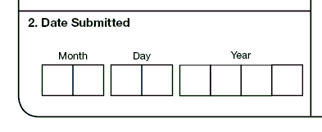

Exercise
2. | Date Submitted

2.1 | The Date Submitted is the date that the…  (circle the one best answer)
 | A. | Sputum sample is submitted to the laboratory
X | B. | RVCT is submitted to the reporting area
 | C. | Laboratory submits a confirmed diagnosis of TB to the health department
 | D. | A, B, and C are all correct
 | E. | Only A and B are correct

Case Study – Sue
On June 1, 2009, Sue, the health care worker at a county TB program, completes the RVCT for a patient from the TB clinic. On June 30, Sue sends the RVCT to the state TB program. On July 10, 2009, the state TB program determines that it is a case of TB.

2.2 | Which date would you enter as Date Submitted?  (circle the one best answer)
 | A. | June 1, 2009
X | B. | June 30, 2009
 | C. | July 10, 2009

Note for answer: Date Submitted is June 30 because this was the date that the RVCT form is submitted to the reporting area. June 1 is the date reported and July 10 is the date counted.

3. | Case Numbers

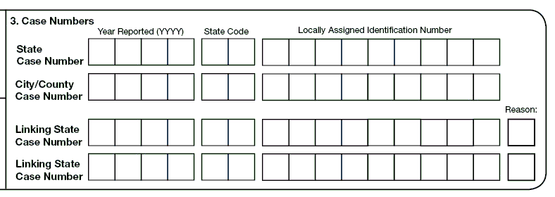

Exercise
3. | Case Numbers

Case Study – Henry
Henry is diagnosed with TB in June 2008 in Seattle, WA. His TB is counted as a new case and his 2008 locally assigned identification number is 000080301. He successfully completes directly observed therapy on December 12, 2008.

In August 2009, Henry presents to the Seattle hospital emergency room with a recent history of fever, weight loss, and non-productive cough. His subsequent sputum smears are positive. In 2009 he is reported as having TB disease, but it is NOT counted as a new TB case (i.e., this is less than 12 months since he completed treatment for his prior diagnosis of TB). His 2009 locally assigned identification number is 000090056.

3.1 | What is Henry’s 2009 State Case Number?  (circle the one best answer)
X | A.
  Year Reported (YYYY) |  |  |  |  | State Code |  |  | Locally Assigned Identification Number
  2 | 0 | 0 | 9 |  | W | A |  | 0 | 0 | 0 | 0 | 9 | 0 | 0 | 5 | 6
 | B.
  Year Reported (YYYY) |  |  |  |  | State Code |  |  | Locally Assigned Identification Number
  2 | 0 | 0 | 9 |  | W | A |  | 0 | 0 | 0 | 0 | 8 | 0 | 3 | 0 | 1

3.2 | What is his Linking State Case Number?  (circle the one best answer)
 | A.
  Year Reported (YYYY) |  |  |  |  | State Code |  |  | Locally Assigned Identification Number
  2 | 0 | 0 | 8 |  | W | A |  | 0 | 0 | 0 | 0 | 9 | 0 | 0 | 5 | 6
X | B.
  Year Reported (YYYY) |  |  |  |  | State Code |  |  | Locally Assigned Identification Number
  2 | 0 | 0 | 8 |  | W | A |  | 0 | 0 | 0 | 0 | 8 | 0 | 3 | 0 | 1

3.3 | What is the Reason for the Linking State Case Number?  (circle the one best answer)
X | A. | Reason 1 – Recurrence or previous diagnosis of TB
 | B. | Reason 2 – Epidemiologically linked case, source case or contact with another case
 | C. | Reason 3 – Case transferred from another area

Case Study – Lisa
In May 2008, Lisa is part of a contact investigation for her brother, who has infectious TB disease. Lisa is evaluated and diagnosed with TB disease also. She starts treatment for TB in June 2008.

3.4 | For Item 3 Case Number, what would you choose as the reason for the Linking State Case Number for Lisa?  (circle the one best answer)
 | A. | Reason 1 – Recurrence or previous diagnosis of TB
X | B. | Reason 2 – Epidemiologically linked case, source case, or contact with another case
 | C. | Reason 3 – Case transferred from another area

4. | Reporting Address for Case Counting

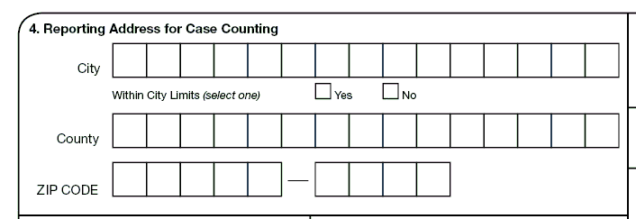

Exercise
4. | Reporting Address for Case Counting

Case Study – Laverne
Laverne lives in Chicago, Illinois. On May 1, 2009, she visits her sister Shirley in Milwaukee, Wisconsin, for a month. During the visit Laverne develops a bad cough and fever. She goes to the Milwaukee health clinic and is diagnosed with TB disease. On
June 2 Laverne returns home to Chicago, where she completes treatment.

4.1 | What reporting address should be entered on the 2009 RVCT for Laverne?  (circle the one best answer)
X | A. | Chicago, Illinois
 | B. | Milwaukee, Wisconsin

Note for answer: Laverne receives a new diagnosis in Milwaukee, but is an out-of-area resident and returns home for treatment. The reporting address should be her address in Chicago.

Case Study – Eduardo
Eduardo, a migrant worker, resides with his family in Sacramento, California. He travels south to work the strawberry harvest every year beginning in February. During harvest season, he lives in a boarding facility in the city of Watsonville, California. In May 2009, Eduardo is diagnosed with TB as part of a Watsonville screening program for migrant workers and begins treatment. After 2 months of treatment, he returns home to Sacramento, where he completes treatment.

4.2 | What reporting address should be entered on the 2009 RVCT?  (circle the one best answer)
 | A. | Sacramento
X | B. | Watsonville

Note for answer: Eduardo, a migrant worker, receives a new diagnosis, but is an out-of-area resident. Because of his migrant status, the reporting address for Eduardo should be the area in which he lives at the time of diagnosis, which is Watsonville. In addition, he should also be counted in the area in which he lives at the time of diagnosis (Watsonville), even if he returned to his permanent home in Sacramento for treatment. For more information on determining the reporting address for patients, see the Guidelines to Determine Reporting Address in the instructions for Reporting Address for Case Counting (item 4). For more information about how cases should be counted, see Count Status (item 5).

5. | Count Status

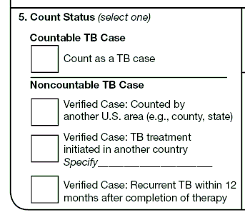

Exercise
5. | Count Status

Count Status (item 5) can be quite confusing, so there are 13 study questions and case studies included to help you understand this item.

5.1 | What information is needed to determine the Count Status?  (circle the one best answer)
 | A. | That it is a verified case of TB
 | B. | Whether the case is countable (meets surveillance definition)
 | C. | Confirmed that it is NOT counted by another US area
X | D. | A, B, and C are all correct
 | E. | Only A and B are both correct

Case Study – Carlos
Carlos is diagnosed with TB in May 2008 after being evaluated at a free clinic for homeless persons in Springfield, Missouri. He successfully completes directly observed therapy on December 10, 2008.

In July 2009, Carlos presents to Springfield Hospital, and an astute clinician recognizes signs of TB disease. Carlos’s chest radiograph is consistent with TB disease. His sputum smear is AFB-positive and he is started on anti-TB therapy. Later his culture result is positive for M. tuberculosis complex.

5.2 | Does Carlos have a countable case for 2009 national surveillance?  (circle the one best answer)
 | A. | Yes, because his recurrence of TB disease is more than 12 months after completion of therapy
 | B. | Yes, because his recurrence of TB disease is more than 12 months after initial diagnosis
X | C. | No, because his recurrence of TB disease is within 12 months of completion of therapy
 | D. | No, because his recurrence of TB disease is more than 12 months after initial diagnosis

Note for answer: Because his recurrence of TB disease was within 12 months of completion of therapy this recurrence is not considered a separate episode of TB. Initial diagnosis does not factor into this decision. A 2009 RVCT would be completed and in Count Status (item 5), Verified Case: Recurrent TB within 12 months would be selected.

Case Study – Carlos (continued)
Instead of having a TB recurrence diagnosed in July 2009, Carlos presents to the hospital on January 18, 2010. All clinical characteristics remain the same.

5.3 | Does Carlos have a countable case for 2010 national surveillance?  (circle the one best answer)
X | A. | Yes, because his recurrence of TB disease is more than 12 months after completion of therapy
 | B. | Yes, because his recurrence of TB disease is more than 12 months after initial diagnosis
 | C. | No, because his recurrence of TB disease is within 12 months of completion of therapy
 | D. | No, because his recurrence of TB disease is more than 12 months after initial diagnosis

Note for answer: It is Yes, because his recurrence of TB disease is more than 12 months after completion of therapy and is considered a new case of TB. A 2010 RVCT would be completed and for Count Status (item 5) count as a TB case would be selected.

Case Study for Items 3 and 5 – Raul
Raul lives in El Paso, Texas, and is diagnosed with TB disease in September 2008 and completes therapy on March 21, 2009. His Texas locally assigned identification number is 200800121. In December 2009, Raul moves to Arizona. He presents to the Tucson General Hospital with symptoms of TB on May 1, 2010, and is evaluated for TB. He is diagnosed with TB disease on May 12, 2010. His Arizona locally assigned identification number is 201000032.

5.4 | What is the State Case Number for Item 3 on the 2010 RVCT?  (circle the one best answer)
 | A.
  Year Reported (YYYY) |  |  |  |  | State Code |  |  | Locally Assigned Identification Number
  2 | 0 | 0 | 8 |  | T | X |  | 2 | 0 | 0 | 8 | 0 | 0 | 1 | 2 | 1
X | B.
  Year Reported (YYYY) |  |  |  |  | State Code |  |  | Locally Assigned Identification Number
  2 | 0 | 1 | 0 |  | A | Z |  | 2 | 0 | 1 | 0 | 0 | 0 | 0 | 3 | 2

5.5 | What is the Linking State Case Number for Item 3 on the 2010 RVCT?  (circle the one best answer)
X | A.
  Year Reported (YYYY) |  |  |  |  | State Code |  |  | Locally Assigned Identification Number
  2 | 0 | 0 | 8 |  | T | X |  | 2 | 0 | 0 | 8 | 0 | 0 | 1 | 2 | 1
 | B.
  Year Reported (YYYY) |  |  |  |  | State Code |  |  | Locally Assigned Identification Number
  2 | 0 | 1 | 0 |  | A | Z |  | 2 | 0 | 1 | 0 | 0 | 0 | 0 | 3 | 2

5.6 | What is the Reason for the Linking State Case Number for Raul?  (circle the one best answer)
X | A. | Reason 1 – Recurrence or previous diagnosis of TB
 | B. | Reason 2 – Epidemiologically linked case, source case, or contact with another case
 | C. | Reason 3 – Case transferred from another area

5.7 | How would you complete item 5, Count Status, on the 2010 RVCT?  (circle the one best answer)
X | A. | Count as a TB case
 | B. | Noncountable – Verified Case: Counted by another U.S. area
 | C. | Noncountable – Verified Case: TB treatment initiated in another country
 | D. | Noncountable – Verified Case: Recurrent TB within 12 months after completion of therapy

Note for answer: Raul’s case is counted as a new case of TB in Arizona because his recurrence of TB is more than 12 months after completion of therapy.
Case Study for Items 3 and 5 – Elton
Elton lives in Cut and Shoot, Texas, and is diagnosed with TB disease in June 2009 and immediately starts therapy. In December 2009, Elton moves to Truth or Consequences, New Mexico, and continues DOT through the County Health Department.

5.8 | What is the Reason for the Linking State Case Number for Elton?  (circle the one best answer)
 | A. | Reason 1 – Recurrence or previous diagnosis of TB
 | B. | Reason 2 – Epidemiologically linked case, source case, or contact with another case
X | C. | Reason 3 – Case transferred from another area

Note for answer: Communication between TB control programs to ensure continuity of care and submission of reports regarding a patient who is moving from one area to another should be conducted as securely and efficiently as possible (e.g., telephone, e-mail, secure fax, express courier).

Case Study for Items 3, 4, and 5 – John
The Tennessee TB program confirms that John is diagnosed with TB on November 1, 2008, and he starts on DOT. Tennessee counts his case as a 2008 case. John receives only one week of anti-TB therapy while in Tennessee. He is then reported as lost.

In December 2008, John moves to Fulton County, Georgia. He goes to the Fulton County TB Clinic on February 2, 2009, complaining of a prolonged cough and fever. During the interview, John reveals that he was treated for TB in the past in Tennessee. The Fulton County TB clinic evaluates him for TB disease. He is started on anti-TB therapy. The Fulton County TB Clinic contacts the Tennessee TB program to confirm the information and to inform the Tennessee program that John is now living in Georgia. On February 16, TB disease is confirmed based on a positive culture, and he completes treatment in Georgia, in August 2009.

5.9 | Which state should count the case?  (circle the one best answer)
X | A. | Tennessee
 | B. | Georgia

5.10 | What reporting address should be entered on the 2008 RVCT?  (circle the one best answer)
X | A. | John’s address in Tennessee
 | B. | John’s address in Georgia

5.11 | What is the Reason for the Linking State Case Number of the 2009 RVCT?  (circle the one best answer)
 | A. | Reason 1 – Recurrence or previous diagnosis of TB
 | B. | Reason 2 – Epidemiologically linked case, source case, or contact with another case
X | C. | Reason 3 – Case transferred from another area

5.12 | What reporting address should be entered on the 2009 RVCT?  (circle the one best answer)
 | A. | John’s address in Tennessee
X | B. | John’s address in Georgia

5.13 | How would you complete item 5, Count Status, on the 2009 RVCT?  (circle the one best answer)
 | A. | Count as a TB case
X | B. | Noncountable – Verified Case: Counted by another U.S. area
 | C. | Noncountable – Verified Case: TB treatment initiated in another country
 | D. | Noncountable – Verified Case: Recurrent TB within 12 months

Note for answer: A 2009 RVCT would be completed by Georgia listing John’s count status in Item 5 as a verified case counted by another area. The 2009 form is completed by Georgia and the 2009 reporting address should reflect his 2009 Georgia address to assess level of burden of a noncountable case. However, Georgia cannot count him in its 2009 case count because he has been counted as a case in Tennessee within 12 months. John never completed therapy in Tennessee, so Georgia should assist John in completing therapy, and communicate with Tennessee to provide details for case close-out.

6. | Date Counted

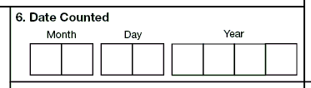

Exercise
6. | Date Counted

For questions 6.1 – 6.3
What is the description for the following items?
(Choose the one best answer by matching the description with the RVCT item. Write the letter for the description on the line next to the question number.)

 | Item |  |  | Description
C___ | 6.1 | Item 1, Date Reported |  | A. | Date the reporting area sends the RVCT to the counting authority
A___ | 6.2 | Item 2, Date Submitted |  | B. | Date that the count authority verifies the case as TB and it is included in the official case count
B___ | 6.3 | Item 6, Date Counted |  | C. | Date that a health department first suspects that the patient might have TB

Case Study – Richard
On September 3, 2009, Richard is diagnosed with culture-positive TB. It is confirmed that he has never had TB disease before. The RVCT form is completed by the county health department on September 12 and sent to the state TB program. On September 21 the state TB program determines that it is a new verified case of TB and reports it to CDC.

6.4 | Which date is the Date Counted?  (circle the one best answer)
 | A. | September 3, 2009
 | B. | September 12, 2009
X | C. | September 21, 2009

Note for answer: The Date Counted is the date that the responsible count authority verifies the case as a new case of TB and includes it in the official TB case count.

Case Study - Items 1, 2, and 6 – Reviewing the RVCT
You are reviewing an RVCT that your colleague Jim completed. You look at the following dates that were entered for Items 1, 2, and 6. You notice that there is a problem with the following dates.

Item 1 – Date Reported – May 18, 2009

Item 2 – Date Submitted – May 18, 2009

Item 6 – Date Counted – May 3, 2009

6.5 | What is the problem with the dates?  (circle the one best answer)
 | A. | The Date Reported cannot be the same date as the Date Submitted because the case cannot be submitted the same day that it was reported.
X | B. | The Date Counted cannot come before the Date Reported because the case has to be reported and evaluated before it can be counted.

7. | Previous Diagnosis of TB Disease

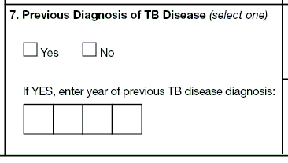

Exercise
7. | Previous Diagnosis of TB Disease

Case Study – David
In January 2009, David has a positive tuberculin skin test (TST) result. His sputum result is smear negative, with a normal chest radiograph, and he is treated for latent TB infection (LTBI). He completes treatment July 15, 2009. He goes to Cape Town, South Africa, for international training and returns home August 15, 2009. Four months later David becomes severely ill and on December 17, 2009, his chest radiographs are abnormal and consistent with TB. At that time, a sputum sample is sent to the laboratory. His sputum results indicate both smear and culture positive for M. tuberculosis complex.

7.1 | Is David considered to have a Previous Diagnosis of TB Disease?  (circle the one best answer)
 | A. | Yes, because he had a positive TST
 | B. | Yes, because he was treated for LTBI
X | C. | No, because he had LTBI and not TB disease

Note for answer: David is not considered to have a Previous Diagnosis of TB Disease because in January 2009 he had LTBI and not TB disease.

8. | Date of Birth

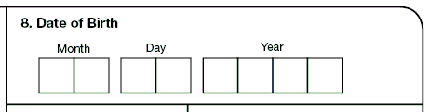

Exercise
8. | Date of Birth

Case Study – Edris
Your patient Edris is from Iran. When you ask him for his date of birth, he says that he is born in 1947, but he has never seen his birth certificate and his parents could not remember when he was born, so he isn’t sure of the month and day. He also mentions that he sometimes uses March 21, 1947, as his birth date and sometimes February 23 as the date.

8.1 | What would be entered for Edris’ date of birth?  (circle the one best answer)
 | A.
  Month |  |  | Day |  |  | Year
  0 | 3 |  | 2 | 1 |  | 1 | 9 | 4 | 7
 | B.
  Month |  |  | Day |  |  | Year
  0 | 2 |  | 2 | 3 |  | 1 | 9 | 4 | 7
X | C.
  Month |  |  | Day |  |  | Year
  9 | 9 |  | 9 | 9 |  | 1 | 9 | 4 | 7

9. | Sex at Birth

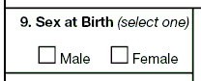

Exercise
9. | Sex at Birth

Case Study – Dahlia
You are meeting with Dahlia and filling out the RVCT form. You ask Dahlia what was her sex at birth. Dahlia insists that she is a woman. You are suspicious because Dahlia looks and dresses like a woman, but she has a very deep voice, large hands and feet, and there appears to be some facial hair. While showing respect for Dahlia and the sensitivity of the situation, you stress confidentiality and mention that this form is for surveillance purposes only. You ask her what sex is listed on her birth certificate. Dahlia mentions that it is male, but she had an operation that brought out her feminine side.

9.1 | What do you list as Dahlia’s sex at birth?  (circle the one best answer)
X | A. | Male
 | B. | Female

Note for the answer: Health care workers are dependent on the answers that the patients provide, regardless of how the health care worker thinks the items should be answered. However, asking the patient probing questions and reviewing the patient’s medical records and other documentation can provide the most accurate answers for biological sex at birth.

10. | Ethnicity

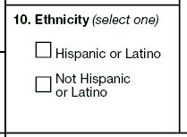

Exercise
10. | Ethnicity

Case Study – Susy
Susy is a school teacher. She went to the Houston, Texas, Health Department for TB testing because of an outbreak at her school. She was diagnosed with TB disease. You ask her ethnicity and she says multi-racial because her father is an American Indian from Arizona and her mother is Cuban. You explain the difference between race and ethnicity and you ask her if she considers herself Hispanic or Latino, or not Hispanic or Latino. Susy says that she is part Hispanic.

10.1 | What do you check for Item 10 Ethnicity?  (circle the one best answer)
X | A. | Hispanic or Latino
 | B. | Not Hispanic or Latino

11. | Race

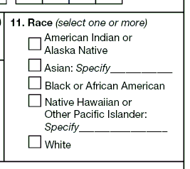

Exercise
11. | Race

Case Study – Joaquin
You ask Joaquin how he defines his race. You state that there are several options for race and he can select whatever he thinks is appropriate. Joaquin says his father is African American and his mother is full-blooded Cherokee Indian, so he thinks he is both of those races.

11.1 | Which of the following do you check for Item 11 Race?  (circle the one best answer)
 | A. | American Indian or Alaska Native
 | B. | Asian
 | C. | Black or African American
 | D. | Native Hawaiian or Other Pacific Islander
X | E. | Both A and C

Note for answer: Joaquin says his mother is American Indian and his father is African American, so the answer is E because both A and C are correct.

Case Study – Trang
The health care worker asks Trang what race she is. She states that she is Filipino and Vietnamese.

11.2 | Which of the following do you check for Item 11 Race?  (circle the one best answer)
 | A. | American Indian or Alaska Native
X | B. | Asian
 | C. | Black or African American
 | D. | Native Hawaiian or Other Pacific Islander
 | E. | Both A and C

Note for answer: Trang is Filipino and Vietnamese, which are both considered Asian race. Even though the Philippines are islands in the Pacific, Filipinos are considered an Asian race.

12. | Country of Birth

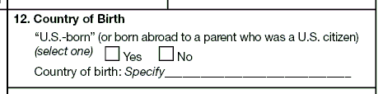

Exercise
12. | Country of Birth

Case Study – Wolfgang
You are completing an RVCT on Wolfgang and you ask him his country of birth. He says he was born in Germany. His father was born in the United States and is a U.S. citizen. His mother is a German citizen. They married when his father was stationed in Germany.

12.1 | What do you specify for “U.S.-born”?  (circle the one best answer)
X | A. | Yes
 | B. | No

Note for answer: When a patient was born abroad to a parent who is a U.S. citizen, the patient is considered “U.S.-born.”

12.2 | What do you specify for Country of Birth?  (circle the one best answer)
 | A. | United States
X | B. | Germany

Note for answer: Because Wolfgang was actually born in Germany, the correct answer is Germany.

Case Study – Bernard
Bernard was born in Tryon, North Carolina. Both of his parents were born in Hungary.

12.3 | What do you specify for “U.S.-born”?  (circle the one best answer)
X | A. | Yes
 | B. | No

Note for answer: Bernard is considered “U.S.-born” because he was born in 1 of the 50 states or the District of Columbia. Even though both of his parents were born in a foreign country, he is still considered “U.S.-born.”

12.4 | What do you specify for Country of Birth?  (circle the one best answer)
X | A. | United States
 | B. | Hungary

Note for answer: Bernard was born in the United States, so the answer would be United States.

Case Study – Mayleen
Mayleen was born in Guam. Both of her parents were born in Palau. They had moved to Guam for one year during the time when Mayleen was born.

12.5 | What do you specify for “U.S.-born”?  (circle the one best answer)
 | A. | Yes
X | B. | No

Note for answer: Mayleen is not considered “U.S.-born” because she was not born in 1 of the 50 states or the District of Columbia and neither of her parents were U.S. citizens. Mayleen is a U.S. citizen but not U.S.-born. Her parents are citizens of Palau. However, if they had been born in Guam they would be considered U.S. citizens and Mayleen would be considered “U.S.-born.”

12.6 | What do you specify for Country of Birth?  (circle the one best answer)
 | A. | Palau
X | B. | Guam
 | C. | United States

Note for answer: Mayleen was born in Guam, so the answer would be Guam.

Case Study – Jiguna
Jiguna was born in Kenya. Both his mother and father were Kenyan citizens. The family moved to the United States when Jiguna was 2 months old.

12.7 | What do you specify for “U.S.-born”?  (circle the one best answer)
 | A. | Yes
X | B. | No

Note for answer: Jiguna was born abroad to parents who were not U.S. citizens. Therefore he is not considered “U.S.-born.”

12.8 | What do you specify for Country of Birth?  (circle the one best answer)
 | A. | United States
X | B. | Kenya

Note for answer: Because Jiguna was born in Kenya, the correct answer is Kenya.

13. | Month-Year Arrived in U.S.

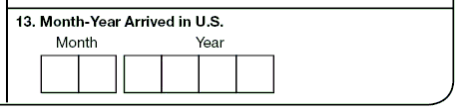

Exercise
13. | Month-Year Arrived in U.S.

Case Study – Julia
Julia is a citizen of El Salvador. In January 2008 she came to the U.S. on a student visa. In June 2009 she returned home to El Salvador. In September 2010 she returned to the United States on another student visa.

13.1 | What is the month and year that Julia arrived in the United States?  (circle the one best answer)
X | A.
  Month |  |  | Year
  0 | 1 |  | 2 | 0 | 0 | 8
 | B.
  Month |  |  | Year
  0 | 9 |  | 2 | 0 | 1 | 0

Note for answer: When a patient is born abroad, the date arrived in the U.S. should be when the patient entered the U.S. for the first time.

Case Study – Ken
Ken was born March 16, 2000, in Majuro, Republic of the Marshall Islands (RMI). His mother is a U.S. citizen and his father is a citizen of the RMI. On December 20, 2009, he migrated with his family to Arkansas. He is diagnosed with TB on March 5, 2010.

13.2 | What do you enter for Ken for Month-Year Arrived in the U.S.?  (circle the one best answer)
 | A.
  Month |  |  | Year
  0 | 3 |  | 2 | 0 | 0 | 0
X | B.
  Month |  |  | Year
  1 | 2 |  | 2 | 0 | 0 | 9
 | C.
  Month |  |  | Year
  0 | 3 |  | 2 | 0 | 1 | 0
 | D.
  Month |  |  | Year
   |  |  |  |  |  |  | (Leave answer blank)

Note for answer: The answer is B. For patients born in another country, enter month and year first arrived in the U.S. Ken was born in the Republic of the Marshall Islands and moved to Arkansas. Even though his mother is a U.S. citizen and Ken is “U.S.-born,” the item is asking when the patient first arrived in the U.S.

14. | Pediatric TB Patients (<15 years old)

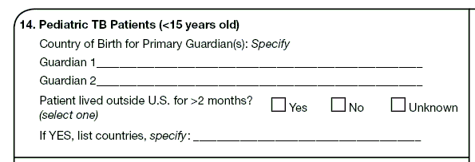

Exercise
14. | Pediatric TB Patients (<15 years old)

Case Study – Pim
Pim, a pediatric TB patient, was born in Portland, Oregon, on March 6, 2000. Her father was born in Thailand and immigrated to the U.S. in 1998. Her mother was born in Burlington, Vermont. The family traveled to Thailand for 3 weeks in 2005, but have not been out of the U.S. since that time. Pim’s parents were divorced in 2006 and her mother remarried in 2008. Pim lives with her mother and stepfather who was also born in Vermont. Her father and mother share joint custody, and Pim stays with her father every other weekend.

14.1 | What would you enter for Country of Birth for the primary guardians?  (circle the one best answer)
X | A. | Guardian 1 - United States (based on mother)  Guardian 2 - Thailand (based on father)
 | B. | Guardian 1 - United States (based on mother)  Guardian 2 - United States (based on stepfather)

Note for answer: Although Pim’s parents are divorced, in this case it is probably best to enter her mother’s and father’s countries of birth. The guardians are usually the parents. There are only 2 lines, so it is not possible to indicate 3 people. In another situation, it might be better to list the stepfather; it just depends on the situation. It is important to identify not only the guardian who has the most contact with the child, but also the guardian who may have a possible risk of TB exposure. In this case, Pim’s father would be a higher priority than the stepfather because he still has regular and frequent contact with her, and he also has a risk factor because he immigrated from Thailand. If the biological father was not at risk of TB and everything else was equal with the stepfather, then the stepfather would probably be listed as the guardian. It just depends on how the state TB program views guardianship and factors that put the patient at greatest risk for TB.

14.2 | What do you specify for Patient lived outside the U.S. for >2 months?  (circle the one best answer)
 | A. | Yes
X | B. | No
 | C. | Unknown

Case Study for Items 12 and 14 – Antonio
Antonio, a pediatric patient, was born in El Salvador. His father was born in the United States and living in El Salvador when Antonio was born. His mother was born in El Salvador and was a citizen of El Salvador. Antonio’s mother died shortly after his birth, and Antonio was raised mostly by his father.

In January 2003, 8-year-old Antonio moved from El Salvador to Houston, Texas, when his father could no longer care for him. At that time, his uncle and aunt, the Trujillos, became his legal guardians and he has lived with them since that time. Both his uncle and aunt were born in El Salvador, but have been living in the United States for over 30 years.

14.3 | For Item 12, what do you select for “U.S.-born”?  (circle the one best answer)
X | A. | Yes
 | B. | No

Note for answer: Antonio is “U.S.-born” because his father was born in the United States and is a U.S. citizen.

14.4 | For Item 12, what is the Country of Birth for Antonio?  (circle the one best answer)
X | A. | El Salvador
 | B. | United States

Note for answer: The answer is El Salvador because Antonio was actually born in El Salvador.

14.5 | For Item 14, what is the Country of Birth for the primary guardians at time of diagnosis for TB?  (circle the one best answer)
 | A. | Guardian 1 – US (based on father)  Guardian 2 – El Salvador (based on his uncle and/or aunt)
X | B. | Guardian 1 – El Salvador (based on uncle)  Guardian 2 – El Salvador (based on aunt)

Note for answer: The answer might depend on how the state TB program views guardianship. Antonio’s legal guardians are his uncle and aunt, the Trujillos, both born in El Salvador. His birth parents’ birth countries are El Salvador (mother) and the United States (father). Following are 3 options for how this item could be answered (depending on the state rules regarding parental care):
- If the TB program decided that Antonio still has contact with his father, the relevant primary guardians might be from El Salvador (Trujillos) and the United States (father).
- If the TB program decided that Antonio is primarily cared for by the Trujillos, the relevant primary guardians might be from El Salvador (Trujillos).
- If the TB program routinely captures data on the country of birth of the pediatric patients’ mother and father, the relevant answer might be El Salvador (mother) and United States (father).

Case Study for Item 14 – Antonio (cont.)
In 2007, Antonio visited his father in El Salvador during June 5 – September 30. He returned to the United States on October 1.

14.6 | For Item 14, did Antonio live outside the U.S. for >2 months?  (circle the one best answer)
X | A. | Yes
 | B. | No
 | C. | Unknown

Note for answer: Since Antonio was out of the United States for an uninterrupted period of more than 2 months, select Yes.

Case Study – Regina
Regina, a pediatric TB patient, visited her grandmother in Russia during April 7 – June 1, 2008. She returned to the United States on June 1.

14.7 | For Item 14, did Regina live outside the U.S. for >2 months?  (circle the one best answer)
 | A. | Yes
X | B. | No
 | C. | Unknown

Note for answer: Answer No because Regina was out of the United States for an uninterrupted period less than 2 months.

Case Study – Lisa
Lisa, a pediatric TB patient, traveled with her parents to the Philippines September 1 –
November 1, 2009. They traveled to Taiwan and visited her grandmother November 1 – November 15. Then they traveled to Vietnam November 15 – December 15. Lisa and her parents returned to the United States on December 16.

14.8 | For Item 14, did Lisa live outside the U.S. for >2 months?  (circle the one best answer)
X | A. | Yes
 | B. | No
 | C. | Unknown

Note for answer: Answer Yes because Lisa was out of the United States for more than 2 months uninterrupted.

15. | Status at TB Diagnosis

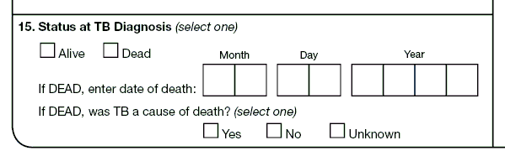

Exercise
15. | Status at TB Diagnosis

Case Study – Thomas
Thomas is admitted to the hospital on August 5, 2009. He is coughing up blood. He reports having symptoms consistent with TB for the past 7 months and his chest radiograph shows significant deterioration of both lung lobes. He is placed in a TB isolation unit and begins isoniazid, ethambutol, rifampin, and pyrazinamide. He dies 1 week later on August 12, 2009.

15.1 | What is the Status at TB Diagnosis?  (circle the one best answer)
X | A. | Alive
 | B. | Dead

Case Study – Ruth
Ruth comes to the emergency room on April 30, 2009. She is diagnosed with pneumonia, given antibiotics, and discharged. She dies 2 weeks later on May 15, 2009. At autopsy, the pathology shows granulomatous changes consistent with TB disease. A lung biopsy culture is found to be positive for M. tuberculosis complex.

15.2 | What is the Status at TB Diagnosis?  (circle the one best answer)
 | A. | Alive
X | B. | Dead

Note for answer: Ruth’s status is dead at diagnosis. Even though she clearly had TB when she came to the emergency room, TB was not suspected until after her death when the autopsy was performed.

15.3 | Was TB a cause of death for Ruth?  (circle the one best answer)
X | A. | Yes
 | B. | No

Note for answer: Yes, TB was a cause of death. Regardless of whether pneumonia was misdiagnosed or was the immediate cause of death, TB was an underlying cause of death based on the autopsy. Ruth has a verified case of TB based on positive pathology results on lung tissue, which would be recorded in Smear/Pathology/Cytology of Tissue and Other Body Fluids (item 19).

16. | Site of TB Disease

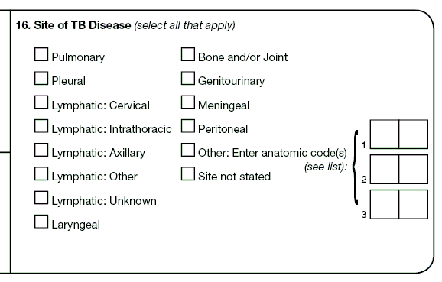

Exercise
16. | Site of TB Disease

Case Study – June
June is 65 years old and has been diagnosed with TB disease. Her chest x-ray shows a right pleural effusion, a right upper lobe infiltrate, and enlargement of the right intrathoracic lymph nodes. The pleural biopsy showed granulomas that were AFB positive and the sputum culture grew M. tuberculosis complex.

16.1 | What is (are) the Site(s) of TB Disease?  (circle the one best answer)
 | A. | Pulmonary
 | B. | Pleural
 | C. | Lymphatic intrathoracic
 | D. | Peritoneal
X | E. | A, B, and C are all correct

Note for answer: TB disease is found in the pulmonary, pleural, and lymphatic intrathoracic sites, so all three sites should be selected. This item is usually completed by an MD consultant.

Case Study – Leonard
Leonard is a 47-year-old HIV-positive male with a 3-month history of progressive fatigue and shortness of breath. His doctor diagnosed severe anemia, and a bone marrow biopsy showed extensive granulomatous inflammation teeming with AFB. Culture of blood and bone marrow grew M. tuberculosis complex. His chest x-ray and chest CT scan were normal.

16.2 | What is (are) the Site(s) of TB Disease?  (circle the one best answer)
 | A. | Bone and/or joint
 | B. | Other, anatomic code 04
 | C. | Other, anatomic code 06
 | D. | A and B are both correct
X | E. | B and C are both correct

Note for answer: Bone and/or joint is not correct. TB disease is found in both the blood and bone marrow. Choose “Other: enter anatomic code(s).” The anatomic codes are listed in Appendix C – Anatomic Codes.
Module B - RVCT
(page 2 of 3)
Items 17 – 25

Module B provides instructions and exercises for completing page 2 of the RVCT report. It includes data about laboratory results and primary reason the patient was evaluated for TB disease.

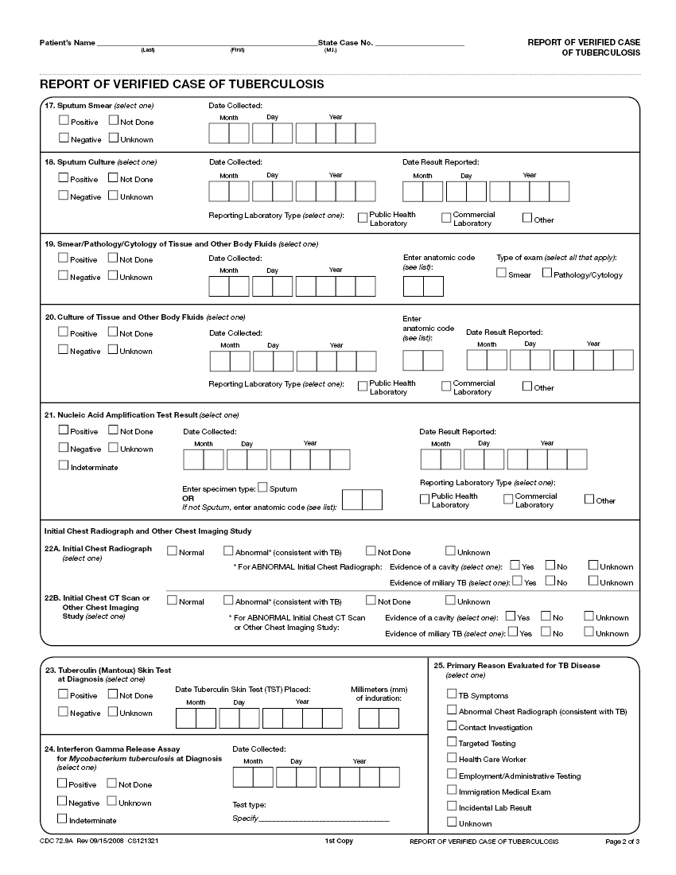

17. | Sputum Smear

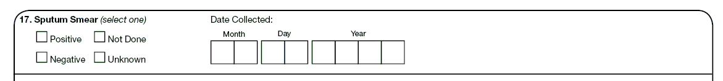

Exercise
17. | Sputum Smear (revised)

Case Study for Items 17 and 18 – James
James is in the hospital from January 13 through January 28, 2009. During that time he is diagnosed with TB. You subsequently receive laboratory reports from the hospital with James’ sputum smear results. They are as follows:
- Specimen collected on January 13 - sputum smear result was positive
- Specimen collected on January 16 - sputum smear result was positive
- Specimen collected on January 22 - sputum smear result was negative
- Specimen collected on January 28 - sputum smear result was negative

17.1 | What option should be selected for Sputum Smear?  (circle the one best answer)
X | A. | Positive
 | B. | Negative
 | C. | Not done
 | D. | Unknown

Note for answer: Select positive if any of the results are positive.

17.2 | What is the date collected?  (circle the one best answer)
X | A. | January 13
 | B. | January 16
 | C. | January 22
 | D. | January 28

Note for answer: January 13 is the date collected because that was the date when the first positive sputum was collected.

18. | Sputum Culture

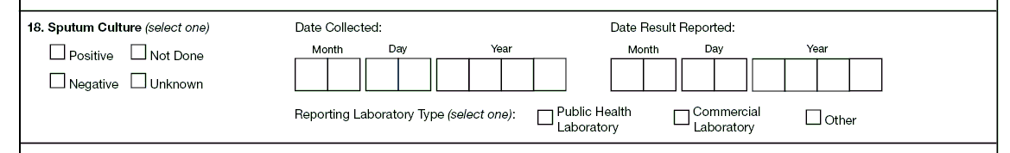

Exercise
18. | Sputum Culture

Case Study – James (continued from Item 17)
In February you received faxed copies of the final sputum culture results for James from Forbes Diagnostics Incorporated. These were for the sputum culture specimens collected while James was in the hospital.

- Specimen collected on January 13 – sputum culture result was negative and result was received on February 13

- Specimen collected on January 16 – sputum culture result was positive and result was received on February 16

- Specimen collected on January 22 – sputum culture result was positive, and result was received on February 22

- Specimen collected on January 28 – sputum culture result was positive, and result was received on February 28

18.1 | What option should be selected for the Sputum Culture?  (circle the one best answer)
X | A. | Positive
 | B. | Negative
 | C. | Not done
 | D. | Unknown

18.2 | What is the date collected?  (circle the one best answer)
 | A. | January 13
X | B. | January 16
 | C. | January 22
 | D. | January 28

18.3 | What is the date that the result is reported?  (circle the one best answer)
 | A. | February 13
X | B. | February 16
 | C. | February 22
 | D. | February 28

Note for answer: January 16 was date that the first positive culture specimen was collected. February 16 is the date that the first positive culture was reported.

18.4 | What reporting laboratory type should be selected?  (circle the one best answer)
 | A. | Public health laboratory
X | B. | Commercial laboratory
 | C. | Other

Note for answer: Forbes Diagnostics Incorporated is a commercial laboratory because fees are charged for each specimen processed or test performed.

18.5 | What Reporting Laboratory Type should be selected if the sputum sample had been analyzed by National Jewish Health hospital laboratory? (circle the one best answer)
 | A. | Public health laboratory
 | B. | Commercial laboratory
X | C. | Other

Note for answer: National Jewish Health hospital laboratory is not considered a public health laboratory or a commercial laboratory. This laboratory sometimes charges for services, but for the purposes of the RVCT it is categorized as “Other.”

19. | Smear/Pathology/Cytology of Tissue and Other Body Fluids

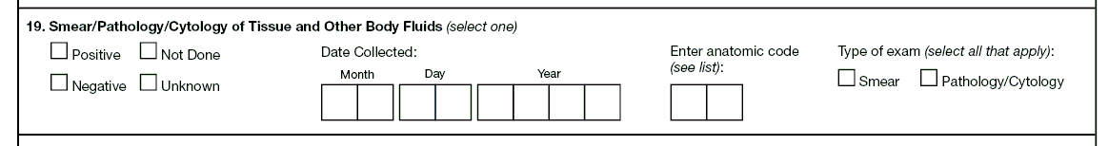

Exercise
19. | Smear/Pathology/Cytology of Tissue and Other Body Fluids

Case Study – Tricia
Four-year-old Tricia has a gastric aspiration procedure done on admission to the hospital on January 7, 2009. The laboratory report indicates that the gastric aspirate smear is negative for acid fast bacilli (AFB).

19.1 | What option should be selected for Smear/Pathology/Cytology of Tissue and Other Body Fluids?  (circle the one best answer)
 | A. | Positive
X | B. | Negative
 | C. | Not done
 | D. | Unknown

19.2 | What is the anatomic code?  (circle the one best answer)
 | A. | 52 – gastric aspirate
X | B. | 56 – gastric aspirate
 | C. | 68 – gastric aspirate

19.3 | What is the type of exam?  (circle the one best answer)
X | A. | Smear
 | B. | Pathology/Cytology

Case Study – Sam
Sam has fine needle aspiration to sample lung fluid followed by a lung biopsy. The laboratory report indicates that the smear of the lung fluid is negative for AFB. However, the lung tissue shows AFB, inflammation, and granulomas consistent with TB disease.

19.4 | What entry should be selected for the results?  (circle the one best answer)
X | A. | Positive, because the lung tissue shows AFB organisms
 | B. | Negative, because the smear results of the fluid are negative
 | C. | Unknown, because there is a discrepancy between the two tests

19.5 | What would be selected for the type of exam?  (circle the one best answer)
 | A. | Smear
X | B. | Pathology/Cytology
 | C. | Both A and B are correct

Note for answer: Any positive result supersedes a negative result in reporting TB diagnostic criteria. Since the results are discrepant (smear negative, pathology positive), Type of Exam should correspond to the result captured as positive. If both smear and pathology are positive, both smear and pathology/cytology should be checked under Type of Exam.

20. | Culture of Tissue and Other Body Fluids

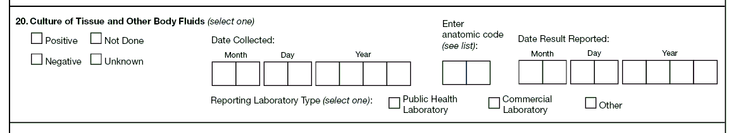

Exercise
20. | Culture of Tissue and Other Body Fluids

Case Study – Kevin
Kevin is hospitalized for TB meningitis. On October 13, 2009, his cerebral spinal fluid is collected. On October 20, the test result is returned and indicates that the sample had been contaminated. On October 25, a second cerebral spinal fluid sample is taken and sent for culture to the state health laboratory. On November 22, the culture result for the second sample is reported to the hospital as positive for M. tuberculosis complex. That same day the result is also reported to the health department.

20.1 | What would be selected for Culture of Tissue and Other Body Fluids?  (circle the one best answer)
X | A. | Positive
 | B. | Negative
 | C. | Not done
 | D. | Unknown

20.2 | What is the date collected?  (circle the one best answer)
 | A. | October 13, 2009
 | B. | October 16, 2009
X | C. | October 25, 2009

Note for answer: The date collected is the date for the specimen that came back positive. The initial specimen collected on October 13 is contaminated. The second specimen collected on October 25 has a positive result, so that is the date used for date collected.

20.3 | What should you enter for date result reported?  (circle the one best answer)
 | A. | October 16, 2009
 | B. | October 25, 2009
X | C. | November 22, 2009

20.4 | What reporting laboratory type should be selected?  (circle the one best answer)
X | A. | Public health laboratory
 | B. | Commercial laboratory
 | C. | Other

Note for answer: Public health laboratory was selected because the specimen was sent to the state health laboratory.

21. | Nucleic Acid Amplification Test Result

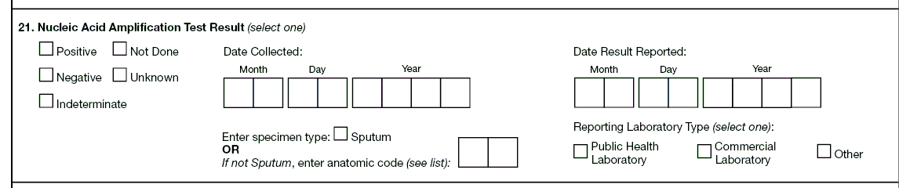

Exercise
21. | Nucleic Acid Amplification Test Result

Case Study – Newton
Newton is planning to go to England on vacation in one week. He is feeling sick and presents at the Newnan County Health Department with symptoms of TB. His doctor requests a nucleic acid amplification (NAA) test because he is a TB suspect. The test can determine if Newton has TB disease before he leaves on vacation. The NAA test result is inconclusive.

21.1 | What NAA test result should be selected?  (circle the one best answer)
 | A. | Positive
 | B. | Negative
 | C. | Not done
 | D. | Unknown
X | E. | Indeterminate

Note for answer: The result was reported as indeterminate. Although the test was done, it was inconclusive rather than positive or negative.

22A. | Initial Chest Radiograph

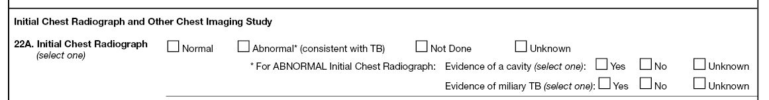

Exercise
22 A. | Initial Chest Radiograph

What is the result of the Initial Chest Radiograph for the following patients?
(Choose the one best answer by matching the results of the initial chest radiograph with the patient. Write in the letter for the result on the line next to the question number.)

 | Patient |  |  | Initial Chest Radiograph
C___ | 22 A.1 | Emily is a 4-year old whose chest radiograph shows tiny  (1- to 2-millimeters), well-defined nodules. |  | A.  B.  C.  D.  E. | Normal  Abnormal with evidence of cavitary lesion  Abnormal with evidence of miliary TB  Not Done  Unknown
A___ | 22 A.2 | Alice has a radiograph that shows no evidence of TB. |  | A.  B.  C.  D.  E.
E___ | 22 A.3 | Lawrence was evaluated for TB while living in Arabia and placed on anti-TB drugs. He remembers getting a chest radiograph but is not sure of the result. |  | A.  B.  C.  D.  E.
B___ | 22 A.4 | Roy has a chest radiograph that shows cavities in the left upper lobe of his lung. |  | A.  B.  C.  D.  E.
D___ | 22 A.5 | Frank’s laboratory results are consistent with TB disease. On his way to the clinic to get a chest radiograph, he dies in an automobile crash. |  | A.  B.  C.  D.  E.

Note for answers:
22 A.1 Emily’s result is C – Abnormal because her radiograph shows tiny, well-defined nodules, indicating evidence of miliary TB.

22 A.2 Alice’s result is A – Normal because her chest radiograph shows no evidence of TB.

22 A.3 Lawrence’s result is E – Unknown because he remembers getting a chest radiograph but the result is not known.

22 A.4 Roy’s result is B – Abnormal with evidence of cavitary lesion because he has an abnormal chest radiograph with a cavitary lesion.

22 A.5 Frank’s result is D – Not Done because the radiograph was not done.

22B. | Initial Chest CT Scan or Other Chest Imaging Study

Exercise
22 B. | Initial Chest CT Scan or Other Chest Imaging Study

Case Study for Items 16, 22A, and 22B – Anna
Anna is a 3-year-old who was diagnosed with miliary TB disease. It appeared in both her initial chest radiograph and her initial chest CT scan.

22. B. 1 | In which item(s) would you record responses indicating that Anna has miliary TB? (circle the one best answer)
 | A. | Item 16 – Site of Disease
 | B. | Item 22 A – Initial Chest Radiograph - Evidence of miliary TB
 | C. | Item 22 B – Initial Chest CT Scan or Other Chest Imaging Study – Evidence of miliary TB
 | D. | A, B, and C are correct
X | E. | Only B and C are correct

Note for answer: Site of Disease (item 16) does not include miliary TB. On the old RVCT, miliary TB could be selected as a Site of Disease. However, in this version of the RVCT, items 22A and 22B are the only items that indicate military TB. Since miliary TB appeared in both the initial chest radiograph and the CT scan, the answer is “E.”

23. | Tuberculin (Mantoux) Skin Test at Diagnosis

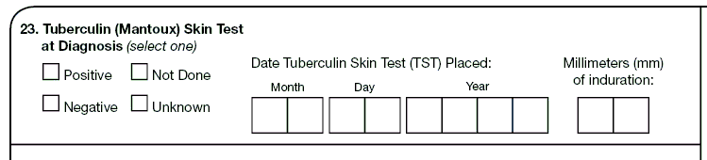

Exercise
23. | Tuberculin (Mantoux) Skin Test at Diagnosis

Case Study – Duc
Duc immigrated from Laos to the United States on May 5, 1995. At that time he was seen at the health department, where he had a TST. The TST result was read 2 days later as an induration of 10 millimeters. Since Duc is from Asia, a TST reaction that is 10 or more millimeters is considered a positive reaction. He completed LTBI treatment in May 1996. In March 2009 he is diagnosed with extrapulmonary TB of the left tibia.

23.1 | What would you select for Tuberculin (Mantoux) Skin Test at Diagnosis?  (circle the one best answer)
X | A. | Positive
 | B. | Negative
 | C. | Not done
 | D. | Unknown

23.2 | What is the date tuberculin skin test (TST) placed?  (circle the one best answer)
X | A.
  Month |  |  | Day |  |  | Year
  0 | 5 |  | 0 | 5 |  | 1 | 9 | 9 | 5
 | B.
  Month |  |  | Day |  |  | Year
  0 | 5 |  | 9 | 9 |  | 1 | 9 | 9 | 5
 | C.
  Month |  |  | Day |  |  | Year
  0 | 5 |  | 9 | 9 |  | 1 | 9 | 9 | 6

Note for answers: The documented TST was May 1995.

23.3 | What would be entered for millimeters (mm) of induration?  (circle the one best answer)
 | A.
  Millimeters (mm) of induration | 9 | 9
X | B.
  Millimeters (mm) of induration | 1 | 0

24. | Interferon Gamma Release Assay for Mycobacterium tuberculosis at Diagnosis

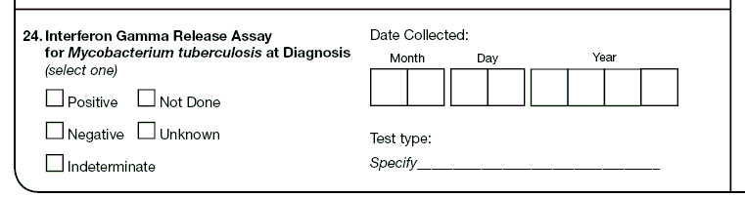

Exercise
24. | Interferon Gamma Release Assay for Mycobacterium tuberculosis at Diagnosis

Case Study – Shepo
Shepo is a recent immigrant from Kenya. He works as a maintenance worker at the Winston Animal Research Facility. The facility conducts annual employee screening for TB to prevent exposing the primates to TB. Shepo is tested with a QuantiFERON®-TB Gold test (QFT-G) because he had BCG vaccination as a child. The QFT-G test result is positive. Upon further evaluation, Shepo is diagnosed with active TB disease and an RVCT is initiated for him.

24.1 | What would you select for Interferon Gamma Release Assay for Mycobacterium tuberculosis at Diagnosis?  (circle the one best answer)
X | A. | Positive
 | B. | Negative
 | C. | Not done
 | D. | Unknown
 | E. | Indeterminate

24.2 | What would you specify as the Test Type?  (circle the one best answer)
 | A. | Interferon gamma release assay
 | B. | Tuberculin skin test
 | C. | Blood test
X | D. | QuantiFERON®-TB Gold test (QFT-G)
 | E. | Unknown

25. | Primary Reason Evaluated for TB Disease

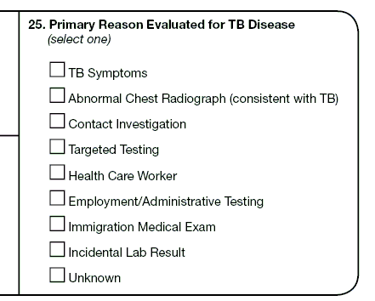

Exercise
25. | Primary Reason Evaluated for TB Disease

What is the Primary Reason Evaluated for TB for the following patients?
(Choose the one best answer by matching the primary reason evaluated with the patient. Write the letter for the reason on the line next to the question number.)

 | Patient |  |  | Primary Reason Evaluated for TB
E___ | 25.1 | Alan is a nurse at New York City health department and participated in the annual workplace TST screening program. |  | A.  B.  C.  D.  E.  F.  G.  H. | TB symptoms  Abnormal chest radiograph  Contact investigation  Targeted testing  Health care worker  Employment/  Administrative testing  Immigration medical exam  Incidental laboratory result
H___ | 25.2 | During an autopsy performed on Ben, the pathologist orders a complete analysis of various tests to help determine cause of death. TB is not suspected, but the AFB test result indicates Ben had TB. |  | A.  B.  C.  D.  E.  F.  G.  H.
C___ | 25.3 | A health care worker is providing DOT to Carla’s father. During one of the DOT visits the health care worker evaluates Carla for TB. Carla is then diagnosed with TB disease. |  | A.  B.  C.  D.  E.  F.  G.  H.
B___ | 25.4 | Drew is in an automobile accident and has a chest radiograph taken for a possible broken rib. The chest radiograph also shows a lung cavity. |  | A.  B.  C.  D.  E.  F.  G.  H.
A___ | 25.5 | Ellen goes to the out patient clinic because she has been coughing and recently lost weight. |  | A.  B.  C.  D.  E.  F.  G.  H.
G___ | 25.6 | Tran recently immigrated from Vietnam and was diagnosed with TB disease. |  | A.  B.  C.  D.  E.  F.  G.  H.
D___ | 25.7 | George is HIV infected. His doctor at the HIV clinic has him tested for TB infection. |  | A.  B.  C.  D.  E.  F.  G.  H.
F___ | 25.8 | Harry is a new primate keeper at the Magnolia Zoo where TSTs are routinely performed on all new employees. |  | A.  B.  C.  D.  E.  F.  G.  H.

Note for answer: 25.1 is E. Health care worker because that reason supersedes Employment/Administrative testing.

Case Study – Lanie
Lanie is a nurse at the Canton Health Department in Ohio. She is identified as a contact during the contact investigation for her brother-in-law, who has TB disease. During the evaluation, Lanie is diagnosed with TB disease also. She completes therapy on September 12, 2009.

25.9 | What is the Primary Reason Lanie was Evaluated for TB in Ohio?  (circle the one best answer)
 | A. | Health care worker
X | B. | Contact investigation
 | C. | TB symptoms
 | D. | Targeted testing

Case Study – Lanie (continued)
On October 1, 2009, Lanie accepts a nursing position at the Indianapolis Health Department in Indiana. On December 14, 2009, Lanie goes to the clinic because she is coughing up blood and is worried that TB has returned. Her laboratory results indicate that her sputum is smear and culture positive.

25.10 | What is the Primary Reason Lanie was Evaluated for TB in Indiana?  (circle the one best answer)
 | A. | Health care worker
 | B. | Contact investigation
X | C. | TB symptoms
 | D. | Targeted testing

Module C - RVCT
(page 3 of 3)
Items 26 – 37

Module C provides instructions and exercises for completing page 3 of the RVCT report. It includes data about risks associated with TB, the date that therapy was started, and the initial drug regimen.

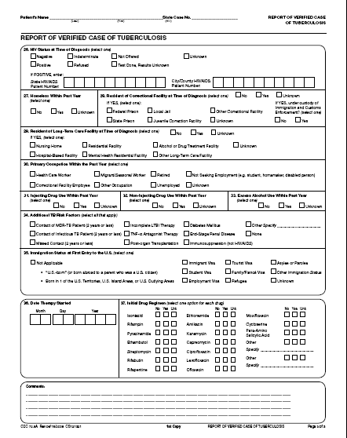

26. | HIV Status at Time of Diagnosis

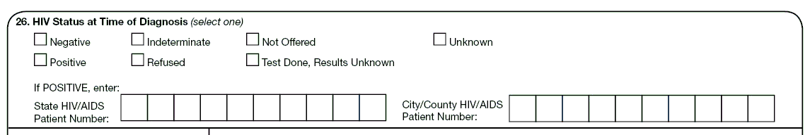

Exercise
26. | HIV Status at Time of Diagnosis

Case Study – Harvey
Harvey is diagnosed with TB at the County Health Department in May 2009. He is offered HIV testing. He states that he was tested earlier that year in January 2009 and the results were negative. Harvey has no other risk factors for HIV. With Harvey’s permission, the TB program confirms the negative HIV test result by reviewing his HIV result listed in his medical records.

26.1 | What would be selected for Harvey’s HIV Status at Time of Diagnosis?  (circle the one best answer)
X | A. | Negative
 | B. | Positive
 | C. | Indeterminate
 | D. | Refused
 | E. | Not offered
 | F. | Test Done, Results Unknown
 | G. | Unknown

27. | Homeless Within Past Year

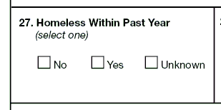

Exercise
27. | Homeless Within Past Year

Case Study – Oscar
Oscar lost his job in December 2008 and subsequently lost his apartment. He had no place to live except when staying with friends or relatives for a few days at a time throughout January 2009. Since then he has lived in homeless shelters and had meals at soup kitchens operated by the American Red Cross. Oscar found a job in July 2009 and has been living in his current apartment since then. He is diagnosed with TB at the Carroll County Health Department in November 2009.

27.1 | How would you fill out Homeless within the Past Year for Oscar?  (circle the one best answer.)
 | A. | No
X | B. | Yes
 | C. | Unknown

Note for answer: Yes, because he was homeless at some time during the past year.

28. | Resident of Correctional Facility at Time of Diagnosis

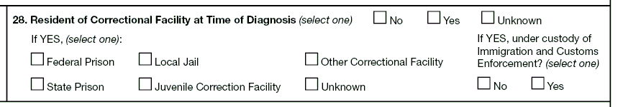

Primary Purpose: Surveillance. Data are used to determine if residence in a correctional facility is associated with TB disease.

Exercise
28. | Resident of Correctional Facility at Time of Diagnosis

Case Study – Pedro
Pedro has been in the U.S. 6 months. He is incarcerated at the Lanner County Jail. He has signs and symptoms of TB. He is evaluated by a health care provider at the jail. A sputum sample is collected on April 25 and sent to the health department. On May 1 he is transferred to the Immigration and Customs Enforcement (ICE) Detention Center in Margaritaville, Alabama, where he waits to be deported. The test result is positive for TB and becomes available on May 5.

28.1 | What type of correctional facility should be selected at time of diagnosis (diagnostic evaluation) for Pedro? (circle the one best answer)
 | A. | Federal Prison
 | B. | State Prison
X | C. | Local Jail
 | D. | Juvenile Correction Facility
 | E. | Other Correctional Facility
 | F. | Unknown

Note for answer: Local jail is the answer because he was at Lanner County Jail when the diagnostic evaluation was performed, even though the result did not come back until he was in the ICE Detention Center.

29. | Resident of Long-Term Care Facility at Time of Diagnosis

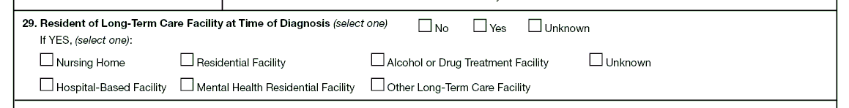

Exercise
29. | Resident of Long-Term Care Facility at Time of Diagnosis

Case Study – Gladys
Gladys was a resident of the Brittany Nursing Home for 5 months from April 2009 until September 2009 while she recovered from a stroke. She returned to her home; 2 months later, in November 2009, she is evaluated and diagnosed with TB.

29.1 | Was Gladys a Resident of Long-Term Care Facility at Time of Diagnosis?  (circle the one best answer)
X | A. | No
 | B. | Yes
 | C. | Unknown

Note for answer: At the time of diagnosis, Gladys is living at home, not at the nursing facility. She may have acquired TB while she lived at the nursing home, but that is not where she was diagnosed. In addition, Gladys was not evaluated for TB when she was at the nursing facility.

30. | Primary Occupation Within the Past Year

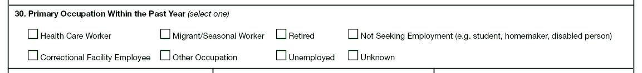

Exercise
30. | Primary Occupation Within Past Year

What is the Primary Occupation Within the Past Year?
(Choose the one best answer by matching the Primary Occupation Within the Past Year with the patient. Write the letter for the occupation on the line next to the question number.)

 | Patient |  |  | Primary Occupation within the Past Year
E___ | 30.1 | Vince completed 30 years of service with the U.S. Army 15 months ago and now spends all of his time working in his garden. |  | A.  B.  C.  D.  E.  F.  G.  H. | Health care worker  Correctional facility employee  Migrant/seasonal worker  Other occupation  Retired  Unemployed  Not seeking employment  Unknown
G___ | 30.2 | Joe, a full time student, does not have a job and is not looking for work. |  | A.  B.  C.  D.  E.  F.  G.  H.
H___ | 30.3 | Isabella refused to disclose where she worked. |  | A.  B.  C.  D.  E.  F.  G.  H.
C___ | 30.4 | Roberto picks tomatoes at Lane Produce Company during the summer season. |  | A.  B.  C.  D.  E.  F.  G.  H.
A___ | 30.5 | Florence is a nurse at the local correctional jail. |  | A.  B.  C.  D.  E.  F.  G.  H.
D___ | 30.6 | Billy Bob is a truck driver for Texaco. |  | A.  B.  C.  D.  E.  F.  G.  H.
B___ | 30.7 | Marybelle is a cook at the juvenile detention center. |  | A.  B.  C.  D.  E.  F.  G.  H.
F___ | 30.8 | Andy has been without a job for the past year. |  | A.  B.  C.  D.  E.  F.  G.  H.
A___ | 30.9 | Debbie is a dietitian at Grady Hospital. |  | A.  B.  C.  D.  E.  F.  G.  H.

31. | Injecting Drug Use Within Past Year

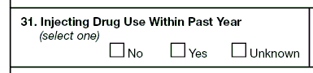

Exercise
31. | Injecting Drug Use Within Past Year

Case Study – Chaz
Chaz has visible needle marks on his arms and appears high, spaced-out, and incoherent. He denies ever using injectable drugs. However, his medical record shows a previous use of injectable drugs and that he was in a methadone detoxification program 11 months ago.

31.1 | How would you fill out Injecting Drug Use Within Past Year for Chaz?  (circle the one best answer)
 | A. | No
X | B. | Yes
 | C. | Unknown

Note for answer: Even though Chaz denies that he injects drugs, his record shows that he was in an injecting drug detoxification program within the past year.

32. | Non-Injecting Drug Use Within Past Year

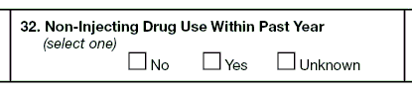

Exercise
32. | Non-Injecting Drug Use Within Past Year

Case Study – Spider
Spider is interviewed for the RVCT on December 13, 2009. He says he completed a drug detoxification program about 14 months ago, on October 30, 2008, and has been drug-free since that time.

32.1 | How would you answer Non-Injecting Drug Use Within Past Year for Spider?  (circle the one best answer)
X | A. | No
 | B. | Yes
 | C. | Unknown

Note for answer: According to Spider, he used non-injecting drugs in the past, but not within the past 12 months. You have to take his word for this because there is no proof that he did use drugs within the past 12 months, and you do not suspect or see any evidence of drug use.

33. | Excess Alcohol Use Within Past Year

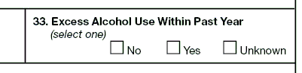

Exercise
33. | Excess Alcohol Use Within Past Year

Case Study – Jack Daniel
Jack Daniel comes to the clinic for daily DOT. He often appears intoxicated and smelling of alcohol. He denies using excess alcohol, but says that he might occasionally have 1 or 2 beers a day. His records indicate that he enrolled in an alcohol treatment program within the past year, but he never completed the program.

33.1 | How would you answer Excess Alcohol Use Within Past Year for Jack Daniel?  (circle the one best answer)
 | A. | No
X | B. | Yes
 | C. | Unknown

Note for answer: Based on your observations of Jack Daniel, you have seen evidence that he has used alcohol excessively during the past 12 months. In addition, he was in an alcohol treatment program within the past year.

34. | Additional TB Risk Factors

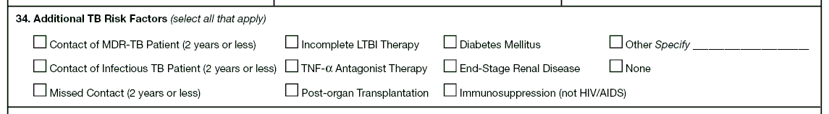

Exercise
34. | Additional TB Risk Factors

What are the Additional Risk Factors for the following patients?
(Choose the one best answer by matching the additional risk factor with the patient. Write the letter for the additional risk factor on the line next to the question number.)

 | Patient |  |  | Additional Risk Factor
E___ | 34.1 | Ralph has rheumatoid arthritis and has been receiving tumor necrosis factor-alpha antagonist therapy. |  | A.  B.  C.  D.  E.  F.  G.  H.  I.  J.  K. | Contact of MDR TB patient  Contact of infectious TB patient  Missed contact  Incomplete LTBI therapy  TNF-α Antagonist Therapy  Post-organ transplantation  Diabetes mellitus  End-stage renal disease  Immunosuppression (not HIV/AIDS)  Other  None
A___ | 34.2 | Maddox works at the local market where he is exposed to a co-worker who has MDR TB. Two weeks later Maddox is contacted by the health department, and they determine that he has active TB. |  | A.  B.  C.  D.  E.  F.  G.  H.  I.  J.  K.
F___ | 34.3 | Rema has a kidney transplant in January 2009 and is diagnosed with TB disease 2 months later in March. |  | A.  B.  C.  D.  E.  F.  G.  H.  I.  J.  K.
I___ | 34.4 | Luella is diagnosed with TB disease in 2010 while being treated for leukemia. |  | A.  B.  C.  D.  E.  F.  G.  H.  I.  J.  K.
D___ | 34.5 | Gloria starts LTBI therapy in November 2008, but stops taking the medication in late January 2009. |  | A.  B.  C.  D.  E.  F.  G.  H.  I.  J.  K.
B___ | 34.6 | Diego lives with his brother, who is diagnosed with pulmonary TB disease in March 2009. Three months later, Diego is also diagnosed with TB disease. |  | A.  B.  C.  D.  E.  F.  G.  H.  I.  J.  K.
G___ | 34.7 | In July 2009, Debbie, who has diabetes, is diagnosed with TB disease during a routine physical. |  | A.  B.  C.  D.  E.  F.  G.  H.  I.  J.  K.
C___ | 34.8 | Marjorie works as a substitute teacher at Dallas High School during the month of April 2009. That same month, there is an outbreak of TB at the high school, but Marjorie does not know about that situation, even though some of the students who have TB are in her class. In May she moves to Denver and is diagnosed with TB disease in June.

35. | Immigration Status at First Entry to the U.S.

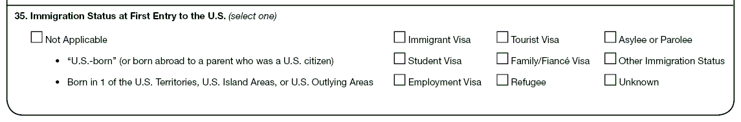

Exercise
35. | Immigration Status at First Entry to the U.S.

What is the Immigration Status at First Entry to the United States for the following patients?
(Choose the one best answer by matching the Immigration Status at First Entry into the U.S. with the patient. Write the letter for the Immigration Status on the line next to the question number.)

 | Patient |  |  | Immigration Status
E___ | 35.1 | Katrina, a law student from the Ukraine, visited Disney World and interviewed for a job at the Thayer Law Firm. |  | A.  B.  C.  D.  E.  F.  G.  H.  I.  J. | Not applicable  (U.S.-born)  Immigrant visa  Student visa  Employment visa  Tourist visa  Family/fiancé visa  Refugee  Asylee or parolee  Other immigration status  Unknown
H___ | 35.2 | Graciano, a Cuban doctor, escaped to Miami from Havana and is applying for a U.S. visa. He will be persecuted if he returns to Cuba. |  | A.  B.  C.  D.  E.  F.  G.  H.  I.  J.
C___ | 35.3 | Pratibha was born in India and is attending a PhD program in Public Health Surveillance at Harvard. |  | A.  B.  C.  D.  E.  F.  G.  H.  I.  J.
D___ | 35.4 | Wong, a Chinese software designer, is visiting the United States to work for Microsoft for 3 months. |  | A.  B.  C.  D.  E.  F.  G.  H.  I.  J.
B___ | 35.5 | Ali was born in Saudi Arabia and entered the United States with permanent resident status. |  | A.  B.  C.  D.  E.  F.  G.  H.  I.  J.
G___ | 35.6 | Anshuman, a bilingual interpreter for the U.S. military, is a refugee from Pakistan. He cannot return to his native Pakistan because of fear of persecution. |  | A.  B.  C.  D.  E.  F.  G.  H.  I.  J.
A___ | 35.7 | Svetlana was born in Moscow. Her father is a U.S. citizen and her mother is a Russian citizen. |  | A.  B.  C.  D.  E.  F.  G.  H.  I.  J.
F___ | 35.8 | Sabeen, an Iraqi secretary, met her fiancé Jim while he served in the Gulf War. She is coming to the United States to meet his parents and marry him. |  | A.  B.  C.  D.  E.  F.  G.  H.  I.  J.
J___ | 35.9 | Boris refuses to define his status. |  | A.  B.  C.  D.  E.  F.  G.  H.  I.  J.
I___ | 35.10 | Jose, a Mexican migrant farmer, illegally entered the United States through Big Bend, Texas. |  | A.  B.  C.  D.  E.  F.  G.  H.  I.  J.

36. | Date Therapy Started

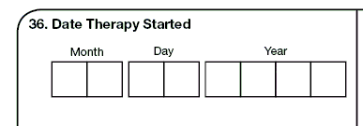

Exercise
36. | Date Therapy Started

Case Study – Thelma
On February 14, 2010, Thelma is diagnosed with TB. That same day her physician prescribes the initial standard four-drug regimen of isoniazid, rifampin, pyrazinamide, and ethambutol. On February 15, Thelma picks up the drugs from the pharmacy. Her medical records indicate that Thelma is not sure when she started taking the drugs. She thinks maybe it was on February 17, February 21, or even later.

36.1 | Which date is the Date Therapy was Started?  (circle the one best answer)
 | A. | February 14, 2010
X | B. | February 15, 2010
 | C. | February 17, 2010
 | D. | February 21, 2010

Note for answer: The documented date that the patient first ingests the drugs is the date that is preferred. But, in this case study, Thelma was not sure about the date she started taking the drugs, so the next documented date would be the date that the pharmacy dispensed the drug, which in this case was February 15.

37. | Initial Drug Regimen

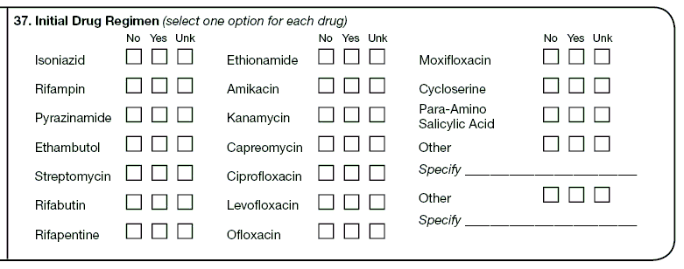

Exercise
37. | Initial Drug Regimen

Case Study – Zelda
On March 30, 2010, Zelda is diagnosed with TB. That same day, her physician prescribes the initial standard four-drug regimen of isoniazid, rifampin, pyrazinamide, and ethambutol.

What is the Initial Drug Regimen that was prescribed?

(Choose the one best answer by checking the box indicating Initial Drug Regimen for each drug.)

 |  | A.  No | B.  Yes | C.  Unknown
37.1 | Isoniazid | □ | X□ | □
37.2 | Rifampin | □ | X□ | □
37.3 | Pyrazinamide | □ | X□ | □
37.4 | Ethambutol | □ | X□ | □
37.5 | Streptomycin | X□ | □ | □
37.6 | Rifabutin | X□ | □ | □

Module D - Initial Drug Susceptibility Report (Follow Up Report - 1)
(page 1 of 1)
Items 38 – 40

Module D provides instructions and exercises for completing the Initial Drug Susceptibility Report. This page is a follow-up report to the RVCT and includes data about genotyping, as well as initial drug susceptibility testing and results.

Complete this report only for cases with positive culture results for M. tuberculosis complex. Complete and submit this report as soon as initial drug susceptibility results are available. Copy patient name and address from page 1 of the RVCT. The patient name and address are retained at the local level for identification purposes; they are not sent to CDC. Enter Year Counted, State Case Number, and City/County Case Number for data entry purposes.

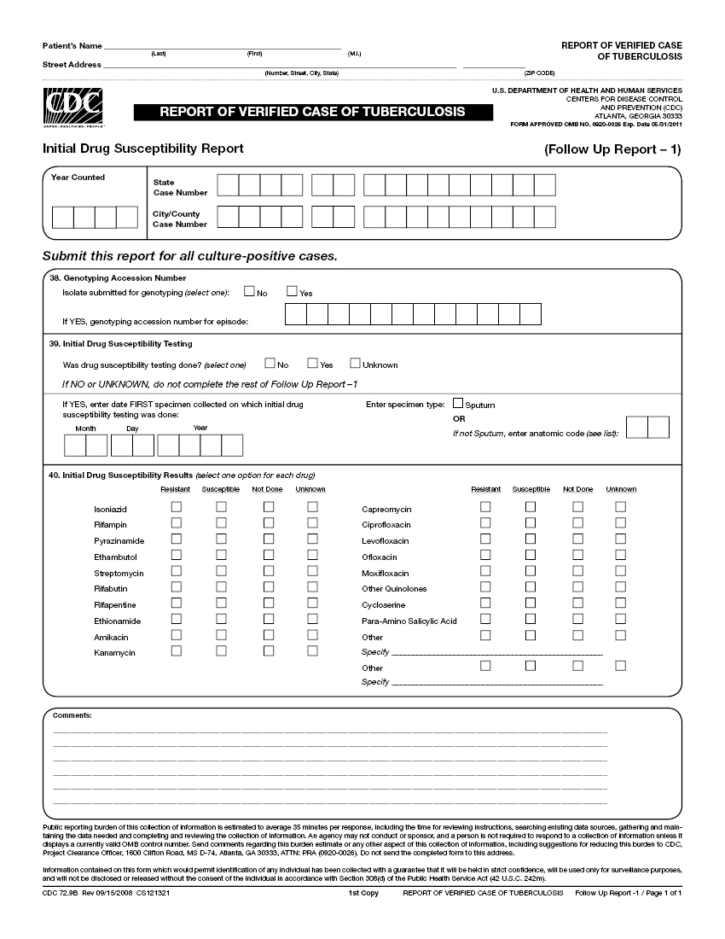

38. | Genotyping Accession Number

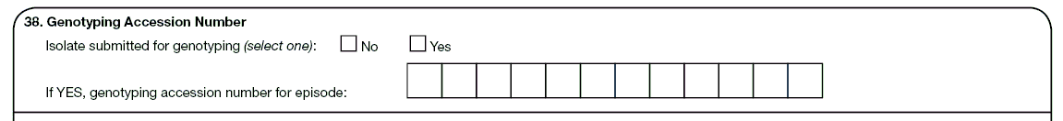

Exercise
38. | Genotyping Accession Number

Case study - Jenna
Jenna is diagnosed with culture-positive TB in Hawaii in 2009. After the initial diagnosis, her isolate is sent to the California reference laboratory as part of universal TB strain genotyping. The Excel spreadsheet that came back from the laboratory looks like this:

09L9564 09AF0254 777777777760731 222325153325 PCR00208

38.1 | What should be entered for the Genotyping Accession Number?  (circle the one best answer)
X | A.
  0 | 9 | L | 9 | 5 | 6 | 4
 | B.
  0 | 9 | A | F | 0 | 2 | 5 | 4
 | C.
  P | C | R | 0 | 0 | 2 | 0 | 8

Note for answer: There are 12 spaces for genotyping accession number. Instructions are to complete the number beginning at the left-most box. Do not add zeros to finish filling the boxes. This genotyping accession number is from the California laboratory because it has the 2-digit year (09) followed by L, then 4 digits. If the genotyping accession number is from the CDC laboratory, it will have a hyphen after the 2-digit year; this hyphen should also be entered into a box as part of the genotyping accession number. If the genotyping accession number is from the Michigan laboratory, it will have RF after the 2-digit year.

The last three columns above are the spoligotype, MIRU, and PCR type, respectively. The second column is not a genotyping accession number because it does not fit the numbering format of any of the three reference laboratories. RVCT users should be aware that there may be additional local, state, submitter, cluster, or other identification numbers listed on a genotyping report. RVCT users should be able to identify the genotyping accession number by becoming familiar with the format used by the NTGS laboratory serving their reporting area.

39. | Initial Drug Susceptibility Testing

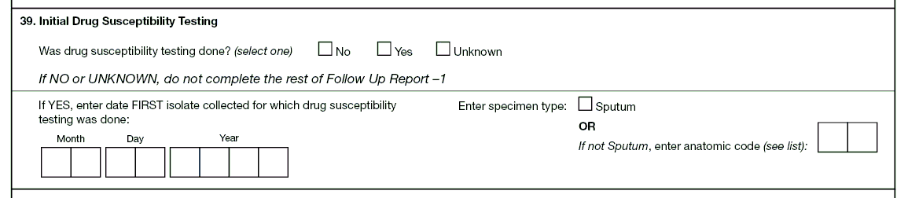

Exercise
39. | Initial Drug Susceptibility Testing

Case study – Esmeralda
On July 3, 2009, Esmeralda is suspected of having TB. That same day a urine specimen is collected and she starts treatment. On July 29 the result of the urine specimen indicates that it is culture positive for TB. Drug susceptibility results on the urine specimen are received on August 8.

Three consecutive sputum specimens are collected from Esmeralda on July 5, 6, and 7. On August 13, the results indicate that all three specimens are smear negative and culture positive for TB. Drug susceptibility testing performed on the July 5 sputum specimen is reported on August 21 and is identical to the drug susceptibility testing results from the urine specimen.

39.1 | What is the date of the first specimen on which drug susceptibility testing was done?  (circle the one best answer)
X | A. | July 3, 2009
 | B. | July 5, 2009
 | C. | August 8, 2009
 | D. | August 13, 2009
 | E. | August 21, 2009

39.2 | What should be entered for specimen type?  (circle the one best answer)
 | A. | Sputum
X | B. | Anatomic Code - Urine (69)
 | C. | Both A and B are correct

Note for answer: Item 39 refers to the first culture positive specimen on which drug susceptibility testing was performed, regardless of which site it was taken from (e.g., it does not have to be the major site of disease). Because the urine culture grew before the sputum cultures, drug susceptibility testing was performed on the urine specimen. Therefore the urine is the first specimen on which drug susceptibility testing was performed. That is why July 3 is the answer for 39.1, and the specimen type is urine for 39.2. If the July 5 sputum culture had grown first, initial drug susceptibility testing would have been performed on that specimen; July 5 would have been the answer for 39.1, and sputum would have been the answer for 39.2. Even though the major site of disease may be pulmonary, this question is asking for the first specimen on which drug susceptibility testing was performed.

40. | Initial Drug Susceptibility Results

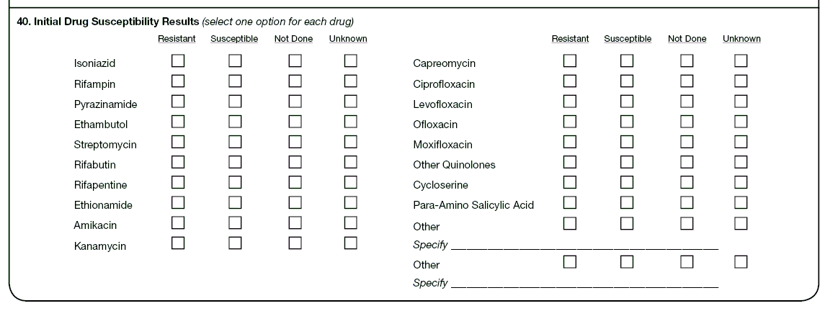

Exercise
40. | Initial Drug Susceptibility Results

Case study – Esmeralda (continued from Item 39)
The following first-line drug susceptibility test results for the isolate of M. tuberculosis complex are received on August 21 from laboratory #1. The second-line laboratory results are received on September 19 from laboratory #2. The laboratory results are indicated in the table below.

Results from Laboratory #1 | Results from Laboratory #2
- INH – Low-level resistance  - Rifampin – No resistance  - Pyrazinamide – No resistance  - Ethambutol – Resistance  - Streptomycin – Testing not done | - Rifabutin – Resistance  - Rifapentine – Testing not done  - Ethionamide – Not known if test was done  - Amikacin – Susceptible  - Kanamycin – Testing not done

What are the Initial Drug Susceptibility Results entered on the RVCT?
(Choose the one best answer by checking the box indicating Initial Drug Susceptibility Results from the laboratory for each drug.)

 |  | A.  Resistant | B.  Susceptible | C.  Not Done | D.  Unknown
40.1 | Isoniazid | X□ | □ | □ | □
40.2 | Rifampin | □ | X□ | □ | □
40.3 | Pyrazinamide | □ | X□ | □ | □
40.4 | Ethambutol | X□ | □ | □ | □
40.5 | Streptomycin | □ | □ | X□ | □
40.6 | Rifabutin | X□ | □ | □ | □
40.7 | Rifapentine | □ | □ | X□ | □
40.8 | Ethionamide | □ | □ | □ | X□
40.9 | Amikacin | □ | X□ | □ | □
40.10 | Kanamycin | □ | □ | X□ | □

Note for answer:
40.1 Isoniazid: Any resistance is resistance, even if it is low.

40.8 Ethionamide: It is not known if the test was done, so Unknown should be selected. Some laboratories report no resistance, which means susceptible.

Module E - Case Completion Report (Follow Up Report – 2)
Items 41 – 49

Module E provides instructions and exercises for completing the Case Completion Report. This 2 page report includes data about treatment outcomes, provider status, and if the patient moved during treatment.

Complete this form for all patients who were alive at the time of TB diagnosis. Enter data as soon as information becomes available during patient follow-up. This report should be completed when the case is closed to supervision and is due no later than 2 years after the initial RVCT.

Copy patient name and address from page 1 of the RVCT form. Patient name and address are retained at the local level for identification purposes; they are not sent to CDC. Enter Year Counted, State Case Number, and City/County Case Number for data entry purposes.

(page 1 of 2)
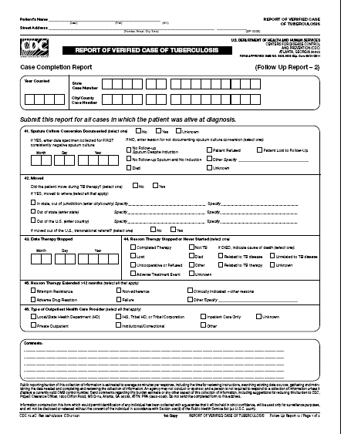
(page 2 of 2)
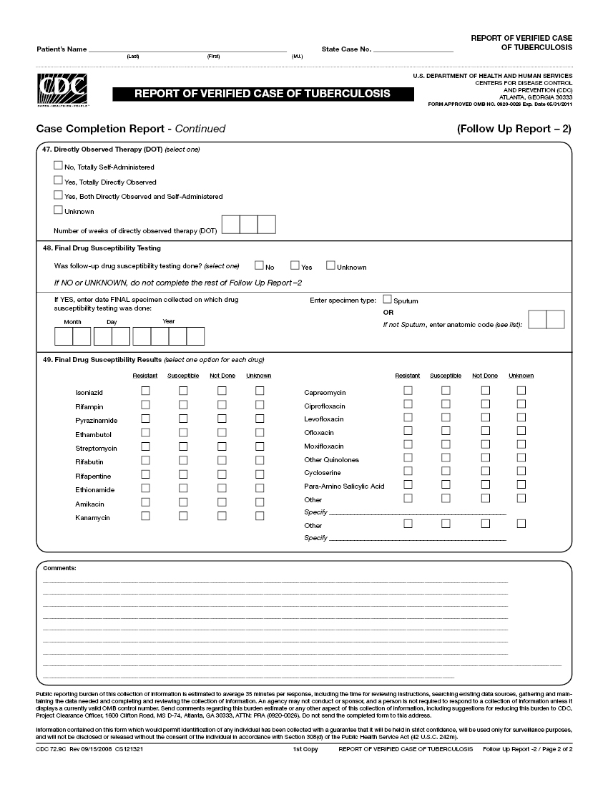

41. | Sputum Culture Conversion Documented

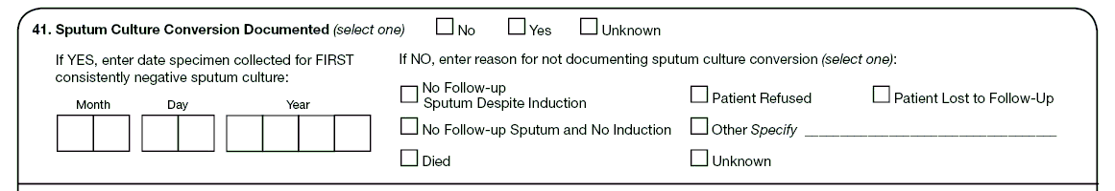

Exercise
41. | Sputum Culture Conversion Documented

How would you document Sputum Culture Conversion for the following patients?
(Choose the one best answer by matching the sputum culture conversion with the patient. Write the letter for the sputum culture conversion on the line next to the question number.)

 | Patient |  |  | Sputum Culture Conversion
D___ | 41.1 | Alice has a positive sputum culture in September. After that she does not allow any more specimens to be taken because it hurts when she coughs. |  | A  B.  C.  D.  E.  F. | No, because no follow-up sputum despite induction  No, because no follow-up sputum and no induction  No, because patient died  No, because patient refused  No, because patient was lost to follow-up  Yes
B___ | 41.2 | Gene has 3 positive sputum cultures in May. His physician does not order any other additional induction to collect additional sputum samples. |  | A  B.  C.  D.  E.  F.
C___ | 41.3 | Ivan has a terrible cough. On June 6 he produces a positive sputum culture. He dies on July 5 before any other specimen is collected. |  | A  B.  C.  D.  E.  F.
F___ | 41.4 | Joyce has a positive sputum culture in July. Subsequent sputum specimens are collected on September 21, 22, and 23. Her medical records indicate that on November 8 all September sputum sample cultures are negative. |  | A  B.  C.  D.  E.  F.
A___ | 41.5 | Ollie has a positive sputum culture in November, and by December his condition improves. An induction machine is unsuccessful in collecting additional sputum specimens. |  | A  B.  C.  D.  E.  F.
E__ | 41.6 | Roy has a positive sputum culture in July. He is lost to follow-up and no more sputum samples are collected. |  | A  B.  C.  D.  E.  F.

42. | Moved

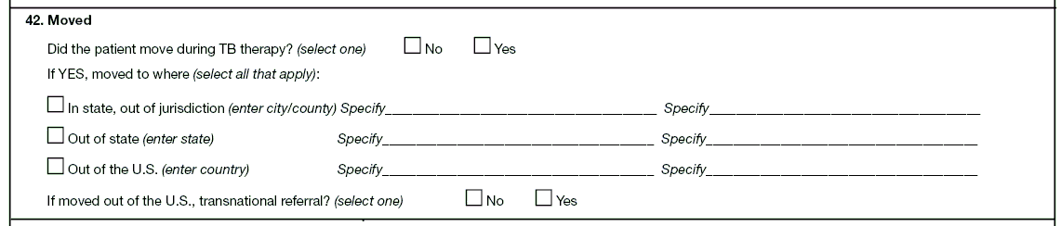

Exercise
42. | Moved

Case Study – Johann
Johann is diagnosed on August 30 with TB disease at the Bogalusa Medical Center in Washington Parish, Louisiana. He receives DOT and adheres to treatment. On September 30 his job requires him to relocate from his home in Bogalusa to Opelousas, Louisiana, 170 miles away. He continues TB treatment at the St. Landry Parish Health Clinic in Opelousas.

42.1 | Which of the following statements is true about whether Johann moved?  (circle the one best answer)
 | A. | No, did not move during TB therapy
X | B. | Yes, moved in state, out of jurisdiction
 | C. | Yes, moved out of state
 | D. | Yes, moved out of the U.S. and indicate no for U.S. transnational referral
 | E. | Yes, moved out of the U.S. and indicate yes for U.S. transnational referral

Notes for answer: Moved is defined as a relocation of a patient’s residence, resulting in a change in local health department jurisdiction. Therefore Johann moved in state, but out of jurisdiction.

43. | Date Therapy Stopped

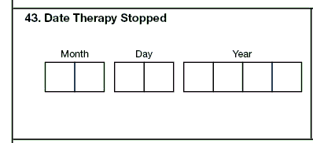

Exercise
43. | Date Therapy Stopped

Case Study – Hannibal
Hannibal, a convicted murderer, was diagnosed on October 31, 2009, with TB disease while incarcerated at Folsom Prison. He also had HIV and liver disease. He received DOT. On November 23, 2009, he complained of nausea, fever, and had yellowish skin. On November 24, Hannibal received DOT in the morning. He became very ill and died later that evening. The medical examiner determined that Hannibal’s death was likely due to an adverse reaction to INH.

43.1 | What is the Date for Therapy Stopped?  (circle the one best answer)
 | A.
  Month |  |  | Day |  |  | Year
  1 | 1 |  | 2 | 3 |  | 2 | 0 | 0 | 9
X | B.
  Month |  |  | Day |  |  | Year
  1 | 1 |  | 2 | 4 |  | 2 | 0 | 0 | 9
 | C.
  Month |  |  | Day |  |  | Year
  1 | 1 |  | 9 | 9 |  | 2 | 0 | 0 | 9

44. | Reason Therapy Stopped or Never Started

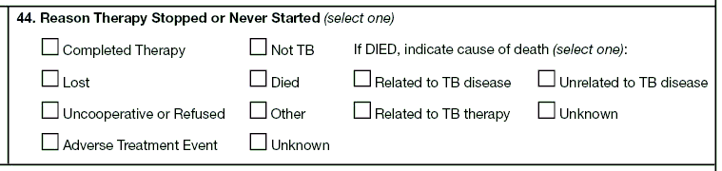

Exercise
44. | Reason Therapy Stopped or Never Started

Case Study – Hannibal (continued from Item 43)

44.1 | What is the Reason that Therapy was Stopped for Hannibal?  (circle the one best answer.)
 | A. | Completed Therapy
 | B. | Adverse Treatment Event
X | C. | Died

Note to answer: This question is asking what is the reason that therapy was stopped, not what is the cause of death. The autopsy indicated that his death was likely due to an adverse treatment event to INH. However, the reason that therapy was stopped was that Hannibal died, and then it was determined the cause of death was related to TB therapy.

If his therapy had been stopped before he died, the answer would still be the same because he died. You would answer adverse treatment event for therapy stopped only for a patient who had not died and his/her treatment was permanently stopped.

45. | Reason Therapy Extended >12 Months

Exercise
45. | Reason Therapy Extended >12 months

What is the Reason Therapy was Extended for > 12 Months for the following patients?
(Choose the one best answer by matching the Reason Therapy was Extended for > 12 Months with the patient. Write the letter for the Reason Therapy was Extended next to the question number.)

 | Patient |  |  | Reason Therapy was Extended > 12 months
D___ | 45.1 | Ralph, a homeless man, begins DOT and has a sputum culture conversion from positive to negative by 2 months. But at 4 months his sputum results are positive. |  | A.  B.  C.  D.  E. | Rifampin resistance  Adverse drug reaction  Non-adherence  Failure  Clinical indications – other reasons
E___ | 45.2 | Amy, a 3-year-old, has TB meningitis. |  | A.  B.  C.  D.  E.
C___ | 45.3 | Jose and his brother Raul go on an extended camping trip to Yosemite National Park. He loses his medicine and does not get more medicine until he returns to the clinic 2 months later. |  | A.  B.  C.  D.  E.
A___ | 45.4 | Bob’s initial drug susceptibility results indicate that the isolate is resistant to isoniazid and rifampin. |  | A.  B.  C.  D.  E.
B___ | 45.5 | Nancy experiences severe breathing difficulties and hives a week into therapy. Her doctor changes her anti-TB medications. |  | A.  B.  C.  D.  E.

46. | Type of Outpatient Health Care Provider

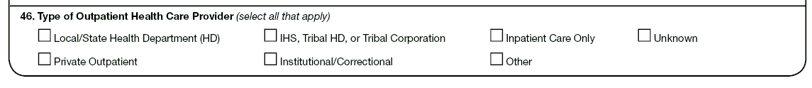

Exercise
46. | Type of Outpatient Health Care Provider

What is the Type of Outpatient Health Care Provider for the following patients?
(Choose the one best answer by matching the Type of outpatient health care provider with the Patient. Write the letter for the type of provider next to the question number.)

 | Patient |  |  | Type of Outpatient Health Care Provider
D___ | 46.1 | Clyde is arrested for armed robbery. He is diagnosed and treated for TB disease during the 6 months that he is in the Bonnie Springs Jail. |  | A.  B.  C.  D.  E.  F.  G. | Local/  State Health  Department  Private Outpatient  IHS, Tribal HD, or Tribal Corporation  Institutional/  Correctional  Inpatient Care Only  Other  Unknown
F___ | 46.2 | Victor, a Vietnam War veteran, comes to a Virginia Veterans Administration Hospital to receive DOT. |  | A.  B.  C.  D.  E.  F.  G.
E___ | 46.3 | Howard, an HIV patient, is admitted to National Jewish Health hospital for treatment of XDR TB, where he receives all of his TB treatment. |  | A.  B.  C.  D.  E.  F.  G.
C___ | 46.4 | Nita is treated for TB disease at the Cherokee Indian Hospital. |  | A.  B.  C.  D.  E.  F.  G.
A ___ | 46.5 | Curtis is diagnosed with active TB at the Dallas County Health Department and starts DOT. |  | A.  B.  C.  D.  E.  F.  G.
B___ | 46.6 | Joel is diagnosed and treated for TB disease by his physician at the Kaiser Permanente Health Center. |  | A.  B.  C.  D.  E.  F.  G.

47. | Directly Observed Therapy (DOT)

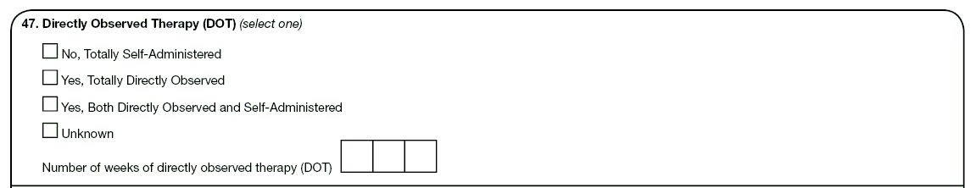

Exercise
47. | Directly Observed Therapy (DOT)

Case study – Maximo
Maximo is diagnosed with TB in June 2009 after being evaluated through a free clinic in Laredo, Texas. He is provided housing by the health department and starts on a 4-drug DOT regimen administered by the health department on June 9, 2009. On August 4 (after 8 weeks of daily 4-drug therapy), his DOT regimen changes to twice-weekly INH and RIF. He misses doses on August 25 and 27, October 8, and November 26 (Thanksgiving day). He successfully completes treatment and adheres to DOT up to December 17, 2009.

47.1 | What would you select for Directly Observed Therapy?  (circle the one best answer)
 | A. | No, totally self-administered
X | B. | Yes, totally directly observed
 | C. | Yes, both directly observed and self-administered
 | D. | Unknown

Use this calendar to determine weeks of DOT.

May |  |  |  |  |  |  | June |  |  |  |  |  |  | July |  |  |  |  |  |  | August
 |  |  |  |  | 1 | 2 |  | 1 | 2 | 3 | 4 | 5 | 6 |  |  |  | 1 | 2 | 3 | 4 |  |  |  |  |  |  | 1
3 | 4 | 5 | 6 | 7 | 8 | 9 | 7 | 8 | 9 | 10 | 11 | 12 | 13 | 5 | 6 | 7 | 8 | 9 | 10 | 11 | 2 | 3 | 4 | 5 | 6 | 7 | 8
10 | 11 | 12 | 13 | 14 | 15 | 16 | 14 | 15 | 16 | 17 | 18 | 19 | 20 | 12 | 13 | 14 | 15 | 16 | 17 | 18 | 9 | 10 | 11 | 12 | 13 | 14 | 15
17 | 18 | 19 | 20 | 21 | 22 | 23 | 21 | 22 | 23 | 24 | 25 | 26 | 27 | 19 | 20 | 21 | 22 | 23 | 24 | 25 | 16 | 17 | 18 | 19 | 20 | 21 | 22
24 | 25 | 26 | 27 | 28 | 29 | 30 | 28 | 29 | 30 |  |  |  |  | 26 | 27 | 28 | 29 | 30 | 31 |  | 23 | 24 | 25 | 26 | 27 | 28 | 29
31 |  |  |  |  |  |  |  |  |  |  |  |  |  |  |  |  |  |  |  |  | 30 | 31
September |  |  |  |  |  |  | October |  |  |  |  |  |  | November |  |  |  |  |  |  | December
 |  | 1 | 2 | 3 | 4 | 5 |  |  |  |  | 1 | 2 | 3 | 1 | 2 | 3 | 4 | 5 | 6 | 7 |  |  | 1 | 2 | 3 | 4 | 5
6 | 7 | 8 | 9 | 10 | 11 | 12 | 4 | 5 | 6 | 7 | 8 | 9 | 10 | 8 | 9 | 10 | 11 | 12 | 13 | 14 | 6 | 7 | 8 | 9 | 10 | 11 | 12
13 | 14 | 15 | 16 | 17 | 18 | 19 | 11 | 12 | 13 | 14 | 15 | 16 | 17 | 15 | 16 | 17 | 18 | 19 | 20 | 21 | 13 | 14 | 15 | 16 | 17 | 18 | 19
20 | 21 | 22 | 23 | 24 | 25 | 26 | 18 | 19 | 20 | 21 | 22 | 23 | 24 | 22 | 23 | 24 | 25 | 26 | 27 | 28 | 20 | 21 | 22 | 23 | 24 | 25 | 26
27 | 28 | 29 | 30 |  |  |  | 25 | 26 | 27 | 28 | 29 | 30 | 31 | 29 | 30 |  |  |  |  |  | 27 | 28 | 29 | 30 | 31

47.2 | What would you enter for the number of weeks of DOT?  (circle the one best answer)
 | A.
  0 | 2 | 0
X | B.
  0 | 2 | 6
 | C.
  0 | 3 | 2

Note for answer: There always need to be 3 numbers entered into the boxes provided. In this case there needs to be a leading 0 in the first box as opposed to entering “2” in the left-most box. If the number of weeks of DOT is a single digit such as 8 weeks, this would be entered as 008. If the patient has 2 full years of DOT, this would be entered as 104 weeks.

Count the following weeks of DOT for Maximo:
- 8 weeks of daily 4-drug regimen
- 18 weeks of 2-drug regimen
This equals a total of 26 weeks of DOT.

Do not count the following doses of DOT for Maximo:
- The missed doses on August 25 and 27 when no drugs were given. (The missed doses in August were “made up” on December 8 and 10 by adding an extra week of therapy.)
- The week when only 1 dose of a twice-weekly regimen was given on October 6 and missed on October 8. (The missed dose on October 8 was “made up” on December 15. October 6 and December 15 contribute 0.5 of a twice-weekly regimen each, adding up to 1 week.)
- The week when only 1 dose of a twice-weekly regimen was given on November 24 and missed on November 26. (The missed dose on November 26 was “made up” on December 17. November 24 and December 17 contribute 0.5 of a twice-weekly regimen each, adding up to 1 week.)

Case study for Items 43–47 – Maximo (continued)
Now imagine that Maximo self-administers doses on August 25, August 27, and September 1 because he was out of town visiting his sister that week. He still missed the October 8 dose and the November 26 dose.

How would you complete items 43–47 on the RVCT?

47.3 | Item 43: Date Therapy Stopped  (circle the one best answer)
 | A. | December 12, 2009
X | B. | December 17, 2009

47.4 | Item 44: Reason Therapy Stopped or Never Started  (circle the one best answer)
X | A. | Completed Therapy
 | B. | Unknown

47.5 | Item 45: Reason Therapy Extended > 12 Months  (circle the one best answer)
 | A. | Nonadherence
X | B. | Not applicable, leave blank

47.6 | Item 46: Type of Outpatient Health Care Provider  (circle the one best answer)
X | A. | Local/State Health Department
 | B. | Private

47.7 | Item 47: Directly Observed Therapy (DOT)  (circle the one best answer)
X | A. | Yes, both directly observed and self-administered
 | B. | Unknown

47.8 | Item 47: Directly Observed Therapy (DOT). How many weeks of DOT were provided?  (circle the one best answer)
 | A. | 020
X | B. | 025

Note for answers:
47.3 Item 43: Date Therapy Stopped is December 17, 2009 (12/17/2009).

47.4 Item 44: Reason Therapy Stopped or Never Started is completed therapy.

47.5 Item 45: Reason Therapy Extended > 12 Months is not applicable, leave
blank.

47.6 Item 46: Type of Outpatient Health Care Provider is Local/state health department.

47.7 Item 47: Directly Observed Therapy (DOT) is Yes, both directly observed and
self-administered.

47.8 Item 47: Directly Observed Therapy (DOT) Use the above calendar to count the number of weeks of DOT. The total number of DOT weeks from initiation of therapy to completion is entered as 025. There were 8 weeks of 4-drug regimen and 17 weeks of 2-drug regimen. Do not count the last week of August, when no DOT doses were given. Then begin counting 7-day periods on September 7. The dose on October 10 (whether missed or self-administered) is skipped, and October 5 and 12 administration forms a DOT week (2 doses appropriately given). Begin counting whole weeks again the week of October 16. The December 12 dose counts as 0.5 dose, but there is no dose to match it with, so it does not form a DOT week.

48. | Final Drug Susceptibility Testing

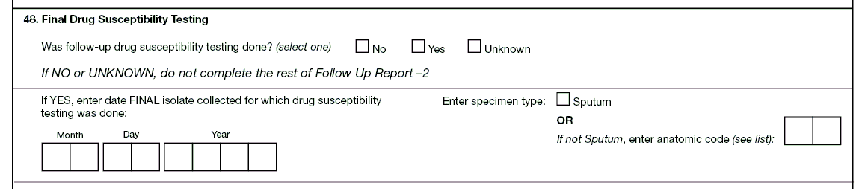

Exercise
48. | Final Drug Susceptibility Testing

48.1 | When must the final specimen be collected on which Final Drug Susceptibility Testing is done?  (circle the one best answer)
 | A. | The date can be any time after the collection date for the initial specimen on which drug susceptibility was done.
 | B. | The date should be less than 30 days after the collection date for the initial specimen on which drug susceptibility testing was done.
X | C. | The date should be 30 or more days after the collection date for the initial specimen on which drug susceptibility testing was done.

49. | Final Drug Susceptibility Results

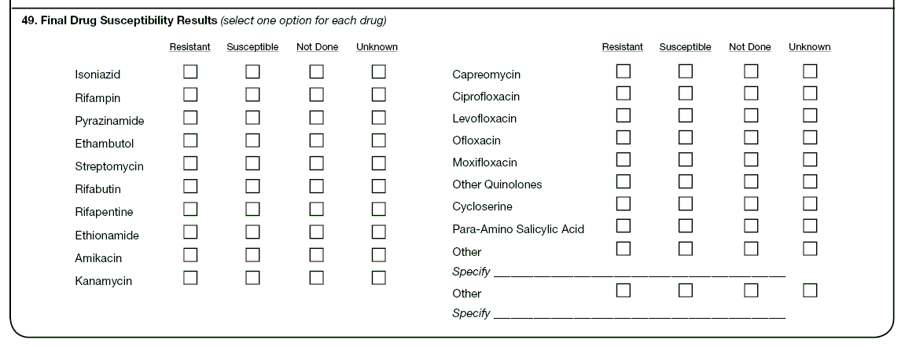

Exercise
49. | Final Drug Susceptibility Results

Case study for Items 48 and 49 – Lana
Lana is diagnosed with sputum culture-positive TB in October 2009. Initial drug susceptibility tests showed her TB is sensitive to all of the first-line drugs that are prescribed. She has a number of treatment interruptions and develops rifampin resistance, which is discovered upon repeat drug susceptibility testing of sputum collected on December 13, 2009. The isolate remains susceptible to isoniazid, pyrazinamide, and ethambutol. The isolate is also found to be susceptible to rifabutin, ciprofloxacin, moxifloxacin, streptomycin, amikacin, and kanamycin. No other drugs are tested.

What are the Final Drug Susceptibility Results for Lana?
(Choose the one best answer by checking the box indicating Final Drug Susceptibility Results from the laboratory for each drug.)

 |  |  | A.  Resistant |  | B.  Susceptible | C.  Not Done |  | D.  Unknown |  |  | A.  Resistant | B.  Susceptible |  | C.  Not Done | D.  Unknown
49.1 | Isoniazid | □ |  | X□ |  | □ | □ |  | 49.11 | Capreomycin | □ | □ |  | X□ | □
49.2 | Rifampin | X□ |  | □ |  | □ | □ |  | 49.12 | Ciprofloxacin | □ | X□ |  | □ | □
49.3 | Pyrazinamide | □ |  | X□ |  | □ | □ |  | 49.13 | Levofloxacin | □ | □ |  | X□ | □
49.4 | Ethambutol | □ |  | X□ |  | □ | □ |  | 49.14 | Ofloxacin | □ | □ |  | X□ | □
49.5 | Streptomycin | □ |  | X□ |  | □ | □ |  | 49.15 | Moxifloxacin | □ | X□ |  | □ | □
49.6 | Rifabutin | □ |  | X□ |  | □ | □ |  | 49.16 | Other Quinolones | □ | □ |  | X□ | □
49.7 | Rifapentine | □ |  | □ |  | X□ | □ |  | 49.17 | Cycloserine | □ | □ |  | X□ | □
49.8 | Ethionamide | □ |  | □ |  | X□ | □ |  | 49.18 | Para-Amino  Salicylic  Acid | □ | □ |  | X□ | □
49.9 | Amikacin | □ |  | X□ |  | □ | □ |  | 49.18 | Para-Amino  Salicylic  Acid
49.10 | Kanamycin | □ |  | X□ |  | □ | □ |  | 49.19 | Other | □ | □ |  | X□ | □
 |  |  |  |  |  |  |  |  |  | Specify ____________________________________________
 |  |  |  |  |  |  |  |  | 49.20 | Other | □ | □ | X□ |  | □
 |  |  |  |  |  |  |  |  |  | Specify ____________________________________________

Note for answers: All items have to be checked as either resistant, susceptible, not done, or unknown. You can’t leave any of them blank unless the item is pending.

Appendix G
Answer Key for the Exercises

Module A – RVCT (page 1) Items 1-16

# | Correct Answer | Notes for Answers
1.1 | E
1.2 | B
1.3 | A | For this item, the month and year always need to be entered. But if the exact day is not known, enter 99.  It is important to read the instructions for entering the dates for each item because they can vary from item to item. For some items enter “99” for the unknown month or day, and “9999” for the unknown year. This may vary from what will be entered into a computer software program.  - 03 99 2009 – for March, unknown day, in 2009  - 99 99 2009 – for unknown month and day in 2009  - 01 02 9999 – for January 2, in a year that is unknown
1.4 | A | The Date Reported is the date that a health department first suspects that the patient might have TB or first receives a report (verbal or written notification) from a health care provider. In this instance, the Date Reported is January 6. January 10 is the date that the county health department received laboratory results confirming TB diagnosis. January 27 is the Date Submitted.
2.1 | B
2.2 | B | Date Submitted is June 30 because this was the date that the RVCT form is submitted to the reporting area. June 1 is the date reported and July 10 is the date counted.
3.1 | A
3.2 | B
3.3 | A
3.4 | B
4.1 | A | Laverne receives a new diagnosis in Milwaukee, but is an out-of-area resident and returns home for treatment. The reporting address should be her address in Chicago.
4.2 | B | Eduardo, a migrant worker, receives a new diagnosis, but is an out-of-area resident. Because of his migrant status, the reporting address for Eduardo should be the area in which he lives at the time of diagnosis, which is Watsonville. In addition, he should also be counted in the area in which he lives at the time of diagnosis (Watsonville), even if he returned to his permanent home in Sacramento for treatment. For more information on determining the reporting address for patients, see the Guidelines to Determine Reporting Address in the instructions for Reporting Address for Case Counting (item 4). For more information about how cases should be counted, see Count Status (item 5).
5.1 | D
5.2 | C | Because his recurrence of TB disease was within 12 months of completion of therapy this recurrence is not considered a separate episode of TB. Initial diagnosis does not factor into this decision. A 2009 RVCT would be completed and in Count Status (item 5), Verified Case: Recurrent TB within 12 months would be selected.
5.3 | A | It is Yes, because his recurrence of TB disease is more than 12 months after completion of therapy and is considered a new case of TB. A 2010 RVCT would be completed and for Count Status (item 5) count as a TB case would be selected.
5.4 | B
5.5 | A
5.6 | A
5.7 | A | Raul’s case is counted as a new case of TB in Arizona because his recurrence of TB is more than 12 months after completion of therapy.
5.8 | C | Communication between TB control programs to ensure continuity of care and submission of reports regarding a patient who is moving from one area to another should be conducted as securely and efficiently as possible (e.g., telephone, e-mail, secure fax, express courier).
5.9 | A
5.10 | A
5.11 | C
5.12 | B
5.13 | B | A 2009 RVCT would be completed by Georgia listing John’s count status in Item 5 as a verified case counted by another area. The 2009 form is completed by Georgia and the 2009 reporting address should reflect his 2009 Georgia address to assess level of burden of a noncountable case. However, Georgia cannot count him in its 2009 case count because he has been counted as a case in Tennessee within 12 months. John never completed therapy in Tennessee, so Georgia should assist John in completing therapy, and communicate with Tennessee to provide details for case close-out.
6.1 | C
6.2 | A
6.3 | B
6.4 | C | The Date Counted is the date that the responsible count authority verifies the case as a new case of TB and includes it in the official TB case count.
6.5 | B
7.1 | C | David is not considered to have a Previous Diagnosis of TB Disease because in January 2009 he had LTBI and not TB disease.
8.1 | C
9.1 | A | Health care workers are dependent on the answers that the patients provide, regardless of how the health care worker thinks the items should be answered. However, asking the patient probing questions and reviewing the patient’s medical records and other documentation can provide the most accurate answers for biological sex at birth.
10.1 | A
11.1 | E | Joaquin says his mother is American Indian and his father is African American, so the answer is E because both A and C are correct.
11.2 | B | Trang is Filipino and Vietnamese, which are both considered Asian race. Even though the Philippines are islands in the Pacific, Filipinos are considered an Asian race.
12.1 | A | When a patient was born abroad to a parent who is a U.S. citizen, the patient is considered “U.S.-born.”
12.2 | B | Because Wolfgang was actually born in Germany, the correct answer is Germany.
12.3 | A | Bernard is considered “U.S.-born” because he was born in 1 of the 50 states or the District of Columbia. Even though both of his parents were born in a foreign country, he is still considered “U.S.-born.”
12.4 | A | Bernard was born in the United States, so the answer would be United States.
12.5 | B | Mayleen is not considered “U.S.-born” because she was not born in 1 of the 50 states or the District of Columbia and neither of her parents were U.S. citizens. Mayleen is a U.S. citizen but not U.S.-born. Her parents are citizens of Palau. However, if they had been born in Guam they would be considered U.S. citizens and Mayleen would be considered “U.S.-born.”
12.6 | B | Mayleen was born in Guam, so the answer would be Guam.
12.7 | B | Jiguna was born abroad to parents who were not U.S. citizens. Therefore he is not considered “U.S.-born.”
12.8 | B | Because Jiguna was born in Kenya, the correct answer is Kenya.
13.1 | A | When a patient is born abroad, the date arrived in the U.S. should be when the patient entered the U.S. for the first time.
13.2 | B | The answer is B. For patients born in another country, enter month and year first arrived in the U.S. Ken was born in the Republic of the Marshall Islands and moved to Arkansas. Even though his mother is a U.S. citizen and Ken is  “U.S.-born,” the item is asking when the patient first arrived in the U.S.
14.1 | A | Although Pim’s parents are divorced, in this case it is probably best to enter her mother’s and father’s countries of birth. The guardians are usually the parents. There are only 2 lines, so it is not possible to indicate 3 people. In another situation, it might be better to list the stepfather; it just depends on the situation. It is important to identify not only the guardian who has the most contact with the child, but also the guardian who may have a possible risk of TB exposure. In this case, Pim’s father would be a higher priority than the stepfather because he still has regular and frequent contact with her, and he also has a risk factor because he immigrated from Thailand. If the biological father was not at risk of TB and everything else was equal with the stepfather, then the stepfather would probably be listed as the guardian. It just depends on how the state TB program views guardianship and factors that put the patient at greatest risk for TB.
14.2 | B
14.3 | A | Antonio is “U.S.-born” because his father was born in the United States and is a U.S. citizen.
14.4 | A | The answer is El Salvador because Antonio was actually born in El Salvador.
14.5 | B | The answer might depend on how the state TB program views guardianship. Antonio’s legal guardians are his uncle and aunt, the Trujillos, both born in El Salvador. His birth parents’ birth countries are El Salvador (mother) and the United States (father). Following are 3 options for how this item could be answered (depending on the state rules regarding parental care):  - If the TB program decided that Antonio still has contact with his father, the relevant primary guardians might be from El Salvador (Trujillos) and the United States (father).  - If the TB program decided that Antonio is primarily cared for by the Trujillos, the relevant primary guardians might be from El Salvador (Trujillos).  - If the TB program routinely captures data on the country of birth of the pediatric patients’ mother and father, the relevant answer might be El Salvador (mother) and United States (father).
14.6 | A | Since Antonio was out of the United States for an uninterrupted period of more than 2 months, select Yes.
14.7 | B | Answer No because Regina was out of the United States for an uninterrupted period less than 2 months. .
14.8 | A | Answer Yes because Lisa was out of the United States for more than 2 months uninterrupted.
15.1 | A
15.2 | B | Ruth’s status is dead at diagnosis. Even though she clearly had TB when she came to the emergency room, TB was not suspected until after her death when the autopsy was performed.
15.3 | A | Yes, TB was a cause of death. Regardless of whether pneumonia was misdiagnosed or was the immediate cause of death, TB was an underlying cause of death based on the autopsy. Ruth has a verified case of TB based on positive pathology results on lung tissue, which would be recorded in Smear/Pathology/Cytology of Tissue and Other Body Fluids (item 19).
16.1 | E | TB disease is found in the pulmonary, pleural, and lymphatic intrathoracic sites, so all three sites should be selected. This item is usually completed by an MD consultant.
16.2 | E | Bone and/or joint is not correct. TB disease is found in both the blood and bone marrow. Choose “Other: enter anatomic code(s).” The anatomic codes are listed in Appendix C – Anatomic Codes.
Module B – RVCT (page 2) Items 15-25

# | Correct  Answer | Notes for Answers
17.1 | A | Select positive if any of the results are positive.
17.2 | A | January 13 is the date collected because that was the date when the first positive sputum was collected.
18.1 | A
18.2 | B
18.3 | B | January 16 was date that the first positive culture specimen was collected. February 16 is the date that the first positive culture was reported.
18.4 | B | Forbes Diagnostics Incorporated is a commercial laboratory because fees are charged for each specimen processed or test performed.
18.5 | C | National Jewish Health hospital laboratory is not considered a public health laboratory or a commercial laboratory. This laboratory sometimes charges for services, but for the purposes of the RVCT it is categorized as “Other.”
19.1 | B
19.2 | B
19.3 | A
19.4 | A
19.5 | B | Any positive result supersedes a negative result in reporting TB diagnostic criteria. Since the results are discrepant (smear negative, pathology positive), Type of Exam should correspond to the result captured as positive. If both smear and pathology are positive, both smear and pathology/cytology should be checked under Type of Exam.
20.1 | A
20.2 | C | The date collected is the date for the specimen that came back positive. The initial specimen collected on October 13 is contaminated. The second specimen collected on October 25 has a positive result, so that is the date used for date collected.
20.3 | C
20.4 | A | Public health laboratory was selected because the specimen was sent to the state health laboratory.
21.1 | E | The result was reported as indeterminate. Although the test was done, it was inconclusive rather than positive or negative.
22.A 1 | C | Emily’s result is C – Abnormal because her radiograph shows tiny, well-defined nodules, indicating evidence of miliary TB.
22.A 2 | A | Alice’s result is A – Normal because her chest radiograph shows no evidence of TB
22.A 3 | E | Lawrence’s result is E – Unknown because he remembers getting a chest radiograph but the result is not known.
22.A 4 | B | Roy’s result is B – Abnormal with evidence of cavitary lesion because he has an abnormal chest radiograph with a cavitary lesion.
22.A 5 | D | Frank’s result is D – Not Done because the radiograph was not done.
22.B 1 | E | Site of Disease (item 16) does not include miliary TB. On the old RVCT, miliary TB could be selected as a Site of Disease. However, in this version of the RVCT, items 22A and 22B are the only items that indicate military TB. Since miliary TB appeared in both the initial chest radiograph and the CT scan, the answer is “E.”
23.1 | A
23.2 | A | The documented TST was May 1995.
23.3 | B
24.1 | A
24.2 | D
25.1 | E | Health care worker is the answer because that reason supersedes Employment/Administrative testing.
25.2 | H
25.3 | C
25.4 | B
25.5 | A
25.6 | G
25.7 | D
25.8 | F
25.9 | B
25.10 | C
Module C – RVCT (page 3) Items 26-37

# | Correct  Answer | Notes for Answers
26.1 | A
27.1 | B | Yes, because he was homeless at some time during the past year.
28.1 | C | Local jail is the answer because he was at Lanner County Jail when the diagnostic evaluation was performed, even though the result did not come back until he was in the ICE Detention Center.
29.1 | A | At the time of diagnosis, Gladys is living at home, not at the nursing facility. She may have acquired TB while she lived at the nursing home, but that is not where she was diagnosed. In addition, Gladys was not evaluated for TB when she was at the nursing facility.
30.1 | E
30.2 | G
30.3 | H
30.4 | C
30.5 | A
30.6 | D
30.7 | B
30.8 | F
30.9 | A
31.1 | B | Even though Chaz denies that he injects drugs, his record shows that he was in an injecting drug detoxification program within the past year.
32.1 | A | According to Spider, he used non-injecting drugs in the past, but not within the past 12 months. You have to take his word for this because there is no proof that he did use drugs within the past 12 months, and you do not suspect or see any evidence of drug use.
33.1 | B | Based on your observations of Jack Daniel, you have seen evidence that he has used alcohol excessively during the past 12 months. In addition, he was in an alcohol treatment program within the past year.
34.1 | E
34.2 | A
34.3 | F
34.4 | I
34.5 | D
34.6 | B
34.7 | G
34.8 | C
35.1 | E
35.2 | H
35.3 | C
35.4 | D
35.5 | B
35.6 | G
35.7 | A
35.8 | F
35.9 | J
35.10 | I
36.1 | B | The documented date that the patient first ingests the drugs is the date that is preferred. But, in this case study, Thelma was not sure about the date she started taking the drugs, so the next documented date would be the date that the pharmacy dispensed the drug, which in this case was February 15.
37.1 | B
37.2 | B
37.3 | B
37.4 | B
37.5 | A
37.6 | A

Module D – Initial Drug Susceptibility Report (Follow Up Report – 1) Items 38–40

# | Correct  Answer | Notes for Answers
38.1 | A | There are 12 spaces for genotyping accession number. Instructions are to complete the number beginning at the left-most box. Do not add zeros to finish filling the boxes. This genotyping accession number is from the California laboratory because it has the 2-digit year (09) followed by L, then 4 digits. If the genotyping accession number is from the CDC laboratory, it will have a hyphen after the 2-digit year; this hyphen should also be entered into a box as part of the genotyping accession number. If the genotyping accession number is from the Michigan laboratory, it will have RF after the 2-digit year.  The last three columns above are the spoligotype, MIRU, and PCR type, respectively. The second column is not a genotyping accession number because it does not fit the numbering format of any of the three reference laboratories. RVCT users should be aware that there may be additional local, state, submitter, cluster, or other identification numbers listed on a genotyping report. RVCT users should be able to identify the genotyping accession number by becoming familiar with the format used by the NTGS laboratory serving their reporting area.
39.1 | A
39.2 | B | Item 39 refers to the first culture positive specimen on which drug susceptibility testing was performed , regardless of which site it was taken from (e.g., it does not have to be the major site of disease). Because the urine culture grew before the sputum cultures, drug susceptibility testing was performed on the urine specimen. Therefore the urine is the first specimen on which drug susceptibility testing was performed. That is why July 3 is the answer for 39.1, and the specimen type is urine for 39.2. If the July 5 sputum culture had grown first, drug susceptibility testing would have been performed on that specimen; July 5 would have been the answer for 39.1, and sputum would have been the answer for 39.2. Even though the major site of disease may be pulmonary, this question is asking for the first specimen on which drug susceptibility testing was performed.
40.1 | A | Isoniazid: Any resistance is resistance, even if it is low.
40.2 | B
40.3 | B
40.4 | A
40.5 | C
40.6 | A
40.7 | C
40.8 | D | Ethionamide: It is not known if the test was done, so Unknown should be selected. Some laboratories report no resistance, which means susceptible.
40.9 | B
40.10 | C

Module E – Case Completion Report (Follow Up Report – 2) Items 41–49

# | Correct  Answer | Notes for Answers
41.1 | D
41.2 | B
41.3 | C
41.4 | F
41.5 | A
41.6 | E
42.1 | B | Moved is defined as a relocation of a patient’s residence, resulting in a change in local health department jurisdiction. Therefore Johann moved in state, but out of jurisdiction.
43.1 | B
44.1 | C | This question is asking what is the reason that therapy was stopped, not what is the cause of death. The autopsy indicated that his death was likely due to an adverse treatment event to INH. However, the reason that therapy was stopped was that Hannibal died, and then it was determined the cause of death was related to TB therapy.  If his therapy had been stopped before he died, the answer would still be the same because he died. You would answer adverse treatment event for therapy stopped only for a patient who had not died and his/her treatment was permanently stopped.
45.1 | D
45.2 | E
45.3 | C
45.4 | A
45.5 | B
46.1 | D
46.2 | F
46.3 | E
46.4 | C
46.5 | A
46.6 | B
47.1 | B
47.2 | B | There always need to be 3 numbers entered into the boxes provided. In this case there needs to be a leading 0 in the first box as opposed to entering “2” in the left-most box. If the number of weeks of DOT is a single digit such as 8 weeks, this would be entered as 008. If the patient has 2 full years of DOT, this would be entered as 104 weeks.  Count the following weeks of DOT for Maximo:  - 8 weeks of daily 4-drug regimen  - 18 weeks of 2-drug regimen  This equals a total of 26 weeks of DOT.  Do not count the following doses of DOT for Maximo:  - The missed doses on August 25 and 27 when no drugs were given. (The missed doses in August were “made up” on December 8 and 10 by adding an extra week of therapy.)  - The week when only 1 dose of a twice-weekly regimen was given on October 6 and missed on October 8. (The missed dose on October 8 was “made up” on December 15. October 6 and December 15 contribute 0.5 of a twice-weekly regimen each, adding up to 1 week.)  - The week when only 1 dose of a twice-weekly regimen was given on November 24 and missed on November 26. (The missed dose on November 26 was “made up” on December 17. November 24 and December 17 contribute 0.5 of a twice-weekly regimen each, adding up to 1 week.)
47.3 | B | Item 43: Date Therapy Stopped is December 17, 2009 (12/17/2009).
47.4 | A | Item 44: Reason Therapy Stopped or Never Started is completed therapy.
47.5 | B | Item 45: Reason Therapy Extended > 12 Months is not applicable, leave  blank.
47.6 | A | Item 46: Type of Outpatient Health Care Provider is Local/state health department.
47.7 | A | Item 47: Directly Observed Therapy (DOT) is Yes, both directly observed and  self-administered.
47.8 | B | Item 47: Directly Observed Therapy (DOT) Use the above calendar to count the number of weeks of DOT. The total number of DOT weeks from initiation of therapy to completion is entered as 025. There were 8 weeks of 4-drug regimen and 17 weeks of 2-drug regimen. Do not count the last week of August, when no DOT doses were given. Then begin counting 7-day periods on September 7. The dose on October 10 (whether missed or self-administered) is skipped, and October 5 and 12 administration forms a DOT week (2 doses appropriately given). Begin counting whole weeks again the week of October 16. The December 12 dose counts as 0.5 dose, but there is no dose to match it with, so it does not form a DOT week.
48.1 | C
49.1 | B
49.2 | A
49.3 | B
49.4 | B
49.5 | B
49.6 | B
49.7 | C
49.8 | C
49.9 | B
49.10 | B
49.11 | C
49.12 | B
49.13 | C
49.14 | C
49.15 | B
49.16 | C
49.17 | C
49.18 | C
49.19 | C | All items have to be checked as either resistant, susceptible, not done, or unknown. You can’t leave any of them blank unless the item is pending.
49.20 | C | All items have to be checked as either resistant, susceptible, not done, or unknown. You can’t leave any of them blank unless the item is pending.

