How to Use the Excel Agenda
This agenda has been developed so that the time will automatically adjust when you add, delete, or revise the time. This will save a lot of time when developing an agenda. It is basically an Excel document that includes a formula that calculates the time for you. It is easy to use once you have some practice with it.

Open up the Excel agenda file

It will look something like this
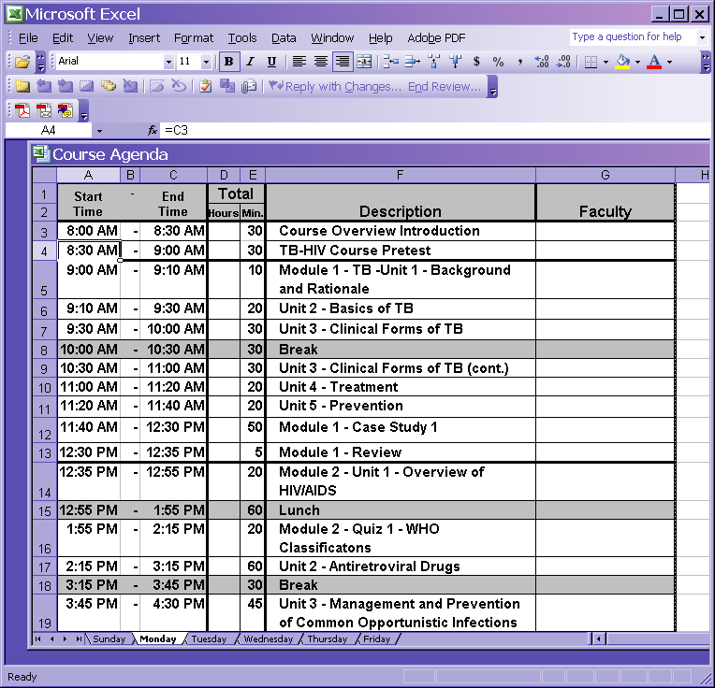
The time in the “C” column is where the calculating formula is located. This automatically adjusts each time you change the hours and minutes in columns D and E.
The hours and minutes in columns D & E are actual time – not a formula. If you change the time in these columns the end time for that row, and the times for the following rows will automatically change. One hour can be either a “1” in the Hour column or “60” minutes in the Min. column.

The first “Start time” (in cell A3) is the actual time (8:00). It is not a formula. So you have to type in whatever start time you want.

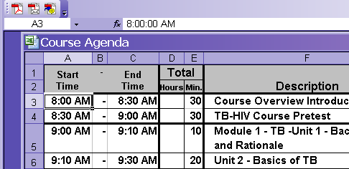
The second Start Time (e.g. 8:30 am in cell A4) in the A column is a formula and equals the same time as in the C column for the row above. So for cell A4 the formula is “=C3”; for 5A “= C4”.
The time in the diagonal cells need to match. In other words the time in the “C” in the column in the row above needs to match the time in the A column in the row below . This is true for all times.

Adding a Row

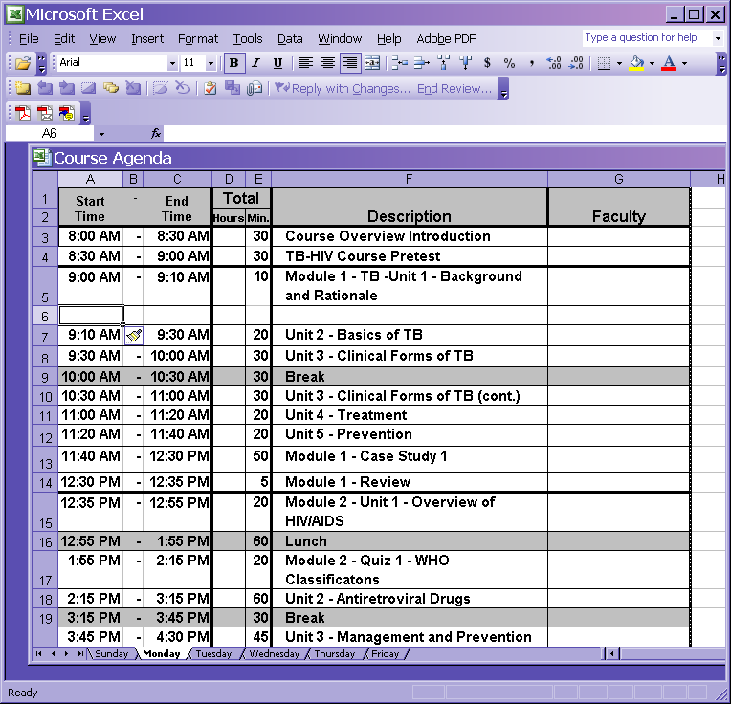
When adding a row you can copy cells A, B, and C above and paste them in the new cells. If you copy cells 5A, 5B, and 5C and paste into 6A, 6B and 6C it will copy the formulas. When you add in the time for the hours and minutes it should automatically adjust. Don’t copy the cells from the first row (Row 3) because the start time in A3 is not a formula.
Copy
Paste
You might have retype the formula for A6 to be “=C5” in the formula bar.
Add in the amount of time for that event in columns D & E and the time should adjust automatically.

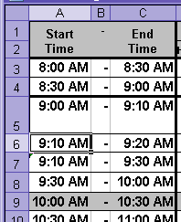
Sometimes a tiny green triangle “ ” appears in the upper left corner of a cell and indicates that something is wrong with the time. But sometimes there can be something wrong with the time and the triangle does not appear. Check to make sure the diagonal times are the same.
It is VERY important to always double check ALL of the times. Check the diagonal times for cell “ C” in the row above to cell “A” in the row below to make sure they match.
For example, C5 and A6 match. But C6 and A7 don’t match. C6 is 9:20 and A7 is 9:10. They should both be 9:20. In this case, change the formula in the A7 to “=C6” to correct the problem.
Don’t
match
Match

When adding a row you can copy cells A, B, and C above and paste them in the new cells. So copy 5A, 5B, and 5C and paste into 6A, 6B and 6C.
When adding a row you can copy cells A, B, and C above and paste them in the new cells. So copy 5A, 5B, and 5C and paste into 6A, 6B and 6C.

Deleting a Row

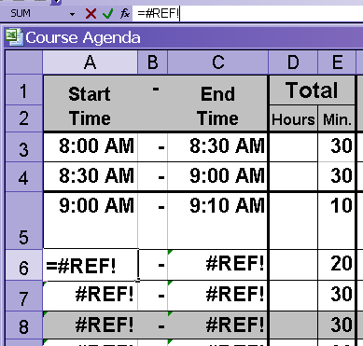
When deleting a row “#REF!” appears and you think everything is messed up. But it is not. Retype the formula in the problem row in the A cell and everything should automatically recalculate. For example, retype the formula for A6 to be “=C5”.

(Another option is to copy cells A, B, & C from the row above and paste into the first problem row. For example copy A 5, B5, & C5 and paste into A6, B6 and C6.

Always double check to make sure everything adjusts correctly.

Double check to make sure that all of the content shows in a row. Sometimes it can be hidden and might not adjust to show additional rows of text. To increase the height of a row select the row, go to Tables in the Toolbar you can click on the line in the left far column, hold down the mouse and drag the line lower to increase the height.
Sometimes when adding and deleting the rows the formatting changes for the lines and shading. So this might need to be adjusted. In this example the several lines were deleted.
Change the Header and Footer

You will need to change the header and footer to reflect the name, location and dates of your training. This will need to be changed on each worksheet. The header and page numbers in the footer are not automatic they are put in manually for each page.
Select File
Select Page Setup
Select Header/Footer
Select Custom Header
Change header
Click Ok
Select Custom Footer (You can type in the page number that you want because it won’t automatically type it in for the different worksheets)
Change Footer
Click Ok
Select Print Preview
Select Margins
Change if necessary by placing cursor on margin lines and moving
Select Close
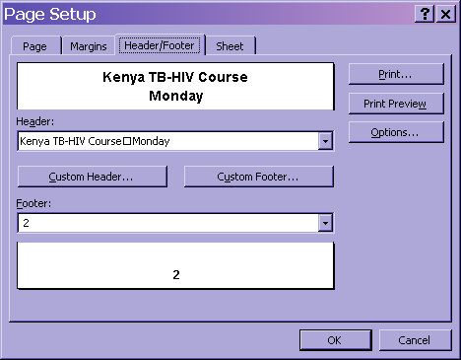

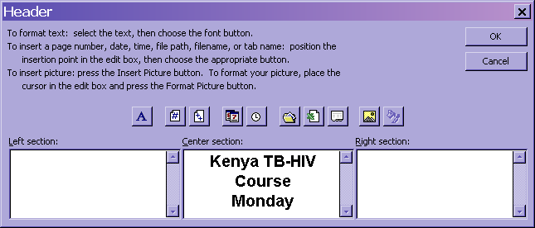

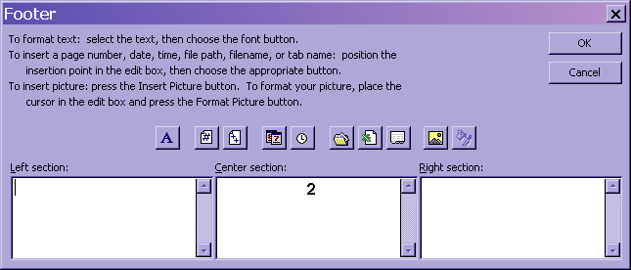

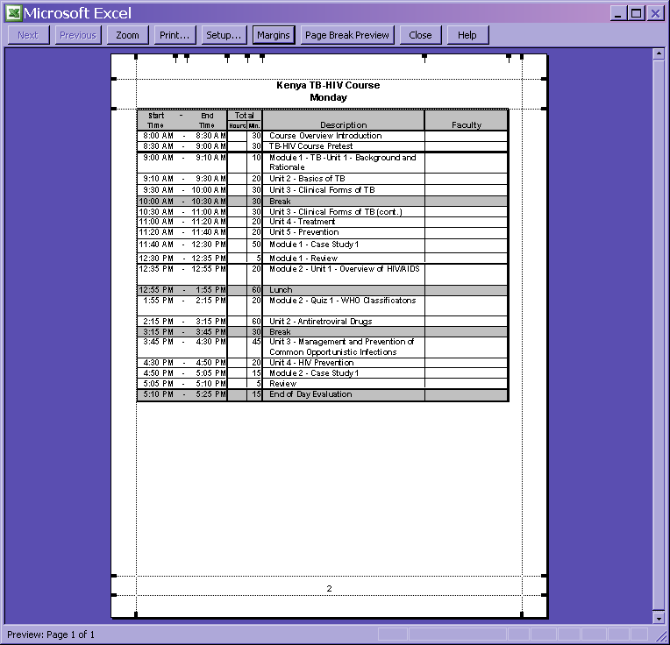
You can click on the margins (the dotted lines) and drag them to adjust them here.

