___________________________
Your Name

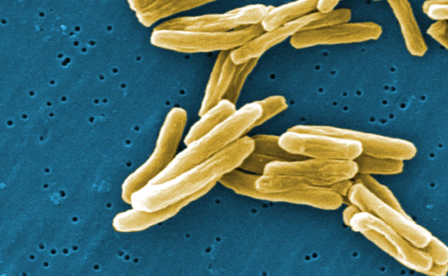

Report of Verified
Case of Tuberculosis (RVCT)
Self-Study Modules
Training Course

Answer Sheets

June, 2009

Module A – RVCT (page 1)

# | Your  Answer | Correct Answer  (if different from your answer) |  | # | Your  Answer | Correct Answer  (if different from your answer)
1.1 |  |  |  | 7.1
1.2 |  |  |  | 8.1
1.3 |  |  |  | 9.1
1.4 |  |  |  | 10.1
2.1 |  |  |  | 11.1
2.2 |  |  |  | 11.2
3.1 |  |  |  | 12.1
3.2 |  |  |  | 12.2
3.3 |  |  |  | 12.3
3.4 |  |  |  | 12.4
4.1 |  |  |  | 12.5
4.2 |  |  |  | 12.6
5.1 |  |  |  | 12.7
5.2 |  |  |  | 12.8
5.3 |  |  |  | 13.1
5.4 |  |  |  | 13.2
5.5 |  |  |  | 14.1
5.6 |  |  |  | 14.2
5.7 |  |  |  | 14.3
5.8 |  |  |  | 14.4
5.9 |  |  |  | 14.5
5.10 |  |  |  | 14.6
5.11 |  |  |  | 14.7
5.12 |  |  |  | 14.8
5.13 |  |  |  | 15.1
6.1 |  |  |  | 15.2
6.2 |  |  |  | 15.3
6.3 |  |  |  | 16.1
6.4 |  |  |  | 16.2
6.5

Module B – RVCT (page 2)

# | Your  Answer | Correct Answer  (if different from your answer) |  | # | Your  Answer | Correct Answer  (if different from your answer)
17.1 |  |  |  | 22.B 1
17.2 |  |  |  | 23.1
18.1 |  |  |  | 23.2
18.2 |  |  |  | 23.3
18.3 |  |  |  | 24.1
18.4 |  |  |  | 24.2
18.5 |  |  |  | 25.1
19.1 |  |  |  | 25.2
19.2 |  |  |  | 25.3
19.3 |  |  |  | 25.4
19.4 |  |  |  | 25.5
19.5 |  |  |  | 25.6
20.1 |  |  |  | 25.7
20.2 |  |  |  | 25.8
20.3 |  |  |  | 25.9
20.4 |  |  |  | 25.10
21.1
22.A 1
22.A 2
22.A 3
22.A 4
22.A 5

Module C – RVCT (page 3)

# | Your  Answer | Correct Answer  (if different from your answer) |  | # | Your  Answer | Correct Answer  (if different from your answer)
26.1 |  |  |  | 35.1
27.1 |  |  |  | 35.2
28.1 |  |  |  | 35.3
29.1 |  |  |  | 35.4
30.1 |  |  |  | 35.5
30.2 |  |  |  | 35.6
30.3 |  |  |  | 35.7
30.4 |  |  |  | 35.8
30.5 |  |  |  | 35.9
30.6 |  |  |  | 35.10
30.7 |  |  |  | 36.1
30.8 |  |  |  | 37.1
30.9 |  |  |  | 37.2
31.1 |  |  |  | 37.3
32.1 |  |  |  | 37.4
33.1 |  |  |  | 37.5
34.1 |  |  |  | 37.6
34.2
34.3
34.4
34.5
34.6
34.7
34.8
Module D – Follow Up Report 1

# | Your  Answer | Correct Answer  (if different from your answer)
38.1
39.1
39.2
40.1
40.2
40.3
40.4
40.5
40.6
40.7
40.8
40.9
40.10

Module E – Follow Up Report 2

# | Your  Answer | Correct Answer  (if different from  your answer) |  | # | Your  Answer | Correct Answer  (if different from  your answer)
41.1 |  |  |  | 48.1
41.2 |  |  |  | 49.1
41.3 |  |  |  | 49.2
41.4 |  |  |  | 49.3
41.5 |  |  |  | 49.4
41.6 |  |  |  | 49.5
42.1 |  |  |  | 49.6
43.1 |  |  |  | 49.7
44.1 |  |  |  | 49.8
45.1 |  |  |  | 49.9
45.2 |  |  |  | 49.10
45.3 |  |  |  | 49.11
45.4 |  |  |  | 49.12
45.5 |  |  |  | 49.13
46.1 |  |  |  | 49.14
46.2 |  |  |  | 49.15
46.3 |  |  |  | 49.16
46.4 |  |  |  | 49.17
46.5 |  |  |  | 49.18
46.6 |  |  |  | 49.19
47.1 |  |  |  | 49.20
47.2
47.3
47.4
47.5
47.6
47.7
47.8
Posttest

# | Your  Answer | Correct Answer  (if different from  your answer) |  | # | Your  Answer | Correct Answer  (if different from  your answer)
1 |  |  |  | 16
2 |  |  |  | 17
3 |  |  |  | 18
4 |  |  |  | 19
5 |  |  |  | 20
6 |  |  |  | 21
7 |  |  |  | 22
8 |  |  |  | 23
9 |  |  |  | 24
10 |  |  |  | 25
11 |  |  |  | 26
12 |  |  |  | 27
13 |  |  |  | 28
14 |  |  |  | 29
15 |  |  |  | 30

