**Cross-cutting Tool - 4b**

**Mapping Old RVCT Data (1993-2008) to   
New RVCT Data (2009-present)**

These are visual examples of three of the calculated RVCT variables mentioned in Cross-cutting Tool-4a 2009 RVCT Trending Guidance.

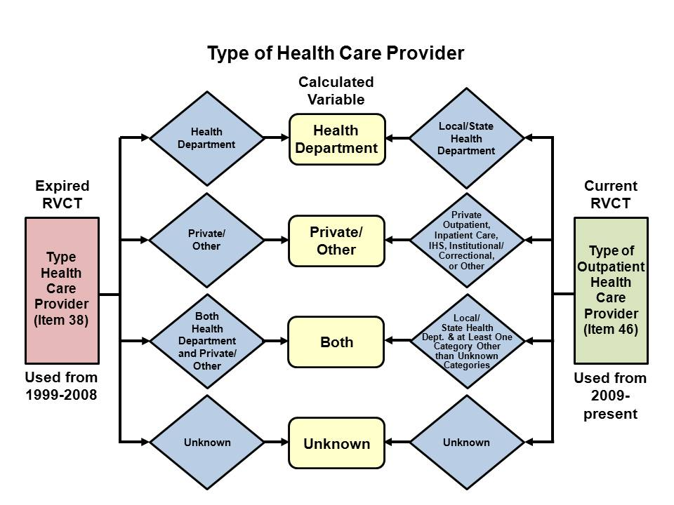

Calculated variable means the value is assigned based on the contents of one or more RVCT variables.

