Web Plus Administration Tool

Learning Objectives
In this chapter you will learn:
- About the major purpose and functions of the Web Plus Administration Tool
- How to install the Web Plus Administration Tool
- How to log into the Web Plus Administration Tool
- Use the Web Plus Administration Tool to export abstracts and uploaded files out of Web Plus
- Use the Web Plus Administration Tool to run automated edits on files in the current NAACCR version of Web Plus
- Use the Web Plus Administration Tool to run edits manually on an uploaded NAACCR file

Overview
The Web Plus application runs on a web server that sits outside the organizations internal firewall. Abstracts that are uploaded and/or manually abstracted online are stored in the SQL database which resides inside the internal firewall. Abstracts and uploaded files (bundle submissions) need to be exported out of the SQL database so that they can be imported into the central cancer registry database.
The Web Plus application is located on the web server outside the internal firewall, it does not have direct access to the storage areas (network drives) on the internal local area network (LAN), and cannot export to these storage areas. As a result, the export of abstracts and files must be accomplished using a windows application called the Web Plus Administration Tool, which can be run on any PC on the internal network. In addition to exporting abstracts and uploaded files this tool can also be used to run scheduled, batch edits on uploaded files, as well as to manually run edits on any uploaded file in NAACCR file format.

Installing the Web Plus Administration Tool
To install the Web Plus Administration Tool on the Central Registry Administrator’s PC (must have administrative rights to the computer to install this application):
- Download the Web Plus Administration Tool install program from the CDC ftp site. You should have received the folder and the name of the latest install file in an email.
- Double-click on the install program file to begin the installation process, and follow the screen prompts to complete the install. The install program will create a menu entry called “Web Plus Administration” under the Start-->All Programs menu.

- Obtain the SQL Server name, database, User ID (SQL Server Login), and password; this information will need to be entered when the Administrator launches the Web Plus Administration Tool in order for it to initially connect to the SQL server. This information is only required the first time this application is run. For subsequent runs only the Central Registry Administrator username and password are required to log in.

Logging In to the Web Plus Administration Tool

- To launch the Web Plus Administration Tool, click on Start––>All Programs––>Web Plus Administration––>Batch Processing.
- This brings up the Log In dialog box:

Log In Field | What to Enter
Server | Name or IP address of SQL Server
Database | Name of SQL database
UserID | SQL Server Login ID
Password | Password for SQL Server
NW Library | Select a network library to use (Named Pipe or TCP/IP)
Port | Enter Port number SQL Server listens on (1433 is the default)
Use Windows Authentication Option | Check this if using windows authentication for log on. There is no need to enter the UserID and password if this is checked.

- Upon initial login, you will need to obtain the above information from your SQL database administrator. Fill in the fields and click on the Login button to launch the Web Plus Administration Tool.
- Once you have entered the above information once, upon future logins, you need only enter your Central Registry Administrator username and password to log into the Web Plus Administration Tool.

Your IT staff may have already entered the initial log in information for you. Just enter the information that the Web Plus Tool asks for.

Exporting Abstracts out of Web Plus
- Log in to the Web Plus Administration Tool, click on the File menu option, and select Export Released Abstracts.
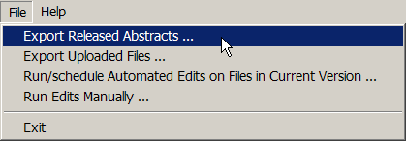
Result: The Export Released Abstracts window opens.
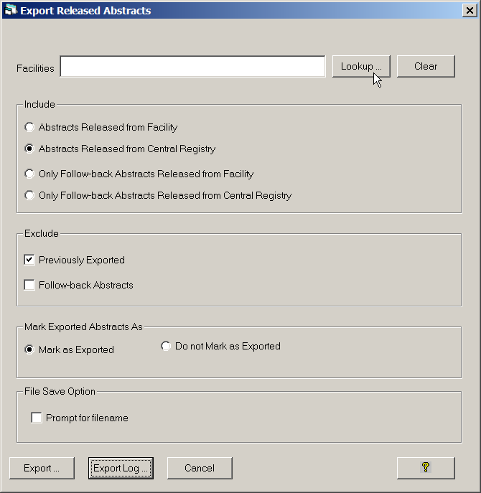
For the facilities selected, export options can be set for the export of abstracts submitted by those facilities. The Export Released Abstracts window contains these export options:
Export Option | Sub Option | Function When Checked or Clicked
Include | Abstracts Released from Facility | Selects all abstracts that have been released from the facility (includes abstracts under review by a central abstractor); Use this option if you are not suing Web Plus to centrally review abstracts released by facilities
 | Abstracts Released from Central Registry | Selects all abstracts that have been released by central registry
 | Only Follow-back Abstracts Released from Facility | Selects only follow-back abstracts have been released from the facility (includes follow-back abstracts under review by a central abstractor)
 | Only Follow-back Abstracts Released from Central Registry | Selects only follow-back abstracts that have been released by central registry
Exclude | Previously Exported | Excludes previously exported abstracts (default is checked); When unchecked will select either all facility and/or all central registry-released depending upon what options are selected under the Include group
 | Follow-back Abstracts | Excludes follow-back abstracts
Mark Exported Abstracts As | Mark as Exported | Updates export status upon export; default is clicked
 | Do Not Mark as Exported | When clicked, exported abstracts do not get marked as exported, i.e., export status does not change upon export; may want to use when testing
File Save Option | Prompt for filename | When clicked, user is prompted for a filename for the generated file of exported abstracts; when left un-clicked, Web Plus names the files using the naming convention of wpxxxxxxxxxx_yy.dat, where the x’s represent the reporting facility ID, and the y’s represent a sequential number assigned to each file uploaded from that facility (e.g., wp1111111111_11.dat)
- Click Lookup… to the right of the Facilities box.
Result: The Select Facility window opens.
- Select the facility or facilities for which you would like to export abstracts, and click Select, then Close.
Result: You are returned to the Release Exported Abstracts window, with the selected facilities listed in the Facilities box.
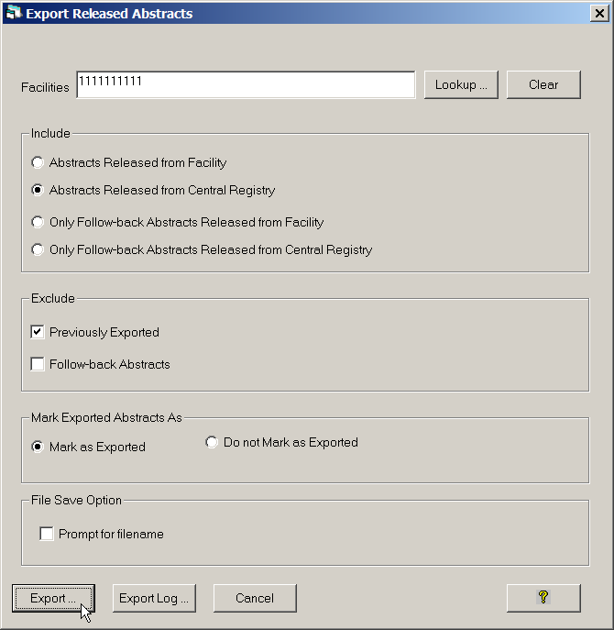
- Click Export.
- Choose a location on your PC or shared network folder where you would like to save the file of exported abstracts.
- Click Ok.
Under File Save Option, if the Prompt for filename option is left un-checked, Web Plus names the files using the naming convention of wpxxxxxxxxxx_yy.dat, where the x’s represent the reporting facility ID, and the y’s represent a sequential number assigned to each file uploaded from that facility (e.g., wp1111111111_11.dat). If the Prompt for filename option is checked, upon export, you will be prompted to overwrite the default filename provided by Web Plus.
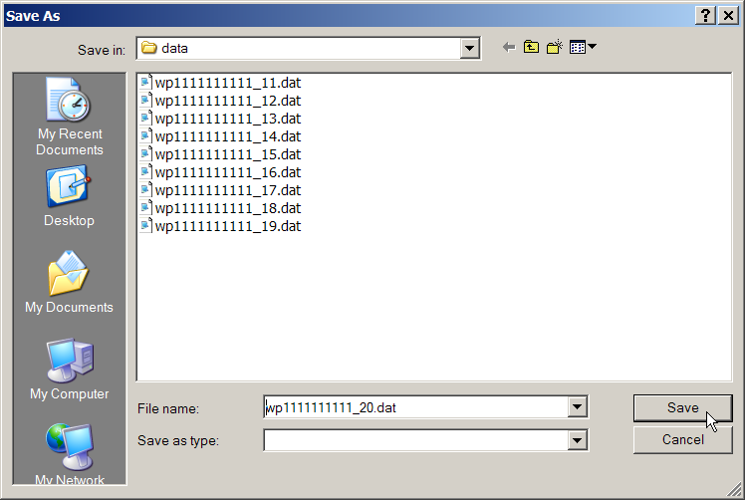

Exporting Uploaded Files
To export files (NAACCR and non-NAACCR) out of Web Plus:
- Log in to the Web Plus Administration Tool, click on the File menu option, and select Export Uploaded Files.
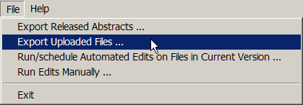
Result: The Export uploaded files window opens.
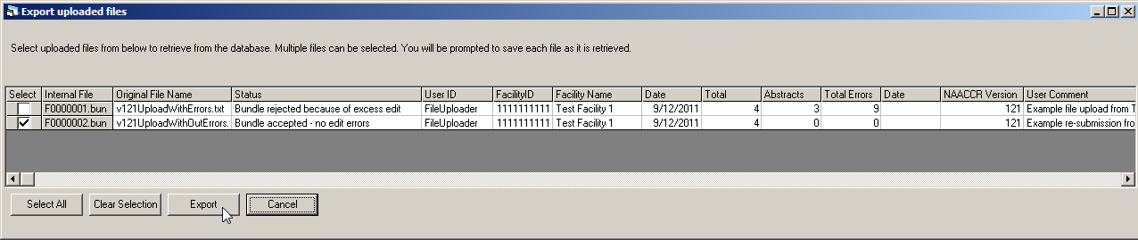
- Select the uploaded file that you wish to export by clicking a check into the Select column on the row of the file. For each uploaded file, the Web Plus Administration Tool lists the internal filename, original filename, file status, User ID and facility ID and name of the File Uploader who uploaded the file, the date the file was uploaded, the number of abstracts, the number of abstracts containing errors, and the total number of errors in the uploaded file, as well as the date exported, NAACCR version, and any comments uploaded with the file.
- Click Export.
Both NAACCR and non-NAACCR files may be exported. A NAACCR file rejected due to edit errors may also be exported.
- Choose a location on your PC or shared network folder where you would like to save the file of exported abstracts.
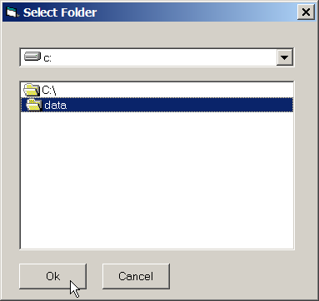
- Accept or overwrite the default filename for exported file, and click OK.

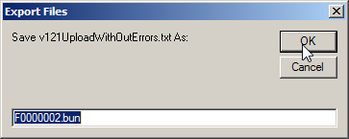
- The file is exported to the specified directory with the specified filename.

Exported Filenames
Note that when you export a file out of Web Plus the name of the exported file can be either the Web Plus internal filename (e.g., F0000002.bun), or the original filename of the file that was uploaded (e.g., v121UploadWithOutErrors.txt). The file naming convention is specified in the WebPlus.ini file that is located in the C:\Windows folder.
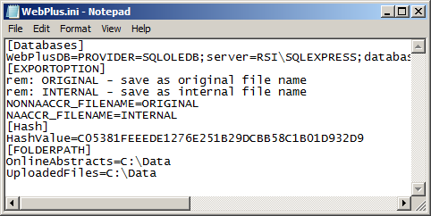
This preference is specified in the EXPORTOPTION section of the WebPlus.ini file as shown below:
[EXPORTOPTION]
rem: ORIGINAL - save as original file name
rem: INTERNAL - save as internal file name
NONNAACCR_FILENAME=ORIGINAL
NAACCR_FILENAME=INTERNAL
If you would like the original filename of an uploaded NAACCR file to be preserved upon export, then you would specify: NAACCR_FILENAME=ORIGINAL. If you would like the Web Plus internal filename as the name of the exported file you would specify: NAACCR_FILENAME=INTERNAL.
Prior to export, abstracts in a uploaded file, as well as the error report for an uploaded file of abstracts, may be viewed, from within the Administrator pages of the Web Plus application. Reviewing the abstracts and edit errors is recommended prior to exporting an uploaded NAACCR file, especially one that has been rejected.

Running Automated Edits on Files in Current Version
When large files are being uploaded, or when many files are being uploaded at one time, the edits may take some time to run. To prevent bottlenecking of uploaded files due to the time it takes to run the edits, an option for offline, batch running of edits is available.
Batch edits can be run on uploaded files when the Defer Edits option is clicked on Manage Systems Preferences page of the Web Plus application, or when the Defer edits on file upload (Overrides the system default) option is clicked for any individual facility account. When files of abstracts are uploaded via Web Plus, they are stored on the SQL server. When either of the Defer Edits options is turned on, no edits are run on the files when they are uploaded. Instead, the Web Plus Administration Tool can be used to schedule the running of batch edits at a later, specified time. When batch edits are run at the specified time, edits are run on the files stored on the SQL server, an edit report is created, and an e-mail is sent out to the Central Registry Administrator and the File Uploader notifying them that the edits have run, and the error report will be available for viewing when they next login to Web Plus. All files edited using the Run/schedule Automated Edits on Files in Current Version option will be edited using the edit set assigned to the display type selected for file upload for each facility on the facility’s account page in Web Plus.
To run or schedule automated edits on files uploaded in the current NAACCR version (i.e., the NAACCR version that your Web Plus applications is based on) using the Web Plus Administration Tool:
- Log in to the Web Plus Administration Tool, click on the File menu option, and select Run/schedule Automated Edits on Files in Current Version.
n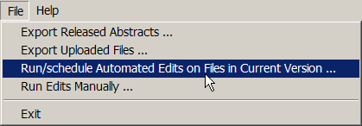
Result: The Run/schedule automated edits on files in current version window opens.
At the top of the window is a listing of all NAACCR files that that been submitted in the current NAACCR version (i.e., the NAACCR version that your Web Plus application is based on), but that had the running of edits deferred.
- Select the files for which you would like to schedule the running of edits by clicking either Select All, or by clicking the Select checkbox for the individual file(s) of interest.
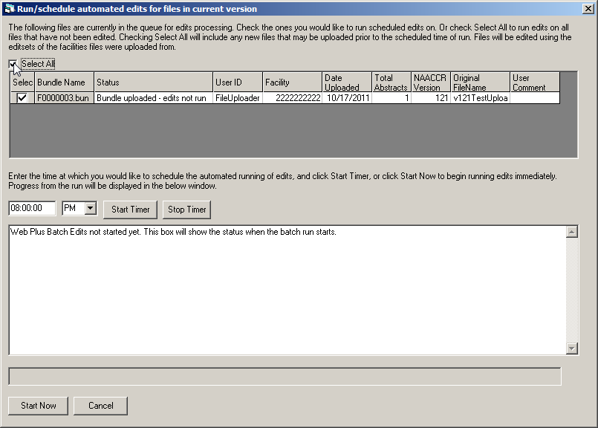
- The scheduling of the edits run is done in the lower half of the Run/schedule automated edits on files in current version window. Enter the time at which you would like the edits to run. This can be a time after you have left for the day (just leave your PC running).
- Click Start Timer. The edits will run at the specified time, an error report will be generated and posted to the Web Plus application, and the notifying e-mails will be sent. The display area will show the status of the batch run once it has begun.
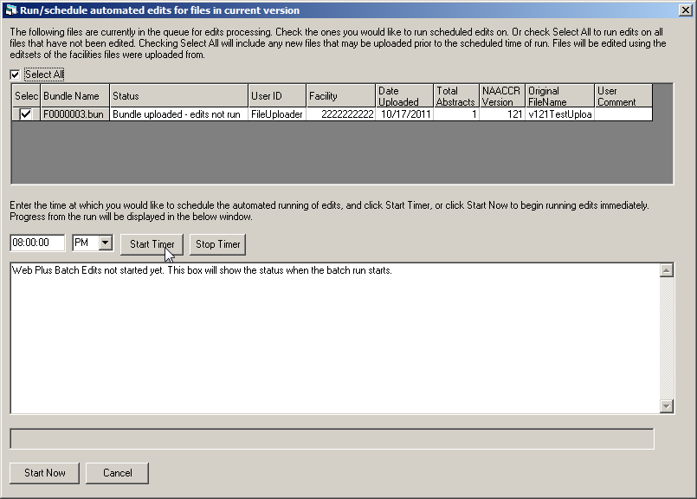
If you would like to run the batch edits right away (i.e., not at a later specified time), you can leave the time fields blank, and just click Start Now.

Running Edits Manually
A registry may defer the running of edits in Web Plus for several reasons. The registry may want to defer edits for a facility because they would like to run a different edit set than that currently assigned to the facility’s display type in Web Plus. Or, there are often times when a central registry must accept submissions in multiple NAACCR versions, in particular when a new NAACCR version is being implemented. For example, when NAACCR version 12.1 is implemented, many central registries will have a mix of NAACCR version 12.0 and NAACCR version 12.1 files being uploaded, until all reporting facilities have been converted to version 12.1. When accepting multiple NAACCR versions in file uploads, the registry must be able to differentially run multiple corresponding versions of the NAACCR edits metafiles on these files.
Web Plus automatically runs edits on files uploaded in the NAACCR version on which the Web Plus application is based, and automatically defers the running of edits on files uploaded in other NAACCR versions. For example, if a registry’s Web Plus application is based on NAACCR version 12.1, and a NAACCR version 12.0 file is uploaded, the running of edits will automatically be deferred for the file.
In order to accommodate the running of central registry version-specific metafiles on uploaded files, Web Plus offers a Defer edits on file upload option for any individual facility. The registry may choose to automatically run, for example, a NAACCR version 12.1 metafile in their Web Plus application, and let this metafile run automatically in Web Plus (i.e., (leave the defer edits check boxes un-checked for the facilities submitting NAACCR version 12.1). Or the registry may choose to defer the running of edits, and run the edits manually using the Web Plus Administration Tool.
The Web Plus Administration Tool Run Edits Manually feature allows for the selection of the uploaded file for which edits was deferred, and then selection of the metafile and edit set that you would like to run on the file. The Web Plus Administration Tool interacts with Web Plus. When edits are run manually on an uploaded file using the Web Plus Administration Tool, edits are run on the files stored on the SQL server, an edit report is created, an e-mail is sent out to the Central Registry Administrator and the File Uploader notifying them that the edits have run, and the error report will be available for viewing when they next login to Web Plus.
To manually run edits on files for which the running of edits was deferred upon upload:
- Log in to the Web Plus Administration Tool, click on the File menu option, and select Run Edits Manually.
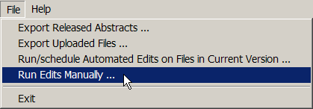
Result: The Run Edits Manually window opens.
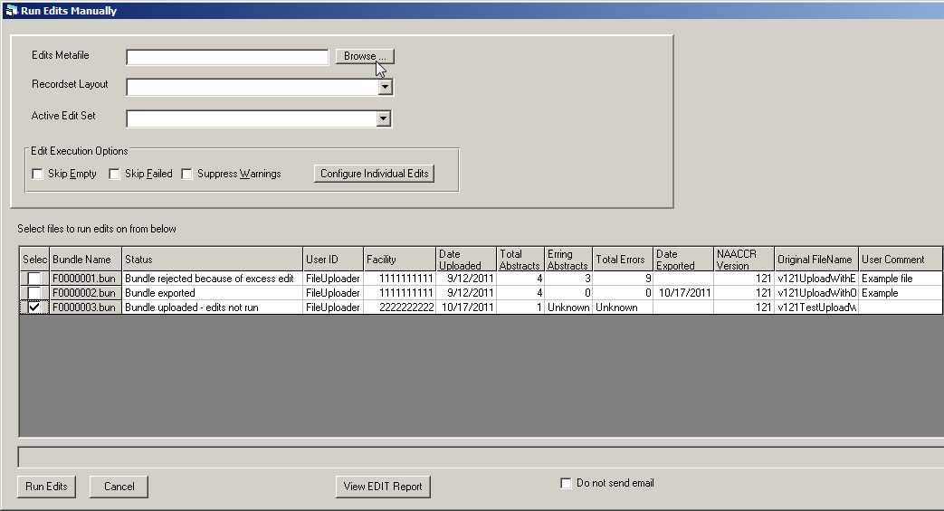
- At the top left of the window, browse on your computer and select the edits metafile that you would like to use, and then select the appropriate record layout and edit set.
- Select any Edit Execution Options, if appropriate.
- Select the uploaded file(s) for which you would like to run edits by clicking the Select column of the row of the file(s).
- Click Run Edits.
Result: The specific edit set will be run on the specified file(s), an error report created, an e-mail is sent out to the Central Registry Administrator and the File Uploader notifying them that the edits have run, and the error report will be available for viewing when they next login to Web Plus.
- To view the error report immediately, click View EDIT Report.
By default, the Do not send e-mail option is left un-checked, so that when edits are manually run on a file(s), and e-mail will automatically be sent to the Central Registry Administrator and the File Uploader notifying them that the edits have run. However, you can choose not to send an e-mail upon the running of the edits by clicking the Do not send e-mail option.

