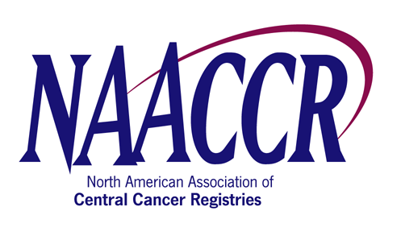

Request Form for a NAACCR Annual Conference Workshop

Workshop Title: | CDC Registry Plus Link Plus Workshop
Name of Organizer: | Kathleen Thoburn/Scott Van Heest
Address of Organizer: | Cancer Surveillance Branch  Division of Cancer Prevention and Control  Centers for Disease Control and Prevention  4770 Buford Hwy., MS K-53
City: | Atlanta | State/Province: |  | Georgia | Zip: | 30341 | Country: | USA
Phone: | 7704884863 | Fax: | 770-488-3040 |  | Email: | SVanheest@cdc.gov
What are the workshop objectives? | 1. To provide an overview of basic probabilistic record linkage concepts.  2. To communicate the exceptional features of Link Plus, including available phonetic systems and matching methods, powerful support for manual review of uncertain matches, and export of merged file after assignment of match status.  3. To instruct potential Link Plus users about how to obtain and use the program.
What is the purpose of training? | To familiarize workshop participants with the various features of the Link Plus program, and provide participants with the basic knowledge necessary to perform linkages using Link Plus.
Provide a general course description. | A ½ day (4.0 hour) Link Plus training to include a brief overview of record linkage concepts and the use of record linkage in central cancer registries, overview of deterministic and probabilistic matching, description of the Link Plus software and the steps required to conduct a linkage using Link Plus, record linkage exercises using Link Plus, and open discussion among training participants, workshop speakers, and David Gu, Link Plus Developer.
Are there knowledge/skill requirements of the participants  (or other pre-reqs)? | Should be familiar with Windows computing environment, and have basic knowledge of data and data files. Participants should bring their own laptops, and have Link Plus installed prior to the workshop (download/installation instructions will be provided to participants in advance).
Who is the intended audience? | Individuals conducting linkages for their cancer registries, or those having an interest in using Link Plus.
What is the training approach? | PowerPoint presentations for linkage/Link Plus overviews, interactive, hands-on external linkage and deduplication exercises with participants using the program on their own laptops.
Provide a workshop agenda – including times & speaker names | Please see attached agenda.
The Budget Proposal for Workshop, signed by the NAACCR Director of Administration, is attached.
Signed Speaker/Faculty Agreement Forms are attached for each proposed faculty.

