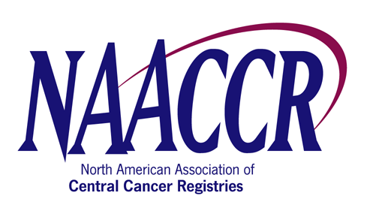

NAACCR Annual Conference Workshop Speaker/Faculty Agreement Form

I, Kathleen K. Thoburn (name), of Northrop Grumman (CDC/NPCR Contractor) (company), agree to participate as a speaker at the NAACCR
Registry Plus Link Plus (name of workshop) Workshop, which will be held on Sunday, June 8 , 2008 (date) in
Denver, Colorado (city, state or province).
I understand that my travel expenses WILL WILL NOT be reimbursed by NAACCR.
Further, I WILL WILL NOT accept an honorarium in the amount of $200 per day for my participation.

Name: (Print) | Kathleen K. Thoburn
Signature: |  |  |  |  | Date: |  | 8/27/2007
Address: | 11123 South Street, State Route 32
City: | Greenville | State/Province: | NY | Zip: | 12083 | Country: |  | USA
Phone: | (518)9665143 | Fax: | Same | Email: | kthoburn@cdc.gov
Name of Workshop Organizer

