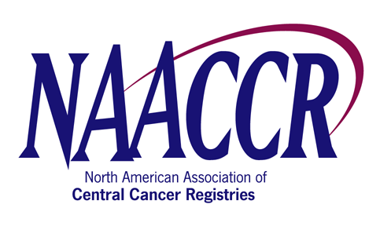

NAACCR Annual Conference Workshop Speaker/Faculty Agreement Form

I, David Gu (name), of Science Applications International Corporation (CDC/NPCR contractor) (company), agree to participate as a speaker at the NAACCR
CDC Registry Plus Link Plus (name of workshop) Workshop, which will be held on Sunday, June 8, 2008 (date) in
Denver, Colorado (city, state or province).
I understand that my travel expenses WILL WILL NOT be reimbursed by NAACCR.
Further, I WILL WILL NOT accept an honorarium in the amount of $200 per day for my participation.

Name: (Print) | David Gu
Signature: |  |  |  |  | Date:
Address: | NCCDPHP, DCPC, Koger Office Park, Davidson Building Rm 3246, Mail Stop K-53, 2858 Woodcock Blvd
City: | Atlanta | State/Province: | GA | Zip: | 30341 | Country: |  | USA
Phone: | 7704883178 | Fax: | 770-488-4759 | Email: | dgu@cdc.gov
Name of Workshop Organizer | Kathleen Thoburn/Scott Van Heest

