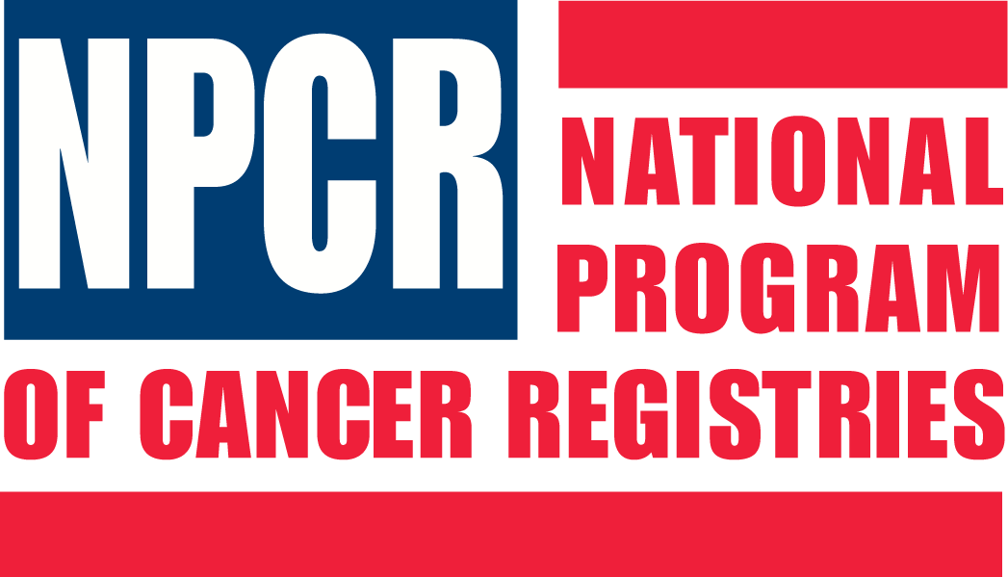

Link Plus
Application Overview & User Training
Denver, Colorado
June 8, 2008

AGENDA

8:00-8:10 Welcome and Introductions
(Rich Pinder/Kathleen Thoburn)
8:10-8:45 Record Linkage Concepts (Rich Pinder)
8:45-9:15 Overview of Link Plus Application
& Linkage Process (Kathleen Thoburn)
9:15-10:30 External Linkage Exercise (Kathleen Thoburn)
10:30-10:45 Break
10:45-11:45 Deduplication Linkage Exercise
(Kathleen Thoburn)
11:45-11:55 Open Discussion (David Gu)
11:55-12:00 Evaluation & Wrap up questions
(Kathleen Thoburn)



