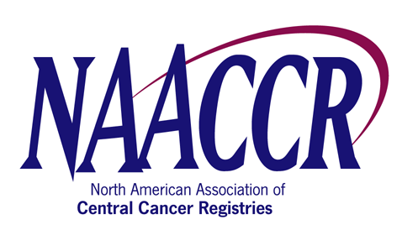

Request Form for a NAACCR Annual Conference Workshop

Workshop Title: | CDC EDITS Workshop
Name of Organizer: | Susan Capron/Kathleen Thoburn/Scott Van Heest
Address of Organizer: | Cancer Surveillance Branch  Division of Cancer Prevention and Control  Centers for Disease Control and Prevention  4770 Buford Hwy., MS K-53
City: | Atlanta | State/Province: |  | Georgia | Zip: | 30341 | Country: | USA
Phone: | 7704884863 | Fax: | 770-488-3040 |  | Email: | SVanheest@cdc.gov
What are the workshop objectives? | 1. To provide an overview of basic data editing concepts.  2. To communicate the features of EditWriter3 and GenEDITS Plus software.  3. To instruct potential EDITS users about how to obtain and use the programs.
What is the purpose of training? | To familiarize workshop participants with the various features of the EditWriter3 and GenEDITS Plus programs, and provide participants with the basic knowledge necessary to write state-specific edits and create their own edit sets using EditWriter3, and then apply the edits to data using GenEDITS Plus.
Provide a general course description. | A ½ day (4.0 hour) EDITS training to include a brief overview and description of basic data editing concepts, the use of data quality edits in the field of cancer registration, description of EditWriter3 and GenEDITS Plus software programs and the steps required to generate edits and edit sets, and apply them to data.
Are there knowledge/skill requirements of the participants  (or other pre-reqs)? | Should be familiar with Windows computing environment, and have basic knowledge of data and data files. Participants should bring their own laptops, and have EditWriter3 and GenEDITS Plus installed prior to the workshop (download/installation instructions will be provided to participants in advance).
Who is the intended audience? | Individuals data quality assurance activities for their cancer registries, or those having an interest in using the EDITS tools.
What is the training approach? | PowerPoint presentations for edits and software overviews, interactive, hands-on edits and edit set exercises with participants using the program on their own laptops.
Provide a workshop agenda – including times & speaker names | Please see attached agenda.
The Budget Proposal for Workshop, signed by the NAACCR Director of Administration, is attached.
Signed Speaker/Faculty Agreement Forms are attached for each proposed faculty.

