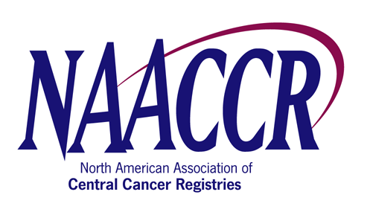

NAACCR Annual Conference Workshop Speaker/Faculty Agreement Form

I, Kathleen K. Thoburn (name), of Northrop Grumman (CDC/NPCR contractor) (company), agree to participate as a speaker at the NAACCR
CDC Registry Plus EDITS (name of workshop) Workshop, which will be held on Sunday, June 8, 2008 (date) in
Denver, Colorado (city, state or province).
I understand that my travel expenses WILL WILL NOT be reimbursed by NAACCR.
Further, I WILL WILL NOT accept an honorarium in the amount of $200 per day for my participation.

Name: (Print) | Kathleen K. Thoburn
Signature: |  |  |  |  | Date: |  | 8/27/2007
Address: | 11123 South Street, State Route 32
City: | Greenville | State/Province: | NY | Zip: | 12083 | Country: |  | USA
Phone: | 5189665143 | Fax: |  | Email: | kthoburn@cdc.gov
Name of Workshop Organizer | Susan Capron/Kathleen Thoburn/Scott Van Heest

