

National Program of Cancer Registries


Registry Plus Software for Cancer Registries

Web Plus Training Manual
for Facility Abstractors
Version 1.0
(Based on Web Plus Version 1.0)



Contents

Chapter 1: Introduction 1
Overall Learning Objectives 1
Overview of the Web Plus Training Manual 1
Web Plus Features 1
Users 2
Requirements for Web Access 2
Chapter 2: The Basics 3
Learning Objectives 3
Overview 3
Log In 3
Home Page 4
Abstracting Process 5
Data Entry Page 5
Changing Your Password 8
Web Plus Version Information 8
Logging Out 9
Questions 9
Chapter 3: Creating an Abstract 10
Learning Objectives 10
Overview 10
Entering Information into Fields 10
Questions 13
Activity – Creating an Abstract 13
Chapter 4: Adding Data to an Abstract 14
Learning Objectives 14
Overview 14
Opening and Updating an Abstract 14
Activity – Activity – Adding Data, Part One 17
Adding Data, Part Two 17
Text Fields 18
Activity – Using Text Fields 19
Print Preview 19
Deleting an Abstract 19
Questions 21
Activity – Adding Information and Deleting 21
Chapter 5: Correcting Errors 22
Learning Objectives 22
Overview 22
Understanding Edit Sets 22
Edit Errors Tab 22
Correcting Errors 23
Activity – Correcting Errors 24
Releasing the Abstract 25
Questions 26
Chapter 6: Running Reports 27
Learning Objectives 27
Overview 27
Opening Reports 27
Available Reports 29
Changing the Date Range of a Report 29
Local Reports 30
Abstracts Submitted Sorted by Abstractor Report 30
Abstracts Accessed Sorted by Patient Name Report 32
Descriptive Statistics on Released Abstracts Report 33
Activity Report 36
Audit Reports 36
Activity – Finding Report Information 38
Chapter 7: Final Learner Activity 39
Overview 39
Medical Record 39
Hints 39
Appendix A: Answers 40

Introduction

Overall Learning Objectives

These are the overall learning objectives for the Web Plus Facility Abstractor training manual:
- Learn the major functions of Web Plus
- Create abstracts in compliance with cancer registry standards
- Correct errors so that the abstract is error-free and complete
- Release abstracts
- View and modify the reports of Web Plus

Overview of the Web Plus Training Manual
The Web Plus Facility Abstractor Training Manual provides you with the information to understand and use this web application. In this manual you not only learn about the tools in Web Plus 1.0, you also create an abstract and follow the process of updating and correcting the abstract until it is complete and released to the central registry. Also, each chapter contains questions that test your knowledge of Web Plus and activities that allow you to practice your new skills on your own.
Although Web Plus can use any of a number of edit sets, this manual uses the edit set “Central: VS11 NPCR Required.” The edit set you use at your facility may differ.

Web Plus Features
Web Plus 1.0 is a web-based application used to collect cancer data securely over the public Internet. It is most suited for physicians’ offices and other low-volume reporting sources that do not have facility-based cancer registries.
Records are saved in a database at the hosting central registry, and abstracts entered by one facility or office are not visible to other facilities or offices. Data entered are validated by the CDC EDITS Engine running on a web server. The data items collected and required, as well as the edit set used to edit the data, are managed by the hosting central registry.
Web Plus is hosted on a secure web server that has a digital certificate installed; the communication between the client and the server is encrypted with Secure Socket Layer (SSL) technology.

Users
The results from the design staff and usability testing have identified these types of Web Plus users:

Users | Description
Facility Abstractor | Works in a local facility and handles patients’ medical records and paperwork. When a patient is diagnosed with cancer, the facility abstractor reports the case to the state’s central cancer registry.
Central Registry Abstractor/Reviewer | Reviews abstract submitted by hospitals and doctors’ offices for completeness and accuracy; compares text in the abstract against codes submitted to make sure they are the correct codes; corrects any errors or discrepancies found; also abstracts new cases.
Central Registry Administrator | Sets up the local facilities with access to the Web Plus software to report their data; creates a configuration for the facilities and defines their required fields and validation rules.
Local Administrator | Manages local users of a facility.
File Uploader | Uploads files of abstracts in the appropriate NAACCR format that were not abstracted using Web Plus, views EDITS error report and cleans, or works with abstractors to clean, errors on rejected files prior to re-uploading.

Requirements for Web Access
Web Plus requires Microsoft Internet Explorer version 5.0 or later or a Mozilla browser to operate the system fully. Although Web Plus works at 800 X 600 resolution, it can be best viewed at 1024 X 768 or higher resolution. It is highly recommended that you change your resolution to 1024 X 768 or higher when using the Web Plus application.

The Basics

Learning Objectives
In this chapter, you will learn to:
- Identify the menu options of Web Plus
- Understand the process of working on an abstract
- Log in and out of Web Plus
- Change your password

Overview
This lesson covers the basics of Web Plus. You’ll learn about logging in and out of Web Plus and the key elements of Web Plus.

Log In
To log in, complete these steps:
- Open your Internet browser and type the Internet address for the Web Plus in the Address field.
- Press Enter.
Result: Either the network password window or the Web Plus window opens.
  - If the Enter Network Password window opens, go to step 3.
  - If the Web Plus window opens, go to step 5.
- Click within the User ID field to place your cursor there.
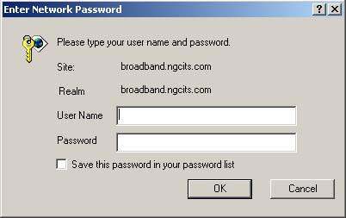
- Type demo into both the User Name and Password fields and click OK.
Result: The Web Plus Log in page opens.

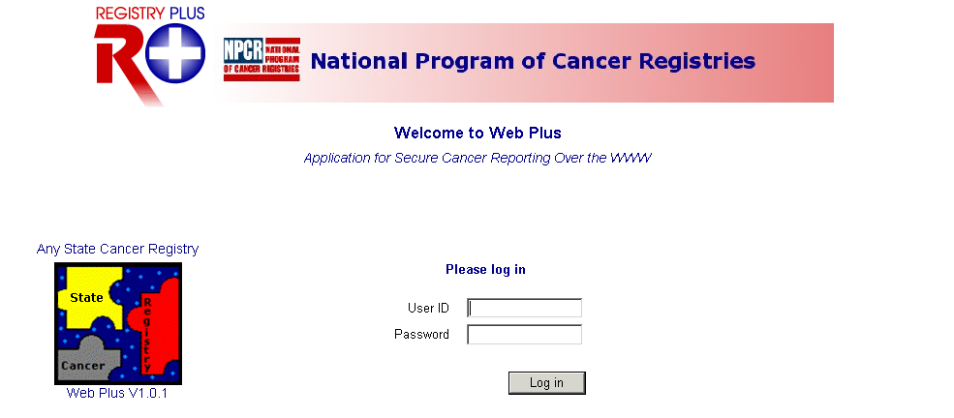
- Type johndoe in the User ID field and abstractor in the Password field.
- Click Log in.
Result: The Web Plus home page opens.

Home Page
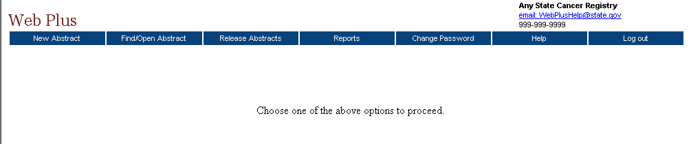
After you log in, the Web Plus Home page is displayed.
From this page you can access the main parts of Web Plus. Click on an option to open the page for the option. This table describes the menu options on the home page:
Menu option | Description
New Abstract | Opens the data entry page for a new abstract
Find/Open Abstract | Opens the page to search for existing abstracts
Release Abstracts | Opens the page that lists all abstracts that are ready for release
Reports | Opens the page that lists the reports available for viewing
Change Password | Opens the change password page
Help | About - Opens a page with the Web Plus, NAACCR, and Collaborative Staging Algorithm Version information
Log off | Logs the user off Web Plus; opens the Web Plus Log in page

Abstracting Process
The process of creating an abstract, entering data and ultimately releasing it to the central registry can all be done in Web Plus. After you create an abstract, you can save it at any time and return to your work at a later time. You can release the abstract to your central registry only after you have completed it, and eliminated any errors it may contain.
The process of generating and abstract includes the following steps:
- Create the abstract with the patient’s name and social security number and save. You can add more information to the abstract and complete it whenever you want.
- Enter codes, using the codes supplied by the Web Plus application, and text in the in the data entry fields. Save the abstract to retain the information you have entered.
- Correct errors. Each time you open or save the abstract, Web Plus automatically edits the entered information for accuracy and completeness using the edit set and required fields chosen by your Web Plus administrator.
- After you have entered all your data and corrected all errors, the system saves your new abstract as complete.
- Release the completed abstract to the central registry. You can release abstracts individually or several at a time.

Data Entry Page
You enter your case information on the Data Entry page. To open the Data Entry page and view its content, follow these steps:
- Log in to Web Plus.
- On the Web Plus menu, click New Abstract.
Result: The Data Entry page opens.
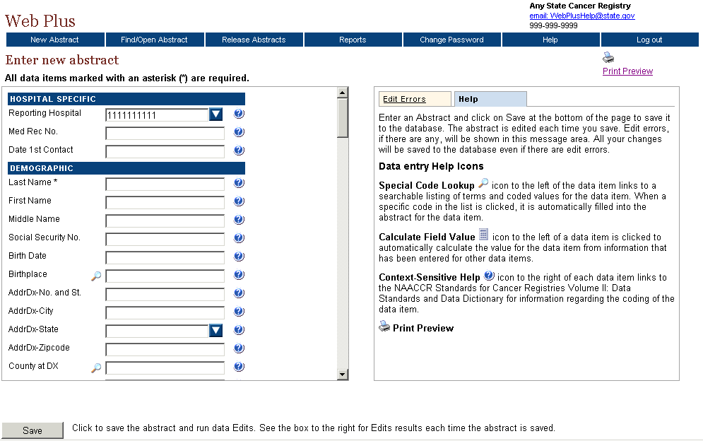
Notice that the page has two main sections. The box on the left contain the fields where you enter your case information. The box on the right contains two tabs: Help and Edit Errors.
- In the entry box on the left, scroll down the list to view all of the fields, including the text fields.
The fields you see depend on your facility or center and the set up chosen by your administrator. The headings, such as Hospital Specific and Demographic, can vary. These are only headings; they do not signify a group of required fields. Your administrator uses them to organize the fields for clearer viewing and to help with data entry.
Refer to “Creating an Abstract,” page 10, to learn how to enter data in these fields.
- In the right box, click each of the tabs to see the content.

These are the Web Plus tabs:
Tab | Description
Help | This area describes the saving and editing of an abstract and provides a description of the data entry help icons available to the abstractor.
Edit Errors | This area lists any errors that may exist in an abstract after you have opened or saved the abstract. This editing feature helps you complete the abstract until it meets the standards acceptable to the central registry. You will learn more about the edit errors tab on page 13.
- Click the Help tab, if the section is not already open. This area provides a legend describing the data entry help icons available to the abstractor and briefly describes the process of saving your abstract.
Result: The Help box opens.
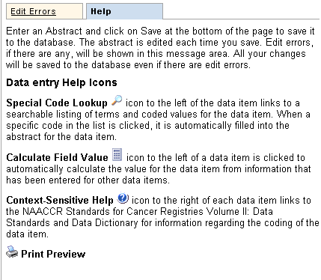
These are the Web Plus icons:
Icon | Description | Click the icon to . . .
 | Special Lookups | open a listing of codes and terms to choose from. Find the term that best applies, and click on the code to the left of the term. When a specific code is clicked, it is automatically filled into the abstract for the data item.
 | Calculate Field Value | calculate a value for a field from values in other fields.
 | Context-sensitive Help | open Help page with the NAACCR Standards for Cancer Registries Volume II: Data Standards and Data Dictionary for information about the data item.
 | Print Preview | open page that shows all of the fields and the content you have entered in your abstract; this page allows you to print a copy of your abstract.

Changing Your Password
To change your password, complete these steps:
- On the Home page menu, click Change Password.
Result: The Change Password page opens.
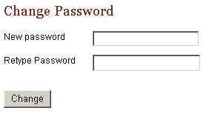
- Type your new password in both of the password fields.
- Click Change.
Result: Your password is successfully changed.

Web Plus Version Information
To view Web Plus, NAACCR, and Collaborative Staging Algorithm Version information, complete these steps:
- On the Web Plus menu, point to Help.
- Click on About.
Result: A page opens with information about the version of the Web Plus application, and the NAACCR and Collaborative Staging Algorithm versions included in the Web Plus application.

Logging Out
To log out of the Web Plus application, click Log out on the Home page menu.
Result: The Web Plus Log In page opens.

Questions
Answer the following questions about the basics of Web Plus (the answers are in Appendix A, page 31):

- Which icon do you click to open a separate window to insert a code into a field?
- How do you log out?
- Do have to complete filling out the abstract at one time? What can you do to begin an abstract and then return to it later?

Creating an Abstract

Learning Objectives
In this chapter, you will learn to:
- Enter information into the data entry fields
- Understand the process for completing an abstract
- Use these data entry tools: drop-down lists, Help, and Special Lookups

Overview
In this chapter you create an abstract that you use throughout this manual. In succeeding chapters you will complete and release this abstract. This chapter also introduces you to some basic entry tools to help you enter information in Web Plus.

Entering Information into Fields
In this section, you create an abstract by entering essential data into the designated fields. You will also learn to use Help, drop-down lists, and special lookups.
To create an abstract, complete these steps:
- Log in, as described in “Log In,” page 3.
- On the Web Plus menu, click New Abstract.
Result: The Data Entry page opens. The Reporting Hospital field is pre-filled.
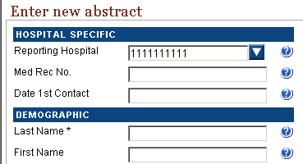
- In the Med Rec No. field, type 162305. (This is the medical record number used by the facility to identify the patient.)
- Click your cursor in the Last Name field and type Johnson.
When you enter name and address information into Web Plus, the application automatically capitalizes the entered text.
- Click the Help icon beside the Last Name field.
Result: A separate window opens giving you information about the field.
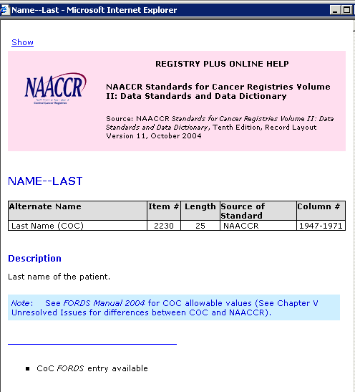
The context-sensitive Help information for Web Plus is from the NAACCR Standards for Cancer Registries Volume II: Data Standards and Data Dictionary. Each field has a help icon that you can click to open a page with information about the field.
- Close the Help window.
- Type this information into these fields:
Field | Value
First Name | Samuel
Social Security No. | 111222333
AddrDx–City | Decatur
- Go to the AddrDx–State field and click the arrow for the drop-down list.

Result: A list of states opens.
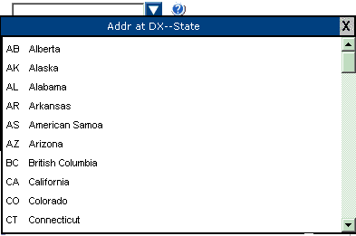
- Select GA Georgia from the list.
Result: The state code is entered in the field.
 | If you know the two-letter code for the state, you can type it in the field.
- At the County at DX field, click the Special Lookup icon.
Result: A separate window opens, which provides a list of county codes.
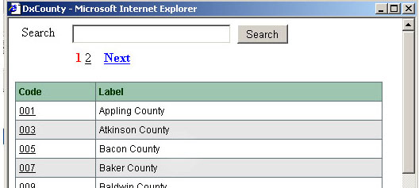
- In the Search field, type Dekalb and click Search.
Result: The system finds DeKalb county and its code.
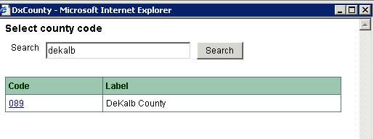
You can also find the code by scrolling down the page or by clicking a page number at the top of the page to see other codes in the list.
- Click the 089 code number for DeKalb county.
Result: The system enters the code in the County at DX field.
- In the AddrDx–Zipcode field, type 30030.
- To save your entries, click Save.
Result: The Web Plus system saves your new abstract. You can open it later and continue to work on it until completion.
When you save the abstract, the system displays edit errors. The procedure for resolving these are described in “Correcting Errors,” page 14.

In the next chapter, “Chapter 4: Adding Data to an Abstract, page 14” you continue to add data to this abstract.

Questions
Answer the following questions about entering data (the answers are in Appendix A, page 31):
- Which icon do you click to learn more about a field?
- What is the purpose of a Special Lookup page?

Activity – Creating an Abstract
Create a new abstract of your own. Provide this information and then save your new abstract:

- Patient name
- Social Security number
- Medical Record number
- City
- State
- County
- Zip Code

Remember this abstract name because you will use this information in another activity, “,” page 21.

Adding Data to an Abstract

Learning Objectives
In this chapter, you will learn to:
- Find a specific abstract
- Enter information into text fields
- Identify and use tools necessary for entering an abstract
- Preview an abstract for printing

Overview
In this chapter you continue to enter data in the abstract you have already started. This chapter does not address correcting edits; this will be done in the next chapter, “Correcting Errors,” page 13.
First you will find your abstract and then add data to the abstract.

Opening and Updating an Abstract
In this section, you learn to find an abstract, select a reason for opening the abstract, use a calculator field, and use pop-up window information.
To update an abstract, follow these steps:
- Log in, if you are not already, as described in “Log In,” page 3.
- On the Web Plus menu, click Find/Open Abstract.
Result: The Find Abstract page opens.
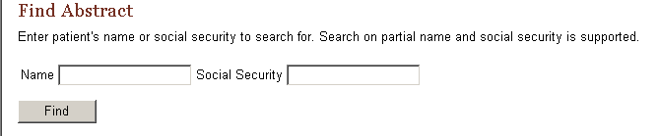
To find a specific abstract you can type in a name or a social security number such as 784500000, or a partial name or number.
- Click Find.
Result: A list of all abstracts opens.

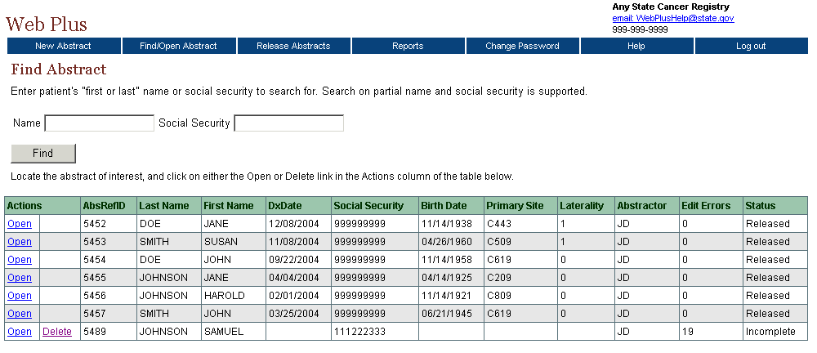

The list of abstracts has these twelve columns:

Column Head | Description
Actions | You have the option to open or delete an abstract
AbsRefId | A system-generated number identifying the abstract
Last Name | Last name of patient
First Name | First name of patient
DxDate | Diagnosis date
Social Security | Patient’s social security number
Birth Date | Patient’s date of birth
Primary Site | The location of the major tumor
Laterality | Code for the side of a paired organ, or the side of the body on which the reportable tumor originated
Abstractor | Code for the person who created the abstract
Edit Errors | The number of errors found in the edit process after an abstract has been saved
Status | Web Plus has three types of statuses:  - incomplete (not all data have been entered)  - complete (all errors have been addressed)  - released (sent to the central registry)
- Click Open in the Action column of the incomplete abstract you started for Samuel Johnson.
Result: The Reason for Opening page opens.
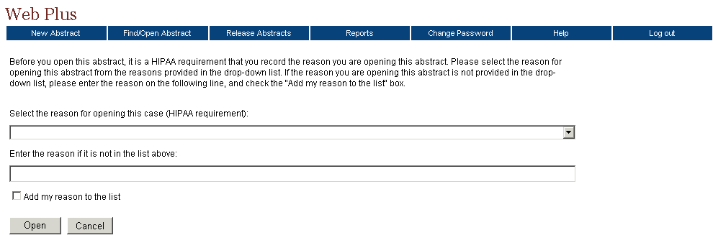
Any time that you open an abstract, you must give a reason for your action. It is required by the Health Insurance Portability and Accountability Act of 1996 (HIPAA). Your Web Plus administrator has ready-made reasons for you to select. However, you can create your own in the Enter the reason . . . field.
- Select a reason from the drop-down list and click Open.
Result: The Data Entry page opens and displays the previously entered data for the abstract. The heading above the entry fields now is “Update Abstract” because the abstract already contains some information.
- At the Age at Diagnosis field, click the calculator icon .
Result: An error message is displayed.
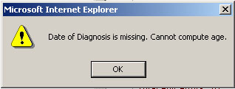
In order to use the calculator to calculate patient age at diagnosis, you must first enter the date of diagnosis and the patient’s birth date.
- Click OK to close the error message window.
- Type 06211945 in the Birth Date field and 03252004 in the Date of Diagnosis field.
- At the Age of Diagnosis field, click again.
Result: The age of the patient is automatically computed and the age entered into the field.
- Scroll down to the Follow-Up/Recurrence Death section, and click in the Cause of Death field.
Result: A pop-up box appears. The pop-up window is another method of providing a field code to you.
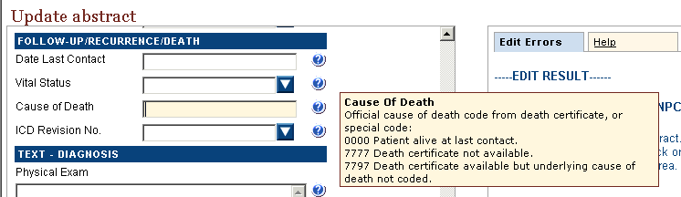
- In the Cause of Death field, type 0000 for Patient alive at last contact.
- Click Save to retain your changes to the abstract.

Activity – Activity – Adding Data, Part One
- Continue entering information into the abstract for Samuel Johnson. Enter the following information in the appropriate fields (use the fields’ drop-down lists to enter the proper codes):
Field | Content
AddrDx–No. and St. | 101 Clairemont Ave.
Race 1 | Black
Sex | Male

- After you have finished entering the information, save your work.

Adding Data, Part Two
More data can be added that pertains to the medical history of the patient.
- Add this information to the entry fields as shown:
Field | Content | Values
Primary Site | Prostate NOS | C619
Laterality | Not a paired site | 0
Histology ICDO3 | Carcinoma, acinar | 8550
Behavior ICDO3 | Malignant | 3
Grade | Grade 3, poorly differentiated | 3
- Click Save.

Text Fields
Text Fields are another type of data entry field. This is an area where you enter text to describe diagnostic and treatment information such as X-rays or surgery. The text fields displayed depend on the display type assigned to your facility by your Web Plus administrator.
You can use text fields to document supplemental information not contained within the coded values. You can also provide information that you are uncertain how to code so that a central abstractor/reviewer may code it properly in the data fields when the abstract is released to the central registry. The text is limited only by the maximum number of characters indicated for each field.
The information in text fields are not subject to Web Plus edits. However, some text fields can be designated as critical and are required to have information in the fields. In this case, the system does not read the information; it only requires the field to have text.
Critical (required) fields are labeled with an asterisk (*).
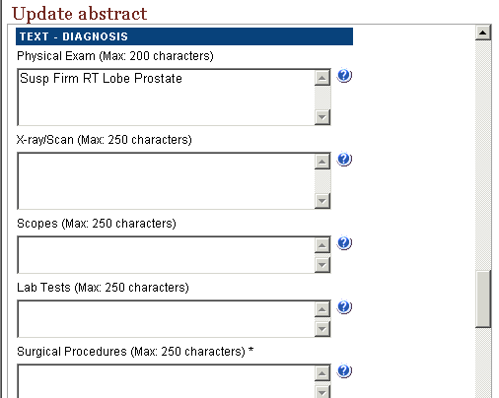

In data entry box, scroll down to locate the below Text Fields and follow these steps to enter information:
- In the Physical Examination field, type the following information:
Susp Firm RT Lobe Prostate
- In the X-ray/Scan field, type Unknown.
- In the Histology Title field, type Carcinoma, acinar.
- Save your work.

Activity – Using Text Fields
Practice entering information into text fields by typing more information for the Samuel Johnson abstract.
- In the below text fields, type the following information:
Field | Content
Lab tests | Slightly elevated PSA
Surgical Procedures | 3/25/2004 Ultrasound guided BX RT lobe prostate  4/05/2004 TURP
Pathology | 3/25/2004 S95-354: Prostate BX R lobe: Adenoca, presumably infil, acinar type, GR2
- Click Save and check that the data you entered in the fields have been saved.
Work on correcting abstract errors begins in the next chapter, “Correcting Errors,” page 13. Critical (required) text field errors will be addressed in “Edit Errors Tab,” page 13.

Print Preview
The Print Preview feature allows you to view all of the fields and the content you have entered in your abstract. You can also print a copy of the abstract from the Print Preview window.
- Open an abstract.
- Click the Print Preview link .
Result: A separate window opens that displays all of your abstract entry fields and content.
- To print a copy of the abstract, use your browser’s printer.

Deleting an Abstract
To delete an existing abstract, use the Find Abstract page. In this section, you create a new abstract, save it, find it, and then delete it.
To create and then delete an abstract, follow these steps:
- Log in, if you are not already, as described in “Log In,” page 3.
- On the Web Plus menu, click New Abstract.
Result: The Data Entry page opens.
- Create a new abstract by typing Derrick Chung in the name fields and 891234567 as a Social Security Number.
- Click Save.
Result: The system saves the abstract to the database.
- On the Web Plus menu, click Find/Open Abstract.
Result: The Find Abstract page opens.
- Type 891234567 in the Social Security number field.
Result: The results display the Chung abstract entry.
- Click Delete in the Action column. Be sure to note the Abstract Reference ID (AbsRefID) number.
Result: The Confirm Delete window opens. It displays the Abstract Reference ID number of the abstract you want to delete (ID number 4287 is an example; your Abstract Reference ID number will be different).
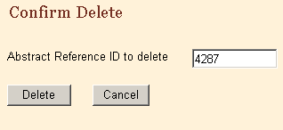
- Click Delete.
Result: On the Confirm Delete window a message confirms the deletion.
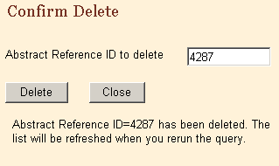
- Click Close.
- On the Find Abstract window, click Find and confirm in the results window that the system has deleted the abstract.

Questions
Answer these questions about adding data to an abstract (the answers are in Appendix A, page 31):
- What is the purpose of the text fields?
- How can you print your abstract and what does the printed copy contain?
- Which menu option do you click to open the page where you can delete your abstract?

Activity – Adding Information and Deleting
In this activity you continue with the abstract you created on page 13, view a print preview, and delete the abstract.
- Find your own abstract you created and add this information into the text fields:
Field | Content
Physical Exam | N.A.
X-ray/Scan | 9/11/97 CT Neck showed no def abnormalities noted.

- Calculate the diagnosis age by first adding the patient’s birth date and his diagnosis date.
- View a print preview of your abstract.
- Delete the abstract.

Correcting Errors

Learning Objectives
In this chapter, you will learn to:
- Correct errors to complete an abstract
- Understand how edit sets affect the completion of an abstract
- Understand the edit error messages

Overview
In this chapter you continue working on your abstract. You will use the Edit Errors feature of Web Plus to find errors or blank required fields and work toward the completion of your abstract. You can only release completed abstracts, which have no errors.

Understanding Edit Sets
Each abstract is edited whenever you save or open it. The edits applied to the information depend on the edit set selected for your facility by your Web Plus administrator. The edit set used for this training guide is “Central: VS11 NPCR Required.”
As an abstractor you must correct all identified errors to complete your abstract before you release it to the central registry.

Edit Errors Tab
The edit errors pane lists edits in the abstract. The edit set runs each time the abstract is saved or re-opened.
To correct your abstract errors, complete these steps:
- Log in, if you are not already, as described in “Log In,” page 3.
- Find and open the Johnson abstract.
- On the Data Entry page, click the Edit Errors tab in the information pane, if it is not already open.
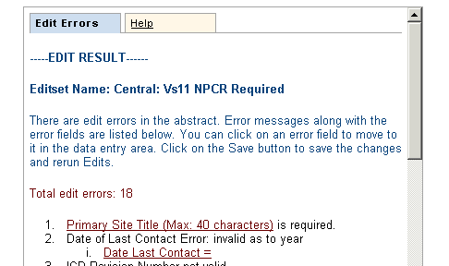
- Click the Primary Site Title (Max: 40 characters) link.
Result: The system moves your cursor to the Primary Site Title field.
- Type Prostate in the field.
- In Edit Errors, click the Date Last Contact link.
- Result: The system moves your cursor to the Date Last Contact field.
- In the Date Last Contact field type: 07152004.
- Click Save and check the errors box to ensure that the Primary Site Title and the Date Last Contact errors have been eliminated.
If there are any other critical text fields, indicated by an asterisk (*), that do not have an entry, type NA in the fields. Once the field has an entry, the next edit of the abstract eliminates the error for an empty critical field.

Correcting Errors
To continue correcting errors, complete these steps:
  - In Edit Errors, click the ICD Revision No. = link.
Result: The cursor moves to the ICD Revision No. field.
  - At the ICD Revision No., use the pull-down menu to select, 0 – Patient Alive.
  - Click Save.
  - Result: The system again runs an edit check. View the Edit Errors area now: the system has deleted the error for the ICD Revision No. code.
  - The procedure for correcting errors is the same for each error. Find an error identified by the system and correct or add the field information for the field.
  - In the Edit Errors box, scroll until you see the Conflict among RX Summ—Surg Prim Site, Primary Site, and Histologic Type ICD-O-3 error:
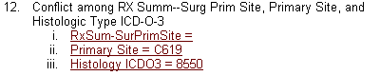
  - Click the RxSum-SurPrimSite link.
Result: The cursor is moved to the RxSum-SurPrimSite field.
Although in this exercise you do not have to click the link to the other fields because we know them to be correct as-is, this may not always be the case. When correcting errors, all fields identified by the edit should be verified, especially when setting an over-ride flag.
  - At the RxSum-SurPrimSite field, click the Special Lookup icon

Result: A separate window opens containing Surgery to Primary Site codes.
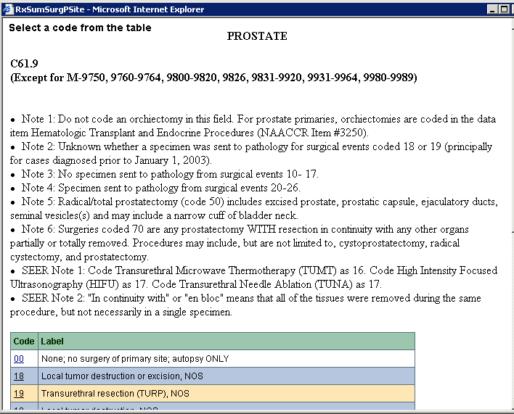
  - Click on the 19 link to the left of Transurethral resection (TURP), NOS.
Result: The code of 19 gets filled into the RxSum-SurPrimSite field.
  - Click Save and check the errors box to ensure that the errors have been eliminated.

Activity – Correcting Errors

Continue correcting the errors, saving the abstract and re-running Edits until no errors remain. Use the information in this table to complete the abstract.
- Click on the field links in the Edit Error area and enter the values listed in this table:
Field/error | Description | Values
RxSum-ScpeRegLN | Scope of Regional Lymph Node Surgery | 9 – Unknown or not applicable
RxSum-SurgOthReg | Surgery of Other Regional Site(s), Distant Site(s) or Distant Lymph Nodes (SEER/COC) | 9 – Unknown
Vital Status | — | 1 – Alive
Race 2 – 5 | — | 88 – No further race documented

- If necessary, correct any other errors that may appear until you have completed all the required fields.
- Save your work. When the Edit Result shows no errors, you have completed your abstract.
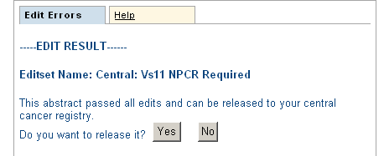

- Do not release the abstract now. Click No and go to the next section, “Releasing the Abstract”, below.
Result: The abstract is saved and completed, but not released.
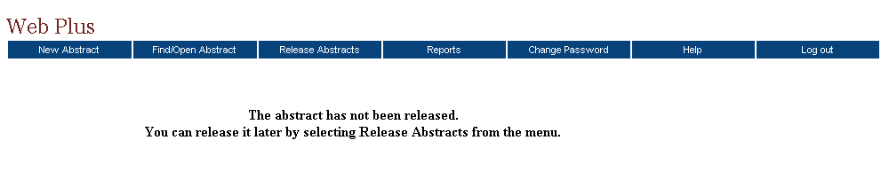
You can release your abstract here by clicking Yes, but you can also release one or more abstracts on the Release Abstracts page. For further details, see the next section, “Releasing the Abstract.”

Releasing the Abstract
Once your abstract has no errors, it is completed, and you can release it to the central registry.
Follow these steps to release an abstract:
- On the Web Plus menu, click Release Abstracts.

Result: The system displays a list of completed abstracts.
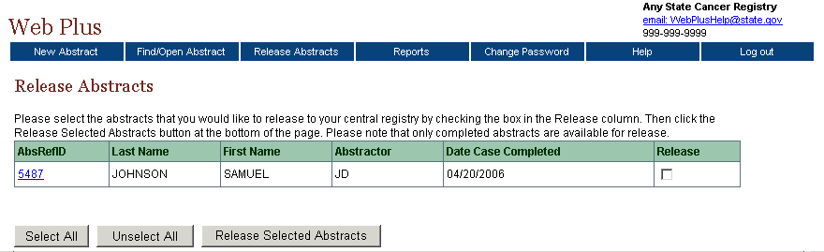
- Click the box in the Release column for the Samuel Johnson abstract.
To select all of the abstracts listed, click the Select All button.

- Click Release Selected Abstracts.
Result: The system releases the selected abstracts to your designated central registry and changes the status of the abstracts to Released. Use the Find/Open page to view the released abstracts. You can view them but cannot amend them.
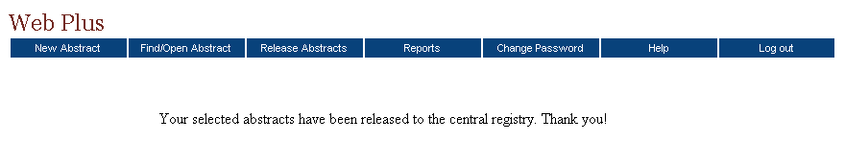

Questions
Answer these questions about correcting and releasing abstracts (the answers are in Appendix A, page 31):
- How can you release more than one abstract at a time?
- What are two ways to release a single abstract?
- Where do you find the errors list?

Running Reports

Learning Objectives
In this chapter, you will learn:
- How to open a report
- How to set a date range for a report
- About the reports available in Web Plus

Overview
Web Plus provides reports for monitoring abstract reporting and system activity. You can view and print several types of reports. You can also set the date ranges for the information in the reports.

Opening Reports
To open a report after you have logged in, complete these steps:
- On the Web Plus menu, click Reports.
Result: Web Plus displays a list of reports available for you.
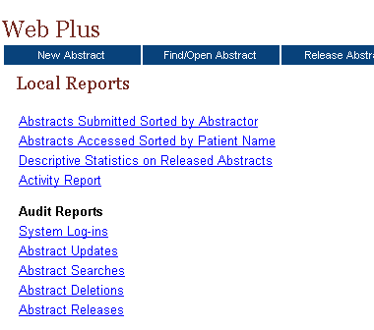
- Click the Abstracts Submitted Sorted by Abstractor link.

Result: The Abstracts Submitted Sorted by Abstractor report page opens.
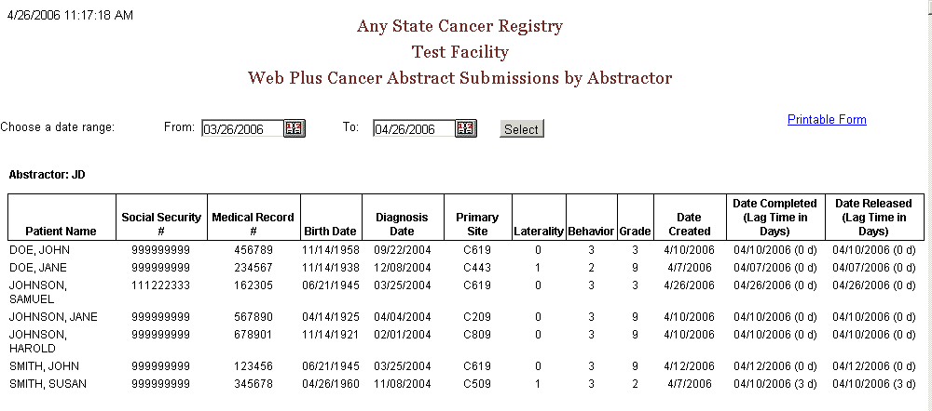
- To print the report, click on the Printable Form link.
Result: A page opens with a printable version of the report.
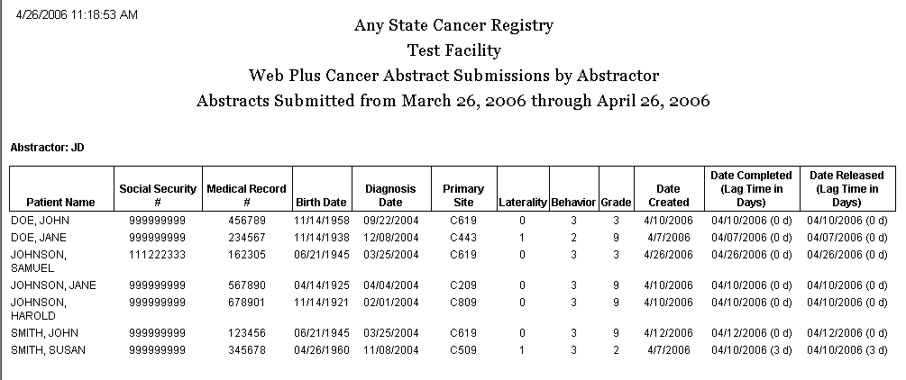
For optimum printing results, print Web Plus reports in landscape mode. To print in landscape, click on File→Page Setup, and click on Landscape.
In addition, if you wish to remove the internal report name from the upper left-hand corner of the printed report, remove the &w&b from the header field. If you wish to remove the URL listing from the bottom of the report, remove the information in the footer field (the date prints on the report already).

Available Reports
The below table describes reports that are available for viewing by a Web Plus abstractor. Click the name of the report to open a separate window displaying the report.
This report . . . | Lists . . .
Local Reports
Abstracts Submitted  Sorted by Abstractor | all abstracts that a facility has released within a given time period. The abstracts are sorted first by the name of the abstractor and then by patient name.
Abstracts Accessed  Sorted by Patient Name | all abstracts that a facility has released within a given time period sorted by patient name.
Descriptive Statistics on Released Abstracts | descriptive statistics on released abstracts such as demographics and site group.
Activity Report | the number of released and unreleased abstracts for each month of the selected date range.
Audit Reports
System Logins | the users from your facility and their times for logging in and out of Web Plus within a selected date range.
Abstract Updates | the dates and times that abstracts from your facility have been updated.
Abstract Searches | the abstractor and the date and time for all searches for abstracts at your facility.
Abstract Deletions | the dates and times that abstracts have been deleted at your facility.
Abstract Releases | information about abstracts released from your facility including release time and date and abstractor.

Changing the Date Range of a Report
To change the date range of a report, complete these steps:
- On the Web Plus menu, click Reports.
- Click Abstracts Accessed Sorted by Patient Name.
Result: The Abstracts Accessed sorted by Patient Name report page opens.

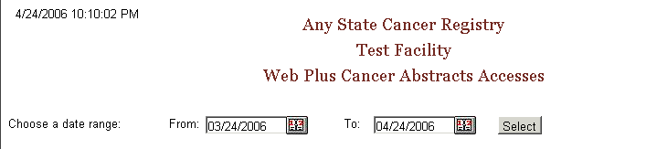
- Click the calendar icon beside the From date field.
Result: The calendar window opens.
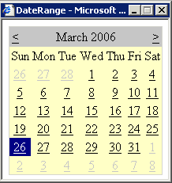
- Click on the date you want. To change the month, click on either the ≤ or ≥ symbols in the month header. The system inserts the date in the field, and closes the calendar window.
You can also type the date directly into the field by using the mm/dd/yyyy format, such as 04/01/2006 for April 1, 2006.
- Repeat steps 3 and 4 for the To date field.
- Click Select.
Result: Web Plus displays the report again with the information in the date range you selected.

Local Reports

Abstracts Submitted Sorted by Abstractor Report
The Abstracts Submitted Sorted by Abstractor report provides the history of the abstract: when it was created, completed, and submitted to the central registry.
To access the Abstracts Submitted Sorted by Abstractor report, follow these steps:
- On the Web Plus menu, click Reports.
Result: Web Plus displays a list of reports available.
- Click on the Abstracts Submitted Sorted by Abstractor link.
Result: The Abstracts Submitted Sorted by Abstractor report page opens in a separate window.
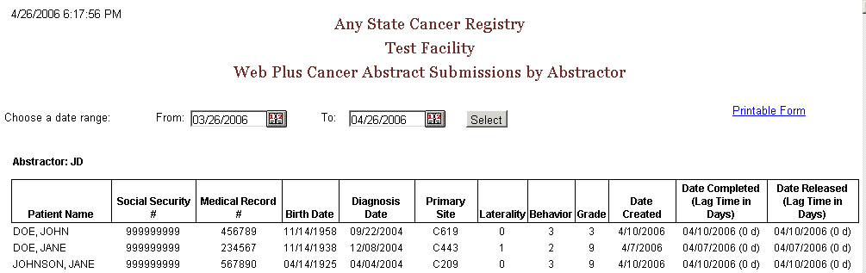
The report contains these columns for each abstract, and the abstracts are grouped by abstractor:
Column Heading | Description
Patient Name | Name of patient on abstract
Social Security Number | Patient’s social security number
Medical Record Number | Patient’s medical record number
Birth Date | Patient’s birth date
Diagnosis Date | Diagnosis date of the tumor being reported
Primary Site | ICD-O-3 topography code for the primary site of the tumor being reported
Laterality | Laterality code for the tumor being reported
Behavior | ICD-O-3 behavior code for the tumor being reported
Grade | ICD-O-3 grade/differentiation code for the tumor being reported
Date Created | Date the abstract was created
Date Completed | Date the abstract was completed, with the lag time (in days) between date of creation and completion in parentheses
Date Released | Date the abstract was released to the central registry, with the lag time (in days) between date of completion and release in parentheses

The date range can be modified for the Abstracts Submitted Sorted by Abstractor report.
If you would like to print the report, click on the Printable Form link, and print the report in landscape mode using your browser’s printer.

Abstracts Accessed Sorted by Patient Name Report
The Abstracts Accessed Sorted by Patient Name report provides the dates and times that an abstract is opened and the reason why it was opened.
To access the Abstracts Accessed Sorted by Patient Name report, follow these steps
- On the Web Plus menu, click Reports.
Result: Web Plus displays a list of reports available.
- Click the Abstracts Accessed Sorted by Patient Name link.
Result: The Abstracts Accessed Sorted by Patient Name report page opens in a separate window.
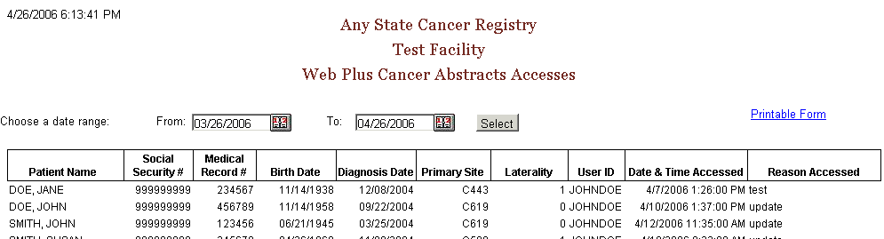
The Abstracts Accessed Sorted by Patient Name report contains these fields:
Field/Headings | Description
Patient Name | Name of patient on abstract
Social Security # | Patient’s social security number
Medical Record Number | Patient’s medical record number
Birth Date | Patient’s birth date
Diagnosis Date | Diagnosis date of the tumor being reported
Primary Site | ICD-O-3 topography code for the primary site of the tumor being reported
Laterality | Laterality code for the tumor being reported
User ID | User ID of the abstractor
Date & Time Accessed | Date and time that the abstractor opened the abstract
Reason Accessed | Reason that abstract was opened

The date range can be modified for the Abstracts Accessed Sorted by Patient Name report.
If you would like to print the report, click on the Printable Form link, and print the report in landscape mode using your browser’s printer.

Descriptive Statistics on Released Abstracts Report
The Descriptive Statistics on Released Abstracts report includes a series of tables consisting of the number and percent of released abstracts broken down by the following: county of residence, zip code of residence, sex and race, age group, site group, and treatment group.
To run and/or modify the report for Descriptive Statistics on Released Abstracts complete these steps:
- On the Web Plus menu, click Reports.
Result: Web Plus displays a list of reports available.
- Click the Descriptive Statistics on Released Abstracts link.
Result: The Descriptive Statistics on Released Abstracts report page opens.
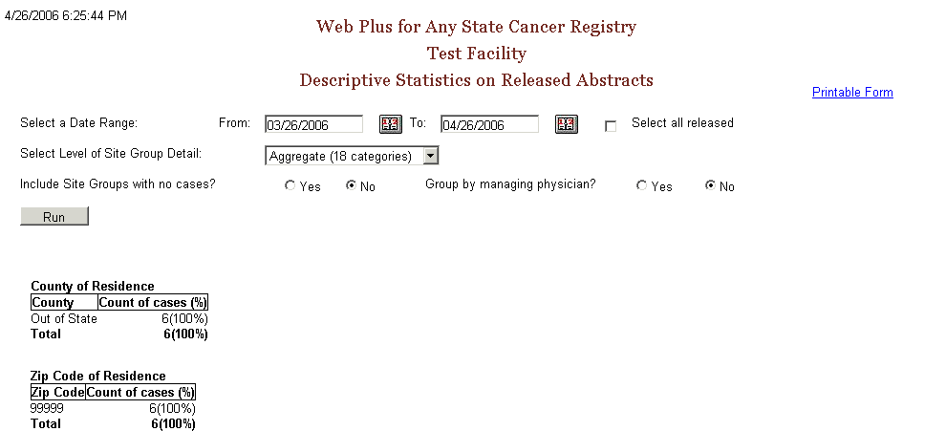
The descriptive statistics provided are broken down as follows:
Grouping Variable(s) | Groupings by…
County of Residence | individual county of residence at diagnosis
Zip Code of Residence | individual zip code of residence at diagnosis
Sex and Race | patient sex (male/female) by race (white/black/other)
Age Group | ten age groups (0-9, 10-19,….90+)
Site Group | three levels of primary site grouping:
  Grouping Level | Description
  Aggregate | 18 categories
  Subaggregate | 60 categories
  Recode | 78 groups
Treatment Group | type of summary treatment (RX Summ) recorded:  Surgery of Primary Site  Chemotherapy  Hormone  BRM  Other  Rad-Regional RX Modality  Transplant/Endocrine
The following options are available to modify the Descriptive Statistics on Released Abstracts report:
Option | Description
Date Range | Includes only those abstracts that were released within the specified date range
Select all released | When clicked, all abstracts released by the facility will be included, regardless of date released
Select Level of Site Group Detail | Specifies what level of primary site grouping to use for the report; the default grouping is 18 categories
Include site groups with no cases | When Yes is clicked, the primary site distribution will show all site groups for the level of detail chosen, whether or not abstracts were released containing each of the site groups  When No is clicked, only those primary site groups contained in the released abstracts released will appear on the report
Group by managing physician | When Yes is clicked, the records in the report will be grouped into sections by managing physician, displaying the descriptive statistics for abstracts released by each managing physician
- Next to Include Site Groups with no cases, click on Yes.
- Click Run.
Result: Web Plus displays the report again with all 18 site groupings displayed.
- Click on the Printable Form link.
Result: A separate window opens with the report formatted for printing.
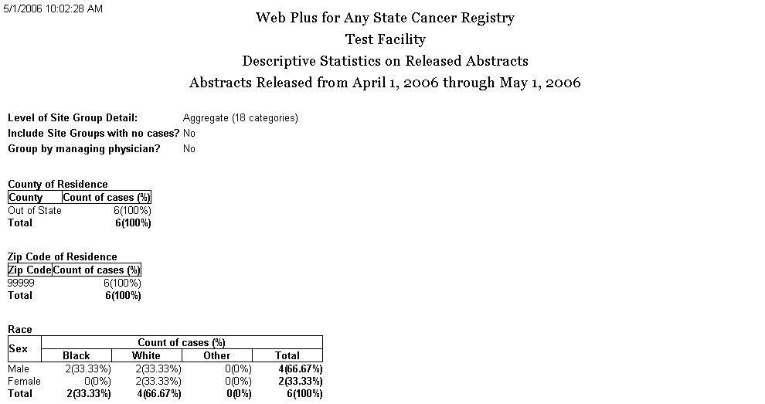
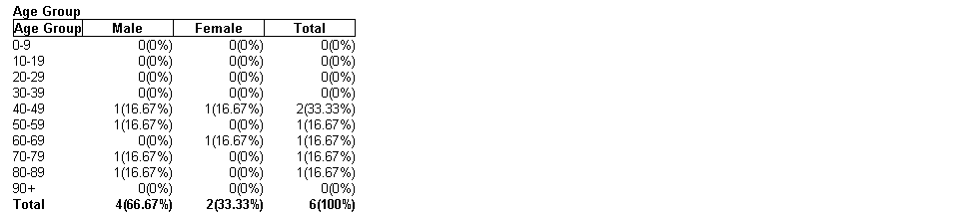
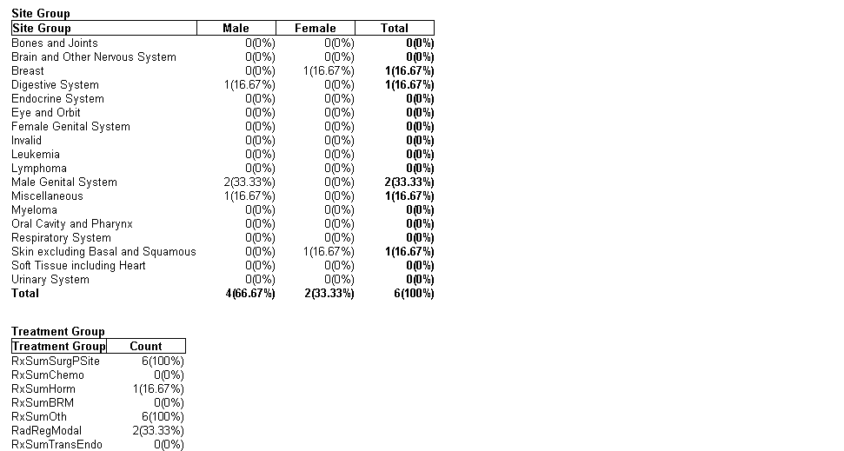

Activity Report
The Activity report provides information on the abstracting activity at your facility, in terms of the number of released and unreleased abstracts.
To open the Activity report:
- On the Web Plus menu, click Reports.
Result: Web Plus displays a list of reports available.
- Click the Activity Report link.
Result: The Activity Report window opens.
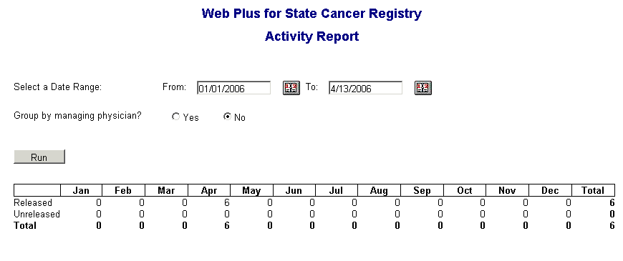

The default From date is January 1 of the current year, and the default To date is the current day.
The date range can be modified for the Activity report. If the specified date range spans more than one year, the report will display the number of released and unreleased cases for each year rather than each month.
You can also group the information in the Activity report by managing physician; just click on Yes next to Group by managing physician.
If you would like to print the report, click on the Printable Form link, and print the report in landscape mode using your browser’s printer.

Audit Reports
This table describes the audit reports available for viewing by the Web Plus facility abstractor. Clicking the name of the report opens a separate window displaying the report.
This Report . . . | Lists . . .
System Log-ins | the user, date, and time of all Web Plus system log-ins and log outs at your facility within a selected date range
Abstract Updates | the user, date, and time of all abstract updates at your facility
Abstract Searches | the user, date, and time of all abstract searches at your facility
Abstract Deletions | the user, date, and time of all abstract deletions at your facility
Abstract Releases | information about abstract releases from your facility including release time and date, and abstractor
- Click the System Log-ins link.
Result: The Login Audit report page opens.
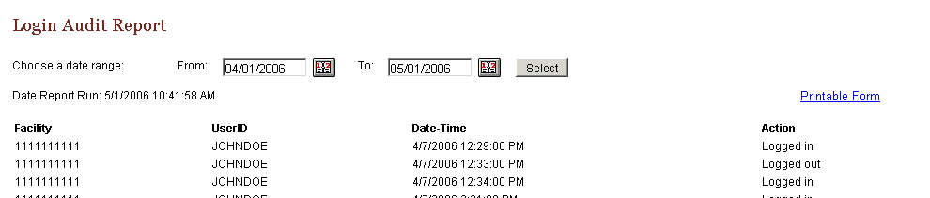
The report contains these column headings:
Column Heading | Description
Facility | Facility ID Number of your facility
UserID | User ID of the user
Date-Time | Date and time of the log in/out
Action | Indicates the user activity being logged:  - Logged in  - Logged out  - Invalid log in attempt
- Close the report window.
- On the Reports page under Audit Reports, click Abstract Updates.
Result: The Abstract Update Log Opens.

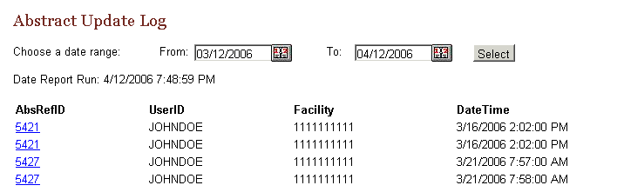
The Abstract Update Log contains these column headings:
Column Heading | Description
AbsRefID | A unique, system-generated number identifying the abstract
UserID | User ID of the abstractor
Facility | Number of facility that sent the abstract
Date-Time | Date and time of the action
The remaining audit reports contain the same column headings and information as the Abstract Update Log for their specific user activities:
  - Abstract Searches
  - Abstract Deletions
  - Abstract Exports
  - Abstract Releases

Activity – Finding Report Information
Look at the list of reports and find this information:
- The case you abstracted earlier
- The number of updates done to abstracts in the last month
- The last user to update the Samuel Johnson abstract

Final Learner Activity

Overview
For your final activity you will create an abstract from a medical record. Enter the information into the appropriate fields, save it, correct errors, and release the abstract.

Medical Record
Seaford Nanticoke Memorial Hospital
Discharge Summary

Reporting Physician: Anne Bobula

Patient Information
Medical Record Number: 67234
Last Name: Orvis
First Name: John
Middle Name: Wayne
Address: 2276 Waverly St., Philadelphia, PA 19101.
County: Philadelphia
Race: Black
Sex: Male
Date of Birth: February 28, 1925
Social Security Number: 456456456

Admission: June 12, 2004
Discharge: June 18, 2004

Notes:
Mr. Orvis was admitted for follow-up of prostate biopsy positive for cancer performed May 30 in Doctor’s Clinic. Radical prostatectomy was performed on 6/13/04. Findings included a 1.5cm adenocarcinoma in prostate, grade 1. All nodes negative. Patient was discharged in good condition. No further treatment is contemplated.

Hints
These are a few hints to help you complete your abstract:
- Fill in what you know at first and then save your work. Web Plus will run the edit check and show the entry fields’ blanks or errors.
- Look at the Help page for a field if you need to interpret the field name.
- Use the Search feature on the Lookup page to find the proper code.
- Answers

Chapter 2: The Basics
These are the answers to the questions (page 9) about the basics of Web Plus:
- Click the Special Lookups icon to open a separate window to insert a code into a field.
- To log out, click Log Out on the Web Plus menu.
- You do not have to complete filling out the abstract at one time. Begin an abstract and save it. Then you can return to it later by using the Find/Open Abstract tool.

Chapter 3: Creating an Abstract
These are the answers to the questions (page 13) about entering data:
- You click the Help icon to learn more about a field.
- The Special Lookup page provides codes for specific field information.

Chapter 4: Adding Data to an Abstract
These are the answers to the questions (page 21) about adding data to an abstract:
- Text fields provide an area to enter written information about a patient’s medical history.
- Click the Print Preview link to open a copy of an abstract in a separate window. This preview displays all of the fields and entered data for the abstract. Use your browser’s printer to print out a copy.
- Click Delete in the Action column of the Find Abstract page to open the page where you can delete your abstract.

Chapter 5: Correcting Errors
These are the answers to the questions (page 17) about correcting and releasing abstracts:
- To release more than one abstract at a time, click Release Abstracts on the Web Plus menu and select the abstracts you want to release.
- You can release an abstract by clicking the Yes button in the Edit Result box after you have completed it or by releasing it from the Release Abstract page.
- The errors list is in the Edit Errors box on the right side of the Data Entry page.

