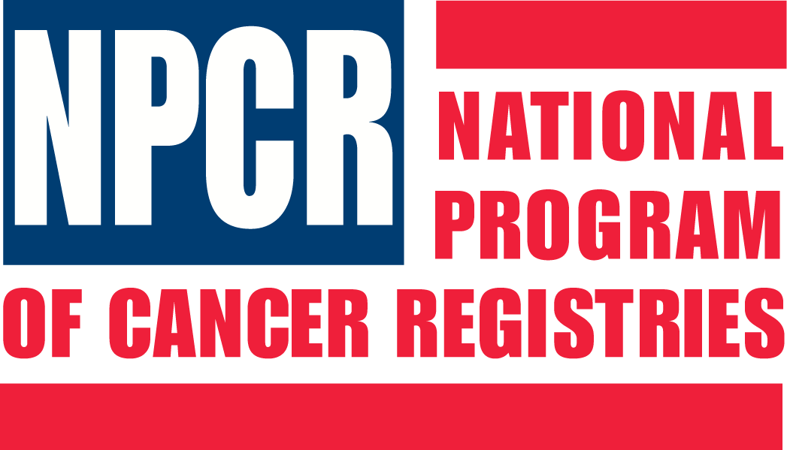
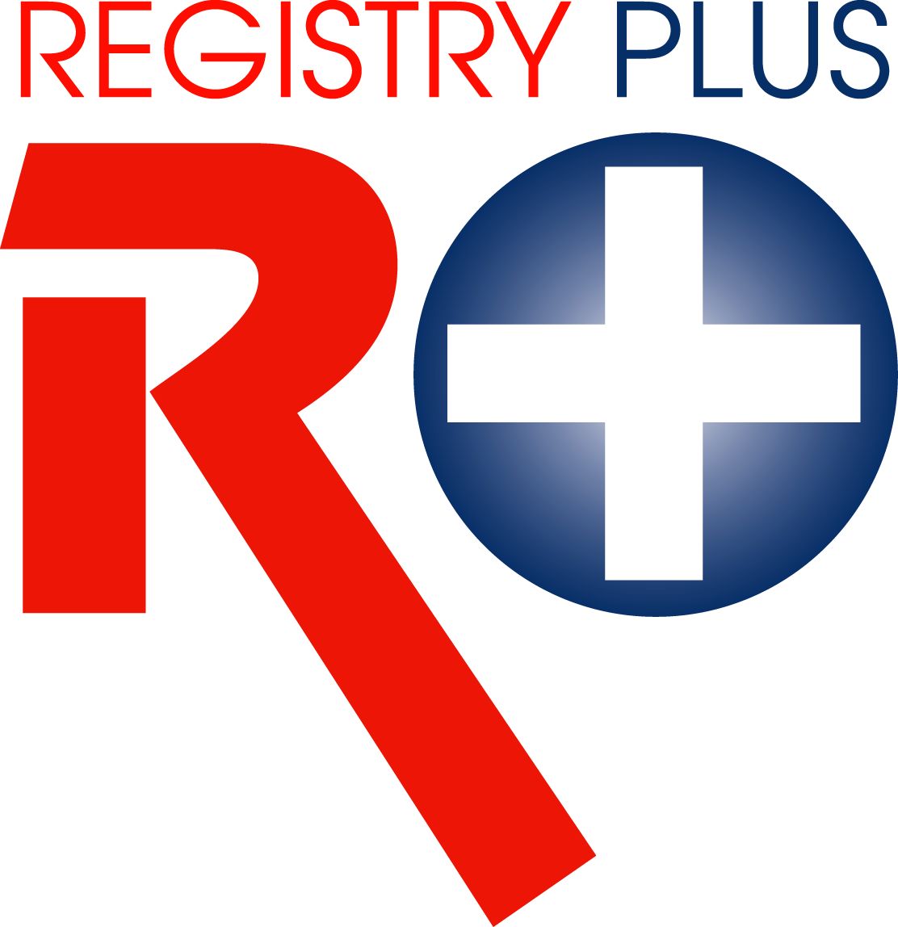
Link Plus
Application Overview & User Training
Portland, Oregon
May 24, 2006

AGENDA

8:00-8:25 Record Linkage Concepts
8:25-9:00 Overview of Link Plus Application
& Linkage Process
9:00-10:00 External Linkage Exercise
10:00-10:15 Break
10:15-10:45 Deduplication Linkage Exercise
10:45-11:15 Open Discussion
11:15-11:30 Evaluation & Wrap up questions



