Epi infoTM web analytics and visualization (EWAV) encryption utility

help document
Version 1.0
05/06/2014

VERSION HISTORY

Version # | Implemented  By | Revision  Date | Reason
1.0 | Daniel Shorter | 1/15/2014 | Version 1.0 of the document
1.0 | Sachin Agnihotri | 2/21/2014 | Version 1.0 review and updates

TABLE OF CONTENTS
1 Introduction 4
1.1 Purpose 4
1.2 Audience 4
2 Worflow 1 – create keys for A new INSTALLAtion 4
3 workflow 2 - load keys from existing web.config 5
4 Worflow 3 - AD-hoc decrypt 7
5 workflow 4 – ad-hoc Encrypt 8

Introduction

Purpose
The purpose of this document is to provide an overview of the key functionalities of the Epi InfoTM Web Analytics and Visualization (EWAV) Encryption Utility. This document goes hand in hand with the EWAV deployment document. The configuration of EWAV on the web server cannot be completed without this document.

Audience
The audience for this document is an Administrator, a Manager or a person responsible for managing the EWAV system.

Worflow 1 – create keys for A new INSTALLAtion
Step 1 – Click the “create new keys” button in EWAV Encryption Utility
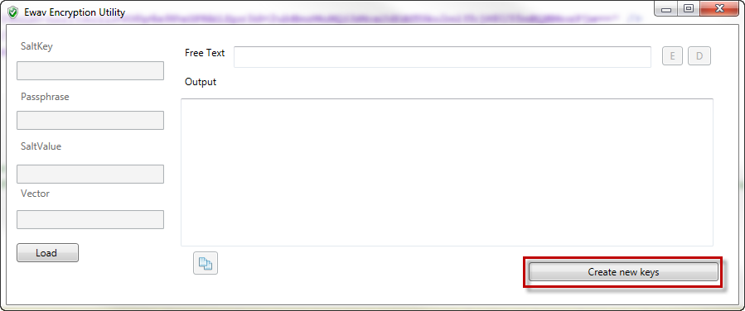

Step 2 - The keys and entries for web.config are generated and displayed in Output textbox.
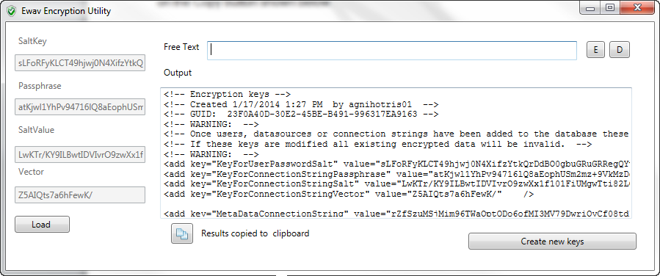

Step 3 – Copy the newly created section to the application’s web.config file by clicking on the Copy button located in the lower left corner of the dialog box.
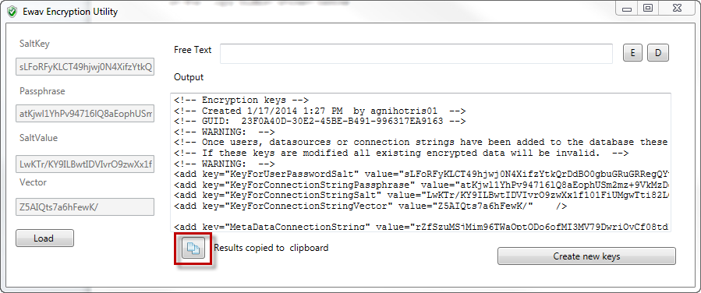

Step 4 – Update the Encryption Keys section of the web.config file with the copied text.

workflow 2 - load keys from existing web.config

Step 1 – Click the “Load” button
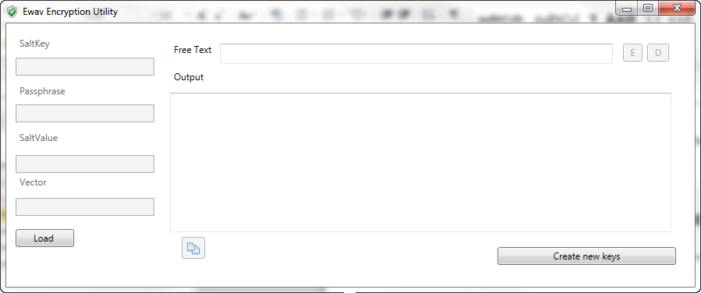

Step 2 – Browse to an existing Ewav web.config file. This should be the location of EWAV on the web server at “inetpub\wwwroot\Ewav”
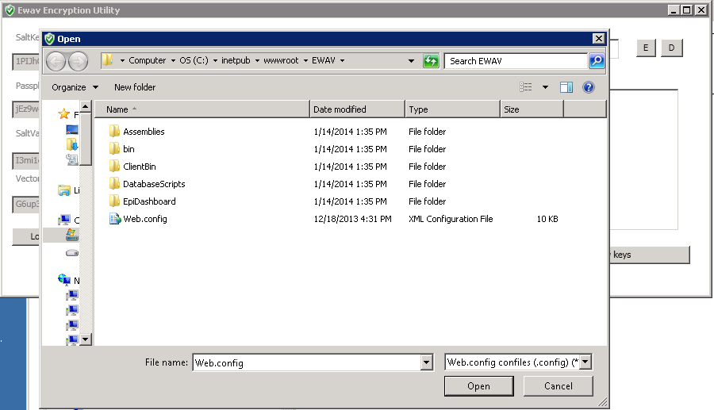

Step 3 – Click “Open”. The EWAV Encryption Utility will read the existing keys and populate the SaltKey, Passphrase, SaltValue and Vector text box which are disabled.
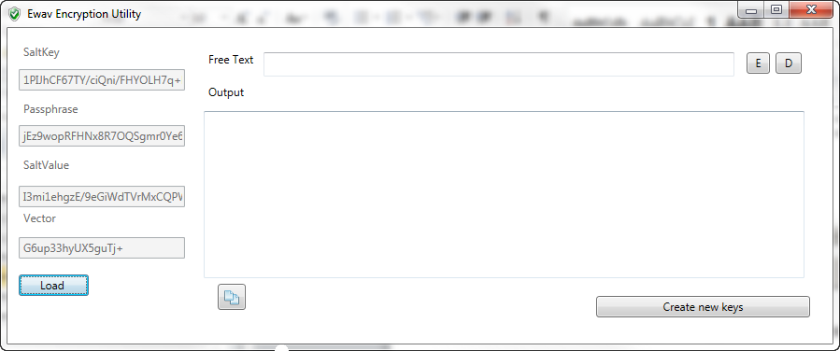

Worflow 3 - AD-hoc decrypt
This functionality can be used to decrypt the connection string in the web.config file in case the application is not able to connect to the database. After decryption the connection string can be inspected and updated as needed to resolve database connection problem.

Step 1 – Follow steps of workflow 2

Step 2 – Paste a string that was encrypted with the loaded keys into the “Free text” text box
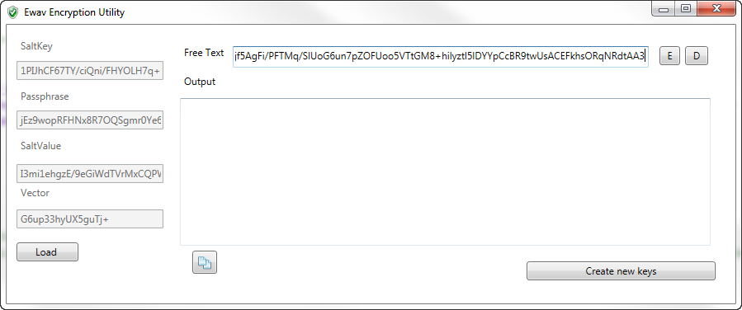

Step 3 – Click the “D” button
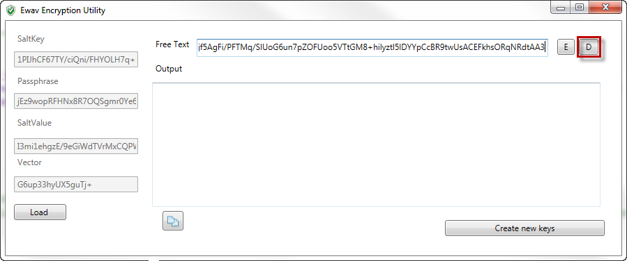

Step 4 – Use the Decrypted string provided in output textbox to debug the issues if any encountered during the application configuration
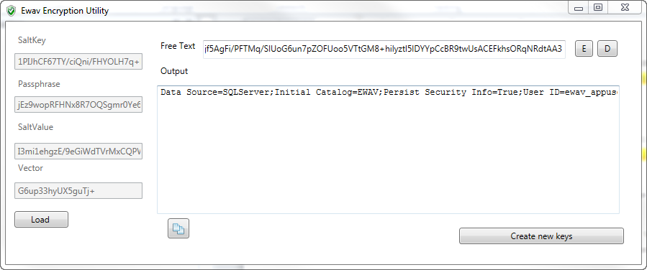

workflow 4 – ad-hoc Encrypt
This functionality is to be used to encrypt the connection string for the database type applicable to your organization. Once encrypted update the sample encrypted connection string provided in the web.config file for the database type that is relevant for your deployment.

Step 1 – Follow steps of workflow 2

Step 2 – Paste an unencrypted string into the “Free text” text box
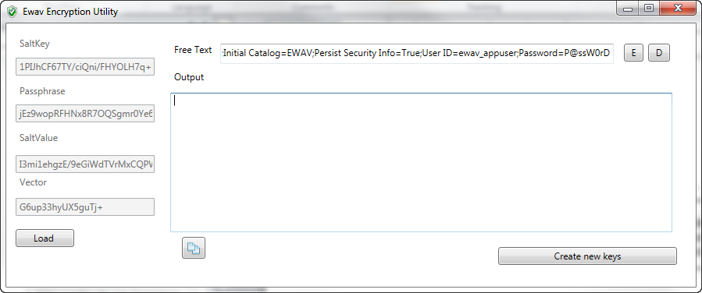

Step 3 – Click the “E” button
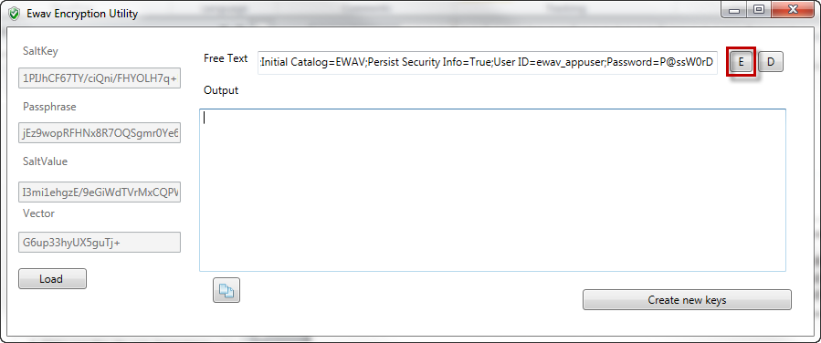

Step 4 – Use the Encrypted string provided in output textbox to update the relevant connection string for your database type section in the web.config file.
