1. How do I upgrade Abstract Plus?
1. Unzip downloaded Abstract Plus Updater file on convenient place like Desktop or C:\Temp. You will notice the following file/ folder structure.
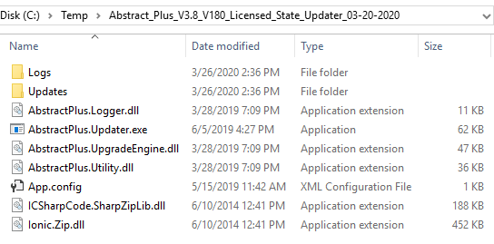
2. Double Click on AbstractPlus.Updater.exe file. You will see the following window
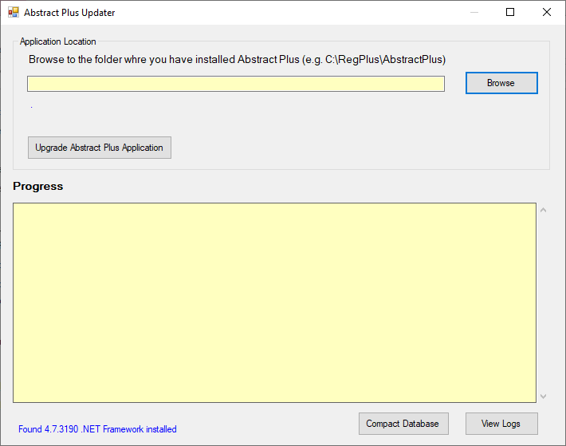
3. Click on Browse button to locate the folder where Abstract Plus is installed. More likely your Abstract Plus is in C:\RegPlus\AbstractPlus
4. Click on OK button. You will see the following window. It tells you which version installed as of now (e.g. 3.7.0.1)
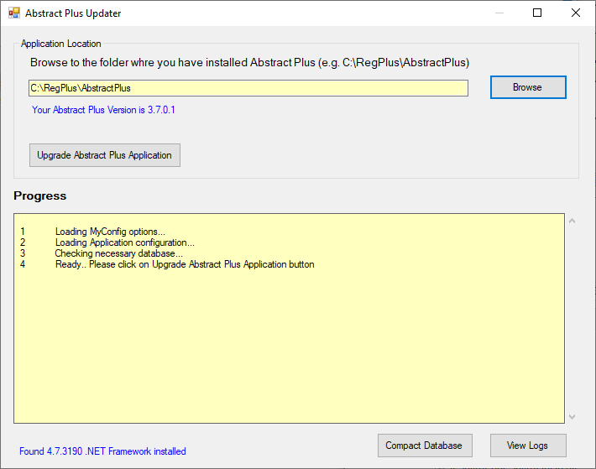
5. Now, click on “Upgrade Abstract Plus Application” button
6. You will be prompted with the following message.
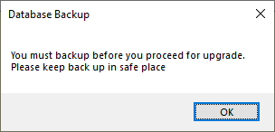
7. Critical Step: At this point the updater program is about make a backup of MDBS file. Make sure you keep this copy in a safe place. This backup comes handy if we need to restore data back to the previous version.
8. On Database Backup message prompt, click on OK. You will notice the following folder browser screen.
9. Critical Step: Make sure you choose safe place to put backup. (e.g. My Document). If necessary click on “Make New Folder” to create subfolder to put backed up database file in Zip format.
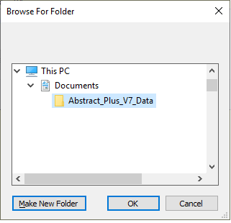
In this example, I have created “Abstract_Plus_V7_Data” inside My Document folder to keep my backup
10. Once Application completes, you will see the following message.
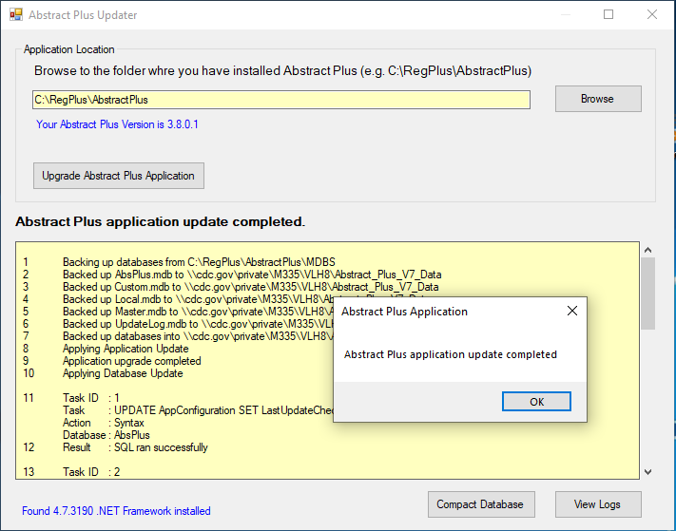
11. Click on OK
12. Scroll up and down in Yellow bottom area to check if there is error during upgrade or not. Alternatively you can click on View Logs button to view logs in text editor program.
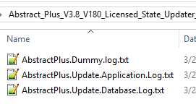
Open log file to check to see if there were any error during upgrade. If you find any issue, please report. Do not assume that upgrade went well.
13. Click X button to close “Abstract Plus Updater” window
14. At this point your application upgrade to Abstract Plus V3.8 is complete.

2. Opening Abstract Plus after upgrading
1. Now, open Abstract Plus as you normally would. You will see the Abstract Plus Splash Screen.
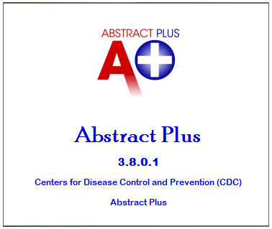
2. New login screen looks like below. You should notice the version number 3.8.0.1
You will also notice your cancer Registry Name (e.g. ABS Cancer Registry and Research Center)
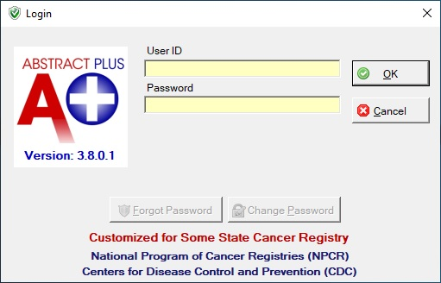

3. Things you should know

3.1 Backed up databases
In above steps you were asked to put database backups in proper place. If you check the folder where you kept your backups, you will see zipped files similar to shown below in the picture. Please keep these backups in safe place until we upgrade for next year.
