- Unzip provided Abstract_Plus.Patch_State_MM-DD-2016.zip file
- You will notice the following file/folder structure
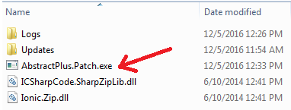
- Double click on AbstractPlus.Updater.exe. You will see screen as shown below
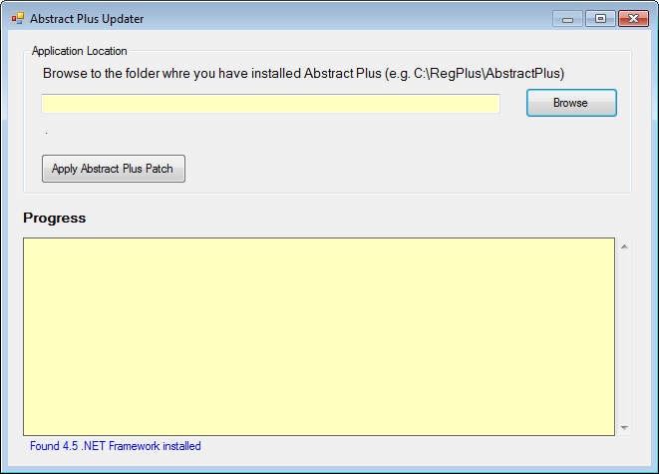
- Click on Browse to locate where Abstract Plus is installed. By default it is usually installed in C:\RegPlus\AbstractPlus
- You will notice application info as shown below
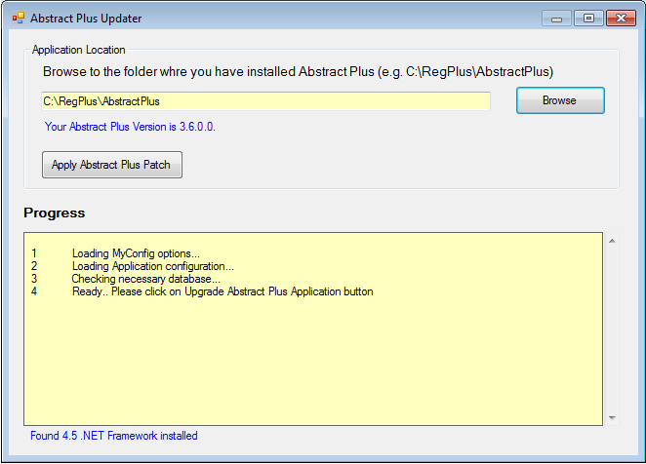
- Now click on “Apply Abstract Plus Patch”
- You will be asked to take back up of database and put it on safe place before it applies changes.
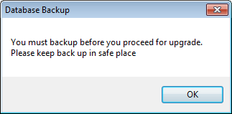
- Click on OK
Now select the folder where you want to keep backed up files. Please keep these files in safe place.
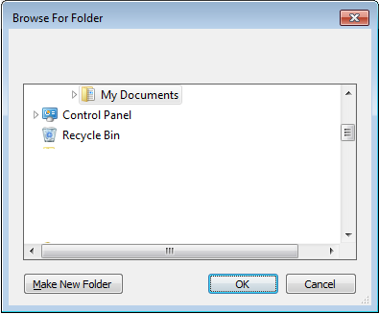
- Click on OK
- You will see progress as shown below
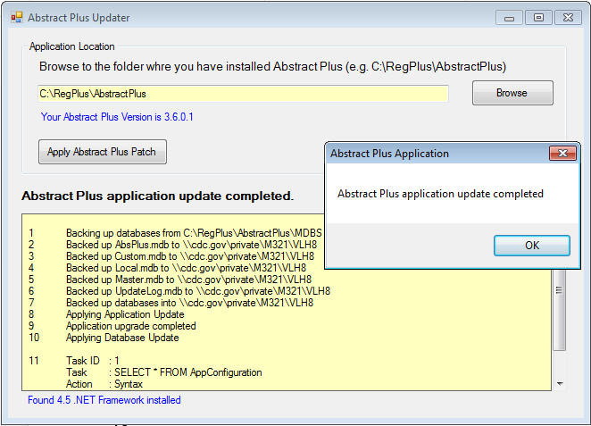
- At the end you will be prompted “Abstract Plus application update completed”. Click on OK and close Updater window.

