
Abstract Plus Training
Manual for Administrators
Version 7.0
(Based on Abstract Plus Version 3.5, NAACCR v15.0)
Centers for Disease Control and Prevention
National Center for Chronic Disease Prevention and Health Promotion
Division of Cancer Prevention and Control
National Program of Cancer Registries
Registry Plus™ Software for Cancer Registries

Contents
Chapter 1: Introduction 1
Overall Learning Objectives 1
Overview of the Abstract Plus Administrator Training Manual 1
Abstract Plus Features 1
Abstract Plus User Roles 2
System Requirements 3
Downloading and Installing Abstract Plus 4
Launching Abstract Plus 4
User Support 5
Chapter 2: Abstract Plus General User Basics 6
Learning Objectives 6
Overview 6
Logging In 6
Creating a User Account upon Initial Access and First-Time Log In 7
Routine Log In 13
Activity 1 – Logging in to Abstract Plus 14
The Abstract Plus Main Window 15
The File Menu 15
The Administration Menu 17
The Auditor Menu 18
The Utilities Menu 19
The Reports Menu 20
The Options Menu 21
The Help Menu 22
New Abstract Plus Abstracting and Editing Features 23
The Abstract Plus Abstracting Process 23
The Abstract Plus Abstracting Window 23
Entering Dates in Abstract Plus 29
New Data Quality Edits and Error Resolution Features 30
Changing Your General User Password 32
Possible Errors when Changing Your Password 34
Resetting a Forgotten Password 35
Updating Personal Security Questions 37
Abstract Plus Auto-update Feature 38
Benefits of the Auto-update Feature 39
No Uninstall and Re-install of Abstract Plus is Necessary 39
No Loss of Data is Possible 39
Auto-updates can be Implemented Automatically or Manually 39
Automatic Detection of Available Updates for Customized Versions 39
Auto-updates can be Distributed and Implemented Locally (No Internet Connection Required) 40
Automatic Updates for Users Who Have Not Updated on a Regular Basis 40
User is Notified When the CDC FTP Site is Experiencing Issues 40
User is Notified When No Updates are Available 40
Checking for Software Updates via the Internet 41
Applying Software Updates Locally 42
Viewing Software Update History 45
Exiting Abstract Plus and Using the Backup Option 46
Using the Restore Option 49
Questions 51
Chapter 3: Abstract Plus Administrator Basics 52
Learning Objectives 52
Overview 52
Abstract Plus Administrator Tasks 52
Logging In As Administrator 52
Activity 2 – Logging in to Abstract Plus as Administrator 54
Maintaining the Administrator Password 54
Possible Errors when Changing the Administrator Password 56
Questions 57
Chapter 4: Abstract Plus Configuration 58
Learning Objectives 58
Overview 58
Selecting Application Preferences 58
The General Tab 59
The Security Policies Tab 62
Security Questions Tab 64
Adding Security Questions 64
Removing Security Questions 65
The Password Expression Tab 67
Sample Expressions / Translations 68
The Database Tab 69
The Reports Tab 71
Configuring Abstracting Display Types 71
Creating an Abstracting Display Type 72
Opening the Manage Display Types Window 72
The Display Types Tab 74
Included Abstracting Display Types 74
Adding a New Abstracting Display Type 78
Activity 3 – Creating a New Display Type by Adding New 79
Copying an Existing Abstracting Display Type 79
Activity 4 – Creating a New Display Type by Copying 81
Deleting a Display Type 81
Activity 5 – Deleting a Display Type 83
Five Steps for Building a Display Type 83
Step 1: The Display Fields Tab 83
Adding Section Headings to a Display Type 85
Activity 6 – Adding a Section Heading to a Display Type 87
Managing Section Headings 87
Adding a New Section Heading 87
Editing the Name of an Existing Section Heading 88
Deleting a Section Heading 89
Adding Fields to a Display Type 90
NAACCR Text Fields and Display Types 92
Activity 7 – Adding Fields to a Display Type 93
Assigning Property Values to Individual Fields 94
Setting Properties for NAACCR Text Fields 97
System Fields and Display Types 98
Activity 8 – Adding Properties to Display Type Fields 98
Managing Abstract Plus Projects 99
Adding a New Project Field to the Application 101
Editing an Existing Project Field Name 101
Deleting a Project Field from the Application 102
Assigning a Project Field to a Display Type 103
The Display Fields Report 105
The Report Viewer Main Toolbar 107
The Report Viewer Page Navigation Controls 108
The Report Viewer Search Toolbar 108
The Report Viewer Page View Controls 109
Saving the Display Fields Report 109
Activity 9 – Printing the Display Fields Report 110
Step 2: The Critical Fields Tab 110
Activity 10 – Selecting Critical Fields into a Display Type 113
Step 3: The Edits Configuration Tab 113
Step 4: The Individual Edits Tab 116
Step 5: CS (Collaborative Staging) Calculations Tab 118
Activity 11 – Specifying Edits and CS Calculation Settings 120
Viewing and Testing a New Abstracting Display Type 120
Activity 12 – Viewing and Testing Abstracting Display Types 122
Importing Local Hospital and Doctor Codes 124
Required Hospital Codes Import File Format 125
Required Doctor Codes Import File Format 125
Questions 126
Chapter 5: Creating and Modifying User Accounts 127
Learning Objectives 127
Overview 127
Adding a New User 127
Resetting a User’s Password 130
Changing the Current User 132
Deleting a User 133
Activity 13 – Adding and Deleting Users 135
Questions 135
Chapter 6: Abstract Plus Report Wizard Basics 136
Learning Objectives 136
Overview 136
The Abstract Plus Report Wizard 136
Running a Saved Custom Report 137
Chapter 7: Abstract Plus Database Encryption 139
Appendix A: Answers to Chapter Questions 140
Appendix B: Standard Keyboard Shortcuts 142

Introduction

Overall Learning Objectives
These are the overall learning objectives for this Abstract Plus training manual for Administrators:
- Identify the various features of Abstract Plus
- Learn how to Log in into Abstract Plus, and learn how to Log in as Administrator and maintain the Administrator password
- Learn about the Abstract Plus menu items; in particular the Administrator menu items and major functions of the Administrator role within Abstract Plus
- Create and manage Abstract Plus user accounts
- Learn how to configure the Abstract Plus application, including setting application preferences and creating and maintaining display types
- Become familiar with the auditing features of Abstract Plus and the process of creating and setting up Abstract Plus audits for Auditors to perform

Overview of the Abstract Plus Administrator Training Manual
The Abstract Plus Administrator Training Manual provides you with the information to understand and use the administrator features of Abstract Plus. This manual describes the functions available to the Administrator. The major sections include logging in to Abstract Plus, logging in to the Administrator features of the program, creating and managing user accounts, configuring the application for abstracting, and configuring the application for auditing. Also, each chapter contains questions that test your knowledge of the Abstract Plus administrator features and activities that allow you to practice your new skills on your own.

Abstract Plus Features
Abstract Plus is a free-of-charge, cancer data collection tool developed by the Centers for Disease Control and Prevention (CDC) that supports two main functions: abstracting and auditing. The application can be customized by central cancer registries to be used centrally, as well as for distribution to and use by hospitals and other reporting sources. Although the product is not designed to include all functionality needed in an American College of Surgeons (ACoS)-approved hospital cancer registry, it is suitable for reporting to central registries from non-registry hospitals, clinics, laboratories, and other sources for cancer incident reports. The program can also be used for special projects and start-up registries.
The abstracting capability of Abstract Plus is used to summarize medical records into an electronic report of cancer diagnosis and treatment by abstractors or anyone working with cancer data. Abstract Plus supports the abstraction of all data items in national standard data sets, including all text fields, as well as any state-specific data items. The output of Abstract Plus is an electronic abstract in the format of the North American Association of Central Cancer Registries (NAACCR) data exchange layout.
Abstracts entered into Abstract Plus are validated by customizable edits, allowing for interactive error correction while abstracting. Abstract Plus includes Registry Plus Online Help, a collection of standard coding manuals that are cross-referenced, indexed, and context-linked to minimize the need for reference to printed manuals during abstracting.
The all-new auditing capability included in Abstract Plus allows central registries to use the program to perform case completeness and data quality audits of reporting facilities, as well as data quality audits of central registry abstractors. For assessing case completeness, casefinding audits are available, and for assessing data quality, both reabstraction and recoding audits are available. The application allows for either blinded or un-blinded reabstraction audits, and for recoding audits, un-blinded submitted text can be recoded for both reporting facilities as well as central registry abstractors.
Please note that due to development priorities, Abstract Plus is being released without the Auditor features; description of Auditor features provided in this manual is for informational purposes only. The Auditor features of Abstract Plus will be released in a future version of the program.
Abstract Plus is programmed using .NET technology. The application has a user-friendly abstracting interface, including direct grid entry of coded values for a streamlined abstracting experience, as well as easy viewing of text fields, online help, and edit errors.
Abstract Plus also has enhanced security features. All records are saved in Microsoft Access or SQL server databases, and all tables are password protected and encrypted using Microsoft functions. All users must have a User ID and password to access the abstracting features of the application, and access to administrative and auditor functions requires the entry of special restricted passwords. A security challenge question feature is also included in case a user forgets his or her password, which enables the user to securely reset their password without administrator intervention.

Abstract Plus User Roles
Abstract Plus users consist of abstractors, central cancer registrars, and other individuals or groups who work with cancer data. Abstract Plus includes 3 types of users, or roles:
User | Description
Abstractor/  General User | The Abstractor or general user manages data entry and has access to all of the abstracting features of the program.  Abstractors can add new abstracts, edit existing abstracts, copy, print, and delete abstracts, and can import and export abstracts in NAACCR file format. Abstractors can also view available reports and update their password and personal security challenge questions.  All Abstractors must have a user account, and log in to the application using a User ID and password.
Auditor | The Auditor manages audit entry and reporting and has access to all of the abstracting features of the program described above for the general user; however, Auditors also have access to all of the auditing features of the program.  Auditors can open and close audits, and perform casefinding, reabstraction, and recoding audits (including pre- and post-reconciliation tasks), and run available audit reports. Auditors can also export newly identified tumors in NAACCR file format from casefinding efforts, and can export completed reabstraction and recoding audits.  All Auditors must have a general user account, and log in to the application using a User ID and password. Auditors access auditing functions using a special Auditor password.
Administrator | The Administrator manages the setup of the program and has access to all of the abstracting features of the program described above for the general user and all of the auditing features available to the Auditor; however Administrators have access to additional administrative features of the program. They can perform administrative functions such as managing the Administrator password, creating and modifying general user accounts, specifying application preferences, creating and managing abstracting display types, managing Type M records, and creating and managing audit display types, discrepancy codes and databases.  All Administrators must have a general user account, and log in to the application using a User ID and password. Administrators access administrative functions using a special Administrator password. Entry of the Administrator password also allows access to all auditing functions (i.e., entry of the Auditor password is not required for Administrators).

System Requirements
Abstract Plus is programmed for the Microsoft Windows 32-bit environment installed on an Intel Pentium or Pentium-compatible computer. The minimum hardware requirements are the same as those of the Microsoft Windows operating system used. Additional system requirements include:
- Microsoft operating system from Windows XP and higher
- 128 MB RAM (512 MB minimum recommended)
- Latest version of Microsoft Internet Explorer (recommended)
- The available hard-disk space requirement for Abstract Plus depends on the number of abstracts that will be created and maintained in the database. A minimum of 70 MB of free hard drive space is required.

Downloading and Installing Abstract Plus
A generic (non-customized) version of Abstract Plus is available from the CDC’s Registry Plus Web site (http://www.cdc.gov/cancer/npcr/). This Web site provides a fully documented generic installation and version enhancement information.
Please note, however, most users will require a customized version of the software set up to meet requirements and procedures of a specific locale, usually a state, or for a specific study. Potential users of Abstract Plus should contact their state central cancer registry staff first to inquire about their customized version and for support. State registry contact information can be found at the National Program of Cancer Registries Web site: http://nccd.cdc.gov/dcpc_Programs/default.aspx?NPID=3
You must have administrative privileges to your computer in order to install Abstract Plus. Contact your system administrator to install the program if you do not have administrative privileges.
To download and install Abstract Plus, complete these steps:
- Open your Internet browser and type in the following URL for the NPCR web site in the address field: http://www.cdc.gov/cancer/npcr/ and press Enter.
- In the NPCR section on the left, Click Software and Tools.
- In the Registry Plus™—Software Programs for Cancer Registries section, click the Abstract Plus link.
- Click the Technical Information and Installation link.
- Read the information provided in the section Installing and Upgrading Abstract Plus.
- To download the latest version of Abstract Plus, click the link to the latest .exe file. Click Run on the displayed page and follow all the prompts to download and install Abstract Plus.
 | If you have Abstract Plus 3.4 installed on your computer, and would like to upgrade to Abstract Plus version 3.5, NAACCR v15.0-based software, there is no automatic upgrade available. Do not uninstall your current version. to upgrade to Abstract Plus version 3.5, NAACCR v15.0-based software, complete the following steps:  - Make a copy of your C:\RegPlus\AbstractPlus\MBDS folder, and place the copy in a known, secure location on the computer other than in the C:\RegPlus\AbstractPlus folder.  - Export all abstracts out of your current Abstract Plus version 3.4, NAACCR 14.0 software.  - Un-install the Abstract Plus version 3.4, NAACCR 14.0 software.  - Delete the C:\RegPlus\AbstractPlus folder on your computer.  - Install the Abstract Plus version 3.5, NAACCR 15.0 software.  Note: By default, in Abstract Plus v3.5, the application gets installed under the “Program Files” folder and the databases are created under the user’s My Documents Folder.  - Create a user account and import the abstracts that you exported from your Abstract Plus version 3.4, NAACCR 14.0 software (abstracts will be converted to NAACCR version 15.0 upon import).

Launching Abstract Plus
Once installed, you can launch Abstract Plus:
- From the Start menu, select All Programs, Registry Plus, Abstract Plus, and then Abstract Plus.

User Support
For technical support via e-mail, contact cancerinfo@cdc.gov.
The CDC Registry Plus Development group is funded primarily to support NPCR-funded state central cancer registries. As a result, CDC helps state central cancer registries set up the software and perform basic customizations. CDC also provides periodic software updates and problem-solving to the extent of available resources. CDC does not provide on-site services, and does not support hospitals, clinics, laboratories, or other private users.
Abstract Plus is intended for redistribution to cancer reporters after customization by the central registry. The state central registry or other institution redistributing Registry Plus software should provide all support to end users.
State registry contact information can be found at the National Program of Cancer Registries Web site: http://nccd.cdc.gov/dcpc_Programs/default.aspx?NPID=3.
Other users of Abstract Plus will need to independently understand and maintain the software application.

Abstract Plus General User Basics

Learning Objectives
In this chapter, you will learn to:
- Create your own user account upon initial access to the program
- How to address first-time log in and routine log in to Abstract Plus as an Abstractor/general user
- Familiarize yourself with the Abstract Plus main window and identify Abstract Plus abstracting menu options
- Change your general user password
- Reset your password if forgotten, by answering your security challenge questions
- Update your security challenge questions and answers after initial set up
- Check for software updates over the Internet and view software update history
- Exit Abstract Plus and use the Backup option
- Use the Restore option to restore your abstracts database if corrupted

Overview
This chapter covers the all of the features available to general users of Abstract Plus, the majority of which the Abstract Plus Administrator needs to be aware. This chapter describes basics of logging in to and out of Abstract Plus. It includes a description of the process by which a user account is generated, how to log into Abstract Plus for the first time, how to address the security challenge questions presented upon initial log in, how log in to Abstract Plus routinely using a User ID and password, how to maintain your general user password, how to check for software updates over the Internet and view your software update history, how to exit the application and use the Backup feature, and how to use the Restore feature to restore a corrupted abstracts database.

Logging In
After installing Abstract Plus, upon initial launch of the program, you will be prompted to create a new user account. You will then need to log in using the new login information you entered along with an initial password of Welcome1, change your password, and then answer security or “challenge” questions. Your answers to these questions will be used to validate your identity if you forget your Abstract Plus password---if you forget your password, Abstract Plus will ask you for the answers you provided to these security questions, and then allow you to reset your password if the questions are answered correctly.
The creation of a user account is enabled for the general user only upon initial launch of the program. If other users already exist in your Abstract Plus application (i.e. the program has already been launched and user account(s) created), you will need to log in as Administrator to create a user account.
When logged in with your own User ID and password, you are recorded as the abstractor when conducting either general abstracting or auditing tasks (unless your Administrator has modified this system option). This information can be used as selection criteria for reports and exports, and can also be used for general tracking purposes to associate abstractors with their specific abstracts, and auditors with the audits that they have conducted.

Creating a User Account upon Initial Access and First-Time Log In
After installing Abstract Plus, if you are the first person to launch the program, you will be prompted to create a new user account. You will then be prompted to log in to Abstract Plus using your newly-created User ID and an initial password of Welcome1.
If other users already exist in your Abstract Plus application (i.e. the program has already been launched and user account(s) created), you will need to log in as Administrator to create a user account.
To create a new user account upon initial launch of the program, and log in to the application for the first time complete these steps:
- To launch the program, from the Start menu, select All Programs, Registry Plus, Abstract Plus, and then Abstract Plus.
Result: The Create Users window opens.
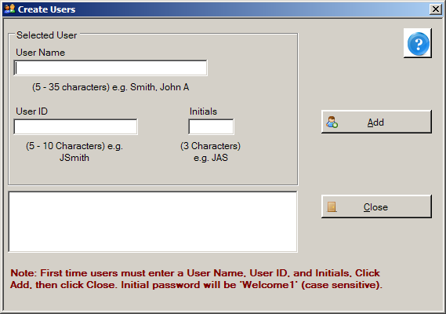
- Enter your full name in the User Name field. The format for name entry is last name, and then first name and middle initial, e.g., Smith, John A. In the example shown, the user name being entered has the last name USER, first name NEW, and middle initial A.
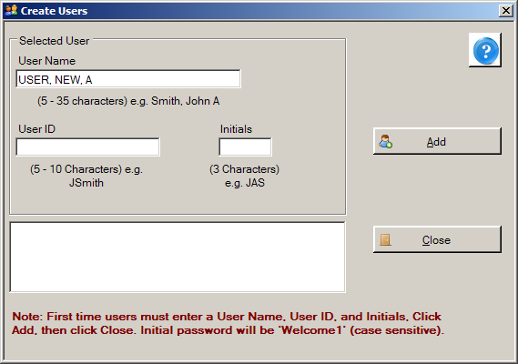
- Enter a User ID in the User ID field. User IDs can only be characters, and are 5-10 characters in length. In the future, you will enter your User ID when logging in to Abstract Plus. In the example shown, the User ID being entered is NUSER.
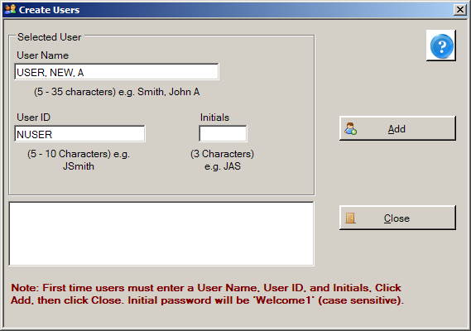
- Enter your initials in the Initials field. Your initials will be displayed on the main Abstract Plus window to indicate when you are logged in to the application, and may be automatically recorded in the Abstracted By field when abstracting abstracts or conducting audits if this application preference is enabled when configuring the application. This information is recorded in order to associate abstractors with the abstracts they have generated, and auditors with the audits that they have conducted. In the example shown, the initials entered are NAU.
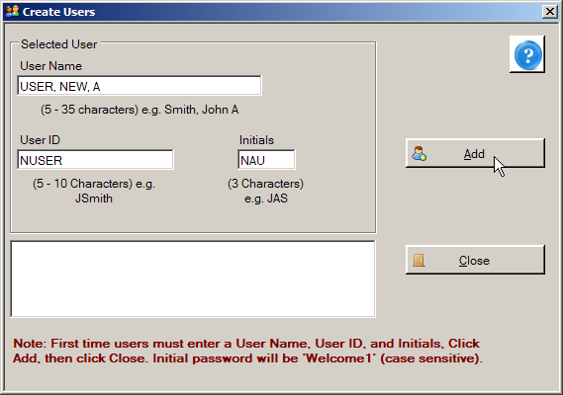
- Click Add.
Result: The system adds the new user account to the users list.
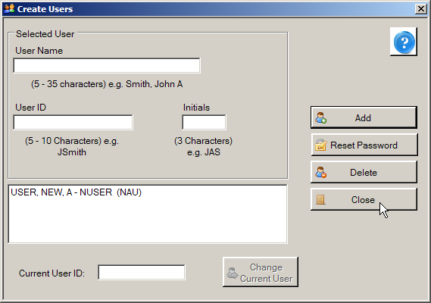
- Click Close.
Result: The Login window opens.
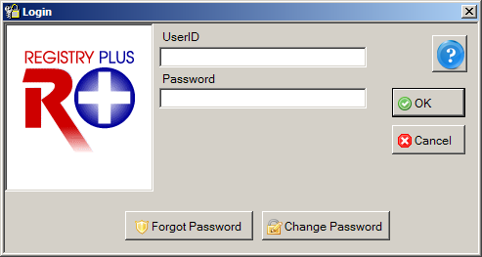
- Enter your User ID in the User ID field.
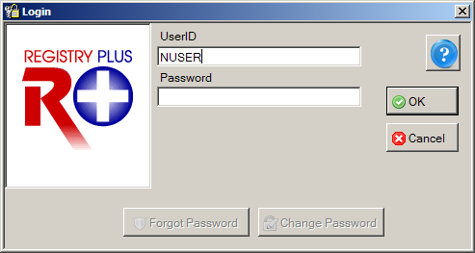
- Enter Welcome1 in the Password field.
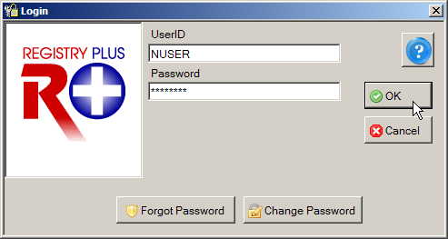
Welcome1
When entering your password, asterisks will be displayed rather than your password for added security. Note that passwords are case sensitive.
- Click OK.
Result: A Password Update message is issued that lets you know you need to change your password. This occurs upon initial log in only. When changing your password, you must change it to a password that meets the password requirements set when configuring the application.
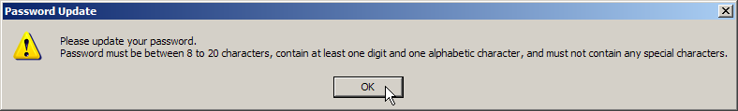
- Click OK.
Result: The Change User’s Password window opens, displaying your User ID and Old Password (which is Welcome1 at this point).
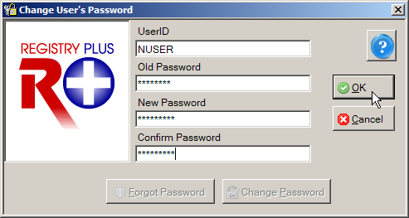
- Enter a new password in both the New Password and Confirm Password boxes, and click OK. You must type the same new password in both boxes.
By default, your new password must be between 8 and 20 characters, contain at least one digit and one alphabetical character, and must not contain any special characters; password requirements are maintained by the Administrator.
Result: The Define User’s Security Questions window opens, with your User ID displayed.
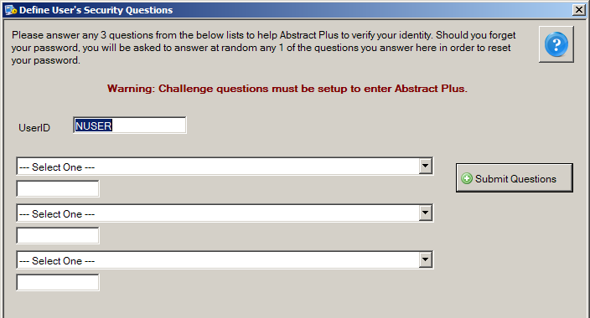
To complete your initial log in to Abstract Plus, you are required to select the specified number of security questions and answer them. By default you will need to select and answer 3 questions; however, this number may be modified when configuring the application. Your answers to these questions will be used to validate your identity if you forget your general user Abstract Plus password. If you forget your password, Abstract Plus will ask you for the answers you provided to your chosen security questions, and then allow you to reset your password if the questions are answered correctly. If you forget both your password and your answers to your selected security questions, you will need to log in as Administrator to reset your password.
- Select a question from the first drop-down list and enter your answer in the box below the question.
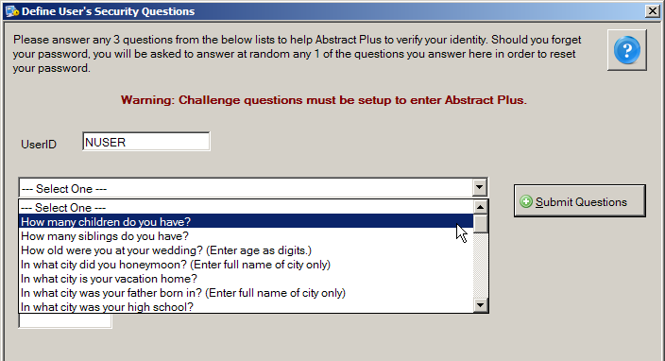
- Continue selecting questions and answering them until each question is answered.
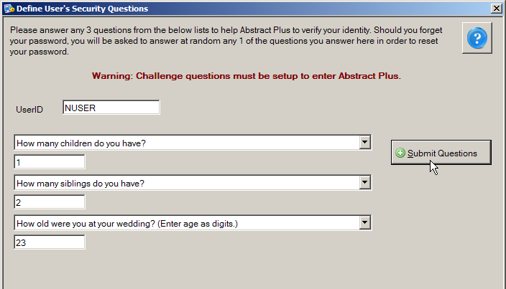
- Once all questions are selected and answers entered, click Submit Questions.
Result: The Abstract Plus main window opens, with you logged in as a general user. Note that your User ID is displayed at the bottom of the window.
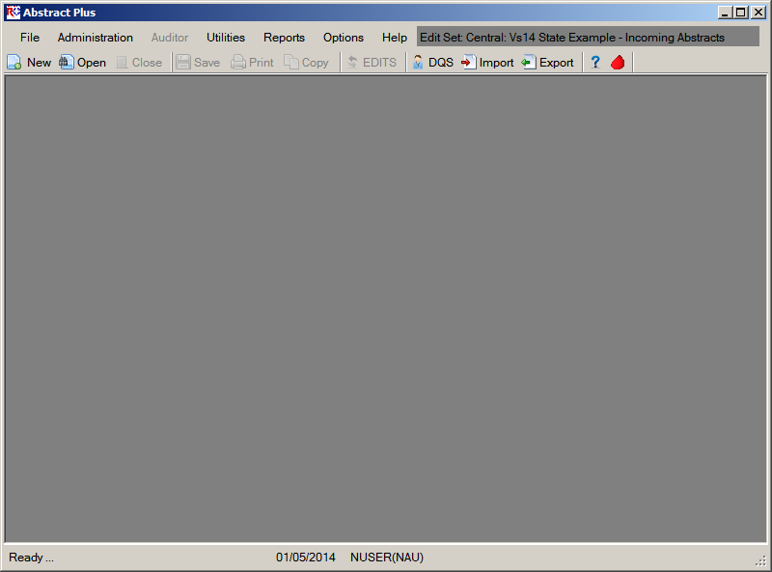

Routine Log In
After installation and initial log in to Abstract Plus, you will have a User ID and password for routine log in to your Abstract Plus general user account.
For routine log in to Abstract Plus, complete these steps:
- To launch the program, from the Start menu, select All Programs, Registry Plus, Abstract Plus, and then Abstract Plus.
Result: The Login window opens.
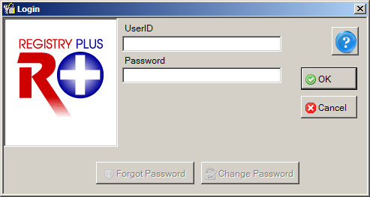
- Enter your User ID in the User ID box. In the example shown, the User ID being entered is NUSER.
- Enter your password in the Password box, and Click OK.
When entering your password, asterisks will be displayed rather than your password for added security. Note that passwords are case sensitive.
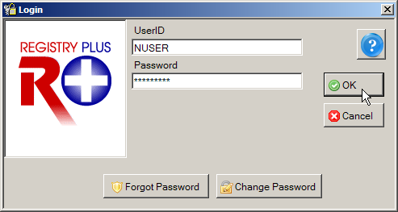
Result: The Abstract Plus main window opens, with you logged in as a general user. Note that your User ID is displayed at the bottom of the window.
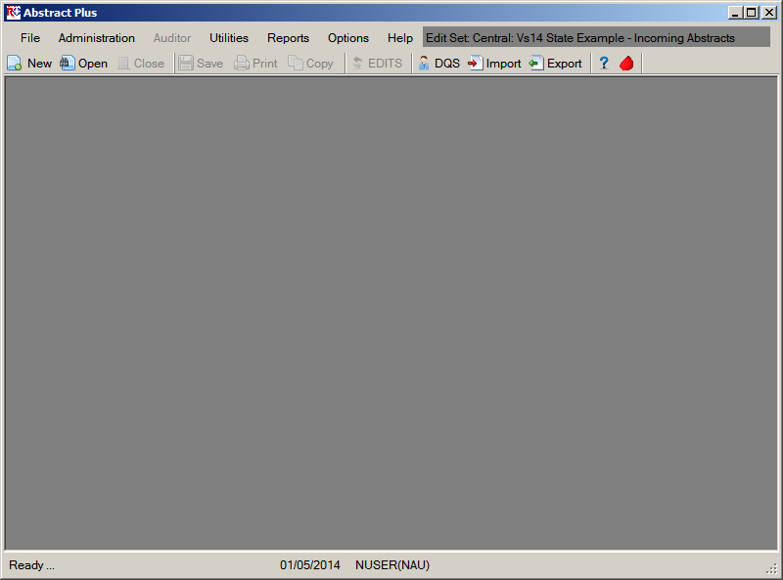

Activity 1 – Logging in to Abstract Plus
Using what you have just learned, launch Abstract Plus and log in as a General User.
If you have not yet accessed the program, see page 7 of this manual or click here for instructions for initial login to the program.

The Abstract Plus Main Window
The Abstract Plus main window provides access to all of the application’s features. Your User ID is displayed at the bottom of the window, and important system messages are displayed in the lower left-hand corner of the window. The default edit set is displayed in the upper right-hand corner of the window. When logged in as a general user, you will automatically have access to all of the application’s abstracting features via the main menu items. Some menu options are also available as buttons in the toolbar as shown below. Access to Administrator and Auditor functions require entry of special passwords.
 | By default Microsoft comes with sound effect features. One of those features is a “beep” feedback sound in response to pressing the tab or enter, etc. keys. If you do not like these sounds being issued as you use Abstract Plus, you can turn them off by going to Start→Control Panel→Sound→Sounds Tab→select Default Beep→select None from the Sounds pull-down menu→Click OK.  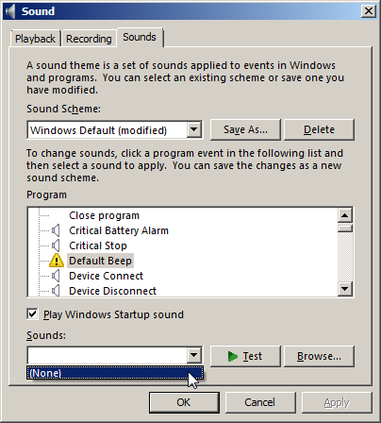

The File Menu
The File menu is used to access the majority of features that are used to work with abstracts. To access the File menu items, click on the File menu item, and select the desired sub-option, or use the appropriate keystroke combination for the desired sub-option.
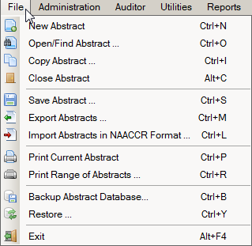
The following table describes the Abstract Plus File menu sub-options:
Sub-option (Keystroke) |  | Toolbar Icon | Function
New Abstract (Ctrl+N) |  |  | Create a new abstract
Open/Find Abstract… (Ctrl+O) |  |  | Search for and open an existing abstract
Copy Abstract… (Ctrl+I) |  |  | Copy an open abstract
Close Abstract (Alt+C) |  |  | Close an open abstract
Save Abstract… (Ctrl+S) |  |  | Save entered information
Export Abstracts… (Ctrl+M) |  |  | Export abstracts out of the Abstract Plus database into a NAACCR-formatted file
Import Abstracts in NAACCR Format… (Ctrl+L) |  |  | Import abstracts in a NAACCR-formatted file into the Abstract Plus database
Print Current Abstract (Ctrl+P) |  |  | Preview the displayed abstract and/or print it
Print Range of Abstracts… (Ctrl+R) |  |  | Select and print a range of abstracts or save in a file
Backup Abstract Database (Ctrl+B) |  |  | Create backup database to be used by Restore feature if database becomes corrupted
Restore… (Ctrl+Y) |  |  | Restore/replace corrupted database with a previously saved backup database
Exit (Alt+F4) |  |  | Log off Abstract Plus with an option to back up the database with your work
 | Please see the Abstract Plus Training Manual for Abstractors for more information regarding Abstract Plus abstracting and general user functions.

The Administration Menu
The Administration menu is used to access the administrative features of the program, such as managing user accounts and setting up the application for abstraction and auditing. No toolbar icons are available for any Administration menu options. To access the Administration menu items, click on the Administration menu item, and select the desired sub-option, or use the appropriate keystroke combination for the desired sub-option.
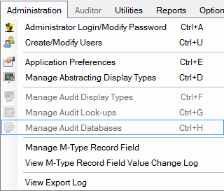
Entry of a special Administrator password is required in order to access the Administration menu items; the application will prompt you for the Administrator password when you attempt to access any of the Administration menu items. Administrator functions will be described in greater detail in later chapters of this training manual.
The following table describes the Abstract Plus Administration menu sub-options:
Sub-option (Keystroke) | Function
Administrator Login/Modify Password (Ctrl+A) | Log in as Administrator or change the Administrator password
Create/Modify Users (Ctrl+U) | Add, edit, or delete a user account or reset a password
Application Preferences (Ctrl+E) | Maintain all general, security, database and report application settings
Manage Abstracting Display Types (Ctrl+D) | Create, edit, or delete display types available for the abstracting features
Manage Audit Display Types (Ctrl+F) | Create, edit, or delete display types available for the auditing features (currently disabled)
Manage Audit Look-ups (Ctrl+G) | Maintain special audit lookup tables (currently disabled)
Manage Audit Databases (Ctrl+H) | Create, edit, or delete audit databases (currently disabled)

The Auditor Menu
The Auditor menu is used to access all of the available auditing features, such as opening and closing audits, and performing casefinding, reabstraction, and recoding audits. No toolbar icons are available for any Auditor menu options. To access the Auditor menu items, click on the Auditor menu item, and select the desired sub-option, or use the appropriate keystroke combination for the desired sub-option.
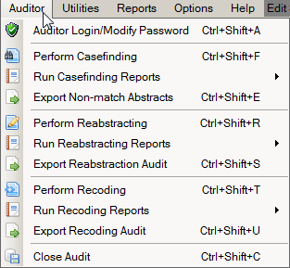
Entry of a special Auditor password is required in order to access the Auditor menu items; the application will prompt you for the Auditor password when you initially access any of the Auditor menu items. Note: If the Administrator password has already been entered, entry of the Auditor password is not required; Administrators automatically have access to all auditing features.
Please see the Abstract Plus Training Manual for Auditors for more information regarding Auditor functions.
Please note that due to development priorities, Abstract Plus is being released without the Auditor features Description of Auditor features provided in this manual is for informational purposes only. The Auditor features of Abstract Plus will be released in a future version of the program.
The following table describes the Abstract Plus Auditor menu sub-options:
Sub-option (Keystroke) | Function
Auditor Login/Modify Password (Ctrl+Shift+A) | Login as Auditor, and/or modify Auditor password
Perform Casefinding (Ctrl+Shift+F) | Perform a casefinding audit on opened audit
Run Casefinding Reports | Run casefinding audit pre-reconciliation and final reports
Export Non-match Abstracts (Ctrl+Shift+E) | Export unreported tumors found upon casefinding audit in NAACCR file format
Perform Reabstracting (Ctrl+Shift+R) | Perform a reabstracting audit on opened audit
Run Reabstracting Reports | Run reabstraction audit pre-reconciliation and final reports
Export Reabstraction Audit (Ctrl+Shift+S) | Export text file with reabstracting audit data for further analysis
Perform Recoding (Ctrl+Shift+T) | Perform a recoding audit on opened audit
Run Recoding Reports | Run recoding audit pre-reconciliation and final reports
Export Recoding Audit (Ctrl+Shift+U) | Export text file with recoding audit data for further analysis
Close Audit (Ctrl+Shift+C) | Close the audit

The Utilities Menu
The Utilities menu is used to access a few supplementary functions included in the program, such as re-running edits in batch mode, querying your local database of doctors, and managing facility and doctor codes.
To access the Utilities menu items, click on the Utilities menu item, and select the desired sub-option, or use the appropriate keystroke combination for the desired sub-option.
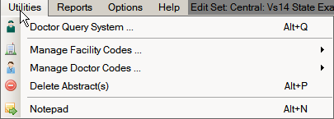
The following table describes the Abstract Plus Utilities menu sub-options:
Sub-option (Keystroke) |  | Toolbar Icon | Function
Doctor Query System (Alt+Q) |  |  | Query and search the doctor database; DQS can be accessed whether or not an abstract is opened, or a physician field selected
Manage Facility Codes… |  |  | Import (can use Alt+I keystroke) or edit (can use Alt+J keystroke) local facility codes
Manage Doctor Codes… |  |  | Import (can use Alt+K keystroke) or edit (can use Alt+L keystroke) local physician codes
Delete Abstract(s) (Alt+P) |  |  | Delete selected abstracts
Notepad (Alt+N) |  |  | Launch Notepad to view created text files
 | Please see the Abstract Plus Training Manual for Abstractors for more information regarding Abstract Plus utilities.

The Reports Menu
The Reports menu is used to access all of the available reports regarding abstracts in the Abstract Plus database. No toolbar icons are available for any Reports menu options.
To access the Reports menu items, click on the Reports menu item, and select the desired report, or use the appropriate keystroke combination for the desired report.
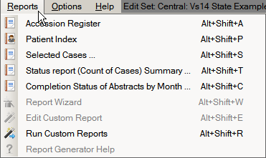
The following table describes the Abstract Plus Reports menu sub-options:
Sub-option (Keystroke) |  | Function
Accession Register (Alt+Shift+A) |  | Opens the Accession Register Report, which includes a line listing of all abstracts in the database, sorted by reporting hospital and accession number
Patient Index (Alt+Shift+P) |  | Opens the Patient Index Report, which includes a line listing of all abstracts in the database, sorted alphabetically by name
Selected Cases (Alt+Shift+S) |  | Opens a line listing report which includes abstracts based on user-specified criteria
Status Report (Count of Cases) Summary… (Alt+Shift+T) |  | Opens a report that includes the total number of complete and incomplete abstracts by export status within a user-specified date range
Completion Status of Abstracts by month (Alt+Shift+C) |  | Opens a report that includes abstract completion status by year and month of Date of Adm/1st Contact within a user-specified date range
Report Wizard (Alt+Shift+W) |  | Newly-added feature to enable users to generate their own custom reports (currently disabled)
Edit Custom Reports (Alt_Shift+E) |  | Edit an existing custom report (currently disabled)
Run Custom Reports (Alt+Shift+R) |  | Runs selected custom reports that have been added to the application using the Report Wizard
Report Generator Help |  | Opens online help for the Report Wizard; optional installation by Administrator required (currently disabled)
 | Please see the Abstract Plus Training Manual for Abstractors for more information regarding Abstract Plus abstract reports. Audit Reports are described in more detail in later chapters of this manual.

The Options Menu
For security purposes, users may want to change their passwords and security questions on a routine basis. The Options menu is used to update the user’s security questions or change their password. No toolbar icons are available for any Options menu selections.
To access the Options menu items, click on the Options menu item, and select the desired sub-option, or use the appropriate keystroke combination for the desired sub-option.
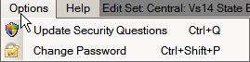
The following table describes the Abstract Plus Options menu sub-options:
Sub-option (Keystroke) |  | Function
Update Security Questions (Ctrl+Q) |  | Opens the Update User’s Security Questions window with the current User ID displayed along with the current security questions and answers specified by the user; new answers to existing questions may be entered, as well as new questions and answers
Change Password (Ctrl+Shift+P) |  | Opens Change User’s Password window, where the user can enter their current password, and a new password in both New Password and Confirm Password in order to change their password
 | For more information regarding updating personal security questions, see page 37 of this manual or click here. For more information regarding changing your general user password, see page 31of this manual or click here.

The Help Menu
The Help menu is used to access the online help that is available within the program. To access the Help menu items, click on the Help menu item, and select the desired sub-option, or use the appropriate keystroke combination for the desired sub-option.
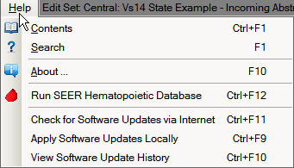
The following table describes the Abstract Plus Help menu sub-options:
Sub-option (Keystroke) | Toolbar Icon | Function
Contents… (Ctrl+F1) |  | View the contents of Abstract Plus online Help
Search for help on… (F1) |  | Enter search terms for topics on which you need more information
About (F10) |  | View Abstract Plus, Collaborative Staging, and Edits metafile version information
Run SEER Hematopoietic Database |  | Launch the SEER Hematopoietic Database stand-alone application to help you code hematopoietic and lymphoid neoplasms cases diagnosed beginning January 1, 2010
Check for Software Updates via the Internet (Ctrl+F11) |  | Check for Software Updates via the Internet (Internet connection required)
Apply Software Updates Locally (Ctrl+F9) |  | Apply software updates that have been distributed to you (no Internet connection required)
View Software Update History (Ctrl+F10) |  | View historical software updates that have been applied via the Abstract Plus Auto-update  feature

New Abstract Plus Abstracting and Editing Features
One of the primary activities that Abstract Plus is used for is the abstraction of information from medical records. As mentioned, Abstract Plus has been entirely reprogrammed using .NET technology, and has a new, extremely user-friendly abstracting interface. New direct grid entry of coded values and quick select options for pull-down menus allow for an easy, streamlined abstracting experience, as well as easier viewing of text fields, online help, and edit errors.
As you will learn, the majority of features offered for abstraction of regular abstracts are also offered for abstracting tasks for casefinding, reabstraction, and recoding audits.

The Abstract Plus Abstracting Process
The basic process of generating and updating an abstract is as follows:
- Create the abstract with the patient’s identifiers, such as name and social security number.
- Enter codes and text in the data entry fields. Save the abstract to retain the information you have entered.
NOTE: After creating an abstract, Abstract Plus will auto save the abstract at specified time intervals set by the Abstract Plus Administrator. When an abstract is manually saved, by clicking on the “Save” button, edits are automatically ran. Edits are not ran on an abstract at the time of auto-save.
- Correct errors. Each time you open or manually save the abstract, Abstract Plus can automatically edit the entered information for accuracy and completeness using the edit set and required fields chosen by your Abstract Plus Administrator.
- After you have entered all your data and corrected all errors, the system saves your new abstract as complete. You will see the edits error count and completion status indicators at the bottom of the abstracting window turn from red to green, indicating that the abstract is complete.

The Abstract Plus Abstracting Window
The Abstract Plus Abstracting window is divided into 2 main sections: a data entry grid for coded values on the left, and a data entry grid for text fields on the right. When you left-click and hold your mouse on the vertical divider bar in the center of the window, a splitter is highlighted which you can drag to the left or right to resize the view of codes or text fields, and the application remembers your last placement of the divider bar. You can vertically scroll the view of coded values and text fields independently to easily and concurrently view codes and associated text.
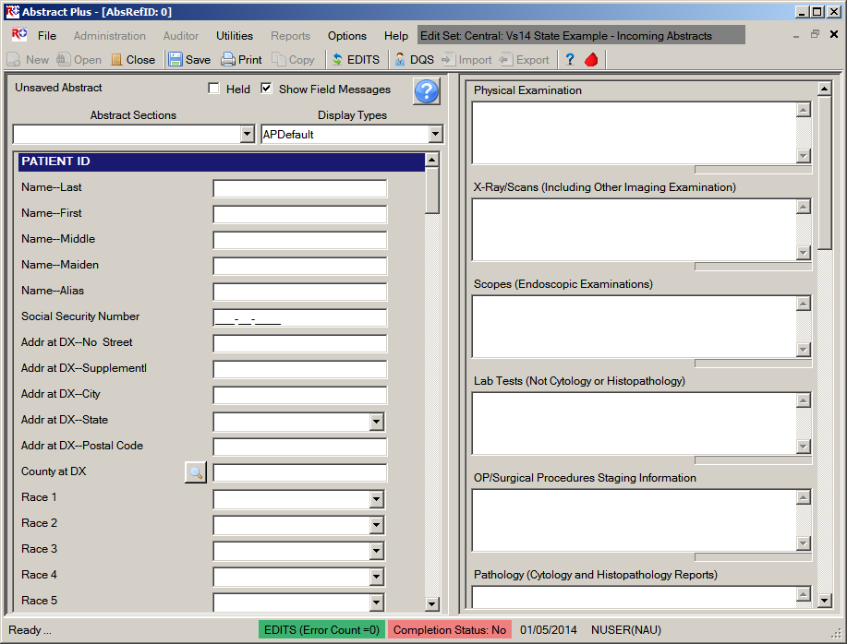
Edit Error Count
Easy, Direct Access to Text Fields
Can Resize Panes
Right-click Any Field for Help and Edit Errors
Direct Grid Entry
Section Headers
Custom Data Item Labels
Completion Status
Optionally Show Field Messages OptionCan Resize Panes
The Abstract Plus user-friendly abstracting interface includes the following abstracting features:
  - The abstracting interface is called a display type. A display type basically includes information regarding the fields displayed/collected, critical (or required) fields, edit set selections, and collaborative staging preferences, and is configured by the Abstract Plus Administrator upon setup of the application. The data items in a display type are labeled and ordered by the Administrator, as well as grouped into logical sections, which also have customizable labels.
Regardless of the customized label a data item may have, when a data item is selected, the associated NAACCR item name is always displayed in the lower left-hand corner of the window. This information is helpful when looking up information regarding a data item in the online help reference books.
  - Many data items offer code selection from drop-down lists. In addition, the drop-down lists feature an auto-complete, find-as-you-type function that allows the user to type in the first letter, or first few letters, of the desired code label, and the application auto-selects the first item in the list beginning with that letter. In the example shown below, an A has been typed into the Race 1 field, and the application auto-selects the value of American Indian, Aleutian, or Eskimo:
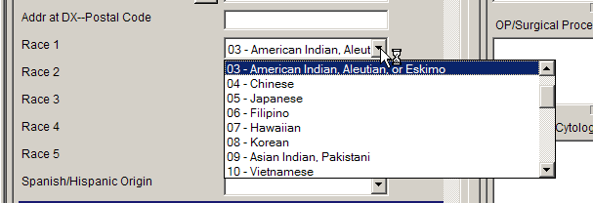
If you begin typing in the data item, but find you need to revise what you have typed, press the backspace key to delete what you have already entered, and start typing again. This enables the find-as-you-type feature to automatically find your revised entry.
  - For data items with extensive listing of coded values, such as primary site, there is lookup assisted data entry with an advanced search feature. You can either enter the code directly if known, or click on the magnifying glass icon to the left of the data item (or press F4) to use the search feature:
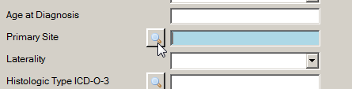
Enter a full or partial search term or code to search for, and then double-click on the code of your choice to transfer the value to the data item in the data entry grid.
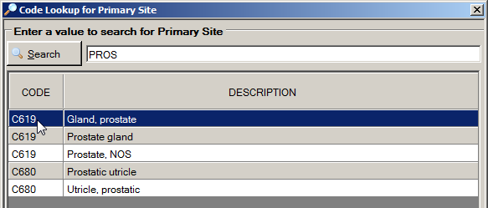
  - Depending on the system preferences set by your Abstract Plus Administrator, users can automatically calculate Age at Diagnosis once date of birth and diagnosis are entered, and can calculate Collaborative Stage derived data items by clicking on the calculator icon to the left of the data item:
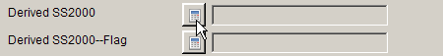
Or, your Administrator may choose set turn on the option to automatically calculate Collaborative Stage derived data items upon save of the abstract after the following CS input data items have been abstracted:
- CS Tumor Size
- CS Extension
- CS Tumor Size/Ext Eval
- CS Lymph Nodes
- CS Lymph Nodes Eval
- CS Mets at DX
- CS Mets Eval
- CS Site-Specific Factor 1-25
If your Administrator has turned this option on, CS derived data items will be calculated upon every save after the above fields have been entered.
  - Depending on the system preferences set by your Abstract Plus Administrator, if the address at diagnosis is the same as the current address for a patient, users can automatically copy the values in all address at diagnosis data items to the current address fields by pressing F5 when the cursor is located in the Addr Current—No Street data item:
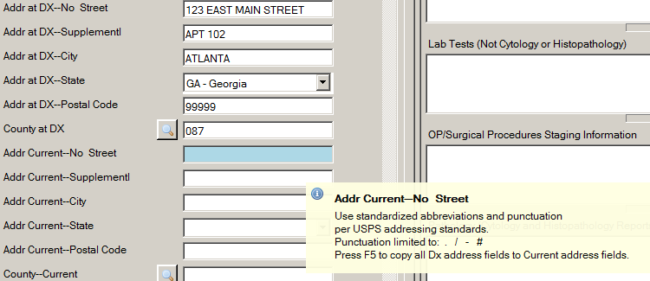
Upon pressing the F5 key the address at diagnosis values get copied over to the current address fields:
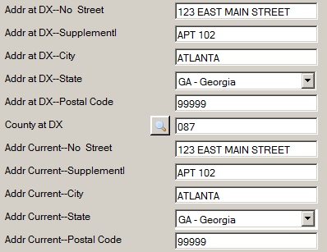
  - If the coded values for certain Rx Summ treatment data items are determined to be the same as the associated Rx Hosp data items, the value in a particular Rx Hosp data item can automatically copied over to the associated Rx Summ data item by pressing F5 while the cursor is still in the Rx Hosp Data item:
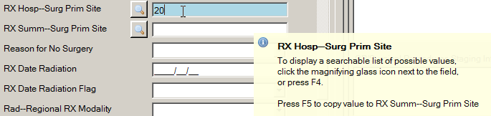
Upon pressing the F5 key the Rx Hosp value gets copied over to the Rx Summ data item:
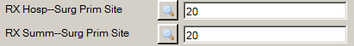
Below is a list of Rx Hosp treatment data items that Abstract Plus offers the ability to be mapped to their associated Rx Summ data item:
NAACCR Item No | Hosp Rx Data Item Name | NAACCR Item No | Rx Summ Data Item Name
670 | RX Hosp--Surg Prim Site | 1290 | RX Summ--Surg Prim Site
672 | RX Hosp--Scope Reg LN Sur | 1292 | RX Summ--Scope Reg LN Sur
674 | RX Hosp--Surg Oth Reg/Dis | 1294 | RX Summ--Surg Oth Reg/Dis
676 | RX Hosp--Reg LN Removed | 1296 | RX Summ--Reg LN Examined
690 | RX Hosp—Radiation | 1360 | RX Summ--Radiation
700 | RX Hosp—Chemo | 1390 | RX Summ--Chemo
710 | RX Hosp—Hormone | 1400 | RX Summ--Hormone
720 | RX Hosp—BRM | 1410 | RX Summ--BRM
730 | RX Hosp—Other | 1420 | RX Summ--Other
740 | RX Hosp--DX/Stg Proc | 1350 | RX Summ--DX/Stg Proc
3280 | RX Hosp--Palliative Proc | 3270 | RX Summ--Palliative Proc
746 | RX Hosp--Surg Site 98-02 | 1646 | RX Summ--Surg Site 98-02
747 | RX Hosp--Scope Reg 98-02 | 1647 | RX Summ--Scope Reg 98-02
748 | RX Hosp--Surg Oth 98-02 | 1648 | RX Summ--Surg Oth 98-02
  - Prompt messages may be associated with each data item, so that when the abstractor clicks into the field, a pop-up box comes up with a message or instructions about abstracting that field:
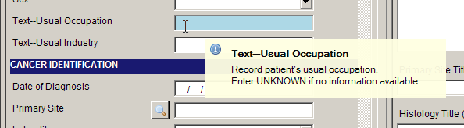
  - For the experienced abstractor, the field messages may turned on or off depending on the abstractor's preference and knowledge of coded values for specific fields:. To turn off the field messages, un-check the Show Field Messages checkbox at the top of the abstracting grid:
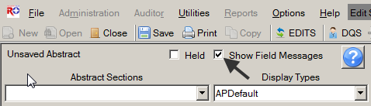
This option should be used with extreme caution. Sometimes the field message includes essential coding instructions that can only be found by looking up the data item in NAACCR Volume II or some other coding reference. For example, for the field of Cause of Death, without the display of the field message, the inexperienced coder would not know to code 0000 for an alive patient.
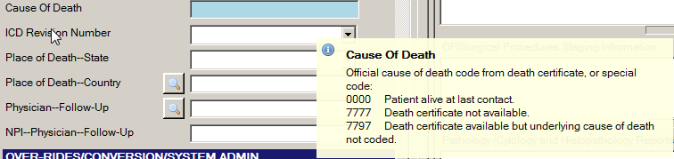
  - When entering text, a progress bar is displayed below each text field indicating how much space is left so that you can properly prioritize the information you are entering:
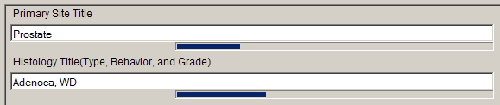
  - Keyboard and mouse alternatives are now available for every function in the software. Note that Keystroke options are displayed on menus for all menu items, and Appendix B of this training manual contains a listing of standard Abstract Plus keyboard shortcuts to functions.
  - All-new right-click functions for individual data items, including access to field context help, edits error information, field messages, and a function to clear all Collaborative Stage fields:
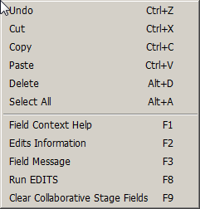
  - Color-coded edits error count and abstract completion status information is clearly displayed to the user at the bottom of the abstracting window, and changes from red to green upon completion of the abstract:
Incomplete abstract containing edit errors:
Complete abstract containing no edit errors:
  - Once saved, each abstract is assigned an unique Abstract Reference ID (or AbsRefID), displayed in the upper left-hand corner of the data entry area of abstracting window, as well as in the title bar of the application along with the patient name:
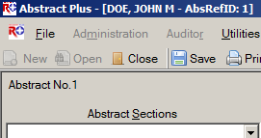
  - Abstracts can be held to prevent export. The Held check box allows an abstractor to prevent a case from being exported even if it is considered complete by the system. This can be used if, for example, the abstractor is searching for additional information to be included before the abstract is exported. If checked, the abstract will not be exported, regardless of Completion Status:
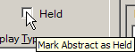

Entering Dates in Abstract Plus
As of the NAACCR version 12x record layout, all dates are in the YYYYMMDD format. Because the NAACCR standards are so tightly integrated with the Abstract Plus program, dates are entered in the YYYY/MM/DD format in Abstract Plus.
The Abstractor and Auditor will enter dates in the new YYYYMMDD format as follows:
YYYYMMDD – when complete date is known and valid
YYYYMM – when year and month are known and valid, and day is unknown
YYYY – when year is known and valid, and month and day are unknown
Blank – when no known date applies
Abstract Plus has a date field entry mask on all date fields that already has the slashes in it. Although the application allows you to type the slashes and dashes when entering dates fields, you can save keystrokes by only typing the 8 characters of the date. For example for the date of August 1, 2012, the date can be entered as 20120801.

New Data Quality Edits and Error Resolution Features
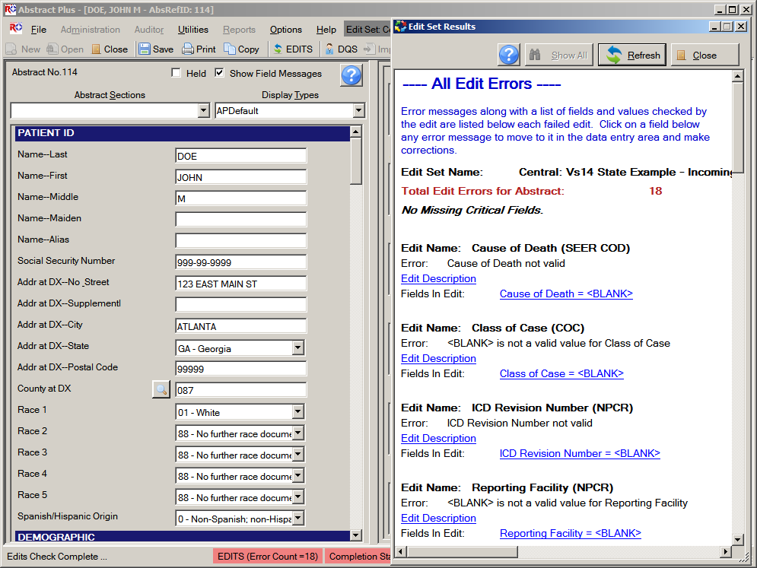
Each time an abstract is opened or saved, Abstract Plus automatically edits the entered information for accuracy and completeness using the edit set and required fields chosen by your Abstract Plus Administrator.
You must resolve all edit errors and fill in all critical (required) fields in order to complete the abstract.
Abstract Plus has edit error display features that greatly facilitate the error resolution process. Editing features include:
- The edit set being run on the abstract is clearly displayed at the top of the abstracting window. In the example shown, the edit set being applied is named Central Vs 14 State Example - Incoming Abstracts:
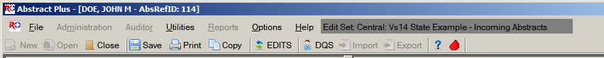
- When edits are run, the Edit Set Results window automatically opens and displays the full information for any edit errors that exist, or lets you know that there are no errors. The Edit Set Results window lists the total number of edit errors for the abstract, missing critical (required) fields, and the edit errors. For each edit error, the failed edit name, error message, and fields involved in the edit are listed. Using the information listed in the Edit Set Results window to help you resolve the edit errors, you can click on a link to a field to move to it in the data entry grid and make corrections:
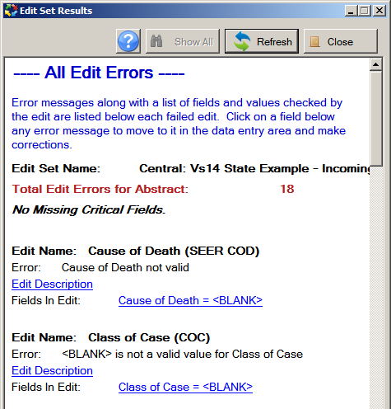
Links to fields in data entry grid
When greater detail regarding the edit is required to resolve the edit error, click on the Edit Description link, which expands to display the edit description; once opened, you can click anywhere to close the edit description:
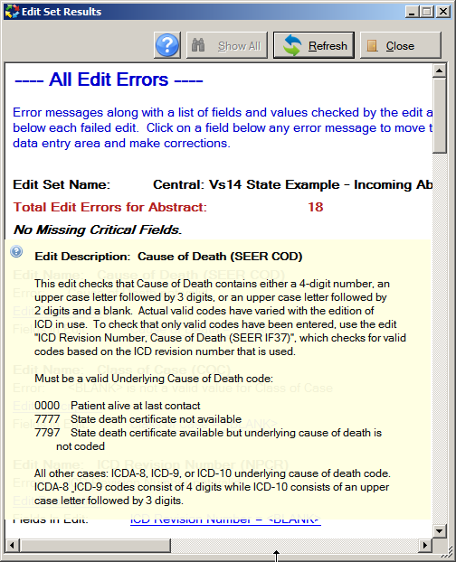
Click Edit Description link to open description; click anywhere to close description
- Edit errors can be viewed for the entire abstract, or just for individual fields. You can view all edit errors for the abstract as shown above by clicking on the EDITS icon on the toolbar , right-clicking and selecting Run Edits, or by pressing F8.
Or you can choose to view edit errors by individual data field by right-clicking and selecting Edits Information, or by pressing F2. In the example shown, the edit errors for the individual field of Cause of Death are being viewed:
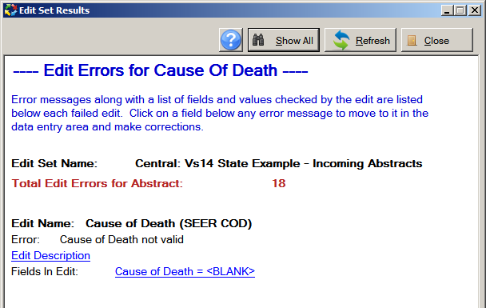
When viewing edit errors for an individual field, you can switch from the individual data field edit errors view to the all edit errors view by clicking on the Show All button.
You can make corrections to fields by clicking on the links to the fields in the Edit Set Results windows. To see your corrections reflected, click the Refresh button.

Changing Your General User Password
For security purposes, you may be prompted to change your general user password periodically, based on the Password Policy specified upon configuration of the application. Upon set up of the application, as Administrator, you will specify password requirements, how often the user needs to change their password, as well as how many of their last passwords they cannot repeat.
To change your Abstractor/general user password, complete these steps:
- Open the Change User’s Password window. This may be done in 2 ways:
  - From Options Menu, select Change Password.
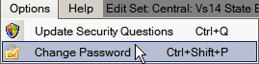
  - When logging in to Abstract Plus, enter your User ID, tab or click into the Password box, and then click Change Password on the Login window.
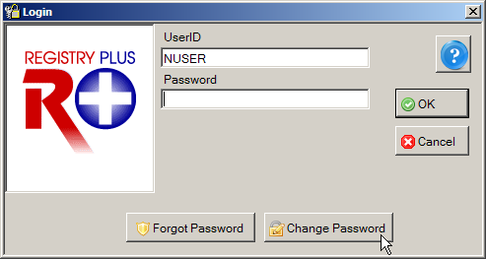
Result: The Change User’s Password window opens, with your User ID displayed.
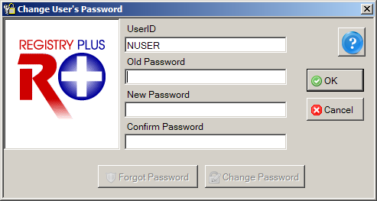
- Enter your Current Password in Old Password box.
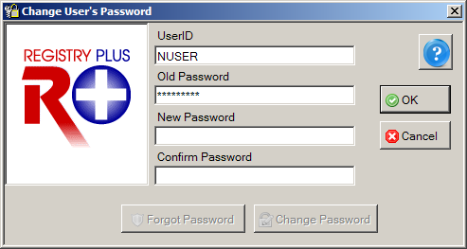
- Enter a New Password in New Password box that meets the password requirements specified upon configuration of the application.
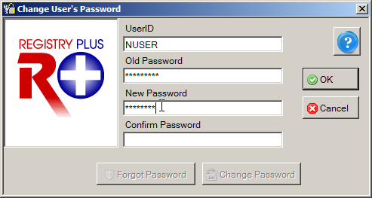
By default, the new password must be between 8 and 20 characters, contain at least one digit and one alphabetical character, and must not contain any special characters; however, these requirements may be modified when configuring the application.
- Re-enter your New Password in the Confirm Password box.
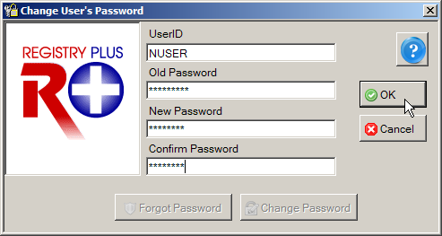
- Click OK to change your password.
Result: Your password is changed, and the Abstract Plus main window is opened.

Possible Errors when Changing Your Password
There are three possible errors you may receive when attempting to change your password:
- Old password is incorrect. You must correctly enter your old password in order to successfully change it. Click OK, and then correctly re-enter your old password.
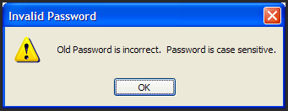
- New passwords do not match. The new password entered into the New Password and Confirm Password boxes must match exactly. Click OK, and then correctly re-enter your new password in the New and Confirm password boxes.
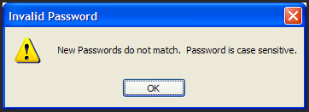
- New password does not meet specified password requirements. Your new password must meet the password requirements specified by the application. Click OK, and then re-enter a new password that meets the stated password requirements.
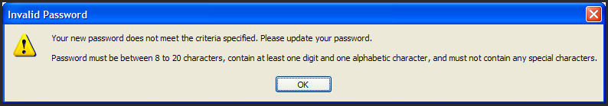

Resetting a Forgotten Password
In the event that you should forget your password, Abstract Plus has a security challenge question feature that will allow you to reset your own password without having to log in as Administrator. The security challenge question feature enables you to securely reset your password by answering a specified number of the security questions that you selected and answered upon initial login to Abstract Plus.
Your answers to these questions are used to validate your identity. Abstract Plus will ask for the answers that you provided to your chosen security questions, and then allow you to reset your password if the questions are answered correctly. If you forget both your password and your answers to your security questions, you will need to log in as Administrator to reset your password.
To reset your password if you have forgotten it, complete these steps:
- When logging in to Abstract Plus, enter your User ID, tab or click into the Password box, and then click Forgot Password on the Login window.
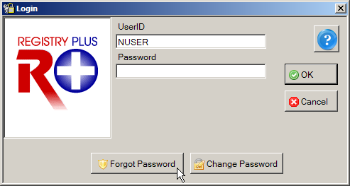
Result: The Reset User’s Password window opens, with your User ID displayed, as well as the number of security questions specified upon set up of Abstract Plus.
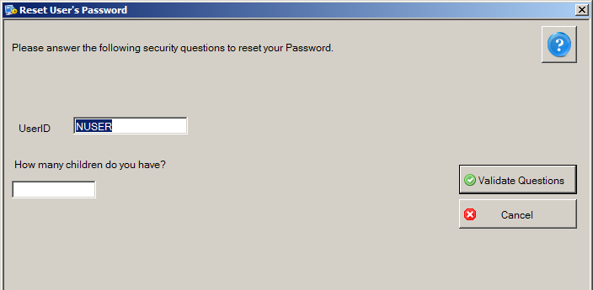
- Enter the answer to each displayed question with the same answer you provided upon initial login to Abstract Plus.
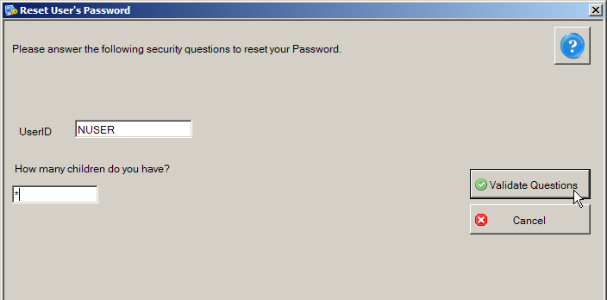
- Click Validate Questions once all questions are answered.
Result: The Reset User’s Password window opens, with your User ID displayed.
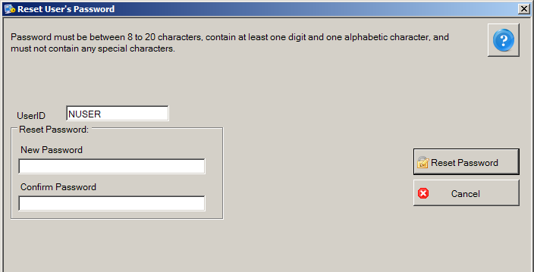
- Enter a New Password in both the New and Confirm password boxes, and then click Reset Password.
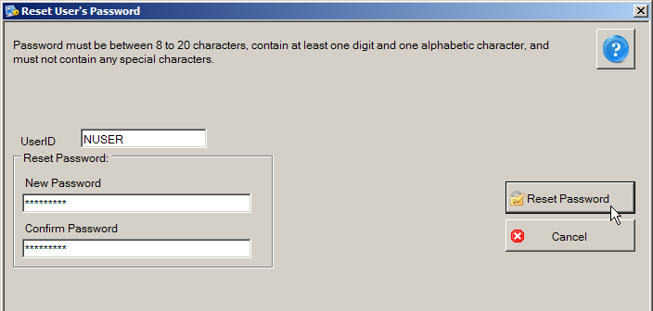
Result: The Forgot Password window opens, with your User ID displayed.
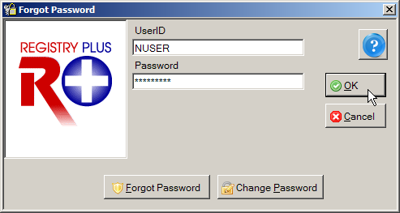
- Enter your New Password in Password box, and click OK.
Result: The Abstract Plus main window opens, with you logged in as a general user. Your password has been successfully set to the new password you have specified.

Updating Personal Security Questions
Once you are logged in to Abstract Plus, you can update your selected security questions and/or answers at any point. For example, if you selected the security question of “How many children do you have?” and you just had a new child enter your family, you can update your answer to this question.
To update your security questions and/or answers, complete these steps:
- From Options Menu, select Update Security Questions.
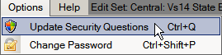
Result: The Update User’s Security Questions window opens, with your User ID displayed, as well as the current security questions and answers which you have specified. For added security asterisks are displayed rather than your answers to the questions.
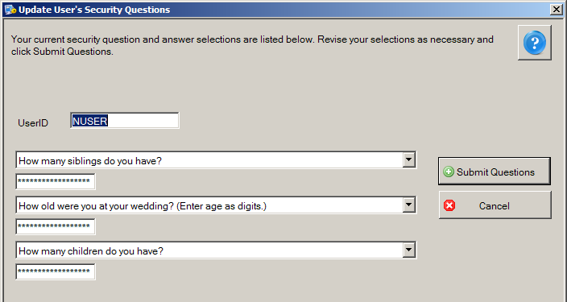
- You can select new questions and answer them or supply new answers to your previously selected questions. When you have completed your changes, click Submit Questions.
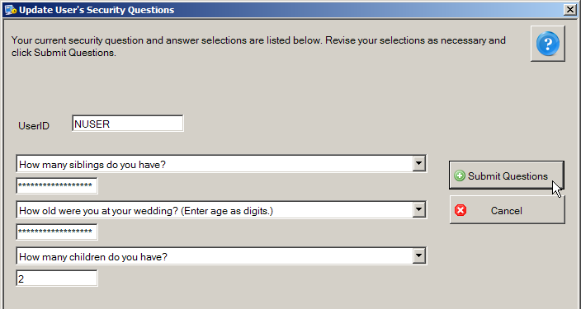
Result: You are returned to the Abstract Plus main window, with your changes saved for future use.

Abstract Plus Auto-update Feature
The “Auto-update” feature enables delivery of application bug fixes, enhancements and updates associated with Abstract Plus via the Internet after software distribution and initial installation. This new mechanism downloads the necessary applicable files from the CDC Abstract Plus FTP site and replaces the existing files with the updated/revised versions to apply updates/fixes. In the event that you are an Abstract Plus user that does not have access to the Internet, software update packages can be distributed to you and you can apply them locally from a folder on your computer or network.
Two modules are included in the in the Auto-update feature, so that revisions, fixes, or updates can be made from the CDC and or state levels:
- Generic Auto-update Module: This module primarily delivers application enhancements, updates, and resolutions to identified problems that are applicable regardless of the state, region, or project for which Abstract Plus has been customized. It will also be used to update the generic version of Abstract Plus available from the NPCR website. The generic auto-update module will deploy updates for issues identified at the CDC-level, including, but not limited to: resolutions to identified issues, updated example display types, edits metafiles, online help files, revisions to the Catvals tables, and updated application files.
For example, the initial release of Abstract Plus 3.5 will include a version of RPOH that will include the NAACCR Version 15 Volume II Data Dictionary and the updated Abstract Plus User’s Guide. As soon as additional manuals are added to RPOH, they will be distributed via the generic auto-update module.
- Custom Auto-update Module: This module also works in the same manner as “Generic Auto-update”, but addresses updates to customizations made for a certain state or project. This module identifies the Abstract Plus user’s customized version, and downloads the update package version for their specific installation.

Benefits of the Auto-update Feature
Many states have a large number of Abstract Plus end users and even more individuals download and use the generic version of Abstract Plus. With each new version that is released, sometimes issues are identified that need to be corrected, or a state decides to make a change to their customizations. As a result, if issues/revisions are identified after a state has distributed the program, the state may have to obtain a new installation and re-distribute. For some states this is a very onerous process, and often the end user would need to uninstall and re-install the application which is quite inconvenient. States often have to assess the value added of a specific correction or update, i.e., is it worth going through redistribution of the software?
In order to alleviate states and end users from the time and resource-consuming efforts of redistribution, the CDC has programmed a new Auto-update feature.

No Uninstall and Re-install of Abstract Plus is Necessary
After the initial installation of the application, the new Auto-update mechanism does not require the end user to uninstall/reinstall the application to obtain software updates. It simply replaces the associated files on the CDC FTP site with those already installed on the end users computer.

No Loss of Data is Possible
Although it is highly recommended for the end user to back-up their data prior to launching the Auto-update, the Auto-update mechanism does not directly interfere or touch the user or abstract data. There is absolutely no possibility of any data loss when the user uses the Auto-update feature.

Auto-updates can be Implemented Automatically or Manually
There are two ways initiate the Auto-update mechanism. There is a new Application Property that allows your Administrator to customize Abstract Plus to run the Auto-update feature automatically. The frequency with which the application automatically checks for updates can also be specified; there is a new option that allows the state to specify how the number of days in-between checking for available updates. In addition, the abstractor can check for software updates manually at any time.

Automatic Detection of Available Updates for Customized Versions
Once the Auto-update feature is invoked, Abstract Plus looks to an XML file (AvailableUpdateInfo.xml) on the CDC FTP Server. This XML includes all the update information that is systemically organized. Every time CDC releases an update (states will communicate customization updates to the CDC and CDC will update the XML files and post the appropriate files to the CDC FTP site), CDC updates this file with appropriate information (See sample XML file below).
<?xml version='1.0'?>
<RegistryPlusApplications>
<Application Name = 'ABSTRACTPLUS'>
<GenericPackage>
<Version>1</Version>
<DownloadPath>http://ftp.cdc.gov/pub/NPCR-AP-UPDATES/AbstractPlus/GenericUpdate/GenericPackage_EDITS-Fix_02-25-2013.zip</DownloadPath>
<PrerequisitePackageVersion>0</PrerequisitePackageVersion>
<PackageDescription>This update package will address issue associated with EDITS for generic Abstract Plus. This issue was reported by Kathleen Thoburn on 02-25-2013.
</PackageDescription>
<RequiredNAACCRVersion>122</RequiredNAACCRVersion>
<ReleaseMode>UAT</ReleaseMode>
</GenericPackage>

<PackageGroup Name ='GA'>
<CustomPackage>
<Version>1</Version>
<DownloadPath>http://ftp.cdc.gov/pub/NPCR-AP-UPDATES/AbstractPlus/CustomUpdate/GA/CustomPackage1.zip</DownloadPath>
<PrerequisitePackageVersion>0</PrerequisitePackageVersion>
<PackageDescription>
This Custom update package version 1 for GA, has such and such updated files…, etc.
</PackageDescription>
<ReleaseMode>UAT</ReleaseMode>
</CustomPackage>

<CustomPackage>
<Version>2</Version>
<DownloadPath>http://ftp.cdc.gov/pub/NPCR-AP-UPDATES/AbstractPlus/CustomUpdate/GA/CustomPackage2.zip</DownloadPath>
<PrerequisitePackageVersion>1</PrerequisitePackageVersion>
<PackageDescription>
This Custom update package version 2 for GA, has such and such updated files…, etc.
</PackageDescription>
<ReleaseMode>UAT</ReleaseMode>
</CustomPackage>

<CustomPackage>
<Version>3</Version>
<DownloadPath>http://ftp.cdc.gov/pub/NPCR-AP-UPDATES/AbstractPlus/CustomUpdate/GA/CustomPackage3.zip</DownloadPath>
<PrerequisitePackageVersion>2</PrerequisitePackageVersion>
<PackageDescription>
This Custom update package version 3 for GA, has such and such updated files…, etc.
</PackageDescription>
<ReleaseMode>UAT</ReleaseMode>
</CustomPackage>
</PackageGroup>

Auto-updates can be Distributed and Implemented Locally (No Internet Connection Required)
In the event that you are an Abstract Plus user that does not have access to the Internet, software updates can be distributed to you and you can apply them locally from a folder on your computer or network.

Automatic Updates for Users Who Have Not Updated on a Regular Basis
If the automatic Auto-update system preference is not on, and a user does not check for updates for quite some time, several updates may have been released since they last checked for updates. The Auto-update mechanism keeps track of what updates were already applied and those that have not been applied, and will upgrade all released updates sequentially since the last update run to make the software current with all update releases.

User is Notified When the CDC FTP Site is Experiencing Issues
If the CDC FTP site is temporarily down, Abstract Plus displays a message to the user to try updating at a later time.

User is Notified When No Updates are Available
When the application or user checks for updates and there are no updates available Abstract Plus issues a message that states “No update is required at this time”.

Checking for Software Updates via the Internet
As mentioned earlier, Auto-updates can be implemented automatically or manually. Your software will automatically check for software updates if your Administrator has set up Abstract Plus to do so. You can also manually check for auto-updates. Note that if your Administrator has configured the software to automatically check for updates, you can still manually check for updates at any time.
To check for auto-updates manually, complete these steps:
- Open the Auto-update window. This can be done in 2 ways:
  - From Help Menu, select Check for Software Updates via Internet.
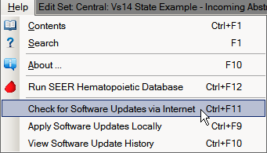
  - Use the keystroke Ctrl+F11.
Result: The Confirm Auto-update dialog box opens. As updating could be time-consuming task the application asks you to confirm that you would like to proceed with the update process.
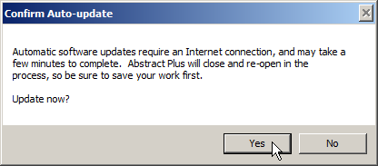
- Click Yes.
Result: The Abstract Plus Auto-update window opens, and the Auto-update mechanism begins. Abstract Plus will close and will then check for any available updates. If there are any applicable updates available Abstract Plus will download the update package(s) and begin updating Abstract Plus. Once the updates are applied, Abstract Plus will re-open. The Abstract Plus Auto-update window provides you with step-by-step feedback regarding the update process.
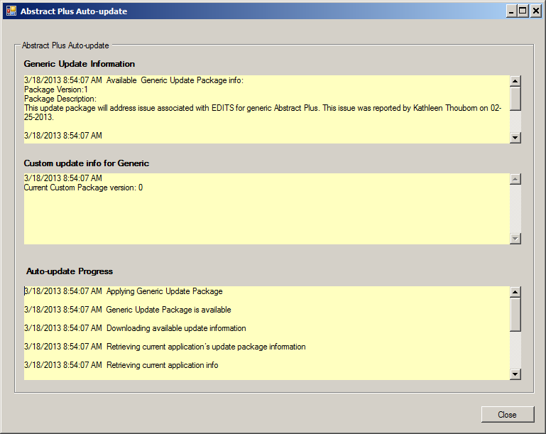
- To close the Auto-update, click Close.
Result: The Abstract Plus Auto-update window will close, and Abstract Plus will re-open. You can now log back in and continue working in the application.

Applying Software Updates Locally
In the event that you are an Abstract Plus user that does not have access to the Internet, software update packages can be distributed to you and you can apply them locally from a folder on your computer or network. The Auto-update package comes in the form of a win-zipped file that just needs to be placed in a folder on your computer or network, and then you navigate to that folder.
To apply software updates that have been distributed to you via an update package (e.g., via mailed CD), complete these steps:
- Open the Auto-update window. This can be done in 2 ways:
  - From Help Menu, select Apply Software Updates Locally.
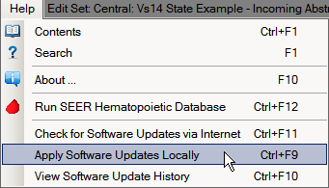
  - Use the keystroke Ctrl+F9.
Result: The Abstract Plus Auto-update window for local updates opens.
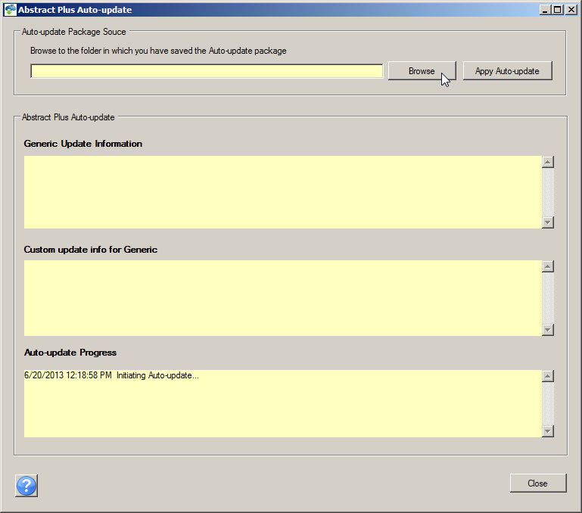
- Click Browse to navigate to the folder on your computer or network in which you have saved the auto-update package that was distributed to you.
Result: The Browse for Folder window opens.
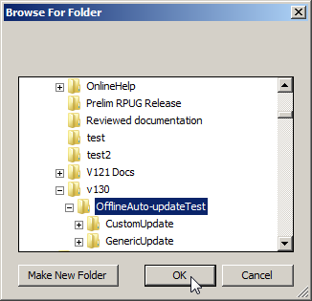
- Navigate to the folder on your computer or network in which you have saved the auto-update package that was distributed to you and click OK.

Result: You are returned to the Abstract Plus Auto-update window for local updates, and the selected folder is displayed.
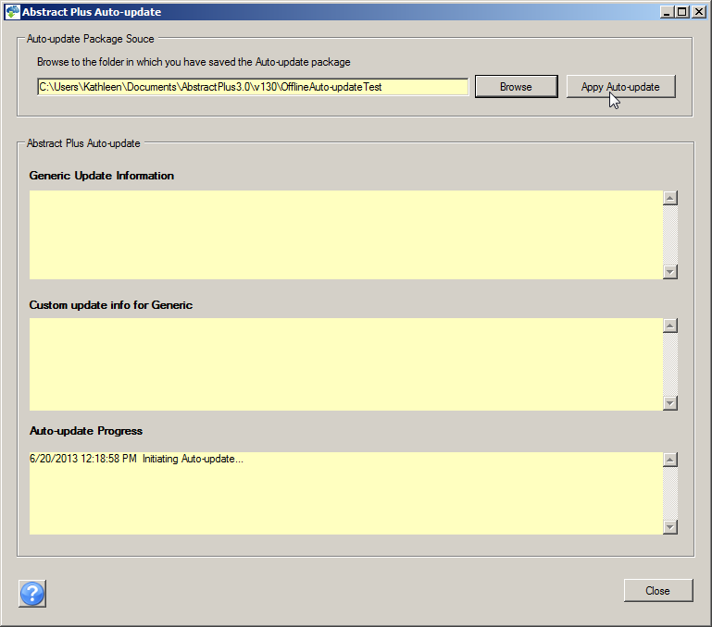
- Click Apply Auto-update.
Result: The Confirm Auto-update dialog box opens. As updating could be time-consuming task the application asks you to confirm that you would like to proceed with the update process.
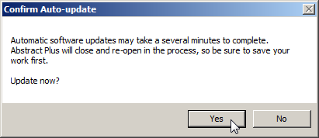
- Click Yes.
Result: The Abstract Plus Auto-update window opens, and the Auto-update mechanism begins. Abstract Plus will close and will then check the specified folder for the available updates. The Auto-update process will begin and updates are applied. The Abstract Plus Auto-update window provides you with step-by-step feedback regarding the update process.
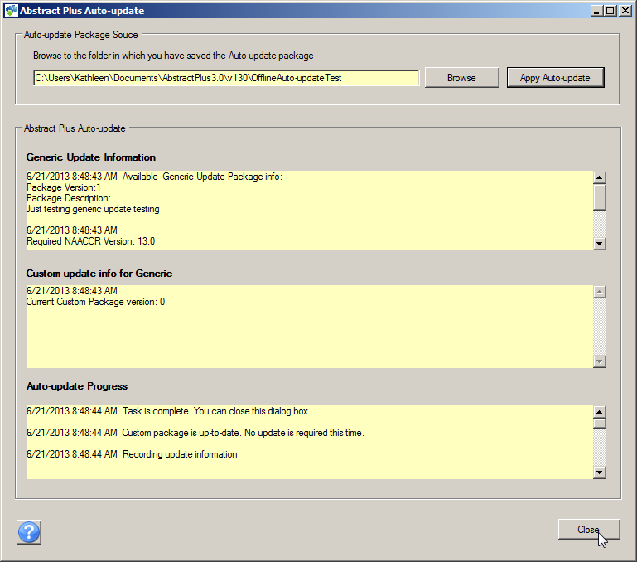
- To close the Auto-update window, click Close.
Result: The Abstract Plus Auto-update window will close, and Abstract Plus will re-open. You can now log back in and continue working in the application.

Viewing Software Update History
You can view your software update history to see if you have the latest software updates.
To view your software update history, complete these steps:
- Open the Software Auto-update History window. This can be done in 2 ways:
  - Click on the Help menu, and select View Software Update History.
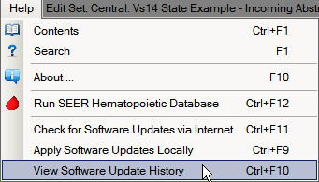
  - Use the keystroke Ctrl+F10.
Result: The Abstract Plus View Software Update History window opens, and provides you with a listing of all updates you have implemented. A detailed description of each update is located in the Package Description column.
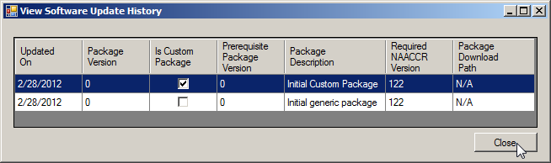
- To close the View Software Update History window, click Close.

Exiting Abstract Plus and Using the Backup Option
When logging off and exiting Abstract Plus, the application will prompt you to back up the current abstract database.
To log off / exit Abstract Plus and use the database backup option, complete these steps:
- Exit Abstract Plus. This can be done in 3 ways:
  - Click on the File menu, and select Exit.
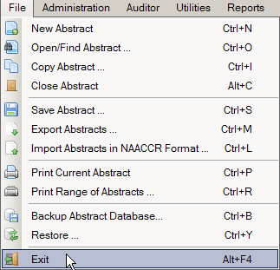
  - Use the keystroke Alt+F4.
  - Click the X in upper right corner of screen.
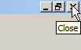
Result: The Exit Program window opens, and asks if you are sure you want to exit the program.
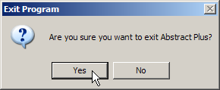
- Click Yes.
Result: The Backup Database window opens, and asks if you would like to backup your Abstract Plus abstracts database (ABSPLUS.MDB).
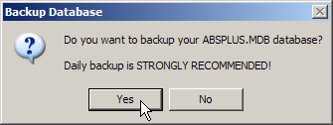
Although you can choose not to backup your database, it is highly recommended that you backup your database after finishing an abstracting session during which changes were made (abstracts were added, updated, or deleted). Note that the Backup and Restore Database menu options are not available when using SQL Server database
- Click Yes.
Result: The Abstract Plus Database Backup window opens with defaults set.
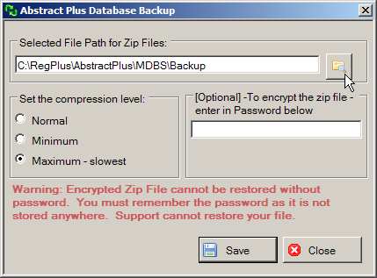
- To change the default path, navigate to and identify the location on your computer or network where you would like to save your backup file by clicking the Folder icon .
Result: The Browse for Folder window opens.
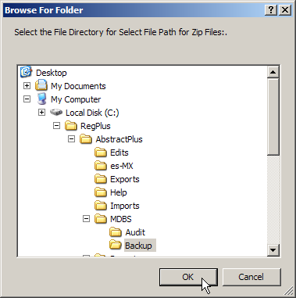
The default location for saving backup files is C:\RegPlus\AbstractPlus\MDBS\Backup. You may navigate to a different location if you so choose.
- To accept the default location for saving the backup, click OK.
- Select the desired compression level for the zip file if other than the default.
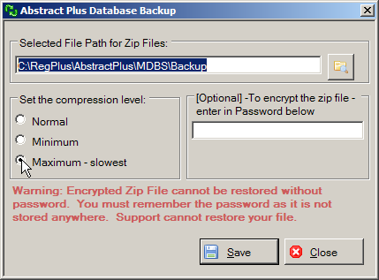
- Enter a password to encrypt the zip file (optional), and click Save to create the backup and exit or click Close to exit the application without saving the backup file.
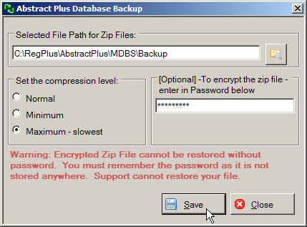
If you choose to password-protect your backup file, the encrypted zip file cannot be restored without the specified password. It is very important that you remember this password!
Result: The backup is saved in the zip file, and a confirmation window opens. A progress bar is also displayed at the bottom of the screen.
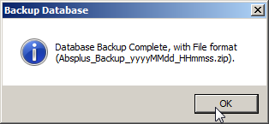
A progress bar is also displayed at the bottom of the screen.
- Click OK.
Result: The Abstract Plus application closes.

Using the Restore Option
In the event that your Abstract Plus abstracts database (absplus.mdb) is corrupted, if you have used the Backup option to backup your database you will be able to restore your database using the Restore option. The Restore option allows you to go back to a file that you saved on a date when you encountered no problems. This is why it is so strongly recommended that you back up your work when exiting the application.
To use the Restore option to restore your Abstract Plus abstract database to an earlier saved backup, complete these steps:
- Open the Restore Database window. This can be done in 2 ways:
  - Click on the File menu, and select Restore.
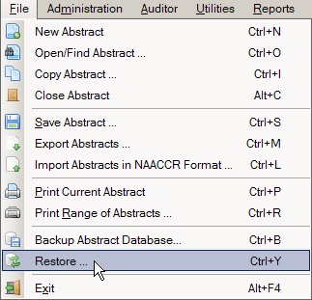
  - Use the keystroke Ctrl+Y.
Result: The Restore Abstract Plus Database window opens.
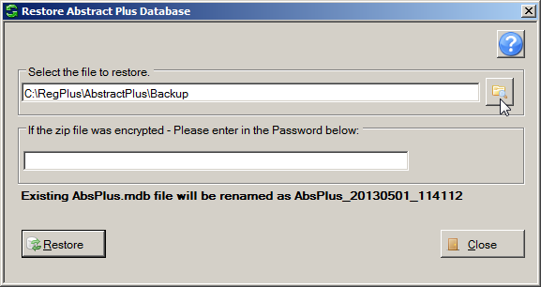
- Navigate to and identify the zipped backup file on your computer or network by clicking the Folder icon .
Result: The Select the file you want to restore window opens with a list of backup files displayed.
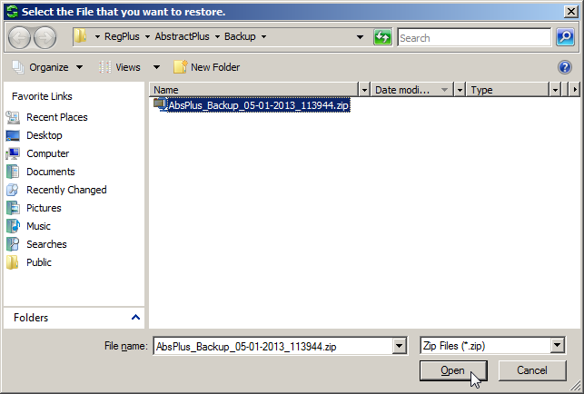

The default location for saving backup files is C:\RegPlus\AbstractPlus\MDBS\Backup. You may need to navigate to a different location if you saved your backup file in a location other than the default location.
- Select the backup file to which you wish to restore your Abstract Plus abstract database, and click Open.
Result: You are returned to the Restore Abstract Plus Database window, with the selected backup file displayed.
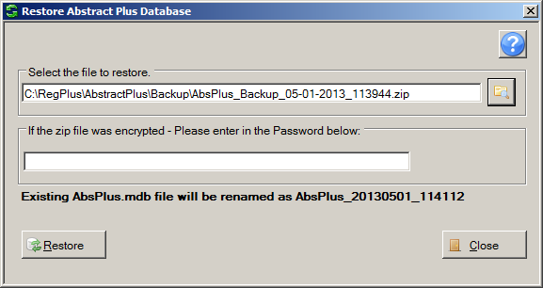
- If you password protected the selected backup file, enter the password in the password box, and click Restore.
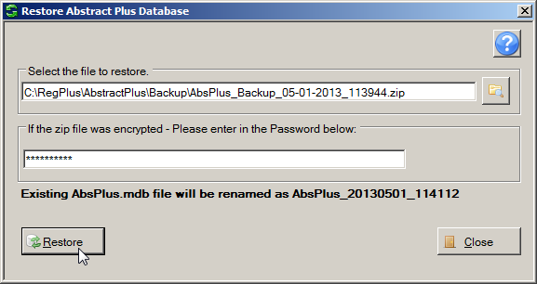
Result: The Abstract Plus main window opens, with the selected abstracts backup database restored. You may now resume abstracting activities.

Questions
Answer these questions about Abstract Plus General User Basics (the answers are in Appendix A, on page 140):
- What are the first things you need to do upon initial login into Abstract Plus?
- What is the point of the security challenge questions in Abstract Plus?
- Why is it important that you have your own User ID and password?
- When logging off Abstract Plus, how can you ensure that the work you did during the session is secure and safe?

Abstract Plus Administrator Basics

Learning Objectives
In this chapter, you will learn to:
- Identify the different types of functions that are specific to the Administrator role in Abstract Plus
- Log in to the Abstract Plus Administrator functions
- Maintain the Administrator password

Overview
This chapter provides an overview of basic Abstract Plus Administrator concepts. It includes a description of the different types of functions carried out by the Administrator, how to log into the Abstract Plus administration features using the special Administrator password, and how to change the Administrator password.

Abstract Plus Administrator Tasks
The main duties of the Abstract Plus Administrator are:
- Creating user accounts for new users, and maintaining existing user accounts
- Setting up the application for abstraction by specifying various application preferences, and maintaining abstracting display types
- Setting up the application to be used for performing casefinding, reabstracting, or recoding audits, including managing auditing display types and look-ups, and creating audit databases to be used by Auditors to perform audits
The above tasks are covered in greater detail in later chapters of this training manual. To access the Administration menu items, click on the Administration menu item, and select the desired sub-option, or use the appropriate keystroke combination for the desired sub-option.

Logging In As Administrator
For security purposes and to ensure standardized use of the application, access to the Administrator functions is restricted and password-protected. Once you have logged in to Abstract Plus with your general User ID and password, you may then log in as an Administrator. Abstract Plus will prompt you to enter a special Administrator password when you try to access any of the Administrator menu items.
The Abstract Plus Administrator role has access to all functions of the software, including all of the auditing functions; entry of the Administrator password allows access to Auditor functions without entry of the Auditor password.
To login as the Administrator and access the Administrator functions of Abstract Plus, complete these steps:
- Open the Administrator Login window. This can be done in 3 ways:
  - Click on the Administration menu, and select Administrator Login/Modify Password.
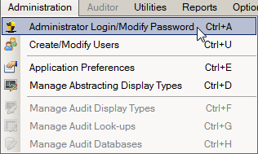
  - Click on the Administration menu, and select any sub-option from the menu.
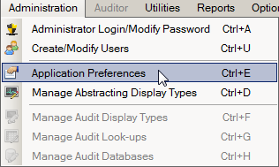
  - Use the keystroke Ctrl+A.
Result: The Administrator Login window opens.
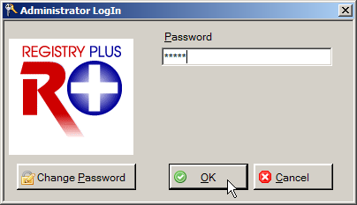
- Enter Admin in the Password box, and click OK.
Admin is the default Administrator password that comes with Abstract Plus. It is recommended that this be modified upon setup of the application.
Result: The Abstract Plus main window opens, with a message in the lower left-hand corner of the window letting you know that you are successfully logged in as Administrator. You will now have access to all features of the program: abstracting, auditing and administration.
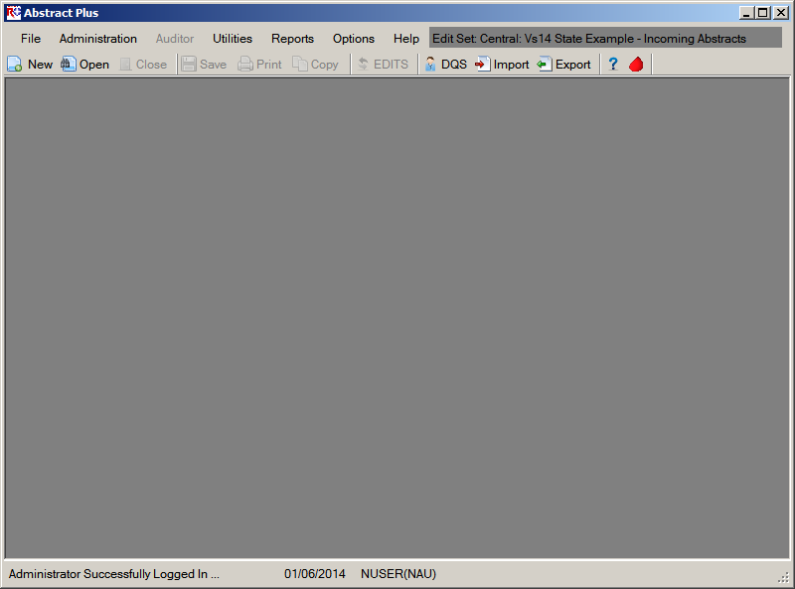

Activity 2 – Logging in to Abstract Plus as Administrator
Using what you have just learned, log in as Administrator. If you have not yet accessed the program, see page 53 of this manual or click here for instructions regarding logging in as Administrator. Please leave yourself logged in as Administrator, so that you may carry out the next few activities.

Maintaining the Administrator Password
For security purposes, you will want to change the default Administrator password from Admin to something more secure that only you and your other Administrators know.
To change Administrator password complete these steps:
- Open the Administrator Login window. This can be done in 2 ways:
  - Click on the Administration menu, and select Administrator Login/Modify Password.
  - Use the keystroke Ctrl+A.
Result: The Administrator Login window opens.
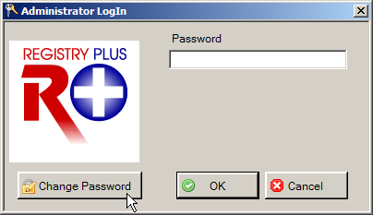
- Click Change Password.
Result: The Change Administrator Password window opens.
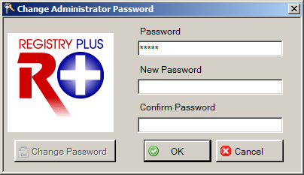
- Enter Admin (or your current Administrator password) in the Password box.
- Enter the new password to which you would like to change the Administrator password in the New and Confirm Password boxes, and click OK.
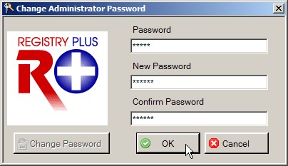
Result: The Abstract Plus main window opens, with a message in the lower left-hand corner of the window stating that the Administrator password has been successfully changed.
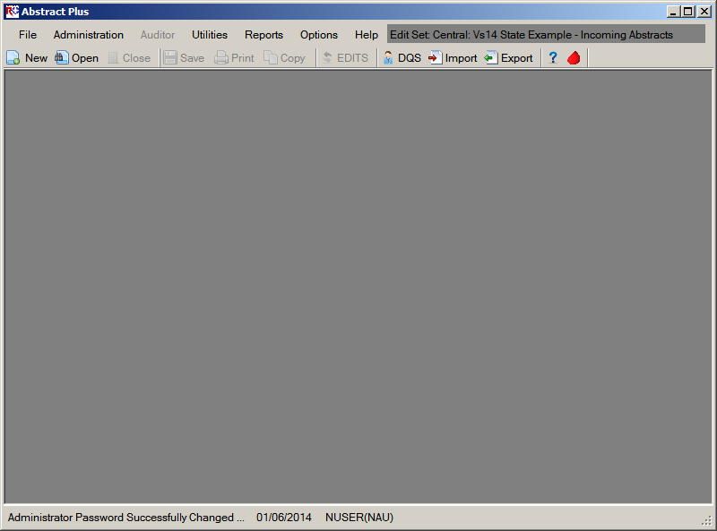

Possible Errors when Changing the Administrator Password
There are two possible errors you may receive when attempting to change your Administrator password:
- Old password is incorrect. You must correctly enter your old password in order to successfully change it. Click OK, and then correctly re-enter your old Administrator password.
- New passwords do not match. The new password entered into the New Password and Confirm Password boxes must match exactly. Click OK, and then correctly re-enter your new password in the New and Confirm password boxes.

Questions
Answer these questions about Abstract Plus Administrator Basics (the answers are in Appendix A on page 140).
- What are the basic Administrator functions in Abstract Plus?
- Can anyone who can log in to Abstract Plus use the Administrator features?
- Does the Administrator need to enter the special Auditor password in order to access the Auditor features of the program?

Abstract Plus Configuration

Learning Objectives
In this chapter you learn:
- How to set Abstract Plus application preferences
- All about display types
  - What a display type is, and the five main steps used to build a display type
  - How to start a new display type
  - How to copy an existing display type and modify it
  - How to select fields and section headings into a display type
  - How to set field properties for individual data items in a display type
  - How to select an edit set and individual edit options for a display type
  - How to set Collaborative Staging calculation preferences for a display type
  - How to delete a display type
- About Abstract Plus database encryption, and how to obtain more information regarding accessing the encrypted databases in order to be able to customize the application for local or project-specific use
- How to customize the application for local or project-specific use
  - How to add custom or local fields to the application (i.e., any field not listed in NAACCR Volume II Data Dictionary) so that they can be selected into a display type
  - How to add custom look-ups to the application so that they can be associated with custom or local fields
  - How to use your own edits runtime metafile with the application, allowing for selection of your customized edit sets when generating display types

Overview
In this chapter you learn how to configure the Abstract Plus application, including how to set application preferences such as all general, security, database and report application settings and to create display types. A display type is basically the user interface where the Abstract Plus Abstractor or Auditor will enter data, and consists of an ordered subset of standard NAACCR and local data items collected by your central registry, an edit set with associated options specified, and Collaborative Staging calculation preferences.

Selecting Application Preferences
The Administrator initially configures Abstract Plus and controls certain features of the program by specifying various application preferences. Application preferences include general settings (such as whether or not to automatically calculate age at diagnosis), security challenge question(s), password policies and settings, and default database and report settings.
Please note that there are no activities associated with the setting of system preferences; rather, the following instructions that should be followed to initially set up the application.
To specify Abstract Plus system preferences, complete these steps:
- Open the Application Properties window. This can be done in 2 ways:
  - Click on the Administrator menu, and select Application Preferences.
  - Use the keystroke Ctrl+E.
Result: The Application Properties window opens defaulted to the General tab.
The Application Properties window consists of a series of tabs which display different windows addressing various application settings: General, Security Policies, Security Questions, Password Expression, Database, and Reports.

The General Tab
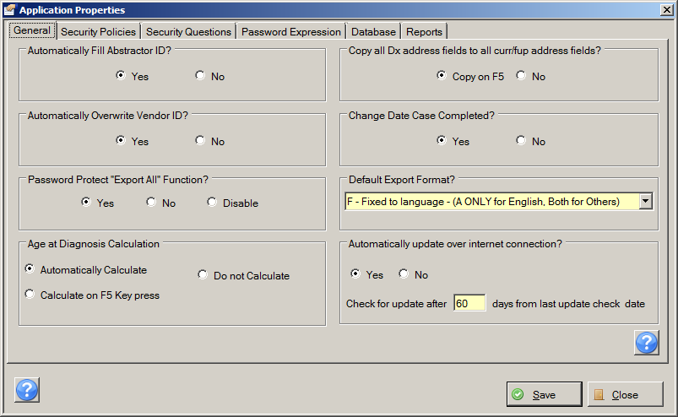
As mentioned, upon opening the Application Properties window, the General tab is displayed by default. The following table describes the application settings included on the General tab:
Setting | Description
Automatically Fill Abstractor ID? | Option to have the data item of Abstracted By [#570] automatically filled for new abstracts with the initials of the user currently logged on; default setting is Yes.
Automatically Overwrite Vendor ID? | Option to have the data item of Vendor Name [#2170] automatically filled with the Abstract Plus vendor name on imported abstracts; any existing vendor name information in the imported abstracts will be overwritten
Password Protect “Export All” Function? | Option to restrict the function Export All Abstracts in Database to Administrators or to disable this feature for general users
Age at Diagnosis Calculation | Option to automatically calculate the data item of Age at Diagnosis [#230] when the data items Birth Date [#240] and Date of Diagnosis [#390] have been entered or changed, have the user press F5 to calculate, or have the user manually enter the data item
Copy all DX address fields to all curr/fu address fields? | Option to allow user to copy the Address at Diagnosis data items of Addr at DX---No & Street [#2330], Addr at DX---City [#70], Addr at DX---State [#80], Addr at DX---Postal Code [#100], and Addr at DX---Supplemental [#2335] to the corresponding current address fields by pressing F5 when the user has the cursor in the data item of Addr Current—No & Street [#2350]
Change Date Case Completed? | Option to automatically update the data item of Date Case Completed [#2090] if the abstract becomes incomplete after once being designated complete
Default Export Format? | Option to set the default export file format for exported abstracts to NAACCR type A record or comma-delimited format
Automatically update over internet connection? | Option to implement Auto-update feature, which enables delivery of application bug fixes, enhancements and updates associated with Abstract Plus via Internet after software distribution and initial installation.
- Under Automatically Fill Abstractor ID?, click Yes or No to specify whether or not you would like the data item of Abstracted By [#570] automatically filled for new abstracts with the initials of the current user. If No is selected, Abstracted By will be left blank and can be filled in manually by the user. The default setting of Yes is highly recommended in order to prevent entry errors.
- Under Automatically Overwrite Vendor ID?, click Yes or No to specify whether or not you would like the data item of Vendor Name [#2170] automatically filled with the Abstract Plus vendor name on imported abstracts. If Yes is selected any existing vendor name information in the imported abstracts will be overwritten. If No is selected then existing Vendor Name information in the imported abstracts will be retained.
- Under Password Protect “Export All” Function?, click Yes if you would like to restrict the function Export All Abstracts in Database to Administrators and require entry of the Administrator password prior to export; No if you do not want to restrict this function, and allow general users to use the Export All feature; or Disable if you would like to disable this feature for general users, and gray out the feature in the export dialog window.
- Under Age at Diagnosis Calculation, click Yes if you would like to calculate the data item of Age at Diagnosis [#230] when the data items Birth Date [#240] and Date of Diagnosis [#390] have been entered or changed (the user cannot manually override the calculated value); click Calculate on F5 Key press if you would like the program to calculate by pressing F5 when the Age at Diagnosis field is selected in the abstracting grid (the user can manually change the calculated value); or click Do Not Calculate if you would like to require manual entry of the data item.
- Under Copy all DX address fields to all curr/fu address fields?, click Copy on F5 if you would like to have the user copy the Address at Diagnosis data items of Addr at DX---No & Street [#2330], Addr at DX---City [#70], Addr at DX---State [#80], Addr at DX---Postal Code [#100], and Addr at DX---Supplemental [#2335] to the corresponding current address fields by pressing F5 when the user has the cursor in the data item of Addr Current—No & Street [#2350]; or click No if you would like to require the user to enter the current address data items manually.
- Under Change Date Case Completed?, click Yes if you would like to automatically update the data item of Date Case Completed [#2090] if an abstract becomes incomplete after once being designated complete; click No if you would like Date Case Completed to always represent the date the case was first completed.
- Under Default Export Format?, Use the drop-down menu to select the default export file format you would like the program to use when exporting abstracts:
  - A—NAACCR Layout: When selected, NAACCR type-A records will be the default selection on the export dialog window, and comma delimited will be available for as an alternative selection.
  - C--Comma-delimited: When selected, comma-delimited records will be the default selection on the export dialog window, and NAACCR type-A will be available as an alternative selection.
  - F--Fixed to language: When selected, only one export format will be made available to the user on the export dialog window, based on the language of the installation. For English, only the choice of NAACCR type-A records is available. For Spanish, only delimited is available.
- Under Automatically update over internet connection?, click Yes if you would like Abstract Plus to run the Auto-update feature automatically, so the user does not need to check for software updates manually. Click No if you would like for the end user to check for software updates manually.
  - If you clicked Yes to run the Auto-update feature automatically, specify how often you would like the application to check for updates by entering a number of days in the Check for update once in every days box.
- Once you have specified your preferences on the General Tab, click the Security Policies Tab.
Result: The Application Properties window opens the Security Policies tab.

The Security Policies Tab
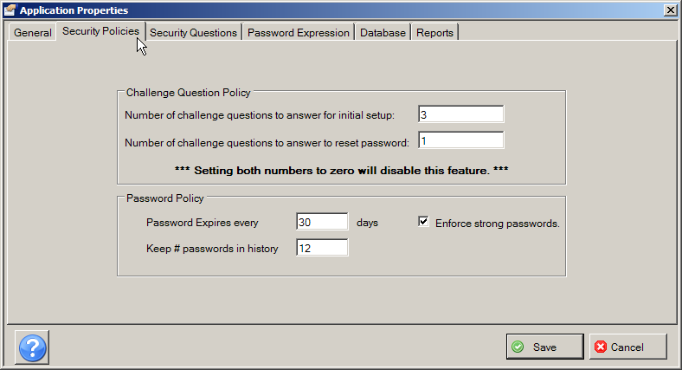
Recall that all Abstract Plus users must have a User ID and password to access the abstracting features of the application, and that a security challenge question feature is also included in case a user forgets his or her password, which enables the user to securely reset their password without Administrator intervention.
The Administrator sets challenge question and password policy attributes on the Security Policies Tab. The following table describes the application settings included on the Security Policies Tab:
Setting | Description
Number of challenge questions to answer upon initial setup | Number of security challenge questions that the user must enter upon initial log in and setup of the challenge question feature; the user is asked the specified number of questions, and answers are saved by the application for future user validation
Number of challenge questions to answer to reset password | Number of security challenge questions that a user must answer to be permitted to reset their password; the questions presented for password reset are randomly selected from the questions answered by the user upon initial log in or update of their questions
Password Expires every ___ days | Number of days after which a user’s Abstract Plus password will expire
Keep # passwords in history | Number of historical passwords kept by Abstract Plus for each user; users can not re-use a saved historical password
Enforce strong passwords | Option to enable password restrictions
- Under Challenge Question Policy:
  - In the Number of challenge questions to answer upon initial setup field, enter the number of questions that you would like the user to have to answer upon initial setup of the challenge question feature. The first time the user logs in to Abstract Plus, the program will require the user to answer, and will store the answers for the specified number of challenge questions. The challenge questions that are presented to the user upon initial log in are defined on the Security Questions tab.
  - In the Number of challenge questions to answer to reset password field, enter the number of challenge questions that you would like the user to be required to answer in order to be able to reset their own password. Abstract Plus will randomly pick this number of questions from the available challenge questions list for the user, and will present the questions to the user when they try to reset their password. The user will have to answer each question correctly (i.e., enter the same answer as they did upon initial setup or update) in order to be permitted to reset their password.
If both of the Challenge Question Policy options are set to zero, then the challenge question feature will be disabled. It is highly recommended NOT to disable this feature.
- Under Password Policy:
  - In the Passwords expire every ___ days field, enter the number of days after which you would like a user’s Abstract Plus password to expire.
  - In the Keep # passwords in history field, enter the number of historical passwords you would like for Abstract Plus to keep for each user. Users will not be able to reuse a password until the number specified in this field is met.
  - Click the Enforce strong passwords check box if you would like to place restrictions on the passwords that users can generate for themselves. Password restrictions are enforced via the Regular Expression defined on the Password Expression tab.
For security purposes, enforcing strong passwords is strongly recommended.
- Once you have specified your preferences on the Security Policies tab, click the Security Questions Tab.
Result: The Application Properties window opens the Security Questions tab.

Security Questions Tab
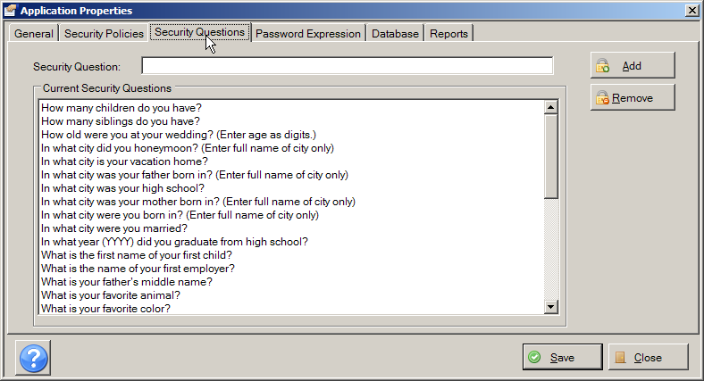
The Abstract Plus Administrator can customize the list of challenge questions presented to users upon initial log in by adding or removing security questions to the list displayed on the Security Questions tab. Abstract Plus comes preloaded with 35 challenge questions.

Adding Security Questions
To add a new security question to the Current Security Questions list, complete these steps:
- Type a question into the Security Question box, and click Add. Be sure to specify a format for any dates or numbers.
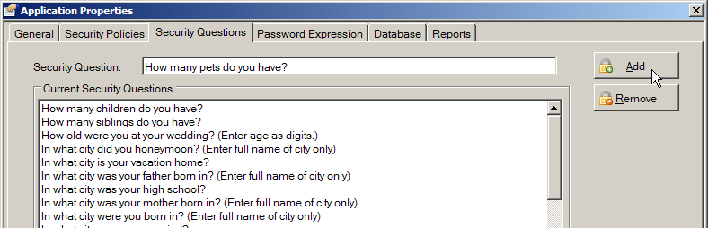
Result: The question entered is added to the Current Security Questions List.
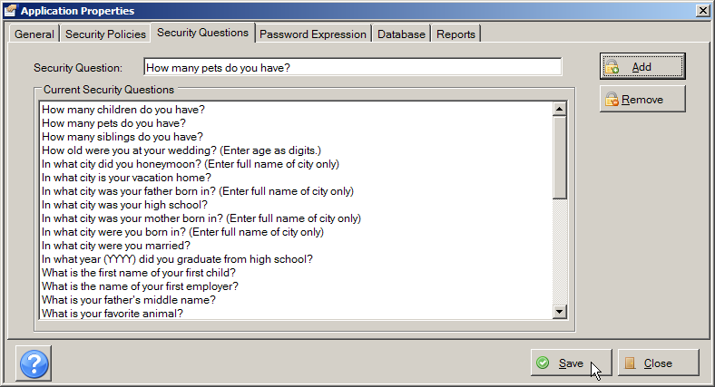
- Click Save.
Result: The new question is saved.

Removing Security Questions
To remove a Security Question from the Current Security Questions list, complete these steps:
- Select the question you want to remove from the Current Security Questions list, and click Remove.
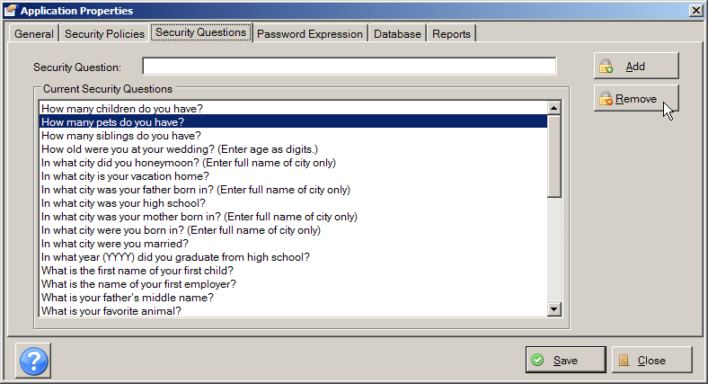
Result: The application lets you know that the challenge question has been removed.
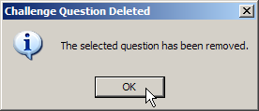
- Click OK on the confirmation message window.
Result: You are returned to the Security Questions tab, where the deleted challenge question is no longer listed.
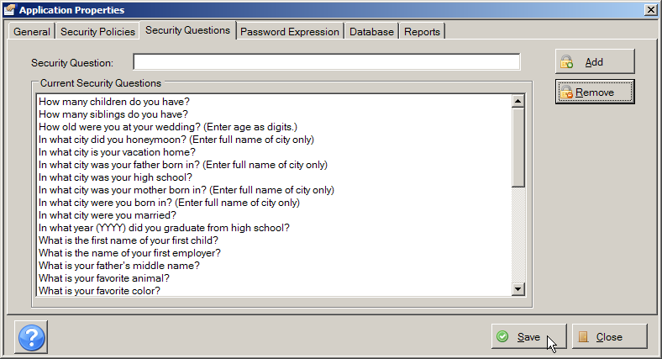
- Click Save.
Result: The Current Security Questions are updated.
- Once you have specified your challenge questions on the Security Questions tab, click the Password Expression tab.
Result: The Application Properties window opens the Password Expression tab.

The Password Expression Tab
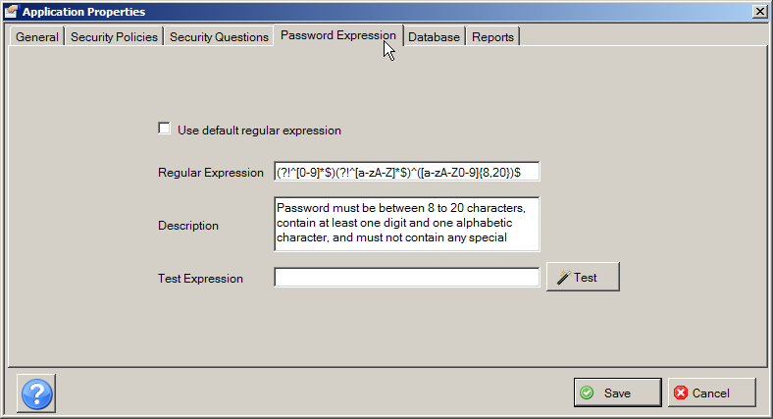
The Administrator can define password restriction rules on the Password Expression tab via a regular expression (Regex) which specifies what types of passwords are acceptable. The default regular expression provided with the application requires users to enter passwords that are 8 to 20 characters in length, contain at least one digit and one alphabetic character, and must not contain any special characters.
The following table describes the application settings included on the Password Expression tab:
Setting | Description
Use default regular expression | When checked, this resets the regular expression to the original default expression provided by Abstract Plus
Regular Expression | The RegEx used by the application to check passwords to ensure that they meet the standards defined. The default regular expression is (?!^[0-9]*$)(?!^[a-zA-Z]*$)^([a-zA-Z0-9]{8,20})$ (Password must be between 8 to 20 characters, contain at least one digit and one alphabetic character, and must not contain any special characters); Other or additional password restrictions may be implemented by editing the Regular Expression
Description | Textual description of the password restriction enforced by the Regular Expression; communicates the password restriction rules to the user
Test Expression | To test a regular expression, enter the expression in the Test Expression box and click Test

To use a regular expression other than the default expression provided, enter the expression into the Regular Expression box, along with a description of the password restrictions it enforces in the Description box. The Description is viewed by the user when setting their password, and communicates the password restriction rules to the user.
The Administrator can generate their own regular expressions and then test them by entering the expression in the Test Expression box and clicking Test.

Sample Expressions / Translations
The following table provides a few other example regular expressions for potential use:
Expression | Translation
^(?=[^\d_].*?\d)\w(\w|[!@#$%]){8,20} | Restrict passwords to a length of 8 to 20 alphanumeric characters and select special characters. The password also cannot start with a digit, underscore, or special character and must contain at least one digit.
^(?=(.*[a-z]){1,})(?=(.*[\d]){1,})(?=(.*[\W]){1,})(?!.*\s).{7,30}$ | Requires at least 1 lowercase, 1 uppercase, 1 numeric, 1 non-word, must be between 7 and 30 characters, and no whitespace.
^(?=.*\d)(?=.*[a-z])(?=.*[A-Z]).{8,10}$ | Must be between 8 and 10 characters. Must contain a combination of uppercase, lowercase, and numeric digits, with no special characters.
^(?=.*[a-z].*[a-z])(?=.*[A-Z].*[A-Z])(?=.*\d.*\d)(?=.*\W.*\W)[a-zA-Z0-9\S]{9,}$ | Requires at least two lowercase letters, two uppercase letters, two digits, and two special characters. There must be a minimum of 9 characters total, and no white space characters are allowed.

If you are not very comfortable writing regular expressions it is recommended that you do not make any change to the default expression, or use one of the example expressions provided.
Always be sure to test any new expression entered to make sure it is functioning properly.

- Once you have configured your password restrictions on the Password Expression tab, click the Database tab.
Result: The Application Properties window opens the Database tab.

The Database Tab
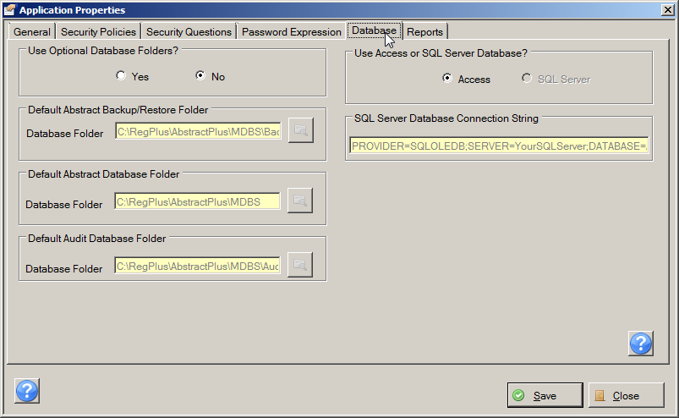
The Administrator uses the Database tab to specify default folders in which to store the Abstract Plus abstract and audit databases, as well as automatic upgrade and Access/SQL Server database options.
The following table describes the application settings included on the Database tab:
Setting | Description
Use Optional Abstract Database Folders? | Option to allow the backup abstracts, abstracts, and audit database folders to be stored in a user-specified location/folders rather than the default locations of C:\RegPlus\AbstractPlus\MDBS\Backup, C:\RegPlus\AbstractPlus\MDBS, and C:\RegPlus\AbstractPlus\MDBS\Audit  The Use Optional Abstract Database Folder? option must be set to Yes in order to be able to modify any of the database locations
Default Abstract Plus Backup/Restore Folder | Option to change the default Backup Database location from C:\RegPlus\AbstractPlus\MDBS\Backup to a user-specified location
Default Abstract Database Folder | Option to change the default Abstract Database location from C:\RegPlus\AbstractPlus\MDBS to a user-specified location (required files needed in user-specified location)
Default Audit Database Folder | Option to change the default Audit Database location from C:\RegPlus\AbstractPlus\MDBS\Audit to a user-specified location (audit databases needed in user-specified location)
Use Access or SQL Server database | Option to use an SQL Server database rather than the default Access database; if SQL Server is selected, the server connection string must be entered in the SQL Server Database Connection String field
SQL Server Database Connection String | Server connection string for abstract database when SQL Server is selected as the database type
- Under Use Optional Abstract Database Folder?, click Yes or No to specify whether or not you would like to store the backup abstracts, abstracts, and audit database folders in user-specified location/folders rather than the default locations of C:\RegPlus\AbstractPlus\MDBS\Backup, C:\RegPlus\AbstractPlus\MDBS, and C:\RegPlus\AbstractPlus\MDBS\Audit.
- Under Default Abstract Plus Backup/Restore Folder, if you would like to specify a location for the Backup Database other than the default location of C:\RegPlus\AbstractPlus\MDBS\Backup, click the Browse folder icon to the right of the Database Folder box and navigate to the folder of your choice. Click Save to save the change.
- Under Default Abstract Database Folder, if you would like to specify a location for the Abstract Database other than the default location of C:\RegPlus\AbstractPlus\MDBS, click the Browse folder icon to the right of the Database Folder box and navigate to the folder of your choice. Click Save to save the change.
- Under Default Audit Database Folder, if you would like to specify a location for the Audit Database other than the default location of C:\RegPlus\AbstractPlus\MDBS\Audit, click the Browse folder icon to the right of the Database Folder box and navigate to the folder of your choice. Click Save to save the change.
The Use Optional Abstract Database Folder? option must be set to Yes in order to be able to modify any of the database locations. Required files will be needed in the user-specified location.
- Under Use Access or SQL Server database, click Access if you would like to use the default database type of Microsoft Access database, or click SQL Server if you would like to use an SQL server for your database.
The SQL Server database option is available for the abstracts database only; Audit databases will always be in Access.
- Under SQL Server Database Connection String, if you are using the SQL Server database option, enter the connection string to the SQL Server in the box provided.
- Once you have configured your database settings on the Database tab, click the Reports tab.
Result: The Application Properties window opens the Reports tab.

The Reports Tab
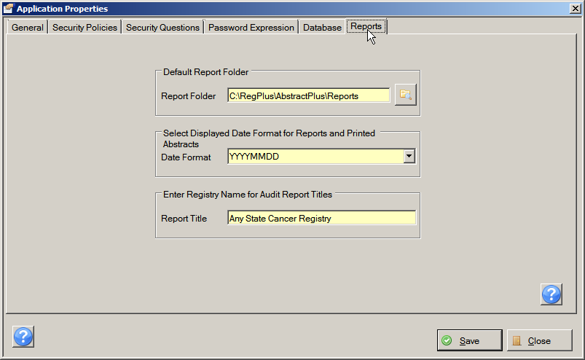
On the Reports tab, the Administrator specifies the default folder in which to store Abstract Plus reports when saving reports, as well as the formal central registry name as it is to be viewed on audit report titles.
- Under Default Report Database Folder, if you would like to specify a location for the Reports other than the default location of C:\RegPlus\AbstractPlus\Reports, click the Browse folder icon to the right of the Database Folder box and navigate to the folder of your choice (required files needed in user-specified location). Click Save to save the change.
- Under Select Displayed Date Format for Reports and Printed Abstracts, select the date format in which you would like dates to be displayed on all Abstract Plus reports (abstracts and audits) and printed abstracts. A variety of formats based on the YYYYMMDD, MMDDYYYY, and DDMMYYYY date formats are available.
- Under Enter Registry Name for Audit Report Titles, enter your central registry’s name, as you would like it to be listed in all Abstract Plus audit report titles.
- When you have finished specifying applications preferences, click Save, and then click Close.

Configuring Abstracting Display Types
A display type is basically the user interface where the Abstractor or Auditor enters abstract data. Display types are highly customizable, and are configured by the Abstract Plus Administrator. Display types include information regarding fields collected, required fields (i.e., fields that can’t be blank), edit sets, individual edit options, and Collaborative Staging preferences. Any standard data items and state-specific fields can be included in a display type, and can be assigned customized labels, ordered into sections, and have various properties that can be set, such as default values.

Creating an Abstracting Display Type
You can create different display types for different facilities, types of cancer reporters, or audits. Abstract data are entered and edited using the display type assigned to the abstract. To generate a display type, you first name and add it to the application, and then go through five main steps to build the display type:
- Select Fields
- Select Critical Fields
- Select Edit Set
- Select Individual Edit Options
- Select Collaborative Staging Preference.
You can create a display type in one of two ways. You can start from scratch by adding a new display type or you can copy an existing display type and revise it. Either way you create a display type, you can customize it for your own needs.

Opening the Manage Display Types Window
The Administrator creates and maintains display types using the Manage Display Types window.
To open the Manage Display Types window and work with display types, complete these steps:
- Opening the Manage Abstracting Display Types window can be done in 2 ways:
- Click on the Administration menu, and select Manage Abstracting Display Types.
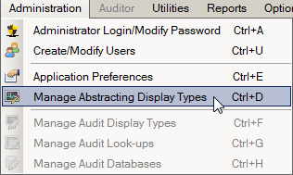
- Use the keystroke Ctrl+D.
Result: The Manage Display Types window opens defaulted to the Display Types tab.
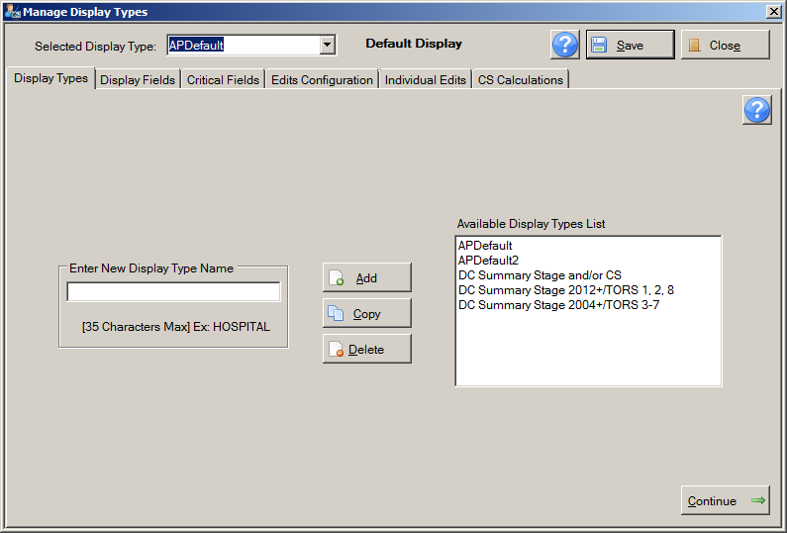
Tabs Addressing Steps Required to Build a Display Type
The Manage Display Types window consists of a series of tabs which open different windows addressing the various steps required to build or update a display type: Display Types, Display Fields, Critical Fields, Edits Configuration, Individual Edits, and CS (Collaborative Staging) Calculations. At the top of the Manage Display Types window is a Selected Display Type pull-down menu from which you can select the display type that you would like to modify. The Manage Display Types window also includes the following:
Use this icon… | To…
 | Save the selections on the window.
 | Close the window without saving the information; you will be prompted to save any changes if desired
 | Save the selections on the window, and continue to the next tab
 | Open the help information for the current Manage Display Types window tab

The Display Types Tab
Upon opening the Manage Display Types window, the Display Types tab is displayed by default. The Administrator uses the Display Types tab to add a new display type, copy an existing display type under a new name, and edit or delete an existing display type. A list of existing abstracting display types is displayed in the Available Display Types List on the right.

Included Abstracting Display Types
Abstract Plus comes with 5 abstracting display types already configured for use. Any of these display types can be copied and used as a starting point for your own central registry’s display types. The display types included with the Abstract Plus installation are described in the following table:

Display Type | Description
APDefault | This abstracting display type is assigned to all new abstracts by default and is compliant with NPCR minimal data collection requirements as listed in the NAACCR Standards for Cancer Registries, Volume II: Data Standards and Data Dictionary, Chapter VIII: Required Status Table (Record Layout Version 14.0, effective January 1, 20143); use of this default display type will result in the collection of data that will meet NPCR requirements for annual data submission to NPCR and includes the CS input data items that accommodate the calculation of all Derived CS fields. The APDefault example display type has CS SSF 1-24 defaulted to the values of 988. This is to save the Abstractor the time of entering 988 for most SSFs for the majority of schemas. When reporting CS, the NAACCR 14.0 edits metafiles have edits that will result in an error when the defaulted value of 988 is not valid (i.e., when the Abstractor needs to revise the value of 988 to a valid value for the entered schema). So in order to assess what SSFs are required, all the Abstractor needs to do is run edits once they have entered CS input fields other than the SSFs.
APDefault2 | This abstracting display type includes all of the same fields as the APDefault abstracting display type, but also includes all Collaborative Staging (CS) input data items. As for the display type APDefault, this display type also has CS SSF 1-24 defaulted to the values of 988.
DC Summary Stage and/or CS | This abstracting display type accommodates the abstraction of DC Summary Stage [759] and/or Derived SS2000 [3020] and includes DC Summary Stage and Over-ride CS 20 in addition to all CS data items.  SSFs can be blank or completed when Over-ride CS 20 is set to “1-Directly coded SEER Summary Stage 2000”. When the Over-ride CS 20 flag is blank, the SSFs required for deriving SS2000 must be populated;  - If only DC Summary Stage is abstracted the CS Over-ride 20 field must be set to 1  - If both DC Summary Stage and Derived Summary Stage are abstracted the CS Over-ride field must be left blank  - If only Derived Summary Stage is abstracted the CS Over-ride 20 field must be left blank
DC Summary Stage 2012+/TORS 1, 2, 8 | This abstracting display type accommodates the new 2012 NPCR reporting requirements that involve the abstraction of directly coded SEER Summary Stage 2000 [759] (DC Summary Stage) in lieu of Derived SS2000 [3020].  For cases diagnosed 2012 and later with a Type of Reporting Source (TORS) of 1, 2, or 8:  1 (Hospital inpatient; Managed health plans with comprehensive, unified medical records),  2 (Radiation Treatment Centers or Medical Oncology Centers (hospital-affiliated or independent),  or 8 (Other hospital outpatient units/surgery centers),  NPCR permits the use of DC Summary Stage in those cases where collection of CSv02 is not feasible due to lack of data or due to staffing and time constraints at the local or central registry. The data item 'Over-ride CS 20' is used to flag an abstract where DC Summary Stage is recorded in lieu of Derived SS2000.  When abstracting the DC Summary Stage field:  - Over-ride CS 20 flag [3769] must be set to “1-Directly coded SEER Summary Stage 2000”. As a result, the Over-ride CS 20 field is included in this display and defaulted to a value of 1.  - In addition, the following other staging fields must also be abstracted (on a schema-specific basis) and are included in this display type:  Regional Nodes Examined (all schemas)  Regional Nodes Positive (all schemas)  CS Tumor Size(all schemas)  CS Version Input Original (all schemas)  CS Version Input Current (all schemas)  SSF 25 (all schemas)
DC Summary Stage 2004+/TORS 3-7 | This abstracting display type accommodates the new 2012 NPCR reporting requirements that involve the abstraction of directly coded SEER Summary Stage 2000 [759] (DC Summary Stage) in lieu of Derived SS2000 [3020].  For cases diagnosed 2004 and later with a Type of Reporting Source (TORS) of 3-7:  3 (laboratory only)  4 (physician's office)  5 (nursing home)  6 (autopsy only)  7 (death certificate only)  NPCR permits the use of DC Summary Stage in those cases where collection of CSv02 is not feasible due to lack of data or due to staffing and time constraints at the local or central registry. The data item 'Over-ride CS 20' is used to flag an abstract where DC Summary Stage is recorded in lieu of Derived SS2000.  When abstracting the DC Summary Stage field:  - Over-ride CS 20 flag [3769] must be set to “1-Directly coded SEER Summary Stage 2000”. As a result, the Over-ride CS 20 field is included in this display and defaulted to a value of 1.  - In addition, all CS input fields may be blank and are not included in this display type

All example display types include the CS Over-ride 20 field. In APDefault and APDefault2, CS Over-ride 20 is included, defaulted to blank, and made invisible. Many of the CS edits now include CS Over-ride 20 in the list of fields checked by the edits. Due to the way the CS edits run, you will need to include CS Over-ride 20 field in your display type in order for some CS edits to run correctly.
In addition, you will need to be careful when selecting editing options for your display types. On the Administration, Manage Abstracting Display Types, Edits Configuration tab, you need to be aware of whether the Skip Data Items Not Included in Display Type option is checked or un-checked.
If you have the Skip Data Items Not Included in Display Type option checked and you do not include CS Over-ride 20 in your display type, then all CS edits that include CS Over-ride 20 in the list of fields to be checked by the edit will not run.
If you intend to collect CS, it is recommended that you include CS Over-ride 20, leave it blank and protect it and make it invisible. In this way you can leave the Skip Data Items Not Included in Display Type option checked, and the CS edits will be run.

By default, the APDefault display type is assigned to all new abstracts when abstracting. However, the Abstractor may modify this selection by choosing another display type from the Display Types pull-down menu on the abstracting window prior to saving any information entered for the new abstract:
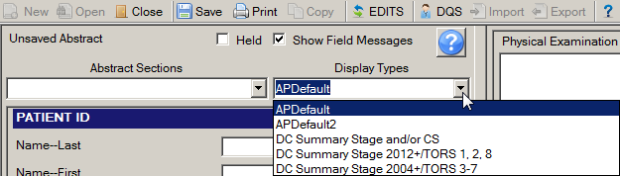
The display type selections available to the Abstractor from the Display Types pull-down menu are based on those listed on the Available Display Types List on the Display Types tab.

Adding a New Abstracting Display Type
One way to create an abstracting display type is to add a new one.
To add a new abstracting new display type, complete these steps:
- Open the Manage Abstracting Display Types window, either by clicking on the Administration menu, and selecting Manage Abstracting Display Types, or using the Ctrl+D keystroke.
Result: The Manage Display Types window opens defaulted to the Display Types tab.
- Type a name for the new display type in the Enter New Display Type Name box on the left, and click Add. In the example shown, a new abstracting display type named TEST DISPLAY is being added to the application.
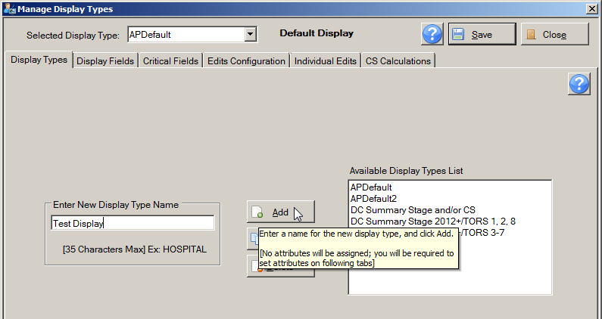
Result: The new display type is added to the Available Display Types List, and automatically becomes the selected display type in the Selected Display Type pull-down menu at the top of the Manage Display Types window so that you may continue your work on the new display type and go through the remaining steps required to build the display type.
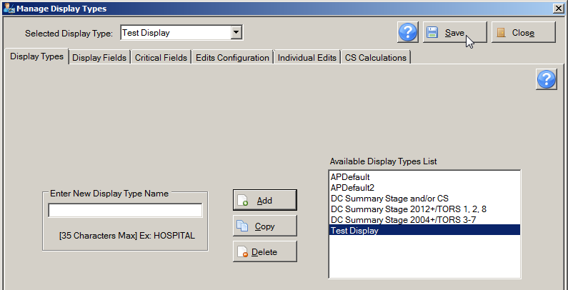
No display type attributes other than the display type name will be assigned to the new display type at this point. Other attributes, such as fields included in the display type, must be set using the other Manage Display Types tabs.
- Click Save.

Activity 3 – Creating a New Display Type by Adding New
Using what you have just learned, add a new abstracting display type to the application called Test Display.
Please see page 79 of this manual or click here for instructions regarding adding a new display type. You will delete the Test Display display type in Activity 5.

Copying an Existing Abstracting Display Type
The other way to create a display type is to copy an existing display type and revise it to meet your needs.
To create a new abstracting display type by copying an existing one, complete these steps:
- Open the Manage Abstracting Display Types window, either by clicking on the Administration menu, and selecting Manage Abstracting Display Types, or using the Ctrl+D keystroke.
Result: The Manage Display Types window opens defaulted to the Display Types tab.
- Type a name for the new display type in the Enter New Display Type Name box on the left. In the example shown, the name of the new display type being created is Training Display.
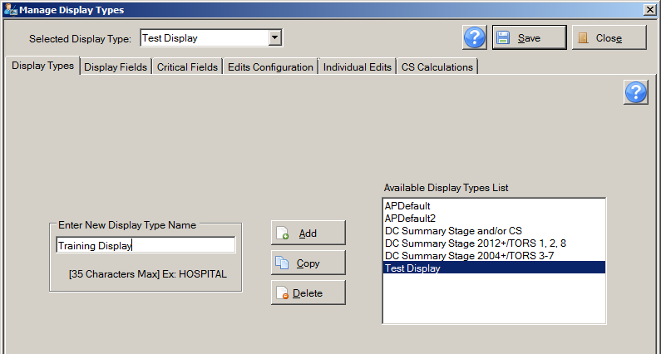
- Select the existing abstracting display type that you would like to copy from the Available Display Types List on the right, and click Copy. In the example shown, the APDefault display type is being copied under the name of Training Display.
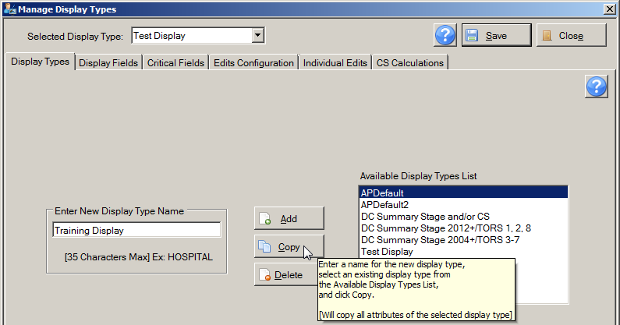
Result: The application prompts you to confirm that you would like to copy the currently selected display type.
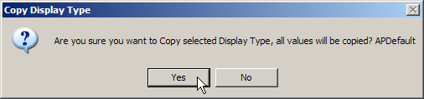
- Click Yes.
Result: The new display type is added to the Available Display Types List and automatically becomes the selected display type in the Selected Display Type pull-down menu at the top of the Manage Display Types window so that you may go through any of the remaining steps required to modify the display type.
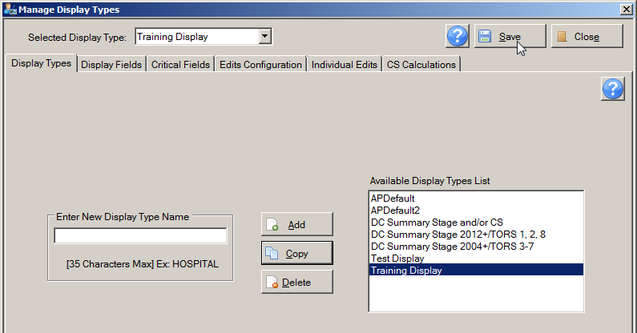
All display type attributes of the copied display type will be assigned to the new display type at this point. Modifications may now be made to the display type to suit your needs using the other Manage Display Types tabs.
- Click Save.

Activity 4 – Creating a New Display Type by Copying
Using what you have just learned, copy the APDefault display type under the name of Training Display.
Please see page 80 of this manual or click here for instructions regarding copying an existing display type under a new name. You will continue to modify the Training Display display type in the next few activities.

Deleting a Display Type
To delete an abstracting display type, complete these steps:
- Open the Manage Abstracting Display Types window, either by clicking on the Administration menu, and selecting Manage Abstracting Display Types, or using the Ctrl+D keystroke.
Result: The Manage Display Types window opens defaulted to the Display Types tab.
- Select the display type that you would like to delete from the Available Display Types List on the right, and click Delete.
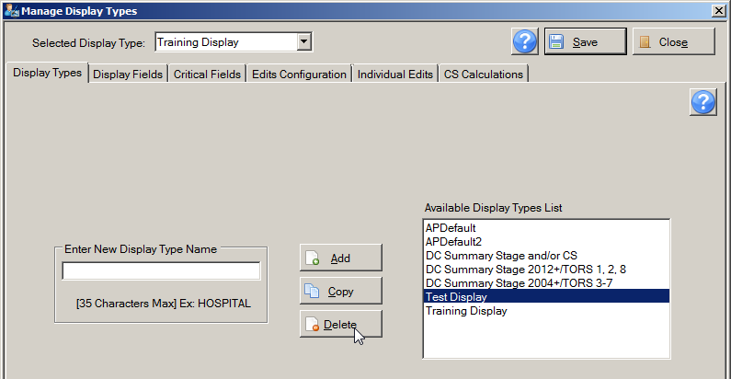
Result: The application prompts you to confirm that you would like to delete the currently selected display type.
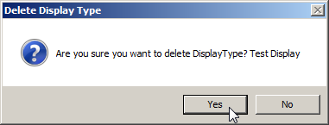
- Click Yes.
Result: The display type is deleted from the application, and is no longer listed in the Available Display Types List.
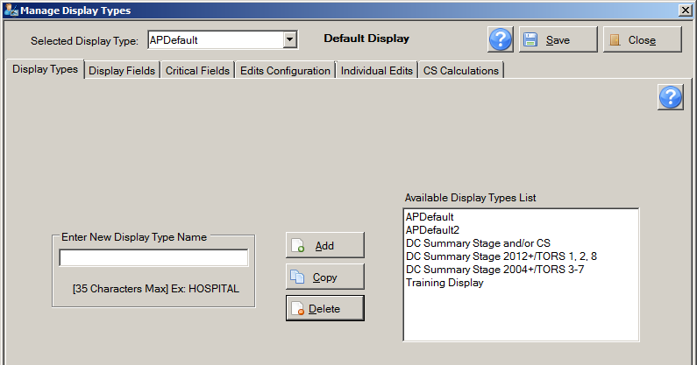

Activity 5 – Deleting a Display Type
Using what you have just learned, delete the Test Display display type.
Please see page 82 of this manual or click here for instructions regarding copying an existing display type under a new name.

Five Steps for Building a Display Type
Whether you create a new abstracting display type by adding a new one or copying an existing one, as mentioned earlier, there are five steps you will need to go through next to build the display type. You do not have to use the options in all five steps. Once you have named and created a new display type on the Display Types tab, the remaining tabs on the Manage Display Types window take you through the steps to build or update the display type. This table describes these steps:
On this tab . . . | You select the following for the display type. . .
1. Display Fields | fields that are to be collected with the display type, set properties for individual fields, and group fields into sections if desired
2. Critical Fields | fields that must contain information to complete an abstract (required fields)
3. Edits Configuration | edit set (determines how the system edits the abstracted data), and set edit set execution options
4. Individual Edits | edit set execution options for individual edits, over-riding the options selected for the edit set
5. CS Calculations | Collaborative Staging calculation options

Step 1: The Display Fields Tab
After adding a new or copying an existing display type to create a new display type, you then modify the display type. The first step is to select data fields into the display type, which includes setting field properties such as a customized field label or default value, if desired. At the discretion of the Administrator, the fields in the display type can be organized into logical sections, which also have customizable labels. Section headings, for example, Hospital Specific and Demographic, are user-specified and can organize the fields for clearer viewing and facilitation of data entry by the Abstractor.
To open the Display Fields tab, complete these steps:
- Select the display type you would like to build or update from Selected Display Type menu at the top of the Manage Display Types window. In the example shown, the Training Display display type is being selected and modified.
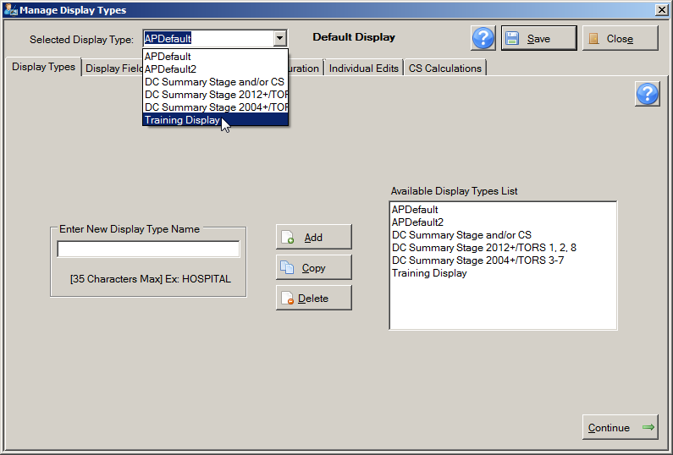
- Click the Display Fields tab.
Result: The Manage Display Types window opens the Display Fields tab for the selected display type.
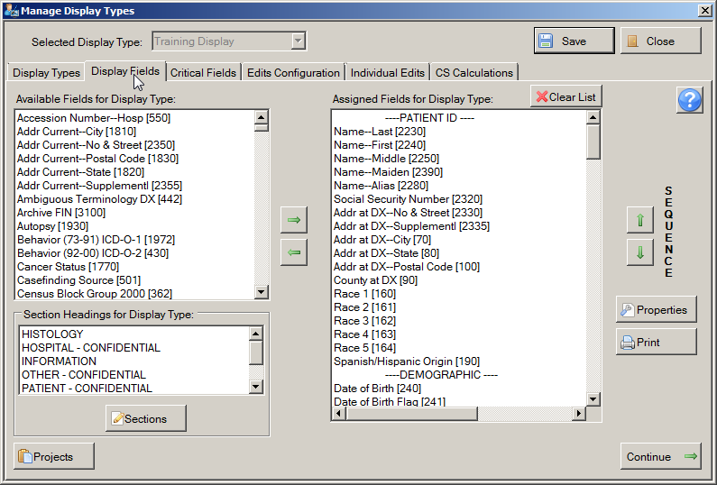
Move Fields and Headings into/out of Display Type
Available Fields and Section Headings
Re-order Fields and Headings
Set Field Properties
Fields Assigned to Display Type
The Administrator uses the Display Fields tab to select the fields for which data is to be collected into or out of the display type, and group the fields into sections if desired. Using the left and right arrow buttons, fields and section headings are moved from the lists of available data fields and section headings on the left side of the window to the list of data fields and section headings on the right to include them in the selected display type. The Sequence up and down arrow buttons are used to re-order the fields and section headings once they have been added to the display type.

Adding Section Headings to a Display Type
Section headings are added to a display type to organize the fields in the display type into logical groups of related fields.
At a minimum, at least one section heading is required to be assigned to each display type, and must be placed as the first item in the display type.

To add an existing section heading to a display type, complete these steps:
- In the Assigned Fields for Display Type list, select the field above which you would like to place the Section header. In the example shown, the section heading of HISTOLOGY is being moved into the Training Display display type above the field of Histologic Type ICD-O-3, so the field of Histologic Type ICD-O-3 is selected from the Assigned Fields for Display Type list.
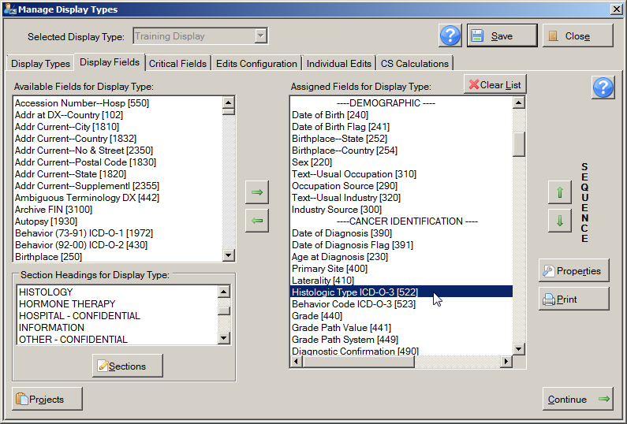
- In the Section Headings for Display Type list on the lower left of the Display Fields tab, select the section heading that you would like to move into the display type. In the example shown, the section heading of HISTOLOGY is being moved into the Training Display display type.
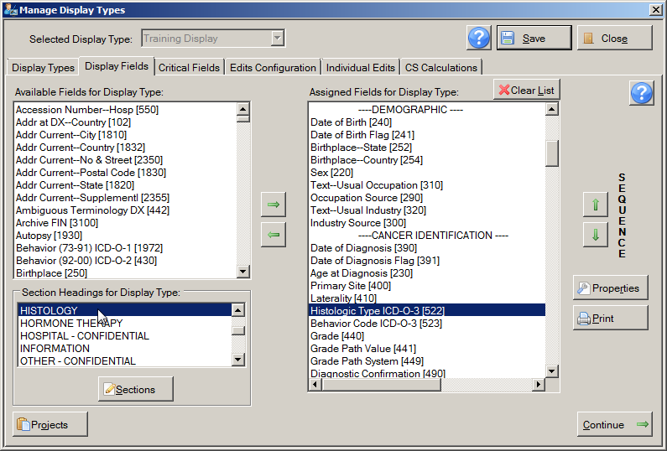
- Click the green right-pointing arrow to move the heading into the display type.
Result: The section heading is removed from the Section Headings for Display Type list on the left, and is moved into the Assigned Fields for Display Type list on the right, above the currently-selected field in the list.
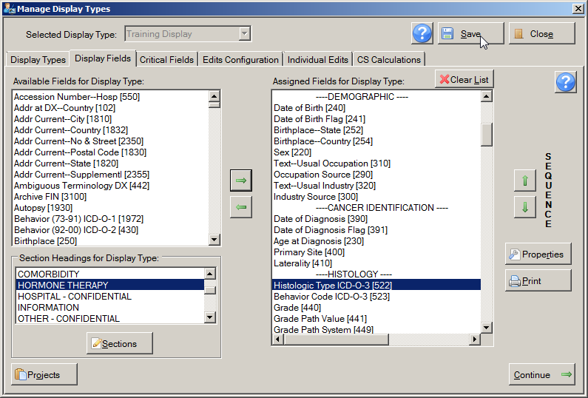
- If the placement of the header is not as desired, use the SEQUENCE up ( ) and down () arrows to move the section heading up or down in the order of the display type to the desired position.
- Click Save.

Activity 6 – Adding a Section Heading to a Display Type
Using what you have just learned, add the section heading of HISTOLOGY to the Training Display display type, and position the heading directly above the Histologic Type ICD-O-3 field in the Assigned Fields for Display Type list. Feel free to add other section headings as well. Please see page 86 of this manual or click here for instructions regarding adding section headings to display types.

Managing Section Headings
Although Abstract Plus comes with many section headings, you are not limited to these section headings. The Administrator can create new section headings, rename existing section headings, and delete section headings.
To manage the Section Headings for Display Type list, complete these steps:
- On the Display Fields tab, click Sections in the lower left-hand area of the window.
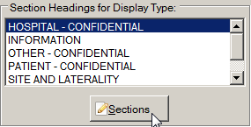
Result: The Edit Section Headings window opens.
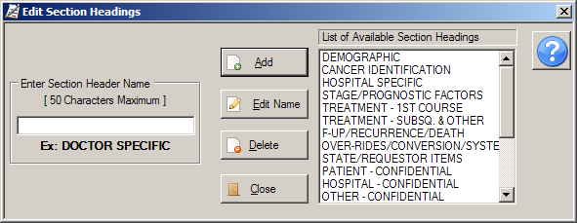
The Administrator uses the Edit Section Headings window to add a new section heading to the application, edit the name of an existing section heading, or delete an existing section heading. A list of existing section headings is displayed in the List of Available Section Headings on the right.

Adding a New Section Heading
To add a new section heading to the application, complete these steps:
- On the Edit Section Headings window, type a name for the new section heading in the Enter Section Header Name box on the left, and click Add. In the example shown, a new section heading named TEST HEADING is being added to the application.
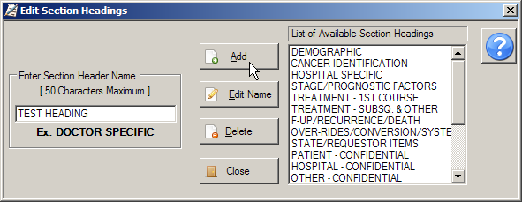
Result: The new section heading is added to the List of Available Section Headings on the right.
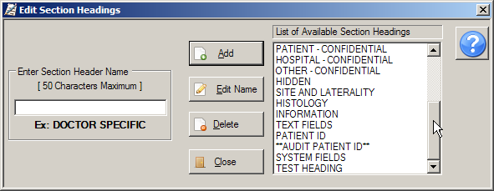

Editing the Name of an Existing Section Heading
To edit the name of an existing section heading, complete these steps:
- Select the section heading that you would like to rename from the List of Available Section Headings on the right. In the example shown, the section heading named TEST HEADING is being re-named, so it is selected from the List of Available Section Headings.
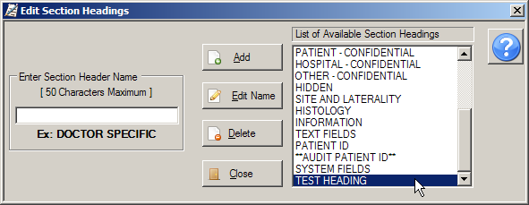
- Type the new name for the existing section heading in the Enter Section Header Name box on the left, and click Edit Name. In the example shown, the section heading named TEST HEADING section heading is being re-named to TEST HEADING 2.
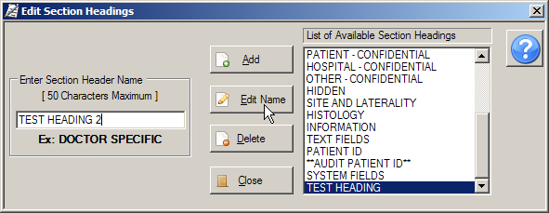
Result: The section heading is renamed in the List of Available Section Headings.
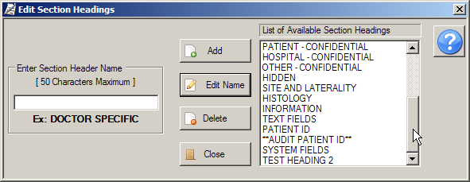

Deleting a Section Heading
To delete a section heading, complete these steps:
- Select the section heading that you would like to delete from the List of Available Section Headings on the right, and click Delete. In the example shown, the section heading being deleted is named TEST HEADING 2, so it is selected from the List of Available Section Headings.
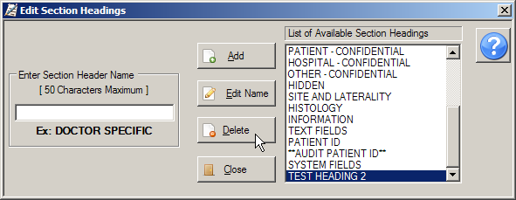
Result: The application prompts you to confirm that you would like to delete the currently selected section heading.
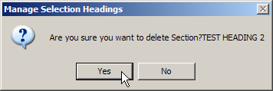
- Click Yes.
Result: The section heading is deleted from the application, and is no longer listed in the List of Available Section Headings.

Adding Fields to a Display Type
After adding section headings to the Assigned Fields for Display Type list, you then add fields to the display type. When adding fields to a display type it is important to keep in mind what data items you would like to collect, and of those data items, which you would like to require (i.e., make a critical field, cannot be blank), as well as what data items for which you would like to present a default value to Abstractor. It is also important to know what data items your central registry system will eventually require, for example, system fields such as Morph Coding Sys-Current.
To add fields to a display type, complete these steps:
- In the Assigned Fields for Display Type list, select the field or section heading above which you would like to place the field that you are adding to the display type. In the example shown, the Addr Current fields are being added to the Training Display display type above the field of Race 1, so the field of Race 1 is selected from the Assigned Fields for Display Type list.
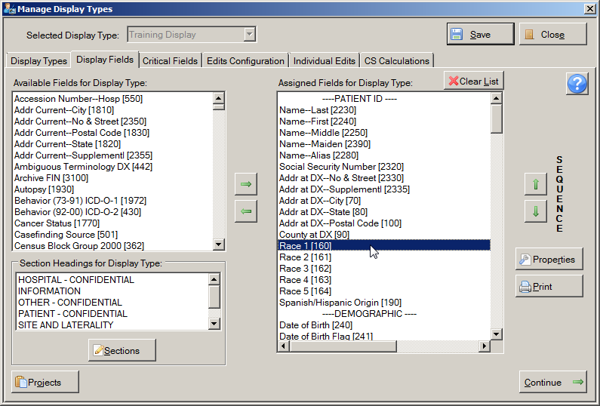
- In the Available Fields for Display Type list on the upper left of the Display Fields tab, select the field or fields that you would like to move into the display type. In the example shown, the Addr Current fields are being added to the Training Display display type.
If your central registry collects any state-specific or non-standard fields (i.e., any field not listed in the NAACCR Volume II Data Dictionary: http://www.naaccr.org/standards/volumeii), and/or has any state-specific look-ups, the fields and look-ups can be added to the application. Please see the Abstract Plus System and IT Personnel Requirements document for more information about adding custom fields and or custom look-ups to the application.
CDC will create customized installations of Abstract Plus for NPCR-funded registries only. Other interested parties should follow the instructions provided in the Abstract Plus System and IT Personnel Requirements document to add custom fields and look-ups to the application for use in their jurisdiction.
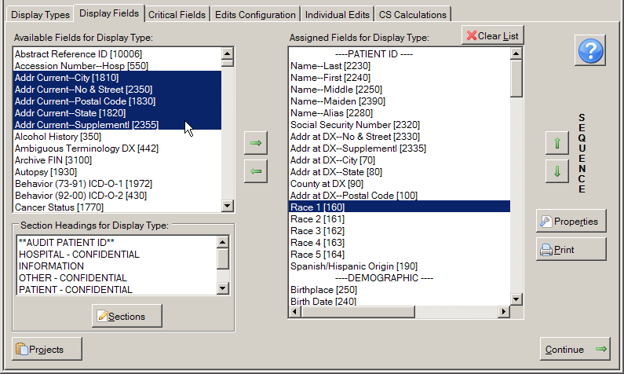
To select one field, click the name of the field. To select a group of fields together, click the first field, press and hold the SHIFT key, and then click the last field in the group. To select multiple fields that are not in order, press and hold the CTRL key and click each field.
- Click the green right-pointing arrow to move the field or fields into the display type.
Result: The field(s) is removed from the Available Fields for Display Type list on the left, and is moved into the Assigned Fields for Display Type list on the right, above the currently-selected field in the list.
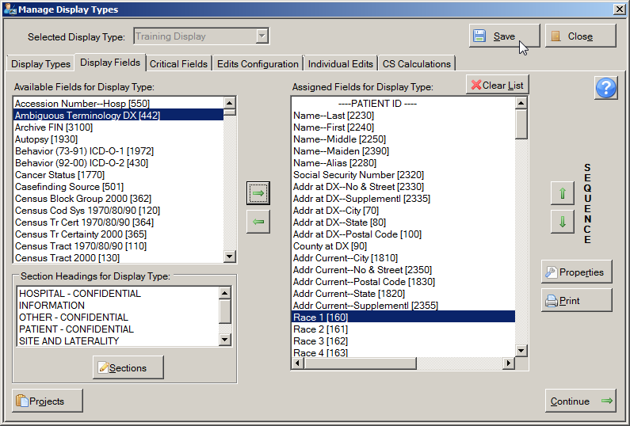
- If the order of the placed fields is not as desired, use the SEQUENCE up ( ) and down () arrows to move the field or fields up or down in the order of the display type to the desired position.
When you move the available fields into a display type, the system places the fields directly above the field that you have selected in the Assigned Fields for Display Type list. If you have not selected a field in the Assigned Fields for Display Type list the system places the fields at the top of the Assigned Fields for Display Type list.
- You can save updates to the fields either by clicking Save, or the Continue button, which saves updates and opens the next tab, Step 2, Critical Fields.
Clicking (Clear List) at the top of the Assigned Fields for Display Type list will remove all fields and sections from a display type. This should be done with caution.

NAACCR Text Fields and Display Types
As you learned in Chapter 2 of this manual, the Abstract Plus Abstracting window is divided into 2 main sections: a data entry grid for coded values on the left, and a data entry grid for text fields on the right. When generating display types, it is important to note that the text fields are handled differently than regular data fields. Rather than being able to select the individual text fields into and out of a display type, all NAACCR text data items [items #2520 – 2690] are included in every display type in a special section at the very bottom of the display type called TEXT FIELDS:
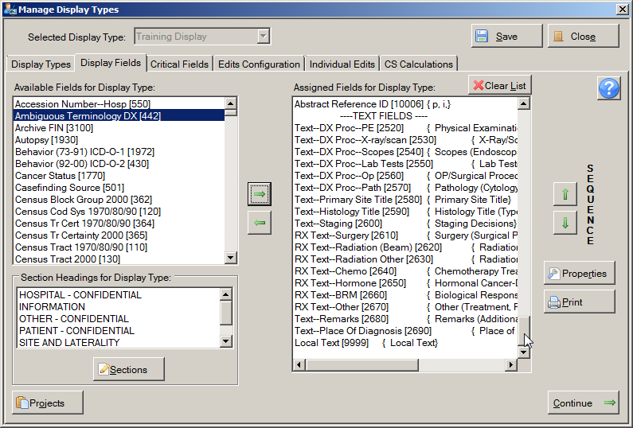
These are the text fields that are displayed to the Abstractor in the data entry grid on the right in the abstracting window.
Although all text fields are automatically included in all display types and are restricted to the TEXT FIELDS section, the order in which the text fields are displayed to the Abstractor in the data entry grid on the right in the abstracting window may be modified by selecting the text field in the Assigned Fields to Display Type list, and using SEQUENCE up ( ) and down () arrows to move the text field up or down in the display order within the TEXT FIELDS section to the desired position.

Activity 7 – Adding Fields to a Display Type
Using what you have just learned, add all of Addr Current-- fields to the Training Display display type, and position them directly above the Race 1 field in the Assigned Fields for Display Type list. Reorder the fields so that they are listed in the following order:
- Addr Current—No & Street
- Addr Current—Supplemental
- Addr Current—City
- Addr Current—State
- Addr Current—Postal code
Feel free to experiment and add other fields as well. Please see page 91 of this manual or click here for instructions regarding adding fields to display types.

Assigning Property Values to Individual Fields
Once a field has been added to a display type, special properties may be specified for the field, such as a customized label or default value.
To assign property values to a field, complete these steps:
- In the Assigned Fields for Display Type list, locate and select the data item for which you would like to specify field properties. In the example shown, properties are being reviewed for the field of NAACCR Record Version.
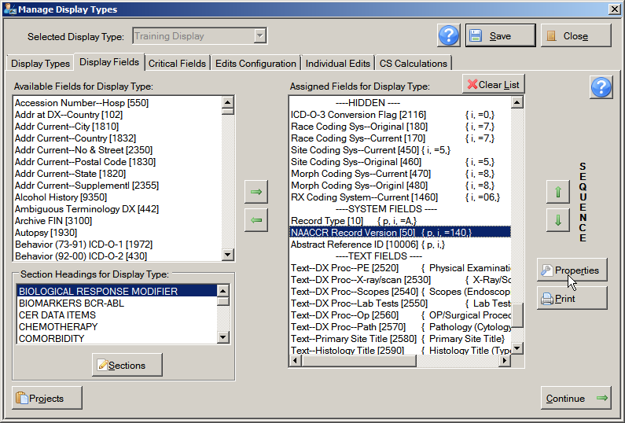
- Click Properties.
Result: The Properties window opens for the selected field.
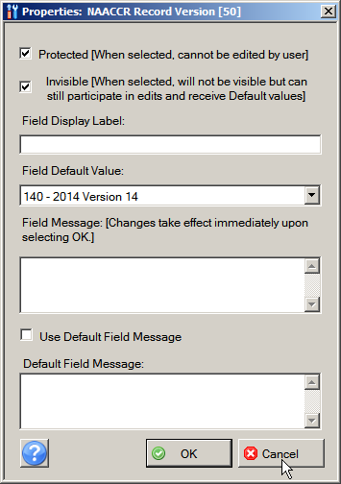
These are the fields in the Properties window:
Property | Description
Protected | When check box is checked, value of field is displayed to the Abstractor, but cannot be edited
Invisible | When check box is checked, the field is not visible to the Abstractor, but a defaulted value is edited and transmitted with the abstract
Field Display Label | User-specified label for the field; by default the standard NAACCR data item name is used for a field label, but this default label can be customized
Field Default Value | Value that is initially displayed in the field.
Field Message | Information entered for the Field Message property appears in a text box that pops up when the Abstractor places the cursor in the field; for example, a reminder regarding the format of a date field entry
Use Default Field Message | Some fields that come with default field messages, you can choose whether to use the default message or enter your own in the Field Message box; when check box is checked, the default field message is used
Default Field Message | For fields that come with default messages, the default message will be displayed here
In the example shown, the field of NAACCR Record Version has been protected, set to invisible, and defaulted to a value of 140.
Defaulting values for a field can save the Abstractor the time of abstracting values into these fields, in particular for situations where the majority of abstracts end up with the field coded to the default value. If the Protected and Invisible properties are not checked for a defaulted field, the Abstractor may modify the presented default values if necessary.
Important Information Regarding Assigning Default Values to Collaborative Staging (CS) Site-Specific Factors (SSFs): Abstract Plus automatically fills in default values for CS SSFs that are undefined for the schema being entered. However, some central registries may choose not to collect a certain SSF regardless of whether or not it is defined for the entered schema---i.e., there may be some SSFs that the registry is not collecting at all. For any SSF that is not being collected by the registry for any schema, the SSF can be defaulted to 988. In this way the SSF field no longer participates in the automatic defaulting, and is always submitted to the registry as 988.
- Click Cancel.
Result: You are returned to the Display Fields tab.
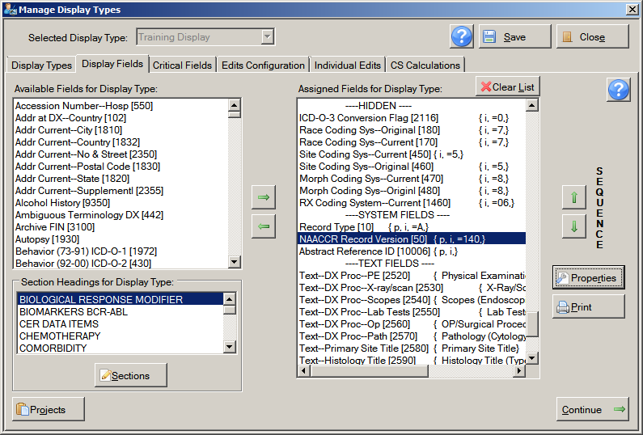
Now take notice of the symbols in brackets to the right of the NAACCR Record Version field name. These symbols represent the properties assigned to the field.
Field property definitions are displayed between the brackets {} to the right of the field name and NAACCR number in the Assigned Fields for Display Type list. In addition, they are separated with commas and are always listed in the same order, as defined in the following table:
Property Symbol | Description
p | Protected – value cannot be changed by auditor
i | Invisible – value cannot be seen in the entry screen
= | Default Value Follows equal sign – value that will automatically be added to this field in the entry screen.
Field label if assigned | Field Display Label
The following table illustrates some examples of set properties and the symbols that are displayed for the set properties in the Assigned Fields for Display Type list:
Property Setting | Description
Record Type [10] { NAACCR Record Type} | The field of Record Type, NAACCR item #10, will be labeled as NAACCR Record Type on the data entry grid
Record Type [10] { =A,} | The field of Record Type, NAACCR item #10, will be defaulted to a value of A; the field may be modified by the Abstractor
Record Type [10] {i, =A,} | The field of Record Type, NAACCR item #10 is set to invisible, and defaulted to a value of A; the field cannot be modified by the Abstractor because it will not be visible in the data entry grid
Record Type [10] {p, i, =A, NAACCR Record Type } | The field of Record Type, NAACCR item #10 is set to protected, invisible, assigned a default value of A, and has a customized label of NAACCR Record Type
If a field label, whether it be the default formal NAACCR data item name, or a custom label specified via the Properties window, is longer than what can be displayed in the abstracting window, the first 20 or so characters of the label will be displayed, followed by “…” to represent that there are more characters in the field label.
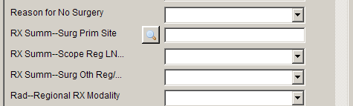
Although the option to customize a field’s label in the display type is available, note that the field will be listed by the standard NAACCR data item name when the Abstractor goes to view the majority of context help for the data item, e.g., looking up the field in NAACCR Volume II Data Dictionary, or viewing edits error information. To facilitate the retrieval of supplemental information for a field regardless of the customized label that is assigned to the field in the display type, the standard NAACCR data item name of the current field in the data entry gird is displayed in the lower left-hand corner of the abstracting window:
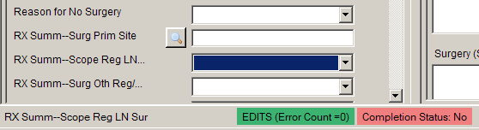

Setting Properties for NAACCR Text Fields
As mentioned, the text fields that are displayed to the Abstractor in the data entry grid on the right in the abstracting window are handled differently than other fields in the display type. Since the NAACCR text data items [items #2520 – 2690] are included in the TEXT FIELDS section in every display type and displayed to the Abstractor, the Protected and Invisible properties cannot be set for the text fields. In addition the Field Default Value property cannot be set for the text fields.
However, the remaining properties of the Field Display Label and the Field Message can be set for the text fields. In particular, customized field messages specified for text fields that state specifically what information is expected to be entered in the text field can be very helpful to the Abstractor.

System Fields and Display Types
A final consideration when generating abstracting display types is the inclusion of and provision of default values to any system- or coding system-related fields that your central registry system may require when the completed abstract is eventually submitted for processing at your central registry. The below table contains a list of NAACCR data items, along with their suggested default values, that are recommended for inclusion in display types. If you do not want the Abstractor to see these fields or their values, you can assign defaults values to the fields, and then set the fields to protected and invisible. In this way, the fields will be transmitted with the complete abstract, but the Abstractor will not have to abstract or even be aware of the fields.
NAACCR Data Item Name | Data Item # | Column # | Suggested Default Value
Record Type | 10 | 001 | A
FIN Coding System | 35 | 002 | 2
NAACCR Record Version | 50 | 017 | 140
Race Coding Sys-Current | 450 | 187 | 7
Race Coding Sys-Original | 180 | 188 | 7
Site Coding Sys-Current | 450 | 558 | 5
Site Coding Sys-Original | 460 | 559 | 5
Morph Coding Sys-Current | 470 | 560 | 8
Morph Coding Sys-Original | 480 | 561 | 8
RX Coding System-Current | 1460 | 1593 | 06
SEER Coding Sys-Current | 2120 | 1930 | D
SEER Coding Sys-Original | 2130 | 1931 | D
COC Coding Sys-Current | 2140 | 1932 | 08
COC Coding Sys-Original | 2150 | 1934 | 08
ICD-O-3 Conversion Flag | 2116 | 2015 | 0

Activity 8 – Adding Properties to Display Type Fields
Using what you have just learned, assign the properties in the following table to the specified fields in the Training Display display type. For each field for which you are setting properties, remember to:
  - Locate and select the field in the Assigned Fields to Display Type list.
  - Click Properties.
  - Specify the properties.
  - Click OK.
See page 95 of this training manual or click here for instructions on adding properties to display type fields.
For this field | Set this field property | To…
NAACCR Record Version [50] | Protected and Invisible | Verify these are checked
Name—Last [2230] | Field Display Label | Last Name
Name—First [2240] | Field Display Label | First Name
Addr at DX–No & Street [2330] | Field Display Label | Street Address at Diagnosis
Race 2 [161] | Field Default Value | 88
Race 3 [162] | Field Default Value | 88
Race 4 [163] | Field Default Value | 88
Race 5 [164] | Field Default Value | 88
Text–DxProc–PE [2520] | Field Message | Please be concise and include all relevant information

Managing Abstract Plus Projects
A Project is an avenue for labeling an abstract and grouping abstracts together. With Abstract Plus version 2, all abstracts had to be assigned to a “Project”. At least one project had to exist in the system, and by default, version 2 of Abstract Plus came with a Project called STATE to which each new abstract needed to be physically assigned.
As the overwhelming majority of Abstract Plus users did not utilize the Projects feature of Abstract Plus version 2.0, although the use of Projects is still available, it is no longer required. In Abstract Plus version 3.x, Projects are optional True/False application-specific fields that are available from the Available Fields for Display Type List and can be added to any display type (in the same manner as any standard NAACCR data item). As a result, unless the central registry intentionally requires a Project field, abstracts are no longer required to be assigned to a project.
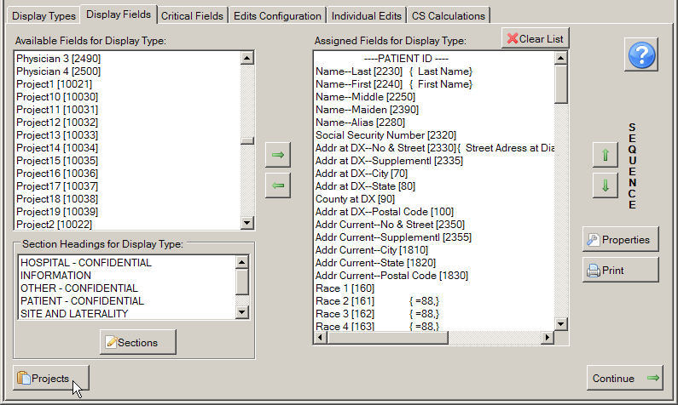
In addition, properties for Project fields can also be set, and work the same way as for standard NAACCR data items with the exception of the Field Display Label property. The Field Display Label of a Project field is automatically set by the Administrator when the Project field is added to the application and associated with one of the 20 Project fields in the Available Fields for Display Type list on the Display Fields tab. Abstract Plus comes with 20 Project fields that can be customized and added to the application and display types.
Please note that the Projects feature of the program is not functioning correctly at this time. This issue will be corrected in a future version of the program.
To manage Projects for Abstract Plus display types, complete these steps:
- On the Display Fields tab, click Projects.
Result: The Edit Projects for Abstract Identification window opens.
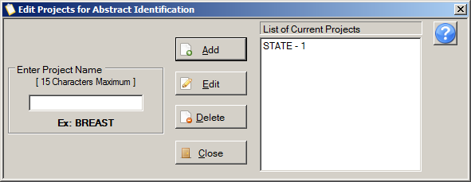
The Administrator uses the Edit Projects for Abstract Identification window to add a new Project to the application, edit the name of an existing Project, or delete an existing Project. A list of existing Projects is displayed in the List of Current Projects on the right. By default, Abstract Plus comes with an example STATE Project already added to the application.

Adding a New Project Field to the Application
When a new Project field is added to the application, it is automatically associated with the next available Project field in the Available Fields for Display Type list on the Display Fields tab. The List of Current Projects list tracks what Project field name is associated with which of the 20 Project fields in the Available Fields for Display Type list. The example STATE Project field that comes with the application is associated with the Project1 [10021] field in the Available Fields for Display Type list, so the STATE Project field is listed as STATE – 1 in the List of Current Projects to the right.
To add a new Project field to the application, complete these steps:
- On the Edit Projects for Abstract Identification window, type a name for the new Project in the Enter Project Name box on the left, and click Add. In the example shown, a new Project named TEST PROJECT is being added to the application.
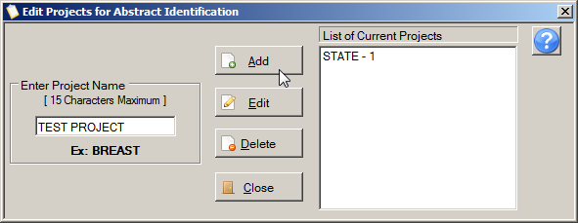
Result: The new Project is added to the List of Current Projects on the right, and is automatically associated with the next available Project field in the Available Fields for Display Type list on the Display Fields tab. In the example shown, the TEST PROJECT Project field is associated with the Project2 [10022] field in the Available Fields for Display Type list, so the TEST PROJECT Project field is listed as TEST PROJECT– 2 in the List of Current Projects to the right.
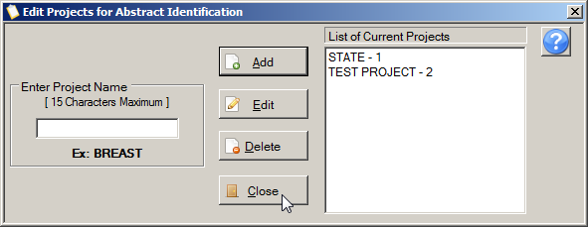
- Click Close.

Editing an Existing Project Field Name
To edit the name of an existing Project, complete these steps:
- Select the Project that you would like to rename from the List of Current Projects on the right. In the example shown, the example Project named STATE is being re-named, and is selected from the List of Current Projects.
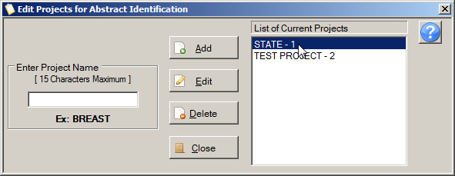
- Type the new name for the existing Project in the Enter Project Name box on the left, and click Edit. In the example shown, the Project named STATE is being re-named to BREAST.
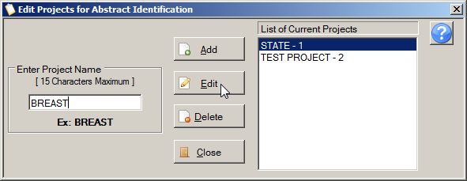
Result: The Project is renamed in the List of Current Projects.
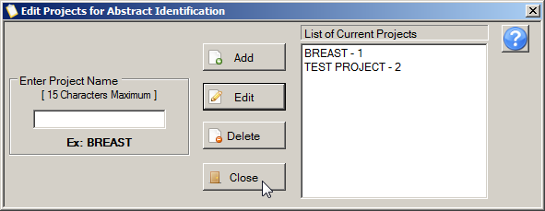

Deleting a Project Field from the Application
To delete a Project field from the application, complete these steps:
- Select the Project that you would like to delete from the List of Current Projects on the right, and click Delete. In the example shown, the Project being deleted is named TEST PROJECT, and is selected from the List of Available Projects.
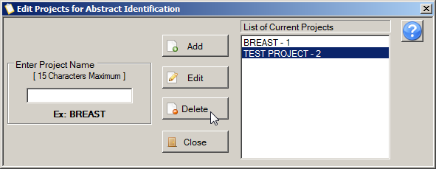
Result: The application prompts you to confirm that you would like to delete the currently selected Project.
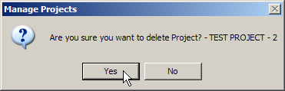
- Click Yes.
Result: The Project is deleted from the application, and is no longer listed in the List of Current Projects.
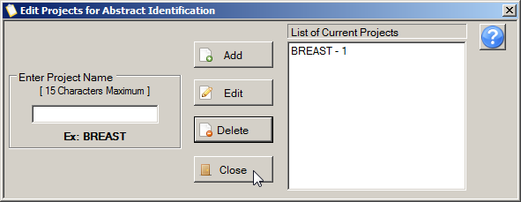
- Click Close.
You cannot delete a Project field if it has been added to a display type and has an abstract assigned to it.

Assigning a Project Field to a Display Type
Once a Project field has been added to the application, it can then be assigned to a display type. Project fields are assigned to display types in the same way as standard NAACCR fields, however, the field property of Field Display Label is automatically assigned the Project field name, and the Field Default Value is defaulted to TRUE - 1.
To assign a project to a display type, complete these steps:
- In the Assigned Fields for Display Type list, select the field above which you would like to place the Project field that you are adding to the display type. In the example shown, the Project1 [10021] is being added to the Training Display display type above the field of ICD-O-3 Conversion Flag [2116], so the field of ICD-O-3 Conversion Flag is selected from the Assigned Fields for Display Type list.
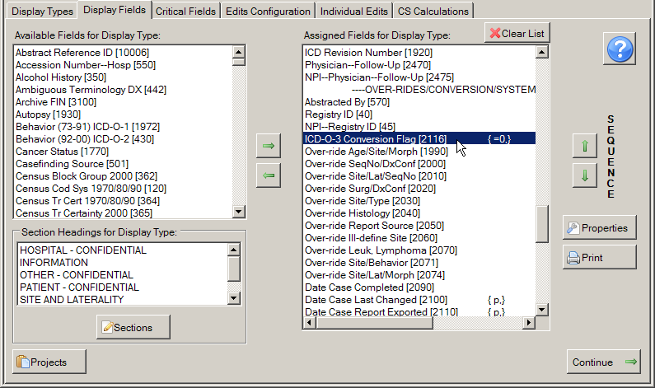
- In the Available Fields for Display Type list on the upper left of the Display Fields tab, select the Project field that you would like to move into the display type. In the example shown, the Project1 [12021] is being added to the Training Display display type.
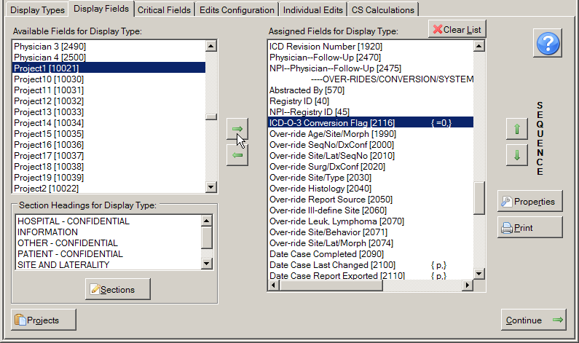
- Click the green right-pointing arrow to move the Project field into the display type.
Result: The Project field is removed from the Available Fields for Display Type list on the left, and is moved into the Assigned Fields for Display Type list on the right, above the currently-selected field in the list.
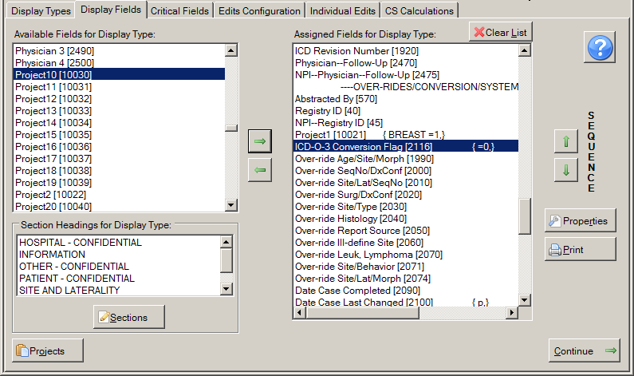
Notice that the field property of Field Display Label is automatically assigned the Project field name, and the Field Default Value is defaulted to TRUE - 1. In the example shown, the Project1 [10021] Project field has Project field name of BREAST, and has been defaulted to a value of 1 (True).
- Click Save.

The Display Fields Report
A Display Fields report is available which can be very helpful when adding fields to a display type, and for display type documentation purposes.
To view, print, or save a copy of the Display Type Fields report, follow these steps:
- On the Display Fields tab, click Print.
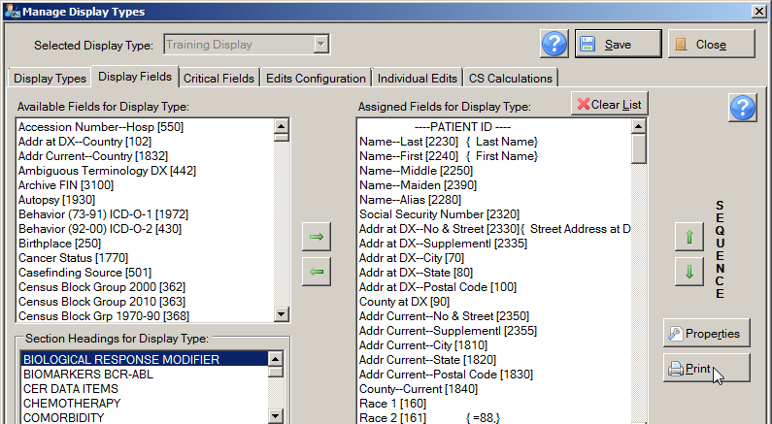
Result: The Display Fields report opens in the Abstract Plus Report Viewer window.
The Display Fields report lists the display fields that have been selected into the display type, along with field properties that were set.
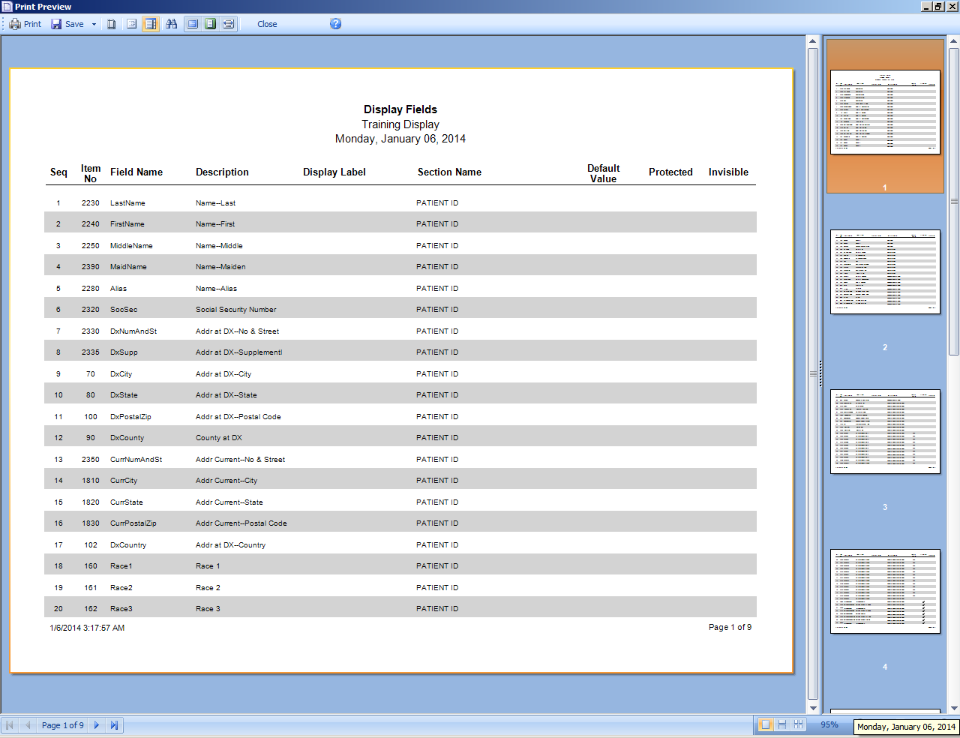
The Display Fields report contains these column headings:
Column | Description
Seq | The sequence number of the field (its position in the display type)
Item No | The NAACCR data item number for the field
Field Name | The Abstract Plus system name for the field
Description | The standard NAACCR data item name for the field
Display Label | The user-specified name (if any) for a field
Section Name | The display type section to which the field is assigned
Default Value | The default value (if any) assigned to the field
Protected | Indicates whether or not the Protected property has been set for the field
Invisible | Indicates whether or not the Protected property has been set for the field
The Abstract Plus Report Viewer window is divided into 2 main sections: a window in which to view reports on the left, and a pane for viewing report thumbnails on the right. When you left-click and hold your mouse on the vertical divider bar in the center of the window, a splitter appears which you can drag to the left or right to resize the view report and thumbnails views.

The Report Viewer Main Toolbar

The Report Viewer Page Navigation Controls
Report page navigation controls are located in the lower left-hand corner of the Report Viewer window and help you navigate through the various pages of the Display Fields report. The following table describes the function of each of the page navigation controls.
Control | Function
 | View the first page of the report being viewed
 | View the previous page of the report being viewed
 | Lists the page number of the current page of the report being viewed
 | View the next page of the report being viewed
 | View the last page of the report being viewed

The Report Viewer Search Toolbar
The search panel is used to search for specific text within the report. To access feature, click the binocular icon on the main toolbar.

The Report Viewer Page View Controls
Report page view controls are located in the lower right-hand corner of the Report Viewer window, and include icons to help you control how many pages of the report to view, as well as to zoom in or out on the current report being viewed. The following table describes the function of each of the page view controls.
Control | Keystroke | Function
 | Shift+F2 | Single Page: View the report one page at-a- time
 | Shift+F3 | Continuous: View the report with all pages displayed continuously
 | Shift+F4 | Multiple Pages: based on the selected zoom, all possible pages are displayed to fill the viewer window
 | No keystroke | Selected Zoom: View the report at the percent size specified

Saving the Display Fields Report
Abstract Plus offers an extensive number of file formats in reports can be saved. You can save the Display Fields report in the file formats listed under the Save As icon on the Main Toolbar of the Report Viewer:
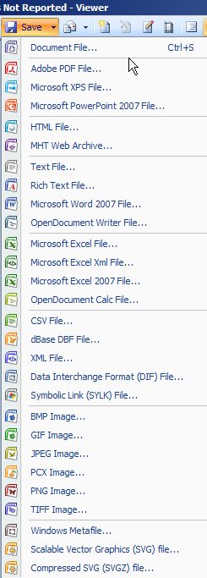

Activity 9 – Printing the Display Fields Report
Using what you have just learned, print a copy of the Display Fields report for the Training Display display type.
Please see page 106 of this manual or click here for instructions regarding viewing and printing the Display Fields report.

Step 2: The Critical Fields Tab
After fields have been added to the display type, the Administrator then specifies which (if any) of the included fields are Critical fields. In Abstract Plus display types, Critical (or required) fields must be filled in by the Abstractor in order to complete and release an abstract. When edits are run on the abstract, Critical fields are indicated clearly to the Abstractor on the Edit Set Results Window.
To assign critical fields to a display type, complete these steps:
- Select the display type you would like to build or update from Selected Display Type menu at the top of the Manage Display Types window. In the example shown, the Training Display display type is being selected and modified.
- Click the Critical Fields tab.
Result: The Manage Display Types window opens the Critical Fields tab for the selected display type.
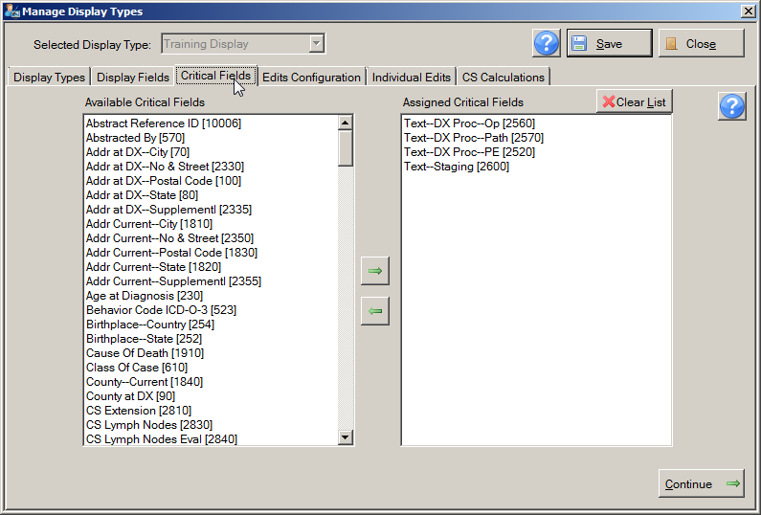
Move Critical Fields into/out of Display Type
Available Critical Fields
Critical Fields Assigned to Display Type
On the Critical Fields tab, the application displays the fields that you selected into the Assigned Fields for Display Type list on the Display Fields tab in alphabetical order as available critical fields. The Administrator uses the Critical Fields tab to specify Critical Fields for a display type. Using the left and right arrow buttons, fields are moved from the Available Critical Fields list on the left to the Assigned Critical Fields list on the right to include them in the selected display type.
With Abstract Plus, required fields can be enforced via the Critical Fields feature, or via the running of data quality edits on the abstract. It is a good idea to maintain field requirements in one place, i.e., either via the Critical Fields feature of Abstract Plus or via the edit set associated with the display type.
- From the Available Critical Fields list on the left, select the fields that you would like to designate as critical, or required. In the example shown, the fields of Addr at DX---City, No & Street, Postal Code, and State are being designated as required for the Training Display display type.
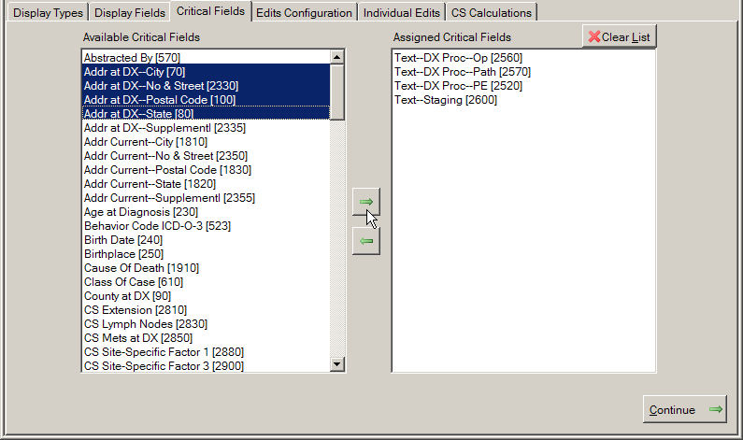
- Click the green right-pointing arrow to move the Critical field or fields into the display type.
Result: The field(s) is removed from the Available Critical Fields list on the left, and is moved into the Assigned Critical Fields list on the right. When abstracting abstracts with the selected display type, the Abstractor will not be able to complete an abstract without filling in the critical fields.
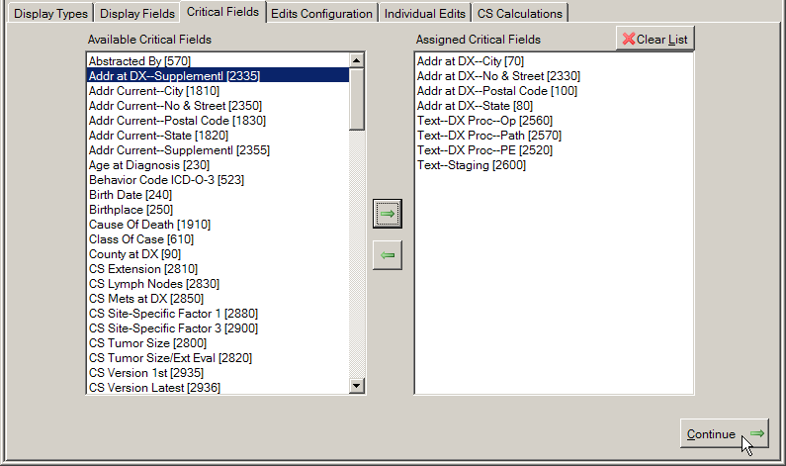
- Click Continue to save your changes and move on to Step 3, the Edits Configuration tab.
You can also save your work by clicking Save. Clicking Clear List will remove all fields from the Critical Fields list.

Activity 10 – Selecting Critical Fields into a Display Type
Using what you have just learned, designate the following fields as Critical Fields for the Training Display display type:
- Addr at DX—City [70]
- Addr at DX—No & Street [2330]
- Addr at DX—Postal Code [100]
- Addr at DX—State [80]
Feel free to experiment and add other Critical fields as well. Please see page 110 of this manual or click here for instructions regarding adding Critical fields to display types.

Step 3: The Edits Configuration Tab
In this step, you choose the edit set for your display type. To ensure that the information contained within an abstract makes sense and codes are coded correctly, both individually and in relation to one another, data quality "edits" are applied to each abstract as it is saved.
An edit set contains a collection of individual edits. If there are errors when an abstract is saved or edits are run, Abstract Plus displays those errors in the Edit Set Results window so the abstractor can correct them. An abstract cannot be completed and released to the central registry until all errors have been resolved, and all critical fields have been filled in.
To select an edit set, complete these steps:
- Make sure that the display type you would like to build or update is selected from Selected Display Type menu at the top of the Manage Display Types window. In the example shown, the Training Display display type is being selected and modified.
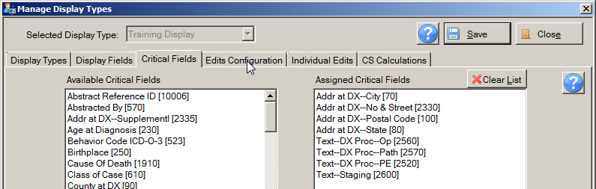
- Click the Edits Configuration tab.
Result: The Manage Display Types window opens the Edits Configuration tab for the selected display type.
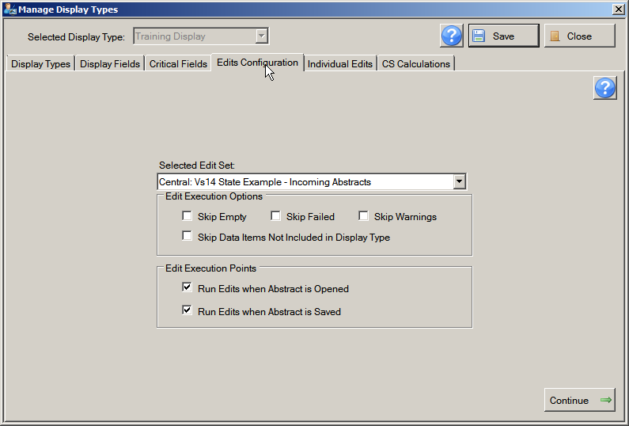
Edit Set Execution Options
Selected Edit Set
When to Run Edits
The Administrator uses the Edits Configuration tab to specify an edit set for the display type, and to set important edit set execution options.
Recall that required fields can be enforced via the Critical Fields feature or via the running of data quality edits on the abstract. It is a good idea to maintain field requirements in one place, i.e., either via the Critical Fields feature of Abstract Plus or via the edit set associated with the display type.
- Select the desired edit set from the Selected Edit Set pull down menu. This is the edit set that will be run on abstracts being abstracted with the selected display type. In the example shown, the Central: Vs14.0 State Example—Incoming Abstracts edit set is selected for the Training Display display type.
The edits sets listed in the Selected Edits Set list are based on the edits metafile that is included in the C:\RegPlus\AbstractPlus\Edits folder. By default, the most current standard NAACCR edits metafile is included with the application (http://www.naaccr.org/standards/volumeiv). If your central registry has any state-specific edit sets (i.e., any edit not included in the standard NAACCR metafile), your state-specific edits metafile can be added to the application. The edit set for current install can be changed at any time by replacing the edits runtime metafile (.rmf file) in the C:\RegPlus\AbstractPlus\Edits folder with your own customized metafile.
CDC will create customized installations of Abstract Plus that include custom metafiles for NPCR-funded registries only (metafile to be provided by registry.
In addition to selecting an edit set, the Administrator may choose to set certain global Edit Set Execution Options. These are the Edit Execution Options on the Edits Configuration tab:
Option | Description
Skip Empty | Prevents an edit from running if any of the fields that it edits are blank
Skip Failed | Prevents a multi-field edit from executing if any field in its list has failed its single-field edit
Skip Warnings | Prevents the return of warning messages by converting the return value to pass
Skip Data Items Not Included in the Display Type | Prevents an edit from running if any of the fields that the edit is checking are not included in the display type; use of this feature will prevent unwarranted edit error errors for an abstract due to discrepancies between the fields included in a display type and the fields edited by the selected edit set for the display type
- Click the check boxes for the edit set execution options you would like to specify for the selected display type.
In addition to running edits upon request from the Abstractor (clicking EDITS, or pressing F8 or F2), the Administrator can specify whether or not to run edits upon the opening or saving of an abstract. These are the Edit Execution Points on the Edits Configuration tab:
Option | Description
Run Edits When Abstract is Opened | When checked, after creation of an abstract edits will run on the abstract each time it is opened
Run Edits When Abstract is Saved | When checked, edits will run each time an abstract is saved
- Click the check boxes for the edit execution points you would like to specify for the selected display type.
By default, both of these options are selected; edits will run each time an abstract is opened or saved (this is the recommended setting).
- Click Continue to save your changes and move on to Step 4, the Individual Edits tab.
You can also save your work by clicking Save.
Result: The system saves the edit set selection and opens the window for the next step in building a display type, the Individual Edits tab.

Step 4: The Individual Edits Tab
In this step, for any individual edit in the edit set, the Administrator can over-ride the global edit set execution options chosen on the Edits Configuration tab in step 3 for the entire edit set. The Administrator can select individual edit options when an available edit set meets the editing needs of the central registry with the exception of a few edits. When individual edit options are set, the edit set options are over-ridden. The setting of individual edit options requires a thorough understanding of the edit set itself.
To select individual edit options, complete the following steps:
- Make sure that the display type you would like to build or update is selected from Selected Display Type menu at the top of the Manage Display Types window. In the example shown, the Training Display display type is being selected and modified.
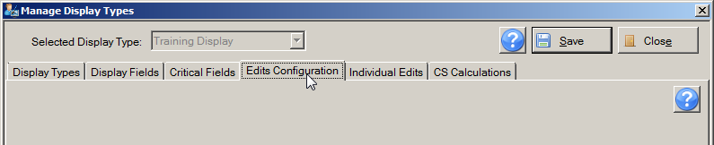
- The Individual Edit tab window should already be opened because you clicked Continue in the previous step. If it is not open, click the Individual Edits tab.
Result: The Manage Display Types window opens the Individual Edits tab for the selected display type.
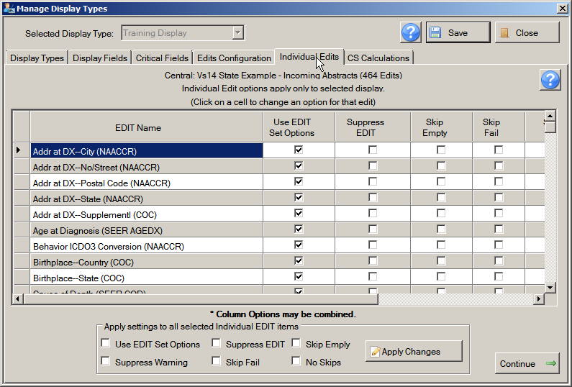
Edits Included in Selected Edit Set
Individual Edit Options
Selected Edit Set and Total Number of Edits
The Individual Edits tab lists the name of the selected edit set and the total number of edits it includes. The names of all of the edits in the selected edit set for the display type are listed in the 1st column on the left and individual edit options on set on the right. Options are set for individual edits by clicking the check box for the option for the specified edit in the grid, or by setting options for multiple edits at the same time using the features at the bottom of the window.
The Individual Edits tab includes these options:
Option | Description
Use EDIT Set Options | This option is checked by default for all edits in the edit set; when checked, only the global options set for the edit set on the Edits Configuration tab will be applied to the individual edit
Suppress EDIT | Prevents the individual edit from executing when the edit set is run on an abstract
Skip Empty | Prevents the individual edit from executing if any of the fields that it edits are blank
Skip Fail | Prevents an individual multi-field edit from executing if any field that it checks has failed its associated single field edit
Suppress Warning | Prevents the return of any warning messages by the edit
No Skips | Edit runs for the field, over-riding any global Skip Empty or Skip Fail options that may be set for the edit set on the Edits Configuration tab
To select any of the individual edit options for an individual edit, locate the edit for which you would like to set options in the grid, and click the check box in the columns of the desired options. Note that the Skip Empty and Skip Fail options may be combined for an edit by clicking the check boxes in both columns.
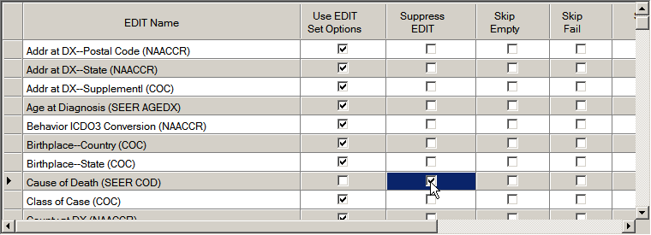
To select any of the individual edit options for multiple edits at the same time, highlight the edits in the EDIT Name column using your ctrl and shift keys on your keyboard, click the check box in the columns of the desired options in the center panel at the bottom of the window, and click Apply Changes.
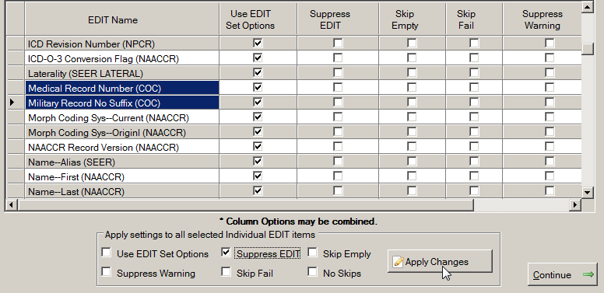
- Select any individual edit options for any of the individual edits in the edit set.
Edit Sets | Before you select an edit set, you should be aware of all of the edits in the set and how they edit the data.  To get a detailed view of the edit set and individual edits, you must use the EditWriter software.  To quickly view the edits in an edit set, select the edit set on the Edits Configuration tab, and view its contents on the Individual Edits tab.
- Click Continue to save your changes and move on to Step 5, the CS Calculations tab.
You can also save your work by clicking Save.
Result: The system saves any individual edit option selections and opens the window for the next step in building a display type, the CS Calculations tab.

Step 5: CS (Collaborative Staging) Calculations Tab
The Abstract Plus application can calculate stage according to three separate systems: SEER Summary Stage 77, SEER Summary Stage 2000, and AJCC Stage Group. In step 5 on the CS (Collaborative Staging) Calculation tab, the Administrator has the option to select among these three Collaborative Staging (CS) preferences. Single or multiple staging systems may be selected, depending on what CS fields are being collected with the display type, and what derived CS fields you would like to store in your central registry.
To specify Collaborative Staging preferences for a display type, complete the following steps:
- Make sure that the display type you would like to build or update is selected from Selected Display Type menu at the top of the Manage Display Types window. In the example shown, the Training Display display type is being modified.
The CS Calculations tab window should already be opened because you clicked Continue in the previous step. If it is not open, click the CS Calculations tab.
Result: The Manage Display Types window opens the CS Calculations tab for the selected display type.
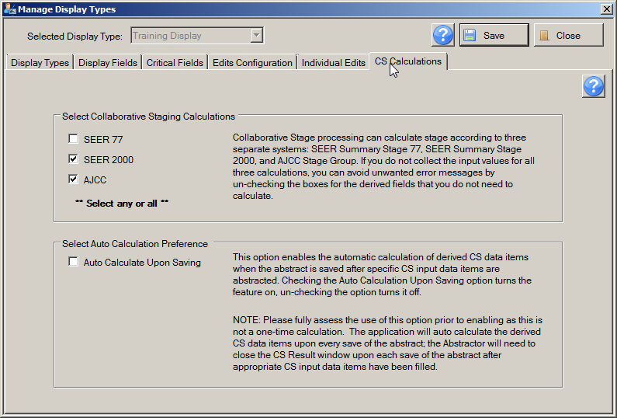
CS Calculation Options
Abstract Plus offers the following CS staging preferences:
Process | Description
Compute SEER1977 | From the Collaborative Staging fields collected, the derived SEER Summary Stage 1977 is calculated
Compute SEER2000 | From the Collaborative Staging fields collected, the derived SEER Summary Stage 2000 is calculated
Compute AJCC | From the Collaborative Staging fields collected, the derived AJCC Stage Group fields are calculated
Auto Calculate Upon Saving | This option enables the automatic calculation of derived CS data items when the abstract is saved after the following CS input data items have been abstracted:  - CS Tumor Size  - CS Extension  - CS Tumor Size/Ext Eval  - CS Lymph Nodes  - CS Lymph Nodes Eval  - CS Mets at DX  - CS Mets Eval  - CS Site-Specific Factor 1-25  Checking the Auto Calculation Upon Saving option turns the feature on, un-checking the option turns it off. If this option is turned on, CS derived data items will be calculated upon every save after the above fields have been entered.
- Select the CS Calculations that you would like for the display type.
- Check the Auto Calculate Upon Saving checkbox if you would like Abstract Plus to auto-calculate the derived CS fields after the specific CS input data items are abstracted. Leave checkbox un-checked if you would like the user to utilize the calculator icon to calculate the derived CS fields.
Please fully assess the use of this option prior to enabling as this is not a one-time calculation. The application will auto calculate the derived CS data items upon every save of the abstract after the specified CS input fields have been abstracted. As a result the Abstractor will need to close the CS Result window upon each save of the abstract after the specified CS input data items have been abstracted.
- Click Save.
- Click Close to close the Manage Display Types window.
Result: The Manage Display Types window closes, and you are returned to the main Abstract Plus window.

Activity 11 – Specifying Edits and CS Calculation Settings
Using what you have just learned, review the edit set, individual edits, and CS Calculation options that have already been set for the Training Display display type. Recall that these options were copied over from the APDefault display type. In particular, note the edit set that was selected (Central: Vs14 State Example—Incoming Abstracts), that there are no individual edit options set, and that the only CS Calculation option set to on is the calculation of SEER Summary Stage 2000. Please see page 112 of this manual or click here for instructions regarding the setting of edits configurations and CS calculation options.
After you have finished reviewing, click Close to close the Manage Display Types window.

Viewing and Testing a New Abstracting Display Type
While the Administrator is generating a new abstracting display type, he or she may want to view and test and test it from the Abstractor’s perspective. Once a new abstracting display has been completed, it is essential that it is fully tested prior to implementation.
To view and test an abstracting display type, complete the following steps:
- Create a new abstract. This can be done in 3 ways:
  - Click on the File menu, and select New Abstract.
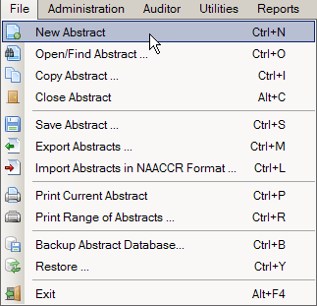
  - Click the New icon on the Toolbar.
  - Use the keystroke Ctrl+N.
Result: The Abstract Plus Abstracting window opens for a new abstract.
- From the Display Types pull-down in the upper right-hand corner of the data entry grid, select the new abstracting display type to be viewed or tested. In the example shown, the Training Display display type is being selected.
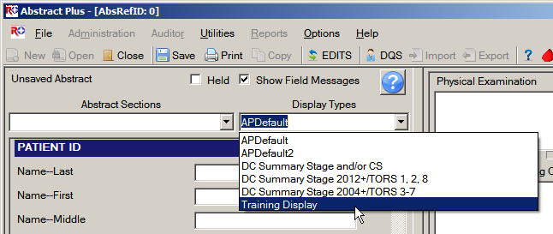
Result: The Abstract Plus Abstracting window is switched to the selected display type.
- Once the new abstracting display type has been selected, the display type can be tested. It is recommended that a test abstract be abstracted from creation through to completion, in order to verify all settings for the display type. In particular the Administrator should verify that:
  - The intended fields are included in the display type in the intended sequence, listed under their intended section headings.
  - Field Properties (Protected, Invisible, Field Label, Default Value, Field Message) that have been set for particular fields function as intended.
    - Double-check that fields for which the Protected property was set can not be edited.
    - Verify that fields for which the Invisible property was set are not visible in the display type.
    - Double-check that any customized field labels are displayed correctly.
    - To test default values for correctness enter a few fields and click Save; default values are filled into fields upon first save of the abstract.
    - To test Field Messages for correctness, click into the field and view the pop-up message; be sure to double-check spelling and grammar as well as message content.
  - When edits are run, that all critical fields that are blank are listed as Missing Critical Fields as counted as errors in the Edit Set Results window.
  - The edit set displayed at the top of the abstracting window is the edit set that was selected for the display type.
  - The abstract can physically be completed with the specified fields, critical fields and edit settings.
- When you have finished testing the display type, close the abstract, and be sure to delete any test abstracts that were generated during testing:
  - From the Utilities menu, select Delete Abstracts, or use the Alt+P keystroke.
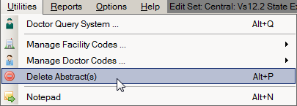
  - Use the available search criteria on the Delete Abstracts window to search for any test abstracts, select them, and click Delete.

Activity 12 – Viewing and Testing Abstracting Display Types
Using what you have just learned, test the Training Display display type in the Abstract Plus Abstracting window, in particular reviewing the display type’s functions for the modifications you made to the Training Display display type in Activities 6 - 11:
- Open a new abstract, and select the Training Display display type from the Display Type pull-down menu in the upper right-hand corner of the data entry grid:
- Verify the section heading of HISTOLOGY is included in the display type, and that it is positioned directly above the field of Histologic Type ICD-O-3:
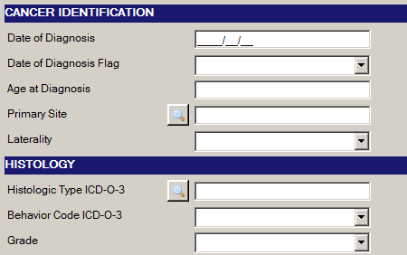
- Verify that the following fields are included in the display type, are listed in the following order, and are positioned directly above the Race 1 field:
    - Addr Current—No & Street
    - Addr Current—Supplemental
    - Addr Current—City
    - Addr Current—State
    - Addr Current—Postal code
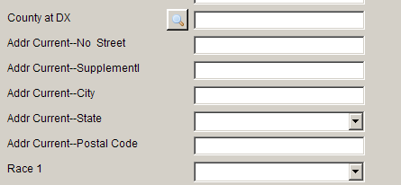
- Double-check that NAACCR Record [50] field is not displayed on the data entry grid, as the field properties of Protected and Invisible were set for this field.
- Verify that the Name—Last [2230] field has a custom label of Last Name, Name—First has a custom label of First Name, and that Addr at DX–No & Street [2330] has a customized label of Street Address at Diagnosis. Notice that the label of Street Address at Diagnosis is most likely too long to be displayed in full and is truncated followed by “…”.
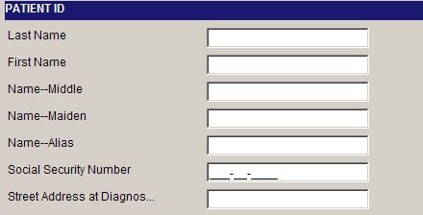
- Verify that the Race 2 – Race 5 [161-164] fields default to a value of 88.
- Upon first save of the test abstract, verify that if left blank, the following fields that were designated as Critical fields generate an error and are listed in the Edit Set Results window as Missing Critical Fields.
    - Addr at DX—City [70]
    - Addr at DX—No & Street [2330]
    - Addr at DX—Postal Code [100]
    - Addr at DX—State [80]
    - Addr Current—Postal code
- Double-check that the edit set listed at the top of the abstracting window is Central: Vs14 State Example—Incoming Abstracts.
- When the cursor is placed in the Text–DxProc–PE [2520] text field in the data entry grid on the right, verify that the field message that pops up reads “Please be concise and include all relevant information.”:
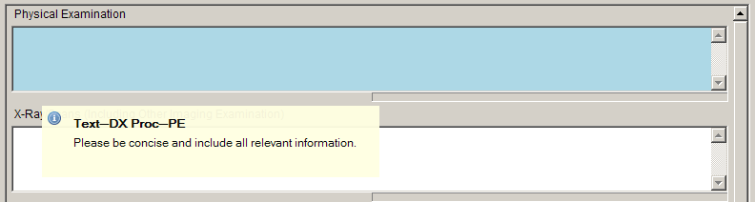
- Continue testing the display type, making sure that you are able to complete the test abstract with the display type.
- Once you have finished testing the display, be sure to delete any test abstracts that you generated from the Abstract Plus application.

Importing Local Hospital and Doctor Codes
The final task of configuring the Abstract Plus application is the addition of hospital and doctor codes specific to the state or locale using the application. The generic installation of Abstract Plus comes with a small file of fictitious doctor names and codes, as well as a small file of fictitious hospital names and codes. Each central registry user can provide the program with files containing local information for doctors and hospitals. The information regarding the locale’s physicians; their names, identifiers, and other items, are needed for the Doctor Query System (DQS), as well as for abstracting any fields containing look-ups for physician codes. The information regarding the locale’s hospitals is used for abstracting all fields containing hospital code look-ups.
To import doctor or hospital tables, click on the Utilities menu, and select either Manage Facility Codes or Manage Doctor Codes.
You can choose to either import a table of codes, or edit the existing codes manually. If you choose to import your doctor and hospital codes, the following files formats are required.

Required Hospital Codes Import File Format
Field Name | Field Length |  | Column Start | Column Stop
Value* | 10 | 1 |  | 10
(Empty) | 5 | 11 |  | 15
Label* | 40 | 16 |  | 55
ContactName | 35 | 56 |  | 90
Phone | 13 | 91 |  | 103
NPI Facility Code | 10 | 104 |  | 113
*Required fields

Required Doctor Codes Import File Format
Field Name | Field Length | Column Start | Column Stop
Doctor Code* | 8 | 1 | 8
Address1* | 35 | 9 | 43
Address2 | 35 | 44 | 78
City* | 20 | 79 | 98
State* | 2 | 99 | 100
Zip code* | 10 | 101 | 110
Phone | 13 | 111 | 123
Last Name* | 20 | 124 | 143
First Name* | 20 | 144 | 163
Organization | 45 | 164 | 208
Specialty* | 20 | 209 | 228
Practice | 20 | 229 | 248
Pathloc | 35 | 249 | 283
Suppresslet | 1 | 284 | 284
NPI Doctor Code | 10 | 285 | 294
*Required fields--displayed within Doctor Query System

Please see the Abstract Plus System and IT Personnel Requirements document for more information about adding local hospital and doctor codes to Abstract Plus.

Questions
Answer these questions about configuring Abstract Plus (the answers are in Appendix A, on page 140):
- Can the security challenge questions presented to users upon initial log in to Abstract Plus be modified?
- What does the Enforce Strong Password option do?
- How do you change the password expression that defines password requirements for Abstract Plus?
- What are the two ways to create a new display type?
- What are section headings?
- What is the difference between configuring edit set options and setting individual edit options?
- How can you protect a field from being edited by an abstractor?

Creating and Modifying User Accounts

Learning Objectives
In this chapter, you will learn how to:
- Add a user to the application
- Reset a user’s password
- Change the current user
- Delete a user from the system

Overview
One of the tasks of the Administrator is to manage user accounts for all of the users using the Abstract Plus application. This chapter provides an overview of basic user account management. It includes a description of how to add new users to the system, reset a user’s password, change the current user, and delete users.

Adding a New User
To add a user to the system, complete the following steps:
- Open the Create/Modify Users window. This can be done in 2 ways:
  - From the Administration menu, select Create/Modify Users.
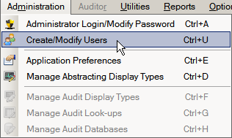
  - Use the Ctrl+U keystroke.
Result: The Create/Modify Users window opens. The current user is displayed, as well as a list of all users in the system.
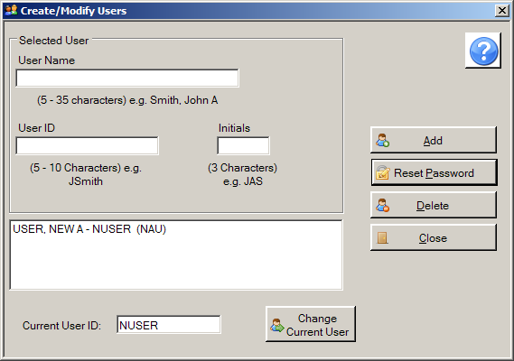
- Type the name of the new user is the User Name box using the convention of Last Name, First Name, Middle initial. In the example shown, a new user account is being added for a user name John A. Doe, so DOE, JOHN, A is being entered in the User Name box.
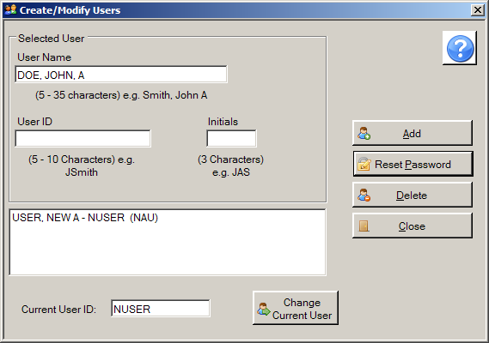
- Press Tab to move the cursor to the User ID box, and enter a User ID for the new user. In the example shown, the new users name is John Doe, so the User ID being assigned is JODOE.
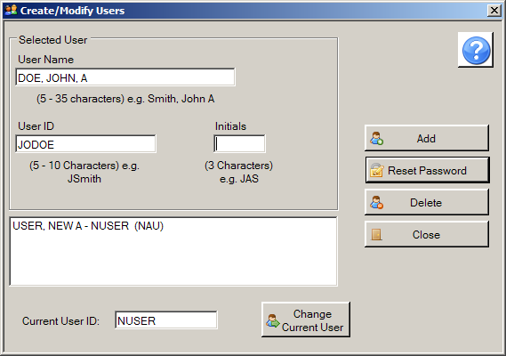
- Press Tab to move the cursor to the Initials box, and enter the new user’s 3 character initials. In the example shown, the new users name is John A. Doe, so the User ID being assigned is JAD.
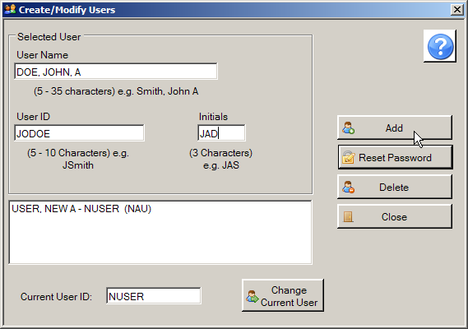
- Click Add.
Result: The new user is added to the system, and is listed in the list of users in the application.
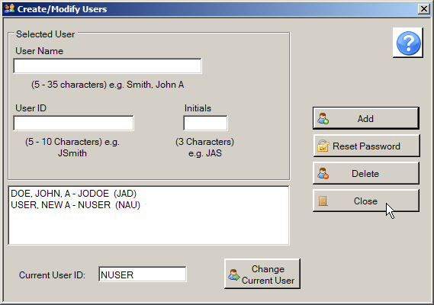
- Click Close to close the Create/Modify Users window.

Resetting a User’s Password
If an Abstract Plus user forgets their password, and does not correctly recall their answers to their security challenge questions, the Abstract Plus Administrator will need to reset the user’s password.
When a user’s password is reset, it will always be set back to the initial password of Welcome1.
To reset the password for an existing user, complete the following steps:
- From the Administration menu, select Create/Modify Users, or use the Ctrl+U keystroke.
Result: The Create/Modify Users window opens.
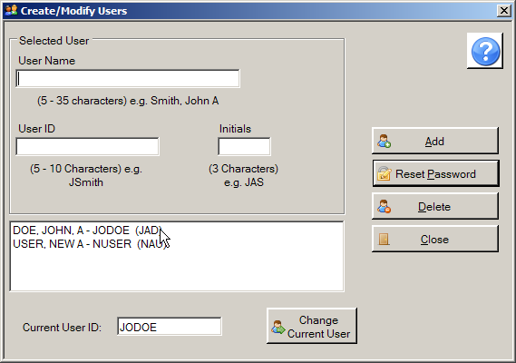
- From the list of all users in the system, select the user for which you would like the password reset. In the example shown, the password is being reset for the John Doe user account, so the John Doe user account is being selected.
Result: The system displays the selected user’s information in the User Name, Initials, and User ID fields.
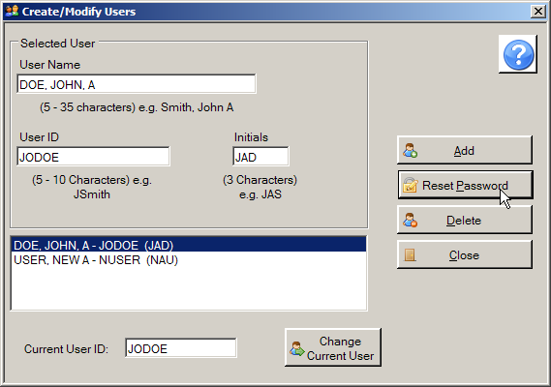
- Click Reset Password.
Result: The system asks to you to verify that you would like to reset the password of the currently selected user.
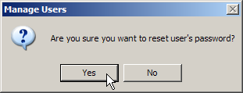
- Click Yes.
Result: The system resets the password for the currently selected user to the initial Abstract Plus password of Welcome1.
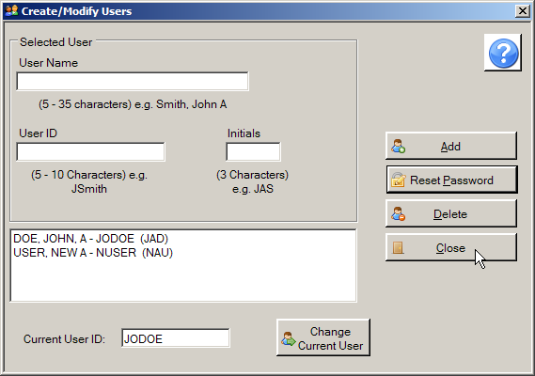
- Click Close to close the Create/Modify Users window.

Changing the Current User
The Administrator may be called upon to change the current user in the Abstract Plus application.
To change a current user, complete the following steps:
- From the Administration menu, select Create/Modify Users, or use the Ctrl+U keystroke.
Result: The Create/Modify Users window opens, displaying the User ID of the current user at the bottom of the window. In the example shown, the current user is JODOE.
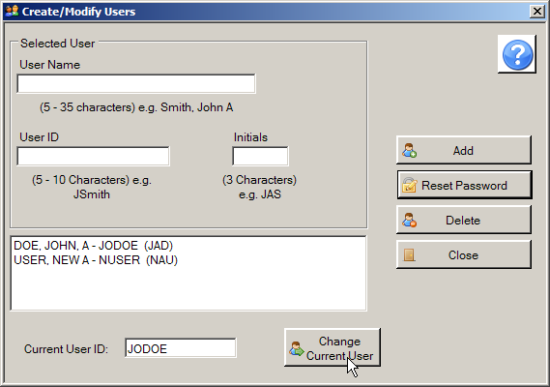
- Click Change Current User
Result: The system displays the Login window.
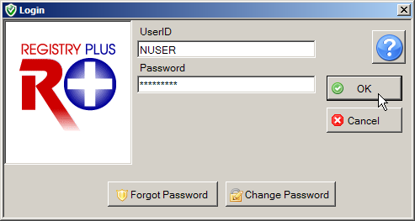
- Type in the UserID and Password for the user to which you would like to switch, and click OK. In the example shown, the current user is being changed from JODOE to NUSER.
Result: You are returned to the Create/Modify Users window, where the system has changed the current user to the one that was just logged in; the Current User ID field now displays the new user’s User ID.
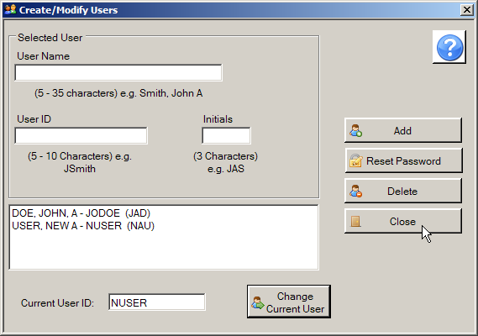
- Click Close to close the Create/Modify Users window.

Deleting a User
To delete a user from the application:
- From the Administration menu, select Create/Modify Users, or use the Ctrl+U keystroke.
Result: The Create/Modify Users window opens.
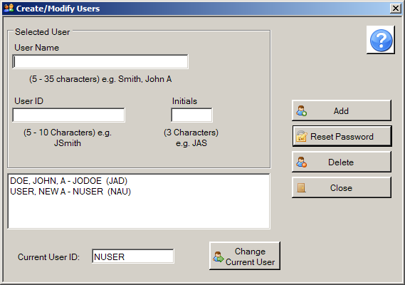
- Select the user that you would like to delete, and click Delete. In the example shown, the John Doe user is being deleted.
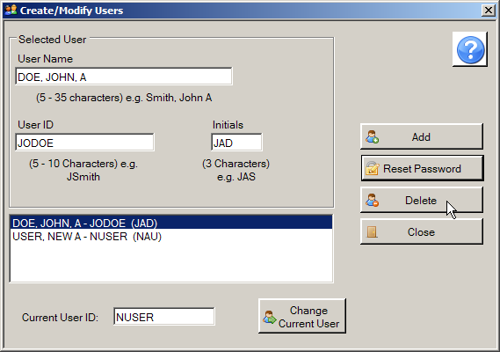
Result: The system asks to you to verify that you would like to delete the currently selected user.
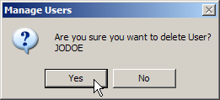
- Click Yes.
Result: The system deletes the currently selected user, and clears the user information from the Create/Modify Users window.
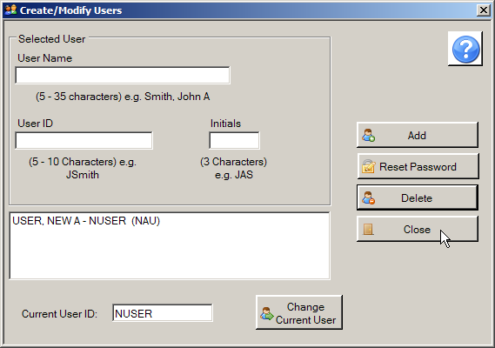
- Click Close to close the Create/Modify Users window.
Be sure that you want to remove a user before you select the Delete User option as the system immediately deletes the selected user.
Note: You cannot delete the current user.

Activity 13 – Adding and Deleting Users
Using what you have just learned, add a new user to Abstract Plus, and then delete that new user. Please see page 127 of this manual or click here for instructions regarding adding users to and deleting users from Abstract Plus.

Questions
Answer these questions about managing Abstract Plus user accounts (the answers are in Appendix A, on page 141):

- How can you easily identify the current user on the Create/Modify Users window?

- How do you add a new user to Abstract Plus?

Abstract Plus Report Wizard Basics

Learning Objectives
In this chapter, you will learn to:
- Learn about the Abstract Plus Report Wizard
- Learn how to use the Report Wizard to generate a basic custom report

Overview
This chapter provides an overview of the Abstract Plus Reporting Wizard, and the basics of running a custom report.
For security purposes, all Abstract Plus databases are now encrypted. If you have been accessing any of the various Abstract Plus databases in the past via Microsoft Access to generate local reports, you will no longer be able to do so without special instruction to access the now-encrypted databases. Please see page 139 of this manual or click here for more information on Abstract Plus database encryption.

The Abstract Plus Report Wizard
Because Abstract Plus provides for such flexible design of abstracting and audit features but only offers a few standard reports, an ad-hoc reporting capability has been added to the software to offer users the option of enhanced data analysis. The all-new Report Wizard, available from the Reports menu, guides users in creating, managing, and running customized reports. Both abstracting and audit data are available through the Report Wizard, which can be used to create simple or complex reports, including cross-tab, hierarchical, and chart reports.
Due to development priorities, the Report Wizard report generation features have been disabled in Abstract Plus, and will be released in a future version of the program.
However, you can still run a CDC-developed custom report. To request a custom report, please contact CDC via e-mail: cancerinfo@cdc.gov.
To access the Report Wizard features, click on the Reports menu item, and select the desired Report Wizard option, or use the appropriate keystroke combination for the desired option.
Report Wizard Menu Sub-options

The following table describes the Abstract Plus Report Wizard menu sub-options:
Sub-option (Keystroke) | Function
Report Wizard (Alt+Shift+W) | Newly-added feature to enable users to generate their own custom reports (currently disabled)
Edit Custom Reports (Alt_Shift+E) | Edit an existing custom report (currently disabled)
Run Custom Reports (Alt+Shift+R) | Runs selected custom reports that have been added to the application using the Report Wizard
Report Generator Help | Opens online help for the Report Wizard; optional installation by Administrator required (currently disabled)
The Abstract Plus Report Wizard provides a friendly Graphical User Interface (GUI) for the creation of custom reports, and does not require the user to have an in-depth knowledge of Sequel Query Language (SQL). The GUI allows the user to create and preview a report to ensure the desired design and all relevant information are captured. Reports can be designed to work with both the Microsoft Access and Microsoft SQL Server database options of Abstract Plus.

Running a Saved Custom Report
Once a custom report has been generated by CDC and provided to you, it can then be opened and viewed from within Abstract Plus.
To run a Custom Report, complete the following steps:
- Custom reports can be opened in 2 ways:
  - From Reports menu, select Run Custom Reports.
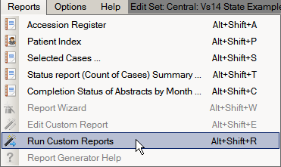
  - Use the Alt+Shift+R keystroke.
Result: A file selection window opens to allow you to select which custom report to open. Custom reports generated using the Abstract Plus Report Wizard will have the file extension of .mrt.
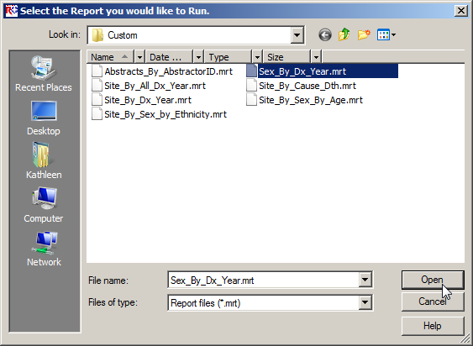
- Select the file for the report you would like to open, and click Open.
Result: The report will compile and display in the Abstract Plus Report Viewer window.
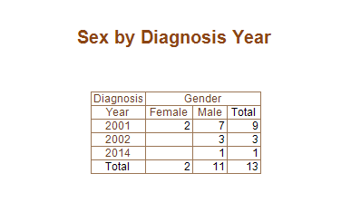
- The report may now be viewed, printed, or saved in one of the variety of file formats available.
- To close the report, close the Report Viewer window.

Abstract Plus Database Encryption
As a part of Abstract Plus enhanced security features, all records are saved in Microsoft Access or SQL server databases and all tables are password protected and encrypted using Microsoft functions.
As a result, any activity in the past that has required direct access to the Abstract Plus Access databases will now require special steps to first access the encrypted databases. As mentioned, Abstract Plus can be customized with local (non-standard) fields and look-ups. However this requires direct modification of one of the Abstract Plus databases. In addition, if you have been accessing any of the various Abstract Plus databases in the past via Microsoft Access to generate local reports, you will no longer be able to do so without special instructions to access the now-encrypted databases.
As CDC creates customized installations of Abstract Plus for any NPCR-funded central registry, access to the databases should no longer be required due to the new reporting and audit information exporting features:
- With the all-new Report Wizard, you no longer need to access the databases directly to create customized reports; generation of custom reports is now a user-friendly feature of the program and can be accomplished via the application interface. In addition, you can further access to data in the database by generating and saving custom reports in any format for further analysis of the data.
- For audits, you can export all audit information directly via the Auditor features of the program.
However, all other interested parties that need to customize the application for local use will need to access the encrypted databases, and some NPCR-funded registries still may find the need to access the databases as well.
As a result, special instructions and passwords are available that allow for direct access to the encrypted databases. Please contact CDC for full details regarding Abstract Plus database encryption, and instructions on gaining access to the encrypted databases if required.

Appendix A: Answers to Chapter Questions
Chapter 2: Abstract Plus General User Basics
These are the answers to the questions (page 51) about the basics for Abstract Plus general users:
- The first things you need to do upon initial login into Abstract Plus are: 1) create a user account, 2) log in, 3) change your password, and then 4) select and answer security challenge questions.
- Your answers to the security challenge questions that you select will be used to validate your identity if you forget your Abstract Plus password---if you forget your password, Abstract Plus will ask you for the answers you provided to these security questions, and then allow you to reset your password if the questions are answered correctly.
- It is important to have your own User ID and password for Abstract Plus for security purposes; never share your account information with others. In addition, when logged in using your own User ID and password, your initials will be displayed on the main Abstract Plus window to indicate when you are logged in to the application, and will be automatically recorded in the Abstracted By field when abstracting abstracts or conducting audits; this information is recorded in order to associate abstractors with the abstracts they have generated, and auditors with the audits that they have conducted.
- When logging off Abstract Plus, you can use the Backup option to save your work to a secure location.
Chapter 3: Abstract Plus Administrator Basics
These are the answers to the questions (page 58) about Abstract Plus Administrator Basics:
- The basic Administrator functions in Abstract Plus are managing user accounts and setting up the application for abstraction and auditing.
- No. For security purposes and to ensure standardized use of the application, access to the Administrator functions is restricted and password-protected. Once you have logged in to Abstract Plus with your general User ID and password, you may then log in as an Administrator.
- No. The Abstract Plus Administrator role has access to all functions of the software, including all of the auditing functions; entry of the Administrator password allows access to Auditor functions without entry of the Auditor password.
Chapter 4: Abstract Plus Configuration
These are the answers to the questions (page 124) about configuring Abstract Plus:
- Yes. The Abstract Plus Administrator can customize the list of challenge questions presented to users upon initial log in by opening the Application Properties window, clicking the Security Questions tab, and adding or removing security questions to the list displayed on the Security Questions tab.
- The Enforce Strong Password option enables the password restrictions feature.
- The Administrator can define password restriction rules by opening the Application Properties window, clicking the Password Expression tab, and modifying the regular expression (Regex) which specifies what types of passwords are acceptable.
- The Administrator can create a new abstracting display type by adding a new one or copying an existing one and modifying it.
- Section headings are used to group fields in a display type for clearer viewing and to facilitate data entry by the Abstractor.
- When you select an edit set, you are selecting a set of edits that will all be applied to the abstract in the same way; i.e., using the same Edit Set execution options (Skip Empty, Skip Failed and Suppress Warnings) for all the edits in the selected Edit Set. When you select individual edit options, you can override Edit Set execution options for any individual edit, or choose to suppress an individual edit, preventing it from running when the edit set is run.
- To protect a field from being edited by the abstractor, once you have selected the data item for your display type, click Properties, enter a default value for the data item, and then check the Protected check box.
Chapter 5: Managing Users
These are the answers to the questions (page 135) about managing Abstract Plus user accounts:
- The current user is easily identified on the Create/Modify Users window by looking in the Current User ID box in the bottom of the window.
- To add a new user to Abstract Plus, from the Administration menu, select Create/Modify Users, or use the Ctrl+U keystroke to open the Create/Modify Users window. Type the name of the new user is the User Name box using the convention of Last Name, First Name, Middle initial. Press Tab to move the cursor to the User ID box, and enter a User ID for the new user. Press Tab to move the cursor to the Initials box, and enter the new user’s 3 character initials, and then click Add.

Appendix B: Standard Keyboard Shortcuts
Function | Keyboard Combination
Menus
File Menu | Alt+ F
Administration Menu | Alt+ M
Utilities Menu | Alt+ U
Reports Menu | Alt+ R
Options Menu | Alt+ O
Help Menu | Alt+ H
Right-Click Menu:
Search Help / Field Context | F1
Edits Information for current field | F2
Field Message | F3
Special Field Lookup | F4
CS or Age calculations | F5
Run EDITS on current Abstract | F8
Undo text change | Ctrl+ Z
Cut selected text | Ctrl+ X
Copy selected text | Ctrl+ C
Paste text from clipboard | Ctrl+ V
Delete selected text | Alt+ D
Select All text in entry field | Alt+ A
Move to first Text Field | Ctrl+ T
Section Headings | Alt+ S
Display Types | Alt+ T
General
Open a pull-down data item listing | Alt+ Down Arrow
Move to next field | Enter or Tab
Move to previous field | Shift+Enter or Shift+Tab

