Abstract Plus Updater
Upgrading from Abstract Plus 3.3 to Abstract Plus 3.5

Centers for Disease Control and Prevention
National Center for Chronic Disease Prevention and Health Promotion
Division of Cancer Prevention and Control
National Program of Cancer Registries
Registry Plus Software for Cancer Registries

Table of Contents
1. Overview 2
2. How do I upgrade Abstract Plus? 3
2.1 Step 1 5
2.2 Step 2 8
2.3 Step 3 9
3. Things you should know 10
3.1 Backed up databases 10
4. Opening Abstract Plus after upgrading 11

Overview
Abstract Plus Updater allows you to upgrade existing Abstract Plus to newer version. This tool allows you to upgrade directly from Abstract Plus 3.3 (NAACCR 13.0 based) to Abstract Plus 3.5 (NAACCR 15.0). This tool is replacing lots of manual steps that we used to take in the past. After upgrading you will be able to continue with the same user name and password that you have been using to access Abstract Plus.

We used to take the following listed steps before but now all you need to do is simply follow guided screen.
1) Exporting Abstract
2) Uninstalling Abstract Plus
3) Cleaning old data traces of MDBS
4) Installing new Abstract Plus
5) Create user name/password
6) Importing exported data in steps one.

How do I upgrade Abstract Plus?
- Unzip downloaded Abstract Plus Updater file on convenient place like Desktop or My Document. You will notice the following file/ folder structure.
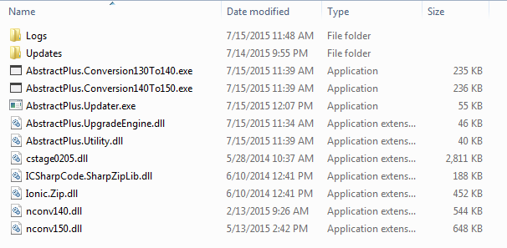

- Double Click on AbstractPlus.Updator.exe file. You will see the following window
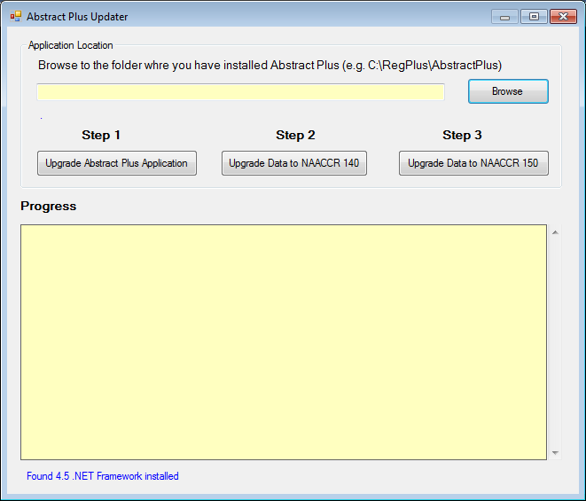

- Click on Browse button to locate the folder wherever you have Abstract Plus installed. More likely your Abstract Plus is located in C:\RegPlus\AbstractPlus
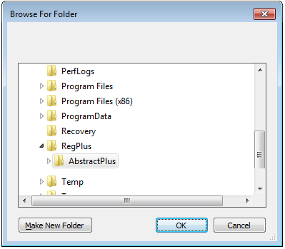

- Click on OK button. You will see the following window. It tells you which version you are in (e.g. 3.3.1.2)
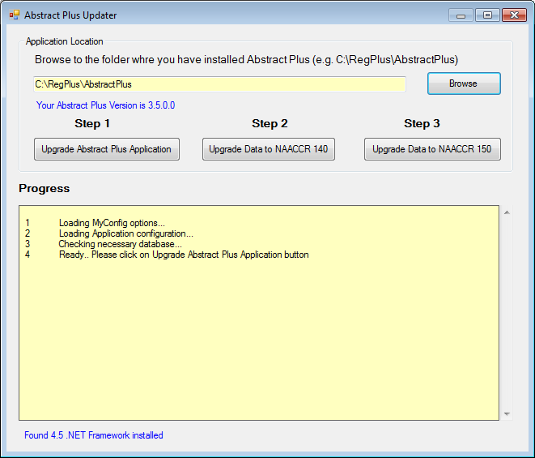

- There are three distinct tasks you have to accomplish. As you can see on Updater window, these are marked clearly by Step 1, Step 2, and Step 3. Please perform task sequentially.
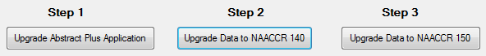
Step 1: You will apply update that is necessary to upgrade to Abstract Plus 3.5 which use NAACCR 150
Step 2: You will convert Abstracts from NAACCR Version 130 to NAACCR 140
Step 3: You will convert Abstracts from NAACCR Version 140 to NAACCR 150

2.1 Step 1
- Now, click on “Upgrade Abstract Plus Application” button
- You will be promoted with the following message.
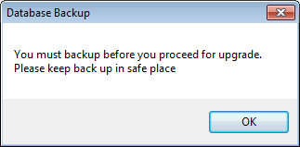

- Critical Step: At this point updater program is about take backup of MDBS file. Make sure you keep this copy in safe place. This backup comes handy if we need to restore data back to previous version.

- On Database Backup message prompt, click on OK.
- You will notice the following folder browser screen.
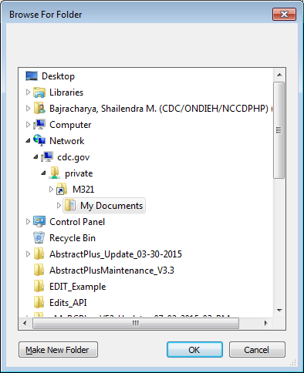

- Critical Step: Make sure you choose safe place to put backup. (E.g. My Document). If necessary click on “Make New Folder” to create subfolder to put backed up database file in Zip format.
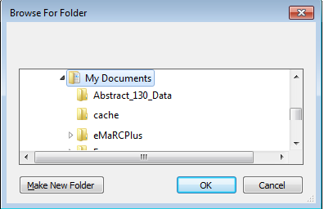

In this example, I have created “AbsPlus_130_Data” inside My Document folder to keep my backup

- Once Application completes, you will see the following message.
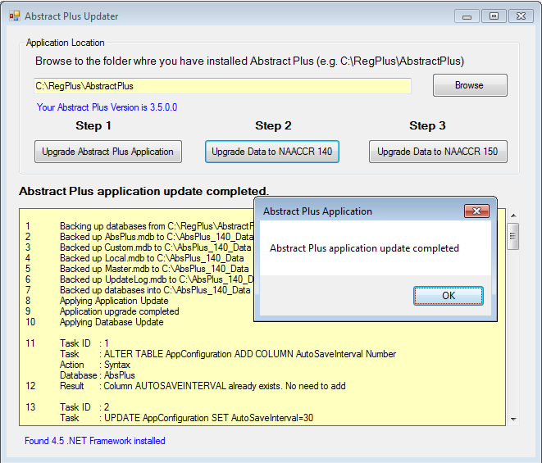

- Click on OK
- If you scroll update information text area, you will notice up to Task 21
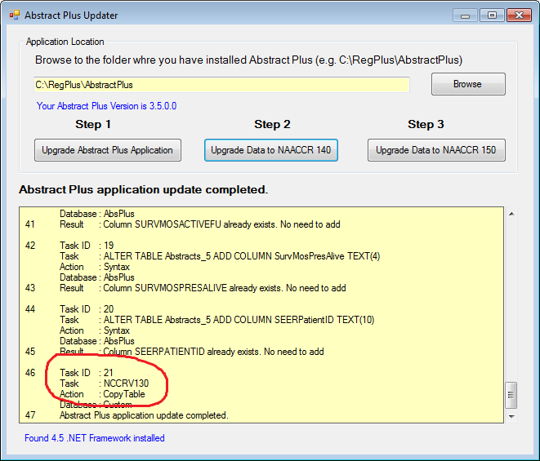
- At this point your application upgrade is complete.
But you are NOT done with converting Abstracts to NAACCR 140, and then NAACCR 150 format. See Step 2 and 3

2.2 Step 2
- Click on “Upgrade Data to NAACCR 140” button. You will notice the following window.
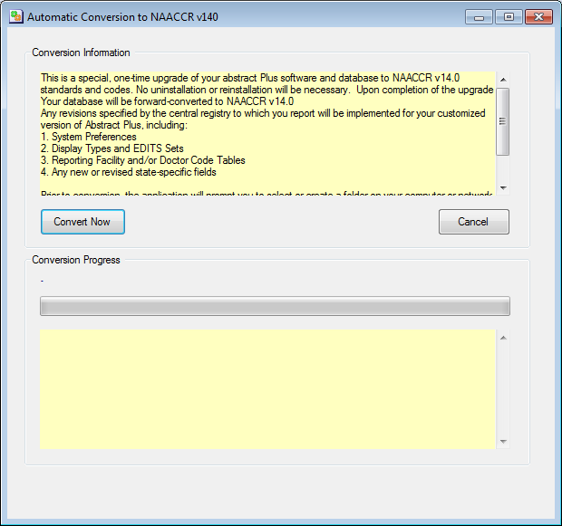

- Click on “Convert Now” button.
- You will see progress bar moving while performing conversation. Let it convert Abstracts. You will notice Conversion completed message.
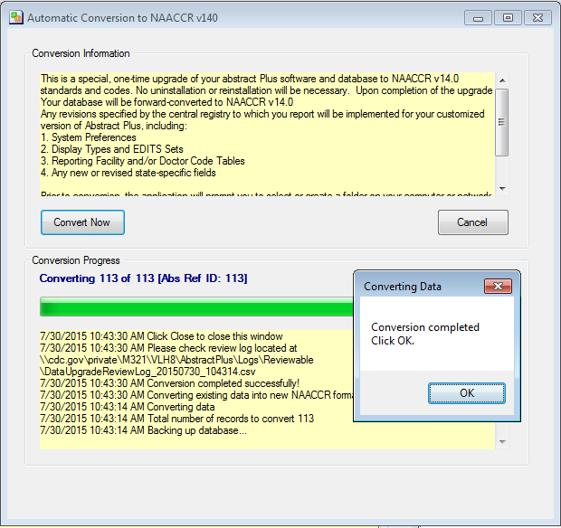
- Click on “OK”.
- Click X button to close “Automatic Conversation to NAACCR v140” window.
- You are not DONE yet. Please go to Step 3

2.3 Step 3
- Click on “Upgrade Data to NAACCR 150” button. You will notice the following window.
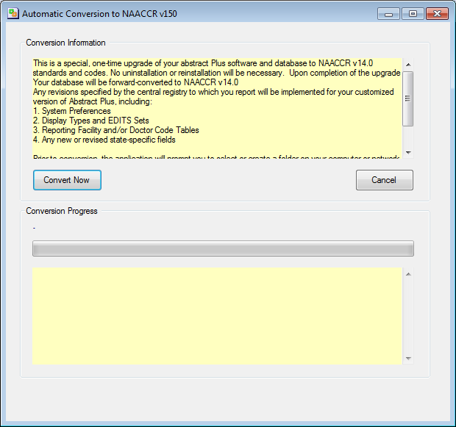
- Click on “Convert Now” button.
- You will see progress bar moving while performing conversation. Let it convert Abstracts. You will notice Conversion completed message.
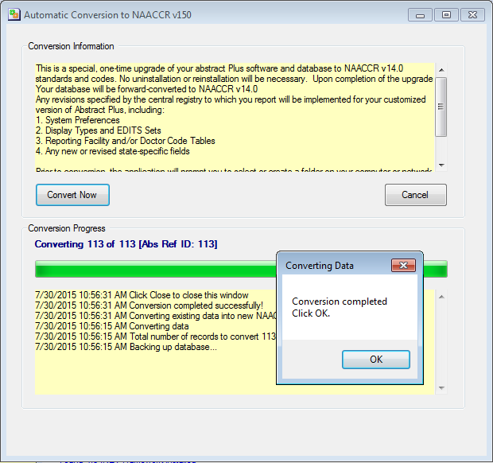
- Click on “OK”.
- Click X button to close “Automatic Conversation to NAACCR v150” window.
- Click X button to close “Abstract Plus Updater” screen
- Now you are done necessary Abstracts conversations.

Things you should know

3.1 Backed up databases
In Step 1, you were asked to put database backups in proper place. If you check the folder where you kept your backups, you will see zipped files similar to shown below in picture. Please keep these backup in safe place until we upgrade for next year.
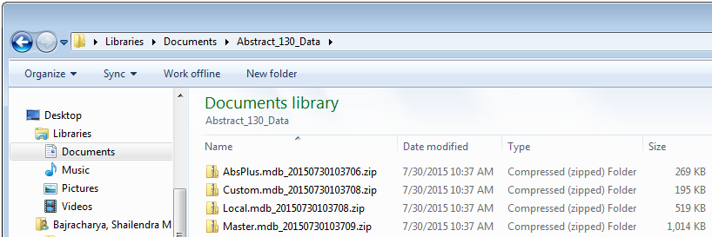

Opening Abstract Plus after upgrading
Now you can open Abstract Plus as you normally would. You will be using the same user name and password that you have been using.
You will notice Abstract Plus splash screen with version information, and login screen as shown below
