Abstract Plus 3.5 Installation Guide
Centers for Disease Control and Prevention
National Center for Chronic Disease Prevention and Health Promotion
Division of Cancer Prevention and Control
National Program of Cancer Registries
Registry Plus Software for Cancer Registries

Abstract Plus 3.5 Installation Guide

Contents
1. About Abstract Plus 3.5 with NAACCR Version 15.0 Abstract Plus 3.5 has several enhancements, bug fixes and new features. 2
2. Installing Abstract Plus 2
2.1 Installing Abstract Plus on Default location 2
2.2 Installing Abstract Plus under Program Files folder. 5
2.3 Setting up Full Control Folder Permission on Application folder and MDBS folder 9
3. Opening Abstract Plus for the first time 13
4. Logging in to Abstract Plus for the very first time 14

About Abstract Plus 3.5 with NAACCR Version 15.0
Abstract Plus 3.5 has several enhancements, bug fixes and new features.

Installing Abstract Plus
Abstract Plus can be installed on the default location or any desired location. We have been using C:\RegPlus\AbstractPlus as default installation location for several years.
IT protocol and Microsoft guideline encourage to install any program under Program Files folder. The recommended folder for installing Abstract Plus under Program File can be one of the following:
(a) 32 Bit Computer, you will notice “C:\Program Files\RegPlus\AbstractPlus\
(b) 64 Bit Computer, you will notice “C:\Program Files (x86)\RegPlus\AbstractPlus\

2.1 Installing Abstract Plus on Default location
- Unzip installation file provided to you. You will notice two different files, similar to shown on image below.
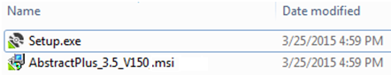
- Double Click on Setup.exe file. You will see “Welcome to the Abstract Plus Setup Wizard” window.
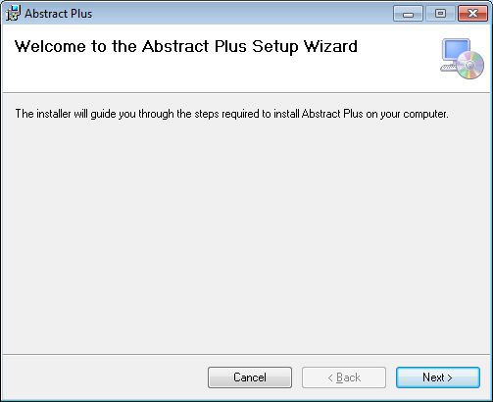

- Click on Next, you will see the “Select Installation Folder” window
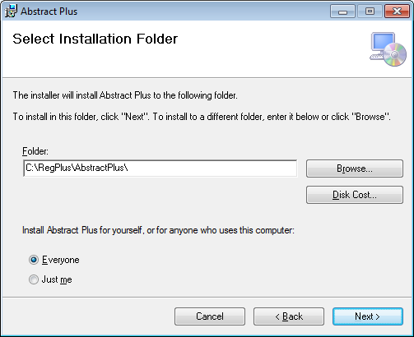

- Click on Next, you will see the “Confirm Installation” window.
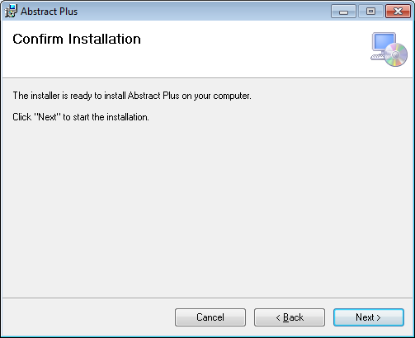

- Click on Next, you will see the “Installing Abstract Plus” window with progress bar.
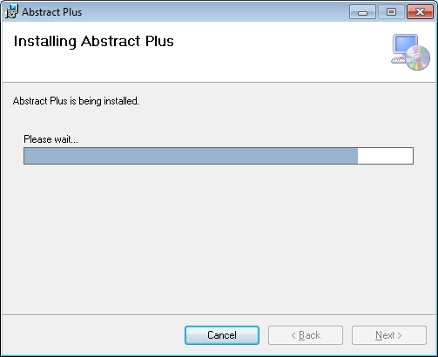
- You will see “Installation Complete” window.
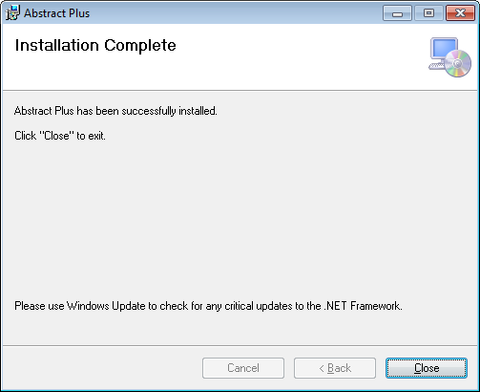

- Click on Close. Installation is complete.

2.2 Installing Abstract Plus under Program Files folder.
IT protocol and Microsoft guideline encourage us to install any program under Program Files folder. The recommended folder for installing Abstract Plus under Program File can be one of the following:
(a) 32 Bit Computer, you will notice “C:\Program Files\RegPlus\AbstractPlus\
(b) 64 Bit Computer, you will notice “C:\Program Files (x86)\RegPlus\AbstractPlus\
- Unzip installation file provided to you. You will notice two different files, similar to shown on image below.
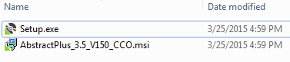
- Double Click on Setup.exe file. You will see “Welcome to the Abstract Plus Setup Wizard” window.

- Click on “Next”. You will see “Select Installation Folder” Window.
If you are using 32 Bit Computer, you will notice “C:\Program Files\RegPlus\AbstractPlus\
If you are using 64 Bit Computer, you will notice “C:\Program Files (x86)\RegPlus\AbstractPlus\
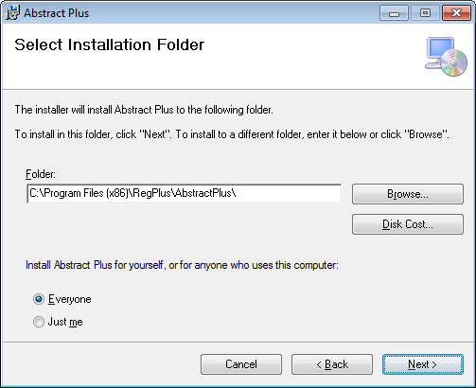
- Click on “Next” You will see “Confirm Installation” Window.
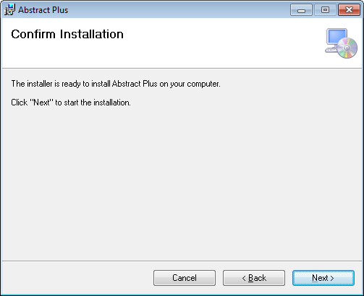

- Click on “Next” You will see “Installing Abstract Plus” Window.
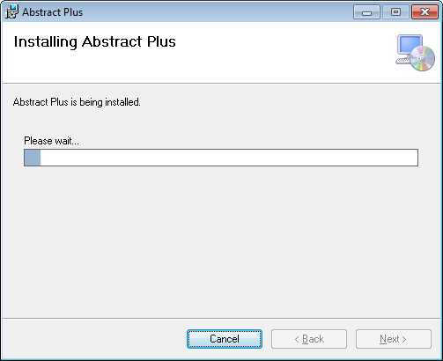

- You will see “Installation Complete” Window as shown below.

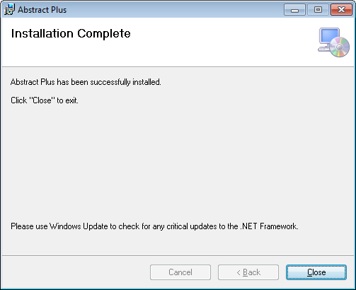

- Click on Close button
- We are NOT done here. Please read next step about MyConfig.cfg file

- Now open MyConfig.cfg file in Notepad or any text editor of your choice. This file configuration file is located in “C:\Program Files (x86)\RegPlus\AbstractPlus or “C:\Program Files\RegPlus\AbstractPlus
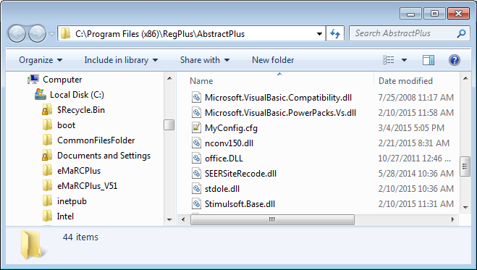

- Now open MyConfig.cfg file in Notepad or any text editor of your choice.
Now change OptionValue for AccessDatabasePath to C:\Program Files (x86)\RegPlus\AbstractPlus\MDB

Then save and close configuration file.
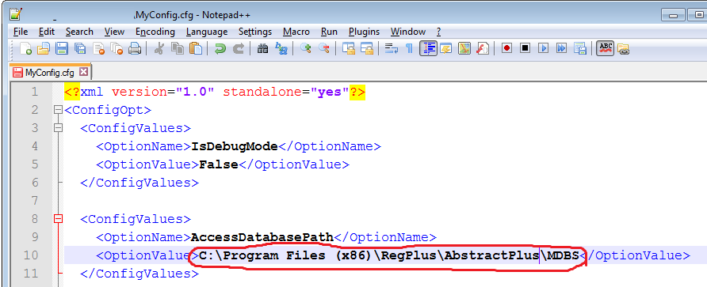
Note:
In above example, the database of Abstract Plus is also located in application folder. We highly recommend that you should put entire MDBS folder that you find in installation folder to some secure network folder. If you move MDBS to different folder (e.g. N:\AbstractPlus_MDBS) then OptionValue for AccessDatabasePath would be also N:\AbstractPlus_MDBS

2.3 Setting up Full Control Folder Permission on Application folder and MDBS folder
User must have Full Control permission to Write/Read on the application folder, and wherever MDBS file are located if it is not located inside Application Folder.
If you keep these file under Users’ My Documents, permission will not be issue as this is the users’ private folder.
If you keep the MDBS file in another location such as a Network Drive (As shown on above example) then the user must have Full Permission to read/write to the folder.
How to Grant Full Control permissions in Windows 7
- Locate the folder Application folder (C:\RegPlus\AbstractPlus or C:\Program Files\RegPlus\AbstractPlus etc.)
- Right click on file or folder and select “Properties” from Context Menu
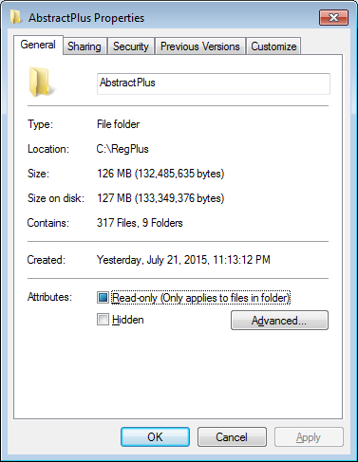

- Click on Security Tab
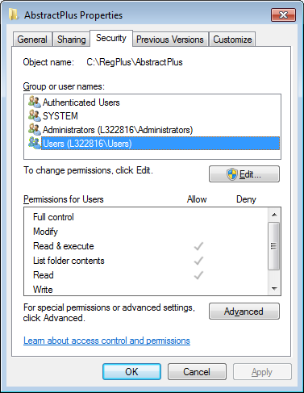
- Click on “EDIT” button
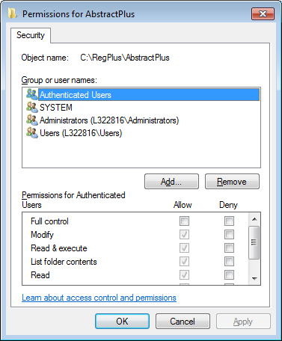

- Select user/group from permission windows or click add to add other user or group.
- Under the Permission section, check the rights which you want to grant, i.e. check “Full Control” under the “Allow” column to assign full access rights control permissions to Administrators group.
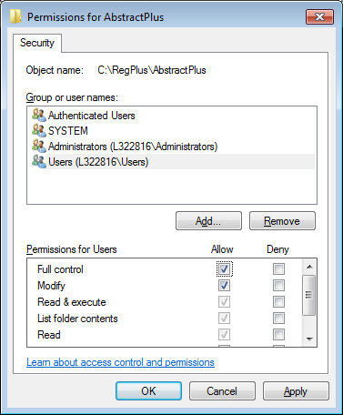
- Click Ok for changes to take effect
- Click Ok again to exit Properties window.
- You can now access files of folder in windows 7 with full permissions.

Opening Abstract Plus for the first time
- Upon opening Abstract Plus for the first time, you will be ask to create User.
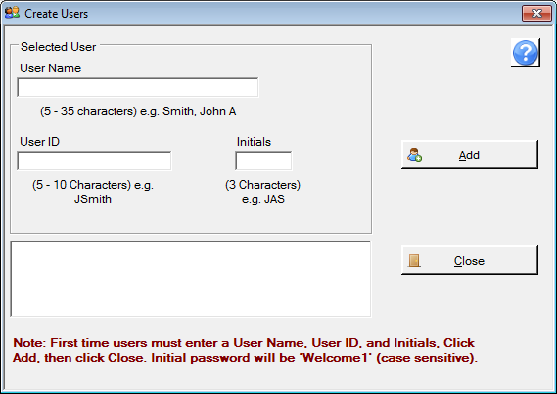
- Complete information as shown below
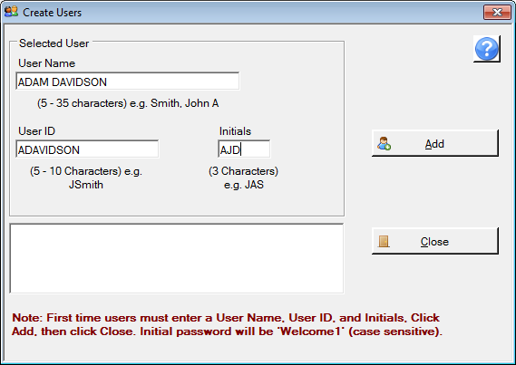

- Click the “Add” button. You will see user info is added. Repeat above step if you have more than one user who will use the same computer to access Abstract Plus.
The default password for each user will be Welcome1. Each user will be asked to change their password on their first login.
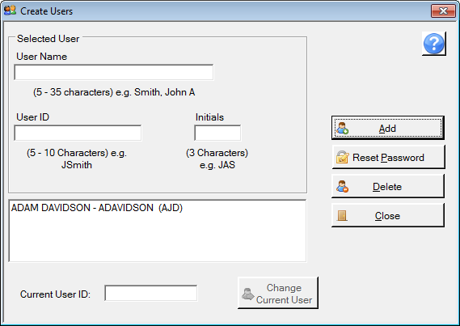
- Click on Close button

Logging in to Abstract Plus for the very first time
- Use your login info. Remember your default password is Welcome1
Password is case sensitive.
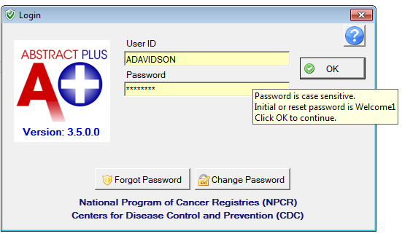
- You will be prompted with Password Criteria
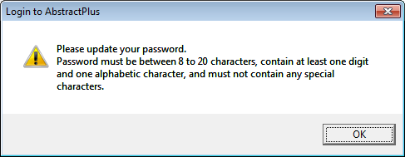

- Click on OK
- You will notice New Password screen
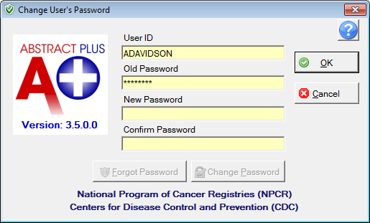
- Fill in new password. Make sure your new password meets the Password Criteria

- Now you will be asked to set security questions. These questions and answers will be used if the user forgets their password.
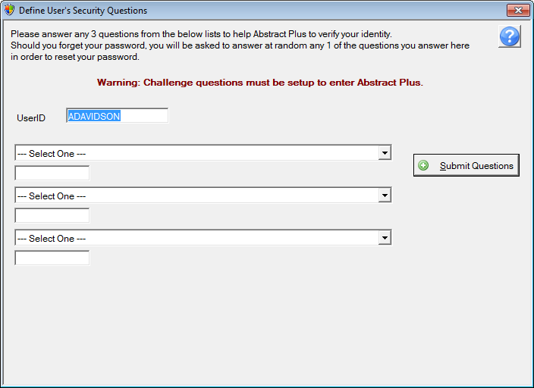

- Choose any three question and provide the answers
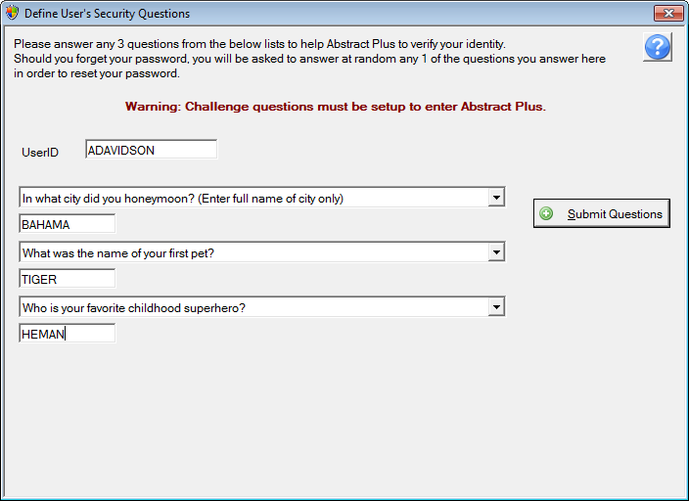

- Click the “Submit Questions” button.
- You will be taken to the main Abstract Plus window as shown below.

