
Abstract Plus™ Training
Manual for Abstractors
Version 7.0
(Based on Abstract Plus Version 3.5, NAACCR v15.0)
Centers for Disease Control and Prevention
National Center for Chronic Disease Prevention and Health Promotion
Division of Cancer Prevention and Control
National Program of Cancer Registries
Registry Plus™ Software for Cancer Registries

Contents
Chapter 1: Introduction 1
Overall Learning Objectives 1
Overview of the Abstract Plus Abstractor Training Manual 1
Abstract Plus Features 1
Abstract Plus User Roles 2
System Requirements 3
Downloading and Installing Abstract Plus 4
Launching Abstract Plus 5
User Support 5
Chapter 2: Abstract Plus General User Basics 6
Learning Objectives 6
Overview 6
Logging In 6
Creating a User Account upon Initial Access and First-Time Log In 7
Routine Log In 13
Activity 1 – Logging in to Abstract Plus 15
The Abstract Plus Main Window 15
The File Menu 16
The Administration Menu 17
The Auditor Menu 18
The Utilities Menu 19
The Reports Menu 20
The Options Menu 21
The Help Menu 22
Abstract Plus Abstracting and Editing Features 23
The Abstract Plus Abstracting Process 23
The Abstract Plus Abstracting Window 23
Data Quality Edits and Error Resolution Features 25
Changing Your General User Password 25
Possible Errors when Changing Your Password 27
Resetting a Forgotten Password 28
Updating Personal Security Questions 30
Abstract Plus Auto-update Feature 31
Benefits of the Auto-update Feature 32
No Uninstall and Re-install of Abstract Plus is Necessary 32
No Loss of Data is Possible 32
Auto-updates can be Implemented Automatically or Manually 32
Automatic Detection of Available Updates for Customized Versions 33
Auto-updates can be Distributed and Implemented Locally (No Internet Connection Required) 33
Automatic Updates for Users Who Have Not Updated on a Regular Basis 34
User is Notified When the CDC FTP Site is Experiencing Issues 34
User is Notified When No Updates are Available 34
Checking for Software Updates via the Internet 34
Applying Software Updates Locally 35
Viewing Software Update History 39
Exiting Abstract Plus and Using the Backup Option 39
Using the Restore Option 43
Questions 45
Chapter 3: Working with Abstracts 46
Learning Objectives 46
Overview 46
Importing Abstracts 46
Activity 2 – Importing Abstracts 51
Creating a New Abstract 51
The Abstract Plus Abstracting Window 52
Entering Dates in Abstract Plus 58
Activity 3 – Creating a New Abstract and Abstracting Patient Information 58
Questions—Creating Abstracts 60
Entering Information into Text Fields 61
Activity 4 – Entering Text Fields 61
Activity 5 – Abstracting Cancer Information 62
Abstracting Histologic Type 62
Activity 6 – Abstracting Histologic Type 64
Saving Abstracts 66
Correcting Edit Errors 67
Activity 7 – Correcting Edit Errors 70
Abstracting and Deriving Collaborative Staging Fields 71
Abstracting CS Input Fields 71
Abstracting CS SSFs 72
Calculating Derived CS Fields 73
CS Fields and Tumors Diagnosed 2003 and Earlier 74
Activity 8 – Abstracting and Deriving Collaborative Staging Fields 74
Questions---Abstracting and Saving Information 81
Completing Abstracts 81
Closing Abstracts 81
Activity 9 – Completing and Closing an Abstract 82
Searching for and Opening an Existing Abstract 85
Copying an Abstract 88
Activity 10 – Finding, Opening, and Copying an Abstract 90
An Aside on Abstract Plus “Projects” 90
Questions---Completing, Finding, and Copying Abstracts: 91
Exporting Abstracts 91
Printing Abstracts 98
Printing an Open Abstract 98
Printing a Range of Abstracts 99
Questions---Exporting and Printing Abstracts: 101
Chapter 4: Using Abstract Plus Utilities 102
The Doctor Query System 102
Managing Facility Codes 103
Managing Doctor Codes 106
Deleting Abstracts 109
Using the Notepad Function 112
Questions---Using Abstract Plus Utilities 114
Chapter 5: Running Reports 115
Learning Objectives 115
Overview 115
Available Reports 115
Opening Reports 115
Viewing Reports – The Report Viewer Window 116
The Main Toolbar 116
Page Navigation Controls 117
The Search Toolbar 118
Page View Controls 118
Saving Reports 119
Accession Register Report 120
Patient Index Report 122
Selected Cases Report 123
Status Report (Count of Cases) Summary 125
Completion Status of Abstracts by Month 127
Running Custom Reports 128
Questions 129
Chapter 6: Appendix A: Answers to Chapter Questions 130
Chapter 7: Appendix B: Standard Keyboard Shortcuts 133
Chapter 8: Appendix C: Flowchart for Hematopoietics 134

Introduction

Overall Learning Objectives
These are the overall learning objectives for this Abstract Plus training manual for Abstractors:
- Learn how to Log in into Abstract Plus
- Learn about the Abstract Plus menu items
- Become familiar with the basic steps for abstracting using Abstract Plus
- Learn how to begin abstracting by starting a new abstract, opening an existing abstract, or copying an existing abstract
- Become familiar with the abstracting features of Abstract Plus, including entering text fields, coding histologic type, and coding and deriving Collaborative Staging fields
- Learn about the Abstract Plus editing features and how to correct edit errors
- Learn how to print abstracts
- Learn how to export abstracts out of Abstract Plus
- Become familiar with Abstract Plus Utilities
- View, print, and save available abstract reports, and run custom reports

Overview of the Abstract Plus Abstractor Training Manual
The Abstract Plus Abstractor Training Manual provides you with the information to understand and use the abstracting features of Abstract Plus. This manual describes the functions available to the Abstractor. The major sections include logging in to Abstract Plus, abstracting information, editing abstracted information, completing abstracts, exporting abstracts, using utilities, and viewing abstract reports. Also, each chapter contains questions that test your knowledge of the Abstract Plus abstracting features and activities that allow you to practice your new skills on your own.

Abstract Plus Features
Abstract Plus is a free-of-charge, cancer data collection tool developed by the Centers for Disease Control and Prevention (CDC) that supports two main functions: abstracting and auditing. The application can be customized by central cancer registries to be used centrally, as well as for distribution to and use by hospitals and other reporting sources. Although the product is not designed to include all functionality needed in an American College of Surgeons (ACoS)-approved hospital cancer registry, it is suitable for reporting to central registries from non-registry hospitals, clinics, laboratories, and other sources for cancer incident reports. The program can also be used for special projects and start-up registries.
The abstracting capability of Abstract Plus is used to summarize medical records into an electronic report of cancer diagnosis and treatment by abstractors or anyone working with cancer data. Abstract Plus supports the abstraction of all data items in national standard data sets, including all text fields, as well as any state-specific data items. The output of Abstract Plus is an electronic abstract in the format of the North American Association of Central Cancer Registries (NAACCR) data exchange layout or an Excel file of all data items including system fields.
Abstracts entered into Abstract Plus are validated by customizable edits, allowing for interactive error correction while abstracting. Abstract Plus includes Registry Plus Online Help, a collection of standard coding manuals that are cross-referenced, indexed, and context-linked to minimize the need for reference to printed manuals during abstracting.
The all-new auditing capability included in Abstract Plus allows central registries to use the program to perform case completeness and data quality audits of reporting facilities, as well as data quality audits of central registry abstractors. For assessing case completeness, casefinding audits are available, and for assessing data quality, both reabstraction and recoding audits are available. The application allows for either blinded or un-blinded reabstraction audits, and for recoding audits, un-blinded submitted text can be recoded for both reporting facilities as well as central registry abstractors.
Please note that due to development priorities, Abstract Plus is being released without the Auditor features; description of Auditor features provided in this manual is for informational purposes only. The Auditor features of Abstract Plus will be released in a future version of the program.
Abstract Plus is programmed using .NET technology. The application has a user-friendly abstracting interface, including direct grid entry of coded values for a streamlined abstracting experience, as well as easy viewing of text fields, online help, and edit errors.
Abstract Plus also has enhanced security features. All records are saved in Microsoft Access or SQL server databases, and all tables are password protected and encrypted using Microsoft functions. All users must have a User ID and password to access the abstracting features of the application, and access to administrative and auditor functions requires the entry of special restricted passwords. A security challenge question feature is also included in case a user forgets his or her password, which enables the user to securely reset their password without administrator intervention.

Abstract Plus User Roles
Abstract Plus users consist of abstractors, central cancer registrars, and other individuals or groups who work with cancer data. Abstract Plus includes 3 types of users, or roles:
User | Description
Abstractor/  General User | The Abstractor or general user manages data entry and has access to all of the abstracting features of the program.  Abstractors can add new abstracts, edit existing abstracts, copy, print, and delete abstracts, and can import and export abstracts in NAACCR file format. Abstractors can also view available reports and update their password and personal security challenge questions.  All Abstractors must have a user account, and log in to the application using a User ID and password.
Auditor | The Auditor manages audit entry and reporting and has access to all of the abstracting features of the program described above for the general user; however, Auditors also have access to all of the auditing features of the program.  Auditors can open and close audits, and perform casefinding, reabstraction, and recoding audits (including pre- and post-reconciliation tasks), and run available audit reports. Auditors can also export newly identified tumors in NAACCR file format from casefinding efforts, and can export completed reabstraction and recoding audits.  All Auditors must have a general user account, and log in to the application using a User ID and password. Auditors access auditing functions using a special Auditor password.
Administrator | The Administrator manages the setup of the program and has access to all of the abstracting features of the program described above for the general user and all of the auditing features available to the Auditor; however Administrators have access to additional administrative features of the program. They can perform administrative functions such as managing the Administrator password, creating and modifying general user accounts, specifying application preferences, creating and managing abstracting display types, managing Type M records, and creating and managing audit display types, discrepancy codes and databases.  All Administrators must have a general user account, and log in to the application using a User ID and password. Administrators access administrative functions using a special Administrator password. Entry of the Administrator password also allows access to all auditing functions (i.e., entry of the Auditor password is not required for Administrators).

System Requirements
Abstract Plus is programmed for the Microsoft Windows 32-bit environment installed on an Intel Pentium or Pentium-compatible computer. The minimum hardware requirements are the same as those of the Microsoft Windows operating system used. Additional system requirements include:
- Microsoft operating system from Windows XP and higher
- 128 MB RAM (512 MB minimum recommended)
- Latest version of Microsoft Internet Explorer (recommended)
- The available hard-disk space requirement for Abstract Plus depends on the number of abstracts that will be created and maintained in the database. A minimum of 70 MB of free hard drive space is required.

Downloading and Installing Abstract Plus
A generic (non-customized) version of Abstract Plus is available from the CDC’s Registry Plus Web site (http://www.cdc.gov/cancer/npcr/). This Web site provides a fully documented generic installation and version enhancement information.
Please note, however, most users will require a customized version of the software set up to meet requirements and procedures of a specific locale, usually a state, or for a specific study. Potential users of Abstract Plus should contact their state central cancer registry staff first to inquire about their customized version and for support. State registry contact information can be found at the National Program of Cancer Registries Web site: http://nccd.cdc.gov/dcpc_Programs/default.aspx?NPID=3.
You must have administrative privileges to your computer in order to install Abstract Plus. Contact your system administrator to install the program if you do not have administrative privileges.
To download and install Abstract Plus, complete these steps:
- Open your Internet browser and type in the following URL for the NPCR web site in the address field: http://www.cdc.gov/cancer/npcr/ and press Enter.
- In the NPCR section on the left, Click Software and Tools.
- In the Registry Plus™—Software Programs for Cancer Registries section, click the Abstract Plus link.
- Click the Technical Information and Installation link.
- Read the information provided in the section Installing and Upgrading Abstract Plus.
- To download the latest version of Abstract Plus, click the link to the latest .exe file. Click Run on the displayed page and follow all the prompts to download and install Abstract Plus.
 | If you have Abstract Plus 3.4 installed on your computer, and would like to upgrade to Abstract Plus version 3.5, NAACCR v15.0-based software, there is no automatic upgrade available. Do not uninstall your current version. to upgrade to Abstract Plus version 3.5, NAACCR v15.0-based software, complete the following steps:  - Make a copy of your C:\RegPlus\AbstractPlus\MBDS folder, and place the copy in a known, secure location on the computer other than in the C:\RegPlus\AbstractPlus folder.  - Export all abstracts out of your current Abstract Plus version 3.4, NAACCR 14.0 software.  - Un-install the Abstract Plus version 3.4, NAACCR 14.0 software.  - Delete the C:\RegPlus\AbstractPlus folder on your computer.  - Install the Abstract Plus version 3.5, NAACCR 15.0 software.  Note: By default, the application gets installed under the “Program Files” folder and the databases are created under the user’s My Documents Folder.  - Create a user account and import the abstracts that you exported from your Abstract Plus version 3.4, NAACCR 14.0 software (abstracts will be converted to NAACCR version 15.0 upon import).

Launching Abstract Plus
Once installed, you can launch Abstract Plus:
- From the Start menu, select All Programs, Registry Plus, Abstract Plus, and then Abstract Plus.

User Support
For technical support via e-mail, contact cancerinfo@cdc.gov.
The CDC Registry Plus Development group is funded primarily to support NPCR-funded state central cancer registries. As a result, CDC helps state central cancer registries set up the software and perform basic customizations. CDC also provides periodic software updates and problem-solving to the extent of available resources. CDC does not provide on-site services, and does not support hospitals, clinics, laboratories, or other private users.
Abstract Plus is intended for redistribution to cancer reporters after customization by the central registry. The state central registry or other institution redistributing Registry Plus software should provide all support to end users.
State registry contact information can be found at the National Program of Cancer Registries Web site: http://nccd.cdc.gov/dcpc_Programs/default.aspx?NPID=3.
Other users of Abstract Plus will need to independently understand and maintain the software application.

Abstract Plus General User Basics

Learning Objectives
In this chapter, you will learn to:
- Create your own user account upon initial access to the program
- How to address first-time log in and routine log in to Abstract Plus as an Abstractor/general user
- Familiarize yourself with the Abstract Plus main window and identify Abstract Plus abstracting menu options
- Change your general user password
- Reset your password if forgotten, by answering your security challenge questions
- Update your security challenge questions and answers after initial set up
- Check for software updates over the Internet and view software update history
- Exit Abstract Plus and use the Backup option
- Use the Restore option to restore your abstracts database if corrupted

Overview
This chapter covers the basics of logging in to and out of Abstract Plus. It includes a description of the process by which a user account is generated, how to log into Abstract Plus for the first time and how to address the security challenge questions presented upon initial log in, how to log in to Abstract Plus routinely using a user ID and password, how to maintain your general user password, how to check for software updates over the Internet and view your software update history, how to exit the application and use the Backup feature, and how to use the Restore feature to restore a corrupted abstracts database.

Logging In
After installing Abstract Plus, upon initial launch of the program, you will be prompted to create a new user account. You will then need to log in using the new login information you entered along with an initial password of Welcome1, change your password, and then answer security or “challenge” questions. Your answers to these questions will be used to validate your identity if you forget your Abstract Plus password---if you forget your password, Abstract Plus will ask you for the answers you provided to these security questions and then allow you to reset your password if the questions are answered correctly.
The creation of a user account is enabled for the general user only upon initial launch of the program. If other users already exist in your Abstract Plus application (i.e. the program has already been launched and user account(s) created), you will need to contact your Administrator to create a user account for you.
When logged in with your own user ID and password, you are recorded as the abstractor when conducting either general abstracting or auditing tasks (unless your Administrator has modified this system option). This information can be used as selection criteria for reports and exports, and can also be used for general tracking purposes to associate abstractors with their specific abstracts, and auditors with the audits that they have conducted.

Creating a User Account upon Initial Access and First-Time Log In
After installing Abstract Plus, if you are the first person to launch the program, you will be prompted to create a new user account. You will then be prompted to log in to Abstract Plus using your newly-created User ID and an initial password of Welcome1.
If other users already exist in your Abstract Plus application (i.e. the program has already been launched and user account(s) created), you will need to contact your Administrator to create a user account for you and obtain your User ID.
To create a new user account upon initial launch of the program, and log in to the application for the first time complete these steps:
- To launch the program, from the Start menu, select All Programs, Registry Plus, Abstract Plus, and then Abstract Plus.
Result: The Create Users window opens.
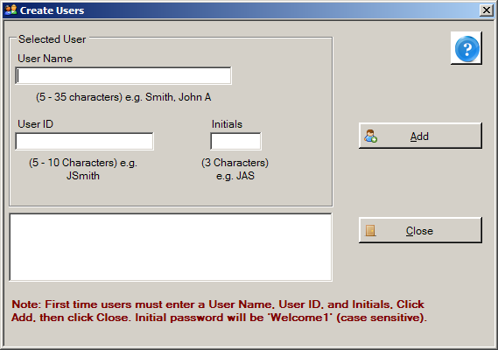

If your Administrator has already provided you with a User ID, go directly to step 7.
- Enter your full name in the User Name field. The format for name entry is last name, and then first name and middle initial, e.g., Smith, John A. In the example shown, the user name being entered has the last name USER, first name NEW, and middle initial A.
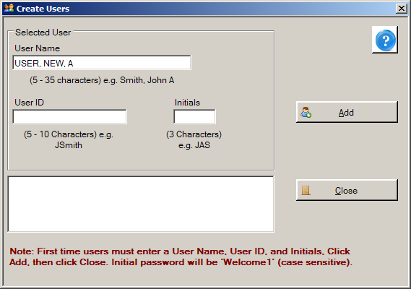
- Enter a User ID in the User ID field. User IDs can only be characters, and are 5-10 characters in length. In the future, you will enter your User ID when logging in to Abstract Plus. In the example shown, the User ID being entered is NUSER.
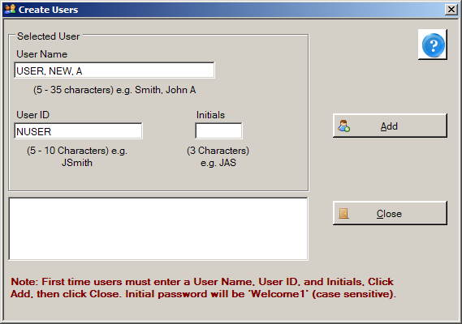
- Enter your initials in the Initials field. Your initials will be displayed on the main Abstract Plus window to indicate when you are logged in to the application, and may be automatically recorded in the Abstracted By field when abstracting abstracts or conducting audits if this application preference is enabled by your Abstract Plus Administrator. This information is recorded in order to associate abstractors with the abstracts they have generated, and auditors with the audits that they have conducted. In the example shown, the initials entered are NAU.
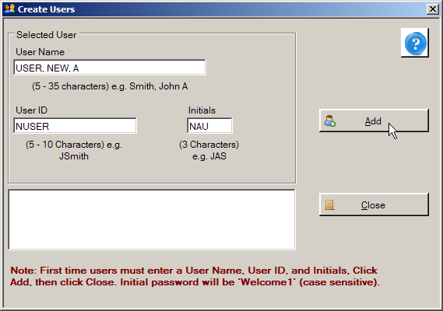
- Click Add.
Result: The system adds the new user account to the users list.
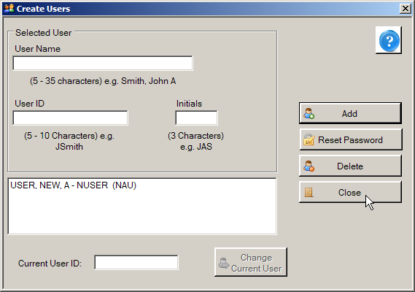
- Click Close.
Result: The Login window opens.
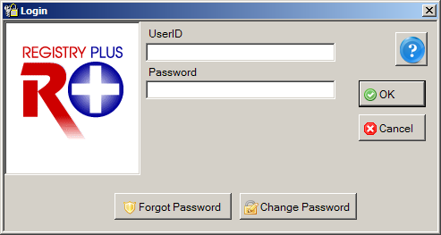
- Enter your User ID in the User ID field. In the example shown, the User ID of NUSER is being entered.
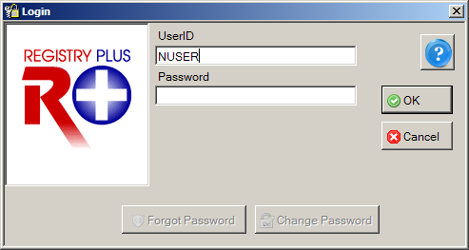
- Enter the default initial password of Welcome1 in the Password field.
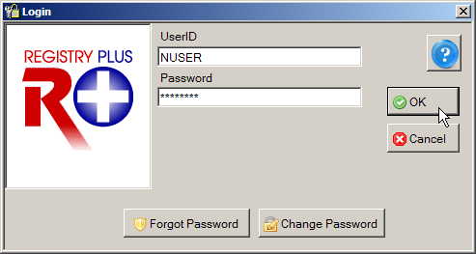
Welcome1
When entering your password, asterisks will be displayed rather than your password for added security. Note that passwords are case sensitive.
- Click OK.
Result: A Password Update message is issued that lets you know you need to change your password. This occurs upon initial log in only. When changing your password, you must change it to a password that meets the password requirements set by your Abstract Plus Administrator.
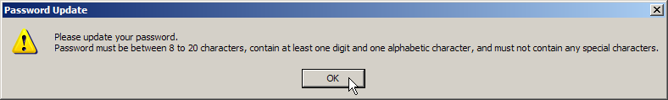
- Click OK.
Result: The Change User’s Password window opens, displaying your User ID and Old Password (which is Welcome1 at this point).
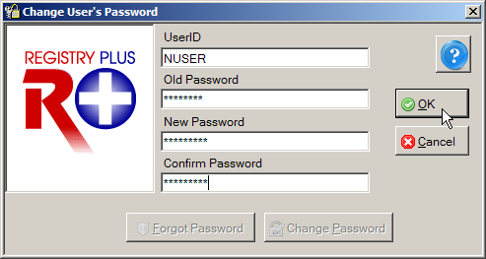
- Enter a new password in both the New Password and Confirm Password boxes, and click OK. You must type the same new password in both boxes.
If your Administrator has made no changes, by default, your new password must be between 8 and 20 characters, contain at least one digit and one alphabetical character, and must not contain any special characters.
Result: The Define User’s Security Questions window opens, with your User ID displayed.
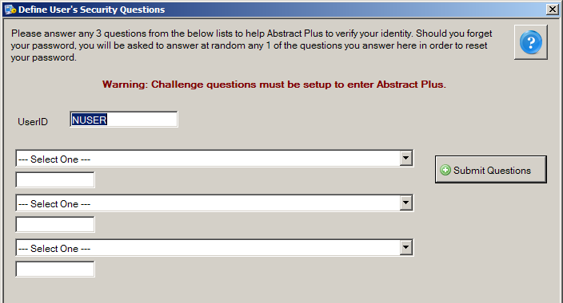
To complete your initial log in to Abstract Plus, you are required to select the specified number of security questions and answer them. The number of questions you will need to select and answer will depend on the number of security questions specified by your Abstract Plus Administrator when setting up Abstract Plus. Your answers to these questions will be used to validate your identity if you forget your general user Abstract Plus password. If you forget your password, Abstract Plus will ask you for the answers you provided to your chosen security questions, and then allow you to reset your password if the questions are answered correctly. If you forget both your password and your answers to your selected security questions, you will need to have your Abstract Plus Administrator reset your password.
- Select a question from the first drop-down list and enter your answer in the box below the question.
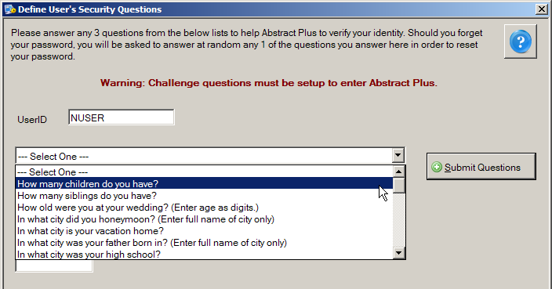
- Continue selecting questions and answering them until each question is answered.
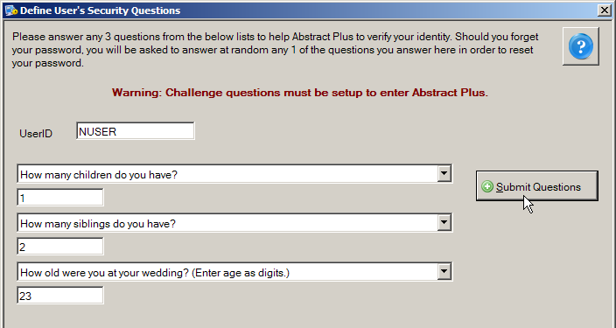
- Once all questions are selected and answers entered, click Submit Questions.
Result: The Abstract Plus main window opens, with you logged in as a general user. Note that your User ID is displayed at the bottom of the window.
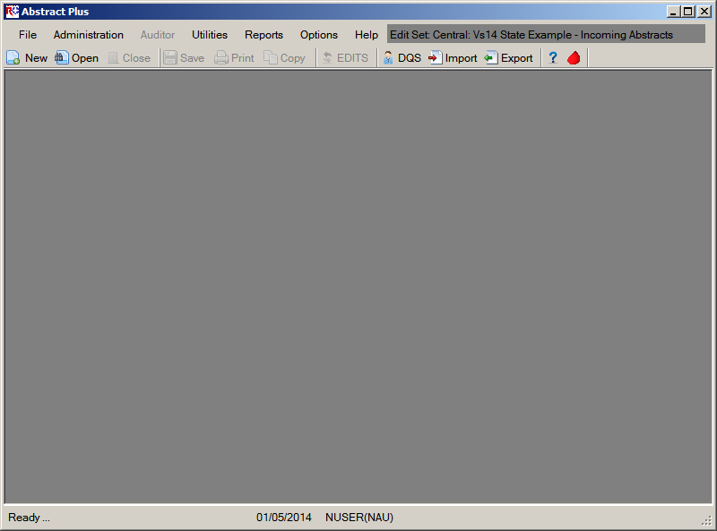

Routine Log In
After installation and initial log in to Abstract Plus, you will have a User ID and password for routine log in to your Abstract Plus general user account.
For routine log in to Abstract Plus, complete these steps:
- To launch the program, from the Start menu, select All Programs, Registry Plus, Abstract Plus, and then Abstract Plus.
Result: The Login window opens.
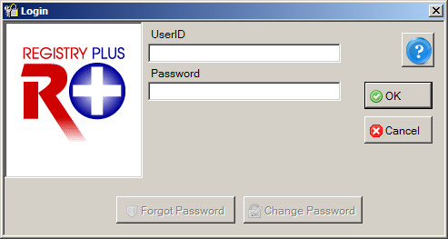
- Enter your User ID in the User ID box. In the example shown, the User ID being entered is NUSER.
- Enter your password in the Password box, and Click OK.
When entering your password, asterisks will be displayed rather than your password for added security. Note that passwords are case sensitive.
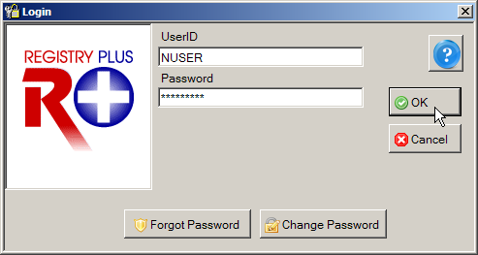
Result: The Abstract Plus main window opens, with you logged in as a general user. Note that your User ID is displayed at the bottom of the window.
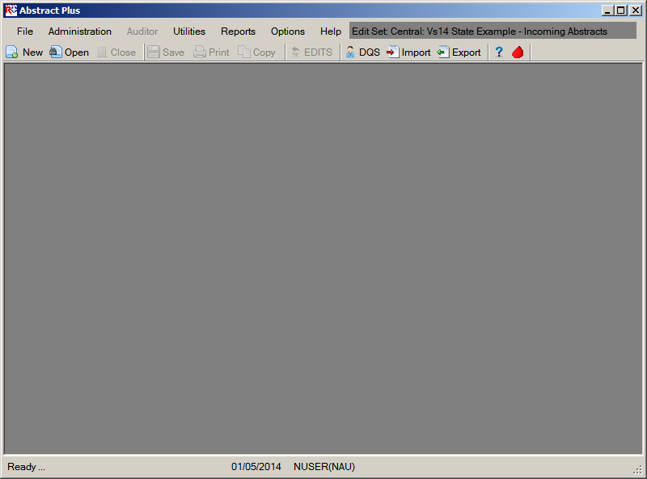
Activity 1 – Logging in to Abstract Plus
Using what you have just learned, launch Abstract Plus and log in to the application.
If you have not yet accessed the program, see page 7 of this manual or click here for instructions for initial login to the program.
If your Administrator has already set up a user account for you and provided you with a User ID, see page 13 of this manual or click here for instructions regarding routine login.

The Abstract Plus Main Window
The Abstract Plus main window provides access to all of the application’s features. Your User ID is displayed at the bottom of the window, and important system messages are displayed in the lower left-hand corner of the window. The default edit set is displayed in the upper right-hand corner of the window. When logged in as an Abstractor, you will automatically have access to all of the application’s abstracting features via the main menu items. Some menu options are also available as buttons in the toolbar as shown below. Access to Administrator and Auditor functions require entry of special passwords.
 | By default, Microsoft comes with sound effect features. One of those features is a “beep” feedback sound in response to pressing the tab or enter, etc. keys. If you do not like these sounds being issued as you use Abstract Plus, you can turn them off by going to Start→Control Panel→Sound→Sounds Tab→select Default Beep→select None from the Sounds pull-down menu→Click OK.  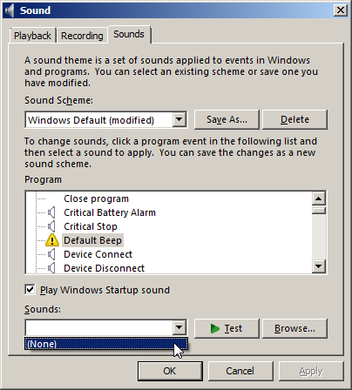

The File Menu
The File menu is used to access the majority of features that are used to work with abstracts. To access the File menu items, click on the File menu item, and select the desired sub-option, or use the appropriate keystroke combination for the desired sub-option.
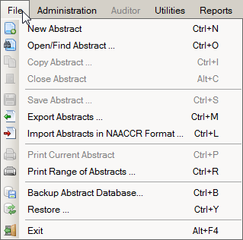
The following table describes the Abstract Plus File menu sub-options:
Sub-option (Keystroke) | Toolbar Icon | Function
New Abstract (Ctrl+N) |  | Create a new abstract
Open/Find Abstract… (Ctrl+O) |  | Search for and open an existing abstract
Copy Abstract… (Ctrl+I) |  | Copy an open abstract
Close Abstract (Alt+C) |  | Close an open abstract
Save Abstract… (Ctrl+S) |  | Save entered information
Export Abstracts… (Ctrl+M) |  | Export abstracts out of the Abstract Plus database into a NAACCR-formatted file
Import Abstracts in NAACCR Format… (Ctrl+L) |  | Import abstracts in a NAACCR-formatted file into the Abstract Plus database
Print Current Abstract (Ctrl+P) |  | Preview the displayed abstract and/or print it
Print Range of Abstracts… (Ctrl+R) |  | Select and print a range of abstracts or save in a file
Backup Abstract Database (Ctrl+B) |  | Create backup database to be used by Restore feature if database becomes corrupted
Restore… (Ctrl+Y) |  | Restore/replace corrupted database with a previously saved backup database
Exit (Alt+F4) |  | Log off Abstract Plus with an option to back up the database with your work

The Administration Menu
The Administration menu is used to access the administrative features of the program, such as managing user accounts and setting up the application for abstraction and auditing. No toolbar icons are available for any Administration menu options. To access the Administration menu items, click on the Administration menu item, and select the desired sub-option, or use the appropriate keystroke combination for the desired sub-option.
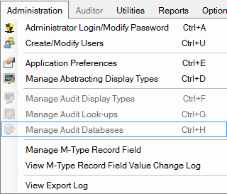
Entry of a special Administrator password is required in order to access the Administration menu items; the application will prompt you for the Administrator password when you attempt to access any of the Administration menu items. Please see the Abstract Plus Training Manual for Administrators for more information regarding Abstract Plus Administrator functions.
The following table describes the Abstract Plus Administration menu sub-options:
Sub-option (Keystroke) | Function
Administrator Login/Modify Password (Ctrl+A) | Log in as Administrator or change the Administrator password
Create/Modify Users (Ctrl+U) | Add, edit, or delete a user account or reset a password
Application Preferences (Ctrl+E) | Maintain all general, security, database and report application settings
Manage Abstracting Display Types (Ctrl+D) | Create, edit, or delete display types available for the abstracting features
Manage Audit Display Types (Ctrl+F) | Create, edit, or delete display types available for the auditing features (currently disabled)
Manage Audit Look-ups (Ctrl+G) | Maintain special audit lookup tables (currently disabled)
Manage Audit Databases (Ctrl+H) | Create, edit, or delete audit databases (currently disabled)
Manage M-Type Record Field | Select variables that will trigger the creation of an M record.
View M-Type Record Field Value Change Log | View log of M record changes
View Export Log | View log of exported abstracts

The Auditor Menu
The Auditor menu is used to access all of the available auditing features, such as opening and closing audits, and performing casefinding, reabstraction, and recoding audits. No toolbar icons are available for any Auditor menu options. To access the Auditor menu items, click on the Auditor menu item, and select the desired sub-option, or use the appropriate keystroke combination for the desired sub-option.
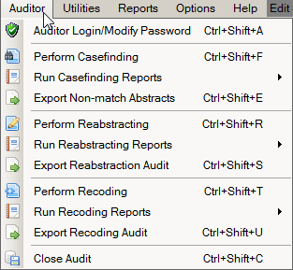
Entry of a special Auditor password is required in order to access the Auditor menu items; the application will prompt you for the Auditor password when you initially access any of the Auditor menu items. Note: If the Administrator password has already been entered, entry of the Auditor password is not required; Administrators automatically have access to all auditing features.
Please note that due to development priorities, Abstract Plus is being released without the Auditor features; description of Auditor features provided in this manual is for informational purposes only. The Auditor features of Abstract Plus will be released in a future version of the program.

The following table describes the Abstract Plus Auditor menu sub-options:
Sub-option (Keystroke) | Function
Auditor Login/Modify Password (Ctrl+Shift+A) | Login as Auditor, and/or modify Auditor password
Perform Casefinding (Ctrl+Shift+F) | Perform a casefinding audit on opened audit
Run Casefinding Reports | Run casefinding audit pre-reconciliation and final reports
Export Non-match Abstracts (Ctrl+Shift+E) | Export unreported tumors found upon casefinding audit in NAACCR file format
Perform Reabstracting (Ctrl+Shift+R) | Perform a reabstracting audit on opened audit
Run Reabstracting Reports | Run reabstraction audit pre-reconciliation and final reports
Export Reabstraction Audit (Ctrl+Shift+S) | Export text file with reabstracting audit data for further analysis
Perform Recoding (Ctrl+Shift+T) | Perform a recoding audit on opened audit
Run Recoding Reports | Run recoding audit pre-reconciliation and final reports
Export Recoding Audit (Ctrl+Shift+U) | Export text file with recoding audit data for further analysis
Close Audit (Ctrl+Shift+C) | Close the audit

The Utilities Menu
The Utilities menu is used to access a few supplementary functions included in the program, such as re-running edits in batch mode, querying your local database of doctors, managing facility and doctor codes, and deleting abstracts.
To access the Utilities menu items, click on the Utilities menu item, and select the desired sub-option, or use the appropriate keystroke combination for the desired sub-option.
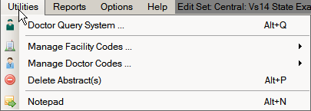

The following table describes the Abstract Plus Utilities menu sub-options:
Sub-option (Keystroke) | Toolbar Icon | Function
Doctor Query System (Alt+Q) |  | Query and search the doctor database; DQS can be accessed whether or not an abstract is opened, or a physician field selected
Manage Facility Codes… |  | Import (can use Alt+I keystroke) or edit (can use Alt+J keystroke) local facility codes
Manage Doctor Codes… |  | Import (can use Alt+K keystroke) or edit (can use Alt+L keystroke) local physician codes
Delete Abstract(s) (Alt+P) |  | Delete selected abstracts
Notepad (Alt+N) |  | Launch Notepad to view created text files

The Reports Menu
The Reports menu is used to access all of the available reports regarding abstracts in the Abstract Plus database. No toolbar icons are available for any Reports menu options.
To access the Reports menu items, click on the Reports menu item, and select the desired report, or use the appropriate keystroke combination for the desired report.
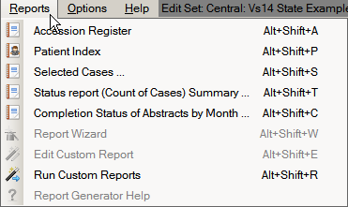
The following table describes the Abstract Plus Reports menu sub-options:
Sub-option (Keystroke) | Function
Accession Register (Alt+Shift+A) | Opens the Accession Register Report, which includes a line listing of all abstracts in the database, sorted by reporting hospital and accession number
Patient Index (Alt+Shift+P) | Opens the Patient Index Report, which includes a line listing of all abstracts in the database, sorted alphabetically by name
Selected Cases (Alt+Shift+S) | Opens a line listing report which includes abstracts based on user-specified criteria
Status Report (Count of Cases) Summary… (Alt+Shift+T) | Opens a report that includes the total number of complete and incomplete abstracts by export status within a user-specified date range
Completion Status of Abstracts by month (Alt+Shift+C) | Opens a report that includes abstract completion status by year and month of Date of Adm/1st Contact within a user-specified date range
Report Wizard (Alt+Shift+W) | Newly-added feature to enable users to generate their own custom reports (currently disabled)
Edit Custom Reports (Alt_Shift+E) | Edit an existing custom report (currently disabled)
Run Custom Reports (Alt+Shift+R) | Runs selected custom reports that have been added to the application using the Report Wizard
Report Generator Help | Opens online help for the Report Wizard; optional installation by Administrator required (currently disabled)

The Options Menu
For security purposes, users may want to change their passwords and security questions on a routine basis. The Options menu is used to update the user’s security questions or change their password. No toolbar icons are available for any Options menu selections.
To access the Options menu items, click on the Options menu item, and select the desired sub-option, or use the appropriate keystroke combination for the desired sub-option.
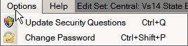

The following table describes the Abstract Plus Options menu sub-options:
Sub-option (Keystroke) |  | Function
Update Security Questions (Ctrl+Q) |  | Opens the Update User’s Security Questions window with the current User ID displayed along with the current security questions and answers specified by the user; new answers to existing questions may be entered, as well as new questions and answers
Change Password (Ctrl+Shift+P) |  | Opens Change User’s Password window, where the user can enter their current password, and a new password in both New Password and Confirm Password in order to change their password
 | For more information regarding updating personal security questions, see page 31 of this manual or click here. For more information regarding changing your general user password, see page 26 of this manual or click here.

The Help Menu
The Help menu is used to access the online help that is available within the program. To access the Help menu items, click on the Help menu item, and select the desired sub-option, or use the appropriate keystroke combination for the desired sub-option.
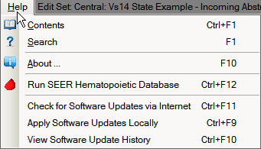
The following table describes the Abstract Plus Help menu sub-options:
Sub-option (Keystroke) | Toolbar Icon | Function
Contents… (Ctrl+F1) |  | View the contents of Abstract Plus online Help
Search for help on… (F1) |  | Enter search terms for topics on which you need more information
About (F10) |  | View Abstract Plus, Collaborative Staging, and Edits metafile version information
Run SEER Hematopoietic Database |  | Launch the SEER Hematopoietic Database stand-alone application to help you code hematopoietic and lymphoid neoplasms cases diagnosed beginning January 1, 2010
Check for Software Updates via Internet (Ctrl+F11) |  | Check for Software Updates via the Internet (Internet connection required)
Apply Software Updates Locally (Ctrl+F9) |  | Apply software updates that have been distributed (no Internet connection required)
View Software Update History (Ctrl+F10) |  | View historical software updates that have been applied via the Abstract Plus Auto-update  Feature

Abstract Plus Abstracting and Editing Features
One of the primary activities that Abstract Plus is used for is the abstraction of information from medical records. As mentioned, Abstract Plus has been entirely reprogrammed using .NET technology, and has a new, extremely user-friendly abstracting interface. New direct grid entry of coded values and quick select options for pull-down menus allow for an easy, streamlined abstracting experience, as well as easier viewing of text fields, online help, and edit errors.

The Abstract Plus Abstracting Process
The basic process of generating and updating an abstract is as follows:
- Create the abstract with the patient’s identifiers, such as name and social security number.
- Enter codes and text in the data entry fields. Save the abstract to retain the information you have entered.
NOTE: After creating an abstract, Abstract Plus will auto save the abstract at specified time intervals set by the Abstract Plus Administrator. When an abstract is manually saved, by clicking on the “Save” button, edits are automatically ran. Edits are not ran on an abstract at the time of auto-save.
- Correct errors. Each time you open or manually save the abstract, Abstract Plus can automatically edit the entered information for accuracy and completeness using the edit set and required fields chosen by your Abstract Plus Administrator.
- After you have entered all your data and corrected all errors, the system saves your new abstract as complete. You will see the edits error count and completion status indicators at the bottom of the abstracting window turn from red to green, indicating that the abstract is complete.

The Abstract Plus Abstracting Window
The Abstract Plus Abstracting window is divided into 2 main sections: a data entry grid for coded values on the left, and a data entry grid for text fields on the right. When you left-click and hold your mouse on the vertical divider bar in the center of the window, a splitter is highlighted which you can drag to the left or right to resize the view of codes or text fields, and the application remembers your last placement of the divider bar. You can vertically scroll the view of coded values and text fields independently to easily and concurrently view codes and associated text.
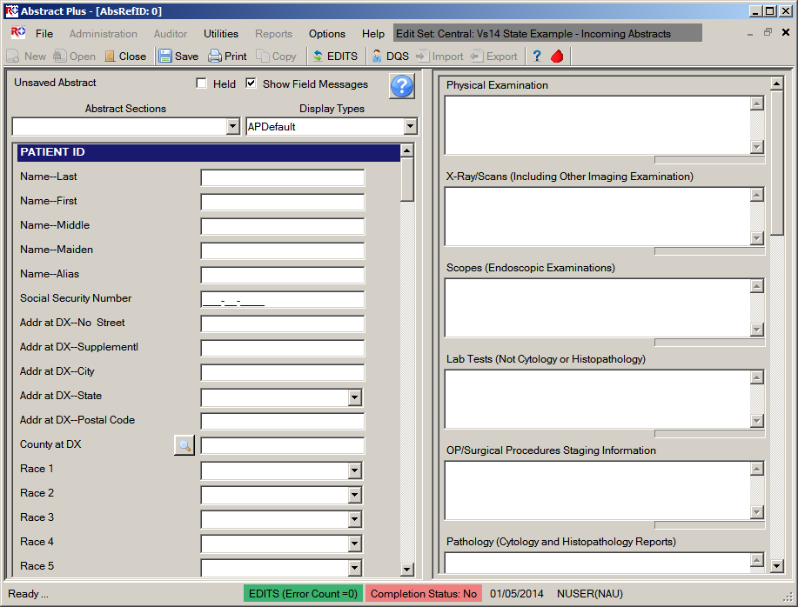
Easy, Direct Access to Text Fields
Can Resize Panes
Direct Grid Entry
The Abstract Plus user-friendly abstracting interface includes all new abstracting features. Please see page 50 of this training manual, or click here for more information regarding Abstract Plus abstracting features.
The abstracting interface is called a display type. A display type basically includes information regarding the fields displayed/collected, critical (or required) fields, edit set selections, and collaborative staging preferences, and is configured by your Abstract Plus Administrator upon setup of the application. The data items in a display type are labeled and ordered by your Administrator, as well as grouped into logical sections, which also have customizable labels.
Regardless of the customized label a data item may have, when a data item is selected, the associated NAACCR item name is always displayed in the lower left-hand corner of the window. This information is helpful when looking up information regarding a data item in the online help reference books.

Data Quality Edits and Error Resolution Features
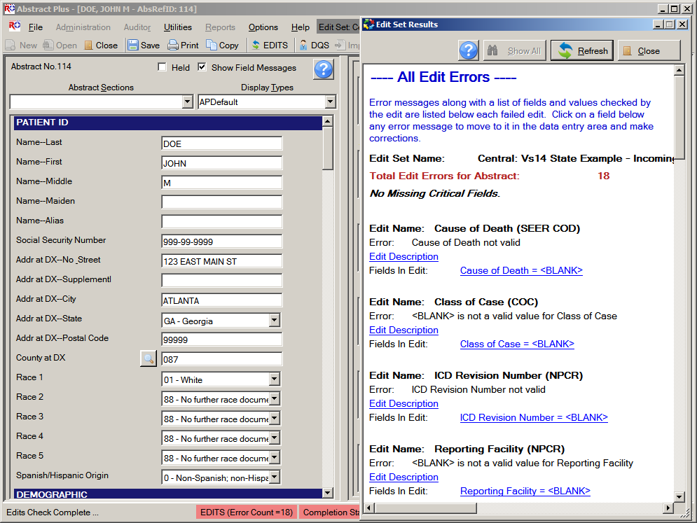
Each time an abstract is opened or manually saved, Abstract Plus automatically edits the entered information for accuracy and completeness using the edit set and required fields chosen by your Abstract Plus Administrator.
You must resolve all edit errors and fill in all critical (required) fields in order to complete the abstract.
Abstract Plus has edit error display features that greatly facilitate the error resolution process. Editing features include display of the name of the edit set being run at the top of the abstracting window and an all-new Edit Set Results window. Please see page 66 of this training manual, or click here for more information regarding Abstract Plus editing features.

Changing Your General User Password
For security purposes, you may be prompted to change your general user password periodically, based on the Password Policy specified by your Abstract Plus Administrator. Your Administrator specifies your password requirements, how often you need to change your password, as well as how many of your last passwords you cannot repeat.
To change your Abstractor/general user password, complete these steps:
- Open the Change User’s Password window. This may be done in 2 ways:
  - From Options Menu, select Change Password.
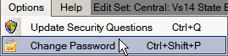
  - When logging in to Abstract Plus, enter your User ID, tab or click into the Password box, and then click Change Password on the Login window.
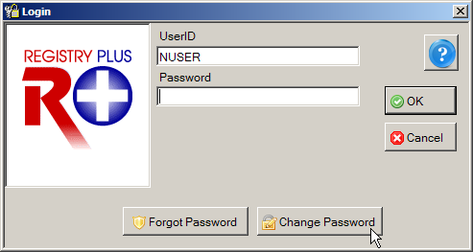
Result: The Change User’s Password window opens, with your User ID displayed.
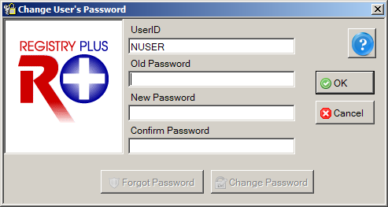
- Enter your Current Password in Old Password box.
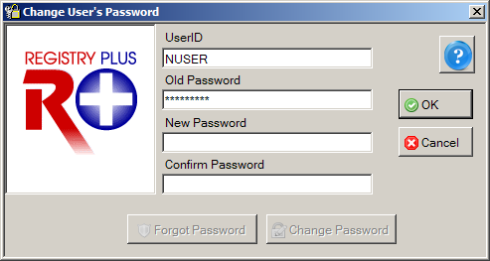
- Enter a New Password in New Password box that meets the password requirements specified by your Abstract Plus Administrator.
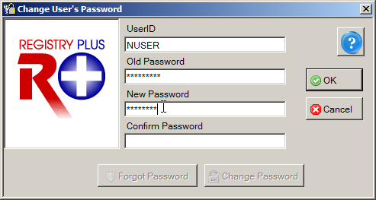
If your Administrator has made no changes, by default, your new password must be between 8 and 20 characters, contain at least one digit and one alphabetical character, and must not contain any special characters.
- Re-enter your New Password in the Confirm Password box.
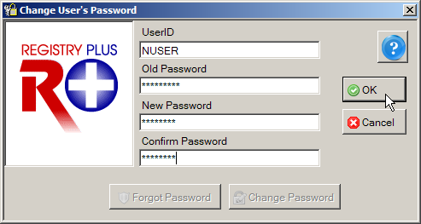
- Click OK to change your password.
Result: Your password is changed, and the Abstract Plus main window is opened.

Possible Errors when Changing Your Password
There are three possible errors you may receive when attempting to change your password:
- Old password is incorrect. You must correctly enter your old password in order to successfully change it. Click OK, and then correctly re-enter your old password.
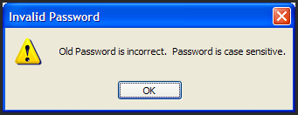
- New passwords do not match. The new password entered into the New Password and Confirm Password boxes must match exactly. Click OK, and then correctly re-enter your new password in the New and Confirm password boxes.
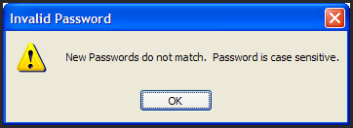
- New password does not meet specified password requirements. Your new password must meet the password requirements specified by your Abstract Plus Administrator. Click OK, and then re-enter a new password that meets the stated password requirements.
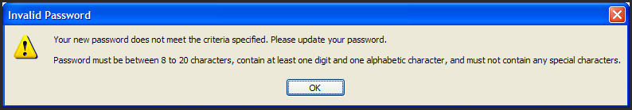

Resetting a Forgotten Password
In the event that you should forget your password, Abstract Plus has a security challenge question feature that will allow you to reset your own password without having to contact your Administrator. The security challenge question feature enables you to securely reset your password by answering a specified number of the security questions that you selected and answered upon initial login to Abstract Plus.
Your answers to these questions are used to validate your identity; Abstract Plus will ask you for the answers you provided to your chosen security questions, and then allow you to reset your password if the questions are answered correctly. If you forget both your password and your answers to your security questions, you will need to have your Abstract Plus Administrator reset your password.
To reset your password if you have forgotten it, complete these steps:
- When logging in to Abstract Plus, enter your User ID, tab or click into the Password box, and then click Forgot Password on the Login window.
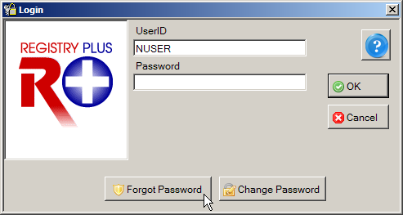
Result: The Reset User’s Password window opens, with your User ID displayed, as well as the number of security questions specified by your Administrator upon set up of Abstract Plus.
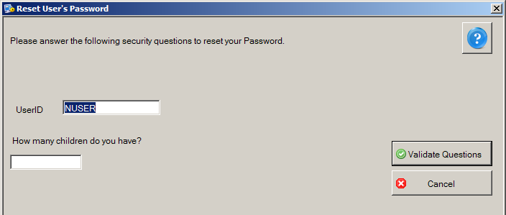
- Enter the answer to each displayed question with the same answer you provided upon initial login to Abstract Plus.
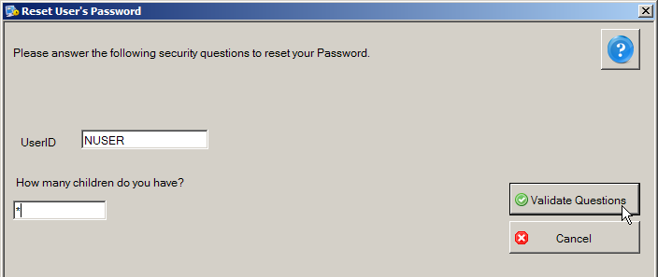
- Click Validate Questions once all questions are answered.
Result: The Reset User’s Password window opens, with your User ID displayed.
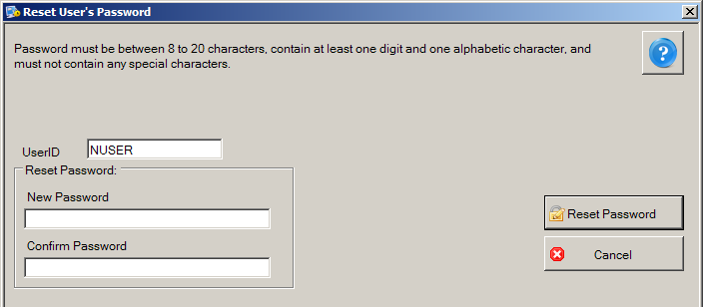
- Enter a New Password in both the New and Confirm password boxes, and then click Reset Password.
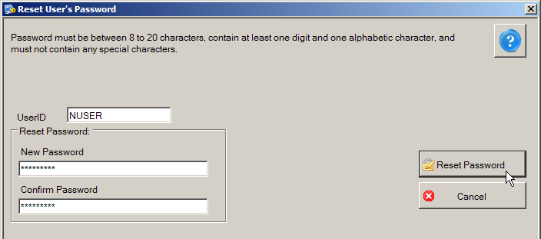
Result: The Forgot Password window opens, with your User ID displayed.
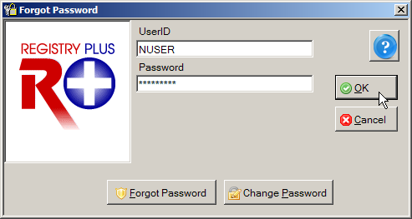
- Enter your New Password in Password box, and click OK.
Result: The Abstract Plus main window opens, with you logged in as a general user. Your password has been successfully set to the new password you have specified.

Updating Personal Security Questions
Once you are logged in to Abstract Plus, you can update your selected security questions and/or answers at any point. For example, if you selected the security question of “How many children do you have?” and you just had a new child enter your family, you can update your answer to this question.
To update your security questions and/or answers, complete these steps:
- From Options Menu, select Update Security Questions.
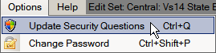
Result: The Update User’s Security Questions window opens, with your User ID displayed, as well as the current security questions and answers which you have specified. For added security asterisks are displayed rather than your answers to the questions.
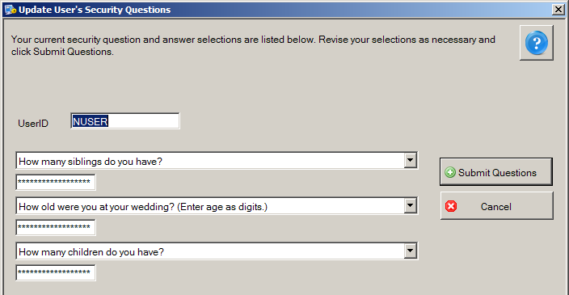
- You can select new questions and answer them or supply new answers to your previously selected questions. When you have completed your changes, click Submit Questions.
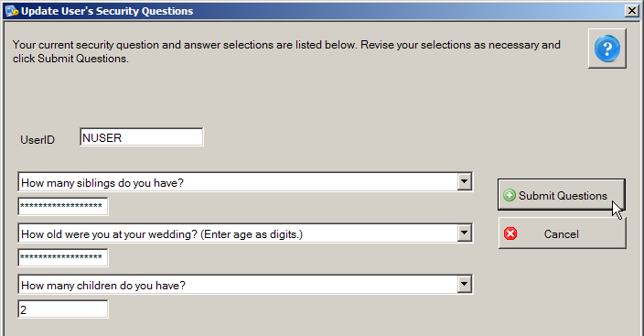
Result: You are returned to the Abstract Plus main window with your changes saved for future use.

Abstract Plus Auto-update Feature
The “Auto-update” feature enables delivery of application bug fixes, enhancements and updates associated with Abstract Plus via the Internet after software distribution and initial installation. This new mechanism downloads the necessary applicable files from the CDC Abstract Plus FTP site and replaces the existing files with the updated/revised versions to apply updates/fixes. In the event that you are an Abstract Plus user that does not have access to the Internet, software update packages can be distributed to you and you can apply them locally from a folder on your computer or network.
Two modules are included in the in the Auto-update feature, so that revisions, fixes, or updates can be made from the CDC and or state levels:
- Generic Auto-update Module: This module primarily delivers application enhancements, updates, and resolutions to identified problems that are applicable regardless of the state, region, or project for which Abstract Plus has been customized. It will also be used to update the generic version of Abstract Plus available from the NPCR website. The generic auto-update module will deploy updates for issues identified at the CDC-level, including, but not limited to: resolutions to identified issues, updated example display types, edits metafiles, online help files, revisions to the Catvals tables, and updated application files.
For example, the initial release of Abstract Plus 3.5 will include a version of RPOH that will include the NAACCR Version 15 Volume II Data Dictionary and the updated Abstract Plus User’s Guide. As soon as additional manuals are added to RPOH, they will be distributed via the generic auto-update module.
- Custom Auto-update Module: This module also works in the same manner as “Generic Auto-update”, but addresses updates to customizations made for a certain state or project. This module identifies the Abstract Plus user’s customized version, and downloads the update package version for their specific installation.

Benefits of the Auto-update Feature
Many states have a large number of Abstract Plus end users and even more individuals download and use the generic version of Abstract Plus. With each new version that is released, sometimes issues are identified that need to be corrected, or a state decides to make a change to their customizations. As a result, if issues/revisions are identified after a state has distributed the program, the state may have to obtain a new installation and re-distribute. For some states this is a very onerous process, and often the end user would need to uninstall and re-install the application which is quite inconvenient. States often have to assess the value added of a specific correction or update, i.e., is it worth going through redistribution of the software?
In order to alleviate states and end users from the time and resource-consuming efforts of redistribution, the CDC has programmed a new Auto-update feature.

No Uninstall and Re-install of Abstract Plus is Necessary
After the initial installation of the application, the new Auto-update mechanism does not require the end user to uninstall/reinstall the application to obtain software updates. It simply replaces the associated files on the CDC FTP site with those already installed on the end users computer.

No Loss of Data is Possible
Although it is highly recommended for the end user to back-up their data prior to launching the Auto-update, the Auto-update mechanism does not directly interfere or touch the user or abstract data. There is absolutely no possibility of any data loss when the user uses the Auto-update feature.

Auto-updates can be Implemented Automatically or Manually
There are two ways initiate the Auto-update mechanism via the Internet. There is a new Application Property that allows your Administrator to customize Abstract Plus to run the Auto-update feature automatically. The frequency with which the application automatically checks for updates can also be specified; there is a new option that allows the state to specify how the number of days in-between checking for available updates. In addition, the abstractor can check for software updates manually at any time.

Automatic Detection of Available Updates for Customized Versions
Once the Auto-update feature is invoked, Abstract Plus looks to an XML file (AvailableUpdateInfo.xml) on the CDC FTP Server. This XML includes all the update information that is systemically organized. Every time CDC releases an update (states will communicate customization updates to the CDC and CDC will update the XML files and post the appropriate files to the CDC FTP site), CDC updates this file with appropriate information (See sample XML file below).
<?xml version='1.0'?>
<RegistryPlusApplications>
<Application Name = 'ABSTRACTPLUS'>
<GenericPackage>
<Version>1</Version>
<DownloadPath>http://ftp.cdc.gov/pub/NPCR-AP-UPDATES/AbstractPlus/GenericUpdate/GenericPackage_EDITS-Fix_02-25-2013.zip</DownloadPath>
<PrerequisitePackageVersion>0</PrerequisitePackageVersion>
<PackageDescription>This update package will address issue associated with EDITS for generic Abstract Plus. This issue was reported by Kathleen Thoburn on 02-25-2013.
</PackageDescription>
<RequiredNAACCRVersion>122</RequiredNAACCRVersion>
<ReleaseMode>UAT</ReleaseMode>
</GenericPackage>

<PackageGroup Name ='GA'>
<CustomPackage>
<Version>1</Version>
<DownloadPath>http://ftp.cdc.gov/pub/NPCR-AP-UPDATES/AbstractPlus/CustomUpdate/GA/CustomPackage1.zip</DownloadPath>
<PrerequisitePackageVersion>0</PrerequisitePackageVersion>
<PackageDescription>
This Custom update package version 1 for GA, has such and such updated files…, etc.
</PackageDescription>
<ReleaseMode>UAT</ReleaseMode>
</CustomPackage>

<CustomPackage>
<Version>2</Version>
<DownloadPath>http://ftp.cdc.gov/pub/NPCR-AP-UPDATES/AbstractPlus/CustomUpdate/GA/CustomPackage2.zip</DownloadPath>
<PrerequisitePackageVersion>1</PrerequisitePackageVersion>
<PackageDescription>
This Custom update package version 2 for GA, has such and such updated files…, etc.
</PackageDescription>
<ReleaseMode>UAT</ReleaseMode>
</CustomPackage>

<CustomPackage>
<Version>3</Version>
<DownloadPath>http://ftp.cdc.gov/pub/NPCR-AP-UPDATES/AbstractPlus/CustomUpdate/GA/CustomPackage3.zip</DownloadPath>
<PrerequisitePackageVersion>2</PrerequisitePackageVersion>
<PackageDescription>
This Custom update package version 3 for GA, has such and such updated files…, etc.
</PackageDescription>
<ReleaseMode>UAT</ReleaseMode>
</CustomPackage>
</PackageGroup>

Auto-updates can be Distributed and Implemented Locally (No Internet Connection Required)
In the event that you are an Abstract Plus user that does not have access to the Internet, software updates can be distributed to you and you can apply them locally from a folder on your computer or network.

Automatic Updates for Users Who Have Not Updated on a Regular Basis
If the automatic Auto-update system preference is not on, and a user does not check for updates for quite some time, several updates may have been released since they last checked for updates. The Auto-update mechanism keeps track of what updates were already applied and those that have not been applied, and will upgrade all released updates sequentially since the last update run to make the software current with all update releases.

User is Notified When the CDC FTP Site is Experiencing Issues
If the CDC FTP site is temporarily down, Abstract Plus displays a message to the user to try updating at a later time.

User is Notified When No Updates are Available
When the application or user checks for updates and there are no updates available Abstract Plus issues a message that states “No update is required at this time”.

Checking for Software Updates via the Internet
As mentioned earlier, Auto-updates can be implemented via the Internet automatically or manually via the Internet. Your software will automatically check for software updates via the Internet if your Administrator has set up Abstract Plus to do so. You can also manually check for auto-updates. Note that if your Administrator has configured the software to automatically check for updates, you can still manually check for updates at any time.
To check for auto-updates manually, complete these steps:
- Open the Auto-update window. This can be done in 2 ways:
  - From Help Menu, select Check for Software Updates via Internet.
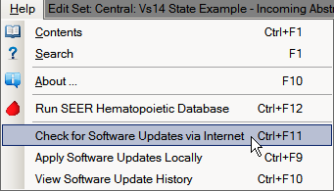
  - Use the keystroke Ctrl+F11.
Result: The Confirm Auto-update dialog box opens. As updating could be time-consuming task the application asks you to confirm that you would like to proceed with the update process.
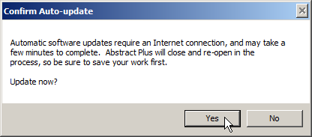
- Click Yes.
Result: The Abstract Plus Auto-update window opens, and the Auto-update mechanism begins. Abstract Plus will close and will then check for any available updates. If there are any applicable updates available Abstract Plus will download the update package(s) and begin updating Abstract Plus. Once the updates are applied, Abstract Plus will re-open. The Abstract Plus Auto-update window provides you with step-by-step feedback regarding the update process.
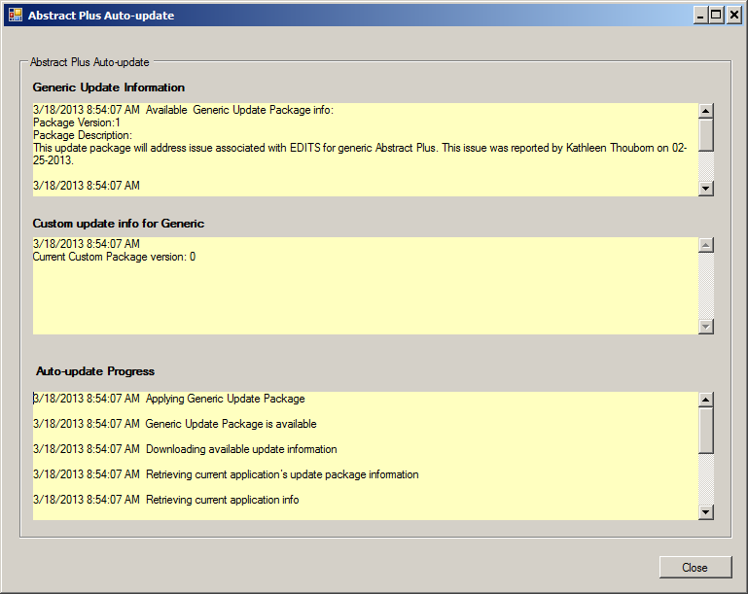
- To close the Auto-update, click Close.
Result: The Abstract Plus Auto-update window will close, and Abstract Plus will re-open. You can now log back in and continue working in the application.

Applying Software Updates Locally
In the event that you are an Abstract Plus user that does not have access to the Internet, software update packages can be distributed to you and you can apply them locally from a folder on your computer or network. The Auto-update package comes in the form of a win-zipped file that just needs to be placed in a folder on your computer or network, and then you navigate to that folder.
To apply software updates that have been distributed to you via an update package (e.g., via mailed CD), complete these steps:
- Open the Auto-update window. This can be done in 2 ways:
  - From Help Menu, select Apply Software Updates Locally.
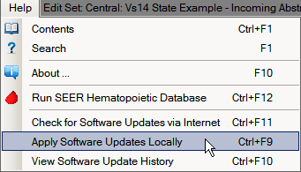
  - Use the keystroke Ctrl+F9.
Result: The Abstract Plus Auto-update window for local updates opens.
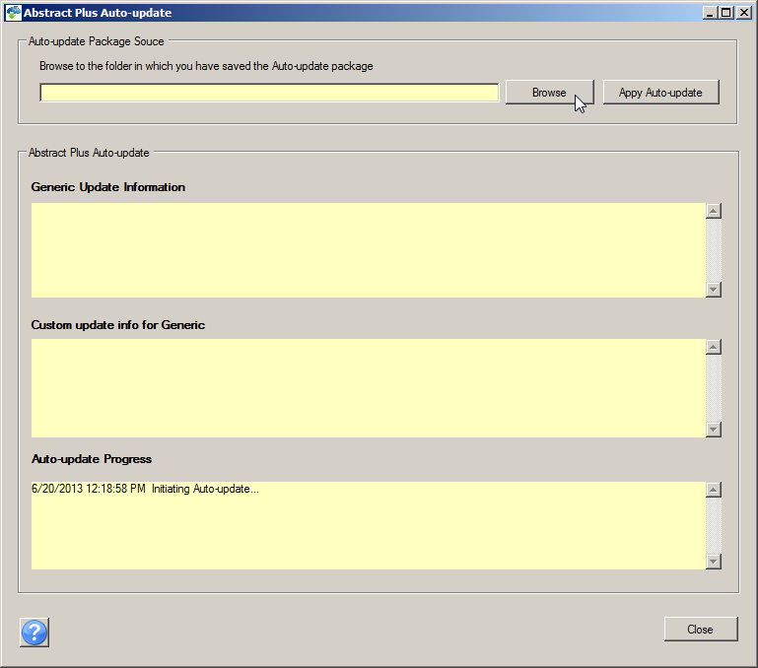
- Click Browse to navigate to the folder on your computer or network in which you have saved the auto-update package that was distributed to you.
Result: The Browse for Folder window opens.
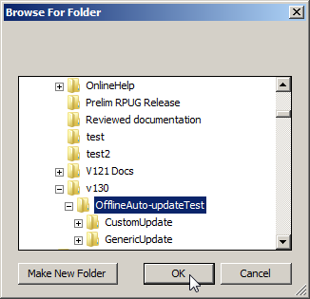
- Navigate to the folder on your computer or network in which you have saved the auto-update package that was distributed to you and click OK.
Result: You are returned to the Abstract Plus Auto-update window for local updates, and the selected folder is displayed.
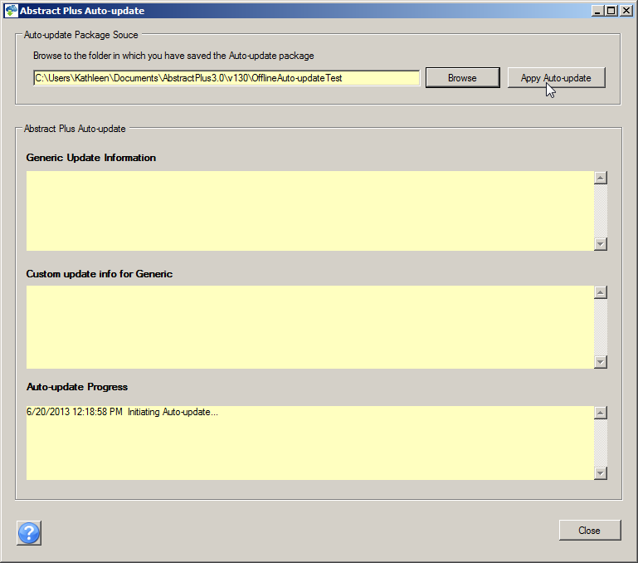
- Click Apply Auto-update.
Result: The Confirm Auto-update dialog box opens. As updating could be time-consuming task the application asks you to confirm that you would like to proceed with the update process.
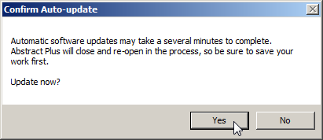
- Click Yes.
Result: The Abstract Plus Auto-update window opens, and the Auto-update mechanism begins. Abstract Plus will close and will then check the specified folder for the available updates. The Auto-update process will begin and updates are applied. The Abstract Plus Auto-update window provides you with step-by-step feedback regarding the update process.
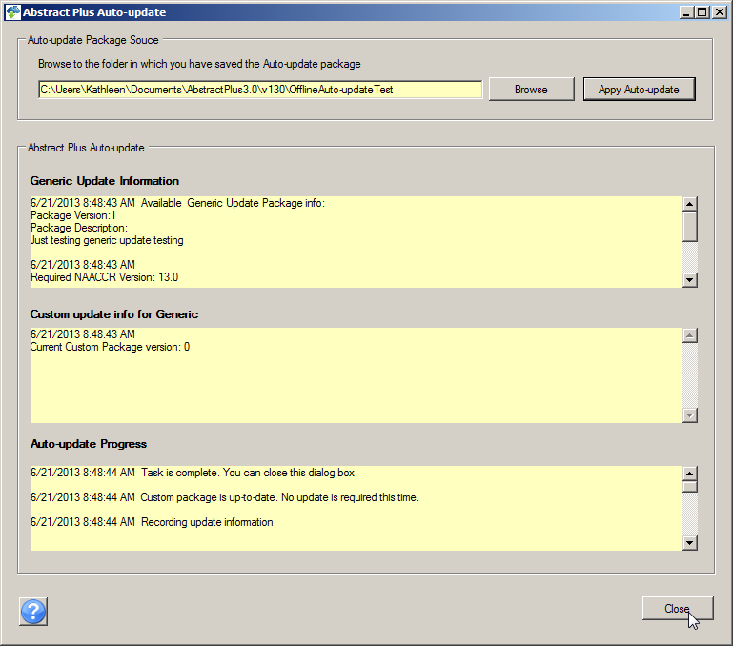
- To close the Auto-update, click Close.
Result: The Abstract Plus Auto-update window will close, and Abstract Plus will re-open. You can now log back in and continue working in the application.

Viewing Software Update History
You can view your software update history to see if you have the latest software updates.
To view your software update history, complete these steps:
- Open the Software Auto-update History window. This can be done in 2 ways:
  - Click on the Help menu, and select View Software Update History.
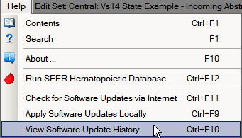
  - Use the keystroke Ctrl+F10.
Result: The Abstract Plus View Software Update History window opens, and provides you with a listing of all updates you have implemented. A detailed description of each update is located in the Package Description column.
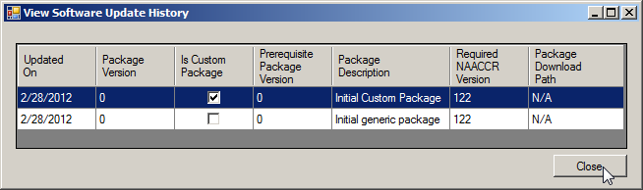
- To close the View Software Update History window, click Close.

Exiting Abstract Plus and Using the Backup Option
When logging off and exiting Abstract Plus, the application will prompt you to back up the current abstract database.
To log off / exit Abstract Plus and use the database backup option, complete these steps:
- Exit Abstract Plus. This can be done in 3 ways:
  - Click on the File menu, and select Exit.
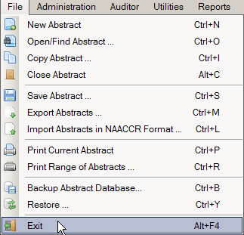
  - Use the keystroke Alt+F4.
  - Click the X in upper right corner of screen.
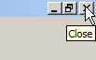
Result: The Exit Program window opens, and asks if you are sure you want to exit the program.
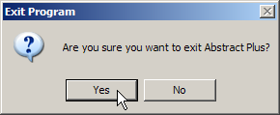
- Click Yes.
Result: The Backup Database window opens, and asks if you would like to backup your Abstract Plus abstracts database (ABSPLUS.MDB).
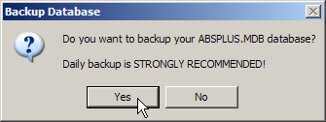
Although you can choose not to backup your database, it is highly recommended that you backup your database after finishing an abstracting session during which changes were made (abstracts were added, updated, or deleted). Note that the Backup and Restore Database menu options are not available when using SQL Server database.
- Click Yes.
Result: The Abstract Plus Database Backup window opens with defaults set.
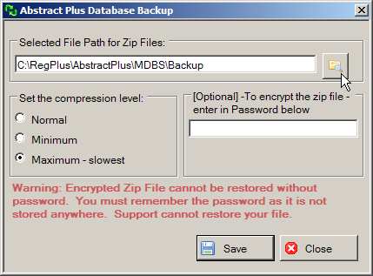
- To change the default path, navigate to and identify the location on your computer or network where you would like to save your backup file by clicking the Folder icon .
Result: The Browse for Folder window opens.
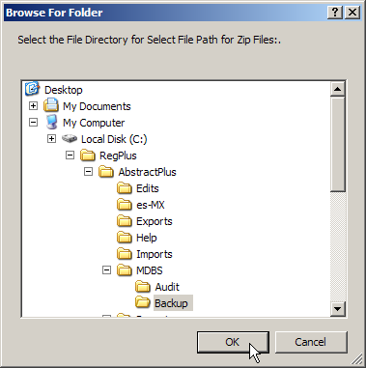
The default location for saving backup files is C:\RegPlus\AbstractPlus\MDBS\Backup. You may navigate to a different location if you so choose.
- To accept the default location for saving the backup, click OK.
- Select the desired compression level for the zip file if other than the default.
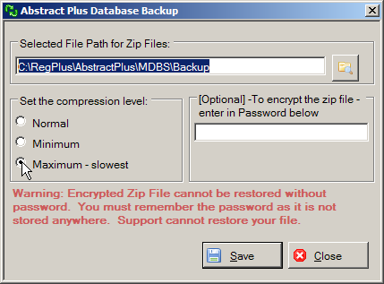
- Enter a password (optional) to encrypt the zip file. Click Save to create the backup and exit or click Close to exit the application without saving the backup file.
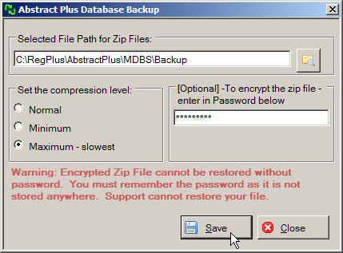

If you choose to password-protect your backup file, the encrypted zip file cannot be restored without the specified password. It is very important that you remember this password!
Result: The backup is saved in the zip file, and a confirmation window opens. A progress bar is also displayed at the bottom of the screen.
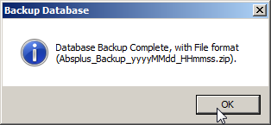
A progress bar is also displayed at the bottom of the screen.
- Click OK.
Result: The Abstract Plus application closes.

Using the Restore Option
In the event that your Abstract Plus abstracts database (ABSPLUS.MDB) is corrupted, if you have used the Backup option to backup your database you will be able to restore your database using the Restore option. The Restore option allows you to go back to a file that you saved with the same Abstract Plus version on a date when you encountered no problems. This is why it is so strongly recommended that you back up your work when exiting the application.
To use the Restore option to restore your Abstract Plus abstract database to an earlier saved backup, complete these steps:
- Open the Restore Database window. This can be done in 2 ways:
  - Click on the File menu, and select Restore.
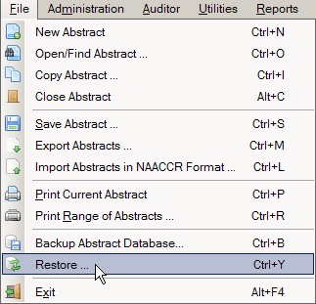
  - Use the keystroke Ctrl+Y.
Result: The Restore Abstract Plus Database window opens.
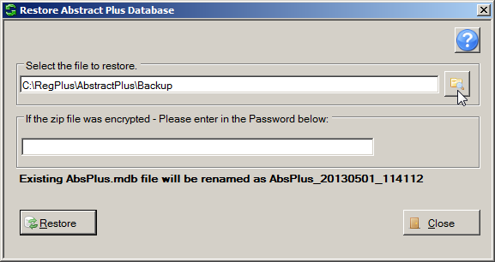
- Navigate to and identify the zipped backup file on your computer or network by clicking the Folder icon .
Result: The Select the file you want to restore window opens with a list of backup files displayed.
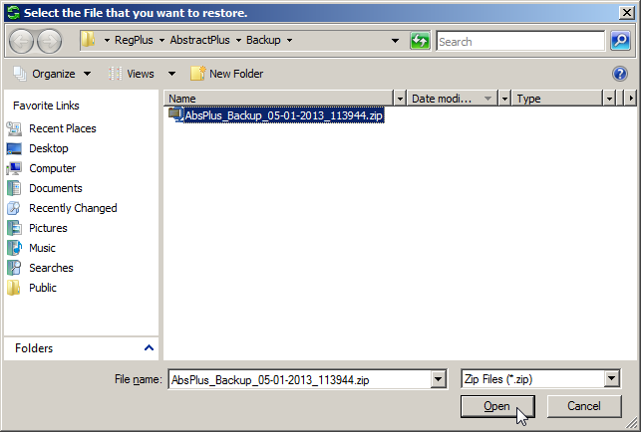

The default location for saving backup files is C:\RegPlus\AbstractPlus\MDBS\Backup. You may need to navigate to a different location if you saved your backup file in a location other than the default location.
- Select the backup file to which you wish to restore your Abstract Plus abstract database, and click Open.
Result: You are returned to the Restore Abstract Plus Database window, with the selected backup file displayed.
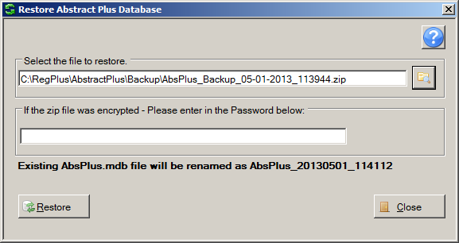
- If you password protected the selected backup file, enter the password in the password box, and click Restore.
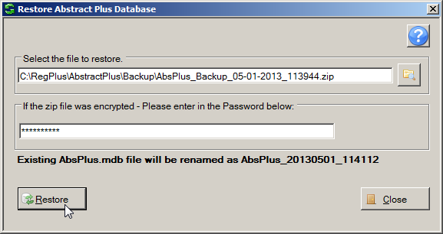
Result: The Abstract Plus main window opens, with the selected abstracts backup database restored. You may now resume abstracting activities.
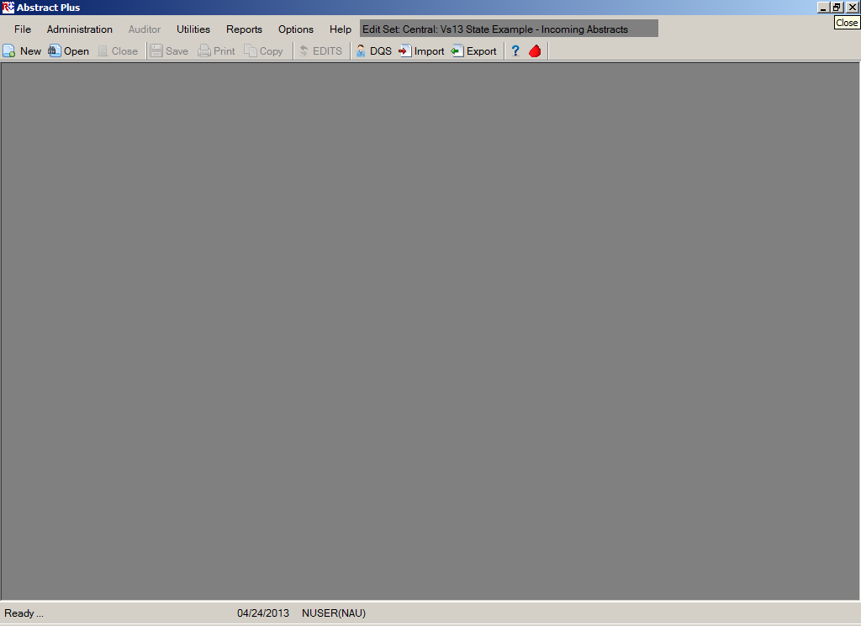

Questions
Answer these questions about Abstract Plus General User Basics (the answers are in Appendix A, on page 128):
- What are the first things you need to do upon initial login into Abstract Plus?
- What is the point of the security challenge questions in Abstract Plus?
- Why is it important that you have your own user ID and password?
- When logging off Abstract Plus, how can you ensure that the work you did during the session is secure and safe?

Working with Abstracts

Learning Objectives
In this chapter, you will learn to:
- Import abstracts into Abstract Plus
- Identify the areas in the Abstract Plus abstracting screen
- Create a new abstract
- Modify an abstract, including entering text, coding histologic type, and coding and deriving Collaborative Staging fields
- Correct errors in an abstract
- Copy an abstract
- Export abstracts
- Print a range of abstracts
- Use the Utility functions (Utilities)
- Use the Help functions to find out more information about fields

Overview
This chapter covers the basics about abstracting and working with abstracts in Abstract Plus. It includes a description of the process by which abstracts are generated, modified, edited, and completed, as well as how to print and copy existing abstracts and how to import and export abstracts in NACCR file format.
You can start working with abstracts by
- Importing abstracts in NAACCR format
- Creating a new abstract
- Searching for and opening an existing abstract
- Copying an existing abstract and saving it as a new one
An existing abstract can be modified and the changes saved. Abstracts can also be exported in NAACCR format to any other system.

Importing Abstracts
You can import abstracts in NAACCR format from any system into Abstract Plus. Both complete and incomplete abstracts can be imported, as long as the information is in NAACCR file format.
To import an abstracts or file of abstracts in NAACCR file format, complete these steps:
- Open the Import Abstracts window. This can be done in 3 ways:
- Click on the File menu, and select Import Abstracts in NAACCR Format.
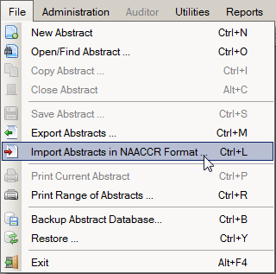
- Click the Import icon on the tool bar .
- Use the keystroke Ctrl+L.
Result: The Import Abstracts in NAACCR Format window opens.
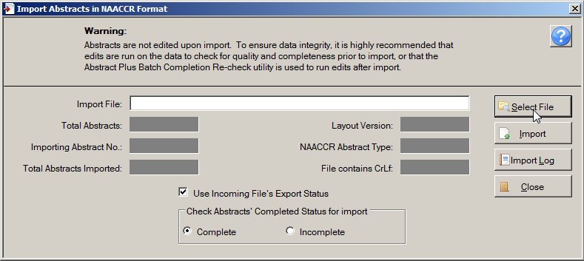
The Import Abstracts function in Abstract Plus 3.5, NAACCR v15.0-based software allows you to import NAACCR-format Version 15.0 abstract records of NAACCR Record Types I, C, A, or M. Any records in NAACCR version 14.0 will be converted to NAACCR version 15.0 prior to importing, and Collaborative Staging will be re-derived. The import function also performs a basic structural check for record size and version number before importing the abstracts. The system will verify that the file contains valid NAACCR records and will display a record count and other information about the file.

The Import Abstracts window includes these fields and options:
Field/Option | Description
Import File | The name and location of the file of abstracts in NAACCR file format to be imported (click Select File to identify file for import)
Total Abstracts | The total number of abstracts included in the file to be imported
Importing Abstract No. | While importing, this field displays the sequential number of the abstract currently being imported
Total Abstracts Imported | While importing and upon completion of import, this field displays the total number of abstracts imported
Layout Version | The NAACCR Record Version [item #50 ]of the file to be imported
NAACCR Abstract Type | The NAACCR Record Type [item # 10] of the abstracts in the file to be imported
File contains CrLf | The import file may or may not contain Carriage Return, Line Feed characters after each abstract; this field informs you as to whether it does or not
Use Incoming File’s Export Status | Option to use the export status included in the import file; when checked, Abstract Plus will check the field of Date Case Report Exported [item #2110]---if the Date Case Report Exported is filled, the incoming abstract will be marked as exported within Abstract Plus
Check Abstracts’ completed Status for import | Option to set the Completion Status of the imported abstracts to Complete or Incomplete
Activity 2 – Importing Abstracts
Using what you have just learned, import a file of abstracts in NAACCR file format into Abstract Plus. You can import a file of your own, or any of the sample data files in the Abstract Plus Imports folder.
Please see page 47 of this training manual or click here for more information about importing abstracts into Abstract Plus.

Creating a New Abstract
To create a new abstract, complete these steps:
- Open the Abstract Plus Abstracting window. This can be done in 3 ways:
- Click on the File menu, and select New Abstract.
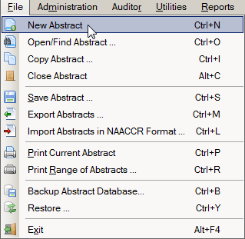
- Click the New icon on the tool bar .
- Use the keystroke Ctrl+N.
Result: The Abstract Plus Abstracting Window opens.

The Abstract Plus Abstracting Window
As mentioned, Abstract Plus has been entirely reprogrammed using .NET technology, and has an extremely user-friendly abstracting interface. Direct grid entry of coded values and quick select options for pull-down menus allow for an easy, streamlined abstracting experience, as well as easier viewing of text fields, online help, and edit errors.
The Abstract Plus Abstracting window is divided into 2 main sections: a data entry grid for coded values on the left, and a data entry grid for text fields on the right. When you left-click and hold your mouse on the vertical divider bar in the center of the window, a splitter is highlighted which you can drag to the left or right to resize the view of codes or text fields, and the application remembers your last placement of the divider bar. You can vertically scroll the view of coded values and text fields independently to easily and concurrently view codes and associated text.
Edit Error Count
Easy, Direct Access to Text Fields
Can Resize Panes
Right-click Any Field for Help and Edit Errors
Direct Grid Entry
Section Headers
Custom Data Item Labels
Completion Status
Optionally Show Field Messages OptionCan Resize Panes
Recall that the basic process of generating and updating an abstract is as follows:
- Create the abstract with the patient’s identifiers, such as name and social security number and save. After you create an abstract, you can save it at any time and return to your work at a later time.
- Enter codes and text in the in the data entry fields. Save the abstract to retain the information you have entered.
- Correct errors. Each time you open or save the abstract, Abstract Plus can automatically edit the entered information for accuracy and completeness using the edit set and required fields chosen by your Abstract Plus Administrator.
- After you have entered all your data and corrected all errors, the system saves your new abstract as complete. You will see the edits error count and completion status indicators at the bottom of the abstracting window turn from red to green, indicating that the abstract is complete.
The Abstractor uses the following abstracting features of the abstracting window to enter information regarding the patient and tumor being abstracted:
  - Many data items offer code selection from drop-down lists. In addition, the drop-down lists feature an auto-complete, find-as-you-type function that allows the user to type in the first letter, or first few letters, of the desired code label, and the application auto-selects the first item in the list beginning with that letter. In the example shown below, an A has been typed into the Race 1 field, and the application auto-selects the value of American Indian, Aleutian, or Eskimo:
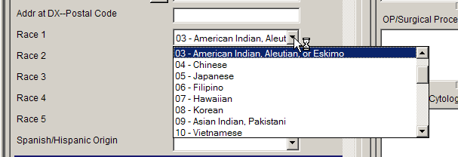
If you begin typing in the data item, but find you need to revise what you have typed, press the backspace key to delete what you have already entered and start typing again. This enables the find-as-you-type feature to automatically find your revised entry.
  - For data items with extensive listing of coded values, such as primary site, there is lookup assisted data entry with an advanced search feature. You can either enter the code directly if known, or click on the magnifying glass icon to the left of the data item (or press F4) to use the search feature:
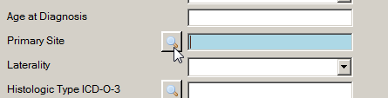
Enter a full or partial search term or code to search for, and then double-click on the code of your choice to transfer the value to the data item in the data entry grid.
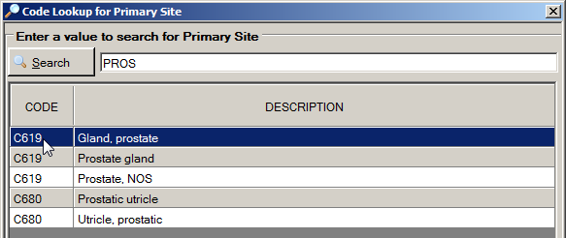
  - Depending on the system preferences set by your Abstract Plus Administrator, users can automatically calculate Age at Diagnosis once date of birth and diagnosis are entered, and can calculate Collaborative Stage derived data items by clicking on the calculator icon to the left of the data item:
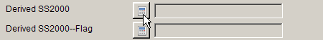
Or, your Administrator may choose set turn on the option to automatically calculate Collaborative Stage derived data items upon save of the abstract after the following CS input data items have been abstracted:
- CS Tumor Size
- CS Extension
- CS Tumor Size/Ext Eval
- CS Lymph Nodes
- CS Lymph Nodes Eval
- CS Mets at DX
- CS Mets Eval
- CS Site-Specific Factor 1-25
If your Administrator has turned this option on, CS derived data items will be calculated upon every save after the above fields have been entered.
  - Depending on the system preferences set by your Abstract Plus Administrator, if the address at diagnosis is the same as the current address for a patient, users can automatically copy the values in all address at diagnosis data items to the current address fields by pressing F5 when the cursor is located in the Addr Current—No Street data item:
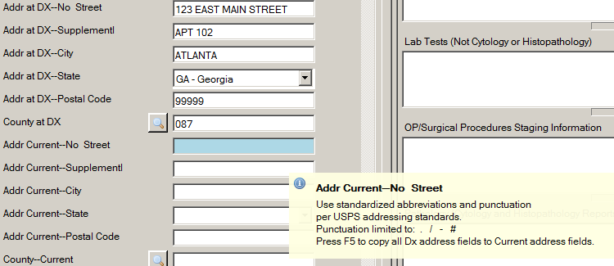
Upon pressing the F5 key the address at diagnosis values get copied over to the current address fields:
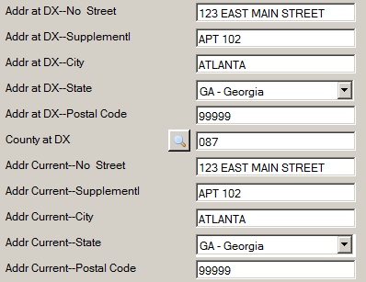
  - If the coded values for certain Rx Summ treatment data items are determined to be the same as the associated Rx Hosp data items, the value in a particular Rx Hosp data item can automatically copied over to the associated Rx Summ data item by pressing F5 while the cursor is still in the Rx Hosp Data item:
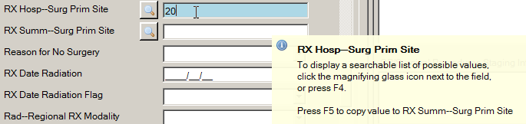
Upon pressing the F5 key the Rx Hosp value gets copied over to the Rx Summ data item:
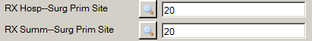
Below is a list of Rx Hosp treatment data items that Abstract Plus offers the ability to be mapped to their associated Rx Summ data item:
NAACCR Item No | Hosp Rx Data Item Name | NAACCR Item No | Rx Summ Data Item Name
670 | RX Hosp--Surg Prim Site | 1290 | RX Summ--Surg Prim Site
672 | RX Hosp--Scope Reg LN Sur | 1292 | RX Summ--Scope Reg LN Sur
674 | RX Hosp--Surg Oth Reg/Dis | 1294 | RX Summ--Surg Oth Reg/Dis
676 | RX Hosp--Reg LN Removed | 1296 | RX Summ--Reg LN Examined
690 | RX Hosp—Radiation | 1360 | RX Summ--Radiation
700 | RX Hosp—Chemo | 1390 | RX Summ--Chemo
710 | RX Hosp—Hormone | 1400 | RX Summ--Hormone
720 | RX Hosp—BRM | 1410 | RX Summ--BRM
730 | RX Hosp—Other | 1420 | RX Summ--Other
740 | RX Hosp--DX/Stg Proc | 1350 | RX Summ--DX/Stg Proc
3280 | RX Hosp--Palliative Proc | 3270 | RX Summ--Palliative Proc
746 | RX Hosp--Surg Site 98-02 | 1646 | RX Summ--Surg Site 98-02
747 | RX Hosp--Scope Reg 98-02 | 1647 | RX Summ--Scope Reg 98-02
748 | RX Hosp--Surg Oth 98-02 | 1648 | RX Summ--Surg Oth 98-02
  - Prompt messages may be associated with each data item, so that when the abstractor clicks into the field, a pop-up box comes up with a message or instructions about abstracting that field:
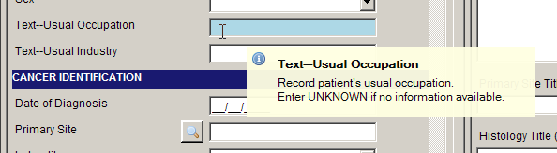
  - For the experienced abstractor, the field messages may turned on or off depending on the abstractor's preference and knowledge of coded values for specific fields:. To turn off the field messages, un-check the Show Field Messages checkbox at the top of the abstracting grid:
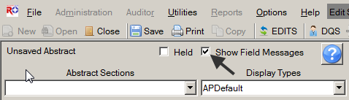
This option should be used with extreme caution. Sometimes the field message includes essential coding instructions that can only be found by looking up the data item in NAACCR Volume II or some other coding reference. For example, for the field of Cause of Death, without the display of the field message, the inexperienced coder would not know to code 0000 for an alive patient.
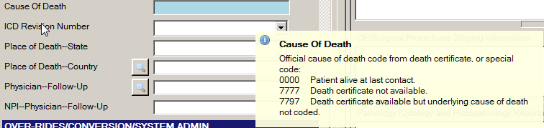
  - When entering text, a progress bar is displayed below each text field indicating how much space is left so that you can properly prioritize the information you are entering:
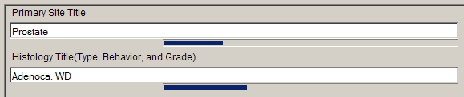
  - Keyboard and mouse alternatives are now available for every function in the software. Note that Keystroke options are displayed on menus for all menu items, and Appendix B of this training manual contains a listing of standard Abstract Plus keyboard shortcuts to functions.
  - All-new right-click functions for individual data items, including access to field context help, edits error information, field messages, and a function to clear all Collaborative Stage fields:
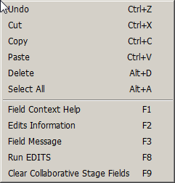
  - Color-coded edits error count and abstract completion status information is clearly displayed to the user at the bottom of the abstracting window, and changes from red to green upon completion of the abstract:
Incomplete abstract containing edit errors:
Complete abstract containing no edit errors:
  - Once saved, each abstract is assigned an unique Abstract Reference ID (or AbsRefID), displayed in the upper left-hand corner of the data entry area of abstracting window, as well as in the title bar of the application along with the patient name:
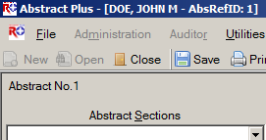
  - Abstracts can be held to prevent export. The Held check box allows an abstractor to prevent a case from being exported even if it is considered complete by the system. This can be used if, for example, the abstractor is searching for additional information to be included before the abstract is exported. If checked, the abstract will not be exported, regardless of Completion Status:
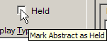

Entering Dates in Abstract Plus
As of the NAACCR version 12x record layout, all dates are in the YYYYMMDD format. Because the NAACCR standards are so tightly integrated with the Abstract Plus program, dates are entered in the YYYY/MM/DD format in Abstract Plus.
The Abstractor will enter dates in the new YYYYMMDD format as follows:
YYYYMMDD – when complete date is known and valid
YYYYMM – when year and month are known and valid, and day is unknown
YYYY – when year is known and valid, and month and day are unknown
Blank – when no known date applies
Abstract Plus has a date field entry mask on all date fields that already has the slashes in it. Although the application allows you to type the slashes and dashes when entering dates fields, you can save keystrokes by only typing the 8 characters of the date. For example for the date of August 1, 2012, the date can be entered as 20120801.

Activity 3 – Creating a New Abstract and Abstracting Patient Information
Using what you have just learned, create a new abstract. Please see page 49 of this training manual or click here for more information about creating a new abstract.
- Type DOE in the Name--Last field, and press Enter. Notice that the next field is now highlighted.
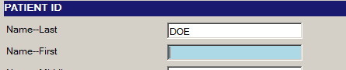
- Enter the following information in the following fields:
Field | Value to be Entered
Name—First | JOHN
Name—Middle | M
Name—Maiden | Leave blank (press enter to move to next field)
Name—Alias | Leave blank (press enter to move to next field)
Social Security Number | 999-99-9999
Addr at DX—No Street | 123 EAST MAIN ST
Addr at DX—Supplementl | Leave blank (press enter to move to next field)
Addr at DX--City | ATLANTA
- Click or tab into the Addr at DX State field.
Result: A list of states appears in the Select New Value field.
- Start typing Georgia. Notice that the system displays the full name of the state in the even before you finish typing. Press Enter.
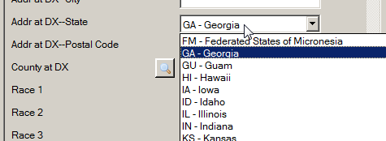
If you begin typing in the data item, but find you need to revise what you have typed, press the backspace key to delete what you have already entered, and start typing again. This enables the find-as-you-type feature to automatically find your revised entry.
- Type 999999999 in the Addr at DX—Postal Code field, and press Enter.
- Click on the magnifying glass icon to the left of the County at DX field to open the Code Lookup for County at DX window.
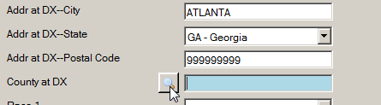
Result: The Code Lookup for County at DX window opens.
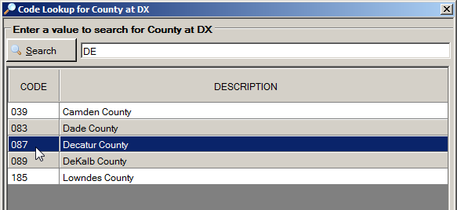
- Enter DE in the search box, and double-click on the 087 value for Decatur County.
Result: The value of 087 is automatically entered into the data entry grid for the County at DX field, and the Code Lookup for County at DX window automatically closes.
- Enter the following information in the following fields, either typing the value, using the drop-down list feature, or using the advanced search feature by clicking on the magnifying glass icon where available:
Field | Value to be Entered
Race 1 | 01 – White
Race 2 | 88 – No further race documented
Race 3 | 88 – No further race documented
Race 4 | 88 – No further race documented
Race 5 | 88 – No further race documented
Spanish/Hispanic Origin | 0 – Non-Spanish; non-Hispanic
Date of Birth | 1961/03/16
Date of Birth Flag | Leave blank (press enter to move to next field)
Birthplace--State | GA – Georgia
Birthplace--Country | USA – United States
Sex | 1 – Male
Text—Usual Occupation | FARMER
Occupation Source | 1-Reporting facility records
Text—Usual Industry | FARMER/RANCHER
Industry Source | 1-Reporting facility records

Questions—Creating Abstracts
Answer these questions about creating an abstract in Abstract Plus (the answers are in Appendix A, on page 128):
- What are the three ways that you can use to start working with abstracts?
- What are the two main areas of the Abstract Plus Abstracting window?

Entering Information into Text Fields
The NAACCR Volume II Data Dictionary defines text documentation as an essential component of a complete electronic abstract. Text information is utilized for quality control and special studies, and is needed to justify coded values and to document supplemental information not transmitted within coded values. High-quality text documentation facilitates consolidation of information from multiple reporting sources at the central registry.
The text field must contain a description that has been entered by the abstractor independently from the code(s). Information documenting the disease process and treatments provided should be entered manually from the medical record. It is best practice to abstract all available text information prior to entering codes for any of the coded cancer identification of treatment data items.
In Abstract Plus, the various text fields are presented within the data entry grid on the right side of the Abstracting Window. The order and names of the text fields that you see are specified by your Abstract Plus Administrator upon set up of the software.
You can scroll up and down in the text entry grid separate from the data entry grid on the left, facilitating the concurrent viewing of text and codes. Note that when entering text, a helpful progress bar is displayed below each text field that indicates how much space is left so that you can properly prioritize the information you are entering.
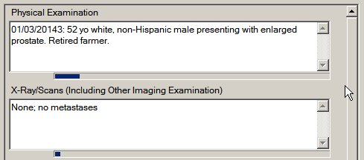
Line returns are not allowed in Abstract Plus text fields. Pressing Enter will move the cursor to the next text field in the text entry grid.
Activity 4 – Entering Text Fields
To practice entering text into the text area entry grid, enter the following information into the following text fields:
Text Field | Value to be Entered
Physical Examination | 01/03/2014: 52 yo white, non-Hispanic male presenting with enlarged prostate. Retired farmer.
X-ray/Scans (including Other Imaging Examination) | None; no metastases
Lab Tests | 01/03/2014: PSA , elevated, 0.2 ng/ml
OP/Surgical Procedures | 01/05/2014: TURP, NOS
Pathology | 01/05/2014, TURP, incidental finding of adenocarcinoma in situ, size 001 mm
Primary Site Title | Prostate
Histology Title (Type, Behavior, and Grade) | Adenocarcinoma, in situ, grade I
Staging Decisions | Physician states nodes are clinically negative

Activity 5 – Abstracting Cancer Information
To practice entering information regarding cancer identification information about the tumor being reported, enter the following information into the following fields either by typing the value, using the drop-down list feature, or using the advanced search feature by clicking on the magnifying glass icon where available:
Field | Value to be Entered
Date of Diagnosis | 2014/01/05
Date of Diagnosis Flag | Leave blank (press enter to move to next field)
Primary Site | C619 (Prostate, NOS)
Laterality | 0 – Not a paired site

Note: Upon entry of both the Date of Birth and Date of Diagnosis fields, The Age at Diagnosis (052) is automatically calculated and entered into the Age at Diagnosis field.

Abstracting Histologic Type
Prior to cases diagnosed in 2010, coding of Histologic Type in Abstract Plus entailed using the advanced search feature for the Histologic Type field: click the magnifying glass icon to the left of the field, enter a search term in the search window that opens, and double-click the histologic code that is listed for the specific term for which a search was conducted.
However, new reportability instructions and data collection rules for hematopoietic and lymphoid neoplasms have gone into effect for cases diagnosed beginning January 1, 2010. As a result, two tools have been developed by SEER for use beginning in 2010: The Hematopoietic and Lymphoid Neoplasm Case Reportability and Coding Manual, and the Hematopoietic Database (DB). The Hematopoietic and Lymphoid Neoplasm Case Reportability and Coding Manual comes with the Hematopoietic Database; contains reportability instructions and rules for determining the number of primaries, the primary site and histology, and grade.
The Hematopoietic DB is a stand-alone application developed to assist in screening for reportable cases and determining reportability requirements, and contains abstracting and coding information for all hematopoietic and lymphoid neoplasms (9590/3-9992/3).
The SEER Hematopoietic Database must be independently installed and maintained by the Abstractor. It can be downloaded from the following URL: http://seer.cancer.gov/tools/heme/. In order to stay abreast of revisions in the database, it is recommended that you sign up on the website to receive e-mails when the database is updated:
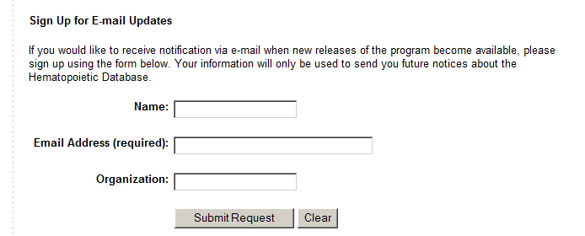
Once installed on the same computer on which Abstract Plus is installed, the Hematopoietic Database is minimally integrated into Abstract Plus, and can be launched in the following 3 ways:
- From the Histology Lookup window: Click on the magnifying glass icon to the left of the Histologic Type ICD-O-3 data item (or press F4) to use the search feature:
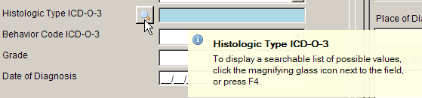
And then click the Hematopoietic Database blood drop icon to launch the database.
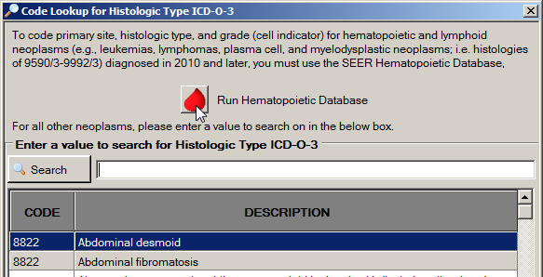
- Click on the Help menu, and select Run SEER Hematopoietic Database.
- Click the Hematopoietic Database icon on the tool bar .
Be sure to follow the steps in the flowchart in Appendix C when using Hematopoietic Database and Manual to code hematopoietic and lymphoid neoplasms.
Activity 6 – Abstracting Histologic Type
To practice entering Histologic Type, complete these steps:
- Click the magnifying glass icon to the left of the Histologic Type ICD-O-3 field, and type Adenocarcinoma, NOS in the Search box.
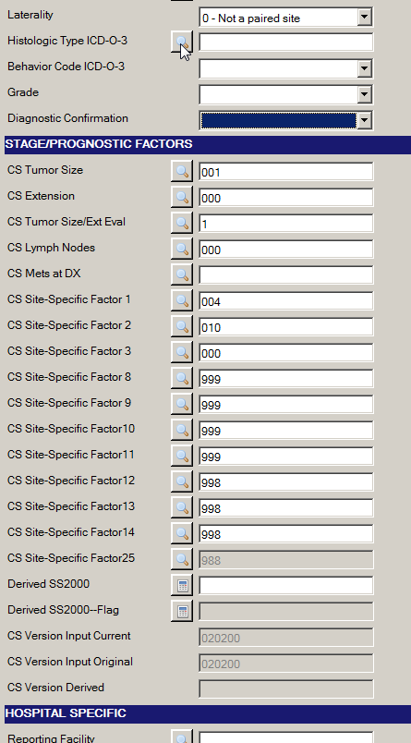
Result: The Code Lookup for Histologic Type ICD-O-3 window opens.
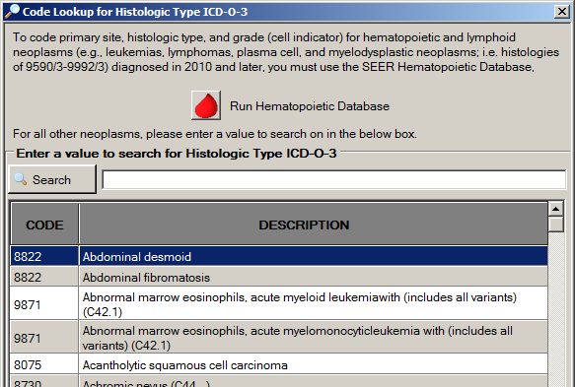
- Type Adenocarcinoma in the search box, and double-click the 8140 code value to the left of the Adenocarcinoma in situ, NOS description.
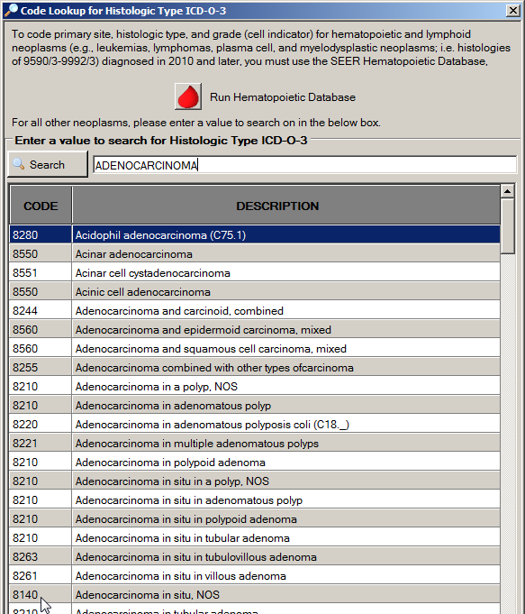
Result: The value of 8140 is automatically entered into the data entry grid for the Histologic Type ICD-O-3 field, and the Code Lookup for Histologic Type ICD-O-3 window automatically closes.
In this activity, we are abstracting the histologic type for an Adenocarcinoma of the prostate. If you are abstracting Histologic Type for a hematopoietic or lymphoid neoplasm, be sure to click the blood drop icon to run the SEER Hematopoietic Database.
- Complete the coding for the Cancer Identification section by entering the following information into the following fields either typing the value or using the drop-down list feature:
Field | Value to be Entered
Behavior Code ICD-O-3 | 2 – Carcinoma in situ
Grade | 1 – Grade 1; well differentiated
Grade Path Value | 1 – Recorded as Grade I or 1
Grade Path System | 4 – Four-Grade System
Diagnostic Confirmation | 1 – Positive Histology

Saving Abstracts
Once you have entered information into an abstract, it is a good idea to save your work often. To save your work, complete these steps:
- Saving an abstract can be done in 3 ways:
- Click on the File menu, and select Save Abstract.
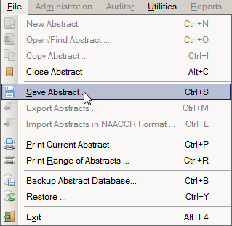
- Click the Save icon on the tool bar .
- Use the keystroke Ctrl+S.
Results:
1) The information entered thus far for the abstract is saved to the database, and
2) edits will run (depending on the way your Abstract Plus Administrator set up your Abstract Plus application).
3) The Edit Set Results window opens and displays information about any edit errors the abstract may contain.
4) Once saved, each abstract is assigned an unique Abstract Reference ID (or AbsRefID), displayed in the upper left-hand corner of the data entry area of abstracting window, as well as in the title bar of the application along with the patient name:
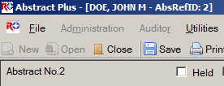
5) The EDITS Error Count and Abstract Completion status indicators reflect the current edit error count and completion status of the abstract. If there are any errors within the abstract, both of these indicators will display in red. In the example shown, the abstract contains 18 edit errors and as a result, is deemed incomplete.

Correcting Edit Errors
For any abstract you can run edits and view edit errors by saving the abstract, clicking the EDITS button on the toolbar, or pressing F8.
Each time an abstract is opened or saved Abstract Plus automatically edits the entered information for accuracy and completeness using the edit set and required fields chosen by your Abstract Plus Administrator.
You must resolve all edit errors and fill in all critical (required) fields in order to complete the abstract.
Abstract Plus has edit error display features that greatly facilitate the error resolution process. Editing features include:
- The edit set being run on the abstract is clearly displayed at the top of the abstracting window. In the example shown, the edit set being applied is named Central Vs 14 State Example - Incoming Abstracts:
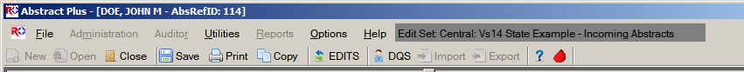
- When edits are run, the Edit Set Results window automatically opens and displays the full information for any edit errors that exist, or lets you know that there are no errors. The Edit Set Results window lists the total number of edit errors for the abstract, missing critical (required) fields, and the edit errors. For each edit error, the failed edit name, error message, and fields involved in the edit are listed. Using the information listed in the Edit Set Results window to help you resolve the edit errors, you can click on a link to a field to move to it in the data entry grid and make corrections:
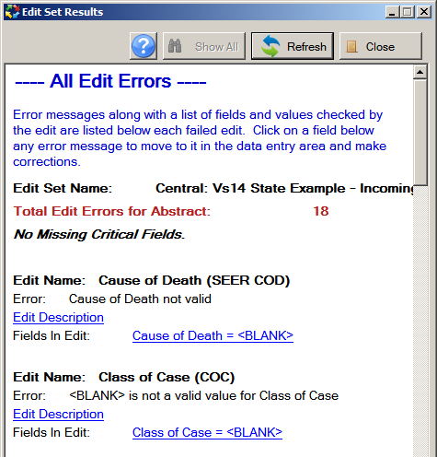
Links to fields in data entry grid
When greater detail regarding the edit is required to resolve the edit error, click on the Edit Description link, which expands to display the edit description; once opened, you can click anywhere to close the edit description:
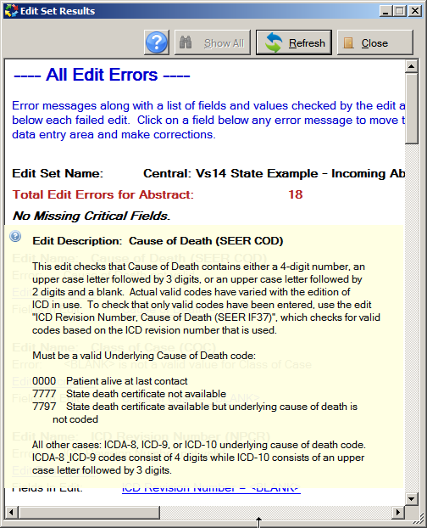
Click Edit Description link to open description; click anywhere to close description
- Edit errors can be viewed for the entire abstract, or just for individual fields. You can view all edit errors for the abstract as shown above by clicking on the EDITS icon on the toolbar , right-clicking and selecting Run Edits, or by pressing F8.
Or you can choose to view edit errors by individual data field by right-clicking and selecting Edits Information, or by pressing F2. In the example shown, the edit errors for the individual field of Cause of Death are being viewed:
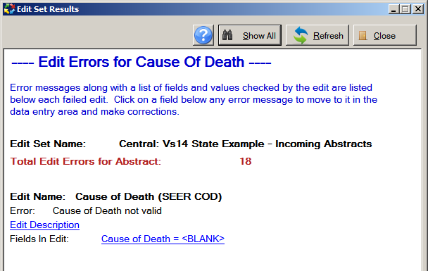
When viewing edit errors for an individual field, you can switch from the individual data field edit errors view to the all edit errors view by clicking on the Show All button.
You can make corrections to fields by clicking on the links to the fields in the Edit Set Results windows. To see your corrections reflected, click the Refresh button.
Activity 7 – Correcting Edit Errors
To practice correcting edit errors, complete the following steps:
- Either save the abstract, click the EDITS button on the toolbar, or press F8 to run the edits.
Result: The Edit Set Results window opens and displays information regarding any edit errors within the abstract.
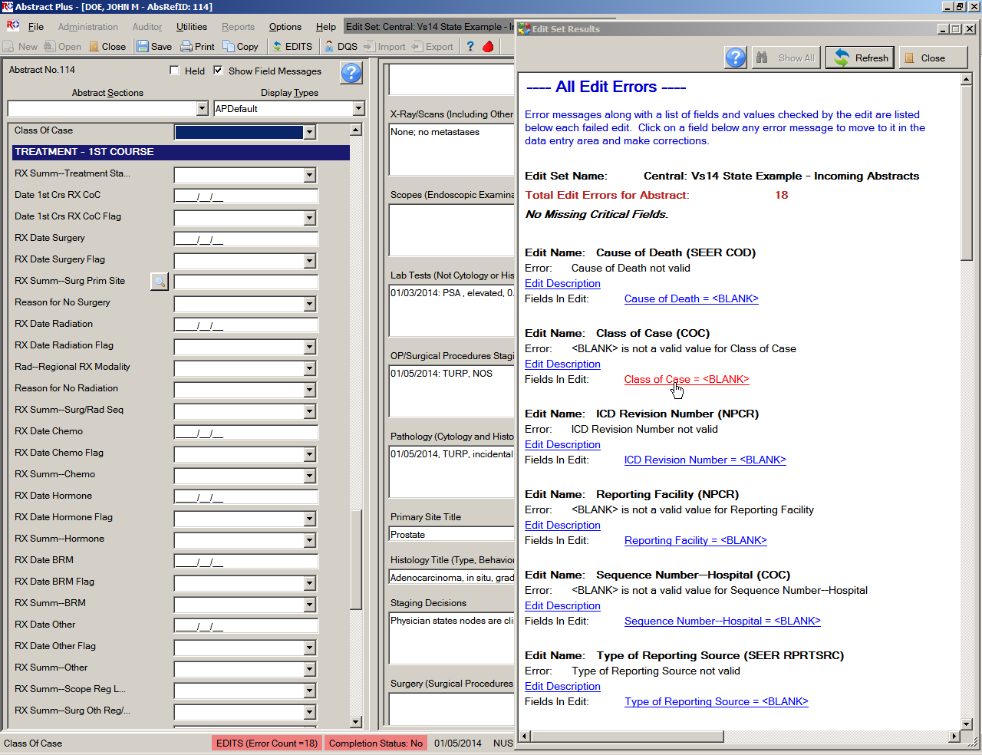
- In the Edit Set Results window, click on the Class of Case = <BLANK> link.
Result: The application directs you to the Class of Case field in the data entry grid, so that you can correct the error.
- Enter 14 to indicate that the patient was diagnosed at and all treatment given at the reporting facility to resolve the edit error.
- Either save the abstract, click the EDITS button on the toolbar, press F8, or click Refresh to run the edits.
Result: The application re-runs the edits. The Class of Case edit error is removed from the Edit Set Results window, and the Total Edit Errors for Abstract count goes down by 1. In the example shown, the edit error count goes down from 18 to 17.
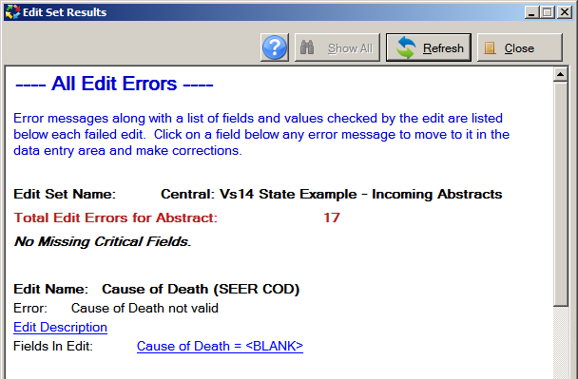

The edit error resolved in this exercise was easy to figure out. If you need further detail regarding the edit error to resolve the error, click on the Edit Description link for the failed edit, which will expand to display the edit description information.

Abstracting and Deriving Collaborative Staging Fields
Abstract Plus has some special features to facilitate the abstraction of Collaborative Staging (CS) input fields, in particular for the Site-specific Factors (SSFs).

Abstracting CS Input Fields
Once the fields of primary site and histology have been entered, each CS input data item has a special site-specific look-up associated with it that is accessed by clicking the magnifying glass icon to the left of the field or pressing F4.
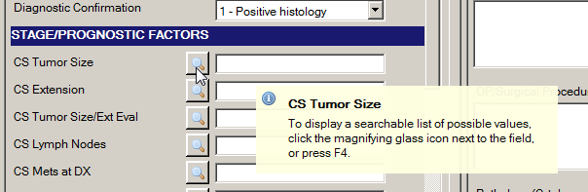

Abstracting CS SSFs
Abstract Plus allows for automatic defaulting of CS SSFs and running of edits to identify required CS fields, automatic filling in of CS Version fields, as well as the blanking out of CS input fields for cases diagnosed 2003 and earlier.
For the filling of the CS Version fields, once the Abstractor enters Primary Site, Histology, DxDate and Behavior (in no particular expected order), the fields of CS Version Input Current (item #2937) and CS Version Input Original (item #2935) are both automatically filled when the Abstractor enters any CS input field. CS Version Derived (item #2936) is filled when you derive the CS derived fields.
Once entered, a check on primary site and histology is run to ascertain whether or not SSF25 is required for schema identification. Upon checking the primary site and histology entered:
- If SSF25 is required for the primary site and histology entered:
  - The SSF25 look-up window for the entered schema will open so that you can select a value for SSF25.
  - Once you have entered SSF25, automatic defaulting and disabling of SSFs that are undefined for the entered schema will occur. This will enable you to clearly discern what SSFs are not required, and which SSFs are required. The automatic defaulting will delineate what SSFs are not defined for the identified schema, and the running of edits will delineate what SSFs are required.
If the primary site and histology initially entered are revised to result in a different schema, you will be offered the option of clearing all CS input fields and re-coding CS for the abstract. Regardless of whether you clear all values and re-code CS, or keep existing values and modify the codes, the above SSF defaulting routine will run again for the newly entered schema.
- If SSF25 is not required for the primary site and histology entered:
  - SSF25 will be automatically defaulted and disabled.
  - Automatic defaulting and disabling of other SSFs that are undefined for the entered schema will occur. This will enable you to clearly discern what SSFs are not required, and which SSFs are required. The automatic defaulting will delineate what SSFs are not defined for the identified schema, and the running of edits will delineate what SSFs are required.
For Abstract Plus version 3.4, NAACCR v14.0-based software, the APDefault and APDefault2 example display types have CS SSF 1-24 defaulted to the values of 988. This is to save the Abstractor the time of entering 988 for most SSFs for the majority of schemas. The NAACCR 14.0 edits metafiles have edits that will result in an error when the defaulted value of 988 is not valid (i.e., when the Abstractor needs to revise the value of 988 to a valid value for the entered schema). So in order to assess what SSFs are required, all the Abstractor needs to do is run edits once they have entered CS input fields other than the SSFs.

Calculating Derived CS Fields
To derive the derived CS fields, after the appropriate CS input fields have been entered, place the cursor into any of the derived fields and click the calculator icon to the left of the field, or press F5.
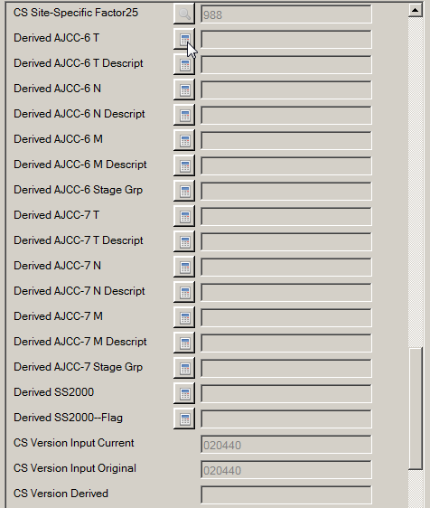
Or, your Administrator may choose set turn on the option to automatically calculate Collaborative Stage derived data items upon save of the abstract after the following CS input data items have been abstracted:
- CS Tumor Size
- CS Extension
- CS Tumor Size/Ext Eval
- CS Lymph Nodes
- CS Lymph Nodes Eval
- CS Mets at DX
- CS Mets Eval
- CS Site-Specific Factor 1-25
If your Administrator has turned this option on, CS derived data items will be calculated upon every save after the above fields have been entered.

CS Fields and Tumors Diagnosed 2003 and Earlier
One further helpful feature is that upon entry of a Date of Diagnosis of 2003 and earlier, you will be offered the option of clearing all CS fields.
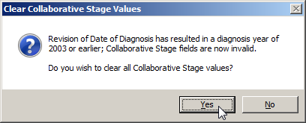
The Clear Collaborative Staging Values window opens automatically upon entry of a diagnosis year of less than 2004. However, you can clear Collaborative Staging fields at any time by using the right-click function of Clear Collaborative Stage Fields or pressing F9.
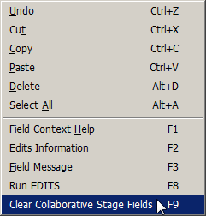
Activity 8 – Abstracting and Deriving Collaborative Staging Fields
To practice abstracting and deriving CS fields and using the CS special help features provided by Abstract Plus, complete the following steps:
- Type 001 in the CS Tumor Size field (or click the magnifying glass icon to have the application guide the entry of the value), representing a tumor size of 001 millimeters. Press Enter.
Result:
a) The CS Version Input Current and Original fields are filled in and disabled.
b) Automatic defaulting of SSFs undefined for the entered schema (in this case prostate) occurs, and these fields are disabled. In the example shown, SSF25 is automatically defaulted and disabled.
If a SSF is defined for the entered schema, it will not be automatically defaulted, as valid values will exist and can be coded for the SSF. However, there will be SSFs that are defined for schemas that are not currently being required/collected. Depending on your reporting requirements, these SSFs that are defined but not required may require the entry of 988 (Not applicable; information not collected for this case).
Defined, required SSFs will not be defaulted, and they will be listed as edit errors in the Edit Results window. You will need to enter a valid code for these SSFs. Defined, not required SSFs will not automatically be defaulted and will not be counted as edit errors in the Edit Results window. Depending on your reporting requirements (enforced by the edits), these SSFs may need to be manually filled with 988 (Not applicable; information not collected for this case), or 999.
As stated earlier in this manual, for Abstract Plus version 3.4, NAACCR v14.0-based software, the APDefault and APDefault2 example display types have CS SSF 1-24 defaulted to the values of 988. This is to save the Abstractor the time of entering 988 for most SFFs for the majority of schemas. The NAACCR 14.0 metafiles have new edits that will result in an error when the defaulted value of 988 is not valid (i.e., when the Abstractor needs to revise the value of 988 to a valid value for the entered schema). So in order to assess what SSFs are required, all the Abstractor needs to do is run edits once they have entered CS input fields other than the SSFs.

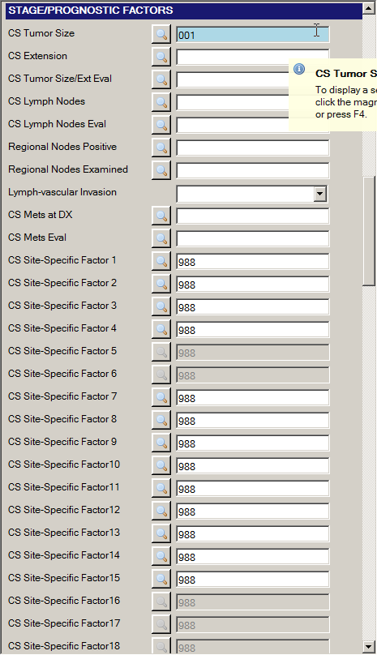

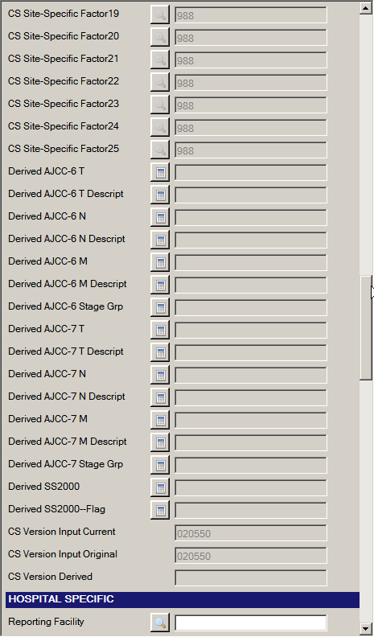
In the above example, the prostate schema has been entered, and the automatic CS SSF defaulting routine has run. In addition, in this example display type, the remaining SSFs have been manually defaulted to 988, but are left open so that you may change the value depending on your central registry’s requirements (which are enforced via the running of the edits). You can see that all of the CS SSFs have been defaulted in this example display type. You can easily see which of the SSFs are undefined for the entered schema as they have been defaulted and grayed-out. In addition, you can easily see which of the SSFs that are defined for the entered schema are required (i.e., cannot be blank or equal 988) by running the edits and viewing the Edit Results window.
Depending on the reporting requirements of your central registry, and how your Abstract Plus Administrator has set up your abstracting display, some SSFs may be blank after the running of the automatic CS SSF defaulting routine. These fields may have to be manually coded with valid values or coded to 988 (or applicable code for not required).
Enter the following information into the remaining CS fields either by just typing the value in the field or using the advanced search feature to guide your input by clicking on the magnifying glass icon to the left of the field:

Field | Value to be Entered
CS Extension | 000 (in situ; non-invasive; intraepithelial)
CS Tumor Size/Ext Eval | 1 (No prostatectomy done. Evaluation based on endoscopic examination, diagnostic biopsy, including needle core biopsy or fine needle aspiration biopsy, transurethral resection (TURP) or other invasive techniques including surgical observation without biopsy. No autopsy evidence used.)
CS Lymph Nodes | 000 (No regional lymph node involvement)
CS Lymph Nodes Eval | 0 (Does not meet criteria for AJCC pathologic staging:  No regional lymph nodes removed for examination. Evidence based on physical examination, imaging examination, or other non-invasive clinical evidence. No autopsy evidence used.)
Regional Nodes Positive | 98 (No nodes examined)
Regional Nodes Examined | 00 (No nodes examined)
Lymph-Vascular Invasion | 0 Lymph-vascular Invasion stated as Not Present
CS Mets at DX | 00 (No distant metastasis)
CS Mets Eval | 0 (Does not meet criteria for AJCC pathologic staging of distant metastasis:  Evaluation of distant metastasis based on physical examination, imaging examination, and/or other non-invasive clinical evidence. No microscopic examination of metastatic specimen performed or microscopic examination was negative.)
Site-Specific Factor 1  (PSA lab value) | Change the defaulted value of 988 to 002 (002 ng/ml; actual value with implied decimal point)
Site-Specific Factor 2 (PSA interpretation) | Change the defaulted value of 988 to 010 (Positive; elevated)
Site-Specific Factor 3  (Pathologic extension) | Change the defaulted value of 988 to 970 – No prostatectomy done within first course of treatment
Site-Specific Factor 4 | Leave the defaulted value of 988 (Not applicable; information not collected for this case)
Site-Specific Factor 7 | Leave the defaulted value of 988 (Not applicable; information not collected for this case)
Site-Specific Factor 8 | Leave the defaulted value of 988 (Not applicable; information not collected for this case)
Site-Specific Factor 9 | Leave the defaulted value of 988 (Not applicable; information not collected for this case)
Site-Specific Factor 10 | Leave the defaulted value of 988 (Not applicable; information not collected for this case)
Site-Specific Factor 11 | Leave the defaulted value of 988 (Not applicable; information not collected for this case)
Site-Specific Factor 12 | Leave the defaulted value of 988 (Not applicable; information not collected for this case)
Site-Specific Factor 13 | Leave the defaulted value of 988 (Not applicable; information not collected for this case)
Site-Specific Factor 14 | Leave the defaulted value of 988 (Not applicable; information not collected for this case)
Site-Specific Factor 15 | Leave the defaulted value of 988 (Not applicable; information not collected for this case)
Once all CS input fields have been filled in, you must derive the CS derived fields as appropriate. Place the cursor in the derived field, and either press F5 or click the calculator icon to the left of the field. In the example shown, all CS derived fields will be calculated or derived.
- Click the calculator icon to the left of the Derived AJCC-6 T, or press F5.
Result: The Collaborative Staging Result window open and displays the calculated values.
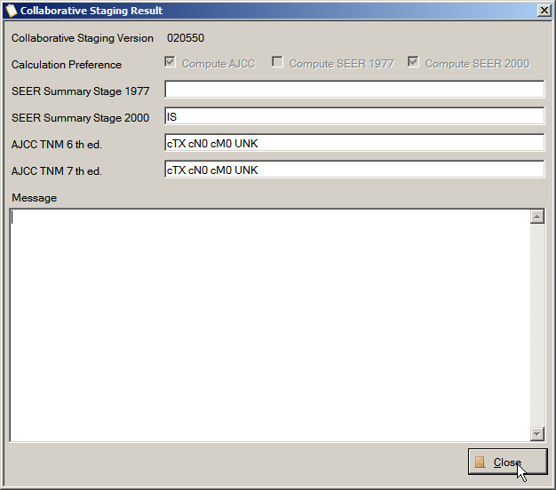
- Click Close.
Result: The appropriate derived CS fields are calculated and values are automatically filled in. In the example shown, all CS derived fields are calculated and filled. In addition the CS Version Derived field is also automatically filled upon derivation.
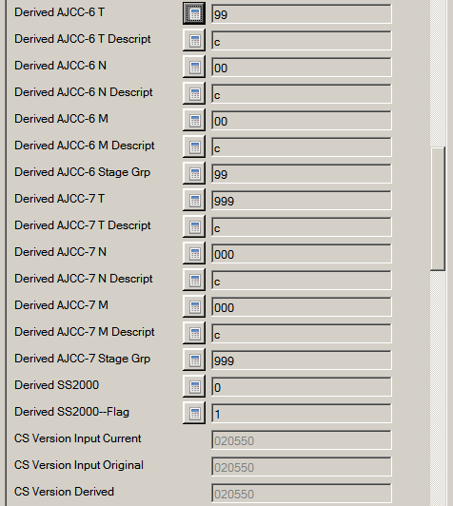

Questions---Abstracting and Saving Information
Answer these questions about abstracting and saving information in Abstract Plus (the answers are in Appendix A, on page 128):
- How do you know how much data you can enter into any particular text field?
- How do you open the SEER Hematopoietics Database to obtain coding help for hematopoietic and lymphoid neoplasms diagnosed beginning January 1, 2010?
- How do you save an abstract?
- What is an Abstract Reference ID (AbsRefID), and when is it generated for an abstracts?
- How do you know that an abstract contains errors, and where can you find the total number of errors that exist in an abstract?
- Where do you obtain the information you need about any edit errors that exist in an abstract?
- When coding Collaborative Staging fields, what Site-specific Factors are automatically defaulted?

Completing Abstracts
As mentioned, you must resolve all edit errors and fill in all critical (required) fields in order to complete an abstract. Abstract Plus displays helpful, color-coded edits error count and abstract completion status information at the bottom of the abstracting window. Once you have resolved all edit errors and completed all missing critical fields, upon the next save of the abstract, the status information changes from red to green upon completion of the abstract:
Incomplete abstract containing edit errors:
Complete abstract containing no edit errors:

Closing Abstracts
Once you have entered information into an abstract and saved your work, you can close the abstract and open it in the future to complete your work. You can also search for an open completed abstracts.
To close an abstract, complete these steps:
- Abstracts can be closed in 3 ways:
- Click on the File menu, and select Close Abstract.
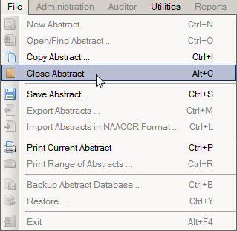
- Click the Save icon on the tool bar .
- Use the keystroke Alt+C.
Result: The abstract is closed, and you are returned to the Abstract Plus main window.
Activity 9 – Completing and Closing an Abstract
Using what you have just learned, complete and close the John Doe abstract.
- To complete the John Doe abstract, enter the following information into the following fields, either typing the value, using the drop-down list feature, or using the advanced search feature by clicking on the magnifying glass icon where available:
Field | Value to be Entered
Reporting Facility | 1111111111 – Test Facility 1
NPI--Reporting Facility | Leave blank (press enter to move to next field)
Type of Reporting Source | 1 – Hosp. inpatient; Managed health plans with comprehensive unified records
Medical Record Number | 12312312312
Primary Payer at DX | 10 – Insurance, NOS
Sequence Number—Hospital | 00
Date of 1st Contact | 2014/01/03
Date of 1st Contact Flag | Leave blank (press enter to move to next field)
Rx Summ—Treatment Status | 1 – Treatment given
Date of 1st Crs RX—COC | 2014/01/05
Date of 1st Crs RX--COC Flag | Leave blank (press enter to move to next field)
RX Date--Surgery | 2014/01/05
RX Date--Surgery Flag | Leave blank (press enter to move to next field)
RX Summ--Surg Prim Site | 22 – TURP-cancer is incidental finding during surgery for benign disease
Reason for No Surgery | 0 – Surgery of primary site performed
RX Date--Radiation | Leave blank (press enter to move to next field)
RX Date--Radiation Flag | 11 – RX modality not given; autopsy only
Rad--Regional RX Modality | 00 – No radiation treatment
Reason for No Radiation | 1 – Radiation therapy not administered; not planned 1st course
RX Summ--Surg/Rad Seq | 0 – No radiation and/or no cancer-directed surgery
RX Date--Chemo | Leave blank (press enter to move to next field)
RX Date—Chemo Flag | 11 – RX modality not given; autopsy only
RX Summ--Chemo | 00 – None
RX Date--Hormone | Leave blank (press enter to move to next field)
RX Date--Hormone Flag | 11 – RX modality not given; autopsy only
RX Summ--Hormone | 00 – None
RX Date--BRM | Leave blank (press enter to move to next field)
RX Date--BRM Flag | 11 – RX modality not given; autopsy only
RX Summ--BRM | 00 – None
RX Date--Other | Leave blank (press enter to move to next field)
RX Date--Other Flag | 11 – RX modality not given; autopsy only
RX Summ--Other | 0 – None
RX Summ--Scope Reg LN Sur | 0 – No regional lymph nodes removed
RX Summ--Surg Oth Reg/Dis | 0 – None
RX Summ--Transplnt Endocr | 00 – No transplant or endocrine therapy; autopsy- only
RX Summ--Systemic/Sur Seq | 0 – No systemic therapy and/or surgical procedures
Date of Last Contact | 2014/01/05
Date of Last Contact Flag | Leave blank (press enter to move to next field)
Vital Status | 1 – Alive
Follow-up Source | 0 – Reported hospitalization
Cause of Death | 0000 (Patient alive at last contact.)
ICD Revision Number | 0 – Patient Alive
Place of Death--State | Leave blank
Place of Death--Country | Leave blank
Physician Follow-Up | 99999999 (Follow-up physician unknown or ID number not assigned)
NPI—Physician Follow-Up | Leave blank

- Click Save to save your work.
Result: Edits are run; the Edit Set Results window opens and displays a message indicating that no errors remain on the abstract. In addition, the EDITS error count and completion status bars at the bottom of the abstracting window turn from red to green to indicate that the abstract has been deemed complete by the system.
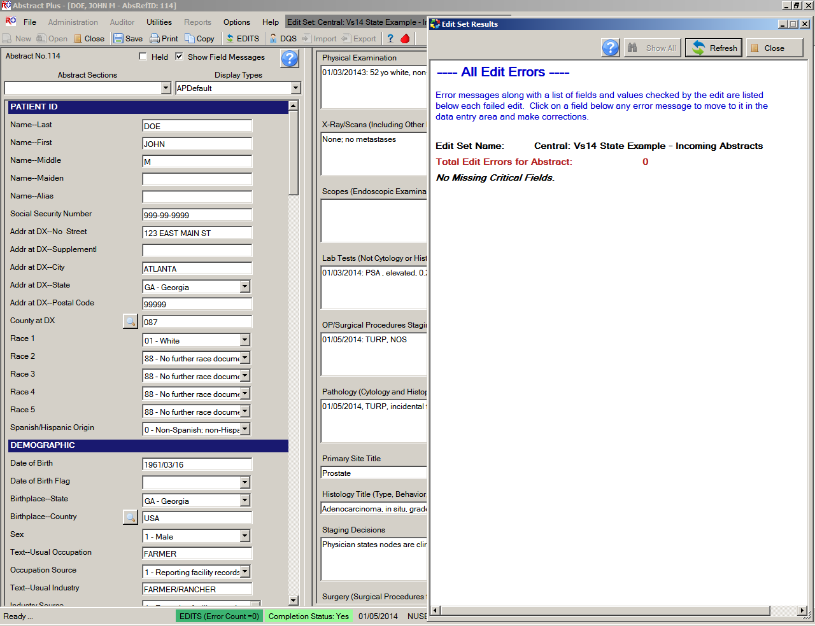
- Close the abstract. For more information about how to close an abstract, see page 80 of this training manual, or click here.

Searching for and Opening an Existing Abstract
We have just learned that you can begin abstracting work by creating a new abstract. Another way that you can begin abstracting work is to search for and open an existing abstract.
To find and open an existing abstract, complete these steps:
- Existing abstracts can be searched for and opened in 3 ways:
- Click on the File menu, and select Open/Find Abstract.
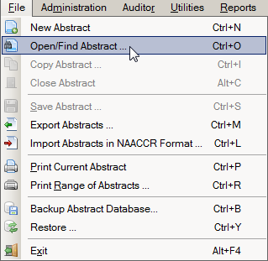
- Click the Open icon on the tool bar .
- Use the keystroke Ctrl+O.
Result: The Open/Find Abstract window opens.
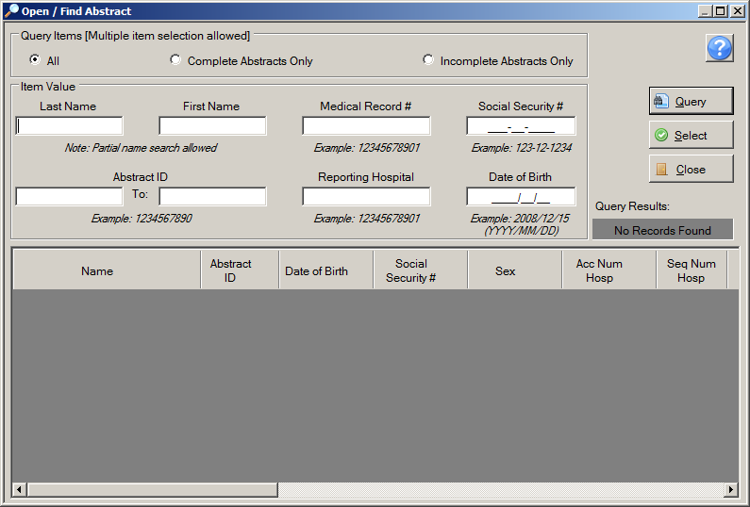
Query Criteria
List of Abstracts to be Opened (Resulting from Search)
The Open/Find Abstract window has two main sections. The patient query area is located in the upper portion of window, and the lower portion of the window displays the query results as a list of abstracts from which the abstract of interest can be opened. Abstracts listed can be queried by any combination of patient first and last names, medical record number, social security number, date of birth, reporting hospital, or Abstract Reference ID. In addition, abstracts can be queried for by abstract completion status by clicking on the appropriate search option at the top of the window.
If you click the Incomplete Abstracts Only search criteria option, only abstracts for which abstraction has not yet been completed will be displayed; this is very helpful for identifying abstracts yet to be completed.
The abstract list window includes these fields and column headings:
Columns | Description
Name | Name of Patient (Last, First)
Abstract ID | A system-generated number identifying the abstract
Date of Birth | Patient’s date of birth
Social Security # | Patient’s social security number
Sex | Patient’s sex
Acc Num Hosp | Hospital accession number reported by the audited facility for the reported tumor
Seq Num Hosp | Sequence number hospital reported by the audited facility for the reported tumor
Date 1st Contact | Date of 1st contact reported by the audited facility for the reported tumor
Diagnosis Date | Diagnosis date of the reported tumor
Primary Site | ICD-O-3 topography code describing the location of the reported tumor
Reporting Hospital | COC code for the reporting facility that reported the tumor
Laterality | Code for the side of a paired organ, or the side of the body on which the reported tumor originated
Hist/Beh ICDO3 | ICD-O-3 histology and behavior codes for the reported tumor
Medical Record # | Patient’s medical record number
Date Last Contact | Date last contact reported by the audited facility for the reported tumor
Vital Status | Patient’s vital status
Abstract Status | The status of the reabstract---incomplete, complete, or held

The order of the columns on the abstract list window may be modified. Simply left-click and hold on the column header, and slide the column to the desired position in the column viewing order.
- Query for a patient on the list of tumors to be opened. Enter the first letter of the patient’s last name in the Last Name search criteria box on the Open/Find Abstract window, and click Query. You can also use any of the other available search criteria to search upon. In the example shown, the abstract being searched for is for a patient named John Doe, so a D is entered in the Last Name search criteria box.
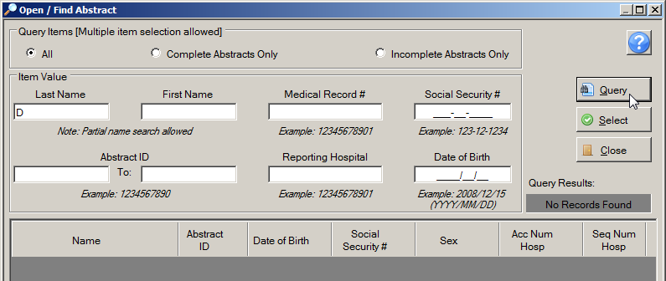
Result: The Open/Find Abstract window presents the results of the query, and displays any potential matches in the tumor list window.
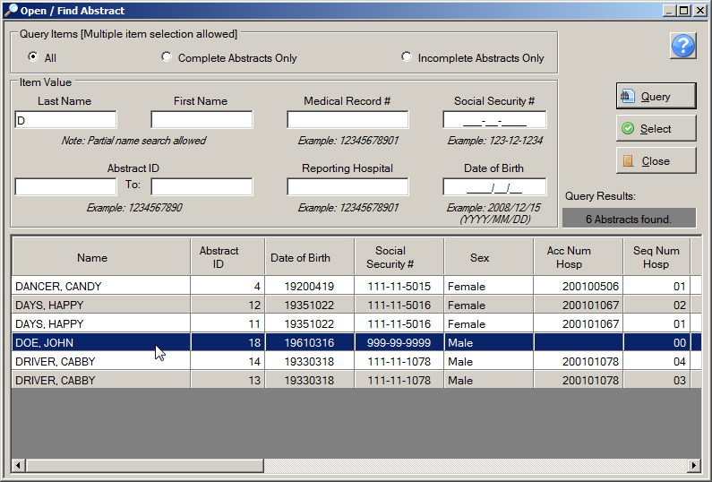
- From the abstracts listed, locate the abstract of interest and open it, either by double-clicking the row for the abstract or select the row for the abstract and click Select.
Result: The Abstract Plus Abstracting window opens so that you can modify the abstract that has just been opened.

Copying an Abstract
Thus far we have learned that you can begin abstracting work by creating a new abstract, or searching for and opening an existing abstract. The third way to begin abstracting is to copy an existing abstract and modify the information it contains. The copy feature is especially helpful for the reporting of patients with multiple primaries. Simply open the abstract for the first primary for the patient, copy the abstract, and then enter the tumor and treatment information for the subsequent primary tumor.
To copy an abstract, complete these steps:
- Make sure that you have the abstract to be copied open in the abstracting window.
- Abstracts can be copied in 3 ways:
- Click on the File menu, and select Copy Abstract.
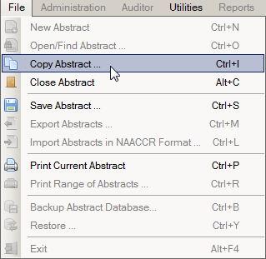
- Click the Copy icon on the tool bar .
- Use the keystroke Ctrl+I.
Result: The Copy Abstract dialog window opens and asks you to confirm that you would like to copy the abstract.
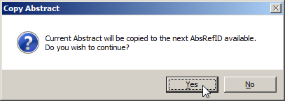
- Click Yes.
Result: The abstract is copied to a new Abstract Reference ID. Note that the patient demographics from the original abstract are copied into the new abstract, so that you need only enter information regarding the tumor being abstracted. Edits are run, and the Edits Error Count and Completion Status indicators will indicate that there are errors (missing fields) for the abstract and that the abstract is incomplete.
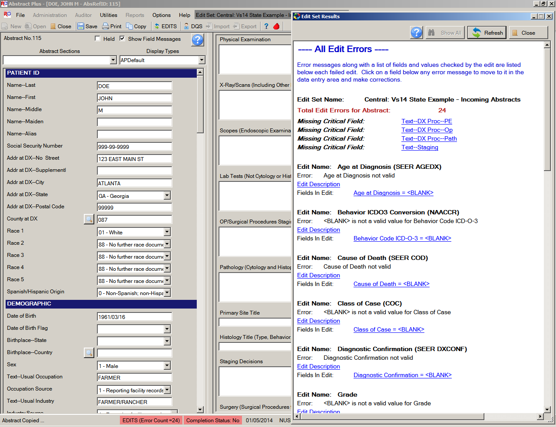
- Once you have finished work on the newly copied abstract, save your work, and close the abstract.
If you find an abstract that looks very much like an abstract you want to create for the same patient but with a different primary site, you can simply save the abstract as a new one and then modify the necessary fields in the new abstract.
Activity 10 – Finding, Opening, and Copying an Abstract
Use what you have just learned to practice searching for, opening and copying abstracts, complete these steps:
- Search for and open the John Doe abstract. For more information on finding an opening existing abstracts, see page 84 of this training manual, or click here.
- Now copy the John Doe abstract. For more information on copying abstracts, see page 87 of this training manual, or click here.

An Aside on Abstract Plus “Projects”
A Project is an avenue for labeling an abstract and grouping abstracts together. With Abstract Plus version 2, all abstracts had to be assigned to a “Project”. In Abstract Plus version 2 at least one project had to exist in the system, and by default, version 2 of Abstract Plus came with a Project called STATE to which each new abstract needed to be physically assigned.
As the overwhelming majority of Abstract Plus users did not utilize the Projects feature of Abstract Plus version 2.0, although the use of Projects is still available, it is no longer required. In Abstract Plus version 3.x, Projects are optional True/False application-specific fields that can be added to any display type (in the same manner as any standard NAACCR data item). As a result, unless the central registry intentionally requires a Project field, abstracts are no longer required to be assigned to a project.
Please note that the Projects feature of the program is not functioning correctly at this time. This issue will be corrected in a future version of the program.

Questions---Completing, Finding, and Copying Abstracts:
Answer these questions about completing, finding, and copying abstracts in Abstract Plus (the answers are in Appendix A, on page 129):

- How do you know when an abstract is complete?

- How can you locate and open a specific saved abstract?

- Can you change the information contained in an existing abstract?

- How can you create a second abstract for a patient using the demographic information from an already existing abstract for the patient?

- Can an abstract exist without being attached to a project?

Exporting Abstracts
When exporting abstracts, you can choose to export all abstracts in the abstracts database, including complete and incomplete abstracts, or enter criteria for selecting NAACCR Type A Records or NAACCR Type M Records for export. Depending on how your Abstract Plus Administrator set up your application, the feature for including complete or incomplete abstracts during export may or may not be available to you.
You can export abstracts in NAACCR Layout, depending on options selected by your Abstract Plus Administrator upon setup of the program. The default is to export abstracts in the NAACCR file format. However, you do have the option to export all cases with all fields, including system fields, into an Excel file.
To export abstracts, complete these steps:
- Abstracts can be exported in 3 ways:
- Click on the File menu, and select Export Abstracts.
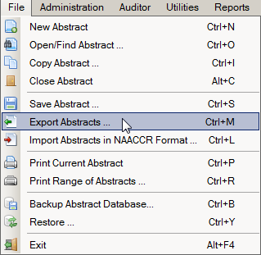
- Click the Export icon on the tool bar .
- Use the keystroke Ctrl+M.
Result: The Export Abstracts window opens, and presents you with different options for exporting abstracts.
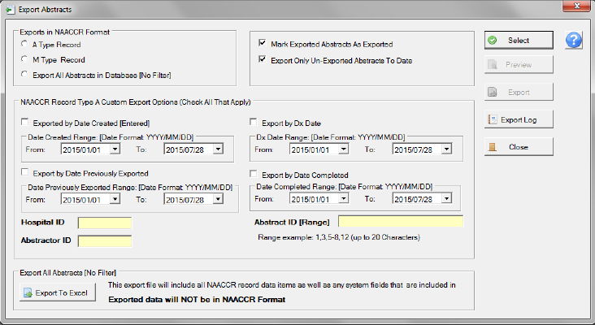
You can modify the default options selected on the export window to export only the particular abstracts that you would like to export.
The Mark Exported Abstracts as Exported and Export Only Un-Exported Abstracts To Date options are selected by default and generally should not be changed as these options will prevent re-export of previously exported abstracts, thus preventing reporting of duplicate abstracts to your central registry.
The Export Abstracts window includes the following options for exporting abstracts:
Export Option | Description
Export A Type Records | When checked, this option will export Type A Records Only. You will have the ability to filter this export based on additional selection criteria
Export M Type Records | When checked, this option will export all Type M records in Abstract Plus
Export All Abstracts in Database | When checked, this option will over-ride any other export option, and all abstracts in the database will be exported regardless of completion status
Mark Exported Abstracts as Exported | When this option is checked, all exported abstracts will be marked as exported; when used in combination with the Export Only Un-Exported Abstracts To Date export option, this prevents duplicate export of abstracts
Export Only Un-Exported Abstracts To Date | When this option is checked, only those completed abstracts that have not yet been exported will be exported; when used in combination with Mark Exported Abstracts as Exported export option, this prevents duplicate export of abstracts
Export by Date Created | This option allows the user to enter a date range to export completed Type A abstracts by the date they were created
Export by Date Previously Exported | This option allows the user to enter a date range to export previously exported, completed Type A abstracts by the date they were previously exported
Export by Dx Date | This option allows the user to enter a date range to export completed Type A abstracts by the diagnosis date of the tumors reported in the abstracts
Export by Date Completed | This option allows the user to enter a date range to export completed Type A abstracts by the date they were completed
Hospital ID | This option allows the user to enter a facility ID number to export completed Type A abstracts for a particular facility
Project ID | For those users with applications set up to collect information on Projects, this option allows the user to enter a Project ID to export completed Type A abstracts for a particular Project
Abstractor ID | This option allows the user to enter an Abstractor ID to export completed Type A abstracts for a particular Abstractor
Abstract ID Range | This option allows the user to enter an Abstract Reference ID number (or range of AbsRefIDs) to export specific completed Type A abstracts
Export to Excel | When selected, this will over-ride any other export option, and all abstracts in the database will be exported regardless of completion status to an Excel file. This export is not a NAACCR file and includes all system fields as well as any NAACCR data items.

The Export All Abstracts in Database function may only be available to administrators.
- Select the export options you require, and Click Select.
Result: The system displays the number of abstracts that meet the export criteria and are to be exported in the lower left-hand corner of the main window.
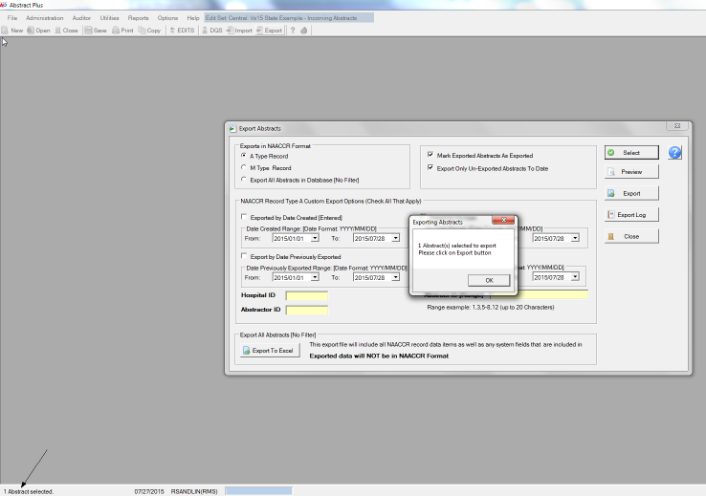
The system also issues a message:
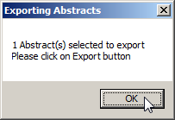
- Click OK.
- Now click Preview.
Result: The Export Selection Preview window opens.
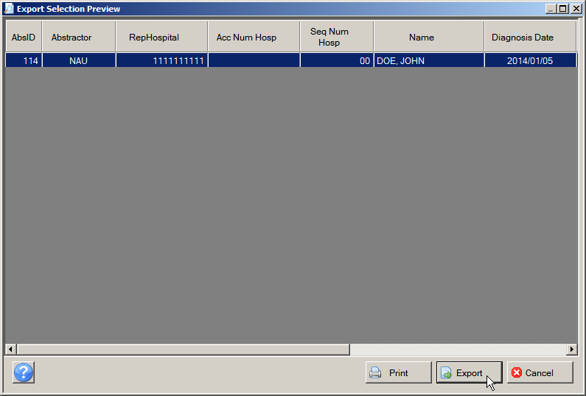
- Click Export.
Result: The Save As window opens.

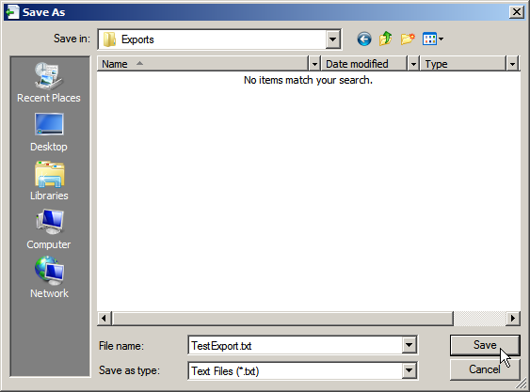
- Enter a file name for the export file in the File name box and click Save. In the example shown, the export file is being saved as TestExport.txt.
Result: The system saves the abstracts into a text file and lets you preview a report that you can print. By Default, Abstract Plus saves your export files to C:\RegPlus\AbstractPlus\Exports.
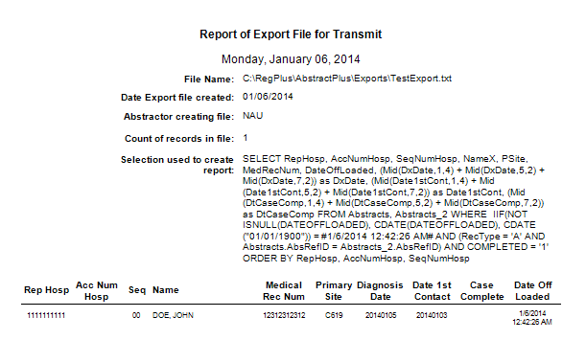
- Close the report preview and return to the Export Abstracts window.
- Click Export Log to view the log of exported abstracts.
Result: The Export Log window opens. Notice that you can enter a date range or enter Select Case ID, and click Select to view exports that contain the specified values.
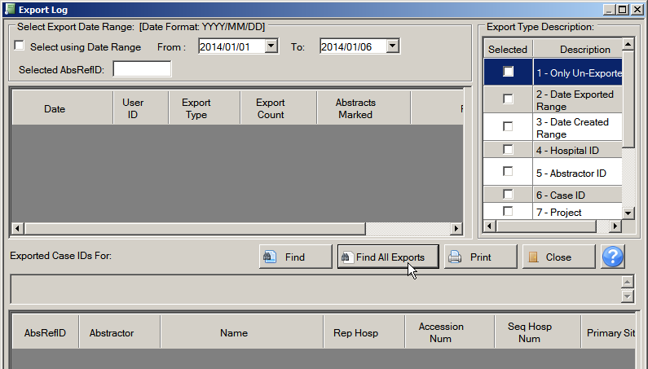
- Enter an export date range or specific AbsRefID, and click Find, or click Find All Exports to view all exports in the log.
Result: Specific fields for exported cases meeting the criteria entered are displayed in the lower window.
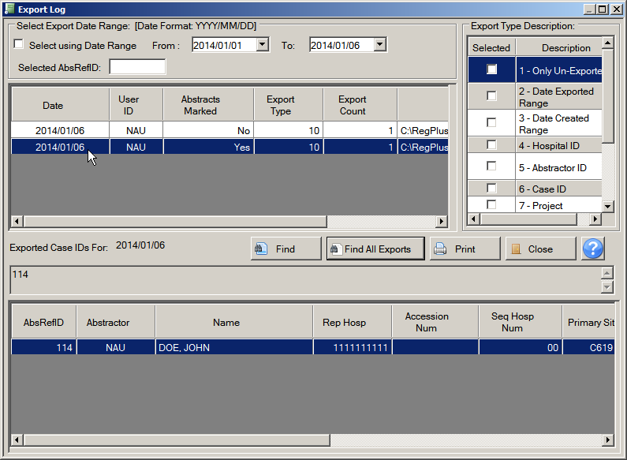
- Click Close to return to the Export Abstracts window and Close to return to the main menu.

Printing Abstracts
You can print any individual abstract that is open, or you can select one or more abstracts from your local database and print them. You can also choose to print the abstracts to a text file instead of sending them directly to a printer.

Printing an Open Abstract
To print an individual abstract that is open, complete these steps:
- An opened abstract can be printed in 3 ways:
- Click on the File menu, and select Print Current Abstract.
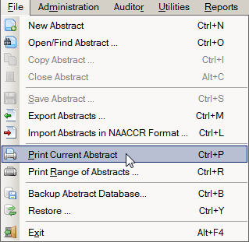
- Click the Print icon on the tool bar .
- Use the keystroke Ctrl+P.
Result: The Abstract Plus Report Viewer window opens with a print preview of the abstract to be printed. Note that for the majority of fields, the coded value and the label are printed. Please see page 116 of this manual or click here to learn more about using the Report Viewer window to view, save and print reports.
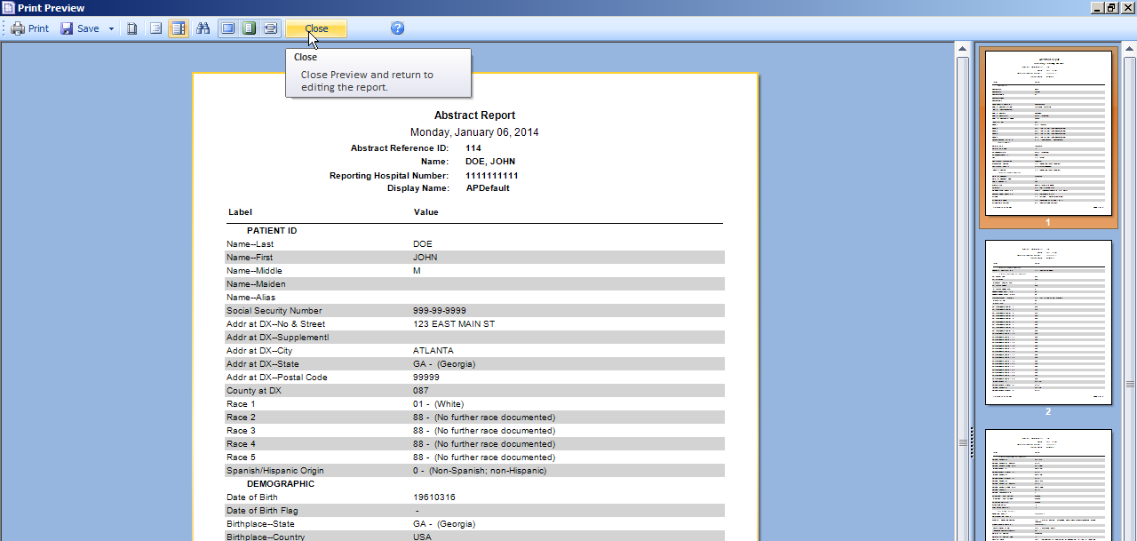
- Click Print or Save to print or save the abstract in the format of your choice.
- When you are done viewing/printing the abstract, click Close.

Printing a Range of Abstracts
To print a range of abstracts, complete these steps:
- Printing a range of abstracts can be done in 2 ways:
- Click on the File menu, and select Print Range of Abstracts.
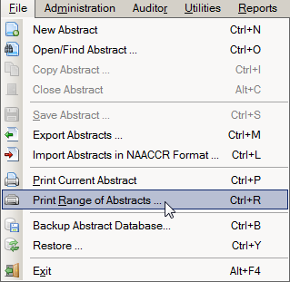
- Use the keystroke Ctrl+R.
Result: The Print Abstracts window opens.
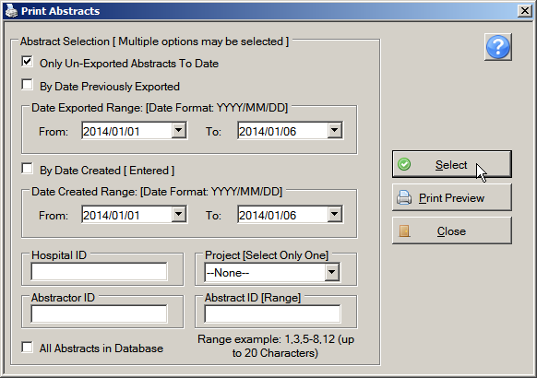
- Enter the abstract selection criteria for the range of abstracts that you would like to print. You can select the only un-exported Abstracts To Date or All Abstracts in Database options, or you can select abstracts by date previously exported, date created, Facility or Project ID, Abstractor ID or AbsRefID. In the example shown the Select the All Abstracts in Database printing option is checked.
- Click Select.
Result: The system displays the number of abstracts that meet the selected criteria at the bottom of the window.
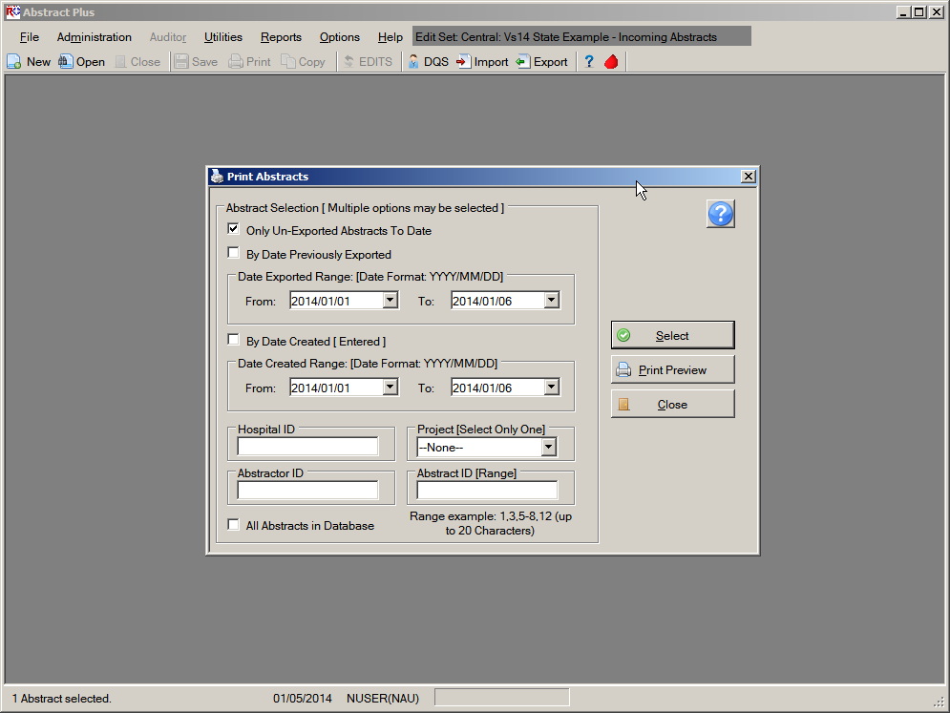
- Click Print Preview.
Result: The Report Viewer window opens with the selected abstracts formatted for printing.
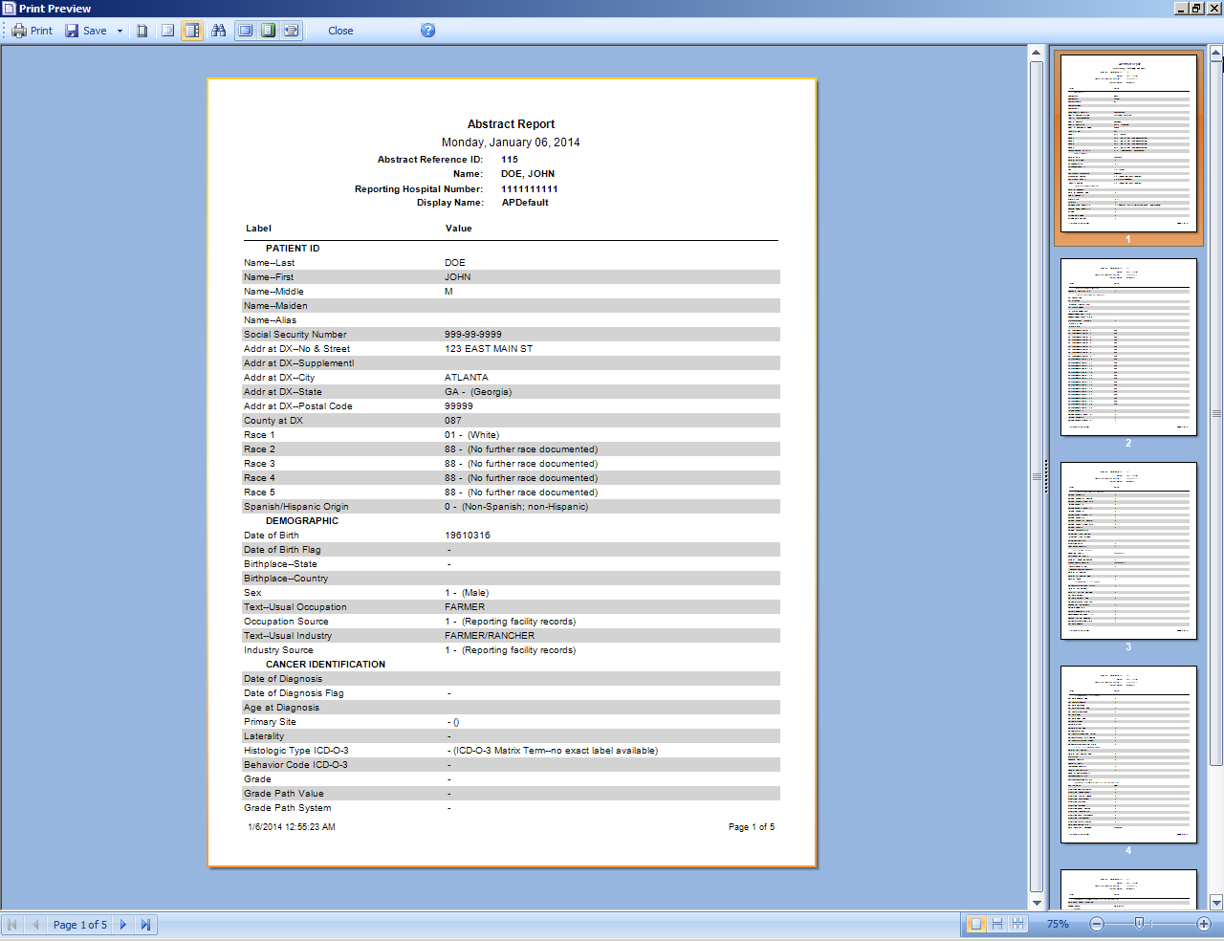
- When you are done viewing the report, click Print to print the report, Save to save the report.
- Click Close to close the report.
- Close the Print Abstracts window.

Questions---Exporting and Printing Abstracts:
Answer these questions about exporting and printing abstracts in Abstract Plus (the answers are in Appendix A, on page 129):
- How can you avoid exporting duplicate abstracts?
- How can you see all the abstracts you exported?
- How can you print multiple abstracts at the same time?

Using Abstract Plus Utilities
The Utilities menu is used to access a few supplementary functions included in the program, such as querying your local database of doctors, managing facility and doctor codes, and deleting abstracts.
To access the Utilities menu items, click on the Utilities menu item and select the desired sub-option, or use the appropriate keystroke combination for the desired sub-option.
Sub-option (Keystroke) | Toolbar Icon | Function
Doctor Query System (Alt+Q) |  | Query and search the doctor database; DQS can be accessed whether or not an abstract is opened, or a physician field selected
Manage Facility Codes… |  | Import (can use Alt+I keystroke) or edit (can use Alt+J keystroke) local facility codes
Manage Doctor Codes… |  | Import (can use Alt+K keystroke) or edit (can use Alt+L keystroke) local physician codes
Delete Abstract(s) (Alt+P) |  | Delete selected abstracts
Notepad (Alt+N) |  | Launch Notepad to view created text files

The Doctor Query System
The Abstract Plus Doctor Query System (DQS) allows you to search your local doctor database. The DQS can be accessed whether or not an abstract is opened, or whether or not you have a physician field selected in the data entry grid.
To open the DQS and search for a doctor, complete these steps:
- The DQS can be accessed in 2 ways:
- Click on the Utilities menu, and select Doctor Query System.
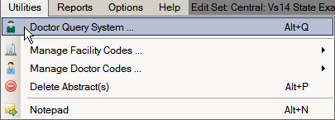
- Use the keystroke Alt+Q.
Result: The Doctor Query System window opens.
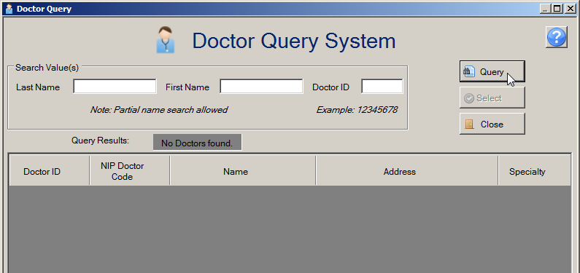
- Enter the search criteria of your choice and click Query. The DQS can be searched by doctor name or ID.
Result: Doctors meeting the search criteria entered are listed in the lower portion of the window.
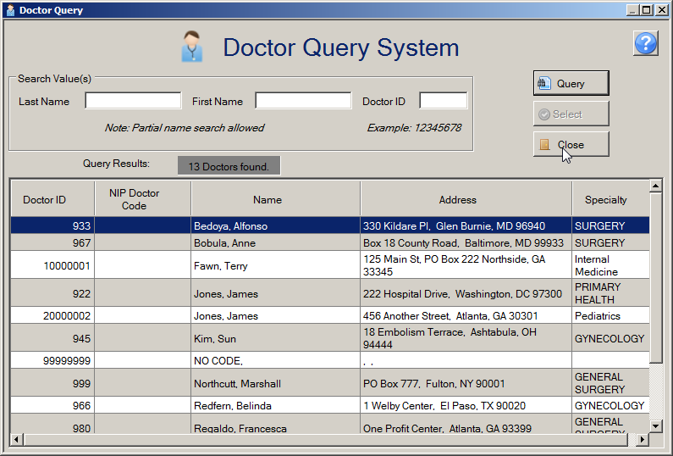
- When you have finished look-up doctor codes, click Close to close the DQS window.

Managing Facility Codes
Abstract Plus allows you to manage codes for facilities. The initial list of facility codes is added to the application by your Abstract Plus Administrator, however, you can add or delete individual facilities to or from the list.
To manage facility codes, complete these steps:
- You can manage facility codes in 2 ways:
- Click on the Utilities menu, and select Manage Facility Codes.
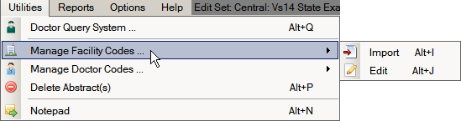
- Use the keystroke Alt+J.
Result: The Edit Facility Codes window opens.
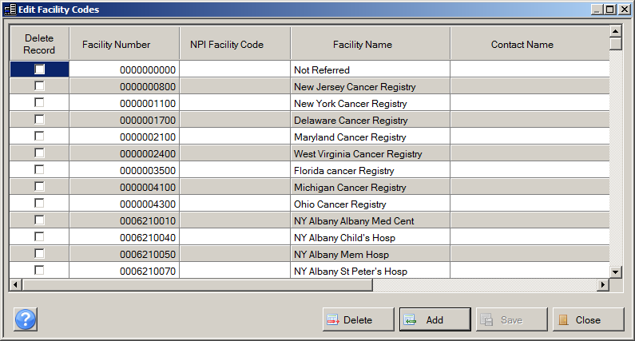
- To delete a facility or facilities from the list, check the Delete Record check box for the row of the facility or facilities that you would like to delete.

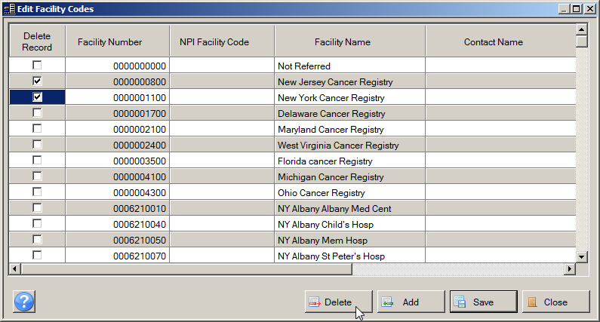
- Click Delete.
Result: The facility or facilities selected for deletion are deleted from the list.
- To add a facility or facilities to the list, click Add.
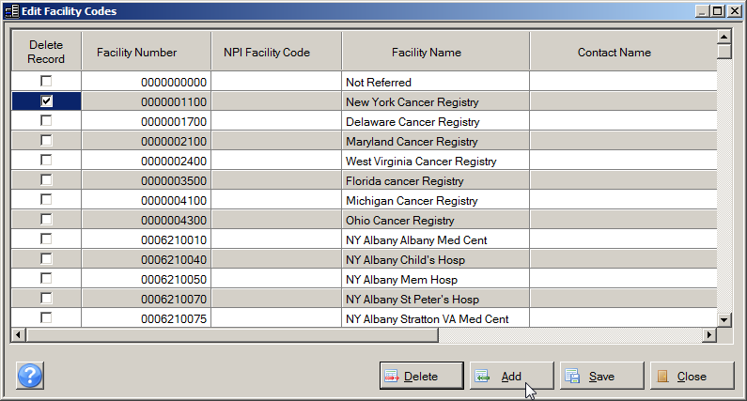
Result: The application directs you to a new row into which you can enter information for the facility such as the facility name and number and add the facility to the list.

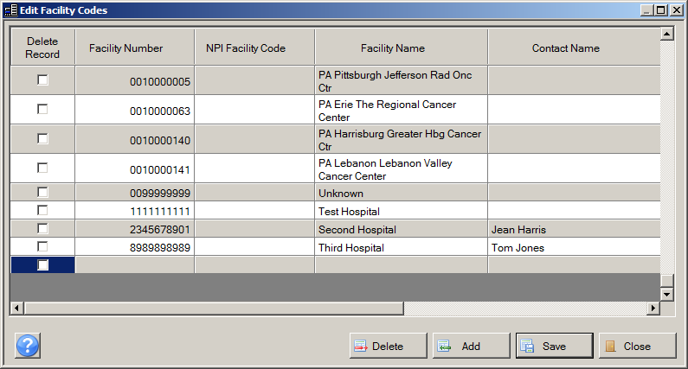
- At a minimum, enter the facility name and number, and then click Save.
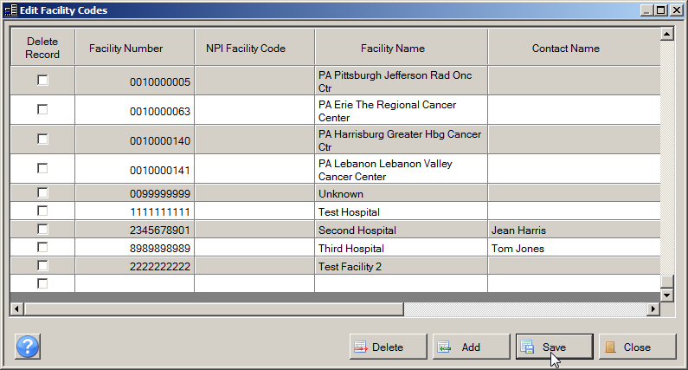
Result: The facility is added to the list.
- When you are one editing facility codes, click Close.

Managing Doctor Codes
Abstract Plus also allows you to manage codes for doctors. The initial list of doctor codes is added to the application by your Abstract Plus Administrator, however, you can add or delete individual doctors to or from the list.
To manage doctor codes, complete these steps:
- You can manage doctor codes in 2 ways:
- Click on the Utilities menu, and select Manage Doctor Codes.
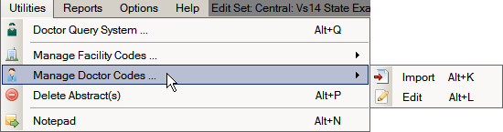
- Use the keystroke Alt+L.
Result: The Edit Doctor Codes window opens.
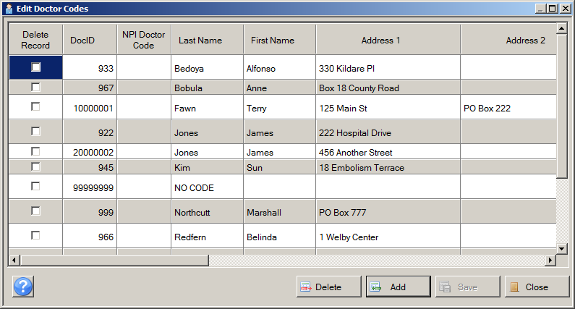
- To delete a doctor or doctors from the list, check the Delete Record check box for the row of the doctor or doctors that you would like to delete, and click Delete.
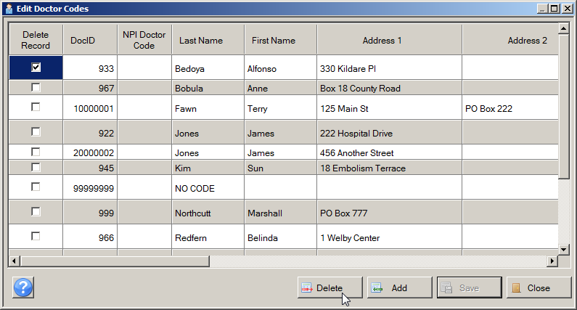
Result: The doctor or doctors selected for deletion are deleted from the list.
- To add a doctor to the list, click Add.
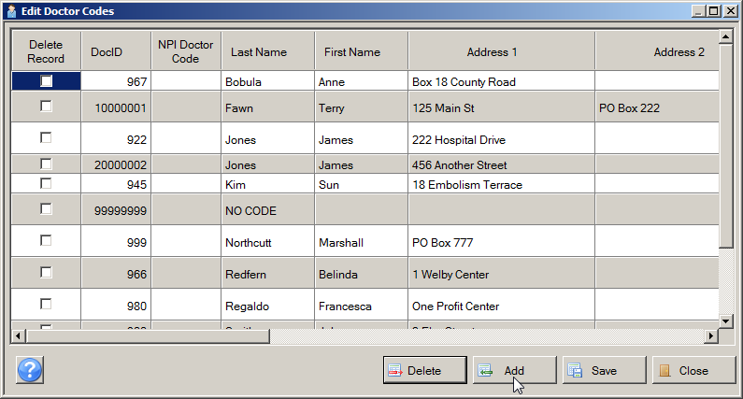
Result: The application directs you to a new row into which you can enter information for the doctor such as the doctor name and number and add the doctor to the list.
- At a minimum, enter the doctor name and number, and then click Save.
Result: The doctor is added to the list.
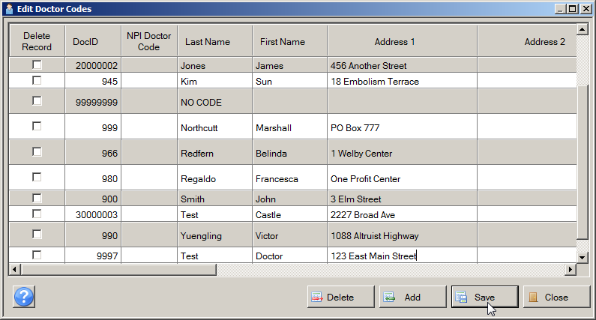
- When you are done editing doctor codes, click Close.
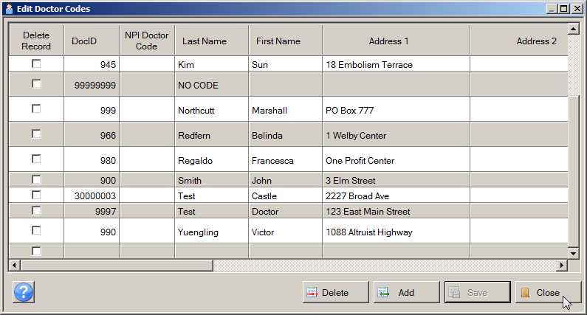

Deleting Abstracts
Abstract Plus allows you to delete abstracts from the abstract database. This feature should be used with caution, as abstracts are permanently deleted from the database.
To delete an abstract, complete these steps:
- Abstracts can be deleted in 2 ways:
- Click on the Utilities menu, and select Delete Abstract(s).
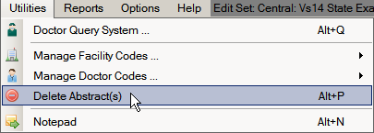
- Use the keystroke Alt+P.
Result: The Delete Abstracts window opens.
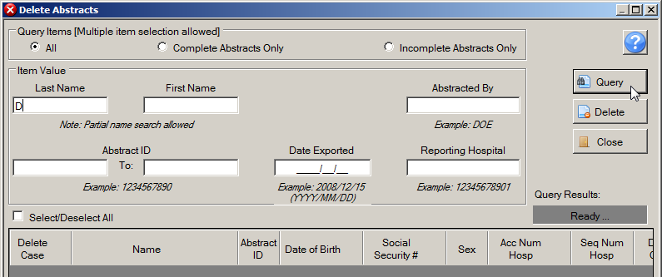
- Abstracts to be deleted can be searched for via various search criteria: patient name, Abstractor’s initials, Abstract Reference ID, Reporting Facility, and export date.
- Enter your search criteria, and click Query. In the example shown, the abstract for the patient named John Doe is being searched for and deleted, so a D is entered in the patient Last Name box.
Result: Abstracts that match the specified search criteria are displayed in the lower portion of the window. Note that all abstracts listed are selected for deletion. In the example shown, all patient abstracts with the last name beginning with D are displayed and selected for deletion.
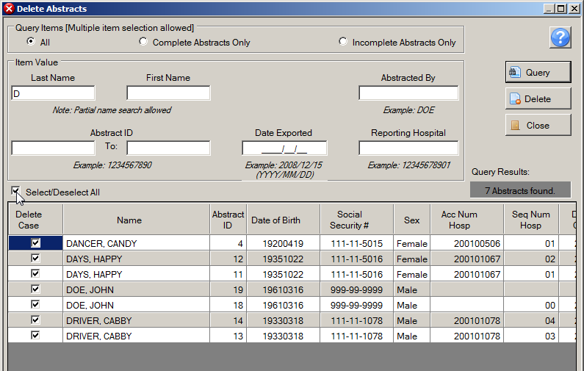
- To select an individual abstract for deletion from the displayed list, click Select/Deselect All.
Result: All abstracts in the window are deselected.
- Select individual abstracts for deletion by checking the Delete Case check box for the abstract(s), and clicking Delete.
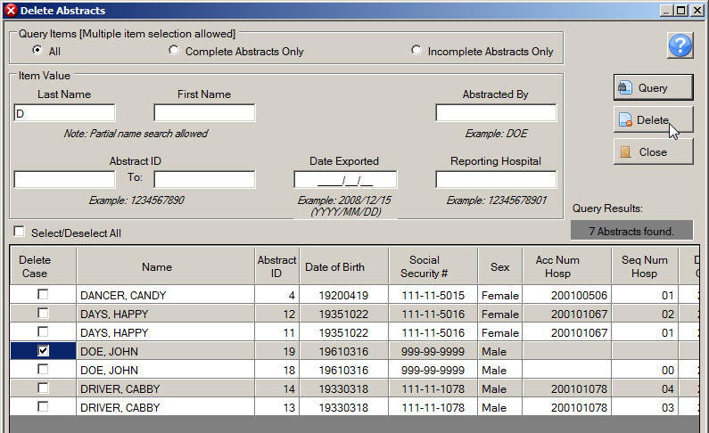
Result: The system verifies that you would like to delete the selected abstract(s), and creates a backup database.
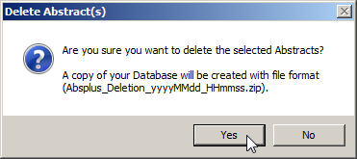
- Click Yes.
Result: The system lets you know that the abstract has been deleted.
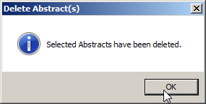
- Click OK.
Result: You are returned to the Delete Abstracts window, where the abstract(s) has been deleted from the list.
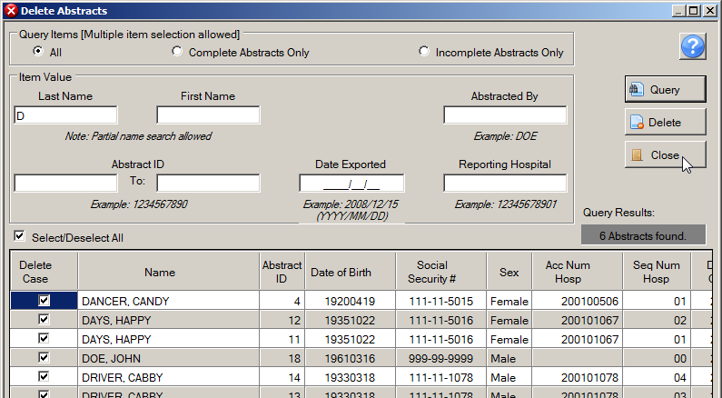
- When you have finished deleting abstracts click Close to close the Delete Abstracts window.

Using the Notepad Function
The Notepad program is integrated into Abstract Plus under the Utilities menu. Notepad allows you to view the contents of a file using the Notepad program without having to navigate away from Abstract Plus.
To use the Notepad feature, complete these steps:
- The Notepad feature can be opened in 2 ways:
- Click on the Utilities menu, and select Notepad.
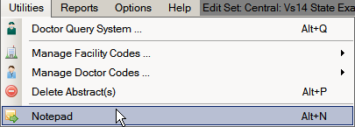
- Use the keystroke Alt+N.
Result: Notepad opens.
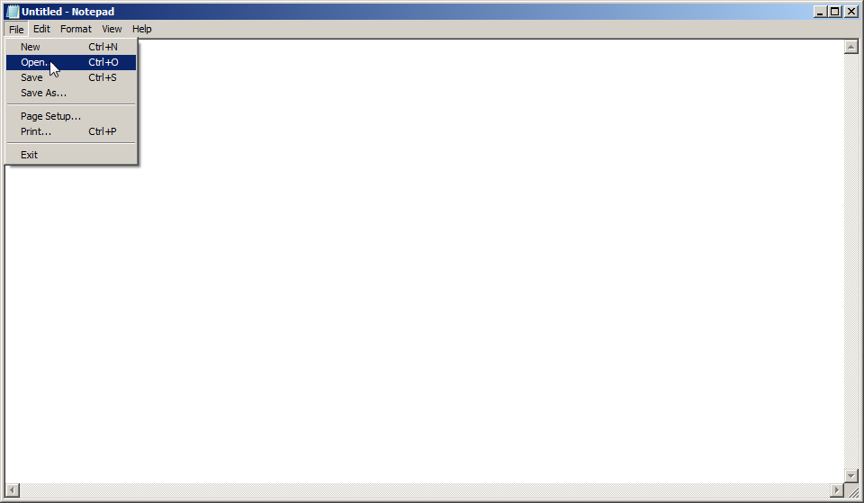
- Click File on the Notepad menu and select Open.
Result: An Open file windows dialog box opens.
- Navigate to the folder and text file that you would like to open, and click Open.
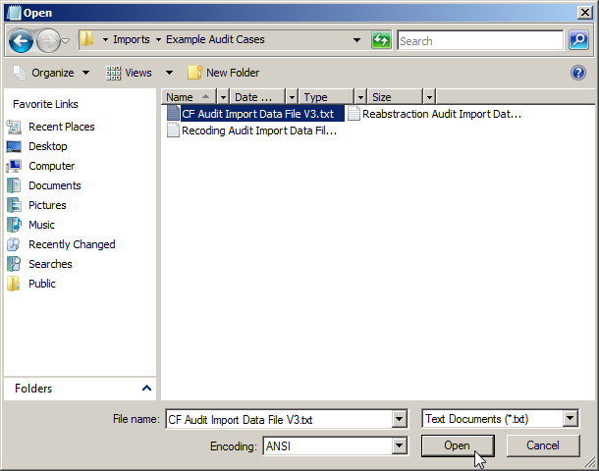
Result: The selected file opens in Notepad.
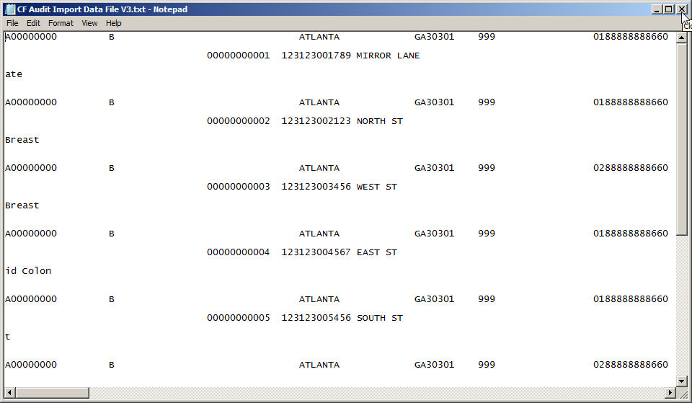
- When you are done viewing the contents of the file, close Notepad.

Questions---Using Abstract Plus Utilities
Answer these questions about exporting and printing abstracts in Abstract Plus (the answers are in Appendix A, on page 130):
- How can you query and search the doctor database in your Abstract Plus application?
- How can you delete abstracts?
- What is the main benefit of the Notepad integration feature?

Running Reports

Learning Objectives
In this chapter, you will learn to:
- Identify the different reports you can run using Abstract Plus
- Open an Abstract Plus report, and use the various Report Viewer window options to maximize your report viewing experience
- Become familiar with the all of the different file formats in which reports can be saved

Overview
This chapter covers general information about Abstract Plus reports. It includes a description of all abstract reports offered by the application, how to open the reports, how to use the Report Viewer window, and how to print and save reports.

Available Reports
The abstracting features of Abstract Plus are supported by a few standard, easy-to-understand reports that can help facilitate and track abstracting activities. The reports included can be upon request using the Reports menu item. The available abstract reports are described in the table below.
Report | Description
Accession Register | Includes a line listing of all abstracts in the database, sorted by reporting hospital and accession number
Patient Index | Includes a line listing of all abstracts in the database, sorted alphabetically by name
Selected Cases | Line listing report which includes abstracts based on user-specified criteria
Status Report (Count of Cases) Summary… | Includes the total number of complete and incomplete abstracts by export status within a user-specified date range
Completion Status of Abstracts by month | Includes abstract completion status by year and month of Date of Adm/1st Contact within a user-specified date range

Opening Reports
To open any of the various abstract reports, complete these steps:
- All abstract reports can be opened in 2 ways:
- Click on the Reports menu, and select the report of interest.
- Use the appropriate keystroke designated on the Reports menu to open the report of interest. For example, to open the Accession Register Report, use the keystroke Alt+Shift+A.
Result: The report of interest opens in the Abstract Plus Report Viewer window.

Viewing Reports – The Report Viewer Window
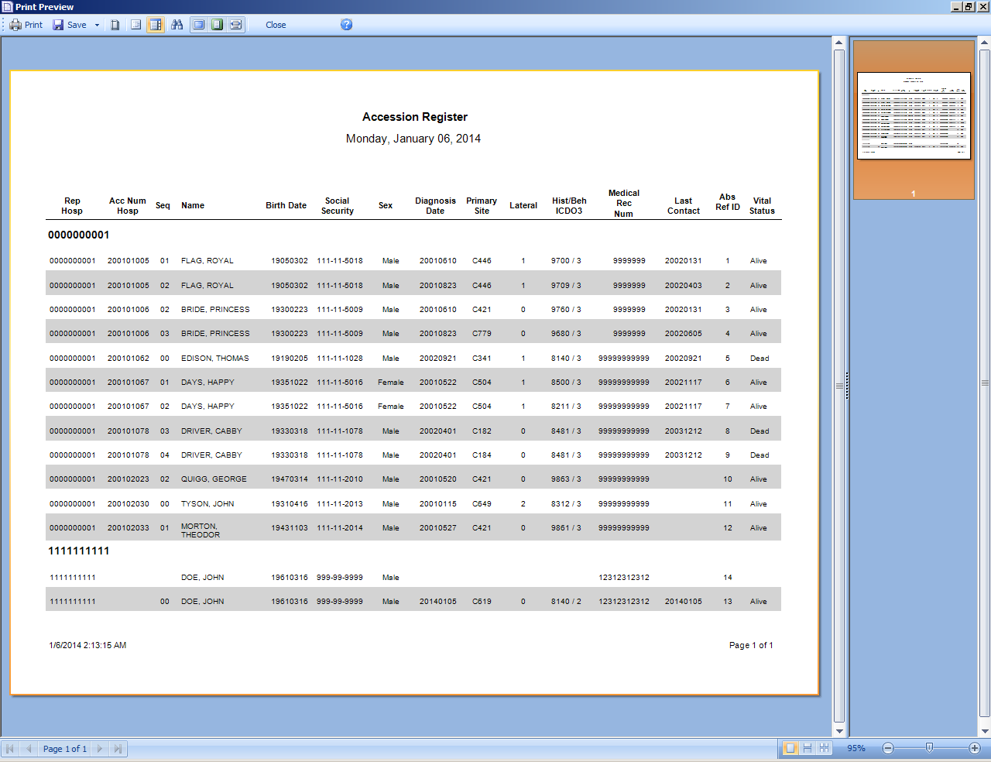
Page Navigation Controls
Can Resize Panes
Main Toolbar
Page View Controls
Report Being Run
Report Thumbnails
Open Search Toolbar
The Abstract Plus Report Viewer window is divided into 2 main sections: a window in which to view reports on the left, and a pane for viewing report thumbnails on the right. When you left-click and hold your mouse on the vertical divider bar in the center of the window, a splitter appears which you can drag to the left or right to resize the view report and thumbnails views.

The Main Toolbar

Page Navigation Controls
Report page navigation controls are located in the lower left-hand corner of the Report Viewer window and help you navigate through the various pages of the report being viewed. The following table describes the function of each of the page navigation controls.
Control | Function
 | View the first page of the report being viewed
 | View the previous page of the report being viewed
 | Lists the page number of the current page of the report being viewed
 | View the next page of the report being viewed
 | View the last page of the report being viewed

The Search Toolbar
The search panel is used to search for specific text within the report. To access feature, click the binocular icon on the main toolbar.

Page View Controls
Report page view controls are located in the lower right-hand corner of the Report Viewer window, and include icons to help you control how many pages of the report to view, as well as to zoom in or out on the current report being viewed. The following table describes the function of each of the page view controls.

Control | Keystroke | Function
 | Shift+F2 | Single Page: View the report one page at-a- time
 | Shift+F3 | Continuous: View the report with all pages displayed continuously
 | Shift+F4 | Multiple Pages: based on the selected zoom, all possible pages are displayed to fill the viewer window
 | No keystroke | Selected Zoom: View the report at the percent size specified

Saving Reports
In order to facilitate the utilization of the information included in the Abstract Plus reports, Abstract Plus offers an extensive number of file formats in which the reports can be saved. You can save the reports in different file formats in order to further analyze or format the data included differently or you can save the report as an image file to be placed in documents and presentations.
You can save your audit report in any of the file formats listed under the Save As icon on the Main Toolbar of the Report Viewer:
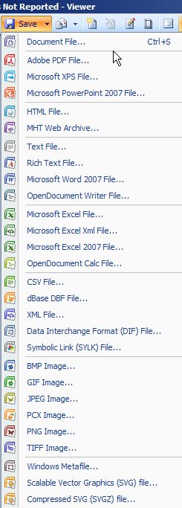

Accession Register Report
To run the Accession Register report, complete these steps:
- The Accession Register report can be opened in 2 ways:
  - Click on the Reports menu, and select Accession Register.
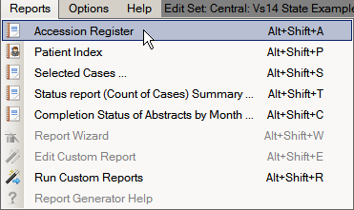
  - Use the keystroke Alt+Shift+A.
Result: The Accession Register report opens in the Report Viewer window. Notice that the accession numbers are displayed in ascending order and grouped by the reporting hospital.
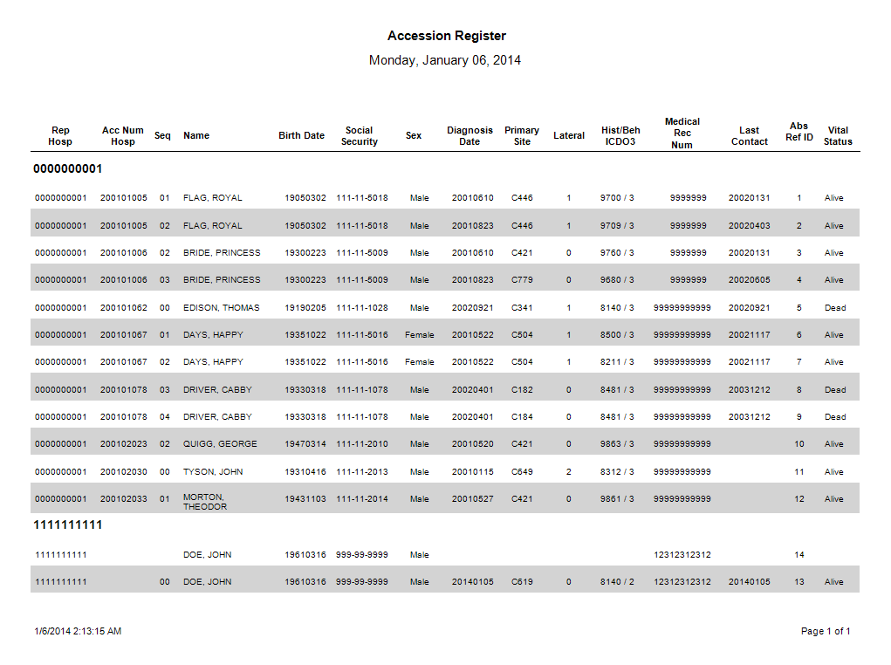
The Accession Register report includes these fields:
Columns | Description
Rep Hosp | COC code for the reporting facility of the abstract
Acc Num Hosp | Hospital Accession Number for the tumor
Seq | Hospital Sequence Number for the tumor
Name | Name of Patient (Last, First)
Birth Date | Patient’s date of birth
Social Security | Patient’s social security number
Sex | Patient’s sex
Diagnosis Date | Diagnosis date of the tumor
Primary Site | ICD-O-3 topography code describing the location of the tumor
Lateral | Laterality code for the laterality of the tumor
Hist/Beh ICDO3 | ICD-O-3 histology and behavior codes for the tumor
Medical Rec Num | Patient’s medical record number
Last Contact | Date of Last Contact with the patient
Abs Ref ID | A unique, system-generated number identifying the abstract
Vital Status | Patient’s vital status
- When you are done viewing the report, click Print to print the report, Save to save the report, or Close to close the report.

Patient Index Report
To run the Patient Index report, complete these steps:
- The Patient Index report can be opened in 2 ways:
- Click on the Reports menu, and select Patient Index.
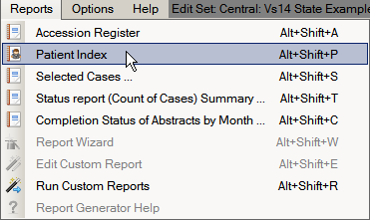
- Use the keystroke Alt+Shift+P.
Result: The Patient Index report opens in the Report Viewer window. Notice that the abstracts are displayed in alphabetic order by the name.
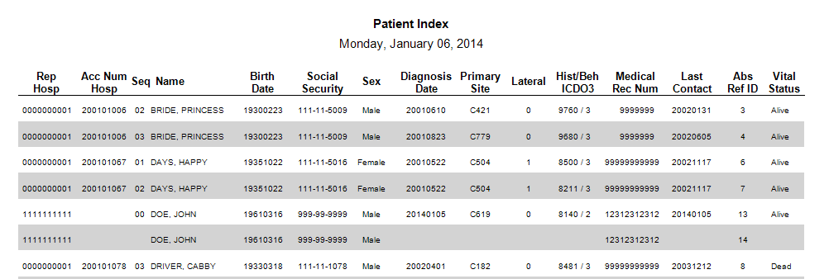
The Patient Index report includes these fields:
Columns | Description
Rep Hosp | COC code for the reporting facility of the abstract
Acc Num Hosp | Hospital Accession Number for the tumor
Seq | Hospital Sequence Number for the tumor
Name | Name of Patient (Last, First)
Birth Date | Patient’s date of birth
Social Security | Patient’s social security number
Sex | Patient’s sex
Diagnosis Date | Diagnosis date of the tumor
Primary Site | ICD-O-3 topography code describing the location of the tumor
Lateral | Laterality code for the laterality of the tumor
Hist/Beh ICDO3 | ICD-O-3 histology and behavior codes for the tumor
Medical Rec Num | Patient’s medical record number
Last Contact | Date of Last Contact with the patient
Abs Ref ID | A unique, system-generated number identifying the abstract
Vital Status | Patient’s vital status
- When you are done viewing the report, click Print to print the report, Save to save the report, or Close to close the report.

Selected Cases Report
To run the Selected Cases report, complete these steps:
- The Selected Cases report can be opened in 2 ways:
- Click on the Reports menu, and select Selected Cases.
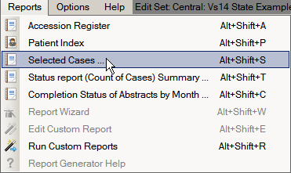
- Use the keystroke Alt+Shift+S.
Result: The system displays a window to enter report criteria.
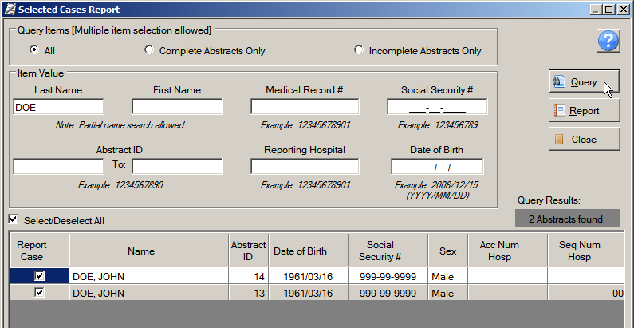
- Enter report selection criteria, and click Query. Available report selection criteria include patient last name, first name, medical record number, social security number, date of birth, Abstract Reference ID, reporting hospital, and abstract completion status. In the example shown, the report criterion of Last Name of DOE is being specified.
Result: The system displays the cases that meet the entered criteria in the query result window.

You can further restrict the cases included in the report by un-checking the Report Case checkbox in the left-most column of the query window for those cases you would like to exclude from the report.
- Click Report.
Result: The Selected Cases report opens in the Report Viewer window. Notice that it displays only the cases that fall within the specified range. The system also records and displays the SQL statement used to create the report at the top of the report.
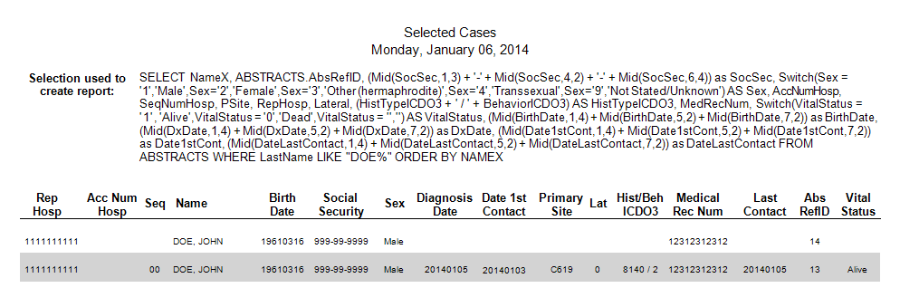
The Selected Cases report includes these fields:
Columns | Description
Rep Hosp | COC code for the reporting facility of the abstract
Acc Num Hosp | Hospital Accession Number for the tumor
Seq | Hospital Sequence Number for the tumor
Name | Name of Patient (Last, First)
Birth Date | Patient’s date of birth
Social Security | Patient’s social security number
Sex | Patient’s sex
Diagnosis Date | Diagnosis date of the tumor
Date 1st Contact | Date of first contact with the patient
Primary Site | ICD-O-3 topography code describing the location of the tumor
Lateral | Laterality code for the laterality of the tumor
Hist/Beh ICDO3 | ICD-O-3 histology and behavior codes for the tumor
Medical Rec Num | Patient’s medical record number
Last Contact | Date of Last Contact with the patient
AbsRefID | A unique, system-generated number identifying the abstract
Vital Status | Patient’s vital status
- When you are done viewing the report, click Print to print the report, Save to save the report, or Close to close the report.

Status Report (Count of Cases) Summary
To run the Status Report (Count of Cases) Summary report, complete these steps:
- Status Report (Count of Cases) Summary report can be opened in 2 ways:
- Click on the Reports menu, and select Status report (Count of Cases) Summary.
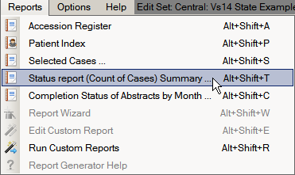
- Use the keystroke Alt+Shift+T.
Result: The system displays a window where you enter a date range, or select all cases in the database for the report.
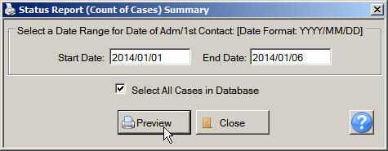
- Enter the desired date range, or check the Select All Cases in Database check box to include all abstracts in the database, and click Preview. In the example shown all abstracts in the database are being included in the report.
Result: The Status Report (Count of Cases) Summary report opens in the Report Viewer window displays the summary information for the abstracts.
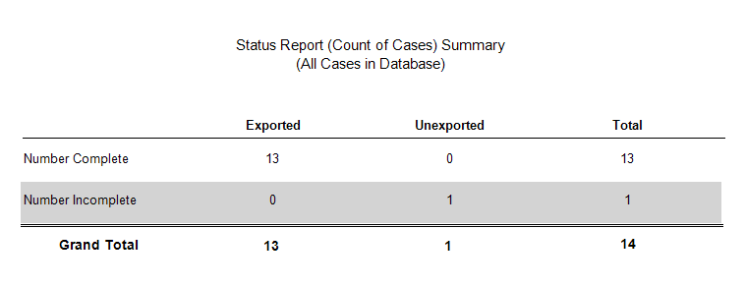
The Status Report (Count of Cases) Summary report includes the number of incomplete and complete abstracts, stratified by abstract export status.
- When you are done viewing the report, click Print to print the report, Save to save the report, or Close to close the report.

Completion Status of Abstracts by Month
To run the Completion Status of Abstracts by Month report, complete these steps:
- The Completion Status of Abstracts by Month report can be opened in 2 ways:
- Click on the Reports menu, and select Completion Status of Abstracts by Month.
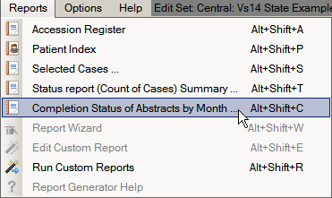
- Use the keystroke Alt+Shift+C.
Result: The system displays a window where you enter a date range, or select all cases in the database for the report.
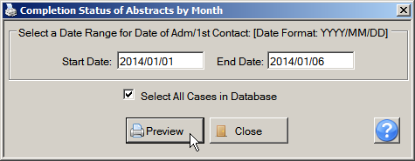
- Enter the desired date range, or check the Select All Cases in Database check box to include all abstracts in the database, and click Preview. In the example shown all abstracts in the database are being included in the report.
Result: The Completion Status of Abstracts by Month report opens in the Report Viewer window displays the summary information for the abstracts.
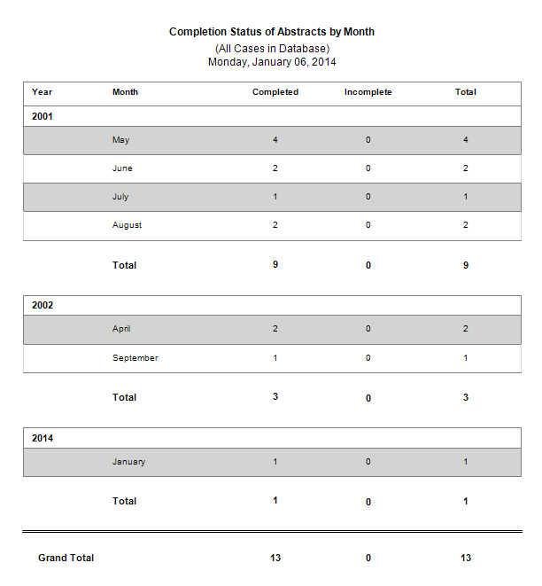
The Completion Status of Abstracts by Month report includes the number of incomplete and complete abstracts, stratified by diagnosis month and or year.
- When you are done viewing the report, click Print to print the report, Save to save the report, or Close to close the report.

Running Custom Reports
Abstract Plus offers a custom reports feature. This feature is being implemented in phases. In the first release, custom reports that have been generated by the Abstract Plus Development team at CDC can be opened by Abstract Plus users. The various other custom report features, such as being able to generate your own report or modify an existing one, will be implemented in future versions of Abstract Plus.
To open and view a custom report, complete these steps:
- The custom report can be opened in 2 ways:
- Click on the Reports menu, and select Run Custom Reports.
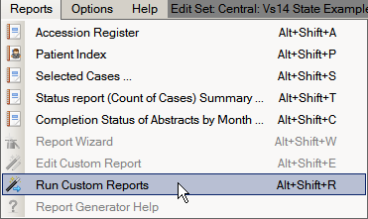
- Use the keystroke Alt+Shift+R.
Result: The Select the Report you would like to Run window opens.
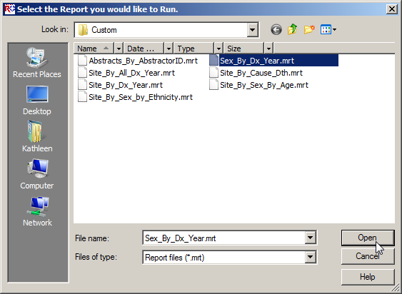
- Select the custom report you would like to open and click Open.
Result: The selected report opens in the Abstract Plus Report viewer window.
- When you are done viewing the report, click Print to print the report, Save to save the report, or Close to close the report.

Questions
Answer these questions about Abstract Plus reports (the answers are in Appendix A, on page 130 ):
- What is the name of the window where you view Abstract Plus abstract reports?
- How do you print an abstract report?
- How do you save a report?

Appendix A: Answers to Chapter Questions
Chapter 2: Abstract Plus General User Basics
These are the answers to the questions (page 46) about the basics for Abstract Plus general users:
- The first things you need to do upon initial login into Abstract Plus are: 1) create a user account, 2) log in, 3) change your password, and then 4) select and answer security challenge questions.
- Your answers to the security challenge questions that you select will be used to validate your identity if you forget your Abstract Plus password---if you forget your password, Abstract Plus will ask you for the answers you provided to these security questions, and then allow you to reset your password if the questions are answered correctly.
- It is important to have your own user ID and password for Abstract Plus for security purposes; never share your account information with others. In addition, when logged in using your own user ID and password, your initials will be displayed on the main Abstract Plus window to indicate when you are logged in to the application and will be automatically recorded in the Abstracted By field when abstracting abstracts or conducting audits. This information is recorded in order to associate abstractors with the abstracts they have generated, and auditors with the audits that they have conducted.
- When logging off Abstract Plus, you can use the Backup option to save your work to a secure location.
Chapter 3: Working With Abstracts
Creating Abstracts:
Here are the answers to the questions on page 59 about creating an abstract.
- You can start working with abstracts by importing, creating, or copying abstracts.
- The Abstract Plus Abstracting window is divided into 2 main sections: a data entry grid for coded values on the left, and a data entry grid for text fields on the right.
Abstracting and Saving Information:
Here are the answers to the questions on page 80 about abstracting and saving information.
- Each text field has a progress bar beneath it that indicates what percentage of the text field has already been filled so that you can properly prioritize entered information.
- The SEER Hematopoietics Database can be opened from the Histology Lookup window (Click on the magnifying glass icon to the left of the Histologic Type ICD-O-3 data item or press F4); from the Help menu, or by clicking the Hematopoietic Database icon on the tool bar.
- You can save an abstract in 3 ways: 1) Click on the File menu, and select Save Abstract; 2) Click the Save icon on the tool bar; 3) Use the keystroke Ctrl+S.
- Each abstract is assigned an Abstract Reference ID (or AbsRefID), which is a unique, system-generated number identifying the abstract. The AbsRefID is generated upon first save of the abstract, and displayed in the upper left-hand corner of the data entry area of abstracting window, as well as in the title bar of the application along with the patient name.
- Color-coded edits error count and abstract completion status information is clearly displayed to the user at the bottom of the abstracting window, and edits error count is displayed in red if any errors exist (changes from red to green upon completion of the abstract).
- When edits are run, the Edit Set Results window automatically opens and displays the full information for any edit errors that exist, or lets you know that there are no errors. The Edit Set Results window lists the total number of edit errors for the abstract, missing critical (required) fields, and the edit errors. For each edit error, the failed edit name, error message, and fields involved in the edit are listed. When greater detail regarding the edit is required to resolve the edit error, you can click on the Edit Description link in the Edit Set Results window, which expands to display the edit description.
- If SSF25 is required for the primary site and histology entered, you will first be directed to enter SSF25. Once you have entered SSF25, automatic defaulting and disabling of SSFs that are not defined for the entered schema will occur. The automatic defaulting will delineate what SSFs are not defined for the identified schema, and the running of edits will delineate what defined SSFs are required.
Completing, Finding, and Copying Abstracts:
Here are the answers to the questions on page 90 about completing, finding, and copying abstracts:
- You must resolve all edit errors and fill in all critical (required) fields in order to complete an abstract. Abstract Plus displays helpful, color-coded edits error count and abstract completion status information at the bottom of the abstracting window. Once you have resolved all edit errors and completed all missing critical fields, upon the next save of the abstract, the status information changes from red to green upon completion of the abstract.
- You can locate a saved abstract by selecting the Open/Find Abstract option under the File menu or clicking the Open/Find Abstract icon on the tool bar.
- Yes, you can change the information contained in an existing abstract. Access the abstract, update the information, and click the Save button on the tool bar.
- Open the existing abstract for the patient and use the Copy Abstract option under the File menu to copy the demographic information in the abstract to a new abstract. Abstract information on the new tumor as needed.
- Yes. Since the overwhelming majority of Abstract Plus users did not utilize the Projects feature of Abstract Plus version 2.0, although the use of Projects is still available, it is no longer required. In Abstract Plus version 3.x, Projects are optional True/False application-specific fields that can be added to any display type (in the same manner as any standard NAACCR data item). As a result, unless your central registry intentionally requires a Project field, abstracts are no longer required to be assigned to a project.

Exporting and Printing Abstracts:
Here are the answers to the questions on page 101 about exporting and printing abstracts.
- You can avoid exporting duplicate abstracts by selecting the following check boxes on the Export Abstracts window: Mark abstracts as exported and Export only un-exported Abstracts to date.
- You can see all the abstracts you have exported by clicking the Export Log button on the Export Abstracts window for a detailed export history.
- You can print multiple abstracts at the same time by selecting Print Range of Abstracts from the File menu.

Chapter 4: Using Abstract Plus Utilities
Here are the answers to the questions on page 114 about Abstract Plus utilities.
- The Abstract Plus Doctor Query System (DQS) allows you to search your local doctor database. The DQS can be accessed whether or not an abstract is opened, or whether or not you have a physician field selected in the data entry grid. To open the DQS and search for a doctor, click on the Utilities menu, and select Doctor Query System, or use the keystroke Alt+Q.
- Abstract Plus allows you to delete abstracts from the abstract database. This feature should be used with caution, as abstracts are permanently deleted from the database. To delete an abstract, click on the Utilities menu, and select Delete Abstract(s), or use the keystroke Alt+P.
- The integrated Notepad feature gives you the ability to view the contents of a file without leaving Abstract Plus.

Chapter 5: Reports
These are the answers to the questions (page 127) about reports:
- The name of the window where you view Abstract Plus reports is called the Abstract Plus Report Viewer window.
- To print a report, you must first open the report in the Report Viewer window. Click on the Reports menu item, and select the sub-option for the report of choice or use the appropriate keystroke designated on the Reports menu to open the report in the Report Viewer window. To print the report, click the Print icon on the Main Toolbar.
- To save a report, click on the Save icon on the Report Viewer Main Toolbar, and select the desired file format in which you would like to save the report information.

Appendix B: Standard Keyboard Shortcuts
Function | Keyboard Combination
Menus
File Menu | Alt+ F
Administration Menu | Alt+ M
Utilities Menu | Alt+ U
Reports Menu | Alt+ R
Options Menu | Alt+ O
Help Menu | Alt+ H
Right-Click Menu:
Search Help / Field Context | F1
Edits Information for current field | F2
Field Message | F3
Special Field Lookup | F4
CS or Age calculations | F5
Run EDITS on current Abstract | F8
Undo text change | Ctrl+ Z
Cut selected text | Ctrl+ X
Copy selected text | Ctrl+ C
Paste text from clipboard | Ctrl+ V
Delete selected text | Alt+ D
Select All text in entry field | Alt+ A
Move to first Text Field | Ctrl+ T
Section Headings | Alt+ S
Display Types | Alt+ T
General
Open a pull-down data item listing | Alt+ Down Arrow
Move to next field | Enter or Tab
Move to previous field | Shift+Enter or Shift+Tab

Appendix C: Flowchart for Hematopoietics

