APPENDIX 6

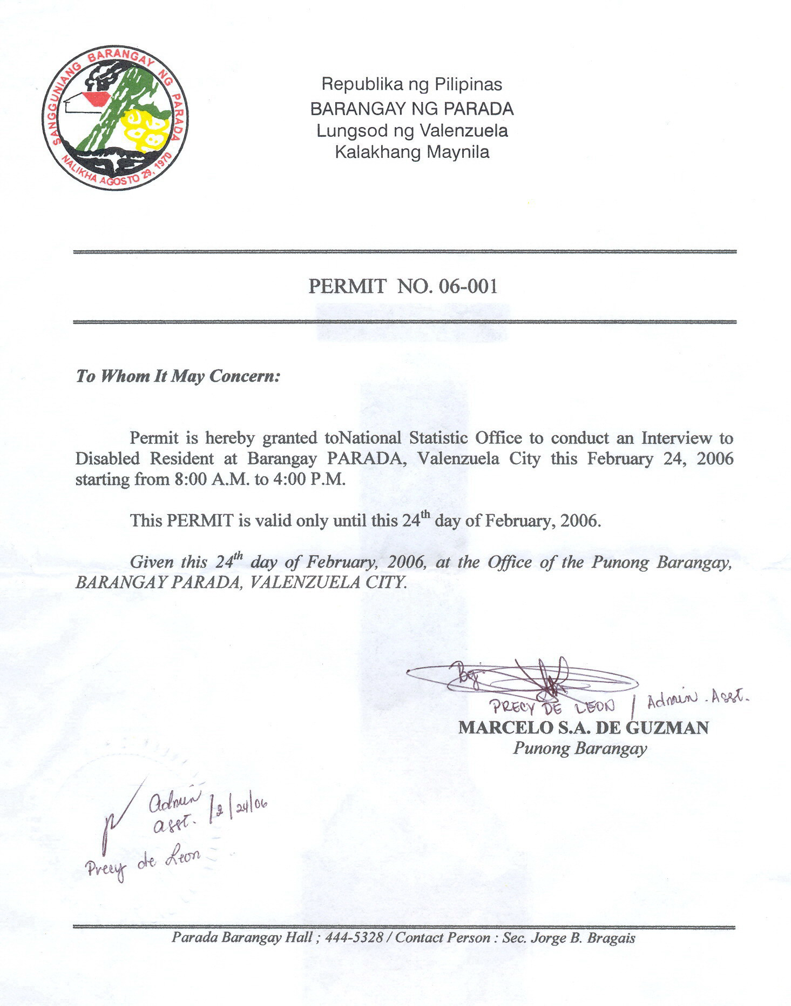
COPY OF PERMIT TO CONDUCT INTERVIEW FOR COGNITIVE TEST

