
Web Plus
Training Manual for
Central Registry Abstractor/Reviewer
Version 3.5.0
(Based on Web Plus Version 3.5.0, NAACCR v15)
Centers for Disease Control and Prevention
National Center for Chronic Disease Prevention and Health Promotion
Division of Cancer Prevention and Control
National Program of Cancer Registries
Registry Plus™ Software for Cancer Registries

Table of Contents
Chapter 1: Introduction 2
Overall Learning Objectives 2
Overview of the Web Plus Central Registry Abstractor/Reviewer Manual 2
Web Plus Features 2
Web Plus User Roles 3
Requirements for Web Access 4
Chapter 2: The Basics 5
Learning Objectives 5
Overview 5
Log In 5
Central Registry Abstractor/Reviewer Menu Options 6
Changing Your Password 7
Log Out 7
Web Plus Version Information 7
Questions 8
Chapter 3: Creating an Online Abstract 9
Learning Objectives 9
Overview 9
Entering Information into Fields 9
Questions 15
Activity 1 – Creating an Abstract 15
Chapter 4: Updating Abstracts 18
Learning Objectives 18
Overview 18
Opening and Updating an Abstract 18
Text Fields 20
Activity 2 – Adding Data, Part One 20
Abstracting Histologic Type 21
Activity 3 – Adding Data, Part Two 22
Activity 4 – Entering Text Fields 22
Adding Comments to an Abstract 23
Print Preview 23
Holding an Abstract 24
Deleting an Abstract 24
Questions 25
Learning Objectives 25
Activity 5 – Adding Information to and Deleting an Abstract 26
Chapter 5: Correcting Errors 27
Overview 27
Understanding Edit Sets 27
Edit Errors Tab 27
Questions 28
Chapter 6: Abstracting and Deriving Collaborative Stage Fields 29
Learning Objectives 29
Overview 29
Abstracting CS Input Fields 29
Abstracting CS SSFs 30
Calculating Derived CS Fields 31
Activity 6 – Abstracting and Deriving Collaborative Staging Fields 32
Questions 37
Chapter 7: Completing and Releasing Abstracts 38
Learning Objectives 38
Overview 38
Completing the Abstract 38
Activity 7 – Completing an Abstract 38
Releasing the Abstract 41
Questions 42
Chapter 8: Accepting Held Abstracts 43
Learning Objectives 43
Overview 43
Accepting Held Abstracts 43
Questions 43
Chapter 9: Reports 44
Learning Objective 44
Overview 44
Opening Reports 44
Central Registry Reports 45
Changing the Date Range of a Report 47
Facility Reports 47
Abstracts Submitted Sorted by Abstractor Report 48
Abstracts Accessed Sorted by Patient Name Report 50
Descriptive Statistics on Released Abstracts Report 51
Activity Report 55
Questions 56
Appendix A: Answers 57
Chapter 2: The Basics 57
Chapter 3: Creating an Abstract 57
Chapter 4: Adding Data to an Abstract 57
Chapter 5: Correcting Errors 57
Chapter 6: Abstracting and Deriving Collaborative Staging Fields 57
Chapter 7: Completing and Releasing Abstracts 58
Chapter 8: Accepting Abstracts 58
Chapter 9: Reports 58

Introduction

Overall Learning Objectives
These are the overall learning objectives for this Web Plus training manual for Central Registry Abstractor/Reviewer:
Learn the major functions of the Abstractor/Reviewer role within Web Plus:
- Creating New Abstracts
- Find/Open Abstracts
- Edit Abstracts
- Accept Abstracts
- Generate and view Web Plus reports

Overview of the Web Plus Central Registry Abstractor/Reviewer Manual
The Web Plus Central Registry Abstractor/Reviewer Training Manual provides you with the information to understand and use this web application. This manual describes the functions available to the Web Plus Abstractor/Reviewer of a central cancer registry. The major sections include creating new abstracts, finding and opening abstracts, editing abstracts, accepting abstracts held for review and viewing central and facility-level reports. Also, each chapter contains questions that test your knowledge of Web Plus and activities that allow you to practice your new skills on your own.

Web Plus Features
Web Plus is a secure web-based application that is used to collect cancer data over the Internet. The Web Plus application is hosted on a secure web-server. The communication between the client and the server is encrypted using Secure Socket Layer (SSL) technology. The data is stored in a secure database behind the hosting institutions firewall. The hosting institution manages facility and user rights to ensure that data is only accessible to the hosting institution and the institution submitting the data. Web Plus is for use by central registries for all electronic reporting needs.
Web Plus supports three main functions; online abstracting, file upload/download, and follow-back efforts. The online abstracting capability of Web Plus is used for reporting from physicians’ offices and other low-volume reporting sources. The Web Plus file upload feature can be used to upload NAACCR-formatted files, as well as supporting documents in any file format. Web Plus can also be used to post files of any type for secure download by facilities. Web Plus allows for editing of uploaded NAACCR formatted records as well as records abstracted online.
The Web Plus follow-back features enable upload of partial abstracts generated from death certificate and pathology lab files, and subsequent notification to physicians or facilities via e-mail to log in and update the abstracts. The features also allow for the tracking of follow-back abstracts to ensure their resolution.

Web Plus User Roles
The results from the design staff and usability testing have identified these types of Web Plus users:
Users | Description
Facility Abstractor | Works in a facility or doctor’s office and handles patients’ medical records and paperwork. When a patient is diagnosed with cancer, the Facility Abstractor reports the case to the state’s central cancer registry. The Facility Abstractor also completes and submits any follow-back abstracts that the central registry has posted for their facility.
File Uploader | Uploads either files of abstracts in the appropriate NAACCR format that were not abstracted using Web Plus or non-NAACCR files in any format, views EDITS error report and cleans, or works with abstractors to clean, errors on rejected abstracts prior to resubmitting, downloads files posted by the central registry, and views reports.
Local Administrator | Manages local users of a facility.
Central Registry Administrator | Sets up facilities with access to the Web Plus software to report their data, manages facility accounts and users at both the central registry and facilities, configures display types, edit sets and system preferences, manages assignment of abstracts to central registry staff, exports data, and views reports.
Follow-back Supervisor | Uploads files of partially-filled follow-back abstracts, manually adds follow-back abstracts online, tracks follow-back abstracts by uploaded file or by facility, and generates and views Web Plus follow-back reports.
Follow-back Monitor | Tracks follow-back abstracts by assigned facility, generates and views Web Plus follow-back reports.
File Upload Supervisor | Monitors upload of files to the central registry; tracks file uploads and rejected abstracts by facility, communicates with facility to ensure resubmission of rejected abstracts, and views reports.
Central Registry Abstractor/Reviewer | Reviews abstracts submitted to the central registry for completeness and accuracy and may abstract additional data items from submitted text; also abstracts new cases.

Requirements for Web Access
Web Plus requires Microsoft Internet Explorer version 9.0 or later to operate the system fully. Although Web Plus may work at 800 X 600 resolution you may have trouble with some features; it can be best viewed at 1024 X 768 or higher resolution. It is highly recommended that you change your resolution to 1024 X 768 or higher when using the Web Plus application.

The Basics

Learning Objectives
In this chapter, you will learn to:
Log in to Web Plus
Identify Web Plus menu options
Change your password
Log out of Web Plus

Overview
This chapter covers the basics of the Web Plus Central Registry Abstractor/Reviewer Role. It includes a description of the Web Plus menu options available to the Central Registry Abstractor/Reviewer, how to change your password, and the means of logging in and out of Web Plus.

Log In
To log in, complete the following steps:
- Open your Internet Explorer browser and type your registry’s Web Plus web address (URL) in the Address field.
- Press Enter.
Result: The Web Plus main Log in page is displayed
- Type in your Administrator User ID and password into the User ID and Password fields. For testing purposes, you can use the User ID of Administrator, and the password of admin1.
- Click Log in.
Result: The Web Plus home page opens. As Central Registry Abstractor/Reviewer, you will see a hyperlink for the “Central Abstractor/Reviewer Functions”.
The Web Plus home page is unique to each user, and includes links to the role or roles that have been assigned to the user. In the example shown above, the user has been assigned the role of Central Registry Abstractor/Reviewer.

- Click the Central Abstractor/Reviewer Functions link.

Result: The Web Plus Central Abstractor/Reviewer Main page is displayed.

Central Registry Abstractor/Reviewer Menu Options
From this page you can access the main menu options of Web Plus. Click on a menu option to open the page for the option. The below table describes the menu options on the home page, and provides a page reference within this manual for more information about the menu option:
Menu option | Sub-option |  | Opens web page to . . . | Refer to page . . .
Home |  |  | Display links to assigned roles in Web Plus | 7
 |  |  | Change password | 9
 |  |  | Log out of Web Plus | 9
New Abstract |  |  | Create new online abstract | 11
Find/Open Abstract |  |  | Search for online abstract by Name, Social Security Number, Facility, Status and Source | 18
Held Abstracts |  |  | Accept Abstracts Held to authenticated Central Registry Abstractor/Reviewer | 43
Reports |  |  | View Central Registry Abstractor/Reviewer reports and facility reports | 44
Change Password |  |  | Change Password | 9
Help |  | About | View Web Plus, NAACCR, Collaborative Staging Algorithm Version, Edits Metafile and Edits Record Layout | 9
Log out |  |  | Log out of Web Plus and open the Log in page | 9

Changing Your Password
To change your password, complete these steps:
- On the Home page menu or the Central Registry Abstractor/Reviewer Main Menu, click Change Password.
Result: The Change Password page opens.
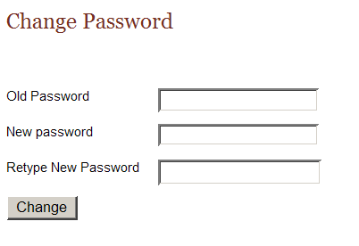
- Type your current password in the old password field, and your new password in both of the new password fields.
- Click Change.
Result: Your password is successfully changed.

Log Out
To log out of Web Plus, click Log out on either the Home page or from the Administrator menu.
Result: The system logs you out of Web Plus, and the Log in page opens.

Web Plus Version Information
To view your current Web Plus Version Information, point to Help and click About.
Result: The About Web Plus page opens.
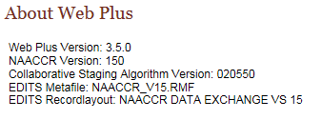

Questions
Answer these questions about the basics of Web Plus (the answers are in Appendix A, page 57):

- Which menu option opens the page to create a new online abstract?
- How do you logout?
- Which menu option opens the page to accept an abstract that has been held to you for review?

Creating an Online Abstract

Learning Objectives
In this chapter, you will learn to:
- Enter information into the data entry fields
- Understand the process for completing an abstract
- Use these data entry tools: drop-down lists, Help, and Special Lookups

Overview
In this chapter you create an abstract that you continue to work with throughout this manual. In succeeding chapters you will complete and release this abstract. This chapter also introduces you to some basic entry tools to help you enter information in Web Plus.

Entering Information into Fields
In this section, you create an abstract by entering essential data into the designated fields. You will also learn to use Help, drop-down lists, and special lookups.
To create an abstract, complete these steps:
- Log in, as described in “Login” page 9.
- On the Web Plus menu, click New Abstract.
Result: The Data Entry page opens. Notice that the Abstractor field is pre-filled with your Abstractor ID.
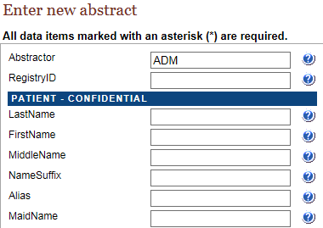

- Type JOHNSON in the Last Name field, and press Enter. Notice that the next field is now highlighted.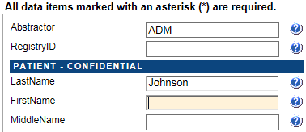
When you enter name and address information into Web Plus, the application automatically capitalizes the entered text.
- Click the Help icon beside the Last Name field.
Result: A separate window opens giving you information about the field.
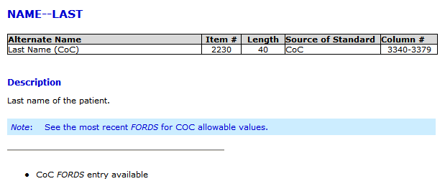
The context-sensitive Help information for Web Plus is from the NAACCR Standards for Cancer Registries Volume II: Data Standards and Data Dictionary. Each field has a help icon that you can click to open a page with information about the field.
- Close the Help window.
- Enter the following information in the following fields:
Field | Value to be Entered
First Name | JOHN
Middle Name | M
Maiden Name | Leave blank (press enter to move to next field)
Alias | Leave blank (press enter to move to next field)
Social Security No. | 999999999
Number and Street | 123 EAST MAIN ST
Supp Address | Leave blank (press enter to move to next field)
City | ATLANTA
- Click Save to save your work.
Result: The Web Plus system saves your new abstract.
When you save the abstract the system displays edit errors. Notice that the Edit Errors tab is automatically opened on the right and displays the total number of and details of the edit errors contained in the abstract. The procedures for resolving edit errors are described in a later chapter in this manual.
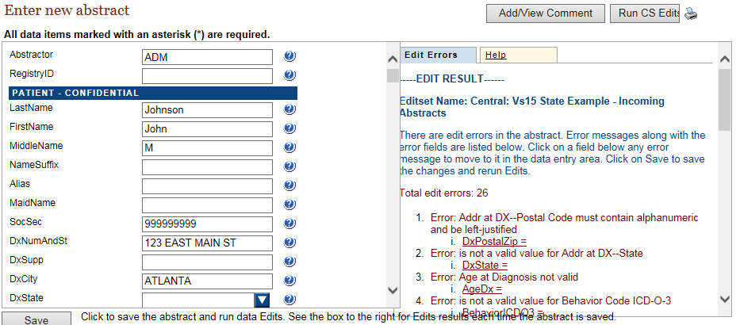
- Press enter or tab into the State field, and click the arrow to display the drop-down list.
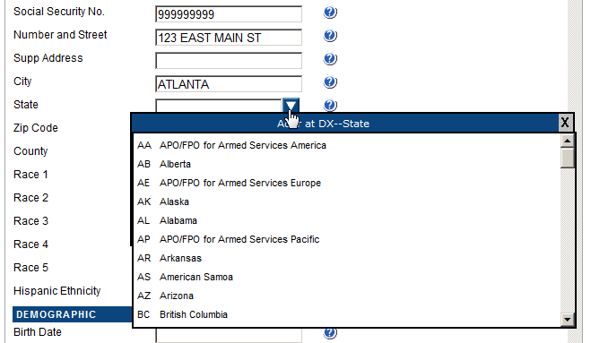
Result: A list of states appears in the pull-down menu.
- Scroll down and select the value of Georgia by clicking on it.
 | If you know the two-letter code for the state, you can type it in the field.
- Type 999999999 in the Zip Code field, and press Enter.
- Click on the magnifying glass icon to the left of the County field.
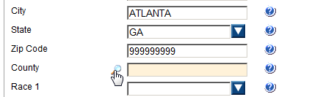
Result: The Select county code window opens, which provides a list of county codes.
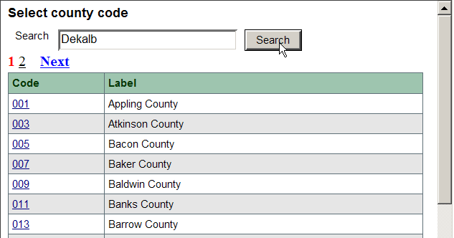
- In the Search field, type Dekalb and click Search.
You can also find the code by scrolling down the page or by clicking a page number at the top of the page to see other codes in the list.
Result: The system finds DeKalb county and its code.
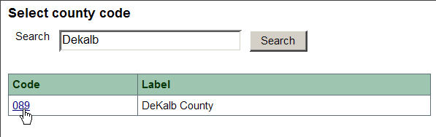
- Click the 089 code number for DeKalb County.
Result: The value of 089 is automatically entered into the data entry grid for the County field, and the Select county code window automatically closes.
- Enter the following information in the following fields, either by typing the value, using the drop-down list feature, or using the advanced search feature by clicking on the magnifying glass icon where available.
- Type 999999999 in the Zip Code field, and press Enter.
- Click on the magnifying glass icon to the left of the County field.
Result: The Select county code window opens, which provides a list of county codes.
- In the Search field, type Dekalb and click Search.
You can also find the code by scrolling down the page or by clicking a page number at the top of the page to see other codes in the list.
Result: The system finds DeKalb county and its code.
- Click the 089 code number for DeKalb County.
Result: The value of 089 is automatically entered into the data entry grid for the County field, and the Select county code window automatically closes.
- Enter the following information in the following fields, either by typing the value, using the drop-down list feature, or using the advanced search feature by clicking on the magnifying glass icon where available.
As of the NAACCR version 12 record layout, all dates are in the YYYYMMDD format. Because the NAACCR standards are so tightly integrated with Web Plus, dates are entered in the YYYYMMDD format.
The Abstractor will enter dates in the new YYYYMMDD format as follows:
YYYYMMDD – when complete date is known and valid
YYYYMM – when year and month are known and valid, and day is unknown
YYYY – when year is known and valid, and month and day are unknown
Blank – when no known date applies
A date flag field is filled out for each date field which is “unknown” or “not applicable” explaining why the corresponding date field is blank. The date field flag is left blank if a valid date is transmitted in its associated date item.

Field |  | Value to be Entered
Race 1 |  | 01 – White
Race 2 |  | 88 – No further race documented
Race 3 |  | 88 – No further race documented
Race 4 |  | 88 – No further race documented
Race 5 |  | 88 – No further race documented
Hispanic Ethnicity |  | 0 – Non-Spanish; non-Hispanic
Birth Date |  | 19610316
Birth Date Flag |  | Leave blank (press enter to move to next field)
Birthplace State |  | GA--Georgia
Birthplace Country |  | USA- United States
Sex |  | 1 – Male
Usual Occupation |  | FARMER
Occupation Source |  | 1-Reporting facility records
Usual Industry |  | FARMER/RANCHER
Industry Source |  | 1-Reporting facility records

- To save your entries, click Save.
Result: The Web Plus system saves your new abstract. If you so choose, you can close the abstract and open it later and continue to work on it until completion.
In the next chapter, “Chapter 4: Updating Abstracts”, page 18, you continue to add data to this abstract.

Questions
Answer the following questions about entering data (the answers are in Appendix A, page 57):
- Which icon do you click to learn more about a field?
- What is the purpose of a Special Lookup page?

Activity 1 – Creating an Abstract
Create a new abstract of your own. Provide this information and then save your new abstract:

Patient name
Social Security number
Medical Record number
City
State
County
Zip Code

Remember the patient name for this abstract because you will use this information in another activity, “ an Abstract”, page 26.

Updating Abstracts

Learning Objectives
In this chapter, you will learn to:
- Find a specific abstract
- Enter information into text fields
- Identify and use tools necessary for entering information into an abstract
- Add comments to an abstract
- Preview an abstract for printing
- Hold an abstract for review
- Delete an unreleased abstract

Overview
In this chapter you continue to enter data in the abstract you have already started. This chapter does not address correcting edits; this will be done in the next chapter, “Correcting Errors”, page 27.

Opening and Updating an Abstract
In this section, you learn to find an existing abstract and open it, use a calculator field, and use pop-up window information.
To update an abstract, follow these steps:
- Log in, if you are not already, as described in “Login” page 7.
- On the Web Plus menu, click Find/Open Abstract.
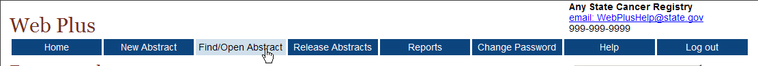
Result: The Find Abstract page opens.
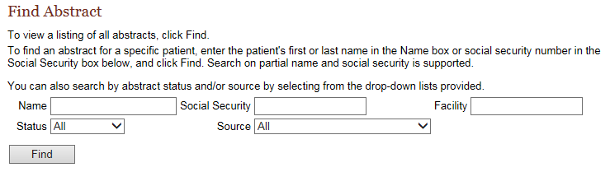
The Find Abstract page is searchable by patient name, social security number, abstract status, and/or abstract source.
 | The Central Abstractor/Reviewer can only open cases that they abstract or abstracts that have been held to them and accepted by them. You will learn how to “Accept” a held abstract in a later chapter in this manual.
- Select CCR Abstraction Review from the Source pull-down menu, and click Find.
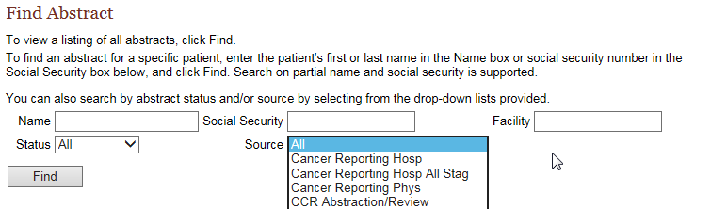
You can search on partial name or social security number.
Result: A list of all abstracts that were abstracted under the CCR Abstraction Review opens.

The list of abstracts has these following twelve columns:
Column Head | Description
Actions | You have the option to open, hold or delete an abstract
AbsRefID | A system-generated number identifying the abstract
Last Name | Last name of patient
First Name | First name of patient
DxDate | Diagnosis date
Social Security | Patient’s social security number
Birth Date | Patient’s date of birth
Primary Site | The location of the major tumor
Laterality | Code for the side of a paired organ, or the side of the body on which the reportable tumor originated
Abstractor | Code for the person who created the abstract
Edit Errors | The number of errors found in the edit process after an abstract has been saved
Status | Web Plus has three types of statuses:  - Incomplete (not all data have been entered)  - Complete (all errors have been addressed)  - Released (sent to the central registry)
Source | The type of Web Plus abstract; this is the name of the link that you clicked on your home page
- Click Open in the Action column of the incomplete abstract you started for JOHN JOHNSON.
Result: The Data Entry page opens and displays the previously entered data for the abstract. The heading above the entry fields now is “Update Abstract” because the abstract already contains some information.
- Type 20130223 in the Date of Diagnosis field, and press Enter.
- Press Enter again to leave the Diagnosis Date Flag field blank.
- At the Age at Diagnosis field, click the calculator icon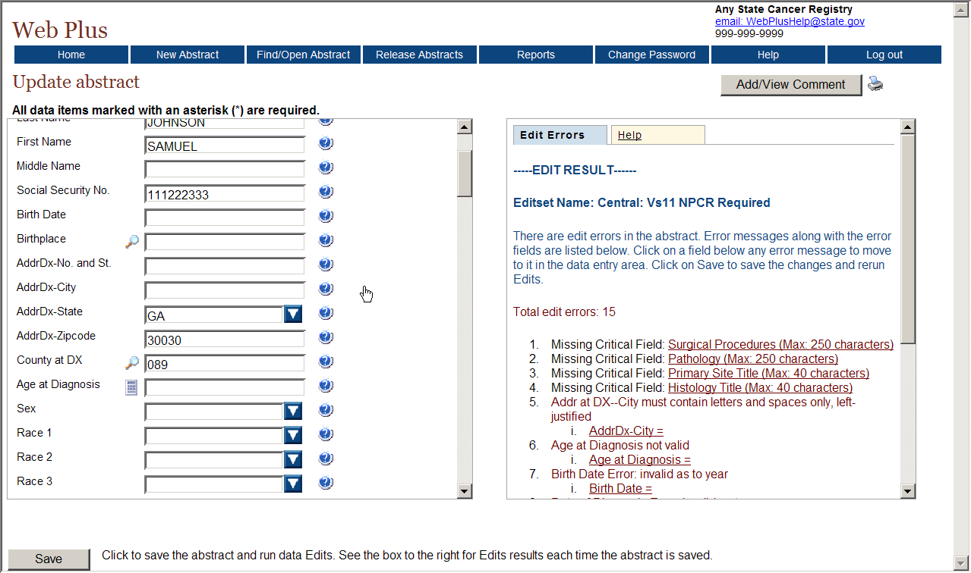.
Result: The Age at Diagnosis (051) is automatically calculated and entered into the Age at Diagnosis field.

Text Fields
Text Fields are another type of data entry field. This is an area where you enter text to describe diagnostic information, such as information from a pathology report, and treatment information, such as X-rays or surgery. The text fields displayed depend on those collected by your central registry.
You can use text fields to document supplemental information not contained within the coded values. You can also provide information that you are uncertain how to code so that a central abstractor/reviewer may code it properly in the data fields when the abstract is released to the central registry. The text is limited only by the maximum number of characters indicated for each field (for the majority of text fields, 1,000 characters are allowed).
Critical (required) fields are labeled with an asterisk (*).

Activity 2 – Adding Data, Part One
Continue entering information into the abstract for JOHN JOHNSON. Enter the following information in the appropriate fields (when necessary use the fields’ magnifying glass icons or drop-down lists to enter the proper codes):
Field | Content
Primary Site Text | Prostate
ICDO3 Site Code | C619 (Prostate, NOS)
Tumor Laterality | 0 – Not a paired site
Morphology Text | Adenocarcinoma, in situ, grade I
Pathology Text | 2/23/2011, TURP, incidental finding of adenocarcinoma in situ, size 001 mm

After you have finished entering the information, save your work.

Abstracting Histologic Type
Prior to cases diagnosed in 2010, coding of ICDO3 Histology entailed using the advanced search feature for the ICDO3 Histology field: click the magnifying glass icon to the left of the field, enter a search term in the search window that opens, and double-click the histology code that is listed for the specific term for which a search was conducted.
However, reportability instructions and data collection rules for hematopoietic and lymphoid neoplasms have gone into effect for cases diagnosed beginning January 1, 2010. As a result, two tools have been developed by SEER for use beginning in 2010: The Hematopoietic and Lymphoid Neoplasm Case Reportability and Coding Manual, and the Hematopoietic Database (DB). The Hematopoietic and Lymphoid Neoplasm Case Reportability and Coding Manual comes with the Hematopoietic Database and contains reportability instructions and rules for determining the number of primaries, the primary site and histology, and grade.
The Hematopoietic DB is a stand-alone application developed to assist in screening for reportable cases and determining reportability requirements, and contains abstracting and coding information for all hematopoietic and lymphoid neoplasms (9590/3-9992/3).
The SEER Hematopoietic Database must be independently installed and maintained by the Abstractor. It can be downloaded from the following URL: http://seer.cancer.gov/tools/heme/. In order to stay abreast of revisions in the database, it is recommended that you sign up on the website to receive e-mails when the database is updated:
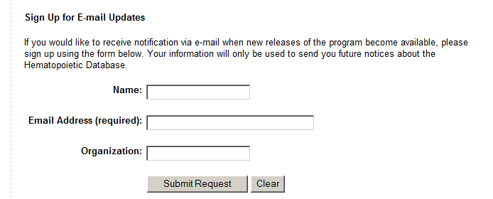
Be sure to follow the steps in the flowchart in Appendix B when using Hematopoietic Database and Manual to code hematopoietic and lymphoid neoplasms.

Activity 3 – Adding Data, Part Two
Next you will add more data that pertains to the tumor being reported.
- Complete the coding for the Cancer Identification section by entering the following information into the following fields either typing the value, using the drop-down list feature, or using the fields’ magnifying glass icon:
Field | Value to be Entered
ICDO3 Histology | 8140 – Adenocarcinoma in situ, NOS
ICDO3 Behavior | 2 – Carcinoma in situ
Grade | 1 – Grade 1; well differentiated
Grade Path Value | 1 – Recorded as Grade I or 1
Diagnostic Confirm. | 1 – Positive Histology

2. Click Save.

Activity 4 – Entering Text Fields
To practice entering text into text fields, enter the following information into the following text fields:
Text Field | Value to be Entered
Physical Exam | 02/15/2011: 45 y/o white, non-Hispanic male presenting with enlarged prostate. Retired farmer.
Lab Tests | 02/17/2011: PSA , elevated, 0.2 ng/ml
X-ray/Scans | None; no metastases
Staging Text | Physician states nodes are clinically negative

Adding Comments to an Abstract
It may be helpful to save notes about an abstract while you are in the process of abstracting it, or to relate supplemental information about the abstract to the central registry. Comments may be added to the abstract while abstracting it so that you can reference the information at a later time.
To add a comment to an abstract, complete these steps:
1. Click on Add/View Comments in the upper right-hand corner of the page.
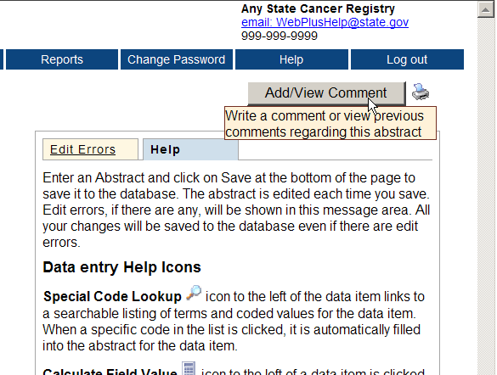
Result: The abstract comments window opens.
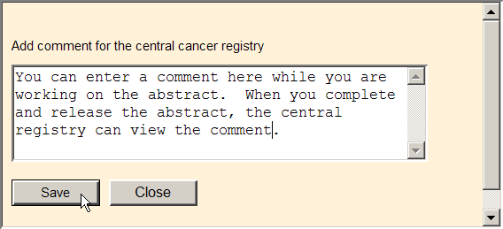
2. Enter your comments and click Save.

Print Preview
The Print Preview feature allows you to view all of the fields and the content you have entered in your abstract. You can also print a copy of the abstract from the Print Preview window.
1. Open an abstract.
2. Click Print Preview .
Result: A separate window opens that displays all of your abstract entry fields and content.
3. To print a copy of the abstract, use your browser’s printer.

Holding an Abstract
To hold an existing abstract to a Central Registry Abstractor/Reviewer use the Find Abstract page. Follow the steps listed below to hold an abstract to another user:
- Log in, if you are not already, as described in “Login”, page 7.
- Click on Find/Open Abstract
- Search for the abstract that you wish to hold to another user
- In the Action column, click on Hold
Result: The Hold Abstract dialog box opens.
- Select the user from the drop-down list.
- Click Hold

Deleting an Abstract
To delete an existing abstract, use the Find Abstract page. The Web Plus Administrator reserves the right to allow Central Registry Abstractor/Reviewers to delete abstracts that have been released by the facility. If the administrator has not selected the option for you to delete an abstract after it has been released, the delete option for those abstracts will not be available.
In this section, you create a new abstract, save it, find it, and then delete it.
To create and then delete an abstract, follow these steps:
- Log in, if you are not already, as described in “Login”, page 7.
- On the Web Plus menu, click New Abstract.
Result: The Data Entry page opens.
- Create a new abstract by typing Derrick Chung in the name fields and 891234567 as a Social Security Number.
- Click Save.
Result: The system saves the abstract to the database.
- On the Web Plus menu, click Find/Open Abstract.
Result: The Find Abstract page opens.
- Type 891234567 in the Social Security number field.
Result: The results display the Chung abstract entry.
- Click Delete in the Action column. Be sure to note the Abstract Reference ID (AbsRefID) number.
Result: The Confirm Delete window opens. It displays the Abstract Reference ID number of the abstract you want to delete (ID number 205 is an example; your Abstract Reference ID number will be different).
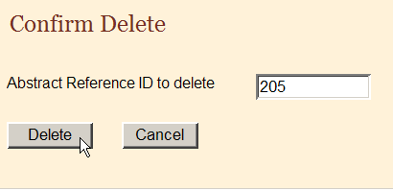
- Click Delete.
Result: On the Confirm Delete window a message confirms the deletion.
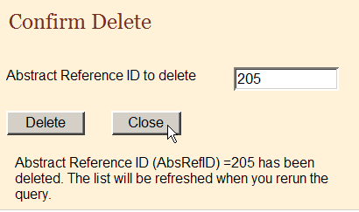
- Click Close.
- On the Find Abstract window, click Find and confirm in the results window that the system has deleted the abstract.

Questions
Answer these questions about adding data to an abstract (the answers are in Appendix A, page 57):
- What is the purpose of the text fields?
- How can you print your abstract and what does the printed copy contain?
- Which menu option do you click to open the page where you can delete an abstract?

Learning Objectives
In this chapter, you will learn to:
- Correct edit errors
- Understand how edit sets affect the completion of an abstract
- Understand the edit error messages

Activity 5 – Adding Information to and Deleting an Abstract
- In this activity you continue with the abstract you created on page 17, view a print preview of the abstract, and then delete the abstract.
- Find and open the abstract you created and add this information into the text fields:
Field | Content
Physical Exam | No information available.
X-ray/Scan | 9/11/06 CT Neck showed no def abnormalities noted.
- Calculate the Age at Diagnosis, by first entering the patient’s birth date and diagnosis date---you can make up dates for this purpose. Then click the calculator icon.
- View a print preview of your abstract.
- Delete the abstract.

Correcting Errors

Overview
In this chapter you continue working on your abstract, and will use the Edit Errors feature of Web Plus to find errors or blank required fields and work toward the completion of your abstract. You can only release completed abstracts which have no edit errors.

Understanding Edit Sets
Each abstract is edited for data quality and completeness whenever you save or open it. The edits applied to the information depend on the edit set selected for your facility by your Web Plus Administrator at your central registry. The edit set used for this training guide is “Central: Vs15 State Example-Incoming Abstracts.”
As an abstractor you must correct all identified errors to complete your abstract before you release it to the central registry.

Edit Errors Tab
The edit errors pane lists edits in the abstract. The edit set runs each time the abstract is saved or re-opened. To correct abstract edit errors, complete these steps:
- Find and open the JOHN JOHNSON abstract. For more information on finding and opening abstracts click here.
- On the Data Entry page, view the Edit Errors tab in the information pane on the right.
- In the Edit Errors list, click on the Class of Case = <BLANK> link.
Result: The application directs you to the Class of Case field in the data entry grid, so that you can correct the error.
- Enter 14 to indicate that the patient was diagnosed at and all treatment given at the reporting facility to resolve the edit error.
- Save the abstract to re-run the edits.
Result: The application re-runs the edits. The Class of Case edit error is removed from the Edit Set Results window, and the Total Edit Errors for Abstract count goes down by 1. In the example shown, the edit error count goes down from 27 to 26.
To resolve all edit errors, you would continue to click on links to fields containing edit errors and enter correct values for the fields. For now, prior to resolving the remaining edit errors for this abstract, we will move onto the abstraction and derivation of Collaborative Staging fields.

Questions
Answer these questions about correcting errors (the answers are in Appendix A, page 57):
- When are the data quality and completeness edits ran in Web Plus?
- Where are the edit errors listed?
- How do I resolve edit errors on an abstract?

Abstracting and Deriving Collaborative Stage Fields

Learning Objectives
In this chapter, you will learn to:
- Abstract and calculate Collaborative Staging (CS) fields
- Run CS-specific edits to determine CS Site-Specific Factor requirements
- Understand when the CS Version fields are automatically filled in

Overview
Web Plus has some special features to facilitate the abstraction of Collaborative Staging (CS) input fields, in particular for the Site-specific Factors (SSFs). Your central registry may or may not be collecting information on CS from you via Web Plus. If you are not required to submit CS information, please disregard this chapter of the training manual (with the exception of filling in the values for the JOHN JOHNSON abstract specified in Activity 6; you will need to enter these values in order to complete the abstract).

Abstracting CS Input Fields
Once the fields of primary site and histology have been entered, each CS input data item has a special site-specific look-up associated with it that is accessed by clicking the magnifying glass icon to the left of the field.
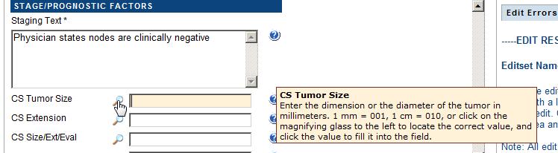
Once the particular CS input field look-up window is open, click on the appropriate value, and it will be automatically filled into the associated field in the data entry grid.
As soon as any of the CS input field look-ups is activated by clicking the magnifying glass to the left of the CS input field Once you derive the CS derived fields, the fields of CS Version Input Current (item #2937), CS Version Input Original (item #2935) and CS Version Derived (item #2936) are automatically filled in.

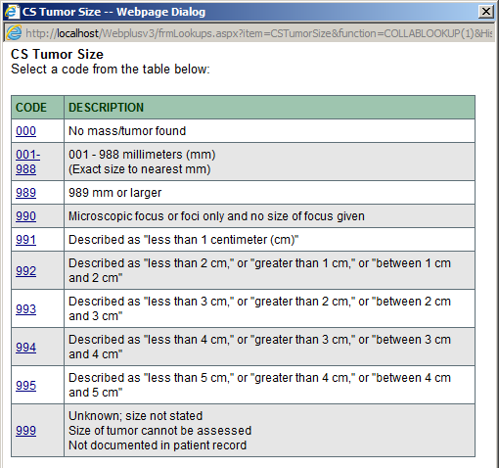

Abstracting CS SSFs
Web Plus automatically defaults all CS SSFs to a value of 988 when the first of any of the CS input field look-ups is activated by clicking the magnifying glass to the left of the CS input field.
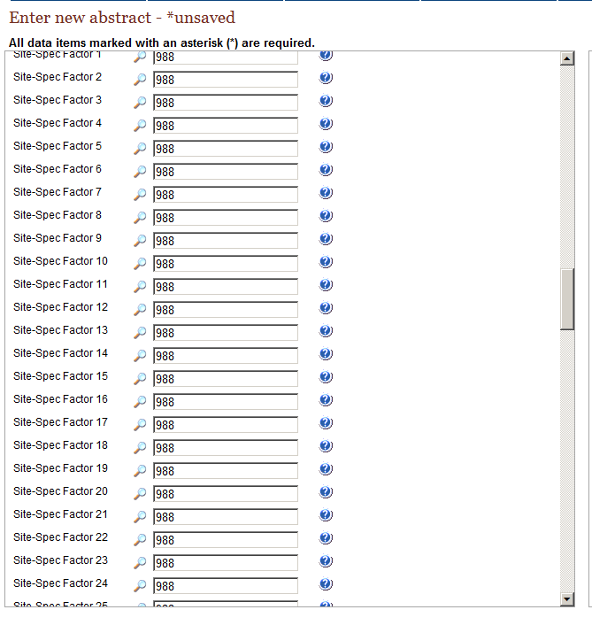
This automatic defaulting will save you a good deal of time, as the value of 988 will need to be entered for most of the SSFs for the majority of schemas. In order to determine which of the CS SSF fields needs to be revised from the defaulted value of 988 to a more specific value Web Plus has a special Run CS Edits button to run CS-specific edits to identify required CS fields.
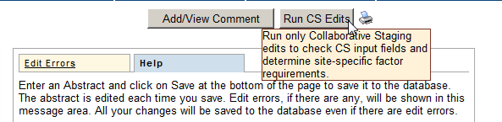

Calculating Derived CS Fields
To calculate the derived CS fields, after the appropriate CS input fields have been entered place the cursor into any of the derived fields and click the calculator icon to the left of the field.
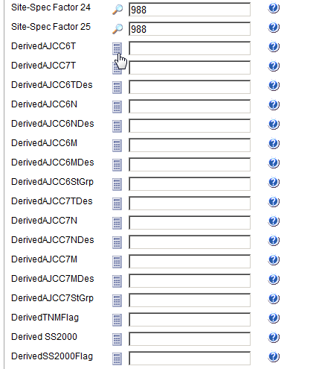
Once you derive the CS derived fields, the field of CS Version Derived (item #2936) is automatically filled in.

Activity 6 – Abstracting and Deriving Collaborative Staging Fields
To practice abstracting and deriving CS fields and using the CS special help features provided by Web Plus, complete the following steps:
- Click the magnifying glass icon to the left of the CS Tumor Size field, and click on the 001-988 value. The application prompts you to enter a specific value in the 001-988 range. Enter 001.
Result: All CS SSFs are automatically defaulted to a value of 988.
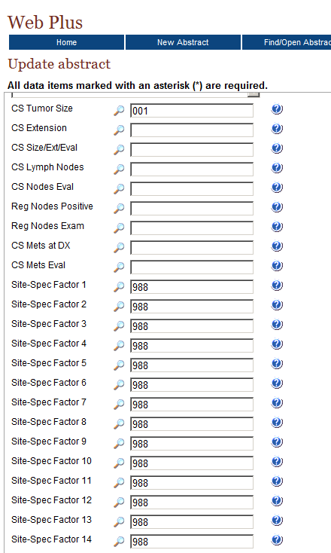
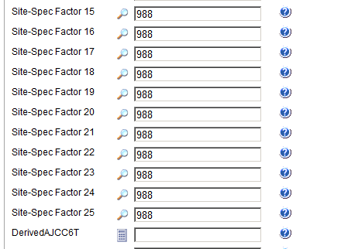
- Enter the following information into the remaining CS input fields either by just typing the value in the field or using the advanced search feature to guide your input by clicking on the magnifying glass icon to the left of the field:
Field | Value to be Entered
CS Extension | 000 (in situ; non-invasive; intraepithelial)
CS Size/Ext Eval | 1 (No prostatectomy done. Evaluation based on endoscopic examination, diagnostic biopsy, including needle core biopsy or fine needle aspiration biopsy, transurethral resection (TURP) or other invasive techniques including surgical observation without biopsy. No autopsy evidence used.)
CS Lymph Nodes | 000 (No regional lymph node involvement)
CS Nodes Eval | 0 (Does not meet criteria for AJCC pathologic staging:  No regional lymph nodes removed for examination. Evidence based on physical examination, imaging examination, or other non-invasive clinical evidence. No autopsy evidence used.)
Reg Nodes Positive | 98 (No nodes examined)
Reg Nodes Exam | 00 (No nodes examined)
CS Mets at DX | 00 (No distant metastasis)
CS Mets Eval | 0 (Does not meet criteria for AJCC pathologic staging of distant metastasis:  Evaluation of distant metastasis based on physical examination, imaging examination, and/or other non-invasive clinical evidence. No microscopic examination of metastatic specimen performed or microscopic examination was negative.)

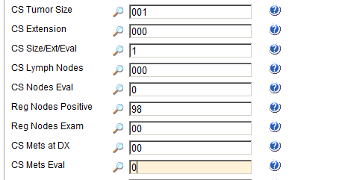
- Click Save.
Once you have entered all of the other CS input fields, click the Run CS Edits button in order to determine which of the CS SSF fields needs to be revised from the defaulted value of 988 to a more specific value.

- Click the Run CS Edits button located in the upper right-hand corner of the data entry page.
Result: CS-specific edits are run. You can now view the Edit Errors tab to determine which of the CS SSF fields needs to be revised from the defaulted value of 988 to a more specific value.
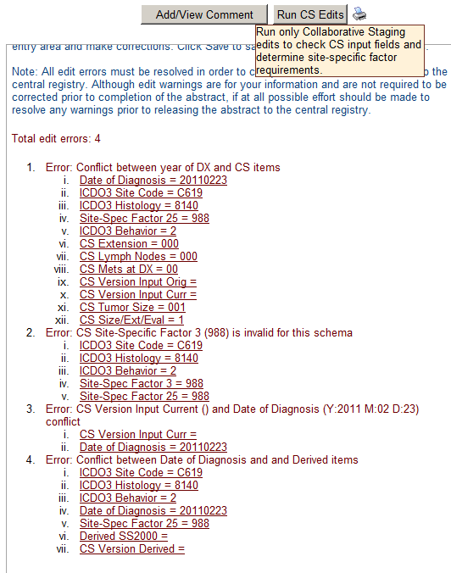
Please note that the CS-specific edits are run on the derived CS fields as well as the CS input fields. As you have not yet calculated the derived CS fields at this point you can disregard any edit errors addressing the derived CS fields.
- You can see from the Edit Errors tab, Error #3 that for the entered schema of Prostate, the field of CS SSF3 is required and must be revised from the defaulted value of 988 to a more specific value. However, as we have information available from the text available for this abstract, for the purposes of this exercise we will revise CS SSFs 1-3 to the following values:
Field | Value to be Entered
Site-Spec Factor 1  (PSA lab value) | Change the defaulted value of 988 to 002 (002 ng/ml; actual value with implied decimal point)
Site-Spec Factor 2 (PSA interpretation) | Change the defaulted value of 988 to 010 (Positive; elevated)
Site-Spec Factor 3  (Pathologic extension) | Change the defaulted value of 988 to 970 – No prostatectomy done within first course of treatment
- Click Save.
- Now that the CS input fields have been filled in, you must calculate the CS derived fields. To calculate derived CS fields click the calculator icon to the left of the field.
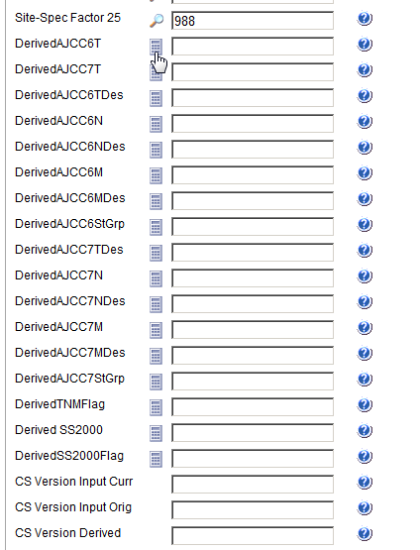
Result: The CStage Output window open and displays the calculated values.
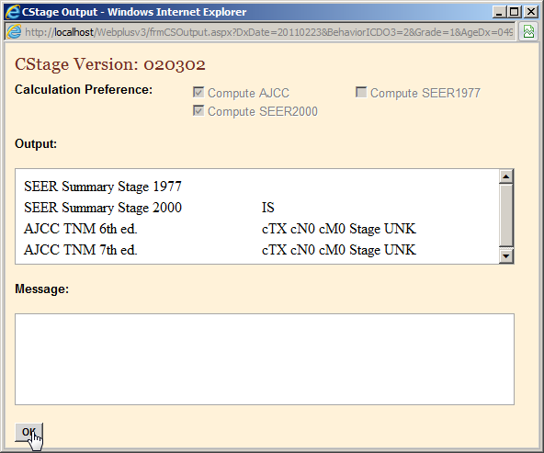
- Click OK.
Result: The appropriate derived CS fields are calculated and values are automatically filled in. In the example shown, all CS derived fields are calculated and filled. In addition the fields of CS Version Input Curr, CS Version Input Orig, and CS Version Derived are automatically filled in.
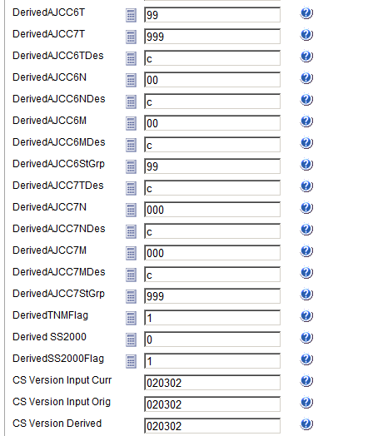
- Click Save.

Questions
Answer these questions about abstracting and deriving Collaborative Staging fields (the answers are in Appendix A, page 57):
- How do you enter information in the CS input data fields?
- How do you know what CS Site-Specific Factors are required to be filled out with a specific value?
- How do you calculate the CS derived data items?
- When and how are the CS Version fields filled in?

Completing and Releasing Abstracts

Learning Objectives
In this chapter, you will learn to:
- Complete an abstract
- Understand the two different ways to release a completed abstract to your central registry

Overview
In this chapter you complete working on your abstract, and will about the two different ways to release the completed abstract to your central registry. You can only release completed abstracts which have no edit errors.

Completing the Abstract
As mentioned, you must resolve all edit errors and fill in all critical (required) fields in order to complete an abstract. Once you have resolved all edit errors and completed all missing critical fields, upon the next save of the abstract, Web Plus informs you that the abstract is complete and ready for release to the central registry.
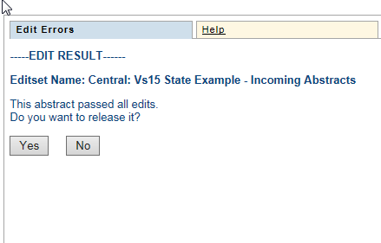

Activity 7 – Completing an Abstract
- Continue correcting errors, saving the abstract and re-running Edits until no errors remain. Use the information in this table to complete the JOHN JOHNSON abstract. Enter the following information into the following fields, either typing the value, using the drop-down list feature, or using the advanced search feature by clicking on the magnifying glass icon where available.
As you abstract the below fields, remember to save your work often. It is good practice to click the Save button each time after you enter a few fields. If you do not click Save often enough, you will lose the work you have done as Web Plus will log you out of the system due to inactivity.

Field | Value to be Entered
Reporting Facility | 1111111111 – Test Hospital (Note that this field is automatically filled in for you by Web Plus).
NPI--Reporting Facility | Leave blank (press enter to move to next field)
Type Report Source | 1 – Hosp. inpatient; Managed health plans with comprehensive unified records
Medical Record Num | 12312312312
Primary Payer at DX | 10 – Insurance, NOS
Sequence Num Hosp | 00
Date of 1st Contact | 20110215
Date 1st Contact Flag | Leave blank (press enter to move to next field)
Treatment Status | 1 – Treatment given
First Rx Date | 20110223
First Rx Date Flag | Leave blank (press enter to move to next field)
Surgery Text | 02/23/2011: TURP, NOS
Surgery Date | 20110223
Surgery Date Flag | Leave blank (press enter to move to next field)
Surgery Prim Site | 22 – TURP-cancer is incidental finding during surgery for benign disease
Reason for No Surgery | 0 – Surgery of primary site performed
Radiation Therapy Text | Leave blank (press enter to move to next field)
Other Radiation Text | Leave blank (press enter to move to next field)
Radiation Date | Leave blank (press enter to move to next field)
Radiation Date Flag | 11 – RX modality not given; autopsy only
Radiation Type | 00 – No radiation treatment
Radiation/Surg Seq. | 0 – No radiation and/or no cancer-directed surgery
Chemotherapy Text | Leave blank (press enter to move to next field)
Chemotherapy Date | Leave blank (press enter to move to next field)
Chemo Date Flag | 11 – RX modality not given; autopsy only
Chemotherapy Type | 00 – None
Hormonal Therapy Text | Leave blank (press enter to move to next field)
Hormone Rx Date | Leave blank (press enter to move to next field)
Horm Rx Date Flag | 11 – RX modality not given; autopsy only
Hormone Rx Type | 00 – None
BRM Therapy Text | Leave blank (press enter to move to next field)
BRM Therapy Date | Leave blank (press enter to move to next field)
BRM Rx Date Flag | 11 – RX modality not given; autopsy only
BRM Therapy Type | 00 – None
Other Therapy Text | Leave blank (press enter to move to next field)
RX Date—Other | Leave blank (press enter to move to next field)
RX Date--Other Flag | 11 – RX modality not given; autopsy only
RX Summ--Other | 0 – None
Scope Reg LN Rx | 0 – No regional lymph nodes removed
Non-Cancer Surgery | 0 – None
Transplant/Endo Rx | 00 – No transplant or endocrine therapy; autopsy- only
Systemic/Surg Seq | 0 – No systemic therapy and/or surgical procedures
Date Last Contact | 20110223
Date Last Cont Flag | Leave blank (press enter to move to next field)
Vital Status | 1 – Alive
Follow Up Source | 0 – Reported hospitalization
Cause of Death | 0000 (Patient alive at last contact.)
ICD Revision Num | 0 – Patient Alive
Place of Death | 997 (Alive)
Follow Up Physician | 99999999 (Follow-up physician unknown or ID number not assigned)
NPI Follow Up Phys | Leave blank

- Click Save to save the last entries that you made.
Result: Edits are run; the Edit Result shows no errors, and the application informs you that the abstract is complete and ready for release to the central registry.
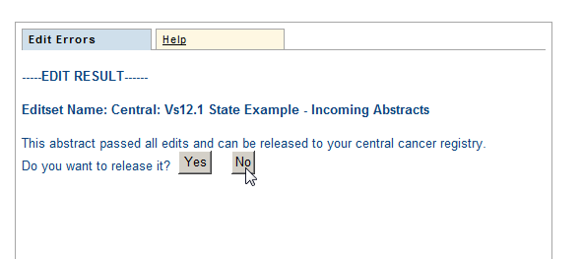
- Do not release the abstract now. Click No and go to the next section of this training manual, “Releasing the Abstract”.
Result: The abstract is saved and completed, but not released.
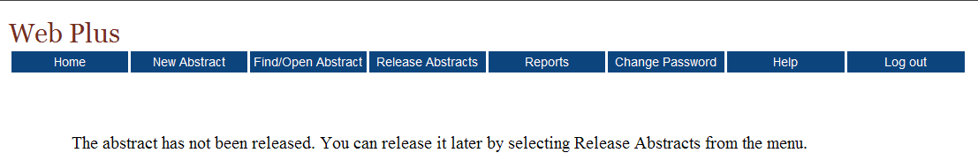
You could release your abstract at this point by clicking Yes, but you can also release one or more abstracts on the Release Abstracts page. For further details, see the next section, “Releasing the Abstract.”

Releasing the Abstract
Once your abstract has no errors, it is completed, and you can release it to the central registry.
Follow these steps to release an abstract:
- On the Web Plus menu, click Release Abstracts.
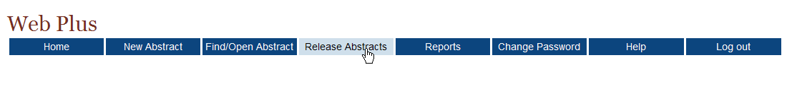
Result: The system displays a list of completed abstracts.
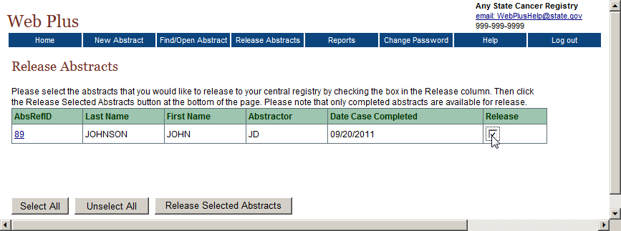
- Click the box in the Release column for the JOHN JOHNSON abstract.
To select all of the abstracts listed, click the Select All button.
- Click Release Selected Abstracts.
Result: The system releases the selected abstracts to your designated central registry and changes the status of the abstracts to Released. Use the Find/Open page to view the released abstracts. Note that you can view an abstract that has been released but cannot revise it.
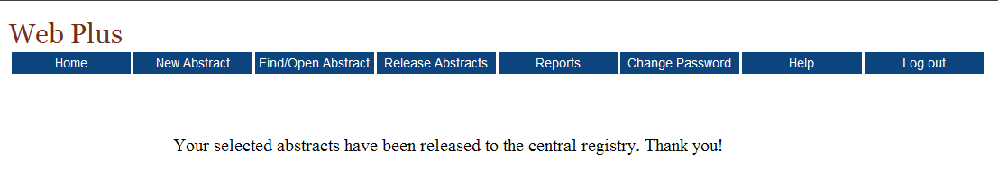

Questions
Answer these questions about completing and releasing abstracts (the answers are in Appendix A, page 57):
- How are abstracts completed?
- How can you release more than one abstract at a time?
- What are two ways to release a single abstract?

Accepting Held Abstracts

Learning Objectives
In this chapter you will learn how to accept abstracts that have been held to you for review.

Overview
Abstracts may be held to the Central Registry Abstractor/Reviewer by the Web Plus Administrator or by another Central Registry Abstractor/Reviewer. The Web Plus Administrator can assign a “Managing Central Abstractor/Reviewer” to facilities so that the abstracts are automatically held to the Central Registry Abstractor/Review when released by the facility. This can be useful for the manual review process.

Accepting Held Abstracts
- If you are not already logged in to Web Plus as the Central Registry Abstractor/Reviewer, login.
- Click on the Held Abstracts menu item.
Result: Abstracts that have been held to you will be listed.
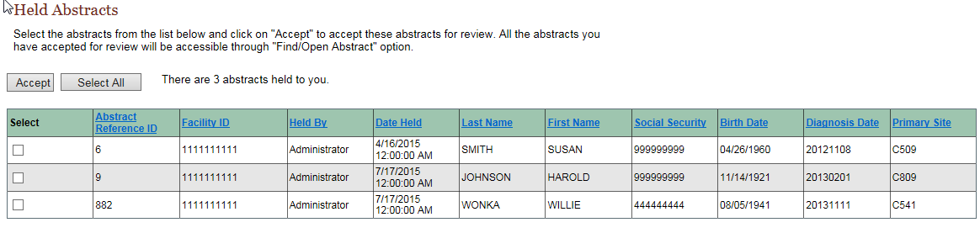
- To select all held abstracts, click “Select All”; then click “Accept”. You also have the option to select one or more abstracts by clicking in the checkbox beside the appropriate abstract; then click “Accept”.
Result: Once the abstract is selected, it will be removed from the “Held” abstracts list. You can then search for the abstracts under the “Find/Open Abstract” menu option.

Questions
- Where do you find abstracts that have been held to you for review?
- When you accept an abstract, where do you go to find it?

Reports

Learning Objective
In this chapter, you will learn:
- To open a report
- About the various reports available to the Central Registry Abstractor/Reviewer in Web Plus
- To set a date range for a report

Overview
Web Plus provides reports for the Central Registry Abstractor/Reviewer at both the central registry and facility level. The central registry-level reports show the logs of system logins and abstract activities in Web Plus. The facility-level reports allow a Central Registry Abstractor/Reviewer to view the activities on abstracts from specific facilities, such as when the abstracts were released. You can view, print, and set the date ranges (when appropriate) for all of these reports.

Opening Reports
To open a report after you have logged in, complete these steps:
- On the Web Plus menu, click Reports.
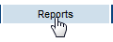
Result: Web Plus displays a list of reports available to you.
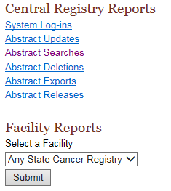

Central Registry Reports
This table describes the central registry reports available for viewing by the Central Registry Abstractor/Reviewer. Clicking the name of the report opens a separate window displaying the report.
This Report . . . | Lists . . .
System Log-ins | the facility, user, date, and time of all system log-ins and log outs in Web Plus within a selected date range
Abstract Updates | the user, facility, date, and time of all abstract updates
Abstract Searches | the user, facility, date, and time of all abstract searches
Abstract Deletions | the user, facility, date, and time of all abstract deletions
Abstract Releases | information about abstract releases including release time and date, abstractor, and facility
- Click System Log-ins.
Result: The Login Audit Report page opens.
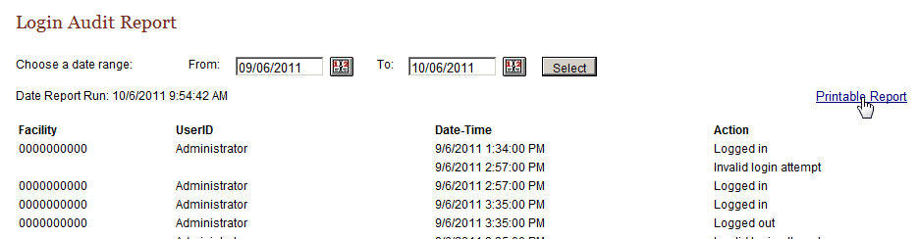
The report contains these column headings:
Column Heading | Description
Facility | Facility ID Number of user’s facility
UserID | User ID of the user
Date-Time | Date and time of the log in/out
Action | Indicates the user activity being logged:  Logged in  Logged out  Invalid log in attempt
- To print the report, click on the Printable Report link.
Result: A page opens with a printable version of the report.
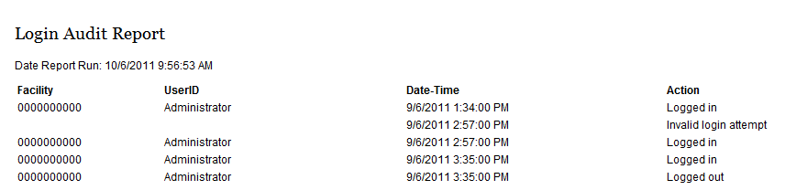
For optimum printing results, print Web Plus reports in landscape mode. To print in landscape, click on File→Page Setup, and click on Landscape.
In addition, if you wish to remove the internal report name from the upper left-hand corner of the printed report, remove the &w&b from the header field. If you wish to remove the URL listing from the bottom of the report, remove the information in the footer field (the date prints on the report already).
- Close the report window.
- On the Reports page under Central Registry Reports, click Abstract Updates.
Result: The Abstract Update Log report page opens.
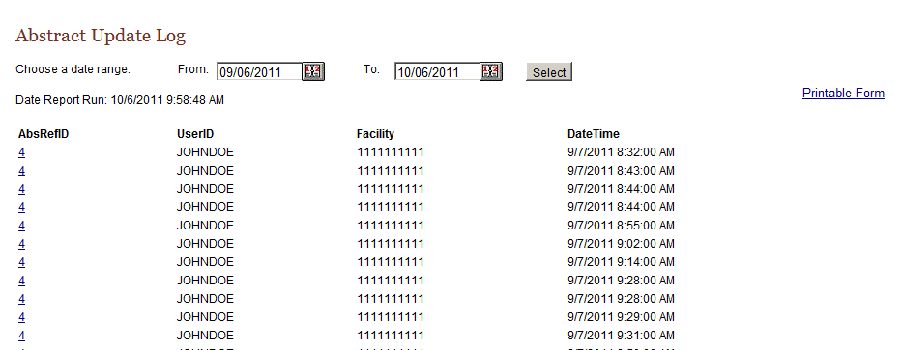
The Abstract Update Log report contains these column headings:
Column Heading | Description
AbsRefID | A unique, system-generated number identifying the abstract
UserID | User ID of the abstractor
Facility | Number of facility that sent the abstract
Date-Time | Date and time of the action
The remaining central registry reports contain the same column headings and information as the Abstract Update Log for their specific user activities:
  - Abstract Searches
  - Abstract Deletions
  - Abstract Exports
  - Abstract Releases

Changing the Date Range of a Report
To change the date range of a report, complete these steps:
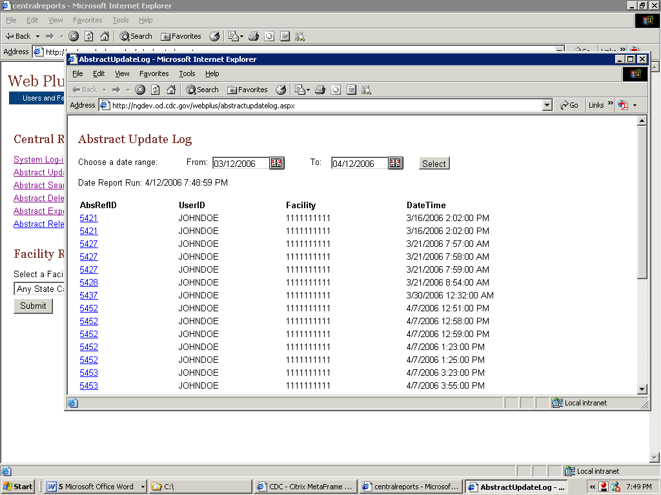
- On any opened report page, click the calendar icon beside the From date field.
Result: The calendar window opens.
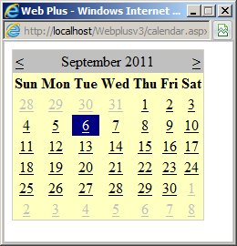
- Double-click the date you want. The system inserts the date in the field and closes the calendar window.
You can also type the date in the window by using the mm/dd/yyyy format, such as 09/01/2011 for September 1, 2011. The date calendar and format are the same for both the From and To date fields.
- Repeat steps 1 and 2 for the To date field.
- Click Select.
Result: The report is displayed with the information restricted to the date range selected.

Facility Reports
The Facility Reports section of the Central Registry Abstracotr/Reviewer pages of Web Plus include reports on facility activities and descriptive statistics on released abstracts from facilities.
To open a Facility Report, complete the following steps:
- On the Web Plus menu, click Reports.
- Under Facility Reports, use the pull-down menu to select a facility. In the example shown Test Facility is selected.
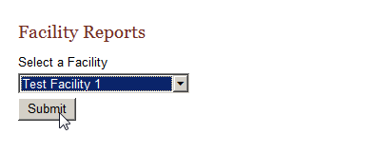
- Click Submit.
Result: The Facility Reports page opens for the selected facility.
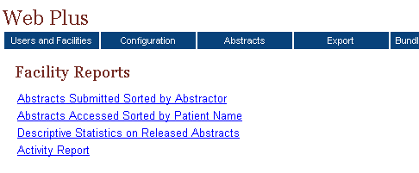
These facility reports are available to the Central Registry Abstractor/Reviewer:
This report . . . | Lists . . .
Abstracts Submitted  Sorted by Abstractor | all abstracts that a facility has released for a user-specified time range; the abstracts are sorted first by the name of the abstractor and then by patient name
Abstracts Accessed  Sorted by Patient Name | all abstracts that a facility has released for a user-specified time range sorted in order of patient name
Descriptive Statistics on Released Abstracts | descriptive statistics on released abstracts such as demographics and site group
Activity Report | the numbers of cases released and unreleased abstracts by month or year (depending on the length of the date range specified)

Abstracts Submitted Sorted by Abstractor Report
The Abstracts Submitted Sorted by Abstractor report provides the history of the abstract: when it was created, completed, and submitted to the central registry.
To access the Abstracts Submitted Sorted by Abstractor report, follow these steps:
- On the Facility Reports page for a selected facility, click the Abstracts Submitted Sorted by Abstractor link.
Result: The Abstracts Submitted Sorted by Abstractor report page opens in a separate window.
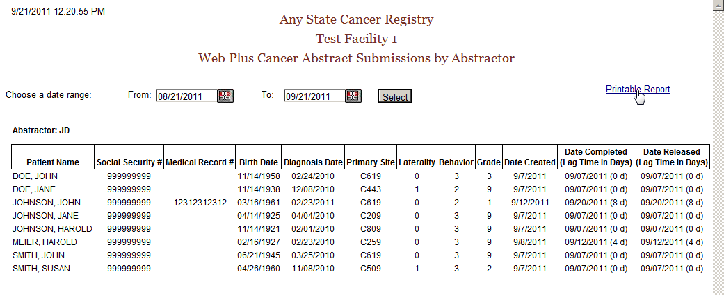
The report contains these columns for each abstract released by the facility, and the abstracts are grouped by abstractor initials:
Column Heading | Description
Patient Name | Name of patient on abstract
Social Security # | Patient’s social security number
Medical Record # | Patient’s medical record number
Birth Date | Patient’s birth date
Diagnosis Date | Diagnosis date of the tumor being reported
Primary Site | ICD-O-3 topography code for the primary site of the tumor being reported
Laterality | Laterality code for the tumor being reported
Behavior | ICD-O-3 behavior code for the tumor being reported
Grade | ICD-O-3 grade/differentiation code for the tumor being reported
Date Created | Date the abstract was created
Date Completed | Date the abstract was completed, with the lag time (in days) between date of creation and completion in parentheses
Date Released | Date the abstract was released to the central registry, with the lag time (in days) between date of completion and release in parentheses

The date range can be modified for the Abstracts Submitted Sorted by Abstractor report.
If you would like to print the report, click on the Printable Report link, and print the report in landscape mode using your browser’s printer.
- Close the report window.

Abstracts Accessed Sorted by Patient Name Report
The Abstracts Accessed Sorted by Patient Name report provides the dates and times that an abstract is opened and the reason why it was opened.
To access the Abstracts Accessed Sorted by Patient Name report, follow these steps
- On the Facility Reports page for a selected facility, click the Abstracts Accessed Sorted by Patient Name link.
Result: The Abstracts Accessed Sorted by Patient Name report page opens in a separate window.
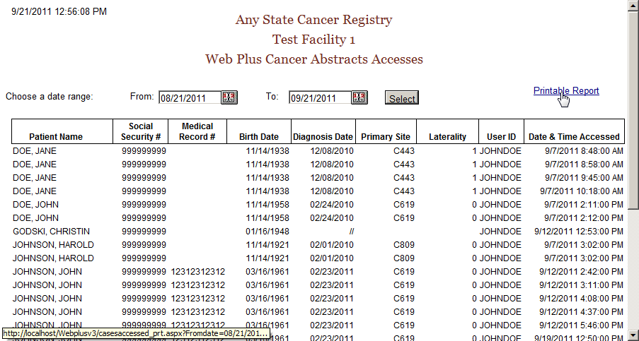
The Abstracts Accessed Sorted by Patient Name report contains these fields:
Field/Headings | Description
Patient Name | Name of patient on abstract
Social Security # | Patient’s social security number
Medical Record # | Patient’s medical record number
Birth Date | Patient’s birth date
Diagnosis Date | Diagnosis date of the tumor being reported
Primary Site | ICD-O-3 topography code for the primary site of the tumor being reported
Laterality | Laterality code for the tumor being reported
User ID | User ID of the abstractor
Date & Time Accessed | Date and time that the abstractor opened the abstract

The date range can be modified for the Abstracts Accessed Sorted by Patient Name report.
If you would like to print the report, click on the Printable Report link, and print the report in landscape mode using your browser’s printer.
- Close the report window.

Descriptive Statistics on Released Abstracts Report
The Descriptive Statistics on Released Abstracts report includes a series of tables consisting of the number and percent of released abstracts broken down by the following: county of residence, zip code of residence, sex and race, age group, site group, and treatment group.
To run and/or modify the report for Descriptive Statistics on Released Abstracts complete these steps:
- On the Facility Reports page for a selected facility, click the Descriptive Statistics on Released Abstracts link.
Result: The Descriptive Statistics on Released Abstracts report page opens.
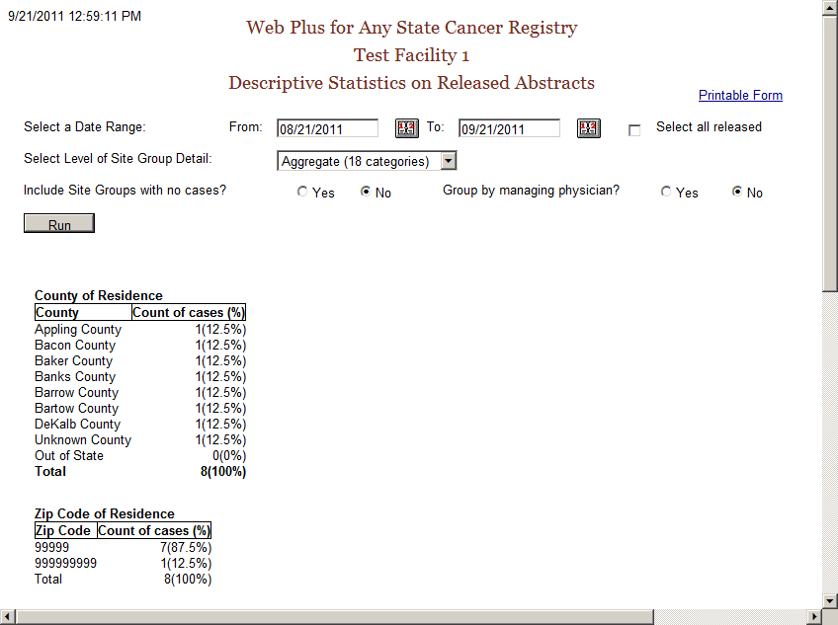
The descriptive statistics provided are broken down as follows:
Grouping Variable(s) | Groupings by…
County of Residence | individual county of residence at diagnosis
Zip Code of Residence | individual zip code of residence at diagnosis
Sex and Race | patient sex (male/female) by race (white/black/other)
Age Group | ten age groups (0-9, 10-19,….90+)
Site Group | three levels of primary site grouping:
  Grouping Level | Description
  Aggregate | 18 categories
  Subaggregate | 60 categories
  Recode | 78 groups
Treatment Group | type of summary treatment (RX Summ) recorded:  Surgery of Primary Site  Chemotherapy  Hormone  BRM  Other  Rad-Regional RX Modality  Transplant/Endocrine
The following options are available to modify the Descriptive Statistics on Released Abstracts report:
Option | Description
Date Range | Includes only those abstracts that were released within the specified date range
Select all released | When clicked, all abstracts released by the facility will be included, regardless of date released
Select Level of Site Group Detail | Specifies what level of primary site grouping to use for the report; the default grouping is 18 categories
Include site groups with no cases | When Yes is clicked, the primary site distribution will show all site groups for the level of detail chosen, whether or not abstracts were released containing each of the site groups  When No is clicked, only those primary site groups contained in the released abstracts released will appear on the report
Group by managing physician | When Yes is clicked, the records in the report will be grouped into sections by managing physician, displaying the descriptive statistics for abstracts released by each managing physician
- Next to Include Site Groups with no cases, click on Yes.
- Click Run.
Result: Web Plus displays the report again with all 18 site groupings displayed.
- Click on the Printable Form link.
Result: A separate window opens with the report formatted for printing.
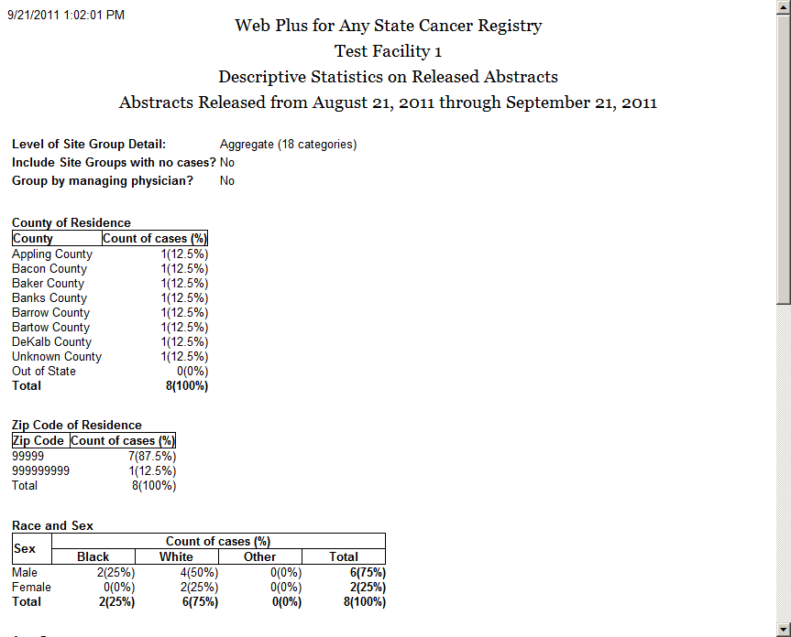
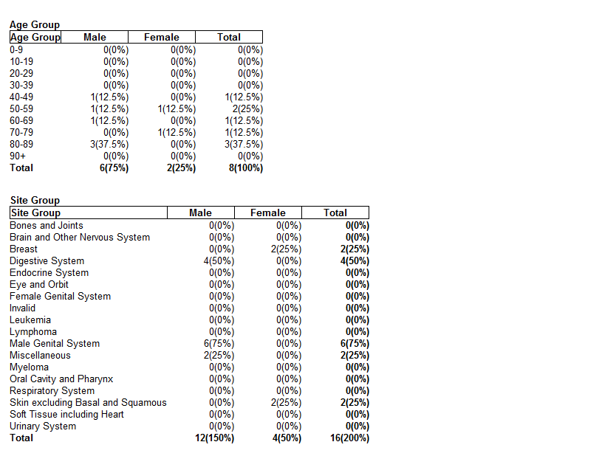
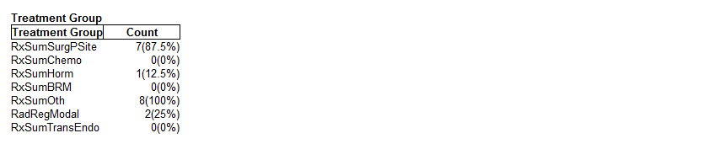
- Close the printable report window and then close the report window to return to the Facility Reports page.

Activity Report
The Activity report provides information on the abstracting activity at a facility, in terms of the number of released and unreleased abstracts. Viewing the Activity report is a good way to monitor submissions from individual facilities or doctors’ offices.
To open the Activity report:
- On the Facility Reports page for a selected facility, click the Activity Report link.
Result: The Activity Report window opens.
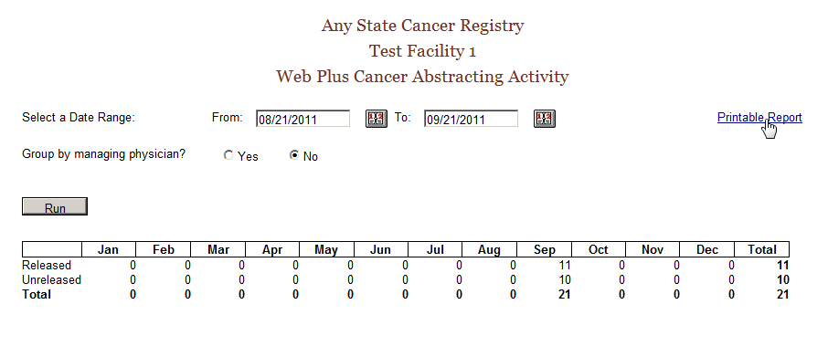
- If desired, enter a date range for the Activity report. If the specified date range spans more than one year, the report will display the number of released and unreleased cases for each year rather than each month.
- You can also group the information in the Activity report by managing physician; just click on Yes next to Group by managing physician, and click Run.
- If you would like to print the report, click on the Printable Report link, and print the report in landscape mode using your browser’s printer.
The default From date is one month prior to the current date and the default To date is the current day.
If the specified date range spans more than one year, the report will display the number of released and unreleased cases for each year rather than each month.
To modify the Activity report:
- Set the date range.
- Specify whether or not you would like the data in the report grouped by managing physician by clicking on Yes or No.
- Click Run to create the modified report.
- Close the report window.

Questions
Answer these questions about Web Plus reports (the answers are in Appendix A, on page 57 ):
- What are the two main types of reports available to the Central Registry Abstractor/Reviewer?
- Where can you find the Descriptive Statistics on Released Cases report?

Appendix A: Answers

Chapter 2: The Basics
These are the answers to the questions (page 10) about the basics of Web Plus:
- To create a new online abstract, click on New Abstract menu item.
- To log out, click Log Out on the Web Plus menu.
- To accept abstracts that have been held to you for review, click on the Held Abstracts menu item.

Chapter 3: Creating an Abstract
These are the answers to the questions (page 17) about entering data:
- You click the Help icon to learn more about a field.
- The Special Lookup page provides codes for specific field information.

Chapter 4: Adding Data to an Abstract
These are the answers to the questions (page 25) about adding data to an abstract:
- Text fields provide an area to enter written information about a patient’s medical history.
- Click the Print Preview link to open a copy of an abstract in a separate window. This preview displays all of the fields and entered data for the abstract. Use your browser’s printer to print out a copy.
- Click Delete in the Action column of the Find Abstract page to open the page where you can delete your abstract.

Chapter 5: Correcting Errors
These are the answers to the questions (page 28) about correcting and releasing abstracts:
- Abstracts are edited for data quality and completeness upon saving or opening of the abstract.
- The errors list is in the Edit Errors box on the right side of the Data Entry page.
- You resolve edit errors on an abstract by to clicking on links to fields containing edit errors in the Edit Errors box, entering correct values for the fields, and rerunning the edits by saving the abstract.

Chapter 6: Abstracting and Deriving Collaborative Staging Fields
These are the answers to the questions (page 37) about abstracting and deriving Collaborative Staging (CS) fields:
- Once the fields of primary site and histology have been entered, each CS input data item has a special site-specific look-up associated with it that is accessed by clicking the magnifying glass icon to the left of the field. Click the magnifying glass icon and then click the link to the appropriate value from the list of displayed values for the field.
- Once you have entered all of the other CS input fields, click the Run CS Edits button in order to determine which of the CS SSF fields needs to be revised from the defaulted value of 988 to a more specific value.
- You calculate the CS derived data items by clicking the calculator icon located to the left of any derived CS data field in the data entry grid.
- Once you calculate the CS derived fields, the fields of CS Version Input Current (item #2937), CS Version Input Original (item #2935) and CS Version Derived (item #2936) are automatically filled in.

Chapter 7: Completing and Releasing Abstracts
These are the answers to the questions (page 42) about completing and releasing abstracts:
- Once you have resolved all edit errors and completed all missing critical fields, upon the next save of the abstract, Web Plus informs you that the abstract is complete and ready for release to the central registry.
- To release more than one abstract at a time, click Release Abstracts on the Web Plus menu and select the abstracts you want to release.
- You can release an abstract by clicking the Yes button in the Edit Result box after you have completed it or by releasing it from the Release Abstract page.

Chapter 8: Accepting Abstracts
These are answers to the questions (page 43) about accepting abstracts.
- If an abstracts is held to the Central Registry Abstractor/Reviewer, the abstract will be under the “Held Abstracts” Menu option, until the abstracts has been accepted.
- When the Central Registry Abstractor/Reviewer accepts an abstract, the abstract can be found by searching for it under the “Find/Open Abstracts” menu option.

Chapter 9: Reports
These are the answers to the questions (page 56) about reports:
- The two main types of reports on the Central Registry Abstractor/Reviewer pages of Web Plus are Central Registry Reports and Facility Reports.
- You can find the Descriptive Statistics on Released Cases report by clicking on Reports on the Web Plus menu, selecting a facility, clicking the Submit button, and then clicking on the Descriptive Statistics on Released Cases link.
- The Web Plus User Account Management Report provides a listing of users assigned to each facility in Web Plus, and includes an at-a-glance overview of information for each user.

