
Web Plus
Training Manual for
Facility Abstractors
Version 3.0
(Based on Web Plus Version 3.1, NAACCR v12.1)
Centers for Disease Control and Prevention
National Center for Chronic Disease Prevention and Health Promotion
Division of Cancer Prevention and Control
National Program of Cancer Registries
Registry Plus™ Software for Cancer Registries

Contents

Chapter 1: Introduction 1
Overall Learning Objectives 1
Overview of the Web Plus Training Manual 1
Web Plus Features 1
Web Plus Users 2
Requirements for Web Access 3
Chapter 2: The Basics 4
Learning Objectives 4
Overview 4
Log In 4
Abstracting Process 6
Data Entry Page 7
Changing Your Password 9
Web Plus Version Information 9
Logging Out 10
Questions 10
Chapter 3: Creating an Abstract 11
Learning Objectives 11
Overview 11
Entering Information into Fields 11
Questions 16
Activity 1 – Creating an Abstract 16
Chapter 4: Adding Data to an Abstract 14
Learning Objectives 14
Overview 14
Opening and Updating an Abstract 14
Text Fields 16
Activity 2 – Adding Data, Part One 17
Abstracting Histologic Type 17
Activity 3 – Adding Data, Part Two 18
Activity 4 – Entering Text Fields 19
Adding Comments to an Abstract 19
Print Preview 20
Deleting an Abstract 20
Questions 21
Activity 5 – Adding Information to and Deleting an Abstract 22
Chapter 5: Correcting Errors 23
Learning Objectives 23
Overview 23
Understanding Edit Sets 23
Edit Errors Tab 23
Questions 24
Chapter 6: Abstracting and Deriving Collaborative Staging Fields 25
Learning Objectives 25
Overview 25
Abstracting CS Input Fields 25
Abstracting CS SSFs 26
Calculating Derived CS Fields 27
Activity 6 – Abstracting and Deriving Collaborative Staging Fields 27
Questions 33
Chapter 7: Completing and Releasing Abstracts 34
Learning Objectives 34
Overview 34
Completing the Abstract 34
Activity 7 – Completing an Abstract 34
Releasing the Abstract 37
Questions 38
Chapter 8: Follow-Back Abstracts 39
Learning Objectives 39
Overview 39
The Follow-back Process 39
Rejecting Follow-back Abstracts 43
Questions 44
Chapter 9: Running Reports 45
Learning Objectives 45
Overview 45
Opening and Printing Reports 45
Available Reports 46
Changing the Date Range of a Report 48
Local Reports 49
Abstracts Submitted Sorted by Abstractor Report 49
Abstracts Accessed Sorted by Patient Name Report 50
Descriptive Statistics on Released Abstracts Report 52
Activity Report 56
Facility Outstanding Follow-back Abstract Listing Report 57
HIPAA Accounting of Disclosure Report 59
Audit Reports 61
Activity – Finding Report Information 62
Chapter 10: Final Learner Activity 63
Overview 63
Medical Record 63
Hints 63
Appendix A: Answers 64
Chapter 2: The Basics 64
Chapter 3: Creating an Abstract 64
Chapter 4: Adding Data to an Abstract 64
Chapter 5: Correcting Errors 64
Chapter 6: Abstracting and Deriving Collaborative Staging Fields 64
Chapter 7: Completing and Releasing Abstracts 65
Chapter 8: Follow-back Abstracts 65
Appendix B: Flowchart for Hematopoietics 66

Introduction

Overall Learning Objectives

These are the overall learning objectives for the Web Plus Facility Abstractor training manual:
- Learn the major functions of Web Plus
- Create abstracts in compliance with cancer registry standards
- Correct errors so that the abstract is error-free and complete
- Release abstracts
- Complete and release, or reject, follow-back abstracts
- View and modify the reports of Web Plus

Overview of the Web Plus Training Manual
The Web Plus Facility Abstractor Training Manual provides you with the information to understand and use this web application. In this manual you not only learn about the tools in Web Plus, you also create an abstract and follow the process of updating and correcting the abstract until it is complete and released to the central registry. You will also learn about completing follow-back abstracts that have been partially-filled by your central registry and posted for you to complete. Also, each chapter contains questions that test your knowledge of Web Plus and activities that allow you to practice your new skills on your own.
Although Web Plus can use any edit set, this manual uses the edit set “Central: Vs12.1 State Example-Incoming Abstracts.” The edit set you use at your facility may differ.

Web Plus Features
Web Plus is a web-based application that collects cancer data securely over the public Internet. It is ideal for use by central cancer registries for all electronic reporting needs. Web Plus supports three main functions; online abstracting (which is addressed in this training manual), file upload/download, and follow-back efforts. The online abstracting capability of Web Plus is ideal for reporting from physicians’ offices and other low-volume reporting sources, while the file upload feature can be used for electronic submission of data from all other reporting sources to the central cancer registry.
The Web Plus follow-back features enable your central cancer registry to upload partially-filled abstracts generated from death certificate and pathology lab files, and to notify you via e-mail to log in and update the abstracts.
All records are saved in a database at the hosting central cancer registry and cases entered by one facility or office are not visible to other facilities. Data entered are validated by the CDC EDITS Engine running on a web server. Users, display types, and edit configurations are managed at the hosting central registry. Web Plus is hosted on a secure web server that has a digital certificate installed; the communication between the client and the server is encrypted with Secure Socket Layer (SSL) technology.

Web Plus Users
The results from the design staff and usability testing have identified these types of Web Plus users:
Users | Description
Facility Abstractor | Works in a facility or doctor’s office and handles patients’ medical records and paperwork. When a patient is diagnosed with cancer, the Facility Abstractor reports the case to the state’s central cancer registry. The Facility Abstractor also completes and submits any follow-back abstracts that the central registry has posted for their facility.
File Uploader | Uploads either files of abstracts in the appropriate NAACCR format that were not abstracted using Web Plus or non-NAACCR files in any format, views EDITS error report and cleans, or works with abstractors to clean, errors on rejected abstracts prior to resubmitting, downloads files posted by the central registry, and views reports.
Local Administrator | Manages local users of a facility.
Central Registry Administrator | Sets up facilities with access to the Web Plus software to report their data, manages facility accounts and users at both the central registry and facilities, configures display types, edit sets and system preferences, manages assignment of abstracts to central registry staff, exports data, and views reports.
Follow-back Supervisor | Uploads files of partially-filled follow-back abstracts, manually adds follow-back abstracts online, tracks follow-back abstracts by uploaded file or by facility, and generates and views Web Plus follow-back reports.
Follow-back Monitor | Tracks follow-back abstracts by assigned facility, generates and views Web Plus follow-back reports.
File Upload Supervisor | Monitors upload of files to the central registry; tracks file uploads and rejected abstracts by facility, communicates with facility to ensure resubmission of rejected abstracts, and views reports.
Central Registry Abstractor/Reviewer | Reviews abstracts submitted to the central registry for completeness and accuracy and may abstract additional data items from submitted text; also abstracts new cases.

Requirements for Web Access
Web Plus requires Microsoft Internet Explorer version 5.0 or later or a Mozilla browser to operate the system fully. Although Web Plus may work at 800 X 600 resolution, you may have trouble with some features; it can be best viewed at 1024 X 768 or higher resolution. It is highly recommended that you change your resolution to 1024 X 768 or higher when using the Web Plus application.

The Basics

Learning Objectives
In this chapter, you will learn to:
- Identify the menu options of Web Plus
- Understand the process of working on an abstract
- Log in and out of Web Plus
- Change your password

Overview
This lesson covers the basics of Web Plus. You’ll learn about logging in and out of Web Plus and the key elements of Web Plus.

Log In
To log in, complete these steps:
- Open your Internet browser and type the Internet address for your state registry’s Web Plus in the Address field.
- Press Enter.
Result: The Web Plus Log in page opens.
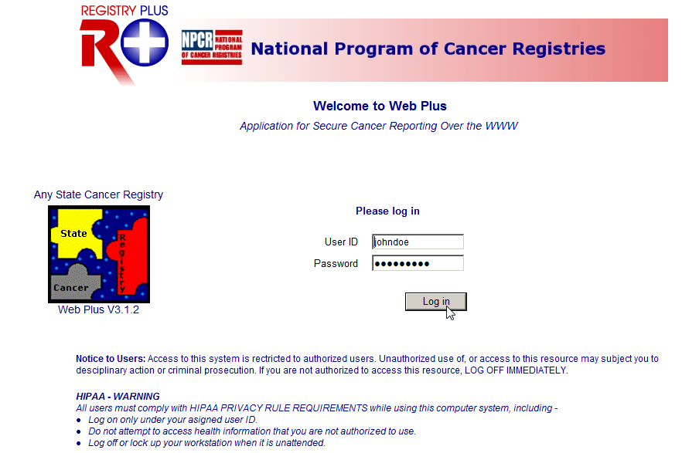
- Type in the User ID and password provided to you by your central registry into the User ID and Password fields, or type johndoe in the User ID field and abstract1 in the Password field.
- Click Log in.
Result: Your Web Plus homepage opens, with a list of links to the facilities and roles that have been assigned to you.
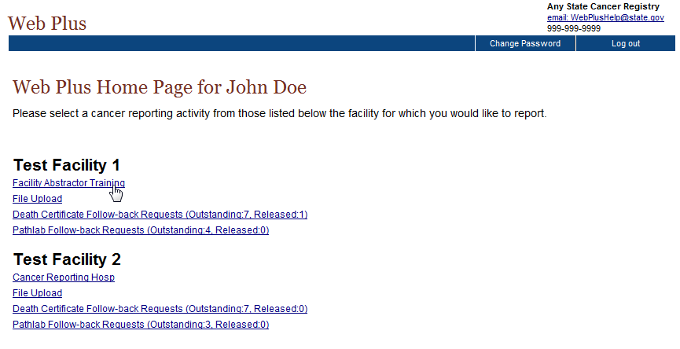
- Click the Facility Abstractor Training link.
 | The link that you click on your homepage is associated with a specific abstract “Source”, indicated by the name of the link. You can only abstract information for abstracts of the Source (or link) that you select. For example, if you select Facility Abstractor Training, you cannot open and work on follow-back abstracts. To work on abstracts of a different Source, click Home on the Web Plus menu, and click the link for the type of abstract you would like to work with.
Result: The Facility Abstractor menu items are displayed.
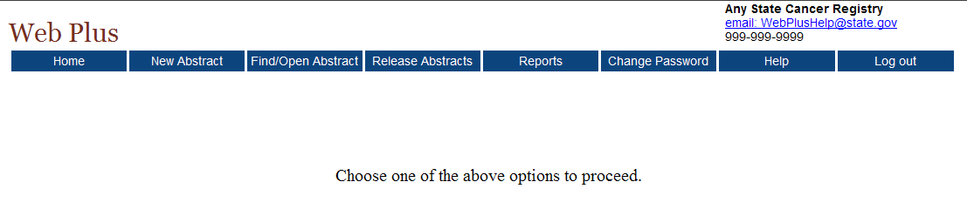
From this page you can access the main parts of Web Plus. Click on an option to open the page for the option.
This table describes the menu options on the home page:
Menu option | Description
Home | Opens the user’s home page, which displays a list of links for the facilities and roles that have been assigned to you; to work on abstracts of a particular source, click on the link for the type of abstract
New Abstract | Opens the data entry page for a new abstract
Find/Open Abstract | Opens the page to search for existing abstracts
Release Abstracts | Opens the page that lists all abstracts that are completed and ready for release
Reports | Opens the page that lists the reports available for viewing
Change Password | Opens the change password page
Help | About - Opens a page with the Web Plus, NAACCR, and Collaborative Staging Algorithm Version information
Log out | Logs the user out of Web Plus; opens Web Plus Log in page

Abstracting Process
The process of creating an abstract, entering data and ultimately releasing it to the central registry can all be done in Web Plus. After you create an abstract, you can save it at any time and return to your work at a later time. You can release the abstract to your central registry only after you have completed it and eliminated any errors it may contain.

The process of generating an abstract includes the following steps:
- Create the abstract with the patient’s name and social security number and save. You can add more information to the abstract and complete it whenever you want.
- Enter codes using the codes supplied by the Web Plus application and text in the in the data entry fields. Save the abstract to retain the information you have entered.
- Correct errors. Each time you open or save the abstract, Web Plus automatically edits the entered information for accuracy and completeness using the edit set and required fields chosen by your Web Plus Administrator.
- After you have entered all your data and corrected all errors, save the abstract and the system will designate your new abstract as complete.
- Release the completed abstract to the central registry. You can release abstracts individually or several at a time.

Data Entry Page
You enter your case information on the Data Entry page. To open the Data Entry page and view its content, follow these steps:
- Log in to Web Plus.
- On the Web Plus menu, click New Abstract.
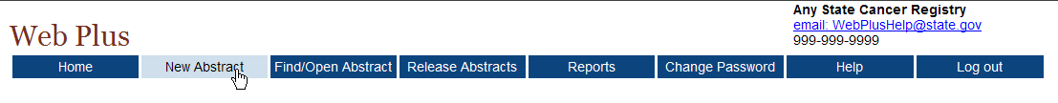
Result: The Data Entry page opens.
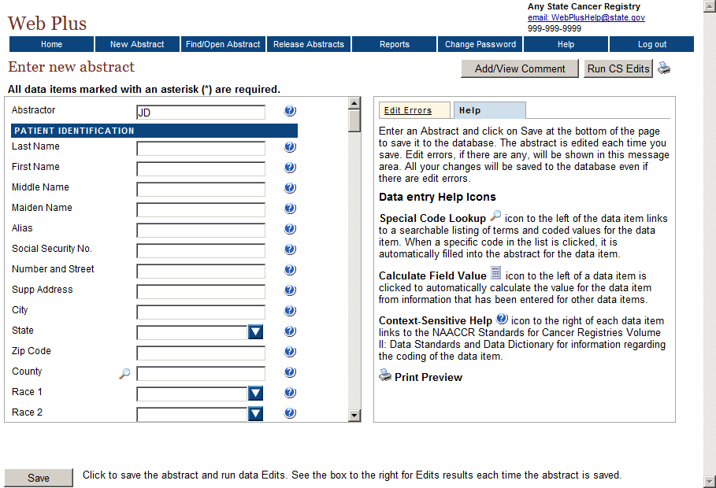
Notice that the page has two main sections. The box on the left contain the fields where you enter your case information. The box on the right contains two tabs: Help and Edit Errors.
- In the entry box on the left, scroll down the list to view all of the fields in the data entry grid, including the text fields.
The fields you see depend on your facility or center and the set up chosen by your Web Plus Administrator. The headings, such as Hospital Specific and Demographic, can vary. These are only headings; they do not signify a group of required fields. Your Web Plus Administrator uses them to organize the fields for clearer viewing and to help with data entry.
Refer to “Creating an Abstract,” page 11, to learn how to enter data in these fields.
In the right box, click each of the tabs to see the content. These are the Web Plus tabs:
Tab | Description
Help | This area describes the saving and editing of an abstract and provides a description of the data entry help icons available to the abstractor.
Edit Errors | This area lists any errors that may exist in an abstract after you have opened or saved the abstract. This editing feature helps you complete the abstract until it meets the standards acceptable to the central registry. You will learn more about the edit errors tab on page 22.
- Click the Help tab, if the section is not already open. This area provides a legend describing the data entry help icons available to the abstractor and briefly describes the process of saving your abstract.
Result: The Help box opens.
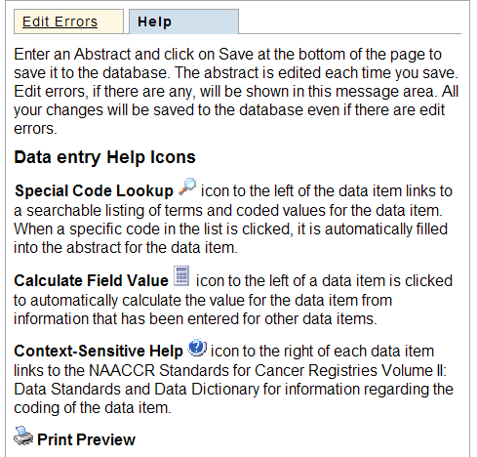
These are the Web Plus icons:
Icon | Description | Click the icon to . . .
 | Special Lookups | open a listing of codes and terms to choose from. Find the term that best applies, and click on the code to the left of the term. When a specific code is clicked, it is automatically filled into the abstract for the data item.
 | Calculate Field Value | calculate a value for a field from values in other fields.
 | Context-sensitive Help | open Help page with the NAACCR Standards for Cancer Registries Volume II: Data Standards and Data Dictionary for information about the data item.
 | Print Preview | open page that shows all of the fields and the content you have entered in your abstract; this page allows you to print a copy of your abstract.

Changing Your Password
To change your password, complete these steps:
- On the Home page menu, click Change Password.
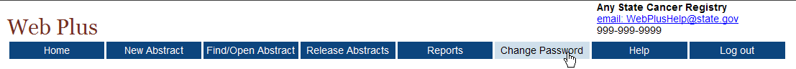
Result: The Change Password page opens.
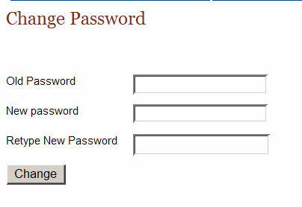
- Type your current password in the Old Password field.
- Type your new password in both of the New Password fields.
- Click Change.
Result: Your password is successfully changed.

Web Plus Version Information
To view Web Plus, NAACCR, and Collaborative Staging Algorithm Version information, complete these steps:
- On the Web Plus menu, point to Help.
- Click on About.
Result: A page opens with information about the version of the Web Plus application, and the NAACCR and Collaborative Staging Algorithm versions included in the Web Plus application.
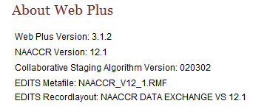

Logging Out
To log out of the Web Plus application, click Log out on the Home page menu.
Result: The Web Plus Log In page opens.
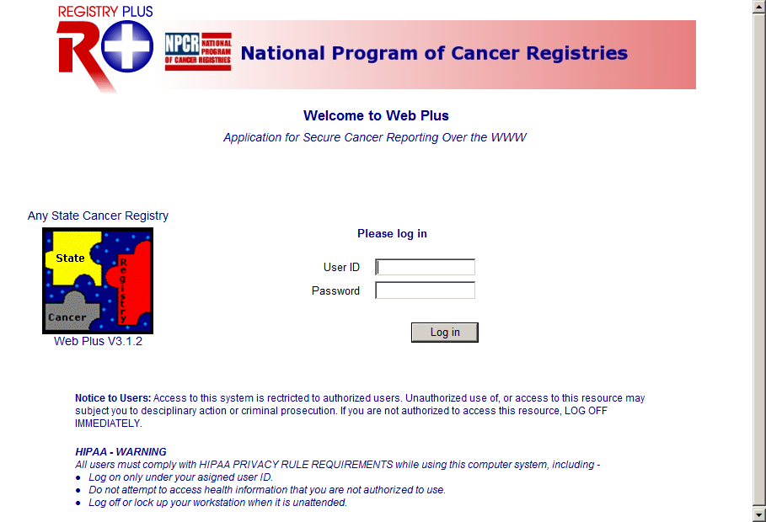

Questions
Answer the following questions about the basics of Web Plus (the answers are in Appendix A, page 63):
- Which icon do you click to open a separate window to insert a code into a field?
- How do you log out?
- Do have to complete filling out the abstract at one time? What can you do to begin an abstract and then return to it later?

Creating an Abstract

Learning Objectives
In this chapter, you will learn to:
- Enter information into the data entry fields
- Understand the process for completing an abstract
- Use these data entry tools: drop-down lists, Help, and Special Lookups

Overview
In this chapter you create an abstract that you continue to work with throughout this manual. In succeeding chapters you will complete and release this abstract. This chapter also introduces you to some basic entry tools to help you enter information in Web Plus.

Entering Information into Fields
In this section, you create an abstract by entering essential data into the designated fields. You will also learn to use Help, drop-down lists, and special lookups.
To create an abstract, complete these steps:
- Log in, as described in “Log In,” page 4.
- On the Web Plus menu, click New Abstract.
Result: The Data Entry page opens. Notice that the Abstractor field is pre-filled with your Abstractor ID.
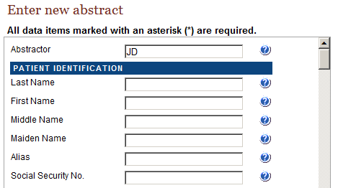
- Type JOHNSON in the Last Name field, and press Enter. Notice that the next field is now highlighted.
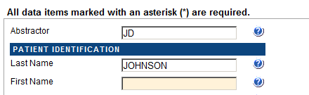
When you enter name and address information into Web Plus, the application automatically capitalizes the entered text.
- Click the Help icon beside the Last Name field.
Result: A separate window opens giving you information about the field.
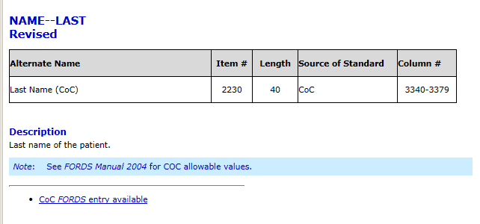
The context-sensitive Help information for Web Plus is from the NAACCR Standards for Cancer Registries Volume II: Data Standards and Data Dictionary. Each field has a help icon that you can click to open a page with information about the field.
- Close the Help window.
- Enter the following information in the following fields:
Field | Value to be Entered
First Name | JOHN
Middle Name | M
Maiden Name | Leave blank (press enter to move to next field)
Alias | Leave blank (press enter to move to next field)
Social Security No. | 999999999
Number and Street | 123 EAST MAIN ST
Supp Address | Leave blank (press enter to move to next field)
City | ATLANTA
- Click Save to save your work.
Result: The Web Plus system saves your new abstract.
When you save the abstract the system displays edit errors. Notice that the Edit Errors tab is automatically opened on the right and displays the total number of and details of the edit errors contained in the abstract. The procedures for resolving edit errors are described in a later chapter in this manual.
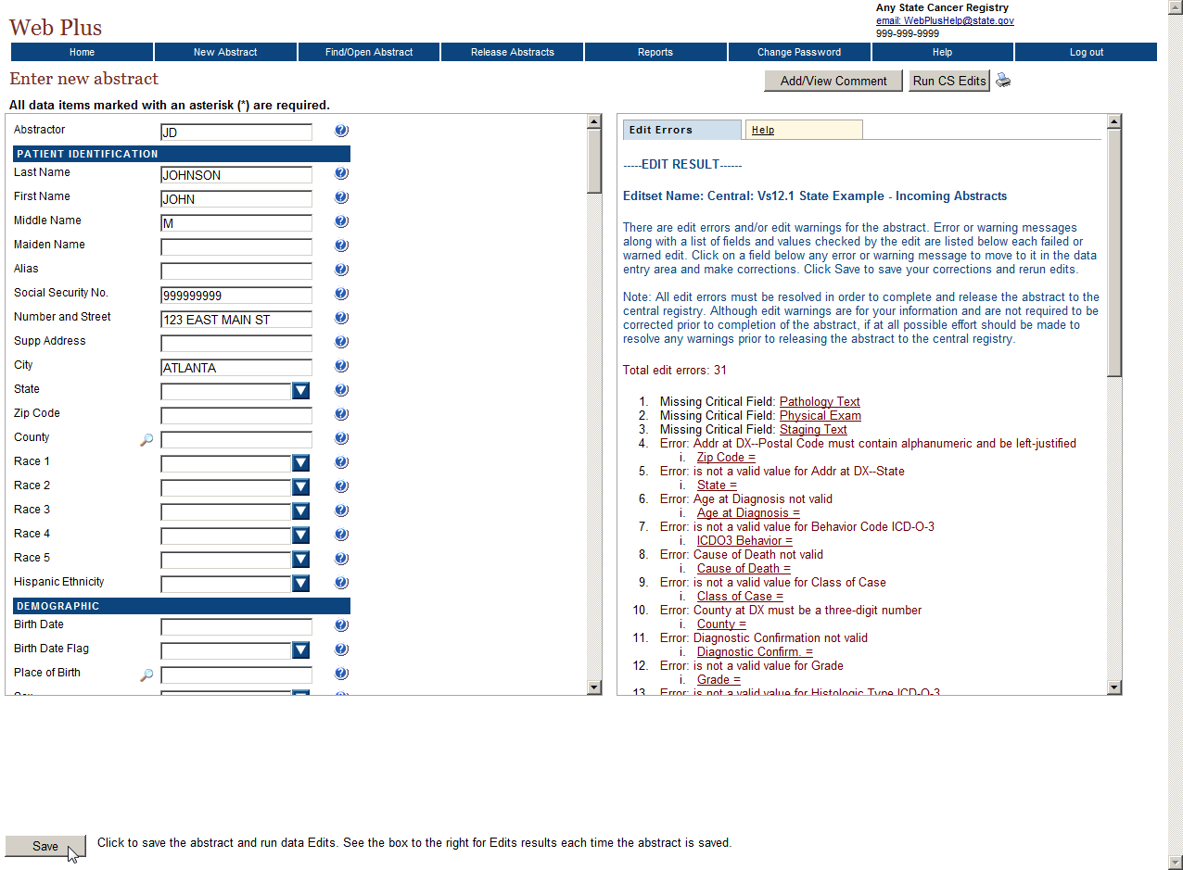
- Press enter or tab into the State field, and click the arrow to display the drop-down list.
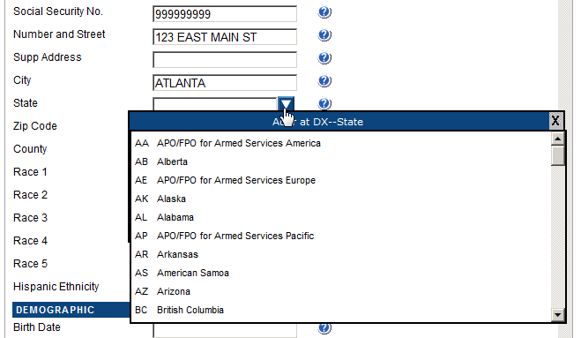
Result: A list of states appears in the pull-down menu.
- Scroll down and select the value of Georgia by clicking on it.
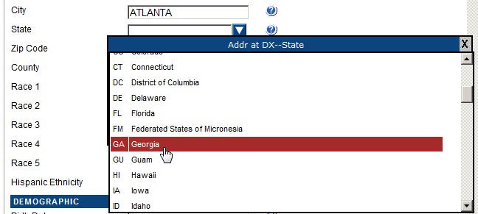
Result: GA is filled into the State field in the data entry grid.
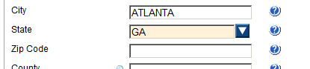
 | If you know the two-letter code for the state, you can type it in the field.
- Type 999999999 in the Zip Code field, and press Enter.
- Click on the magnifying glass icon to the left of the County field.
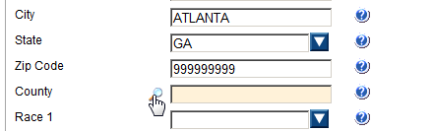
Result: The Select county code window opens, which provides a list of county codes.
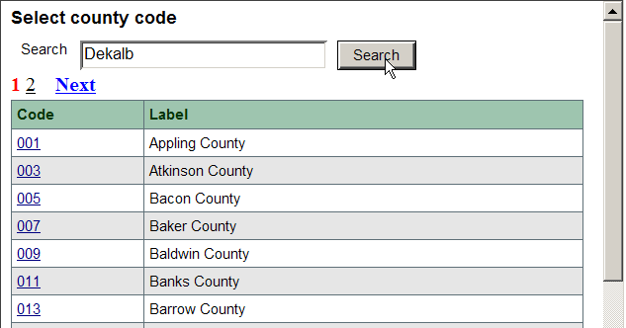
- In the Search field, type Dekalb and click Search.
You can also find the code by scrolling down the page or by clicking a page number at the top of the page to see other codes in the list.
Result: The system finds DeKalb county and its code.
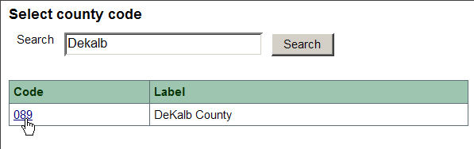
- Click the 089 code number for DeKalb County.
Result: The value of 089 is automatically entered into the data entry grid for the County field, and the Select county code window automatically closes.
- Enter the following information in the following fields, either by typing the value, using the drop-down list feature, or using the advanced search feature by clicking on the magnifying glass icon where available.
As of the NAACCR version 12 record layout, all dates are in the YYYYMMDD format. Because the NAACCR standards are so tightly integrated with Web Plus, dates are entered in the YYYYMMDD format.
The Abstractor will enter dates in the new YYYYMMDD format as follows:
YYYYMMDD – when complete date is known and valid
YYYYMM – when year and month are known and valid, and day is unknown
YYYY – when year is known and valid, and month and day are unknown
Blank – when no known date applies
A date flag field is filled out for each date field which is “unknown” or “not applicable” explaining why the corresponding date field is blank. The date field flag is left blank if a valid date is transmitted in its associated date item.

Field |  | Value to be Entered
Race 1 |  | 01 – White
Race 2 |  | 88 – No further race documented
Race 3 |  | 88 – No further race documented
Race 4 |  | 88 – No further race documented
Race 5 |  | 88 – No further race documented
Hispanic Ethnicity |  | 0 – Non-Spanish; non-Hispanic
Birth Date |  | 19610316
Birth Date Flag |  | Leave blank (press enter to move to next field)
Place of Birth |  | 000 – United States, NOS
Sex |  | 1 – Male
Usual Occupation |  | FARMER
Occup Census Code |  | 605-- Farmworkers, Farm and Ranch Animals
Occupation Source |  | 1-Reporting facility records
Usual Industry |  | FARMER/RANCHER
Indus Census Code |  | 018
Industry Source |  | 1-Reporting facility records

- To save your entries, click Save.
Result: The Web Plus system saves your new abstract. If you so choose, you can close the abstract and open it later and continue to work on it until completion.
In the next chapter, “Chapter 4: Adding Data to an Abstract, page 13” you continue to add data to this abstract.

Questions
Answer the following questions about entering data (the answers are in Appendix A, page 63):
- Which icon do you click to learn more about a field?
- What is the purpose of a Special Lookup page?

Activity 1 – Creating an Abstract
Create a new abstract of your own. Provide this information and then save your new abstract:

- Patient name
- Social Security number
- Medical Record number
- City
- State
- County
- Zip Code

Remember the patient name for this abstract because you will use this information in another activity, “ an Abstract,” page 21.

Adding Data to an Abstract

Learning Objectives
In this chapter, you will learn to:
- Find a specific abstract
- Enter information into text fields
- Identify and use tools necessary for entering information into an abstract
- Add comments to an abstract
- Preview an abstract for printing
- Delete an unreleased abstract

Overview
In this chapter you continue to enter data in the abstract you have already started. This chapter does not address correcting edits; this will be done in the next chapter, “Correcting Errors,” page 22.
First you will find and open your abstract and then add data to the abstract.

Opening and Updating an Abstract
In this section, you learn to find an existing abstract and open it, use a calculator field, and use pop-up window information.
To update an abstract, follow these steps:
- Log in, if you are not already, as described in “Log In,” page 4.
- On the Web Plus menu, click Find/Open Abstract.
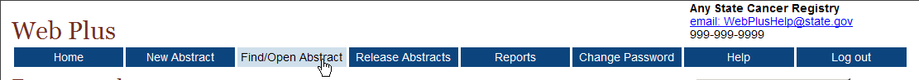
Result: The Find Abstract page opens.
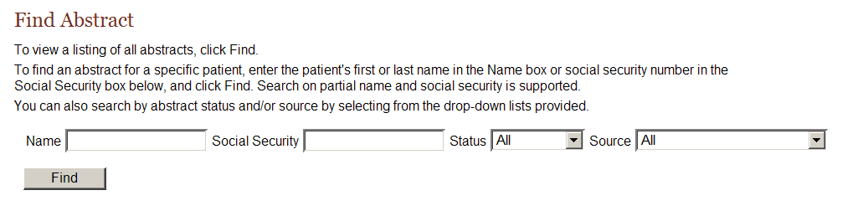
The Find Abstract page is searchable by patient name, social security number, abstract status, and/or abstract source.
The link that you click on your homepage is associated with a specific abstract Source, indicated by the name of the link. You can only open abstracts of the Source (or link) that you select from your homepage. For example, if you select Facility Abstractor Training, you cannot open and work on follow-back abstracts. To open abstracts of a different Source, click Home on the Web Plus menu, and click the link for the type of abstract you would like to open.
- Select Facility Abstractor Training from the Source pull-down menu, and click Find.
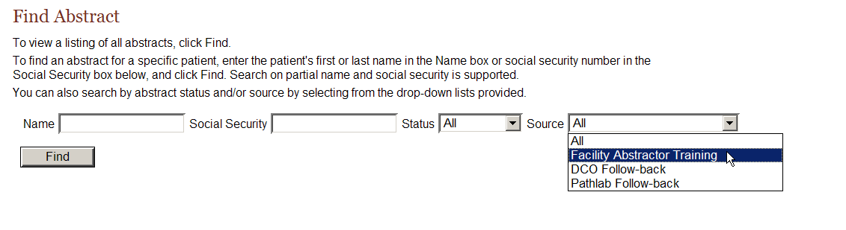
You can search on partial name or social security number.
Result: A list of all abstracts that were abstracted under the Facility Abstractor Training link opens.
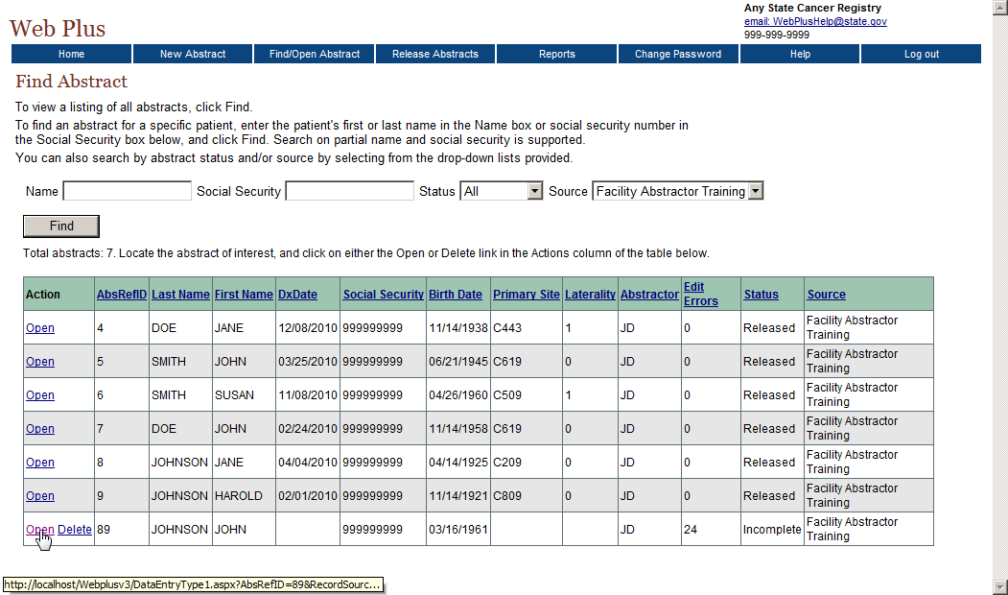
The list of abstracts has these following twelve columns:
Column Head | Description
Actions | You have the option to open or delete an abstract
AbsRefID | A system-generated number identifying the abstract
Last Name | Last name of patient
First Name | First name of patient
DxDate | Diagnosis date
Social Security | Patient’s social security number
Birth Date | Patient’s date of birth
Primary Site | The location of the major tumor
Laterality | Code for the side of a paired organ, or the side of the body on which the reportable tumor originated
Abstractor | Code for the person who created the abstract
Edit Errors | The number of errors found in the edit process after an abstract has been saved
Status | Web Plus has three types of statuses:  - Incomplete (not all data have been entered)  - Complete (all errors have been addressed)  - Released (sent to the central registry)
Source | The type of Web Plus abstract; this is the name of the link that you clicked on your home page
- Click Open in the Action column of the incomplete abstract you started for JOHN JOHNSON.
Result: The Data Entry page opens and displays the previously entered data for the abstract. The heading above the entry fields now is “Update Abstract” because the abstract already contains some information.
- Type 20110223 in the Date of Diagnosis field, and press Enter.
- Press Enter again to leave the Diagnosis Date Flag field blank.
- At the Age at Diagnosis field, click the calculator icon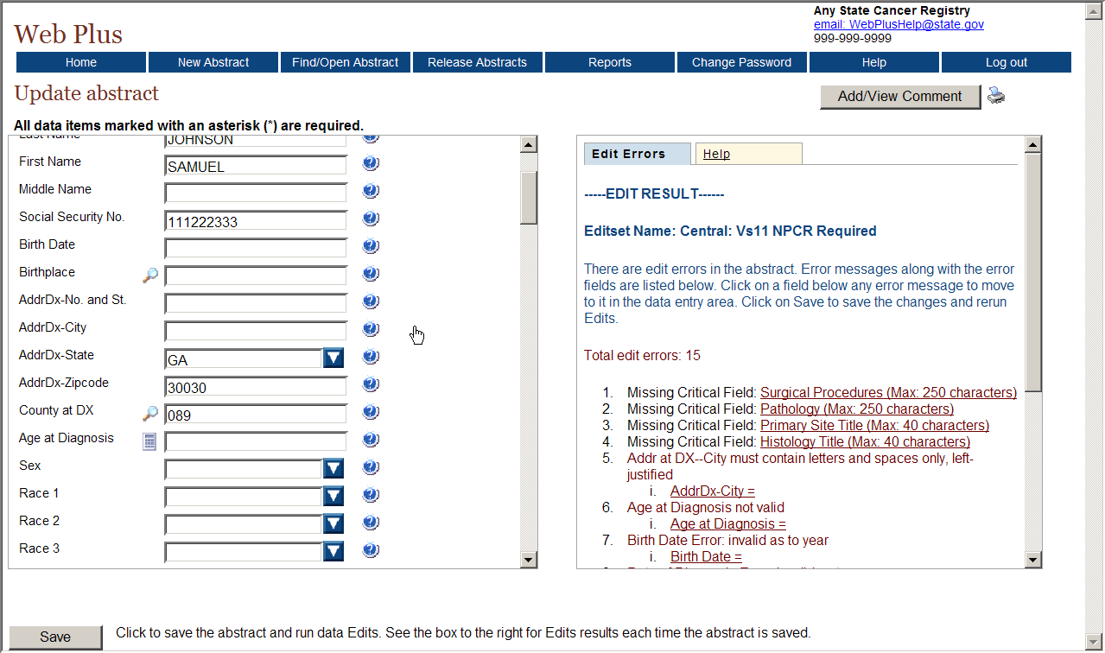.
Result: The Age at Diagnosis (049) is automatically calculated and entered into the Age at Diagnosis field.

Text Fields
Text Fields are another type of data entry field. This is an area where you enter text to describe diagnostic information, such as information from a pathology report, and treatment information, such as X-rays or surgery. The text fields displayed depend on those collected by your central registry.
You can use text fields to document supplemental information not contained within the coded values. You can also provide information that you are uncertain how to code so that a central abstractor/reviewer may code it properly in the data fields when the abstract is released to the central registry. The text is limited only by the maximum number of characters indicated for each field (for the majority of text fields, 1,000 characters are allowed).
Critical (required) fields are labeled with an asterisk (*).

Activity 2 – Adding Data, Part One
- Continue entering information into the abstract for JOHN JOHNSON. Enter the following information in the appropriate fields (when necessary use the fields’ magnifying glass icons or drop-down lists to enter the proper codes):
Field | Content
Primary Site Text | Prostate
ICDO3 Site Code | C619 (Prostate, NOS)
Tumor Laterality | 0 – Not a paired site
Morphology Text | Adenocarcinoma, in situ, grade I
Pathology Text | 2/23/2011, TURP, incidental finding of adenocarcinoma in situ, size 001 mm

- After you have finished entering the information, save your work.

Abstracting Histologic Type
Prior to cases diagnosed in 2010, coding of ICDO3 Histology entailed using the advanced search feature for the ICDO3 Histology field: click the magnifying glass icon to the left of the field, enter a search term in the search window that opens, and double-click the histology code that is listed for the specific term for which a search was conducted.
However, new reportability instructions and data collection rules for hematopoietic and lymphoid neoplasms have gone into effect for cases diagnosed beginning January 1, 2010. As a result, two tools have been developed by SEER for use beginning in 2010: The Hematopoietic and Lymphoid Neoplasm Case Reportability and Coding Manual, and the Hematopoietic Database (DB). The Hematopoietic and Lymphoid Neoplasm Case Reportability and Coding Manual comes with the Hematopoietic Database and contains reportability instructions and rules for determining the number of primaries, the primary site and histology, and grade.
The Hematopoietic DB is a stand-alone application developed to assist in screening for reportable cases and determining reportability requirements, and contains abstracting and coding information for all hematopoietic and lymphoid neoplasms (9590/3-9992/3).
The SEER Hematopoietic Database must be independently installed and maintained by the Abstractor. It can be downloaded from the following URL: http://seer.cancer.gov/tools/heme/. In order to stay abreast of revisions in the database, it is recommended that you sign up on the website to receive e-mails when the database is updated:
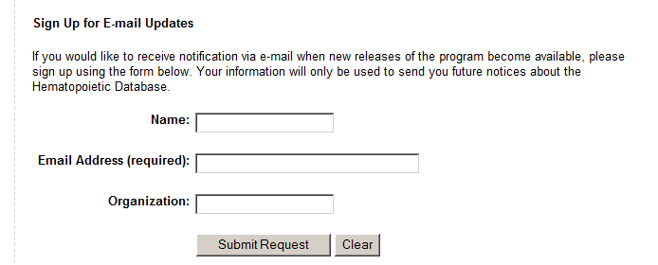
Be sure to follow the steps in the flowchart in Appendix B when using Hematopoietic Database and Manual to code hematopoietic and lymphoid neoplasms.

Activity 3 – Adding Data, Part Two
Next you will add more data that pertains to the tumor being reported.
- Complete the coding for the Cancer Identification section by entering the following information into the following fields either typing the value, using the drop-down list feature, or using the fields’ magnifying glass icon:
Field | Value to be Entered
ICDO3 Histology | 8140 – Adenocarcinoma in situ, NOS
ICDO3 Behavior | 2 – Carcinoma in situ
Grade | 1 – Grade 1; well differentiated
Grade Path Value | 1 – Recorded as Grade I or 1
Grade Path System | 4 – Four-Grade System
Diagnostic Confirm. | 1 – Positive Histology

- Click Save.

Activity 4 – Entering Text Fields
To practice entering text into text fields, enter the following information into the following text fields:
Text Field | Value to be Entered
Physical Exam | 02/15/2011: 45 yo white, non-Hispanic male presenting with enlarged prostate. Retired farmer.
Lab Tests | 02/17/2011: PSA , elevated, 0.2 ng/ml
X-ray/Scans | None; no metastases
Staging Text | Physician states nodes are clinically negative

Adding Comments to an Abstract
It may be helpful to save notes about an abstract while you are in the process of abstracting it, or to relate supplemental information about the abstract to the central registry. Comments may be added to the abstract while abstracting it so that you can reference the information at a later time.
To add a comment to an abstract, complete these steps:
- Click on Add/View Comments in the upper right-hand corner of the page.
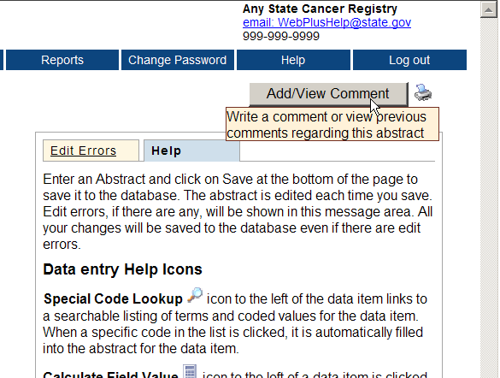
Result: The abstract comments window opens.
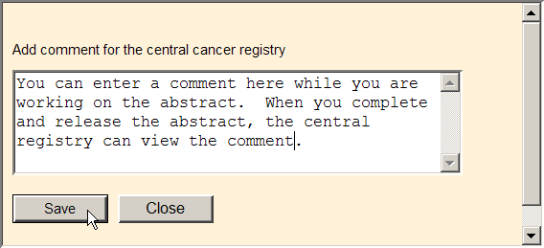
- Enter your comments and click Save.
The abstract comments are available for viewing until you complete and release the abstract. After the abstract is released, the comments are then available for viewing by central registry staff.

Print Preview
The Print Preview feature allows you to view all of the fields and the content you have entered in your abstract. You can also print a copy of the abstract from the Print Preview window.
- Open an abstract.
- Click Print Preview .
Result: A separate window opens that displays all of your abstract entry fields and content.
- To print a copy of the abstract, use your browser’s printer.

Deleting an Abstract
To delete an existing abstract, use the Find Abstract page. In this section, you create a new abstract, save it, find it, and then delete it.
To create and then delete an abstract, follow these steps:
- Log in, if you are not already, as described in “Log In,” page 4.
- On the Web Plus menu, click New Abstract.
Result: The Data Entry page opens.
- Create a new abstract by typing Derrick Chung in the name fields and 891234567 as a Social Security Number.
- Click Save.
Result: The system saves the abstract to the database.
- On the Web Plus menu, click Find/Open Abstract.
Result: The Find Abstract page opens.
- Type 891234567 in the Social Security number field.
Result: The results display the Chung abstract entry.
- Click Delete in the Action column. Be sure to note the Abstract Reference ID (AbsRefID) number.
Result: The Confirm Delete window opens. It displays the Abstract Reference ID number of the abstract you want to delete (ID number 205 is an example; your Abstract Reference ID number will be different).
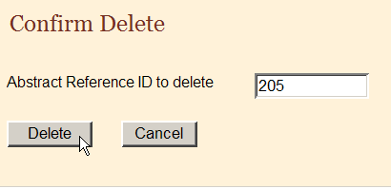
- Click Delete.
Result: On the Confirm Delete window a message confirms the deletion.
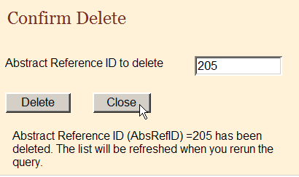
- Click Close.
- On the Find Abstract window, click Find and confirm in the results window that the system has deleted the abstract.

Questions
Answer these questions about adding data to an abstract (the answers are in Appendix A, page 63):
- What is the purpose of the text fields?
- How can you print your abstract and what does the printed copy contain?
- Which menu option do you click to open the page where you can delete an abstract?

Activity 5 – Adding Information to and Deleting an Abstract
In this activity you continue with the abstract you created on page 16, view a print preview of the abstract, and then delete the abstract.
- Find and open the abstract you created and add this information into the text fields:
Field | Content
Physical Exam | No information available.
X-ray/Scan | 9/11/06 CT Neck showed no def abnormalities noted.
- Calculate the Age at Diagnosis, by first entering the patient’s birth date and diagnosis date---you can make up dates for this purpose. Then click the calculator icon.
- View a print preview of your abstract.
- Delete the abstract.

Correcting Errors

Learning Objectives
In this chapter, you will learn to:
- Correct edit errors
- Understand how edit sets affect the completion of an abstract
- Understand the edit error messages

Overview
In this chapter you continue working on your abstract, and will use the Edit Errors feature of Web Plus to find errors or blank required fields and work toward the completion of your abstract. You can only release completed abstracts which have no edit errors.

Understanding Edit Sets
Each abstract is edited for data quality and completeness whenever you save or open it. The edits applied to the information depend on the edit set selected for your facility by your Web Plus Administrator at your central registry. The edit set used for this training guide is “Central: Vs12.1 State Example-Incoming Abstracts.”
As an abstractor you must correct all identified errors to complete your abstract before you release it to the central registry.

Edit Errors Tab
The edit errors pane lists edits in the abstract. The edit set runs each time the abstract is saved or re-opened. To correct abstract edit errors, complete these steps:
- Find and open the JOHN JOHNSON abstract. For more information on finding and opening abstracts click here.
- On the Data Entry page, view the Edit Errors tab in the information pane on the right.

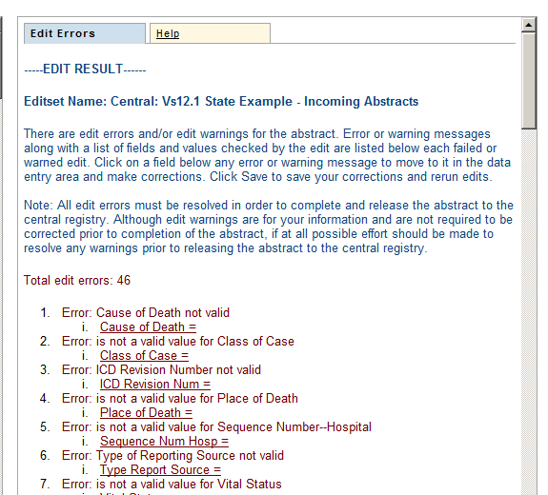
- In the Edit Errors list, click on the Class of Case = <BLANK> link.
Result: The application directs you to the Class of Case field in the data entry grid, so that you can correct the error.
- Enter 14 to indicate that the patient was diagnosed at and all treatment given at the reporting facility to resolve the edit error.
- Save the abstract to re-run the edits.
Result: The application re-runs the edits. The Class of Case edit error is removed from the Edit Set Results window, and the Total Edit Errors for Abstract count goes down by 1. In the example shown, the edit error count goes down from 46 to 45.
To resolve all edit errors, you would continue to click on links to fields containing edit errors and enter correct values for the fields. For now, prior to resolving the remaining edit errors for this abstract, we will move onto the abstraction and derivation of Collaborative Staging fields.

Questions
Answer these questions about correcting errors (the answers are in Appendix A, page 63):
- When are the data quality and completeness edits run in Web Plus?
- Where are the edit errors listed?
- How do I resolve edit errors on an abstract?

Abstracting and Deriving Collaborative Staging Fields

Learning Objectives
In this chapter, you will learn to:
- Abstract and calculate Collaborative Staging (CS) fields
- Run CS-specific edits to determine CS Site-Specific Factor requirements
- Understand when the CS Version fields are automatically filled in

Overview
Web Plus has some special features to facilitate the abstraction of Collaborative Staging (CS) input fields, in particular for the Site-specific Factors (SSFs). Your central registry may or may not be collecting information on CS from you via Web Plus. If you are not required to submit CS information, please disregard this chapter of the training manual (with the exception of filling in the values for the JOHN JOHNSON abstract specified in Activity 6; you will need to enter these values in order to complete the abstract).

Abstracting CS Input Fields
Once the fields of primary site and histology have been entered, each CS input data item has a special site-specific look-up associated with it that is accessed by clicking the magnifying glass icon to the left of the field.
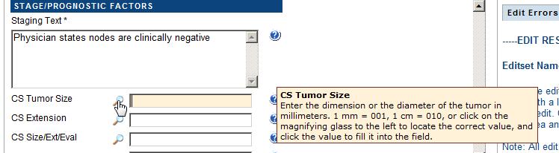
Once the particular CS input field look-up window is open, click on the appropriate value, and it will be automatically filled into the associated field in the data entry grid.
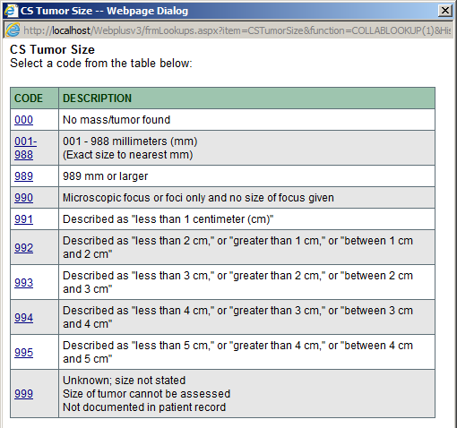

Abstracting CS SSFs
Web Plus automatically defaults all CS SSFs to a value of 988 when the first of any of the CS input field look-ups is activated by clicking the magnifying glass to the left of the CS input field.
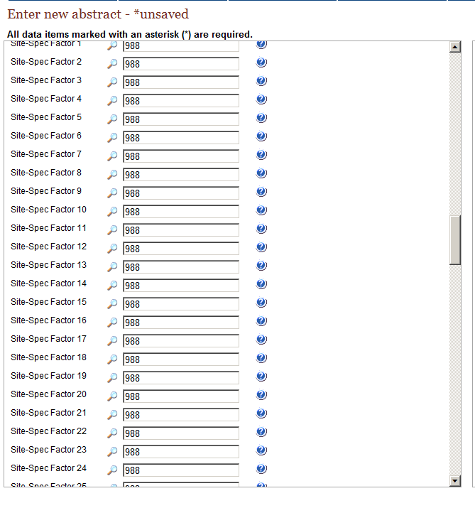
This automatic defaulting will save you a good deal of time, as the value of 988 will need to be entered for most of the SSFs for the majority of schemas. In order to determine which of the CS SSF fields needs to be revised from the defaulted value of 988 to a more specific value Web Plus has a special Run CS Edits button to run CS-specific edits to identify required CS fields.
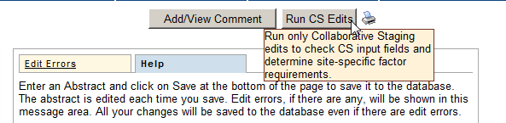

Calculating Derived CS Fields
To calculate the derived CS fields, after the appropriate CS input fields have been entered place the cursor into any of the derived fields and click the calculator icon to the left of the field.
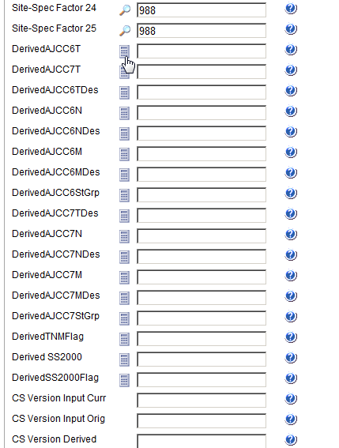
Once you derive the CS derived fields, the fields of CS Version Input Current (item #2937), CS Version Input Original (item #2935) and CS Version Derived (item #2936) are automatically filled in.

Activity 6 – Abstracting and Deriving Collaborative Staging Fields
To practice abstracting and deriving CS fields and using the CS special help features provided by Web Plus, complete the following steps:
- Click the magnifying glass icon to the left of the CS Tumor Size field, and click on the 001-988 value. The application prompts you to enter a specific value in the 001-988 range. Enter 001.
Result: All CS SSFs are automatically defaulted to a value of 988.
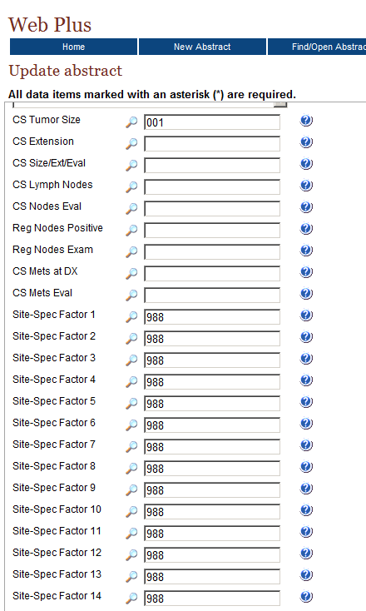
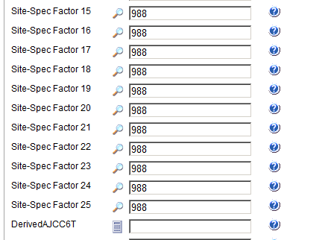
- Enter the following information into the remaining CS input fields either by just typing the value in the field or using the advanced search feature to guide your input by clicking on the magnifying glass icon to the left of the field:
Field | Value to be Entered
CS Extension | 000 (in situ; non-invasive; intraepithelial)
CS Size/Ext Eval | 1 (No prostatectomy done. Evaluation based on endoscopic examination, diagnostic biopsy, including needle core biopsy or fine needle aspiration biopsy, transurethral resection (TURP) or other invasive techniques including surgical observation without biopsy. No autopsy evidence used.)
CS Lymph Nodes | 000 (No regional lymph node involvement)
CS Nodes Eval | 0 (Does not meet criteria for AJCC pathologic staging:  No regional lymph nodes removed for examination. Evidence based on physical examination, imaging examination, or other non-invasive clinical evidence. No autopsy evidence used.)
Reg Nodes Positive | 98 (No nodes examined)
Reg Nodes Exam | 00 (No nodes examined)
CS Mets at DX | 00 (No distant metastasis)
CS Mets Eval | 0 (Does not meet criteria for AJCC pathologic staging of distant metastasis:  Evaluation of distant metastasis based on physical examination, imaging examination, and/or other non-invasive clinical evidence. No microscopic examination of metastatic specimen performed or microscopic examination was negative.)

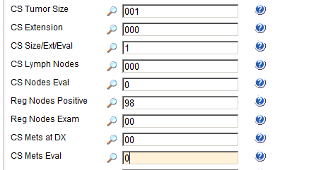
- Click Save.
Once you have entered all of the other CS input fields, click the Run CS Edits button in order to determine which of the CS SSF fields needs to be revised from the defaulted value of 988 to a more specific value.

- Click the Run CS Edits button located in the upper right-hand corner of the data entry page.
Result: CS-specific edits are run. You can now view the Edit Errors tab to determine which of the CS SSF fields needs to be revised from the defaulted value of 988 to a more specific value.
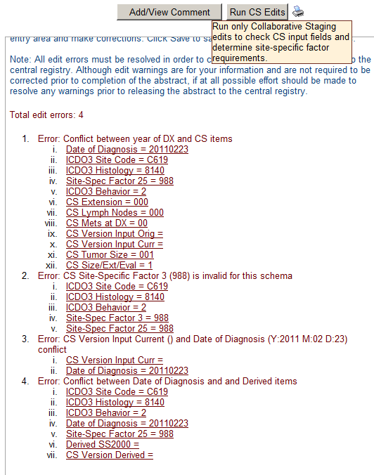
Please note that the CS-specific edits are run on the derived CS fields as well as the CS input fields. As you have not yet calculated the derived CS fields at this point you can disregard any edit errors addressing the derived CS fields.
- You can see from the Edit Errors tab, Error #3 that for the entered schema of Prostate, the field of CS SSF3 is required and must be revised from the defaulted value of 988 to a more specific value. However, as we have information available from the text available for this abstract, for the purposes of this exercise we will revise CS SSFs 1-3 to the following values:
Field | Value to be Entered
Site-Spec Factor 1  (PSA lab value) | Change the defaulted value of 988 to 002 (002 ng/ml; actual value with implied decimal point)
Site-Spec Factor 2 (PSA interpretation) | Change the defaulted value of 988 to 010 (Positive; elevated)
Site-Spec Factor 3  (Pathologic extension) | Change the defaulted value of 988 to 970 – No prostatectomy done within first course of treatment
- Click Save.
- Now that the CS input fields have been filled in, you must calculate the CS derived fields. To calculate derived CS fields click the calculator icon to the left of the field.
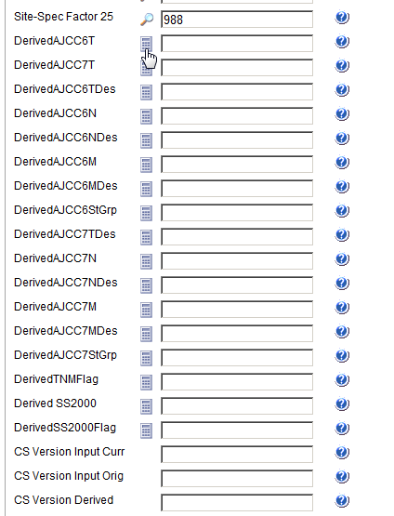
Result: The CStage Output window open and displays the calculated values.
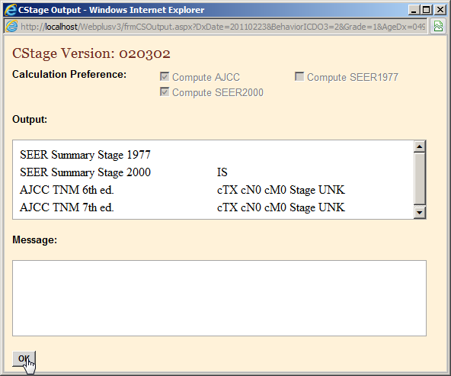
- Click OK.
Result: The appropriate derived CS fields are calculated and values are automatically filled in. In the example shown, all CS derived fields are calculated and filled. In addition the fields of CS Version Input Curr, CS Version Input Orig, and CS Version Derived are automatically filled in.
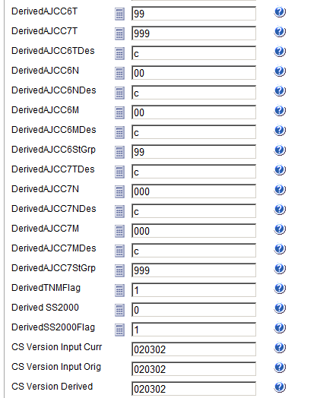
- Click Save.

Questions
Answer these questions about abstracting and deriving Collaborative Staging fields (the answers are in Appendix A, page 63):
- How do you enter information in the CS input data fields?
- How do you know what CS Site-Specific Factors are required to be filled out with a specific value?
- How do you calculate the CS derived data items?
- When and how are the CS Version fields filled in?

Completing and Releasing Abstracts

Learning Objectives
In this chapter, you will learn to:
- Complete an abstract
- Understand the two different ways to release a completed abstract to your central registry

Overview
In this chapter you complete working on your abstract, and will about the two different ways to release the completed abstract to your central registry. You can only release completed abstracts which have no edit errors.

Completing the Abstract
As mentioned, you must resolve all edit errors and fill in all critical (required) fields in order to complete an abstract. Once you have resolved all edit errors and completed all missing critical fields, upon the next save of the abstract, Web Plus informs you that the abstract is complete and ready for release to the central registry.
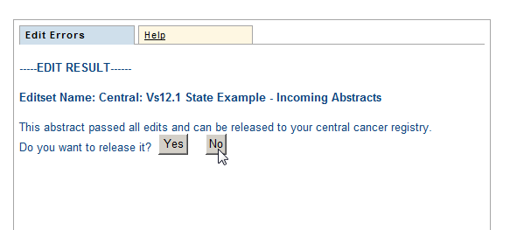

Activity 7 – Completing an Abstract
- Continue correcting errors, saving the abstract and re-running Edits until no errors remain. Use the information in this table to complete the JOHN JOHNSON abstract. Enter the following information into the following fields, either typing the value, using the drop-down list feature, or using the advanced search feature by clicking on the magnifying glass icon where available.
As you abstract the below fields, remember to save your work often. It is good practice to click the Save button each time after you enter a few fields. If you do not click Save often enough, you will lose the work you have done as Web Plus will log you out of the system due to inactivity.

Field | Value to be Entered
Reporting Facility | 1111111111 – Test Hospital (Note that this field is automatically filled in for you by Web Plus).
NPI--Reporting Facility | Leave blank (press enter to move to next field)
Type Report Source | 1 – Hosp. inpatient; Managed health plans with comprehensive unified records
Medical Record Num | 12312312312
Primary Payer at DX | 10 – Insurance, NOS
Sequence Num Hosp | 00
Date of 1st Contact | 20110215
Date 1st Contact Flag | Leave blank (press enter to move to next field)
Treatment Status | 1 – Treatment given
First Rx Date | 20110223
First Rx Date Flag | Leave blank (press enter to move to next field)
Surgery Text | 02/23/2011: TURP, NOS
Surgery Date | 20110223
Surgery Date Flag | Leave blank (press enter to move to next field)
Surgery Prim Site | 22 – TURP-cancer is incidental finding during surgery for benign disease
Reason for No Surgery | 0 – Surgery of primary site performed
Radiation Therapy Text | Leave blank (press enter to move to next field)
Other Radiation Text | Leave blank (press enter to move to next field)
Radiation Date | Leave blank (press enter to move to next field)
Radiation Date Flag | 11 – RX modality not given; autopsy only
Radiation Type | 00 – No radiation treatment
Radiation/Surg Seq. | 0 – No radiation and/or no cancer-directed surgery
Chemotherapy Text | Leave blank (press enter to move to next field)
Chemotherapy Date | Leave blank (press enter to move to next field)
Chemo Date Flag | 11 – RX modality not given; autopsy only
Chemotherapy Type | 00 – None
Hormonal Therapy Text | Leave blank (press enter to move to next field)
Hormone Rx Date | Leave blank (press enter to move to next field)
Horm Rx Date Flag | 11 – RX modality not given; autopsy only
Hormone Rx Type | 00 – None
BRM Therapy Text | Leave blank (press enter to move to next field)
BRM Therapy Date | Leave blank (press enter to move to next field)
BRM Rx Date Flag | 11 – RX modality not given; autopsy only
BRM Therapy Type | 00 – None
Other Therapy Text | Leave blank (press enter to move to next field)
RX Date—Other | Leave blank (press enter to move to next field)
RX Date--Other Flag | 11 – RX modality not given; autopsy only
RX Summ--Other | 0 – None
Scope Reg LN Rx | 0 – No regional lymph nodes removed
Non-Cancer Surgery | 0 – None
Transplant/Endo Rx | 00 – No transplant or endocrine therapy; autopsy- only
Systemic/Surg Seq | 0 – No systemic therapy and/or surgical procedures
Date Last Contact | 20110223
Date Last Cont Flag | Leave blank (press enter to move to next field)
Vital Status | 1 – Alive
Follow Up Source | 0 – Reported hospitalization
Cause of Death | 0000 (Patient alive at last contact.)
ICD Revision Num | 0 – Patient Alive
Place of Death | 997 (Alive)
Follow Up Physician | 99999999 (Follow-up physician unknown or ID number not assigned)
NPI Follow Up Phys | Leave blank

- Click Save to save the last entries that you made.
Result: Edits are run; the Edit Result shows no errors, and the application informs you that the abstract is complete and ready for release to the central registry.
- Do not release the abstract now. Click No and go to the next section of this training manual, “Releasing the Abstract”.
Result: The abstract is saved and completed, but not released.
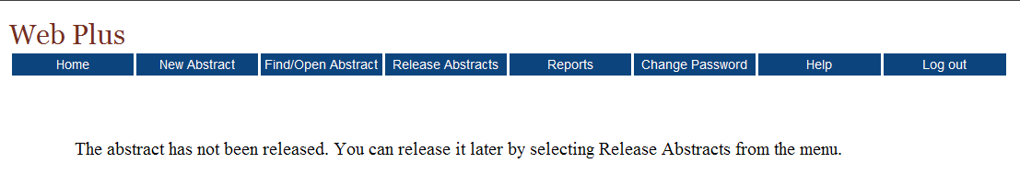
You could release your abstract at this point by clicking Yes, but you can also release one or more abstracts on the Release Abstracts page. For further details, see the next section, “Releasing the Abstract.”

Releasing the Abstract
Once your abstract has no errors, it is completed, and you can release it to the central registry.
Follow these steps to release an abstract:
- On the Web Plus menu, click Release Abstracts.
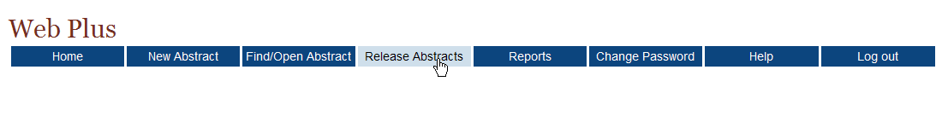
Result: The system displays a list of completed abstracts.
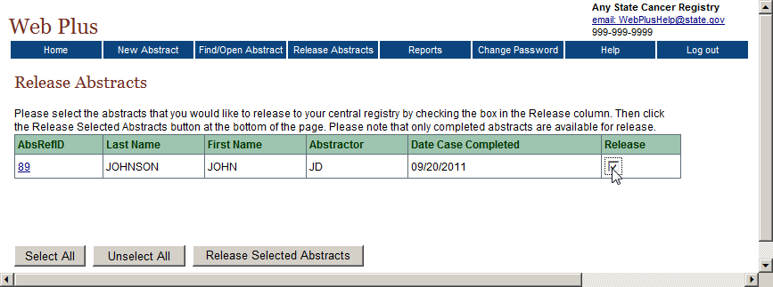
- Click the box in the Release column for the JOHN JOHNSON abstract.
To select all of the abstracts listed, click the Select All button.
- Click Release Selected Abstracts.
Result: The system releases the selected abstracts to your designated central registry and changes the status of the abstracts to Released. Use the Find/Open page to view the released abstracts. Note that you can view an abstract that has been released but cannot revise it.
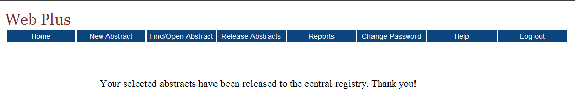

Questions
Answer these questions about completing and releasing abstracts (the answers are in Appendix A, page 64):
- How are abstracts completed?
- How can you release more than one abstract at a time?
- What are two ways to release a single abstract?

Follow-Back Abstracts

Learning Objectives
In this chapter, you will learn:
- To understand the basic steps of the follow-back process in Web Plus
- How to open, complete, and release a follow-back abstract
- How to reject a follow-back abstract

Overview
Your central cancer registry may receive information about a tumor for a patient that you have diagnosed and/or treated (or that was diagnosed/and or treated at your facility) from other reporting sources, such as death certificates or pathology laboratory reports. If the central registry obtains this information before you have reported the tumor to them, they may choose to use the information that they have received to generate a request for more information from you. They do this by creating a follow-back abstract, which they fill with what information they have, and post to Web Plus for you to add to and complete.

The Follow-back Process
The Web Plus follow-back process allows central registries to electronically collect follow-back information in an organized and efficient manner. Central registries generally conduct death certificate follow-back by mailing out a cancer reporting form to a physician for the reporting of a tumor identified solely by death certificate (Death Certificate Only, or DCO), having the physician complete the form and mail it back, and then having central registry staff abstract the information returned on the form into some sort of abstraction software to get the information in electronic form so that it may then be processed by the central registry. Pathology lab follow-back may be conducted in a similar manner to physicians, or may involve mailing a facility a list of tumors identified via pathology lab not yet reported by the facility, and having the facility abstract the tumors from scratch to report the tumors. These efforts are frequently tracked by central registries via paper lists, or via manually checking reported tumors off of some sort electronic listing.
Web Plus death certificate and pathology lab follow-back features enable a central registry to pre-fill online abstracts with known information from death certificates or pathology lab reports, and have the reporter log on to update the information and complete the abstract. The end result is a completed abstract in NAACCR file format, an electronic report of a previously unreported tumor, without the use of paper forms or redundant recording of information. In addition, the follow-back tracking features of Web Plus allow the central registry to closely and electronically track the status of each follow-back abstract to ensure that it gets completed.
Basically, the follow-back process in Web Plus takes advantage of the existing online abstracting feature to enable physicians and facility abstractors to complete partially-filled abstracts online. The abstractor can save their work at any time and return their work at a later time. They release an abstract to the central registry only after they have completed it, and eliminated any errors it may contain.
Notification to facility via e-mail
Facility corrects errors
Facility completes abstract
Facility releases abstract
Facility updates abstract
Facility rejects abstract
Central registry reroutes abstract
Central registry deletes abstract
Central registry uploads file of partial abstracts or manually enters abstracts online

The Web Plus follow-back process includes the following steps:
- The Follow-back Supervisor at your central cancer registry uploads files of partially-filled abstracts generated with information from death certificate and pathology lab files into Web Plus, or manually begins the individual abstracts online.
- Your central registry notifies you via e-mail to log into Web Plus and update the follow-back abstracts.
- Once posted for you to complete, follow-back abstracts are processed via the regular Web Plus record flow; with the exception that you can reject follow-back abstracts with a justifying comment back to the central registry, where the Follow-back Supervisor or Monitor can either re-route the abstract to a new facility/physician, or delete the abstract from the follow-back process.
- Once completed, you release the follow-back abstracts to your central registry.
Throughout the follow-back process, the Follow-back Supervisor and Follow-back Monitors use Web Plus follow-back reports and tracking features to communicate with you via e-mail, and track follow-back abstracts to ensure that they are completed and released.
A nice feature of the follow-back system is that if your central registry has posted follow-back abstracts to Web Plus for you to complete, the system places a link to these abstracts on your homepage. The follow-back request links include running outstanding and released follow-back abstract totals that are updated as you complete and release, or reject the follow-back abstracts.
To open and work with a follow-back abstract, complete these steps:
- On the Web Plus menu, click Home.
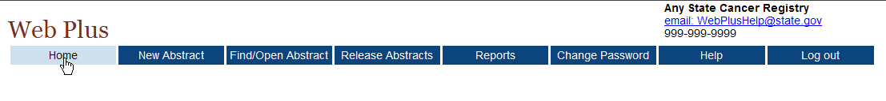
Result: Your Web Plus homepage opens, with a list of links to the facilities and roles that have been assigned to you.
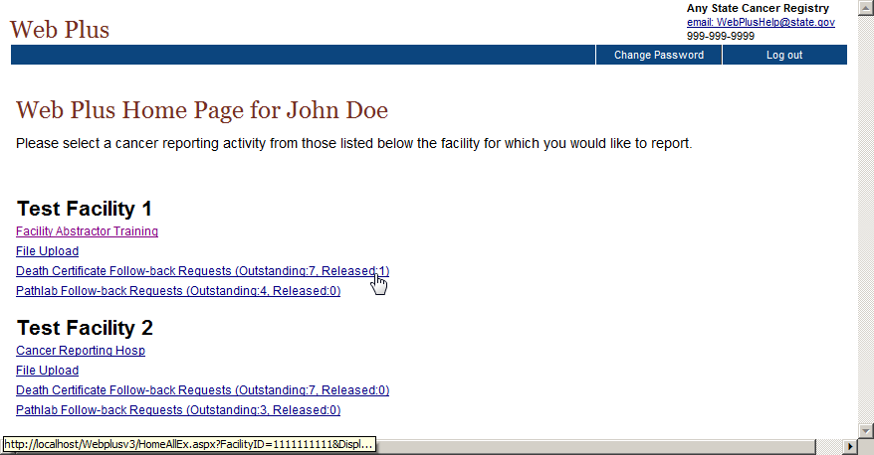
Recall that the link that you click on your homepage is associated with a specific abstract Source, indicated by the name of the link. If your central registry has posted death certificate follow-back abstracts to Web Plus for you to complete, you will see a Death Certificate Follow-back Requests link. If your central registry has posted pathology laboratory follow-back abstracts to Web Plus for you to complete, you will see a Pathlab Follow-back Requests link.
Remember that you can only abstract information for abstracts of the Source (or link) that you select. For example, if you select Facility Abstractor Training, you cannot open and work on follow-back abstracts.
The follow-back request links include running outstanding and released follow-back abstract totals that are updated as you complete and release, or reject the follow-back abstracts.
- Click on either the Death Certificate Follow-back Requests or Pathlab Follow-back Requests link.
Result: A page opens with a list of follow-back abstracts of the specified type that have been assigned to your facility.
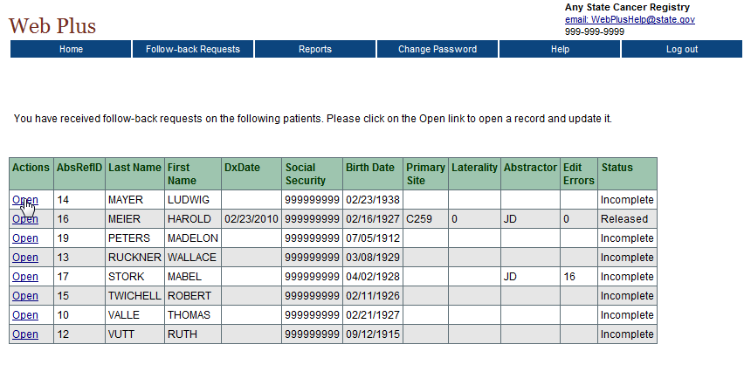
- Open one of the follow-back abstracts by clicking Open in the Actions column for the abstract.
Result: The Data Entry page for the follow-back abstract opens.
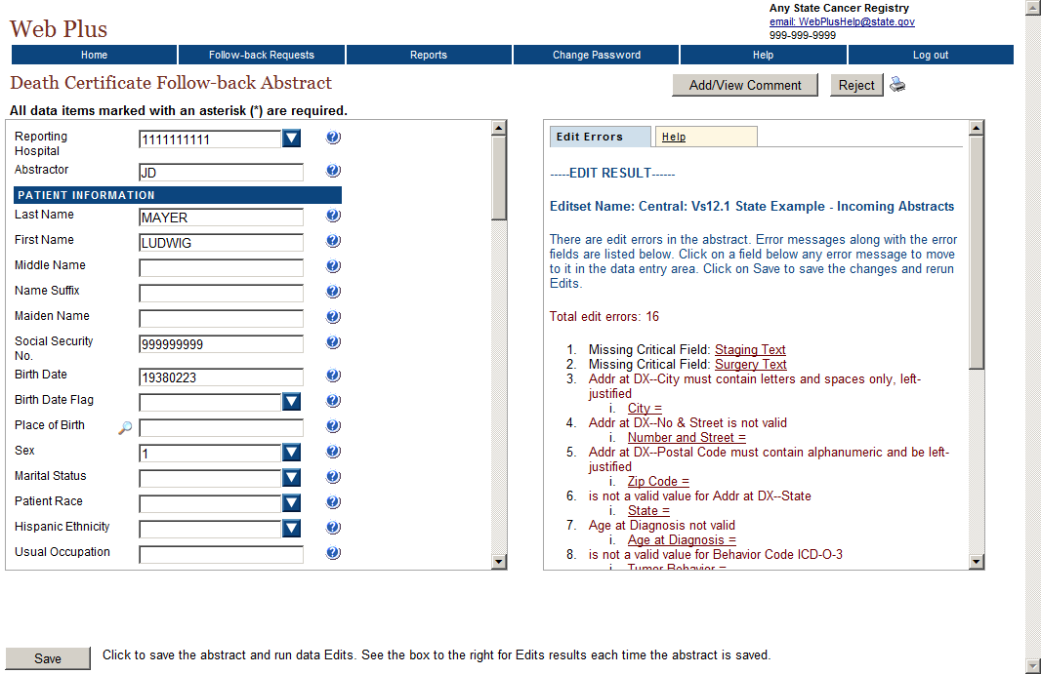
The data entry page for a follow-back abstract functions the same as for a regular abstract, in terms of data entry, the running of data quality edits and the cleaning of edit errors, completion, and release of abstracts. However, your central registry may have different reporting requirements for regular reports of tumors and follow-back abstracts. As a result, you may see different data fields, required fields, and edits for your follow-back abstracts than you do for your regular reporting. In addition, you also have the added ability to reject a follow-back abstract.

Rejecting Follow-back Abstracts
It may be that you have not diagnosed, treated, or seen the patient listed on a follow-back abstract. In this case, you can reject the follow-back abstract back to the central registry, where they can re-route it to another doctor’s office or facility.
To reject a follow-back abstract, complete these steps:
- Click Reject in the upper right-hand corner of the abstract.
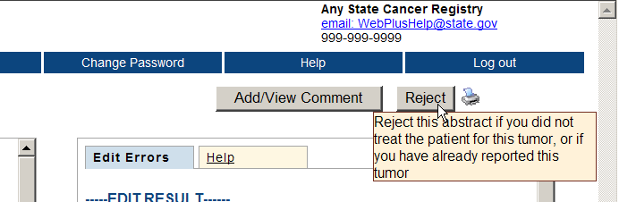
Result: The Reject Follow-back Request page opens.
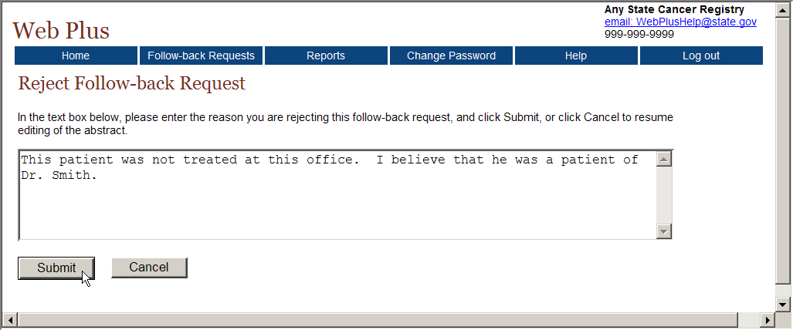
- Enter a comment justifying the rejection, and click Submit.
As your central registry will be trying to re-route the follow-back abstract to another office or facility for follow-back, any referral information you can provide in your comment would be very helpful.
Result: Web Plus lets you know that the abstract has been successfully rejected.
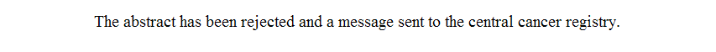
When you return to your homepage, the running outstanding abstracts total on the follow-back abstracts link will be updated (one less), and when you click on the link to the follow-back abstracts, the rejected abstract will no longer be included in the list of follow-back abstracts that have been assigned to your facility.
- On the Web Plus menu, click Follow-back Requests.
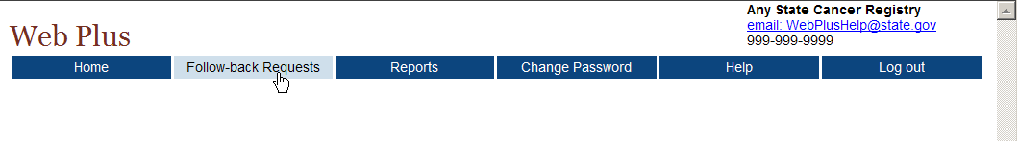
Result: The page with a list of follow-back abstracts that have been assigned to your facility opens, where the rejected follow-back abstract is no longer listed.
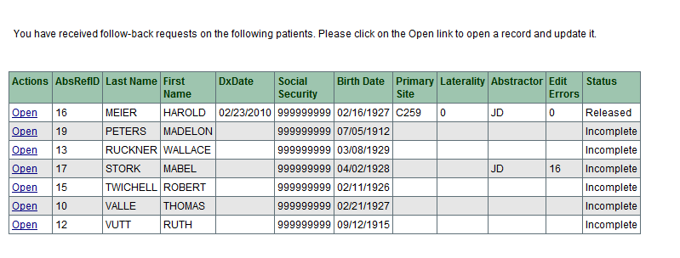

Questions
Answer these questions about follow-back abstracts (the answers are in Appendix A, page 64):
- How do you open a follow-back abstract?
- How do you reject a follow-back abstract?

Running Reports

Learning Objectives
In this chapter, you will learn:
- How to open and print a report
- How to set a date range for a report
- About the reports available in Web Plus

Overview
Web Plus provides reports for monitoring abstract reporting and system activity. You can view and print several types of reports. You can also set the date ranges for the information in the reports.

Opening and Printing Reports
To open a report after you have logged in, complete these steps:
- On the Web Plus menu, click Reports.
Result: Web Plus displays a list of reports available for you.
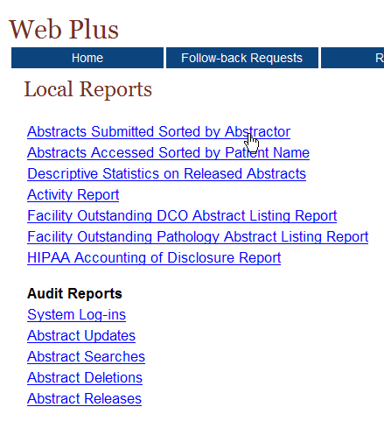
Clicking the name of the report opens a separate window displaying the report.
- Click the Abstracts Submitted Sorted by Abstractor link.
Result: The Abstracts Submitted Sorted by Abstractor report page opens.

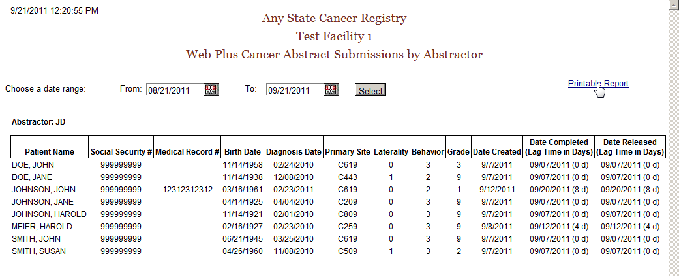
- To print the report, click on the Printable Report link.
Result: A page opens with a printable version of the report.
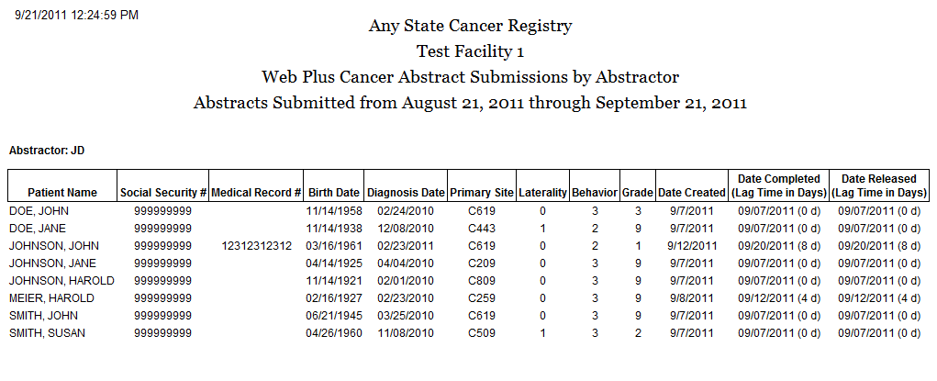
For optimum printing results, print Web Plus reports in landscape mode. To print in landscape, click on File→Page Setup, and click on Landscape.
In addition, if you wish to remove the internal report name from the upper left-hand corner of the printed report, remove the &w&b from the header field. If you wish to remove the URL listing from the bottom of the report, remove the information in the footer field (the date prints on the report already).

Available Reports
The below table describes reports that are available for viewing by a Web Plus abstractor. To view a particular report, click the link for the name of the report to open a separate window displaying the report.

This report . . . | Lists . . .
Local Reports
Abstracts Submitted  Sorted by Abstractor | all abstracts that a facility has released within a given time period. The abstracts are sorted first by the name of the abstractor and then by patient name.
Abstracts Accessed  Sorted by Patient Name | all abstracts that a facility has released within a given time period sorted by patient name.
Descriptive Statistics on Released Abstracts | descriptive statistics on released abstracts such as demographics and site group.
Activity Report | the number of released and unreleased abstracts for each month of the selected date range.
Facility Outstanding DCO Abstract Listing Report | a line listing of all death certificate follow-back abstracts assigned to your facility that have not yet been released to the central registry
Facility Outstanding Pathology Abstract Listing Report | a line listing of all pathology laboratory follow-back abstracts assigned to your facility that have not yet been released to the central registry
HIPPA Accounting of Disclosure report | a user-generated HIPPA-compliant report of information disclosure (via abstracts) to your central registry using Web Plus
Audit Reports
System Logins | the users from your facility and their times for logging in and out of Web Plus within a selected date range.
Abstract Updates | the dates and times that abstracts from your facility have been updated.
Abstract Searches | the abstractor and the date and time for all searches for abstracts at your facility.
Abstract Deletions | the dates and times that abstracts have been deleted at your facility.
Abstract Releases | information about abstracts released from your facility including release time and date and abstractor.

Changing the Date Range of a Report
Some Web Plus reports offer the user the option to enter a date range for the report.
To change the date range of a report, complete these steps:
- On any opened report page, click the calendar icon beside the From date field.
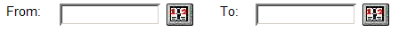
Result: The calendar window opens.
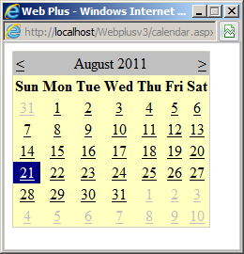
- In general, the From date is defaulted to the day one full month prior to the current date and the To date is defaulted to the current date. Click the date you would like. To change the month, click on either the ≤ or ≥ symbols in the month header. The system inserts the date in the field and closes the calendar window.
You can also type the date in the window by using the mm/dd/yyyy format, such as 09/01/2011 for September 1, 2011. The date calendar and format are the same for both the From and To date fields.
- Repeat steps 1 and 2, clicking on the calendar icon beside the To date field.
Result: You are returned to the report window, with the specified dates entered into the From and To date fields.
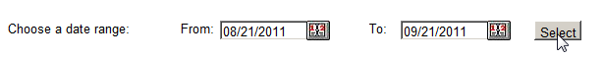
- Click Select.
Result: Web Plus displays the report again with the information in the date range you selected.
All of the test data that is included in the application for the training purposes was released in September of 2011. To view reports for this test data, your date range should include the month of September 2011.

Local Reports

Abstracts Submitted Sorted by Abstractor Report
The Abstracts Submitted Sorted by Abstractor report provides the history of the abstract: when it was created, completed, and submitted to the central registry.
To access the Abstracts Submitted Sorted by Abstractor report, follow these steps:
- On the Web Plus menu, click Reports.
Result: Web Plus displays a list of reports available.
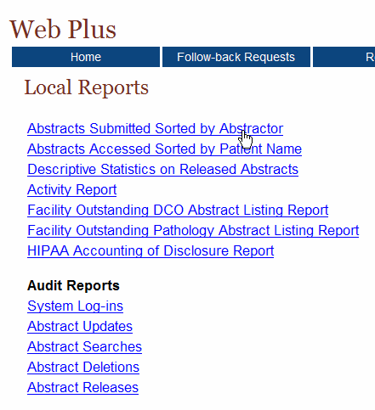
- Click on the Abstracts Submitted Sorted by Abstractor link.
Result: The Abstracts Submitted Sorted by Abstractor report page opens in a separate window.

The report contains these columns for each abstract, and the abstracts are grouped by abstractor:
Column Heading |  | Description
Patient Name |  | Name of patient on abstract
Social Security # |  | Patient’s social security number
Medical Record # |  | Patient’s medical record number
Birth Date |  | Patient’s birth date
Diagnosis Date |  | Diagnosis date of the tumor being reported
Primary Site |  | ICD-O-3 topography code for the primary site of the tumor being reported
Laterality |  | Laterality code for the tumor being reported
Behavior |  | ICD-O-3 behavior code for the tumor being reported
Grade |  | ICD-O-3 grade/differentiation code for the tumor being reported
Date Created |  | Date the abstract was created
Date Completed |  | Date the abstract was completed, with the lag time (in days) between date of creation and completion in parentheses
Date Released |  | Date the abstract was released to the central registry, with the lag time (in days) between date of completion and release in parentheses
The date range can be modified for the Abstracts Submitted Sorted by Abstractor report.
If you would like to print the report, click on the Printable Report link, and print the report in landscape mode using your browser’s printer.

Abstracts Accessed Sorted by Patient Name Report
The Abstracts Accessed Sorted by Patient Name report provides the dates and times that an abstract is opened and the reason why it was opened.
To access the Abstracts Accessed Sorted by Patient Name report, follow these steps
- On the Web Plus menu, click Reports.
Result: Web Plus displays a list of reports available.
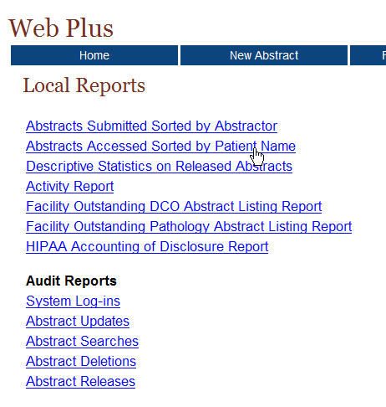
- Click the Abstracts Accessed Sorted by Patient Name link.
Result: The Abstracts Accessed Sorted by Patient Name report page opens in a separate window.
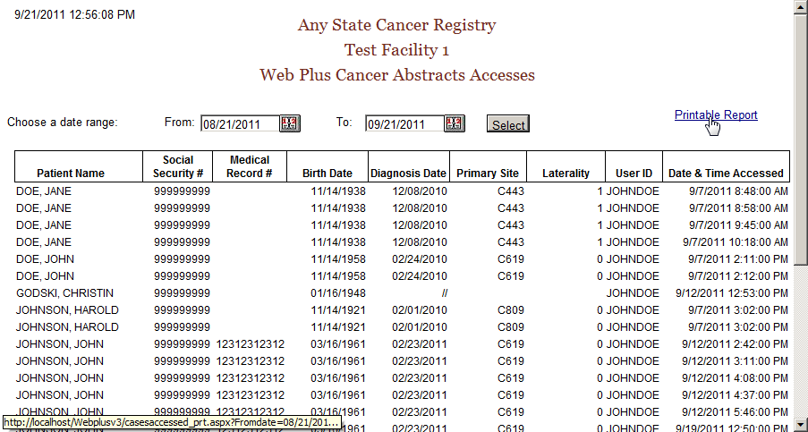
The Abstracts Accessed Sorted by Patient Name report contains these fields:
Field/Headings | Description
Patient Name | Name of patient on abstract
Social Security # | Patient’s social security number
Medical Record # | Patient’s medical record number
Birth Date | Patient’s birth date
Diagnosis Date | Diagnosis date of the tumor being reported
Primary Site | ICD-O-3 topography code for the primary site of the tumor being reported
Laterality | Laterality code for the tumor being reported
User ID | User ID of the abstractor
Date & Time Accessed | Date and time that the abstractor opened the abstract

The date range can be modified for the Abstracts Accessed Sorted by Patient Name report.
If you would like to print the report, click on the Printable Report link, and print the report in landscape mode using your browser’s printer.

Descriptive Statistics on Released Abstracts Report
The Descriptive Statistics on Released Abstracts report includes a series of tables consisting of the number and percent of released abstracts broken down by the following: county of residence, zip code of residence, sex and race, age group, site group, and treatment group.
To run and/or modify the report for Descriptive Statistics on Released Abstracts complete these steps:
- On the Web Plus menu, click Reports.
Result: Web Plus displays a list of reports available.
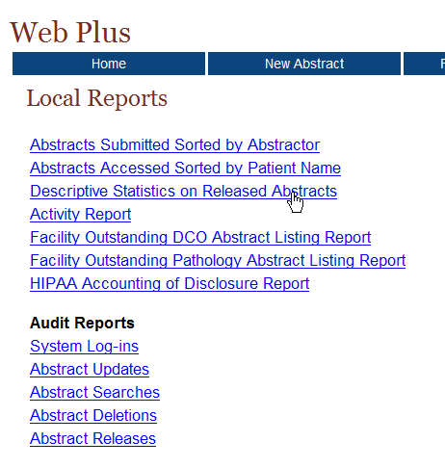
- Click the Descriptive Statistics on Released Abstracts link.
Result: The Descriptive Statistics on Released Abstracts report page opens.
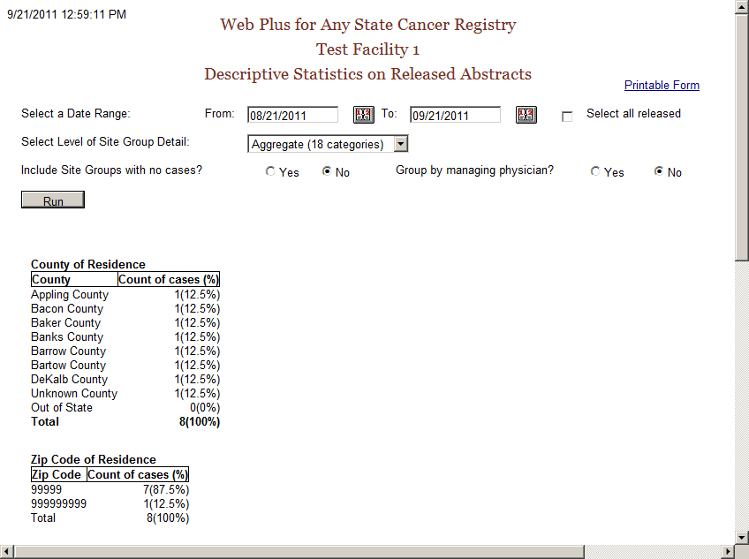
The descriptive statistics provided are broken down as follows:
Grouping Variable(s) | Groupings by…
County of Residence | individual county of residence at diagnosis
Zip Code of Residence | individual zip code of residence at diagnosis
Sex and Race | patient sex (male/female) by race (white/black/other)
Age Group | ten age groups (0-9, 10-19,….90+)
Site Group | three levels of primary site grouping:
  Grouping Level | Description
  Aggregate | 18 categories
  Subaggregate | 60 categories
  Recode | 78 groups
Treatment Group | type of summary treatment (RX Summ) recorded:  Surgery of Primary Site  Chemotherapy  Hormone  BRM  Other  Rad-Regional RX Modality  Transplant/Endocrine
The following options are available to modify the Descriptive Statistics on Released Abstracts report:
Option | Description
Date Range | Includes only those abstracts that were released within the specified date range
Select all released | When clicked, all abstracts released by the facility will be included, regardless of date released
Select Level of Site Group Detail | Specifies what level of primary site grouping to use for the report; the default grouping is 18 categories
Include site groups with no cases | When Yes is clicked, the primary site distribution will show all site groups for the level of detail chosen, whether or not abstracts were released containing each of the site groups  When No is clicked, only those primary site groups contained in the released abstracts released will appear on the report
Group by managing physician | When Yes is clicked, the records in the report will be grouped into sections by managing physician, displaying the descriptive statistics for abstracts released by each managing physician
- Next to Include Site Groups with no cases, click on Yes.
Click Run.
Result: Web Plus displays the report again with all 18 site groupings displayed.
- Click on the Printable Form link.
Result: A separate window opens with the report formatted for printing.
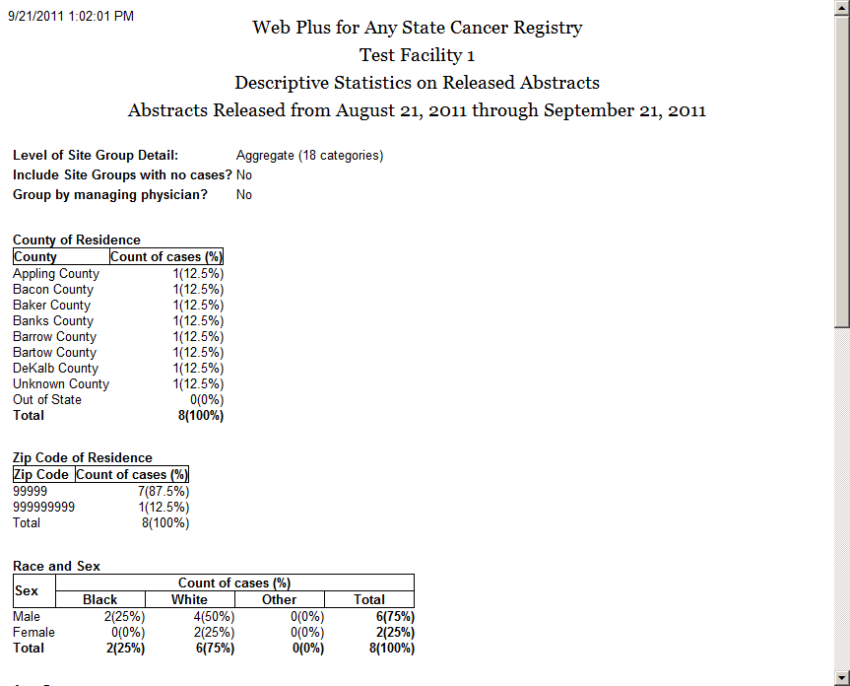
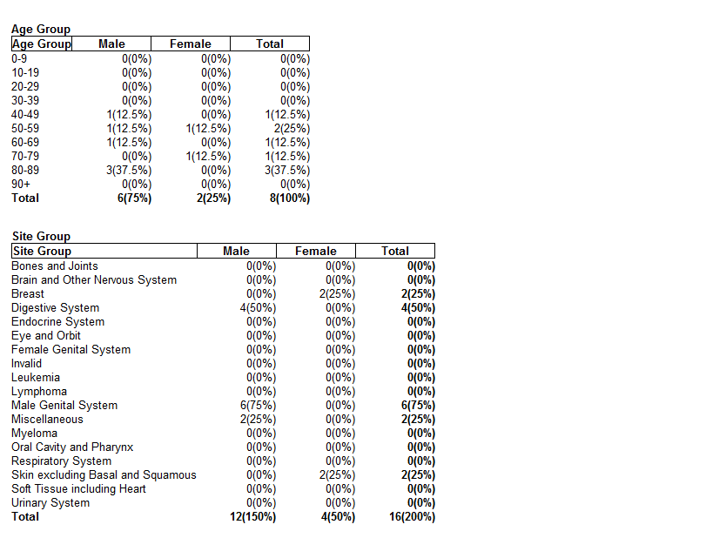
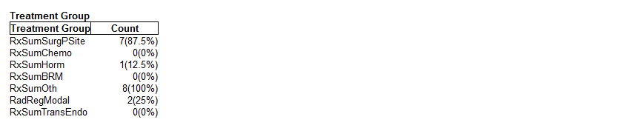

Activity Report
The Activity report provides information on the abstracting activity at your facility, in terms of the number of released and unreleased abstracts.
To open the Activity report:
- On the Web Plus menu, click Reports.
Result: Web Plus displays a list of reports available.
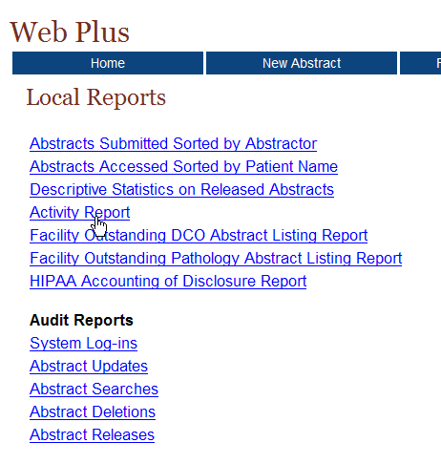
- Click the Activity Report link.
Result: The Activity Report window opens.
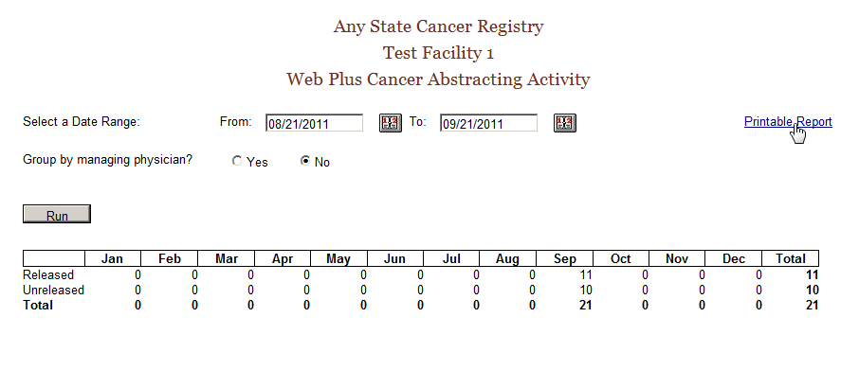
- If desired, enter a date range for the Activity report. If the specified date range spans more than one year, the report will display the number of released and unreleased cases for each year rather than each month.
- You can also group the information in the Activity report by managing physician; just click on Yes next to Group by managing physician, and click Run.

- If you would like to print the report, click on the Printable Report link, and print the report in landscape mode using your browser’s printer.

Facility Outstanding Follow-back Abstract Listing Report
The Facility Outstanding Follow-back Abstract Listing report includes a line listing of all follow-back abstracts assigned to your facility that you have not yet released. You can print this report for your records, or if you need to go somewhere away from your computer to look up patient records.
To open the Facility Outstanding Follow-back Abstract Listing report, complete these steps:
- On the Web Plus menu, click Reports.
Result: Web Plus displays a list of available follow-back reports.
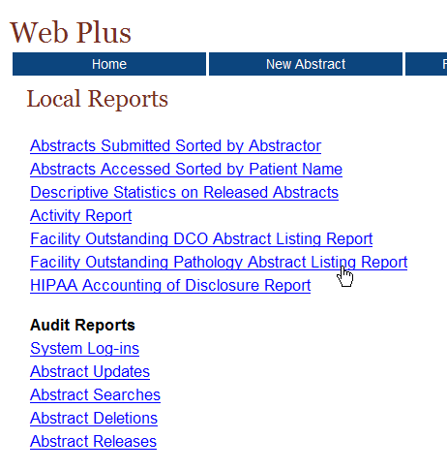
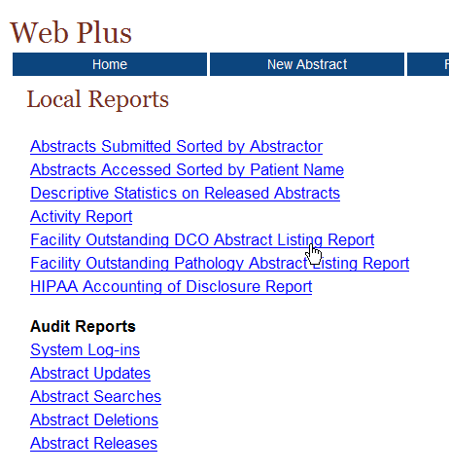 or
- Click on either the Facility Outstanding DCO Follow-back Abstract Listing Report or the Facility Outstanding Pathology Follow-back Abstract Listing Report link. In the example shown the Facility Outstanding DCO Follow-back Abstract Listing Report is opened.
Result: The Facility Outstanding Follow-back Abstract Listing Report for the particular follow-back type opens in a separate window.
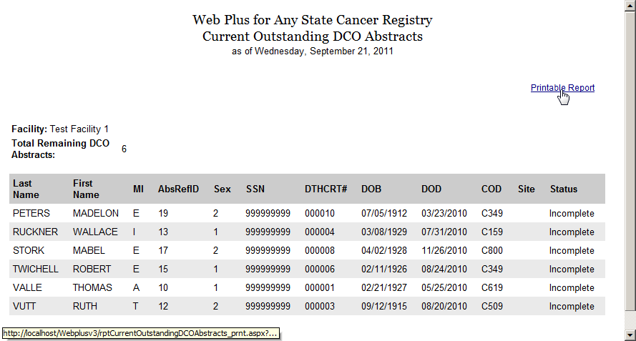
The Facility Outstanding Follow-back Abstract Listing Reports contain these fields:
Field/Headings | Description
Last Name | Last name of patient
First Name | First name of patient
MI | Middle initial of patient
AbsRefID | A unique, system-generated number identifying the abstract
Sex | Patient’s sex
SSN | Patient’s social security number
DTHCRT# | Death certificate number from death certificate (for death certificate follow-back only)
DOB | Patient’s birth date
DOD | Date of patient’s death from death certificate (for death certificate follow-back only)
COD | ICD-10 Cause of Death (for death certificate follow-back only)
Site | ICD-O-3 topography code for the primary site of the tumor being reported
Status | Current status of the outstanding follow-back abstract:  Incomplete, E-mail sent, Rejected, or Rerouted
- If you would like to print the report, click on the Printable Report link, and print the report in landscape mode using your browser’s printer.

HIPAA Accounting of Disclosure Report
When a physician or hospital submits information to a central cancer registry, an accounting of disclosures of protected health information is required. The Web Plus HIPAA Accounting of Disclosure Report is a HIPAA-compliant report that includes the date of the disclosure, the name and address of the central cancer registry (entity who received the protected health information), a brief description of the protected health information disclosed, and a brief statement of the purpose of the disclosure. The HIPAA Accounting of Disclosure Report can be generated for all released abstracts and abstracts released within a specified date range, as well as for individual released abstracts.
To open the HIPAA Accounting of Disclosure Report, complete these steps:
- On the Web Plus menu, click Reports.
Result: Web Plus displays a list of available follow-back reports.
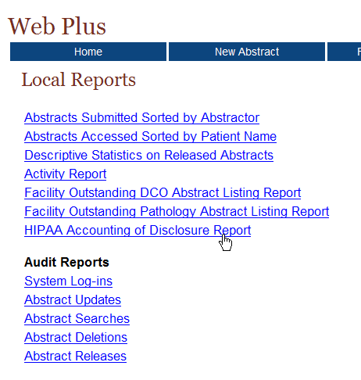
- Click on the HIPAA Accounting of Disclosure Report link.
Result: The HIPAA Accounting of Disclosure Report page opens in a separate window.
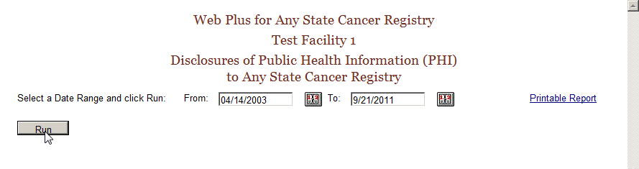
- Enter a date range for the report. The default From date is April 14, 2003, the date HIPAA went into effect, and the default To date is the current date.
- Click Run.
Result: You are returned to the HIPAA Accounting of Disclosure Report window, with the information displayed restricted to the date range you selected.
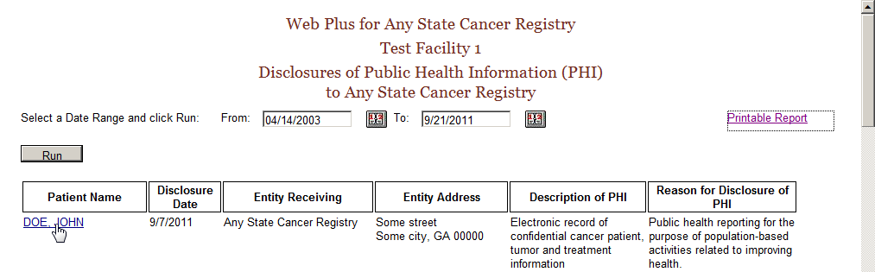
- If you would like to print the report, click on the Printable Report link, and print the report in landscape mode using your browser’s printer.
- To generate a report for an individual disclosure, click on the patient name link for the patient of interest. In the example shown, the report is opened for Jane Doe.
Result: A printable HIPAA Accounting of Disclosure Report for the individual opens.
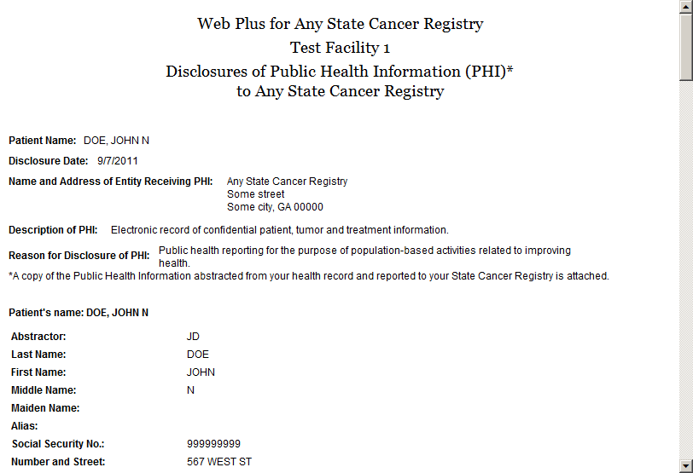

Audit Reports
This table describes the audit reports available for viewing by the Web Plus facility abstractor. Clicking the name of the report opens a separate window displaying the report.
This Report . . . | Lists . . .
System Log-ins | the user, date, and time of all Web Plus system log-ins and log outs at your facility within a selected date range
Abstract Updates | the user, date, and time of all abstract updates at your facility
Abstract Searches | the user, date, and time of all abstract searches at your facility
Abstract Deletions | the user, date, and time of all abstract deletions at your facility
Abstract Releases | information about abstract releases from your facility including release time and date, and abstractor
- Click the System Log-ins link.
Result: The Login Audit report page opens.
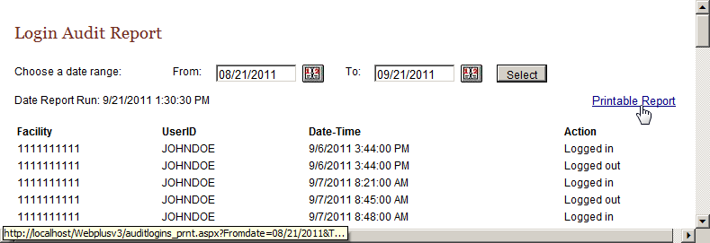
The report contains these column headings:
Column Heading | Description
Facility | Facility ID Number of your facility
UserID | User ID of the user
Date-Time | Date and time of the log in/out
Action | Indicates the user activity being logged:  - Logged in  - Logged out  - Invalid log in attempt
- Close the report window.
- On the Reports page under Audit Reports, click Abstract Updates.
Result: The Abstract Update Log Opens.
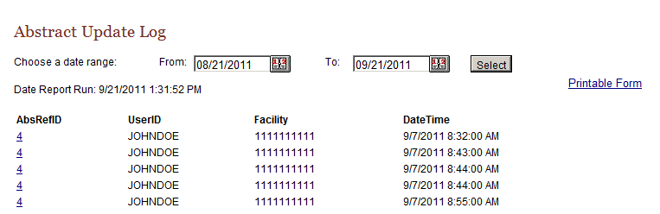
The Abstract Update Log contains these column headings:
Column Heading | Description
AbsRefID | A unique, system-generated number identifying the abstract
UserID | User ID of the abstractor
Facility | Number of facility that sent the abstract
Date-Time | Date and time of the action
The remaining audit reports contain the same column headings and information as the Abstract Update Log for their specific user activities:
  - Abstract Searches
  - Abstract Deletions
  - Abstract Exports
  - Abstract Releases

Activity – Finding Report Information
Look at the list of reports and find this information:
- The case you abstracted earlier
- The number of updates done to abstracts in the last month
- The last user to update the JOHN JOHNSON abstract

Final Learner Activity

Overview
For your final activity you will create an abstract from a medical record. Enter the information into the appropriate fields, save it, correct errors, and release the abstract.

Medical Record
Test Facility 1
Discharge Summary

Reporting Physician: Jeffery Banyas

Patient Information
Medical Record Number: 67234
Last Name: Orvis
First Name: John
Middle Name: Wayne
Address: 2276 Waverly St., Philadelphia, PA 19101.
County: Philadelphia
Race: Black
Sex: Male
Date of Birth: February 28, 1925
Social Security Number: 456456456

Admission: June 12, 2011
Discharge: June 18, 2011

Notes:
Mr. Orvis was admitted for follow-up of prostate biopsy positive for cancer performed May 30 in Doctor’s Clinic. Radical prostatectomy was performed on 6/13/11. Findings included a 1.5cm adenocarcinoma in prostate, grade 1. All nodes negative. Patient was discharged in good condition. No further treatment is contemplated.

Hints
These are a few hints to help you complete your abstract:
- Fill in what you know at first and then save your work. Web Plus will run the edit check and show the entry fields’ blanks or errors.
- Look at the Help page for a field if you need to interpret the field name.
- Use the Search feature on the Lookup page to find the proper code.
- Answers

Chapter 2: The Basics
These are the answers to the questions (page 10) about the basics of Web Plus:
- Click the Special Lookups icon to open a separate window to insert a code into a field.
- To log out, click Log Out on the Web Plus menu.
- You do not have to complete filling out the abstract at one time. Begin an abstract and save it. Then you can return to it later by using the Find/Open Abstract tool.

Chapter 3: Creating an Abstract
These are the answers to the questions (page 16) about entering data:
- You click the Help icon to learn more about a field.
- The Special Lookup page provides codes for specific field information.

Chapter 4: Adding Data to an Abstract
These are the answers to the questions (page 20) about adding data to an abstract:
- Text fields provide an area to enter written information about a patient’s medical history.
- Click the Print Preview link to open a copy of an abstract in a separate window. This preview displays all of the fields and entered data for the abstract. Use your browser’s printer to print out a copy.
- Click Delete in the Action column of the Find Abstract page to open the page where you can delete your abstract.

Chapter 5: Correcting Errors
These are the answers to the questions (page 23) about correcting and releasing abstracts:
- Abstracts are edited for data quality and completeness upon saving or opening of the abstract.
- The errors list is in the Edit Errors box on the right side of the Data Entry page.
- You resolve edit errors on an abstract by to clicking on links to fields containing edit errors in the Edit Errors box, entering correct values for the fields, and rerunning the edits by saving the abstract.

Chapter 6: Abstracting and Deriving Collaborative Staging Fields
These are the answers to the questions (page 32) about abstracting and deriving Collaborative Staging (CS) fields:
- Once the fields of primary site and histology have been entered, each CS input data item has a special site-specific look-up associated with it that is accessed by clicking the magnifying glass icon to the left of the field. Click the magnifying glass icon and then click the link to the appropriate value from the list of displayed values for the field.
- Once you have entered all of the other CS input fields, click the Run CS Edits button in order to determine which of the CS SSF fields needs to be revised from the defaulted value of 988 to a more specific value.
- You calculate the CS derived data items by clicking the calculator icon located to the left of any derived CS data field in the data entry grid.
- Once you calculate the CS derived fields, the fields of CS Version Input Current (item #2937), CS Version Input Original (item #2935) and CS Version Derived (item #2936) are automatically filled in.

Chapter 7: Completing and Releasing Abstracts
These are the answers to the questions (page 37) about completing and releasing abstracts:
- Once you have resolved all edit errors and completed all missing critical fields, upon the next save of the abstract, Web Plus informs you that the abstract is complete and ready for release to the central registry.
- To release more than one abstract at a time, click Release Abstracts on the Web Plus menu and select the abstracts you want to release.
- You can release an abstract by clicking the Yes button in the Edit Result box after you have completed it or by releasing it from the Release Abstract page.

Chapter 8: Follow-back Abstracts
These are the answers to the questions (page 43) about follow-back abstracts:
- To open a follow-back abstract, click on the follow-back link on your home page, and click open, to open the follow-back abstract of interest.
- To reject a follow-back abstract, open the abstract and click Reject in the upper right-hand corner of the abstract.

Appendix B: Flowchart for Hematopoietics

