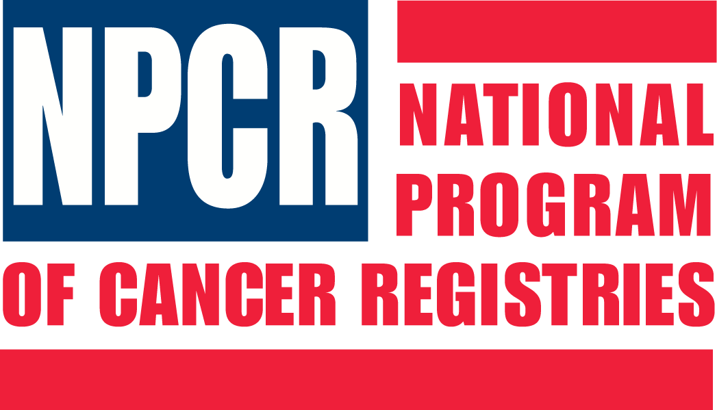

National Program of Cancer Registries

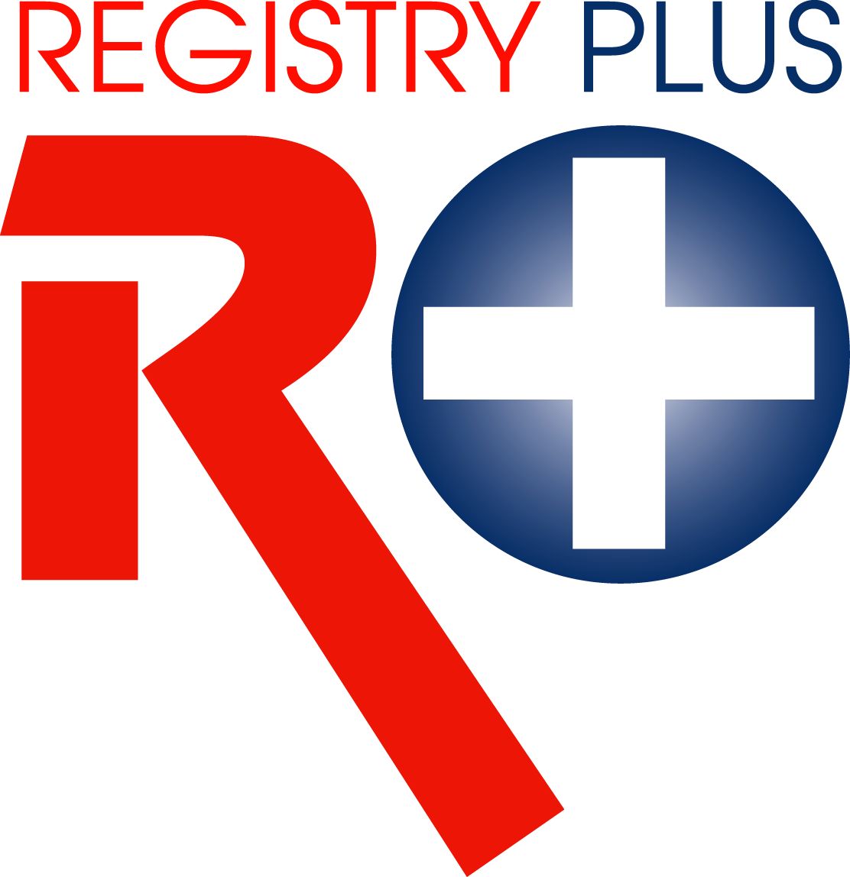
Registry Plus Software for Cancer Registries

Web Plus Training Manual
for Follow-back Supervisors
Version 1.0
(Based on Web Plus Version 2.0)



Contents
Chapter 1: Introduction 1
Overall Learning Objectives 1
Overview of the Web Plus Follow-back Supervisor Training Manual 1
Web Plus Features 1
Web Plus User Roles 2
Requirements for Web Access 3
Chapter 2: The Basics 4
Learning Objectives 4
Overview 4
Log In 4
Follow-back Supervisor Menu Options 5
The Follow-back Process 7
Changing Your Password 8
Log Out 9
Questions 9
Chapter 3: Generating/Uploading Follow-back Files 10
Learning Objectives 10
Overview 10
Generating Follow-back Files 10
Reporting Facility 11
Patient Identifying Information 11
Other Potentially-Available Information 11
System Fields 12
Uploading Follow-back Files 13
Questions 17
Chapter 4: Tracking Follow-back Requests by File 18
Learning Objectives 18
Overview 18
Track Follow-back Requests by File Page 18
Tracking Individual Abstracts by File 19
View 21
Reroute 22
View History 24
Send Notice 26
Delete 27
Viewing File History 28
Sending Notice 29
Deleting a Follow-back File 30
Questions 32
Chapter 5: Tracking Follow-back Requests by Facility 33
Learning Objectives 33
Overview 33
Track Follow-back Requests by Facility Page 33
Tracking Individual Abstracts by Facility 34
View 36
Reroute 37
View History 39
Send Notice 41
Delete 42
Sending Notice 44
Questions 45
Chapter 6: Sending E-mail Notices 46
Learning Objectives 46
Overview 46
Sending E-mail Notices 46
Selecting and Working with Templates 47
Saving New E-mail Templates 48
Deleting E-mail Templates 48
Filling the “To” Field 48
Questions 51
Chapter 7: Adding Follow-back Abstracts Online 52
Learning Objectives 52
Overview 52
Online Follow-back Abstracting Process 52
Adding Follow-back Abstracts Online 53
Adding Comments/Sending E-mails 56
Questions 56
Chapter 8: Finding Incomplete Follow-back Abstracts 57
Learning Objectives 57
Overview 57
Finding Incomplete Online Abstracts 57
Deleting an Online Follow-back Abstract 59
Questions 61
Chapter 9: Assigning Follow-back Monitors 62
Learning Objectives 62
Overview 62
Web Plus Follow-back Monitor 62
Follow-back Monitor Menu Options 62
Assigning Follow-back Monitors 63
Questions 65
Chapter 10: Reports 66
Learning Objective 66
Overview 66
Opening, Setting Date Ranges, and Printing Follow-back Reports 66
Opening Follow-back Reports 66
Setting the Date Range for Follow-back Reports 68
Printing Follow-back Reports 69
Follow-back Tracking Progress Report 70
Follow-back Monitor Reports 73
Outstanding Follow-back Abstracts by Follow-back Monitor 73
Outstanding Follow-back Abstracts by Follow-back Monitor and Facility 75
Facility Outstanding Follow-back Abstract Listing Report 77
Rejected Follow-back Abstracts by Facility 80
Questions 82
Appendix A: Answers 83
Chapter 2: The Basics 83
Chapter 3: Generating/Uploading Follow-back Files 83
Chapter 4: Tracking Follow-back Requests by File 83
Chapter 5: Tracking Follow-back Requests by Facility 84
Chapter 6: Sending E-mail Notices 84
Chapter 7: Adding Follow-back Abstracts Online 85
Chapter 8: Finding Incomplete Follow-back Abstracts 85
Chapter 9: Assigning Follow-back Monitors 85
Chapter 10: Reports 85

Introduction

Overall Learning Objectives
These are the overall learning objectives for this Web Plus training manual for Follow-back Supervisors:
- Learn the major functions of the Follow-back Supervisor role within Web Plus
- Upload files of follow-back requests
- Track follow-back abstracts by uploaded file or by facility
- Manually add follow-back abstracts online
- Search for incomplete follow-back abstracts
- Assign facilities to Follow-back Monitors
- View Web Plus follow-back reports

Overview of the Web Plus Follow-back Supervisor Training Manual
The Web Plus Follow-back Supervisor Training Manual provides you with the information to understand and use the follow-back features of Web Plus. This manual describes the functions available to the Web Plus Follow-back Supervisor in a central cancer registry. The major sections include uploading follow-back files, tracking follow-back requests, adding follow-back abstracts online, finding incomplete follow-back abstracts, assigning facilities to Follow-back Monitors, and viewing follow-back reports.
The Web Plus application installation includes sample display types, facilities, users, and abstracts to be used as examples, and for application testing and user training. This includes some test follow-back users and follow-back abstracts in various stages of processing. This manual includes step-by-step instructions that allow you to practice your new skills on your own using the test follow-back users and data that come with the Web Plus application. Also, each chapter contains questions that test your knowledge of follow-back processes in Web Plus.
 | To ensure accurate tracking and reports, you should coordinate with your Web Plus Central Registry Administrator to delete all test follow-back users and data prior to implementing Web Plus for a follow-back effort for your registry.

Web Plus Features
Web Plus is a web-based application that collects cancer data securely over the public Internet. It is ideal for use by central registries for all electronic reporting needs. Web Plus supports three main functions; online abstracting, file upload, and follow-back efforts. The online abstracting capability of Web Plus is ideal for reporting from physicians’ offices and other low-volume reporting sources, while the file upload feature can be used for electronic submission of data from all other reporting sources, as well as for interstate data exchange. Web Plus can be used to upload NAACCR-formatted files, as well as supporting files in any file format.
The Web Plus follow-back features enable upload of partial abstracts generated from death certificate and pathology lab files, and subsequent notification to physicians/facilities via e-mail to log in and update the abstracts. The features also allow for the tracking of follow-back abstracts to ensure their resolution.
All records are saved in a database at the hosting central cancer registry and cases entered by one facility or office are not visible to other facilities. Data entered are validated by the CDC EDITS Engine running on a web server. Users, display types, and edit configurations are managed at the hosting central registry. Web Plus is hosted on a secure web server that has a digital certificate installed; the communication between the client and the server is encrypted with Secure Socket Layer (SSL) technology.

Web Plus User Roles
The results from the design staff and usability testing have identified these types of Web Plus users:
Users | Description
Facility Abstractor | Works in a local facility or doctor’s office and handles patients’ medical records and paperwork. When a patient is diagnosed with cancer, the facility abstractor reports the case to the state’s central cancer registry.
Central Registry Abstractor/Reviewer | Reviews abstracts submitted to the central registry for completeness and accuracy and may abstract additional data items from submitted text; also abstracts new cases.
Central Registry Administrator | Sets up the local facilities with access to the Web Plus software to report their data, manages facility accounts and users at both central registry and facilities, configures display types, edit sets and system preferences, manages assignment of abstracts to central registry staff, exports data and views reports.
Local Administrator | Manages local users of a facility.
File Uploader | Uploads files of abstracts in the appropriate NAACCR format that were not abstracted using Web Plus, views EDITS error report and cleans, or works with abstractors to clean, errors on rejected files prior to re-uploading.
Follow-back Supervisor | Uploads files of partially-filled follow-back abstracts, manually adds follow-back abstracts online, tracks follow-back abstracts by uploaded file or by facility, generates and views Web Plus follow-back reports
Follow-back Monitor | Tracks follow-back abstracts by assigned facility, generates and views Web Plus follow-back reports

Requirements for Web Access
Web Plus requires Microsoft Internet Explorer version 5.0 or later or a Mozilla browser to operate the system fully. Although Web Plus works at 800 X 600 resolution, it is best viewed at 1024 X 768 or higher resolution. It is highly recommended that you change your screen resolution to 1024 X 768 or higher when using the Web Plus application.

The Basics

Learning Objectives
In this chapter, you will learn to:
- Log in to Web Plus
- Identify Web Plus Follow-back Supervisor menu options
- Understand the basic steps of the follow-back process in Web Plus
- Change your password
- Log out of Web Plus

Overview
This chapter covers the basics of the Web Plus Follow-back Supervisor role. It includes a description of the Web Plus menu options available to the Follow-back Supervisor, an overview of the follow-back process, and the means of logging in and logging out of Web Plus.

Log In
To log in to Web Plus, complete these steps:
- Open your Internet Explorer browser and type your registry’s Web Plus web address (URL) in the Address field.
- Press Enter.
Result: The Web Plus main Log in page is displayed.
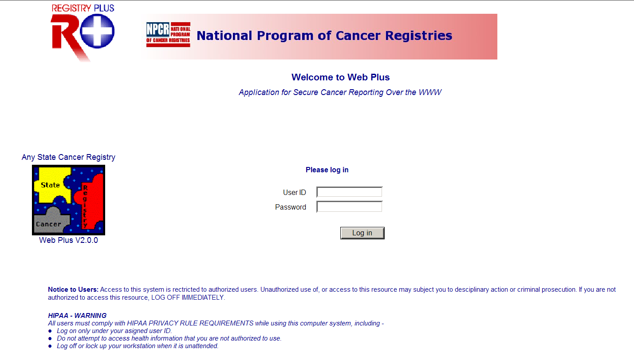
- Type in your User ID and password into the User ID and Password fields, or use the User ID of FBSuper, and the password of super.
- Click Log in.
Result: Your Web Plus homepage opens, with a list of links to the roles that have been assigned to you.
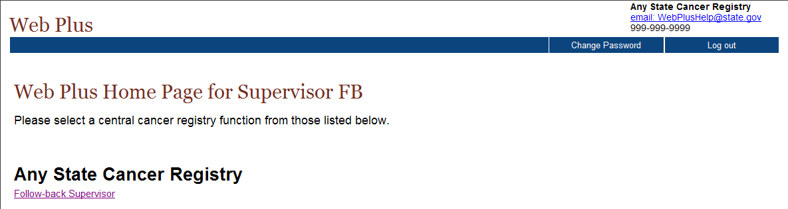
- Click the Follow-back Supervisor link.
Result: The Follow-back Supervisor menu items are displayed.
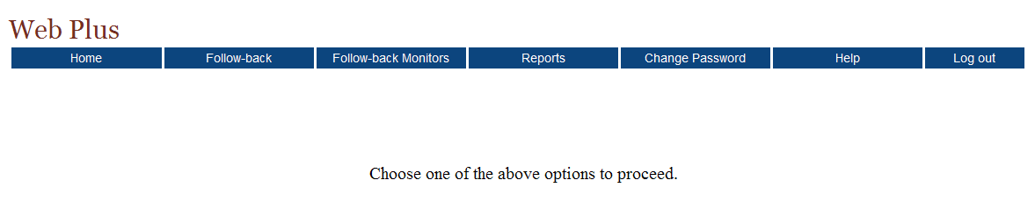

Follow-back Supervisor Menu Options
After you log in and click the Follow-back Supervisor link, the Web Plus Follow-back Supervisor menu items are displayed:

From this page you can access the main menu options for the Follow-back Supervisor role in Web Plus. Click on a menu option to open the page for the option. The following table describes the menu options for the Follow-back Supervisor, and provides a page reference within this manual for more information about the menu option.

Menu option | Sub-option |  | Opens web page to . . . | Refer to page . . .
Home |  |  | the user’s home page, for each assigned role, a link to a page that displays menu items for that role is displayed | 4
Follow-back | Load Follow-back File |  | upload a file of partially-filled abstracts in NAACCR format for follow-back in Web Plus | 13
Follow-back | Track Requests by File |  | track follow-back abstracts (view, reroute, view history, send notice, or delete) by the file in which they were uploaded; can also view the history of and delete follow-back files | 18
Follow-back | Track Requests by Facility |  | track follow-back abstracts (view, reroute, view history, send notice, or delete) by the facility to which they were assigned | 33
Follow-back | Add Follow-back Online |  | add a follow-back abstract manually (rather than in an uploaded file), by entering select fields for the abstract online | 52
Follow-back | Find Incomplete Follow-back abstracts |  | identify and complete unfinished abstracts which have begun to be manually entered online | 58
Follow-back Monitors |  |  | assign Follow-back Monitors to specific facilities for tracking of follow-back abstracts from those facilities | 63
Reports |  |  | view follow-back reports to aid in the tracking of follow-back abstracts | 69
Change Password |  |  | change your Web Plus login password | 8
Help |  | About | view Web Plus, NAACCR, and Collaborative Staging Algorithm Versioning information
Log out |  |  | log out of Web Plus and open the Log in page | 9

The Follow-back Process
The Web Plus follow-back process allows central registries to electronically collect follow-back information in an organized and efficient manner. Central registries generally conduct death certificate follow-back by mailing out a cancer reporting form to a physician for the reporting of a tumor identified solely by death certificate (Death Certificate Only, or DCO), having the physician complete the form and mail it back, and then having central registry staff abstract the information returned on the form into some sort of abstraction software to get the information in electronic form so that it may then be processed by the central registry. Pathology lab follow-back may be conducted in a similar manner to physicians, or may involve mailing a facility a list of tumors identified via pathology lab not yet reported by the facility, and having the facility abstract the tumors from scratch to report the tumors. These efforts are frequently tracked by central registries via paper lists, or via manually checking reported tumors off of some sort electronic listing.
Web Plus follow-back features enable a central registry to pre-fill online abstracts with known information from death certificates or pathology lab reports, and have the reporter log on to update the information and complete the abstract. The end result is a completed abstract in NAACCR file format, an electronic report of a previously unreported tumor, without the use of paper forms or redundant recording of information. In addition, the follow-back tracking features of Web Plus allow the central registry to closely and electronically track the status of each follow-back abstract to ensure that it gets completed.
Basically, the follow-back process in Web Plus takes advantage of the existing online abstracting feature to enable physicians and facility abstractors to complete partially-filled abstracts online. The abstractor can save their work at any time and return their work at a later time. They release an abstract to the central registry only after they have completed it, and eliminated any errors it may contain.
Notification to facility via e-mail
Facility corrects errors
Facility completes abstract
Facility releases abstract
Facility updates abstract
Facility rejects abstract
FB Supervisor reroutes abstract
FB Supervisor deletes abstract
FB Supervisor uploads file of partial abstracts or manually enters abstracts online

The Web Plus follow-back process includes the following steps:
- The Follow-back Supervisor (FB Supervisor) uploads files of partially-filled abstracts generated with information from death certificate and pathology lab files into Web Plus, or manually enters individual abstracts online.
Records for follow-back need to be prepared outside of Web Plus and should be in NAACCR record format for upload into the Web Plus database.
- Notification to facilities/physicians to log in and update the follow-back abstracts is sent via e-mail.
- Once posted for facilities/physicians to complete, follow-back abstracts are processed via the regular Web Plus record flow; with the exception that follow-back abstracts can be rejected by the facility/physician with a justifying comment back to the central registry, where the Follow-back Supervisor can either re-route the abstract to a new facility/physician, or delete the abstract from the follow-back process.
- Once completed by the facility/physician, the follow-back abstracts are released to the central registry, where they are reviewed and released by the Central Registry Abstractor/Reviewer, and subsequently exported out of the Web Plus database by the Central Registry Administrator.
Throughout the follow-back process, the Follow-back Supervisor and Follow-back Monitors use the follow-back reports and tracking features to communicate with the cancer reporters via e-mail, and track follow-back abstracts to ensure their resolution.

Changing Your Password
To change your password, complete these steps:
- On the Home page menu, click Change Password.
Result: The Change Password page opens.
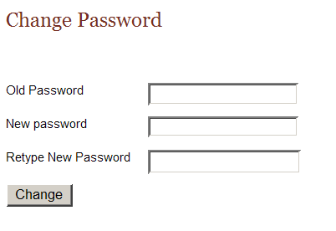
- Type your current password in the old password field, and your new password in both of the new password fields.
- Click Change.
Result: Your password is successfully changed.

Your Central Administrator may have set minimum criteria for creating passwords. You will need to meet those criteria when changing your password, or Web Plus will not accept your new password, and will issue an error message saying your password does not meet the specified criteria.

Log Out
To log out of Web Plus, click Log out on the Home page menu.
Result: The system logs you out of Web Plus, and the Log in page opens.

Questions
Answer these questions about the basics of Web Plus follow-back (the answers are in Appendix A, page 86):

- Which menu option opens the page where you can track follow-back abstracts by facility?

- Is uploading a file of partial abstracts the only way to start the follow-back process in Web Plus?

- How do you log out of Web Plus?

Generating/Uploading Follow-back Files

Learning Objectives
In this chapter you learn:
- What file format follow-back files should be in
- What minimum information should be included when generating a file of follow-back abstracts
- How to upload a file of partially-filled follow-back abstracts, and select a follow-back type for the file

Overview
In this chapter you learn about the first step in the Web Plus follow-back process, how to upload a file of partially-filled abstracts into the Web Plus database, including how to label the uploaded abstracts with the correct follow-back type. You will also learn about what format the files should be in, and recommendations regarding what information should initially be included in the follow-back file.

Generating Follow-back Files
The Web Plus follow-back process takes advantage of the fact that, typically, central registries can obtain death certificate and pathology lab files in electronic format. Because the information is in electronic format, the information in the files can be manipulated, and mapped to data items in a standard record format. Web Plus follow-back files must be in the format found in the North American Association of Central Cancer Registries (NAACCR), Standards for Cancer Registries, Volume II, Data Standards and Data Dictionary. The NAACCR Data Standards & Data Dictionary may be found at the following URL:
http://www.naaccr.org/index.asp?Col_SectionKey=7&Col_ContentID=133
The version of NAACCR file format should be the same as the NAACCR version your Web Plus application is based on. It is the responsibility of the central registry to generate the follow-back files. Any means convenient for your registry may be used to map data items from your death certificate or pathology lab files to the NAACCR file format (SAS, ACCESS, etc.).
In particular, for the mapping of pathology lab files that are received in HL7 format, Registry Plus offers Mapper Plus, an application that can be used to parse HL7 messages and map HL7 data elements to NAACCR data elements. Central registries interested in obtaining Mapper Plus should contact cancerinfo@cdc.gov for more information.

Records for follow-back need to be prepared outside of Web Plus and should be in the NAACCR record format for upload into the Web Plus database.
There are certain data items that the Web Plus system will be expecting in a follow-back file, and other data items that your registry may want to consider including as well.

Reporting Facility
The field of Reporting Facility must be filled in on each follow-back abstract record in an uploaded follow-back file:
NAACCR Data Item Name | Data Item # | Column # | Length
Reporting Facility | 540 | 701 | 10

When a file of follow-back abstracts is uploaded, Web Plus refers to the Reporting Facility field on each record to determine to which facility to assign the follow-back abstract. All facilities listed in the Reporting Facility field in the follow-back file must have a facility account set up in Web Plus. If a follow-back file contains records with Reporting Facility numbers not associated with an existing facility in Web Plus, an error message will be issued upon upload.

Patient Identifying Information
As much patient identifying information as possible should be mapped to each abstract in the follow-back file. Fields commonly available from the Death Certificate or pathology report that can be mapped to the follow-back files may include, but are not limited to, the following:
NAACCR Data Item Name | Data Item # | Column # | Length
Race 1 | 160 | 177 | 2
Spanish/Hispanic Origin | 190 | 189 | 1
Sex | 220 | 192 | 1
Birth Date | 240 | 196 | 8
Birthplace | 250 | 206 | 3
Name—Last | 2230 | 3340 | 40
Name—First | 2240 | 3380 | 40
Name—Middle | 2250 | 3420 | 40
Social Security Number | 2320 | 3619 | 9

Other Potentially-Available Information
Depending on the type of follow-up and availability of information from the state vital statistics data system and pathology reports, other information could potentially be mapped to the follow-back file. These fields include, but are not limited to, those listed in the following table. Comments or suggested default values are provided for each field.

NAACCR Data Item Name | Data Item # | Column # | Comment/Suggested Default Value
Potentially available from Death Certificate or filled in
Primary Site | 400 | 540 | Some registries may choose to manually code/convert, and map these fields
Histologic Type ICD-O-3 | 522 | 550
Date of Last Contact | 1750 | 2116 | Fill with Date of Death from Death Certificate
Vital Status | 1760 | 2126 | 0 = Dead (COC)
Follow-up Source Central | 1791 | 2278 | 05 = State Death Tape/Death Certificate File
Cause of Death | 1910 | 2269 | Fill with ICD-10 COD code from Death Certificate
ICD Revision Number | 1920 | 2273 | 1 = ICD-10
DC State File Number | 2380 | 3878 | Fill with Death Certificate Number
Physician—Managing | 2460 | 4405 | Can fill with Physician License Number from Death Certificate
Text—Remarks | 2680 | 19765 | Can be used to relay other available information, such as Physician Name from Death Certificate
Potentially available from pathology lab report or filled in
Date of Diagnosis | 390 | 530 | Fill with Specimen Date from Pathology Report
Primary Site | 400 | 540 | Information for these fields is not usually available in coded form; some registries may choose to manually code these fields prior to follow-back
Histologic Type ICD-O-3 | 522 | 550
Behavior Code ICD-O-3 | 523 | 554
Grade | 440 | 555
Text—Dx Proc Path | 2570 | 10565 | Transfer Final Diagnosis text if available from pathology report

System Fields
A final consideration when generating follow-back files is the inclusion and provision of default values to any system fields that your central registry system may require when the completed abstract is eventually submitted for processing at your central registry. The below table contains a list of NAACCR data items, along with their suggested default values, that are recommended for potential inclusion in follow-back files:
NAACCR Data Item Name | Data Item # | Column # | Suggested Default Value
Record Type | 10 | 1 | A
FIN Coding System | 35 | 3 | 2
NAACCR Record Version | 50 | 17 | 121
Race Coding Sys-Current | 170 | 187 | 7
Race Coding Sys-Original | 180 | 188 | 7
Site Coding Sys-Current | 450 | 558 | 5
Site Coding Sys-Original | 460 | 559 | 5
Morph Coding Sys-Current | 470 | 560 | 8
Morph Coding Sys-Original | 480 | 561 | 8
RX Coding System-Current | 1460 | 1593 | 06
First Course Calc Method | 1500 | 1595 | 1
SEER Coding Sys-Current | 2120 | 1930 | A
SEER Coding Sys-Original | 2130 | 1931 | A
COC Coding Sys-Current | 2140 | 1932 | 08
COC Coding Sys-Original | 2150 | 1934 | 08
ICD-O-3 Conversion Flag | 2116 | 2015 | 0

 | Be sure to coordinate the generation of the follow-back file with the generation of the required Web Plus follow-back display types by your Web Plus Central Registry Administrator. At a minimum, fields that are included in the follow-back file will need to be included in the follow-back display types. System fields can be protected and set to invisible, so that they will be transmitted with the abstract, but not seen or edited by the abstractor.

Uploading Follow-back Files
Once the follow-back file has been generated and is in the appropriate NAACCR file format, it can be uploaded to Web Plus to begin the follow-back process.
To upload a file of partially-filled abstracts in NAACCR format, complete these steps:
- On the Web Plus menu, point to Follow-back, then click Load Follow-back File.
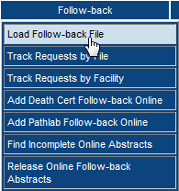
Result: The Upload Follow-back Requests File page opens.
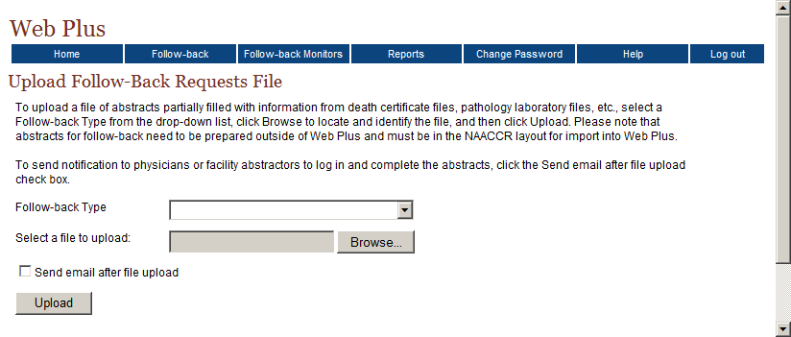
- Select the appropriate Follow-back Type from the Follow-back Type pull-down menu. Currently, there are 2 Web Plus follow-back types to choose from: Death Certificate Follow-back and Pathlab Follow-back. In the example shown, the follow-back type of Death Certificate Follow-back is selected.
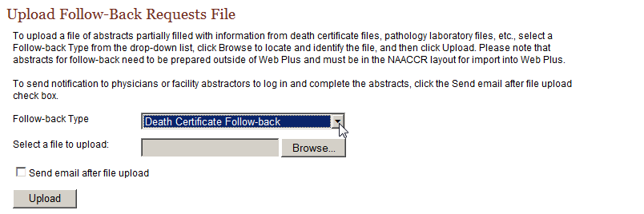
- Click Browse to the right of the Select a file to upload box to bring up the file browser.
Result: The Choose file dialog box opens.
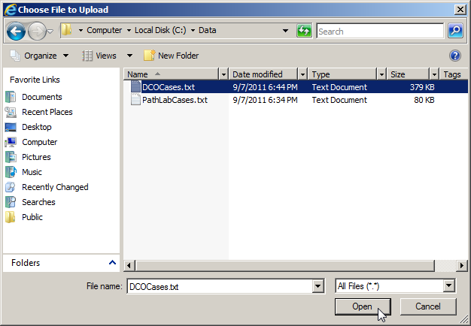
- Navigate to the follow-back file, select it, and click Open.
Result: You are returned to the Follow-back Requests File page, with your follow-back data file specified for upload.
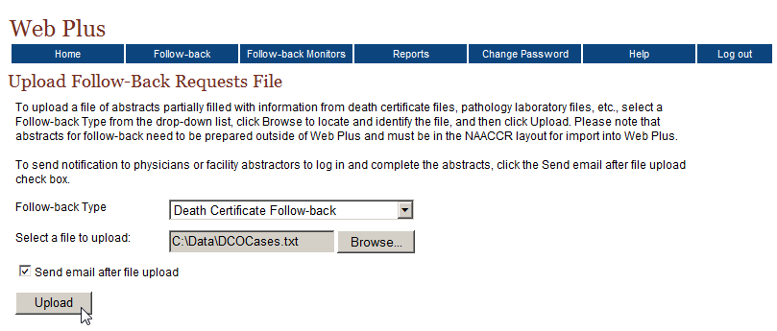
- Click Upload.
Result: If you do not have the Send e-mail after file upload checkbox clicked, you will remain on the Follow-back Requests File page, and the following message is displayed:
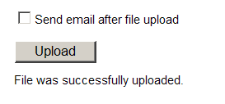
However, if the Send e-mail after file upload checkbox is clicked:
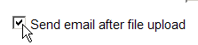
When you click upload, you will be taken to the follow-back upload confirmation page that states that the file has been successfully uploaded:
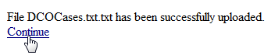

- Click Continue.
Result: You are taken to the Send E-mail Notice page, to compose and send an e-mail to the abstractors at the facilities included in the follow-back file regarding the follow-back abstracts just posted to Web Plus. You will learn more about sending e-mail notices in Chapter 6: Sending E-mail Notices.
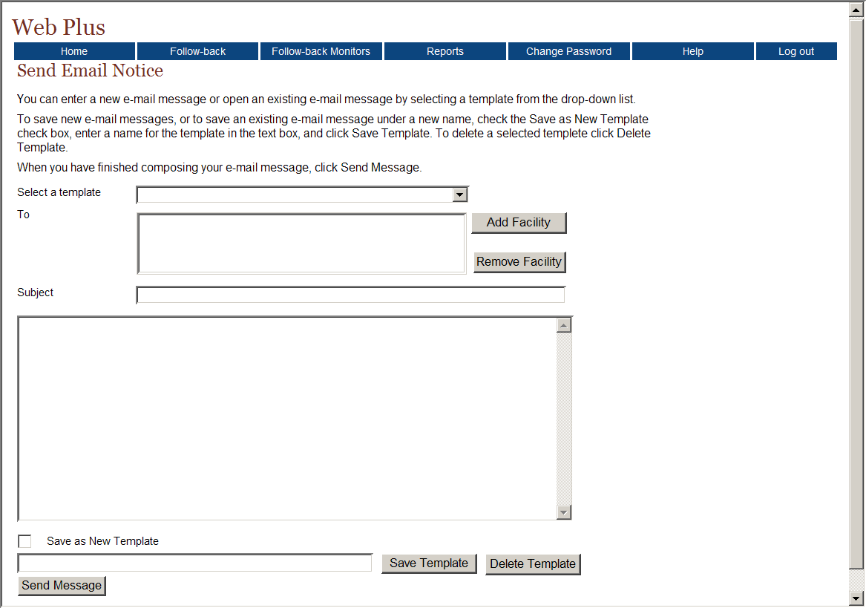
In the example shown, a death certificate follow-back file is uploaded. To upload a pathology lab follow-back file, all of the steps are the same, except for that in step 2, the Path Lab Follow-back follow-back type would be selected.
Upon upload of the follow-back file, each of the partially-filled abstracts in the file is assigned to the facility listed in the Reporting Facility field of the abstract. A link to the follow-back abstracts will appear on the corresponding facility abstractors’ homepages. The follow-back request links include running outstanding and released follow-back abstract totals that are updated as the facility abstractor completes and releases, or rejects the follow-back abstracts.
In addition, the follow-back abstracts are posted to the Web Plus follow-back tracking system, which allows the Follow-back Supervisor and Follow-back Monitors to monitor the progress of each follow-back abstract until it has been completed by the facility abstractor and released to the central registry. Please see Chapter 4: Tracking Follow-back Requests by File or Chapter 5: Tracking Follow-back Requests by Facility for further information on tracking follow-back abstracts.

Questions
Answer these questions about generating and uploading follow-back files in Web Plus (the answers are in Appendix A, page 86):

- Which menu option opens the page where you can upload follow-back files?

- What file format must Web Plus follow-back files be in?

- What types of follow-back does Web Plus currently offer?

- What help is available for the mapping of pathology lab files received in HL7 format?

Tracking Follow-back Requests by File

Learning Objectives
In this chapter you learn to:
- Monitor the status of follow-back abstracts by the file in which they were uploaded, including viewing, rerouting, viewing the history of, and deleting individual abstracts, as well as sending e-mails regarding individual abstracts
- View the follow-back file history
- Send an e-mail notice to abstractors at all facilities included in an uploaded file
- Delete an uploaded follow-back file

Overview
As soon as follow-back abstracts have been added to the Web Plus follow-back system, they are available at the facility level for completion or rejection, and they are added to the Web Plus follow-back tracking system. As a Follow-back Supervisor, you can track the status of follow-back abstracts by the file in which they were uploaded, or by the facility to which they are assigned. This chapter covers the procedures to manage follow-back files, including tracking individual follow-back abstracts that they contain. Please see Chapter 5: Tracking Follow-back Requests by Facility to learn more about tracking follow-back abstracts by facility.

Track Follow-back Requests by File Page
To manage follow-back files, and track follow-back requests by the file in which they were uploaded, complete these steps:
- On the Web Plus menu, point to Follow-back, then click Track Requests by File.
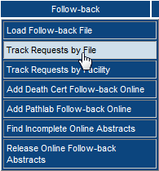
Result: The Track Follow-back Requests by File page opens.
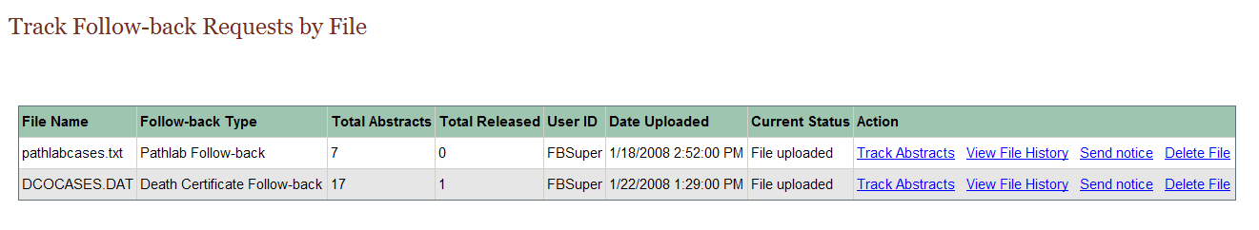
The Track Follow-back Requests by File page includes these fields and column headings:
Columns | Description
File Name | Name of the uploaded follow-back file
Follow-back Type | Type of follow-back abstracts (Death Certificate or Pathlab) included in the file
Total Abstracts | Total number of follow-back abstracts included in the file
Total Released | Total number of follow-back abstracts included in the file that have been completed and released by the facility to which they are assigned
User ID | User ID of the current owner of the follow-back file
Date Uploaded | Date the follow-back file was uploaded into Web Plus
Current Status | Current status of the follow-back file
Actions | Links to the various actions that can be performed on the follow-back file:  Track Abstracts: Track the status of the individual follow-back abstracts included in the file  View File History: View the history of actions on the uploaded file  Send Notice: Send an e-mail notice to all facility abstractors at the facility(ies) included in the follow-back file  Delete File: Delete the follow-back file and all abstracts included in the file from Web Plus

Tracking Individual Abstracts by File
To track individual abstracts by the file in which they were uploaded to Web Plus, complete these steps:
- On the Track Follow-back Requests by File page, locate the file which contains the follow-back abstracts you would like to monitor, and click the Track Abstracts link in the Action column.
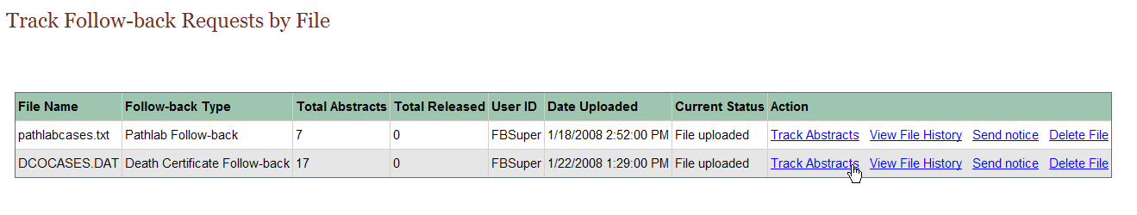

Result: The Track Individual Follow-back Abstracts page opens for the selected follow-back file.
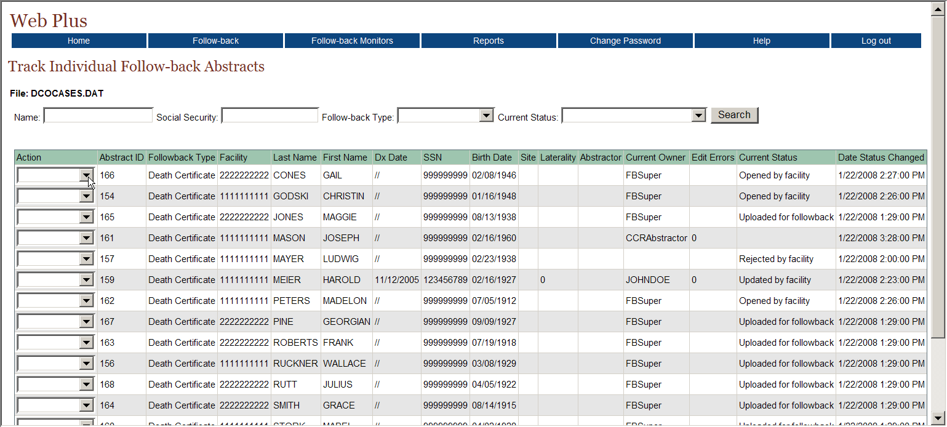
The Track Individual Follow-back Abstracts page lists information for each follow-back abstract in the selected follow-back file, and includes these fields and column headings:
Columns | Description
Action | Select from among the various actions that can be performed on a follow-back abstract:  View: View the follow-back abstract; the abstract will be viewed with the central registry display type---fields can only be viewed not updated/edited  Reroute: Reroute a rejected follow-back abstract to another facility for follow-back  View History: View the history of actions performed on the follow-back abstract  Send Notice: Send an e-mail notice regarding the follow-back abstract to all facility abstractors at the facility  Delete: Delete the follow-back abstract from Web Plus
Abstract ID | A system-generated number identifying the abstract
Follow-back Type | Type of follow-back abstract (Death Certificate or Pathlab)
Facility | The facility to which the follow-back abstract is currently assigned
Last Name | Last name of patient
First Name | First name of patient
Dx Date | Diagnosis date
SSN | Patient’s social security number
Birth Date | Patient’s date of birth
Site | The location of the major tumor
Laterality | Code for the side of a paired organ, or the side of the body on which the reportable tumor originated
Abstractor | Code for the person at the facility who has updated the follow-back abstract
Current Owner | User who currently owns the abstract in Web Plus
Edit Errors | The number of errors found in the edit process after a follow-back abstract has been opened and saved
Current Status | Current status of the follow-back abstract; Web Plus has the following follow-back abstract statuses:  Uploaded for followback  Opened by facility  Rejected by facility  Released by facility  Rerouted to different facility  Updated by facility  Message sent to facility  Review by CCR abstractor  Review released
Date Status Changed | The date and time at which the status of follow-back abstract was last changed
Follow-back Supervisors can use the Track Individual Follow-back Abstracts page to track the current status of, and perform certain actions on, follow-back abstracts. The Track Individual Follow-back Abstracts page can be searched by name, Social Security Number, Follow-back Type, and/or current status. Search on partial name and Social Security Number is supported. The search feature can be used to search for an individual follow-back abstract, or to restrict the follow-back abstracts listed to a certain follow-back type and/or follow-back abstract status.

View
To view an individual follow-back abstract in a follow-back file, complete these steps:
- On the Track Follow-back Requests by File page, locate the file which contains the follow-back abstracts you would like to monitor, and click the Track Abstracts link in the Action column.
Result: The Track Individual Follow-back Abstracts page opens for the selected follow-back file.
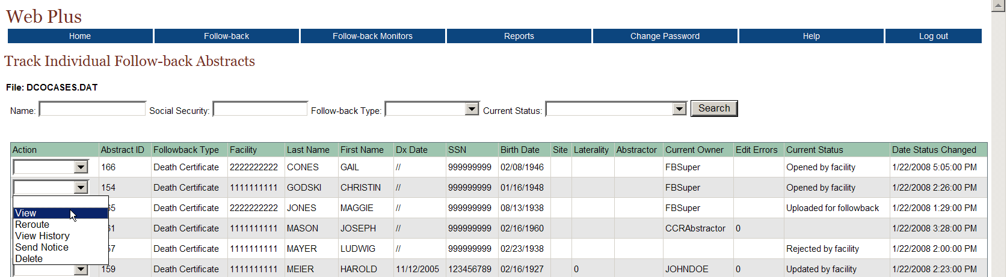
- From the listing of follow-back abstracts in the file, locate the follow-back abstract of interest, and using the pull-down menu in the Action column, select View.
Result: The follow-back abstract is opened for viewing.
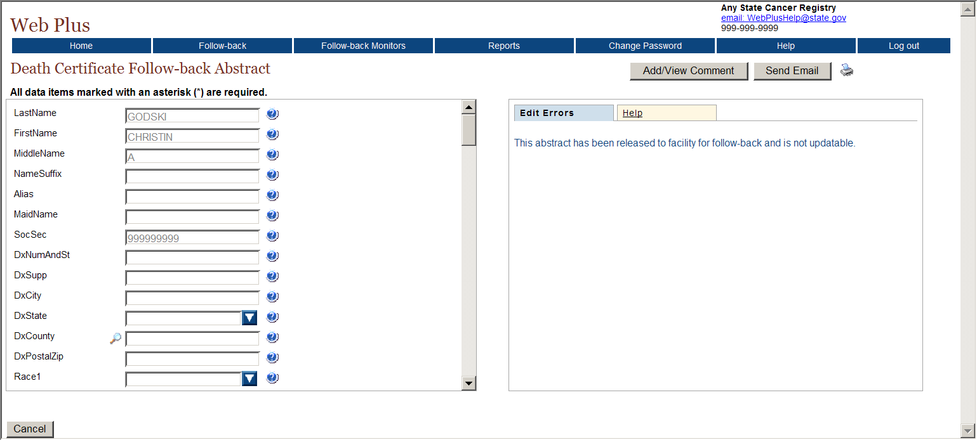
Note that the abstract is viewed with the follow-back display type assigned for central abstractor/reviewers by the Central Registry Administrator, and the fields are grayed-out, and cannot be updated.
To facilitate tracking efforts, comments may be added to the abstract while viewing it by clicking on Add/View Comments in the upper right-hand corner of the page. In addition, an e-mail may be sent regarding the follow-back abstract being viewed by clicking on Send Email in the upper right-hand corner of the page. You are taken to the Send E-mail Notice page, to compose and send an e-mail to the abstractors at the facility to which the follow-back abstract is assigned. You will learn more about sending e-mail notices in Chapter 6: Sending E-mail Notices.

Reroute
Once follow-back abstracts have been added to the Web Plus follow-back system, they are available at the facility level for completion or rejection. If a facility abstractor rejects a follow-back abstract, the follow-back abstract may be rerouted to a different facility or deleted.
To reroute an individual follow-back abstract in a follow-back file, complete these steps:
- On the Track Follow-back Requests by File page, locate the file which contains the follow-back abstracts you would like to monitor, and click the Track Abstracts link in the Action column.
Result: The Track Individual Follow-back Abstracts page opens for the selected follow-back file.
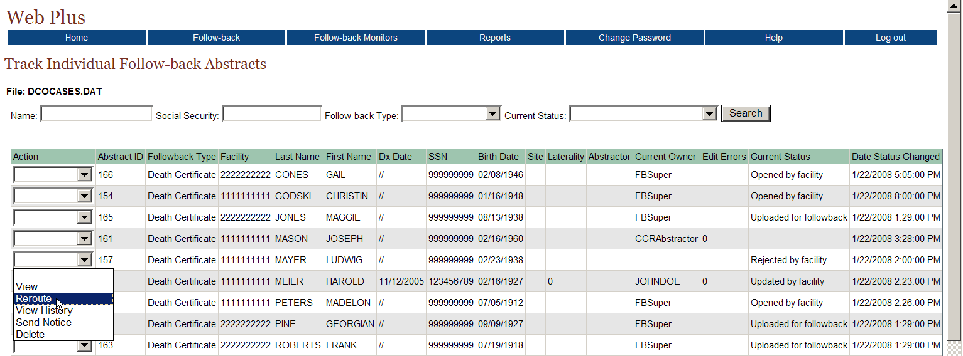
- From the listing of follow-back abstracts in the file, locate the abstract you would like to reroute, and using the pull-down menu in the Action column, select Reroute.
Result: The Reroute Follow-back Abstract page opens.
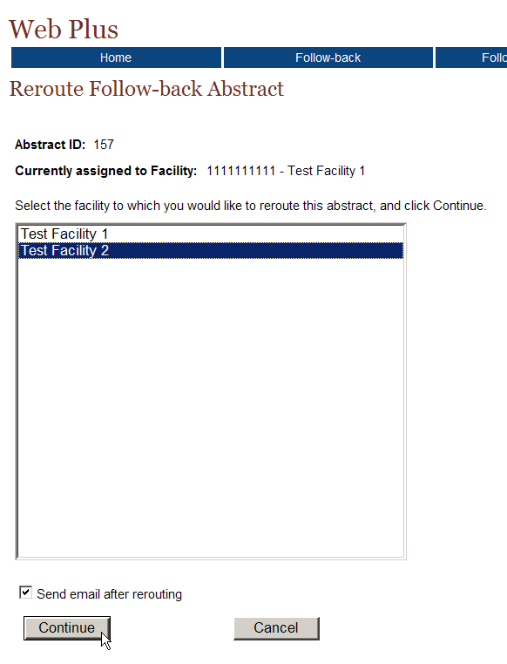
The Reroute Follow-back Abstract lists the follow-back abstract’s Abstract ID, and the facility to which the follow-back abstract is currently assigned.
- From the list of facilities, select the facility you would like to reroute the abstract to, and click Continue.
Result: If you do not have the Send e-mail after file upload checkbox clicked, a message will be displayed confirming that the follow-back abstract has been rerouted:
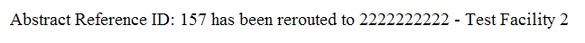
However, if the Send e-mail after file upload checkbox is clicked:
When you click continue, you will be taken to the reroute follow-back abstract confirmation page, which states that the abstract has been successfully rerouted:
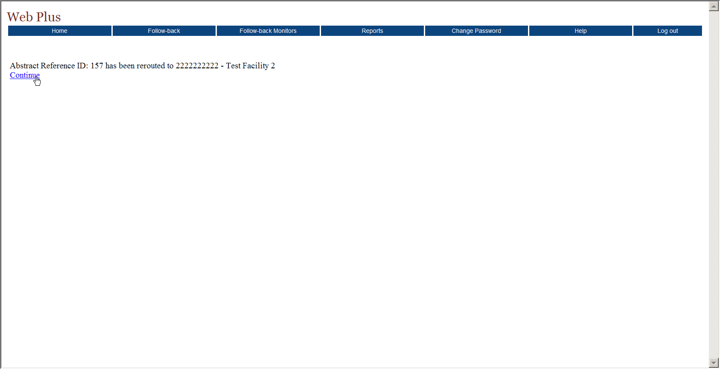
- Click Continue.
Result: You are taken to the Send E-mail Notice page, to compose and send an e-mail to the abstractors at the facility to which the follow-back abstract was rerouted. You will learn more about sending e-mail notices in Chapter 6: Sending E-mail Notices.

View History
Each action that is performed on a follow-back abstract is logged by the Web Plus follow-back tracking system. As a result, a complete “history”, i.e., each action performed, when it was performed, and by whom, can be viewed for each follow-back abstract. The Follow-back Supervisor can use this information when monitoring follow-back abstracts or when communicating with facilities regarding a regarding specific follow-back abstract.
To view the history of an individual follow-back abstract in a follow-back file, complete these steps:
- On the Track Follow-back Requests by File page, locate the file which contains the follow-back abstracts you would like to monitor, and click the Track Abstracts link in the Action column.
Result: The Track Individual Follow-back Abstracts page opens.
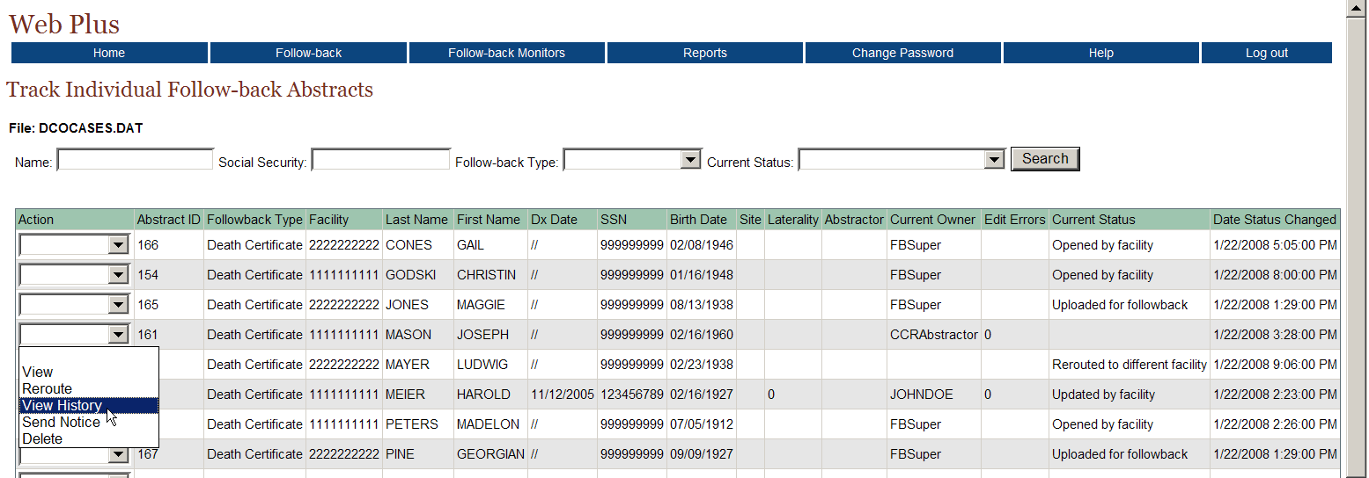
- From the listing of follow-back abstracts in the file, locate the follow-back abstract of interest, and using the pull-down menu in the Action column, select View History.
Result: The View Follow-back Abstract History window opens.
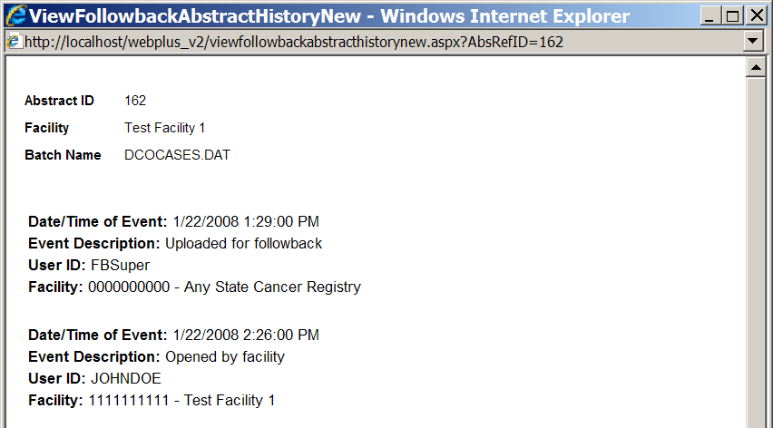
The Abstract ID of the follow-back abstract, the facility to which the follow-back abstract is assigned, and the file in which the abstract was uploaded are displayed at the top of the window. For each action performed on a follow-back abstract, the View Follow-back Abstract History window lists the date/time of the action, a description of the action taken, the User ID of the user performing the action, and the facility at which the action was performed.

Send Notice
Follow-back Supervisors can access the follow-back e-mail functions from the Track Individual Follow-back Abstracts page to send e-mails to abstractors at the facility to which a follow-back abstract is assigned. To send an e-mail regarding an individual follow-back abstract in a follow-back file, complete these steps:
- On the Track Follow-back Requests by File page, locate the file which contains the follow-back abstracts you would like to monitor, and click the Track Abstracts link in the Action column.
Result: The Track Individual Follow-back Abstracts page opens.
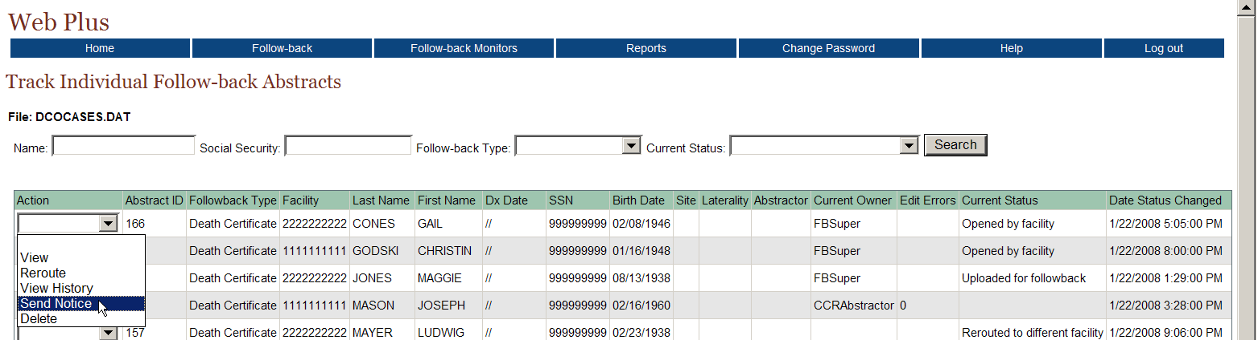
- From the listing of follow-back abstracts in the file, locate the follow-back abstract of interest, and using the pull-down menu in the Action column, select Send Notice.
Result: You are taken to the Send E-mail Notice page, to compose and send an e-mail to the abstractors at the facility to which the follow-back abstract is assigned. You will learn more about sending e-mail notices in Chapter 6: Sending E-mail Notices.
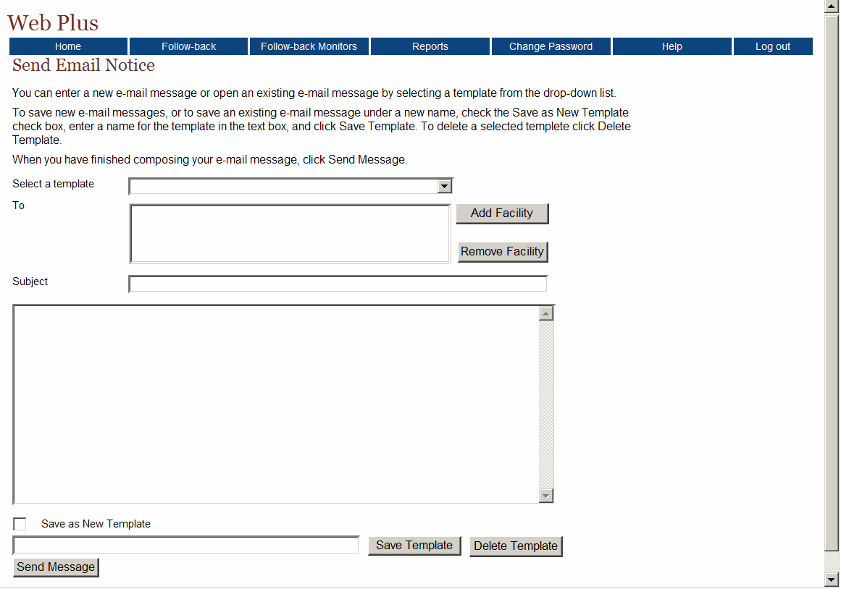

Delete
Sometimes follow-back efforts for a follow-back abstract hit a “dead-end”, i.e., it may be rejected by a facility because the patient was not treated there, and no other facility/physician can be identified for follow-back efforts, or a tumor associated with a follow-back abstract may be reported by another reporting source or via other means during the follow-back effort. As a result, the Follow-back Supervisor may occasionally need to delete a follow-back abstract from the Web Plus follow-back system.
When you delete a follow-back abstract, you remove all traces of the abstract from Web Plus, i.e., it will be removed from the facility follow-back list, as well as the follow-back tracking system; no record of the abstract will remain in the system.
As with regular online abstracts, Web Plus will not let you delete a follow-back abstract once it has been completed and released by the facility. Once information has been released from the facility, the facility must maintain a record of the released information as required by HIPAA; either in hardcopy or online.
To delete an individual follow-back abstract identified via its uploaded follow-back file, complete these steps:
- On the Track Follow-back Requests by File page, locate the file which contains the follow-back abstracts you would like to monitor, and click the Track Abstracts link in the Action column.
Result: The Track Individual Follow-back Abstracts page opens for the specified file.
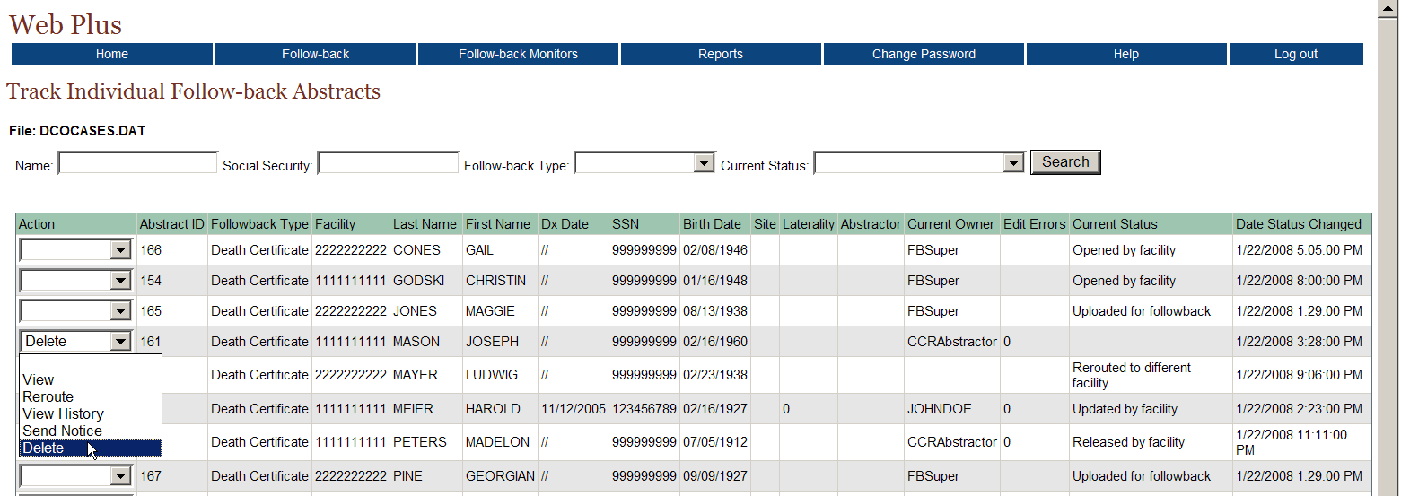
- From the listing of follow-back abstracts in the file, locate the follow-back abstract you would like to delete, and using the pull-down menu in the Action column, select Delete.
Result: The Delete Follow-back Abstract window opens, asking for confirmation of the deletion.
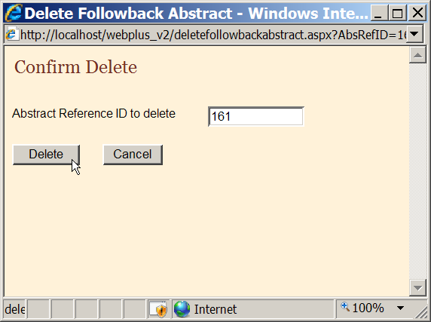
- Click Delete.
Result: A message appears in the Delete Follow-back Abstract window to let you know that abstract has been successfully deleted.
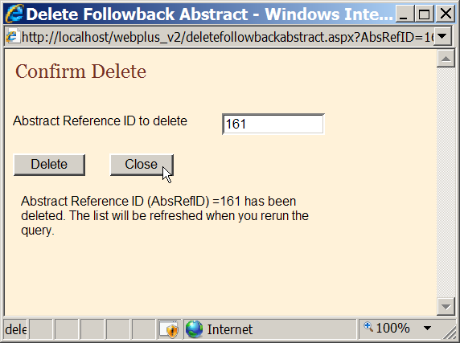
- Click Close.
Result: You are returned to the Track Individual Follow-back Abstracts page. When this page is refreshed, the deleted abstract will no longer be included in the list of follow-back abstracts.

Viewing File History
Each action that is performed on a follow-back file is logged by the Web Plus follow-back tracking system. As a result, a complete “history”, i.e., each action performed, when it was performed, and by whom, can be viewed for each follow-back file. The Follow-back Supervisor can use this information when managing follow-back files.
To view the history of a follow-back file, complete these steps:
- On the Track Follow-back Requests by File page, locate the file you would like to view the history of, and click the View File History link in the Action column.
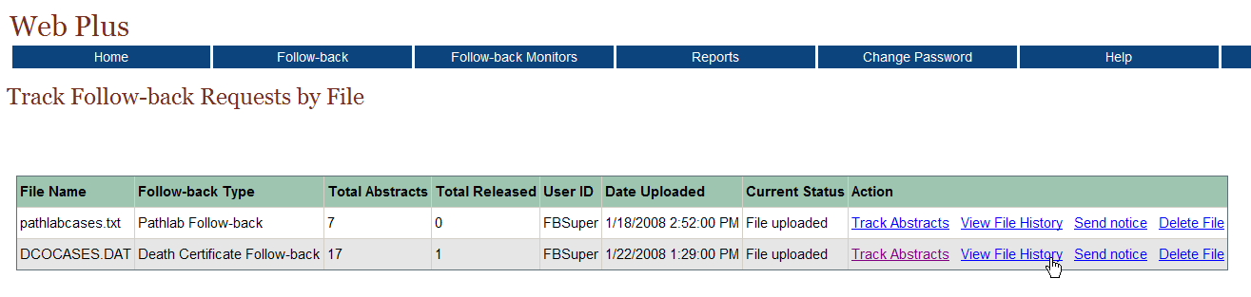
Result: The View Follow-back Batch History window opens.
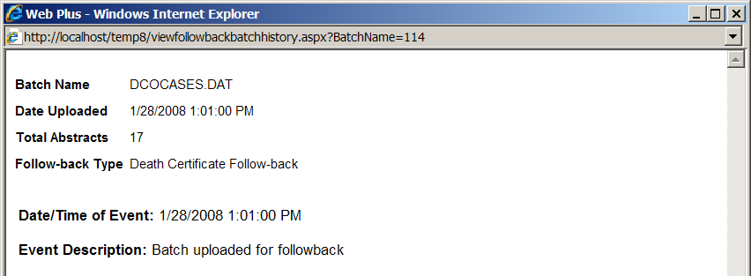
The name of the follow-back file, the date the file was uploaded, the total number of abstracts contained in the file, and the type of follow-back assigned to the file are displayed at the top of the window. For each action performed on the follow-back file, the abstract, the View Follow-back Batch History window lists the date/time of the action, and a description of the action taken.

Sending Notice
The Track Follow-back Requests by File page is one of many ways to access the Web Plus e-mail function. The Follow-back Supervisor can use the Track Follow-back Requests by File page to quickly send e-mails to abstractors at all of the facility(ies) included in a follow-back file.
To send an e-mail to all abstractors at the facilities included in a follow-back file, complete these steps:
- On the Track Follow-back Requests by File page, locate the follow-back file which contains the follow-back abstracts about which you would like to send an e-mail, and click the Send Notice link in the Action column.
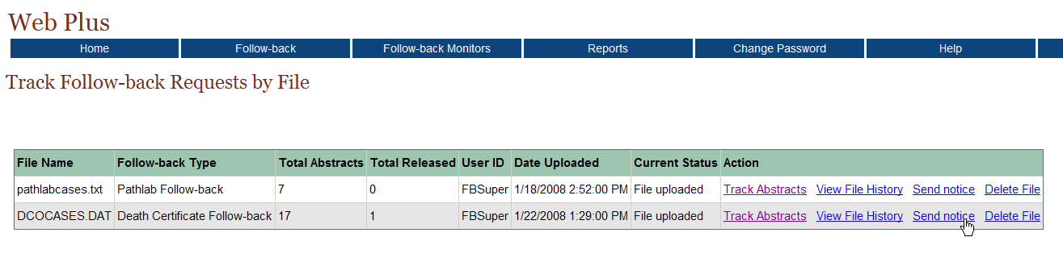
Result: You are taken to the Send E-mail Notice page, to compose and send an e-mail to the abstractors at the facility(ies) included in the follow-back file. You will learn more about sending e-mail notices in Chapter 6: Sending E-mail Notices.

Deleting a Follow-back File
Sometimes the Follow-back Supervisor may upload a follow-back file in error, or may find that a follow-back file that has been uploaded contains errors which need to be fixed. As a result, the Follow-back Supervisor may occasionally need to delete an entire follow-back file from the Web Plus follow-back system.
When you delete a file of follow-back abstracts, you remove all traces of the abstracts from Web Plus, i.e., they will be removed from the facility follow-back list, as well as the follow-back tracking system; no record of the abstracts will remain in the system.

Web Plus will not let you delete follow-back abstracts once they have been completed and released by the facility. Once information has been released from the facility, the facility must maintain a record of the released information as required by HIPAA; either in hardcopy or online.
To delete a follow-back file from Web Plus, complete these steps:
- On the Track Follow-back Requests by File page, locate the file which you would like to delete, and click contains the follow-back abstracts you would like to monitor, and click the Delete File link in the Action column. In the example shown, the follow-back file being deleted is named DCOCASES.DAT.
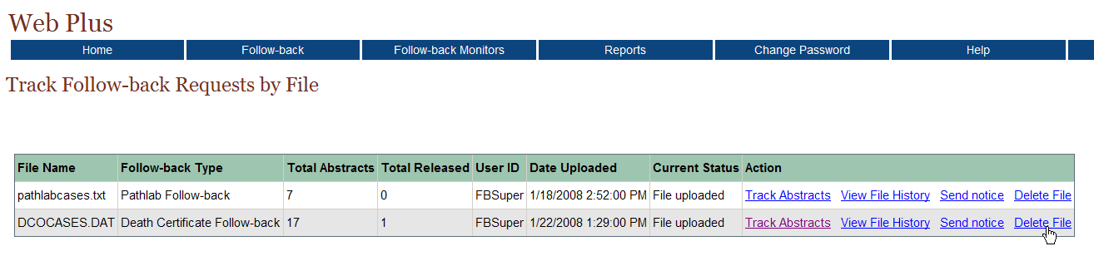
Result: The Delete Follow-back Bundle window opens, asking for confirmation of the deletion.
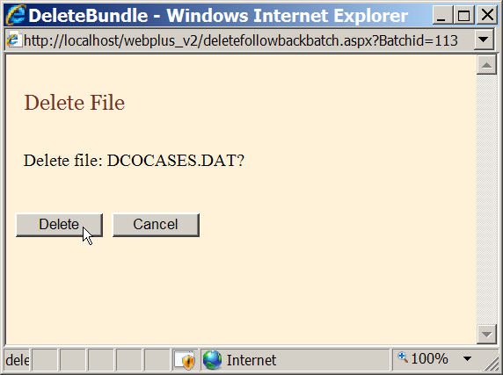
- Click Delete.
Result: You are returned to the Track Follow-back Requests by File page, where the deleted follow-back file is no longer listed.
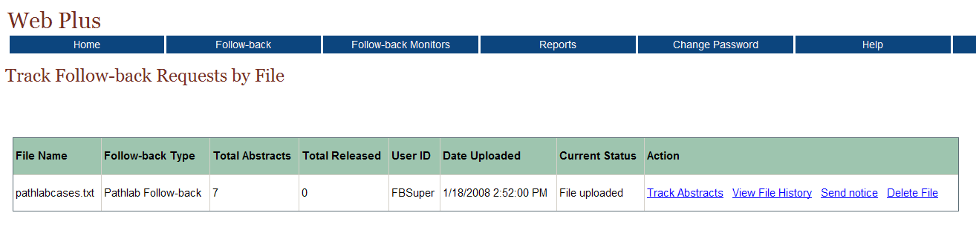

Questions
Answer these questions tracking follow-back requests by follow-back file (the answers are in Appendix A, on page 86 ):

- What menu item and option do you use to track follow-back requests by the follow-back file in which the abstracts were uploaded?

- How do you view a follow-back abstract when tracking follow-back abstracts by follow-back file?

- How do you reroute a follow-back abstract once it has been rejected by a facility?

- How do you delete a follow-back file?

Tracking Follow-back Requests by Facility

Learning Objectives
In this chapter you learn to:
- Monitor the status of follow-back abstracts by the facility to which they are assigned, including viewing, rerouting, viewing the history of, and deleting individual abstracts, as well as sending e-mails regarding individual abstracts
- Send an e-mail notice to all abstractors at a facility

Overview
As mentioned earlier, as soon as follow-back abstracts have been added to the Web Plus follow-back system, they are available at the facility level for completion or rejection, and they are added to the Web Plus follow-back tracking system. As a Follow-back Supervisor, you can track the status of follow-back abstracts by the facility to which they are assigned, or by the file in which they were uploaded. This chapter covers the procedures to track follow-back abstracts by facility. Please see Chapter 4: Tracking Follow-back Requests by File to learn more about tracking follow-back abstracts by follow-back file.

Track Follow-back Requests by Facility Page
To track follow-back requests by the facility to which they were assigned, complete these steps:
- On the Web Plus menu, point to Follow-back, then click Track Requests by Facility.
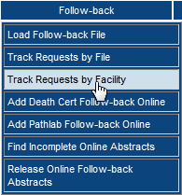
Result: The Track Follow-back Requests by Facility page opens.
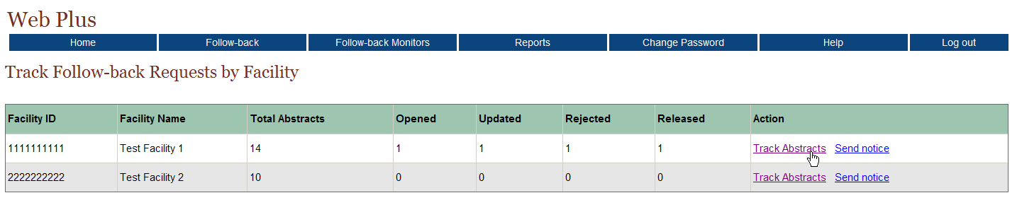

The Track Follow-back Requests by Facility page includes these fields and column headings:
Columns | Description
Facility ID | Facility ID number
Facility Name | Name of Facility
Total Abstracts | Total number of follow-back abstracts assigned to the facility; this includes both death certificate and pathology lab follow-back abstracts
Opened | Total number of follow-back abstracts opened by abstractors at the facility
Updated | Total number of follow-back abstracts opened and updated (saved) by abstractors at the facility
Rejected | Total number of follow-back abstracts rejected by abstractors at the facility
Released | Total number of follow-back abstracts released by abstractors at the facility
Action | Links to the actions that can be performed to monitor the facility’s follow-back abstracts:  Track Abstracts: Track the status of the individual follow-back abstracts included in the file  Send Notice: Send an e-mail notice to all facility abstractors at the facility(ies) included in the follow-back file

Tracking Individual Abstracts by Facility
To track individual abstracts by the facility to which they are assigned, complete these steps:
- On the Track Follow-back Requests by Facility page, locate the facility for which you would like to monitor follow-back abstracts, and click the Track Abstracts link in the Action column. In the example shown, Test Facility 1 (Facility ID 1111111111) is selected.
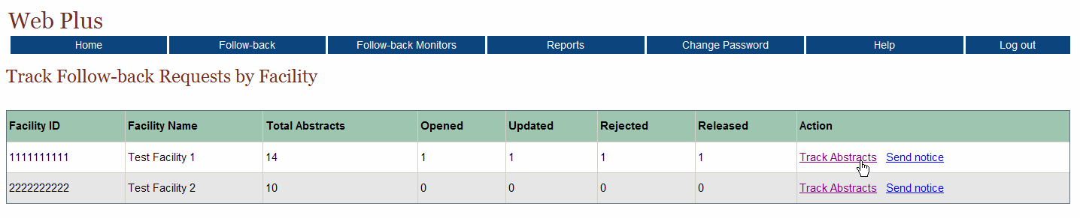

Result: The Track Individual Follow-back Abstracts page opens for the selected facility.
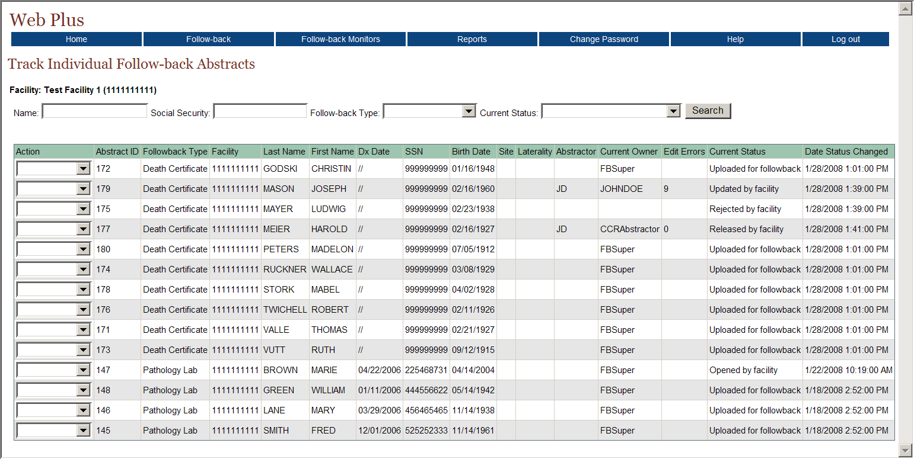
The Track Individual Follow-back Abstracts page lists information for each follow-back abstract assigned to the selected facility, and includes these fields and column headings:
Columns | Description
Action | Select from among the various actions that can be performed on a follow-back abstract:  View: View the follow-back abstract; the abstract will be viewed with the central registry display type---fields can only be viewed not updated/edited  Reroute: Reroute a rejected follow-back abstract to another facility for follow-back  View History: View the history of actions performed on the follow-back abstract  Send Notice: Send an e-mail notice regarding the follow-back abstract to all facility abstractors at the facility  Delete: Delete the follow-back abstract from Web Plus
Abstract ID | A system-generated number identifying the abstract
Follow-back Type | Type of follow-back abstract (Death Certificate or Pathlab)
Facility | The Facility ID of the facility to which the follow-back abstract is currently assigned
Last Name | Last name of patient
First Name | First name of patient
Dx Date | Diagnosis date
SSN | Patient’s social security number
Birth Date | Patient’s date of birth
Site | The location of the major tumor
Laterality | Code for the side of a paired organ, or the side of the body on which the reportable tumor originated
Abstractor | Code for the person at the facility who has updated the follow-back abstract
Current Owner | User who currently owns the abstract in Web Plus
Edit Errors | The number of errors found in the edit process after a follow-back abstract has been opened and saved
Current Status | Current status of the follow-back abstract; Web Plus has the following follow-back abstract statuses:  Uploaded for followback  Opened by facility  Rejected by facility  Released by facility  Rerouted to different facility  Updated by facility  Message sent to facility  Review by CCR abstractor  Review released
Date Status Changed | The date and time at which the status of follow-back abstract was last changed
Follow-back Supervisors can use the Track Individual Follow-back Abstracts page to track the current status of, and perform certain actions on, follow-back abstracts. The Track Individual Follow-back Abstracts page can be searched by name, Social Security Number, Follow-back Type, and/or current status. Search on partial name and Social Security Number is supported. The search feature can be used to search for an individual follow-back abstract, or to restrict the follow-back abstracts listed to a certain follow-back type and/or follow-back abstract status.

View
To view an individual follow-back abstracts for a facility, complete these steps:
- On the Track Follow-back Requests by Facility page, locate the facility for which you would like to monitor follow-back abstracts, and click the Track Abstracts link in the Action column. In the example shown, Test Facility 1 (Facility ID 1111111111) is selected.

Result: The Track Individual Follow-back Abstracts page opens for the selected facility.
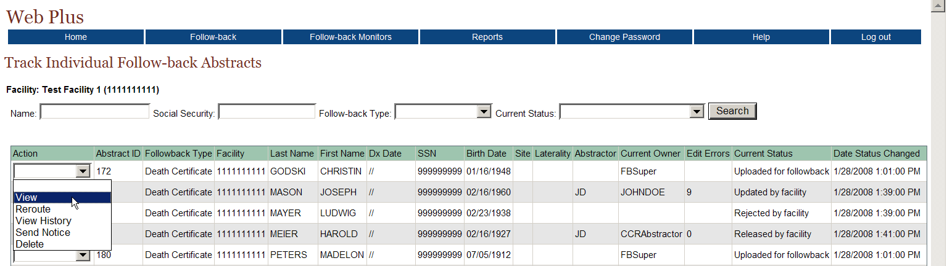
- From the listing of follow-back abstracts for the facility, locate the follow-back abstract of interest, and using the pull-down menu in the Action column, select View.
Result: The follow-back abstract is opened for viewing.
Note that the abstract is viewed with the follow-back display type assigned for central abstractor/reviewers by the Central Registry Administrator, and the fields are grayed-out, and cannot be updated.
To facilitate tracking efforts, comments may be added to the abstract while viewing it by clicking on Add/View Comments in the upper right-hand corner of the page. In addition, an e-mail may be sent regarding the follow-back abstract being viewed by clicking on Send Email in the upper right-hand corner of the page. You are taken to the Send E-mail Notice page, to compose and send an e-mail to the abstractors at the facility to which the follow-back abstract is assigned. You will learn more about sending e-mail notices in Chapter 6: Sending E-mail Notices.

Reroute
Once follow-back abstracts have been added to the Web Plus follow-back system, they are available at the facility level for completion or rejection. If a facility abstractor rejects a follow-back abstract (e.g., because the patient was not diagnosed or treated at the facility), the follow-back abstract may be rerouted to a different facility or deleted.
To reroute an individual follow-back abstract, complete these steps:
- On the Track Follow-back Requests by Facility page, locate the facility for which you would like to monitor follow-back abstracts, and click the Track Abstracts link in the Action column. In the example shown, Test Facility 1 (Facility ID 1111111111) is selected.
Result: The Track Individual Follow-back Abstracts page opens for the selected facility.
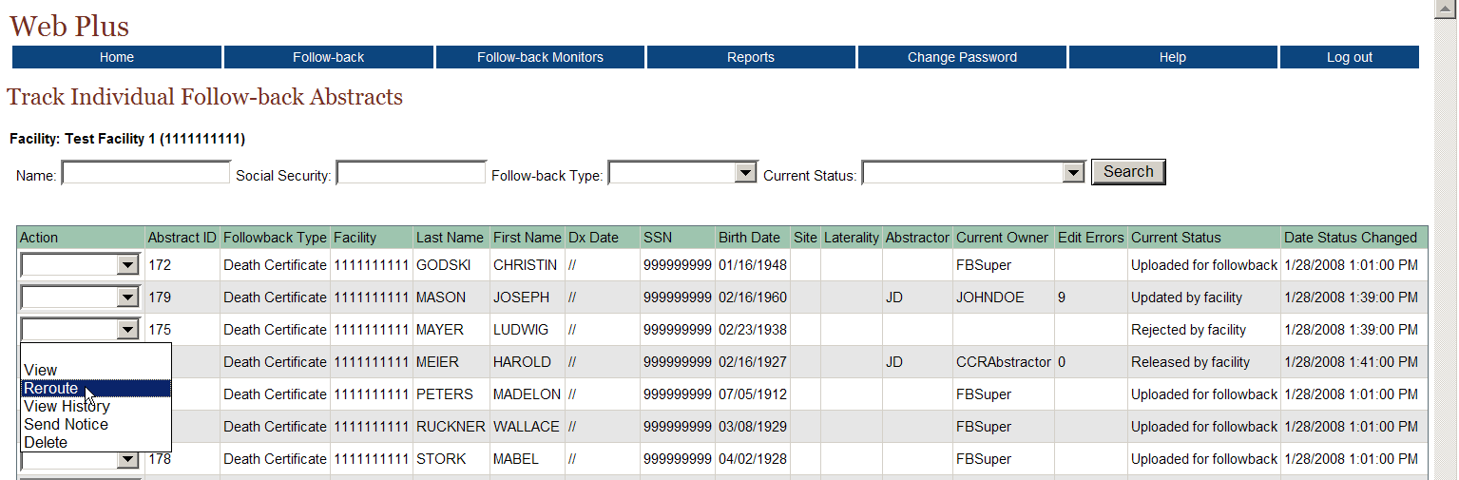
- From the listing of follow-back abstracts in the file, locate the abstract you would like to reroute, and using the pull-down menu in the Action column, select Reroute.
Result: The Reroute Follow-back Abstract page opens.
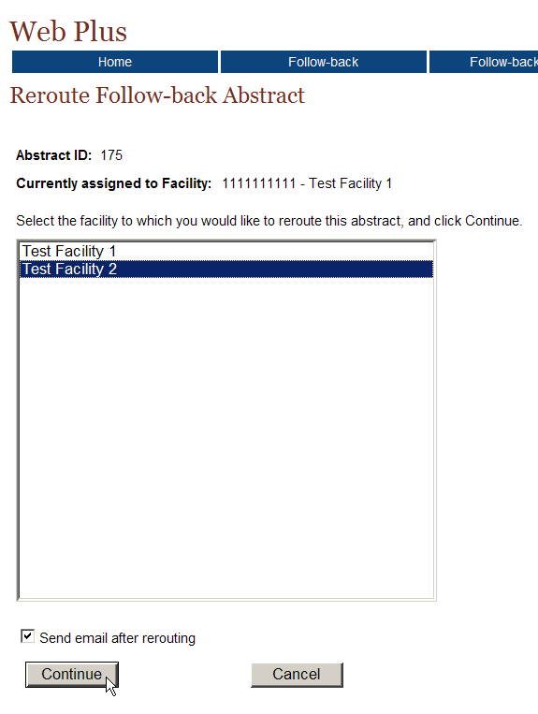
The Reroute Follow-back Abstract lists the follow-back abstract’s Abstract ID, and the facility to which the follow-back abstract is currently assigned.
- From the list of facilities, select the facility you would like to reroute the abstract to, and click Continue. In the example shown, abstract ID # 175 is being rerouted from Test Facility 1 to Test Facility 2.
Result: If you do not have the Send e-mail after file upload checkbox clicked, a message will be displayed confirming that the follow-back abstract has been rerouted:
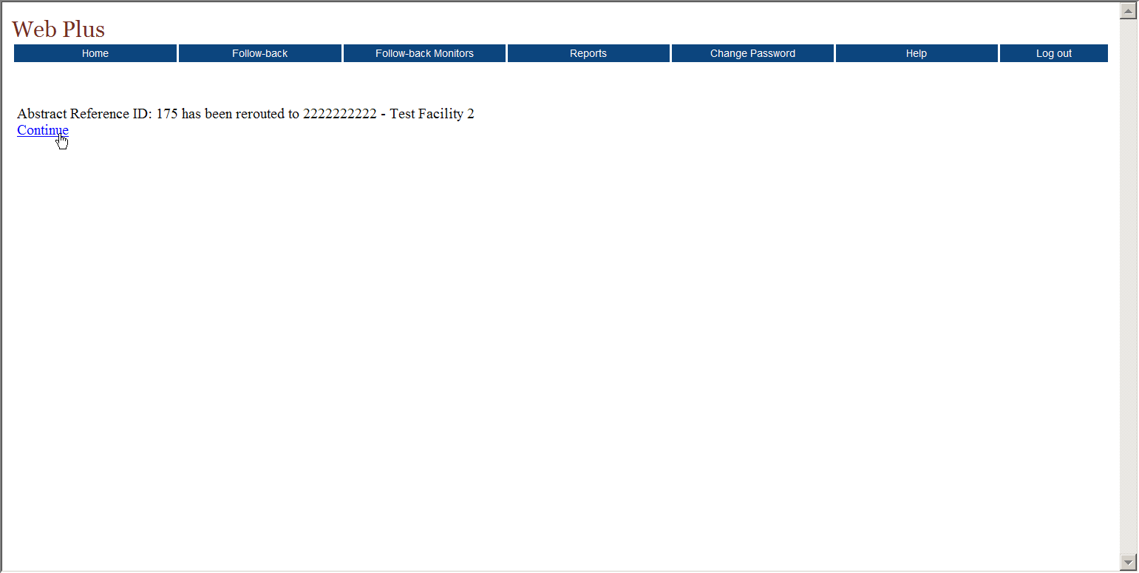
However, if the Send e-mail after rerouting checkbox is clicked:
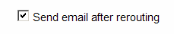
When you click continue, you will be taken to the reroute follow-back abstract confirmation page, which states that the abstract has been successfully rerouted:
- Click Continue.
Result: You are taken to the Send E-mail Notice page, to compose and send an e-mail to the abstractors at the facility to which the follow-back abstract was rerouted. You will learn more about sending e-mail notices in Chapter 6: Sending E-mail Notices.

View History
Each action that is performed on a follow-back abstract is logged by the Web Plus follow-back tracking system. As a result, a complete “history”, i.e., each action performed, when it was performed, and by whom, can be viewed for each follow-back abstract. The Follow-back Supervisor can use this information when monitoring follow-back abstracts or when communicating with facilities regarding a specific follow-back abstract.
To view the history of an individual follow-back abstract for a facility, complete these steps:
- On the Track Follow-back Requests by Facility page, locate the facility for which you would like to monitor follow-back abstracts, and click the Track Abstracts link in the Action column. In the example shown, Test Facility 1 (Facility ID 1111111111) is selected.
Result: The Track Individual Follow-back Abstracts page opens for the selected facility.
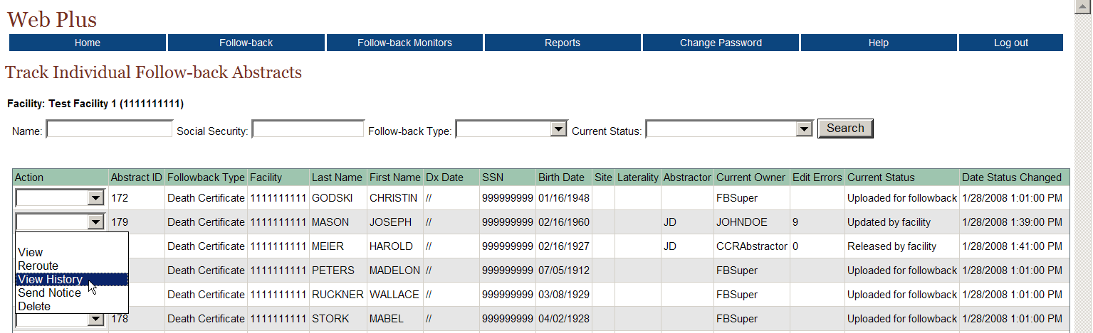
- From the listing of follow-back abstracts in the file, locate the follow-back abstract of interest, and using the pull-down menu in the Action column, select View History.
Result: The View Follow-back Abstract History window opens.
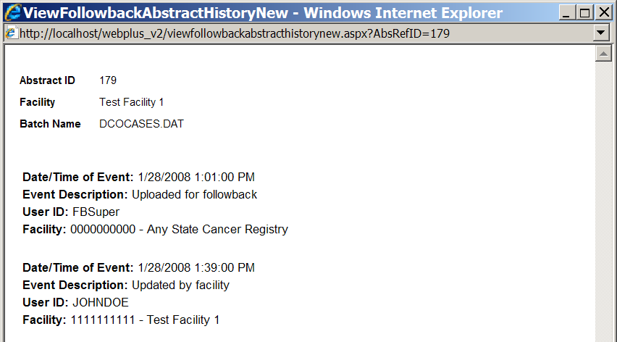
The Abstract ID of the follow-back abstract, the facility to which the follow-back abstract is assigned, and the file in which the abstract was uploaded are displayed at the top of the window. For each action performed on a follow-back abstract, the View Follow-back Abstract History window lists the date/time of the action, a description of the action taken, the User ID of the user performing the action, and the facility at which the action was performed.

Send Notice
Follow-back Supervisors can access the follow-back e-mail functions from the Track Individual Follow-back Abstracts page to send e-mails to abstractors at the facility to which a follow-back abstract is assigned.
To send an e-mail regarding an individual follow-back abstract in a follow-back file, complete these steps:
- On the Track Follow-back Requests by Facility page, locate the facility for which you would like to monitor follow-back abstracts, and click the Track Abstracts link in the Action column. In the example shown, Test Facility 1 (Facility ID 1111111111) is selected.
Result: The Track Individual Follow-back Abstracts page opens for the selected facility.
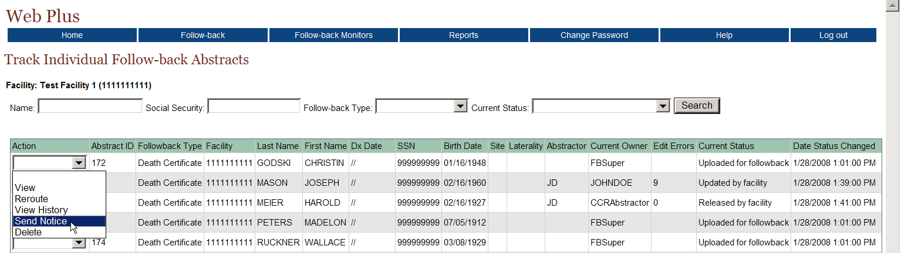
- From the listing of follow-back abstracts in the file, locate the follow-back abstract of interest, and using the pull-down menu in the Action column, select Send Notice.
Result: You are taken to the Send E-mail Notice page, to compose and send an e-mail to the abstractors at the facility to which the follow-back abstract is assigned. You will learn more about sending e-mail notices in Chapter 6: Sending E-mail Notices.

Delete
Sometimes follow-back efforts for a follow-back abstract hit a “dead-end”, i.e., it may be rejected by a facility because the patient was not treated there, and no other facility/physician can be identified for follow-back efforts, or a tumor associated with a follow-back abstract may be reported by another reporting source or via other means during the follow-back effort. As a result, the Follow-back Supervisor may occasionally need to delete a follow-back abstract from the Web Plus follow-back system.
When you delete a follow-back abstract, you remove all traces of the abstract from Web Plus, i.e., it will be removed from the facility follow-back list, as well as the follow-back tracking system; no record of the abstract will remain in the system.
As with regular online abstracts, Web Plus will not let you delete a follow-back abstract once it has been completed and released by the facility. Once information has been released from the facility, the facility must maintain a record of the released information as required by HIPAA; either in hardcopy or online.
To delete an individual follow-back abstract for a facility, complete these steps:
- On the Track Follow-back Requests by Facility page, locate the facility for which you would like to monitor follow-back abstracts, and click the Track Abstracts link in the Action column. In the example shown, Test Facility 1 (Facility ID 1111111111) is selected.
Result: The Track Individual Follow-back Abstracts page opens for the selected facility.
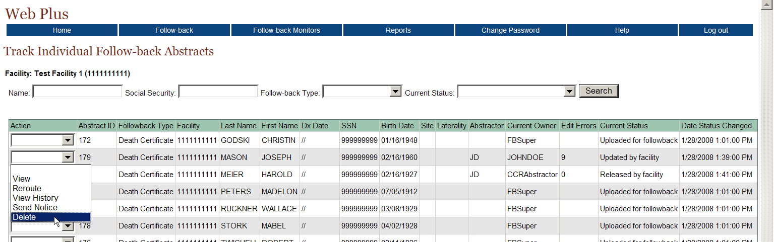
- From the listing of follow-back abstracts in the file, locate the follow-back abstract you would like to delete, and using the pull-down menu in the Action column, select Delete.
Result: The Delete Follow-back Abstract window opens, asking for confirmation of the deletion.
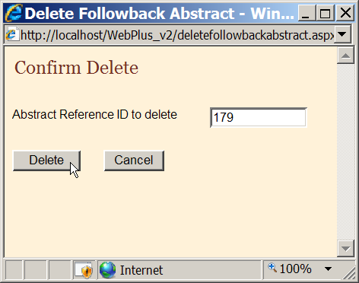
- Click Delete.
Result: A message appears in the Delete Follow-back Abstract window to let you know that abstract has been successfully deleted.
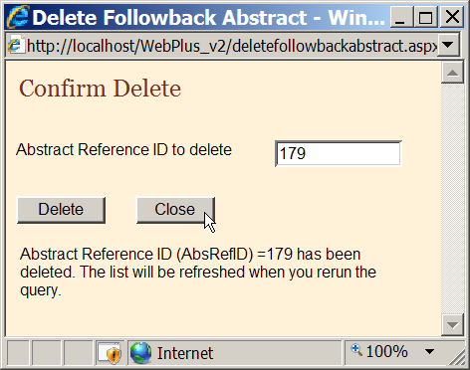
- Click Close.
Result: You are returned to the Track Individual Follow-back Abstracts page. When this page is refreshed, the deleted abstract will no longer be included in the list of follow-back abstracts.

Sending Notice
The Track Follow-back Requests by Facility page is one of many ways to access the Web Plus e-mail function. The Follow-back Supervisor can use the Track Follow-back Requests by Facility page to quickly send e-mails to all abstractors at a particular facility.
To send an e-mail to all abstractors at a facility, complete these steps:
- On the Track Follow-back Requests by Facility page, locate the facility whose abstractors you would like to correspond with, and click the Send Notice link in the Action column.

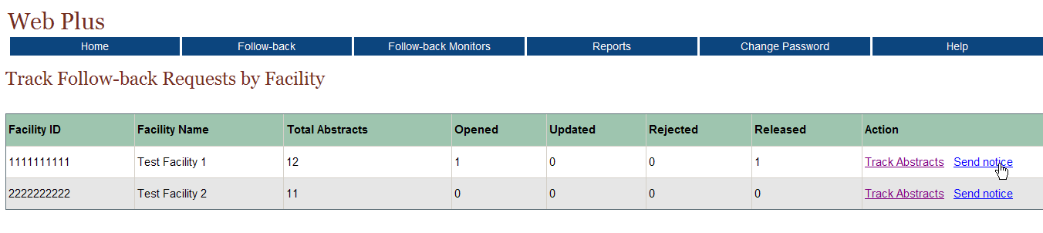
Result: You are taken to the Send E-mail Notice page, to compose and send an e-mail to the abstractors at the selected facility. You will learn more about sending e-mail notices in Chapter 6: Sending E-mail Notices.

Questions
Answer these questions tracking follow-back requests by facility (the answers are in Appendix A, on page 87 ):

- What menu item and option do you use to track follow-back requests by facility?

- How do you view the history of actions performed on a follow-back abstract assigned to a particular facility?

- How do you delete a follow-back abstract from Web Plus?

Sending E-mail Notices

Learning Objectives
In this chapter you learn:
- How to navigate to the Send E-mail Notice page
- How to use the follow-back e-mail feature to send e-mail notices to facility abstractors regarding follow-back abstracts

Overview
In this chapter you learn how to access the Send E-mail notice page, and about how to use the Send E-mail Notice feature to communicate with facility abstractors via e-mail regarding follow-back abstracts.

Sending E-mail Notices
Web Plus follow-back features include a built-in e-mail function, so that central registry Follow-back Supervisors and Follow-back Monitors can communicate with physicians and facility abstractors regarding follow-back abstracts via e-mail. All e-mails are sent using the Send Email Notice page, which can be accessed by Follow-back Supervisors and Monitors from several locations in the Web Plus module. E-mails can be sent at anytime in the follow-back process: upon upload of a follow-back file to Web Plus or when adding a follow-back abstract online, while tracking the completion status of follow-back abstracts by file or facility, upon re-routing of a follow-back abstract, and for reminder purposes.
To send an e-mail to facility abstractors at anytime during follow-back efforts, complete these steps:
- First, you must access the Send Email Notice page:
  - If you are uploading a follow-back file, click the send e-mail after file upload checkbox.
  - If you are rerouting a follow-back abstract, click the send e-mail after rerouting checkbox.
  - If you are tracking follow-back abstracts by file or facility, click the Send Notice link.
  - If you are tracking individual follow-back abstracts, select Send Notice from the Action column of the Track Individual Follow-back Abstracts pages.
  - If you are adding a follow-back abstracts online, click on the Send E-mail button in the upper right-hand corner of the page.

Result: Regardless of from where you access the Send Email Notice page, the same Send Email Notice page will be opened.

Selecting and Working with Templates
To facilitate the follow-back process, the Web Plus follow-back e-mail function allows you to save e-mails for re-sending at a later time. For example, you may want to save death certificate or pathology lab follow-back initial notice and 30-day notice e-mails, and re-use them for subsequent or ongoing follow-back efforts. These saved e-mails are called templates. You can save new templates, and open, update, or delete existing e-mail templates.
When the Send Email Notice page is opened, the Subject field and the body of the e-mail will be blank. You can enter a new e-mail message, or open an existing e-mail message template.
- To begin a new e-mail, just start typing. To open an existing e-mail template, select the template from the drop-down menu to the right of Select a template. In the example shown, the Death Certificate Follow-back Initial Notice template is selected.
Result: The selected e-mail template is opened.
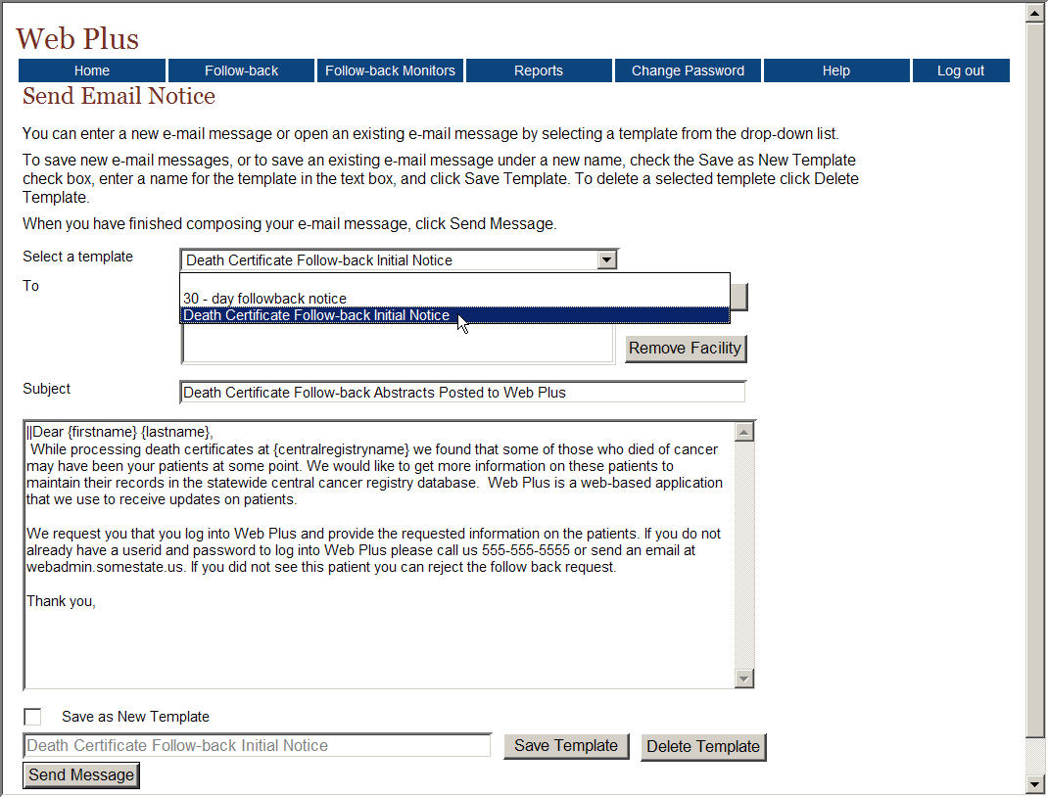

Saving New E-mail Templates
To save new e-mail messages, or to save an existing e-mail message under a new name, check the Save as New Template check box, enter a name for the template in the text box, and click Save Template.

Deleting E-mail Templates
To delete a selected template, select the template from the pull-down menu, and click Delete Template.

Filling the “To” Field
Depending on from where you access the Send Email Notice page, the To field may be filled in automatically. To field is automatically filled in:
- If the send e-mail after file upload checkbox is clicked upon file upload
- If the send e-mail after rerouting checkbox is clicked upon follow-back abstract rerouting
- You access the Send Email Notice page from the Track Follow-back Requests by File page
- You access the Send Email Notice page from the Track Follow-back Requests by Facility page.
However, even when a facility name (or names) is automatically filled into the To field by Web Plus, you can edit the selection.
- To fill the To field, or add a facility to the pre-filled selection, click Add Facility to the right of the To box.
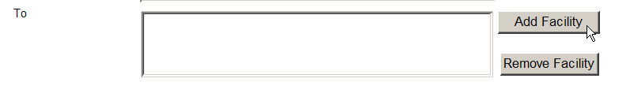
Result: The Add Facility to Email List window opens.
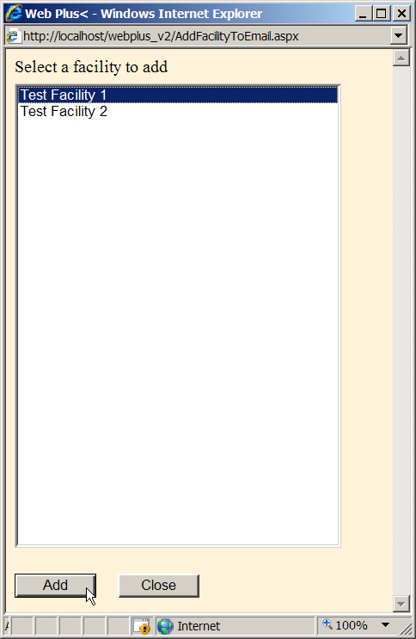
- Select the facility of the abstractors you would like to send an e-mail to, and click Add. In the example shown, Test Facility 1 is selected.
- If you want to send the e-mail to abstractors at another facility, select that facility and click Add. In the example shown, Test Facility 2 is also selected and added. Continue in this manner until you have selected all of the facilities of interest. Then click Close.
Result: The application returns you to the Send Email Notice page, where the name of the facility(ies) selected are entered in the To field. Web Plus will send the e-mail to all abstractors at the facilities listed in the To field of the e-mail, without your having to select all of the individual abstractors’ e-mail addresses.

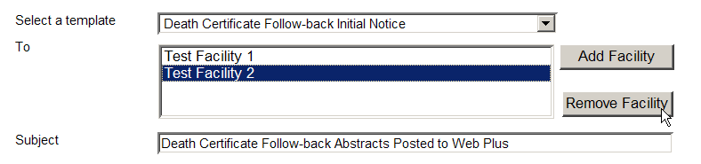
- To remove a facility from the To field, select the facility name, and then click Remove Facility.
Result: The application deletes the selected facility from the To field.
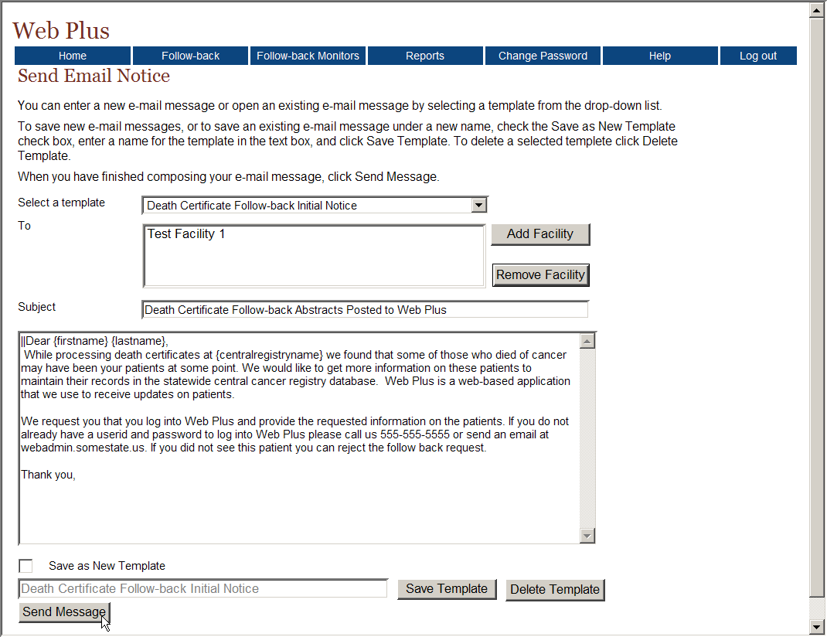
- When you have finished composing your e-mail message, click Send Message.
Result: The Death Certificate Follow-back Initial notice e-mail message is sent to all users at the selected facility(ies). You remain on the Send Email Notice page, where confirmation that the e-mail has been sent is displayed.
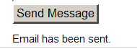
In the body of e-mail you can use some key words to do macro substitutions. {firstname}, {lastname}, and {centralregistryname} can be used to be substituted by the e-mail recipients’ first and last names and the central cancer registry name when the e-mail is sent.

Questions
Answer these questions about sending e-mail notices (the answers are in Appendix A, on page 87 ):

- Name 2 of 5 the ways that you can access the Send Email Notice page in Web Plus follow-back.

- Do you have to type an e-mail from scratch each time you want to send an e-mail?

- How do you delete an e-mail template from Web Plus?

Adding Follow-back Abstracts Online

Learning Objectives
In this chapter you will learn to:
- Understand the process of adding follow-back abstracts online
- Manually add follow-back abstracts online
- Send e-mails to facility abstractors regarding an online follow-back abstract

Overview
In this chapter you learn about follow-back abstracts that are begun online, entered manually rather than being uploaded in a follow-back file. You will learn how to add follow-back abstracts online, and how to send an e-mail to the assigned facility about the follow-back abstract.

Online Follow-back Abstracting Process
In some cases, a registry might not have access to their death certificate or pathology report information in electronic form, and thus cannot map this information to the NAACCR file format and upload a follow-back file to the Web Plus follow-back system. To accommodate these circumstances, Web Plus follow-back features include a function that allows Follow-back Supervisors to manually abstract the necessary information into Web Plus in order to generate the partially-filled follow-back abstracts.
The process of creating a follow-back abstract online, updating it with data, and releasing it to the facility for further updating can be accomplished manually in Web Plus. It is very similar to the process by which Web Plus facility abstractors create new abstracts. After you create a follow-back abstract, you can save it at any time and return to your work at a later time. You can release the abstract to the facility only after you have completed it at the central level, and eliminated any errors it may contain.
1. Create follow-back abstract
2. Update data
3. Correct errors
4. Complete abstract
5. Release follow-back abstract to facility
The process of generating a follow-back abstract includes the following steps:
- Create the follow-back abstract with the Facility ID of the assigned facility, the patient’s name and social security number, and save the abstract. You can open and complete the abstract whenever you want.
- Abstract information from the death certificate or pathology report into the follow-back abstract, entering codes and text as required. Save the follow-back abstract to retain the information you have entered.
- Correct errors. Each time you open or save the abstract, Web Plus automatically edits the entered information for accuracy and completeness using the edit set and required fields selected by your Web Plus Central Registry Administrator for the display type for follow-back initial data entry.
- After you have entered all your data and corrected all errors, the system saves your new abstract as complete.
- Release the completed abstract to the facility for further updating. They will eventually complete the abstract, and release it back to the central registry.

Adding Follow-back Abstracts Online
When adding a follow-back abstract online, you abstract case information from the death certificate or pathology report using the Death Certificate or Pathology Follow-back Abstract data entry page.
To add a follow-back abstract online, complete the following steps:
- On the Web Plus menu, point to Follow-back, then click either Add Death Cert Follow-back Online or Add Pathlab Follow-back Online.
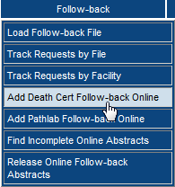 Or 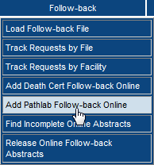
Result: The Data Entry page opens for the selected follow-back type. In the example shown, Add Death Cert Follow-back Online was selected.
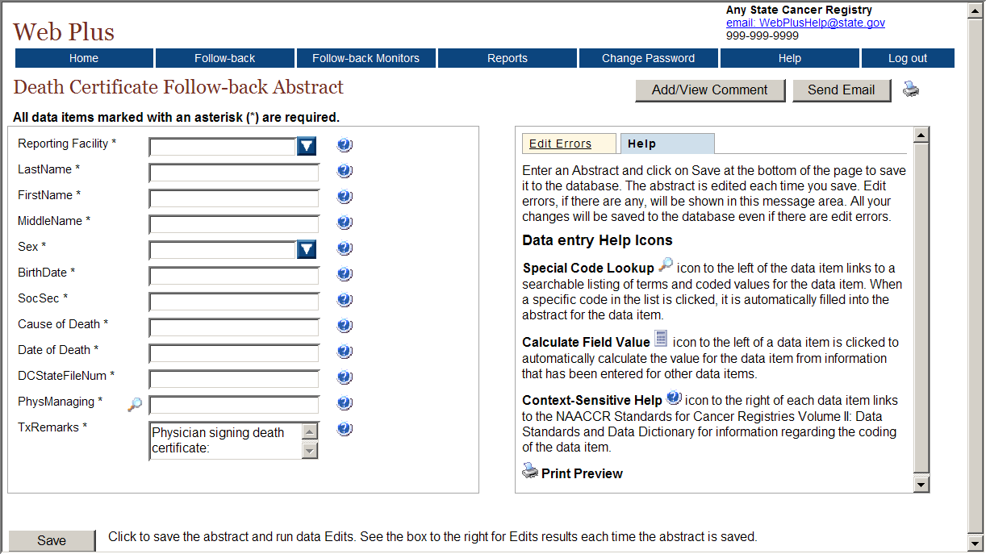
Notice that the page has two main sections. The box on the left contain the fields where you enter the information for the follow-back abstract. The box on the right contains two tabs: Help and Edit Errors.
- In the entry box on the left, scroll down the list to view all of the fields, including the text fields. The fields you see and are required to enter depend on the display type selected by your Web Plus Central Registry Administrator for follow-back initial data entry.
- In the right box, click each of the tabs to see the content. These are the Web Plus tabs:
Tab | Description
Help | This area describes the saving and editing of an abstract and provides a description of the data entry help icons available to the abstractor.
Edit Errors | This area lists any errors that may exist in an abstract after you have opened or saved the abstract.
- Click the Help tab, if is not already open. This area provides a legend describing the data entry help icons available to you as you abstract, and briefly describes the process of saving your abstract.
Result: The Help box opens.
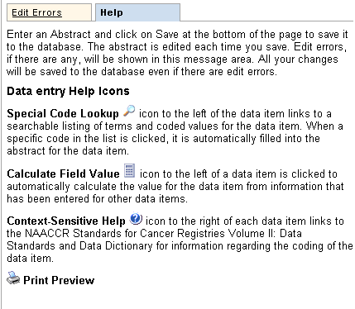
These are the Web Plus icons:
Icon | Description | Click the icon to . . .
 | Special Lookups | open a listing of codes and terms to choose from. Find the term that best applies, and click on the code to the left of the term. When a specific code is clicked, it is automatically filled into the abstract for the data item.
 | Calculate Field Value | Calculate a value for a field from values in other fields.
 | Context-sensitive Help | open Help page with the NAACCR Standards for Cancer Registries Volume II: Data Standards and Data Dictionary for information about the data item.
 | Print Preview | open page that shows all of the fields and the content you have entered in your abstract; this page allows you to print a copy of your abstract.
- Abstract the information from the death certificate or pathology report into the follow-back abstract, saving the information as you enter it. Any edit errors will be displayed on the Edit Errors tab after saving the abstract; when the Edit Result shows no errors, you have completed your abstract. In the example shown, information is being abstracted from a death certificate.
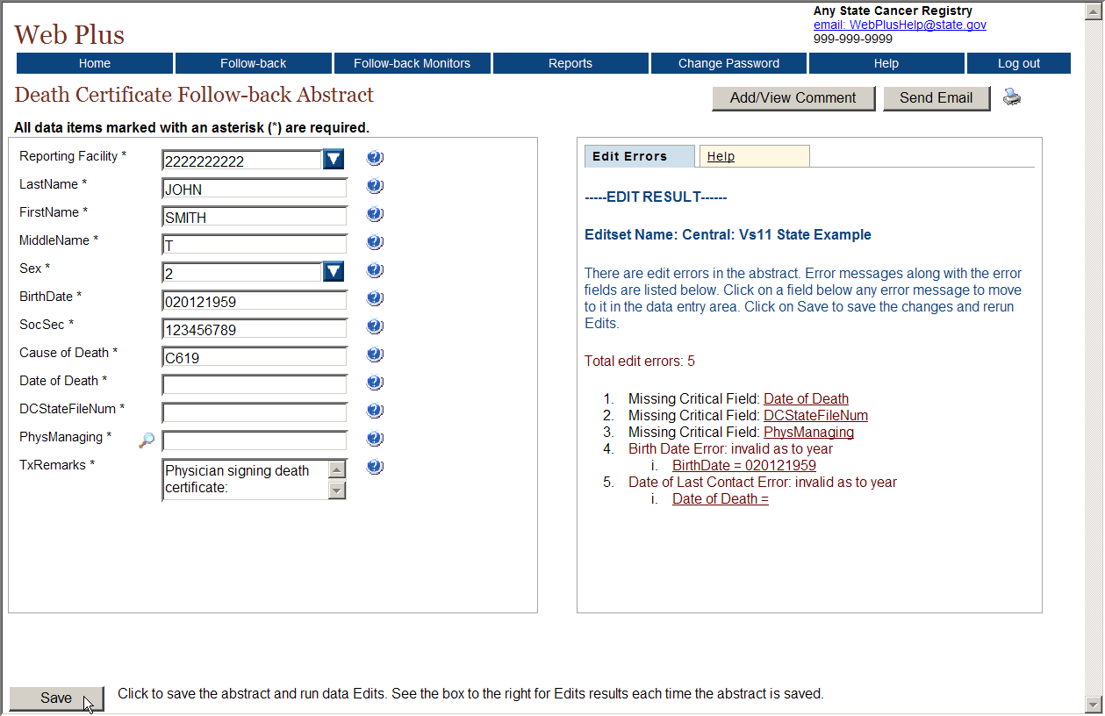
- Click Save.
Result: When you have completed the abstract and saved it with no edit errors, the Edit Errors tab will display the following message:
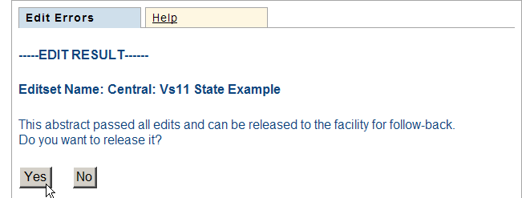
- Click Yes to release the follow-back abstract to the facility for further updating, or No if you would like to release it at a later time.
Once online follow-back abstracts are completed and released to facilities, use the Track Follow-back Status by File or the Track Follow-back Status by Facility option from the Follow-back menu to track the status of the abstracts.

Adding Comments/Sending E-mails
To facilitate tracking efforts, comments may be added to the online follow-back abstract while abstracting it by clicking on Add/View Comments in the upper right-hand corner of the page.
In addition, an e-mail may be sent regarding the follow-back abstract being viewed by clicking on Send Email in the upper right-hand corner of the page. You are taken to the Send E-mail Notice page, to compose and send an e-mail to the abstractors at the facility to which the follow-back abstract is assigned. You will learn more about sending e-mail notices in Chapter 6: Sending E-mail Notices.
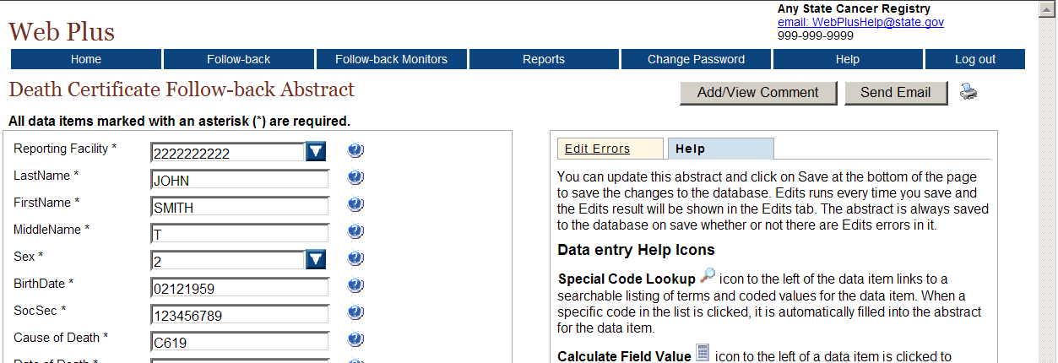

Questions
Answer these questions about adding follow-back abstracts online (the answers are in Appendix A, on page 88 ):

- What menu item and option do you use to add a follow-back abstract online?

- When is a follow-back abstract which has been added online complete?

Finding Incomplete Follow-back Abstracts

Learning Objectives
In this chapter you will learn to:
- Search for incomplete follow-back abstracts that you have begun entering online but have not yet completed
- Open an incomplete online follow-back abstract
- Delete an incomplete online follow-back abstract

Overview
In this chapter you learn about how to locate and open follow-back abstracts that you have begun online, but have not yet completed. You will also learn how to delete an incomplete online follow-back.

Finding Incomplete Online Abstracts
When adding a follow-back abstract online, you may not be able to complete an abstract all at once, or you may want to complete several online follow-back abstracts, and then release them at the same time. As a result, you may have incomplete online follow-back abstracts in the Web Plus follow-back system that you need to find and complete or release.
To find an incomplete online follow-back abstract, complete these steps:
- On the Web Plus menu, point to Follow-back, then click Find Incomplete Online Abstracts.
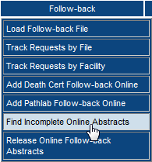
Result: The Find Incomplete Online Abstract page opens.
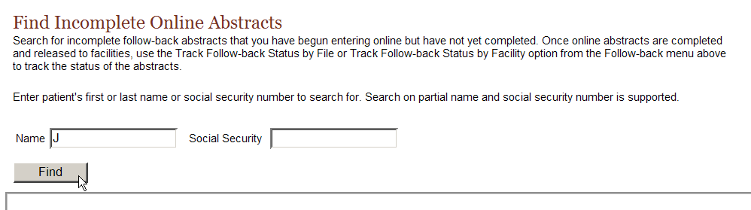
- Enter patient's first or last name or social security number to search for and click Find. Search on partial name and social security number is supported. In the example shown, abstracts with “J” in the name fields have been searched for.
If you click Find without entering any search criteria, a list of all the incomplete online follow-back abstracts is displayed.
Result: The Find Incomplete Online Abstracts page opens with a list of incomplete online follow-back abstracts that match your search criteria.
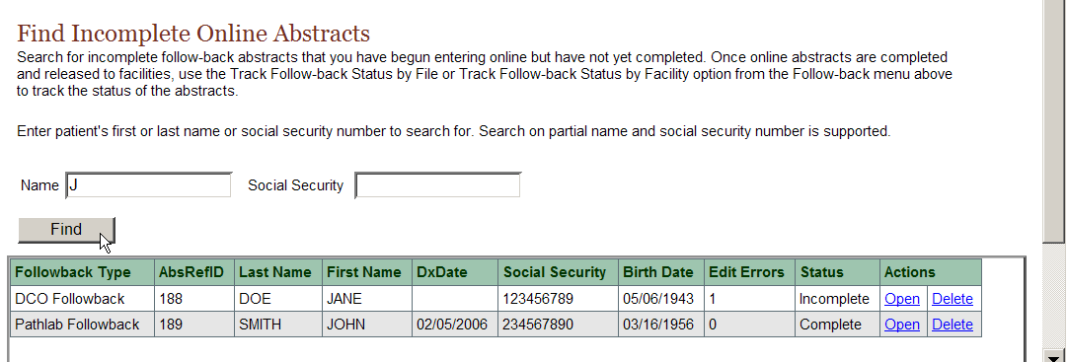
The Find Incomplete Online Abstracts page includes these fields and column headings:
Columns | Description
Follow-back Type | Type of follow-back abstract (Death Certificate or Pathlab)
AbsRefID | AbsRefID, or Abstract ID, is a system-generated number identifying the abstract
Last Name | Last name of patient
First Name | First name of patient
Dx Date | Diagnosis date
Social Security | Patient’s social security number
Birth Date | Patient’s date of birth
Edit Errors | The number of errors found in the edit process after a follow-back abstract has been opened and saved
Status | Current status of the online follow-back abstract, either Incomplete or Complete
Actions | Select from among the actions that can be performed on the incomplete online a follow-back abstract:  Open: Open the online follow-back abstract to update, complete, or release it  Delete: Delete the incomplete online follow-back abstract from Web Plus
- From the list of incomplete follow-back abstracts displayed, select the abstract of interest, and click Open in the Actions column.
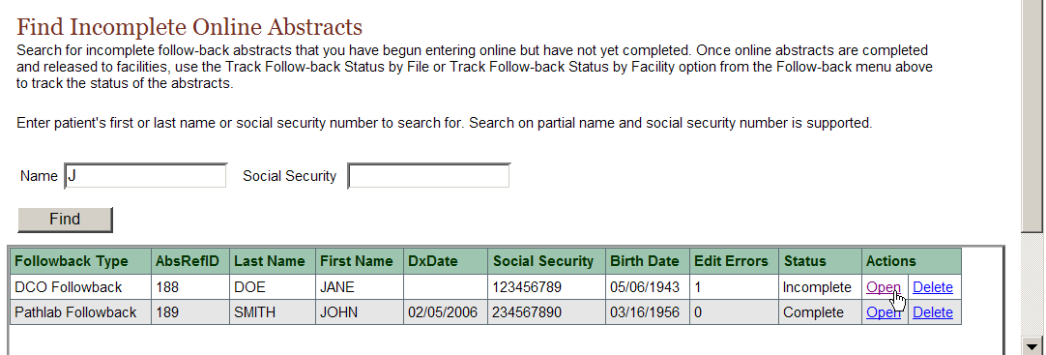
Result: The Data Entry page opens for the selected online follow-back abstract.
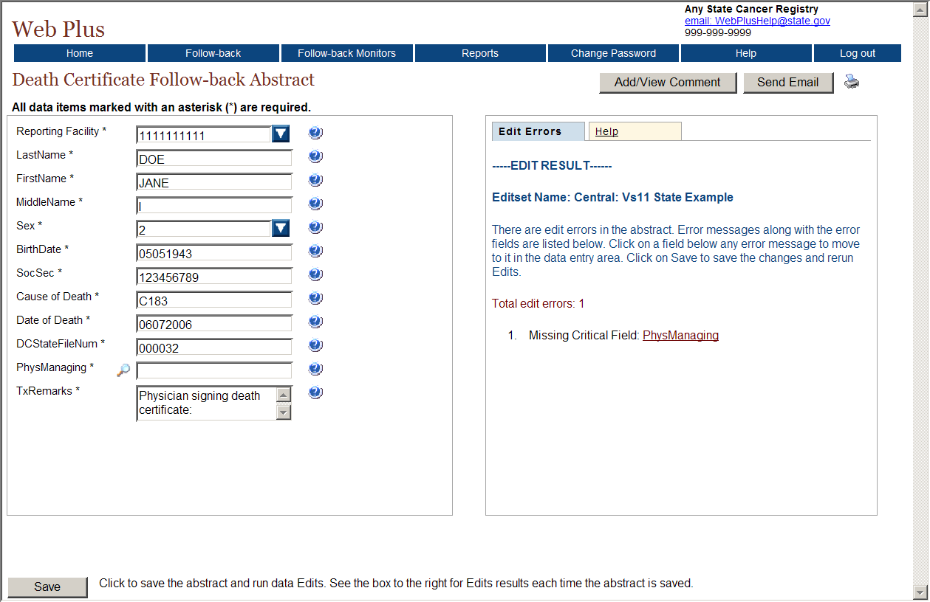
You can now work with the follow-back abstract to update, complete, or release it.

Deleting an Online Follow-back Abstract
An incomplete online follow-back abstract may be begun in error. As a result, the Follow-back Supervisor may occasionally need to delete an incomplete online follow-back abstract from the Web Plus follow-back system.
To delete an incomplete online follow-back abstract, complete these steps:
- On the Web Plus menu, point to Follow-back, then click Find Incomplete Online Abstracts.
- Click Find.
- From the list of online follow-back abstracts displayed, select the abstract of interest, and click Delete in the Actions column.
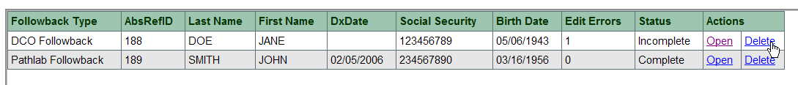
Result: The Delete Follow-back Abstract window opens, asking for confirmation of the deletion.
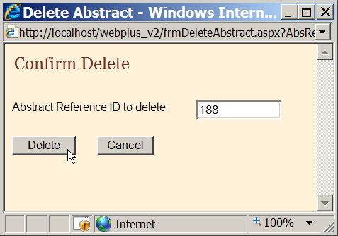
- Click Delete.
Result: A message appears in the Delete Follow-back Abstract window to let you know that abstract has been successfully deleted.
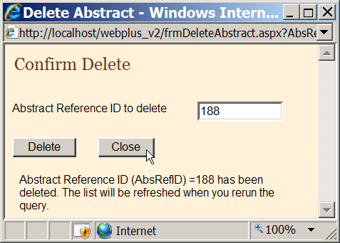
- Click Close.
Result: You are returned to the Find Incomplete Online Abstracts page. When this page is refreshed, the deleted abstract will no longer be included in the list of follow-back abstracts.
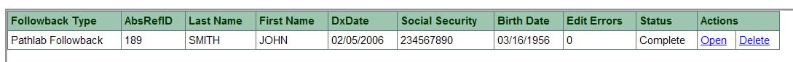

Questions
Answer these questions about finding incomplete online follow-back abstracts (the answers are in Appendix A, on page 88 ):

- What menu item and option do you use to find an incomplete online follow-back abstract?

- How do you delete an incomplete online follow-back abstract?

Batch Release of Online Follow-back Abstracts

Learning Objectives
In this chapter you will learn to:
- Release multiple completed follow-back abstracts that you have entered online at the same time

Overview
In this chapter you learn about how to release more than one online follow-back abstracts at the same time.

Releasing Online Follow-back Abstracts
When adding a follow-back abstracts online, you may not want to release each one as it is completed. Rather, you may want to complete several online follow-back abstracts, and then release them all at once.

To release multiple complete online follow-back abstracts, complete these steps:
- On the Web Plus menu, point to Follow-back, then click Release Online Follow-back Abstracts.
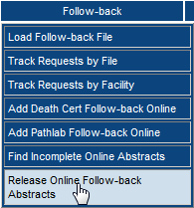
Result: The Find Incomplete Online Abstract page opens.
- Enter patient's first or last name or social security number to search for and click Find. Search on partial name and social security number is supported. In the example shown, abstracts with “J” in the name fields have been searched for.
If you click Find without entering any search criteria, a list of all the incomplete online follow-back abstracts is displayed.
Result: The Find Incomplete Online Abstracts page opens with a list of incomplete online follow-back abstracts that match your search criteria.

Assigning Follow-back Monitors

Learning Objectives
In this chapter you will learn to:
- Understand the Follow-back Monitor role in Web Plus
- Assign a facility to a Follow-back Monitor, so that they can track follow-back efforts for that facility

Overview
In this chapter you learn about the Follow-back Monitor role in Web Plus. You will also learn how to assign facilities to Follow-back Monitors, so that they can track the follow-back abstracts for specific facilities to ensure that the abstracts get completed and released to the central registry.

Web Plus Follow-back Monitor
When conducting follow-back efforts, a central registry may have too many follow-back abstracts in Web Plus to be tracked by a single individual. In this case, the registry might have more than one Follow-back Supervisor, or may choose to have one or more Follow-back Monitors working under the Follow-back Supervisor. The Follow-back Monitor primarily works to track follow-back abstracts for specific facilities to ensure their resolution.

Follow-back Monitor Menu Options
When the Follow-back Monitor logs into Web Plus, they see the Web Plus Follow-back Monitor menu items:
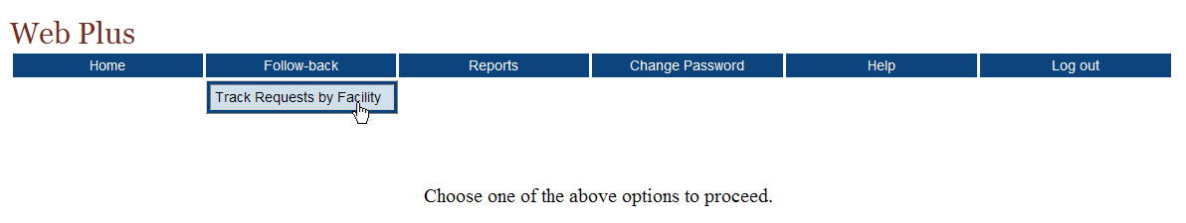
The Follow-back Monitor performs a subset of the Follow-back Supervisor tasks; they can track follow-back abstracts by facility only for their assigned facilities, and generate and view a subset of Web Plus follow-back reports.
The Follow-back Supervisor can oversee the efforts of each individual Follow-back Monitor using specific reports available in the Web Plus follow-back system. Two types of reports in particular, the Outstanding Abstracts by Follow-back Monitor report, and the Outstanding Abstracts by Follow-back Monitor and Facility report, are available for both death certificate follow-back and pathology lab follow-back efforts, and facilitate the supervision of Follow-back Monitors during follow-back efforts. Please see Chapter 10: Web Plus Follow-back Reports for more information about the reports available to you to help you supervise the efforts of Follow-back Monitors at your registry.

Assigning Follow-back Monitors
To assign a Follow-back Monitor to a specific facility, complete these steps:
- On the Web Plus menu, click Follow-back Monitors.
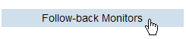
Result: The Assign Follow-back Monitor page opens.
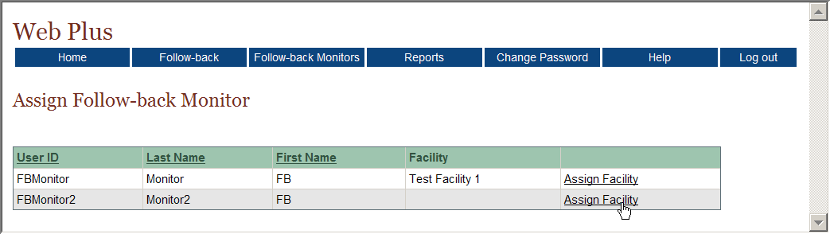
The Assign Follow-back Monitor page displays a list of all Follow-back Monitors in Web Plus, and includes the Follow-back Monitor’s User ID, name, and the facilities to which he or she is assigned.
- Locate the Follow-back Monitor you would like to assign a facility to, and click the Assign Facility link in the right-most column. In the example shown, Test facility 2 is being assigned to FB Monitor2.
Result: The Assign/Remove Follow-back Facilities page opens for the selected Follow-back Monitor.
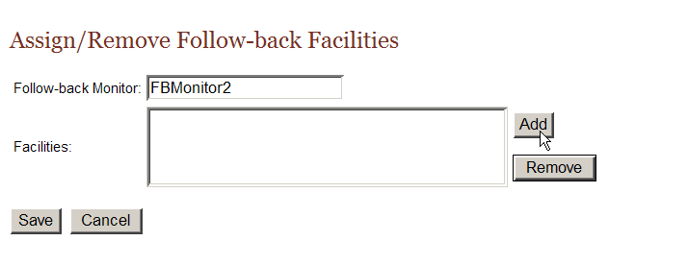
- Click Add.
Result: The Add Facility to Monitor window opens, with a list of facilities to choose from.
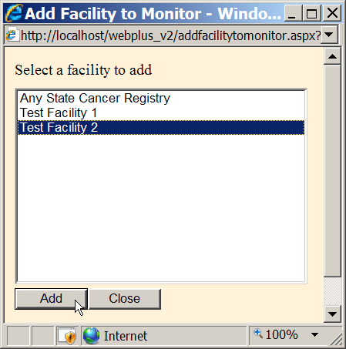
- Select the facility that you would like to assign to the Follow-back Monitor, and click Add, and then click Close.
Result: You are returned to the Assign/Remove Follow-back Facilities page for the selected Follow-back Monitor, with the specified facility assigned.
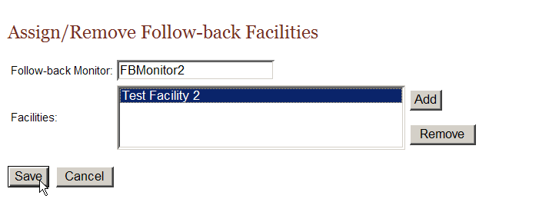
- Click Save.
Result: You are returned to the Assign Follow-back Monitor page, where the added facility is now listed for the Follow-back Monitor.
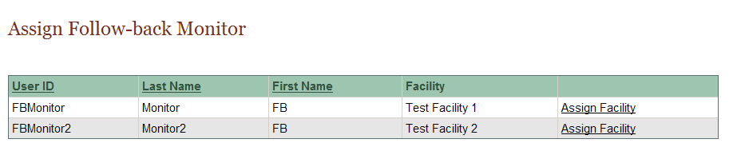
The Follow-back Monitor can now track follow-back abstracts for the assigned facility. When the Follow-back Monitor logs into Web Plus and goes to the Track Abstracts by Facility page, the facility will now be included in the list of facilities displayed and available for tracking by the Follow-back Monitor.

Questions
Answer these questions about assigning Follow-back Monitors (the answers are in Appendix A, on page 88 ):

- What is the main responsibility of the Follow-back Monitor?

- Which menu option opens the page where you assign facilities to Follow-Back Monitors?

Reports

Learning Objective
In this chapter, you will learn:
- To open and print a follow-back report
- To set a date range for a follow-back report
- About the various follow-back reports available in Web Plus

Overview
Web Plus provides follow-back reports at both the central registry and facility level. The central registry follow-back reports are provided to facilitate the tracking of follow-back efforts, as well as the individual follow-back abstracts to ensure their resolution. The available facility follow-back report is a line listing of follow-back abstracts assigned to the facility, and is provided so that Follow-back Supervisors, Follow-back Monitors, and facility abstractors can readily access and print out a list of follow-back abstracts assigned to the facility. The various follow-back reports are available for both death certificate and pathology lab follow-back efforts.

Opening, Setting Date Ranges, and Printing Follow-back Reports

Opening Follow-back Reports
To open a follow-back report, after you have logged in, complete these steps:
- On the Web Plus menu, click Reports.
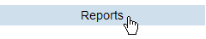
Result: Web Plus displays a list of the follow-back reports available for viewing by Follow-back Supervisors.
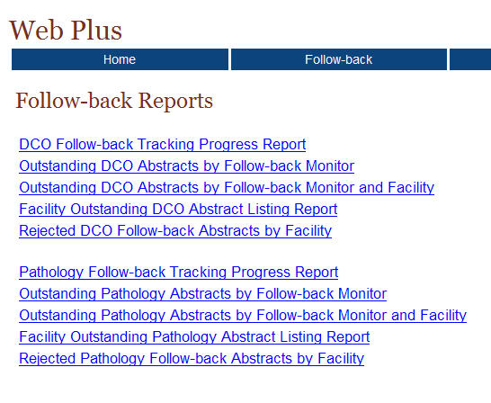
This table describes the follow-back reports available for viewing by the Follow-back Supervisor.
Report. . . | Lists for the follow-back type. . .
DCO Follow-back Tracking Progress Report  Pathology Follow-back Tracking Progress Report | a graph which shows the overall progress of the follow-back effort, and lists the total number of follow-back abstracts that have been resolved, the total number remaining, and how many follow-back abstracts were resolved by week for the past eight weeks
Outstanding DCO Abstracts by Follow-back Monitor  Outstanding Pathology Abstracts by Follow-back Monitor | for each Follow-back Monitor, the total number of follow-back abstracts that have not yet been released by the facilities assigned to the Monitor
Outstanding DCO Abstracts by Follow-back Monitor and Facility  Outstanding Pathology Abstracts by Follow-back Monitor and Facility | for each Follow-back Monitor, the total number of follow-back abstracts that have not yet been released by the facilities assigned to the Monitor, by assigned facility
Facility Outstanding DCO Abstract Listing Report  Facility Outstanding Pathology Abstract Listing Report | a line listing of all follow-back abstracts assigned to the facility that have not yet been released by the facility
Rejected DCO Abstracts by Facility  Rejected Pathology Abstracts by Facility | a line listing of all follow-back abstracts assigned to the facility that have been rejected by the facility
Clicking the name of the report opens a separate window displaying the report.
- Click on the DCO Follow-back Tracking Progress Report link.
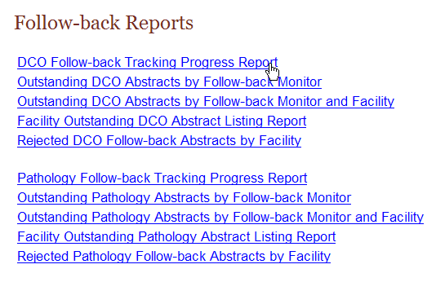
Result: The DCO Follow-back Tracking Progress Report opens in a separate window.

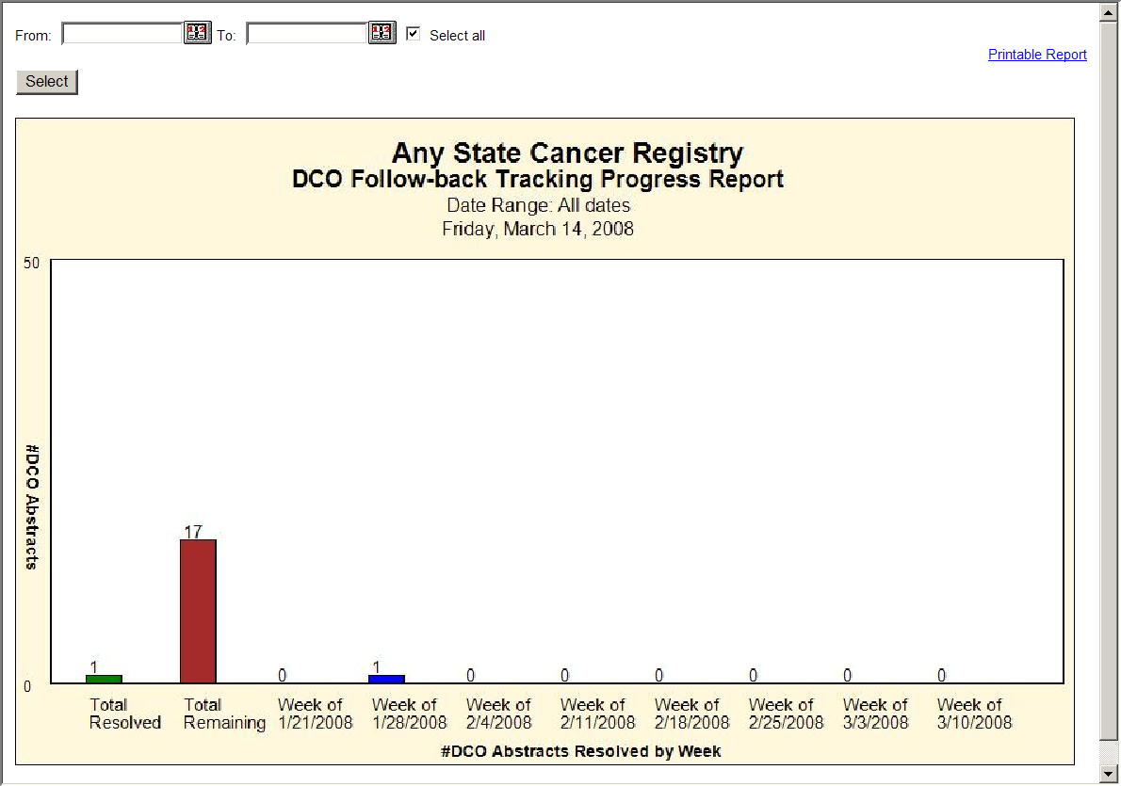

Setting the Date Range for Follow-back Reports
Some follow-back reports offer the user the option to enter a date range for the report. Date ranges work a little differently for follow-back reports than for other reports in Web Plus; the user must be careful to enter the dates associated with the follow-back effort of interest to generate a report for that follow-back effort. The From date will be the upload date for the follow-back file containing the follow-back abstracts for the follow-back effort of interest, or the date that you entered the first online follow-back abstract for the follow-back effort. The To date will be the current date (for present follow-back efforts), or the date a prior follow-back effort ended.
To set the date range for a follow-back report, complete these steps:
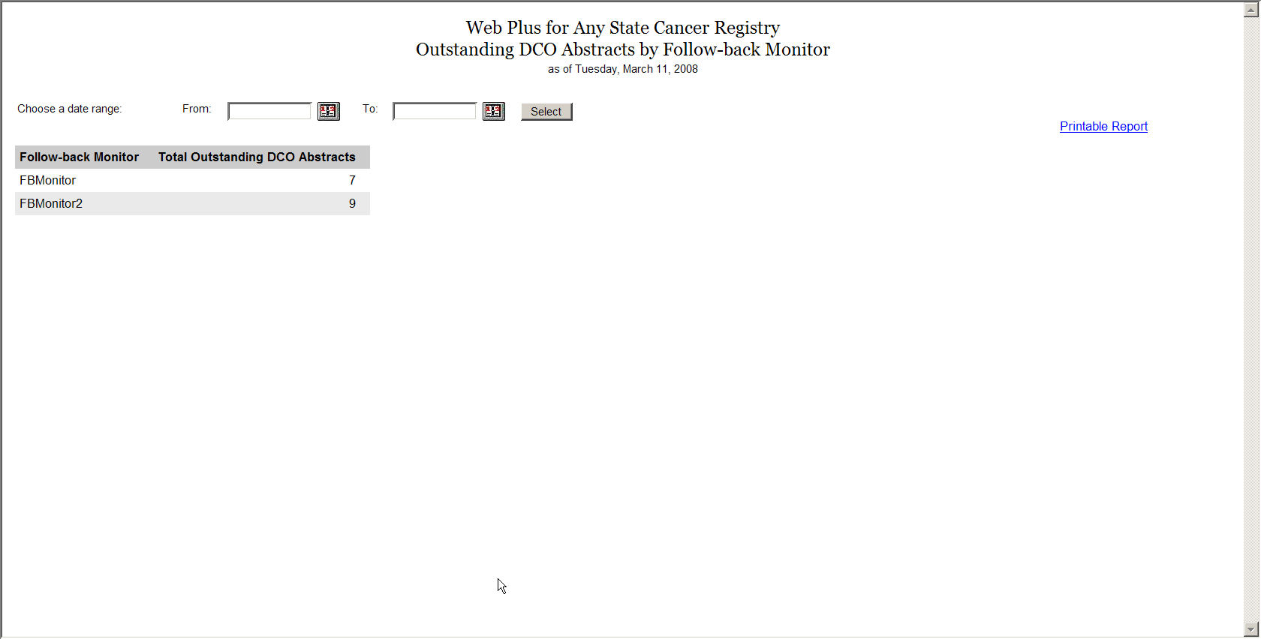
- On any opened report page, click the calendar icon beside the From date field.
Result: The calendar window opens.
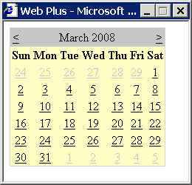
- Click the date you would like. The system inserts the date in the field and closes the calendar window.
You can also type the date in the window by using the mm/dd/yyyy format, such as 03/01/2008 for March 1, 2008. The date calendar and format are the same for both the From and To date fields.
- Repeat steps 1 and 2, clicking on the calendar icon beside the To date field.
Result: You are returned to the Follow-back Report window, with the specified dates entered into the From and To date fields.
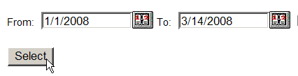
- Click Select.
Result: The follow-back report is displayed with the information restricted to the date range (or follow-back effort) specified.
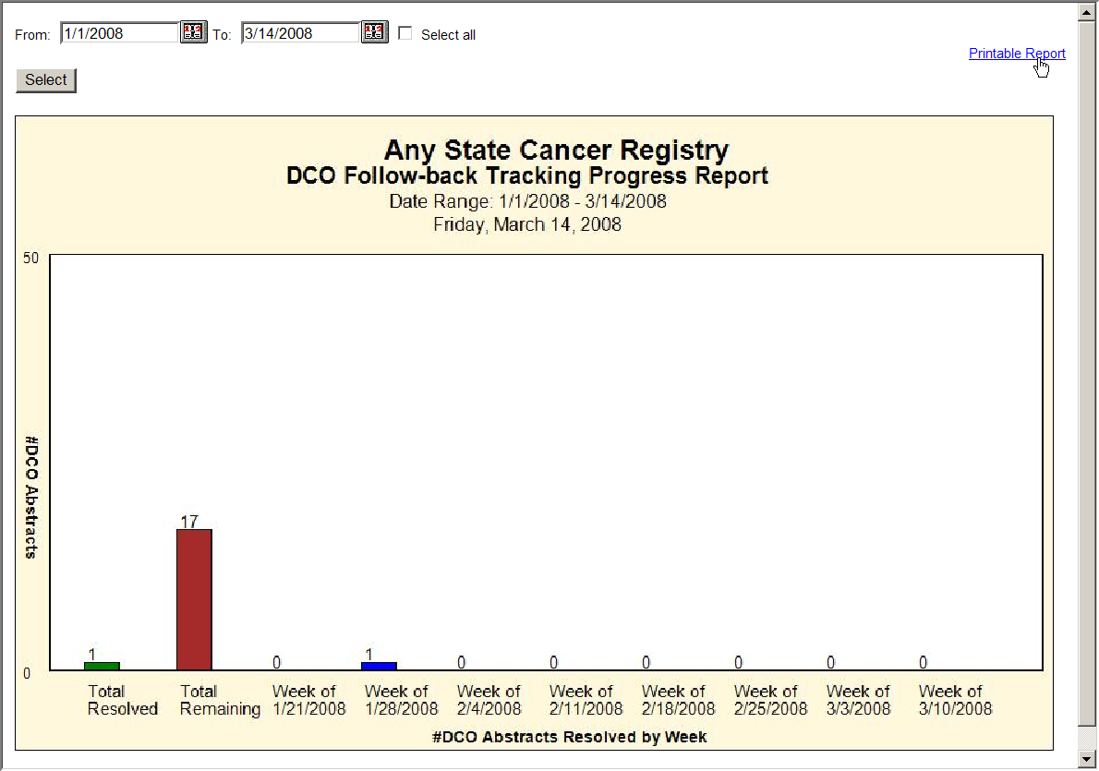

Printing Follow-back Reports
To print a follow-back report, click on the Printable Report link in the upper right-hand corner of the report window.
Result: A page opens with a printable version of the report.
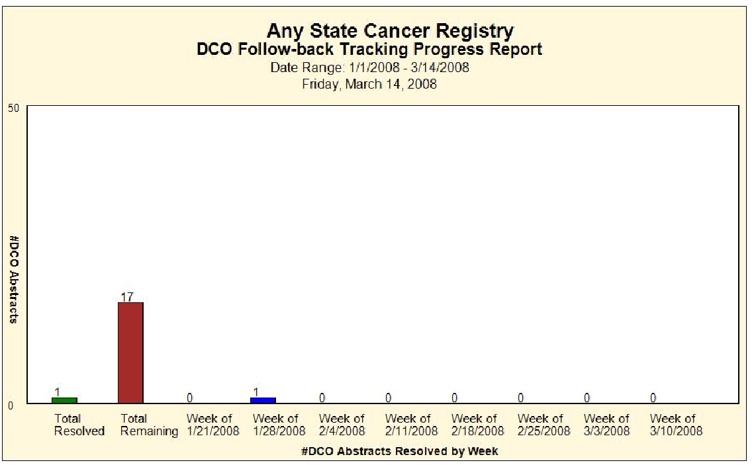
For optimum printing results, print Web Plus reports in landscape mode. To print in landscape, click on File→Page Setup, and click on Landscape.
In addition, if you wish to remove the internal report name from the upper left-hand corner of the printed report, remove the &w&b from the header field. If you wish to remove the URL listing from the bottom of the report, remove the information in the footer field (the date prints on the report already).

Follow-back Tracking Progress Report
The DCO Follow-back Tracking Progress and Pathology Follow-back Tracking Progress Reports can be used to quickly assess where you are in your follow-back efforts. These reports display a graph which shows the overall progress of the follow-back effort for the particular follow-back type, and lists the total number of follow-back abstracts that have been resolved, the total number remaining, and how many follow-back abstracts were resolved by week for an eight week period; either the past eight weeks (by default), or any date range that you specify. As a result, the Follow-back Tracking Progress Reports can be used to view the resolution rate and progress of present or past follow-back efforts.
To open a Follow-back Tracking Progress Report, complete these steps:
- On the Web Plus menu, click Reports.
Result: Web Plus displays a list of available follow-back reports.
- Click on either the DCO Follow-back Tracking Progress Report or Pathology Follow-back Tracking Progress Report link. In the example shown the DCO Follow-back Tracking Progress Report is opened.
Result: The Follow-back Tracking Progress Report for the particular follow-back type opens in a separate window.
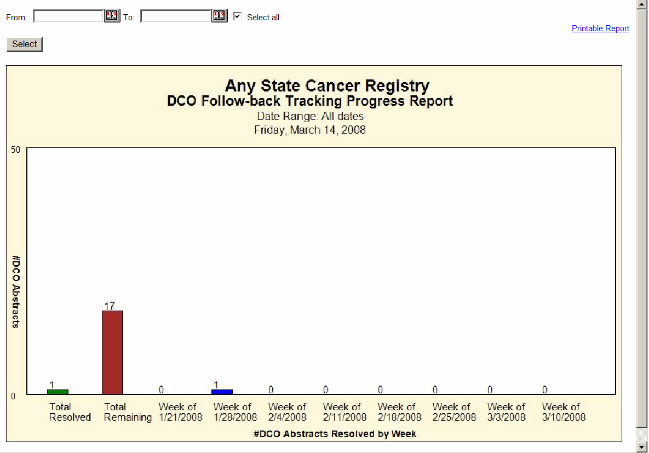
By default, the Select all checkbox is clicked, and the Follow-back Tracking Progress Report will display data for all follow-back abstracts of the particular follow-back type, regardless of when they were added to the Web Plus follow-back system. For your initial follow-back effort, you would leave the Select All check box clicked. However, for subsequent follow-back efforts, you will need to enter a date range to capture the correct data for the graph, to exclude follow-back abstracts from past follow-back efforts.
- To enter a date range, unclick the Select All checkbox.

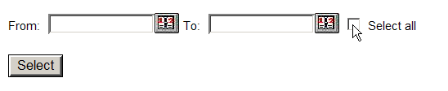
- Enter a From date and To date. For instructions on setting the date range for a follow-back report click here.
The From date will be the upload date for the follow-back file containing the follow-back abstracts for the follow-back effort of interest, or the date that you entered the first online follow-back abstract for the follow-back effort. The To date will be the current date (for present follow-back efforts), or the date a prior follow-back effort ended.
Result: You are returned to the Follow-back Tracking Progress Report window, with the specified dates entered into the From and To date fields.
- Click Select.
Result: The Follow-back Tracking Progress Report is displayed with the information restricted to the date range (or follow-back effort) specified.
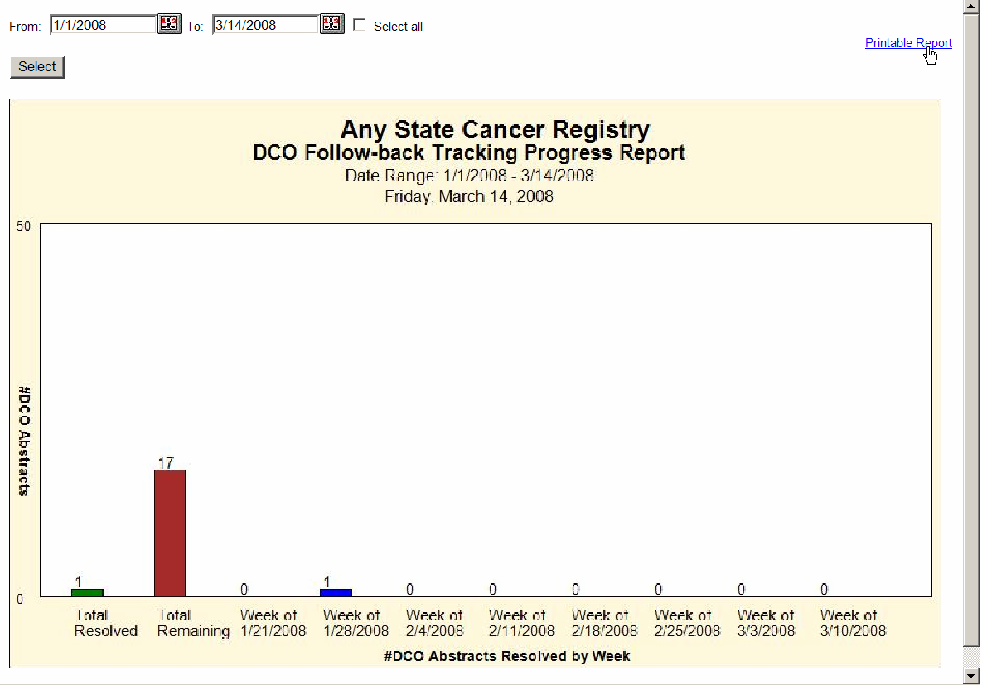
The Total Resolved and Total Remaining bars displayed on the graph will reflect current progress on a present follow-back effort, or for a past follow-back effort, can be used to calculate the resolution rate for that follow-back effort. The # of Abstracts Resolved by Week bars will represent the number of follow-back abstracts released by facilities per week for eight business weeks prior to, and including, the week of the specified End Date.
- To print the report, click on the Printable Report link, or close the report window to return to the Follow-back Reports page.

Follow-back Monitor Reports
Web Plus provides two reports to help the Follow-back Supervisor oversee the efforts of Follow-back Monitors throughout a follow-back effort. The Outstanding Follow-back Abstracts by Follow-back Monitor Report lists the number of follow-back abstracts yet to be released by the facilities assigned to the Follow-back Monitors, and the Outstanding Follow-back Abstracts by Follow-back Monitor and Facility Report lists the number of follow-back abstracts yet to be released by the facilities assigned to the Follow-back Monitors for each facility.

Outstanding Follow-back Abstracts by Follow-back Monitor
The Outstanding Follow-back Abstracts by Follow-back Monitor report can help the Follow-back Supervisor monitor the productivity and remaining workload of the Follow-back Monitors at any point during a follow-back effort.
To open the Outstanding Follow-back Abstracts by Follow-back Monitor Report, complete these steps:
- On the Web Plus menu, click Reports.
Result: Web Plus displays a list of available follow-back reports.
- Click on either the Outstanding DCO Follow-back Abstracts by Follow-back Monitor or the Outstanding Pathology Follow-back Abstracts by Follow-back Monitor link. In the example shown the Outstanding DCO Follow-back Abstracts by Follow-back Monitor report is opened.
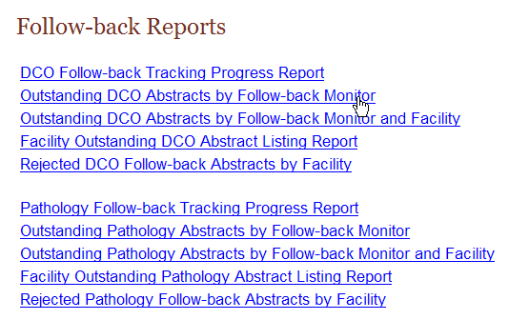
Result: The Outstanding Follow-back Abstracts by Follow-back Monitor report for the particular follow-back type opens in a separate window.

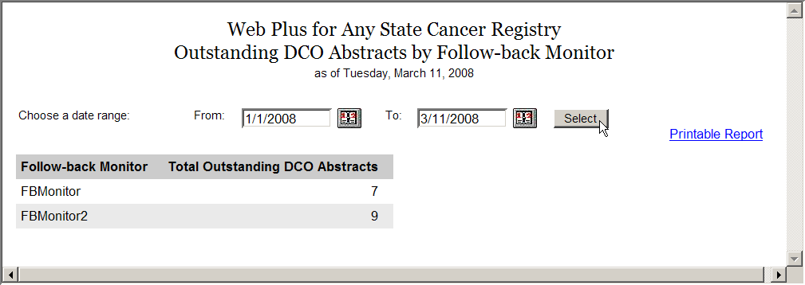
The Outstanding Follow-back Abstracts by Follow-back Monitor report lists for each Follow-back Monitor, the total number of follow-back abstracts that have not yet been released by the facilities that are assigned to the Monitor.
- If necessary, enter a From and To date. By default the From date is January 1, 2008, and the To date is the current date. For instructions on setting the date range for a follow-back report click here.
The From Date will be the upload date for the follow-back file containing the follow-back abstracts for the follow-back effort of interest, or the date that you entered the first online follow-back abstract for the follow-back effort. The To Date will be the current date (for present follow-back efforts), or the date a prior follow-back effort ended.
Result: You are returned to the Outstanding Follow-back Abstracts by Follow-back Monitor report window, with the specified dates entered into the From and To date fields.
- Click Select.
Result: The Outstanding Follow-back Abstracts by Follow-back Monitor report is displayed with the information restricted to the date range (or follow-back effort) specified.
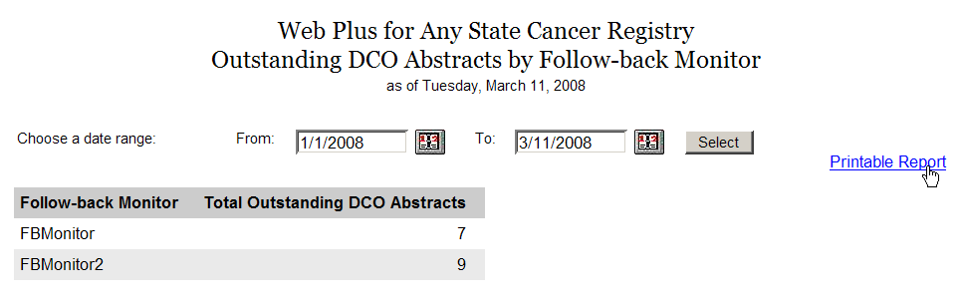
- Click on the Printable Form link.
Result: A page opens with a printable version of the report.
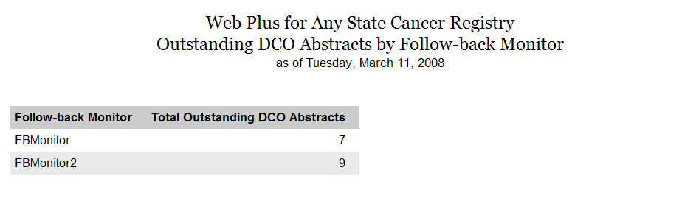

Outstanding Follow-back Abstracts by Follow-back Monitor and Facility
The Outstanding Follow-back Abstracts by Follow-back Monitor and Facility report can help the Follow-back Supervisor easily identify which facilities are posing a challenge for each Follow-back Monitor, and should be targeted for follow-back efforts.
To open the Outstanding Follow-back Abstracts by Follow-back Monitor and Facility report, complete these steps:
- On the Web Plus menu, click Reports.
Result: Web Plus displays a list of available follow-back reports.
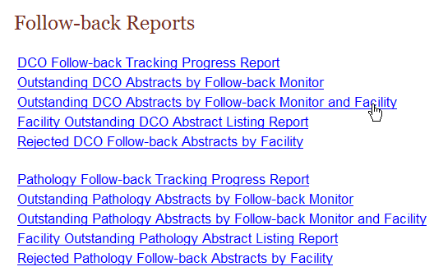
- Click on either the Outstanding DCO Follow-back Abstracts by Follow-back Monitor and Facility or the Outstanding Pathology Follow-back Abstracts by Follow-back Monitor and Facility link. In the example shown the Outstanding DCO Follow-back Abstracts by Follow-back Monitor and Facility report is opened.
Result: The Outstanding Follow-back Abstracts by Follow-back Monitor and Facility Report for the particular follow-back type opens in a separate window.

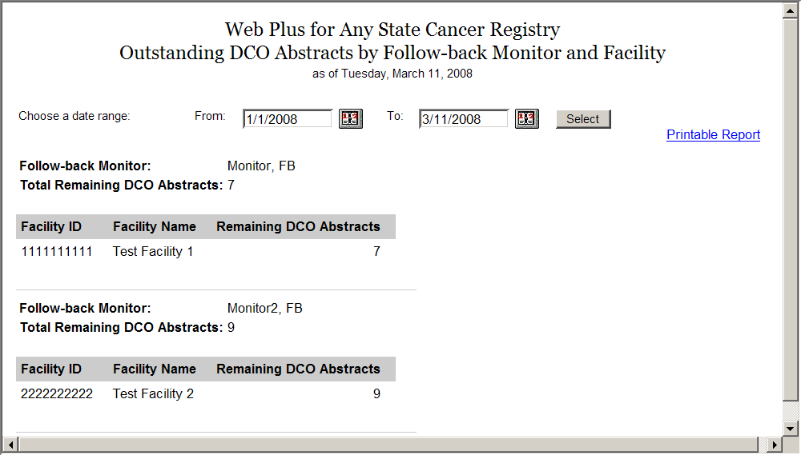
The Outstanding Follow-back Abstracts by Follow-back Monitor by Facility report lists for each Follow-back Monitor, the total number of follow-back abstracts that have not yet been released by the facilities assigned to the Monitor, by assigned facility.
- If necessary, enter a From and To date. By default the From date is January 1, 2008, and the To date is the current date. For instructions on setting the date range for a follow-back report click here.
The From Date will be the upload date for the follow-back file containing the follow-back abstracts for the follow-back effort of interest, or the date that you entered the first online follow-back abstract for the follow-back effort. The To Date will be the current date (for present follow-back efforts), or the date a prior follow-back effort ended.
Result: You are returned to the Outstanding Follow-back Abstracts by Follow-back Monitor and Facility report window, with the specified dates entered into the From and To date fields.
- Click Select.
Result: The Outstanding Follow-back Abstracts by Follow-back Monitor and Facility report is displayed with the information restricted to the date range (or follow-back effort) specified.
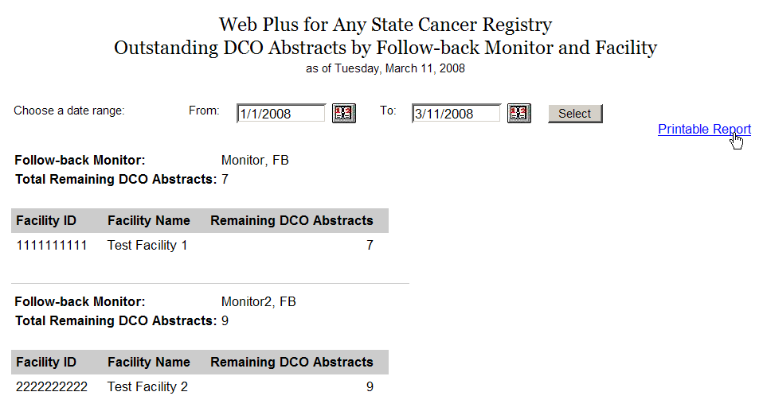
- Click on the Printable Form link.
Result: A page opens with a printable version of the report.
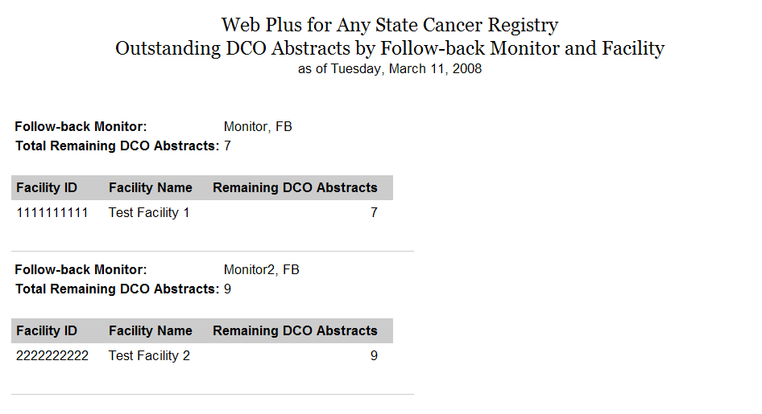

Facility Outstanding Follow-back Abstract Listing Report
The Facility Outstanding Follow-back Abstract Listing report includes a line listing of all follow-back abstracts assigned to facilities that have not yet been released by the facilities, by facility. At the facility level, only the data for the individual facility is included in the report. Facilities can print this report for their records, or if they need to go somewhere away from their computer to look up patient records. Follow-back Supervisors and Monitors can use this report to quickly view a list of outstanding follow-back abstracts for each facility, or to print out a listing for an individual facility. Follow-back Monitors can view data only for facilities assigned to them.
To open the Facility Outstanding Follow-back Abstract Listing report, complete these steps:
- On the Web Plus menu, click Reports.
Result: Web Plus displays a list of available follow-back reports.
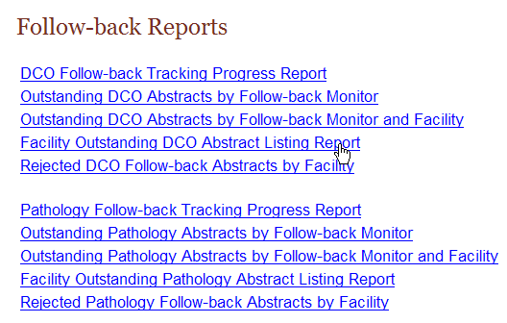
- Click on either the Facility Outstanding DCO Follow-back Abstract Listing Report or the Facility Outstanding Pathology Follow-back Abstract Listing Report link. In the example shown the Facility Outstanding DCO Follow-back Abstract Listing Report is opened.
Result: The Facility Outstanding Follow-back Abstract Listing Report for the particular follow-back type opens in a separate window.
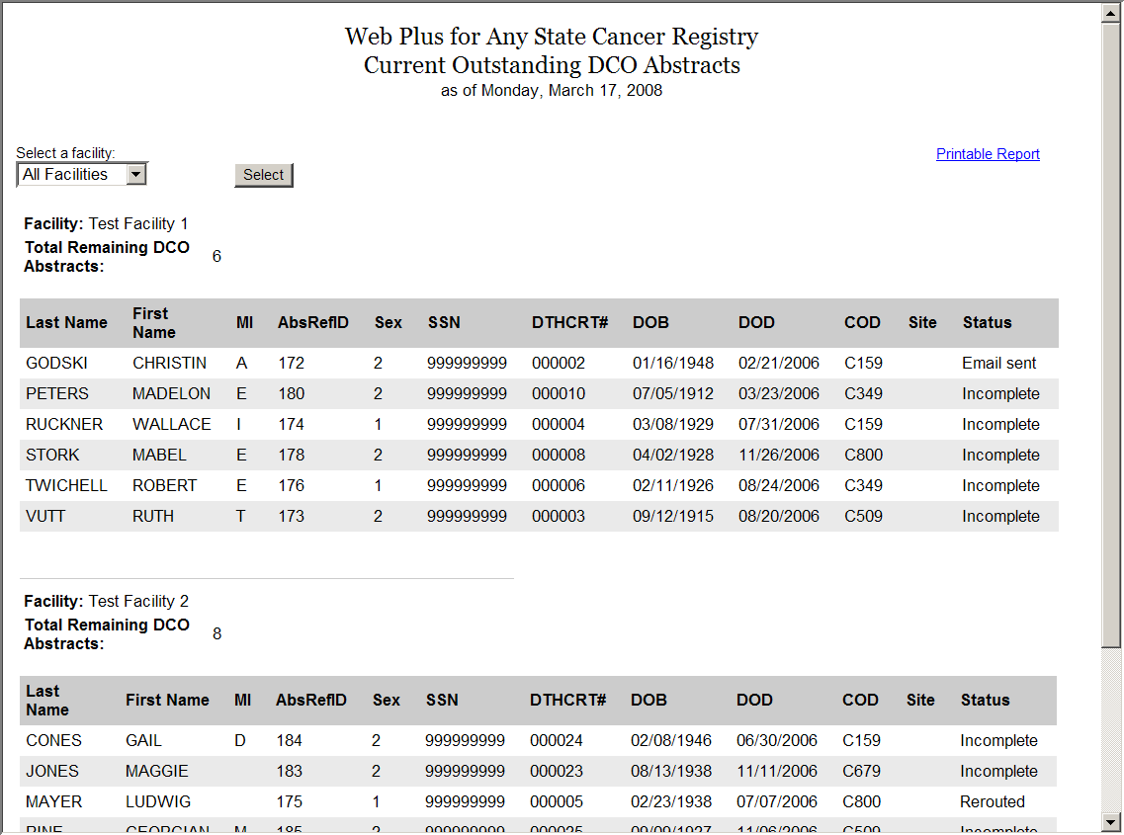
The Facility Outstanding Follow-back Abstract Listing Reports contain these fields:
Field/Headings | Description
Last Name | Last name of patient
First Name | First name of patient
MI | Middle initial of patient
AbsRefID | A unique, system-generated number identifying the abstract
Sex | Patient’s sex
SSN | Patient’s social security number
DTHCRT# | Death certificate number from death certificate (for death certificate follow-back only)
DOB | Patient’s birth date
DOD | Date of patient’s death from death certificate (for death certificate follow-back only)
COD | ICD-10 Cause of Death (for death certificate follow-back only)
Site | ICD-O-3 topography code for the primary site of the tumor being reported
Status | Current status of the outstanding follow-back abstract:  Incomplete, E-mail sent, Rejected, or Rerouted
- By default, line listings will be shown for all facilities. To print out the report for an individual facility, select the facility from the pull-down list, and click Submit. In the example shown, Test Facility 1 is selected.
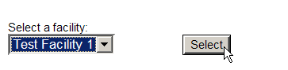
Result: The Facility Outstanding Follow-back Abstract Listing Report for the particular facility opens in a separate window.
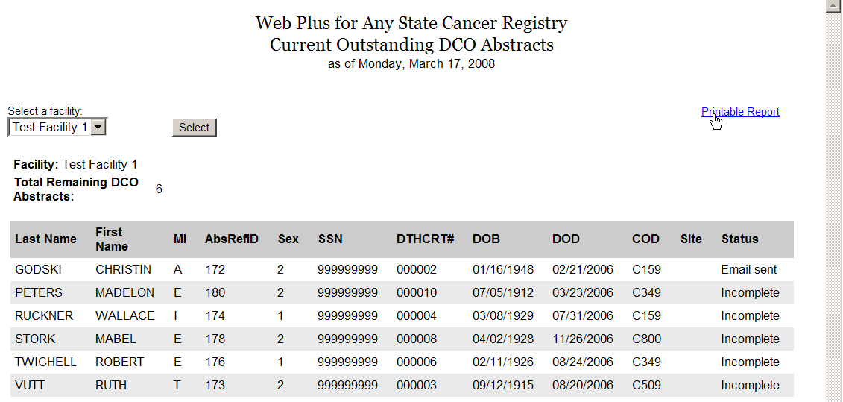
- Click on the Printable Form link.
Result: A page opens with a printable version of the report.
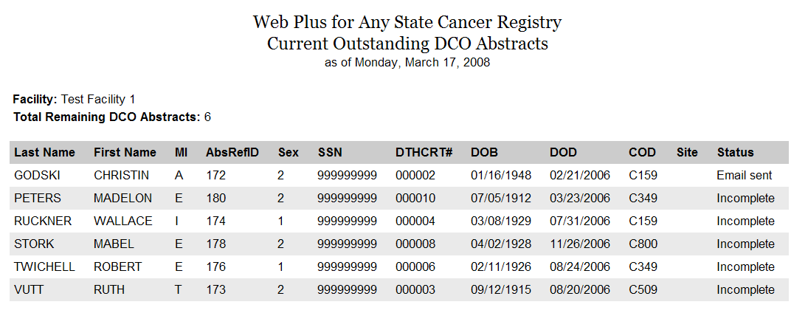

Rejected Follow-back Abstracts by Facility
The Rejected Follow-back Abstracts by Facility reports report includes a line listing by facility of all follow-back abstracts that have been rejected by facilities. Follow-back Supervisors and Monitors can use this report to rapidly identify rejected follow-back abstracts so that they can be re-routed to different facilities or deleted from the Web Plus follow-back system.
To open the Rejected Follow-back Abstracts by Facility report, complete these steps:
- On the Web Plus menu, click Reports.
Result: Web Plus displays a list of available follow-back reports.
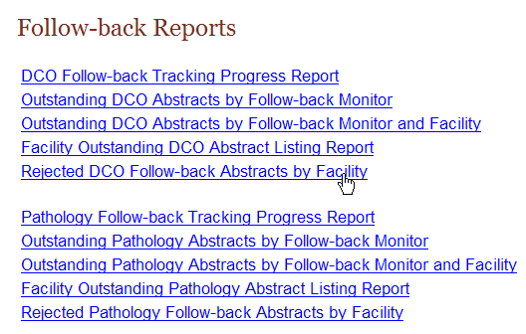
- Click on either the Rejected DCO Follow-back Abstracts by Facility or the Rejected Pathology Follow-back Abstracts by Facility link. In the example shown the Rejected DCO Follow-back Abstracts by Facility report is opened.
Result: The Rejected Follow-back Abstracts by Facility report for the particular follow-back type opens in a separate window.
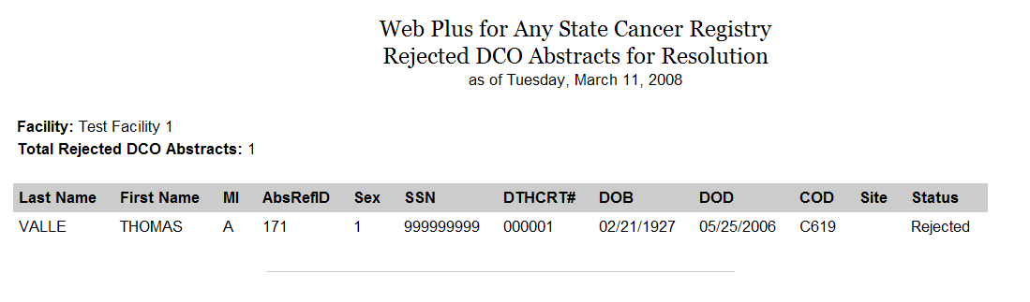
The Rejected Follow-back Abstracts by Facility reports contain these fields:
Field/Headings | Description
Last Name | Last name of patient
First Name | First name of patient
MI | Middle initial of patient
AbsRefID | A unique, system-generated number identifying the abstract
Sex | Patient’s sex
SSN | Patient’s social security number
DTHCRT# | Death certificate number from death certificate (for death certificate follow-back only)
DOB | Patient’s birth date
DOD | Date of patient’s death from death certificate (for death certificate follow-back only)
COD | ICD-10 Cause of Death (for death certificate follow-back only)
Site | ICD-O-3 topography code for the primary site of the tumor being reported
Status | Shows the current Rejected status of the outstanding follow-back abstract

Questions
Answer these questions about follow-back reports (the answers are in Appendix A, on page 88 ):
- Which menu option opens the page where you can view follow-back reports?

- What follow-back report helps track the overall progress of a follow-back effort?

- Where can you go to quickly get a list of follow-back abstracts that have been rejected by facilities?

Appendix A: Answers

Chapter 2: The Basics
These are the answers to the questions (page 9) about the basics of Web Plus:
- To track follow-back abstracts by facility, click the Follow-back menu option, and click Track Follow-back Requests by Facility.
- No, follow-back abstracts may also be manually entered online. click the Follow-back menu option, and click on either Add Death Cert Follow-back Online or Add Pathlab Follow-back Online.
- To log out, click Log Out on the Web Plus menu.

Chapter 3: Generating/Uploading Follow-back Files
These are the answers to the questions (page 17) about generating and uploading follow-back files:
- To upload a file of follow-back abstracts, click the Follow-back menu option, and click on Load Follow-back File.
- All follow-back files should be in NAACCR file format, in the same version you’re your Web Plus application is based on.
- Web Plus currently offers death certificate follow-back and pathology lab follow-back.
- To help map HL7 files to the NAACCR record layout the Mapper Plus program can be used. Contact cancerinfo@cdc.gov for more information.

Chapter 4: Tracking Follow-back Requests by File
These are the answers to the questions (page 32) about managing facilities and user accounts:
- To track individual follow-back requests by uploaded follow-back file, on the Web Plus menu, point to Follow-back, then click Track Requests by File. On the Track Follow-back Requests by File page, locate the follow-back file you for which you would like to track follow-back abstracts, and click on the Track Abstracts link in the Action column.
- To view a follow-back abstract when tracking follow-back abstracts by follow-back file, on the Track Follow-back Requests by File page, locate the file which contains the follow-back abstracts you would like to monitor, and click the Track Abstracts link in the Action column. On the Track Individual Follow-back Abstracts page, from the listing of follow-back abstracts in the file, locate the follow-back abstract of interest, and using the pull-down menu in the Action column, select View.
- To reroute a follow-back abstract once it has been rejected by a facility, on the Track Individual Follow-back Abstracts page, from the listing of follow-back abstracts in the file, locate the follow-back abstract of interest, and using the pull-down menu in the Action column, select Reroute.
- To delete a follow-back file, on the Track Follow-back Requests by File page, locate the file which you would like to delete, and click the Delete File link in the Action column.

Chapter 5: Tracking Follow-back Requests by Facility
These are the answers to the questions (page 45) about tracking follow-back requests by facility:
- To track individual follow-back requests by facility, on the Web Plus menu, point to Follow-back, then click Track Requests by Facility.
- To view the history of actions performed on a follow-back abstract assigned to a particular facility, on the Track Follow-back Requests by Facility page, locate the facility to which the abstract is assigned, and click the Track Abstracts link in the Action column. On the Track Individual Follow-back Abstracts page, from the listing of follow-back abstracts in the file, locate the follow-back abstract of interest, and using the pull-down menu in the Action column, select View History.
- To delete a follow-back abstract from Web Plus, on the Track Follow-back Requests by Facility page, locate the facility to which the abstract is assigned, and click the Track Abstracts link in the Action column. On the Track Individual Follow-back Abstracts page, from the listing of follow-back abstracts in the file, locate the follow-back abstract of interest, and using the pull-down menu in the Action column, select Delete.

Chapter 6: Sending E-mail Notices
These are the answers to the questions (page 51) about sending e-mail notices:
- Any 2 of the 5 following ways that you can access the Send Email Notice page would be correct:
  - Clicking the send e-mail after file upload checkbox when uploading a follow-back file.
  - Clicking the send e-mail after rerouting checkbox when rerouting a follow-back abstract.
  - Clicking the Send Notice link when tracking follow-back abstracts by file or facility.
  - Selecting Send Notice from the Action column of the Track Individual Follow-back Abstracts when tracking individual follow-back abstracts
  - Clicking on the Send E-mail button in the upper right-hand corner of the page when adding a follow-back abstract online.
- No, you do not have to type an e-mail from scratch each time you want to send an e-mail. To save new e-mail messages, check the Save as New Template check box, enter a name for the template in the text box, and click Save Template.
- To delete an e-mail template, select the template from the pull-down menu, and click Delete Template.

Chapter 7: Adding Follow-back Abstracts Online
These are the answers to the questions (page 57) about adding follow-back abstracts online:
- To add a follow-back abstract online, on the Web Plus menu, point to Follow-back, then click either Add Death Cert Follow-back Online or Add Pathlab Follow-back Online.
- A follow-back abstract which has been added online is complete when all of the required fields have been filled, and no edit errors remain upon saving the abstract.

Chapter 8: Finding Incomplete Follow-back Abstracts
These are the answers to the questions (page 62) about finding incomplete online follow-back abstracts:
- To find an incomplete online follow-back abstract, on the Web Plus menu, point to Follow-back, then click Find Incomplete Online Abstracts.
- To delete an incomplete online follow-back abstract, on the Web Plus menu, point to Follow-back, then click Find Incomplete Online Abstracts. Click Find. From the list of online follow-back abstracts displayed, select the abstract of interest, and click Delete in the Actions column.

Chapter 9: Assigning Follow-back Monitors
These are the answers to the questions (page 68) about assigning Follow-back Monitors:
- The main responsibility of the Follow-back Monitor is to track follow-back abstracts for specific facilities to ensure their resolution.
- To assign facilities to Follow-Back Monitors, on the Web Plus menu, click Follow-back Monitors.

Chapter 10: Reports
These are the answers to the questions (page 85) about reports:
- To view Web Plus follow-back reports, on the Web Plus menu, click Reports.
- The DCO Follow-back Tracking Progress and Pathology Follow-back Tracking Progress Reports can be used to track the overall progress of a follow-back effort.
- The Rejected Follow-back Abstracts by Facility reports list follow-back abstracts that have been rejected by facilities.

