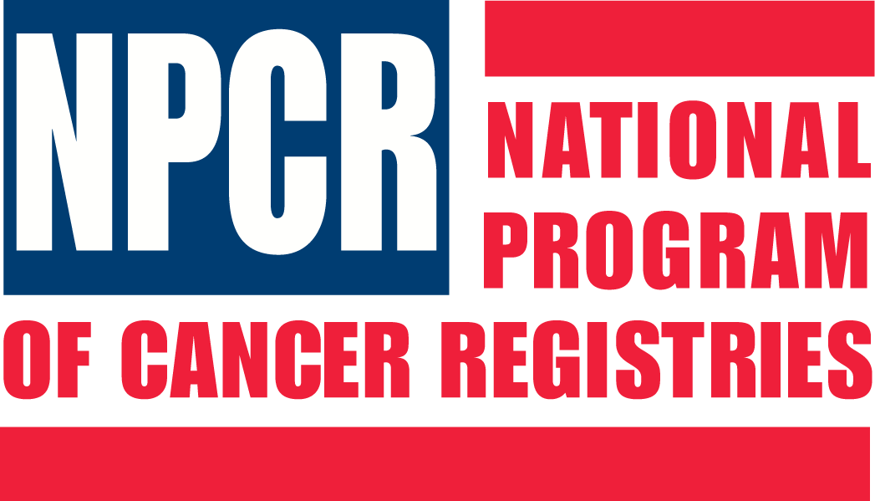

National Program of Cancer Registries

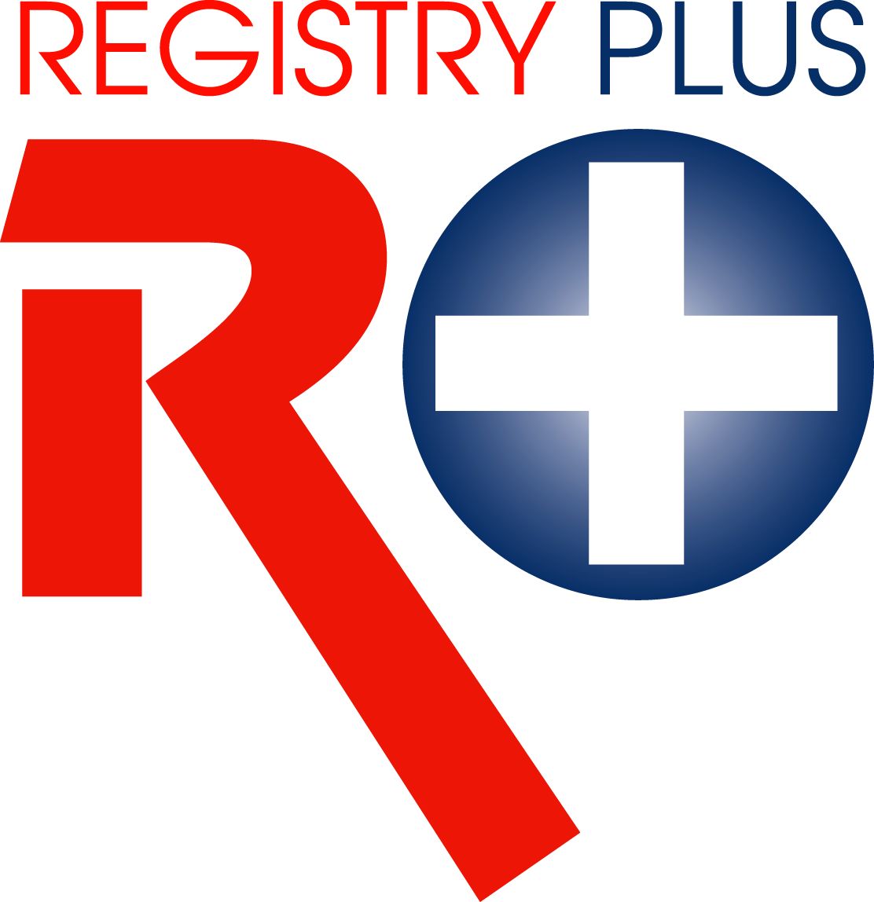
Registry Plus Software for Cancer Registries

Web Plus Training Manual
for Follow-back Monitors
Version 1.0
(Based on Web Plus Version 2.0)



Contents
Chapter 1: Introduction 1
Overall Learning Objectives 1
Overview of the Web Plus Follow-back Monitor Training Manual 1
Web Plus Features 1
Web Plus User Roles 2
Requirements for Web Access 2
Chapter 2: The Basics 3
Learning Objectives 3
Overview 3
Log In 3
Follow-back Monitor Menu Options 4
The Follow-back Process 5
Changing Your Password 6
Log Out 7
Questions 7
Chapter 3: Tracking Follow-back Requests by Facility 8
Learning Objectives 8
Overview 8
Track Follow-back Requests by Facility Page 8
Tracking Individual Abstracts by Facility 9
View 11
Reroute 12
View History 14
Send Notice 15
Delete 16
Sending Notice 18
Questions 19
Chapter 4: Sending E-mail Notices 20
Learning Objectives 20
Overview 20
Sending E-mail Notices 20
Selecting and Working with Templates 21
Saving New E-mail Templates 22
Deleting E-mail Templates 22
Filling the “To” Field 22
Questions 24
Chapter 5: Reports 25
Learning Objective 25
Overview 25
Opening and Printing Follow-back Reports 25
Opening Follow-back Reports 25
Printing Follow-back Reports 26
Outstanding Follow-back Abstracts by Follow-back Monitor and Facility 27
Facility Outstanding Follow-back Abstract Listing Report 29
Rejected Follow-back Abstracts by Facility 32
Questions 33
Appendix A: Answers 34
Chapter 2: The Basics 34
Chapter 3: Tracking Follow-back Requests by Facility 34
Chapter 4: Sending E-mail Notices 34
Chapter 5: Reports 35

Introduction

Overall Learning Objectives
These are the overall learning objectives for this Web Plus training manual for Follow-back Monitors:
- Learn the major functions of the Follow-back Monitor role within Web Plus
- Track follow-back abstracts by facility
- View Web Plus follow-back reports

Overview of the Web Plus Follow-back Monitor Training Manual
The Web Plus Follow-back Monitor Training Manual provides you with the information to understand and use the follow-back features of Web Plus. This manual describes the functions available to the Web Plus Follow-back Monitor in a central cancer registry. The major sections include tracking follow-back requests and viewing follow-back reports.
This manual includes step-by-step instructions that allow you to practice your new skills on your own using the test follow-back users and data that come with the Web Plus application. Also, each chapter contains questions that test your knowledge of follow-back functions and processes in Web Plus.

Web Plus Features
Web Plus is a web-based application that collects cancer data securely over the public Internet. It is ideal for use by central registries for all electronic reporting needs. Web Plus supports three main functions; online abstracting, file upload, and follow-back efforts. The online abstracting capability of Web Plus is ideal for reporting from physicians’ offices and other low-volume reporting sources, while the file upload feature can be used for electronic submission of data from all other reporting sources, as well as for interstate data exchange. Web Plus can be used to upload NAACCR-formatted files, as well as supporting files in any file format.
The Web Plus follow-back features enable upload of partial abstracts generated from death certificate and pathology lab files, and subsequent notification to physicians/facilities via e-mail to log in and update the abstracts. The features also allow for the tracking of follow-back abstracts to ensure their resolution.
All records are saved in a database at the hosting central cancer registry and cases entered by one facility or office are not visible to other facilities. Data entered are validated by the CDC EDITS Engine running on a web server. Users, display types, and edit configurations are managed at the hosting central registry. Web Plus is hosted on a secure web server that has a digital certificate installed; the communication between the client and the server is encrypted with Secure Socket Layer (SSL) technology.

Web Plus User Roles
The results from the design staff and usability testing have identified these types of Web Plus users:
Users | Description
Facility Abstractor | Works in a local facility or doctor’s office and handles patients’ medical records and paperwork. When a patient is diagnosed with cancer, the facility abstractor reports the case to the state’s central cancer registry.
Central Registry Abstractor/Reviewer | Reviews abstracts submitted to the central registry for completeness and accuracy and may abstract additional data items from submitted text; also abstracts new cases.
Central Registry Administrator | Sets up the local facilities with access to the Web Plus software to report their data, manages facility accounts and users at both central registry and facilities, configures display types, edit sets and system preferences, manages assignment of abstracts to central registry staff, exports data and views reports.
Local Administrator | Manages local users of a facility.
File Uploader | Uploads files of abstracts in the appropriate NAACCR format that were not abstracted using Web Plus, views EDITS error report and cleans, or works with abstractors to clean, errors on rejected files prior to re-uploading.
Follow-back Supervisor | Uploads files of partially-filled follow-back abstracts, manually adds follow-back abstracts online, tracks follow-back abstracts by uploaded file or by facility, generates and views Web Plus follow-back reports
Follow-back Monitor | Tracks follow-back abstracts by assigned facility, generates and views Web Plus follow-back reports

Requirements for Web Access
Web Plus requires Microsoft Internet Explorer version 5.0 or later or a Mozilla browser to operate the system fully. Although Web Plus works at 800 X 600 resolution, it is best viewed at 1024 X 768 or higher resolution. It is highly recommended that you change your screen resolution to 1024 X 768 or higher when using the Web Plus application.

The Basics

Learning Objectives
In this chapter, you will learn to:
- Log in to Web Plus
- Identify Web Plus Follow-back Monitor menu options
- Understand the basic steps of the follow-back process in Web Plus
- Change your password
- Log out of Web Plus

Overview
This chapter covers the basics of the Web Plus Follow-back Monitor role. It includes a description of the Web Plus menu options available to the Follow-back Monitor, an overview of the follow-back process, and the means of logging in and logging out of Web Plus.

Log In
To log in to Web Plus, complete these steps:
- Open your Internet Explorer browser and type your registry’s Web Plus web address (URL) in the Address field.
- Press Enter.
Result: The Web Plus main Log in page is displayed.
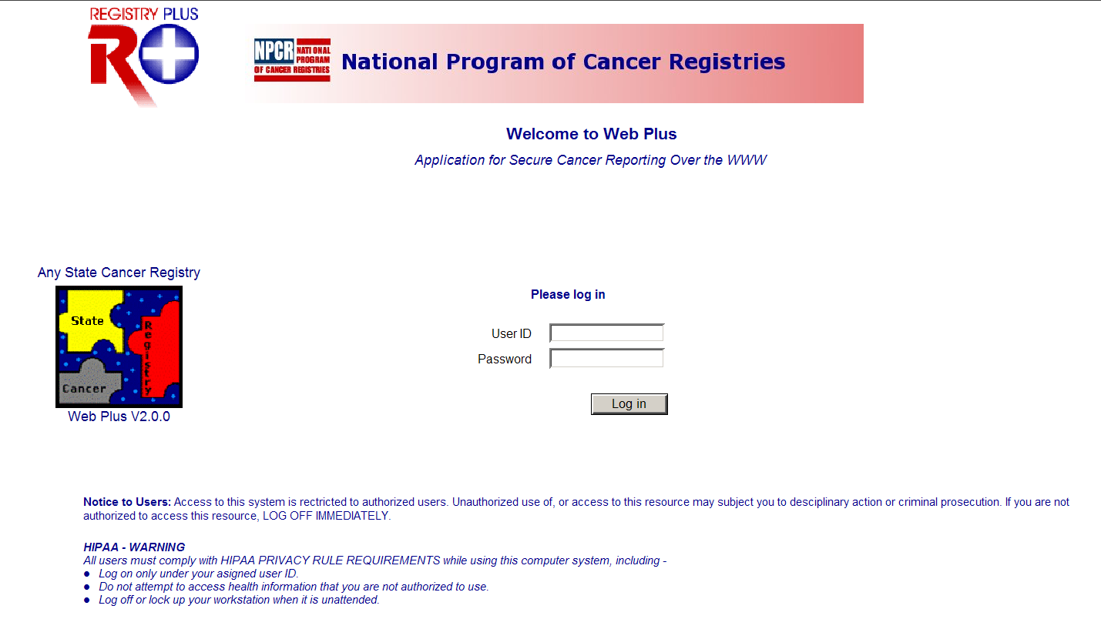
- Type in your User ID and password into the User ID and Password fields, or use the User ID of FBMonitor, and the password of monitor.
- Click Log in.
Result: Your Web Plus homepage opens, with a list of links to the roles that have been assigned to you.
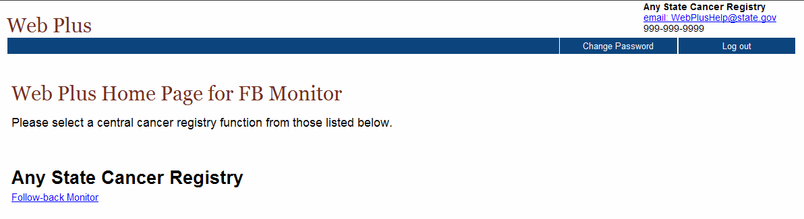
- Click the Follow-back Monitor link.
Result: The Follow-back Monitor menu items are displayed.
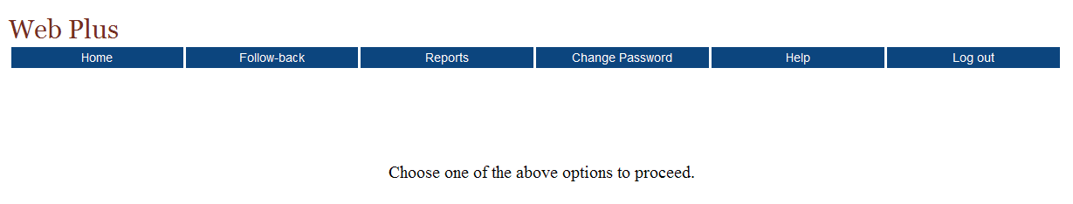

Follow-back Monitor Menu Options
After you log in and click the Follow-back Monitor link, the Web Plus Follow-back Monitor menu items are displayed:
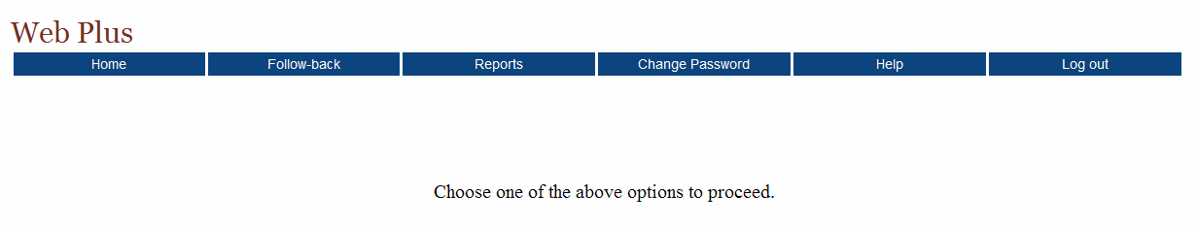

From this page you can access the main menu options for the Follow-back Monitor role in Web Plus. Click on a menu option to open the page for the option. The following table describes the menu options for the Follow-back Monitor, and provides a page reference within this manual for more information about the menu option.

Menu option | Sub-option |  | Opens web page to . . . | Refer to page . . .
Home |  |  | the user’s home page, for each assigned role, a link to a page that displays menu items for that role is displayed | 3
Follow-back | Track Requests by Facility |  | track follow-back abstracts (view, reroute, view history, send notice, or delete) by the facility to which they were assigned | 8
Reports |  |  | view follow-back reports to aid in the tracking of follow-back abstracts | 25
Change Password |  |  | change your Web Plus login password | 6
Help |  | About | view Web Plus, NAACCR, and Collaborative Staging Algorithm Versioning information
Log out |  |  | log out of Web Plus and open the Log in page | 7

The Follow-back Process
The Web Plus follow-back process allows central registries to electronically collect follow-back information in an organized and efficient manner. Central registries generally conduct death certificate follow-back by mailing out a cancer reporting form to a physician for the reporting of a tumor identified solely by death certificate (Death Certificate Only, or DCO), having the physician complete the form and mail it back, and then having central registry staff abstract the information returned on the form into some sort of abstraction software to get the information in electronic form so that it may then be processed by the central registry. Pathology lab follow-back may be conducted in a similar manner to physicians, or may involve mailing a facility a list of tumors identified via pathology lab not yet reported by the facility, and having the facility abstract the tumors from scratch to report the tumors. These efforts are frequently tracked by central registries via paper lists, or via manually checking reported tumors off of some sort electronic listing.
Web Plus follow-back features enable a central registry to pre-fill online abstracts with known information from death certificates or pathology lab reports, and have the reporter log on to update the information and complete the abstract. The end result is a completed abstract in NAACCR file format, an electronic report of a previously unreported tumor, without the use of paper forms or redundant recording of information. In addition, the follow-back tracking features of Web Plus allow the central registry to closely and electronically track the status of each follow-back abstract to ensure that it gets completed.
Basically, the follow-back process in Web Plus takes advantage of the existing online abstracting feature to enable physicians and facility abstractors to complete partially-filled abstracts online. The abstractor can save their work at any time and return their work at a later time. They release an abstract to the central registry only after they have completed it, and eliminated any errors it may contain.
Notification to facility via e-mail
Facility corrects errors
Facility completes abstract
Facility releases abstract
Facility updates abstract
Facility rejects abstract
FB Monitor reroutes abstract
FB Monitor deletes abstract
FB Supervisor uploads file of partial abstracts or manually enters abstracts online

The Web Plus follow-back process includes the following steps:
- The Follow-back Supervisor (FB Supervisor) uploads files of partially-filled abstracts generated with information from death certificate and pathology lab files into Web Plus, or manually enters individual abstracts online.
- Notification to facilities/physicians to log in and update the follow-back abstracts is sent via e-mail.
- Once posted for facilities/physicians to complete, follow-back abstracts are processed via the regular Web Plus record flow; with the exception that follow-back abstracts can be rejected by the facility/physician with a justifying comment back to the central registry, where the Follow-back Supervisor and Follow-back Monitors can either re-route the abstract to a new facility/physician, or delete the abstract from the follow-back process.
- Once completed by the facility/physician, the follow-back abstracts are released to the central registry, where they are reviewed and released by the Central Registry Abstractor/Reviewer, and subsequently exported out of the Web Plus database by the Central Registry Administrator.
Throughout the follow-back process, the Follow-back Supervisor and Follow-back Monitors use the follow-back reports and tracking features to communicate with the cancer reporters via e-mail, and track follow-back abstracts to ensure their resolution.

Changing Your Password
To change your password, complete these steps:
- On the Home page menu, click Change Password.
Result: The Change Password page opens.
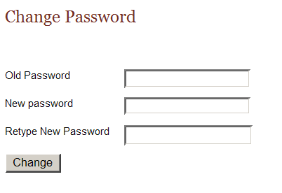
- Type your current password in the old password field, and your new password in both of the new password fields.
- Click Change.
Result: Your password is successfully changed.

Your Central Administrator may have set minimum criteria for creating passwords. You will need to meet those criteria when changing your password, or Web Plus will not accept your new password, and will issue an error message saying your password does not meet the specified criteria.

Log Out
To log out of Web Plus, click Log out on the Home page menu.
Result: The system logs you out of Web Plus, and the Log in page opens.

Questions
Answer these questions about the basics of Web Plus follow-back (the answers are in Appendix A, page 34):
- Which menu option opens the page where you can track follow-back abstracts by facility?
- How do you log out of Web Plus?

Tracking Follow-back Requests by Facility

Learning Objectives
In this chapter you learn to:
- Monitor the status of follow-back abstracts by the facility to which they are assigned, including viewing, rerouting, viewing the history of, and deleting individual abstracts, as well as sending e-mails regarding individual abstracts
- Send an e-mail notice to all abstractors at a facility

Overview
As mentioned earlier, as soon as follow-back abstracts have been added to the Web Plus follow-back system, they are available at the facility level for completion or rejection, and they are added to the Web Plus follow-back tracking system. As a Follow-back Monitor, you can track the status of follow-back abstracts by the facility to which they are assigned.

Track Follow-back Requests by Facility Page
To track follow-back requests by the facility to which they were assigned, complete these steps:
- On the Web Plus menu, point to Follow-back, then click Track Requests by Facility.
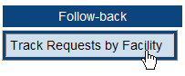
Result: The Track Follow-back Requests by Facility page opens.
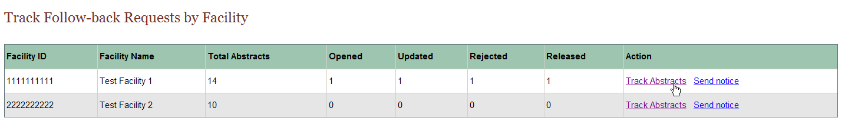
The Track Follow-back Requests by Facility page includes these fields and column headings:
Columns | Description
Facility ID | Facility ID number
Facility Name | Name of Facility
Total Abstracts | Total number of follow-back abstracts assigned to the facility; this includes both death certificate and pathology lab follow-back abstracts
Opened | Total number of follow-back abstracts opened by abstractors at the facility
Updated | Total number of follow-back abstracts opened and updated (saved) by abstractors at the facility
Rejected | Total number of follow-back abstracts rejected by abstractors at the facility
Released | Total number of follow-back abstracts released by abstractors at the facility
Action | Links to the actions that can be performed to monitor the facility’s follow-back abstracts:  Track Abstracts: Track the status of the individual follow-back abstracts included in the file  Send Notice: Send an e-mail notice to all facility abstractors at the facility(ies) included in the follow-back file

Tracking Individual Abstracts by Facility
To track individual abstracts by the facility to which they are assigned, complete these steps:
- On the Track Follow-back Requests by File page, locate the facility for which you would like to monitor follow-back abstracts, and click the Track Abstracts link in the Action column. In the example shown, Test Facility 1 (Facility ID 1111111111) is selected.
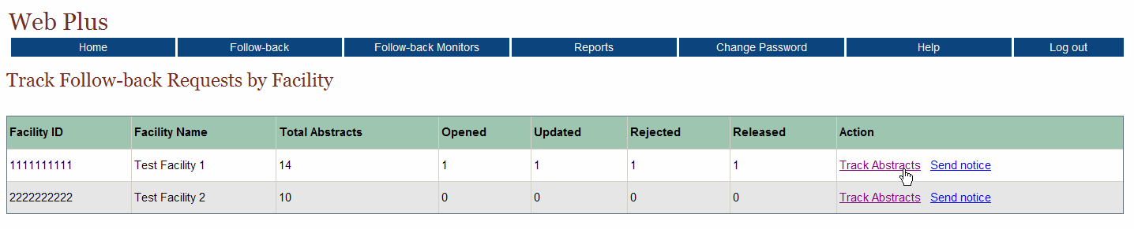
Result: The Track Individual Follow-back Abstracts page opens for the selected facility.
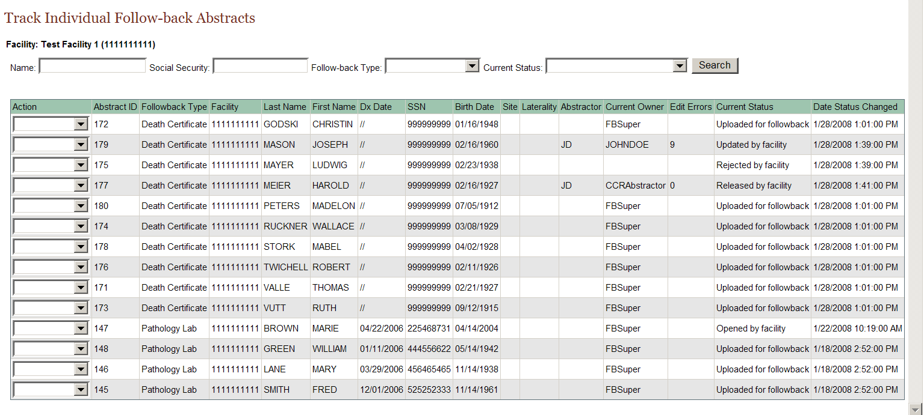
The Track Individual Follow-back Abstracts page lists information for each follow-back abstract assigned to the selected facility, and includes these fields and column headings:
Columns | Description
Action | Select from among the various actions that can be performed on a follow-back abstract:  View: View the follow-back abstract; the abstract will be viewed with the central registry display type---fields can only be viewed not updated/edited  Reroute: Reroute a rejected follow-back abstract to another facility for follow-back  View History: View the history of actions performed on the follow-back abstract  Send Notice: Send an e-mail notice regarding the follow-back abstract to all facility abstractors at the facility  Delete: Delete the follow-back abstract from Web Plus
Abstract ID | A system-generated number identifying the abstract
Follow-back Type | Type of follow-back abstract (Death Certificate or Pathlab)
Facility | The Facility ID of the facility to which the follow-back abstract is currently assigned
Last Name | Last name of patient
First Name | First name of patient
Dx Date | Diagnosis date
SSN | Patient’s social security number
Birth Date | Patient’s date of birth
Site | The location of the major tumor
Laterality | Code for the side of a paired organ, or the side of the body on which the reportable tumor originated
Abstractor | Code for the person at the facility who has updated the follow-back abstract
Current Owner | User who currently owns the abstract in Web Plus
Edit Errors | The number of errors found in the edit process after a follow-back abstract has been opened and saved
Current Status | Current status of the follow-back abstract; Web Plus has the following follow-back abstract statuses:  Uploaded for followback  Opened by facility  Rejected by facility  Released by facility  Rerouted to different facility  Updated by facility  Message sent to facility  Review by CCR abstractor  Review released
Date Status Changed | The date and time at which the status of follow-back abstract was last changed
Follow-back Monitors can use the Track Individual Follow-back Abstracts page to track the current status of, and perform certain actions on, follow-back abstracts. The Track Individual Follow-back Abstracts page can be searched by name, Social Security Number, Follow-back Type, and/or current status. Search on partial name and Social Security Number is supported. The search feature can be used to search for an individual follow-back abstract, or to restrict the follow-back abstracts listed to a certain follow-back type and/or follow-back abstract status.

View
To view an individual follow-back abstracts for a facility, complete these steps:
- On the Track Follow-back Requests by Facility page, locate the facility for which you would like to monitor follow-back abstracts, and click the Track Abstracts link in the Action column. In the example shown, Test Facility 1 (Facility ID 1111111111) is selected.
Result: The Track Individual Follow-back Abstracts page opens for the selected facility.
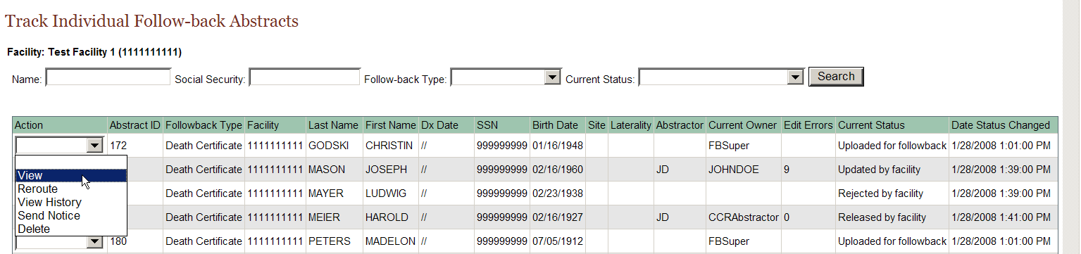
- From the listing of follow-back abstracts for the facility, locate the follow-back abstract of interest, and using the pull-down menu in the Action column, select View.
Result: The follow-back abstract is opened for viewing.
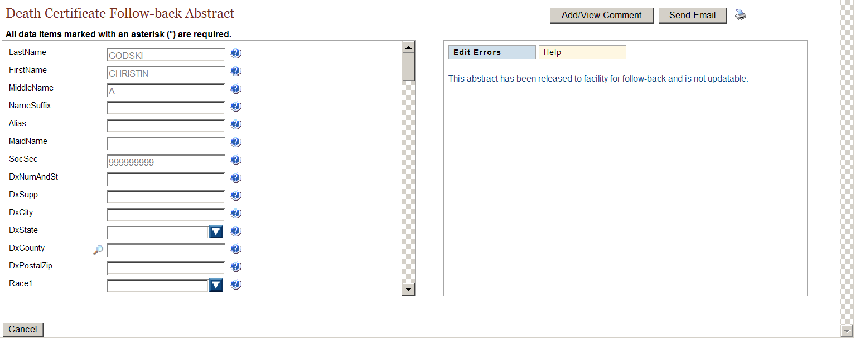
Note that the abstract is viewed with the follow-back display type assigned for central abstractor/reviewers by the Central Registry Administrator, and the fields are grayed-out, and cannot be updated.
To facilitate tracking efforts, comments may be added to the abstract while viewing it by clicking on Add/View Comments in the upper right-hand corner of the page. In addition, an e-mail may be sent regarding the follow-back abstract being viewed by clicking on Send Email in the upper right-hand corner of the page. You are taken to the Send E-mail Notice page, to compose and send an e-mail to the abstractors at the facility to which the follow-back abstract is assigned. You will learn more about sending e-mail notices in Chapter 4: Sending E-mail Notices.

Reroute
Once follow-back abstracts have been added to the Web Plus follow-back system, they are available at the facility level for completion or rejection. If a facility abstractor rejects a follow-back abstract (e.g., because the patient was not diagnosed or treated at the facility), the follow-back abstract may be rerouted to a different facility or deleted.
To reroute an individual follow-back abstract, complete these steps:
- On the Track Follow-back Requests by Facility page, locate the facility for which you would like to monitor follow-back abstracts, and click the Track Abstracts link in the Action column. In the example shown, Test Facility 1 (Facility ID 1111111111) is selected.
Result: The Track Individual Follow-back Abstracts page opens for the selected facility.
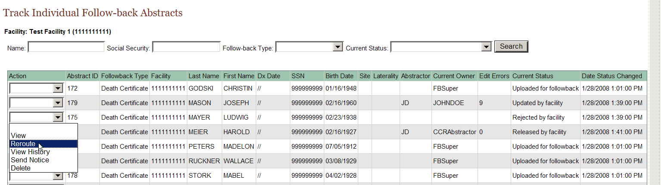
- From the listing of follow-back abstracts in the file, locate the abstract you would like to reroute, and using the pull-down menu in the Action column, select Reroute.
Result: The Reroute Follow-back Abstract page opens.
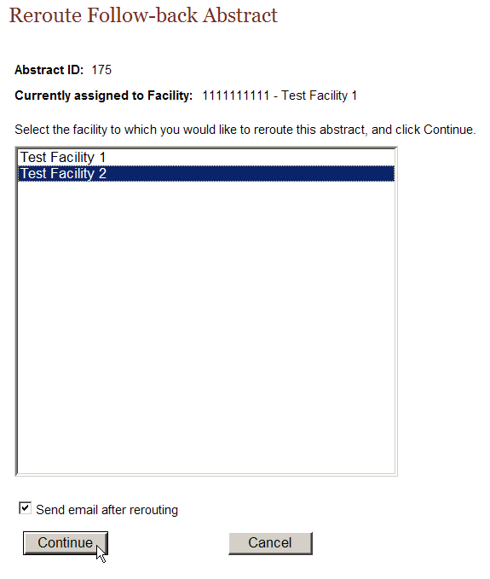
The Reroute Follow-back Abstract lists the follow-back abstract’s Abstract ID, and the facility to which the follow-back abstract is currently assigned.
- From the list of facilities, select the facility you would like to reroute the abstract to, and click Continue. In the example shown, abstract ID # 175 is being rerouted from Test Facility 1 to Test Facility 2.
Result: If you do not have the Send e-mail after file upload checkbox clicked, a message will be displayed confirming that the follow-back abstract has been rerouted:
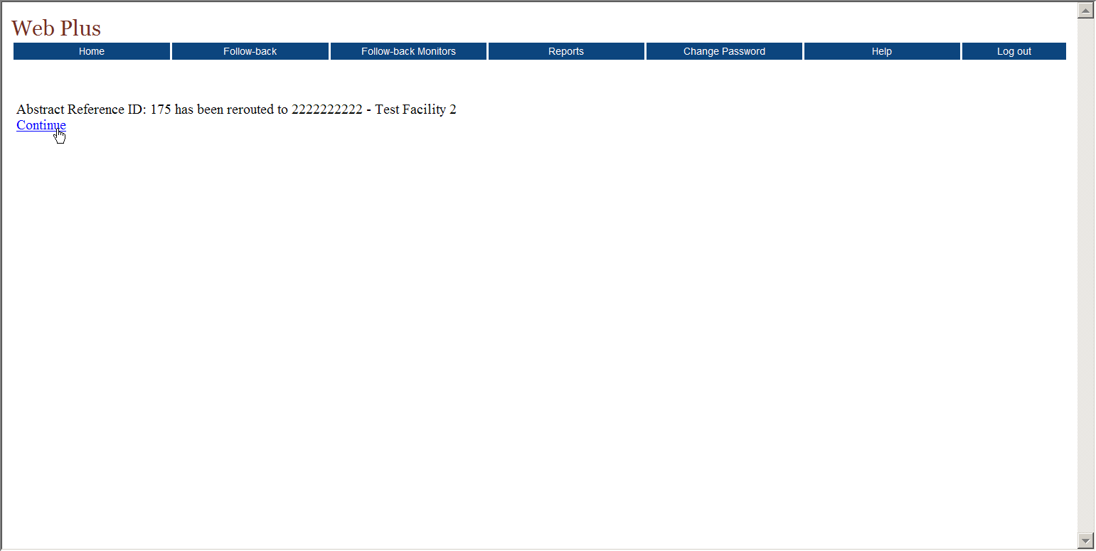
However, if the Send e-mail after rerouting checkbox is clicked:
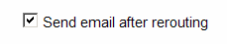
When you click continue, you will be taken to the reroute follow-back abstract confirmation page, which states that the abstract has been successfully rerouted:
- Click Continue.
Result: You are taken to the Send E-mail Notice page, to compose and send an e-mail to the abstractors at the facility to which the follow-back abstract was rerouted. You will learn more about sending e-mail notices in Chapter 4: Sending E-mail Notices.
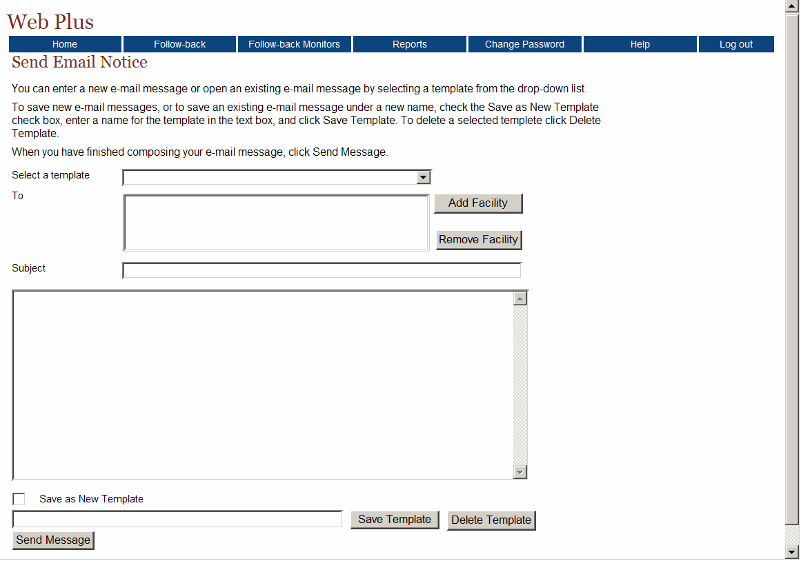

View History
Each action that is performed on a follow-back abstract is logged by the Web Plus follow-back tracking system. As a result, a complete “history”, i.e., each action performed, when it was performed, and by whom, can be viewed for each follow-back abstract. The Follow-back Monitor can use this information when monitoring follow-back abstracts or when communicating with facilities regarding a specific follow-back abstract.
To view the history of an individual follow-back abstract for a facility, complete these steps:
- On the Track Follow-back Requests by Facility page, locate the facility for which you would like to monitor follow-back abstracts, and click the Track Abstracts link in the Action column. In the example shown, Test Facility 1 (Facility ID 1111111111) is selected.
Result: The Track Individual Follow-back Abstracts page opens for the selected facility.
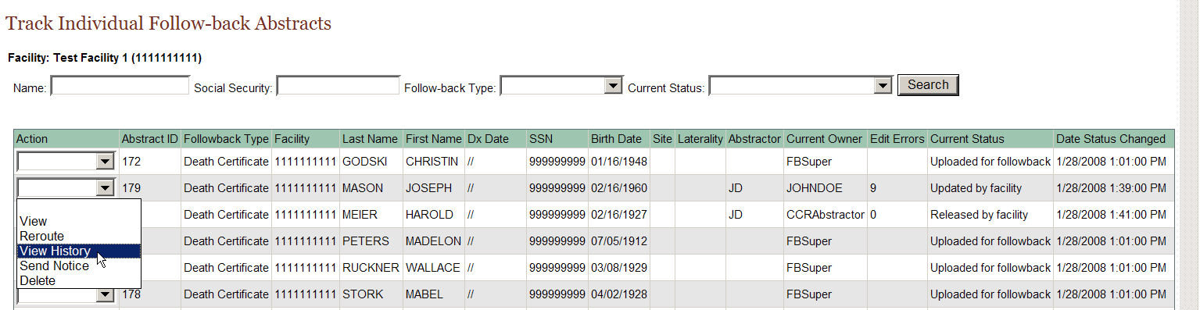
- From the listing of follow-back abstracts in the file, locate the follow-back abstract of interest, and using the pull-down menu in the Action column, select View History.
Result: The View Follow-back Abstract History window opens.
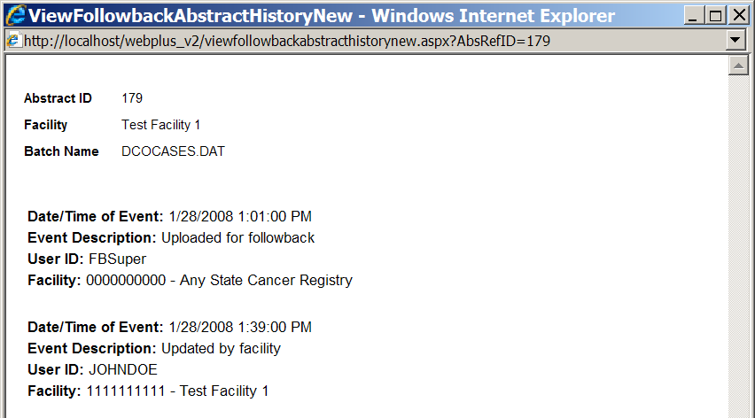
The Abstract ID of the follow-back abstract, the facility to which the follow-back abstract is assigned, and the file in which the abstract was uploaded are displayed at the top of the window. For each action performed on a follow-back abstract, the View Follow-back Abstract History window lists the date/time of the action, a description of the action taken, the User ID of the user performing the action, and the facility at which the action was performed.

Send Notice
Follow-back Monitors can access the follow-back e-mail functions from the Track Individual Follow-back Abstracts page to send e-mails to abstractors at the facility to which a follow-back abstract is assigned. To send an e-mail regarding an individual follow-back abstract in a follow-back file, complete these steps:
- On the Track Follow-back Requests by Facility page, locate the facility for which you would like to monitor follow-back abstracts, and click the Track Abstracts link in the Action column. In the example shown, Test Facility 1 (Facility ID 1111111111) is selected.
Result: The Track Individual Follow-back Abstracts page opens for the selected facility.
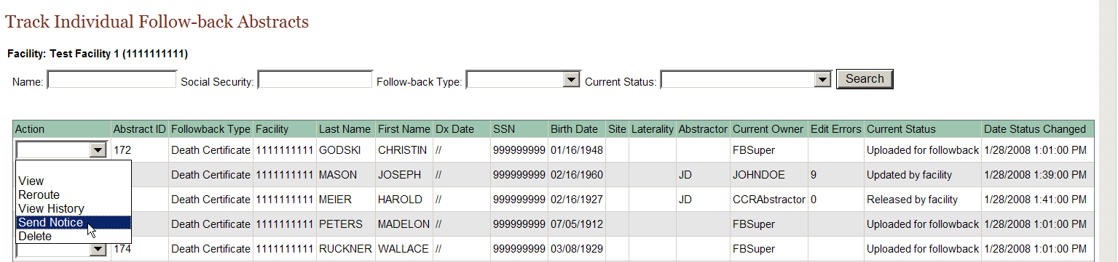
- From the listing of follow-back abstracts in the file, locate the follow-back abstract of interest, and using the pull-down menu in the Action column, select Send Notice.
Result: You are taken to the Send E-mail Notice page, to compose and send an e-mail to the abstractors at the facility to which the follow-back abstract is assigned. You will learn more about sending e-mail notices in Chapter 4: Sending E-mail Notices.

Delete
Sometimes follow-back efforts for a follow-back abstract hit a “dead-end”, i.e., it may be rejected by a facility because the patient was not treated there, and no other facility/physician can be identified for follow-back efforts, or a tumor associated with a follow-back abstract may be reported by another reporting source or via other means during the follow-back effort. As a result, the Follow-back Monitor may occasionally need to delete a follow-back abstract from the Web Plus follow-back system.
 | When you delete a follow-back abstract, you remove all traces of the abstract from Web Plus, i.e., it will be removed from the facility follow-back list, as well as the follow-back tracking system; no record of the abstract will remain in the system.  As with regular online abstracts, Web Plus will not let you delete a follow-back abstract once it has been completed and released by the facility. Once information has been released from the facility, the facility must maintain a record of the released information as required by HIPAA; either in hardcopy or online.
To delete an individual follow-back abstract for a facility, complete these steps:
- On the Track Follow-back Requests by Facility page, locate the facility for which you would like to monitor follow-back abstracts, and click the Track Abstracts link in the Action column. In the example shown, Test Facility 1 (Facility ID 1111111111) is selected.
Result: The Track Individual Follow-back Abstracts page opens for the selected facility.
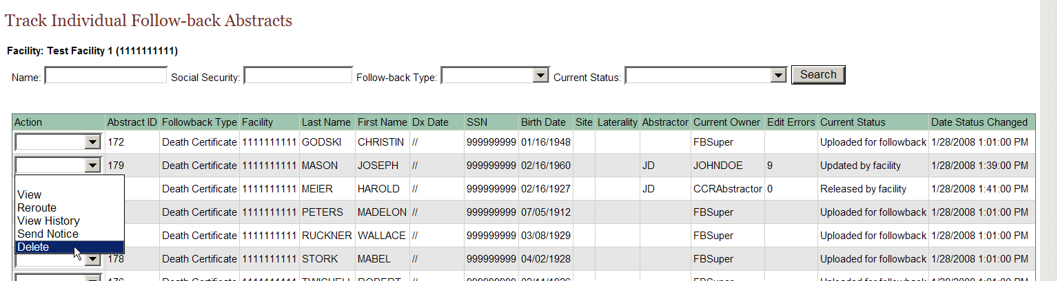
- From the listing of follow-back abstracts in the file, locate the follow-back abstract you would like to delete, and using the pull-down menu in the Action column, select Delete.
Result: The Delete Follow-back Abstract window opens, asking for confirmation of the deletion.
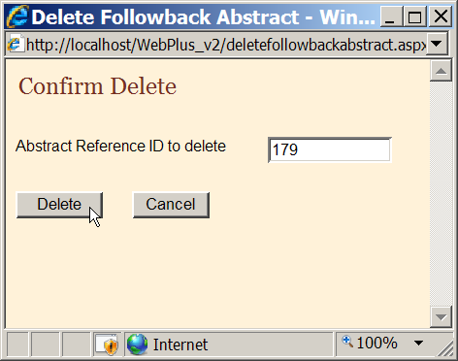
- Click Delete.
Result: A message appears in the Delete Follow-back Abstract window to let you know that abstract has been successfully deleted.
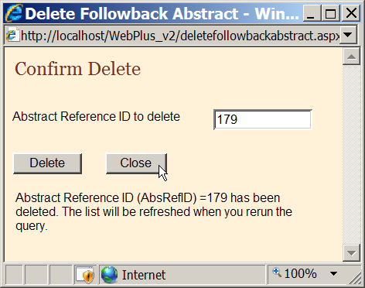
- Click Close.
Result: You are returned to the Track Individual Follow-back Abstracts page. When this page is refreshed, the deleted abstract will no longer be included in the list of follow-back abstracts.

Sending Notice
The Track Follow-back Requests by Facility page is one of many ways to access the Web Plus e-mail function. The Follow-back Monitor can use the Track Follow-back Requests by Facility page to quickly send e-mails to all abstractors at a particular facility.
To send an e-mail to all abstractors at a facility, complete these steps:
- On the Track Follow-back Requests by Facility page, locate the facility whose abstractors you would like to correspond with, and click the Send Notice link in the Action column.
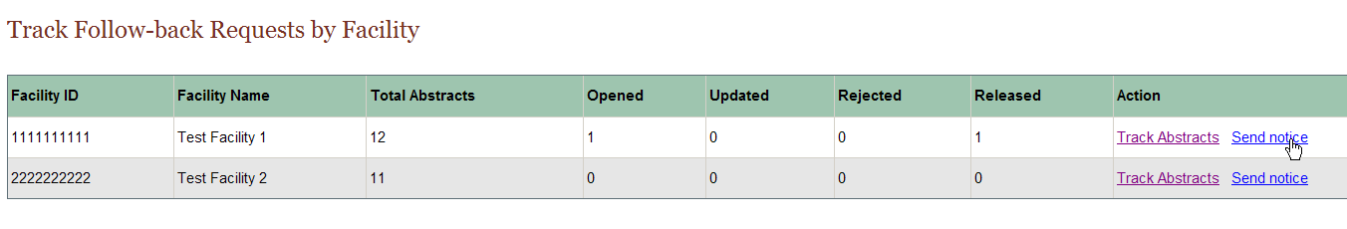
Result: You are taken to the Send E-mail Notice page, to compose and send an e-mail to the abstractors at the selected facility. You will learn more about sending e-mail notices in Chapter 4: Sending E-mail Notices.

Questions
Answer these questions tracking follow-back requests by facility (the answers are in Appendix A, on page 34 ):

- What menu item and option do you use to track follow-back requests by facility?

- How do you view the history of actions performed on a follow-back abstract assigned to a particular facility?

- How do you delete a follow-back abstract from Web Plus?

Sending E-mail Notices

Learning Objectives
In this chapter you learn:
- How to navigate to the Send E-mail Notice page
- How to use the follow-back e-mail feature to send e-mail notices to facility abstractors regarding follow-back abstracts

Overview
In this chapter you learn how to access the Send E-mail notice page, and about how to use the Send E-mail Notice feature to communicate with facility abstractors via e-mail regarding follow-back abstracts.

Sending E-mail Notices
Web Plus follow-back features include a built-in e-mail function, so that central registry Follow-back Supervisors and Follow-back Monitors can communicate with physicians and facility abstractors regarding follow-back abstracts via e-mail. All e-mails are sent using the Send Email Notice page, which can be accessed by Follow-back Monitors from several locations in the Web Plus module. E-mails can be sent at anytime in the follow-back process: while tracking the completion status of follow-back abstracts by facility, upon re-routing of a follow-back abstract, and for reminder purposes.
To send an e-mail to facility abstractors at anytime during follow-back efforts, complete these steps:
- First, you must access the Send Email Notice page:
  - If you are rerouting a follow-back abstract, click the send e-mail after rerouting checkbox.
  - If you are tracking follow-back abstracts by facility, click the Send Notice link.
  - If you are tracking individual follow-back abstracts, select Send Notice from the Action column of the Track Individual Follow-back Abstracts pages.
Result: Regardless of from where you access the Send Email Notice page, the same Send Email Notice page will be opened.

Selecting and Working with Templates
To facilitate the follow-back process, the Web Plus follow-back e-mail function allows you to save e-mails for re-sending at a later time. For example, you may want to save death certificate or pathology lab follow-back initial notice and 30-day notice e-mails, and re-use them for subsequent or ongoing follow-back efforts. These saved e-mails are called templates. You can save new templates, and open, update, or delete existing e-mail templates.
When the Send Email Notice page is opened, the Subject field and the body of the e-mail will be blank. You can enter a new e-mail message, or open an existing e-mail message template.
- To begin a new e-mail, just start typing. To open an existing e-mail template, select the template from the drop-down menu to the right of Select a template. In the example shown, the Death Certificate Follow-back Initial Notice template is selected.
Result: The selected e-mail template is opened.
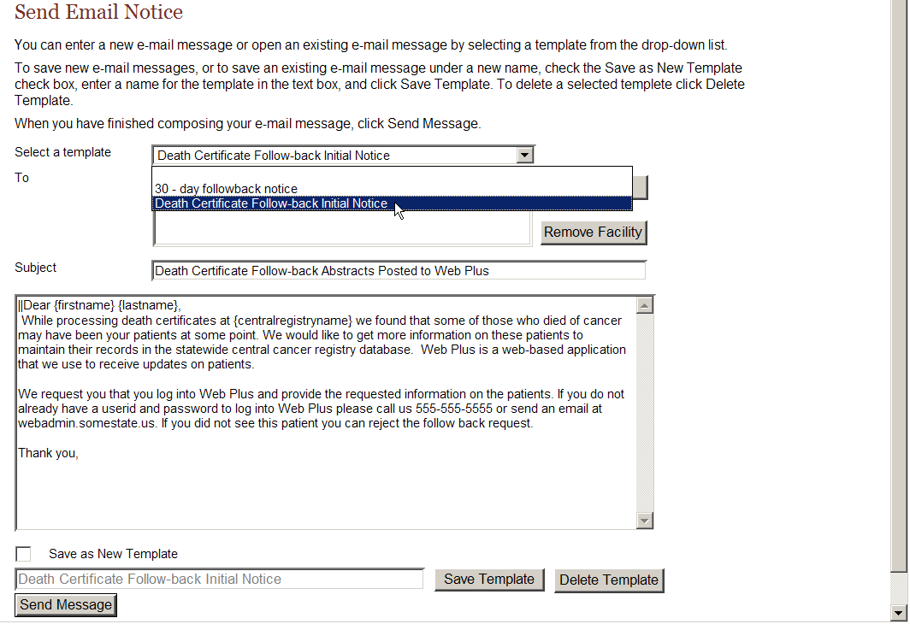

Saving New E-mail Templates
To save new e-mail messages, or to save an existing e-mail message under a new name, check the Save as New Template check box, enter a name for the template in the text box, and click Save Template.

Deleting E-mail Templates
To delete a selected template, select the template from the pull-down menu, and click Delete Template.

Filling the “To” Field
Depending on from where you access the Send Email Notice page, the To field may be filled in automatically. To field is automatically filled in:
- If the send e-mail after rerouting checkbox is clicked upon follow-back abstract rerouting
- You access the Send Email Notice page from the Track Follow-back Requests by Facility page.
However, even when a facility name (or names) is automatically filled into the To field by Web Plus, you can edit the selection.
- To fill the To field, or add a facility to the pre-filled selection, click Add Facility to the right of the To box.
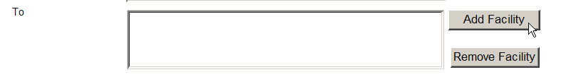
Result: The Add Facility to Email List window opens.
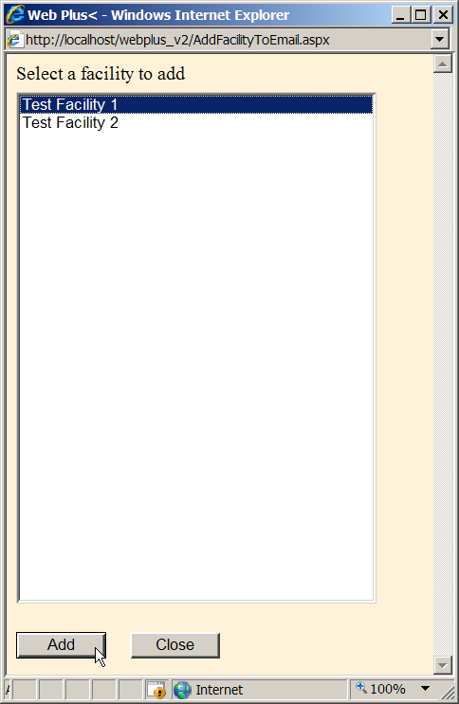
- Select the facility of the abstractors you would like to send an e-mail to, and click Add. In the example shown, Test Facility 1 is selected.
- If you want to send the e-mail to abstractors at another facility, select that facility and click Add. In the example shown, Test Facility 2 is also selected and added. Continue in this manner until you have selected all of the facilities of interest. Then click Close.
Result: The application returns you to the Send Email Notice page, where the name of the facility(ies) selected are entered in the To field. Web Plus will send the e-mail to all abstractors at the facilities listed in the To field of the e-mail, without your having to select all of the individual abstractors’ e-mail addresses.
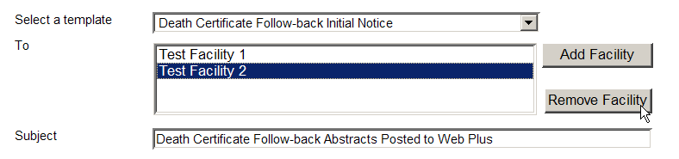
- To remove a facility from the To field, select the facility name, and then click Remove Facility.
Result: The application deletes the selected facility from the To field.
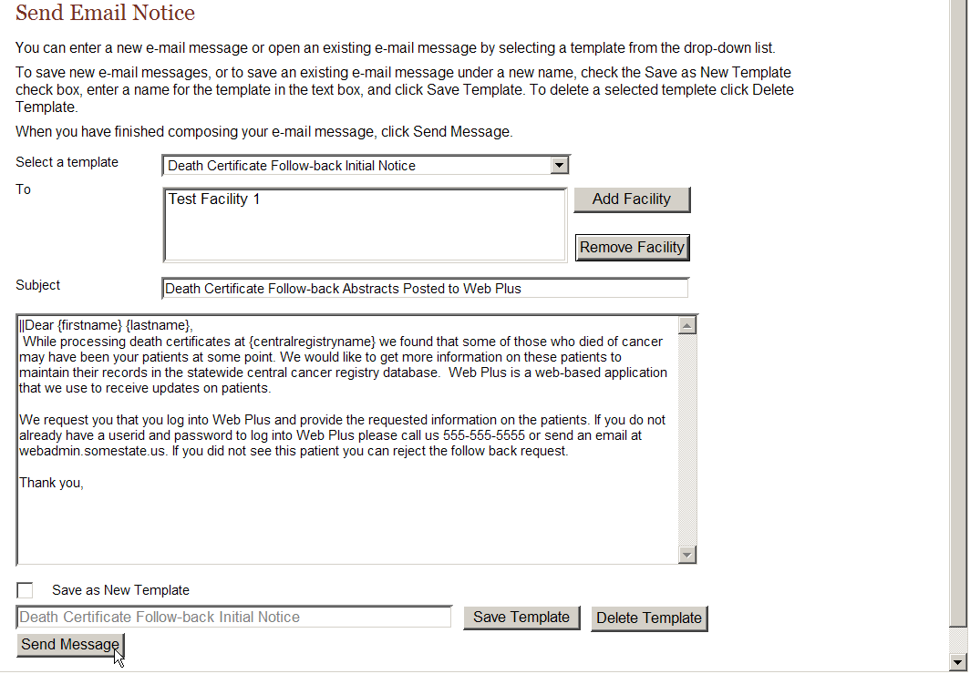
- When you have finished composing your e-mail message, click Send Message.
Result: The Death Certificate Follow-back Initial notice e-mail message is sent to all users at the selected facility(ies). You remain on the Send Email Notice page, where confirmation that the e-mail has been sent is displayed.
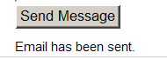
 | In the body of e-mail you can use some key words to do macro substitutions. {firstname}, {lastname}, and {centralregistryname} can be used to be substituted by the e-mail recipients’ first and last names and the central cancer registry name when the e-mail is sent.

Questions
Answer these questions about sending e-mail notices (the answers are in Appendix A, on page 34 ):

- Name 2 of 3 the ways that you can access the Send Email Notice page in Web Plus follow-back.

- Do you have to type an e-mail from scratch each time you want to send an e-mail?

- How do you delete an e-mail template from Web Plus?

Reports

Learning Objective
In this chapter, you will learn:
- To open and print a follow-back report
- About the various follow-back reports available in Web Plus

Overview
Web Plus provides follow-back reports at both the central registry and facility level. The central registry follow-back reports are provided to facilitate the tracking of follow-back efforts, as well as the individual follow-back abstracts to ensure their resolution. The available facility follow-back report is a line listing of follow-back abstracts assigned to the facility, and is provided so that Follow-back Supervisors, Follow-back Monitors, and facility abstractors can readily access and print out a list of follow-back abstracts assigned to the facility. The various follow-back reports are available for both death certificate and pathology lab follow-back efforts.

Opening and Printing Follow-back Reports

Opening Follow-back Reports
To open a follow-back report, after you have logged in, complete these steps:
- On the Web Plus menu, click Reports.
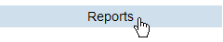
Result: Web Plus displays a list of the follow-back reports available for viewing by Follow-back Monitors.
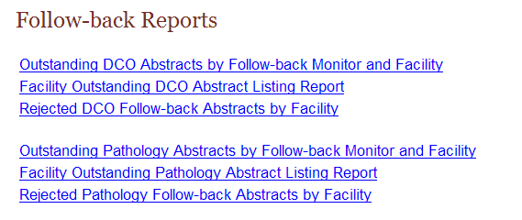

This table describes the follow-back reports available for viewing by the Follow-back Monitor.
Report. . . | Lists for the follow-back type. . .
Outstanding DCO Abstracts by Follow-back Monitor and Facility  Outstanding Pathology Abstracts by Follow-back Monitor and Facility | for each Follow-back Monitor, the total number of follow-back abstracts that have not yet been released by the facilities assigned to the Monitor, by assigned facility
Facility Outstanding DCO Abstract Listing Report  Facility Outstanding Pathology Abstract Listing Report | a line listing of all follow-back abstracts assigned to the facility that have not yet been released by the facility
Rejected DCO Abstracts by Facility  Rejected Pathology Abstracts by Facility | a line listing of all follow-back abstracts assigned to the facility that have been rejected by the facility
Clicking the name of the report opens a separate window displaying the report.
- Click on the Outstanding DCO Abstracts by Follow-back Monitor and Facility link.
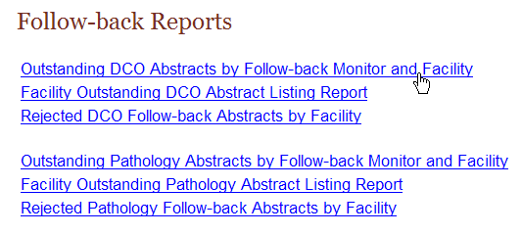
Result: The Outstanding DCO Abstracts by Follow-back Monitor and Facility report opens in a separate window.
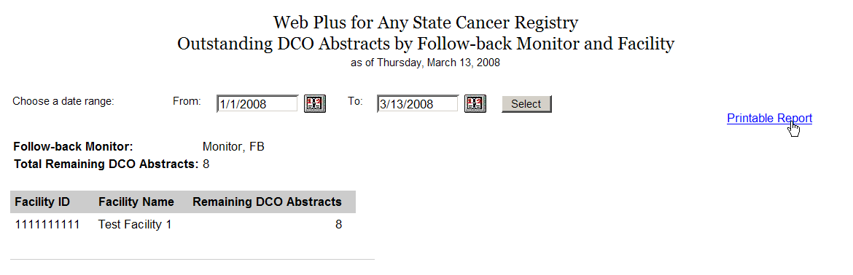

Printing Follow-back Reports
To print a follow-back report, click on the Printable Report link in the upper right-hand corner of the report window.
Result: A page opens with a printable version of the report.
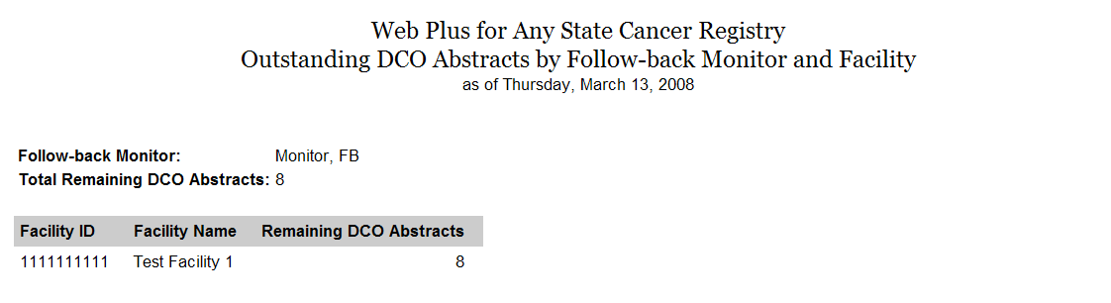
For optimum printing results, print Web Plus reports in landscape mode. To print in landscape, click on File→Page Setup, and click on Landscape.
In addition, if you wish to remove the internal report name from the upper left-hand corner of the printed report, remove the &w&b from the header field. If you wish to remove the URL listing from the bottom of the report, remove the information in the footer field (the date prints on the report already).

Outstanding Follow-back Abstracts by Follow-back Monitor and Facility
The Outstanding Follow-back Abstracts by Follow-back Monitor and Facility Report lists the number of follow-back abstracts yet to be released by the facilities assigned to the Follow-back Monitor, by facility. This report can help the Follow-back Monitor easily identify which facilities should be targeted for follow-back efforts.
To open the Outstanding Follow-back Abstracts by Follow-back Monitor and Facility report, complete these steps:
- On the Web Plus menu, click Reports.
Result: Web Plus displays a list of available follow-back reports.
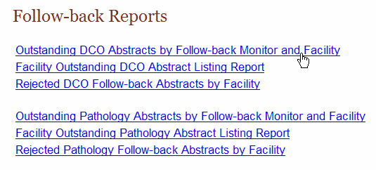
- Click on either the Outstanding DCO Follow-back Abstracts by Follow-back Monitor and Facility or the Outstanding Pathology Follow-back Abstracts by Follow-back Monitor and Facility link. In the example shown the Outstanding DCO Follow-back Abstracts by Follow-back Monitor and Facility report is opened.
Result: The Outstanding Follow-back Abstracts by Follow-back Monitor and Facility Report for the particular follow-back type opens in a separate window.
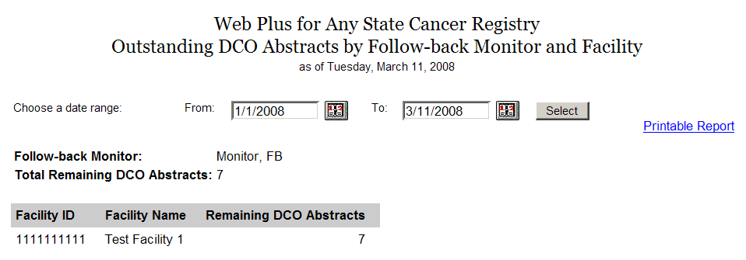
- If necessary, enter a date range for the report (i.e., enter a From and To date). By default the From date is January 1, 2008, and the To date is the current date.
The Outstanding DCO Abstracts by Follow-back Monitor and Facility report offers the user the option to enter a date range for the report. Date ranges work a little differently for follow-back reports than for other reports in Web Plus; the user must be careful to enter the dates associated with the follow-back effort of interest to generate a report for that follow-back effort. The From date will be the date your Follow-back Supervisor uploaded the follow-back file containing the follow-back abstracts for the follow-back effort of interest, or the date that your Follow-back Supervisor entered the first online follow-back abstract for the follow-back effort. The To date will be the current date (for present follow-back efforts), or the date a prior follow-back effort ended.
To set the date range for the Outstanding DCO Abstracts by Follow-back Monitor and Facility report complete these steps:
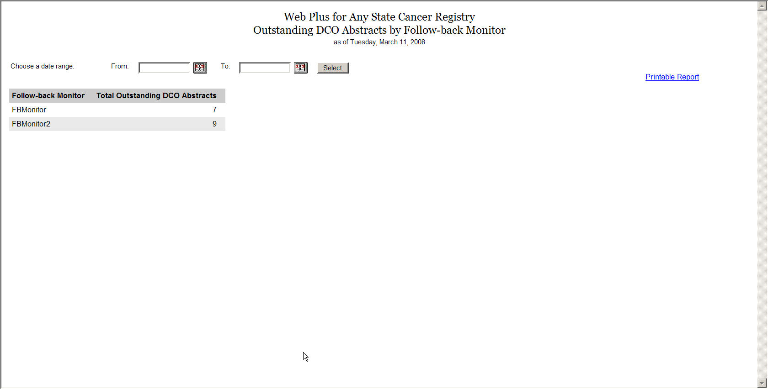
- Click the calendar icon beside the From date field.
Result: The calendar window opens.
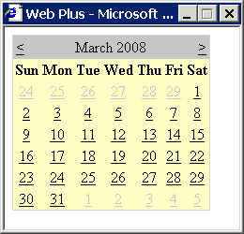
- Click the date you would like. The system inserts the date in the field and closes the calendar window.
You can also type the date in the window by using the mm/dd/yyyy format, such as 03/01/2008 for March 1, 2008. The date calendar and format are the same for both the From and To date fields.
- Repeat steps a and b, clicking on the calendar icon beside the To date field.
Result: You are returned to the Follow-back Report window, with the specified dates entered into the From and To date fields.
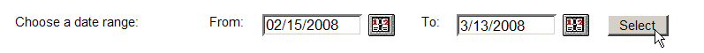
- Click Select.
Result: The follow-back report is displayed with the information restricted to the date range (or follow-back effort) specified.
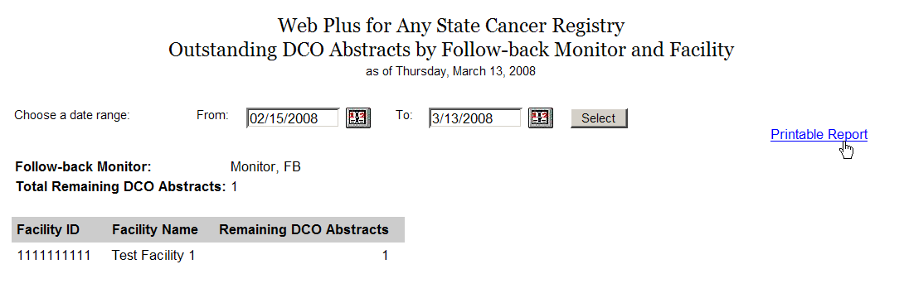
- Click on the Printable Form link.
Result: A page opens with a printable version of the report.
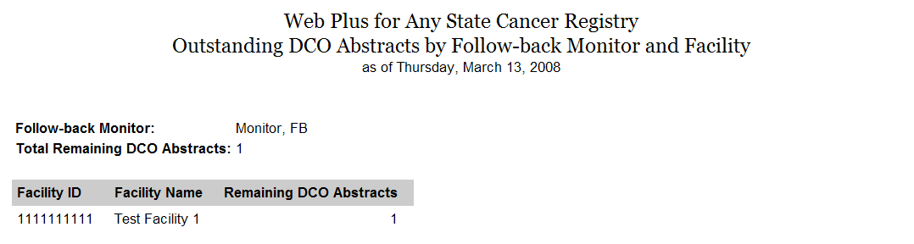

Facility Outstanding Follow-back Abstract Listing Report
The Facility Outstanding Follow-back Abstract Listing report includes a line listing of all follow-back abstracts assigned to facilities that have not yet been released by the facilities, by facility. At the facility level, only the data for the individual facility is included in the report. Facilities can print this report for their records, or if they need to go somewhere away from their computer to look up patient records. Follow-back Supervisors and Monitors can use this report to quickly view a list of outstanding follow-back abstracts for each facility, or to print out a listing for an individual facility. Follow-back Monitors can view data only for facilities assigned to them.
To open the Facility Outstanding Follow-back Abstract Listing report, complete these steps:
- On the Web Plus menu, click Reports.
Result: Web Plus displays a list of available follow-back reports.
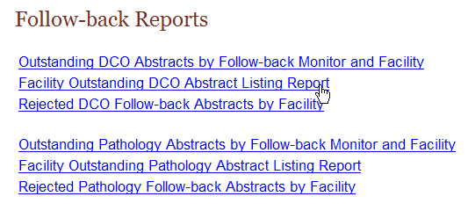
- Click on either the Facility Outstanding DCO Follow-back Abstract Listing Report or the Facility Outstanding Pathology Follow-back Abstract Listing Report link. In the example shown the Facility Outstanding DCO Follow-back Abstract Listing Report is opened.
Result: The Facility Outstanding Follow-back Abstract Listing Report for the particular follow-back type opens in a separate window.
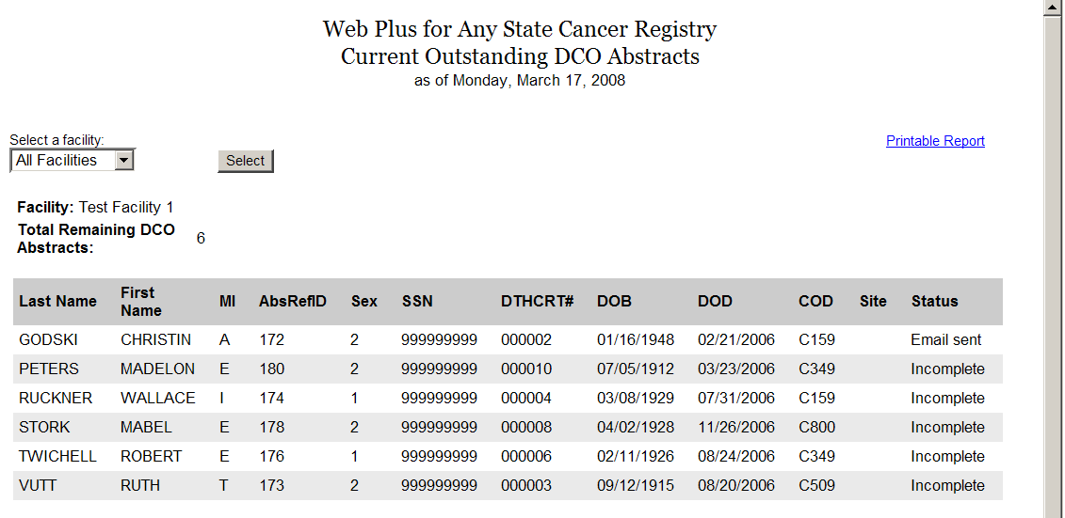
The Facility Outstanding Follow-back Abstract Listing Reports contain these fields:
Field/Headings | Description
Last Name | Last name of patient
First Name | First name of patient
MI | Middle initial of patient
AbsRefID | A unique, system-generated number identifying the abstract
Sex | Patient’s sex
SSN | Patient’s social security number
DTHCRT# | Death certificate number from death certificate (for death certificate follow-back only)
DOB | Patient’s birth date
DOD | Date of patient’s death from death certificate (for death certificate follow-back only)
COD | ICD-10 Cause of Death (for death certificate follow-back only)
Site | ICD-O-3 topography code for the primary site of the tumor being reported
Status | Current status of the outstanding follow-back abstract:  Incomplete, E-mail sent, Rejected, or Rerouted
- By default, line listings will be shown for all facilities that are assigned to you. To print out the report for an individual facility, select the facility from the pull-down list, and click Submit. In the example shown, Test Facility 1 is selected.
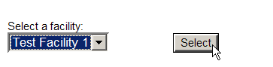
Result: The Facility Outstanding Follow-back Abstract Listing Report for the particular facility opens in a separate window.
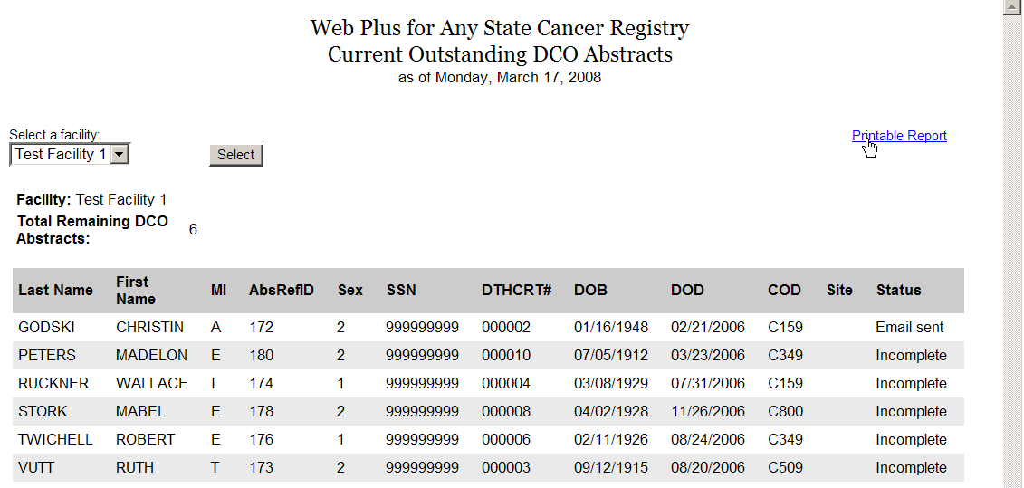
- Click on the Printable Form link.
Result: A page opens with a printable version of the report.
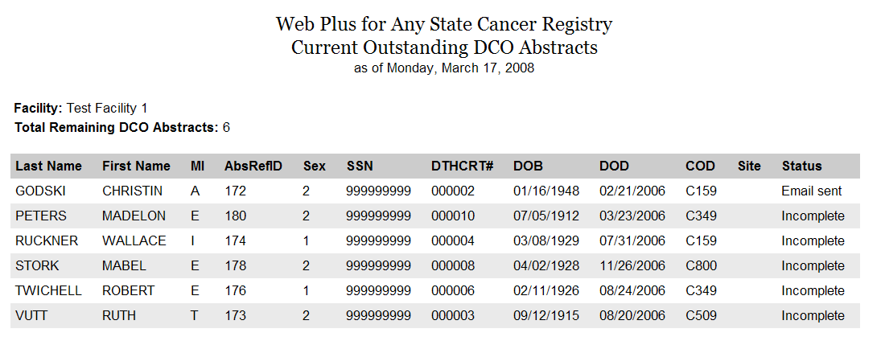

Rejected Follow-back Abstracts by Facility
The Rejected Follow-back Abstracts by Facility reports report includes a line listing by facility of all follow-back abstracts that have been rejected by facilities. Follow-back Supervisors and Monitors can use this report to rapidly identify rejected follow-back abstracts so that they can be re-routed to different facilities or deleted from the Web Plus follow-back system.
To open the Rejected Follow-back Abstracts by Facility report, complete these steps:
- On the Web Plus menu, click Reports.
Result: Web Plus displays a list of available follow-back reports.
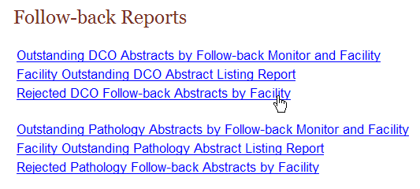
- Click on either the Rejected DCO Follow-back Abstracts by Facility or the Rejected Pathology Follow-back Abstracts by Facility link. In the example shown the Rejected DCO Follow-back Abstracts by Facility report is opened.
Result: The Rejected Follow-back Abstracts by Facility report for the particular follow-back type opens in a separate window.
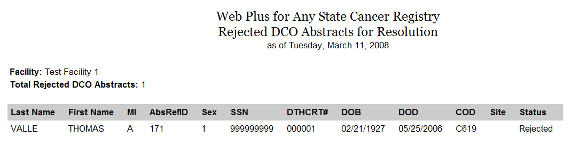
The Rejected Follow-back Abstracts by Facility reports contain these fields:
Field/Headings | Description
Last Name | Last name of patient
First Name | First name of patient
MI | Middle initial of patient
AbsRefID | A unique, system-generated number identifying the abstract
Sex | Patient’s sex
SSN | Patient’s social security number
DTHCRT# | Death certificate number from death certificate (for death certificate follow-back only)
DOB | Patient’s birth date
DOD | Date of patient’s death from death certificate (for death certificate follow-back only)
COD | ICD-10 Cause of Death (for death certificate follow-back only)
Site | ICD-O-3 topography code for the primary site of the tumor being reported
Status | Shows the current Rejected status of the outstanding follow-back abstract

Questions
Answer these questions about follow-back reports (the answers are in Appendix A, on page 35 ):
- Which menu option opens the page where you can view follow-back reports?

- Where can you go to quickly get a list of follow-back abstracts that have been rejected by facilities?

Appendix A: Answers

Chapter 2: The Basics
These are the answers to the questions (page 7) about the basics of Web Plus:
- To track follow-back abstracts by facility, click the Follow-back menu option, and click Track Follow-back Requests by Facility.
- To log out, click Log Out on the Web Plus menu.

Chapter 3: Tracking Follow-back Requests by Facility
These are the answers to the questions (page 19) about tracking follow-back requests by facility:
- To track individual follow-back requests by facility, on the Web Plus menu, point to Follow-back, then click Track Requests by Facility.
- To view the history of actions performed on a follow-back abstract assigned to a particular facility, on the Track Follow-back Requests by Facility page, locate the facility to which the abstract is assigned, and click the Track Abstracts link in the Action column. On the Track Individual Follow-back Abstracts page, from the listing of follow-back abstracts in the file, locate the follow-back abstract of interest, and using the pull-down menu in the Action column, select View History.
- To delete a follow-back abstract from Web Plus, on the Track Follow-back Requests by Facility page, locate the facility to which the abstract is assigned, and click the Track Abstracts link in the Action column. On the Track Individual Follow-back Abstracts page, from the listing of follow-back abstracts in the file, locate the follow-back abstract of interest, and using the pull-down menu in the Action column, select Delete.

Chapter 4: Sending E-mail Notices
These are the answers to the questions (page 24) about sending e-mail notices:
- Any 2 of the 3 following ways that you can access the Send Email Notice page would be correct:
  - Clicking the send e-mail after rerouting checkbox when rerouting a follow-back abstract.
  - Clicking the Send Notice link when tracking follow-back abstracts by facility.
  - Selecting Send Notice from the Action column of the Track Individual Follow-back Abstracts when tracking individual follow-back abstracts
- No, you do not have to type an e-mail from scratch each time you want to send an e-mail. To save new e-mail messages, check the Save as New Template check box, enter a name for the template in the text box, and click Save Template.
- To delete an e-mail template, select the template from the pull-down menu, and click Delete Template.

Chapter 5: Reports
These are the answers to the questions (page 33) about reports:
- To view Web Plus follow-back reports, on the Web Plus menu, click Reports.
- The Rejected Follow-back Abstracts by Facility reports list follow-back abstracts that have been rejected by facilities.

