


Prep Plus™
User’s Manual

September 12, 2019

Centers for Disease Control and Prevention

National Center for Chronic Disease Prevention and Health Promotion

Division of Cancer Prevention and Control

National Program of Cancer Registries

Registry Plus ™ Software for Cancer Registries

Version 5.0

Table of Contents

Table of Contents 2
Introduction 5
Overview of User’s Guide 5
User Support 6
Getting Started 6
Logging In 6
Prep Plus Main Window 6
The Menu Bar 7
The Icon Task Bar 14
Manage Configuration 15
Edits Configuration 15
Setting Individual Edit Options 15
Suppressing Individual Edits: 16
Default Folders 17
Miscellaneous 17
Manage Users 19
Change Password as Administrator 19
Adding a New User 20
Delete User 20
Change Password As User 20
Manage Display Types 21
Configure Display Types 21
Adding a Display 23
Deleting a Display 23
Display Options for SSDIs 24
Section Headers 25
Adding a Section Header 25
Renaming a Section Header 26
Deleting a Section Header 26
Opening a New Bundle in Prep Plus 26
User Interface: General Prep Plus Display 28
Field Values 29
AbsRefID 29
Prev/Next Buttons 29
Save 29
Text 29
Get Abstract 30
TNM8 30
Automated Schema Calculation 30
Derive CS 31
Automated Collaborative Stage Calculation 32
Sections 32
Display Type 32
Current Record 32
Edits Tab 32
Error Navigation 34
Messages 34
Disposition Tab 34
Release 34
Abort Bundle 36
Current Record Option: Hold 36
Current Record Option: Mark for Release 36
Current Record Option: Reject 36
All Records Option: Hold All 36
All Records Option: Mark All 36
All Records Option: Reject All 37
All Records Option: Un-Hold 37
All Records Option: Un-Mark 37
All Records Option: Un-Reject 37
Edit Reports 37
Prep Plus Window 37
General Editing 38
Age Recalculation in Prep Plus 39
Selecting Held Abstracts in Prep Plus 39
User Defined Functions (UDFs) 40
Managing Facilities 40
Managing Doctor Query Table 40
Prep Plus Database Structure 41
Track Database (Track_DB) 41
InPro Database 41
Prep Plus Database 41
Prep Plus Folder Structure 41
AccBun 41
Archive 42
Edits 42
FixedBun 42
mdbs 42
mdfs 42
PrepAbs 42
PrepHelp 42
RawAbs 42
RejAbs 42
RejBun 42
Reports 42

Introduction
Prep Plus is the Registry Plus application used to run standardized edits on all NAACCR-formatted data files submitted from reporting sources and to prepare the abstracts for processing in the main central registry system, CRS Plus. By editing the data prior to import into CRS Plus, the quality of the data is improved on incoming records which is helpful in making linkage and consolidation decisions in CRS Plus. In Prep Plus, all records in the file or a subset of records can be visually edited thus improving the quality of the data.

Prep Plus was initially written in Microsoft Visual Basic, version 6, and implemented in the first central cancer registry in 2001. Prep Plus was recently re-written in Microsoft .NET Framework 4.5 and implemented in cancer registries in 2018.
Prep Plus is a windows-based application that is hosted on a SQL Server. Multiple users can access and process data files at the same time.

The EDITS.dll is a component of the Prep Plus software and used to apply NAACCR standard edits.

The input file imported into Prep Plus must be in NAACCR standard format. Two NAACCR versions can be accommodated, the latest NAACCR format and one previous version. The output file is the current NAACCR Record Version. For example, for v18 Prep Plus, a v16 NAACCR file can be imported into Prep Plus. The file is converted to NAACCR v18 and the resulting prepped output file is the file in NAACCR v18 format.

Prep Plus features include:
- Assigns a unique AbsRefID to each record processed and the ID carries over into CRS Plus serving as a unique key. Records with duplicate AbsRefIDs cannot be imported into CRS Plus.
- Stamps each record with the Date Case Report Received which can be used to track timeliness.
- Edit error reports are generated and can be shared with reporting sources to assist registries in identifying common errors and areas to target for education and training.
- Individual records or entire bundles can be held to another user, marked for release in spite of errors, or rejected.
- Display types can be created and managed by the user to customize the order of data items, assign headers to data item sections, and to include registry-specific data items.

This manual presents the information required by users of the Prep Plus editing software to process cancer data daily. The following chapters of this manual cover the subjects that enable you to:
- Log in to Prep Plus.
- Access the Prep Plus menu items.
- Manage Configurations including Display Types.
- Open Bundles in Prep Plus.
- Interactively Edit in Prep Plus
- Calculate Collaborative Stage and Schema
- Review Disposition Options

Overview of User’s Guide
Through this manual, users will be introduced to Prep Plus User functionalities and capabilities in a detailed step by step manner. This manual provides information on tasks to be performed by users for routine editing of data.

User Support
For technical support via e-mail, contact cancerinformatics@cdc.gov.

Getting Started

Logging In
To access Prep Plus, double click on the Prep Plus icon on your desktop.

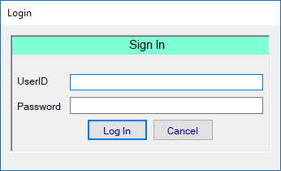

Prep Plus Login dialog.
- Enter your Prep Plus User ID. For security purposes, the list of users is no longer visible.
- Enter your Password.
- Click on Log In or hit the Enter button on the keyboard.
- A general UserID, DOE, with password, Guest, is still available for initial log in to Prep Plus for registries using Prep Plus for the first time.
NOTE: Please contact a Prep Plus Administrator to set up a User name and password for initial login.

Prep Plus Main Window
When a user successfully logs in to Prep Plus, the main window will open.
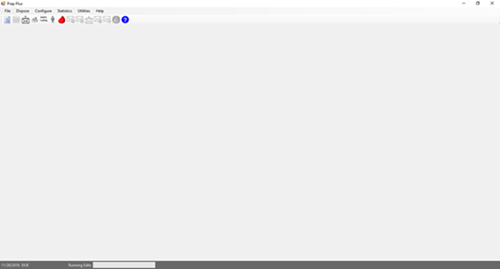

Prep Plus main window.

The Menu Bar
The menu bar contains the following options:
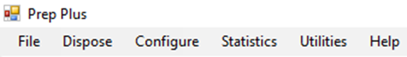

Prep Plus menu bar.
File
Contains menu options available to process data files as well as print the current abstract or all abstracts and exit the application.
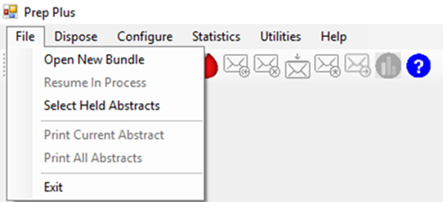

Prep Plus File Menu
Open New Bundle
Menu option used to open a new bundle for editing. Only one bundle can be opened and processed at a time. This menu option will not be available if there is already a bundle in process.

Resume In Process
Menu option used to resume a bundle already in process. A bundle can remain in process and the application can be closed. When the bundle is re-opened using the Resume in Process menu option, the bundle will open, and all previous work completed to edit, and update records will be retained. This menu option will only be available if there is a bundle in process.

Select Held Abstracts
Menu option used to access the Held Abstracts window. This option will only be available if abstracts have been held to the user.

Print Current Abstract
Menu option used to print the current abstract. This option will only be available when an abstract is open.

Print All Abstracts
Menu option used to print all abstracts in a bundle. This option will only be available when a bundle is open.

Exit
Menu option to exit Prep Plus. The X in the top right corner of the Prep Plus window can also be used to exit the application.

Dispose
Contains disposition options for the current abstract, all unmarked abstracts in the bundle, as well as functions to Abort the bundle and Release the bundle. Refer to Disposition Tab for detailed information regarding disposition options.
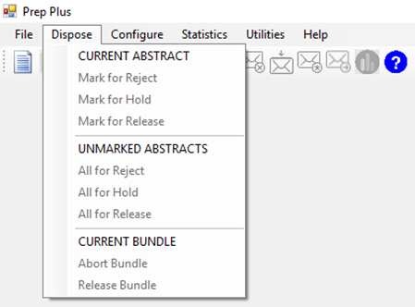

Prep Plus Dispose menu

Configure
The Configure menu option allows user to define configuration settings including selection of customized or updated edit metafiles and edit sets, configure edit exceptions, suppress edits, add and modify user information, and create and modify customized displays.
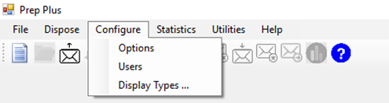

Prep Plus Configure menu
Statistics
The Error Statistics menu option will be active when there is a file in process. It is inactive if a file has not been selected. Unfixed error statistics by edit name are summarized. The statistics are currently cumulative. The data can be exported to Excel. This feature will be enhanced in the future to provide statistics by reporting source and by bundle.
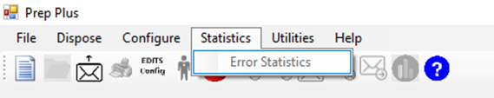

Prep Plus Statistics menu.
Utilities
Four utilities are currently available.
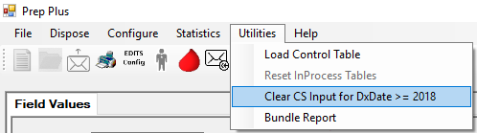

Prep Plus Utilities menu
Load control table
This utility will be used when the Registry Plus team issues a new ControlCatvals Access database. The utility takes the Control Table in the Access database and incorporates it into the PrepPlus MS SQL database (PrepPlus.mdf) without the user needing to perform the process in Microsoft SQL Server Management Studio.

reset inprocess tables
Now that a SQL Server database has been established for Prep Plus, a method is needed to clear working tables since
users may not have access to the SQL Server Database and since registry requests may be placed in a queue for IT or
Database Administrators to resolve. The utility to Reset InProcess tables will clear the tblProcessHeld and
ImportEditResults for the bundle in the event the tables are corrupted or not cleared as expected.

clear cs input for dxdate >= 2018
This utility is enabled when the DXDATE is 2018 and later. The utility clears both CS Inputs and CS Derived values so the user is able to clear all 2018 edits if CS data items are populated. When the utility is selected, the user will be asked “Do you want to clear all CSItems?” 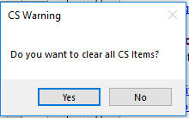

Prep Plus CS Warning Message for Clear CS Input Utility When DxDate >= 2018
If the user selects No, the CS items will not be cleared. Once the user selects Yes, the utility will clear all CS Inputs and CS Derived Values. This will ensure that the user is able to clear all 2018 edits in an efficient manner since the CS edits appear multiple times for each CS data item. All CS input values and CS Derived values will be cleared.
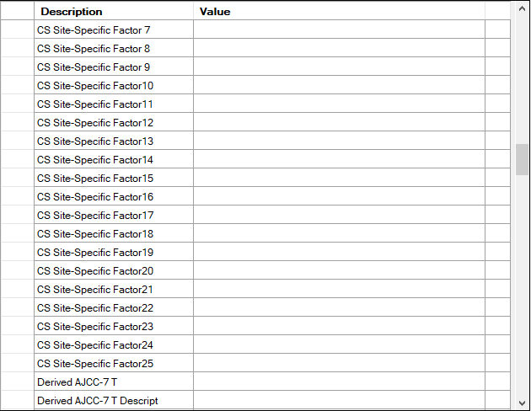
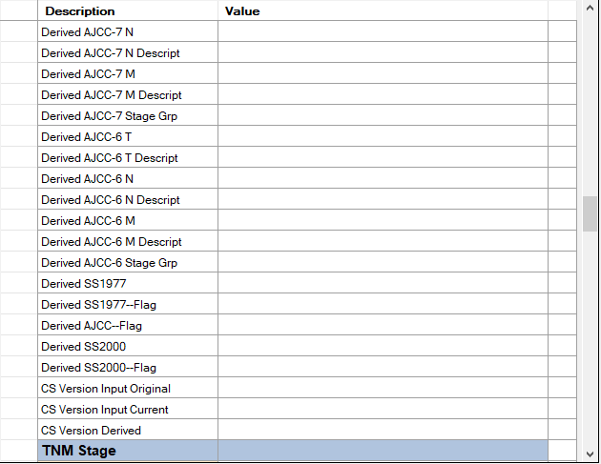

Prep Plus Print Screen of CS Input and Derived Fields Once Utility for Clear CS Input for DxDate >= 2018 Utilized
bundle reports
This utility views all released Abstracts and gives users the ability to track which bundles and abstracts have been released.
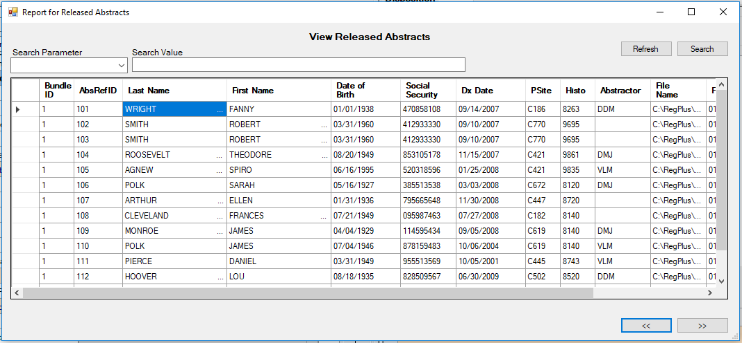

Window View of Report for Released Abstracts
The Search Parameter drop down has four options: Name of Input Bundle, Bundle ID, Last Name, and Abstractor. These options can be used to search for specific released abstracts based on the Search Parameter and Search Value.
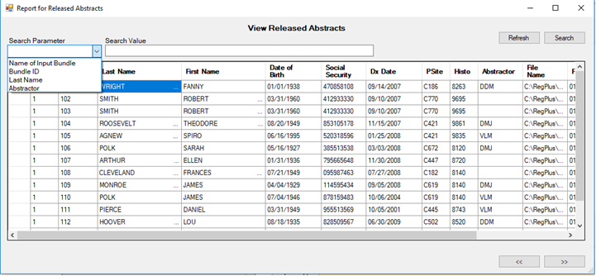

Window View of Search Parameter Drop Down Options

To search for a released abstract:
Ex: by Last Name

- Click the Search Parameter drop down arrow and select the highlighted option Last Name.
- In the Search Value type in the desired last name of the Released Abstract that is being searched for.
Ex. Adams
- Then click on the Search Button
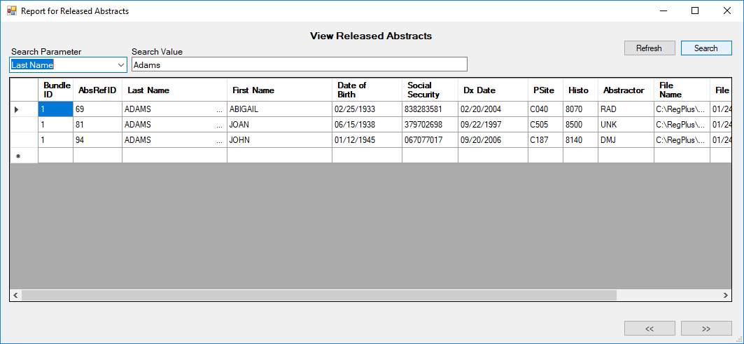
Window View of Report for Released Abstracts by Last Name
To Refresh the Report for Released Abstracts, click the Refresh button and the Report will refresh.
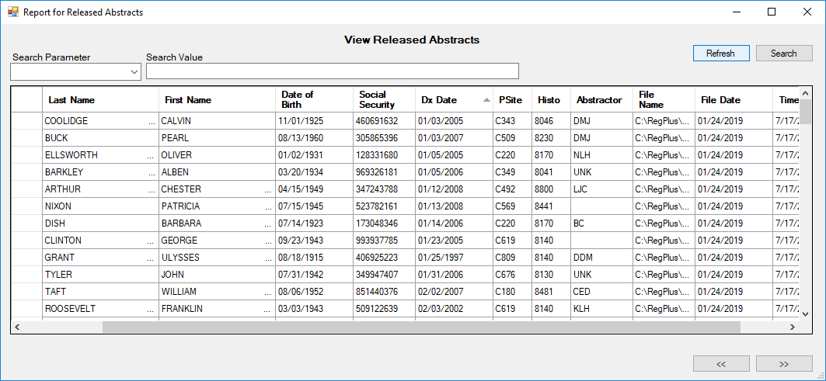

Window View for Released Abstracts after Refresh Button

The arrow buttons at the bottom of the Report for Released Abstracts window can be moved to the Right or the Left to display additional columns.

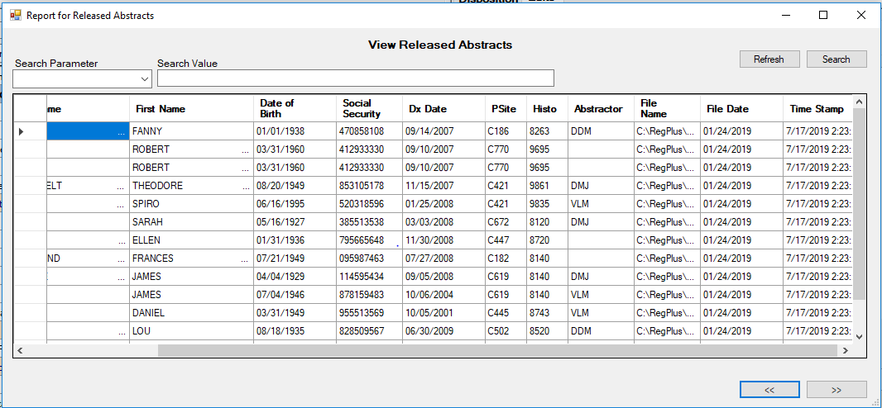
Window View of Report for Released Abstracts
Note: Column Display lists can be sorted by clicking on the Column Headers. For instance, if a user wants to sort the display column listed by Date of Birth, the user can click on the Date of Birth column header and the display list for Date of Birth will be sorted by month in numerical order.
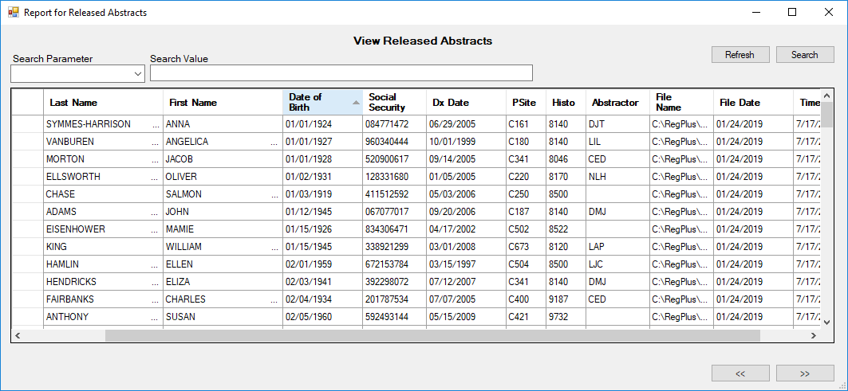

Window View of Report for Released Abstracts, Date of Birth Column Header sorted numerically by month
Help
Provides access to the online help system and a dialog box that displays the Prep Plus version. Online Help will be added
at a later time.
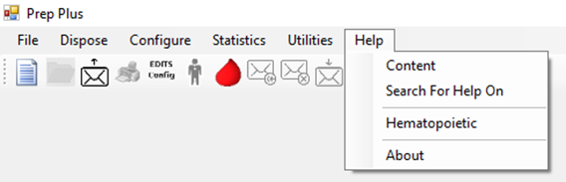

Prep Plus Help menu.
  - About: Opens the About dialog box to view the current version of Prep Plus.

The Icon Task Bar

Prep Plus Icon Task Bar
The following functions are available via the icons:

Open New Bundle Resume Abstract Select Held Abstracts Print Current Abstract EDITS Configuration Configure Users SEER Heme DB Abort Current Bundle Reject Remaining Abstracts Hold Remaining Abstracts Mark Remaining Abstracts for Release Release Bundle Error Statistics Help

The envelope icons will be updated at a later time to distinguish between functions.

Manage Configuration
Configuration and application settings are set by an Administrator. Software features may not be applicable to all registries and are added to Prep Plus as preferences in the Configure → Options menu so users can select applicable features.

Edits Configuration
The first tab in the Configuration Options window is the Edits Configuration tab as displayed below:

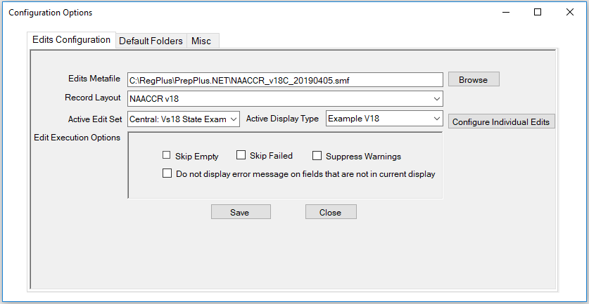

Prep Plus Application Settings – Edits Configuration
After each install, upgrade, or if the edit metafile is replaced, the Edits Configuration settings should be reviewed and updated if necessary. An administrator should verify the appropriate Edits Metafile, Record Layout, and Active Edit set are defaulted appropriately. An edit set can also be assigned to an Active Display Type. Edit Execution Options can be applied to Edit sets.

Setting Individual Edit Options
- Select the Configure Individual Edits radial button to the right of the Active Display Type.
- The Individual Edits Option dialog will open as displayed below.
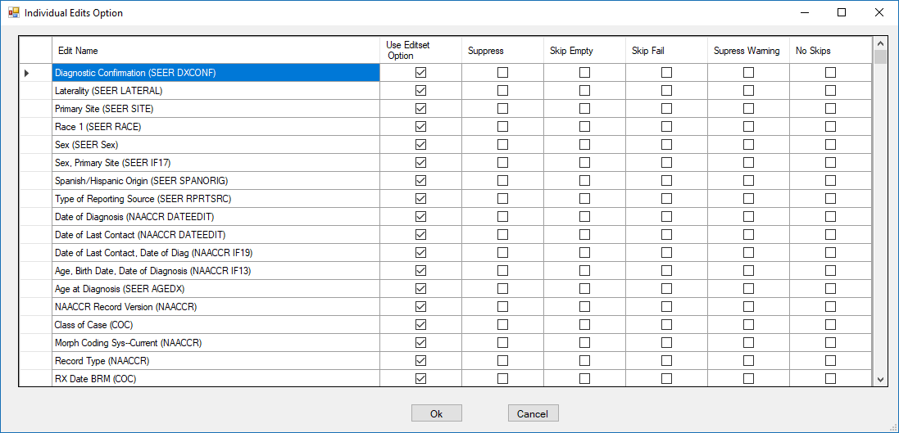

Prep Plus Individual Edits Option Dialog
Individual edits can be suppressed in this window to de-activate the selected edits from running. This is useful if an issue is identified in edit logic and the user wishes to suppress an individual edit until a new edit metafile can be generated.

Suppressing Individual Edits:

- Scroll to identify the Edit Name(s) to suppress.
- Click on the box in the Suppress column to add a check mark for all appropriate rows/Edit Names.
- To un-suppress an edit, click on the box in the Use Editset Option column to remove the checkmark for the edits that have been suppressed.
- When all changes have been made, click on Ok.
- The IndividualEditsOption dialog will close.
- Click on Save in the Configuration Options window to save changes.
Selecting a Different Edit Metafile

  - Retain a copy of the current .smf or rename the current .smf before replacing the metafile.
  - If a registry-specific edit metafile has been generated, copy the .smf to the folder where the edit metafiles are stored for the Prep Plus application (Ex. C:\RegPlus\Prep Plus\Edits or the network location). The metafile no longer needs to be renamed for Prep Plus.
  - In the Configure→ Options menu in Prep Plus, click on the Browse button to the right of the Edits Metafile.
  - An Open dialog window will appear. Select the edit metafile from the appropriate location.
  - Once the edit metafile is selected, select Open.
  - Select the Record Layout for the edit metafile using the dropdown menu.
  - Select the Active Editset from the registry-specific edit metafile using the dropdown menu to apply to the abstracts processed in Prep Plus.
  - Assign the Active Display Type.
  - Once the components of the configuration are selected, click on Save.
  - A confirmation message will appear stating: “Edit configurations have been saved”.
  - Click on OK to close the confirmation message.

Edit Execution Options
The Edit Execution Options are described below. It is recommended the default execution options be retained as is without checking the boxes for these options.
Skip Empty | Prevents the individual edit from executing if any of the fields that it edits are blank.
Skip Fail | Prevents an individual multi-field edit from executing if any field in its list has failed its single field edit.
Suppress Warning | Prevents the return of any warning messages by the edit.

Default Folders
The second tab in the Configuration Options window is the Default Folders tab as displayed below:

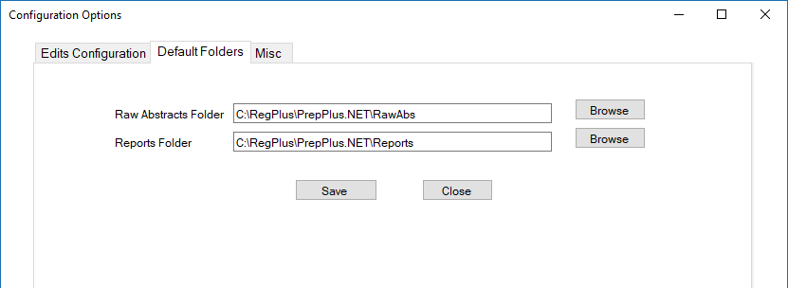

Prep Plus Default Folder Settings
The location of the Raw Abstracts Folder and the Reports Folder can be selected and saved in this tab.

Miscellaneous
The third tab in the Configuration Options window is the Misc tab as displayed below:

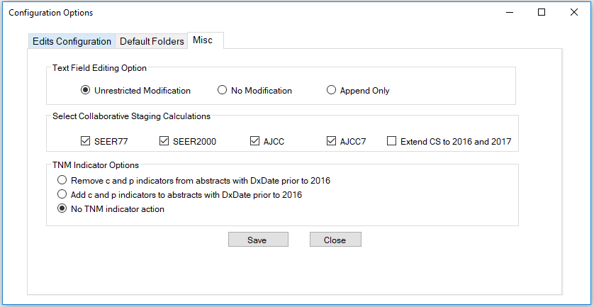

Prep Plus Miscellaneous Settings
Three setting preferences are available in the miscellaneous tab. All settings should be reviewed and confirmed after initial install or upgrade.

Text Field Editing Option
The following three options are available for text field editing: Unrestricted Modification, No Modification, and Append Only. The option for Unrestricted Modification allows updates to text without any restrictions, the option for No Modification does not allow any updates to text, and the option to Append Only allows user to append to the text data items without modifying the existing text submitted by the reporting sources.

Select Collaborative Staging Calculations
The Collaborative Staging Calculation settings should be reviewed and confirmed after initial install or upgrade to verify appropriate settings are applied for the registry.

NOTE: The option to Extend CS to 2016 and 2017 should be used by Cancer Care Ontario only due to differences in staging requirements compared to U.S. registries.

TNM Indicator Options
AJCC TNM 7th Edition codes were modified in NAACCR Record Version 16. An indicator of clinical or pathologic (c or p) was added as a prefix to the T, N, and M codes. The Commission on Cancer (CoC) required all facilities in accredited programs to convert the TNM data from earlier years to the 2016 standards by adding c and p indicators to the codes. NPCR did not require conversion of prior years’ TNM data since NPCR did not request TNM data for pre-2016 to be submitted for call for data. NPCR central registries may have received a mix of TNM data with and without the clinical and pathologic indicators. For this reason, TNM Indicator Options have been added to configuration settings for Prep Plus to assist registries in prepping the source data so the data is consistent prior to importing into the registry database. Central registries are handling this differently and each registry must choose the best method for the individual registry needs. Three options are available:
- Remove c and p indicators from abstracts with DxDate prior to 2016.
- Add c an p indicators to abstracts with DxDate prior to 2016.
- No TNM Indicator action (no changes made to AJCC TNM 7th Edition data; TNM is retained as reported by reporting sources).

Manage Users
Administrators have the ability to manage accounts of Prep Plus users.

From the Configure menu, select Users.
Enter the Administrator password. The Administrator password is provided by the Registry Plus team.
The Users dialog window will open displaying a list of users.
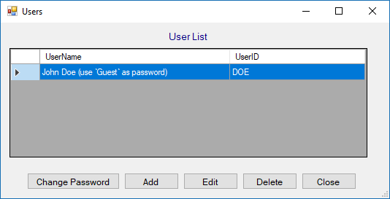

Prep Plus Users dialog window.

Change Password as Administrator
To reset a user’s password within the Prep Plus application:
- Select the user from the list and click the Change Password button within the Users dialog window.
The Change Password dialog window will open as displayed below.
Verify the UserId.
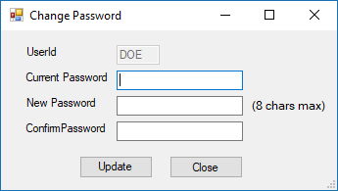

Prep Plus Change Password dialog window.
Enter the current password.
Enter the new password in both the New Password and Confirm Password fields.
NOTE: The password must be at least 4 characters and the maximum length is 8 characters.
Click the Update button. A warning message will be received if the New Password and Confirm Password do not match.

Adding a New User
To provide a new user access to the Prep Plus application:
- Click the Add button within the Users dialog window.
The User Edit dialog window will open.
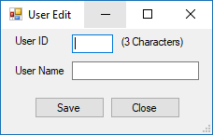

UserEdit dialog window.
Enter the user’s initials or three-letter user ID in the User ID field.
Enter the user’s full name in the User Name field.
Click the Save button.
A dialog window will appear stating the default password is ‘Guest’. Once the user logs in, the user can change their password in the Configure → Users menu option in the tab for Change Password.
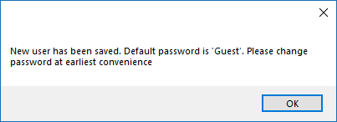

Prep Plus New User Confirmation/Default Password dialog

Delete User
To delete a user, select the user’s name from the Users list and click the Delete button. A Delete Warning dialog window will appear requesting verification of deletion. Select Yes.

A dialog window will appear to confirm the deletion.
NOTE: Users can delete the John Doe user account for additional security.

Change Password As User
To reset a User Id password within the Prep Plus application:
- From the Configure menu, select Users.
The Admin Password dialog window will open.
Select the tab for Change Password as displayed in the print screen below.
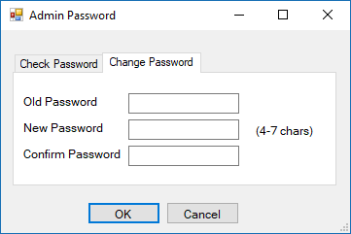

Change Password dialog window.
Enter the old password.
Enter the new password in both the New Password and Confirm Password fields.
NOTE: The password must be at least 4 characters and the maximum length is 8 characters.
Click the OK button. A warning message will be received if the New Password and Confirm Password do not match.

Manage Display Types
Display Types are configurable at a system level by an Administrator, and the configured displays apply to all users. The data items available for display are based on the table structure in the control.mdb for Prep Plus.

Configure Display Types
An example display appropriate to the current NAACCR Record Version is included in Prep Plus. Users have the capability to add displays or modify display names. Section Headers are available and can be customized to group data items and to enhance the user interface. Section Headers will be highlighted in the Prep Plus display grids to clearly separate the sections in the grids. The sort order of the data items and sections can be modified by using the up and down arrows in the Display Configuration window.

NOTE: Existing local fields in the control.mdb will be available for including in the display types. Local fields cannot be added to Prep Plus in Display under Configure Display Types. At this time, localized data items must be added to the control.mdb. Please contact Registry Plus staff to add local fields in Prep Plus.

To set or modify displays for all users in Prep Plus:
1. From the Configure menu, select Display Types.
2. The window labeled Admin Password will open prompting the user to enter the password.
3. Enter the Password. The password is not case sensitive. The Administrator password is provided by the Registry Plus team.
4. Click on OK or hit the Enter key.
5. The Display Configuration window will open as displayed in the following print screen. At the dropdown to the right of the Add Display button, select a display to view or modify from the dropdown list. The Display, Example V18, is selected in the example below.
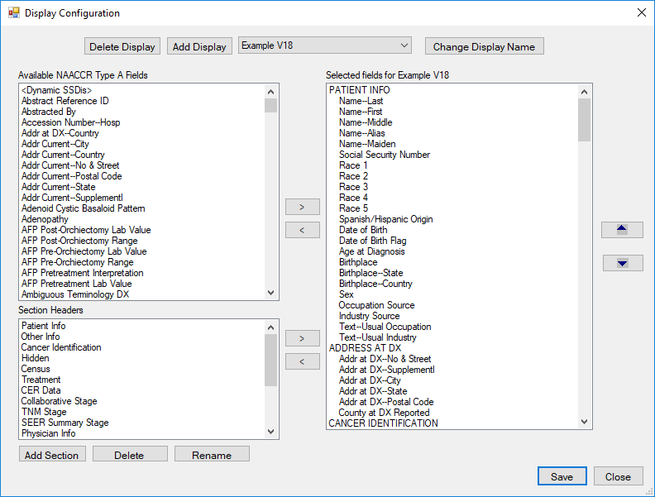

Configure – Display Types
- Review the selected display.
- Data items can be added to the display on the right by selecting data items from the section on the left labeled Available NAACCR Type A Fields.
- To insert a data item in the display, scroll to the area in the right (Selected fields for Example V18) and select a data item by highlighting it, then select the data item from the available fields list on the left and use the right arrow button to move the data item to the highlighted section in the display. Data items will be removed from the available fields list on the left once they are added to the list (Selected fields for Example V18).
NOTE: Text fields are not available in the list of items to select/include in the display since text fields are displayed in a separate window.
- Use the up and down arrow buttons on the far right of the Display Configuration window to move the data items to the desired location in the display.
- To remove a data item from the display, select the data item from the list on the right (Selected fields for Example V18) so the item is highlighted and use the left arrow button to move the data item to the list on the left (Available NAACCR Type A Fields).
- Once the display is configured, click on the Save button to save changes to the display.
- Follow the steps above to modify any other user-defined displays. The desired display should be selected from the dropdown list of display types. The label for the grid on the right will be updated according to the display type selected.

Adding a Display
- Select the Add Display button. The New Display Type window will appear.
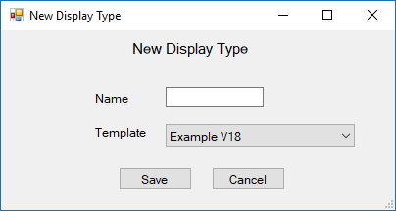

Prep Plus New Display Type window
- Assign a name for the new Display Type.
NOTE: An existing display type can be used as a template to create a new display. This is another way of copying a display and modifying the new display. Select the appropriate template to use as a baseline display. If the preference is to start from scratch and not use an existing template, select No Template from the drop-down list for Template.
- Click on Save. Clicking on the Cancel button will cancel the new display and will close the New Display Type window.

Deleting a Display
- Select the proper Display Type to Delete.

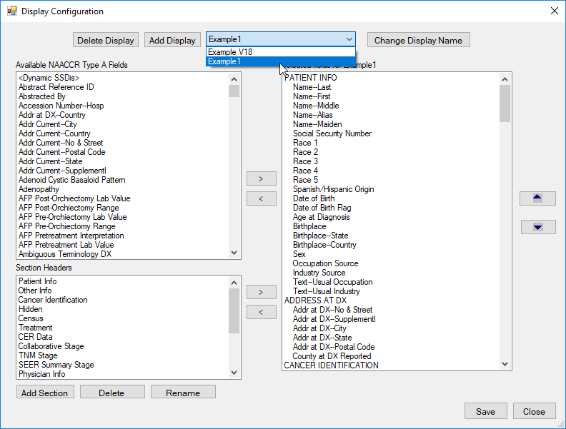
Prep Plus Display Type window selection
- Select the Delete Display button. The Display Type will be Deleted and will no longer be available for Configuration/Selection.

Display Options for SSDIs
The following three options are available in the Prep Plus display for viewing SSDIs:
Constant SSDIs Only
- Selected by user in display.
- Only the selected SSDIs will display; the constant sections cannot be expanded to display all SSDIs for he specified schema.
- User can set the order of the items.
- Constant sections will display for all cases regardless of the specified schema.
- Not recommended to display constant SSDIs only if additional SSDIs need to be expanded since only the SSDIs selected as constants in the display will be visible in the display grids.
Dynamic SSDIs Only
- All SSDIs applicable to a schema will display and the list can be expanded to include all other SSDIs if needed due to edit corrections, etc.
- The order of the data items cannot be modified.
- Cannot be customized by the user.
NOTE: The SSDI edits in the NPCR edit sets fail if a SSDI is populated when the SSDI is not associated with the schema. If the schema is modified and a new set of SSDIs is associated with the new schema, edits will fail for the SSDIs associated with the old schema if they remain populated. Messages are presented to the user in the Registry Plus software when schema is updated, and the user has the option to blank out the existing SSDIs. If the user chooses not to blank out the SSDIs, having the ability to expand the list of dynamic SSDIs will be useful so the user can blank out the items manually.
Dynamic SSDIs and Constants
- Includes user-defined SSDIs and dynamic SSDIs associated with the specified schema.
- All constants display as defined by user in one section and dynamic SSDIs display in a separate section.
- When the dynamic SSDI list is expanded, it will display all SSDIs for all schema listed alphabetically. This may be helpful if the schema is changed.
- The dynamic SSDI section will not include any SSDI specifically included in the display as a constant; therefore, duplicate SSDIs will not be displayed.
As an example, if Prostate items are included in the display as constants, the items will display in the user-defined section. Any Prostate SSDIs not specifically included in the user-defined section will be displayed in the dynamic SSDI section when the schema is Prostate. Users can control this and leave as is or select all Prostate items as constants in one section and order the required SSDIs first.

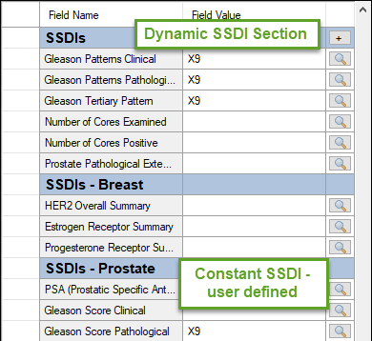

Prostate Schema Display Example of Constant SSDIs defined by user and Dynamic SSDIs displaying all Prostate SSDIs not selected in Constant SSDI Prostate section.

Section Headers
For Section Headers, sections can be added, deleted, or renamed in the list labeled Section Headers in the left lower section of the Display Configuration window.

Adding a Section Header
- To add a section header, click on the Add Section button. The following Add Display Section window will appear.
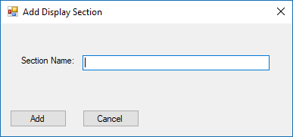

Prep Plus Display Configuration Section Header Add Display Section
- Enter a new Section Name.
- Click on the Add button. Clicking on the Cancel button will cancel the addition and will close the Add Display Section window.
- The Add Display Section window will close, and the new section added will display at the bottom of the Section Headers list.

Renaming a Section Header
- To rename a section header, select the section header from the list so it is highlighted.
- Click on the Rename button. The following Rename Section window will appear.
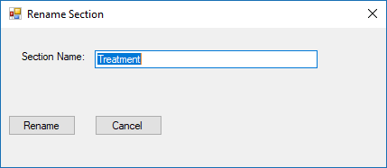

Prep Plus Display Configuration Section Header RenameDisplaySection
- Enter the new Section Name for the section header to be renamed.
- Click on Rename. Clicking on the Cancel button will cancel the renaming and will close the Rename Section window.
- The Rename Section window will close, and the modified Section Header name will display in the list.

Deleting a Section Header
- To delete a section header, select the section header from the list so it is highlighted.
- Click on the Delete Section button. The following verification message labeled Remove Section will be presented.
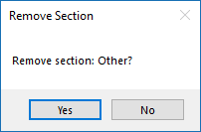

Prep Plus Display Configuration Section Header Remove Section
- Click on Yes to confirm removing the section. Selecting No will cancel the removing of the section and close the Remove Section window.
- Once Yes is selected, the Remove Section window will be closed, and the deleted section header will no longer appear in the list of Section Headers.

Opening a New Bundle in Prep Plus
To open a new bundle or file of abstracts in Prep Plus:
- From the File menu, select Open New Bundle or click on the Open New Bundle icon.
- The following Open window will display.
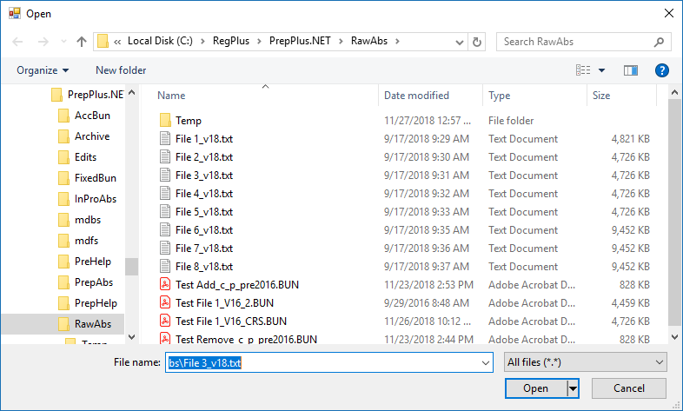

Prep Plus Open window
The RawAbs folder is the default directory for selecting files in Prep Plus.
- Select the file.
- Click on Open. The Bundle Select window will display.
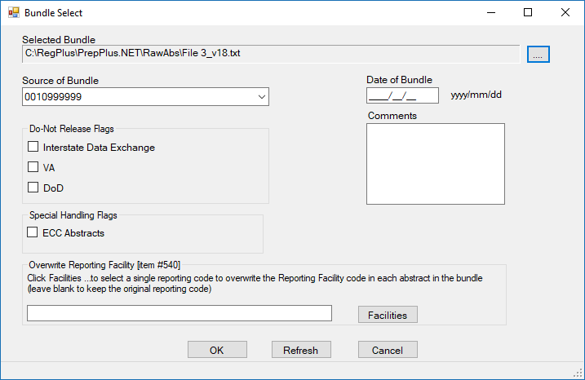

Prep Plus Bundle Select window
- The selected Bundle and location of the file automatically displays under Selected Bundle. A different file can be selected by clicking on the icon .
- If a facility table has been created, the Source of Bundle will display the Reporting Facility number associated with the facility if the number is found in the facility list.
- Enter the date the file was received under Date of Bundle. This will populate the data item, Date Case Report Received, in each record with the date the bundle was received. Entering an accurate date is important as this data item is typically used to calculate timeliness.
- Do Not Release Flags – For those registries utilizing the code values and definitions for the data item, Unusual Follow-Up Method, as adopted by the Registry Plus User’s Group, each abstract in the bundle can be flagged as received from Interstate Data Exchange, Veterans Administration (VA), or Department of Defense (DoD). The flag will be populated in the Unusual Follow-Up Method data item and carried over into CRS Plus. This will mark the records so they can be excluded from release when it is the only available source for the record.
NOTE: A different edit set may need to be selected prior to processing files from Interstate Data Exchange, VA, or DoD depending on available registry-specific edit sets and policies.
- Special Handling Flag – A flag is available to mark abstracts for registries participating in the CDC NPCR Pediatric Early Case Capture (ECC) project. When selecting the ECC Abstracts flag, the NPCR ECC Flag data item will be populated with a value of 1 (Abstract included in NPCR PYAC ECC Project) for all abstracts in the bundle. Registries can use this data item to easily identify and extract ECC Abstracts in CRS Plus.
- Overwrite Reporting Facility – A single reporting code can be selected to overwrite the Reporting Facility code in each abstract of the bundle if the user does not wish to retain the Reporting Facility code originally submitted. This may be of interest for files processed for interstate data exchange.
- Click on OK to open the bundle. The following message will appear as the file is opening.
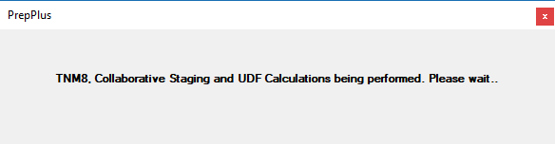

Prep Plus Functions Upon Opening a Bundle

User Interface: General Prep Plus Display
Once a file is opened in the Prep Plus window, the first record in the file containing edit errors will be displayed. A status bar displays at the bottom of the window providing the date, user initials logged in to Prep Plus, the load completion status bar indicating percentage of load completed as the file is opened, the percentage of records in the file with errors, and the total number of records containing errors.

Prep Plus Load Completion Status Bar

Field Values
The Field Values section on the left contains function buttons as well as the selected display type.
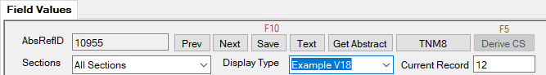

Prep Plus Field Value Window – Function Buttons

AbsRefID
Displays the AbsRefID assigned to the current abstract displayed in the Prep Plus window.

Prev/Next Buttons
There are two sets of navigation buttons in Prep Plus. This set of Prev/Next buttons will navigate the user to the next record in the file regardless of edit errors.

Save
As records are edited and corrected, they are automatically updated. The Save button or F10 function key can also be used to save changes to the record.

Text
Text for each abstract can be viewed and modified in the Prep Plus window dependent upon configuration settings.

- Click on the Text button within the Field Values section above the Abstract grid. A window similar to the following will display:
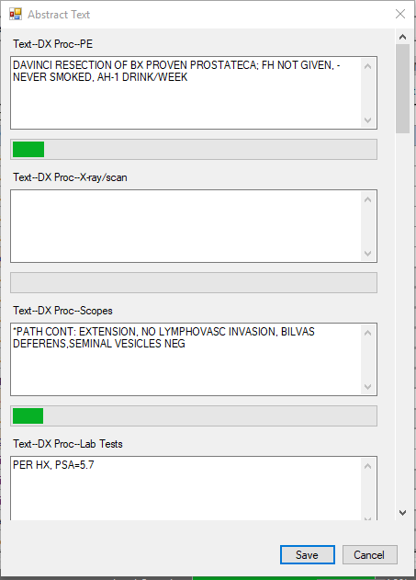

Prep Plus Text window for Abstracts
- Separate sections are available for each text data item defined by NAACCR, and the scroll bar is available on the right of the text window to scroll down to the additional text fields.
- Enter text in the appropriate text sections. The length for the text fields is limited to the field length assigned to the NAACCR text data items, and a status bar will display for text fields containing text.
- Modifications for text depend upon the Text Field Editing Options in the configuration menu.
NOTE: Text can be deleted if accidentally entered by using backspace or highlighting and deleting the text. Copy/Cut/Paste features work as well.
- Once information is entered in the text fields, click on the Save button in the text window. Once Save is selected, the text will save, and the text window will automatically close.
NOTE: The Cancel button can be used in the text window to cancel modifications and close the Text window.
- Cancel or Close can be used if no changes are made to the Abstract text. Close the Text window by clicking on the X in the upper right corner of the Abstract text window.

Get Abstract
Upon clicking on the Get Abstract button, a window labeled Select an Abstract will open displaying a list of all abstracts in the bundle. The list can be sorted by clicking on any of the headers at the top of the list. The number of errors per record is also available in the far-right column in the list of abstracts in the bundle. This is a helpful tool if searching for a specific record.

To open a specific record in the bundle, select the record from the list so that the entire row is highlighted in blue and click on the OK button. The Select an Abstract window will close, and the selected record will open in the Prep Plus window.

TNM8
For cases diagnosed in 2018 or later, Schema calculation is performed to calculate Schema ID and AJCC ID. Schema ID is required for all records, and edits are based on valid values according to Schema ID and AJCC ID. While AJCC ID is not required by NPCR, the TNM 8 DLL is incorporated in Prep Plus; therefore, AJCC ID will be calculated and populated even if the AJCC T, N, and M data items are not coded. If an issue is identified with calculation of AJCC ID or Schema ID, it could help identify a coding issue. It is important for primary site and histology to be coded correctly so Schema ID and AJCC ID can be calculated accurately.

The TNM8 button refers to the Schema calculation. TNM stage calculation is not completed for AJCC TNM 8th Edition in Prep Plus. Registries planning to retain and edit AJCC TNM 8th Edition data items can do so. The data items can be added to the display and the look-up tables for AJCC TNM data items will be available.

In Prep Plus, the TNM8 Schema calculation derives the Schema ID and AJCC ID upon Save and on demand using calculation buttons.

Automated Schema Calculation
For cases diagnosed in 2018 or after, schema calculation runs upon import and runs automatically upon Save. Upon import, Schema ID and AJCC ID will be populated in the abstract if the derivation can run successfully. When any of the data elements defined for a schema are modified, Prep Plus will automatically recalculate and re-populate Schema ID and AJCC ID before navigating to the next record.

Schema Not Applicable
For the instances where a schema is not applicable for AJCC TNM 8th Edition staging, an informational message will be presented to the user. The message does not indicate an application error. The message displayed below returns from the TNM 8 DLL to indicate that AJCC TNM 8 is not applicable for the combination of site and histology. The histology may not be included in the AJCC TNM 8 chapter. AJCC ID will be populated with XX for these scenarios.
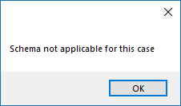

Prep Plus Schema Not Applicable Message
Manual Schema Calculation
In the Prep Plus window, a manual feature is also available for the user to recalculate Schema ID and/or AJCC ID. This function is referred to as “on demand” and it can be invoked in one of two ways: by either pressing the calculation button to the right of either Schema ID or AJCC ID in the abstract grid or by clicking on the TNM8 button located at the top of the abstract grid for a case diagnosed 2018 or later.

Batch TNM Derivation in CRS Plus
AJCC TNM 7th Edition stage calculation to derive the NPCR Derived Clin Stg Grp (3650) and NPCR Derived Path Stg Grp (3655) using the TNM API for cases diagnosed in 2016 and 2017 is no longer performed in Prep Plus since NPCR expected the calculation at the central registry level on consolidated data but not in abstract level data.

A Batch TNM 7 Derivation utility is available within CRS Plus to populate NPCR Derived Clin Stg Grp (3650) and NPCR Derived Path Stg Grp (3655) in abstracts and consolidated records for AJCC TNM 7th Edition. Once this batch program is run, if there are any remaining records with missing TNM staging elements, the NPCR derived data items will be calculated and populated with 99. These records can be identified from the reports generated by the batch program and the missing TNM data elements can be reviewed and coded if known information is available. The NPCR derived data items can be recalculated if additional information is available at a later time. A Batch TNM 8 Derivation utility is also planned for CRS Plus.

Derive CS
The Collaborative Staging (CS) System schemas consist of data input fields necessary to derive T, N, M, and Stage Group according to the AJCC Cancer Staging Manual; SEER Summary Stage 1977; and SEER Summary Stage 2000. Collaborative Staging applies to cases diagnosed January 1, 2004 through December 31, 2015. It is important for primary site to be coded correctly since most schemas are site-specific; although, there are a few schemas such as melanoma and lymphoma that are based on histologic type.

Once the CS data items are completed, the coded values are passed to a computer algorithm that generates the correct stage for the case in the following staging systems: AJCC TNM, 6th Edition, AJCC TNM 7th Edition, SEER Summary Stage 1977, and SEER Summary Stage 2000 based on the application settings in the Configure → Options menu for Collaborative Stage Calculation Preferences. The program returns a set of output values or numeric codes to be stored in the record.

As part of the output of the CS Algorithm, three additional system fields, CS Version Input Original, CS Version Input Current, and CS Version Derived, are generated and stored. CS Version Input Original indicates the number of the version initially used to code CS data items. CS Version Input Current indicates the version of the CS input fields after they have been updated or recoded and is updated each time the CS Derived items are recalculated. CS Version Derived is recorded the first time the CS output items are derived and is updated to reflect the version number of the CS Algorithm used to derive the CS output fields and is updated automatically by the computer every time the CS Derived items are recalculated.

In Prep Plus, the CS Algorithm calculates the derived stage fields upon Save and on demand using calculation buttons.

Automated Collaborative Stage Calculation
Collaborative Stage Calculation runs upon opening a bundle in Prep Plus and when working on individual records meeting the date criteria for Collaborative Stage.

When Date of Diagnosis, Histologic Type ICD-O-3, Primary Site, and/or a CS input item is updated, the derived CS data items are automatically recalculated and re-populated upon Save or when navigating to the next record.

If the CS Algorithm recalculates the derived CS data items successfully, the derived CS data items will automatically be updated. A message of successful recalculation will not appear; however, if there is a problem recalculating derived CS data items, a message will be received stating there were errors in calculating derived stage and all derived stage data items will be blanked out until successful calculation. The message will include reference to the data item causing the error.

Manual Collaborative Stage Calculation
In the Prep Plus window, a manual feature is also available for the user to recalculate the derived CS data items. This function is referred to as “on demand” and it can be invoked in one of three ways: by either pressing the calculation button to the right of any CS derived data item in the abstract, using the F5 function key, or by clicking on the Derive CS button located at the top of a tumor or abstract grid for a record diagnosed between 01/01/2004 and 12/31/2015.

Sections
Select a section from the drop-down list of Sections to be re-directed to the selected section in the Prep Plus window. This is a quicker way to navigate to the section without needing to scroll through the abstract. The default is All Sections. All section headers inserted in the display type in the Display Configuration will be available in the drop-down list.

Display Type
The Display Type will be defaulted; however, a different display type can be selected at the drop-down list to the right of Display Type and the display will be refreshed.

Current Record
The consecutive number assigned to the record will display to the right of Current Record.

Edits Tab
The Edits Tab will display Error Navigation buttons, the number of errors in the record displayed, the total number of errors in the file to be corrected, a list of edits for the current record, and Max errors option to be shown in the edit description window can be selected from All, 5, 10, and 20 to be shown.

If there is a significant number of edit errors for a record or a file, the Max errors option can be set to enhance performance and to reduce the number of edit errors displaying at one time since a large amount of edit errors could take longer to load. Once the specified number of Max edits is corrected, the next set of edit errors for the record will load.

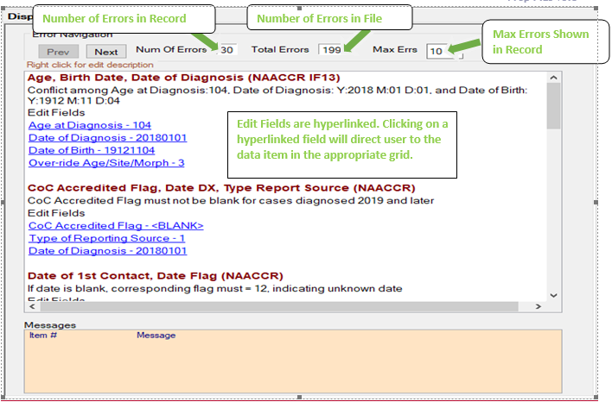

Prep Plus Edits Tab
The full edit description for an edit can be accessed by right-clicking near each edit listed in the Edits tab. An example of an Edit Description window displaying the detailed edit description and the assigned Error Message is provided below. A scroll bar is available for edits with lengthy edit descriptions.
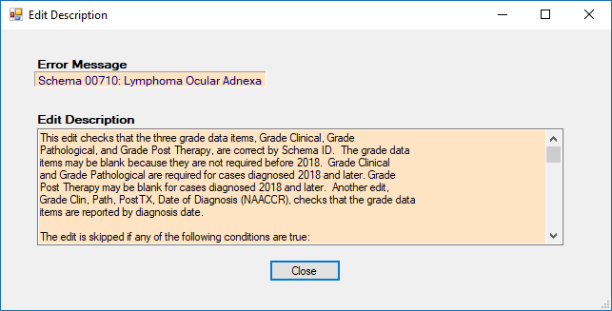

Prep Plus Edit Description Window

Error Navigation
There are two sets of navigation buttons. The set of navigation buttons within the Edits tab under Error Navigation allows the user to navigate between records containing edit errors. Error-free records will not appear when using this set of navigation buttons.

Messages
If a data item has an associated message, the message will be displayed in the light orange section labeled Messages at the bottom of the Edits tab.

Disposition Tab
The Disposition tab includes the current record displayed and the total number of records in the current file. It also includes the functions available to dispose records and bundles. Each function is described below the print screen of the Disposition tab.
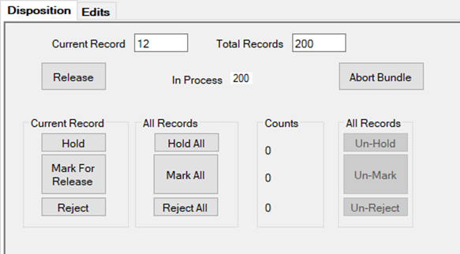

Prep Plus Disposition Tab

Release
When the bundle is released using the Release button in the Disposition tab, all processed records that have not been held or rejected are released and the file is saved in the PrepAbs folder. The tblProcessHeld and ImportEditResult will be cleared automatically. The Total Errors displayed in Error Navigation should be 0 once all errors have been corrected or disposed.

Abstracts with Schema Errors
A valid Schema ID is required for all cases diagnosed in 2018 or later. If Schema ID is blank, the records are identified upon Release. This can occur if a Schema Discriminator is needed to determine the appropriate schema and the Schema Discriminator is blank. The following window labeled, Abstracts with Schema Errors, will appear if there are any records with diagnosed 2018 or later that have blank Schema ID when attempting to release the bundle. This is a safeguard in case edits are not included in the applied edit set to identify records with a blank Schema ID. The window listing records with blank Schema ID will not appear if there are no such records. If the window, Abstracts with Schema Errors, does appear, the AbsRefID, Last Name, and First Name will display in the list. The feature, Get Abstract, can be used to easily find the record(s) and navigate to them to resolve the issue and calculate Schema ID. The list can also be printed so the user does not have to continually click on the Release button if there is more than one abstract with schema errors. Once all schema errors have been corrected, the user can click on the Release button again to release the bundle.
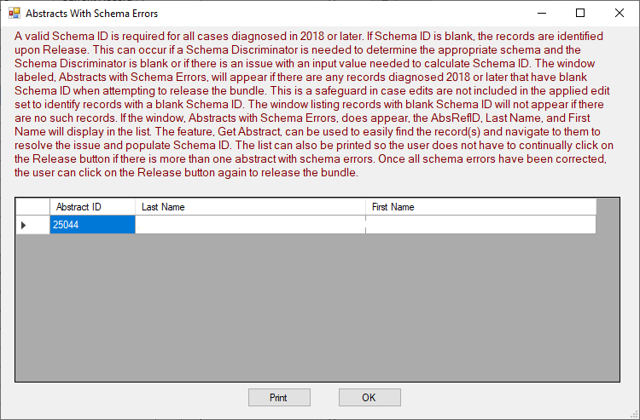

Prep Plus Abstracts with Schema Errors
Click on OK or on the X in the top corner of the Abstracts with Schema Errors window to close. The following message will appear:
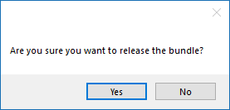

Prep Plus Release Bundle Message
If any abstracts with schema errors still need to be corrected, click on No. The message will close, and the file will remain open so the user can identify the record and continue processing and editing the records in the file.

Once all abstracts with schema errors have been corrected, click on the Release button in the Disposition tab to release the bundle. If the user selects Yes before all abstracts with schema errors are corrected, the corrected records will be released and the abstracts with schema errors will remain in process. Abstracts remaining in process will be appended to the previously released file once processed and released or released in a separate bundle if the original file was moved from the PrepAbs folder once all issues have been resolved.

Abort Bundle
An Abort feature is available to abort a bundle in the event the user decides the file should not be processed. When a file is aborted, the file is saved to the RawAbs folder. The Abort Bundle feature will be disabled and unavailable under the following situations:
- Records have been released.
- Current Held records exist.
- Current Marked for release records exist.
- Current Rejected records exist.
- An abstract is InProcess from Select Held Abstracts.

Current Record Option: Hold
Individual records can be held to an existing user including the user processing the file in order to retrieve additional information or to clarify outstanding questions to finalize the record. Holding the record allows the user to edit remaining records in the file and process the file so the bundle can be released. Held records will not be released with the bundle and can be released at a later time once the issue is resolved. Refer to the section Selecting Held Abstracts in Prep Plus to access the Held abstracts. Held records will be removed from internal memory so they are no longer displayed to the user with the other records in the bundle. The Total Record count and In Process record count will be reduced by the number of records held. Held records will be moved from the InPro database and stored in the tblProcessHeld in the Track database once the bundle is released.

Current Record Option: Mark for Release
Individual records can be marked for release in spite of errors. The errors will be ignored so the bundle can be released without correcting the error(s). This option is not encouraged since records should typically be error-free; however, it provides an option to release in the event there is a logic issue with an edit rather than waiting for an updated edit metafile to be generated. Records marked for release will be retained in the bundle and will still be accessible to the user; therefore, the Total Record count and the InProcess record count will not be reduced when the Mark for Release feature is utilized.

Current Record Option: Reject
Individual records can be rejected. An example of an instance where a central registry may wish to reject records is when a record is not reportable. The facility submitting the bundle may abstract records as reportable by agreement, i.e., records that may be abstracted for the facility purpose only. The central registry may choose not to include the non-reportable records in their database, so the option is available in Prep Plus to reject. Rejected records will not be released with the bundle. Rejected records will be removed from internal memory so they are no longer displayed to the user with the other records in the bundle. The Total Record count and In Process record count will be reduced by the number of records rejected. Rejected records will be stored in the RejectedAbsFolder.

All Records Option: Hold All
All records in the bundle can be held to an existing user. This option may not be used frequently. There could be a bundle with only a few records and the user may need to hold all records in the bundle. Once all records in a bundle are held, the user will be able to select and process a new bundle.

All Records Option: Mark All
All records in the bundle can be marked for release in spite of errors. This is also a feature that will be rarely used; however, it is available in the event it is necessary. This feature may be helpful if there is an edit logic issue and an updated edit metafile is not immediately created.

All Records Option: Reject All
All records in the bundle can be rejected if the Abort Bundle option is not available or if the user chooses to reject all records in the bundle so processing of the file can be discontinued. Rejecting all records deletes all records in the bundle from the tblProcessHeld in the InPro database and from ImportEditResult in the Prep Plus database. Once all records in the bundle are rejected, the option will be available to display the edit reports and a new bundle will be able to be selected for processing.

All Records Option: Un-Hold
Once any records have been held, the Un-Hold feature will be available to un-do the holding of records if held accidentally or if it is determined the record(s) no longer needs to be held. This option will un-hold all records that have been held if there is more than one. The disposition of the records will get set back to InProcess and will be available in internal memory.

All Records Option: Un-Mark
Once any records have been marked for release, the Un-Mark feature will be available. This option will un-mark all records that have been marked for release if there is more than one marked.

All Records Option: Un-Reject
Once any records have been rejected, the Un-Reject feature will be available to change the status of the record(s), so they are no longer set to reject. This option will un-reject all records that have been set as rejected if there is more than one rejected. The disposition of the records will get set back to InProcess and will be available in internal memory.

Edit Reports
Two edit reports are generated for each bundle and saved to the Reports folder. One report is the Edit Summary Report which provides a list of the original edit errors grouped by edit name along with a count for each error. The second report is the Edit Detailed Report which provides a detailed list of every edit error in the bundle including the error message, edit name, fields involved, old values and fixed values. The file name of the Edit Summary Report is the number assigned to the bundle with a preceding S (S0000030.txt), and the file name of the Edit Detailed Report is the number assigned to the bundle with a preceding R (R0000030.txt).

Prep Plus Window
An example of the Prep Plus window is displayed below.
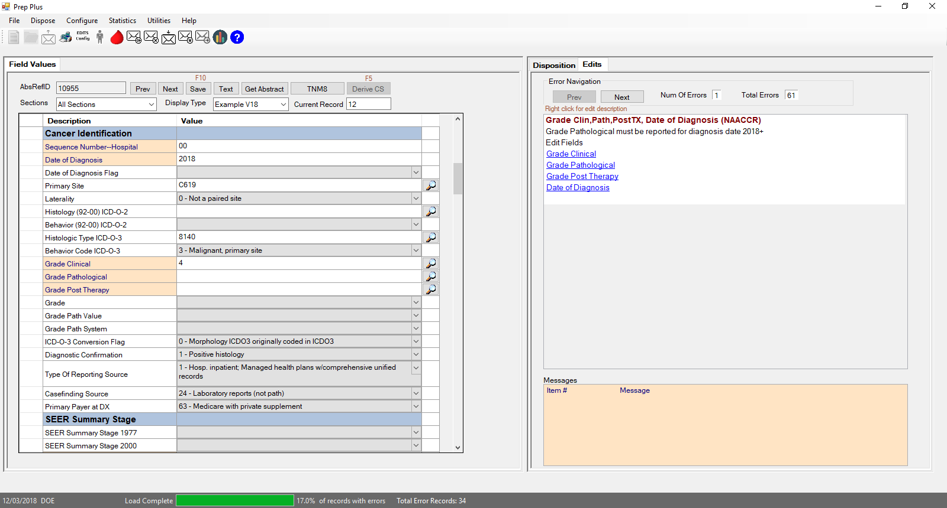

Prep Plus window

General Editing
Corrections are made by typing directly into the Value column or by selecting values from look-up tables and drop-down lists. Values can be modified for any unprotected data item; it is not limited to the fields in the edit errors. Editing occurs interactively as corrections are made; therefore, the corrected edits will be removed from the Edits tab automatically and it is possible for additional edit errors to appear if the update created an edit error. As errors are corrected, the Num of Errors per record and the Total Error counts will be updated. Once all edit errors have been corrected for a record, the following message will appear:
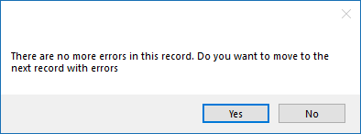

Prep Plus Confirmation of No Additional Errors for Record
The user can choose to select No to remain in the current record to review additional information including text. Otherwise, the user can select Yes and the next record containing edit errors will display. Records with errors will open one at a time on the screen.
NOTE: Data items with a limited number of field values will have drop down menus available for look-ups. Data items with a significant number of field values will have look-up buttons available in the column to the right of the Field Value column for specified data items.
- To modify a data item that does not have a drop-down menu or look-up table, click on the value in the Value column so it is highlighted. The cursor can also be placed within the field to backspace or delete partial information.
To modify a data item that has a drop-down menu, click on the drop-down menu arrow within the Value cell for the data item and the data item codes and associated code definitions will display.
To modify a data item that has a look-up table, click on the look-up button in the column to the right of the Value column for the data item. A table will open displaying all applicable data item code values and associated code definitions for the data item. A search function is available for most data items with look-up tables.
NOTE: Data items that are protected such as the AbsRefID cannot be modified.

Age Recalculation in Prep Plus
A recalculation button is available in the Prep Plus window to recalculate age if a change is made to Date of Diagnosis or Date of Birth. Once a change is made, click on the calculation button to the right of the data item Age at Diagnosis. The Age at Diagnosis value will automatically update.

Selecting Held Abstracts in Prep Plus
To select abstracts held to a user in Prep Plus:

- From the File menu, select Select Held Abstracts or click on the Select Held Abstracts icon. The Select Held Abstracts menu item will only be available if abstracts are held to the user.
The following Pull Abstracts window will display and will include a list of abstracts held to the user. Each column can be widened to view the full field value.
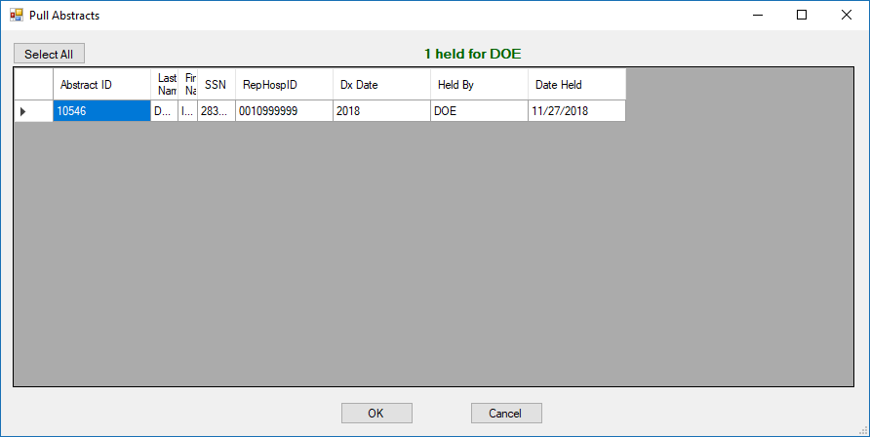

Prep Plus Open window
Select an abstract held to the user.
Click on OK. The abstract will display in the Prep Plus window.
Review the abstract and text to resolve the issue. Refer to the section for General Editing.
Once the data is reviewed and edits are resolved, navigate to the Disposition Tab and Release the abstract.
Select each held abstract following the steps above.

User Defined Functions (UDFs)
For registries with customized UDFs, the Registry Plus team will re-write the UDF in .NET and create a registry-specific UDF.DLL for initial release of v18 Prep Plus. Registries will be expected to maintain and update the user defined functions after initial release of v18.

Managing Facilities
Facilities are currently managed in the ControlCatvals.mdb in the HOSPCODES table.

To manage facilities:
- Open the ControlCatvals.mdb located in the MDBS folder in the application (RegPlus\Prep Plus) directory or shared network location.
Select HOSPCODES from the list of tables in the Access database.
The structure of the first two columns (Value and Label) must be maintained since these columns are read by the program. Additional columns can be added if helpful to the registry; however, the first two columns (Value and Label) must remain in their current position. The Value column contains the facility number assigned to the facility and displayed in the program for the facility data items. The Label column contains the facility names.

Structure of HOSPCODES table.
Enter the new facility’s ID in the Value field.
Enter the new facility’s name in the Label field.
When all facilities have been added and/or edited as desired, save in the Microsoft Access table by selecting File
then Save.
NOTE: A look-up table is available within the grids to look up facility information; however, changes cannot be made in the look-up and can only be made in the HOSPCODES table at this time.

Managing Doctor Query Table
Physicians are currently managed in the ControlCatvals.mdb in the DoctorQuery table.

To manage physicians:
- Open the ControlCatvals.mdb located in the MDBS folder in the application (RegPlus\Prep Plus) directory or shared network location.
Select DoctorQuery from the list of tables in the Access database.
Enter information for the new physician(s).
DOCID must be entered since it is the identification number assigned to the physician that will display in the program for the physician data items.
When all physicians have been added and/or edited as desired, save in the Microsoft Access table by selecting File and Save.
NOTE: A look-up table is available within the grids to look up physician information; however, changes cannot be made in the look-up and can only be made in the DoctorQuery table at this time.

Prep Plus Database Structure

The database structure utilized in Prep Plus is described below:

Track Database (Track_DB)
The Track database controls various functionality associated with Prep Plus:
- Creates and tracks the AbsRefID
- Tracks events such as Release and UDF information
- Stores patient and tumor information for all bundles cumulatively
- Stores bundle information
- Stores Held Abstracts
- Stores the Administrator password
- Stores User IDs and passwords

InPro Database
The InPro database is the storage location for abstract information and includes the following functions:
- Helps determine when the Abort Bundle function is active
- Stores the main Abstract information in the Bundle

Prep Plus Database
The Prep Plus database is the storage location of the configuration files and application files utilized by the program.
- Stores Display information
- Stores Edit Configuration information
- Stores Control Table information imported from ControlCatvals

Prep Plus Folder Structure

The Prep Plus folder structure is described below:

AccBun
Accepted Bundle Folder. The initial bundle is copied to this folder so that it can be brought back if a file is aborted.

Archive
Archive Bundle. The initial bundle is copied to this folder as a backup.

Edits
The Edit Metafile is stored in this folder.

FixedBun
Fixed Bundle folder. If an initial bundle has a format issue and does not have the correct record length, Prep Plus will fix the file and make a copy of the file which is stored in this folder.

mdbs
The Access database stores the application Control table and all look-up tables including data item codes and definitions.

mdfs
InPro.mdf, PrepPlus.mdf, and Track_DB.mdf reside in this folder.

PrepAbs
Prepped Abstracts folder. Released bundles with corrected abstracts are stored in this folder.

PrepHelp
Prep Plus Help folder.

RawAbs
Raw Abstracts folder. This is the typical location for storing files awaiting processing in Prep Plus.

RejAbs
Rejected Abstract folder. Abstracts rejected by the user are stored in this folder.

RejBun
Rejected Bundle folder. When a bundle is rejected by the user, a copy of the bundle is stored in this folder.

Reports
Reports file. The edit detail and summary reports, printed abstracts, error statistics reports and log reports are stored in this folder.

