


CRS Plus™
Administrator’s Manual

March 11, 2019

Centers for Disease Control and Prevention

National Center for Chronic Disease Prevention and Health Promotion

Division of Cancer Prevention and Control

National Program of Cancer Registries

Registry Plus ™ Software for Cancer Registries

Version 4.2

Table of Contents
Table of Contents 2
Introduction 6
Overview of Administrator’s Guide 6
System Requirements 6
User Support 7
Conversion to CRS Plus 7
Special Import 7
Structure of the Database 8
CRS Plus Data Flow 8
Status Codes 8
Status1: Broad status of abstract 8
Status2: Defines the Reason the Abstract was Sent to Pending 9
CRS Plus Flowchart 10
Patient Linkage 11
Data Items Used to Compute Score for Patient Linkage 11
Patient Demographic Data Item Scores Assigned for Matching Algorithm 11
Matching 12
Cut-Off Scores 12
Potential Dispositions for Patient Linkage 12
Patient Linkage Determination 13
Tumor Linkage 13
Data Items Used to Determine Tumor Linkage 13
Site and Histology Tables 13
Site Pair Table: 13
Histology Pair Table: 14
Automated Tumor Linkage Logic 14
Exceptions 15
Description of Enhanced Automated Tumor Linkage 15
RULE SETS 15
Timing/Interval Rule 16
GENERAL DESCRIPTION OF TUMOR LINKAGE ALGORITHM 17
COMPARISON DETAILS 17
Time interval between dates of diagnosis compared to the Rule Set's DX Timing Rule 18
SEARCHING THE LINKAGE RULES TABLE AND OBTAINING DISPOSITION CODES 18
DISPOSITION CODES 19
DETERMINING FINAL DISPOSITION 19
Status 3 Codes 19
Tumor Linkage Dispositions 20
Tumor Linkage Determination 20
Sequence Number Check 20
Preferences for Sequence Number Assignment 20
Calculating Sequence Number Central 21
Data Item Consolidation 21
Consolidation Directives 22
Consolidation Default When Directives Are Not Specified 23
Syntax 23
Schema-Specific Consolidation 24
Use of wild card 24
Directive Definitions 24
AnalyticEliminatesNonanalytic 24
Average(maxVariance, GroupBy) 25
DoNotConsolidateIfAmbiguous 25
DoNotConsolidateIfMeetsCondition (["RecType"="M"]) 25
EarliestDate() 26
EliminateByPresence 26
EliminateIfMeetsCondition 26
FacilityType 27
FullNameOverInitial 27
Golden Reporter 27
Hierarchy 27
HighestCode 28
KnownOverUnknown 28
LatestDate 28
LowestCode 28
ManualIfAmbiguous 29
ManualIfMeetsCondition 29
MostCompleteAddressByDate 29
MostCompleteDate 29
MostFrequent 29
MostFrequent(Collection) 30
MostRecent 30
SameSourceAs 30
SilverReporter 30
UpdateIfMeetsCondition 31
Collaborative Stage Calculation 31
TNM 7 Stage Group Calculation 34
TNM 8 Schema Selection 36
Automated Schema Calculation 36
Editing 37
Duplicate Abstract Determination 38
Dispositions for Duplicate Records 38
Modification Record Processing 38
Handling Death Information for Modification Records 39
Update Case Structure Related to M Records 40
Getting Started 40
Logging In 40
CRS Plus Main Window 41
Report Name 43
Description 43
Using the Extract Wizard in CRS Plus 43
Report Name 49
Description 49
The Icon Task Bar 50
Administration Dropdown Menu 50
Manage Display 51
Display Configuration 51
Display Options for SSDIs 53
Section Headers 54
Adding a Section Header 54
Renaming a Section Header 55
Deleting a Section Header 55
Manage Configuration 55
Edits Configuration 56
Setting Individual Edit Options 56
Suppressing Individual Edits: 57
Miscellaneous 57
Collaborative Staging Calculation Preferences 58
Manage Users 59
Change Password 59
Adding New Users 60
Delete User 61
Manage Roles 61
Change Password 62
Clear Logon Status 63
Unlock Cases/Abstracts 63
Manage Import Log 64
Printing the Import Case Management Report 64
Recalculate TNM Derivation 65
TNM Error Codes 68
Explanation of Record Counts 69
Recalculate Collaborative Stage 69
Batch Update Analysis Recodes 71
Relational Integrity Check 73
Running the Relational Integrity Check: 73
Manage Import 74
Other Administrative Functions 75
Local Fields 75
Managing Facilities 75
Managing Doctor Query Table 75
Update Case Structure 76
Patient Summary Restructuring Options 77
Tumor Summary Restructuring Options 78
Flag for Release of Records/Unusual Follow-Up Method 82
Consolidation Directives for Unusual Follow-Up Method: 82
Instructions to Manually Update Unusual Follow-Up Method: 83

Introduction
The CRS (Central Registry System) Plus software is the Registry Plus application used to manage the central registry database. The program provides for automatic determination of multiple primary tumors and consolidation of data items from multiple abstracts into incidence records.

CRS Plus was initially written in Microsoft Visual Basic, version 6, and implemented in the first central cancer registry in 2001. CRS Plus was recently re-written in Microsoft .NET Framework and implemented in cancer registries in 2018.

CRS Plus supports the linkage of incoming abstracts against the existing database, with software-assisted consolidation into patient, cancer, and facility tables. CRS Plus allows side-by-side displays and automated comparisons of incoming and stored data. CRS Plus creates consolidated patient and tumor tables for the same person and tumor with the best values from multiple reporting sources.

Source records are retained and compared during consolidation. Other features of CRS Plus include a query tool, management reports, and the ability to export records in North American Association of Central Cancer Registries (NAACCR) format. Standard extracts for national calls for data and inter-state data exchange are programmed in NAACCR record format with a simple user interface to generate data files for submission.

CRS Plus requires Prep Plus, software for editing and visual review, to prepare incoming facility abstracts for import into the central registry database. TLC (Tumor Linkage and Consolidation) Plus is an optional tumor linkage and consolidation module within CRS Plus to incorporate partially automated linkage and consolidation logic. The module provides automated support so manual review is not required for all linkage and consolidation decisions.

Abstracts proceed through a defined data flow - Patient Linkage, Sequence Number Check, Tumor Linkage, Data Item Consolidation, Duplicate Check, Collaborative Stage check, and Edit Check. At any point that the program is unable to reach a definitive linkage or consolidation decision, the abstract is assigned a pending status code in CRS Plus. All pending abstracts must then be manually reviewed.

Automated Tumor Linkage has been programmed according to SEER multiple primary rules for high volume sites. Detailed programming logic is described in the Tumor Linkage section of this manual. Programming logic has also been incorporated to calculate Sequence Number Central for the incoming tumor and existing tumors for a patient, based on the chronological order of diagnosis dates within the appropriate range of values for Sequence Number Hospital.

Consolidation rules have been developed for patient items, cancer identification, staging and treatment. The consolidation rules can be modified or de-activated by central registries. Active consolidation directives are described in detail in the Data Item Consolidation section of this manual.

This manual presents the information required by administrators of the CRS Plus database software. The manual describes the foundation for key functionality and automation.

Overview of Administrator’s Guide
Through this manual, users will be introduced to CRS Plus Administrator functionalities and capabilities in a detailed step by step manner. This manual provides information on tasks to be performed by users in an Administrator role. For information regarding Registrar User functionality, please see document “User’s Manual: CRS Plus”.

System Requirements
The CRS Plus program works with 32- and 64-bit Microsoft® Windows® operating systems on x86-compatible processors. CRS Plus utilizes Dynamic Link Libraries (DLLs) written in C. The minimum hardware requirements are the same as those of the Microsoft Windows operating system used.

System requirements include:
- Microsoft operating system Window 7 or newer version.
- Minimum of 2 GB memory for smooth user experience.
- A minimum of 200 MB free hard drive space is required, which excludes CRS Plus database.
- Microsoft .NET Framework Version 4.5 Full Version
- MS SQL Server 2012 or newer version to host the primary database. Lookup tables, data dictionary and some configuration tables are stored in two MS Access databases but installation of MS Access is not required to use the application. It is highly recommended to use a professional grade database server for the primary database to avoid data loss.
- The application can also be hosted on a Windows Server with Terminal Services or on a Citrix Server to allow for remote access. If the application is hosted on a server, it is highly recommended that the primary database be hosted on a different server.

User Support
For technical support via e-mail, contact cancerinformatics@cdc.gov.

The CDC Registry Plus Development group is funded primarily to support NPCR-funded state central cancer registries. As a result, CDC helps state central cancer registries set up the software and perform basic customizations. CDC also provides periodic software updates and problem-solving to the extent of available resources. CDC does not provide on-site services, and does not support hospitals, clinics, laboratories, or other private users.

CRS Plus is intended for distribution to central cancer registries after as-needed customization by the central registry.

Conversion to CRS Plus
Legacy data written in records compliant with North American Association of Central Cancer Registries (NAACCR) data-exchange standards can be loaded into CRS Plus. In reviewing data conversion, it helps to consider the Registry Plus data model: a database of unique patient records, each of which has one or more incidents of cancer, with each incident supported by one or more observations submitted by a reporting facility. This results in a data model consisting of three primary tables: patients, tumors, and abstracts.

Special Import
When a registry is confident of its existing linkage and consolidation, a one-time special import can be performed to load the data into the CRS Plus tables, preserving the relationships among the records. To perform this special import, users must be able to extract their data with a Patient ID Number connecting the records for each patient and a Sequence Number Central (SNC) that distinguishes the record among multiple tumor records for a patient. Each category of records—patients, tumors, and abstracts—must be extracted into a separate file. Special Import preserves the work previously completed to process, link, and consolidate records.

Some existing registry databases do not share the patient/tumor/abstract view of the data, so some external processing on extracted records may be necessary to produce the three files for the special import. Registry Plus programmers may be able to assist through this process; however, a registry that intends to do a special import should be prepared to handle the computer processing of its data.

CDC provides assistance to states to set up the software and perform basic customization. CDC also provides periodic software updates and problem solving to the extent of available resources.

The data needs to be divided into the following three files in NAACCR format:
- Patients (demographic)
- Medical Summary (tumors)
- Abstracts (facility records)
It is recommended a test Special Import be performed to ensure successful transfer of data. IT staff may need to be involved to map data to certain fields within the database.

Structure of the Database
The structure of CRS Plus is based on tables. Storing the information in a relational set of tables instead of a flat file eliminates redundancy of information about the patient and tumor. There are Abstract tables which contain the facility-specific data, there are Medical Summary tables which contain consolidated tumor information, and there are Patient tables which contain the consolidated patient information. Registry data must be separated into these three tables in order to be special imported into CRS Plus at initial implementation.

CRS Plus Data Flow
CRS Plus provides for automatic determination of multiple primary tumors and consolidation of data items from multiple facility abstracts into incidence records. CRS Plus supports the linkage of incoming abstracts against the existing database, with software-assisted consolidation into patient, tumor, and facility tables. CRS plus creates consolidated patient and tumor tables for the same person and tumor with the best values from multiple reporting sources.

Source records are retained and compared during data item consolidation. While the current consolidated value is not considered for the consolidated decision, the existing consolidated values are displayed for reference.

All incoming abstracts are processed through an automated tumor linkage and consolidation module, TLC Plus, which has been incorporated into the central registry software, CRS Plus. Abstracts proceed through a defined data flow upon import – Patient Linkage → Tumor Linkage → Sequence Number Check → Data Item Consolidation → Duplicate Check → Collaborative Stage Calculation or TNM Calculation → Edit Check.

TLC Plus provides automated support to reduce manual review for all linkage and consolidation decisions. At any point the program is unable to reach a definitive linkage or consolidation decision, the abstract is assigned a pending status code in CRS Plus. All pending abstracts require manual intervention.

Status Codes
Within the Abstracts table of CRS Plus, there are Status 1 and Status2 fields.

Status 1 is the broad status of an abstract. The table below provides a list of Status1 codes and the corresponding descriptions:

Status1: Broad status of abstract
Code | Description
97 | Void
99 | Pending
101 | New case
102 | New tumor
103 | New treatment or facility

Status2: Defines the Reason the Abstract was Sent to Pending
The table below indicates the reason the abstract is in pending as well as the corresponding action:

Pending Status Code | Pending Status | Action
0 | Manually Sent Back to Pending | To be processed through the linkage and consolidation process again after being restructured
1 | Sequence New Patient | Does not link to patient in database; Seq > 00; Hospital Sequence Number other than 00, <blank>, 99 for first abstract on a new patient
2 | Patient Linkage | Potential Patient Match; match score was not high enough to be considered a true match or abstract matched on multiple patients
4 | Tumor Linkage | Potential Tumor Match; Automated tumor linkage determined that this case should be manually reviewed
8 | Data Item Consolidation | One or more data items requires manual review
9 | Duplicate Check | Based on Reporting Facility; the abstract is a duplicate (second abstract for the same tumor submitted by the same facility)
10 | Edit Error | Sent to Pending for Edit correction
11 | Collaborative Stage Calculation Error | Failed Collaborative Stage calculation– one or more CS items is invalid requiring correction
12 | Sequence New Tumor | Potential New Tumor; Review Sequence Number
13 | Modification Record | Record is a NAACCR Type M record used to submit changes to originally reported abstracts electronically. M Record processing is partially automated and abstracts may be linked and disposed to the database upon import.
16 | TNM Calculation | Failed TNM Derived Stage Calculation – one or more TNM items is invalid or missing requiring correction or defaulting
18 | TNM Stage Group Comparison | Discrepancy between TNM directly-coded path stage group compared to NPCR Derived Path Stage Group or the TNM directly-coded clinical stage group compared to NPCR Derived Clin Stage Group

CRS Plus Flowchart
The flowchart below visualizes the sequential logic for an incoming abstract going through TLC Plus. The process begins with Patient Linkage.

CRS Plus Flow Chart

Patient Linkage
When a file is imported into CRS Plus each incoming record enters the patient linkage process to determine if the record should be linked to an existing patient in the database. The first step in the Patient Linkage process is known as 'blocking' which is performed to identify all consolidated records similar to the incoming record for (1) soundex of last name, (2) birth date or (3) social security number. Blocking enables the system to complete patient linkage more efficiently. The second step of Patient Linkage involves the matching of specific data items from the incoming record against all consolidated records identified during blocking to assign a match score.

Data Items Used to Compute Score for Patient Linkage
Date of Birth Social Security Number
First Name Sex
Middle Name Race1
Last Name

Comparison of names in Patient Linkage is no longer case-sensitive. For example, ‘SMITH’, ‘Smith’, and ‘smith’ will be considered the same for linkage, regardless of how the names are stored in the database. The full weight of the data item will be assigned if the data matches and the only difference is case.

The matching algorithm assigns different scores for matched or partially matched data items. For example, a record with identical Social Security Number will receive a higher match score than a record matching only five of nine digits of the Social Security Number. A transposition of one number in SSN will not significantly impact the overall score because each of the three parts (first three digits, second two digits and last four digits) of SSN is assigned a separate weight.

Patient Demographic Data Item Scores Assigned for Matching Algorithm
Default data item scores assigned by the matching algorithm are described below. The scoring can be modified if customization is needed for a registry with a unique population. Please contact the Registry Plus Team for assistance. Testing will be necessary to validate modifications to the matching algorithm.

Social Security Number
65 = Exact match all 9 digits (excludes unknown or blank)
OR
11 = Exact match of digits one, two and three
7 = Exact match of digits four and five
14 = Exact match of digits six, seven, eight and nine

Last Name
25 = Fuzzy logic match

First Name
15 = Fuzzy logic match

Middle Name
15 = Fuzzy logic match

Date of Birth
10 = Exact match on month
10 = Exact match on day
10 = Exact match on year (including century)

Sex
10 = Exact match

Race1
10 = Exact match

Matching
Matching utilizes exact match logic for numeric data items or fuzzy match logic for name items. Fuzzy match logic will be called only when there is no exact match. In an exact match, numeric values must be identical, including identical sequence. The full score for a data item is assigned no matter how long or short the strings are. For a fuzzy match, data strings are assigned a number between 0 and 1 based upon the extent of similarity when compared. A perfect match is assigned the value 1 while a 0 is assigned for an absolute non-match. The value is then multiplied by the weight of the data item to compute the contribution to the total match score.

Cut-Off Scores
CRS Plus uses two cut-off scores to identify potential matches. Only the low cut-off score can be modified. The default value for the low cut-off score is 80. All records with a match score less than 80 are eliminated as non-matches. This low score can be determined by individual registries based on evaluation of registry data. All records with a match score of 155 or higher are considered definite matches. The highest possible match score is 170. If all of the demographic data items above considered for patient linkage are exact match including middle initial, a score of 170 will be assigned.

Previously, no weight was assigned to short names; however, in .NET, programming was modified to assign the full weight when short names match, thus improving the overall score. The following example illustrates this change:

 | NET INCOMING ABS | NET EXISTING PT | VB6 INCOMING ABS | VB6 EXISTING PT
LAST NAME | Ha | Ha | Ha | Ha
FIRST NAME | Dillon | Dillon | Dillon | Dillon
MIDDLE NAME | V | V | V | V
SSN | 010933399 | 010933399 | 010933399 | 010933399
DOB | 19310721 | 19310721 | 19310721 | 19310721
SEX | 1 | 1 | 1 | 1
RACE 1 | 99 | 99 | 99 | 99
PENDING STATUS | 4 |  | 2
SCORE | 160 |  | 120 (no score for Last Name and Middle Name – short  name, initial)

NOTE: This scenario proves to be beneficial to PT Linkage because a higher score is produced in .NET and the patient is considered a definite patient match and moves on to Tumor Linkage. In VB6, the patient went to pending for potential patient match.

Potential Dispositions for Patient Linkage
Potential dispositions of the patient linkage process are:
New Patient – no records with match score 80 or greater. Record is sent for sequence number check after which a new Patient record and Tumor record are created in the CRS Plus database.
Pending Patient Linkage - one or more records with a score within the 80 - 154 range; or one record with match score 155 or higher but another record matched with a score that is significantly (30 points) lower. Record is sent to pending for manual patient linkage.
Linked to Patient - only one record with match score 155 or greater; or one record with match score 155 or higher and other record(s) matched with score(s) sufficiently (30 points) lower. PatientID of the matching patient is assigned to the incoming record and the record proceeds to TLCPlus for tumor linkage.

Patient Linkage Determination
The incoming abstract is compared to all patient records on the database. If the incoming abstract does not match an existing patient record on the database, the abstract is disposed to the database and a new patient record is automatically created. Abstracts with limited or unknown patient demographic information may be disposed to the database as new patients if the score is lower than the cutoff value.
NOTE: The deduplication process should be performed on a routine basis to identify duplicate records.
If the incoming abstract potentially matches an existing patient record, the abstract is sent to pending for manual review of the patient match. If the incoming abstract matches an existing patient record on the database, then the Patient ID of the existing patient record is assigned to the abstract, and the abstract is moved on to the next step in TLC Plus, which is tumor linkage determination.

Patient Linkage cases in pending are cases that, at the time of import, matched to one or more existing patients in the database as a result of the scoring algorithm. Patient Linkage cases in pending should always be compared to all potential matched cases in the database. When a Patient Linkage case is opened in the Pending window the system repeats patient linkage logic; therefore, it is possible for a Patient Linkage case to complete automated patient linkage if changes were made to the database (via additional imports, pending record processing or modification record processing) after the record was imported.

Tumor Linkage
Once an incoming abstract is linked to an existing patient record, the abstract enters the TLC Plus automated tumor linkage process to determine if the record should be linked to a tumor already in the database for the patient. Tumor linkage involves the matching of specific data items from the incoming record against the linked consolidated records.

Data Items Used to Determine Tumor Linkage
Primary Site ▪ Behavior (ICD-O-3)
Laterality ▪ Diagnosis Date
Histologic Type (ICD-O-3) ▪ Reporting Hospital

Abstracts proceed through a series of logic routines until a final outcome is determined or all routines are exhausted.

Site and Histology Tables
A workgroup was convened by NAACCR several years ago to develop Primary Site and Histology Pair tables to provide guidance to Central Registries. Several registries participated in the project and developed a site-pair table arranged in order of agreement.

Site Pair Table:
The NAACCR Site Pair Table was incorporated into CRS Plus and called SITEPAIRS table in TumorLinkageRules.mdb. Site pair codes considered to be the same are included in the table. The table includes site pair codes that are identical as well as site code pairs in a common group considered to be the same site. The NAACCR Site Pairs table was adapted to remove some site pair combinations to be handled more conservatively in CRS Plus so the combinations would require manual review. Also, a Match Strength column was added in CRS Plus. A Match Strength code of 4 has been assigned in CRS Plus to evaluate site pairs that often represent the same tumor even though they are not the same. Pairs with Match Strength 4 require manual review in CRS Plus. In the following example, a combination of Site code C199 (Rectosigmoid) and C209 (Rectum) requires manual review. While these codes represent sites that at typically considered to be different tumors, it is quite possible different reporting facilities may be referring to the same tumor if the timeframe is close.
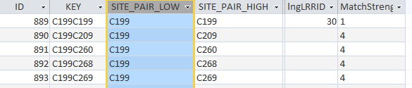

Example from CRS Plus Site Pairs Table

Histology Pair Table:
The HistoPairs table in TumorLinkageRules.mdb defines histology codes considered to be the same. The table includes codes that are identical as well as histology code pairs that would be considered same histology. The table was adapted from the NAACCRHistology Pairs table; however, some histology pairs were removed to be handled more conservatively by manual review. In some instances, site-specific histology pair tables were generated for CRS Plus to address histology combinations applicable to the site only that would not apply to all sites.

Automated Tumor Linkage Logic
Tumor Linkage logic has been programmed based on SEER’s “2018 Solid Tumor Rules” and “Multiple Primary and Histology Coding Rules”. SEER’s rules are site- and histology-specific. Logic for the following rule sets has been programmed for tumor linkage determination. These include the highest volume cancer sites:

Colon (based on SEER's Colon rules)
Rectosigmoid (based on SEER's Other Sites rules)
Rectum (based on SEER's Other Sites rules)
Prostate (based on SEER's Other Sites rules)
Melanoma (for cutaneous melanomas only, based on SEER's Melanoma rules)
Breast (based on SEER's Breast rules)
Lung (based on SEER's Lung rules)

Remaining SEER rules will be added in the future.

Although only the higher volume sites have been programmed, if an incoming abstract in pending with a site that does not have programmed linkage rules is compared to a database tumor having a site with programmed logic, an automated decision can be determined since the logic is defined for one of the tumors. If none of the sites being compared have programmed linkage rules, an automated decision cannot be determined and manual review will continue to be required.

Automated decisions to either link to existing tumors or to create new tumors are determined for approximately 50% of the records in pending for tumor linkage when diagnosed since 2007. Since the tumor information is provided by one source, automated consolidation runs only on the patient demographic data items and typically runs successfully without manual intervention.

Exceptions
Automated tumor linkage is not attempted if the incoming abstract or database tumor has a diagnosis date prior to 2007 or unknown. This is due to the difference in SEER multiple primary rules required over time. One of the most significant impacts is within the urinary sites since the urinary sites considered to be the same primary changed with SEER MP/H effective 2007 compared to previous SEER MP/H rules. Drafting logic for urinary sites when the rules changed for these sites has been problematic.

The following have been listed as exceptions for the automated tumor linkage logic and will require manual review due to the complexity or special handling necessary for the multiple primary determination.

Exceptions
Exception Name | Exception Histology | Exception Sites | Exception Behaviors
Leukemia_Lymphoma | 9590-9992
Kaposi Sarcoma | 9140
Breast (Paget Disease) | 8530,8540,8541,8543 | C500-C509
Unknown Primary |  | C809
Non Reportable In Situ Adenocarcinoma (Prostate) | 8148 | C619 | 2
Non Reportable Squamous Intraepithelial Neoplasia | 8077 | C210-C211, C53, C529, C51 | 2
Non Melanoma Skin | 8000-8005, 8010-8046, 8050-8084, 8090-8110 | C44
Non Reportable Cervix | 8010, 8070 | C53 | 2

Description of Enhanced Automated Tumor Linkage

RULE SETS
The set of directives that applies to a specific set of site/type combinations is called a Rule Set. Each Rule Set is categorized as Lymphatic/Hematopoietic (code L) or Regular (code R).

Rules Sets correspond to the categories used in the SEER rules with some additions. Their definitions are maintained in the RuleSetDefinitions table shown below. The Rule Sets implemented have a check mark in the Implemented column.

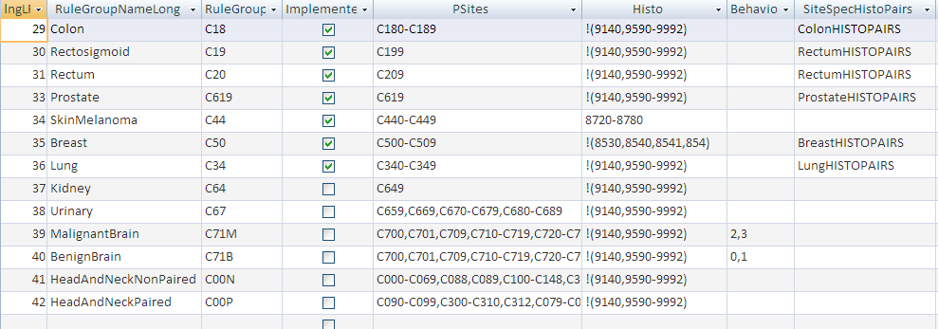

CRS Plus Automated Tumor Linkage RuleSetDefinitions Table

Timing/Interval Rule
SEER rules make use of five different timing interval rules ranging from 60 days to five years. In TLC Plus, the intervals are expressed as days. The available timing rule intervals and their codes are provided below:
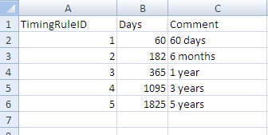

CRS Plus Automated Tumor Linkage Timing Interval Rule Table
Each rule set is associated with a DX Timing Rule and a Behavior Timing Rule as derived from in the SEER rules. For example, Colon is associated with DX Timing Rule 3 and Behavior Timing Rule 1 as shown in the RuleSetTiming table.
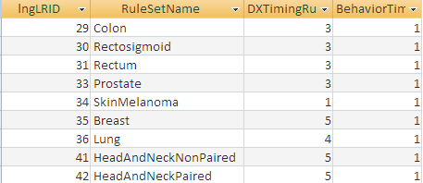

CRS Plus Automated Tumor Linkage Rule Set DX Timing Rule and Behavior Timing Rule Table

If the day part of either date being compared is missing, the month difference is calculated and converted to days. If the month or year is missing on either date, the incoming abstract (IA) is sent to Pending for manual review.

GENERAL DESCRIPTION OF TUMOR LINKAGE ALGORITHM
After an IA has linked to an existing patient in the database, values of selected data items are compared against the corresponding values in the consolidated tumor records for the patient. The results of the comparisons (same, different, etc.) against each tumor are accumulated. The accumulated values identify a specific row in the table of linkage rules, and the identified row contains a disposition indicating whether the IA represents the same or a different tumor, or whether further manual review is needed. If the comparison to any tumor results in a Pending disposition, or if the comparisons result in matches to more than one tumor, the IA is sent to Pending for further manual processing. If the comparison results in a match to a single tumor, the IA is linked to that tumor and the work flow continues to data item consolidation. If no comparisons result in matches or pending abstracts, the IA is processed as a new tumor for the patient.

COMPARISON DETAILS
Since, except for tumors belonging to the BenignBrain Rule Set, benign tumors and tumors of uncertain malignancy are not reportable, if the IA has behavior of 0 or 1 and is not one of the primary site codes for the BenignBrain Rule Set, automated TLC Plus tumor linkage is bypassed and the new abstract is sent to Pending for processing.

Since the MPH rules only apply to cases diagnosed in 2007 and later, if the IA was diagnosed before 2007, automated TLC Plus tumor linkage is bypassed and the new abstract is sent to Pending for processing.

Primary sites and histologies that are exceptions to the rules as implemented are maintained in an Exceptions table. IAs that correspond to the exceptions are sent to Pending for processing. Exceptions include non-solid tumors, Kaposi sarcoma, and primary unknown.

Since the rules for handling inflammatory carcinoma of the breast and Paget disease are confusing and ambiguous, those histologies (8530, 8540, 8541, or 8543) are treated as Exceptions at this time.

Initial comparisons are made to identify the Rule Sets of the IA and existing tumors for the patient.
If all database tumors are members of implemented Rule Sets but the IA is not, then the IA is processed as a new tumor.

If the pair does not belong to the same Rule Set but is on the SITEPAIRS table with a Match Strength of 4, the abstract is sent to Pending for manual review. (Match Strength of 4 indicates a pair of codes that are often used to represent the same tumor even though they are not the same, such as rectosigmoid and sigmoid or lung and pleura.)

Iterative detailed comparisons are made between the IA and each existing database tumor. If the database tumor matches an exception category, the IA is sent to Pending.

When a rule-set match is found, additional comparisons are made.

If the IA and database tumor belong to the same Rule Set but the set has not yet been implemented, the IA is sent to Pending. If they belong to the same Rule Set and the set has been implemented, but the existing tumor was diagnosed before 2007, the abstract is sent to Pending.

When the IA matches an implemented Rule Set for an existing tumor, the following comparisons are made.
Primary Site, to determine Same, Different or Maybe the same, based on the SITEPAIRS table (based on Match Strength where 1 indicates SAME and 3 indicates MAYBE SAME.)

Histology code, using the generic HistoPairs table and/or any rule-set specific pairs. EXAMPLE: For Lung, only a rule-set-specific HistoPairs table is used because the Lung rules are unique in their treatment of combinations of histologies.

Time interval between dates of diagnosis compared to the Rule Set's DX Timing Rule
If behaviors are different, time interval between dates of diagnosis and sequence of occurrence, using the Rule Set's Behavior Timing Rule as shown above.

The table indicates that for Colon, the time interval for 'same tumor' is 1 year, and the relevant interval for tumors with different behaviors is 60 days. The Behavior Timing Sequence comparison results are illustrated below:
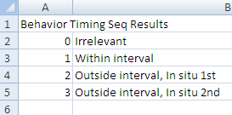

CRS Plus Automated Tumor Linkage Time Interval Between Date of Diagnosis and Rule Set DX Timing Rule Table
For each comparison, there can be multiple possible results:
Same, code = 1
Different, code = 2
Maybe same, code 3 (not used for all comparisons), used when a gray area between match and no match is useful for decision making. EXAMPLE: Records showing a tumor in adjacent segments of colon may represent the same tumor, while records showing a tumor in non-adjacent segments are considered different.
Irrelevant, code = 0 Used when the comparison is not relevant for the Rule Set or because the combination of result codes for all other comparisons already gives a result without the irrelevant comparison.

SEARCHING THE LINKAGE RULES TABLE AND OBTAINING DISPOSITION CODES
Each row in the tblLinkageRules table indicates the Rule Set to which it belongs. There is a row in the table for each possible combination of comparison results (the set of 0s, 1s, 2s, and 3s representing all of the same/different determinations). The accumulated codes for the comparisons of the IA and a tumor in the database will match one rule/row in the table. The results of the comparisons (same, different, etc.) against each tumor are accumulated. The accumulated values identify a specific row in the table of linkage rules, and the identified row contains a disposition indicating whether the IA represents the same or a different tumor, or whether further manual review is needed.

An example of the accumulated values in the linkage rules table is provided below. For each defined rule set, there are multiple rows to account for all combinations of these data items. The Rule ID is 29 which is defined as Colon. Based on this example, all of the values match except for facility.

Ex. Accumulated Comparison – Incoming Abstract and Database Tumor Values:
Site Pair = C187
Histology = 8140
Laterality = 0
Behavior = 3
DxDate = 20151201
Reported by different facilities

The second row displayed in the following example represents the above combination and has Site, Histology, Behavior, and DxDate as the same. For Colon, laterality is irrelevant, and in this example, the tumor was reported by multiple facilities so the DxFacility column contains a 2 which equates to different. The overall Disposition code is 1 meaning this combination of accumulated values is considered the same tumor.

CRS Plus Automated Tumor Linkage - Linkage Rules Table

DISPOSITION CODES
Each rule is associated with one of three dispositions, i.e., the decision about how to process the abstract:
- Match, Same Tumor, code 1. The IA is determined to represent the same tumor as that on the database. Automated processing can proceed, adding the MedRefID to the IA and performing consolidation steps.
- New Tumor, code 2. The IA is determined to represent a new tumor. Automated processing can proceed, assigning a new MedRefID for a new tumor and continuing to next steps.
- Pending, code 3. The IA is sent to Pending for manual determination.

DETERMINING FINAL DISPOSITION
Once comparisons have been completed against all of the patient's tumors, the final disposition for the IA is determined.
If any comparison results in a Pending disposition, the IA is sent to Pending for manual review. The Status2 code will be set to 4 and a Status3 code will be assigned to indicate the reason.

If no comparisons result in a Pending or Same Tumor disposition, the IA is processed as a new tumor. A new MedRefID is assigned and the data item consolidation step is begun. (Status2 code will be set to 5, New Tumor Pending Consolidation.)

If no comparisons result in a Pending disposition and a single comparison results in a Same Tumor/Match disposition, the IA is linked to the matched tumor, the MedRefID is assigned to the abstract, and the data item consolidation step is begun. (Status2 code will be set to 6, Linked Tumor Pending Consolidation.)

If no comparisons result in a Pending disposition and more than one comparison results in a Same Tumor/Match result, the IA is sent to Pending for manual review. (Status2 code will be set to 4 and Status3 code will be set to 7.)

Status 3 Codes
If the abstract is determined to link to an existing tumor or if it is disposed as a New Tumor, the abstract will be reviewed for Data Item Consolidation. Status table (Status3) was created to identify the reason the tumor linkage decision could not be determined.
The Status3 codes and definitions are provided below:

Status3 Code | Description
0 | Processed successfully as new tumor or links to existing tumor and sent back to pending for consolidation
1 | DX year before 2007 or unknown
2 | Behavior of Incoming Abstract <2 and the primary site is not Brain
3 | Incoming Abstract site or histology listed on Exceptions table
4 | Not all Database Tumors members of Implemented Rule Sets
5 | Any site pair on Site Pairs table w/ Match Strength = 4 or Database Tumor site is C809
6 | Linkage ruleset disposition is manual review
7 | More than one match on tumors
8 | Diagnosis Date for tumor has missing month and day

Tumor Linkage Dispositions
Dispositions of the tumor linkage process are:
New Tumor: Tumor is determined to be a new primary, not currently in the database for the patient. A new Tumor record is created in the CRS Plus database and the record proceeds to TLCPlus for automated consolidation (patient data items only).
Pending Tumor Linkage: Automated tumor linkage cannot be determined; record is sent to pending for manual tumor linkage.
Consolidate: Tumor is determined to be same primary as an existing tumor in the database for the patient. MedRefID of the linked tumor is assigned to the incoming record and the record proceeds to TLCPlus for automated consolidation (patient and tumor data items).

Tumor Linkage Determination
If the tumor represented on the incoming abstract does not match a patient and tumor record on the database, the abstract will go to pending to manually review for manual tumor linkage. When a Tumor Linkage case is opened in the Pending window and the TLCPlus button is selected, the system repeats tumor linkage logic; therefore, it is possible for a Tumor Linkage case to complete automated tumor linkage if changes were made to the database (via additional imports, pending record processing or change sheet processing) after the record was imported.

Sequence Number Check
Records designated as a New Patient enter a sequence number check. If the Sequence Number--Hospital value is 00, 99 or blank, the record is assigned a Sequence Number--Central of 00. If the Sequence Number--Hospital equals any other value the abstract is sent to pending for manual Sequence Number--Central assignment. A preference has been added to CRS Plus for tumor sequencing of new patients.

Preferences for Sequence Number Assignment
Review Hospital Sequence Number: (Default) If the hospital sequence number is not 99, 00, or blank, the abstracts are sent to pending.
Disregard Hospital Sequence Number: The central sequence number is set to 00 regardless of the value of the hospital sequence number.
Copy Hospital Sequence Number: The central sequence number is set to the same value as the hospital sequence number unless the hospital sequence number is 99 or blank, in which case the central sequence number is set to 00.

Calculating Sequence Number Central
If an incoming abstract is determined to be a new tumor, Sequence Number Central codes are automatically calculated for the incoming tumor and existing tumors for the patient, based on their chronological order of diagnosis dates within the appropriate range of values for Sequence Number Hospital. If the diagnosis dates are the same, summary stage is reviewed to determine the sequence. If the sequence cannot be resolved, the abstracts will be sent to pending for Sequence Number Central assignment. Programming logic has also been incorporated to address gaps in Sequence Number Central for database tumors.

If the Sequence Number Hospital of the incoming abstract is between 00 and 59, then only tumors with Sequence Number Central between 00 and 59 are included in the sequencing. If the Sequence Number Hospital of the incoming abstract is between 60 and 88, then only tumors with Sequence Number Central between 60 and 88 are included in the sequencing. Before the assigned Sequence Number Central codes are written to the database, the assigned number for the incoming tumor is compared to the Sequence Number Hospital of the incoming tumor. If there is a match, all of the Sequence Number Central values for the patient's tumors will be written to the database. If there is not a match, the incoming tumor will be left in pending for manual Sequence Number Central assignment and none of the existing tumors will be re-sequenced automatically.
Special handling has not been programmed depending on the preference for Sequence Number in CRS Plus. For automated assignment of Sequence Number Central, the assumption is made that the Sequence Number Central values of existing tumors is correct or meets the rules of the registry and that existing tumors pass inter-record edits. The three preferences for tumor sequencing for new patients in CRS Plus are found in the Administration menu in Configuration. In the Application Settings dialog, the following options are provided in the Miscellaneous tab.
- Disregard Sequence Number--Hospital
- Copy Sequence Number--Hospital
- Review Sequence Number--Hospital

The automated Sequence Number Central assignment logic was based on the option to review Sequence Number Hospital following the NAACCR definition for sequence number assignment. The calculation of Sequence Number Central takes the value of the Sequence Number Hospital into account; therefore, no problems are expected to be encountered if the second two options (Copy Sequence Number—Hospital and Review Sequence Number—Hospital) are utilized. If the preference to Disregard Sequence Number—Hospital is set, re-sequencing may be problematic since the Sequence Number Hospital on incoming abstracts was initially disregarded. Testing should be conducted when the preference to disregard Sequence Number Hospital is used in CRS Plus. While the original Sequence Number Hospital would be available for re-sequencing, registries using this preference should verify sequencing issues are not created.
NOTE: Sequence Number Central is also recalculated as records are processed in pending decreasing the amount of cases requiring resequencing in Update Case Structure. A New Tumor with an older Date of Diagnosis can be added with a higher Sequence Number Central and resequencing of the tumors based on Date of Diagnosis will be completed automatically as the record is processed in pending.

Data Item Consolidation
If the incoming abstract links to an existing patient and tumor on the CRS Plus database, the next step in TLC Plus is Data Item Consolidation. If there are differing values for the data items in the abstracts for the tumor, the best value must be determined for the consolidated record. In TLC Plus, consolidation rules are carried out via the application of directives, or automated evaluation criterion used to select a final best value for the consolidated record. If the best values can be determined from consolidation rules in TLC Plus, data item consolidation will be successful and the abstract will move on to the next step, which is Collaborative Staging or the TNM Stage Group calculation depending on Date of Diagnosis.

If any of the consolidation directives fail, the abstract will be sent to pending for manual data item consolidation. The approach utilized for TLC Plus is a combination of automated and manual methods to streamline the consolidation process to assist registries in reducing the resources needed for manual review while at the same time maintaining data quality for consolidated data. Full automation is incorporated for some data items whereas manual intervention is necessary when achieving the best possible consolidated value would require review of codes and text for other data items such as tumor information and staging. Automated consolidation works best when editing and visual review have taken place to ensure the source record data is accurate.

To complete data item consolidation, TLC Plus applies consolidation rules for each field as defined by the user and entered in the TumorLinkageRules.mdb of CRS Plus. Consolidation rules define how data from two or more linked records are evaluated to select a final "best" value for each data item. The application of consolidation rules may be automated, manual or a combination. In TLC Plus, consolidation rules are applied on a field-by-field basis whenever multiple values have been reported for the same field. For a field without defined consolidation rules, the field value from the first abstract received for the patient or tumor will be maintained in the consolidated record, unless manually updated.

Unlike the linkage process, the consolidated record value is not utilized. Consolidation compares values from the incoming record and all historical source records on file for the patient or tumor. All linked records undergo consolidation of patient-specific data items, however only records linked to an existing tumor undergo consolidation of tumor-specific data items.

For each patient and tumor data item there are two potential dispositions from consolidation:

Update: All automated consolidation rules processed successfully, and the consolidated record is updated and the incoming record disposed to the database.
Manual Review: Consolidation rules did not complete successfully for all fields (although it will have completed all fields that it can). The record is sent to pending for manual data item consolidation of only those fields for which consolidation failed.
A default set of consolidation rules is defined for each NPCR-required data item and included in TLC Plus. Registries have varying needs for automation depending on caseload and staffing. The rules can be customized by the user to suit the needs of the registry. Some registries prefer to automate more than others. TLC Plus allows for flexibility. Rules to fully automate consolidation of all consolidated data items is possible in TLC Plus; however, it is highly encouraged that registries adequately test any changes to consolidation rules to ensure quality of the consolidated data. While the Registry Plus team is available to assist registries in modification of the consolidation rules, it is the responsibility of the registries to provide details for how they wish to consolidate the data items and to conduct all testing. The Registry Plus team can also assist in creating directive strings for non NPCR-required data items and local fields; however, registries should provide a detailed description of how they wish to consolidate the data items. The ConsolidationRules table is located in the TumorLinkageRules.mdb.

Consolidation Directives
Directives are the evaluation criteria used by TLC Plus to apply automated consolidation rules. Directives may be used alone or in sequence to define an automated consolidation rule for each field. Sequenced directives are applied in user-defined order until a consolidation decision is reached (only one value remains) or all directives are exhausted. When a string of directives is completed with no single value remaining, the record is placed in the CRS Plus pending file for manual review. However, the failure of a single field does not halt the consolidation process. All fields proceed through the consolidation process with an outcome of a selected consolidated data value or manual review.

To illustrate, if the consolidation rule for Social Security Number is to select a known value over unknown, otherwise the value occurring most frequently, otherwise the value from the reporter with the most recent patient contact. This consolidation rule appears in directive form as: ‘KnownOverUnknown;MostFrequent;MostRecent’. The following examples illustrate how data values are selected through the application of these directives:

Example:
AbsRefID SeqNumCentr SocSecNum DateLastContact
00000012 01 123456789 12/14/2013
00000459 01 999999999 01/15/2014
Selected Value: 123456789
(999999999 eliminated as unknown value.)

Example:
AbsRefID SeqNumCentr SocSecNum DateLastContact
00000012 01 123456789 12/14/2012
00000301 01 987654321 01/15/2014
00000159 01 999999999 01/15/2014
00001010 02 123456789 11/24/2014

Selected Value: 123456789
(999999999 eliminated as unknown value. 987654321 eliminated since it occurs only once. 123456789 occurs twice, most frequent.)

Example:
AbsRefID SeqNumCentr SocSecNum DateLastContact
00000012 01 123456789 12/14/2016
00000301 01 987654321 01/15/2017
00000459 01 999999999 01/15/2017
00001010 02 123456789 11/24/2017
00002330 02 987654321 12/15/2017

Selected Value: 987654321
(99999999 eliminated as unknown value. Since 123456789 and 987654321 both occur twice, value from record 00002330 selected based on latest Date of Last Contact, most recent.)

Consolidation Default When Directives Are Not Specified
When an abstract is imported and it is disposed as a new patient, a patient record is added to the patient table and a tumor record is added to the medsum table. All fields that are indicated as consolidated fields (in the control table) will be populated from values in the abstract. When an abstract is disposed as a new tumor on an existing patient a new tumor record is added to the medsum table and values from this abstract are copied to the medsum record. This is how patient and tumor records are populated with their initial values. These values can change when a second abstract for the patient is processed if there are consolidation directives defined for the fields. If directives are not specified, the initial values never get changed by automated consolidation.

If the directive string does not result in a single value (i.e. two or more records meet the criteria,) then the record will be sent to pending for manual consolidation. If this is not desired, then an additional tie-breaker directive must be added to the string.

Syntax
A semicolon is used to separate the directives when stringing directives together in sequence to create a consolidation rule. The only time case is considered for consolidation is when comparing text values; otherwise, case does not matter. Spaces should not be used within the directives as this will cause the directives to fail. Code values are included in brackets. Ranges can be used to group sets of codes.
Some directives require parameters, others do not and some have optional parameters. Parameters are defined in parentheses. If there are no parameters, parentheses can be left out or empty parentheses can be included. For example, HighestCode(), parentheses should be included. For this example, the highest code would be selected from all abstract values for the specified data item.

The following is a condition statement and the condition is that Manual Review is required if the Class of Case = 99 since this could indicate an incorrect value was reported for Class of Case:
ManualIfMeetsCondition(["ClassCase"="99"])

Note that spaces are not included before and after the equal sign.

The following is an example of several directive strings where there is a range of values with no spaces on either side of the dash. There are also no spaces on either side of the comma when a comma separates two ranges.

KnownOverUnknown;EliminateByPresence([01-98],[00]);EliminateByPresence([01-90,96-98],[95]);EliminateByPresence([01-90,96-97],[98]);EliminateByPresence([01-90],[96-97])

Schema-Specific Consolidation
Schema-specific consolidation rules can be created by using the Rule_Selection column in the ConsolidationRules table to define the schema. Schema-specific rules were implemented with Collaborative Stage since the coding structure of the CS data items was different based on schema.

Ex. Consolidation Rule for CS Lymph Nodes with Rule Selection defined as Schema=Colon:

KnownOverUnknown;EliminateByPresence([050-800],[000]);EliminateByPresence([050-300,410-430,460-480],[800]);EliminateByPresence([460-470],[480]);EliminateByPresence([410-420],[430]);ManualIfAmbiguous

Use of wild card
In some directives wild cards can be used in parameters to indicate ANY value. For example, the directive, EliminateByPresence, requires two parameters. The first parameter is the value(s) whose presence is tested, and second parameter specifies the value(s) that will be eliminated. With the use of the wild card in the second parameter in the below example this directive will eliminate any value that is not equal to 01, if there is at least one abstract with value 01.
KnownOverUnknown;EliminateByPresence([01],[*])

Directive Definitions
The following is an alphabetic listing of all directives available for use in TLC Plus.

AnalyticEliminatesNonanalytic
Uses Class of Case to define an abstract as analytic or non-analytic, then eliminates values from non-analytic records from consideration when both analytic and non-analytic records exist. The codes considered to be analytic and non-analytic are different for central registries than for hospital registries due to the source reporting the information.

Analytic includes Class of Case codes: 00, 10, 11, 12, 13, 14, 20, 21, 22, 40, 41, 42, 43
Non-analytic includes Class of Case Codes: 30, 31, 32, 33, 34, 35, 36, 37, 38, 49, 99

Example:
AbsRefID ClassCase RxSumSurgPSite
00009453 00 20
00020355 30 90
Selected Value: 20
Code 90 is eliminated since record is considered non-analytic.

Example:
AbsRefID ClassCase RxSumSurgPSite
00009453 00 00
00010523 20 52
00020355 30 90
Selected Value: Manual Review
(Code 90 was eliminated since the record is considered non-analytic. In absence of additional directives codes 00 and 52 remain since both records include values that are considered analytic, and manual review would be necessary.)

Average(maxVariance, GroupBy)
Computes the average. If difference between any two values is greater than maxVariance, average is not computed. GroupBy is used to compute weighted average by grouping on the GroupBy field.

Ex. If the directive, Average(10, RepHosp), is used for data item, Weight and the values in the abstracts are as follows:

Facility Weight
1234 40
1234 42
1234 45
3456 43
5678 44

Average is computed as:
Average weight = ((40+42+45)/3 + 43 + 44)/3)

DoNotConsolidateIfAmbiguous
Maintains the value existing in the field on the consolidated record. This directive is used when no follow-up action is taken if values differ. If multiple abstracts have the same value for a field that value will be written to the consolidated record (overwriting user/script entered value on the consolidated record), but if values on abstracts are different the consolidated value will not be touched. Please note that this directive can be strung together with other directives. When it is written this way the directives that come before it will be executed and whatever values are left will be looked at to see if they are same or different.

Example:
AbsRefID TxUsualOcc DtCaseRptLoad
00009453 Oncologist 20160720
00020355 Doctor 20171021

Selected Value: Oncologist
(Value from first record to be entered in the consolidated record.)

DoNotConsolidateIfMeetsCondition (["RecType"="M"])
When this directive is used with a specific data item, consolidation will be excluded for the specified condition.

In this example, automated consolidation will not be completed when Record Type = M.

EarliestDate()
Selects the earliest chronological date. This directive makes no distinction between a date with known month, day or year and dates with partial unknown values. For this reason, this directive is usually applied following the directive MostCompleteDate. This directive accepts parameter specifying which date to use.

Example:
AbsRefID DxDate
00009453 201303
00020355 20140412
00102444 20140430
Selected Value: 201303

EliminateByPresence
Eliminates a value from consideration in the consolidated decision if other specified values are present. This directive requires the user to specify the conditions under which specific codes are eliminated in the following manner:
EliminateByPresence([ListOfEliminatorCodes],[ListOfCodesToBeEliminated])

Example: The consolidation rule for Hispanic includes EliminateByPresence([0-6,8],[7])
AbsRefID Hispanic
00009453 1
00020355 7
Selected Value: 1
Code ‘7’ removed from consideration as the consolidated value since the other abstract contains a value in the range of 0-6.

An asterisk can be used as a wild card.
Example: EliminateByPresence([05],[*])

Any other value other than 05 will be eliminated if there is a value equal to 05.

lngEliminateByPresence(Eliminator Range, values to be removed) – variation of EliminateByPresence that works when the eliminator ranges are long, customized for speed, eliminators can be ranges only and no comma separators are allowed.

EliminateIfMeetsCondition
Eliminates values from consideration in the consolidated decision if specified conditions are met. This directive requires the user to specify the conditions under which specific codes are eliminated in the following manner:

EliminateIfMeetsCondition([Eliminated Codes],[Condition])

Example: For the following example, any value of 8000 or 8010 will be eliminated from the consolidation decision if any source reports a value > 8010 for Histology ICDO3.

EliminateIfMeetsCondition([8000, 8010],["HistTypeICDO3">8010])

AbsRefID HistICDO3
00009422 8140
00020351 8010
Selected Value: 8140
Code ‘8010’ is removed from consideration as the consolidated value since the other abstract contains a value > 8010 (8140).

FacilityType
Requires each facility in the master hospital table to have an associated Facility Type code. The consolidated field value will be taken from the abstract submitted by the facility with the “highest” (occurring first in a defined sequence) Facility Type. An entry in the rule table for the Facility Type ranking 1, 6, 3 is interpreted to mean 1 is “higher” than 6, which in turn is “higher” than 3.

The intent is to enable the user to define, by data item, those facilities classified by type from which data values would always be selected. For example, the registry may choose to always select morphology from Pathology Lab reports, or race from Indian Health Service Providers.

FullNameOverInitial
Selects a value with two or more characters over a single character value.

Example:
AbsRefID FirstName
00009453 R
00020355 Robert
Selected Value: Robert

Golden Reporter
Non-Table Driven Method
For each consolidated data item, one or more Golden Reporters can be identified. If an abstract from a source considered a Golden Reporter is processed, then the consolidated field value will be selected from the Golden Reporter abstract. Golden Reporters are pre-defined for each field and have a specific precedence within the set of Golden Reporters for that field.

Comma-separated facilities are supplied in the order of ranking in a parameter with the highest ranked facility first. If there is only one abstract with the highest-ranking facility, the consolidated values will be selected from this source. If there is no abstract with a facility in the rank list, consolidation will continue with other directives in the directive string. If there are multiple abstracts with the same highest ranked facility, consolidation will move on to the next directive. If there are no additional directives, manual review will be required.

Intent: To enable the user to define, per data item, a facility from which values should always be taken. For example, if the registry receives reports from AFIP and always selects their reported histologic type, then AFIP could be defined as a Golden Reporter for all morphology associated data items.

Hierarchy
A table called tblHierarchy in TumorLinkageRules.mdb maintains a list of value hierarchies for different fields. This directive is used to select the value for the field from the abstract that has the highest value from the hierarchy defined for the specified field. The directive is written in the following format: Hierarchy(field name).

Example: tblHierarchy table defines the Class of Case hierarchy as:
14,13,10,12,11,40,41,42,22,21,20,00,43,35,37,30,31,32,33,34,36,38,99,49

If the directive Hierarchy(ClassCase) is utilized for the PhysManaging field the PhysManaging field value will be selected from the abstract that has the highest class of case hierarchy value.

AbsRefID PhysManaging ClassCase
431 12345678 00
1239 78990000 10
78990000 will be selected because the Class of Case value (10) for this abstract is higher in the class of case hierarchy.

Beginning with the directives used for physician reporting, a form of hierarchy rule was added where instead of pointing to a hierarchy table for a field different from the one being consolidated, the hierarchy of values for the item being consolidated within the directive was included. This can be used for site-specific surgery code hierarchies.

Example: For the directive for consolidating surgery for thyroid:

KnownOverUnknown;Hierarchy(50,40,30,23,22,21,20,27,26,25,13,00,80,90,99)

NOTE: Hierarchy must contain all possible values including blank, indicated by comma with no value. If blank is at the end of the string, end the string with a single comma.
Indicate if first value in string wins. Yes is code '-1', No is ‘0’.

HighestCode
Selects the numerically highest code.

KnownOverUnknown
Eliminates 'Unknown' values when a 'Known' value is present. Blank values are always considered unknown. Blank values pertain to the abstract values and not the existing consolidated value. Unknown values are defined in the CRS Plus control.mdb in the UnknownValues column and conform to NAACCR data standard definitions. Unknown values may be item specific, for example, the defined unknown value for Addr at Dx--State and Addr Current--State is ZZ; however, most unknown value definitions meet the following defaults:

Date fields…………. Blank (full date blank or partial)
Numeric fields……… blank, 9, 99, 999
Text fields…………... blank, Unknown, Unk, NR

If this is the only directive on a field then the unknown values are eliminated, and if the remaining values are the same, that value will be written to the consolidated record; otherwise, if different values remain, manual review will be necessary. If you add DoNotConsolidateIfAmbiguous after KnownOverUnknown then it will not be presented for manual review as the directive is already telling the software not to consolidate.

Example: AbsRefID RxSumm--Chemo
00009453 99
00020355 03
Selected Value: 03; 99 is eliminated as unknown value since it was defined in the UnknownValues column in the control.mdb.

LatestDate
Selects the latest chronological date. This directive makes no distinction between a date with known month, day or year and dates with partial unknown values. Therefore, it is usually applied following the directive MostCompleteDate.

Example:
AbsRefID DateLastContact
00009453 201302
00020355 20140412
Selected Value: 20140412

LowestCode
Selects the numerically lowest code.

ManualIfAmbiguous
Requires manual consolidation if values differ.

ManualIfMeetsCondition
Sets a flag for manual review if a certain condition is met. The directive has the following format:
ManualIfMeetsCondition([condition])

Example: ManualIfMeetsCondition(["ClassCase"="99"]) is defined for Primary Site (PSite) field. If any of the source records has Class of Case value = 99, the case will be flagged for manual review of primary site.

MostCompleteAddressByDate
Selects the value from the abstract that has the most complete address by a date field. This directive requires parameters that specify a flag to designate whether to select the value with the latest or earliest date, a date field to use the address components, the weights (or priorities) of address components.

Example: MostCompleteAddressByDate(Latest,DateLastContact,CurrState,CurrCity,CurrPostalZip,CurrNumAndSt,CurrCounty,CurrSupp,(1,2,3,4,4,4))

In this example, Current state, Current city, Current zip, current street, current county, and supplement address are passed as the address components and the associated weights are assigned.

Weights are treated like priorities, so the lowest number has the highest priority. Completeness takes priority over the date so an incomplete address will always be eliminated, even if it is the earliest/latest date.

To find the most complete address, the address components are reviewed and weights are assigned for each found component. The address that has the most score wins. The length of the strings is not considered.

The weights for address components in the given directive are: state = 1, city = 2, zip = 3, street = 4, county = 5 and supplemental = 5. For example, if an abstract has state, city and zip populated, it will equate to a score of (1+2+3=6) and another abstract that has state, city, zip and street populated will receive a score of 10 (1+2+3+4=10). Therefore, the second abstract wins and the address will be selected from the second address. If the same score is determined for two abstracts, then it will be presented for manual review.

If a directive such as Hierarchy(ClassCase) is specified as the last part of the directive string, and two abstracts have the same score, hierarchy for Class of Case will be reviewed. If both abstracts with the same score happen to have the same Class of Case code, manual review will be necessary. If Class of Case is different for the two abstracts, a consolidated value will be determined based on the hierarchy of Class of Case.

MostCompleteDate
Selects the most complete date.
Can be applied to consolidation of date fields ONLY.

MostFrequent
Selects the value that occurs most often.

Example: The consolidation rule for Social Security Number includes MostFrequent.
AbsRefID SeqNumCentr SocSecNum DateLastContact
00000012 01 123456789 12/14/2016
00000301 01 987654321 01/15/2017
00001010 02 123456789 11/24/2017

Selected Value: 123456789

MostFrequent(Collection)
Allows the selection of most frequent occurrence to be modified by a specified grouping, so that equal values within the same group are counted only once. This directive is used to reduce the possibility that multiple reports from the same reporting facility will add bias to the consolidation decision.

Example: For the directive MostFrequent(RepHosp)

A patient with two primary cancers is reported by three facilities with one facility reporting both primaries. SocSecNum and associated RepHosp values are:

SeqNumCentr RepHosp SocSecNum
01 1111111 123456789
01 2222222 987654321
02 2222222 987654321
02 3333333 123456789

Selected value: 123456789
(The SocSecNum value of 987654321 will be counted only once since it was reported multiple times by the same facility.)

MostRecent
MostRecent(Parameter date field)

Selects the most recent occurrence. This directive can include any NAACCR date field as an input parameter. If no parameter is specified, the Date of Last Contact is the default.

SameSourceAs
Selects the value from the abstract used to select the designated data item. For example, If SameSourceAs(PSite) is used to consolidate the data item, Laterality, then the Laterality value selected for the consolidated record will be selected from the abstract from which the consolidated primary site code was selected.

The SameSourceAs directive may not always resolve to a single selected value if a source record is not selected for the field it depends on. After applying all directives, if values from multiple source records remain but they all have the same value, the value will be selected even though a single source record has not been selected.

However, if there are data items that depend on such a field for which a single source is not selected but a single value is chosen because the remaining values are the same, then those fields which have the SameSourceAs directive will not be resolved. Manual review will be required.

The SortOrder column in the ConsolidationRules table is critical when using the SameSourceAs directive since the field that the item depends on to determine consolidation must be consolidated first. In the example above for Laterality where directive is SameSourceAs(PSite), Primary Site needs to be consolidated first so the consolidation of Laterality can be determined since it is depending on the same source or abstract as the one determined for PSite.

SilverReporter
Selects the consolidated value from the source designated as a Silver Reporter (designated facilities). State-specific Silver Reporters, if defined, are stored in the SilverReporters table in catvals.mdb. There is no ranking of Silver Reporters, and all have the same weight. If there are multiple abstracts from the same or different Silver Reporters, the value from the abstract that has the latest Date of Last Contact is selected. If there are multiple abstracts from the same or different Silver Reporters and more than one has the same Date of Last Contact, consolidation will move on to the next directive. If there are no additional directives, then manual review will be required since there is a tie for Date of Last Contact.

UpdateIfMeetsCondition
Updates the value on the consolidated record if a specific condition is met. This directive is helpful when the combination of two values would equate to another code for a specified data item.

Example: UpdateIfMeetsCondition(3, [RxSumHorm = 1] AND [RxSumHorm = 2])
AbsRefID RxSumHorm
00009453 0
00010523 2
00020355 1
Selected Value: 3
(Sets the consolidated record value for RX Sum--Hormone to ‘3’ since this field contains a ‘1’ on record 00020355 and a ‘2’ on record 00010523. Values on other records do not impact consolidation decision.)

An UpdateIfMeetsConditionEx directive has been developed to take one additional parameter that will control the behavior of this directive. The following three condition statements have been programmed for this purpose:

UpdateIfMeetsConditionEx(" " , ["DxDate"<20160101],1) – update if DxDate in “any” of the linked abstracts is earlier than 2016
UpdateIfMeetsConditionEx(" " , ["DxDate"<20160101],2) – update if DxDate in “all” linked abstracts are earlier than 2016 – may be useful in the future
UpdateIfMeetsConditionEx(" ", ["DxDate"<20160101],3) – update if currently consolidated DxDate is earlier than 2016.
To use this directive, DxDate must be consolidated before the current field by making sure SortOrder on DxDate is lower than that on the current field.

Collaborative Stage Calculation
The incoming abstract next runs through the Collaborative Stage algorithm. If CS calculation fails, the abstract will be sent to pending to correct the CS data item(s); after correction of the CS input field(s), the abstract is sent back into TLC Plus, where CS will again be calculated.

Collaborative Stage Algorithm

The Collaborative Staging (CS) System schemas consist of data input fields necessary to derive T, N, M, and Stage Group according to the AJCC Cancer Staging Manual; Summary Stage 1977; and SEER Summary Stage 2000. Collaborative Staging applies to cases diagnosed January 1, 2004 to December 31, 2015. The CS algorithm will not run on cases diagnosed prior to 2004 or after 2015. It is important for primary site to be coded correctly since most schemas are site-specific. Although, there are a few schemas such as melanoma and lymphoma that are based on histologic type.

Once the CS data items are completed, the coded values are passed to a computer algorithm that generates the correct stage for the case in the following staging systems: AJCC TNM, 6th Edition, AJCC TNM 7th Edition, SEER Summary Stage 1977, and SEER Summary Stage 2000 based on the application settings in the Administration menu for Collaborative Stage Calculation Preferences. The program returns a set of output values or numeric codes to be stored in the record.

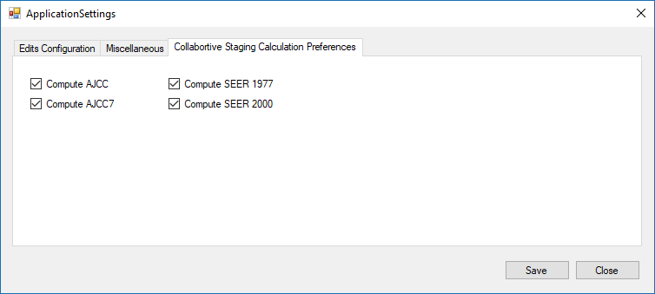

CRS Plus Application Settings for Collaborative Staging Calculation Preferences
As part of the output of the CS Algorithm, three additional system fields, CS Version Input Original, CS Version Input Current, and CS Version Derived, are generated and stored. CS Version Input Original indicates the number of the version initially used to code CS data items. CS Version Input Current indicates the version of the CS input fields after they have been updated or recoded and is updated each time the CS Derived items are recalculated. CS Version Derived is recorded the first time the CS output items are derived and is updated to reflect the version number of the CS Algorithm used to derive the CS output fields and is updated automatically by the computer every time the CS Derived items are recalculated.

How the Algorithm functions in CRS Plus:
In CRS Plus, the Collaborative Stage Algorithm calculates the derived stage fields upon Save and on demand.

Collaborative Stage Calculation upon Save is completed automatically by the program in the following ways:

In Pending
When clicking on Save in the Pending Consolidation window, the CS Derived data items are recalculated based on the CS input values in the updated Consolidated record.

Save in Interactive Patient Update
When Date of Diagnosis, Histologic Type ICD-O-3, Primary Site, and/or a CS input item is updated, CRS Plus will automatically recalculate and re-populate the derived CS data items upon Save.

Close in Interactive Patient Update
When Date of Diagnosis, Histologic Type ICD-O-3, Primary Site, and/or a CS input item is updated, CRS Plus will automatically recalculate and re-populate the derived CS data items if Close (X) is selected prior to Save. Once the Close (X) button is selected, a message prompt will display stating case contents have been modified asking the user if they want to save contents before exiting. When Yes is selected, the derived CS data items are recalculated.

If the CS Algorithm recalculates the derived CS data items successfully upon Save or Close, the derived CS data items will automatically be updated. A message of successful recalculation will not appear; however, if there is a problem recalculating derived CS data items upon Save or Close, a message will be received stating there were errors in calculating derived stage and all derived stage data items will be blanked out until successful calculation. While this message will not include the data item causing the error, a message prompt will appear asking the user if they wish to open the CS calculation window. Once Yes is selected, a Collaborative Staging Result window similar to the example below will open providing details of the error message and fields in error.
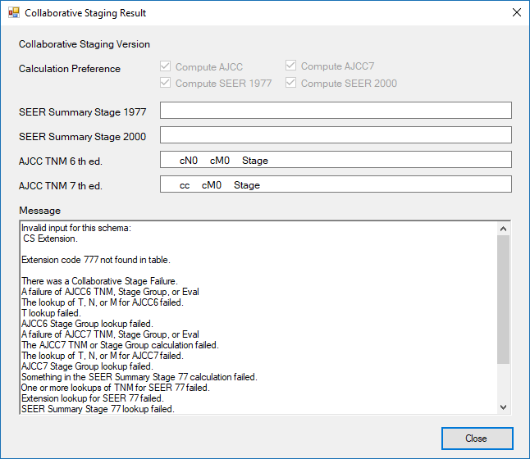

CRS Plus Collaborative Staging Result Window
NOTE: When either Save or Close are initiated, the CS Algorithm will recalculate both the consolidated record and the abstract if updates were made in each.

Manual Collaborative Stage Calculation
In the Interactive Patient Update window, a manual feature is also available for the user to recalculate the derived CS data items. This function is referred to as “on demand” and it can be invoked in one of two ways: by either pressing the calculation button to the right of any CS derived data item in a tumor or abstract grid or by clicking on the CS button located at the top of a tumor or abstract grid for a case diagnosed between 01/01/2004 and 12/31/2015. The CS button and the calculation buttons will not be available if the Diagnosis Date is outside of this range.

The manual functions only run against one grid at a time. Therefore, if a change is made in the abstract and also in the consolidated record, a CS derivation button or the CS button would need to be initiated for each grid for the manual calculation to run on both the abstract and the consolidated record. The Collaborative Staging Result window will display once a CS derivation button or the CS button is invoked.

TNM 7 Stage Group Calculation
The TNM 7 Calculation takes the data input fields necessary to derive stage group and derives the NPCR Derived Clin Stg Grp (3650) and NPCR Derived Path Stg Grp (3655) using the TNM API for cases diagnosed in 2016 and 2017. It is important for primary site to be coded correctly since most schemas are site-specific; although, there are a few schemas such as melanoma and lymphoma that are based on histologic type.

In CRS Plus, the TNM 7 Calculation derives the derived stage group data items upon Save and on demand using calculation buttons.

Automated TNM Calculation
TNM 7 Calculation runs upon import and also runs automatically upon Save. Upon import, NPCR Derived Clin Stg Grp (3650) and NPCR Derived Path Stg Grp (3655) will be populated in the consolidated record if the derivation can run successfully. If the Diagnosis Date is within 2016 or 2017 and a New Patient or New Tumor is created and the incoming abstract is disposed directly to the database upon import, the values from NPCR Derived Clin Stg Grp (3650) and NPCR Derived Path Stg Grp (3655) within the abstract will be copied to the consolidated record. Upon import, an assumption is not made to calculate TNM if there are missing TNM staging elements; therefore, records with missing TNM staging elements may be disposed directly to the database and consolidated records created that do not have NPCR Derived Clin Stg Grp (3650) and NPCR Derived Path Stg Grp (3655) populated. A Batch TNM 7 Derivation program is available within CRS Plus. Once this batch program is run, if there are any remaining records with missing TNM staging elements, the NPCR derived data items will be calculated and populated with 99. These records can be identified from the reports generated by the batch program and the missing TNM data elements can be reviewed and coded if known information is available. the NPCR derived data items can be recalculated if additional information is available at a later time.

The calculation is completed automatically upon Save in the following ways:

In Pending
When clicking on Save in the Pending Consolidation window, NPCR Derived Clin Stg Grp (3650) and NPCR Derived Path Stg Grp (3655) are recalculated if any of the TNM 7 data items defined for a schema are modified in the updated consolidated record or in any abstract updated in the Pending Consolidation window. This is only evident to the user if there is a TNM Calculation failure as a result of recalculation since messages will be displayed only if there is a failure or missing TNM staging elements.

Save in Interactive Patient Update
When any of the TNM data elements defined for a schema are modified, CRS Plus will automatically recalculate and re-populate NPCR Derived Clin Stg Grp (3650) and NPCR Derived Path Stg Grp (3655) upon Save.

Close in Interactive Patient Update
When any of the TNM data elements defined for a schema are modified, CRS Plus will automatically recalculate and re-populate NPCR Derived Clin Stg Grp (3650) and NPCR Derived Path Stg Grp (3655) if the Close (X) button is selected prior to Save as a safety feature to assure the derived fields are recalculated and consistent with the TNM data elements coded for the schema. Once the Close (X) button is selected, a message prompt will display stating case contents have been modified asking the user if they want to save changes before exiting. When Yes is selected, NPCR Derived Clin Stg Grp (3650) and NPCR Derived Path Stg Grp (3655) are recalculated and updated automatically.

If the TNM Calculation recalculates NPCR Derived Clin Stg Grp (3650) and NPCR Derived Path Stg Grp (3655) successfully upon Save or Close, the derived data items will automatically be updated. A message of successful recalculation will not appear; however, if there is a problem recalculating derived data items upon Save or Close, the TNM Staging Results window will display providing issues resulting from TNM 7 Calculation. Invalid values must be corrected for successful calculation. if there are missing TNM staging elements, the Response Code sections in the TNM Staging Results window will indicate this and the user will be provided with the option to populate the NPCR derived data items with default values or the option to complete missing values. If the user chooses to complete missing values, the derived data items will be blanked out until successful calculation. An example of a TNM Staging Results window with an invalid value and missing TNM staging elements is provided below.
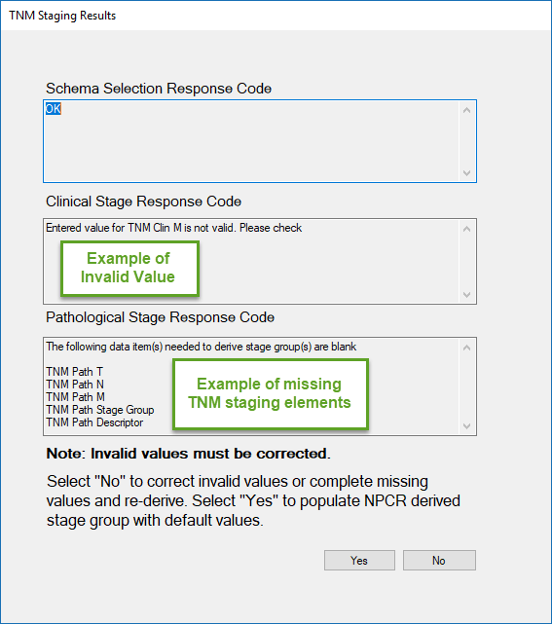

CRS Plus TNM Staging Results window
NOTE: When either Save or Close are initiated, the TNM Calculation will recalculate both the consolidated record and the abstract if updates were made in each.

Manual TNM Calculation
In the Interactive Patient Update window, a manual feature is also available for the user to recalculate NPCR Derived Clin Stg Grp (3650) and NPCR Derived Path Stg Grp (3655). This function is referred to as “on demand” and it can be invoked in one of two ways: by either pressing the calculation button to the right of either NPCR derived data item in a tumor or abstract grid or by clicking on the TNM7 button located at the top of a tumor or abstract grid for a case diagnosed in 2016 or 2017. The calculation buttons will not be available if the Diagnosis Date is outside of this range. If the button to the right of either NPCR derived data item is selected, the calculation only runs for the data item selected. If the TNM7 button located at the top of a tumor or abstract grid is selected, the calculation will run for both NPCR Derived Clin Stg Grp (3650) and NPCR Derived Path Stg Grp (3655).

The manual functions only run against one grid at a time. Therefore, if a change is made in the abstract and also in the consolidated record, a TNM derivation button or the TNM7 button would need to be initiated for each grid for the manual calculation to run on both the abstract and the consolidated record. If the TNM Calculation recalculates NPCR Derived Clin Stg Grp (3650) and NPCR Derived Path Stg Grp (3655) successfully when using the manual functions, the derived data items will automatically be updated. A message of successful recalculation will not appear; however, if there is a problem recalculating derived data items, the TNM Staging Results window will display describing issues resulting from TNM 7 Calculation.

TNM 8 Schema Selection
For cases diagnosed in 2018 or later, Schema selection is performed to calculate Schema ID and AJCC ID. Schema ID is required for all records, and edits are based on valid values according to Schema ID and AJCC ID. While AJCC ID is not required by NPCR, the TNM 8 DLL is incorporated in CRS Plus; therefore, AJCC ID will be calculated and populated even if the AJCC T, N, and M data items are not coded. If an issue is identified with calculation of AJCC ID or Schema ID, it could help identify a coding issue. It is important for primary site and histology to be coded correctly so Schema ID and AJCC ID can be calculated accurately.

TNM Stage Group Calculation for AJCC TNM 8th Edition is not currently performed in CRS Plus to calculate NPCR derived stage group data items for TNM 8; therefore, the NPCR derived stage group items for TNM 8 are not populated upon import or through routine processing of records in CRS Plus as they are for AJCC TNM 7th Edition since AJCC TNM 8th Edition is not required by NPCR. Since AJCC TNM 8th Edition is not required by NPCR, development of a batch TNM 8 derivation function for calculating NPCR derived stage group items for TNM 8 is under consideration.

For cases diagnosed in 2018 or later, the TNM8 button refers to the Schema selection calculation and not calculation of NPCR Derived Stage Group data items. Drop-down listings defining T, N, and M codes by schema are available for cases diagnosed in 2018 or later. The TNM 8 DLL also includes the code values and descriptions for Summary Stage 2018 and EOD data items. Registries planning to retain and edit AJCC TNM 8th Edition data items can do so. The data items can be added to the display and the look-up tables for AJCC TNM data items will be available.

In CRS Plus, the TNM8 Schema selection derives the Schema ID and AJCC ID upon Save and on demand using calculation buttons.

Automated Schema Calculation
For cases diagnosed in 2018 or later, schema selection calculation runs upon import and also runs automatically upon Save. Upon import, Schema ID and AJCC ID will be populated if the derivation can run successfully. When any of the data elements defined for a schema are modified, CRS Plus will automatically re-derive and re-populate Schema ID and AJCC ID before navigating to the next record.

Schema Not Applicable
For the instances where a schema is not applicable for AJCC TNM 8th Edition staging, an informational message will be presented to the user. The message does not indicate an application error. The message displayed below returns from the TNM 8 DLL to indicate that AJCC TNM 8 is not applicable for the combination of site and histology. The histology may not be included in the AJCC TNM 8 chapter. AJCC ID will be populated with XX for these scenarios.
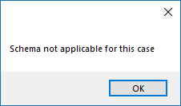

CRS Plus Schema Not Applicable Message
Manual Schema Calculation
In the CRS Plus window, a manual feature is also available for the user to re-derive Schema ID and/or AJCC ID. This function is referred to as “on demand” and it can be invoked in one of two ways: by either pressing the calculation button to the right of either Schema ID or AJCC ID in the tumor or abstract grids or by clicking on the TNM8 button located at the top of the tumor or abstract grid for a case diagnosed 2018 or later.

Messages are presented to the user in the Registry Plus software when schema is updated and the user has the option to blank out the existing SSDIs. If the user chooses not to blank out the SSDIs, having the ability to expand the list of SSDIs will be useful so the user can blank out the items manually. The message is provided below:
CRS Plus Message Received When Schema is Updated
When No is selected, AJCC ID and Schema ID are cleared but AJCC TNM 8 data items and SSDIS are retained.
When Yes is selected, AJCC ID, Schema ID, AJCC TNM 8 data items and SSDIs are cleared.

NOTE: When the Date of Diagnosis is changed to prior to 2018, the user may need to code other staging items required for the diagnosis year and the user must select Yes to the message to clear the SSDIs. Edits may fail if the items are populated for a year when they are not required. If No is selected to retain the information, the user may need to temporarily change the Date of Diagnosis back to 2018 in order to display the dynamic SSDI data items since the items will not display prior to 2018 except for constant SSDIs once the change in Date of Diagnosis is saved.

NOTE: The data items Grade Clinical, Grade Pathological, and Grade Post Therapy, are programmed in the TNM 8 API since they are schema-specific. The items are not visible in the SSDI dynamic section in the displays and can be included anywhere in the displays. These items will need to be updated if there is a change in schema or Date of Diagnosis. The items will also be cleared if the user chooses yes when Date of Diagnosis is changed to pre-2018.

Editing
Prior to final disposition of pending cases, the consolidated record is edited using the CRS Consolidated edit set defined by the registry. If there are no edit errors on the newly consolidated record, it will be sent through to the database; however, if the consolidated record has any edit errors, a message will be displayed to the user indicating the consolidated record contains edit errors. If all edit errors are not corrected for the consolidated record, the abstract will be sent back to pending for Pending Edits. Edits will also be run prior to the Duplicate Check so edit errors can be corrected before the duplicate is processed from pending.

Two edit sets are necessary in CRS Plus; one to run against abstracts since abstracts can be modified and one to run against the consolidated record.

Duplicate Abstract Determination
If the abstract runs through the CS or TNM algorithm based on Diagnosis Date successfully and there are no edit errors for the consolidated record, the abstract will proceed to the next step, Duplicate Abstract Determination. In CRS Plus, an abstract is considered to be a “duplicate” if it is a multiple abstract from the same facility for the same tumor and Record Type is not equal to M for Modification Record.

If the incoming abstract is found to be a “duplicate”, the value in the NAACCR data item of Record Type [#10] is checked to see if it is equal to “M”. If the Record Type is “M” the incoming abstract will be sent to pending for manual review as “M Type Record” so the abstract can run through automated consolidation. If the incoming abstract is found to be a “duplicate” but does not have Record Type equal to “M” (i.e. Record Type equals “A”) the abstract will be sent to pending as a “duplicate” abstract. If not found to be a “duplicate”, it will proceed to the final step – running EDITS on the consolidated record.

All incoming records linked to an existing patient and existing tumor undergo comparison of the Reporting Hospital before final disposition in the CRS Plus database:
- If the Reporting Hospital numbers are different, the record is disposed to the database.
- If the Reporting Hospital numbers are identical, the record is sent to Pending for manual intervention.

Dispositions for Duplicate Records
The following three dispositions are available for duplicate records:
ADD: Facility record is added to the database with appropriate patient and tumor linkages.
VOID: Facility record is voided and does not become a structured record in the database. The voided records are retained but in a separate location. Voided records can be reassigned back to the database if voided accidentally since all data including text is retained.
UPDATE: Default option - Facility record is added to the database and the user is immediately forwarded to the update case window. This option allows the user to update values on the original reporting facility source record from the duplicate record, and then VOID the duplicate from the update window.

Modification Record Processing
Effective with CRS Plus v18, processing of Modification Records (Record Type = M) has been enhanced to automate as much as possible so Modification Records will no longer all be sent to pending for manual processing. An additional level for abstract consolidation within the tree structure has been added to accommodate this automation. When the same reporting source submits an abstract with Record Type = M and it links to an existing patient and tumor with an abstract from the same source, a consolidated abstract will be created for the abstracts from the same reporting source. The additional abstracts from the same source will be visible in the tree structure as another level or tier so there may be a Record Type A consolidated abstract with one or more abstracts with Record Type M abstracts indented below the consolidated abstract for the reporting source. All abstracts from the reporting source will be accessible if the user needs to verify any information.

For the consolidated abstract from the same reporting source, the earliest Date Case Report Received from the initial abstract will be retained for timeliness calculations; however, the updated information included in the Record Type M abstracts including text will be included in the ‘consolidated abstract’ since it is the most recent information from the reporting facility.

There will be instances when Type M abstracts will go to pending. If patient information is updated producing a lower potential match score or if tumor items (Primary Site, Laterality, Behavior ICD-O-3, Histology ICD-O-3, and DxDate > 2 months) are different, an assumption will not be made that the Modification Record should be linked to an existing abstract from the same facility. The tumor items may be updated due to identification of coding issues; however, these differences will be sent to pending so someone can evaluate all information to determine if the Modification Record should be linked. Modification Records may be sent to pending for any status. Modification Records can be identified in pending by viewing the pending list column for Record Type.

When multiple abstracts are submitted from the same source and the consolidated abstract is created, the modified information will get updated in the consolidated abstract and also in the consolidated (patient and tumor) record rather than be sent to pending for consolidation. If there is another source that submitted an abstract awaiting in pending for consolidation between the two sources, the Modification Record will still be able to be automatically linked to the abstract from the same Reporting Facility. Manual consolidation among multiple reporting sources may be necessary if consolidation directives fail for any consolidated data items.

If there is a match and edits pass, then the Modification Records with updated information could be linked and sent directly to the database without staff needing to process the abstracts in pending manually. The consolidated abstract and consolidated record will automatically be updated through the automated process.

M Records will simply be added to the database. If multiple M records are received, the M records will not be overwritten. The data as submitted in each M Record will be retained, and the consolidated abstract will be updated with the most recent information from the reporting source excluding data items such as Date Case Exported. Abstract-specific items will not be updated in the consolidated abstract. Users will not need to void M Records manually.

M Records that do not have an associated Type A abstract will automatically be sent to pending for Status 2 = 13 Pending M Type Record identified in magenta font color. The Type A abstract could be sitting in pending waiting to be processed and this will allow staff to process the Type A abstract first. It is recommended that registries wait to import Type M files until the Type A abstracts are processed from pending to be able to fully benefit from this enhanced automation.

Modification records will go to Pending If a Type M record is imported or processed before the Type A Record, and the tree structure will display a blank line for the consolidated abstract since there is not an associated Type A abstract. This will indicate only an M Record was received. If the Type A is imported or processed at a later time, automation will run to create the consolidated abstract and update it with information from the Type M abstract(s).

Tracking is provided in the ICU Log to log data items and values that have been changed in the consolidated abstract from Type M Records so the source of the updated information is known.

Handling Death Information for Modification Records
If M Record and Vital Status = 0 and Follow-Up Source Central = 04, 05, or 07 in the consolidated record, the following death related data items will not be updated in the consolidated abstract or in the consolidated record:

Date of Last Contact
Vital Status
Follow-Up Source Central
Cause of Death
ICD Revision Number
Place of Death
Place of Death—State
Place of Death—Country
DC State File Number

The values updated from Death Match will be retained in the consolidated abstract and in the consolidated record. Any registry-specific death related data items will be able to be retained as well. If there are state-specific death related data items the user would like to include, please contact the Registry Plus Team for assistance in adding the items to the appropriate tables so the information is retained from Death Match.

Then, if the registry does update abstracts with death information, the values for the fields above from the Type A abstract or consolidated record will be copied to the Type M Record so the death information is consistent across all abstracts. This will be a setting set by the registries regarding whether or not to update the death items since not all registries update abstracts with death information.

Type M records linked when there are multiple Type A from same facility will be linked with the abstract that has the earliest Date Case Report Received.

For registries that do not want to utilize this automation feature, Modification Records should not be imported.

A roll back feature has been implemented for Update Case Structure any time a Type M record is sent to pending. Any abstract that has a linked Type M Record will have the data updated from the Type M rolled back so the Type A record will revert back to the original data reported in the Type A record prior to processing the type M. The data tracked in the ICU log will be used to roll back to the original abstract.

M Record automation will only apply to cases imported and records processed after implementation. Linking of existing records and creation of consolidated abstracts will not occur for M records that have already been processed.

Update Case Structure Related to M Records
While a Type M record can be sent back to pending, if there is only one Type A abstract with associated Type M records attached to a tumor, the Type A abstract will not be allowed to be sent back to pending or deleted. The tumor would need to be deleted and the abstracts (Type A and Type M) sent to pending. The Consolidated abstract (Type A) will have data rolled back to the point prior to linking the Type M using information from ICU log. The Patient may need to be deleted if there is only one tumor to delete.

Getting Started

Logging In
To access CRS, select the CRS Plus icon on your desktop. The default user ID is Doe and the password is guest. These credentials can be used to log in the first time. After your initial login, you should immediately create a new user account with System Administrator rights. Refer to the Manage Users section for more information on creating new accounts and managing user roles. After the newly created account has been tested, it is strongly recommended that the default user ID be deleted before the application is used in a production environment.

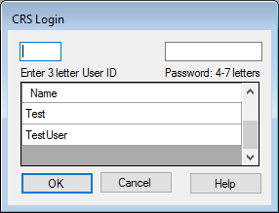

CRS Plus Login dialog window.
- Enter your CRS Plus User ID or select the name from the list of users.
- Enter your Password.
- Click on OK or hit the Enter key on the keyboard.
NOTE: Please contact a CRS Plus Administrator to set up a User name and password for initial login.

CRS Plus Main Window
When a user successfully logs in to CRS Plus, the main window will open.

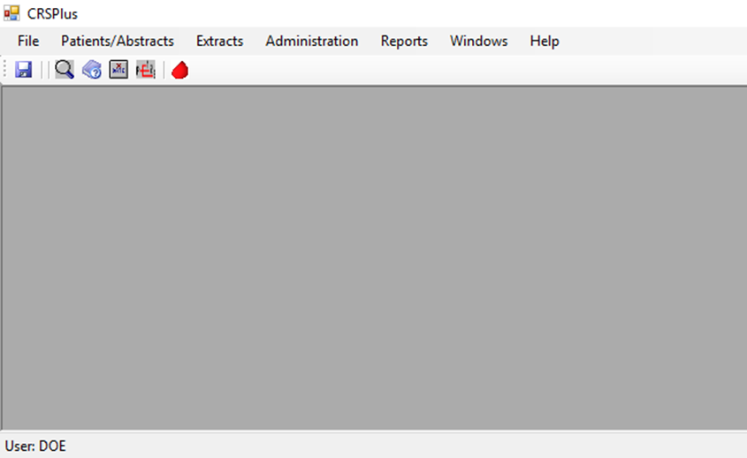

CRS Plus main window.

The Menu Bar
The menu bar contains the following options:

CRS Plus menu bar.

File
Exit is the only current function available in the File menu.

Patients/Abstracts
Contains options commonly performed by users assigned a role of “Consolidator” or “Editor” in CRS Plus.
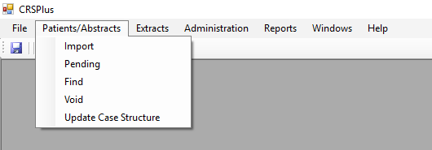

CRS Plus Patients/Abstracts menu.
Extracts
Contains standard extracts for routine file submission as well as tools to create SQL queries and to generate data files in multiple file formats including NAACCR record types and fixed width.
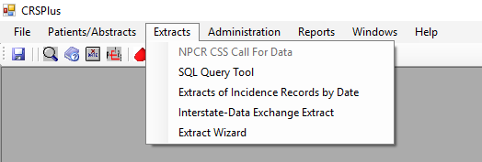

CRS Plus Extracts menu

A list of extracts and tools in the Extracts menu with corresponding descriptions is provided below:

Report Name | Description
NPCR CSS Call for Data | Generates the extracted data file for NPCR CSS data submission including criteria for current submission. This tool extracts only the data items required for NPCR CSS data submission when NPCR CSS is selected. An option was added to create a file for Virtual Pooled Registry Linkage which extracts all data items in Record Type C format when Virtual Pooled Registry is selected.
SQL Query Tool | Tool to create and run SQL queries against the database. Queries can be saved to run at any time and query results can be extracted.
Extracts of Incidence Records by Date | Generates files of Incidence Records (NAACCR Record Type I) by Date of Diagnosis and County.
Interstate-Data Exchange Extract | Extraction tool to create files for interstate data exchange. Multiple files can be created at the same time by selecting multiple registries in the Receiving State section of the tool. The data will be separated by Addr at Dx State and a count for each file will be provided.
Extract Wizard | Provides the ability to create customized queries in multiple file formats including NAACCR record types and fixed width. SQL statements are generated by following the steps in the Wizard without the need for the user to understand SQL. For those with experience in SQL, the generated SQL statement can be modified to run more advanced SQL queries. Queries can be saved to run at any time and query results can be extracted.

Using the Extract Wizard in CRS Plus
From the Extracts menu, select Extract Wizard.

Step 1: Record Info
- Specify the record source (consolidated records or abstract records). Only one can be selected.
- Specify the Registry Type.
- Enter the Registry ID if it should be included in the extract output.
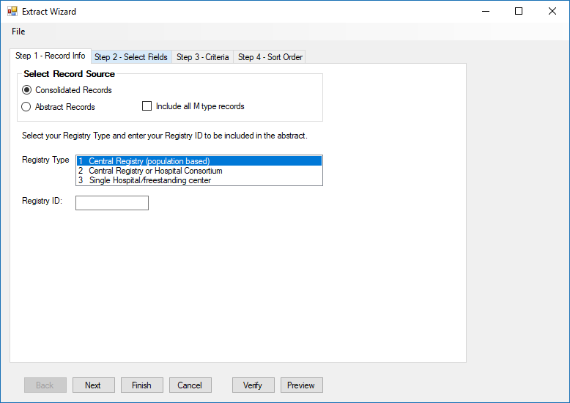

CRS Plus Extract Wizard Step 1
- Select Next and Step 2 will display.

Step 2: Select Fields
- Select fields to be included in the output file. The available fields list on the left contains the NAACCR data items appropriate to the type of record in alphabetic order by Registry Plus short name.
NOTE: The listing for a Consolidated extract will only contain items included in the Consolidated record.
Registry-specific local data items will also be available if included in the database. All fields can be selected or individual data items can be selected and moved to the selected fields window on the right using the arrow key in the middle. The order of selected fields can also be modified using the buttons to move Up or move Down. As fields are selected, the SQL Statement is created in the lower portion of the Extract Wizard window.
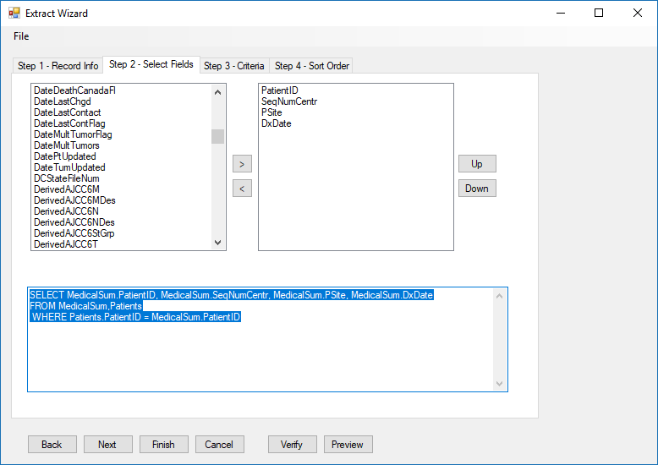

CRS Plus Extract Wizard Step 2
- Select Next and Step 3 will display.

Step 3: Criteria
- Specify the criteria by selecting a field to compare using the dropdown menu.
- Select an Operator function.
- Enter a value to compare.
- Click on the logical connector buttons (AND, OR, NOT) to add the criteria to the Where clause.
- If additional criteria are needed, select the next field to compare, select an Operator function, enter a value to compare, and select the appropriate logical connector.
- The criteria will be automatically added to the SQL Statement.
- To delete or modify the criteria, remove or modify the criteria in the WHERE clause section which will automatically update the SQL Statement in the bottom section of the Extract Wizard window.

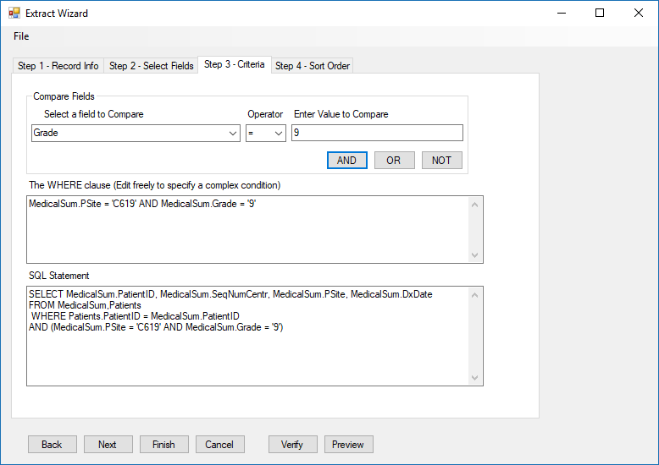

CRS Plus Extract Wizard Step 3
- Select Next and Step 4 will display.

Step 4: Sort Order
- Specify the sort order. The fields selected in Step 2 will be available to select for sorting.
- Once the Sort order is selected, click on Finish to execute the extract.
- A message similar to the following will be presented for the user to verify expected results.
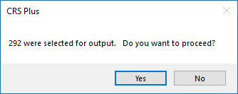

CRS Plus Extract Wizard Output Result Verification
- Select Yes to proceed. Select No if the number of records selected for output is not as expected.
- The SQLQueryExport window will appear. The extract results (data) can be saved.

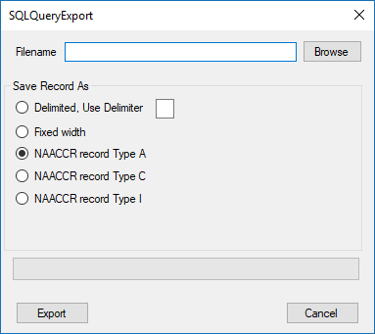

CRS Plus Extract Wizard SQLQueryExport Window
- Select Browse to specify the location and enter a File name.
- Click on Open.
- Select the output format. NAACCR files can be created, as well as fixed width, or delimited files. If Fixed Width output format is selected, the extract results can be opened in Microsoft Excel and formatted.
- Once the output format is selected, click on Export.
- A message will be received confirming the extract is complete and will provide the file location and name of the file.
- The Extract statement can also be saved so the extract can be run or modified at any time. To save the Extract Statement, select File in the upper left corner of the Extract Wizard window.
- Select Save.
- Specify a name for the extract and click on Save.
- To access the saved Extract Statement, select File in the upper left corner of the Extract Wizard window. Select Open. The list of all saved extracts will display in a window labeled ExtractWizardOpen. Select the file and click on Open.
The following additional options are also available:

Verify SQL
This function can be used to verify the SQL statement. Once a SQL Statement is generated in the Extract Wizard, click on Verify. If successful, the following message will appear:

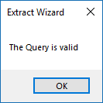

CRS Plus Extract Wizard Verify SQL Confirmation
If unsuccessful, an error message including details of the invalid function will appear so the SQL statement can be modified.

Preview Data
This function can be used to quickly display the results and verify fields and format, but only the first 100 records will be selected. Once Preview is selected, a window labeled ExtractWizardPreview will open displaying the results of the extract. The option is available to Export the results from the ExtractWizardPreview window.

Copy and Paste SQL Statement
A statement can also be pasted into the SQL Statement (lower portion) of the Extract Wizard. This can be used when extracts including both consolidated data and abstract data are needed.

Administration
Most of the options and functionalities in the Administration menu can only be performed when a user is assigned an “Administrator” role in CRS Plus.
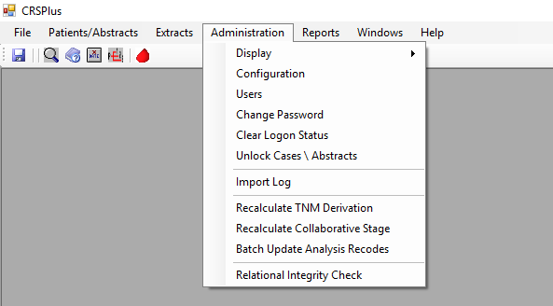

CRS Plus Administration menu.
Reports
Contains standard reports available to users for tracking and administrative analysis. All reports can be saved in the following formats: Excel, PDF, or Word.
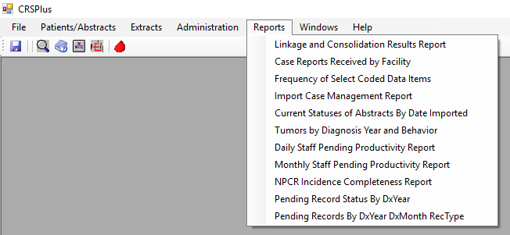

CRS Plus Reports menu.
A list of Reports with corresponding descriptions is provided below:

Report Name | Description
Linkage and Consolidation Results Report | Provides counts for total patients, total tumors, total facility records, and total pending abstracts in the database. Also provides averages for tumors per patient and facility records per tumor.
Case Reports Received by Facility | Provides a listing of facilities, with a month by month total of case reports received based on criteria (Year, Date of Diagnosis or Date Case Report Received) selected.
Frequency of Select Coded Data Items | Provides frequencies of selected data items (Sex, Race, Spanish/Hispanic Origin, Behavior, Type of Reporting Source, Diagnostic Confirmation, and County at DX for State) by diagnosis year.
Import Case Management Report | Provides a listing of Imported files including details for total records sent directly to the database and records sent to pending by Status 2 (Reason for Pending) for each import file. Date Imported range must be selected.
Current Statuses of Abstracts by Date Imported | Provides a listing of the current status of abstracts from imported files including details for total records sent directly to the database and records sent to pending by Status 2 (Reason for Pending) for each import file.
Tumors by Diagnosis Year and Behavior | Provides a summary count of tumors by diagnosis year and behavior. It provides a line by line listing by diagnosis year by total number of tumors and behavior.
Daily Staff Pending Productivity Report | Provides daily staff pending productivity counts by user.
Monthly Staff Pending Productivity Report | Provides monthly staff pending productivity counts by user.
NPCR Incidence Completeness Report | Provides NPCR Incidence Completeness by diagnosis year and includes completeness of critical data elements. This is the same report produced when running the NPCR Extract for NPCR CSS but is able to be run at any time. The criteria and column definitions match those of the NPCR Extract.
Pending Record Status by DxYear | Provides counts of records in pending by diagnosis year and pending status.
Pending Records DxYear DxMonth RecType | Provides counts of records in pending by diagnosis year by month and Record Type.

Help
Provides access to the online help system and a dialog window that displays the CRS Plus version. Online Help will be added at a later time.
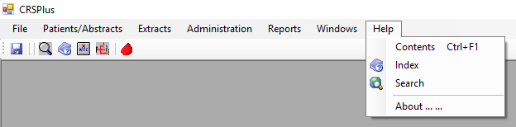

CRS Plus Help menu.
About: Opens the About dialog window to view the current version of CRS Plus.

The Icon Task Bar

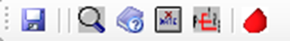

CRS Plus Icon Task Bar
The following functions are available via the icons:

Save Find Case/Abstract Help Void Abstract Compare SEER Heme DB

Administration Dropdown Menu

The Administration Dropdown Menu, contained in the main menu bar of CRS Plus, contains tasks that are only accessible to users who have Administrator level permissions with the exception of the Change Password feature.
NOTE: Each user has the ability to change their own password, regardless of role access granted. Only an Administrator can change the password of another user.
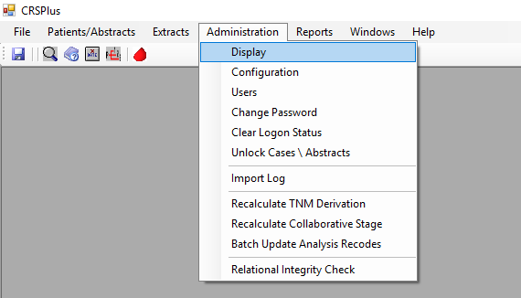

CRS Plus Administration menu.
When a user has been assigned the role of Administrator within the CRS Plus application, they are given permission to perform tasks found under the Administration menu. To assign a user Administrator rights, please see Manage Roles below.

Manage Display
Displays are configurable at a system level by an Administrator, and the configured displays apply to all users. The data items available for display are based on the table structure in the control.mdb for CRS Plus. Data items marked in the PatGrid, MedGrid, and CRSAbsGrid in the control.mdb are available in the corresponding displays, Abstract Display and Consolidated Display, in the Display Configuration window.

Display Configuration
There are currently three displays that can be customized by an Administrator: Abstract Display, Consolidated Display and Pending Consolidated. Section Headers are available and can be customized to group data items and to enhance the user interface. Section Headers will be highlighted in the CRS Plus display grids to clearly separate the sections in the grids. The sort order of the data items and sections can be modified by using the up and down arrows in the Display Configuration window.
NOTE: Existing local fields in the control.mdb will be available for including in the display types. Local fields cannot be added to CRS Plus in Display under Administration. At this time, localized data items must be added to the control.mdb. Please contact Registry Plus staff to add local fields in CRS Plus.

To set or modify displays for all users in CRS Plus:
1. From the Administration menu, select Display.
2. The window labeled Display Configuration will open.
3. At the dropdown to the right of Please Select a Display Type, select a display to view or modify. The Abstract Display is selected for the example below. The Abstract Display will appear in the section on the right side of the Display Configuration window labeled Selected fields for Abstract Display.

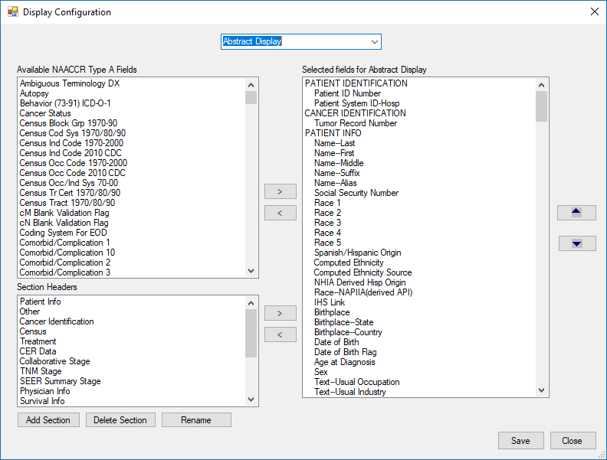

Administration – Display Configuration – Abstract Display
- Review the Abstract Display.
- Data items can be added to the display on the right by selecting data items from the section on the left labeled Available NAACCR Type A Fields.
- To insert a data item in the display, scroll to the area in the right (Selected fields for Abstract Display) and select a data item by highlighting it, then select the data item from the available fields list on the left and use the right arrow button to move the data item to the highlighted section in the display. Data items will be removed from the available fields list on the left once they are added to the list (Selected fields for Abstract Display).
- Use the up and down arrow buttons on the far right of the Display Configuration window to move the data items to the desired location in the display.
- To remove a data item from the display, select the data item from the list on the right (Selected fields for Abstract Display) so the item is highlighted and use the left arrow button to move the data item to the list on the left (Available NAACCR Type A Fields).
NOTE: Histology ICD-O-2 is used in the SEER Site Recode DLL to generate site recode variables for analysis; therefore, an error message will be presented if Histology-ICD-O-2 is removed from the displays.
- Once the display is configured, click on the Save button to save changes to the display.
- Follow the steps above to modify the Consolidated Display or Pending Consolidated display. The desired display should be selected from the dropdown list of display types. The label for the grid on the right will be updated according to the display type selected.
NOTE: The Pending Consolidation window will only initially display consolidated data items with active consolidation directives regardless whether the data items are included in the Pending Consolidated display in the Display Configuration.

Display Options for SSDIs
The following three options are available in the CRS Plus displays, Abstract, Consolidated and Pending Consolidation, for viewing SSDIs:

Constant SSDIs Only
- Selected by user in display.
- Only the selected SSDIs will display; the constant sections cannot be expanded to display all SSDIs for he specified schema.
- User can set the order of the items.
- Constant sections will display for all cases regardless of the specified schema.
- Not recommended to display constant SSDIs only if additional SSDIs need to be expanded since only the SSDIs selected as constants in the display will be visible in the display grids.
Dynamic SSDIs Only
- All SSDIs applicable to a schema will display and the list can be expanded to include all other SSDIs if needed due to edit corrections, etc.
- The order of the data items cannot be modified.
- Cannot be customized by the user.
NOTE: The SSDI edits in the NPCR edit sets fail if a SSDI is populated when the SSDI is not associated with the schema. If the schema is modified and a new set of SSDIs is associated with the new schema, edits will fail for the SSDIs associated with the old schema if they remain populated. Messages are presented to the user in the Registry Plus software when schema is updated and the user has the option to blank out the existing SSDIs. If the user chooses not to blank out the SSDIs, having the ability to expand the list of dynamic SSDIs will be useful so the user can blank out the items manually.
Dynamic SSDIs and Constants
- Includes user-defined SSDIs and dynamic SSDIs associated with the specified schema.
- All constants display as defined by user in one section and dynamic SSDIs display in a separate section.
- When the dynamic SSDI list is expanded, it will display all SSDIs for all schema listed alphabetically. This may be helpful if the schema is changed.
- The dynamic SSDI section will not include any SSDI specifically included in the display as a constant; therefore, duplicate SSDIs will not be displayed.
As an example, if Prostate items are included in the display as constants, the items will display in the user-defined section. Any Prostate SSDIs not specifically included in the user-defined section will be displayed in the dynamic SSDI section when the schema is Prostate. Users can control this and leave as is or select all Prostate items as constants in one section and order the required SSDIs first.

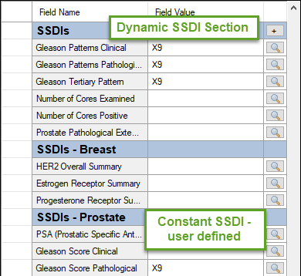

CRS Plus Prostate Schema Display Example of Constant SSDIs defined by user and Dynamic SSDIs displaying all Prostate SSDIs not selected in Constant SSDI Prostate section.
NOTE: In the Pending Consolidation window, an * in front of an SSDI in the dynamic SSDI section indicates a data item with an active consolidation rule.

Section Headers
For Section Headers, sections can be added, deleted, or renamed in the list labeled Section Headers in the left lower section of the Display Configuration window.

Adding a Section Header
- To add a section header, click on the Add Section button. The following Add Display Section window will appear.
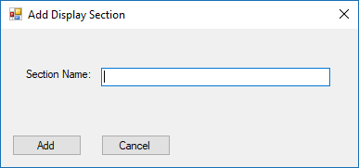

CRS Plus Display Configuration Section Header Add Display Section
- Enter a new Section Name.
- Click on the Add button. Clicking on the Cancel button will cancel the addition and will close the Add Display Section window.
- The Add Display Section window will close and the new section added will display at the bottom of the Section Headers list.

Renaming a Section Header
- To rename a section header, select the section header from the list so it is highlighted.
- Click on the Rename button. The following RenameDisplaySection window will appear.
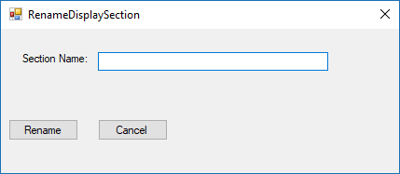

CRS Plus Display Configuration Section Header RenameDisplaySection
- Enter the new Section Name for the section header to be renamed.
- Click on Rename. Clicking on the Cancel button will cancel the addition and will close the RenameDisplaySection window.
- The RenameDisplaySection window will close and the modified Section Header name will display in the list.

Deleting a Section Header
- To delete a section header, select the section header from the list so it is highlighted.
- Click on the Delete Section button. The following verification message labeled Remove Section will be presented.
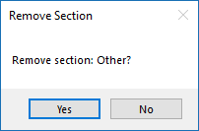

CRS Plus Display Configuration Section Header Remove Section
- Click on Yes to confirm removing the section. Selecting No will cancel the removing of the section and close the Remove Section window.
- Once Yes is selected, the Remove Section window will be closed and the deleted section header will no longer appear in the list of Section Headers.

Manage Configuration
Configuration and application settings are set by an Administrator. Software features may not be applicable to all registries and are added to CRS Plus as preferences in the Configuration menu so users can select applicable features.

Edits Configuration
The first tab in the ApplicationSettings window is the Edits Configuration tab as displayed below:
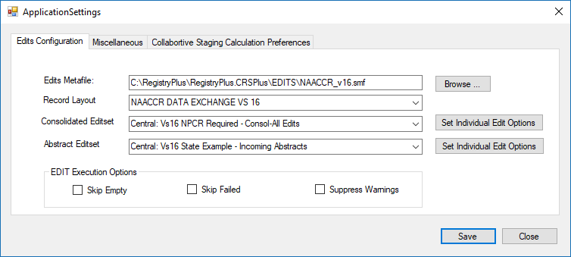

Application Settings – Edits Configuration
After each install, upgrade, or if the edit metafile is replaced, the Edits Configuration settings should be reviewed and updated if necessary. An administrator should verify the appropriate Edits Metafile, Record Layout, Consolidated Editset, and Abstract Editset are defaulted appropriately.

Individual Editset Options can be applied to the Consolidated Editset and the Abstract Editset.

Setting Individual Edit Options
- Select the Set Individual Edit Options radial button to the right of the Consolidated or Abstract Editsets.
- The IndividualEditsOption dialog will open as displayed below.

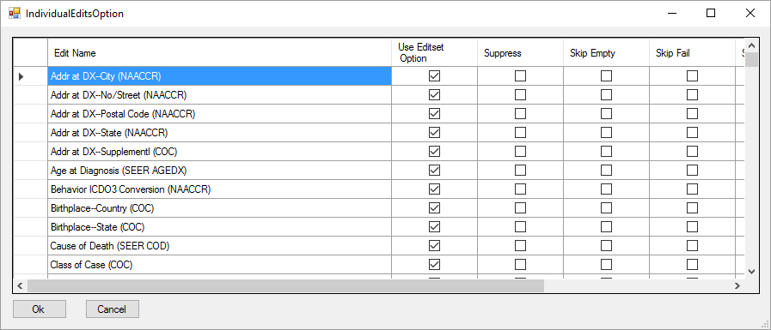

Individual Edits Option Dialog
Individual edits can be suppressed in this window to de-activate the selected edits from running. This is useful if an issue is identified in edit logic and the user wishes to suppress an individual edit until a new edit metafile can be generated.

Suppressing Individual Edits:

- Scroll to identify the Edit Name(s) to suppress.
- Click on the box in the Suppress column to add a check mark for all appropriate rows/Edit Names.
- To un-suppress an edit, click on the box in the Use Editset Option column to remove the checkmark for the edits that have been identified to suppress.
- When all changes have been made, click on Ok.
- The IndividualEditsOption dialog will close.
- Click on Save in the ApplicationSettings window to save changes.

Selecting a Different Edit Metafile

- Retain a copy of the current .rmf or rename the current .rmf before replacing the metafile.
- If a registry-specific edits metafile has been generated, rename the metafile to the name CRS Plus is expecting (Ex. NAACCRv16.rmf).
- Copy the .rmf to the folder where the edit metafiles are stored for the CRS Plus application (Ex. C:\RegPlus\CRS Plus\EDITS or the network location).
- In the ApplicationSettings window in CRS Plus, click on the Browse button to the right of the Edits Metafile.
NOTE: Once the Browse button is clicked, the record layout and Editsets will no longer be defaulted in the text box and will need to be re-selected. If no changes are needed or a new edit metafile was not selected, there is no need to click on the Browse button. The application will remember the selections until the edit metafile is updated.
- An Open dialog window will appear. Select the edit metafile from the appropriate location.
- Once the edit metafile is selected, select Open.
- Select the Record Layout for the edit metafile using the dropdown menu.
- Select the Consolidated Editset from the registry-specific edit metafile using the dropdown menu to apply to the Consolidated Record in CRS Plus.
- Select the Abstract Editset from the registry-specific edit metafile using the dropdown menu to apply to the Abstracts in CRS Plus.
- Once the components of the configuration are selected, click on Save.
- A CRS Settings confirmation message will appear stating: “Edits configuration setting saved”.
- Click on OK to close the confirmation message.

Miscellaneous
The second tab in the ApplicationSettings window is the Miscellaneous tab as displayed below:

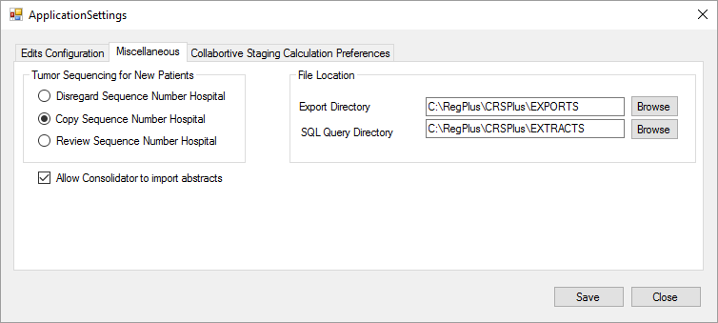

Application Settings - Miscellaneous
Three setting preferences are available in the Miscellaneous tab. All settings should be reviewed and confirmed after initial install or upgrade.

Tumor Sequencing for New Patients
Three options are available to address Sequence Number Central assignment upon import. The three options are Disregard Sequence Number Hospital, Copy Sequence Number Hospital, and Review Sequence Number Hospital. Refer to the section called Sequence Number Check for detailed descriptions.

Allow users with the Consolidator Role to Import Abstracts
Selecting this option will set the preference to allow a user with Consolidator role assigned to import abstracts. Otherwise, only an Administrator is authorized to import abstracts.

Designate File Locations for Exports and Queries.
File locations can be defaulted for saving Exports and SQL Queries. Modifications can be made by clicking on the Browse button and selecting the desired path and folder to save Exports and SQL Queries.

Collaborative Staging Calculation Preferences
The third tab in the ApplicationSettings window is the Collaborative Staging Calculation Preferences tab which is displayed below:

The settings should be reviewed and confirmed after initial install or upgrade to verify appropriate settings are applied for the registry.

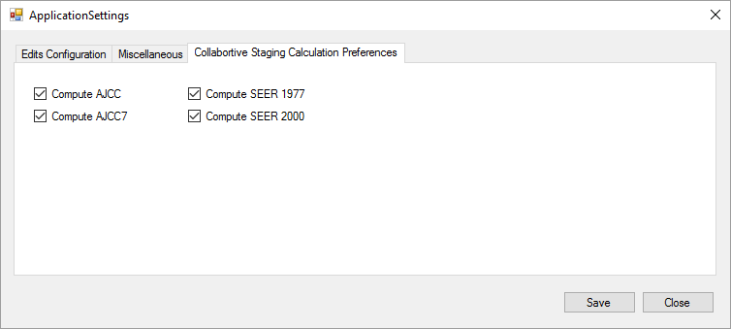

Application Settings – Collaborative Stage Calculation Preferences

Manage Users
As an administrator, you have the ability to manage accounts of CRS Plus users.

From the Administration menu, select Users.
The UserAdmin dialog window opens.
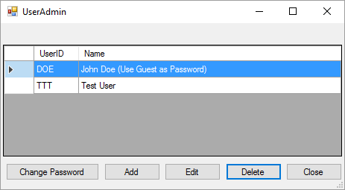

User Admin dialog window.

Change Password
To reset a user’s password within the CRS Plus application:
- From the Administration menu, select Users.
- The UserAdmin dialog window will open.
- Select the user from the list and click the Change Password button within the UserAdmin dialog window.
- The ChangePassword dialog window will open as displayed below. Verify the UserId.
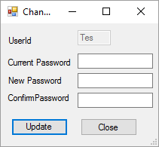

Change Password dialog window.
- Enter the current password.
- Enter the new password in both the New Password and Confirm Password fields.
NOTE: The password must be at least 4 characters and the maximum length is 7 characters.
- Click the Update button. A warning message will be received if the New Password and Confirm Password do not match.
NOTE: Each user has the ability to change their own password, regardless of role access granted. Only an Administrator can change the password of another user.

Adding New Users
To provide a new user access to the CRS Plus application:
- Click the Add button within the UserAdmin dialog window.
- The UserEdit dialog window will open.
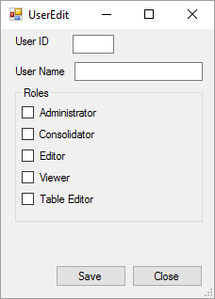

UserEdit dialog window.
- Enter the user’s initials or three-letter user ID in the User ID field.
- Enter the user’s full name in the User Name field.
- Assign User Roles. See the Manage Roles section below for a description of each role.
- Click the Save button.
- The CRS Plus Password Management dialog window will appear stating a temporary password of ‘guest’ will be assigned to the new user. Once the user logs in, the user can change their password in the Administration menu option Change Password.
NOTE: Users who are not assigned the Administrator Role can access the Administration menu option to Change Password.
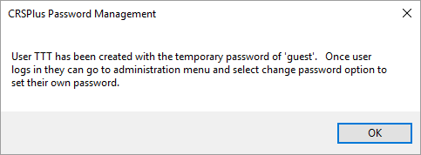

CRS Plus Password Management dialog window.

Delete User
To delete a user, select the user’s name from the UserAdmin list and click the Delete button. A CRS Plus –Confirm Delete dialog window will appear requesting verification of deletion. Select Yes.

A CRS Plus Password Management dialog window will appear to confirm the deletion.
NOTE: Users can delete the John Doe user account for additional security. A new user assigned the Administrator role should be added before the John Doe account is deleted.

Manage Roles
Each user is assigned a role (or roles), which determines their permissions level and ability to perform tasks. The roles
can only be modified by an Administrator. The roles defined in CRS Plus are described below:

Administrator: Administrators setup CRS Plus and have access to all of its features including administrative tasks such as changing the Administrator password and setting up display sections and fields. An administrator can customize the authorizations of all of the other users. All administrators must have a general user account with a user ID and password.
Consolidator: Consolidators review and process pending abstracts and have the ability to modify and update cases in the Interactive Update window.
Editor: Editors review and edit records in the Interactive Update window as well as Voided records; however, users assigned to this role do not have permissions to review and process pending abstracts.
Viewer: Viewers have the ability to view records in the Interactive Update window as well as the Voided records; however, users assigned to this role do not have permissions to make any modifications to the records.
Table Editor: Table Editors manage the Hospital and Physician codes and also have permissions to print cases in the Interactive Update window as well as Voided records.

To manage the roles assigned to a user within the CRS Plus application:
- Select a user from the list and click the Edit button within the UserAdmin dialog window.
- The UserEdit dialog window will open.
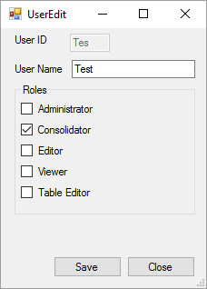

UserEdit dialog window.
- Check the box preceding each role to assign to the user.
- Uncheck the box next to each role to deny to the user.
- Click the Save button.

Change Password
To reset a UserId password within the CRS Plus application:
- From the Administration menu, select Change Password.
- The Change Password dialog window will open.

Change Password dialog window.
- Enter the current password.
- Enter the new password in both the New Password and Confirm Password fields.
NOTE: The password must be at least 4 characters and the maximum length is 7 characters.
- Click the Update button. A warning message will be received if the New Password and Confirm Password do not match.
NOTE: Each user has the ability to change their own password, regardless of role access granted. Only an Administrator can change the password of another user from the Administration menu under Users.

Clear Logon Status
- From the Administration menu, select Clear Logon Status.
- The Clear Logon Status window will open as displayed below.
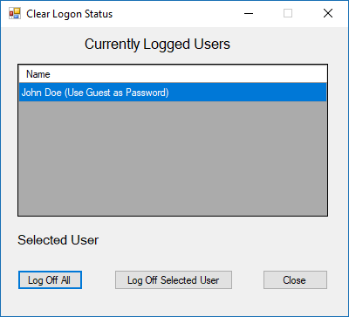

CRS Plus Clear Logon Status Window
- Click on a user name in the list and click on the Log Off Selected User button to clear the logon status for the user.
- If multiple users are currently logged, click on the Log Off All button to clear logon status for multiple users.
- Once logon status has been cleared, select Close.

Unlock Cases/Abstracts
Records may become locked if there is an event such as a power outage or network issue and a user is working on a record at the time.

- From the Administration menu, select Unlock Cases\Abstracts.
- The UnlockCasePatient window will open as displayed below.
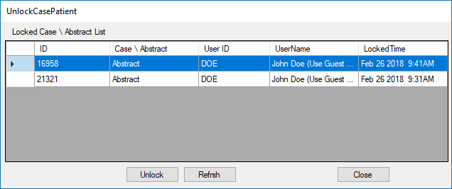

CRS Plus UnlockCasePatient Window
- If records appear in the list, select the individual records and click on Unlock.
- Once all records have been unlocked, select Close.

Manage Import Log
A user assigned an Administrator Role can view the Import Log at any time. The Import Log is a list of all files imported into the database. To access the Import Log:

- From the Administration menu, select Import Log.
- The Import Log will open as displayed below.
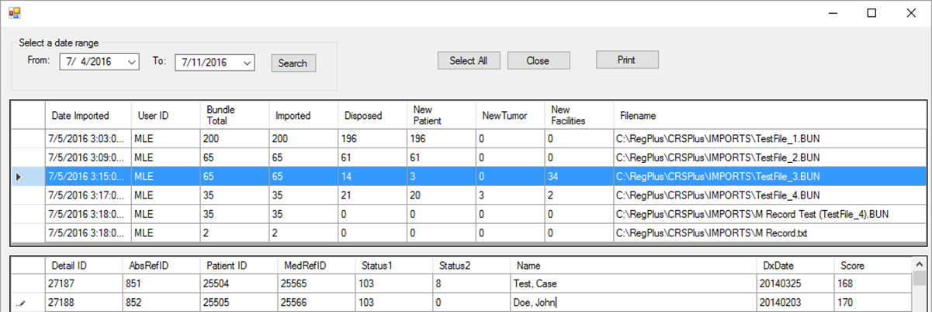

CRS Plus Import Log
A list of all import files displays in the first table. If an import fails, the status and reason for import failure will display. Once an import file from the first table is selected and highlighted, the details of each record in the import file will display in the table at the bottom of the window. The table provides the following details: Abstract identifiers, status of the abstracts upon import, and the score assigned upon Patient Linkage.

A date range can be entered at the top of the window to filter and search for specific import dates (by month, etc.). Select All will select all import files included in the first table.

Printing the Import Case Management Report
The Import Case Management Report can be viewed and printed by selecting an import file from the first table. Once the file is highlighted, click on the Print button and the Import Case Management Report will open. Multiple import files/rows can be selected. When the report opens, all highlighted files will display in the report summarizing records disposed to the database and abstracts sent to pending. The Import Case Management Report can be saved in the following formats: Excel, PDF, or Word.

Recalculate TNM Derivation
A batch recalculation function is available in CRS Plus to recalculate NPCR Derived Clin Stg Grp (3650) and NPCR Derived Path Stg Grp (3655) for TNM on all applicable records in the database when new TNM DLL versions are implemented.

The TNM_Staging.dll is called to run TNM Derivation so the latest TNM_Staging.dll needs to be saved to the application (RegPlus\CRS Plus) directory. The user has the option to recalculate TNM on tumor records only, on abstracts only, or on both tumor records and abstracts.

- From the Administration menu, select Recalculate TNM Derivation.
- The following TNM Staging 7th Edition Batch Recalculation dialog window will appear:
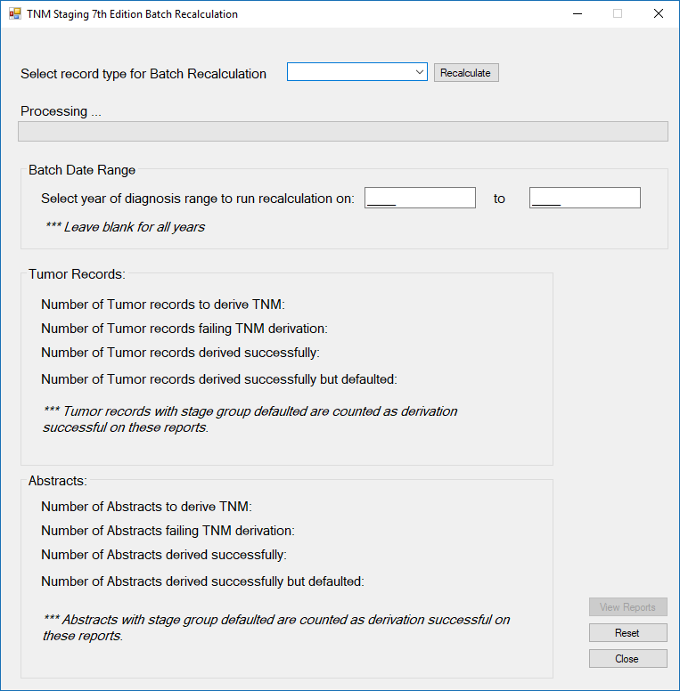

TNM Staging 7th Edition Batch Recalculation Dialog
- Select record type for Batch Recalculation from the drop-down (Tumor Records, Abstracts, or both Tumor Records and Abstracts).
- Specify a range of diagnosis years to recalculate. If the diagnosis range is left blank, all diagnosis years from 2016 through 2017 will be recalculated for TNM 7th Edition. TNM 7th Edition Recalculation will not run for diagnosis years prior to 2016 or after 2017.
- Click on Recalculate.
- Once the TNM Recalculation has completed, the status bar will be filled and a message will display above the status bar stating Processing Complete. A summary of derivation for Tumor Records and Abstracts depending on selected record type will be populated in the lower portion of the TNM Staging 7th Edition Batch Recalculation window.
NOTE: A Reset button is available to reset the screen and start a new TNM Batch Recalculation. This is helpful if only one record type is completed at a time but be sure to view and export reports first.
- Once processing is complete, click on the View Reports button in the right lower corner of the TNM Staging 7th Edition Batch Recalculation window. The Reports window will open.

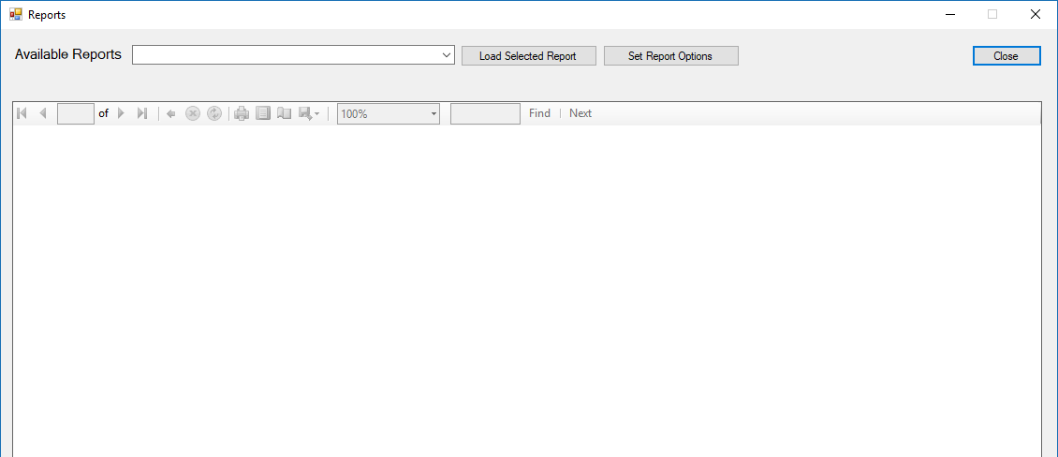

CRS Plus TNM Batch Recalculation Reports Window
- Click on the drop-down to the right of Available Reports to select a report.
NOTE: The Set Report Options button will allow the user to enter the Registry Name to display in the TNM Batch Recalculation reports.
- Once the report is selected, click on Load Selected Report which will load the report in the Reports window.
- Icons are available at the top of the report to Print, set the Print Layout, complete Page Setup, and to Export by Excel, PDF, or Word. A zoom option is available as well as a Find option.
- Once all reports are viewed and exported, click on the Close button in the upper right corner of the Reports window to close the Reports window.
- Once TNM Batch Recalculation is completed, click on the Close button in the lower right corner of the TNM Staging 7th Edition Batch Recalculation window to close the window.

The application creates a total of eight reports; a set of four reports in PDF and a set of the same four reports in Excel format. The group suffixed by "PDF" are optimized for export to PDF files. The group suffixed by "EXCEL" are optimized for export to Microsoft Excel files.
The four reports are described below:

Tumor Records NPCR Stage Group Derivation Failed - a report of tumor records where stage derivation failed
Tumor Records NPCR Derived Stage Group Defaulted - a report of tumor records where stage derivation was not done, but stage group values were set to default values
Abstracts NPCR Stage Group Derivation Failed - a report of abstracts where stage derivation failed
Abstracts NPCR Derived Stage Group Defaulted - a report of abstracts where stage derivation was not done, but stage group values were set to default values

The following fields are included in the report Tumor Records NPCR Stage Group Derivation Failed (PDF and EXCEL):
Patient ID
MedRefID
Primary Site
Histologic Type ICD-O-3
Behavior
Grade
TNM Clin T
TNM Clin N
TNM Clin M
TNM Clin Stage Group
TNM Path T
TNM Path N
TNM Path M
TNM Path Stage Group
The error code that triggered the error/warning
The error message

The following fields are included in the report Tumor Records NPCR Derived Stage Group Defaulted (PDF and EXCEL):
Patient ID
MedRefID
Primary Site
Histologic Type ICD-O-3
NPCR Derived Clin Stg Grp
NPCR Derived Path Stg Grp
The error code that triggered the error/warning
The error message

The following fields are included in the report Abstracts NPCR Stage Group Derivation Failed (PDF and EXCEL):
Record # (starting from 1)
Patient ID
MedRefID
AbsRefID
Primary Site
Histologic Type ICD-O-3
Behavior
Grade
TNM Clin T
TNM Clin N
TNM Clin M
TNM Clin Stage Group
TNM Path T
TNM Path N
TNM Path M
TNM Path Stage Group
The error code that triggered the error/warning
The error message

The following fields are included in the report Abstracts NPCR Derived Stage Group Defaulted (PDF and EXCEL):
Patient ID
MedRefID
AbsRefID
Primary Site
Histologic Type ICD-O-3
NPCR Derived Clin Stg Grp
NPCR Derived Path Stg Grp
The error code that triggered the error/warning
The error message

TNM Error Codes
The TNM staging library's CalculateStage function returns the following three error codes:

One for overall success (a schema has been identified and staging is applicable)
One for clinical stage derivation
One for pathologic stage derivation

Each error is logged separately. For example, if both clinical and pathologic stage derivation fail for a case, the case will be listed in the failure report twice. If one stage group derivation fails for a case and the other stage is defaulted, the case will be listed in both the failure report and defaulted report.

Error codes are grouped into three categories for reporting purposes. Consult the TNM staging API documentation for detailed information on each error code.

Success codes:
OK

Defaulted codes:
STAGE_GROUP_YP_NOT_REPORTABLE
STAGE_GROUP_NOT_FOUND
STAGING_ELEMENT_MISSING

Failure codes:
SYSTEM_EXCEPTION
SITE_NOT_VALID
HISTOLOGY_NOT_VALID
INVALID_CLINICAL_T
INVALID_CLINICAL_N
INVALID_CLINICAL_M
INVALID_CLINICAL_STAGE_GROUP
INVALID_PATHOLOGIC_T
INVALID_PATHOLOGIC_N
INVALID_PATHOLOGIC_M
INVALID_PATHOLOGIC_STAGE_GROUP
CLINICAL_T_TABLE_NOT_FOUND
CLINICAL_N_TABLE_NOT_FOUND
CLINICAL_M_TABLE_NOT_FOUND
CLINICAL_STAGE_GROUP_TABLE_NOT_FOUND
PATHOLOGIC_T_TABLE_NOT_FOUND
PATHOLOGIC_N_TABLE_NOT_FOUND
PATHOLOGIC_M_TABLE_NOT_FOUND
PATHOLOGIC_STAGE_GROUP_TABLE_NOT_FOUND
DERIVED_STAGE_TABLE_NOT_FOUND
STAGE_GROUP_CANNOT_BE_CALCULATED
STAGE_GROUP_IS_ERROR

Explanation of Record Counts
Number of Tumor records to derive TNM - Number of Tumor records selected from the database within the specified date range.
Number of Tumor records failing TNM derivation - A record is counted as failed if any of its three error codes are in the Failure category.
Number of Tumor records derived successfully - A record is counted as successful if none of its three error codes are in the Failure category.
Number of Tumor records derived successfully but defaulted - A record is counted as defaulted if any of its three error codes are in the Defaulted category.
Number of Abstracts to derive TNM - Number of Abstracts selected from the database within the specified date range.
Number of Abstracts failing TNM derivation - A record is counted as failed if any of its three error codes are in the Failure category.
Number of Abstracts derived successfully - A record is counted as successful if none of its three error codes are in the Failure category.
Number of Abstracts derived successfully but defaulted - A record is counted as defaulted if any of its three error codes are in the Defaulted category.

Due to the way the counts are defined, there is overlap between counts. A record cannot be counted as both failed and succeeded; however, a record can be counted as both failed and defaulted, or succeeded and defaulted.

Recalculate Collaborative Stage
A batch recalculation function is available in CRS Plus to recalculate CS including CS Version Latest on all applicable records in the database when new CS versions are implemented.

The cstage0205.dll is called to run CS Recalculation so the latest cstage0205.dll needs to be saved to the RegPlus\CRS Plus directory. The user has the option to recalculate CS on tumor records only or on both abstracts and tumor records as displayed in the print screen below.

- From the Administration menu, select Recalculate Collaborative Stage.
- The following AdminRecalculateCS dialog window will appear:

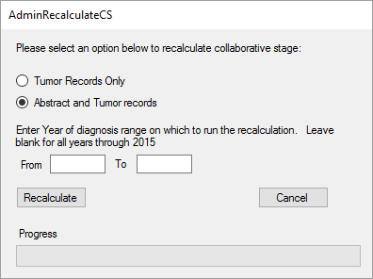

Admin CS Recalculation Dialog
- Select records to be recalculated (Tumor Records Only or Abstract and Tumor Records).
- Specify a range of diagnosis years to recalculate. If the diagnosis range is left blank, all diagnosis years from 2004 through 2015 will be recalculated. CS Recalculation will not run for diagnosis years prior to 2004 or after 2015.
- Click on Recalculate.
- Once the CS Recalculation has completed a message similar to the following will appear:

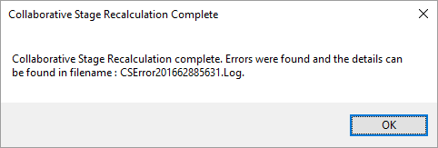

Collaborative Stage Recalculation Confirmation
- Click on OK and the error log report will automatically display. The report is generated at the completion of the batch recalculation to provide a listing of records failing CS Calculation. A sample error log is displayed below:

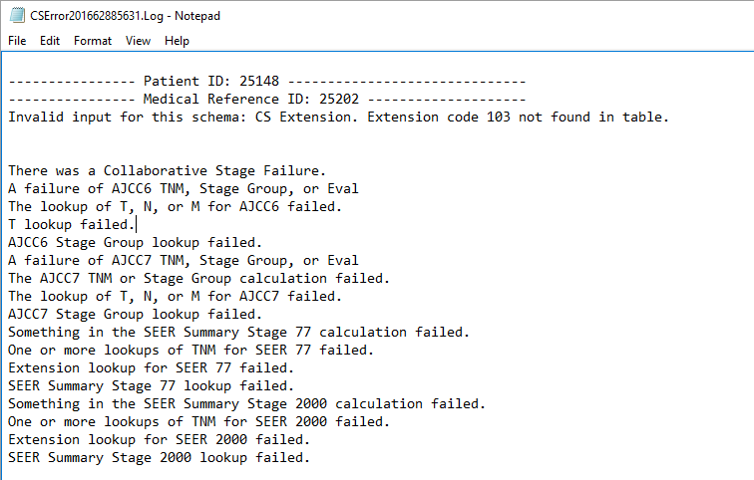

Sample CS Batch Recalculation Log
- Click on Cancel to close the AdminRecalculateCS dialog window.

Batch Update Analysis Recodes
The SEER Site Codes are standard site analysis categories used by SEER, NPCR, and NAACCR. They are generated by calling to the SEERSiteRecode.dll.

There are 3 levels of codes in CRS Plus and each field is five characters in length. The 3 levels are: Aggregate, Sub-aggregate, and Detailed, and the fields are located in the MedicalSum table.
- GrpSite1—Aggregate
Example: 35000, All Leukemias
- GrpSite2—Subaggregate
Example: 35010, Acute leukemias
- GrpSite3—Detail
Example: 35011, Acute lymphocytic leukemia

The codes are stored when tumor records are created or updated and the update is saved. The codes can also be computed on demand on all tumor records by selecting the Batch Update Analysis Recodes option from the Administration menu.

From the Administration menu, select Batch Update Analysis Recodes. The following window will appear:

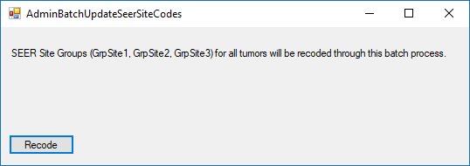

Batch Update Analysis Recode Window
Select Recode.

Once the batch function is selected, a message will appear stating the number of records identified by the program to recode.

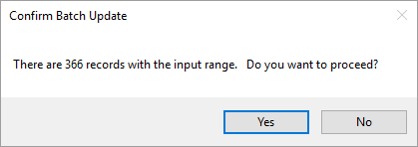

Batch Update Analysis Recode Confirmation
Select Yes to initiate the process. If No is selected, the batch update will not run.

The following message will appear once the SEER Recode process has been completed:

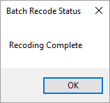

Batch Update Analysis Recode Status Message
Click on OK.
The SEER recode values will display in the following fields provided they are included in the CRS Plus display for abstracts and consolidate records:
GrpSite1
GrpSite2
GrpSite3

Relational Integrity Check
The Relational Integrity Check is available from the Administration menu. It is a database integrity check which can be run on demand to verify the records are structured in the database appropriately. The Relational Integrity Check should be run after Special Import to verify the table structure in the database and to search for Orphan records. Orphans are tables not structured appropriately for a record. For example, an orphan is created if a tumor summary does not have an associated abstract attached to it. The Relational Integrity Check should be run routinely to ensure the database is free of structural issues.

Orphan records occur when data gets corrupted or damaged. Orphans do not typically occur if software and hardware and users are working correctly. However, there could be other unintentional situations such as network issues, power failures, and manipulation of data outside of the CRS Plus application, causing data to get corrupted or causing errors to be introduced.

Running the Relational Integrity Check:
- From the Administration menu, select Relational Integrity Check.
- The Relational Integrity Check will automatically run and the results will display in the Relational Integrity Report which can be printed or saved as Excel, PDF, or Word.
NOTE: Update Case Structure can be used to correct the records in the database.

An example of the report generated from the Relational Integrity Check process is provided below.
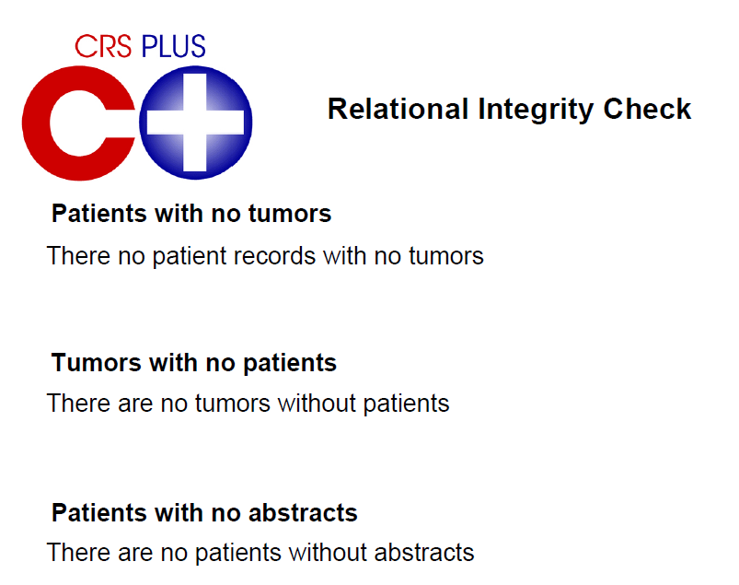
Sample CRS Plus Relational Integrity Check Report

Manage Import
To import files into CRS Plus:
- From the Patients/Abstracts menu, select Import.
- The following Import Abstracts in NAACCR Format dialog will open.
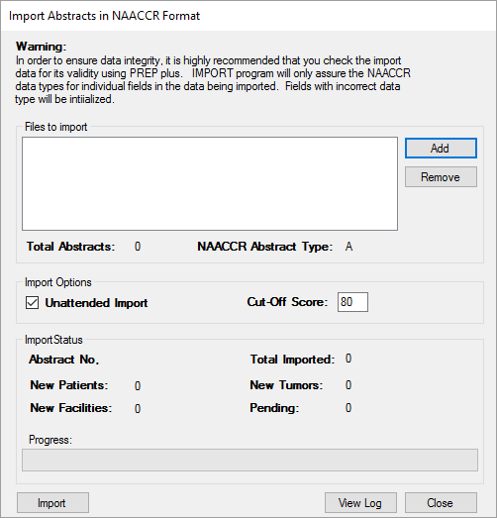

Import Abstracts in NAACCR Format dialog window.
- Select Add.
- A file explorer window will open with the directory defaulted to the folder accessed for the last import. The path will need to be set the first time a file is selected for import.
- Select the file to be imported from the list.
- Click on Open.
- To select more than one import file, follow the steps above to select additional files.
- Once all files are selected, click on Import.
NOTE: If a file fails to import, the database will be rolled back to the point prior to import. The data will not be written to the database until the import completes successfully. If multiple import files are selected for import overnight and the network connection is lost during the process, files that have fully imported will be written to the database. The current file imported at the time of connection failure and any files not initiated will not be imported and can be selected for import at a later time.
- Note the Unattended Import option is defaulted.
NOTE: When Unattended Import is checked, intervention is not needed in between import files when multiple files are selected for import. This feature should be used when importing multiple files overnight.

Other Administrative Functions

Local Fields
State-specific fields can be added to CRS Plus; however, the data items, field positions, and properties must be defined in the Contol.mdb. SQL scripts will also need to be run to add the fields to the database. Please contact Registry Plus staff to add local fields in CRS Plus.

Managing Facilities
Facilities are currently managed in the Catvals.mdb in the HOSPCODES table.

To manage facilities:
- Open the Catvals.mdb located in the MDBS folder in the application (RegPlus\CRS Plus) directory or shared network location.
- Select HOSPCODES from the list of tables in the Access database.
- The structure of the first two columns (Value and Label) must be maintained since these columns are read by the program. Additional columns can be added if helpful to the registry; however, the first two columns (Value and Label) must remain in their current position. The value column contains the facility number assigned to the facility and displayed in the program for the facility data items.

Structure of HOSPCODES table.
- Enter the new facility’s ID in the Value field.
- Enter the new facility’s name in the Label field.
- When all facilities have been added and/or edited as desired, save in the Microsoft Access table by selecting File
then Save.
NOTE: A look-up table is available within the grids to look up facility information; however, changes cannot be made in the look-up and can only be made in the HOSPCODES table at this time.

Managing Doctor Query Table
Physicians are currently managed in the Catvals.mdb in the DoctorQuery table.

To manage physicians:
- Open the Catvals.mdb located in the MDBS folder in the application (RegPlus\CRS Plus) directory or shared network location.
- Select DoctorQuery from the list of tables in the Access database.
- Enter information for the new physician(s).
- DOCID must be entered since it is the identification number assigned to the physician that will display in the program for the physician data items.
- When all physicians have been added and/or edited as desired, save in the Microsoft Access table by selecting File and Save.
NOTE: A look-up table is available within the grids to look up physician information; however, changes cannot be made in the look-up and can only be made in the DoctorQuery table at this time.

Update Case Structure
All linkages completed within CRS Plus can be unlinked and cases restructured using the function to Update Case Structure. Update Case Structure can be accessed from Find in the Patients/Abstracts menu when Patient ID is not known or directly from the Patients/Abstracts menu when Patient ID is known.
NOTE: Only users with Administrator or Consolidator roles assigned can access this function.
The following functions are available in Update Case Structure:

- Voiding Abstracts
- Updating Sequence Numbers
- Unlinking Records
- Deleting Patients or Tumors
- Sending Abstracts Back to Pending to Link Appropriately Either Through Automated Linkage and Consolidation or Manually

To access Update Case Structure:
- From the Patients/Abstracts menu, select Find.
- The Search window will open. Enter Search Criteria in the Search window to find the patient and click on the Search button or click on the Enter key.
- A list of records meeting the search criterial will display in the middle section of the Search window. Select the record from the list of records so the row is highlighted.
- The complete case outline will appear in the Tumors\Abstracts section in the lower section of the Search window.
- Click on the Patient segment in the case outline.
- Click on the Update Case Structure button.
NOTE: Update Case Structure can also be accessed directly from the Patients/Abstracts menu if the Patient ID number is known.
- The UpdateCaseStructure window will open as displayed below.
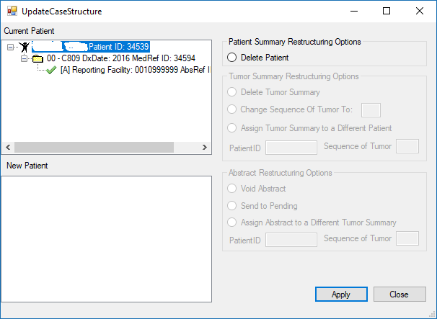

CRS Plus Update Case Structure Window
Restructuring Options will be available based on the segment selected in the complete case outline for the Current Patient. In the example above, the patient segment is selected so only the Patient Summary Restructuring Options are available. For Tumor Summary Restructuring Options, click on a tumor segment and for Abstract Restructuring Options to be available, click on an abstract segment.
NOTE: Only users assigned as Administrator or Consolidator can access Update Case Structure and complete restructuring options.

Patient Summary Restructuring Options
Delete patient

- Select the Patient from the complete case outline so the patient segment is highlighted.
- Select Delete Patient from the Patient Summary Restructuring Options
- Click on Apply and a message similar to the following will appear:
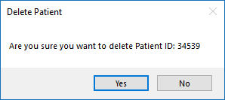

CRS Plus Patient Restructuring Delete Patient Verification
- Select No if the Patient should not be deleted. Otherwise, select Yes and the following message will appear:
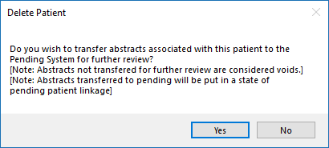

CRS Plus Patient Restructuring and Handling of Associated Abstracts When Deleting Patients
If No is selected, the associated abstracts will be voided rather than sending the abstract to pending. If Yes is selected, the associated abstracts will be sent to pending to be processed appropriately.

Tumor Summary Restructuring Options
Delete tumor summary
- Select the Tumor from the complete case outline so the tumor segment is highlighted.
- Select Delete Tumor Summary from the Tumor Summary Restructuring Options
- Click on Apply and a verification message similar to the following will appear:
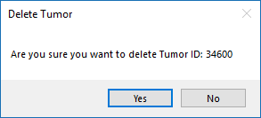

CRS Plus Tumor Restructuring Delete Tumor Verification
If No is selected, the Delete Tumor message will close and no changes will be made. If Yes is selected, the following message will be presented:
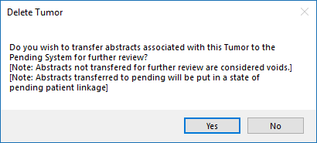

CRS Plus Tumor Restructuring and Handling of Associated Abstracts When Deleting Tumors
If No is selected, the associated abstracts will be voided rather than sending the abstract to pending. If Yes is selected, the associated abstracts will be sent to pending to be processed appropriately.

If there is only one Tumor Summary associated with the patient and Delete Tumor Summary is selected, a message similar to the following will appear since there is only one Tumor Summary. In this case, the Patient should be deleted since there is only one tumor associated with the patient.
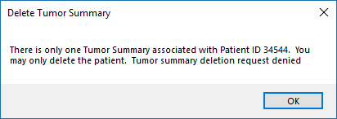

CRS Plus Tumor Restructuring Tumor Summary Deletion Request Denied
changing sequence number
- Select the Tumor from the complete case outline so the tumor segment is highlighted.
- Select Change Sequence of Tumor To: in Tumor Summary Restructuring Options.
- Enter the new Sequence Number for the tumor.
- Click on Apply.
- The Current Patient section will refresh and the new Sequence Number assigned to the tumor will be displayed.
NOTE: Sequence Numbers must be unique and cannot be used more than once. Sequence Numbers for other tumors may need to be modified as well.

assign tumor summary To a different patient
While this restructuring option is not recommended since manual consolidation would be needed, the option is available to assign a tumor summary to a different patient.
NOTE: Automated consolidation does not run when this option is used to restructure records in the database.
- Select the tumor summary from the complete case outline so the tumor summary is highlighted.
- Select Assign Tumor Summary to a Different Patient in Tumor Summary Restructuring Options.
- Enter the PatientID for the patient record and the Sequence Number for the Tumor the abstract will be assigned to. The case outline for the patient will display in the New Patient section of the UpdateCaseStructure window.
- Once the patient and tumor are verified, click on Apply.
- The following message may appear if there is only one tumor summary associated with the current patient.
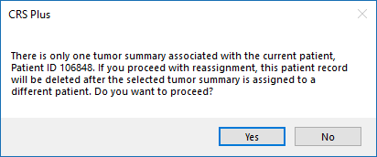

CRS Plus Tumor Summary Restructuring Deleting Tumor Verification When Only Tumor Associated with Patient
If No is selected, restructuring will not be completed. If Yes is selected, the tumor will be re-assigned to the specified patient. The complete case outline in the Current Patient section will refresh and the tumor assigned to the new patient will display in the New Patient section. If the original patient had only one associated tumor, the original patient record will be deleted and the tumor will be assigned to the new patient.
NOTE: Sequence Number Central assignment is not automatically updated since automated Sequence Number logic does not run for Update Case Structure. Sequence Number Central assignment will need to be completed manually using the Tumor Summary Restructuring option to Change Sequence of Tumor.

Void abstract
- Select the Abstract to be voided from the complete case outline so the abstract is highlighted.
- Select Void Abstract in Abstract Restructuring Options.
- Click on Apply.
- A message similar to the following will appear:
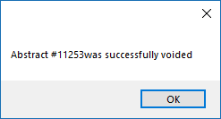

CRS Plus Abstract Restructuring Abstract Voided Confirmation
- Click on OK.
- The complete case outline in the Current Patient section will refresh and the voided abstract will no longer display in the case outline. The abstract can be retrieved from the Void option under the Patients/Abstracts menu if needed.

Send to pending
- Select the Abstract to be sent to pending from the complete case outline so the abstract is highlighted.
- Select Send to Pending in Abstract Restructuring Options.
- Click on Apply.
- A message similar to the following will appear:
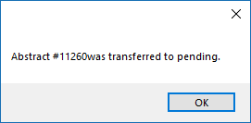

CRS Plus Abstract Restructuring Abstract Transferred to Pending Confirmation
- Click on OK.
- The complete case outline in the Current Patient section will refresh and the abstract sent to pending will no longer display in the case outline. The abstract will be available in Pending to be processed appropriately.

assign abstract to a different tumor summary
While this restructuring option is not recommended since manual consolidation would be needed, the option is available to assign an abstract from one tumor to another tumor for the same patient or to assign an abstract from one patient to a different patient and tumor.
NOTE: Automated consolidation does not run when this option is used to restructure records in the database.
- Select the Abstract from the complete case outline so the abstract is highlighted.
- Select Assign Abstract to a Different Tumor Summary in Abstract Restructuring Options.
- Enter the PatientID for the patient record and the Sequence Number for the Tumor the abstract will be assigned to.
- Click on Apply.
- The following message may appear if there is only one abstract attached to the selected tumor.
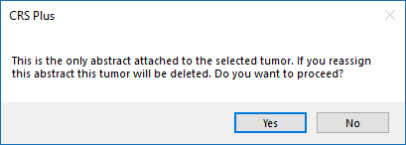

CRS Plus Abstract Restructuring Deleting Tumor Verification When Only Abstract Attached to Selected Tumor
If No is selected, restructuring will not be completed. If Yes is selected, the abstract will be assigned to the specified patient and tumor. The complete case outline in the Current Patient section will refresh and the abstract assigned to the new tumor will display in the New Patient section under the assigned tumor. If the original patient had only one tumor and abstract attached, the patient and tumor will be deleted and the abstract will be assigned to the new patient and tumor.
NOTE: Sequence Number Central assignment is not automatically updated since automated Sequence Number logic does not run for Update Case Structure. Sequence Number Central assignment will need to be completed manually using the Tumor Summary Restructuring option to Change Sequence of Tumor.

Flag for Release of Records/Unusual Follow-Up Method
Records can be flagged in batches in Prep Plus for designating records received from interstate data exchange as well as records received from VA or DOD facilities so the data is not released when it is the only available source. The flags are carried over from Prep Plus into CRS Plus and populated in the Unusual Follow-Up Method (FupUnusual) data item which is a user-defined NAACCR data item. The Registry Plus User’s Group defined the code values and definitions for use in Registry Plus software to indicate whether or not records could be released. HIPAA flags are also included so individual records can be flagged as no release in CRS Plus (i.e. at a patient’s request).

The following code values and definitions for the Unusual Follow-Up Method data item have been adopted by the Registry Plus User’s Group:

Code Value | Description
00 | OK to release
01 | No release - Out of state
02 | No release – HIPAA
03 | No release - HIPAA and Out of state
04 | No release – VA
05 | No release - VA and Out of state
06 | No release - HIPAA and VA
07 | No release - HIPAA and Out of state and VA
08 | No release-Department of Defense (DOD)
09 | No release-DOD and Out of state
10 | No release-DOD and HIPAA
11 | No release-DOD and HIPAA and Out of state
12 | No release-DOD and VA
13 | No release-DOD and VA and Out of state
14 | No release-DOD and HIPAA and VA
15 | No release-DOD and HIPAA and Out of state and VA

Consolidation Directives for Unusual Follow-Up Method:
Manual review required if Unusual Follow-Up Method = 00 (OK to release) on any abstract and 02, 03,06, 07, 10, 11, 14, or 15 (prior HIPAA request) on any other abstract; otherwise select 02 over any other value; otherwise eliminate 01,04, or 08 if any other value = 03, 06, or 10; otherwise if any value = 03 and any other value = 06 update with 07; otherwise eliminate 01, 04, 05, 08, 09, 12, or 13 if any other value = 00; otherwise if any value = 01 and any other value = 04 update with 05;
otherwise if any value = 01 and any other value = 08, update with 09;
otherwise if any value = 03 and any other value = 08, update with 11;
otherwise if any value = 04 and any other value = 08, update with 12;
otherwise if any value = 05 and any other value = 08, update with 13;
otherwise if any value = 06 and any other value = 08, update with 14;
otherwise if any value = 07 and any other value = 08, update with 15;
otherwise if any value = 09 and any other value = 12, update with 13;
otherwise if any value = 10 and any other value = 12, update with 14;
otherwise if any value = 09 and any other value = 10, update with 11;
otherwise if any value = 03 and any other value = 09, update with 11;
otherwise if any value = 03 and any other value = 10, update with 11;
otherwise if any value = 06 and any other value = 09, update with 15;
otherwise if any value = 06 and any other value = 10, update with 14

Instructions to Manually Update Unusual Follow-Up Method:
The only time Unusual Follow-Up Method will require manual intervention is when one abstract (usually the pending record) contains a value = 0 and any other abstract contains a value = 2, 3 or 6. Since code 0 indicates the record may be released and codes 2, 3 and 6 indicate a prior no-release request from the patient, it is imperative that the Unusual Follow-Up Method codes on all tumor records and all abstracts associated with the patient be updated to ensure removal of all codes = 0. The following steps should be taken:

- Document the PatientID and the AbsRefID of the abstract containing 0 in Unusual Follow-Up Method – this information will be needed to update the abstract in the last step.
- Enter code 2 for Unusual Follow-Up Method for the consolidated value.
- Complete processing the record until it is disposed from Pending.
- From the main toolbar, select Patients/Abstracts then Find. The Search window will open.
- Enter the PatientID Number.
- Change the Unusual Follow-up Method value to code 2 on any abstracts containing a value of 0.
Unless processing pending records and following manual instructions listed above, codes for Unusual Follow-Up Method should not be changed.

