Draft Data Flow Specifications for Processing Clinical Document Architecture (CDA) Documents within Registry Plus eMaRC Plus

Overview
The Clinical Document Architecture (CDA) is a markup standard developed by the organization Health Level 7 International (HL7) to define the structure of clinical documents such as discharge summaries and progress notes. CDA is based on XML, the Extensible Markup Language. The CDA uses HL7’s Reference Information Model, the goal of which is to put data in a clinical or administrative context, to define how pieces of data are associated, and to take advantage of coding systems such as Systematized Nomenclature of Medicine -- Clinical Terms (SNOMED CT) and Logical Observation Identifiers Names and Codes (LOINC).
CDA enables the creation of patient records that can be read by any electronic medical record (EMR) or electronic health record (EHR) software system. CDA is a flexible standard and is unique in that it can be read by the human eye or computer processed.
The Centers for Disease Control and Prevention, National Program of Cancer Registries Registry Plus suite of software includes an application called Electronic Mapping, Reporting, and Coding (eMaRC) Plus. eMaRC Plus has been in use in the cancer registration community for years to process pathology reports received in the HL7 Version 2.x file format, identifying reportable cancer records and mapping from the HL7 message format and codes to the North American Association of Central Cancer Registries (NAACCR) Volume II Data Dictionary record layout and codes.
Presently, functionality is being added to eMaRC Plus to enable the processing of physician reports generated by the EHR and received by the cancer registry in CDA document format, and mapping from the CDA data elements and codes to the NAACCR record layout and codes. The purpose of this document is to present a proposed outline of the data flow and steps for the processing of CDA documents in eMaRC Plus to the cancer registration community and receive feedback.

Glossary of Terms/Abbreviations
Cancer CDA Record: The NAACCR Physician Reporting workgroup-specified Clinical Document Architecture document reported by the physician EHR to the central cancer registry. CDA is an XML document that consists of a header and a structured body. It is presented in this format: Header – includes patient information, author, creation date, document type, provider, etc. Body – includes diagnosis, patient details, medications, procedures, follow-up, etc.. Information can be presented as free text in one or multiple sections, and also includes coded entries.
Major Components of a CDA Document:
- A CDA document has a Header and a Body.
- A CDA document Body is comprised of Sections.
- A CDA Section contains one Narrative Block and zero to many Entries.
  - [1..1] Header
  - [1..1] Body
- [1..*] Sections
    - [1..1] Narrative block
    - [0..*] Entries
Example of CDA XML Format Structure:
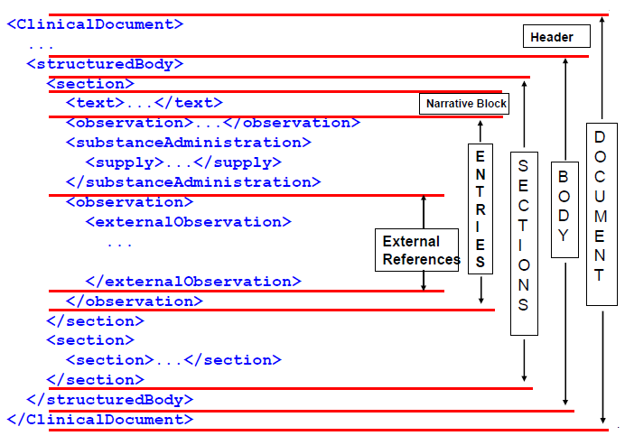

Section Record: A set of related data elements populated from the CDA document grouped by the various sections of the CDA document.
Section Table: The eMaRC Plus database location where section records are stored. There will be a section table for each set of related data elements, e.g., Demographic, Address, Payer, Social History, Cancer Diagnosis, Problems, Procedures, Results, Medications, etc.
CDA Document ID: A unique number assigned by the reporting entity that uniquely identifies the CDA document.
CDA Data Element Name: The name of the field in the CDA document.
CDA Cancer Diagnosis Entry: the component of the CDA document that contains the information about the patient’s cancer: Diagnosis date, site, laterality histology, etc).
NAACCR Data Item Name: The name of the mapped data item in the current NAACCR Standards for Cancer Registries, Volume II, Data Standards and Data Dictionary Record Layout. The NAACCR Data Item Number follows the Data Item Name in brackets, e.g., Date of Birth [#240].
Mapping: Transferring a data element in the CDA document as-is to a NAACCR data item in the NAACCR Record Layout.
Translating: Converting a data element value in the CDA document to the appropriate value NAACCR data item value via translation tables and/or algorithms.
NAACCR Abstract Values: Coded values and textual information resulting from of a combination of mapping and translating to, and defaulting of coded NAACCR data items and text fields from the Section Records (generated from the CDA document) using NAACCR coding conventions.
Abstract Reference Identifier (AbsRefID): A permanent unique identifier assigned to each NAACCR abstract generated by eMaRC Plus from imported CDA documents.
Facility Abstracts Table: The eMaRC Plus database location where mapped, translated, and defaulted NAACCR data item coded values and text fields are stored for each Section record generated by eMaRC Plus from imported CDA documents.
Processing Log: Document generated that includes warning messages and details pertinent to the mapping/translation process. Registries may choose to review this log and make corrections in eMaRC Plus or address any identified issues within the central registry software.
Multiple Record Management: Process by which information included in multiple CDA records received by the central cancer registry from the same reporting entity for the same patient and tumor will be automatically processed in eMaRC Plus. Although manual review of certain records may be suggested by information included in the Processing Log; no manual intervention will be required in eMaRC Plus (registries may choose to address identified issues in the central registry software).
Consolidated Abstract Values: Using the Multiple Record Management process (see Section 2), eMaRC Plus will automatically generate consolidated coded values/text from multiple NAACCR Abstract Values mapped from the same reporting entity for the same patient and tumor. The best Consolidated Value will be automatically determined on a data item by data item basis for all NAACCR data items to be consolidated across all Abstract Values mapped/translated from all CDA documents received. Consolidation is an on-going process as new reports are received.
Patient/Tumor/Reporting Entity Identifier (PTRID): A permanent unique identifier assigned to all abstract entries in the Facility and Consolidated abstracts tables for CDA records received from the same reporting entity for the same patient and tumor.
Consolidated Abstracts Table: The eMaRC Plus database location where consolidated NAACCR abstract values from multiple abstract values mapped from the same reporting entity for the same patient and tumor are stored.
NAACCR Abstract: An abstract in standard NAACCR file format generated upon export of initially reported or consolidated abstracts out of eMaRC Plus:
Initially Reported Abstract: The abstract mapped from the first CDA report received from a reporting entity for a specific patient and tumor. eMaRC Plus will automatically generate Initially Reported Abstracts upon export from eMaRC Plus when specified by the user.
Consolidated Abstract: The abstract that is the culmination of the Multiple Record Management process (see Section 2). eMaRC Plus will automatically generate Consolidated Abstracts upon export from eMaRC Plus when specified by the user.

Technical Specifications
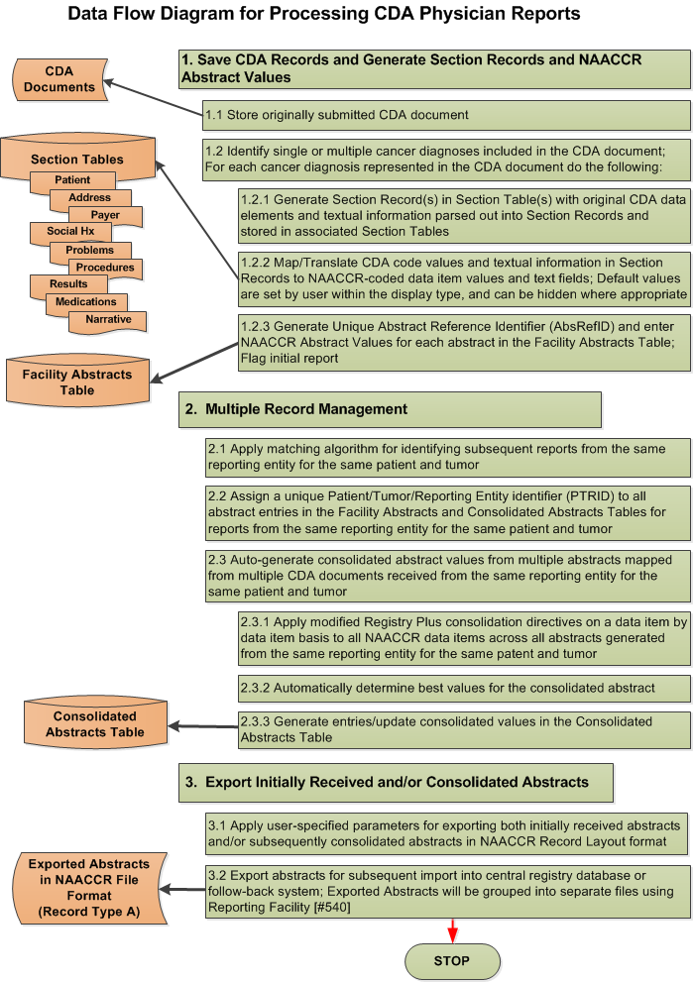

Data Flow Detailed Description
- Save CDA Records and Generate Section Records and NAACCR Abstract Values
  - Store originally submitted CDA document
All validation of CDA structure, content, codes systems will be performed using the Validation Tool prior to processing a CDA document within eMaRC Plus. An archived copy of the CDA document as originally submitted will be stored as a blob in a table in the eMaRC Plus database. eMaRC Plus provides functionality to archive and/or purge these documents as they accumulate over time.
  - Identify single or multiple cancer diagnoses included in the CDA document; For each cancer diagnosis represented in the CDA document do the following:
    - Generate Section Record(s) in Section Table(s) with original CDA information parsed out into Section Records and stored in associated Section Tables
For each Cancer Diagnosis Entry in the CDA document CDA data elements will be parsed out and Section Records will be generated which are stored in the appropriate Section Tables.
Section Record Tables store the data elements (or groups of related elements such as address) as individual rows. Section Tables include the data element, identifiers, value, code, code system, and other supporting information about the data element. They will all be linked to the same CDA document through the Document ID.
Section Records include the CDA information to be mapped and translated as well as supplemental information that has no associated NAACCR data item, such as medication Name and Route of Administration. Separate rows are inserted into a table for elements that are repeated in the CDA document so that historical information is retained. For example, if multiple addresses for a patient are provided in a single CDA report, each address will create a separate row in the Address Section Table. Other examples include occupation and industry.
If multiple cancer diagnoses exist within the CDA record, multiple Section Records will be generated. In the event that the CDA document includes multiple cancer Diagnosis Entries but does not provide any method of linkage between each Cancer Diagnosis Entry and data in other sections, then all data elements will be repeated in each Section Record generated.
    - Map/Translate CDA code values and textual information to NAACCR-coded data item values and text fields; Default values are set by user within the display type, and can be hidden where appropriate
eMaRC Plus parses out individual data elements and textual information from each CDA document and maps each element to a corresponding NAACCR data item and/or text field when one exists. If a central registry wants to map supplemental information in the CDA document to a non-standard data item, this data item will be defined as a state-specific data item in the State/Requestor area of the NAACCR record layout [#2220]. Each State-specific data item must be assigned a NAACCR Data Item Number in the range of 9550-9999, assigned to a columnar position(s) within the State/Requestor area (positions 2340 – 3339), and assigned a unique data item name.
To minimize the onus on the cancer registry of receiving the new physician CDA reporting source data stream, all mapping has been fully automated; no manual review of mapped information is required within eMaRC Plus. Mapping, translating, and defaulting of NAACCR data item values and text fields from the CDA document is accomplished using the mapping logic, translation tables, and recommended user-specified default values developed by the Physician Reporting Workgroup. This information is available in the Mapping and Translation Excel spreadsheet along with various Mapping Rules Word documents for specific data items with extensive mapping rules or algorithms on the NAACCR website at: http://www.naaccr.org/MeaningfulUsePRMappingDocs.aspx.
All new and updated documents will be posted to this URL as the documentation evolves.
    - Generate Unique Abstract Reference Identifier (AbsRefID) and enter NAACCR abstract values for each abstract in the Facility Abstracts Table; Flag initial report
All NAACCR Abstract Values for individual NAACCR abstract entries will be generated from the Section Records containing mapped, translated, or defaulted NAACCR Values and entered in the Facility Abstracts Table for each Cancer Diagnosis Entry with a unique AbsRefID assigned.
When a CDA document has more than one Cancer Diagnosis Entry, eMaRC Plus will create a separate abstract entry in the Facility Abstracts Table for each cancer diagnosis. Due to the fact that linkage and coding of procedures, treatment, and results for each of the multiple cancer diagnoses could possibly be incorrect and may warrant manual review (either within eMaRC Plus or the central registry software), eMaRC Plus will write a warning message to the Processing Log to indicate that multiple abstracts have been created representing the Multiple Cancer Diagnosis Entries .
It is quite possible that multiple CDA reports may be received from the same reporting entity for the same patient and tumor. eMaRC Plus assigns the abstract mapped from the first CDA report received a special “Initial Report” status code, enabling the registry to export the initial report, which may not be complete, for the purposes of Rapid Case Ascertainment (RCA), follow-back, etc.. A more complete consolidated abstract may be exported at a later date if desired (see Multiple Record Management, Section 2).
- Multiple Record Management
  - Apply matching algorithm for identifying subsequent reports from the same reporting entity for the same patient and tumor
After receiving an initial CDA document for a patient and tumor from a particular reporting entity, eMaRC Plus will include a matching algorithm to identify and link any subsequent reports from that same facility for that patient and tumor. The matching algorithm will be applied to the following mapped NAACCR Data Item Values:
Medical Record Number [#2300] (patient identifier from the physician office), Date of Birth [#240], Social Security Number [#2320], Primary Site [#400], Behavior [#523], Histologic Type [#522], Laterality [#410], Diagnosis Date [#390], and Reporting Facility ID [#540].
The matching of tumor information will be accomplished using the TLC Plus logic utilized in the Registry Plus CRS Plus application, which is currently being enhanced to include automatic identification of the same tumor using the SEER Multiple Primary and Histology (MPH) rules. In the enhanced version, the set of directives (or “rules”) that apply to a specific set of site/type combinations is called a rule set. At this time, we anticipate preparing rules sets to correspond to the following categories used in the SEER MPH rules: Head and Neck, Colon, Lung, Cutaneous Melanoma, Breast, Kidney, Renal Pelvis, Ureter, Bladder, and Other Urinary, Malignant Meninges, Brain, Spinal Cord, Cranial Nerves, Pituitary Gland, Craniopharyngeal Duct and Pineal Gland [Malignant Brain], Benign and Borderline Intracranial and CNS Tumors [Benign Brain], and Other sites.
Rule sets are being developed that will utilize the Site Pairs table, the generic HistoPairs table, any rule-set specific pairs (e.g., for Colon, pairs with a histology code indicating a polyp are handled differently than for other rule sets), as well as the time interval between dates of diagnosis. The majority of MPH rules will be incorporated as time and resources allow.
In the meantime, a tumor will be deemed a match if all 4 characters of the ICD-O-3 Topography code, Behavior, Histologic Type, Laterality, and Diagnosis Date (within one month) are a match. This will result in a conservative approach which may generate separate abstract entries in the Facility Abstracts Table for subsequent reports received for the same patient and tumor from the same reporting entity. However, as the reports being linked are from the same reporting entity for the same patient and tumor, it is unlikely that these values will vary on subsequent reports with great frequency. Until the Enhanced MPH Tumor Linkage algorithms are developed and implemented in eMaRC Plus, it is anticipated that erroneously separated reports can be consolidated in the central registry software.
  - Assign a unique Patient/Tumor/Reporting Entity identifier (PTRID) to all abstract entries in the Facility Abstracts and Consolidated Abstracts Tables for reports from the same reporting entity for the same patient and tumor
When the matching algorithm identifies any subsequent reports from the same facility for the same patient and tumor, a permanent unique Patient/Tumor/Reporting Entity identifier (PTRID) will be assigned to the initial abstract entry and all abstract entries based upon subsequent reports in the Facility Abstracts Table as well as the consolidated abstract entry in the Consolidated Abstracts Table.
  - Auto-generate consolidated abstract values from multiple abstracts mapped from multiple CDA documents received from the same reporting entity for the same patient and tumor
    - Apply modified Registry Plus consolidation directives on a data item by data item basis to all NAACCR data items across all abstracts generated from the same reporting entity for the same patent and tumor
The Registry Plus Central Registry Software (CRS Plus) has an extensive interface to answer the question, given multiple reports on the same patient and tumor, what is the best value for each data item to be stored in a consolidated record for the patient and for the tumor?
To complete data item consolidation, CRS Plus applies consolidation directives or automated “rules” for each data item. Consolidation directives define how data from two or more linked records are evaluated to select a final "best" value for each data item in the consolidated record. Consolidation compares values from the incoming record and all historical abstracts for the patient or tumor (the consolidated value is not utilized). The order of the directives can be customized by the user to suit the needs of the registry.
Directives may be used alone or in sequence to define an automated consolidation rule for each field. In CRS Plus, sequenced directives are applied in user-defined order until a consolidation decision is reached (only one value remains) or all directives are exhausted. When a string of directives is completed with no single value remaining, the record is placed in the CRS Plus pending file for manual review. However, the failure of a single field does not halt the consolidation process. All fields proceed through the consolidation process with an outcome of a selected consolidated data value or manual review.
Modified consolidation directives have been developed for eMaRC Plus that address 2 factors: 1) all abstract values to be consolidated will be reported by the same facility, and 2) all directives will successfully consolidate data items so that no manual review is required.
To illustrate a successful consolidation directive requiring no manual review, the consolidation rule for Social Security Number [#2320] (SSN) is to select a known value over unknown, otherwise select the value occurring most frequently, otherwise select the value from the abstract with the most recent patient contact. This consolidation rule appears in directive form as: ‘KnownOverUnknown;MostFrequent;MostRecent’. The following example illustrate how the consolidated SSN value is selected through the application of these directives:
AbsRefID SocSecNum DateLastContact
00000012 123456789 01/14/2013
00000301 987654321 01/15/2013 00000459 999999999 01/15/2013
00001010 123456789 01/24/2013
00002330 987654321 02/15/2013
Selected Value: 987654321
(99999999 eliminated as unknown value. Since 123456789 and 987654321 both occur twice, the value from abstract 00002330 is automatically selected based on the most recent Date of Last Contact).
    - Automatically determine best values for the consolidated abstract
As stated above, all consolidation directives for data items to be consolidated across multiple abstract entries in the Facility Abstracts Table will be modified so that no manual review is ever required and all consolidation will occur automatically.
    - Generate entries/update Consolidated Abstract Values in the Consolidated Abstracts Table
As subsequent CDA documents are received for the same patient and tumor from the same reporting facility, the Consolidated Abstract Values in the Consolidated Abstracts Table will be continually and automatically updated with any new or revised information in the Abstract Values generated from the subsequent reports.
Section 2 Summary: This Multiple Record Management process along with highly-specific abstract export options (see Section 3) will accommodate registries that carry out RCA, or intend to follow-back on the initial report received, and/or allow the registry to wait a user-specified time period prior to exporting a single, consolidated (assumedly more complete) abstract.
- Export Initially Received and/or Consolidated Abstracts
  - Apply user-specified parameters for exporting both initially received abstracts and/or subsequently consolidated abstracts in NAACCR Record Layout format
Below is a draft of the eMaRC Plus CDA module Export Abstracts window (descriptions of all export options follow the screenshot):

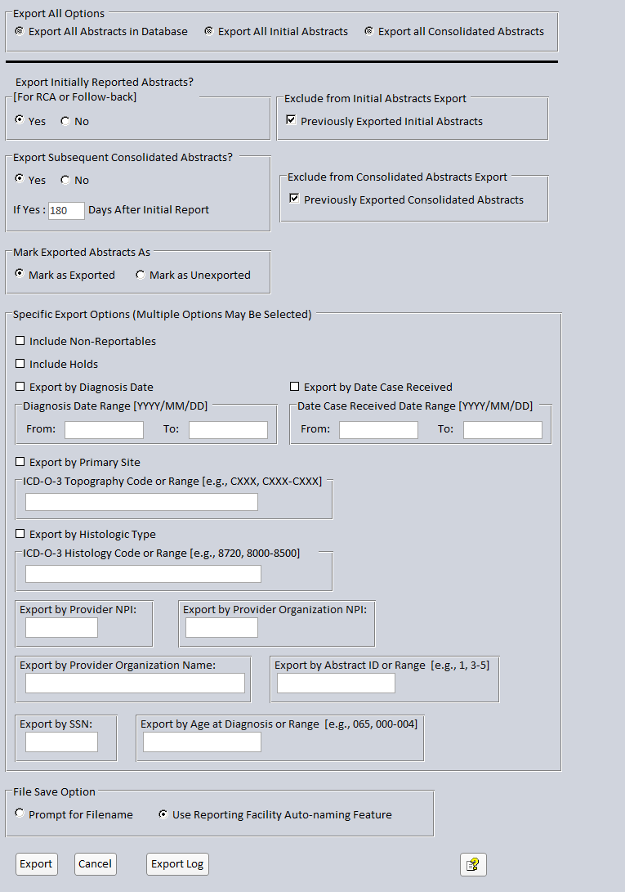
When exporting abstracts, you can choose to export all abstracts in the abstracts database, including both initially received and consolidated abstracts, export all initial abstracts, and export all consolidated abstracts. Registries may want to utilize the Export All options if, for example, they would like to perform a linkage with their central registry database.
You can modify the default options selected on the export window to export only the specific abstracts that you would like to export.

The export options that are selected by default (Export Initially Reported Abstracts; Exclude Previously Exported Initial Abstracts and Export Subsequent Consolidated Abstracts; Exclude Previously exported Consolidated Abstracts, as well as Mark Exported Abstracts as Exported) would allow a registry that performs RCA to export all un-exported abstracts to-date (both RCA and more complete consolidated reports) at the press of a single button, and will prevent re-export of previously exported abstracts, thus preventing reporting of unwanted duplicate abstracts to the central registry. Recall that the initially reported abstract is assigned a special “Initial Report” status code and is stored in the Facility Abstracts Table and is treated as a separate entity from the consolidated abstract residing in the Consolidated Abstracts Table.
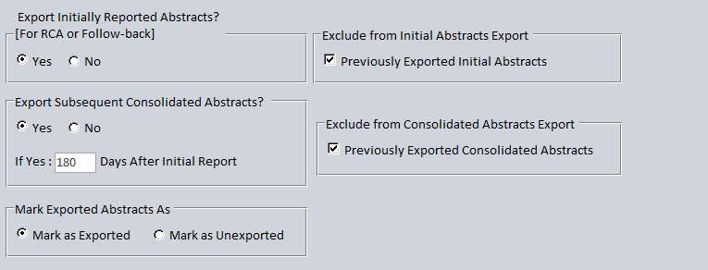
The Export Abstracts window allows for highly-specific export of abstracts, and includes the following options for exporting abstracts:
Export Option | Description
Export All Options  (mutually exclusive, only one of these options can be selected; when using any of the Export All options abstracts will not be marked as exported and no other export options can be applied) | Export All Abstracts in Database: When selected, this option will over-ride any other export option, and all abstracts in the database (both initial and consolidated) will be exported in a single export file regardless of prior export status
 | Export All Initial Abstracts: When selected, this option will over-ride any other export option, and all initially reported abstracts in the database will be exported in a single export file regardless of prior export status
 | Export All Consolidated Abstracts: When selected, this option will over-ride any other export option, and all consolidated abstracts in the database will be exported in a single export file regardless of prior export status
Export Initially Reported Abstracts? [For RCA or Follow-back] | Yes/No option for exporting initially received abstracts (for Rapid Case Ascertainment or Follow-back efforts)
Exclude from Initial Abstracts Export | When the Previously Exported Initial Abstracts option is checked along with the Yes option for Export Initially Reported Abstracts, all initial abstracts that have not yet been exported will be exported, and will prevent re-export of previously exported initial abstracts
Export Subsequent Consolidated Abstracts?  If Yes, XX Days After Initial Report | Yes/No option for exporting consolidated abstracts; if Yes is selected, the user can specify the number of days to wait after the initial report was received, so that the registry could let reports come in and be auto-consolidated and then have the consolidated abstract automatically exported after the specified number of days, e.g., the usual length of time for treatment to be completed
Exclude from Consolidated Abstracts Export | When the Previously Exported Consolidated Abstracts option is checked along with the Yes option for Subsequent Consolidated Abstracts, all consolidated abstracts that have not yet been exported will be exported, and will prevent re-export of previously exported consolidated abstracts
Mark Exported Abstracts as Exported/Unexported | When the Mark as Exported option is selected, all exported abstracts will be marked as exported--this prevents duplicate export of abstracts; When the Mark as Unexported option is selected, all exported abstracts will not be marked as exported
Specific Export Options | Include Non-Reportables: When this option is checked, the abstract export will include abstracts that have been marked as non-reportable
Specific Export Options | Include Holds: When this option is checked, the abstract export will include abstracts that have been manually held
Specific Export Options | Export by Diagnosis Date: This option allows the user to enter a date range to export abstracts by the diagnosis date of the tumors reported in the abstracts
Specific Export Options | Export by Date Case Received: This option allows the user to enter a date range to export abstracts received within a specified date range
Specific Export Options | Export by Primary Site: This option allows the user to enter a ICD-O-3 Topography code or range of codes to export abstracts having the specified primary site(s)
Specific Export Options | Export by Histologic Type: This option allows the user to enter a ICD-O-3 Histology code or range of codes to export abstracts having the specified histology (ies)
Specific Export Options | Export by Provider NPI: This option allows the user to enter a specific Provider NPI number to export abstracts received from that provider
Specific Export Options | Export by Provider Organization NPI: This option allows the user to enter a specific Provider Organization NPI number to export abstracts received from that organization
Specific Export Options | Export by Provider Organization Name: This option allows the user to enter a specific Provider Organization Name to export abstracts received from that organization
Specific Export Options | Export by Abstract ID or Range: This option allows the user to enter a specific AbsRefID or range of AbsRefIDs to export specific abstracts
Specific Export Options | Export by SSN: This option allows the user to enter a specific Social Security Number to export abstracts received for a specific patient
Specific Export Options | Export by Age at Diagnosis or Range: This option allows the user to enter a specific Age at Diagnosis or range of ages to export abstracts received for patients of specific ages (e.g., pediatric cases)
File Save Option | Prompt for Filename: When selected the user is prompted to enter a specific filename for the generated file of exported abstracts  Use Reporting Facility Auto-naming Feature: When selected eMaRC Plus automatically names the files using the naming convention of xxxxxxxxxx_yy.dat, where the x’s represent the reporting facility ID, and the y’s represent a sequential number assigned to each file of abstracts exported for that facility (e.g., 1111111111_11.dat)
  - Export abstracts for subsequent import into central registry database or follow-back system; Exported Abstracts will be grouped into separate files using Reporting Facility [#540]
Regardless of any of the Specific Export Options selected (excluding the Export All Options) all abstracts exported out of the eMaRC Plus CDA module are in the NAACCR Record Type A format and are grouped into separate files by the mapped Reporting Facility ID. Users can utilize the File Save Option to specify whether or not they would like to manually enter a filename for each exported file of abstracts or if they would like eMaRC Plus to automatically name each exported file of abstracts using the Reporting Facility ID.
Please note: Currently the only export of data from eMaRC Plus that is supported by a user interface is the export of NAACCR abstracts in the NAACCR Record Layout. As a result, extraction of original CDA information stored in Section Records and Tables can be achieved by querying the eMaRC Plus database. A relational key exists in each table/record that that can be used to link the various tables, as shown below. A more detailed relational flow will be generated when table definitions have been finalized
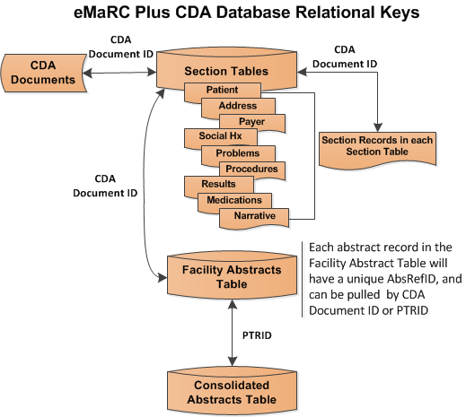
A separate interface for directly querying the database may be considered for a future release.

