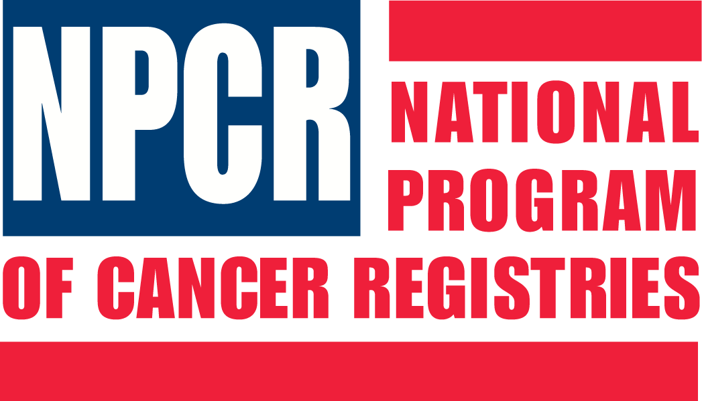
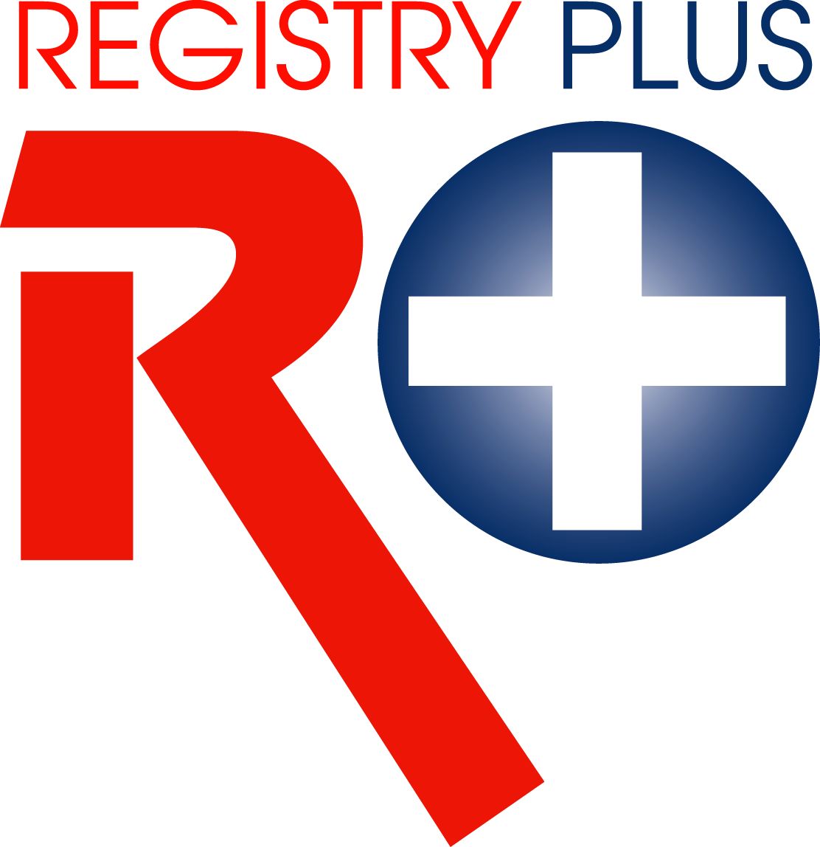
Link Plus
Application Overview & User Training
Central Oklahoma Cancer Center
Southwest INTEGRIS Medical Center
September 11, 2007

AGENDA

1:00-1:05 Welcome and Introductions
1:05-1:30 Record Linkage Concepts
1:30-2:05 Overview of Link Plus Application
& Linkage Process
2:05-3:20 External Linkage Exercise
3:20-3:35 Break
3:35-4:25 Deduplication Linkage Exercise
4:25-4:30 Evaluation & Wrap up questions

