

National Program of Cancer Registries


Registry Plus Software for Cancer Registries

Web Plus Training Manual
for Central Registry Administrators
Version 1.0
(Based on Web Plus Version 1.0)



Contents
Chapter 1: Introduction 1
Overall Learning Objectives 1
Overview of the Web Plus Central Registry Administrator Training Manual 1
Web Plus Features 1
Users 2
Requirements for Web Access 2
Chapter 2: The Basics 3
Learning Objectives 3
Overview 3
Log In 3
Central Registry Administrator Menu Options 4
Log Out 5
Questions 6
Chapter 3: Web Plus Configuration 7
Learning Objectives 7
Overview 7
Selecting System Preferences 7
Creating a Display Type 12
Adding a New Display Type 12
Copying a Display Type 13
Five Steps for Building a Display Type 15
Step 1: Select Fields 16
Adding Section Headings 16
Creating a New Section Heading 17
Deleting a Section Heading 17
Adding Fields 17
Buttons on Manage Display Type Pages 18
Assigning Property Values to Individual Fields 18
Assigning Other Property Values 20
Activity – Adding Properties to Display Type Fields 20
Printing Copy of Display Type Fields 20
Step 2: Select Critical Fields 21
Step 3: Select Edit Sets 22
Step 4: Select Individual Edit Options 23
Step 5: Select Collaborative Staging Preference 25
Questions 26
Activity – Adding Fields to a Display Type 26
Activity – Adding a Heading and Fields 27
Deleting a Display Type 27
Web Plus Version Information 27
Chapter 4: Managing Facilities and Users 28
Learning Objectives 28
Overview 28
Managing Facilities 28
Adding a Facility 28
Editing a Facility Record 30
Activity – Creating a Facility Record 31
Deleting a Facility Record 31
Managing User Accounts 32
Adding Users 32
Editing a User Account 35
Activity – Create a User Account 36
Deleting a User Account 37
Reset Password 37
Locking Out Users 38
Current User Activities 38
Viewing Current User Activities 39
Clear Log Status 40
Questions 41
Activity – Create a New Facility and User and Unlock an Account 41
Viewing the New Display Type 41
Creating a Central Registry User 43
Chapter 5: Managing Abstracts 45
Learning Objectives 45
Overview 45
Assigning Abstracts for Review 45
Reassigning an Abstract 47
Finding and Viewing an Abstract 48
Exporting Abstracts 51
Questions 51
Chapter 6: Bundle Submissions 52
Learning Objectives 52
Overview 52
Viewing List of Abstracts and Edit Report for a Bundle File 52
Deleting an Abstract Bundle File 56
Exporting Bundled Submissions 56
Chapter 7: Reports 57
Learning Objective 57
Overview 57
Opening Central Registry Reports 57
Changing the Date Range of a Report 60
Opening Facility Reports 60
Cases Submitted Sorted by Abstractor Report 61
Cases Accessed Sorted by Patient Name Report 62
Descriptive Statistics on Released Cases Report 64
Activity Report 68
Questions 69
Appendix A: Answers 70

Introduction

Overall Learning Objectives
These are the overall learning objectives for this Web Plus training manual for central registry administrators:
- Learn the major functions of the administrator role within Web Plus
- Configure system preferences, display types, and edit sets
- Manage facilities
- Manage user accounts
- Assign abstracts to central registry staff
- View information regarding bundled files (file uploads)
- Generate and view Web Plus reports

Overview of the Web Plus Central Registry Administrator Training Manual
The Web Plus Central Registry Administrator Training Manual provides you with the information to understand and use this web application. This manual describes the functions available to the Web Plus administrator of a central cancer registry. The major sections include setting system preferences, configuring display types for use by facilities, generating and maintaining facility records and user accounts, managing the assignment of abstracts to central registry abstractors, and viewing central and facility-level reports. Also, each chapter contains questions that test your knowledge of Web Plus and activities that allow you to practice your new skills on your own.

Web Plus Features
Web Plus is a web-based application that collects cancer data securely over the public Internet. It is ideal for use by central registries for reporting from physicians’ offices, low volume facilities, non-hospital reporting sources, and for followback efforts.
Records are saved in a database at the hosting central cancer registry and cases entered by one facility or office are not visible to other facilities. Data entered are validated by the CDC EDITS Engine running on a web server. Users display types and edit configurations are managed at the hosting central registry.
Web Plus is hosted on a secure web server that has a digital certificate installed; the communication between the client and the server is encrypted with Secure Socket Layer (SSL) technology.

Users
The results from the design staff and usability testing have identified these types of Web Plus users:

Users | Description
Facility Abstractor | Works in a local facility or doctor’s office and handles patients’ medical records and paperwork. When a patient is diagnosed with cancer, the facility abstractor reports the case to the state’s central cancer registry.
Central Registry Abstractor/Reviewer | Reviews abstracts submitted to the central registry for completeness and accuracy and may abstract additional data items from submitted text; also abstracts new cases.
Central Registry Administrator | Sets up the local facilities with access to the Web Plus software to report their data, manages facility accounts and users at both central registry and facilities, configures display types, edit sets and system preferences, manages assignment of abstracts to central registry staff, exports data and views reports.
Local Administrator | Manages local users of a facility.
File Uploader | Uploads files of abstracts in the appropriate NAACCR format that were not abstracted using Web Plus, views EDITS error report and cleans, or works with abstractors to clean, errors on rejected files prior to re-uploading.

Requirements for Web Access
Web Plus requires Microsoft Internet Explorer version 5.0 or later or a Mozilla browser to operate the system fully. Although Web Plus works at 800 X 600 resolution, it can be best viewed at 1024 X 768 or higher resolution. . It is highly recommended that you change your resolution to 1024 X 768 or higher when using the Web Plus application.

The Basics

Learning Objectives
In this chapter, you will learn to:
- Identify Web Plus menu options
- Log in and log out

Overview
This chapter covers the basics of the Web Plus central registry administrator role. It includes a description of the Web Plus menu options available to the central registry administrator, and the means of logging in and logging out of Web Plus.

Log In
To log in, complete these steps:
- Open your Internet Explorer browser and type your registry’s Web Plus web address (URL) in the Address field.
- Press Enter.
Result: The Web Plus main Log in page is displayed
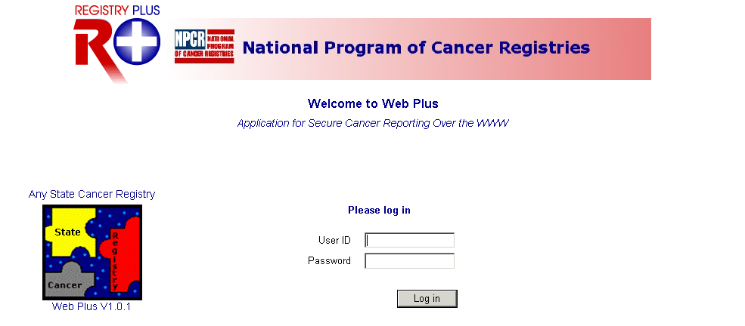
- Type in your administrator User ID and password into the User ID and Password fields, or use the User ID of administrator, and the password of admin.
- Click Log in.
Result: The Web Plus Administrator home page opens.

Central Registry Administrator Menu Options
After you log in, the Web Plus central registry administrator home page is displayed:
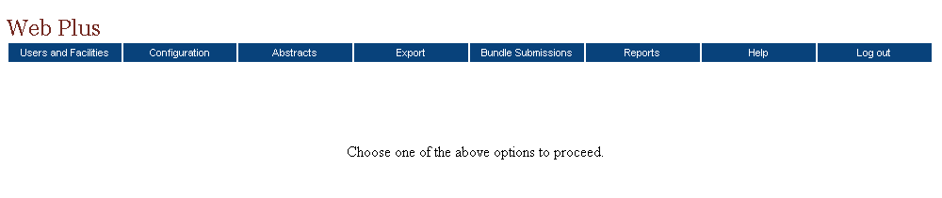

From this page you can access the main menu options of Web Plus. Click on a menu option to open the page for the option. The below table describes the menu options on the home page, and provides a page reference within this manual for more information about the menu option:

Menu option | Sub-option |  | Opens web page to . . . | Refer to page . . .
Users and Facilities | Manage Facilities |  | add, change, or delete facilities | 29
Users and Facilities | Manage Users |  | add, change, or delete users and reset passwords | 33
Users and Facilities | Lock/Unlock Users |  | control access to system | 39
Users and Facilities | Current User Activities |  | monitor user actions | 40
Configuration | Manage Display Types |  | create a new display type, or update, copy, rename or delete existing display types | 11
Configuration | Manage System Preferences |  | specify hosting registry and contact information, and set user account security and password preferences, logging preferences, and edits preferences for uploaded files | 6
Abstracts | Assign Released Abstracts |  | assign released abstracts to central registry abstractor/reviewers for review | 47
Abstracts | View/Change Assignments |  | view abstract assignments or reassign abstracts to another central registry abstractor/reviewer | 49
Abstracts | Find Abstracts |  | search for released abstracts | 51
Export |  |  | view reminder that the Web Plus Administration Tool is used to export abstracts and bundle submissions from Web Plus for incorporation into the central registry | 54
Bundle Submissions |  |  | view a listing of abstracts and EDITS error report for each uploaded bundled file, or delete bundles | 55
Reports |  |  | view central registry reports and facility reports | 61
Help |  | About | Opens a page with the Web Plus, NAACCR, and Collaborative Staging Algorithm Version information | 28
Log out |  |  | log out of Web Plus and open the Log in page | 4

Log Out
To log out of Web Plus, click Log out on the Home page menu.
Result: The system logs you out of Web Plus, and the Log in page opens.

Questions

Answer these questions about the basics of Web Plus (the answers are in Appendix A, page 75):

- Which menu option opens the page where you can add user accounts?

- How do you log out?

- Which menu option do you use to begin creating a display type?

Web Plus Configuration

Learning Objectives
In this chapter you learn:
- How to set system preferences
- What a display type is
- About the five main steps used to build a display type
- How to select fields and section headings
- How to set field properties for individual data items
- How to select an edit set and edit options
- How to set Collaborative Staging calculation preferences

Overview
In this chapter you learn how to configure the Web Plus application, including how to set system preferences and to create display types. A display type is basically the user interface where the abstractor will enter the data, and consists of an ordered subset of standard NAACCR and local data items collected by your central registry, an edit set with associated options specified, and Collaborative Staging calculation preferences.

Selecting System Preferences
On the System Preference page, you can set the parameters for the Web Plus that users will have.
To set system preferences, complete these steps:

- On the Web Plus menu, point to Configuration, then click Manage System Preferences.
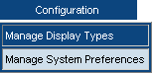
Result: The Manage System Preferences page opens.

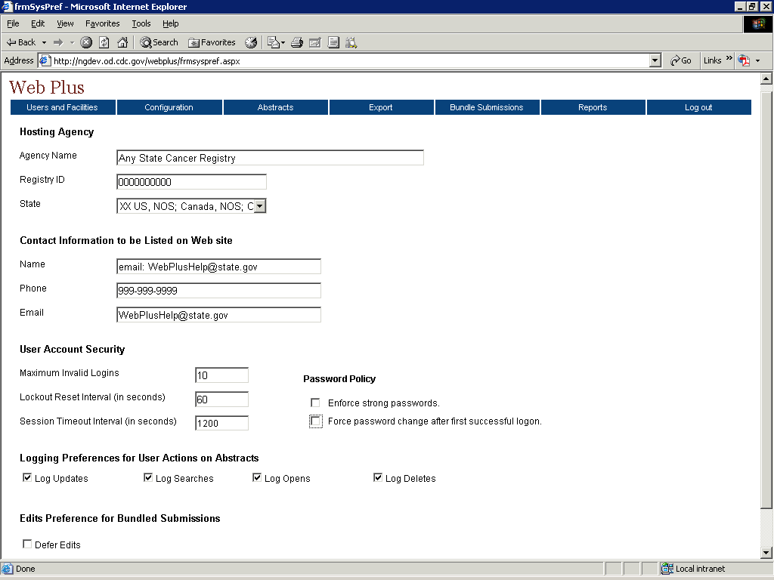
The Manage System Preferences page contains these fields:
Section | Field | Description
Hosting Agency | Agency Name | Name of the state central cancer registry as it will appear within the facility abstractor and file uploader pages of the Web Plus application (at the top right-hand corner of every page) and in report titles
Hosting Agency | Registry ID | A unique code that identifies the central cancer registry
Hosting Agency | State | State of the hosting registry
Contact Information | Name | The text entered into this field will be displayed as an e-mail link at the top of each of the facility abstractor and file uploader pages of the Web Plus application.  This link is available for the user to click when having difficulties or questions (the actual e-mail address to be used is entered in the E-mail field below).
Contact Information | Phone | Enter a phone number for your state registry’s Web Plus technical contact
Contact Information | E-mail | E-mail address of your state registry’s Web Plus technical contact
User Account  Security | Maximum Invalid Logins | Number of times a user can attempt to log in with an incorrect user name or password
User Account  Security | Lockout Reset Interval | The amount of time in seconds that a user will be locked out of the system until administrator restores access to user
User Account  Security | Session Timeout Interval | The amount of time in seconds that a session can last without user activity
Password Policy | Enforce Strong Passwords | This option will place restrictions on user passwords; by default this option requires users to enter passwords that are between 8 to 20 characters, contain at least one digit and one alphabetic character, and must not contain any special characters
Password Policy | Force Password Change After First Successful Logon | This option will force a user to change his password after his account has been created, or his password is reset by the administrator, and he logs onto Web Plus using the new password for the first time
Logging Preferences | Log Updates | These options indicate whether updates to, searches for, opening of, or deletion of an abstract should be recorded in the database
Logging Preferences | Log Searches
Logging Preferences | Log Opens
Logging Preferences | Log Deletes
Edits Preference for Bundled Submissions | Defer Edits | Select this option to prevent Web Plus from editing the abstracts in a bundled file when it is uploaded from a facility
- Under Hosting Agency:
- In the Agency Name field, enter the name of your central cancer registry as you would like it to appear within the facility abstractor and file uploader pages of the Web Plus application (at the top right-hand corner of every page) and in various report titles.
- In the Registry ID field enter the Registry ID number for your central registry. This number can be found in the REDID.DBF table in Appendix B of the NAACCR Volume II: Data Standards and Data Dictionary.
- In the State field enter the state of your registry.
- Under Contact Information to be Listed on Web Site:
- In the Name field, enter the text you would like displayed as an e-mail link at the top of each page of the facility abstractor and file uploader pages of the Web Plus application. This could be an e-mail address, a name, or some other label. This link is available for the user to click when having difficulties or questions (the actual e-mail address to be used is entered in the E-mail field below).
- In the Phone and Email fields, enter a phone number and e-mail address for your state registry’s Web Plus technical contact.
- Under User Account Security:
- In the Maximum Invalid Logins field, enter the number of incorrect log in attempts (incorrect user name or password) you would like to allow a user before the system locks them out.
- In the Lockout Reset Interval field, enter the amount of time (in seconds) that you would like a user to be locked out of the system until their access is restored. The user will be locked out for specified number of seconds if he has exceeded the allowed limit for number of invalid logins. After the specified reset interval, the user can once again attempt to logon to the system.
The Web Plus administrator can override the specified reset interval for locked out users and can let them back into the system earlier.
- In the Session Timeout Interval field, enter the amount of time (in seconds) that you would like to allow a user session to be inactive before the system locks the user out.
- Under Password Policy:
  - Click on the Enforce Strong Passwords check box if you would like to place restrictions on the passwords that users can generate for themselves.
Result: The Build/View Regular Expression button appears.
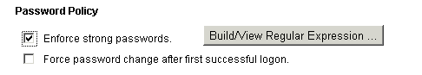
This button is invisible if “Enforce strong password” is not checked.
By default the Enforce strong passwords option requires users to enter passwords that are 8 to 20 characters in length, contain at least one digit and one alphabetic character, and must not contain any special characters. A regular expression (Regex) specifies what types of passwords are acceptable.
- Click on the Build/View Regular Expression button.
Result: The Password Regular Expression Builder box opens.
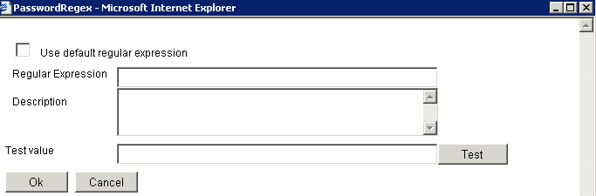
- Click on the Use default regular expression check box.
Result: The default regular expression appears, along with a description of its function.
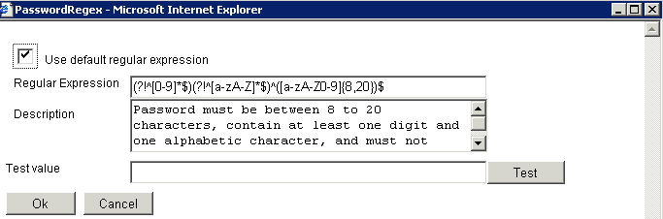

You can implement other or additional password restrictions by editing the regular expression. Always be sure to test any new expression entered to make sure it is functioning properly.
 | If you are not very comfortable writing regular expressions it is recommended that you do not make any change to the default value.
- Click the Ok button if you would like to use the Enforce strong passwords option with the default regular expression, or the Cancel button if you do not want to use any password restrictions.
Result: You are returned to the Manage System Preferences page.
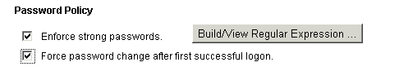
 | If you leave both options unchecked there will be no restriction on passwords. For increased security it is highly recommended that you check both the options.
- Under Logging Preferences:
  - Click the check boxes of the logging preferences of your choice. Until you get used to using your Web Plus system, it is recommended that you click all of these options for now.
- Under Edits Preference for Bundled Submissions:
  - Click the Defer Edits check box only if you would like no edits to be applied to files of abstracts submitted via the file uploader pages of the Web Plus application. Unless you have a large file or heavy upload conditions, it is recommended that you leave this check box unchecked, and administer edits on uploaded files using your display types.
If you click the Defer Edits option, you can still run edits on uploaded files using the Web Plus Administration Tool.
- Click Save.
Result: A confirmation message appears on the System Preference page.
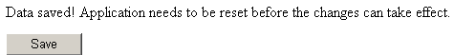
The application can be reset by the web server administrator.
The change of certain system preferences, such as Logging options, and some options under User Account Security do not take effect until the application is restarted. However, changes to system preferences such as contact information and edits preferences will take effect immediately, and do not require resetting of the application.

Creating a Display Type
You can create different display types for different facilities and types of cancer reporters. Abstracts are entered and edited using the display type and edit set assigned to the facility where they are abstracted. To generate a display type, you first create it and then go through five main steps to build the display type:
- Select Fields
- Select Critical Fields
- Select Edit Set
- Select Individual Edit Options
- Select Collaborative Staging Preference.
You can create a display type in one of two ways. You can start from scratch by adding a new display type or you can copy an existing display type and revise it. Either way you create a display type, you can customize it for your own needs.

Adding a New Display Type
One way to create a display type is to add a new one.
To add a new display type, complete these steps:
- Log in to Web Plus. For details, see “Log In,” page 2.
Result: The Web Plus home page opens.
- On the Web Plus menu, point to Configuration, then click Manage Display Types.
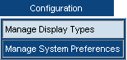
Result: The Manage Display Types page opens.
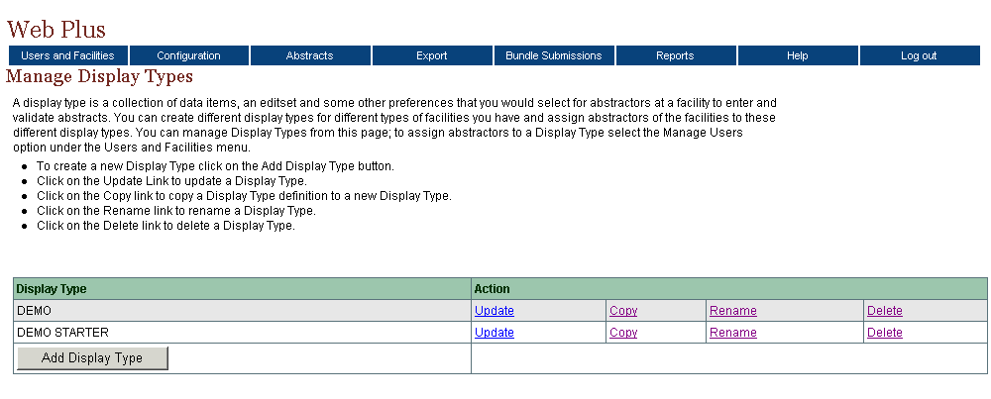
- On the bottom left of the page, click Add Display Type.
Result: The Add Display Type window opens.
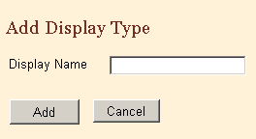
- In the Display Name field, type MD Office. (The field has 12-character limit.)
- Click Add.
Result: The new display type named MD Office is added to the display type list.
To continue building a display type, click Update on the Manage Display Type page to open the update pages. You add fields to this display type in “Activity – Adding Fields to a Display Type 26.

Copying a Display Type
Another way to create a new display type is to copy an existing display type and revise it to meet your needs.
To create a display by copying, complete these steps:
- Log in Web Plus. For details, see “Log In,” page 2.
Result: The Web Plus home page opens.
- On the Web Plus menu, point to Configuration, then click Manage Display Types.
Result: The Manage Display Types page opens.
- Find the Demo Starter display type and click Copy.
Result: The Copy Display Type window opens.
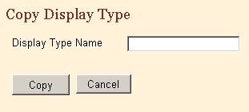
- In the Display Type Name field, type Test Display for the new display type, and then click Copy.
Result: The window closes and Manage Display Type page opens with the TEST DISPLAY display type added to the list.

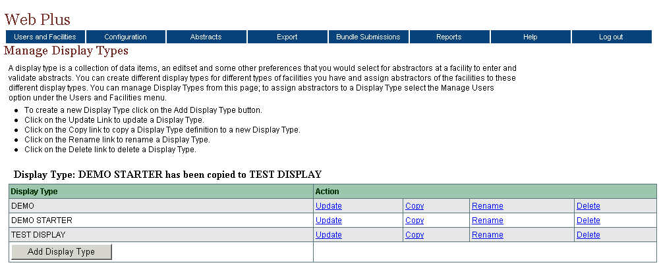
To continue creating a display type, see “Step 1: Select Fields,” page 15.

Five Steps for Building a Display Type
After you have created a display type, there are five steps you will need to go through to build the display type. You do not have to use the options in all five steps. When you click Update on the Manage Display Types page, the system opens the first of a series of update pages that take you through the five main steps to build the display type. This table describes the update pages:
In this step . . . | You select the . . .
- Select Fields | fields that are used in your display type, set properties for individual fields, and group fields into sections if desired.
- Select Critical Fields | fields that must contain information to complete an abstract (required fields).
- Select Edit Set | edit set for your display type (determines how the system edits the abstracted data), and set edit set execution options.
- Select Individual Edit Options | edit set execution options for individual edits, over-riding the options selected for the edit set.
- Select Collaborative Staging Preference | Collaborative Staging calculation options.

When setting up a display type for a file uploader, the only step necessary is Step 3 – Select an Edit Set. It is NOT necessary to select fields, or set critical fields, individual edit options or Collaborative Staging preference. When files are uploaded, the edit set is the only object drawn upon from the display type assigned to the facility of the file uploader.

Step 1: Select Fields
After adding a new, or copying an existing, display type to create a new display type, you modify your display type. The first step is to select section headings and fields for your display type. Section headings, such as Hospital Specific and Demographic, can vary, and are used to organize the fields for clearer viewing and to facilitate data entry by the abstractor.
To add section headings and fields:
- On the Web Plus menu, point to Configuration, then click Manage Display Types.
Result: The Manage Display Types page opens.
- On the Test Display row, click Update.
Result: The Select Fields page opens.
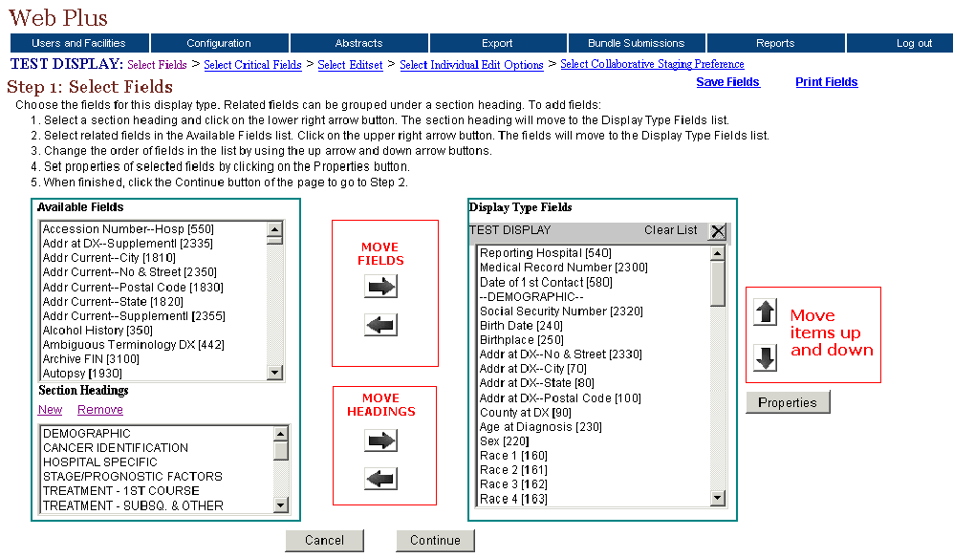
On this page you select the fields for which you want the abstractor to supply information, and group the fields into sections if desired. Using the left and right arrow buttons, you move the fields and section headings from the lists on the left to the list on the right to include them in the display type you are creating. You can use the up and down arrow buttons to re-order the fields once you have added them.

Adding Section Headings
Section headings are added to a display type to organize the fields in the display type into logical groups of related fields.
- In the Section Headings list, select HOSPITAL SPECIFIC.
- Click the lower right arrow to move the heading into the display type.
Result: The section heading moves to the Display Type Fields list.
- In the Display Type field list, select HOSPITAL SPECIFIC and click the up arrow to move the heading to the first position on the list.

Creating a New Section Heading
To create a new section heading, complete these steps:
- On the Select Fields page under Section Headings, click New.
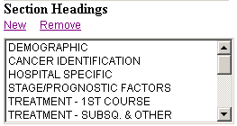
Result: The Add Display Section window opens.
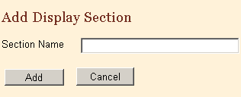
- In the Section Name field, type Miscellaneous.
- Click Add.
Result: The Add Display Section window closes and the system displays the section heading in the Section Headings list.

Deleting a Section Heading
To delete a section heading, complete these steps:
- On the Select Fields page under Section Headings, select Miscellaneous.
- Click Remove.
Result: The Delete Section window opens.
- Click Delete.
Result: The system deletes the section heading from the list.

Adding Fields
After adding section headings to the Display Type Fields lists, add the fields.
- In the Display Type Fields list, select DEMOGRAPHIC.
When you move the available fields into the display type, the system places the fields under the section heading or field that you have selected in the Display Type Field list. If you have not selected a section heading or field then the system places the fields at the bottom of the Display Type Field list.
- In the Available Fields list, select these fields:
- Name–Last
- Name–First
- Name–Middle
Selecting  Fields | To select one field, click the name of the field.  To select a group of fields together, click the first field, press and hold the SHIFT key, and then click the last field in the group.  To select multiple fields that are not in order, press and hold the CTRL key and click each field
- Click the right arrow beside the Available Fields list and move the selected fields to the Display Type Fields list.
- In the Display Type field list, select Name–Last and click the up arrow to move the field to the first position under the heading.
- Click the Save Fields link located in the upper right-hand corner of the screen.
You can save updates to the fields either by clicking Save Fields or the Continue button, which saves updates and opens the next page, Step 2, Select Critical Fields.

Buttons on Manage Display Type Pages
These are the buttons are on the pages that build the display types:
Click this button . . . | To . . .
Back | Open the previous step page; for example, from Step 2 to Step 1
Cancel | Open (return to) the Manage Display Type page
Continue | Save information on the current page and open the next step page

Assigning Property Values to Individual Fields
On the Select Fields page, you can also assign special properties to individual fields. To assign property values to a field, complete these steps:
- In the Display Type Fields list, locate and select the NAACCR Record Version field.
- Click the Properties button.
Result: The Properties window opens.
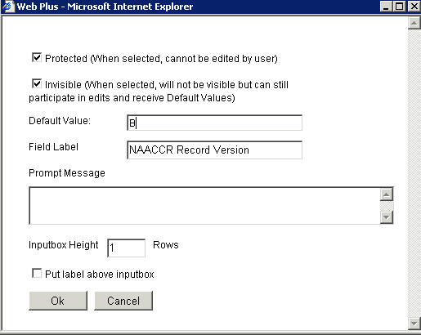
These are the fields in the Properties window:
Property | Description
Protected | When check box is checked, value of field cannot be edited by user.
Invisible | When check box is checked, the field is not visible to user, but the defaulted value is edited and transmitted with the abstract.
Default Value | Value that is initially displayed in the field.
Field Label | User-specified label for the field  Note: Try to restrict the label to 17 characters. At 18 characters the label “wraps” to the next line. Use the Put label above the input box property for longer titles (see below).
Prompt Message | Information entered for the Prompt Message property appears in a text box that pops up when the abstractor places the cursor in the field; for example, a reminder regarding the format of a date field entry.
Inputbox Height | Sets the height of data entry input box for the field in rows. The default value is 1. You may want to change it to a higher value for text fields.
Put label above inputbox | When check box is checked, the label for the field is placed above the input box for the field, rather than to the left of the field. This option is generally used for long field labels, and labels for text fields.
- Click the Protected check box.
- Click the Invisible check box.
- In the Default Value field, type B, for NAACCR Record Version 11.
- Click OK.
Result: The Properties window closes and the system saves the properties.

Assigning Other Property Values
To assign other property values to other fields, complete these steps:
- In the Display Type Fields list, select Social Security Number.
- Click Properties.
- In the Field Label box, type Social Security Number. This is an example of a long label that will wrap-around when you view this display type.
- Click OK.
Result: The system saves the property and closes the window.
- In the Display Type Fields list, select Addr at DX–No. & St.
- Click Properties.
- In the Field Label box, type Address at Diagnosis, Street Address.
- Select the check box for Put label above inputbox.
- Click OK.
Result: The system saves the property and closes the window.
- Click Save Fields.

Activity – Adding Properties to Display Type Fields
In this activity, you add properties for the fields for your display type.
- Add this prompt message to the properties for Text–DxProc–PE:
Please be concise and include all relevant information.
- For the field, RX Text–Other, add the Input Height of 5.
- Click Save Fields.
For each field, select the field and click Properties. Set the desired properties and click OK.

To continue configuring the display type, go to , page 20.

Printing Copy of Display Type Fields
To print a copy of the display type fields, follow these steps:
- On the Select Fields page, click Print Fields.
Result: A separate window opens with a printable report listing the display fields you have selected, along with select properties that were set.
The window contains these column headings:
Column | Description
Field | Default name of field
Label | User-specified name for field
Default value | The initial value in a field
Protected | Value of field cannot be edited by user
Invisible | Value of field is not visible to user but the value is edited
- Print this copy using your browser’s printer.

Step 2: Select Critical Fields
Critical fields, or required fields, are fields that must contain information in order to complete and release an abstract. In step 2, the system displays the fields that you selected in the first step in the Available Fields list. To designate a field as critical, move an available field to the Critical Fields list. Critical fields are indicated to the abstractor within the display type with an asterisk (*) to the right of the field label.
To designate critical fields, complete these steps:
- On the Web Plus menu, point to Configuration, then click Manage Display Types.
Result: The Manage Display Types page opens.
- Click Update for the display type Test Display.
Result: The Select Fields page opens with the links to all selection steps.
- Click the Select Critical Fields link.

Result: The Select Critical Fields page opens.
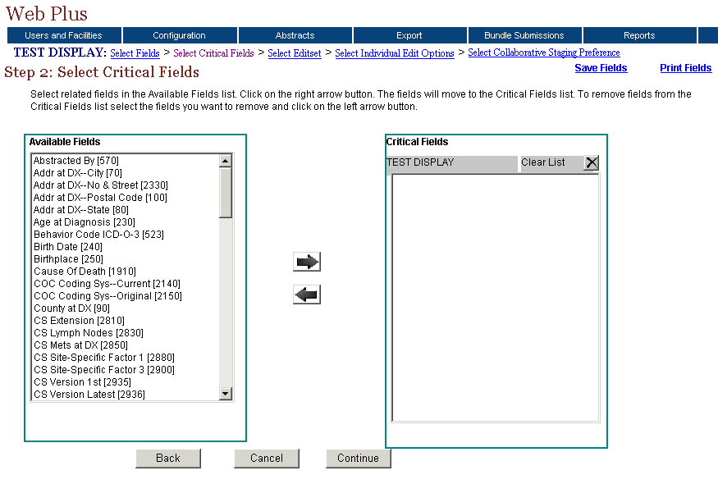
- Select the following fields and move them to the Critical Fields list by clicking the right arrow .
- Name–Last
- Addr at DX–Postal Code
- Text–Histology Title
- Text–Primary Site Title
- Text–DX Proc–Op
- Click Continue.
You can also save your work by clicking the Save Fields link to retain your updates.
Click the Clear Fields button to remove all fields from the Critical Fields list.

Step 3: Select Edit Sets
In this step, you choose the edit set for your display type. To ensure that the information contained within an abstract makes sense and codes are coded correctly, both individually and in relation to one another, data quality "Edits" are applied to each abstract as it is saved.
An edit set contains a collection of individual edits. If there are errors when an abstract is saved, the Web Plus application displays those errors so the abstractor can correct them. An abstract can not be completed and released to the central registry until all errors have been resolved.
To select an edit set, complete these steps:
- The Select Edit Set page should already be opened because you clicked Continue in the previous step. If the page is not open, click the Select Editset link
Result: The Select Edit Set page opens.
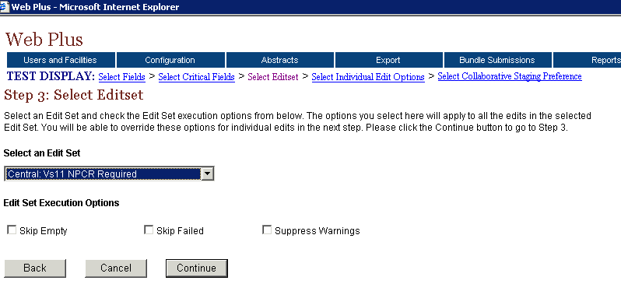
- From the Select an Edit Set drop-down list, select this edit set:
Central: Vs11 NPCR Required
In addition to selecting an edit set, you may choose to set certain global Edit Set Execution Options. These are the Edit Set Execution Options on the Select Edit Set page:
Option | Description
Skip Empty | Prevents an edit from running if any of the fields that it edits are blank.
Skip Failed | Prevents a multi-field edit from executing if any field in its list has failed its single field edit.
Suppress Warnings | Prevents the return of warning messages by converting the return value to pass.
- Click Continue.
Result: The system saves the edit set selection and opens the next step page.

Step 4: Select Individual Edit Options
In this step, for any individual edit in the set you can over-ride the edit set execution options chosen in step 3 for the entire edit set. You would select individual edit options when an available edit set meets your needs with the exception of a few edits. When you choose the individual edit options, you override the edit set options. The setting of individual edit options requires a thorough understanding of the edit set itself.
To select individual edit options, follow these steps:
- The Select Individual Edit Options page should already be opened because you clicked Continue in the previous step. If it is not open, click the Select Individual Edit Options link.
Result: The Select Individual Edit Options page opens.
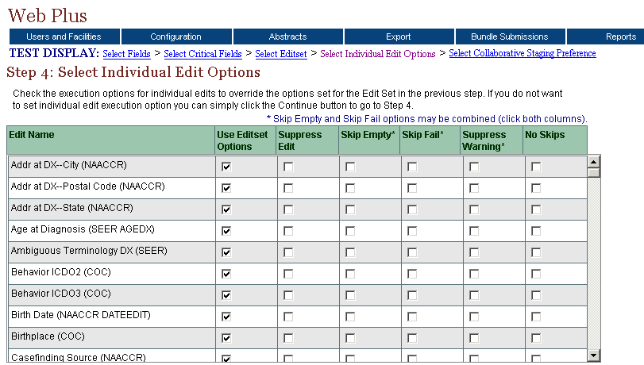
The Select Individual Edit Options page includes these options:
Option | Description
Suppress Edit | Prevents the individual edit from executing when the edit set is run upon saving an abstract.
Skip Empty | Prevents the individual edit from executing if any of the fields that it edits are blank.
Skip Fail | Prevents an individual multi-field edit from executing if any field in its list has failed its single field edit.
Suppress Warning | Prevents the return of any warning messages by the edit.
No Skips | Edit runs for the field, over-riding any Skip Empty or Skip Fail options that may be set for the edit set

To select any of the individual edit options, locate the edit for which you would like to set options, and click the check box in the columns of the desired options. Note that the Skip Empty and Skip Fail options may be combined for an edit by clicking the check boxes in both columns.
- Scroll the list of edits to see the edits included in the set, but don’t select any of the options.
Edit Sets | Before you select an edit set, you should be aware of all of the edits in the set and how they edit the data.  To get a detailed view of the edit set and individual edits, you must use the EditWriter software.  To quickly view the edits in an edit set, select the edit set in step 3, and view its contents in step 4.
- Click Continue.
Result: The system opens the next step page.

Step 5: Select Collaborative Staging Preference
The Web Plus application can calculate stage according to three separate systems: SEER Summary Stage 77, SEER Summary Stage 2000, and AJCC Stage Group. In step 5 you have the option to select among these three Collaborative Staging (CS) preferences. You can select a single or multiple staging systems, depending on what CS fields you are collecting, and what derived CS fields you would like to store in your central registry.

To select your Collaborative Staging preference, follow these steps:
- The Select Collaborative Staging Preference page should already be opened because you clicked Continue on the previous page. If it is not open, click the Select Collaborative Staging Preference link.
Result: The Select Collaborative Staging Preference page opens.
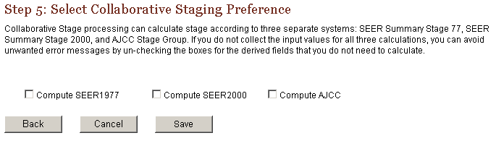
These are the staging preferences:
Process | Description
Compute SEER1977 | From the Collaborative Staging fields collected, the derived SEER Summary Stage 1977 is calculated
Compute SEER2000 | From the Collaborative Staging fields collected, the derived SEER Summary Stage 2000 is calculated
Compute AJCC | From the Collaborative Staging fields collected, the derived AJCC Stage Group fields are calculated
- Select Compute SEER2000.
- Click Save.
Result: The Manage Display Types page opens with a confirmation that the display type has been updated.
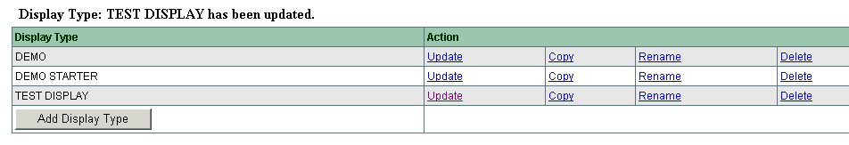

Questions
Answer these questions about configuring a display type (the answers are in Appendix A, 75):
- What is the difference between selecting an edit set and selecting individual edit options?
- How can you protect a field from being edited by an abstractor?
- What are the two ways to create a new display type?
- What are section headings?

Activity – Adding Fields to a Display Type
In this activity, you add and move the fields for your display type, MD Office (created in “Adding a New Display Type,” page 11). Complete these steps to add fields:
- Add these fields to the display type:

- Name–Prefix
- Name–Suffix
- Name–Spouse/Parent
- Social Security Number
- Telephone
- County at DX
- Race 1
- Sex
- Marital Status at DX

- Move the fields up and down until they are in this order:

- Name–Last
- Name–First
- Name–Middle
- Name–Maiden
- Name–Prefix
- Name–Suffix
- Name–Spouse/Parent
- Addr at DX–No. $ Street
- Addr at DX–City
- Addr at DX–Supplementl
- Addr at DX–State
- Addr At DX–Postal Code
- County at DX
- Social Security Number
- Telephone
- Race 1
- Sex
- Marital Status at DX
- Birth Date
- Birthplace

- Save your work.

Activity – Adding a Heading and Fields
In this activity you add a heading and more fields that relate to it.
Follow these steps:
- Add a heading, Cancer Identification, to the bottom of the Display Type list
- Under this heading, add these fields:
- Date of diagnosis
- Primary Site
- Laterality
- Histologic Type ICD-O-3
- Behavior Code ICD-O-3
- Save your work.

Deleting a Display Type
To delete display type, complete these steps:
- On the Web Plus menu, point to Configuration, then click Manage Display Types.
Result: The Manage Display Types page opens.
- Find MD Office, and on that row click Delete.
Result: The Delete Display window opens.
- Click Delete.
The Delete Display window closes and system displays a message on list for deletion.

Web Plus Version Information
To view Web Plus, NAACCR, and Collaborative Staging Algorithm Version information, complete these steps:
- On the Web Plus menu, point to Help.
- Click on About.
Result: A page opens with information about the version of the Web Plus application, and the NAACCR and Collaborative Staging Algorithm versions included in the Web Plus application.

Managing Facilities and Users

Learning Objectives
In this chapter you learn to:
- Manage facilities by adding, editing, and deleting facility records
- Manage user accounts by adding, editing, and deleting user accounts
- Reset user passwords
- Lock and unlock user accounts
- View the user activities log
- View a display type as a facility abstractor
- Create central registry users

Overview
This chapter covers the procedures to manage the facilities and users of your state registry Web Plus application. As an administrator, you can add, edit, and delete facilities and user accounts. In addition, you can reset passwords for individual users.

Managing Facilities
An administrator manages the records of facilities or offices from which users will generate and release abstracts and upload files. You can add, update, and delete facilities in Web Plus.

Adding a Facility
To add a facility, complete these steps:
- Log in to Web Plus. For details, see “Log In,” page 2.
Result: The Web Plus home page opens.
- On the Web Plus menu, point to Users and Facilities, then click Manage Facilities.
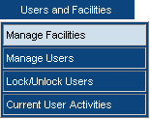

Result: The Manage Facilities page opens.
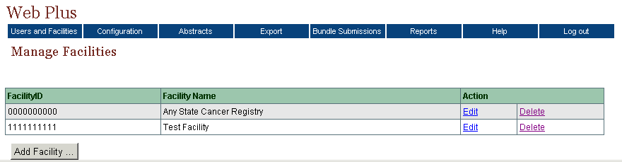
- Click Add Facility.
Result: The Add/Update Facility page opens.
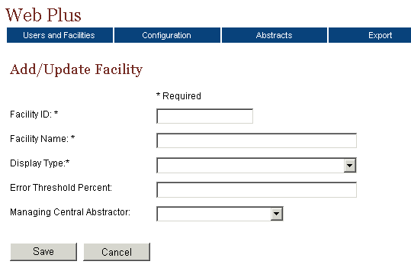
The Add/Update Facility page contains the following fields (fields marked with an asterisk (*) require information to be entered into them):
Field | Description
Facility ID | 10-digit identification number for the facility
Facility Name | Name of the facility or office
Display Type | Name of the display type assigned to the facility
Error Threshold Percent | Limit for the percentage of errors allowed in an uploaded file of abstracts
Managing Central Abstractor | The central registry abstractor/reviewer who will review the facility’s released abstracts

- Enter this information into these fields:
Field | Value
Facility ID | 9123456789
Facility Name | Doctors’ Clinic
Display Type | Test Display
- Click Save.
Clicking Cancel instead of save would close the Add Facility window and return you to the Manage Facilities page without saving any changes.
Result: Doctors’ Clinic is added to the facilities list on the Manage Facilities page.
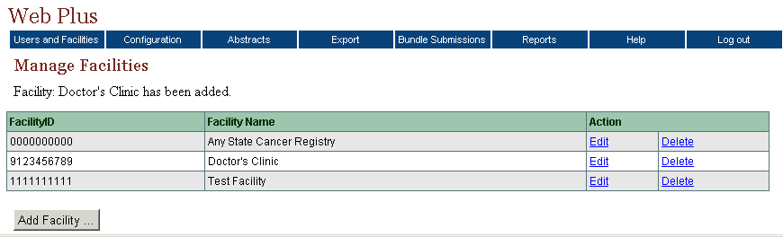

Editing a Facility Record
After creating a facility record, you can update the record.
To edit a facility record, complete these steps:
- On the Web Plus menu, point to Users and Facilities, then click Manage Facilities.
Result: The Manage Facilities page opens.
- On the Doctors’ Clinic row, click Edit.
Result: The Add/Update Facility page opens.
- In the Error Threshold Percent field, type 5.
- In the Managing Central Abstractor list, select Administrator.
- Click Save.
Result: The system saves the changes, closes the Add/Update Facility page, and returns to the Manage Facilities page.

Activity – Creating a Facility Record
Using the information in the following table, create a facility named New Hospital. Follow the steps in “Adding a Facility,” page 29, making sure you save your work.
Field | Value
Facility ID | 8912345678
Facility Name | New Hospital
Display Type | Demo Starter

Deleting a Facility Record
To delete a facility record, complete these steps:
- On the Web Plus menu, point to Users and Facilities, then click Manage Facilities.
Result: The Manage Facilities page opens.
- On the New Hospital row, click Delete.
Result: The Confirm Delete window opens.
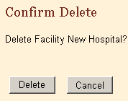
- Click Delete.
Result: The system removes the facility from the Facility list.
Click Cancel to close the Confirm Delete window and return to the Manage Facilities page without deleting a facility record.

Managing User Accounts
This section describes how an administrator can manage user accounts by adding, updating, and deleting user accounts in Web Plus.

Adding Users
To add a user, complete these steps:
- If you are not already, log in to Web Plus. For details, see “Log In,” page 2.
Result: The Web Plus home page opens.
- On the Web Plus menu, point to Users and Facilities, then click Manage Users.
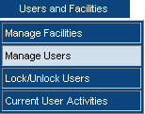
Result: The Manage Users page opens.
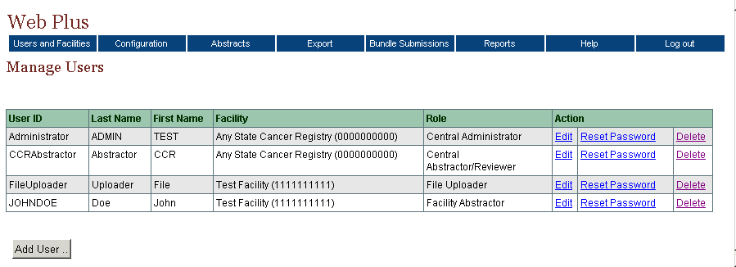
- Click Add User.
Result: The Add/Edit User Account page opens.

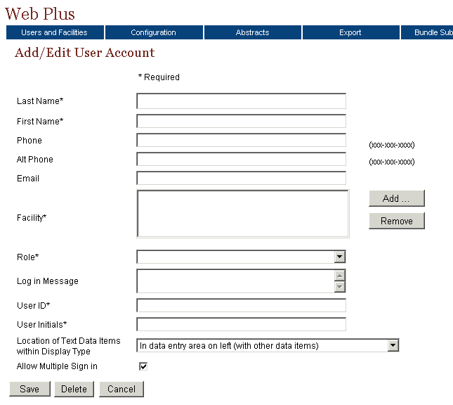
The User Account page contains these fields (you must fill in information for the name fields, Facility, Role, User ID, and User Initials):
Field | Description
Last Name | Last name of user
First Name | First name of user
Phone | Main phone number of user
Alt Phone | An alternate phone number of user
Email | Email address of user
Facility | The name of the user’s facility or office
Role | The Web Plus role of the user
Log in Message | Message displayed for the user at log in
User ID | The User ID of the user, containing at least five characters
User Initials | Initials of the user
Location of Text Data Items within Display Type | This field designates the location of Text data items within the Display Type when viewed by the user;  In data entry area on left (with other data items): Text data items will be located in the data entry area on the left side of the screen with the other data items; this view facilitates the abstraction of the text data items, and allows requirement of Text fields to be clearly seen by the user  Under Text Fields tab in box on right (with Edit Errors and Help tabs): Text data items will be located under a Text Fields tab in the box on the right side of the screen, with the Edit Errors and Help tabs; this view can help facilitate the review of coded values within released abstracts
Allow Multiple Sign in | Enables user to log in to Web Plus at more than one location at the same time
- Enter this information into these fields:
Field | Information
Last Name | Sullivan
First Name | Dorothy
Role | Facility Abstractor
User ID | dsullivan
User Initials | das
Location of Text Data Items within Display Type | In data entry area on left (with other data items)
- At the Facility field, click Add.
Result: The Select a Facility to Add window opens.
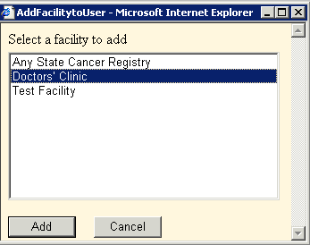
- Select Doctors’ Clinic and click Add.
Result: The facility is added to the user account.
The Select a Facility to Add window remains open so that you can add more than one facility to the user account.
To remove a facility for a user, select it and click Remove.
- Click Cancel to close the Add Facility to User window.
- On the Add/Edit User Account page, click Save.
Result: The system adds the new user to the list of users, and sends an e-mail to the user with the User ID and initial password.
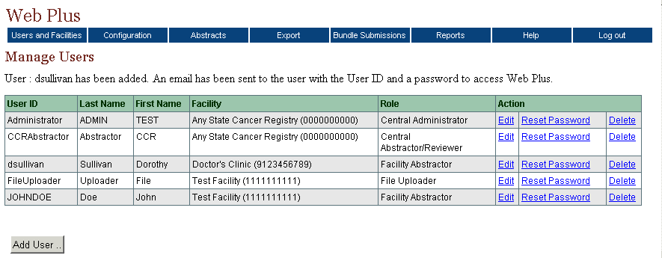
Click Cancel to close the Add/Edit User Account window and return to the Manage User Accounts page without saving any changes.

Editing a User Account
To change a user record, complete these steps:
- On the Web Plus menu, point to Users and Facilities, then click Manage Users.
Result: The Manage Users page opens.
- Find the row for Dorothy Sullivan and click the Edit link.
Result: The Add/Edit User Account page opens.

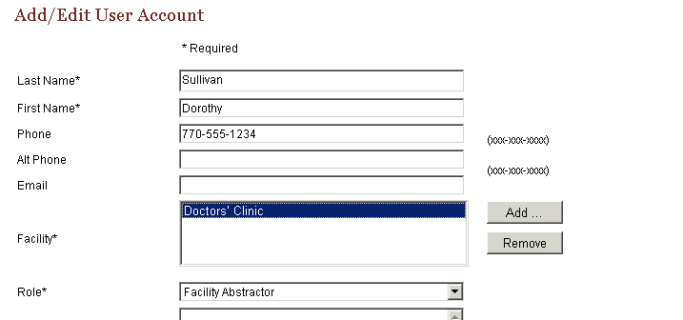
- In the Phone field, type 770-555-1234.
- In the Facility field, select Doctors’ Clinic and click Remove.
Result: The system removes the facility from the user account.
- Click Add.
Result: The Add Facility window opens.
- Select Test Facility and click Add.
Result: The system adds the new facility for the user.
- Close the Add Facility window.
- Click Save.
Result: On the Manage Users page, a message shows that the account has been updated.
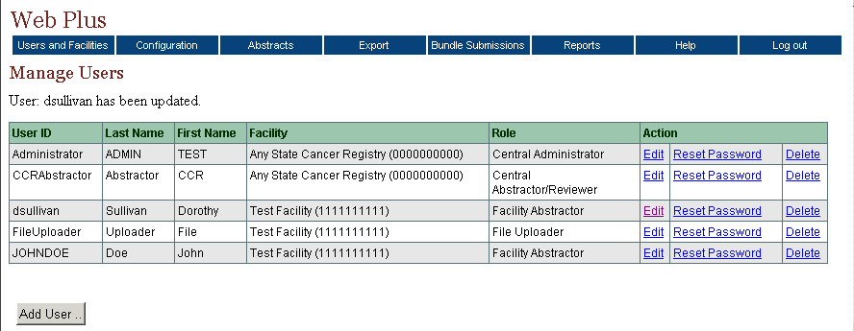

Activity – Create a User Account
Using the information in the following table, create and save a user account for a facility abstractor named Jennifer Davies. Follow the steps in “Adding Users,” page 33.
Field | Information
Role | Facility Abstractor
User ID | jdavies
User Initials | jrd

Deleting a User Account
To delete a user account, complete these steps:
- Log in to Web Plus. For details, see “Log In,” page 2.
Result: The Web Plus home page opens.
- On the Web Plus menu, point to Users and Facilities, then click Manage Users.
Result: The Manage Users page opens.
- Find Jennifer Davies on the users list and click Delete.
Result: The confirmation window opens.
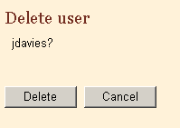
- Click Delete.
Result: The window closes and the system eliminates the user from the list.

Reset Password
The central registry administrator can reset the password for any user. To reset a user’s password, complete these steps:
- On the Web Plus menu, point to Users and Facilities, then click Manage Users.
Result: The Manage Users page opens.
- Find Dorothy Sullivan on the users list and click Reset Password.
Result: The Reset Password window opens.
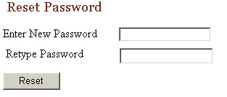
- Type Password1 into both fields.
- Click Reset. User’s password is reset.

Locking Out Users
An administrator can temporarily deny a user access to Web Plus. (To permanently deny access to user, an administrator can delete the user account. For the delete procedure, see page 38.)
To lock out a user from Web Plus, complete these steps:
- Log in to Web Plus. For details, see “Log In,” page 2.
Result: The Web Plus home page opens.
- On the Web Plus menu, point to Users and Facilities, then click Lock/Unlock Users.
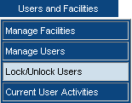
Result: The Lock/Unlock User Accounts window opens.
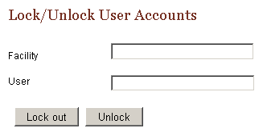
- In the Facility field, type 1111111111 for the Test Facility.
- In the User field, type dsullivan for Dorothy Sullivan.
- Click Lock.
Result: The user is not allowed to log in to Web Plus until the administrator unlocks the account. For the unlock procedure, see the Activity on page 43.

Current User Activities
Web Plus enables an administrator to view a log of the current activities of the systems’ users. The Current User Activity page displays information about the users who are logged in or have failed to login and the users’ Internet addresses that have been locked out. You can also reset the log status of users, if necessary.

Viewing Current User Activities
To view current user activities:
- On the Web Plus menu, point to Users and Facilities, then click Current User Activities.
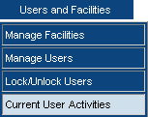
Result: The Current User Activity page opens.
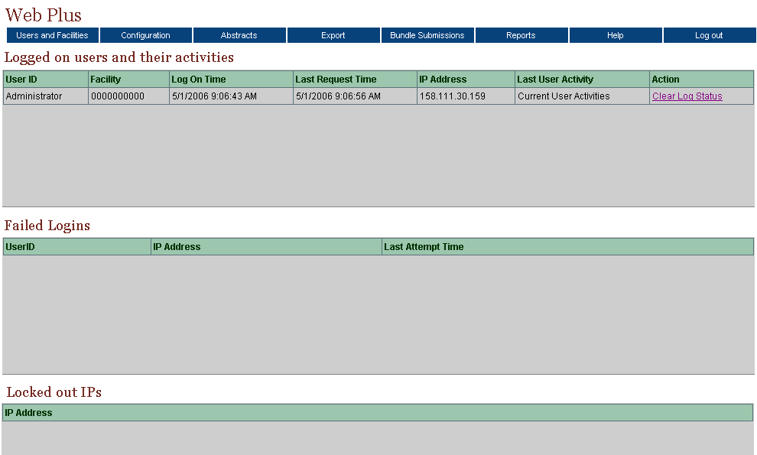
The Current User Activity page contains three tables of information containing information about the activities of current users:
Table | Columns | Description
Logged on users and their activities | User ID | Log in identifier of user
Logged on users and their activities | Facility | Facility of user
Logged on users and their activities | Log On Time | Date and time when user logged on
Logged on users and their activities | Last Request Time | Date and time that user made a request
Logged on users and their activities | IP Address | Identifier of user’s computer
Logged on users and their activities | Last User Activity | Description of user activity
Logged on users and their activities | Action | Clear Log Status link: click this link to release a user’s log on status so that the user can log on again.
Failed Logins | User ID | Log in identifier of user
Failed Logins | IP Address | Identifier of user’s computer
Failed Logins | Last Attempt Time | Date and time that user last attempted to log on
Locked out IPs |  | Address of users that are locked out of Web Plus
- In the Logged on users and their activities table, you can see that you are currently the only active user of the system.

Clear Log Status
To clear a user’s log status, complete these steps:
- On the Web Plus menu, point to Users and Facilities then click Current User Activity.
- In the Logged on users and their activities table, find a user and click Clear Log Status.
Result: The Clear Log Status window opens.
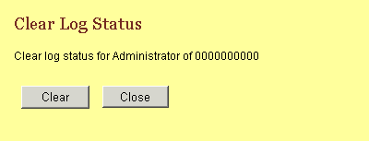
- Click Clear.
Result: A confirmation message appears on the Clear Log Status window.
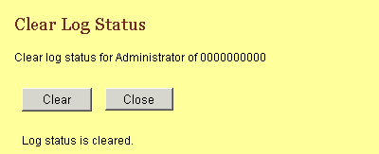
- Click Close.
Result: The window closes and the system clears the user log status for the user.

Questions
Answer these questions about managing facilities and user accounts (the answers are in Appendix A, on page 75 ):

- Are display types assigned to facilities or users?

- What is the menu option where you can add a new facility?

- How do you lock out a user from Web Plus?

Activity – Create a New Facility and User and Unlock an Account
In this activity, you create a new facility, a new user account, and unlock a user.
- Create a new facility. Follow the steps as described in “Adding a Facility,” page 29.
- Create a new user account. Follow the steps as described in “Adding Users,” page 33.
- Unlock the user account for Dorothy Sullivan:
- On the Web Plus menu, point to Users and Facilities, then click Manage Users.
- On the users list, find the facility name for Dorothy Sullivan.
- On the Web Plus menu, point to Users and Facilities, then click Lock/Unlock Users.
Result: The Lock/Unlock User Accounts window opens.
- Type the user name and the facility name in the text boxes.
- Click Unlock.

Viewing the New Display Type
In this section you view the display type you created previously. To do this, log in as the facility abstractor named Dorothy Sullivan. Before viewing this display type, you will need to make sure you have completed the unlock procedure in the above Activity (steps 1-5 above).
- On the Web Plus menu, click Log Out.
- In the User ID field, type dsullivan (the user you created).
- In the Password field, type Password1.
Result: The Web Plus facility abstractor home page opens.
- On the Web Plus menu, click New Abstract.
Result: The Data Entry page opens. This page has the fields of the Display type you created.
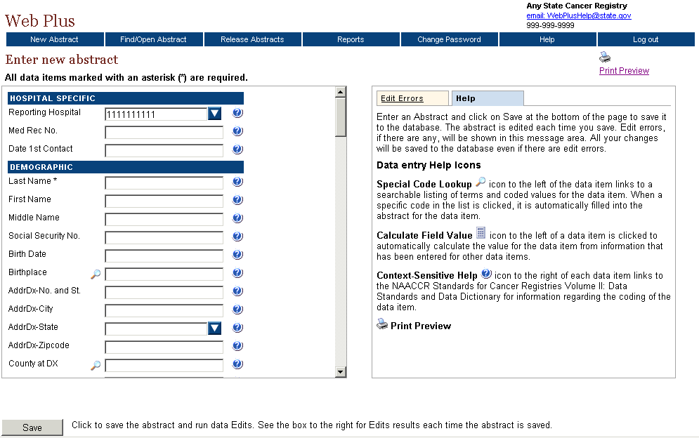
- View the fields that you have created, assigned property values, or designated as critical (required):
Locate … | To see …
Social Security Number | a wrapping label (label continues to next line)
Address at DX | a long label above the input box
Cause of Death | a default prompt
The Over-Rides/  Conversion/System Admin Section | that the NAACCR Record Version and other coding system variables are invisible (they also contain the default values entered for them)
Text–DxProc–PE | a user-generated prompt
RX Text–Other | An input box with a height of five lines
Name–Last  Addr at DX–Postal Code  Text–Histology Title  Text–Primary Site Title  Text–DX Proc–Op | Asterisk designating a critical, or required field
- View the location of the text data items. The user was assigned a Location of Text Data Items within Display Type of In data entry area on left (with other data items). As a result, the text fields are located within the data entry area along with the fields for the other data items, and the box on the right contains only Edit Errors and Help tabs:
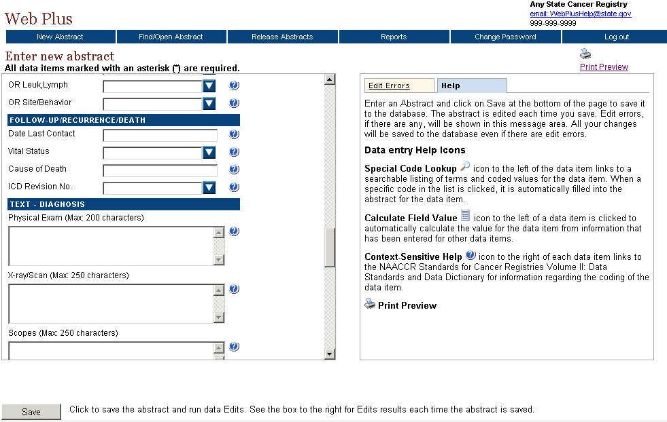
- On the Web Plus menu, click Log out.

Creating a Central Registry User
To create a central registry user, follow these steps:
- Log in to Web Plus as central registry administrator. For details, see “Log In,” page 2.
Result: The Web Plus home page opens.
- On the Web Plus menu, point to Users and Facilities, then click Manage Users.
Result: The Manage Users page opens.
- Click Add User.
Result: The Add/Edit User Account page opens.
- Enter this information into these fields:
Field | Information
Last Name | Smith
First Name | Adam
Role | Central Abstractor/Reviewer
User ID | asmith
User Initials | as
Location of Text Data Items within Display Type | Under Text Fields tab in box on right (with Edit Errors and Help tabs)

- At the Facility field, click Add.
Result: The Add Facility to User window opens.
- Select Any State Cancer Registry and click Add.
Result: The facility is added to the user account.
- Click Cancel to close the Add Facility to User window.
- On the Add/Edit User Account page, click Save.
Result: The system adds the new user to the list of users.

Managing Abstracts

Learning Objectives
In this chapter you will learn to:
- Assign released abstracts to a central registry abstractor/reviewer
- How to reassign previously assigned abstracts to a different central abstractor/reviewer
- Find and view released abstracts

Overview
The central registry administrator is responsible for assigning released abstracts to central registry abstractor/reviewers for review. The administrator can also view abstracts at any point once they have been released to the central registry.

Assigning Abstracts for Review
Administrators assign released abstracts to central abstractor/reviewers on the Assign Released Abstracts page. This page lists the abstracts released from each facility reporting to the central registry and the central registry abstractor/reviewers available to review the abstracts.
To assign abstracts:
- Log in to Web Plus. For further details, see “Log In,” page 2.
- On the Web Plus menu, point to Abstracts, then click Assign Released Abstracts.
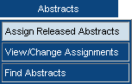
Result: The Assign Abstracts page opens.

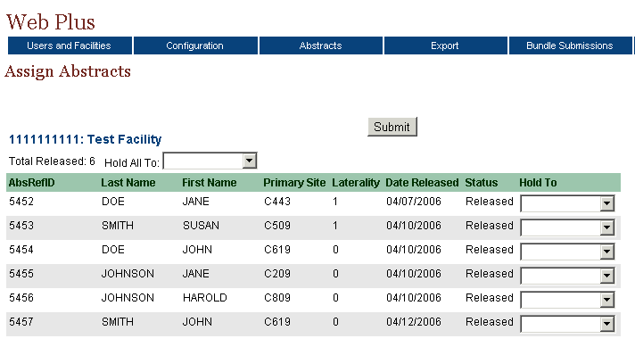
The Assign Abstract page includes these fields and column headings:
Field/Column Heading | Description
Hold All To | Select an abstractor/reviewer to review all the abstracts released by the specific facility
AbsRefID | A unique, system-generated number identifying the abstract
Last Name | Patient’s last name
First Name | Patient’s first name
Primary Site | The ICD-O-3 primary site code of the tumor being reported
Laterality | The laterality code for the tumor being reported
Date Released | Date that the facility released the completed abstract to the central registry
Status | Status of the abstract:
  Status | Description
  Released | Abstract has been released to the central registry
  Held | Abstract has been assigned to a central abstractor/reviewer for review
  Review | Abstract is under review by a central abstractor/reviewer
  Review Released | Abstract has been reviewed by the central abstractor/reviewer and released for export
Hold To | Select an abstractor/reviewer to receive the individual abstract
- Locate the abstract for John Smith, and select asmith from the list in the Hold To column to assign the abstract to the central abstractor/reviewer named Adam Smith.
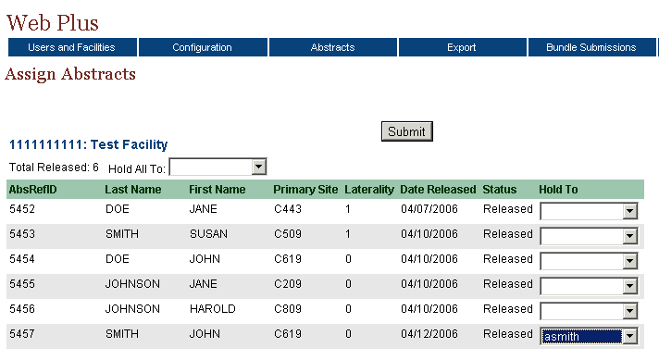
- Click Submit to assign the abstract to Adam Smith.
Result: The system lets you know that you have assigned the abstract, and assigns the abstract to the central abstractor/reviewer, who can review it in a separate Web Plus interface.

Reassigning an Abstract
The central registry administrator can change the review assignment of an abstract to another abstractor/reviewer.
To change an abstract assignment, complete these steps:
- On the Web Plus menu, point to Abstracts, then click View/Change Assignments.
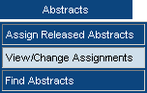
Result: The View/Change Assignments page opens.
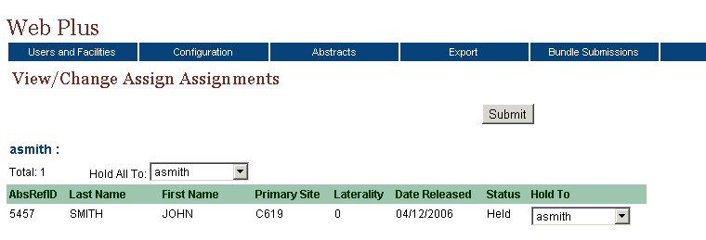

The list of assignments contains these column headings, and is grouped by abstractor:
Heading | Description
Last Name | Patient’s last name
First Name | Patient’s first name
Primary Site | The ICD-O-3 primary site code of the tumor being reported
Laterality | The laterality code for the tumor being reported
Date Released | Date that the facility sent the completed abstract to the central registry
Status | Status of the abstract:
  Status | Description
  Released | Abstract has been released to the central registry
  Held | Abstract has been assigned to a central abstractor/reviewer for review
  Review | Abstract is under review by a central abstractor/reviewer
  Review Released | Abstract has been reviewed by the central abstractor/reviewer and released for export
Hold To | List of central abstractor/reviewers to which abstract can be assigned
- On the row for the John Smith abstract, click the drop-down list in the Hold To column to view the different central abstractor/reviewers.
- Click on CCRAbstractor to reassign the John Smith abstract from the central abstractor/reviewer named Adam Smith to the test central abstractor/reviewer named CCRAbstractor.
After creating user accounts for your real central registry abstractor/reviewers, you can re-assign these released test cases to them for training purposes.

Finding and Viewing an Abstract
You can search for and view abstracts at any point after they have been released from facilities on the Find Abstracts page. You can use a variety of criteria to search for the abstracts you wish to view.
To find an abstract:
- On the Web Plus menu, point to Abstracts, then click Find Abstracts.
Result: The Find Abstract page opens.
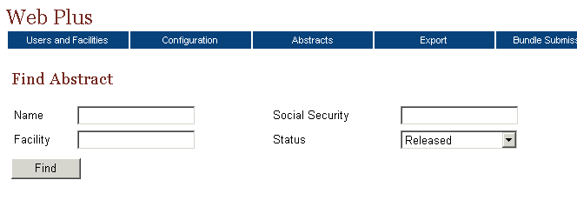
The Find Abstract page contains these search criteria fields:
Field | Description
Name | Name of patient
Facility | Name of facility where abstract is created
Social Security | Social Security number of patient
Status | The statuses of the abstracts that you can select to view are:
  Status | Abstract…
  Released | has been sent to the central registry
  Held | has been assigned to an abstractor but not reviewed yet
  Review | is being reviewed by a central registry abstractor/reviewer
  Review Released | has been reviewed by the central abstractor/reviewer and released for export
  Exported | has been exported from Web Plus

To find a specific abstract you can type in a name or a social security number such as 784500000, or just a partial name or number. You can also leave the Name, Facility and Social Security search criteria blank to obtain a listing of all abstracts with a certain status.
- Click Find (with the default value of Released selected in the Status list).
Result: The system displays the six example released abstracts that come with the Web Plus installation, which have been released from Test Facility.

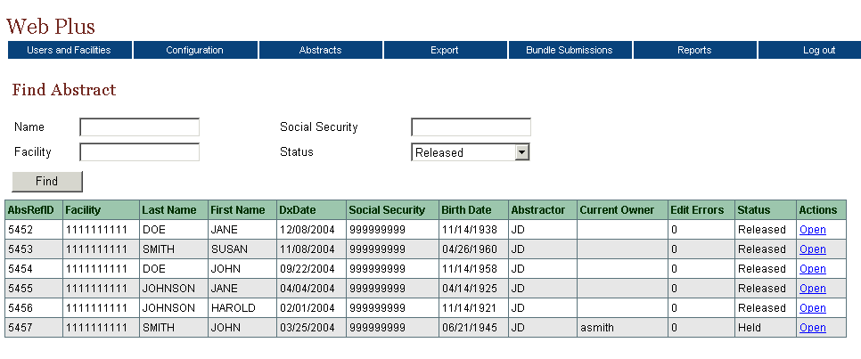

The list of abstracts has ten columns. This table describes the columns:
Column Head | Description
AbsRefId | A unique, system-generated number identifying the abstract
Facility | Name of the facility from which the abstract was released
Last Name | Last name of patient
First Name | First name of patient
DxDate | Diagnosis date of tumor being reported
Social Security | Patient’s social security number
Birth Date | Patient’s date of birth
Abstractor | Initials of the abstractor
Current Owner | Name of abstractor to whom the abstract is currently assigned
Edit Errors | The number of errors found in the edit process after an abstract has been saved
Status | Web Plus has these statuses:
  Status | Description
  Released | Abstracts sent to the central registry
  Held | Abstracts assigned to an abstractor/reviewer
  Review | Abstracts under review by a central registry abstractor/reviewer
  Review Released | Abstracts reviewed by the central registry abstractor/reviewer and released
Actions | Click on the open link to open the abstract and view its contents; information may not be edited

- Click Open in the Action column of one of the abstracts.
Result: The Data Entry page for your selected abstract opens so that you can view the abstract. An administrator can only view abstracts.

Exporting Abstracts
To export abstracts from the Web Plus application, the Web Plus Administration tool is used. Abstracts are exported only after being released following central registry review. Centrally-released abstracts are exported to a file in the NAACCR layout, for import into your central registry database.
Prior to export, centrally-released abstracts may be viewed from within the central registry administrator pages of the Web Plus application.

Questions
Answer these questions about managing abstracts (the answers are in Appendix A, on page 76 ):
- How can you assign abstracts to another abstractor/reviewer?
- What is the Held status of an abstract?
- How do you export abstracts from the Web Plus application?

Bundle Submissions

Learning Objectives
In this chapter you will learn to:
- View abstracts in an uploaded file
- View the edit error report for an uploaded file of abstracts
- Delete an uploaded file

Overview
Central registry administrators can view information for bundle submissions, or file uploads. In addition, uploaded file submissions can be deleted.

Viewing List of Abstracts and Edit Report for a Bundle File
In addition to creating abstracts in Web Plus, facilities can upload NAACCR-formatted, flat files using Web Plus. Web Plus runs edits on these submitted files and generates an edit report showing all of the edit errors found in the file. Although central registry administrators can view a list of the abstracts contained in an uploaded file, they can not update the abstract. They can also view the edit reports generated upon upload for the submitted files.
To view abstract information in a bundle, complete these steps:
- On the Web Plus menu, click Bundle Submissions.
Result: The Bundle Submissions page opens.
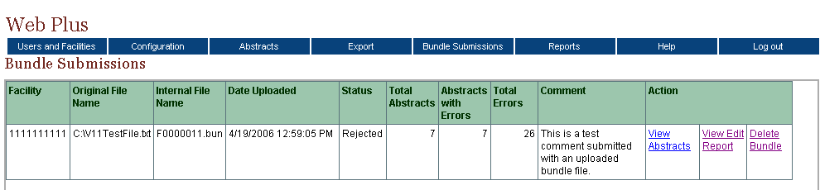
The Bundle Submissions page contains these column headings:
Column Heading | Description
Facility | Facility ID Number
Original File Name | Name of uploaded file
Internal File Name | Name of file within the Web Plus application
Date Uploaded | Date that the file was uploaded
Status
  Status | Description
  Reject | File rejected because it contained a greater percent of errors than specified in the Error Threshold Percent field for the facility that uploaded the file
  No Errors | File contained no errors when edits were run upon upload
  Bundle Uploaded | File has been uploaded, however, the Defer Edits option has been selected on the System Preferences page, so edits have not yet been run on the file; to run batch edits on such a file, use the Web Plus Administration Tool
  Acceptable Errors | File contained an acceptable percent of errors when edits were run upon upload
Total Abstracts | Total number of abstracts in the file
Abstracts with Errors | Number of abstracts that have errors
Total Errors | Total number of errors in the file
Comment | Comment that file uploader may have entered to be transmitted with the file
Action
  Action | Description
  View Abstracts | View a list of the abstracts in the file
  View Edit Report | View the edit error report for the file
  Delete Bundle | Delete the file
- Click the View Abstracts link.

Result: The View Abstracts page opens.
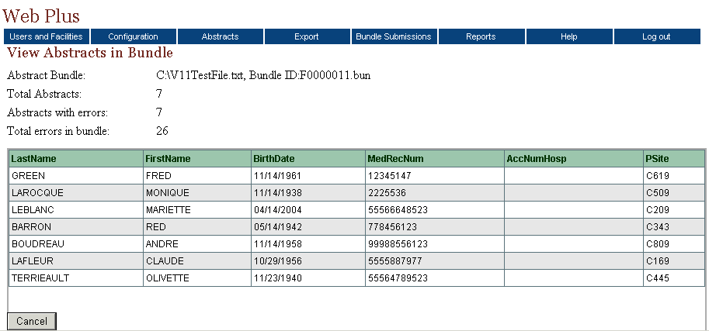
The View Abstracts in Bundle page contains these column headings:
Column Heading | Description
LastName | Last name of patient
FirstName | First name of patient
BirthDate | Birth date of patient
MedRecNum | Medical record number of patient
AccNumHosp | The patient’s accession number at the facility
PSite | The ICD-O-3 topography code for the primary site of the tumor being reported

- Click Cancel to close the View Abstracts in Bundle page and open the Bundle Submissions page again.
- Click the View Edit Report link.

Result: The Edit Report opens.
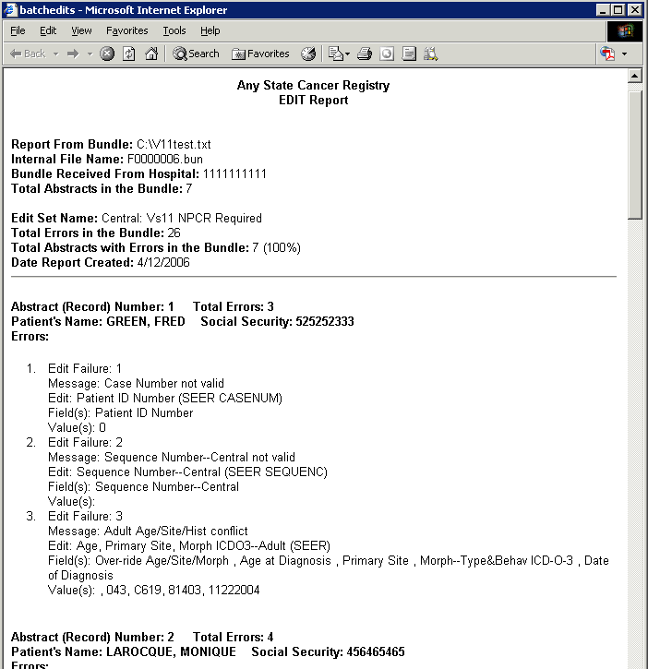
These are the summary fields of the bundle contained in the Edit report:
Field | Description
Report from Bundle | Name of uploaded file
Internal File Name | Name of file in the Web Plus application
Bundle Received from Hospital | Facility ID Number for the facility that uploaded the file
Total Abstracts in Bundle | Total number of abstracts in the file
Edit Set Name | Name of edit set that was run on the file
Total Errors in Bundle | Total number of errors in the file
Total Abstracts with Errors in Bundle | Total number of abstracts with errors in file
Date Report Created | Date that the report was created

These are the identifiers for the individual abstracts listed in the Edit report:
Field | Description
Abstract Number | Number of abstracts in the bundle
Total errors | Total number of errors in the abstract
Patient’s Name | Name of patient for the abstract
Social Security | Social security number of patient for the abstract
Errors | An itemized list of errors in the abstract

Deleting an Abstract Bundle File
To delete an abstract bundle file, complete these steps:
- On the Web Plus menu, click Bundle Submissions.
Result: The Bundle Submissions page opens.
- Locate the file bundle you would like to delete, and click Delete Bundle.
Result: The bundle file is deleted from the database.

Exporting Bundled Submissions
To export bundled submissions from the Web Plus application, the Web Plus Administration Tool is used. File uploads are exported to a file in the NAACCR layout, for import into your central registry database.

Questions
Answer these questions about bundled submissions (the answers are in Appendix A, on page 76 ):
- How do you view a listing of abstracts in a bundled submission file that has been uploaded?
- How do you view the edit error report for an uploaded file of abstracts?
- How do you export an uploaded file from the Web Plus application?

Reports

Learning Objective
In this chapter, you will learn:
- To open a report
- About the reports available in Web Plus
- To set a date range for a report

Overview
Web Plus for administrators provides reports at both the central registry and facility level. The central registry reports basically show the logs of system logins and abstract activities in Web Plus. The facility-level reports allow an administrator to view the activities on abstracts from specific facilities, such as when the abstracts were released. You can view, print, and set the date ranges for all of these reports.

Opening Central Registry Reports
To open a central registry report after you have logged in, complete these steps:
- On the Web Plus menu, click Reports.
Result: Web Plus displays a list of reports available to you.
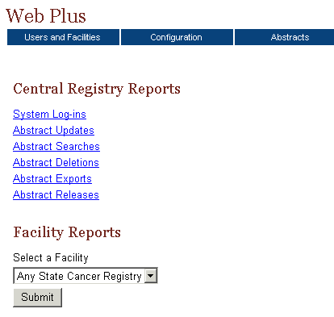

This table describes the central registry reports available for viewing by the central registry administrator. Clicking the name of the report opens a separate window displaying the report.
This Report . . . | Lists . . .
System Log-ins | the facility, user, date, and time of all system log-ins and log outs in Web Plus within a selected date range
Abstract Updates | the user, facility, date, and time of all abstract updates
Abstract Searches | the user, facility, date, and time of all abstract searches
Abstract Deletions | the user, facility, date, and time of all abstract deletions
Abstract Releases | information about abstract releases including release time and date, abstractor, and facility
- Click the System Log-ins link.
Result: The Login Audit Report page opens.
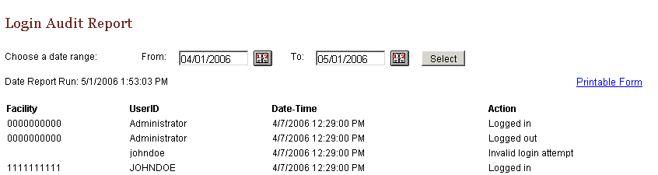
The report contains these column headings:
Column Heading | Description
Facility | Facility ID Number of user’s facility
UserID | User ID of the user
Date-Time | Date and time of the log in/out
Action | Indicates the user activity being logged:  - Logged in  - Logged out  - Invalid log in attempt
- To print the report, click on the Printable Form link.
Result: A page opens with a printable version of the report.

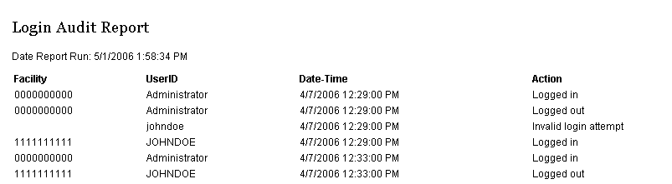
For optimum printing results, print Web Plus reports in landscape mode. To print in landscape, click on File→Page Setup, and click on Landscape.
In addition, if you wish to remove the internal report name from the upper left-hand corner of the printed report, remove the &w&b from the header field. If you wish to remove the URL listing from the bottom of the report, remove the information in the footer field (the date prints on the report already).
- Close the report window.
- On the Reports page under Central Registry Reports, click Abstract Updates.
Result: The Abstract Update Log report page opens.
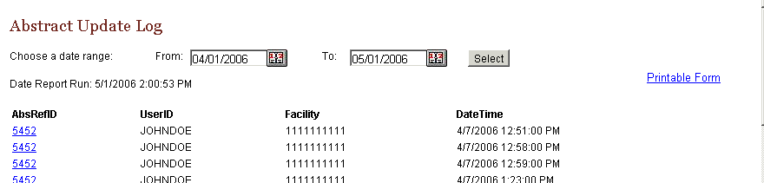
The Abstract Update Log report contains these column headings:
Column Heading | Description
AbsRefID | A unique, system-generated number identifying the abstract
UserID | User ID of the abstractor
Facility | Number of facility that sent the abstract
Date-Time | Date and time of the action
The remaining central registry reports contain the same column headings and information as the Abstract Update Log for their specific user activities:
  - Abstract Searches
  - Abstract Deletions
  - Abstract Exports
  - Abstract Releases

Changing the Date Range of a Report
To change the date range of a report, complete these steps:
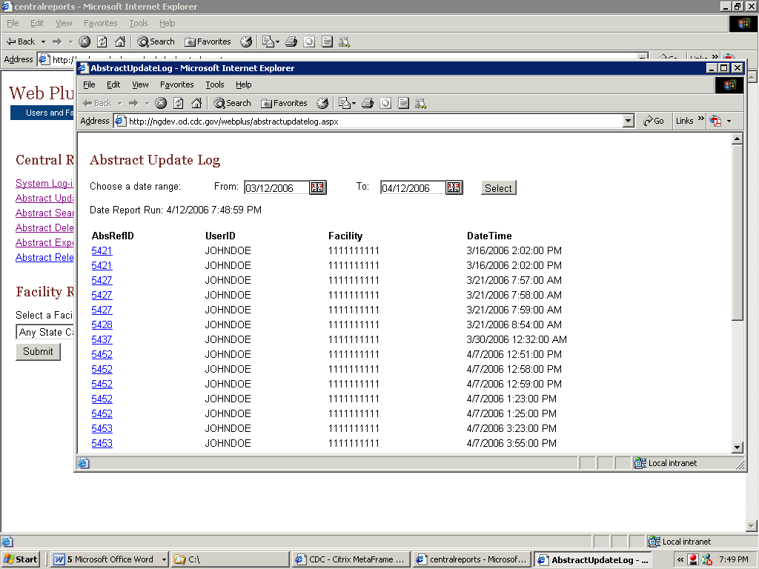
- On any opened report page, click the calendar icon beside the From date field.
Result: The calendar window opens.
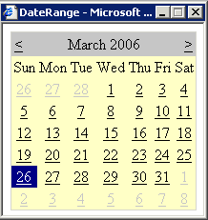
- Double-click the date you want. The system inserts the date in the field and closes the calendar window.
You can also type the date in the window by using the mm/dd/yyyy format, such as 10/01/2006 for October 1, 2006. The date calendar and format are the same for both the From and To date fields.
- Repeat steps 1 and 2 for the To date field.
- Click Select.
Result: The report is displayed with the information restricted to the date range selected.

Opening Facility Reports
The Reports section of the central registry administrator pages of Web Plus include reports on facility activities and descriptive statistics on released abstracts from facilities.
- On the Web Plus menu, click Reports.
- Under Facility Reports, use the pull-down menu to select Test Facility.
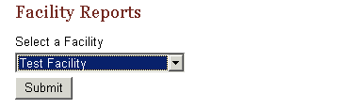
- Click Submit.
Result: The Facility Reports page opens.

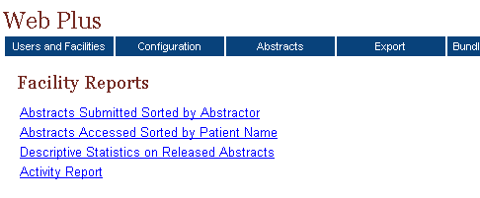
These are the facility reports:
This report . . . | Lists . . .
Abstracts Submitted  Sorted by Abstractor | all abstracts that a facility has released for a user-specified time range; the abstracts are sorted first by the name of the abstractor and then by patient name
Abstracts Accessed  Sorted by Patient Name | all abstracts that a facility has released for a user-specified time range sorted in order of patient name
Descriptive Statistics on Released Abstracts | descriptive statistics on released abstracts such as demographics and site group
Activity Report | the numbers of cases released and unreleased abstracts by month or year (depending on the length of the date range specified)

Abstracts Submitted Sorted by Abstractor Report
The Abstracts Submitted Sorted by Abstractor report provides the history of the abstract: when it was created, completed, and submitted to the central registry.
To open the Abstracts Submitted Sorted by Abstractor report, follow these steps:
- On the Web Plus menu, click Reports.
Result: Web Plus displays a list of reports available.
- Under Facility Reports, select Test Facility and click Submit.
Result: The Facility Reports page opens.
- Click on the Abstracts Submitted Sorted by Abstractor link.

Result: The Abstracts Submitted Sorted by Abstractor report page opens in a separate window.
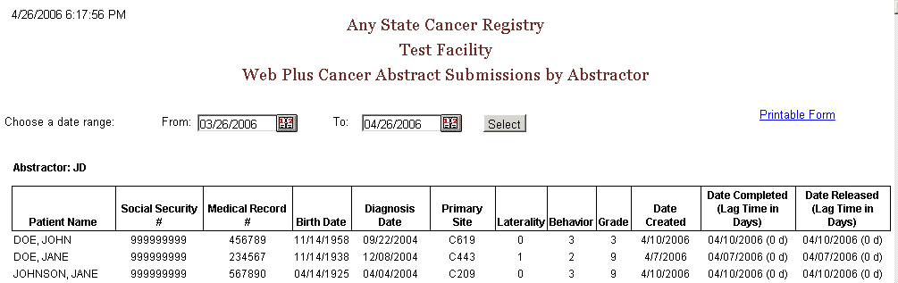
The Abstracts Submitted Sorted by Abstractor report contains these columns for each abstract, and the abstracts are grouped by abstractor:
Column Heading | Description
Patient Name | Name of patient on abstract
Social Security Number | Patient’s social security number
Medical Record Number | Patient’s medical record number
Birth Date | Patient’s birth date
Diagnosis Date | Diagnosis date of the tumor being reported
Primary Site | ICD-O-3 topography code for the primary site of the tumor being reported
Laterality | Laterality code for the tumor being reported
Behavior | ICD-O-3 behavior code for the tumor being reported
Grade | ICD-O-3 grade/differentiation code for the tumor being reported
Date Created | Date the abstract was created
Date Completed | Date the abstract was completed, with the lag time (in days) between date of creation and completion in parentheses
Date Released | Date the abstract was released to the central registry, with the lag time (in days) between date of completion and release in parentheses
- Click the calendar icon beside the From date field.
Result: The calendar window opens.
- Click on March 26, 2006. If you wanted to change the month, you would click on either the ≤ or ≥ symbols in the month header.
Result: The system inserts the date in the field, and closes the calendar window.
You can also type the date in the window by using the mm/dd/yyyy format, such as 04/01/2006 for April 1, 2006.
- Click the calendar icon beside the To date field.
Result: The calendar window opens.
- Click on April 26, 2006. The system inserts the date in the field.
- Click Select.
Result: Web Plus displays the report again with the information in the date range you selected. Note that the six test released abstracts that come with the Web Plus installation are listed.
- Click on the Printable Form link.
Result: A page opens with a printable version of the report.
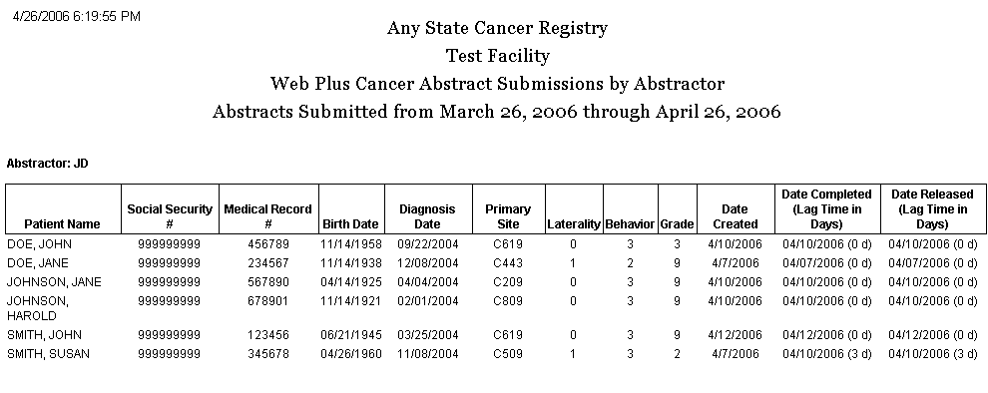

For optimum printing results, print Web Plus reports in landscape mode. To print in landscape, click on File→Page Setup, and click on Landscape.
In addition, if you wish to remove the internal report name from the upper left-hand corner of the printed report, remove the &w&b from the header field. If you wish to remove the URL listing from the bottom of the report, remove the information in the footer field (the date prints on the report already).

Abstracts Accessed Sorted by Patient Name Report
The Abstracts Accessed Sorted by Patient Name report provides the dates and times that an abstract is opened and the reason why it was opened.
To access the Abstracts Accessed Sorted by Patient Name report, follow these steps
- On the Web Plus menu, click Reports.
Result: Web Plus displays a list of reports available.
- Under Facility Reports, select Test Facility, and click on Submit.
Result: The Facility Reports page opens.
- Click the Abstracts Accessed Sorted by Patient Name link.
Result: The Abstracts Accessed Sorted by Patient Name report page opens.
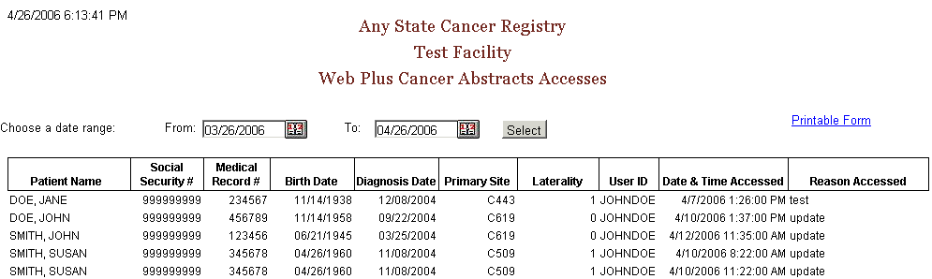
The Abstracts Accessed Sorted by Patient Name report contains these fields:
Field/Headings | Description
Patient Name | Name of patient on abstract
Social Security # | Patient’s social security number
Medical Record Number | Patient’s medical record number
Birth Date | Patient’s birth date
Diagnosis Date | Diagnosis date of the tumor being reported
Primary Site | ICD-O-3 topography code for the primary site of the tumor being reported
Laterality | Laterality code for the tumor being reported
User ID | User ID of the abstractor
Date & Time Accessed | Date and time that the abstractor opened the abstract
Reason Accessed | Reason that abstract was opened

- Click on the Printable Form link.
Result: A page opens with a printable version of the report.

Descriptive Statistics on Released Abstracts Report
The Descriptive Statistics on Released Abstracts report includes a series of tables consisting of the number and percent of released abstracts broken down by the following: county of residence, zip code of residence, sex and race, age group, site group, and treatment group.
To run and/or modify the report for Descriptive Statistics on Released Abstracts complete these steps:
- On the Web Plus menu, click Reports.
Result: Web Plus displays a list of reports available.
- Under Facility Reports, select Test Facility.
Result: The Facility Reports page opens.
- Click the Descriptive Statistics on Released Abstracts link.
Result: The Descriptive Statistics on Released Abstracts report page opens.
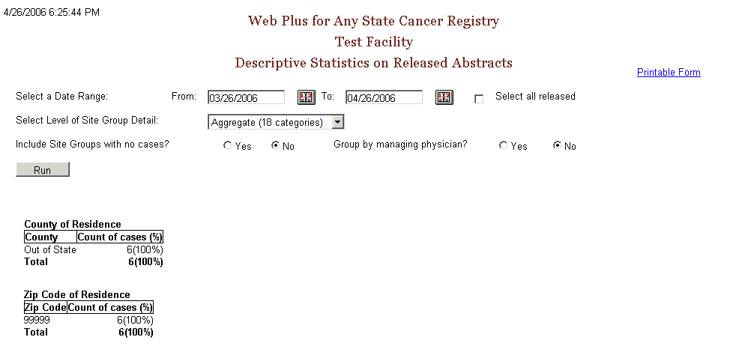

The descriptive statistics provided are broken down as follows:
Grouping Variable(s) | Groupings by…
County of Residence | individual county of residence at diagnosis
Zip Code of Residence | individual zip code of residence at diagnosis
Sex and Race | patient sex (male/female) by race (white/black/other)
Age Group | ten age groups (0-9, 10-19,….90+)
Site Group | three levels of primary site grouping:
  Grouping Level | Description
  Aggregate | 18 categories
  Subaggregate | 60 categories
  Recode | 78 groups
Treatment Group | type of summary treatment (RX Summ) recorded:  Surgery of Primary Site  Chemotherapy  Hormone  BRM  Other  Rad-Regional RX Modality  Transplant/Endocrine
The following options are available to modify the Descriptive Statistics on Released Abstracts report:
Option | Description
Date Range | Includes only those abstracts that were released within the specified date range
Select all released | When clicked, all abstracts released by the facility will be included, regardless of date released
Select Level of Site Group Detail | Specifies what level of primary site grouping to use for the report; the default grouping is 18 categories
Include site groups with no cases | When Yes is clicked, the primary site distribution will show all site groups for the level of detail chosen, whether or not abstracts were released containing each of the site groups  When No is clicked, only those primary site groups contained in the released abstracts released will appear on the report
Group by managing physician | When Yes is clicked, the records in the report will be grouped into sections by managing physician, displaying the descriptive statistics for abstracts released by each managing physician
- Click the calendar icon beside the From date field.
Result: The calendar window opens.
- Click on March 26, 2006. The system inserts the date in the field.
You can also type the date in the window by using the mm/dd/yyyy format, such as 04/01/2006 for April 1, 2006.
- Click the calendar icon beside the To date field.
Result: The calendar window opens.
- Click on April 26, 2006. The system inserts the date in the field.
- Next to Include Site Groups with no cases, click on Yes.
- Click Select.
Result: Web Plus displays the report again with the information in the date range you selected. Note that the six test released abstracts that come with the Web Plus installation are listed. Also note that all 18 site groupings are displayed.
- Click on the Printable Form link.

Result: A separate window opens with the report formatted for printing.

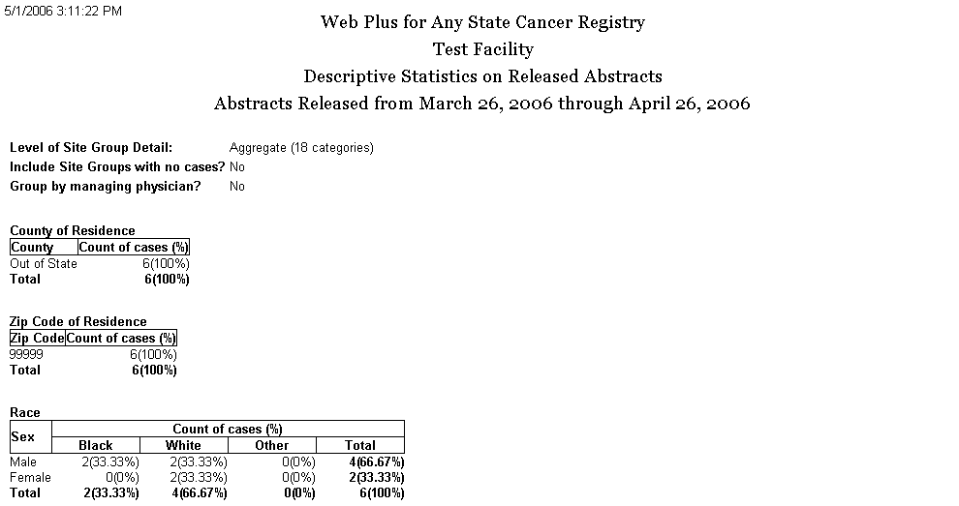
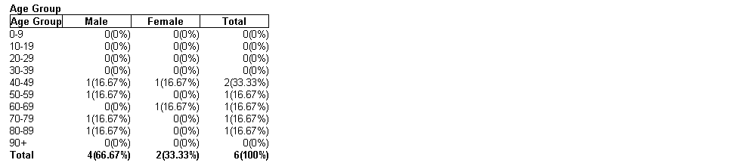
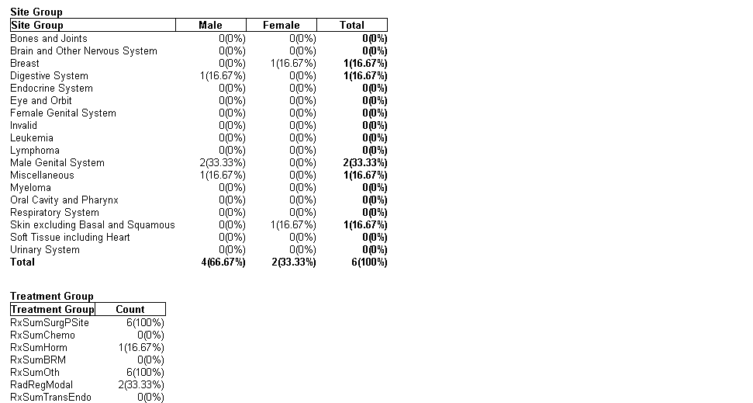

Activity Report
The Activity report provides information on the abstracting activity at a facility, in terms of the number of released and unreleased abstracts. Viewing the Activity report is a good way to monitor submissions from individual facilities or doctors’ offices.
To open the Activity report:
- On the Web Plus menu, click Reports.
- Under Facility Reports, click the Facility list and select Test Facility.
- Click Submit.
Result: The Facility Reports page opens.
- Click the Activity Report link.
Result: The Activity Report page opens.
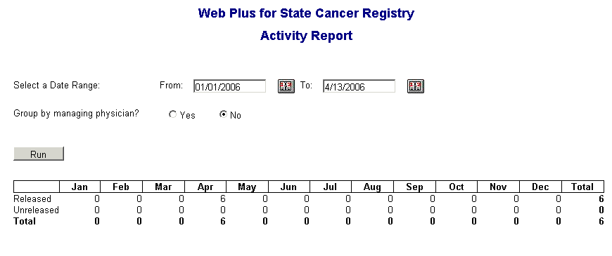
The default From date is January 1 of the current year, and the default To date is the current day.
If the specified date range spans more than one year, the report will display the number of released and unreleased cases for each year rather than each month.
To modify the Activity report:
- Set the date range.
- Specify whether or not you would like the data in the report grouped by managing physician by clicking on Yes or No.
- Click Run to create the modified report.

Questions
Answer these questions about reports (the answers are in Appendix A, on page 76 ):
- What are the two main types of reports available in Web Plus administrator?
- Where can you find the Descriptive Statistics on Released Cases report?
- Which report has information about an abstract’s history?

Appendix A: Answers
Chapter 2: The Basics
These are the answers to the questions (page 5) about the basics of Web Plus:
- To add a user account, click the Users and Facilities menu option, and click on Manage Users.
- To log out, click Log Out on the Web Plus menu.
- To begin creating a display type, click the Configuration menu option, and click on Manage Display Types.

Chapter 3: Web Plus Configuration
These are the answers to the questions (page 25) about configuring a display type:
- When you select an edit set, you are selecting a set of edits that will all be applied to the abstract in the same way; i.e., using the same Edit Set execution options (Skip Empty, Skip Failed and Suppress Warnings) for all the edits in the selected Edit Set. When you select individual edit options, you can override Edit Set execution options for any individual edit, or choose to suppress an individual edit, preventing it from running when the edit set is run.
- To protect a field from being edited by the abstractor, once you have selected the data item for your display type, click on the Properties button, enter a default value for the data item, and then click on the box next to Protected.
- You can create a new display type by either starting from scratch by adding a new display type, or by copying an existing display type and revising it.
- Section headings are used to group fields in a display type for clearer viewing and to facilitate data entry by the abstractor.

Chapter 4: Managing Facilities and Users
These are the answers to the questions (page 42) about managing facilities and user accounts:
- Display types are assigned to facilities, and data are abstracted by the user using the display type assigned to their facility.
- To add a new facility, click the Users and Facilities menu option, and click on Manage Facilities.
- To lock out a user from Web Plus, point to the Users and Facilities menu option, click Lock/Unlock Users, enter the facility and user and click on the Lock out button.

Chapter 5: Managing Abstracts
These are the answers to the questions (page 54) about managing abstracts:
- To assign abstracts to another abstractor/reviewer, point to Abstracts on the Web Plus menu, click on View/Change Assignments, and re-assign the abstracts to the desired central registry abstractor/reviewer.
- The Held status means that the abstract is assigned to a central registry abstractor/reviewer but has not been reviewed yet.
- To export centrally-released abstracts from the Web Plus application, the Web Plus Administration Tool is used.

Chapter 6: Bundle Submissions
These are the answers to the questions (page 59) about bundle submissions:
- To view a listing of abstracts in a bundled submission file that has been uploaded, Click on Bundle Submissions on the Web Plus menu, locate the file for which you would like to view abstracts, and click on the View Abstracts link in the Action column.
- To view an edit error report for a bundled submission file that has been uploaded, Click on Bundle Submissions on the Web Plus menu, locate the file for which you would like to view abstracts, and click on the View Edit Report link in the Action column.
- To export an uploaded file from the Web Plus application, the Web Plus Administration Tool is used.

Chapter 7: Reports
These are the answers to the questions (page 74) about reports:
- The two main types of reports on the central registry administrator pages of Web Plus are Central Registry and Facility.
- You can find the Descriptive Statistics on Released Cases report by clicking on Reports on the Web Plus menu, selecting a facility, clicking the Submit button, and then clicking on the Descriptive Statistics on Released Cases link.
- The Cases Submitted Sorted by Abstractor report contains information about an abstract’s history; when it was created, completed, and submitted to the central registry.

