Link Plus
Stand-Alone Probabilistic Record Linkage Software

Linkage Exercises

Contents
External Linkage Exercise 1
About the Data 1
Launching Link Plus & Beginning the External Linkage Exercise 1
Review of External Linkage Steps 2
Step 1: Select Data Type for File 1 3
Step 2: Locate/Identify File 1 3
Step 3: Data Import for File 1 4
Step 4: Select Data Type for File 2 7
Step 5: Locate/Identify File 2 7
Step 6: Data Import for File 2 8
Step 7: Select Blocking Variables & Phonetic System 10
Step 8: Select Matching Variables & Matching Methods 11
Step 9: Define Missing Values 12
Step 10: Select ID Variables 14
Step 11: Select Direct/EM Method 15
Step 12: Enter Cut-off Value 15
Step 13: Specify Linkage File Name and Location 15
Step 14: Perform Manual Review of Uncertain Matches 18
Manual Review Screen Menu Items 22
The Datasheet View 24
Definition of Class 24
Sorting, Hiding, Re-Ordering, Re-Sizing and Re-Formatting Columns 25
Customizing the Color Scheme 29
Manually Assigning Match Status 30
Assigning Match Status Automatically by Score 30
Display Uncertain Matches Only 32
The Pair View 33
Viewing Summary Information 34
Using the Search Feature 35
Saving and Re-opening Review Sessions 36
Independent Manual Review 38
Assigning Final Match Statuses 38
Step 15: Export Merged File 39

Deduplication Linkage Exercise 40
About the Data 40
Beginning the Deduplication Exercise 40
File Import for Delimited Files 40
Opening Previously-saved Linkage Configuration Files 40
Review of Deduplication Linkage Steps 40
Step 1: Select Data Type for Data File 40
Step 2: Locate/Identify Data File 40
Step 3: Data Import for Data File 40
Step 4: Select Blocking Variables & Phonetic System 40
Step 5: Select Matching Variables & Matching Methods 40
Step 6: Define Missing Values 40
Step 7: Select ID Variables 40
Step 8: Select Direct/EM Method 40
Step 9: Enter Cut-off Value 40
Step 10: Specify Linkage File Name and Location 40
Step 11: Perform Manual Review of Uncertain Matches 40
Hide Record # Column 40
Sort by and Manually Reassign Set ID 40
Assigning Match Status - Review 40
Independent Manual Review 40
Assigning Final Match Statuses 40
Step 12: Export Merged File 40
Obtaining New Releases of Link Plus 40

External Linkage Exercise

About the Data
Today’s external linkage exercise will involve linking a cancer registry data file with a vital statistics data file.
Simulated Cancer Registry Records
The data file Registry_File.txt is a fixed width data file containing 50,000 simulated cancer registry records.
Simulated 2005 Death Data
The data file 2005Death_File.txt is a fixed width data file containing 10,000 simulated death certificate records.
Linkage Results
One hundred and seventy-eight death certificate records potentially match 178 individuals on the cancer registry data file, and are presented for manual review.

Launching Link Plus & Beginning the External Linkage Exercise
To launch the Link Plus application and begin today’s exercise complete the following steps:
- Close all other applications that you may have running.
- Launch the Link Plus application by clicking on Start…All Programs…Registry Plus…Link Plus…Link Plus.
Result: The main Link Plus window opens.
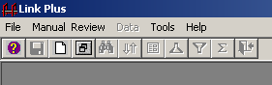
- Click on the File menu option, and select New Linkage.
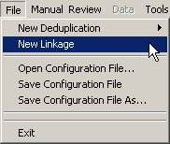
Result: The Link Plus Linkage Configuration window opens.

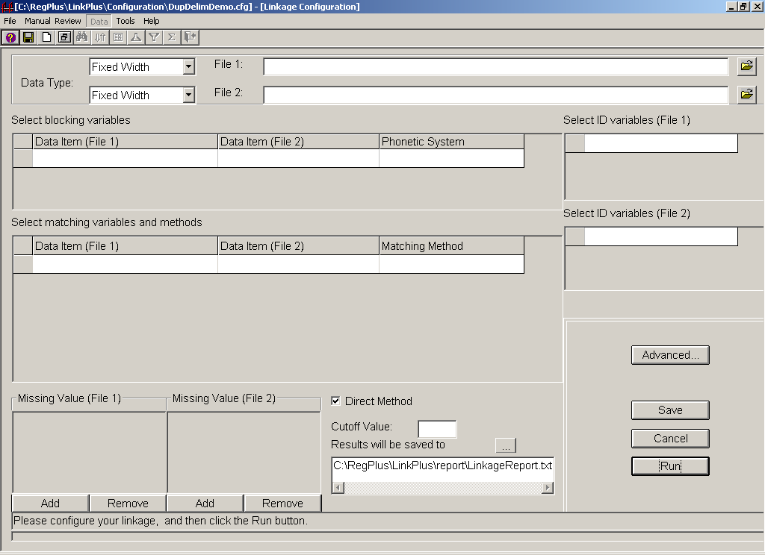

Review of External Linkage Steps
- Select Data Type for File 1
- Locate/Identify File 1
- Data Import for File 1
- Select Data Type for File 2
- Locate/Identify File 2
- Data Import for File 2
- Select Blocking Variables & Phonetic System
- Select Matching Variables & Matching Methods
- Select ID Variables
- Define Missing Values
- Select Direct/EM Method
- Enter Cut-off Value
- Specify Linkage File Name and Location
- Perform Manual Review of Uncertain Matches
- Export Merged File

Step 1: Select Data Type for File 1
Remember that it makes a difference which of your data files you designate as File 1 and File 2. File 1 is generally the larger of the two files, as µ probabilities are based on File 1. At the completion of a linkage run, in addition to the linkage report, Link Plus generates a Non-Match Report, named Non_MatchReport.txt, and stores it in the Report folder of the Link Plus directory. The report is a tab-delimited text file, and can be opened with a text editor or a spreadsheet program.
The Non_MatchReport.txt report will contain records from File 2, that, when matched to records in File 1, receive a linkage score below the specified Cut Off Value (i.e., records in File 2 that are definitely not matches to any records in File 1).
Because our cancer registry file (Registry_File.txt) is the larger of the two files, we will specify it as File 1.
To select the data type for File 1, leave the default value of fixed width selected in the Data Type drop-down menu for File 1.
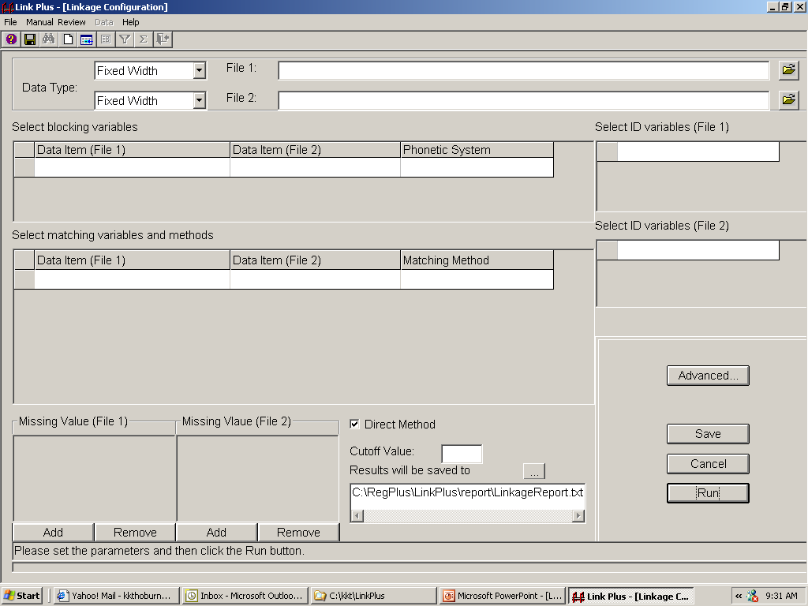

Step 2: Locate/Identify File 1
To locate the Registry_File.txt data file and identify it as File 1, complete the following steps:
- Click on the folder icon to the right of the input box for File 1.
Result: The Open Data File dialog box opens.

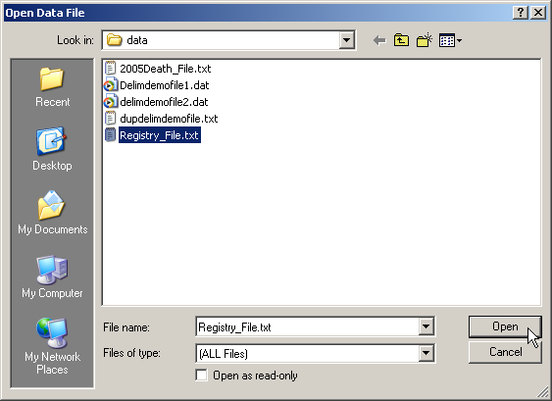
- Click on the Registry_File.txt file, and click Open.
Result: The Data Import Form for Fixed Width File opens.
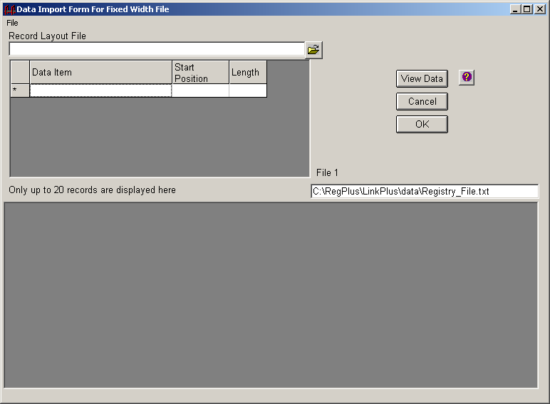

Step 3: Data Import for File 1
To finish the data import process for File 1, complete these steps:
- Place the cursor in the in the Data Item column of the first row of the record layout grid.
- Using the information in the below table, enter the data item name, start position, and length in the record layout grid for each of the variables listed.

Data Item | Start Position | Length
Record ID | 1 | 8
Last Name | 10 | 25
First Name | 36 | 14
Middle Name | 51 | 14
SSN | 66 | 9
Sex | 76 | 1
Date of Birth | 78 | 8
Street | 87 | 40
City | 128 | 30
State | 159 | 2
Zip | 162 | 5
Race | 168 | 2

- Once you have all of the information entered, click on View Data.
Result: Link Plus displays the first 20 lines of data in the file, so you can ascertain whether you have the proper positions and lengths for the variables.
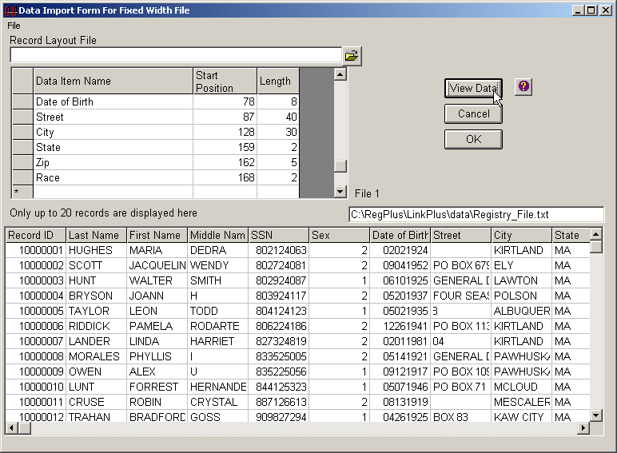
- Make sure everything is aligned properly, and then click OK.
Result: The Save Record Layout File dialog box opens.
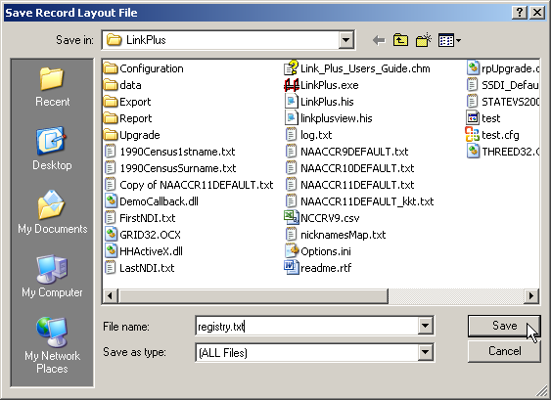
- In the File name box, enter registry.txt, and click Save.
Result: The registry.txt record layout is saved, and the application returns you to the Linkage Configuration window.
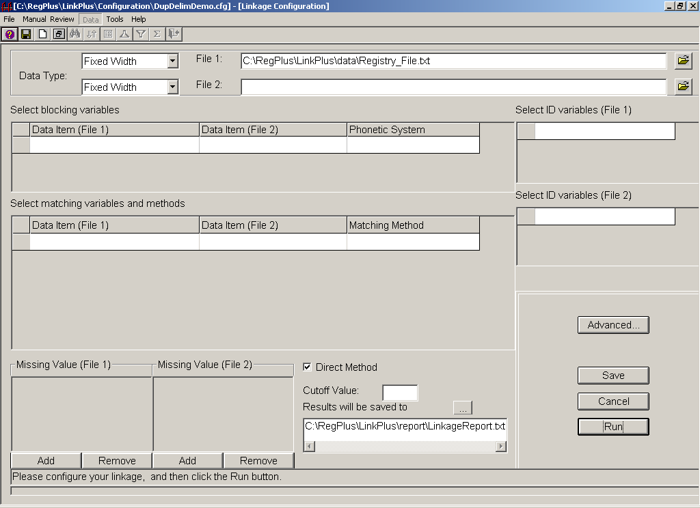

Step 4: Select Data Type for File 2
To select the data type for File 2, leave the default value of fixed width selected in the Data Type drop-down menu for File 2.

Step 5: Locate/Identify File 2
To locate the 2005Death_File.txt data file and identify it as File 2, complete the following steps:
- Click on the folder icon to the right of the input box for File 2.
Result: The Open Data File dialog box opens.
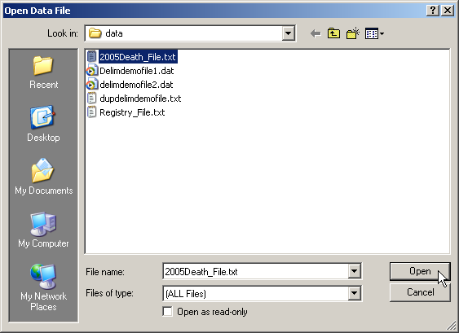
- Click on the 2005Death_File.txt file, and click Open.
Result: The Data Import Form for Fixed Width File opens.

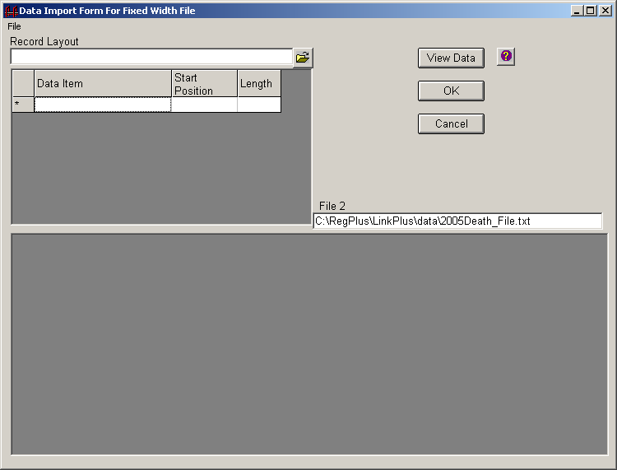

Step 6: Data Import for File 2
To finish the data import process for File 2, we will open a record layout file that has been previously saved. To open a record layout file complete these steps:
- Click on the folder icon to the right of the Record Layout box.
Result: The Open Record Layout File dialog box opens.
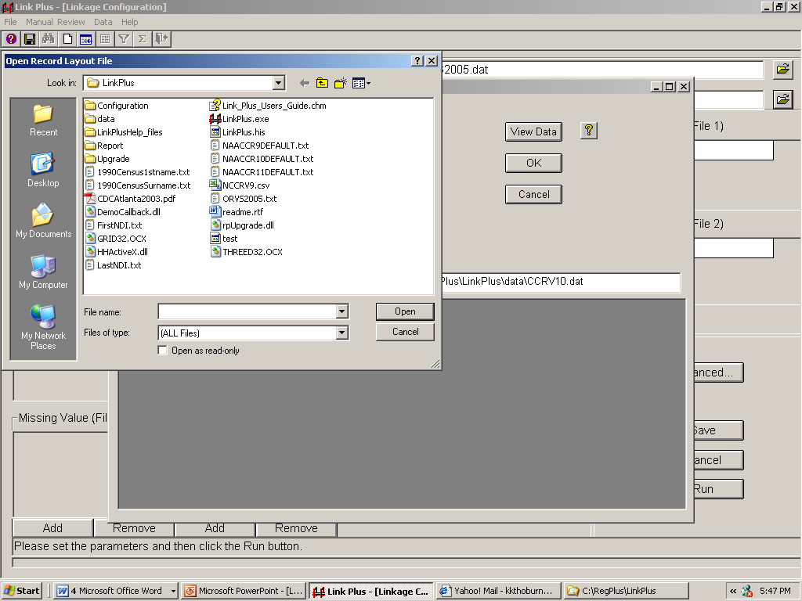
- Double-click on the Configuration folder to open it.
Result: The Open Record Layout File dialog box opens within the Configuration folder.
- Click on the 2005Death_Layout.txt record layout.
Result: The 2005Death_Layout.txt record layout is selected into the File name box.

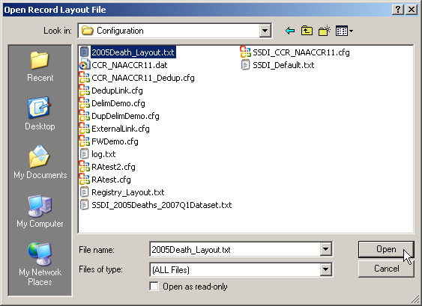
- Click on Open.
Result: You are returned to the Data Import Form for Fixed Width File window, with the 2005Death_Layout.txt record layout entered automatically in the record layout grid.
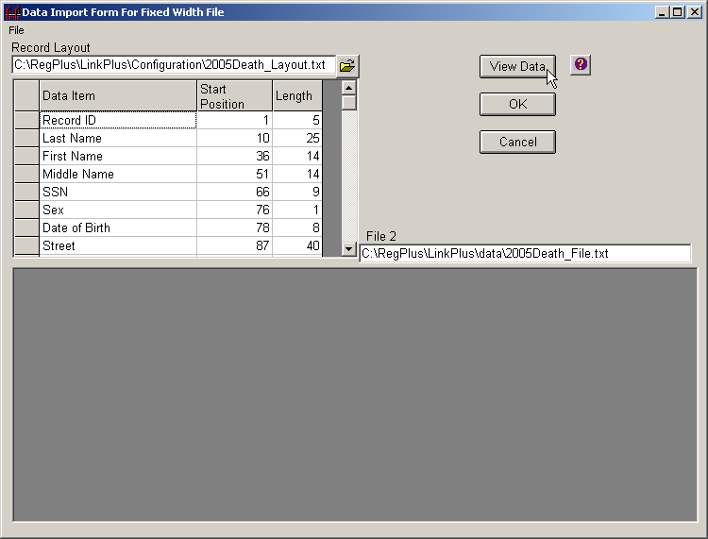
- Click on View Data.
Result: Link Plus displays the first 20 lines of data in the 2005Death_File.txt file, so you can verify you have the proper positions and lengths for the variables.

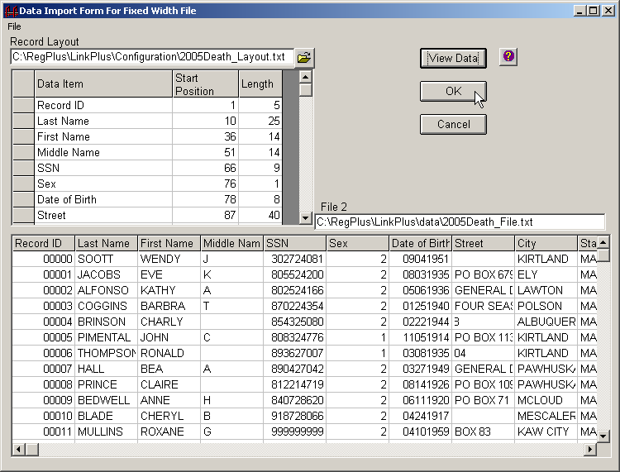
- Click OK.
Result: The 2005Death_Layout.txt record layout is re-saved (in case you needed to make any changes), and the application returns you to the Linkage Configuration window.

Step 7: Select Blocking Variables & Phonetic System
To select blocking variables and a phonetic system (where applicable), complete these steps:
- Click on the first empty cell of the grid in the Select blocking variables section.
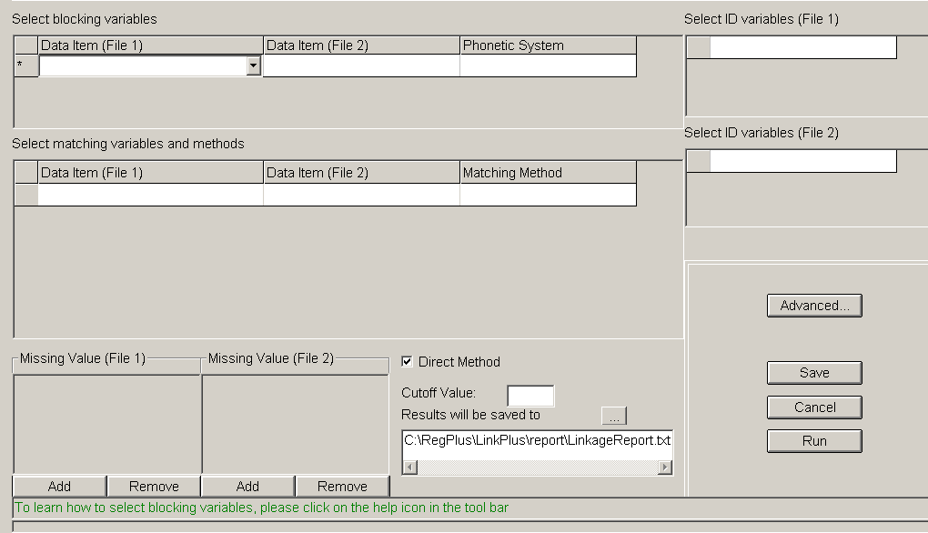
Result: A drop-down menu appears. When clicked, this menu contains all of the variable names of the variables that were specified for the record layout for File 1 (Registry_File.txt ).

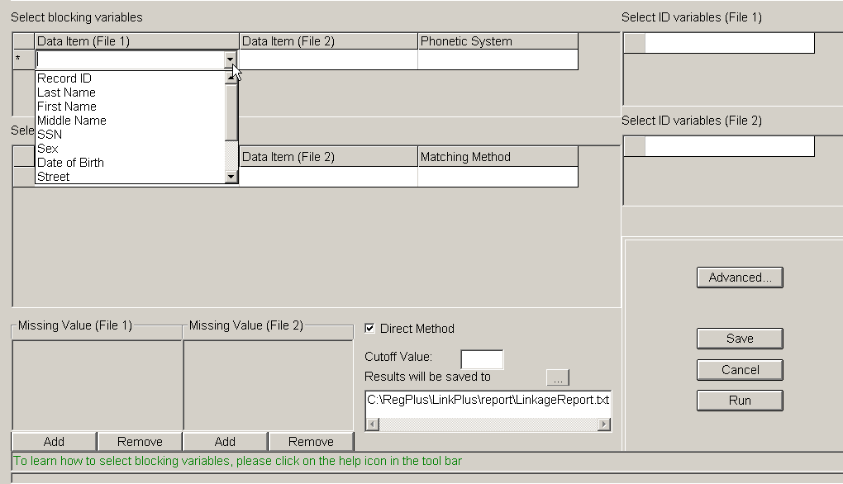
- Using the drop-down menus for each of the three columns, make the following selections for blocking variables and phonetic systems for File 1 (Registry_File.txt) and File 2 (2005Death_File.txt):
Data Item (File 1) | Data Item (File 2) | Phonetic System
Last Name | Last Name | NYSIIS
First Name | First Name | NYSIIS
SSN | SSN

Step 8: Select Matching Variables & Matching Methods
To select matching variables and their respective matching methods, complete these steps:
- Click on the first empty cell of the grid in the Select matching variables and methods section.
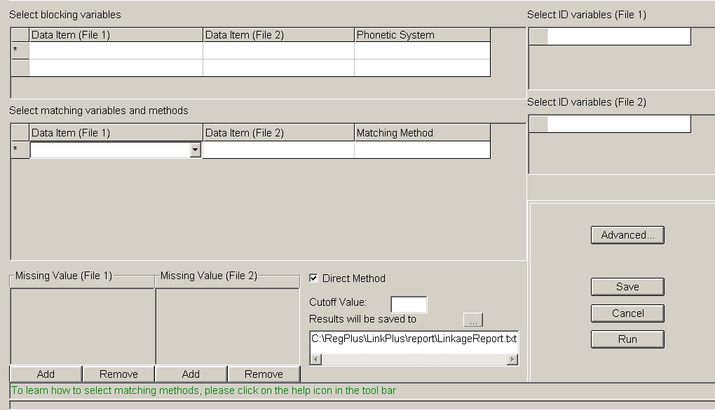
Result: A drop-down menu appears. When clicked, this menu contains all of the variable names of the variables that were specified for the record layout for File 1 (Registry_File.txt ).
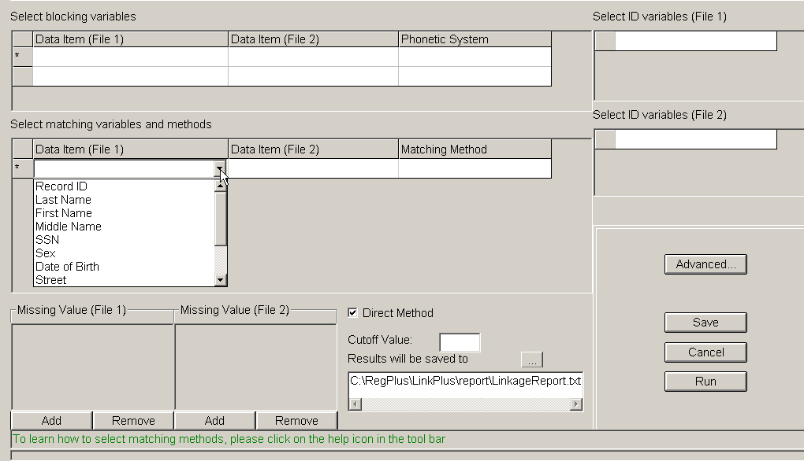
- Using the drop-down menus for each of the three columns, make the following selections for matching variables and matching methods for File 1 (Registry_File.txt) and File 2 (2005Death_File.txt):
Data Item (File 1) | Data Item (File 2) | Matching Method
Date of Birth | Date of Birth | Date
Last Name | Last Name | Last Name
First Name | First Name | First Name
SSN | SSN | SSN
Middle Name | Middle Name | Middle Name
Sex | Sex | Exact

Step 9: Define Missing Values
Link Plus automatically treats null or empty values as missing data for Matching Variables and allows the user to indicate additional values which are to be treated as missing data by the program.
To define Missing Values for the matching variables selected, complete these steps:
- Select the Date of Birth matching variable by clicking on its row in the matching variables grid.
Result: The Missing Values and format grid for dates appears.
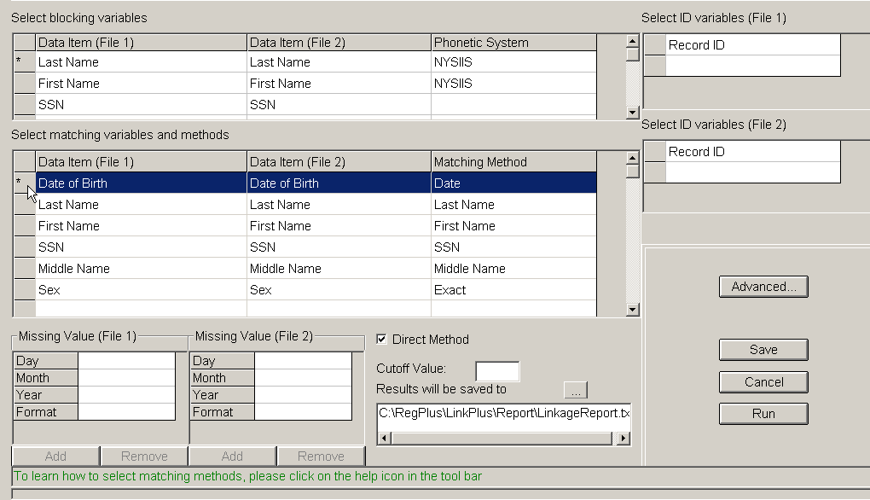
Entering Missing Values for date variables works a little differently from other variables. Missing values are specified separately for each of the date components; day, month, and year.
- Clicking separately into each cell of the missing value grid, enter the missing values in the following table:
Date Component | Missing Value (File 1) | Missing Value (File 2)
Day | 99 | 99
Month | 99 | 99
Year | 9999 | 9999
- In addition to specifying Missing Values separately for each of the date components, the date format must also be specified. Link Plus currently accepts two date formats, MMDDYYYY, and YYYYMMDD. Both of the data files for today’s linkage exercise have the birth date in the MMDDYYYY format.
Use the pull-down menu in the format row of the grid to select MMDDYYYY for both File 1 and File 2.
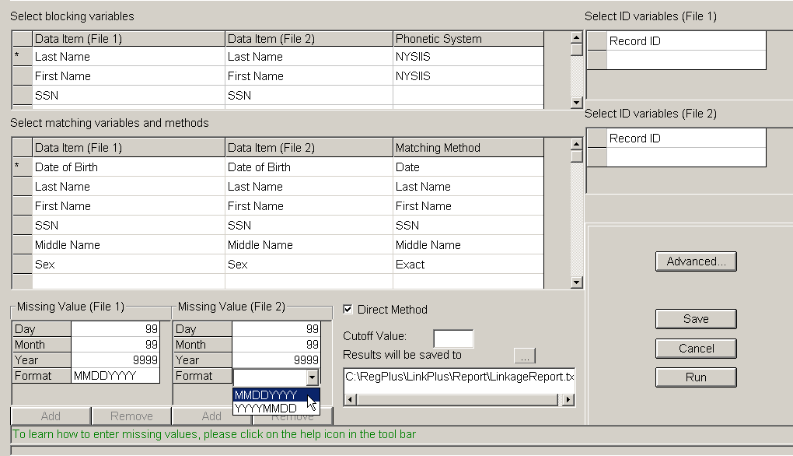
- Select the SSN matching variable by clicking on its row in the matching variables grid.
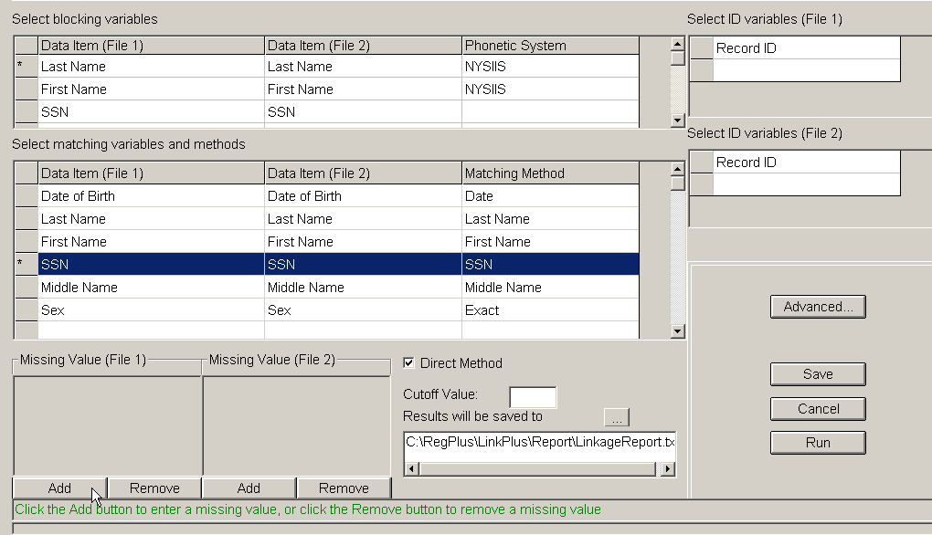
- Click the Add button in the Missing Values grid for File 1.
- Type 999999999 in the cell and click Add. Type 000000000 in the new cell that appears.
- Click the Add button in the Missing Values grid for File 2 at the bottom of the screen.
- Type 999999999 in the cell and click Add. Type 000000000 in the new cell that appears.
- Select the Sex matching variable by clicking on its row in the matching variables grid.
- Click the Add button in the Missing Values grid for File 1.
- Type 9 in the cell that appears.
- Click the Add button in the Missing Values grid for File 2 at the bottom of the screen.
- Type 9 in the cell that appears.
You can add up to 5 Missing Values. Missing Values can be deleted by clicking the Remove button.

Step 10: Select ID Variables
Although the Link Plus linkage report and manual review screen will automatically list the Matching Variables that you have selected, you may want to define other variables to be included in the reports, called ID Variables. ID Variables, such as Patient ID Number, are variables used for identifying records. Selection of ID Variables is optional.
To select ID Variables for File 1 and 2 complete these steps:
- Click in the Select ID variables (File 1) grid, and select the Record ID variable from the drop-down list that appears.
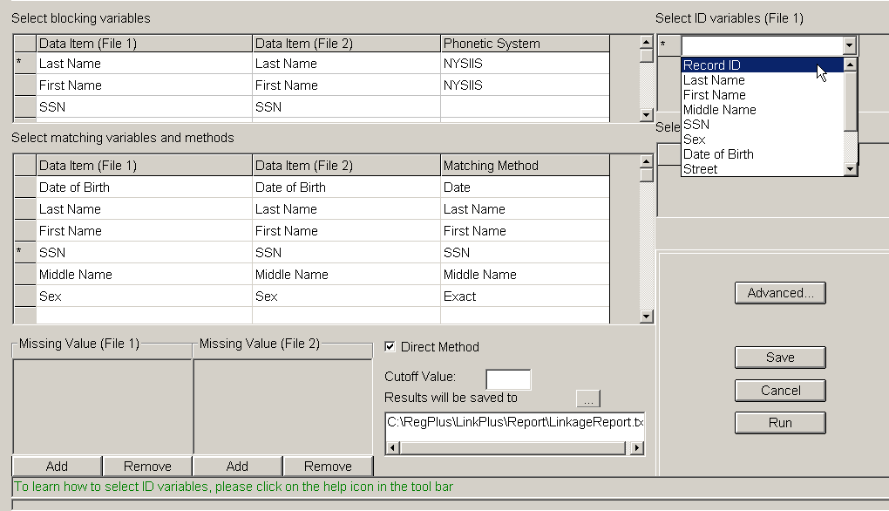
- Click in the Select ID variables (File 2) grid, and select the Record ID variable from the drop-down list that appears.
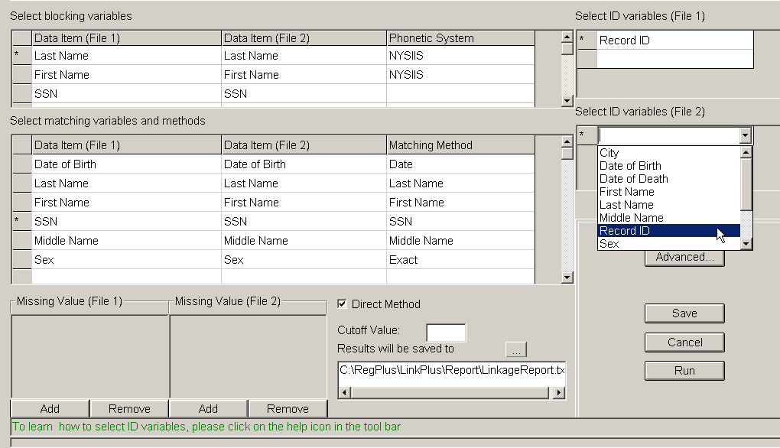

Step 11: Select Direct/EM Method
For the purposes of today’s exercise, we will be using the Direct Method to derive the M-Probabilities used in the linkage. The M-Probability is the probability that a matching variable agrees given that a comparison pair is a match. When the Direct Method box is clicked, default M-Probabilities are used in the linkage. Leave the Direct Method box clicked.
 | You can click on Advanced to view the default M-Probabilities or define your own.  Un-click the Direct Method box if you prefer Link Plus to compute the M-Probabilities based on your data using the EM algorithm.

Step 12: Enter Cut-off Value
Remember that the Cut Off Value is the score value above which comparison pairs are accepted as potential links and presented for manual review. For the purposes of today’s exercise, enter an initial Cut Off Value of 7 in the Cutoff Value box.
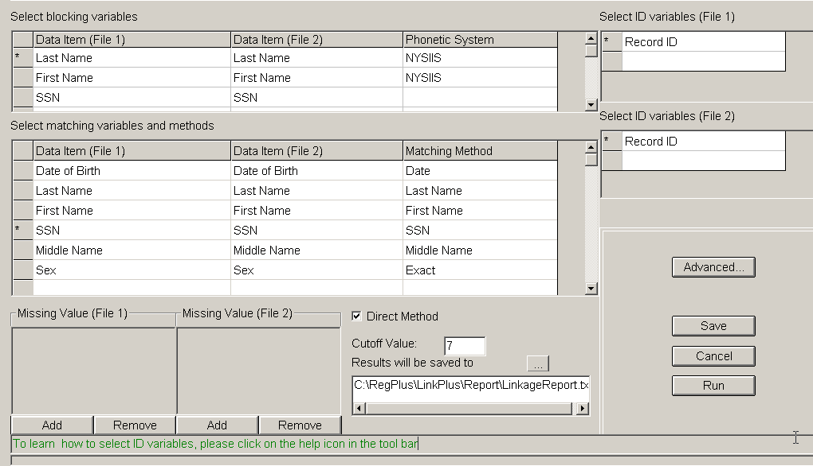

Step 13: Specify Linkage File Name and Location
At the completion of a linkage run, Link Plus will generate a Linkage Report, named LinkageReport.txt, and store it in the Report folder of the Link Plus directory. The report is a tab-delimited text file, and can be opened with the manual review feature of Link Plus (it also can be opened in a text editor or spreadsheet program). Records are presented in comparison pairs, sorted by their linkage scores in descending order. Pairs with scores above the selected Cut Off Value are listed. The detail row for each record contains all of the matching and ID variables used in the linkage.
Link Plus also generates a non-match report, named Non_MatchReport.txt, which contains records from File 2 not matched to records in File 1 (records receiving a linkage score below the specified Cut Off Value).
You should save the Linkage Report under a new name or it will be over-written the next time you run Link Plus.
To rename the Linkage Report, complete these steps:
- Click on the 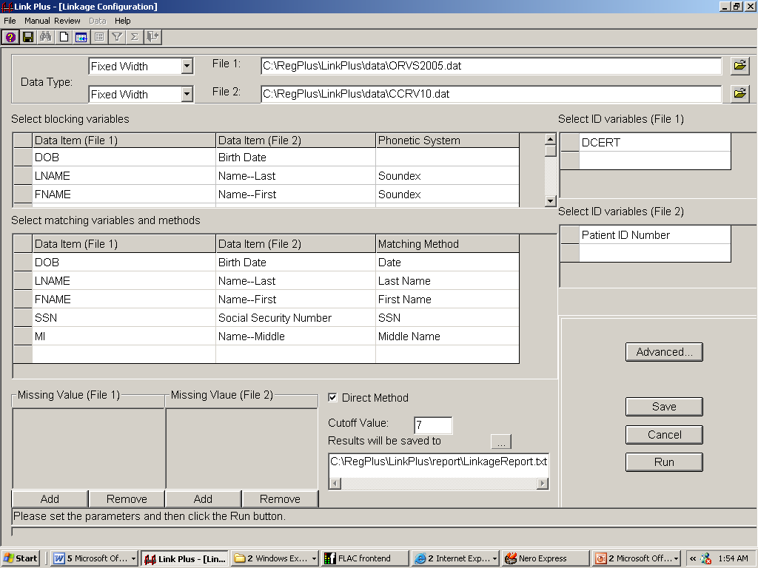 to the right of Results will be saved to.
Result: The Save linkage results to the file below dialog box opens.
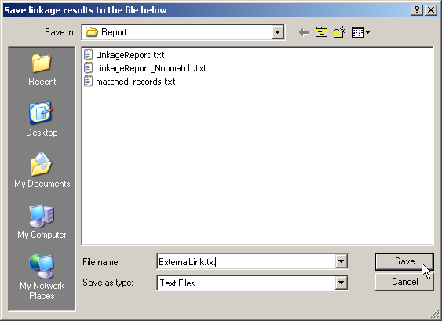
- Enter ExternalLink.txt in the File name box, and click Save.
Result: The application returns you to the Linkage Configuration window, where the linkage report name has been changed to ExternalLink.txt.
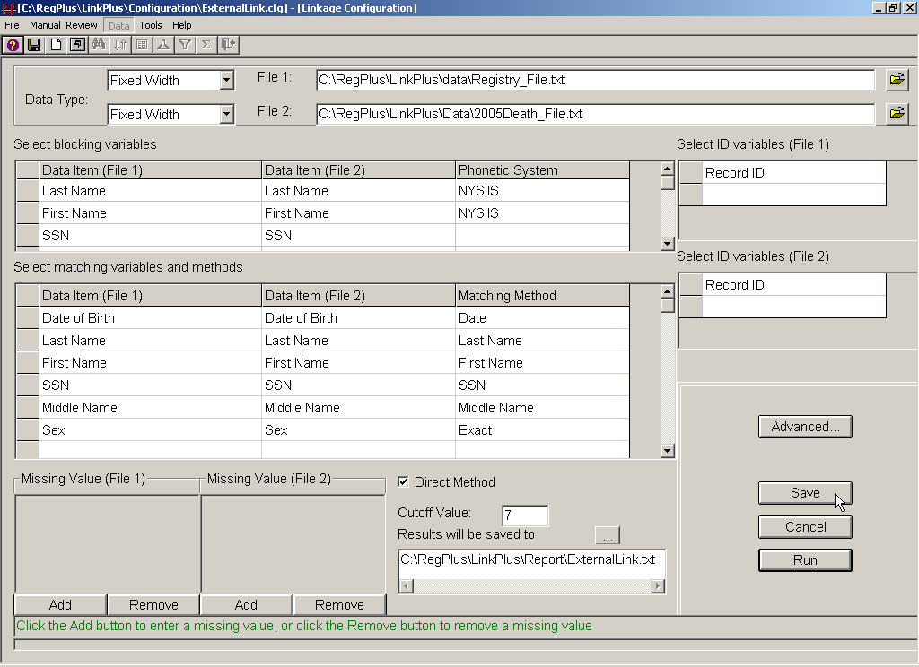
- Click on Save to save the configuration file for this external linkage exercise.
Result: The Save Configuration dialog box opens.
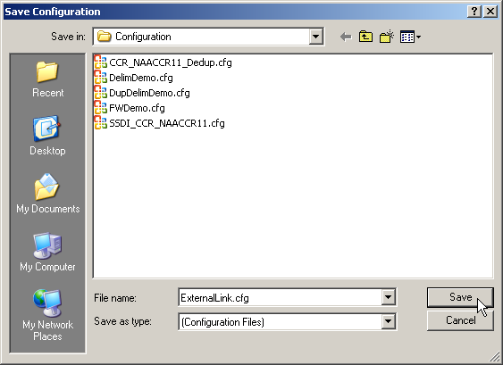
- Enter ExternalLink.cfg in the File name box, and click Save.
- Click Run to run the linkage.
Result: The linkage begins, and the Linkage Process Progress window appears and provides the user with feedback about the linkage process as it is run.
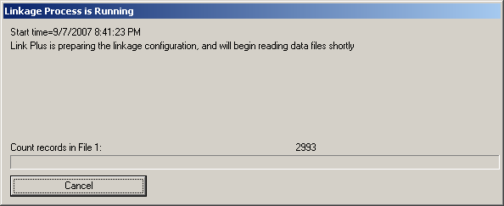
The progress window provides feedback regarding the preparation of the configuration, the reading in of the data files, the blocking of the files, and the calculation of the linkage scores.
When the linkage is complete, the progress window will present the user with the choice of conducting the manual review process directly after the linkage, or closing the progress window, and conducting the manual review process at a later time.

Step 14: Perform Manual Review of Uncertain Matches
To conduct manual review of the potential matches generated by an external linkage (File 1 with File 2), you must either click on Conduct Manual Review Now in the Linkage Process Progress Window at the completion of the linkage:
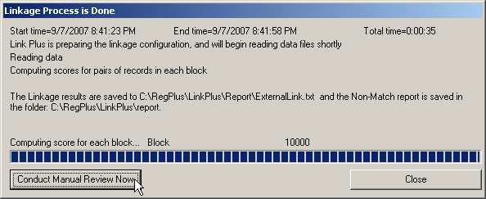
or open the linkage report by clicking on the Manual Review menu item, and click on the New View… option. Either way you open the linkage report, to perform manual review, you will select additional variables for manual review (if desired), and then perform the manual review, assigning a match status to each potential comparison pair.
- Click Conduct Manual Review Now.
Result: The Select Additional Fields for Manual Review dialog box opens.
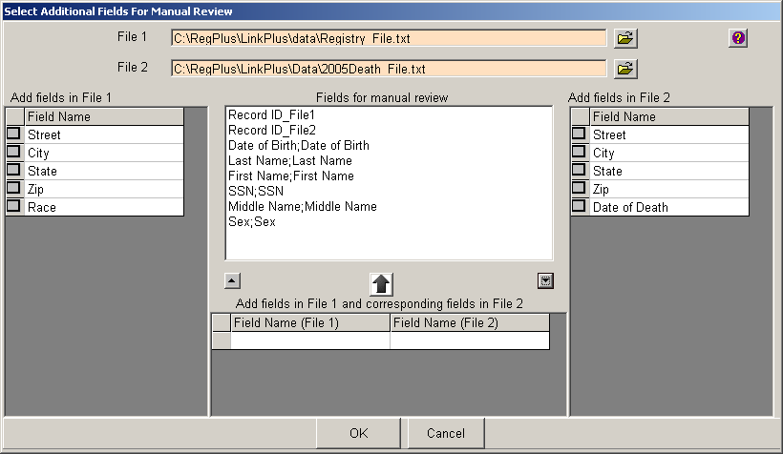
When performing manual review of potential matches, if you would like to view additional fields other than those already chosen for blocking, matching and ID purposes for the linkage, you can check the boxes on the left and/or right grids for the fields you would like to view. Fields added in this manner will be shown on separate columns on the manual review screen.
- Click on the box to the left of the Race field name in the Add fields in File 1 grid.
Result: The Race variable gets added to the center list of Fields for Manual Review, with a _File1 after the field name to indicate that this field comes from File 1.
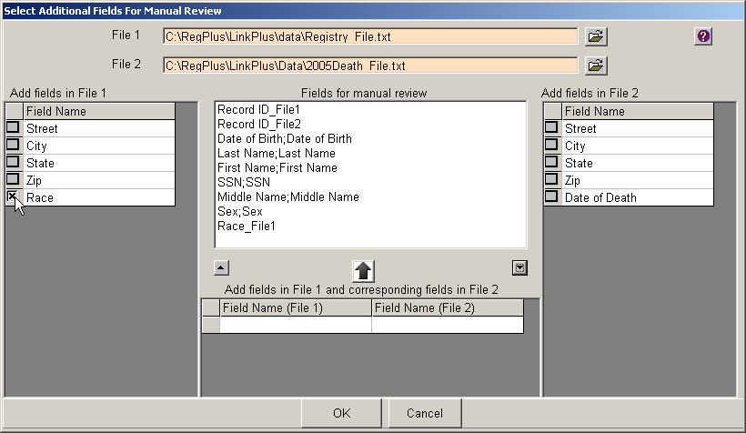
However, if you would like two fields, one from File 1, another from File 2, to display on the same column on the manual review screen, you would go to the bottom grid in the center of the window and click on the cells to bring up drop-down lists of fields on the files to select the fields.
- In the center panel, in the Field Name (File 1) grid, click in the first empty cell.
Result: A pull-down menu appears.
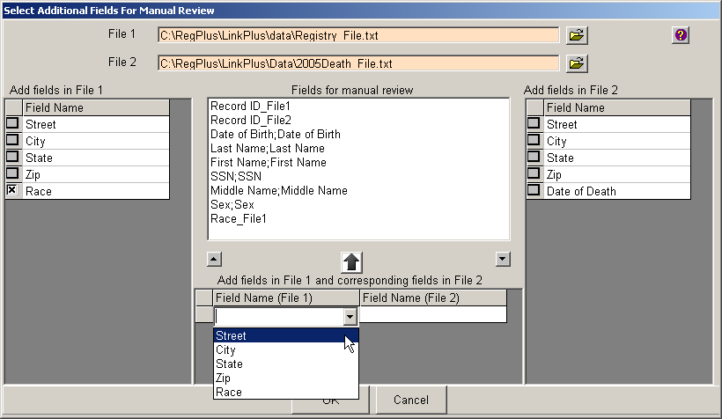
- Select Street from the pull-down menu.
- In the center panel, in the Field Name (File 2) grid, click in the first empty cell.
Result: A pull-down menu appears.
- Select Street from the pull-down menu for File 2.
- In a similar fashion, select the fields of City, State, and Zip for both files.
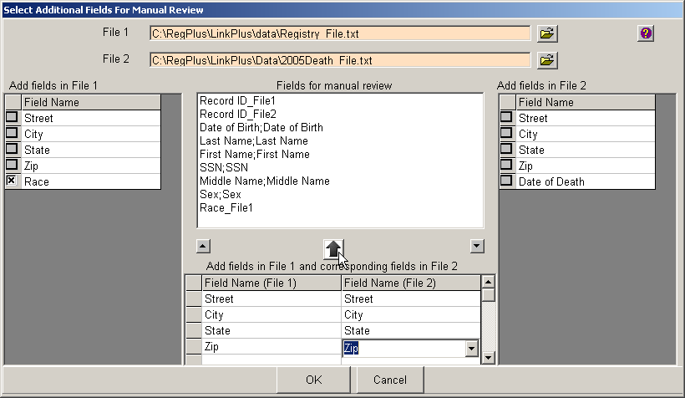
- Click on the button above the grids.
Result: The fields of Street, City, State, and Zip are added for manual review with the fields from each file to be displayed in the same column for each potential match.
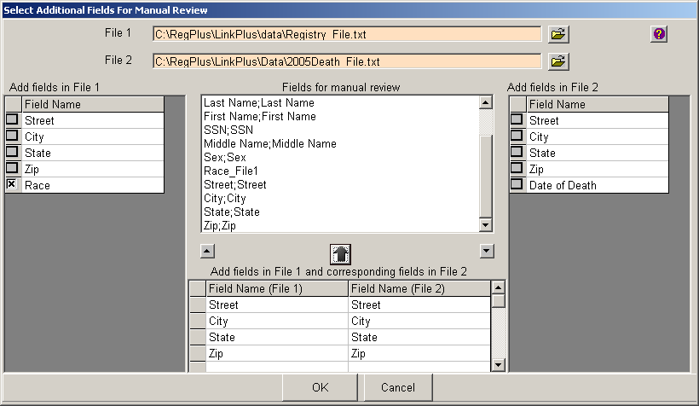
You can also change the order of fields on the manual review list by clicking on a field and using the small up-arrow and down-arrow to move the field up or down in order. This is the order in which the columns will be presented for manual review.
- Select the Race_File1 field on the Fields for manual review list, and click on the down button until the Race_File1 field is the last field on the list.
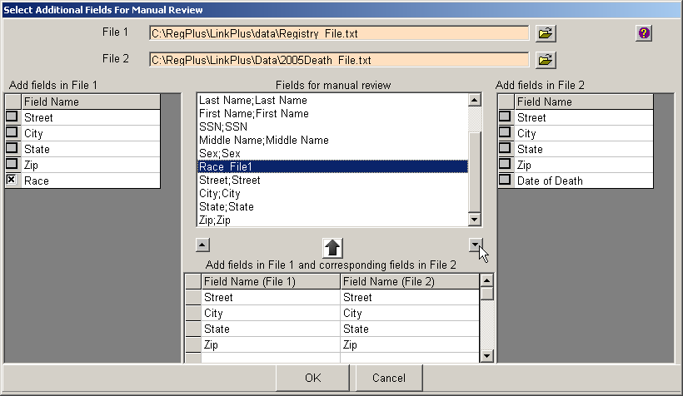
- Click OK.
Result: The manual review screen opens for the ExternalLink.txt linkage report, with the fields and columns ordered as you specified.
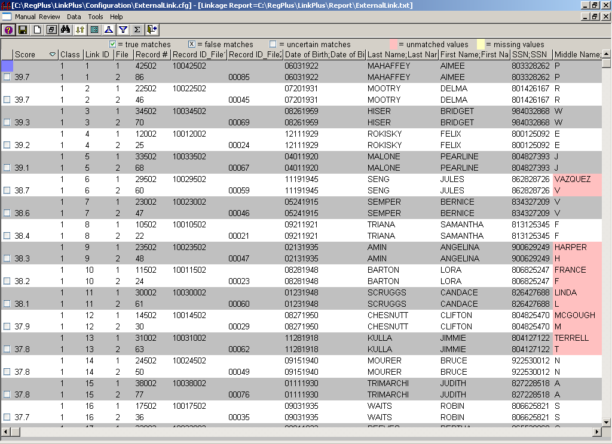

Manual Review Screen Menu Items
From the main Manual Review screen, you can access the menu items for the Link Plus manual review process. Click on a menu item option to perform the specified function for the option. The below table describes the menu options on the main Manual Review Screen:

Menu Item | Sub-option | Tool Bar Icon | Function
Manual Review  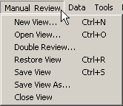 | New View… | 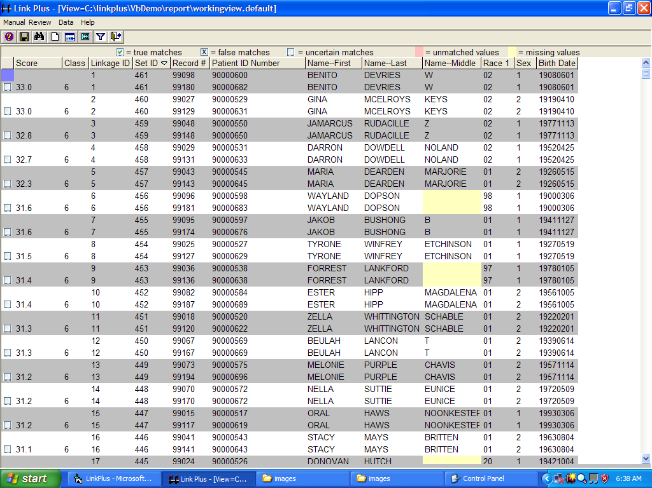 | Create a view from a linkage report
 | Open View… |  | Open an existing view
 | Double Review… |  | Create a view from two views to resolve the differences in assigned match statuses
 | Restore View |  | Open the most recent view
 | Save View |  | Save the current view
 | Save View As… |  | Save the current view under a new name
 | Close View… |  | Close the view
Data  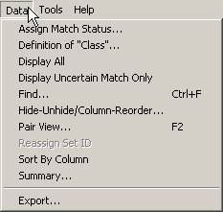 | Assign Match Status… |  | Assign match status based on score
 | Definition of “Class”… |  | Open the form where coding of the “class” category can be viewed
 | Display All |  | Display all pairs for review regardless of match status
 | Display Uncertain Match Only |  | Hide all pairs that have been assigned a match status of true or false, displaying only uncertain matches for review
 | Find |  | Find a word within a column
 | Hide-Unhide/Column-Reorder |  | Hide and unhide columns and change the order of columns
 | Pair View… |  | View the current comparison pair in Pair View mode rather than Datasheet mode
 | Reassign Set ID |  | Reassign Set ID - for deduplication linkages only - Set ID is an unique number assigned to each group of duplicated records and may be manually reassigned
 | Sort By Column |  | Sort the data displayed on the manual review screen in ascending/descending order
 | Summary… | 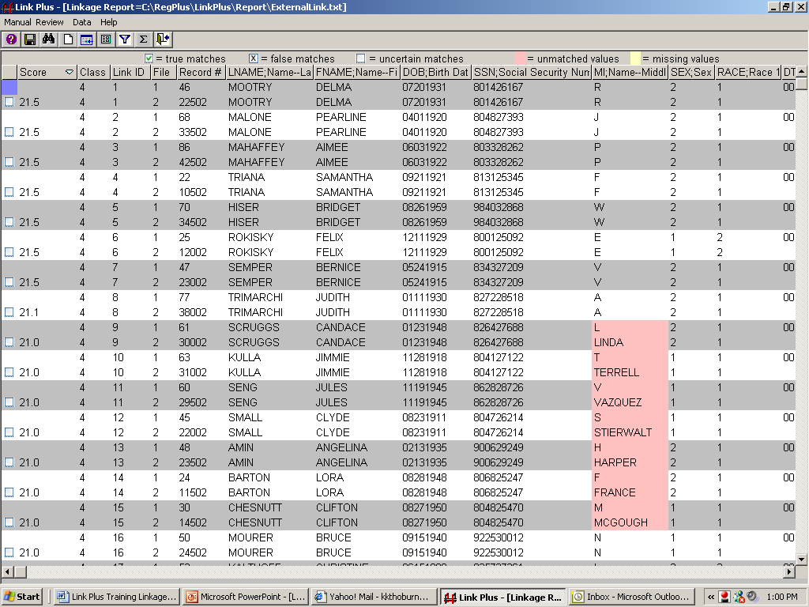 | Display summary information regarding the total number of true matches, false matches, and uncertain matches for the current review session
 | Export |  | Open the merged file export dialog box
Tools  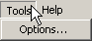 | Options… |  | Manual Review Tab: Specify color scheme for manual review screen  Export Tab: Specify merged export file delimiter, and exported match status  Data Link Tab: Specify CRS Plus User
Help  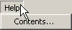 | Contents… |  | Open Link Plus online Help

The Datasheet View
For the manual review of uncertain matches, the default view for comparison pairs is the Datasheet View, where comparison pairs are sorted together and displayed in alternating rows of white and gray colored background. For each comparison pair, in addition to the variables chosen for matching and manual review, Link Plus generates the following:
Score/Identifier | Description
Score | For a comparison pair, the overall weight across all matching variables; a higher score means a higher likelihood of being a match
Class | Each comparison pair is assigned to a “class” category, which is defined by which matching variables the pair matches exactly on; e.g., Class 1 by default is defined by a perfect match on SSN, Birth Date, First and Last Names
Link ID | Unique number assigned to each linked pair
File | For a comparison pair, the File number identifies which file (File 1 or File 2 ) the record in the comparison pair originated from
Set ID | For deduplication linkages only - Set ID is a unique number assigned to each group of duplicated records because a record may have multiple duplicates; Set ID may be reassigned after assignment of match status has been completed
Record # | Record # is the sequential line (row) number for a record in its data file; e.g., the Record # of the record in the first line of a data file is 1

Definition of Class
Link Plus assigns each comparison pair to a “class” category, defined by which of the matching variables of SSN, Birth Date, First and Last Names that the pair matches exactly on. For example, Class 1 by default is defined by a perfect match on SSN, Birth Date, First and Last Names. You may want to sort on Class to sequentially work on groups of similarly matching comparison pairs.
Class category definitions may be viewed by the user. To view Class definitions, complete these steps:
- Click on Data from the main menu, and then click on Definition of “Class”…
Result: The Coding for Class dialog box opens.
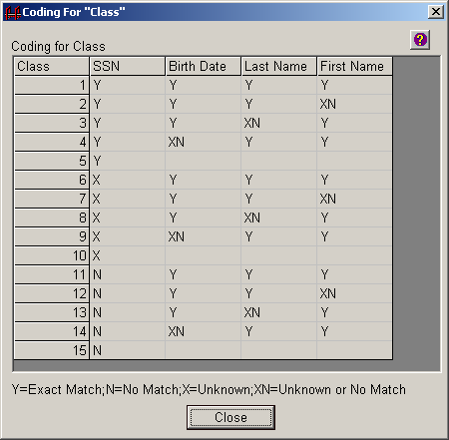
- View the definitions, which use the Y, N, X, and XN coding convention shown.
Within comparison pairs, the record from File 1 is listed first, and the column headers for the variables selected for matching are displayed in a File 1;File 2 format. In addition, unmatched and missing values for matching variables are highlighted in pink and yellow, respectively.
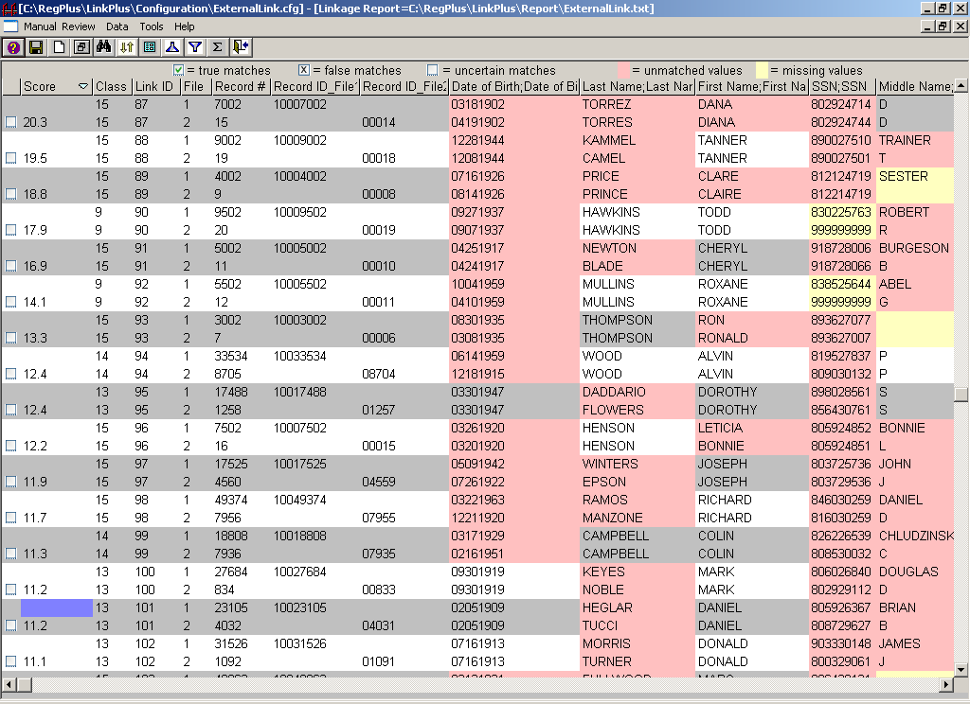

Sorting, Hiding, Re-Ordering, Re-Sizing and Re-Formatting Columns
The Datasheet View is highly customizable. While working in manual review, individual columns may be sorted, hidden/unhidden from view, and re-sized. In addition, the order of the columns on the review screen may be modified at any time.
Sorting Columns
The data within the Datasheet View may be sorted by any individual column, in either of two ways:
- Right-click on the column to select it. For today’s exercise, right-click on the Score column. Select the Sort sub-option.
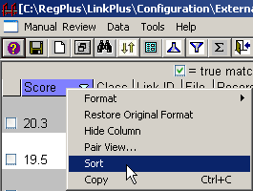
Result: The data, originally sorted by ascending score, are sorted in order of descending score.
- Select the Score column again, and click on the icon.
Result: The data are sorted back in order of ascending score.

Hide-Unhide/Reorder Columns
To hide, unhide, or re-order columns within the Datasheet View complete these steps:
- Click on the Data menu item and select the Hide-Unhide/Column-reorder option.
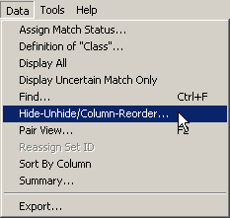

Result: The Hide-Unhide/Reorder Columns dialog box opens.
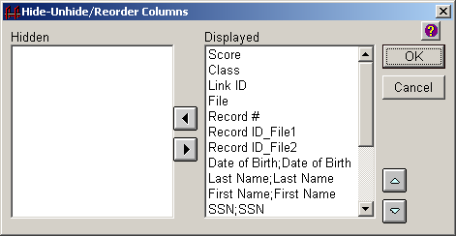
The Hide-Unhide/Reorder Columns dialog box contains two main sections, the Hidden box on the left and the Displayed box on the right. The Hidden box lists the columns you have selected to hide from view, while the Displayed box lists those that you have selected to view.
The Hide-Unhide/Reorder Columns dialog box enables you to control which columns are displayed for manual review by using the Left and/or Right arrow buttons between the Hidden and Displayed list boxes to move columns between the two lists.
A column may also be hidden from view by right-clicking on the column, and selecting the Hide Column option.
The dialog box also enables you to change the order of the displayed columns. Select the column name from the list in the Displayed box and use the light blue Up and/or Down arrow buttons to the right of the Displayed list box to move the column up or down in order.
- Click on Record #, and then click the left arrow button.
Result: The Record # column is moved to the list of hidden columns.
- Click OK.
Result: Link Plus returns to the main manual review screen, with the Record # column hidden from view.

Re-sizing Columns
To re-size any column on the Datasheet View, left-click and hold on the divider between any two column headers, and pull to the right or left to change the column width.

Re-formatting Columns
Link Plus allows the user to re-format columns containing dates, phone numbers, Zip code +4 codes, or social security numbers.
Format | Description
Date (mm/dd/yyyy) | Re-formats the data in the selected column to MM/DD/YYYY
Date (yyyy/mm/dd) | Re-formats the data in the selected column to YYYY/MM/DD
Phone Number | Re-formats the data in the selected column to (###)###-####
Zip Code +4 | Re-formats the data in the selected column to #####-####
Social Security Number | Re-formats the data in the selected column to ###-##-####
- Right-click on the SSN;SSN column, select Format, and then select the Social Security Number format.
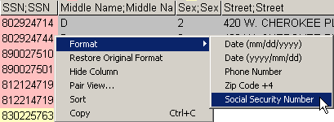
Result: The data is the column is re-formatted to the specified format.
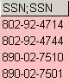
- To restore the data to its original format, right-click on the SSN;SSN column, and select Restore Original Format.
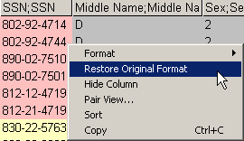
Result: The data is the column is re-formatted back to the original format.
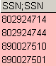

Customizing the Color Scheme
The default colors for the manual review screen are gray and white for alternating pair rows, pink for unmatched values, and yellow for missing values. This color scheme is fully-customizable.
To modify the colors for alternating pair rows, unmatched and missing values, complete these steps:
- Click on the Tools menu item, and select Options…
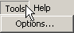
Result: The Options dialog box opens, with the Manual Review tab selected.
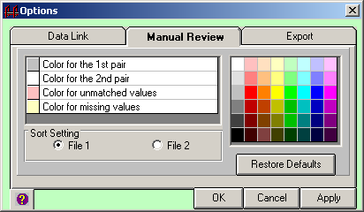
- To change any of the colors, select the color you would like to change from the box on the left (1st pair, 2nd pair, unmatched values, missing values) and then select the color of your choice from the color selection box on the right. Select Color for the first pair, and then select the third green box from the top.
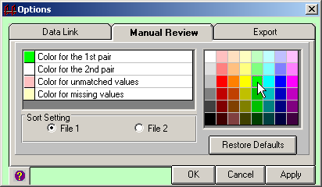
Result: The Color for the first pair changes from gray to green in the box on the left.
- Click Apply.
Result: The color selection has changed on the manual review screen.
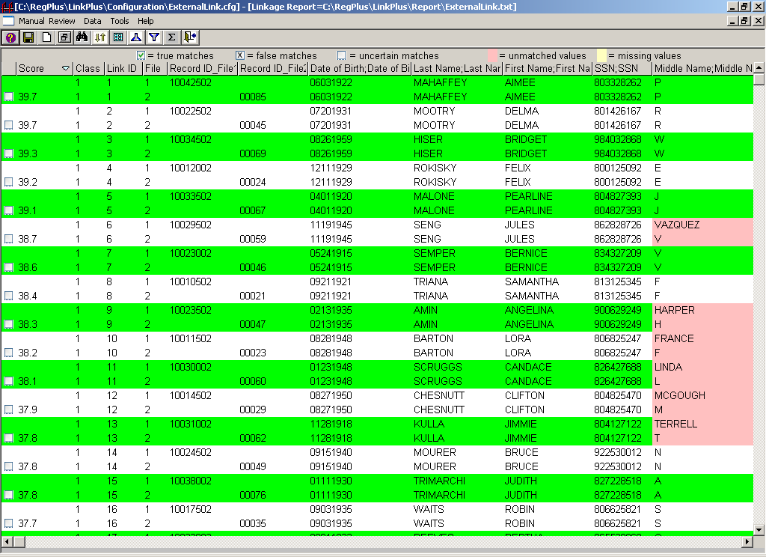
- Click on the Tools menu item, and select Options…
- Change the Color for the 1st pair back to medium gray (3rd gray box from top).
- Click Apply.
Result: The color selection has changed back to gray on the manual review screen.

Manually Assigning Match Status
Match status can be assigned manually by using the mouse to click in the Match Status check box, or by using the keyboard.

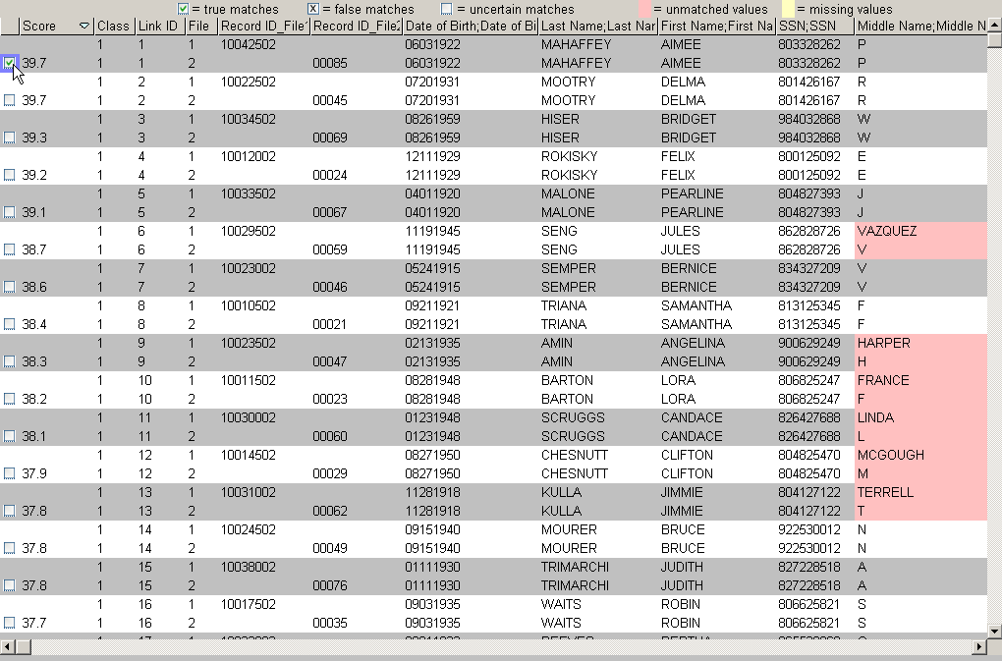
Assigning True Match Status: For the comparison pair being reviewed place the cursor in the Match Status check box and left-click the mouse once, or press the “M” key to select the current pair as a true match and move on to review the next comparison pair.
Assigning False Match Status: For the comparison pair being reviewed place the cursor in the Match Status check box and left-click the mouse twice, or press the “N” key to select the current pair as a false match and move on to review the next comparison pair.
Assigning Uncertain Match Status: For the comparison pair being reviewed place the cursor in the Match Status check box and left-click the mouse three times, or press the “B” key to select the current pair as an uncertain match and move on to review the next comparison pair.

Assigning Match Status Automatically by Score
When a linkage is run, Link Plus saves all potential matches that generated a score above the specified Cut Off Value in the linkage report. When the linkage report is opened for manual review, all potential matches will be presented for review, even those that generated high scores and are almost certain to be matches, and (depending on the Cut Off Value specified) those that generated low scores and are almost certain to be false matches. With practice, after initial review of the list of comparison pairs it is often easy to identify an upper cut off score above which all pairs are true matches, and a lower cut off score below which all pairs are false matches. The remaining pairs are said to be in the “gray area”; uncertain matches requiring manual review.
Rather than having to individually assign the match status to each comparison pair manually, Link Plus offers the option to automatically assign match status for groups of pairs by their linkage score.
To assign match status automatically by score, complete these steps:
- Click on the Data menu item, and select the Assign Match Status… option.
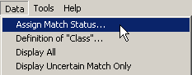
Result: The Assign Match Status dialog box opens.
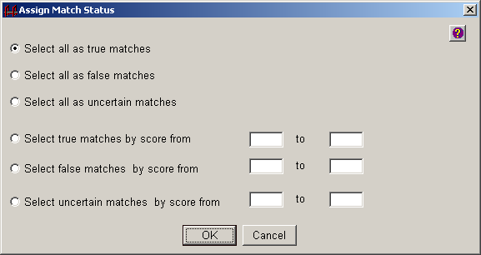

The Assign Match Status dialog box offers the following options:
Option | Description
Select all as true matches | Selecting this button will assign a true match status to all comparison pairs in the current view
Select all as false matches | Selecting this button will assign a false match status to all comparison pairs in the current view
Select all as uncertain matches | Selecting this button will assign an uncertain match status to all comparison pairs in the current view
Select true matches by score | Selecting this button will assign a true match status to all comparison pairs that have a score in the range specified in the from and to boxes
Select false matches by score | Selecting this button will assign a false match status to all comparison pairs that have a score in the range specified in the from and to boxes
Select uncertain matches by score | Selecting this button will assign an uncertain match status to all comparison pairs that have a score in the range specified in the from and to boxes
- Click Cancel.
- Review the comparison pairs, and attempt to identify a match score above which all comparison pairs are true matches.
- Click on the Data menu item, and select the Assign Match Status… option.
- Click on Select true matches by score from, enter the upper score you have identified in the first box, enter 100 in the second box, and then click OK.
Result: The manual review screen re-opens with the specified match statuses assigned.

Display Uncertain Matches Only
While performing manual review, some users may prefer to view only the uncertain matches, and have those pairs that have been assigned a match status of true and false hidden from view.
The manual review screen can be restricted to display only uncertain matches in two different ways:
- Click on the Data menu item, and select the Display Uncertain Match Only option.
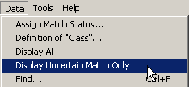
Result: Only uncertain matches will be displayed for review, and those pairs that have been assigned a match status of true and false are hidden from view.
- Click on the Display Only Uncertain Matches icon on the tool bar.
You can return to a view that displays all matches in two different ways as well:
- Click on the Data menu item, and select the Display All option.
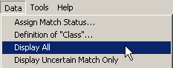
Result: All matches will be displayed for review, regardless of match status.
- Click on the Display All Matches icon on the tool bar.

The Pair View
While performing manual review, some users may prefer to view the comparison pairs individually rather than within the Datasheet View. For these users, Links Plus offers the Pair View, which provides a side-by-side comparison of the two records being currently reviewed.
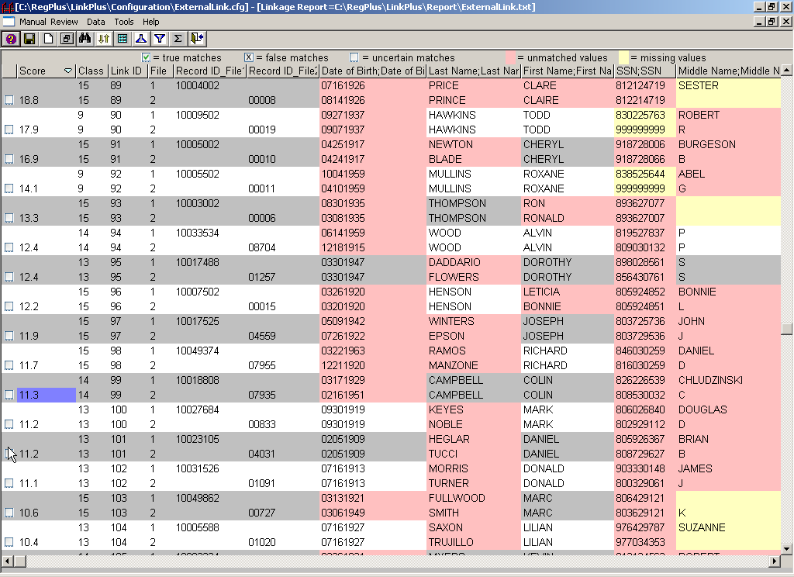

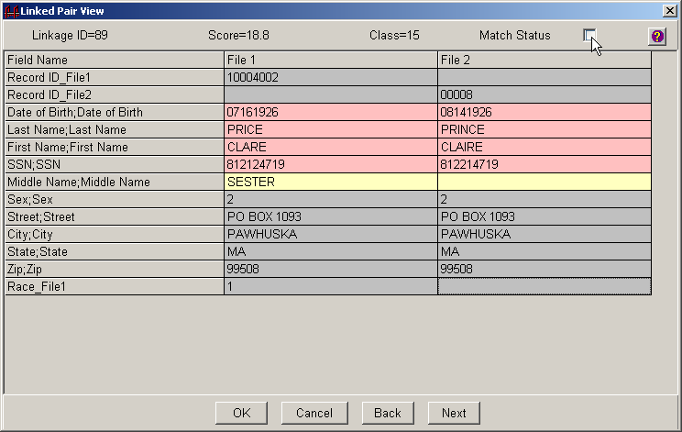
When working in the Pair View, match status can be assigned by using the mouse to click in the Match Status check box, or by using the keyboard.
Assigning True Match Status: Place the cursor in the Match Status check box and left-click the mouse once, or press the “M” key to select the current pair as a true match.
Assigning False Match Status: Place the cursor in the Match Status check box and left-click the mouse twice, or press the “N” key to select the current pair as a false match.
Assigning Uncertain Match Status: Place the cursor in the Match Status check box and left-click the mouse three times, or press the “B” key to select the current pair as an uncertain match.
You can navigate between comparison pairs in the Pair View by clicking the Back and Next buttons.
You can open the Pair View for a comparison pair in four different ways. With the current record selected in the Datasheet View:
- Click on the Pair View Icon on the tool bar.
- Right-click anywhere on the manual review screen, and select the Pair View…option.
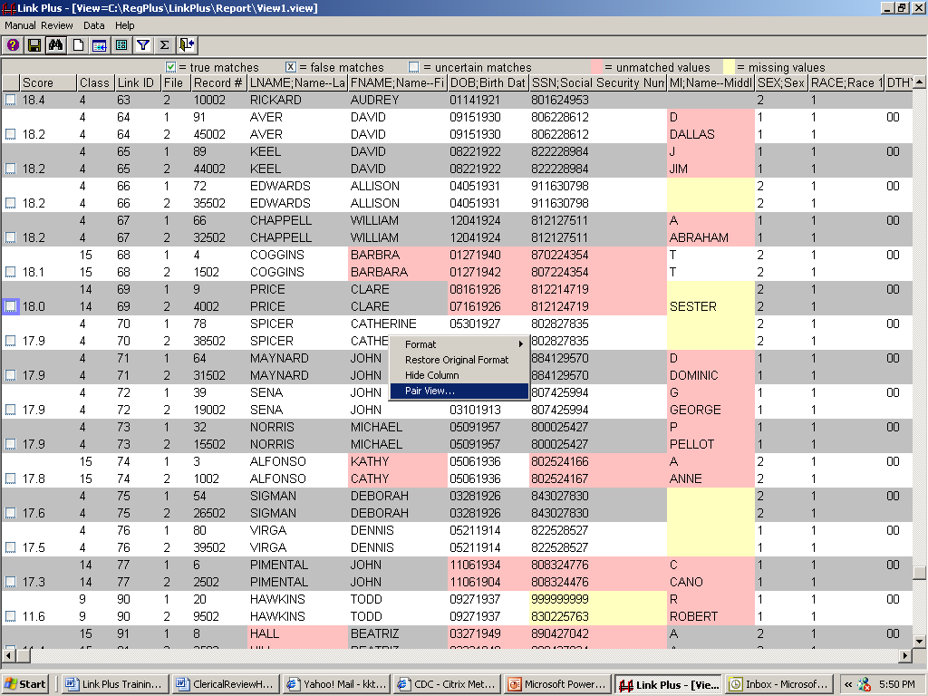
- Click on the Data menu item, and select the Pair View… option.
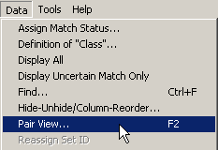
- Press the F2 key.
- Regardless of the way you opened the Pair View, for now, click Cancel to return to the Datasheet View.

Viewing Summary Information
Over the course of the manual review process, and upon its completion, you may want to view summary information regarding the total number of comparison pairs, true matches, false matches, and uncertain matches (as well as these totals for the pairs that are displayed) for the current review session. Link Plus keeps track of this summary-level information, and displays it upon command.
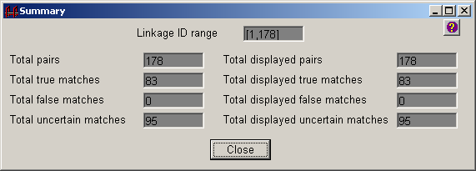
Summary information may be viewed in two different ways:
- Click on the Data menu item, and select the Summary option.
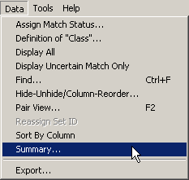
- Click on the Summary icon on the tool bar.
- View the summary information and click Close.

Using the Search Feature
During the manual review process, you may want to find a word within one of the data columns. Link Plus provides a search feature that allows you to do so.
The manual review search feature can be opened in three different ways:
- Click on the Data menu item, and select the Find option.
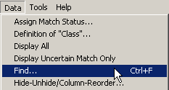
- Click on the Find icon on the tool bar.
- Press Ctrl+F on the keyboard.
Result: The Find dialog box opens.
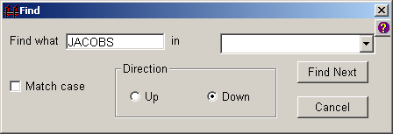
- Enter the word JACOBS in the Find what box.
- Select the Last Name;Last Name column from the pull-down list.
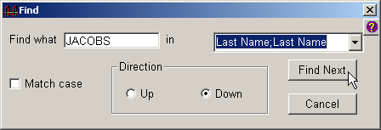
- Select the Down search direction button, and click Find Next.
Result: Link Plus highlights the first occurrence in the down direction of the search term JACOBS in the Last Name;Last Name column.
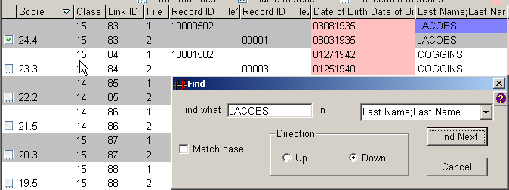
- Click Cancel.

Saving and Re-opening Review Sessions
Any review session may be saved as a .view file, and re-opened to at a later time. It is recommended that you save the view periodically throughout the manual review process, and upon completion of review, to save your match status assignments.
To save this review session, complete these steps:
- Click on the Manual Review menu item and select the Save View As… option.
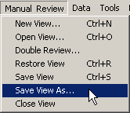
Result: The Save View dialog box opens.
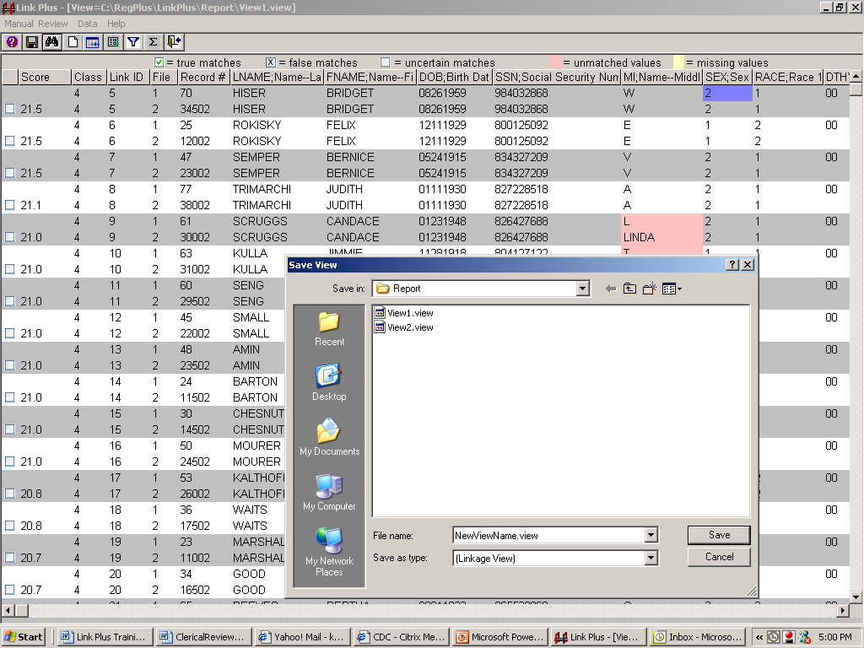
- Enter NewViewName.view in the File name box.
- Click Save.
To re-open a saved review session, complete these steps:
- Click on the Manual Review menu item and select the Open View option.
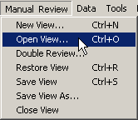
Result: The Open Linkage View File dialog box opens.
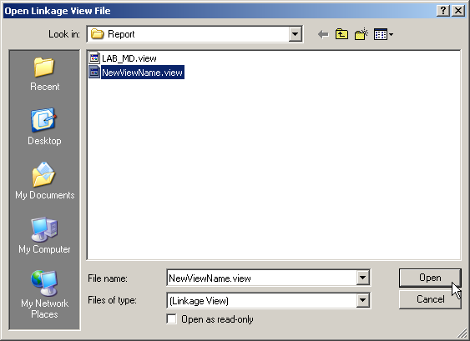
- Click on the NewViewName.view file and click Open.
Result: The manual review screen opens with the linkage view displayed.

Independent Manual Review
Using the information you have just learned about the manual review screen, take some time and resolve a few matches on your own, making sure to view the summary information at least once.
Feel free to modify the screen layout as desired – re-order, re-size or hide columns, change the color scheme, or view the comparison pairs in Datasheet or Pair View. Take note of comparison pairs with Link IDs of 83 and 93 to see examples of how the Link Plus First Name Matching Method links records with nicknames and full names.

Assigning Final Match Statuses
To assign the final match statuses for today’s external linkage exercise automatically by score, complete these steps:
- Click on the Data menu item, and select the Assign Match Status… option.
Result: The Assign Match Status dialog box opens.
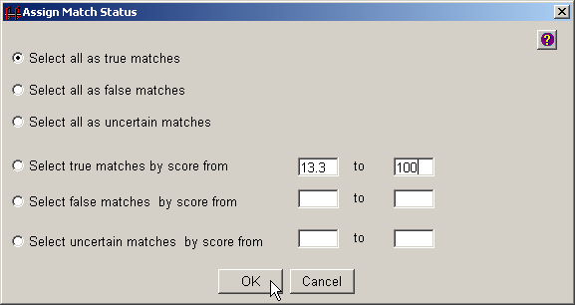
- Click on Select true matches by score from, enter 13.3 in the first box, enter 100 in the second box, and then click OK.
Result: The manual review screen re-opens with the specified match statuses assigned.
- Click on the Data menu item again, and select the Assign Match Status… option a second time.
Result: The Assign Match Status dialog box opens.
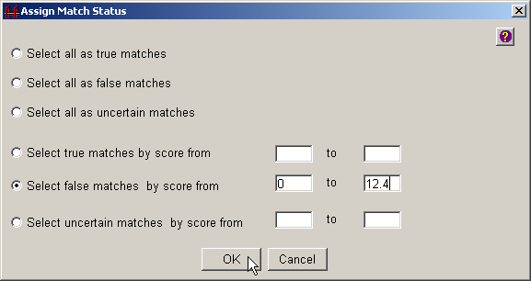
- Click on Select false matches by score from, enter 0 in the first box, enter 12.4 in the second box, and then click OK.
Result: The manual review screen re-opens with the specified match statuses assigned.

Step 15: Export Merged File
Once you have completed your manual review of the potential matches presented for review, and have assigned a match status to them (either manually by clicking, or via the Data…Assign Match Status option), you will want to export a merged file. Link Plus offers the export of the merged file in a text file in delimited file format, and allows you to specify what file delimiter you would like to use, and what match status(es) you would like to export.
To set the export file format option and export a merged file, complete these steps:
- Click on the Tools menu item, and select Options…
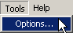
Result: The Options dialog box opens, with the Manual Review tab selected.
- Click on the Export tab.
Result: The Export Options dialog box opens.
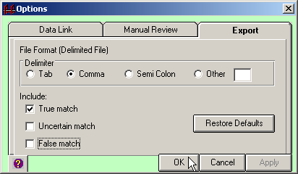
- To set the export file format option to comma-delimited, click on Comma.
- Unclick the Uncertain Match and False Match under Include, and then click OK.
Result: The export file format has now been set to a comma-delimited file format, and when the data are exported, only records assigned a match status of true will be exported.
- To export the file, click on the Data menu item, and click on Export…
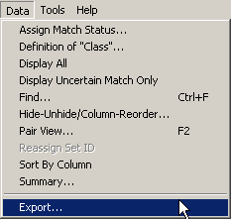
Result: The Export Setting dialog box opens.
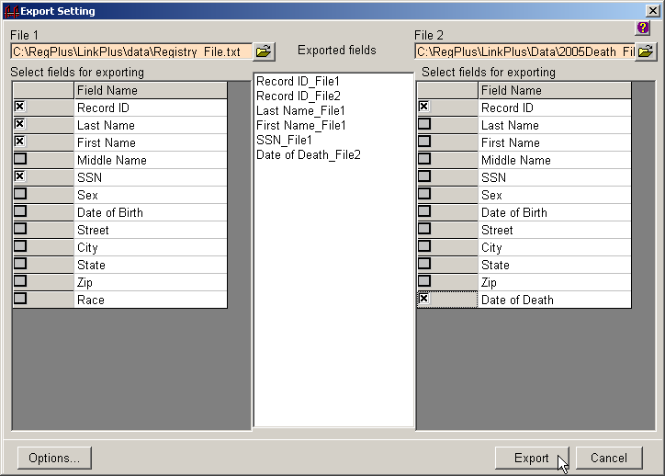
- Select the fields from File 1 and File 2 that you would like in your merged export file by clicking the box in the column to the left of the data field. Click the fields in the order in which you would like them listed in the export file.
- Click on the Export button.
Result: A window opens where you can specify a name for the exported merged file, and location on your PC or on a shared network folder where you would like to save the file. The default location for exported files within Link Plus is the C:/RegPlus/LinkPlus/Export folder.
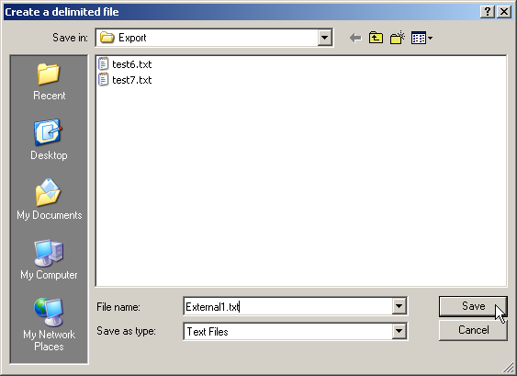
- In the File name box, type External1.txt, and click the Save button.
Result: A comma-delimited merged file (named External1.txt) of records with true match status, with the data fields you selected (in the order you selected them) is generated and placed in the C:/RegPlus/LinkPlus/Export folder. In addition, Notepad will open with a view of the merged file.
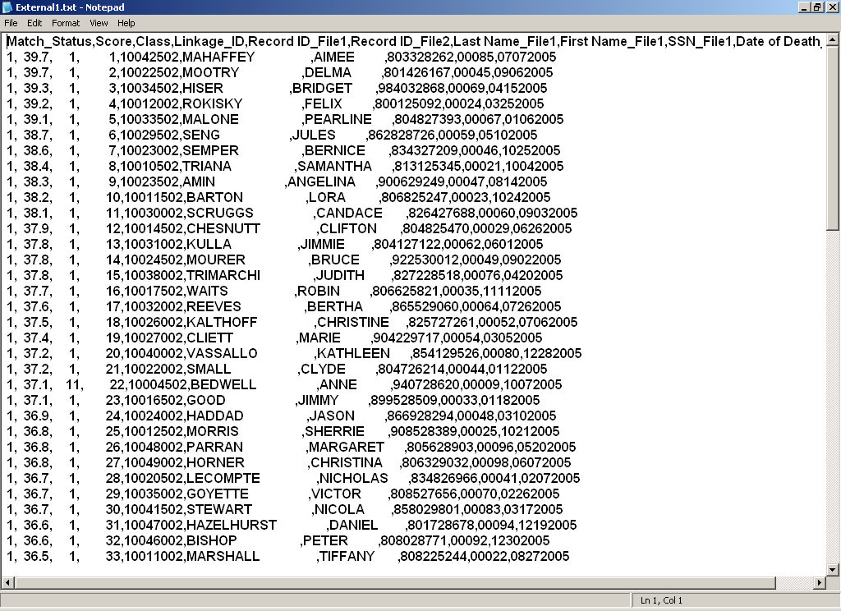
If you are having trouble viewing the information in this file, you can adjust the font size and turn off the Word Wrap option under the Format menu in Notepad.
This file can be easily imported into Microsoft Excel.
- Close out of Notepad and click Cancel on the Export Setting dialog box to return to the manual review screen.
- Click on the Manual Review menu item, and select the Close View option.
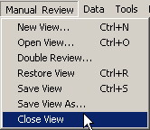
Result: The main Link Plus window opens.

Deduplication Linkage Exercise

About the Data
Today’s deduplication linkage exercise will involve linking a cancer registry data file to itself in order to identify duplicate records.
Simulated Cancer Registry Records
The data file dupdelimdemofile.txt is a tab-delimited data file containing 99,202 simulated cancer registry patient records.
Linkage Results
158 records on the cancer registry data file potentially match themselves and are potential duplicates; these records are presented for manual review.

Beginning the Deduplication Exercise
Our external linkage exercise involved linking two fixed width files together. For today’s deduplication linkage exercise, we will be linking a tab-delimited file to itself. The steps required to configure a linkage for delimited files is the same for those for fixed width files, with the exception of the file import process. Within the file import process, the assignment of variable names is slightly different. Rather than entering the variable names and positions, you first specify the file delimiter, and then assign the variable names from pull-down menus.

File Import for Delimited Files
To become familiar with the import process for delimited files, complete these steps:
- Click on the File menu option, select New Deduplication, and select Delimited File.
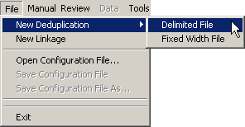
Result: The Link Plus Deduplicating Configuration window opens.
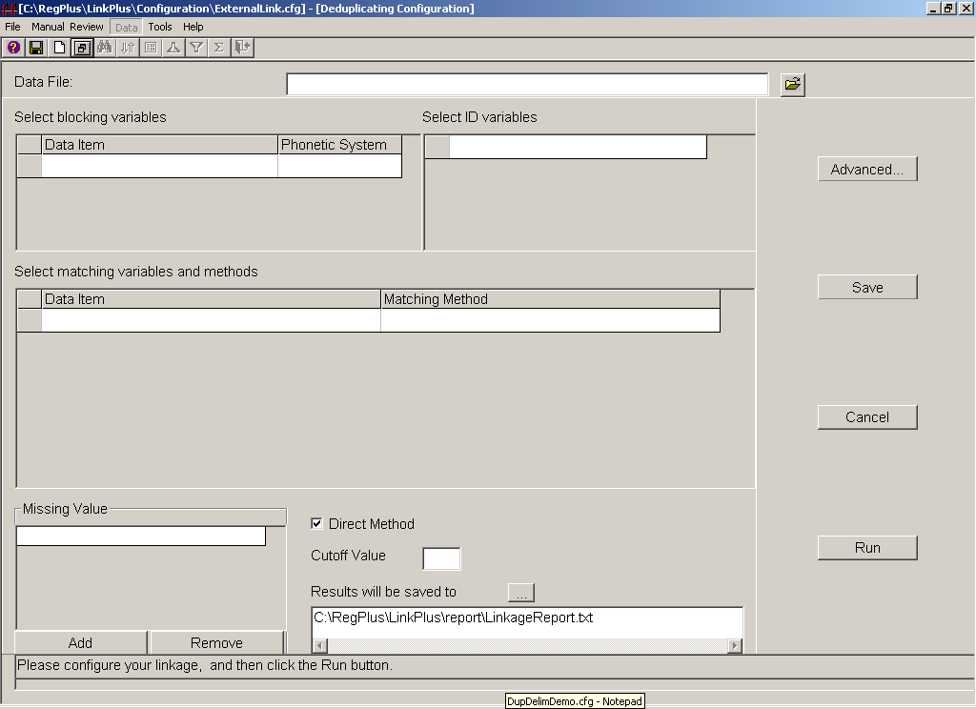

Click on the folder icon to the right of the Data File input box.
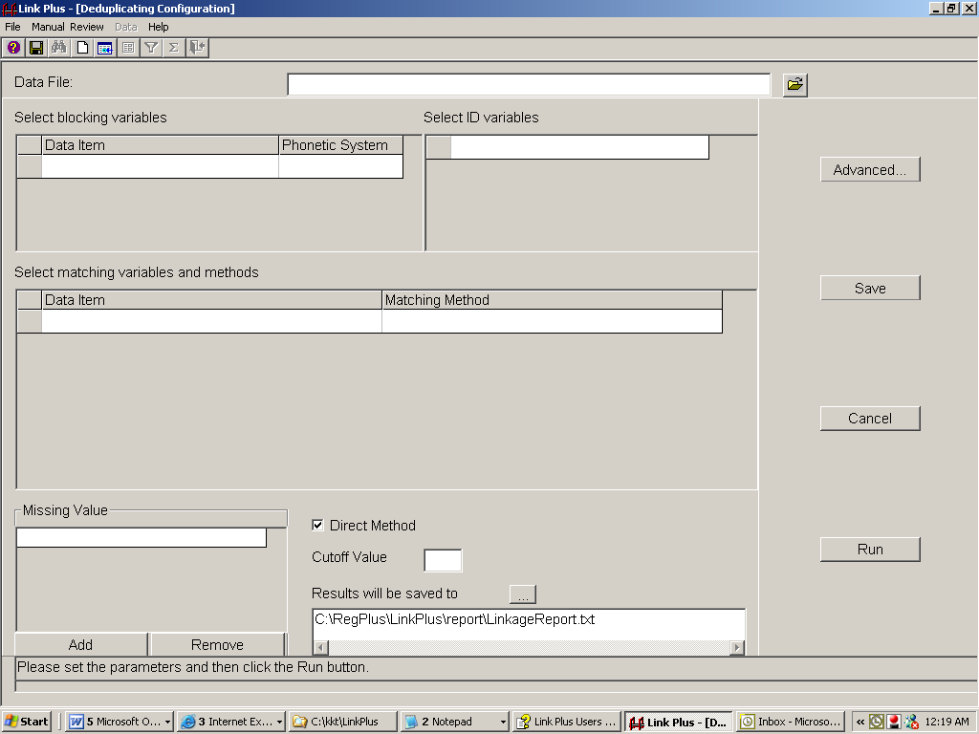
Result: The Open Data File dialog box opens.
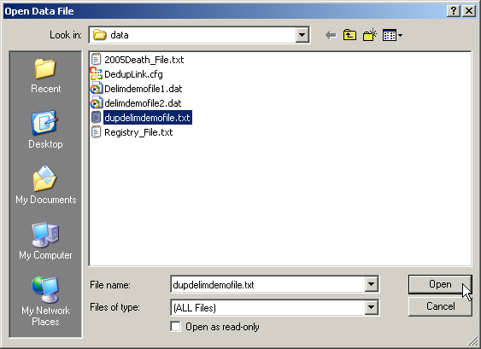
- Click on the dupdelimdemofile.txt file, and click the Open button.
Result: The Data Import Form for Delimited File opens.
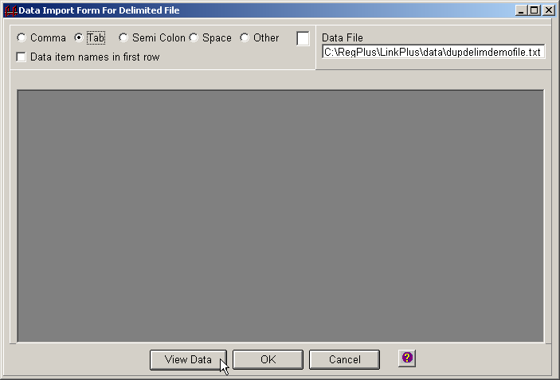
- The data file, dupdelimdemofile.txt is a tab-delimited file; click on Tab, and then click View Data.
Result: The data are displayed correctly in their proper columns, but without variable names.
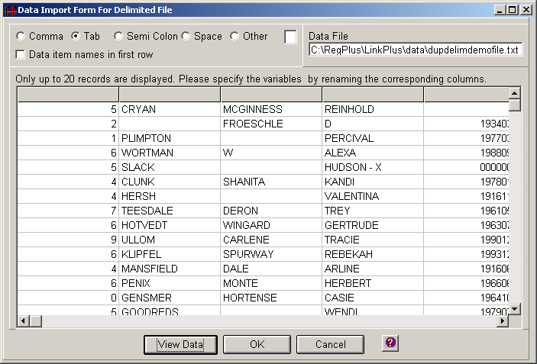
- Click on the column header of the second column.
Result: A pull-down menu appears.
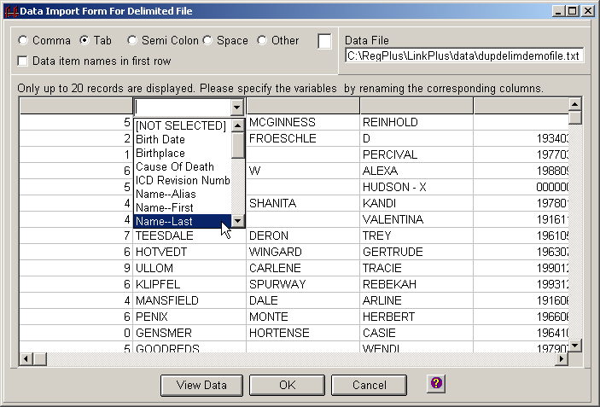
- Select Name—Last from the pull-down menu to label the second column.
- Click on the column header of the third column, and select Name—Middle from the pull-down menu to label the third column.
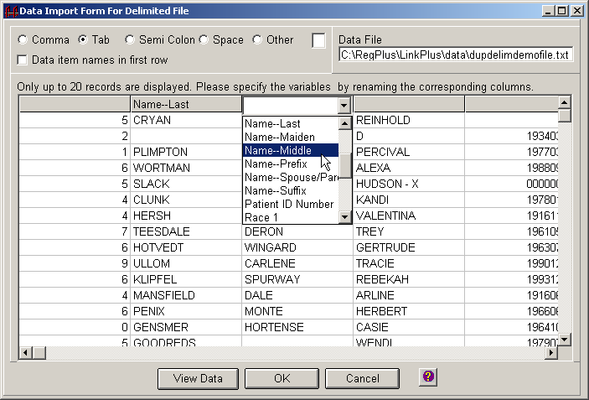
You would continue to label columns in this manner until all of the desired columns are labeled, and then click on OK. Link Plus would then return to the Link Plus Deduplicating Configuration window, where you would complete the linkage configuration.
- Click Cancel.

Opening Previously-saved Linkage Configuration Files
Often Link Plus users need to run the same linkage multiple times, with minor variations in the linkage configuration, such as different data files or Cut Off Values. As you saw in today’s external linkage exercise, Link Plus allows the user to save a linkage configuration file, so it may be opened and used again at a later time (with or with out modifications to the configuration).
For today’s deduplication linkage exercise, we will be opening a previously-saved linkage configuration file, called DupDelimDemo.cfg. To open this configuration file, complete the following steps:
- Click on the File menu option, and select Open Configuration File…
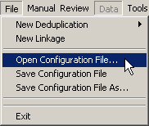
Result: The Open Configuration File dialog box opens.
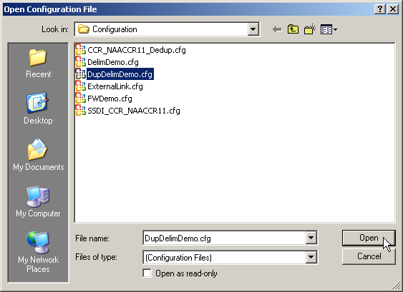
- Click on the DupDelimDemo.cfg file, and click the Open button.
Result: The Deduplication Configuration window opens, with the previously-saved parameters for the linkage specified.
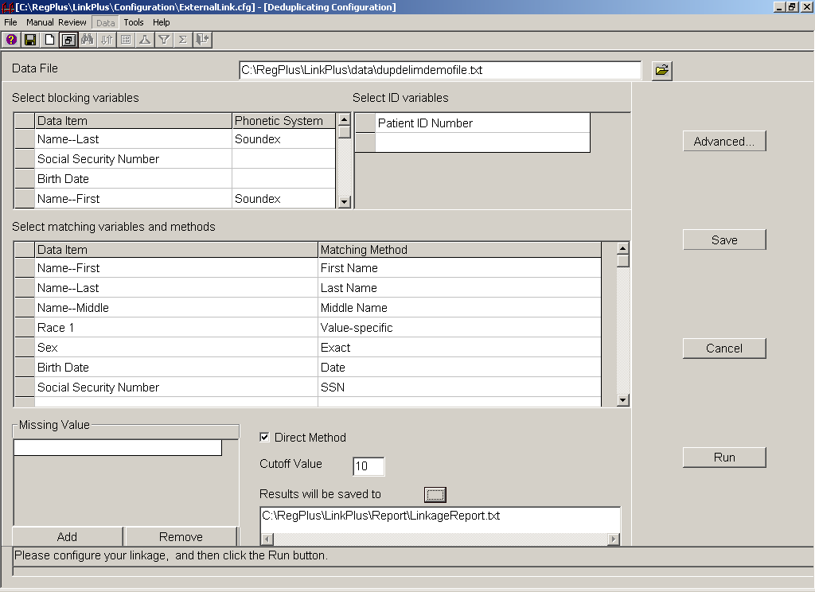

Review of Deduplication Linkage Steps
- Select Data Type for Data File
- Locate/Identify Data File
- Data Import for Data File
- Select Blocking Variables & Phonetic System
- Select Matching Variables & Matching Methods
- Select ID Variables
- Define Missing Values
- Select Direct/EM Method
- Enter Cut-off Value
- Specify Linkage File Name and Location
- Perform Manual Review of Uncertain Matches
- Export Merged File

Step 1: Select Data Type for Data File
As you have just seen, when you select a new deduplication linkage from the file menu, you specify the data type for the file at the same time. The linkage configuration that we opened, DupDelimDemo.cfg, has the data type of delimited previously specified, so at this point Link Plus knows the data type is tab-delimited.

Step 2: Locate/Identify Data File
For deduplication linkages, only one data file is selected. The data file specified for the DupDelimDemo.cfg linkage configuration file is the same dupdelimdemofile.txt file that we just practiced labeling the column headers on, and has already been identified for the configuration.

Step 3: Data Import for Data File

All of the desired data column headers have been labeled for the tab-delimited dupdelimdemofile.txt data file, and saved with the linkage configuration. To view or modify the data column labels saved for the DupDelimDemo.cfg configuration, complete these steps:

Click on the folder icon to the right of the Data File input box.
Result: The Open Data File dialog box opens.
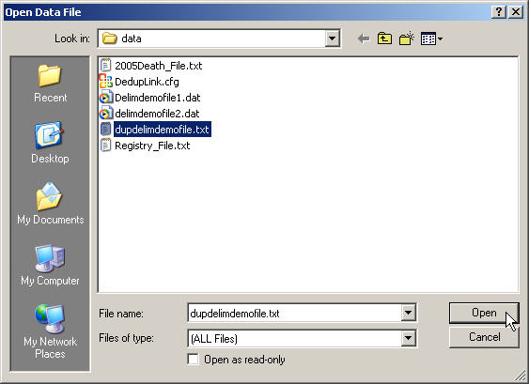
- Click on the dupdelimdemofile.txt file, and click the Open button.
Result: The Data Import Form for Delimited File opens. Note that tab-delimited is specified, and that all of the columns of data to be used in the linkage are labeled.
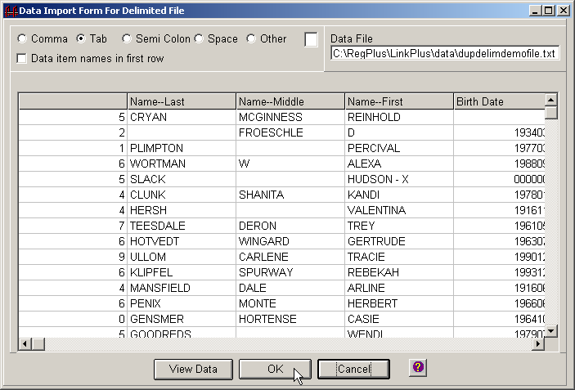
- Click on OK.
Result: The application returns you to the Deduplicating Configuration window.

Step 4: Select Blocking Variables & Phonetic System
Blocking variables and respective phonetic systems (where applicable) are also saved in linkage configuration files. Using the drop-down menus for the Data Item and Phonetic System columns, the following blocking variables and phonetic systems have been specified for the DupDelimDemo.cfg linkage:

Data Item | Phonetic System
Name--Last | Soundex
Social Security Number
Birth Date
Name--First | Soundex

Step 5: Select Matching Variables & Matching Methods
Matching variables and respective Matching Methods are saved in linkage configuration files. Using the drop-down menus for the Data Item and Matching Method columns, the following matching variables and Matching Methods have been specified for the DupDelimDemo.cfg linkage:
Data Item | Matching Method
Name--First | First Name
Name--Last | Last Name
Name—Middle | Middle Name
Race1 | Value-specific
Sex | Exact
Birth Date | Date
Social Security Number | SSN

Step 6: Define Missing Values
Missing Values and date formats are saved in linkage configuration files. Remember that Missing Values and date formats are specified by clicking on the row of a matching variable in the matching variables grid, clicking the Add button below the Missing Values grid, and entering the values in the grid. You can add up to 5 Missing Values. Missing values can be deleted by clicking the Remove button. The following Missing Values were specified for the DupDelimDemo.cfg configuration:
Matching Variable | Missing Value
Name--First
Name--Last
Name—Middle
Race1 | 99
Sex | 9
Birth Date | Day=99, Month=99, Year=9999, YYYYMMDDD format
Social Security Number | 999999999

Step 7: Select ID Variables
Although Link Plus reports will automatically include Matching Variables, you may want to define other variables to be included in the reports, called ID Variables. Recall that ID Variables, such as Patient ID Number (selected for today’s exercise), are variables used for identifying records. Selection of ID Variables is optional.
To select ID Variables for the data file, you would click in the Select ID variables grid, and select the desired variable(s) from the drop-down list that appears.

Step 8: Select Direct/EM Method
For the purposes of today’s deduplication linkage exercise, we will be using the Direct Method to derive the M-Probabilities used in the linkage. The M-Probability is the probability that a matching variable agrees given that a comparison pair is a match. When the Direct Method box is clicked, default M-Probabilities are used in the linkage. Leave the Direct Method box clicked.
You can click on Advanced to view the default M-Probabilities or define your own.
Un-click the Direct Method box if you prefer Link Plus to compute the M-Probabilities based on your data using the EM algorithm.

Step 9: Enter Cut-off Value
Remember that the Cut Off Value is the score value above which comparison pairs are accepted as potential links and presented for manual review. For the purposes of today’s deduplication linkage exercise, a Cut Off Value of 10 has been specified.
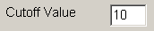

Step 10: Specify Linkage File Name and Location
At the completion of a deduplication linkage run, Link Plus will generate a Linkage Report, named LinkageReport.txt, and store it in the Report folder of the Link Plus directory. The report is a tab-delimited text file, and can be opened with the manual review feature of Link Plus (it also can be opened in a text editor or spreadsheet program). Records are presented in comparison pairs, sorted by their linkage scores in descending order. Pairs with scores above the selected cut off value are listed. The detail row for each record contains all of the matching and ID variables used in the linkage.
You will need to rename the linkage report or it will be over-written the next time you run Link Plus.
To rename the Linkage Report, complete these steps:
- Click on the to the right of Results will be saved to.
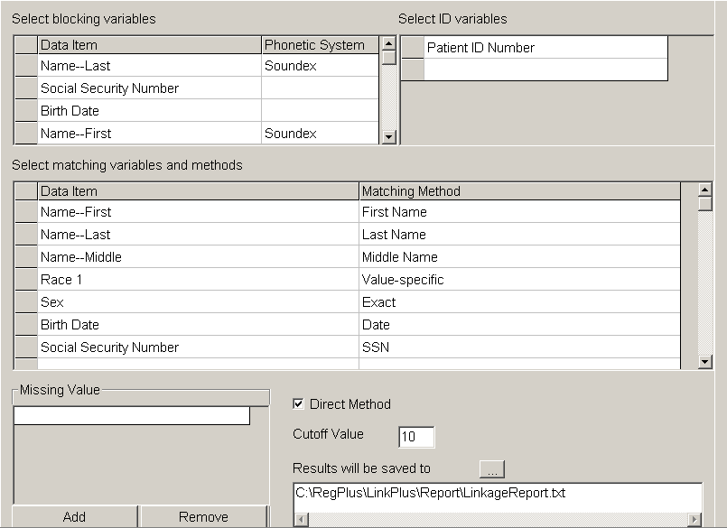
Result: The Save linkage results to the file below dialog box opens.
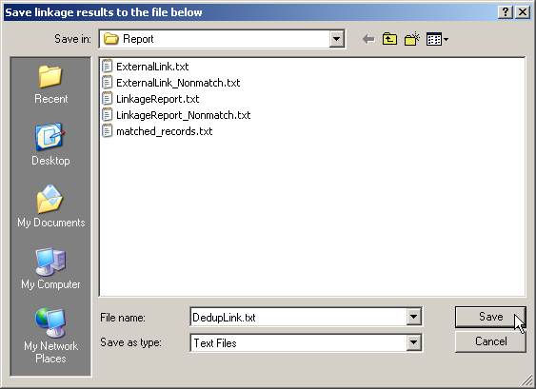
- Enter DedupLink.txt in the File name box, and click Save.
Result: The application returns you to the Deduplicating Configuration window, where the linkage report name has been changed to DedupLink.txt.
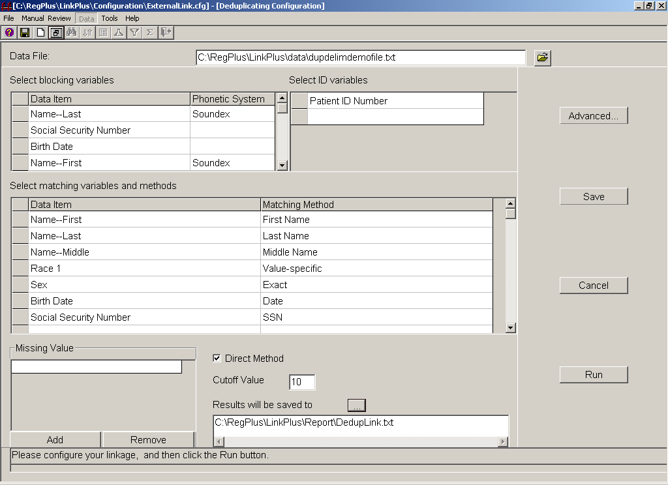
- Click on Save to save the configuration file for this deduplication linkage exercise.
Result: The Save Configuration dialog box opens.
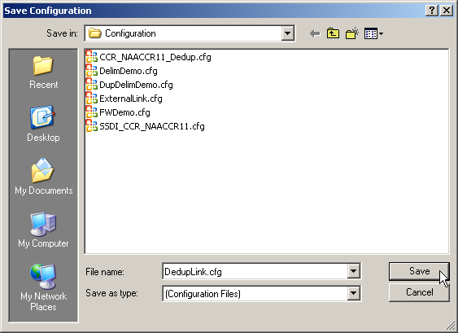
- Enter DedupLink.cfg in the File name box, and click Save.
Result: The application returns to the Deduplicating Configuration window, with a message that the changes to the configuration file have been saved in the DupDelimDemo.cfg file.
- Click Run to run the linkage.
Result: The linkage begins, and the Linkage Process Progress window appears and provides the user with feedback about the linkage process as it is run.
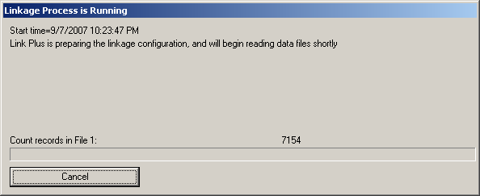
The progress window provides feedback regarding the preparation of the configuration, the reading in of the data files, the blocking of the files, and the calculation of the linkage scores.
When the linkage is complete, the progress window will present the user with the choice of conducting the manual review process directly after the linkage, or closing the progress window, and conducting the manual review process at a later time.

Step 11: Perform Manual Review of Uncertain Matches
To conduct manual review of the potential matches generated by a deduplication linkage, you must either click on Conduct Manual Review Now in the Linkage Process Progress Window at the completion of the linkage:
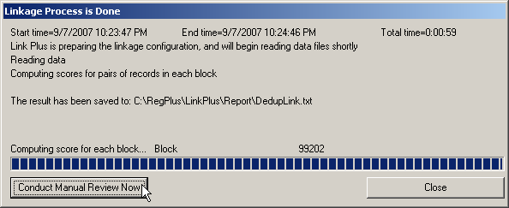
or open the linkage report by clicking on the Manual Review menu item, and click on the New View… option. Either way you open the linkage report, to perform manual review, you will select additional variables for manual review (if desired), and then perform the manual review, assigning a match status to each potential comparison pair.
- Click Conduct Manual Review Now.
Result: The Select Additional Fields for Manual Review dialog box opens.
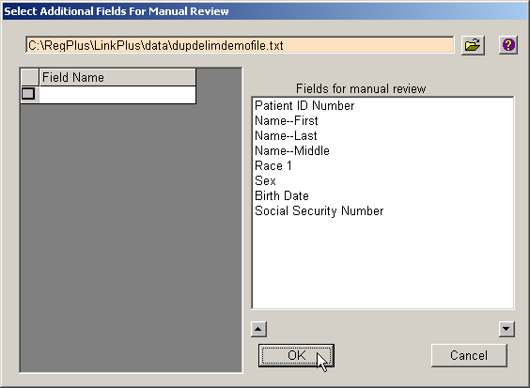
When performing manual review of potential duplicate records, if you would like to view additional fields other than those already chosen for blocking, matching, and ID purposes for the linkage, you can check the boxes on the left grid for the fields you would like to view, and click OK.
Note that for today’s deduplication linkage exercise, all available fields were used for blocking, matching, or ID purposes, so there are no additional fields to be added to the report.
- Click OK.
Result: The manual review screen opens for the DedupLink.txt linkage report.
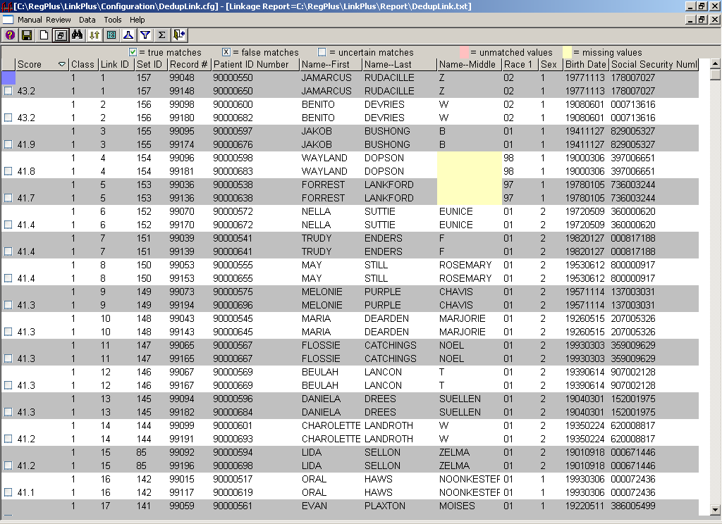
You can fully customize the manual review screen for deduplication linkages, and perform all of the same functions that we learned about earlier when performing the manual review for the external linkage exercise:
- Individual columns may be sorted, hidden/unhidden from view, and re-sized
- The order and format of the columns on the review screen may be modified
- The color scheme may be modified
- Match status can be assigned both manually and automatically by match score
- The list of comparison pairs can be restricted to display uncertain matches only
- You can choose between the Datasheet View and the Pair View
- You can view and modify the coding for the Class variable
- You can view summary information for the manual review process
- You can use the search feature
- You can save and re-open views
As for external linkages, the default view for the manual review of uncertain matches is the Datasheet View, where comparison pairs are sorted together and displayed in alternating rows of white and gray colored background. In addition, unmatched and missing values for matching variables are highlighted in pink and yellow, respectively.
From the main Manual Review screen, you can access all of the same menu items for the Link Plus manual review process as those for the external linkage we performed earlier, plus one additional option. For manual review of deduplication linkages, Link Plus generates one additional identifier called a Set ID. The Set ID is a unique number assigned to each group of duplicated records because a record may have multiple duplicates. The Set ID may be manually re-assigned.
Prior to performing the manual review of uncertain matches, we will first hide the column of Record #, and learn a little more about the Set ID.

Hide Record # Column
To hide the column of Record #, complete these steps:
- Click on the Data menu item and select the Hide-Unhide/Column-reorder option.
Result: The Hide-unhide/Reorder Columns dialog box opens.
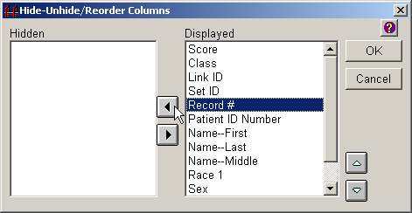
Select the Record # variable from the Displayed list, and click on the left arrow button to move it over to the Hidden list.
Result: The Record # column is moved to the list of hidden columns.
Remember, a column may also be hidden from view by right-clicking on the column in the Datasheet View, and selecting the Hide Column option.
- Click OK.
Result: Link Plus returns to the main manual review screen, with the Record # column hidden from view.
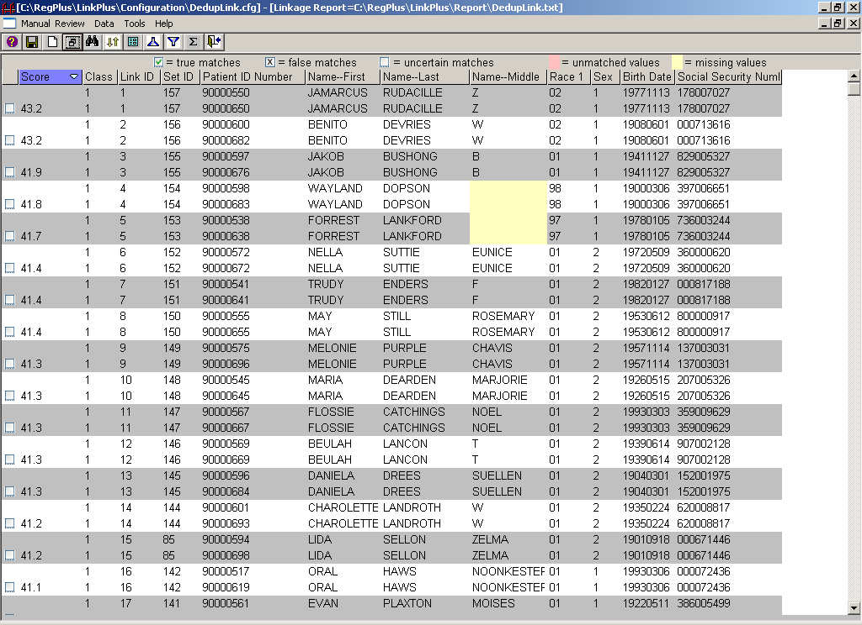

Sort by and Manually Reassign Set ID
Set ID is generated only for deduplication linkages, and is a unique number assigned to each group of duplicated records because a record may have multiple duplicates, and generate multiple comparison pairs. If the data are sorted by the Set ID, then all of the potential comparison pairs for a single individual may be manually reviewed together. The Set ID may be manually reassigned after assignment of match status.
The dupdelimdemofile.txt data file contains one record with potential multiple duplicates; the comparison pairs for this record have been assigned a Set ID of 52. Scroll through the list until you find the Link ID of 78; this is the first of three comparison pairs that have been assigned a Set ID of 52.
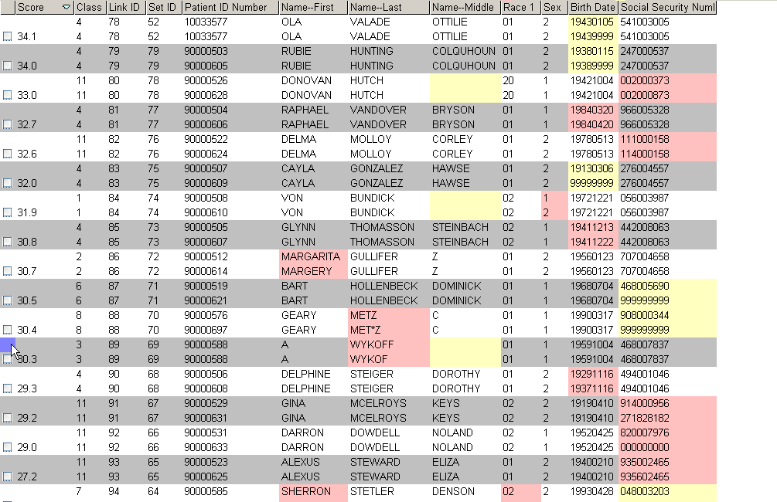
To see all three of the comparison pairs assigned the Set ID of 52:
- Sort the list of comparison pairs by Set ID in ascending order by right-clicking on the column of Set ID, and then selecting the Sort option.
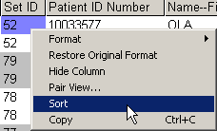
- Scroll through the list until you locate Set ID 52.
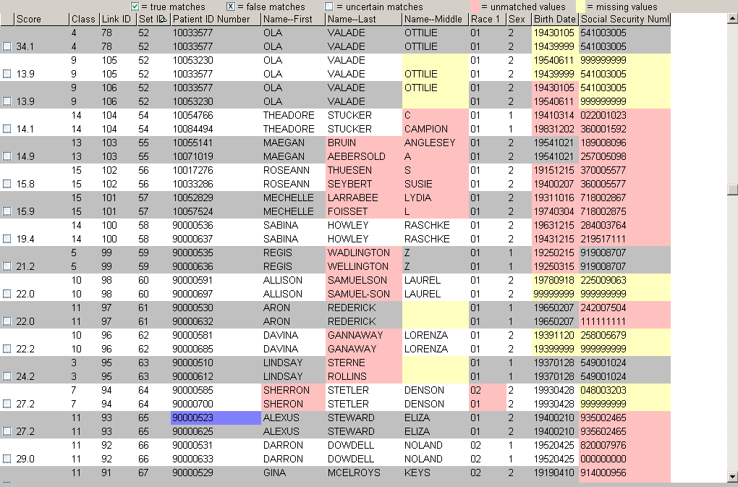
Note that the three comparison pairs assigned the Set ID of 52 (Link IDs of 78, 105 and 106) have very different scores. The first pair, both with the name of OLA VALADE and a Social Security Number of 541003005 (Link ID of 78), has a very high score (34.1) and is definitely a duplicate record. However, the next two pairs (Link IDs 105 and 106) vary on the Birth Date and Social Security Number, and do not match.
As a result, if you would like the Set ID to represent unique individuals, you will want to disassociate the Set IDs of the comparison pair with Link ID 78 from those of 105 and 106. First you will need to assign a match status to each of the comparison pairs, and then reassign the Set IDs.
To reassign Set IDs, complete these steps:
- Assign a true match status to Link ID 78, and a false match status to Link IDs 105 and 106.
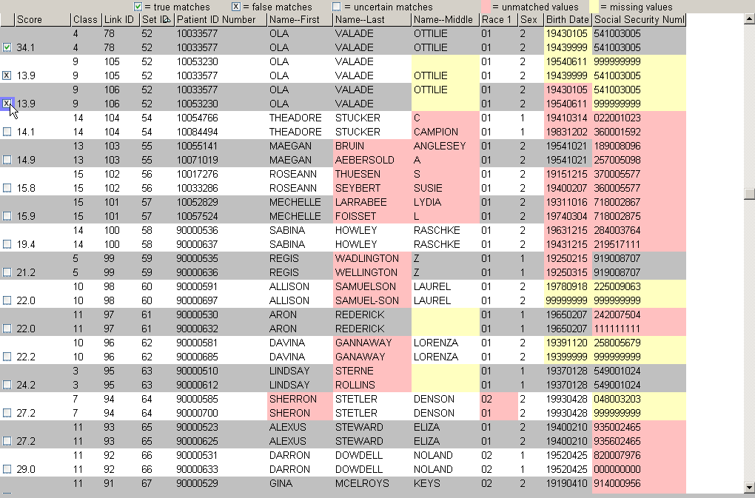
- Click on the Data menu item, and select the Reassign Set ID option.
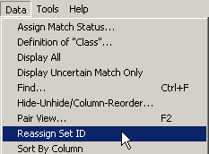
Result: Set ID is automatically reassigned by individual comparison pair.
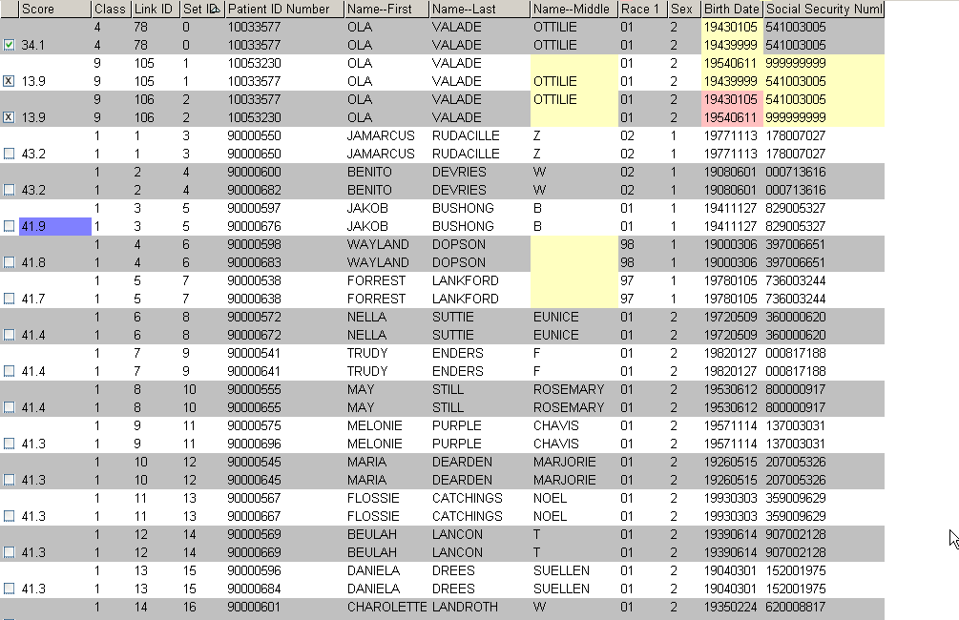
- Scroll to the top of the list of comparison pairs, and view the pair assigned the Link ID of 78; it has now been assigned a unique Set ID of 0.
- Scroll down the list of comparison pairs until you see the pairs assigned the Link IDs of 105 and 106; they have now been assigned unique Set IDs of 1 and 2.

Assigning Match Status - Review
As with manual review for external linkages, match status can be assigned manually within deduplication manual review by using the mouse to click in the Match Status check box, by using the keyboard, or can be assigned automatically by match score.
To assign match status manually, for the comparison pair being reviewed place the cursor in the Match Status check box and:
- Left-click the mouse once, or press the “M” key to assign a true match status.
- Left-click the mouse twice, or press the “N” key to assign a false match status.
- Left-click the mouse three times, or press the “B” key to assign an uncertain match status.
To assign match status automatically by score, click on the Data menu item, and select the Assign Match Status… option.
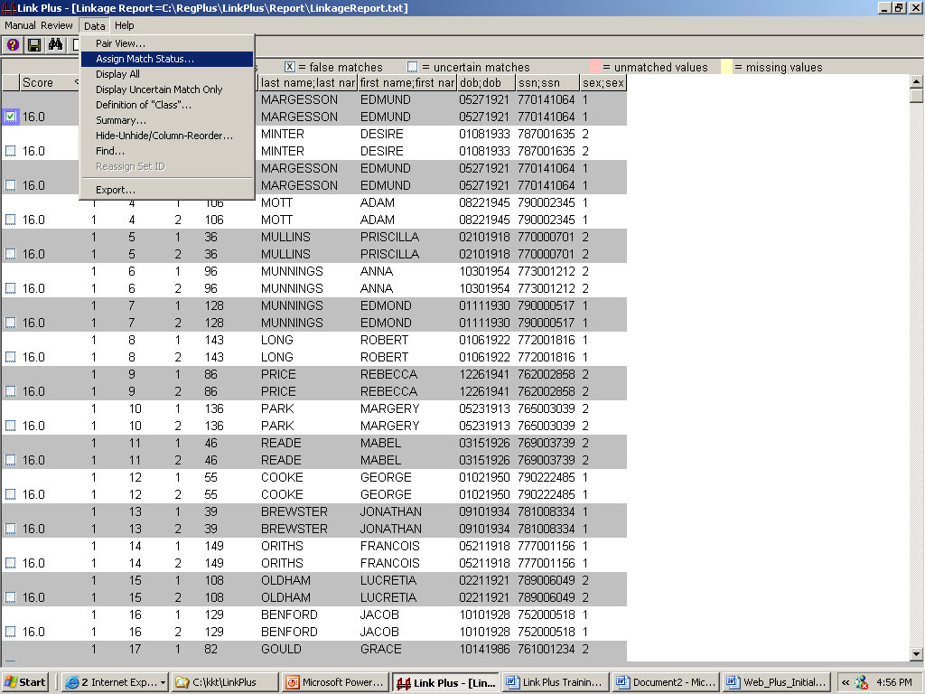
Result: The Assign Match Status dialog box opens.
Enter any scores for which you would like to assign match status automatically, and click OK.

Independent Manual Review
Using the information you have learned today about the manual review process, configure the manual review screen to your liking, and experiment with the different options. Feel free to modify the screen layout as desired; re-order, re-size or hide columns, change the color scheme, or view the comparison pairs in Datasheet or Pair View.
Take note of the comparison pair with Link ID of 65 to see an example of how the Link Plus First Name Matching Method links records with nicknames and full names. Take some time and resolve a few matches on your own, take a guess at approximate upper and lower cut off scores, and assign match statuses automatically by score. Make sure to view the summary information at least once.

Assigning Final Match Statuses
To assign the final match statuses for today’s deduplication linkage exercise automatically by score, complete these steps:
- Click on the Data menu item, and select the Assign Match Status… option.
Result: The Assign Match Status dialog box opens.
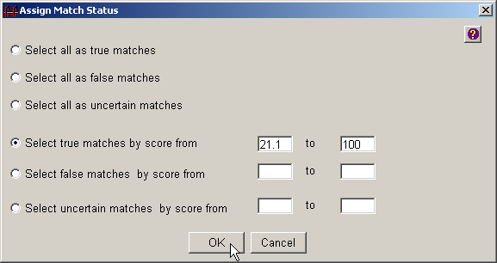
- Click on Select true matches by score from, enter 21.1 in the first box, enter 100 in the second box, and then click OK.
Result: The manual review screen re-opens with the specified match statuses assigned.
- Click on the Data menu item again, and select Assign Match Status… a second time.
Result: The Assign Match Status dialog box opens.
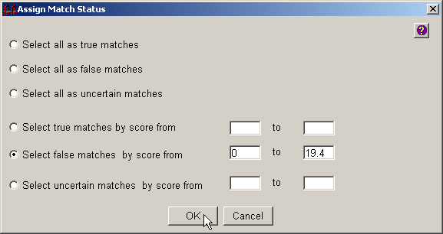
- Click on Select false matches by score from, enter 0 in the first box, enter 19.4 in the second box, and then click OK.
Result: The manual review screen re-opens with the specified match statuses assigned.

Step 12: Export Merged File
Once you have completed your manual review of the potential matches presented for review, and have assigned a match status to them (either manually by clicking, or via the Data…Assign Match Status option), you will want to export a merged file. Link Plus offers the export of the merged file in a text file in delimited file format, and allows you to specify what file delimiter you would like to use, and what match status(es) you would like to export.
To set the export file options and export a merged file, complete these steps:
- Click on the Tools menu item, and select Options…
Result: The Options dialog box opens, with the Manual Review tab selected.
- Click on the Export tab.
Result: The Export Options dialog box opens.
- To set the export file format option to comma-delimited, click on Comma.
- Unclick the Uncertain Match and False Match under Include, and then click the OK button.
Result: The export file format has now been set to a comma-delimited file format, and when the data are exported, only duplicate records (those assigned a match status of true) will be exported.
- To export the file, click on the Data menu item, and click on Export…
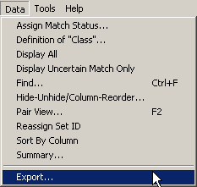
Result: The Export Setting dialog box opens.
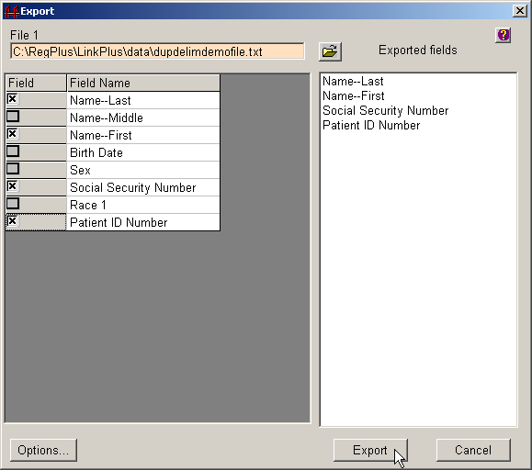
- Select the fields from the data file that you would like in your merged export file by clicking the box in the column to the left of the data field. Click the fields in the order in which you would like them listed in the export file.
- Click on Export.
Result: A window opens where you can specify a name for the exported merged file, and location on your computer or on a shared network folder where you would like to save the file. The default location for exported files within Link Plus is the C:/RegPlus/LinkPlus/Export folder.
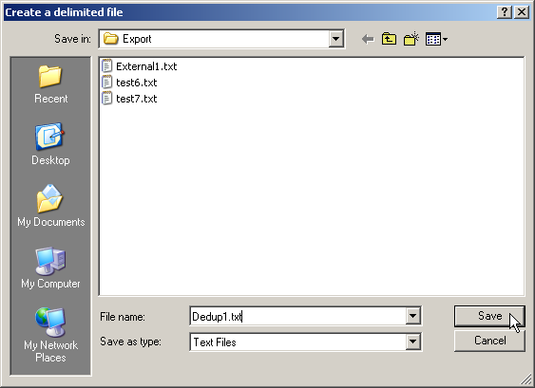
- In the File name box, type Dedup1.txt, and click Save.
Result: A comma-delimited merged file (named Dedup1.txt) of records with true match status, with the data fields you selected (in the order that you specified) is generated and placed in the C:/RegPlus/LinkPlus/Export folder. In addition, Notepad will open with a view of the merged file.
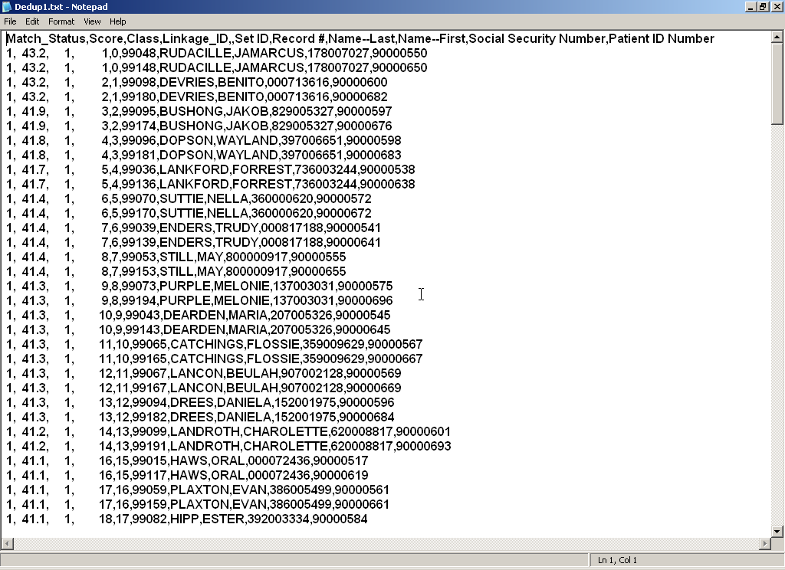
- Close out of Notepad and click Cancel on the Export Setting dialog box to return to the manual review screen.
- Click on the Manual Review menu item, and select the Close View option.
Result: The main Link Plus window opens.

Congratulations!
You have successfully completed today’s
Link Plus linkage exercises.

Obtaining New Releases of Link Plus
You have been provided with version 2 of the Link Plus software for today’s training. New versions of the software will be released in the future.
To obtain any new release of Link Plus when it is available:
- Go to NPCR Home Page:
http://www.cdc.gov/cancer/npcr
- In the ‘Tools’ Section
  - click on Registry Plus
- Under ‘Registry Plus Components’
  - click on Link Plus
- Under ‘On this page’
  - click on Installing and Upgrading Link Plus

