
Using Registry Plus Tools to Conduct Linkage with Breast and Cervical Early Detection Program Data

Centers for Disease Control and Prevention
National Center for Chronic Disease Prevention and Health Promotion
Division of Cancer Prevention and Control
National Program of Cancer Registries
Registry Plus™ Software for Cancer Registries

Contents
Chapter 1: Background for Standardized Approach 1
Standardized Data Exchange and Linkage Overview 1
Standardized Data Flow 2
Chapter 2: Converting the CaST Export File Using Data File Mapper Plus 5
Data File Mapper Plus Overview 5
Converting the CaST File to the NAACR File Format and Codes 6
Description of Standard Mapping Configuration 9
Chapter 3: Conducting Linkage and Manual Review Using Link Plus 13
Link Plus Overview 13
Launching Link Plus and Conducting Linkage of Standardized Data Files 14
Conducting Manual Review of True and Uncertain Matches 22
Manually Assigning Match Status 27
Assigning Match Status Automatically by Score 28
Assigning Match Status to All Comparison Pairs 29
Exporting Linkage Results 29
Exporting True Matches 30
Exporting All Non-matches 35
Chapter 4: Combining Linkage Export Files Using NAACCR Combiner 38
Appendix A: CAST Export File Layout 41
Appendix B: CAST Export to NAACCR (V12.x) Data Mapping Guide 43
Appendix C: Data File Mapper Plus Mapping Configuration 45
Appendix D: Race Formats and Conversation Table 47
Appendix E: Hispanic Origin Formats and Conversion Table 48
Appendix F: CaST Final Diagnosis Formats and Conversion Tables 49
Appendix G: Minimum Data Items to be Included in CCR Extract File 51
Appendix H: Data Items to be Exported from Link Plus after Linkage 52

Background for Standardized Approach

Standardized Data Exchange and Linkage Overview
National Breast and Cervical Cancer Early Detection Program (NBCCEDP) grantees are required to annually link breast and cervical cancers cases diagnosed since 2004 with their corresponding Central Cancer Registry, and report to CDC a set of registry standardized data items.
National Program of Cancer Registries (NPCR) grantees are also required to link with their BCCEDP annually, and are required to collect and report to CDC “Linkage Status Fields” (MDELink and MDEDate) to help monitor the linkages, follow-up on unreported cases, and flag the cases diagnosed through the NBCCEDP to support special analyses of diagnostic and treatment outcomes of this population.
Because both NPCR central cancer registries (CCRs) and BCCEDPs are required to annually link data, a standardized approach to these linkages and software tools that can optionally be used to facilitate the linkages has been developed by CDC. This standardized approach takes advantage of existing standardization within both the CCRs and BCCEDPs.
Existing standardization within the CCRs includes the North American Association of Central Cancer Registries (NAACCR) Standards for Cancer Registries, Volume II: Data Standards and Data Dictionary, the data dictionary and record layout used by all cancer registries. Optional tools developed by CDC to promote standardization among the cancer registries includes the NPCR Registry Plus suite of software, which offers central cancer registries software solutions for all areas of cancer data reporting and processing.
Existing standardization within the BCCEDPs includes the Minimum Data Elements, or MDEs that are submitted to CDC as well as standardized data management expectations. An optional tool developed by CDC to promote standardization among the BCCEDPs is the Cancer Screening and Tracking system software (CaST).
Basically, the main point of the approach is to standardize the data files that are exchanged between the CCRs and BCCEDPs, so that both sides know exactly what data to provide and what data they will be receiving from each other. The optional software tools involved in the standardize approach are the CaST system and the Registry Plus tools of Data file Mapper Plus, Link Plus, and the NAACCR Combiner program.

Standardized Data Flow
The standardized data exchange and linkage process includes the following steps:
- BCCEDP uses CaST to export cancer cases
  - User options to (1) select a date range of cases to export, and (2) export either previously unmatched cases or all cancer cases.
  - Standard fixed width NBCCEDP data file is exported from CAST;
    - Standardized file-naming convention for the CaST export file is registry_export_YYYYMMDD.txt (e.g., registry_export_20111220.txt), dated the day of the export of the file from CaST; see Appendix A
    - Records include flag field to indicate type of cancer (breast, cervical, colorectal), as well as CaST record identifiers
- CCR uses standard mapping configuration in Data File Mapper Plus (DF Mapper Plus) to convert the standard CaST export file to NAACCR format and codes
  - CCR uses standard DF Mapper Plus mapping configuration to convert the standard CAST export file (registry_export_YYYYMMDD.txt ) to the NAACCR file format and codes, in order to properly link with central cancer registry data in NAACCR registry format (see Appendix B for data fields and positions)
  - Modifiable, standard NBCCEDP file mapping configuration that was generated specifically for the mapping of CaST export files to the NAACCR file format and codes is included in DF Mapper Plus. The mapping configuration is named BCCEDP CaST export file to NAACCR v12.x (x equals the version of NAACCR v12 that is currently in use in the CCR (see Appendix C for mapping configuration parameters). See Appendix D (Race), Appendix E (Hispanic Ethnicity), and Appendix F (CaST Final Diagnosis to NAACCR Site, Histology and Behavior) for conversion specifications used in the generation of the standardized mapping configuration.
    - Fields that are common to both files are mapped to standard positions in the NAACCR layout (e.g., Last Name)
    - CAST-specific fields that need to be returned to the NBCCEDP (e.g. Patient_Id, Cycle Id, cancer type) are mapped to standard, specified positions in the State/Requestor area of the NAACCR layout
    - Any state-specific BCCEDP fields (outside of CAST) will be included in the State/Requestor area of the NAACCR layout positioned after any standard CAST-specific fields that need to be returned to the NBCCEDP
  - Standardized file-naming convention for the converted file is converted_registry_export_YYYYMMDD.txt (e.g., converted_registry_export_20111220.txt dated the same date as the exported data file rom CaST)
- CCR generates extract of CCR data for linkage with mapped NBCCEDP data file
  - CCR generates extract file in NAACCR file format from their CCR database; this is the file that will be linked with the mapped BCCEDP data file from Data File Mapper Plus. Appendix G delineates the minimum fields to be included in the CCR data extract. The suggested standard file-naming convention for the CCR extract file is CCR_data_YYYYMMDD.txt
- CCR conducts linkage and manual review of true and uncertain matches using Link Plus
  - CCR conducts linkage using Link Plus
    - Special BCCEDP NAACCR record layout, NAACCR12_ BCCEDP_DEFAULT.txt, is included in Link Plus that has CAST-specific fields that need to be returned to the BCCEDP specified in the State/Requestor area; Record layout is modifiable to accommodate BCCEDP state-specific fields
    - Standard BCCEDP/cancer registry linkage configuration, CCR_BCCEDP_Link.cfg, is included in Link Plus to be used by the CCR to conduct the linkage; Linkage configuration is modifiable to accommodate BCCEDP state-specific fields
    - CCR conducts linkage between the two NAACCR-formatted files using the CCR_BCCEDP_Link.cfg linkage configuration
  - CCR conducts manual review of potential matches, and assigns match statuses
- CCR exports linkage results from Link Plus
  - CCR exports the linkage results for their BCCEDP program, exporting cancer registry data in standard NAACCR fields and exporting CAST-specific fields (e.g., Patient_Id) that need to be returned to the NBCCEDP in the State/Requestor Area
    - CCR exports true matches and all-non-matches in NBCCEDP NAACCR file format (See Appendix H for listing of data items to be exported); Note that registry data fields obtained via the data linkage will be blank for non-matches
    - The suggested standard file-naming convention for the file of true matches is BCCEDP_Matches_YYYYMMDD.txt (e.g., BCCEDP_Matches_20111220.txt)
    - The suggested standard file-naming convention for the file of non-matches is BCCEDP_Non_Matches_YYYYMMDD.txt (e.g., BCCEDP_Non_Matches_20111220.txt)
  - CCR exports non-matches that represent unreported tumors for follow up by the CCR
- CCR combines 2 export files into a single file for return to the BCCEDP
  - CCR combines true and non-match export files into a single data file using NAACCR Combiner
- BCCEDP uses CaST to import NBCCEDP NAACCR-formatted file
  - CAST import process will:
    - Compare incoming central registry data with associated existing CAST data and allow for review of differences on same fields (e.g., Date of Birth)
    - Evaluate NAACCR data items of Derived Summary Stage 2000 [3020], SEER Summary Stage 2000 [759], and SEER Summary Stage 1977 [760] and will fill the Registry Summary Stage field in CaST based on the Registry Date of Diagnosis
    - Evaluate NAACCR data items of Date of Initial RX—SEER [1260], Date of 1st Crs RX---CoC [1270], and RX Summ--Treatment Status [1285] and will fill Date of Treatment (or no treatment) field in CaST depending on what the central registry captures
    - Fill the CaST fields of Linkage Status and Linkage Status Date upon import

Converting the CaST Export File Using Data File Mapper Plus

Data File Mapper Plus Overview
When two data files are linked together it is imperative to use the same coding conventions for the data items that are shared between the two files. As a result, before the CCR can conduct the linkage between the data file provided by the BCCEDP and their CCR data file, the data in the file provided to CCR by the BCCEDP will need to be mapped to the same data file format and codes used for the CCR data file.
Registry Plus Data File Mapper Plus (DF Mapper Plus) is the tool the CCR will use to convert the CaST export files to the NAACCR file format and codes. DF Mapper Plus is the newest Registry Plus program and is currently in the beta testing phase. It is a user-friendly, standalone, Windows-based file mapping tool that maps data items from any fixed width or delimited file to the NAACCR file format and codes.
The file mapping process within DF Mapper Plus is accomplished in three basic steps: 1) Selection of the NAACCR layout version for the NAACCR output file and documentation of any non-standard fields; 2) Generation of a file mapping configuration specific to the input data file; and 3) conversion of the input file to the designated NAACCR file format using the specified mapping configuration.
Mapping configurations include the specification of the input data type, as well as the input file record layout for fixed width files, or file delimiter, field names, and field sequence for delimited files. For each field in the input file to be mapped, the user specifies the NAACCR data item to which the field will be mapped. Field codes within the input file are converted to NAACCR data field codes via user entry of translation tables or through selection of the various conversion functions that are available within the program. The actual file conversion process includes locating and identifying the input file to be converted and selection of a mapping configuration to apply to the file upon conversion.
DF Mapper Plus comes with a modifiable, standard NBCCEDP NAACCR record layout, and a modifiable, standard file mapping configuration that was generated specifically for the mapping of the CaST export file to the NAACCR file format and codes. As a result, all you will need to do is open the application, and convert your CaST export file.
The name of the NAACCR Record Layout is 12x_CaST, and the name of the standard mapping configuration is BCCEDP CaST export file to NAACCR v12.x (x equals the version of NAACCR v12 that is currently in use in the CCR). This mapping configuration maps fields that are common to both files to standard positions in the NAACCR layout (e.g., Last Name) and maps CaST-specific fields that need to be returned to the NBCCEDP (e.g. Patient_Id, Cycle Id, cancer type) to specified positions in the State/Requestor area of the NAACCR layout (see Appendix C for mapping configuration parameters).
 | Any state-specific BCCEDP fields (outside of CAST) will need to be included in the State/Requestor area of the NAACCR layout positioned after any standard CAST-specific fields that need to be returned to the BCCEDP)

Converting the CaST File to the NAACR File Format and Codes
To launch DF Mapper Plus and convert the CaST export file to the NAACCR file format and codes complete the following steps:
- From the Start menu, select All Programs, Registry Plus, Data File Mapper Plus, and then Data File Mapper Plus.
Result: The Main window opens.
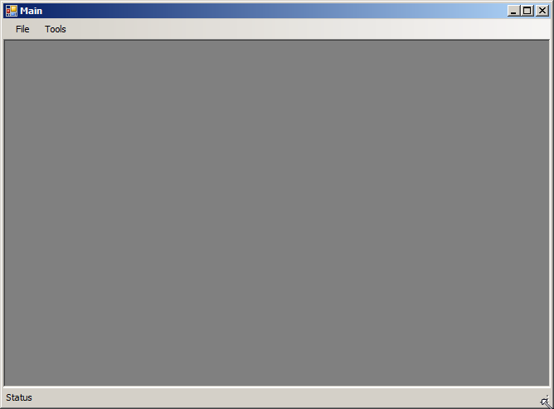
- From the File menu, select Convert, or use the keystroke Ctrl+C.
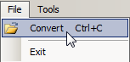
Result: The Convert window opens.
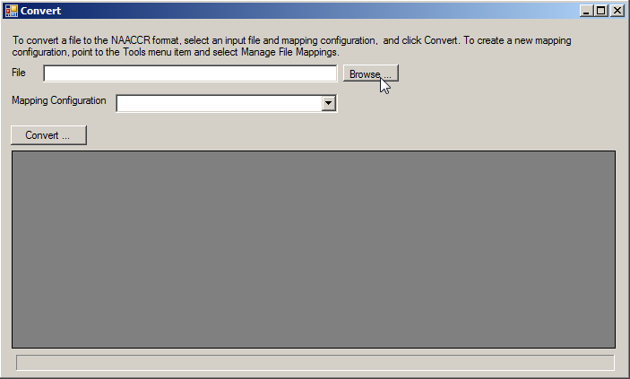
- To select the CaST export file provided by your BCCEDP (registry_export_YYYYMMDD.txt ), click Browse.
Result: The Open window opens.
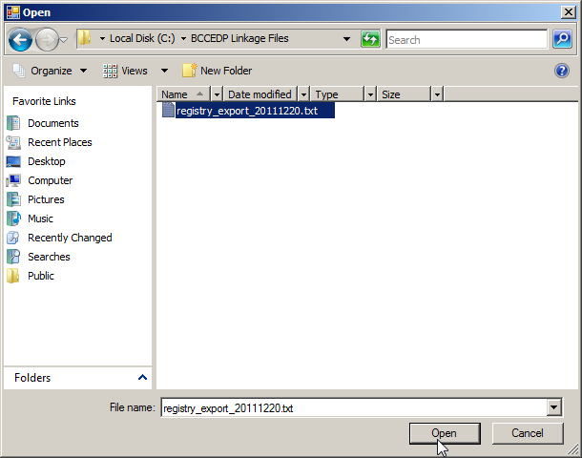
- Navigate to the CaST export file provided by your BCCEDP (registry_export_YYYYMMDD.txt ) on your network or PC, select the file, and click Open. In the example shown, a file named registry_export_20111220.txt is being converted.
Result: You are returned to the Convert window, with the contents of the input data file displayed.
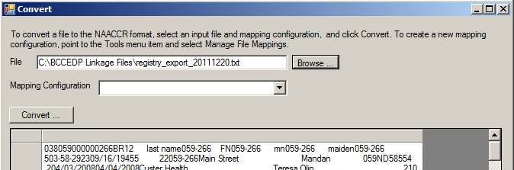
- At this point the data displayed does not make much sense, as a mapping configuration, which includes the input data file layout, has not yet been selected.
There are 3 mapping configurations available (BCCEDP CaST export file to NAACCR v12.x) for the CaST export file, where x equals the version of NAACCR v12 that is currently in use in the CCR, v12.0, v12.1, or v12.2. Select the appropriate mapping configuration for your central registry from the Mapping Configuration drop-down list.
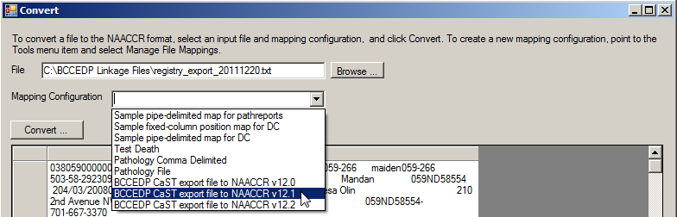
Result: As soon as the configuration file is selected, the data are displayed in the lower window, so that you can ensure that the data are being read in correctly in the mapping configuration, and verify that the correct data items are appearing in their expected locations.
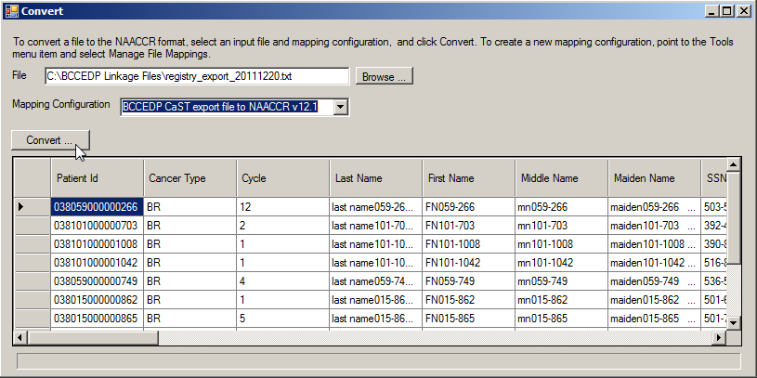

Description of Standard Mapping Configuration
The following describes the parameters of the standard mapping configuration included in DF Mapper Plus. If you have no state-specific BCCEDP fields, you can simply use the mapping configuration to map the CaST export file as described above. However, if you wish to modify any of the parameters of the mapping configuration, instructions for doing so can be found in the Data File Mapper Plus User’s Guide (available from CDC).
    - Uses the data field position mappings listed in Appendix B for the mapping of CaST data fields to the NAACCR file format and codes
    - Uses the 12x_CAST NAACCR Layout, which is pre-configured to include the following custom fields:
NAACCR Item No | Name | Column Start | Column End | Field Length
9500 | CaST Patient ID | 2340 | 2354 | 15
9501 | Cancer Type | 2355 | 2356 | 2
9502 | Cycle | 2357 | 2364 | 8
9503 | Provider Name | 2365 | 2414 | 50
9504 | Provider Contact Person | 2415 | 2464 | 50
9505 | Provider Address Street | 2465 | 2544 | 80
9506 | Provider Address City | 2545 | 2569 | 25
9507 | Provider Address County | 2570 | 2572 | 3
9508 | Provider Address State | 2573 | 2574 | 2
9509 | Provider Address Zip | 2575 | 2584 | 10
9510 | Provider Phone Number | 2585 | 2604 | 20
9511 | Provider Email Address | 2605 | 2654 | 50
9512 | Final Dx | 2655 | 2655 | 1
9980 | NBCCEDP MDE Linkage Rslts | 2840 | 2840 | 1
9981 | NBCCEDP Linkage Date | 2841 | 2848 | 8
    - Uses the following translation tables: BCCEDP_Hispanic_Origin, BCCEDP_Race
    - Uses the following mapping functions: FUNCTION: REPLACE, FUNCTION: NAACCRDate1, FUNCTION: NBCCEDP_CaTypeFinalDxToSite, FUNCTION: NBCCEDP_CaTypeFinalDxToHistology, and FUNCTION: NBCCEDP_CaTypeFinalDxToBehavior
    - Please see Appendix C for full listing of the BCCEDP CaST export file to NAACCR v12.x mapping configuration (for each field in the input file to be mapped, the configuration specifies the NAACCR data item to which the field will be mapped, and field codes requiring conversion are converted to NAACCR data field codes via the specified translation tables or conversion functions); The following table describes the columns included in the mapping configuration
Column Heading | Description
Input Field Name | User-entered name of field in input file; use only alpha-numeric characters and spaces for field names.
Input Column Start | Start column position of field in input file
Input Column Stop | End column position of field in input file
Output NAACCR Item | NAACCR data item number of NAACCR field to which input field is being mapped
Output Default Value | For NAACCR fields not represented in the input file, a default value may be entered; this value will be automatically filled into the specified field for every mapped record in the output file
Translation Table/Function | Translation table or function that has been selected for input fields with values that that require conversion to NAACCR values for the output file
Function Parameter1 | Enter additional function parameters if necessary  Some functions (e.g., REPLACE) require entry of additional parameters by the user  Specify the first parameter in Function Parameter1 column, and the second parameter in the Function Parameter2 column;
Function Parameter2

Please see the Data File Mapper Plus User’s Guide for a full description of translation tables and functions, how to edit or generate new translation tables, and how to add additional state-specific fields to the 12x_CaST record layout.
- Click Convert to run the mapping process on the input data file and generate the NAACCR-formatted output file.
Result: The Save As dialog window opens.
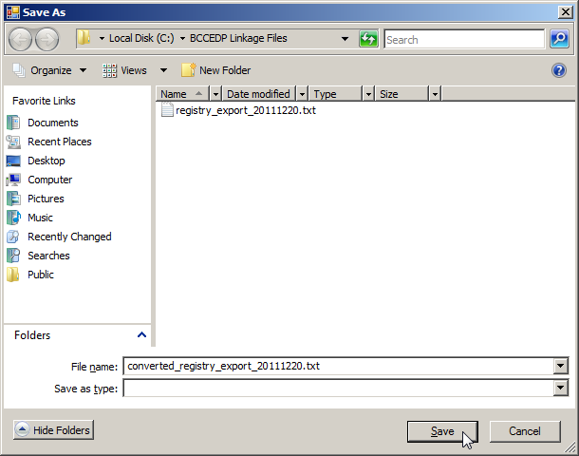
- Navigate to the folder on your PC or network where you would like to store the NAACCR-formatted output file, enter a name for the NAACCR-formatted output file, and click Save. The suggested standard file-naming convention for the converted output file is converted_registry_export_YYYYMMDD.txt. In the example shown, the NAACCR output file is named converted_registry_export_20111220.txt.
Result: A window opens and displays the estimated number of records in the input file.
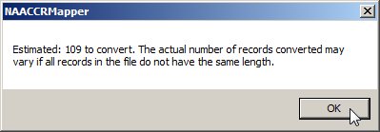
- Click OK to begin the file conversion process.
Result: The file mapping process begins. Progress is denoted by the progress bar.
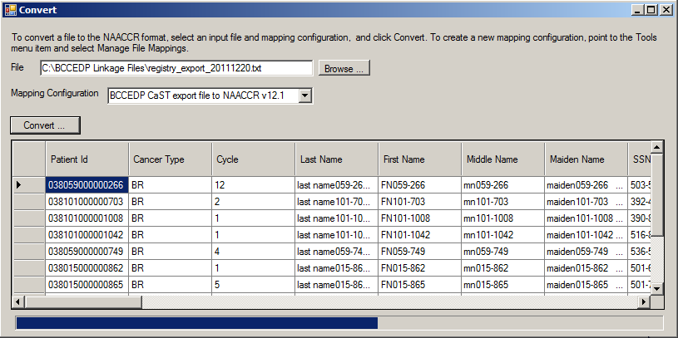
DF Mapper Plus lets you know when the conversion is complete, and reminds you of the output file name and path.
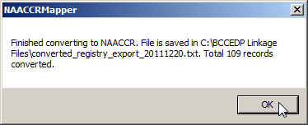
- Click OK to finish the file conversion process.
Result: You are returned to the Convert window.
- From the File menu select Exit to exit Data File Mapper Plus.
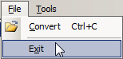

Conducting Linkage and Manual Review Using Link Plus

Link Plus Overview
Registry Plus Link Plus is the tool the CCR will use to conduct the linkage between the CCR data extract file and the converted CaST data file. Link Plus is a stand-alone probabilistic record linkage program which combines ease of use and advanced statistics. Link Plus operates in two modes, it can be used to link cancer registry files to external files, or to detect duplicates within a cancer registry. Link Plus accepts fixed width files, delimited files, and most importantly for this standardized process, NAACCR-formatted files. The program also provides powerful support for manual review of potential matches
Linkage between two data files in Link Plus is accomplished via the following steps:
- Select Data Type for File 1
- Locate/Identify File 1
- Data Import for File 1
- Select Data Type for File 2
- Locate/Identify File 2
- Data Import for File 2
- Select Blocking Variables & Phonetic System
- Select Matching Variables & Matching Methods
- Select ID Variables
- Define Missing Values
- Enter Cut-off Value
- Select Direct/EM Method
- Specify Best Match or Many-Many Matching
- Specify Generation of Non-match Report
- Specify Linkage File Name and Location
- Perform Manual Review of Uncertain Matches
- Export Merged File
Link Plus linkage configurations include the specification of the input data type, location and record layouts/delimiters of the data files to be linked, as well as blocking variables, matching variables and matching methods, and all of the other linkage parameters listed above (information from steps 1-15 above). Often Link Plus users need to run the same linkage multiple times, with minor variations in the linkage configuration, such as different data files or Cut Off Values. Link Plus allows the user to save a linkage configuration file (.cfg file), so it may be opened and used again at a later time (with or without modifications to the configuration).
Link Plus comes with a modifiable, standard NBCCEDP NAACCR record layout, and a modifiable, standard linkage configuration that was generated specifically for the linkage of CCR and BCCEDP data files in the NBCCEDP NAACCR record layout. As a result, all you will need to do is open the application, identify your two data files, and run the linkage.
The name of the NAACCR Record Layout is NAACCR12_BCCEDP_DEFAULT.txt, and the name of the standard linkage configuration is CCR_BCCEDP_Link.cfg.

Launching Link Plus and Conducting Linkage of Standardized Data Files
To launch Link Plus, open the standardized CCR_BCCEDP_Link.cfg linkage configuration file, and run the linkage complete the following steps:
- Launch the Link Plus application by clicking Start…All Programs…Registry Plus…Link Plus…Link Plus.
Result: The main Link Plus window opens.
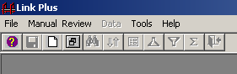
- Click on the File menu option, and select Open Configuration File…
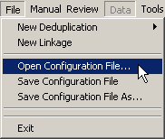
Result: The Open Configuration File dialog box opens.
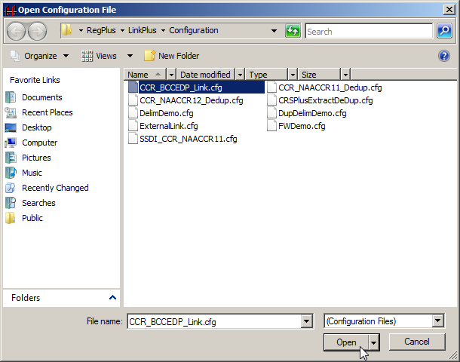
- Highlight the CCR_BCCEDP_Link.cfg file, and click Open.
Result: The Linkage Configuration window opens, with previously-saved parameters for the CCR and BCCEDP data linkage specified in the CCR_BCCEDP_Link.cfg linkage configuration file.
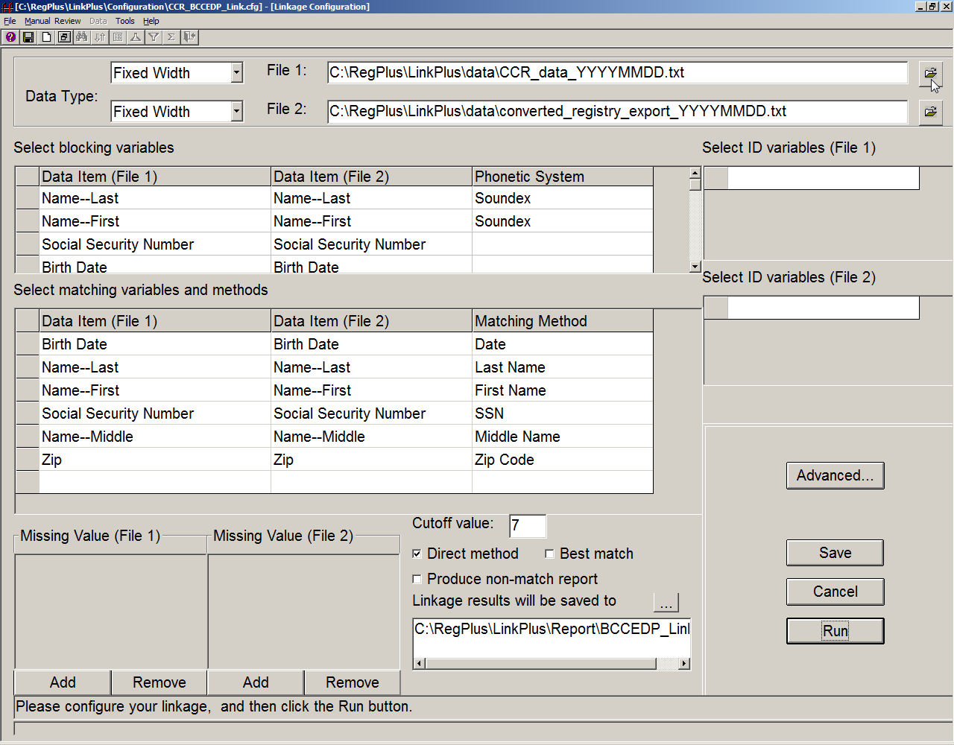
The customized standard linkage configuration includes the following parameters:
    - Data Type of both files is Fixed Width as both files are in NAACCR file format
    - The cancer registry data file has been selected as File 1, and the converted BCCEDP data file has been selected as File 2.
    - The following Blocking Variables have been selected: Name--Last (Soundex), Name--First (Soundex), Social Security Number and Birth Date
    - The following Matching Variables/Matching Methods have been selected: Date of Birth/Date, Name—Last/Last Name, Name—First/First Name, Social Security Number/SSN, Name—Middle/Middle Name, Addr at Dx—Postal Code/Zip Code
    - A Cutoff Value of 7 has been defaulted
    - The Direct Method check box is checked by default
    - The Best Match and Produce Non-match Report check boxes are un-checked by default
      - Best Match should be left un-checked: The BCCEDP data may have multiple records for the same individual. You will want to assign a true match status for all matches for a patient as the BCCEDP is expecting all records in the data file provided to the registry returned to them. As a result, a 1-many linkage needs to be run so the Best Match check box is left un-checked
      - Produce Non-match report should be left un-checked: You will be exporting all non-matches (i.e., those identified upon linkage as well as those identified via manual review) to a single file after completion of manual review
    - By default, linkage results will be saved to C:\RegPlus\LinkPlus\Report\CCR_BCCEDP_Link.txt
 | Default selections can be modified if desired. However, it is recommended that you select your 2 data files and click Run at this point.
- Click the folder icon  to the right of the input box for File 1. File 1 will be the CCR extract data file.
Result: The Open Data File dialog box opens.
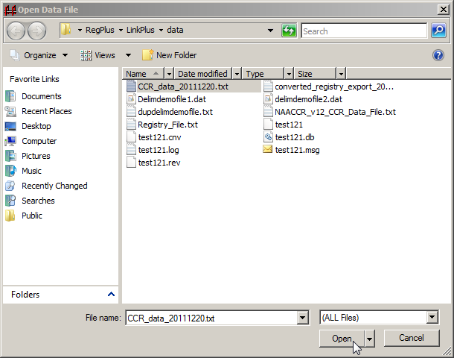
- Navigate to and highlight your CCR data extract file and click Open. Recall that the standard naming convention for the CCR data file is CCR_data_YYYYMMDD.txt. The file being opened in the example shown is named CCR_data_20111220.txt.
Result: The Data Import Form for Fixed Width File opens, with the NAACCR12_BCCEDP_DEFAULT.txt record layout already applied to the data file.
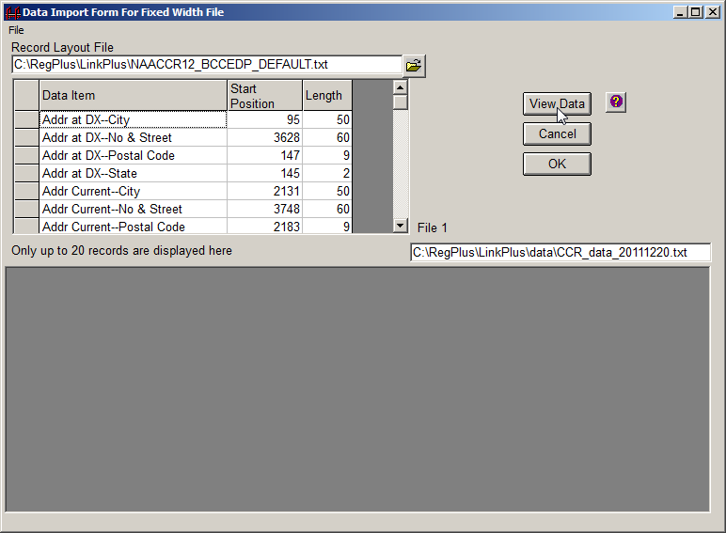
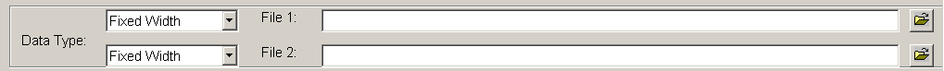
- Click View Data.
Result: Link Plus displays the first 20 lines of data in the file, so you can ascertain whether you have the proper positions and lengths for the variables.
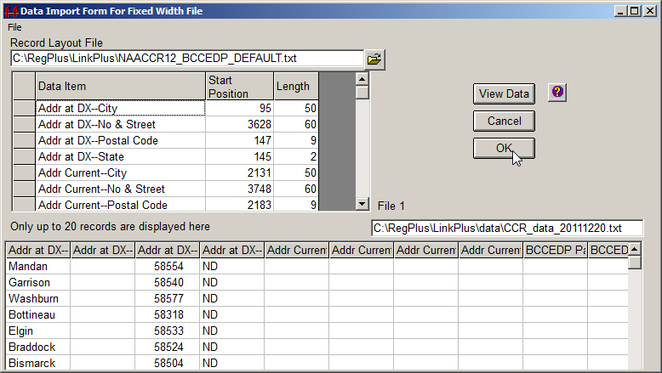
- Make sure all of the data are aligned properly and then click OK.
Result: The application returns you to the Linkage Configuration window.
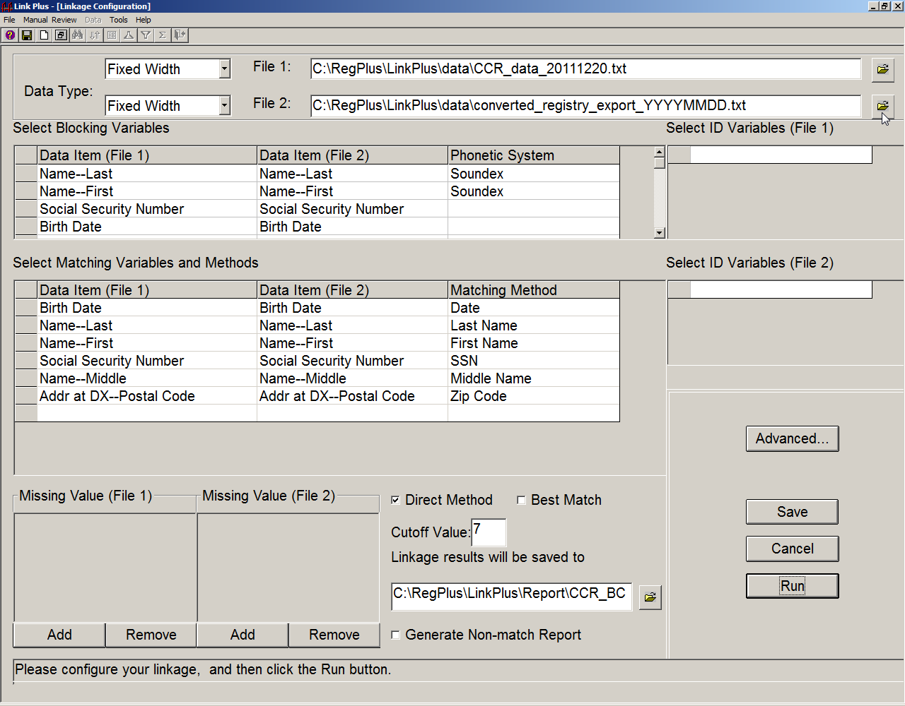
- Click the folder icon to the right of the input box for File 2. File 2 will be the converted BCCEDP data file.
Result: The Open Data File dialog box opens.
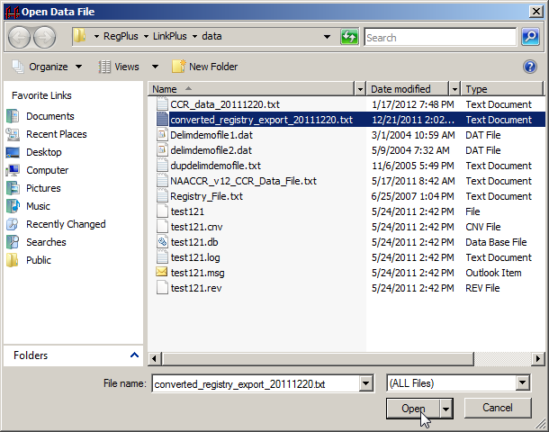
- Navigate to and highlight your converted BCCEDP data file and click Open. Recall that the standard naming convention for the converted BCCEDP data file is converted_registry_export_YYYYMMDD.txt. The file being opened in the example shown is named converted_registry_export_20111220.txt.
Result: The Data Import Form for Fixed Width File opens, with the NAACCR12_BCCEDP_DEFAULT.txt record layout already applied to the data file.
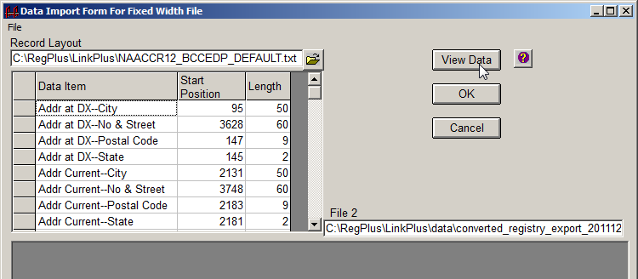
- Click View Data.
Result: Link Plus displays the first 20 lines of data in the file, so you can ascertain whether you have the proper positions and lengths for the variables.
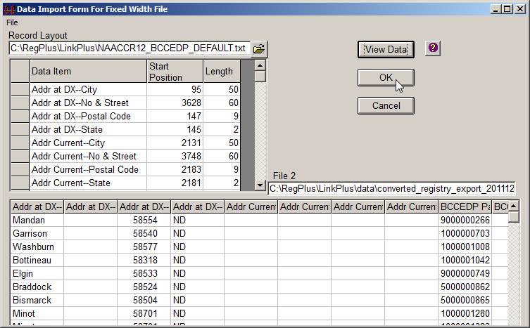
- Make sure all of the data are aligned properly and then click OK.
Result: The application returns you to the Linkage Configuration window.
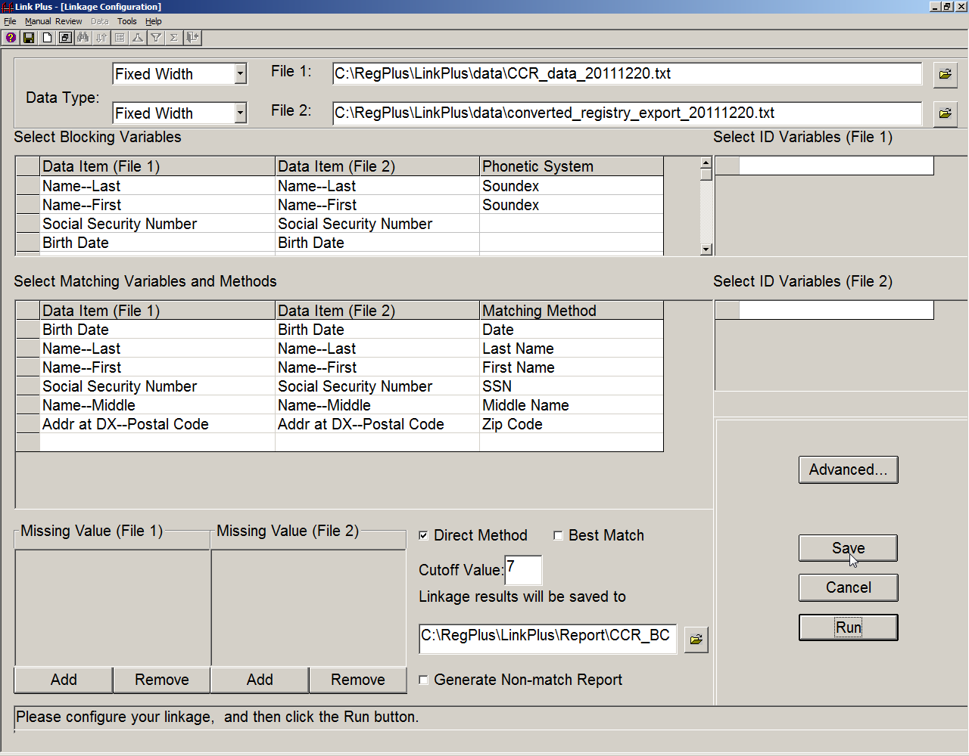
- Click Save to save your changes to the configuration file.
Result: The Save Configuration dialog box opens.
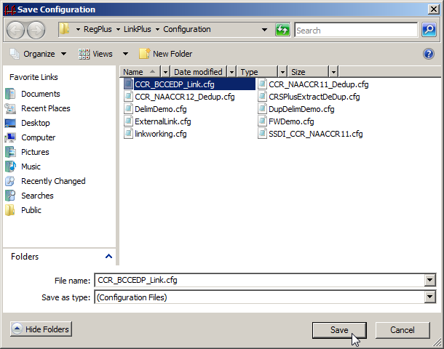
- Highlight CCR_BCCEDP.cfg, and click Save.
- Click Run to run the linkage.
Result: The linkage begins, and the Linkage Process Progress window appears and provides the user with feedback about the linkage process as it is run.
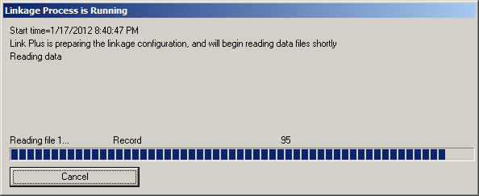
The progress window provides feedback regarding the preparation of the configuration, the reading in of the data files, the blocking of the files, and the calculation of the linkage scores. When the linkage is complete, the progress window will present the user with the choice of conducting the manual review process directly after the linkage, or closing the progress window, and conducting the manual review process at a later time.
Please see the Link Plus Linkage Exercise Document for a full description of program features, and instructions on adding additional state-specific fields to the NAACCR12_BCCEDP_DEFAULT.txt record layout, and revising blocking and matching selections and other linkage parameters.

Conducting Manual Review of True and Uncertain Matches
To conduct manual review of the potential matches generated by the CCR/BCCEDP data linkage, you must either click on Conduct Manual Review Now in the Linkage Process Progress Window at the completion of the linkage:
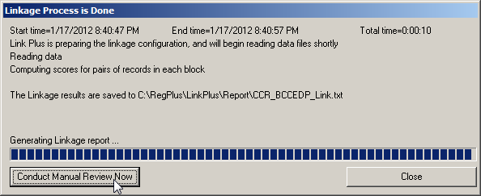
or open the linkage report by clicking on the Manual Review menu item, and click on the New View… option. Either way you open the linkage report, to perform manual review, you will select additional variables for manual review, and then perform the manual review, assigning a match status to each potential comparison pair.
- Click Conduct Manual Review Now.
Result: The Select Additional Fields for Manual Review dialog box opens.
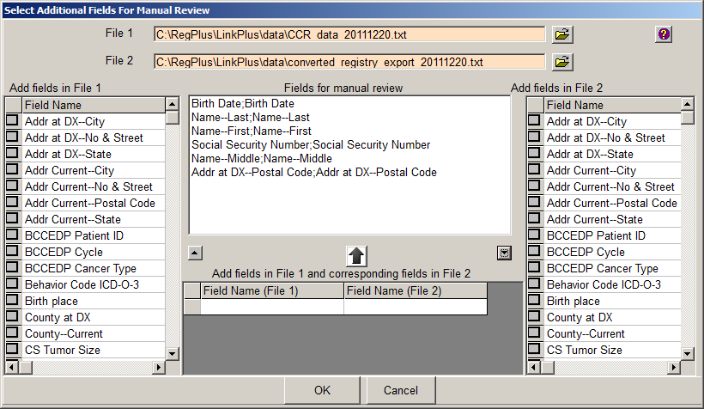
When performing manual review of potential matches for the CCR/BCCEDP data linkage, you will want to view additional fields other than those already chosen for blocking, matching and ID purposes for the linkage, in particular, address fields and the fields of Primary Site and Date of Diagnosis.
If you check the check boxes on the left and/or right grids for the fields you would like to view, the fields will be shown on separate columns on the manual review screen.
- In the left grid (the fields grid for File 1, the CCR data file) scroll down and check the box to the left of the Patient ID Number field name.
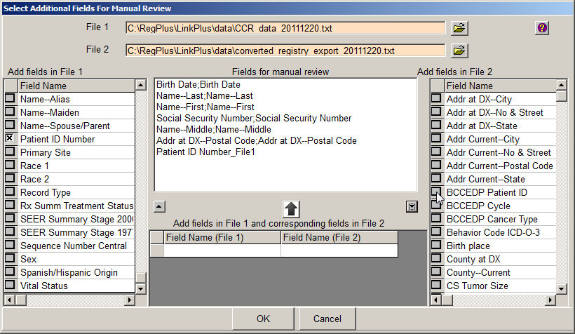
Result: The Patient ID Number variable gets added to the center list of Fields for Manual Review, with a _File1 after the field name to indicate that this field comes from File 1 (the CCR data file).
- In the right grid (the fields grid for File 2, the converted BCCEDP data file) scroll down and check the box to the left of the BCCEDP Patient ID field name.
However, if you would like two fields, one from File 1, another from File 2, to display on the same column on the manual review screen, you would use the bottom grid in the center of the window and click on the cells to bring up drop-down lists of fields on the files to select the fields.
- In the center panel, in the Field Name (File 1) grid, click in the first empty cell.
Result: A pull-down menu appears.
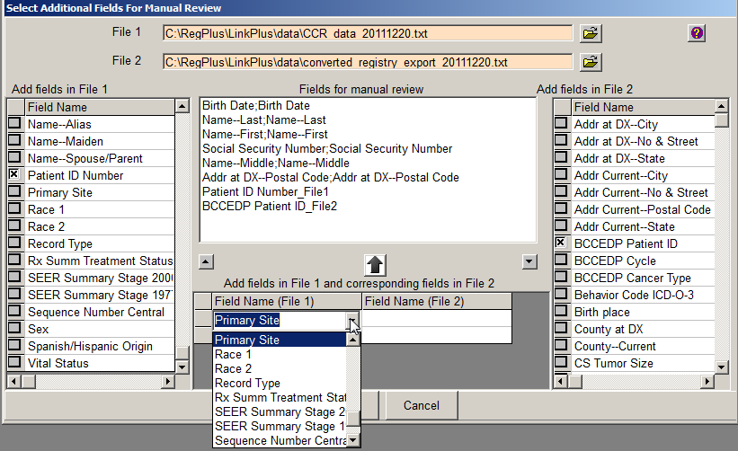
- Select Primary Site from the pull-down menu.
- In the center panel, in the Field Name (File 2) grid, click in the first empty cell.
Result: A pull-down menu appears.
- Select Primary Site from the pull-down menu for File 2. In a similar fashion, select the following fields for both files:
- Histologic Type ICD-O-3
- Behavior ICD-O-3
- Date of Diagnosis
- Name—Maiden
- Addr at DX—No & Street
- Addr at DX—City
- Race 1
- Spanish/Hispanic Origin
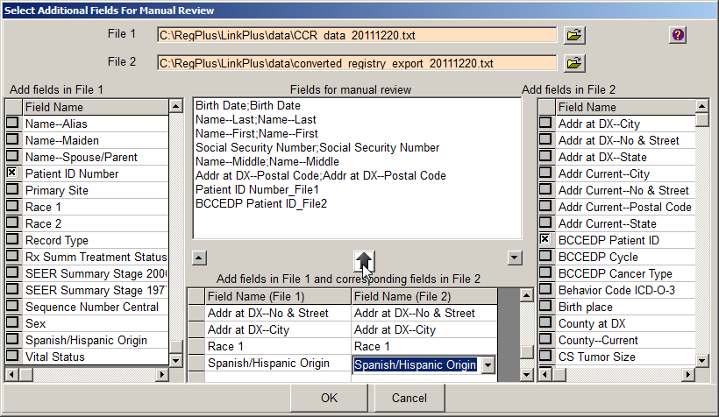
- Click on the button above the grids.
Result: The fields are added for manual review with the fields from each file to be displayed in the same column for each potential match.
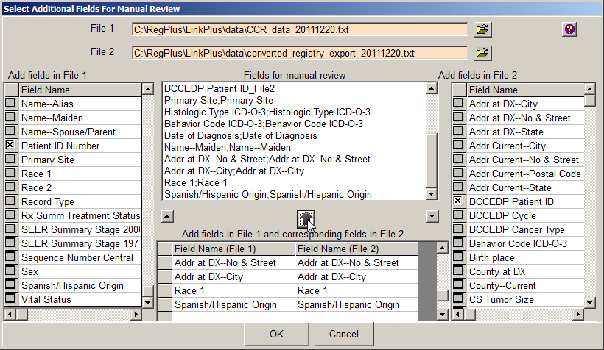
You can also change the order of fields on the manual review list by clicking on a field and using the small up-arrow and down-arrow to move the field up or down in order. This is the order in which the columns will be presented for manual review.
- Select the Name—Maiden;Name_Maiden field on the Fields for manual review list, and click the up button until the Name—Maiden;Name_Maiden field is directly after the Name—Middle field.
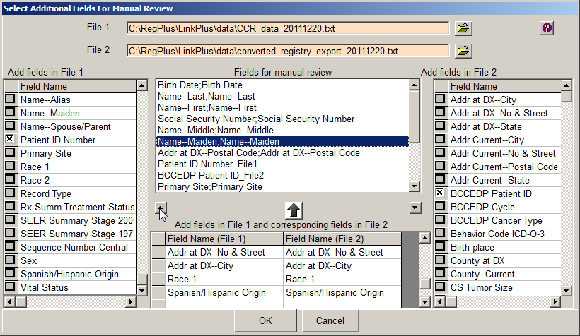
- Continue ordering the fields as you would like to view them on the manual review screen. When you have finished, click OK.
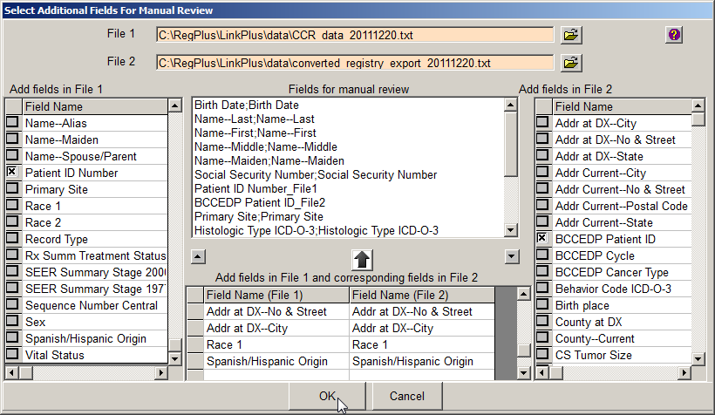
Result: The manual review screen opens for the CCR_BCCEDP_Link.txt linkage report, with the fields and columns ordered as you specified.
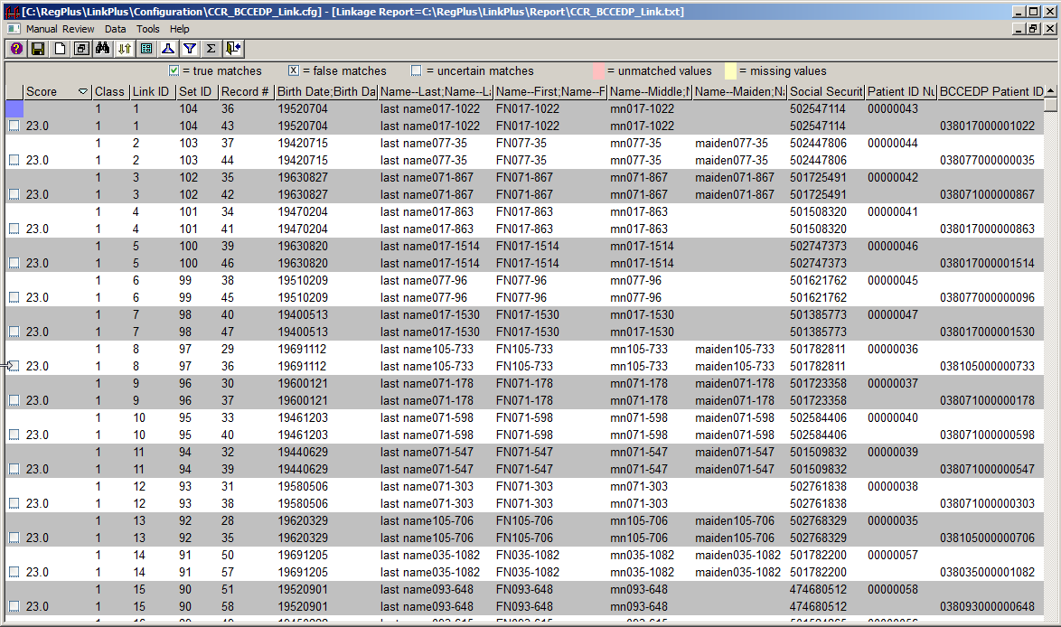

The manual review screen in Link Plus provides special sorting that always keeps the comparison pairs together, and is highly configurable. Individual columns may be sorted, hidden and unhidden from view, and re-sized. The order of the columns on the review screen may be also modified. Link Plus highlights missing (yellow) and unmatched (pink) values, greatly facilitating manual review. Match status may be assigned manually, by clicking in the check box in the leftmost column on the screen, or may be assigned automatically by match score. Review sessions may be saved and re-opened at a later time.

Manually Assigning Match Status
Match status can be assigned manually by using the mouse to click in the Match Status check box, or by using the keyboard.

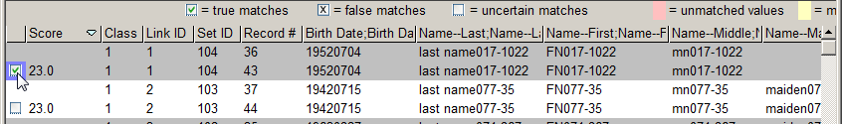
Assigning True Match Status: For the comparison pair being reviewed place the cursor in the Match Status check box and left-click the mouse once, or press the “M” key to select the current pair as a true match and move on to review the next comparison pair.
Assigning False Match Status: For the comparison pair being reviewed place the cursor in the Match Status check box and left-click the mouse twice, or press the “N” key to select the current pair as a false match and move on to review the next comparison pair.
Assigning Uncertain Match Status: For the comparison pair being reviewed place the cursor in the Match Status check box and left-click the mouse three times, or press the “B” key to select the current pair as an uncertain match and move on to review the next comparison pair.

Assigning Match Status Automatically by Score
When a linkage is run, Link Plus saves all potential matches that generated a score above the specified Cut Off Value in the linkage report. When the linkage report is opened for manual review, all potential matches will be presented for review, even those that generated high scores and are almost certain to be matches, and (depending on the Cut Off Value specified) those that generated low scores and are almost certain to be false matches. With practice, after initial review of the list of comparison pairs it is often easy to identify an upper cut off score above which all pairs are true matches, and a lower cut off score below which all pairs are false matches. The remaining pairs are said to be in the “gray area”; uncertain matches requiring manual review.
Rather than having to individually assign the match status to each comparison pair manually, Link Plus offers the option to automatically assign match status for groups of pairs by their linkage score.
To assign match status automatically by score, complete these steps:
Click on the Data menu item, and select the Assign Match Status… option.
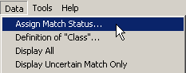
Result: The Assign Match Status dialog box opens.
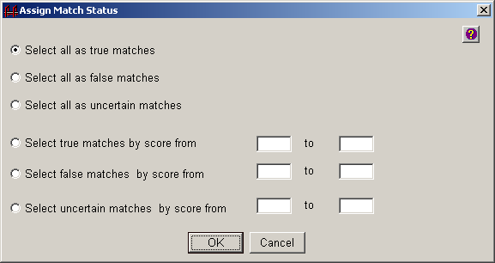
The Assign Match Status dialog box offers the following options:
Option |  |  | Description
Select all as true matches |  |  | Selecting this button will assign a true match status to all comparison pairs in the current view
Select all as false matches |  |  | Selecting this button will assign a false match status to all comparison pairs in the current view
Select all as uncertain matches |  |  | Selecting this button will assign an uncertain match status to all comparison pairs in the current view
Select true matches by score |  |  | Selecting this button will assign a true match status to all comparison pairs that have a score in the range specified in the from and to boxes
Select false matches by score |  |  | Selecting this button will assign a false match status to all comparison pairs that have a score in the range specified in the from and to boxes
Select uncertain matches by score |  |  | Selecting this button will assign an uncertain match status to all comparison pairs that have a score in the range specified in the from and to boxes
 |  | Please see the Link Plus Linkage Exercise Document for a full description of manual review features, and general guidance for manual review of potential comparison pairs.

Assigning Match Status to All Comparison Pairs
For the CCR/BCCEDP data linkages, the BCCEDP’s CaST system will be expecting all records that were provided to be returned to the BCCEDP in the linkage results file. As a result, upon completion of manual review all comparison pairs must be assigned a true or false match status. This will enable the export of two linkage results files: one of all true matches, and one of all non-matches (which will include non-matches identified upon linkage as well as those identified via manual review).

When manually reviewing potential comparison pairs, pay close attention to primary site and diagnosis date. A comparison pair should only be assigned a true match for the same tumor. For example, the cancer registry may have a breast cancer record and the BCCEDP may have a cervical cancer record for the same patient, but this would not be a match because the records represent different tumors. Or, the BCCEDP could have multiple cervical in situ tumor records for a patient, whereas the registry may only have record of one of the tumors.

Exporting Linkage Results
Link Plus allows for export of linkage results in fixed width or delimited file format, and allows for the selective export of true, false, and or uncertain matches. For the CCR/BCCEDP data linkage, data for all linkage results will be exported from File 2 (the BCCEDP data file) in the NAACCR12_BCCEDP_DEFAULT.txt file format. For records in the BCCEDP data file that matched to the CCR data file, values for select cancer registry data fields will be included in the export file; for records that did not match the values for the cancer registry fields will be blank.
Once you have completed manual review of all potential matches presented for review and have assigned a match status to each of them (either manually by clicking, or via the Data…Assign Match Status option), you will need to export 2 linkage result files from Link Plus:
- a file of all true matches; these are the records for which the linkage results file will contain data in the cancer registry fields to be returned to the BCCEDP
- a file of all non-matches which will include non-matches identified upon linkage, as well as those identified via manual review

Exporting True Matches
Link Plus v 3.0 has an Export Fixed Width File export option that allow you to export linkage results in either the File 1 or File 2 record layouts (provided that the files are fixed width files), and allows you to specify the file from which to include values for certain fields.
To export all true matches from the manual review screen in the File 2 record layout, complete the following steps:
- Click on the Data menu option, and select Export Fixed Width File…
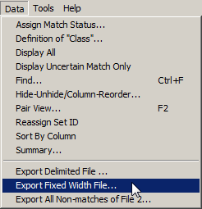
Result: The Export Fixed Width File window opens.
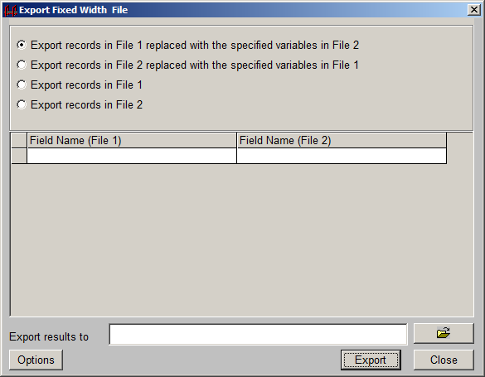
The Export Fixed Width File window offers the following export options:
Option | Description
Export records in File 1 replaced with the specified variables in File 2 | Selecting this option will export specified records in File 1, overwriting values in specific fields with data from fields specified from File 2
Export records in File 2 replaced with the specified variables in File 1 | Selecting this option will export specified records in File 2, overwriting values in specific fields with data from fields specified from File 1
Export records in File 1 | Selecting this option will export specified records in File 1
Export records in File 2 | Selecting this option will export specified records in File 2
- Because the BCCEDP is expecting a data file to be returned to them with the values they originally provided supplemented with cancer registry data for matched records, click the Export records in File 2 replaced with the specified variables in File 1 option.
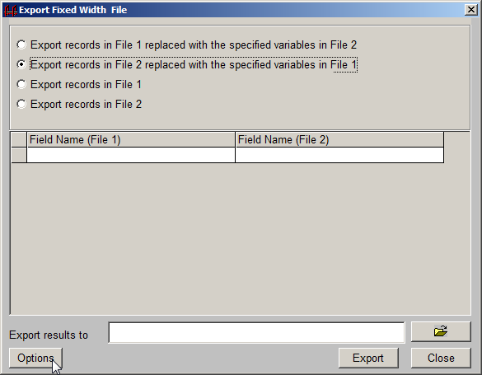
This option will allow you to export records from File 2, the BCEDP data file, and include values from the CCR data file for specific fields.
- To specify for which fields to include values from the CCR data file,
- In the Field Name (File 1) grid, click in the first empty cell.
Result: A pull-down menu appears.
- Select Addr at DX--City from the pull-down menu.
- In the Field Name (File 2) grid, click in the first empty cell.
Result: A pull-down menu appears.
- Select Addr at DX--City from the pull-down menu.
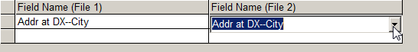
In a similar fashion, select the following fields for both files:

- Addr at DX--City
- Addr at DX--No & Street
- Addr at DX--Postal Code
- Addr at DX--State
- Behavior Code ICD-O-3
- Birth Date
- County at DX
- CS Tumor Size
- CS Extension
- CS Lymph Nodes
- CS Mets at Dx
- Date of Diagnosis
- Date of Initial Rx SEER
- Date of Initial Rx CoC
- Derived Summary Stage 2000
- Derived AJCC6 Stage Group
- Derived AJCC7 Stage Group
- Histologic Type ICD-O-3
- NAACCR Record Version
- Name--First
- Name--Last
- Name--Maiden
- Name--Middle
- Primary Site
- Race 1
- Race 2
- Record Type
- Rx Summ Treatment Status
- SEER Summary Stage 2000
- SEER Summary Stage 1977
- Sex
- Social Security Number
- Spanish/Hispanic Origin

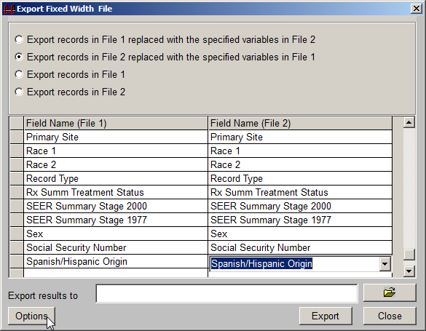
- To specify only true matches be exported, click Options.
Result: The Export Fixed Width File window opens.
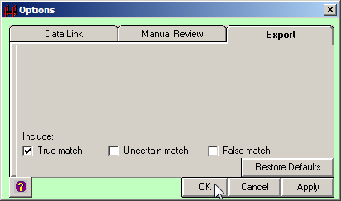
- Make sure that only the True match check box is checked.
- Click OK.
Result: You are returned to the Export Fixed Width File window.
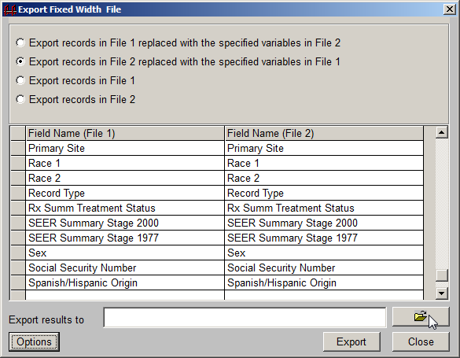
- Click the folder icon to the right of the Export Results to box.
Result: The Create a fix width file dialog box opens.
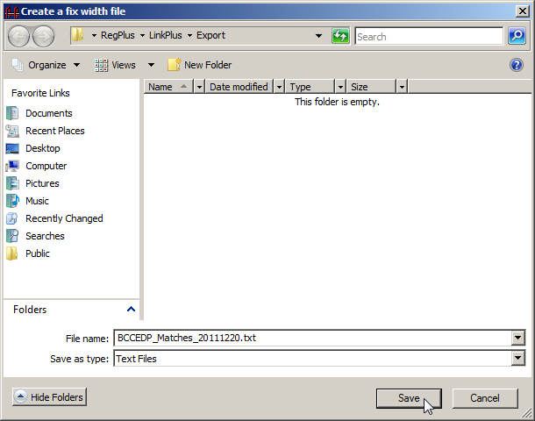
- Enter a name for the match file and click Save. Recall that the standard naming convention for the true match file is BCCEDP_Matches_YYYYMMDD.txt. The export file being saved in the example shown is named BCCEDP_Matches_20111220.txt.
Result: You are returned to the Export Fixed Width File window with the name of the export file specified.
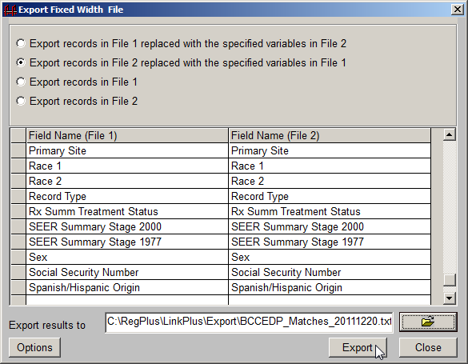
- Click Export.
Result: The application lets you know when the export file has finished saving, and reminds you of the file path and name.
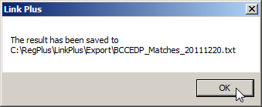
- Click OK.
- Click Close to close the Export Fixed Width File window.

Exporting All Non-matches
Link Plus v3.0 has an Export All Non-matches export option that allows you to export all non-matching records from the linkage in a single export file. This export file will include all records from File 2 that generated a linkage score lower than the Cutoff Value specified for the linkage on the Linkage Configuration window, as well as any records that have been assigned a false match status upon review of potential matches presented for review on the Manual Review window.
The All Non-matches export file will be exported with the same fields and in the same record layout as File 2. In the case of the CCR/BCCEDP data linkage, File 2 is the BCCEDP data file formatted in the standard NAACCR12_BCCEDP_DEFAULT.txt record layout.
To export all non-matches from the linkage in the File 2 record layout, complete the following steps:
- Click on the Data menu option, and select Export All Non-Matches of File 2…
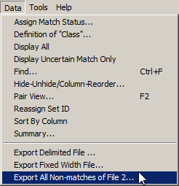
Result: The Export ALL Non-matches window opens.
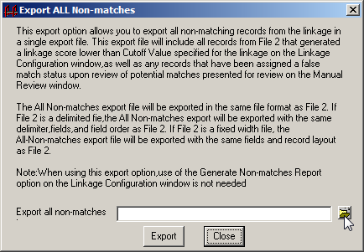
- Click the folder icon to the right of the Export all non-matches box.
Result: The Create a File dialog box opens.
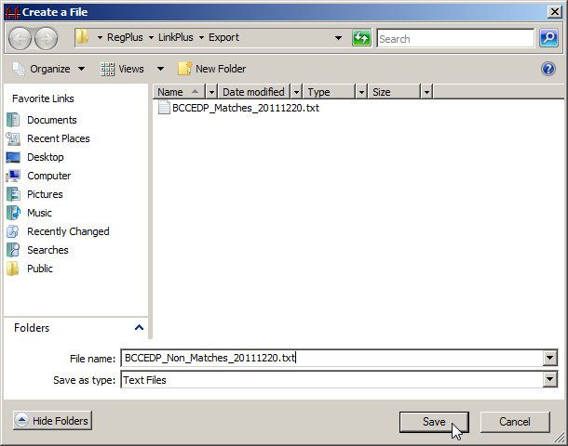
- Enter a name for the non-match file and click Save. Recall that the standard naming convention for the non-match file is BCCEDP_Non_Matches_YYYYMMDD.txt. The export file being saved in the example shown is named BCCEDP_Non_Matches_20111220.txt.
Result: You are returned to the Export All Non-matches window with the name of the export file specified.
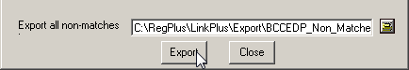
- Click Export.
Result: The application lets you know when the export file has finished saving, and reminds you of the file path and name.
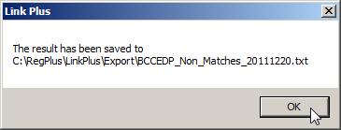
- Click OK.
- Click Close to close the Export ALL Non-matches window.
Please see the Link Plus Linkage Exercise Document for a full description of manual review features, and general guidance for manual review of potential comparison pairs.

Combining Linkage Export Files Using NAACCR Combiner
Once both the true match and non-match export files have been generated, the CCR must append the two export files into a single file to be returned to the BCCEDP. This may be accomplished by several means, such as using SAS or the COPY DOS command. However, if you are not familiar with any of these mechanisms, The Registry Plus NAACCR Combiner program is a tool that can be used to combine the two files together.

The BCCEDP CaST system is expecting true matches to come before the non-matches in the combined file returned to the BCCEDP. Therefore, when appending the 2 linkage export files together, it is essential that the non-match export file be appended to the true match file, so that the true match records are the first records in the combined file.

To launch NAACCR Combiner and append the non-match linkage export file to the true match linkage export file complete the following steps:
- Launch the NAACCR Combiner application by double-clicking the FileCombiner12x.exe file in the folder where you copied it on your computer.
Result: The Join NAACCR Files window opens.
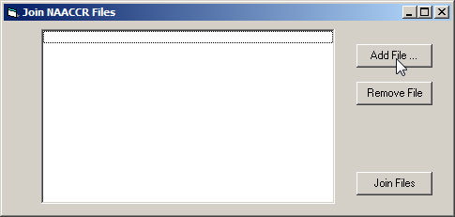
- Click Add File…
Result: The Open dialog box opens.
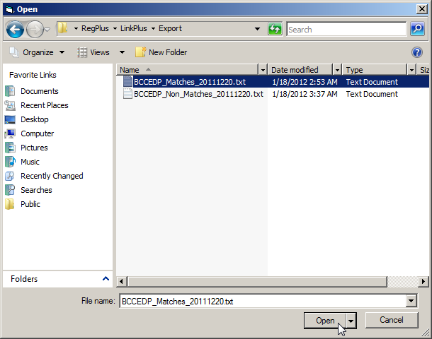
- Navigate to and highlight the true match file on your computer and click Open. The default path for a linkage export file is the C:\RegPlus\LinkPlus\Export folder. Recall that the standard naming convention for the true match file is BCCEDP_Matches_YYYYMMDD.txt. The file being opened in the example shown is named BCCEDP_Matches_20111220.txt, located in the C:\RegPlus\LinkPlus\Export folder.
Result: You are returned to the Join NAACCR Files window, with the true match file selected.
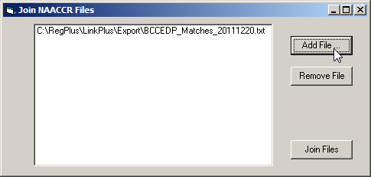
- Click Add File…
Result: The Open dialog box opens.
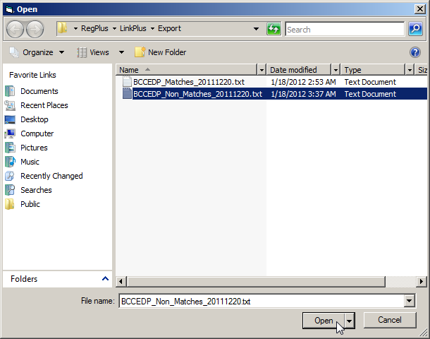
- Navigate to and highlight the non-match file on your computer and click Open. The default path for a linkage export file is the C:\RegPlus\LinkPlus\Export folder. Recall that the standard naming convention for the true match file is BCCEDP_Non_Matches_YYYYMMDD.txt. The file being opened in the example shown is named BCCEDP_Non_Matches_20111220.txt, located in the C:\RegPlus\LinkPlus\Export folder.
Result: You are returned to the Join NAACCR Files window with the true match file listed first and the non-match file listed second in the window.
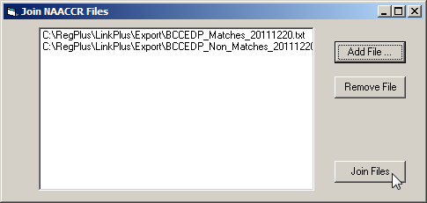
- Click Join Files.
Result: The two files are appended into a single file named combined.dat. The combined.dat file is automatically placed into the same folder on your computer as the FileCombiner12x.exe program file.

Appendix A: CAST Export File Layout
Field | Description | Length | Start | End | Format
Patient ID | Unique patient identifier (CaST field to be returned) | 15 | 1 | 15 | 000000000000000
Cancer Type | Cancer Type; 'BR' = breast, 'CV' = cervical, 'CR' = Colorectal (CaST field to be returned) | 2 | 16 | 17 | "BR", "CV" or "CR"
Cycle | Cycle number (CaST field to be returned) | 8 | 18 | 25 | up to 8 numeric digits
Last Name | Patient last name | 20 | 26 | 45 | free text
First Name | Patient first name | 15 | 46 | 60 | free text
Middle Name | Patient middle name | 15 | 61 | 75 | free text
Maiden Name | Patient maiden name | 20 | 76 | 95 | free text
SSN | Patient social security number | 11 | 96 | 106 | 000-00-0000
Date of Birth | Patient date of birth | 10 | 107 | 116 | mm/dd/yyyy
Race1 | Patient race 1 | 2 | 117 | 118 | CAST value; see race formats
Race2 | Patient race 2 | 2 | 119 | 120 | CAST value; see race formats
Race3 | Patient race 3 | 2 | 121 | 122 | CAST value; see race formats
Race4 | Patient race 4 | 2 | 123 | 124 | CAST value; see race formats
Race5 | Patient race 5 | 2 | 125 | 126 | CAST value; see race formats
Hispanic Origin | Patient Hispanic origin | 1 | 127 | 127 | CAST value; see Hispanic formats
Gender | Patient gender | 1 | 128 | 128 | CAST value = "2" for all breast and cervical records; see gender formats
Address (Street) | Patient street address | 45 | 129 | 173 | free text
Address (City) | City in which the patient resides | 20 | 174 | 193 | free text
Address (County) | County in which the patient resides | 3 | 194 | 196 | 3 digit FIPS Code
Address (State) | State in which the patient resides | 2 | 197 | 198 | 2 letter state abbreviation
Address (Zip) | Zip code in which the patient resides | 10 | 199 | 208 | 00000 or 00000-0000
Final Dx | Final diagnosis of breast or cervical services provided | 1 | 209 | 209 | CAST value; see final_dx formats
Date of Final Dx | Date the final diagnosis was made | 10 | 210 | 219 | mm/dd/yyyy
Date of Treatment | Date treatment was initiated | 10 | 220 | 229 | mm/dd/yyyy
Provider Name | Name of the primary provider site where services were provided | 50 | 230 | 279 | free text
Provider Contact Person | Contact person at the site | 50 | 280 | 329 | free text
Provider Address (Street) | Street address of the site | 80 | 330 | 409 | free text
Provider Address (City) | City in which the site is located | 25 | 410 | 434 | free text
Provider Address (County) | County in which the site is located | 3 | 435 | 437 | 3 digit FIPS Code
Provider Address (State) | State in which the site is located | 2 | 438 | 439 | 2 letter state abbreviation
Provider Address (Zip) | Zip code in which the site is located | 10 | 440 | 449 | 00000 or 00000-0000
Provider Phone Number | Phone number of the site | 20 | 450 | 469 | free text or (000)000-0000
Provider Email Address | Email address for the site | 50 | 470 | 519 | free text

Appendix B: CAST Export to NAACCR (V12.x) Data Mapping Guide
CAST | CAST length | NAACCR Item | NAACCR Name | NAACCR  Length | NAACCR Position (v12x)
Patient Id | 15 | 9500 | n/a – CAST id | 15 | 2340-2354
Cancer Type | 2 | 400, 9501 | Primary Site  n/a – CAST id | 4 | 540-543  2355-2356
Cycle | 8 | 9502 | n/a – CAST id | 8 | 2357-2364
n/a | n/a | 50 | NAACCR Record Version | 3 | 17-19
Last Name | 20 | 2230 | Name—Last | 40 | 3340-3379
First Name | 15 | 2240 | Name—First | 40 | 3380-3419
Middle Name | 15 | 2250 | Name—Middle | 40 | 3420-3459
Maiden Name | 20 | 2390 | Name—Maiden | 40 | 3506-3545
SSN | 11 | 2320 | Social Security Number | 9 | 3619-3627
Date of Birth | 10 | 240 | Date of Birth | 8 | 196-203
Race 1 | 2 | 160 | Race1 | 2 | 177-178
Race 2 | 2 | 161 | Race2 | 2 | 179-180
Race 3 | 2 | 162 | Race3 | 2 | 181-182
Race 4 | 2 | 163 | Race4 | 2 | 183-184
Race 5 | 2 | 164 | Race5 | 2 | 185-186
Hispanic Origin | 1 | 190 | Spanish/Hispanic Origin | 1 | 189-189
Gender | 1 | 220 | Sex | 1 | 192-192
Address (Street) | 45 | 2330 | Addr at DX—No & Street | 60 | 3628-3687
Address (City) | 20 | 70 | Addr at DX—City | 50 | 95-144
Address (County) | 3 | 90 | County at DX | 3 | 156-158
Address (State) | 2 | 80 | Addr at DX—State | 2 | 145-146
Address (Zip) | 10 | 100 | Addr at DX—Postal code | 9 | 147-155
Final Dx | 1 | 522  523 | Histologic Type ICD-O-3  Behavior code ICD-O-3 | 4  1 | 550-553  554-554
Date of Final Dx | 10 | 390 | Date of Diagnosis | 8 | 530-537
Date of Treatment | 10 | 1260  1270 | Date of Initial RX—SEER  Date of 1st Crs RX—CoC | 8  8 | 1436-1443  1446-1453
Provider Name | 50 | 9503 | n/a | 50 | 2365-2414
Provider Contact Person | 50 | 9504 | n/a | 50 | 2415-2464
Provider Address (Street) | 80 | 9505 | n/a | 80 | 2465-2544
Provider Address (City) | 25 | 9506 | n/a | 25 | 2545-2569
Provider Address (County) | 3 | 9507 | n/a | 3 | 2570-2572
Provider Address (State) | 2 | 9508 | n/a | 2 | 2573-2574
Provider Address (Zip) | 10 | 9509 | n/a | 10 | 2575-2584
Provider Phone Number | 20 | 9510 | n/a | 20 | 2585-2604
Provider Email Address | 50 | 9511 | n/a | 50 | 2605-2654

Appendix C: Data File Mapper Plus Mapping Configuration
(BCCEDP CaST export file to NAACCR v12.x*)

Input Field Name | Input Column Start | Input Column Stop | Output NAACCR Item | Output Default Value | Translation Table/ Function | Function Parameter1 | Function Parameter2
Patient Id | 1 | 15 | 9500
Cancer Type | 16 | 17 | 9501
Cycle | 18 | 25 | 9502
Last Name | 26 | 45 | 2230
First Name | 46 | 60 | 2240
Middle Name | 61 | 75 | 2250
Maiden Name | 76 | 95 | 2390
SSN | 96 | 106 | 2320 |  | FUNCTION: REPLACE | -
Date of Birth | 107 | 116 | 240 |  | FUNCTION: NAACCRDate1
Race 1 | 117 | 118 | 160 |  | BCCEDP_Race
Race 2 | 119 | 120 | 161 |  | BCCEDP_Race
Race 3 | 121 | 122 | 162 |  | BCCEDP_Race
Race 4 | 123 | 124 | 163 |  | BCCEDP_Race
Race 5 | 125 | 126 | 164 |  | BCCEDP_Race
Hispanic Origin | 127 | 127 | 190 |  | BCCEDP_Hispanic_Origin
Gender | 128 | 128 | 220
Address (Street) | 129 | 173 | 2330
Address (City) | 174 | 193 | 70
Address (County) | 194 | 196 | 90
Address (State) | 197 | 198 | 80
Address (Zip) | 199 | 208 | 100 |  | FUNCTION: REPLACE | -
Final Dx | 209 | 209 | 9512
Date of Final Dx | 210 | 219 | 390 |  | FUNCTION: NAACCRDate1
Date of Treatment | 220 | 229 | 1270 |  | FUNCTION: NAACCRDate1
Provider Name | 230 | 279 | 9503
Provider Contact Person | 280 | 329 | 9504
Provider Address (Street) | 330 | 409 | 9505
Provider Address (City) | 410 | 434 | 9506
Provider Address (County) | 435 | 437 | 9507
Provider Address (State) | 438 | 439 | 9508
Provider Address (Zip) | 440 | 449 | 9509 |  | FUNCTION: REPLACE | -
Provider Phone Number | 450 | 469 | 9510
Provider Email Address | 470 | 519 | 9511
Site | 0 | 0 | 400 |  | FUNCTION: NBCCEDP_CaTypeFinalDxToSite | [Final Dx] | [Cancer Type]
Histology | 0 | 0 | 522 |  | FUNCTION: NBCCEDP_CaTypeFinalDxToHistology | [Final Dx] | [Cancer Type]
Behavior | 0 | 0 | 523 |  | FUNCTION: NBCCEDP_CaTypeFinalDxToBehavior | [Final Dx] | [Cancer Type]
NAACCR Record Version | 0 | 0 | 50 | 12x*
NAACCR Record Type | 0 | 0 | 10 | A
*x = version of v12 NAACCR Record Version of selected mapping configuration; 1, 2, or 3

Appendix D: Race Formats and Conversation Table
CAST |  |  | NAACCR |  |  | Conversion
Code | Label |  | Code | label |  | CaST | NAACCR
1 | White |  | 01 | White |  | 1 | 01
2 | Black or African American |  | 02 | Black |  | 2 | 02
3 | Asian |  | 03 | Aleutian, Eskimo, American Indian |  | 3 | 96
4 | Native Hawaiian or Other Pacific Islander |  | 04 | Chinese |  | 4 | 97
5 | American Indian or Alaska Native |  | 05 | Japanese |  | 5 | 03
7 | Unknown |  | 06 | Filipino |  | 7 | 99
8 | Asian/Pacific Islander (MDE v4.1 only) |  | 07 | Hawaiian |  | 8 | 98
 |  |  | 08 | Lorean
 |  |  | 09 | Asian Indian, Pakistani
 |  |  | 10 | Vietnamese
 |  |  | 11 | Laotian
 |  |  | 12 | Hmong
 |  |  | 13 | Kampuchean
 |  |  | 14 | Thai
 |  |  | 20 | Micronesian, NOS
 |  |  | 21 | Chamorran
 |  |  | 22 | Guamanian, NOS
 |  |  | 25 | Polynesian, NOS
 |  |  | 26 | Tahitian
 |  |  | 27 | Samoan
 |  |  | 28 | Tongan
 |  |  | 30 | Melanesian, NOS
 |  |  | 31 | Fiji Islander
 |  |  | 32 | New Guinean
 |  |  | 96 | Other Asian, Incl. Asian, NOS and Oriental, NOS
 |  |  | 97 | Pacific Islander, NOS
 |  |  | 98 | Other
 |  |  | 99 | Unknown

Appendix E: Hispanic Origin Formats and Conversion Table

CAST |  |  | NAACCR |  |  | Conversion
Code | Label |  | Code | Label |  | CAST | NAACCR
1 | Yes, Hispanic |  | 0 | Non-Spanish; non-Hispanic |  | 1 | 6
2 | No, Not Hispanic |  | 1 | Mexican (includes Chicano) |  | 2 | 0
3 | Unknown |  | 2 | Puerto Rican |  | 3 | 9
 |  |  | 3 | Cuban
 |  |  | 4 | South or Central American (except Brazil)
 |  |  | 5 | Other specified Spanish/Hispanic origin (includes European; excludes Dominican Republic)
 |  |  | 6 | Spanish, NOS; Hispanic, NOS; Latino, NOS
 |  |  | 7 | Spanish surname only
 |  |  | 8 | Dominican Republic
 |  |  | 9 | Unknown whether Spanish or not

Appendix F: CaST Final Diagnosis Formats and Conversion Tables

 | CaST Breast Cancer Final Diagnosis |  | NAACCR Item Conversion
Code | Label |  | Histology ICDO3 | Behavior ICDO3 | Primary Site
1 | Carcinoma In Situ, Other (Should not be used after 10/01/1999) |  | 8010 | 2 | C509
2 | Invasive Breast Cancer |  | 8000 | 3 | C509
3 | Breast Cancer not diagnosed |  | Blank | Blank | Blank
4 | Lobular Carcinoma In Situ (LCIS) - Stage 0 |  | 8520 | 2 | C509
5 | Ductal Carcinoma In Situ (DCIS) - Stage 0 |  | 8500 | 2 | C509
 | CaST Cervical Cancer Final Diagnosis |  | NAACCR Item Conversion
Code | Label |  | Histology ICDO3 | Behavior ICDO3 | Primary Site
1 | Normal/Benign reaction/inflammation |  | Blank | Blank | Blank
2 | HPV/Condylomata/Atypia |  | Blank | Blank | Blank
3 | CINI/Mild dysplasia (biopsy diagnosis) |  | Blank | Blank | Blank
4 | CINII/Moderate dysplasia (biopsy diagnosis) |  | Blank | Blank | Blank
5 | CINIII/Severe dysplasia/CIS (Stage 0) or Adenocarcinoma In Situ of the cervix (AIS) (biopsy diagnosis) |  | 8077 | 2 | C539
6 | Invasive Cervical Carcinoma (biopsy diagnosis) |  | 8000 | 3 | C539
7 | Other |  | Blank | Blank | Blank
8 | Low Grade SIL (biopsy diagnosis) |  | Blank | Blank | Blank
9 | High Grade SIL (biopsy diagnosis) |  | Blank | Blank | Blank

CaST Colorectal Cancer Final Diagnosis NAACCR Item Conversion
Code | Label |  | Histology ICDO3 | Behavior ICDO3 | Primary Site
1 | Normal/Negative |  | Blank | Blank | Blank
2 | Hyperplastic polyps |  | Blank | Blank | Blank
3 | Adenomatous polyps, no high-grade dysplasia |  | Blank | Blank | Blank
4 | Adenomatous polyp with high-grade dysplasia |  | Blank | Blank | Blank
5 | Cancer |  | 8140 | 3 | C189

Appendix G: Minimum Data Items to be Included in CCR Extract File
NAACCR Item No | Field | Length | NAACCR Layout v12.x
50 | NAACCR Record Version | 3 | 17-19
2230 | Last Name | 40 | 3340-3379
2240 | First Name | 40 | 3380-3419
2250 | Middle Name | 40 | 3420-3459
2390 | Maiden Name | 40 | 3506-3545
2320 | SSN | 9 | 3619-3627
240 | Date of Birth | 8 | 196-203
160 | Race1 | 2 | 177-178
161 | Race2 | 2 | 179-180
190 | Hispanic Origin | 1 | 189-189
220 | Sex | 1 | 192-192
2330 | Address (Street) | 60 | 3628-3687
70 | Address (City) | 50 | 95-144
80 | Address (State) | 2 | 145-146
100 | Address (Zip) | 9 | 147-155
90 | Address (County) | 3 | 156-158
390 | Date of Diagnosis | 8 | 530-537
522 | Histologic Type ICD-O-3 | 4 | 550-553
523 | Behavior Code | 1 | 554-554
759 | SEER Summary Stage 2000 | 1 | 904-904
760 | SEER Summary Stage 1977 | 1 | 905-905
3020 | Derived Summary Stage 2000 | 1 | 1156-1156
3000 | Derived AJCC-6 Stage Group | 2 | 1112-1113
3430 | Derived AJCC-7 Stage Group | 3 | 1126-1128
2800 | CS Tumor Size | 3 | 985-987
2810 | CS Extension | 3 | 988-990
2830 | CS Lymph Nodes | 3 | 992-994
2850 | CS Mets at Dx | 2 | 996-997
400 | Primary Site | 4 | 540-543
1260 | Date of Initial RX—SEER | 8 | 1436-1443
1270 | Date of Initial RX—CoC | 8 | 1446-1453
1285 | RX Summ--Treatment Status | 1 | 1566-1566

Appendix H: Data Items to be Exported from Link Plus after Linkage
NAACCR Item No | Field | Length | NAACCR Layout v12 | Data set from which to export field | CaST import uses field for:
9500 | BCCEDP Patient Id | 15 | 2340-2354 | BCCEDP | ID field
9502 | BCCEDP Cycle | 8 | 2357-2364 | BCCEDP | ID field
9501 | BCCEDP Cancer Type | 2 | 2355-2356 | BCCEDP | ID field
50 | NAACCR Record Version | 3 | 17-19 | CCR | Version control ID
2230 | Last Name | 40 | 3340-3379 | CCR | Manual review
2240 | First Name | 40 | 3380-3419 | CCR | Manual review
2250 | Middle Name | 40 | 3420-3459 | CCR | Manual review
2390 | Maiden Name | 40 | 3506-3545 | CCR | Manual review
2320 | SSN | 9 | 3619-3627 | CCR | Manual review
240 | Date of Birth | 8 | 196-203 | CCR | Manual review
160 | Race1 | 2 | 177-178 | CCR | Manual review
161 | Race2 | 2 | 179-180 | CCR | Manual review
190 | Hispanic Origin | 1 | 189-189 | CCR | Manual review
220 | Sex | 1 | 192-192 | CCR | Manual review
2330 | Address (Street) | 60 | 3628-3687 | CCR | Manual review
70 | Address (City) | 50 | 95-144 | CCR | Manual review
80 | Address (State) | 2 | 145-146 | CCR | Manual review
100 | Address (Zip) | 9 | 147-155 | CCR | Manual review
90 | Address (County) | 3 | 156-158 | CCR | Manual review
390 | Date of Diagnosis | 8 | 530-537 | CCR | Update 14.02, 15.02
522 | Histologic Type ICD-O-3 | 4 | 550-553 | CCR | Update 14.03, 15.03
523 | Behavior Code | 1 | 554-554 | CCR | Update 14.04, 15.04
759 | SEER Summary Stage 2000 | 1 | 904-904 | CCR | Update 14.05, 15.05 DateDx=2001-2003
760 | SEER Summary Stage 1977 | 1 | 905-905 | CCR | Update 14.05, 15.05 DateDx<2001
3020 | Derived Summary Stage 2000 | 1 | 1156-1156 | CCR | Update 14.05, 15.05 DateDx=2004+
3000 | Derived AJCC-6 Stage Group | 2 | 1112-1113 | CCR | Update 14.06, 15.06 DateDx=2004+
3430 | Derived AJCC-7 Stage Group | 3 | 1126-1128 | CCR | Update 14.06, 15.06; DateDX = 2010+ (use first 2 digits)
2800 | CS Tumor Size | 3 | 985-987 | CCR | Update 14.07, 15.07 DateDx=2004+
2810 | CS Extension | 3 | 988-990 | CCR | Update 14.08, 15.08 DateDx=2004+
2830 | CS Lymph Nodes | 3 | 992-994 | CCR | Update 14.09, 15.09 DateDx=2004+
2850 | CS Mets at Dx | 2 | 996-997 | CCR | Update 14.10, 15.10 DateDx=2004+
400 | Primary Site | 4 | 540-543 | CCR | Update 14.11, 15.11
1260 | Date of Initial RX--SEER | 8 | 1436-1443 | CCR | Manual update only
1270 | Date of Initial RX--CoC | 8 | 1446-1453 | CCR | Manual update only
1285 | RX Summ--Treatment Status | 1 | 1566-1566 | CCR | Manual update only

