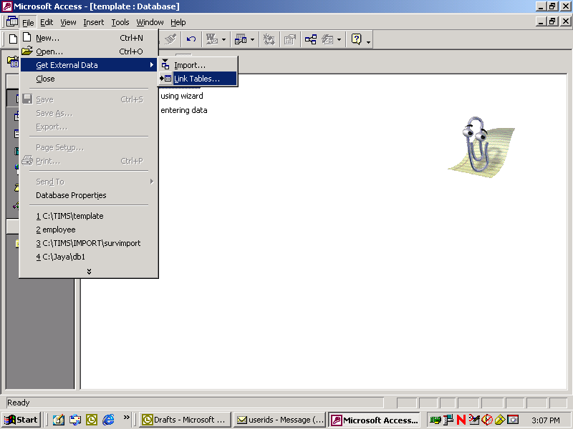

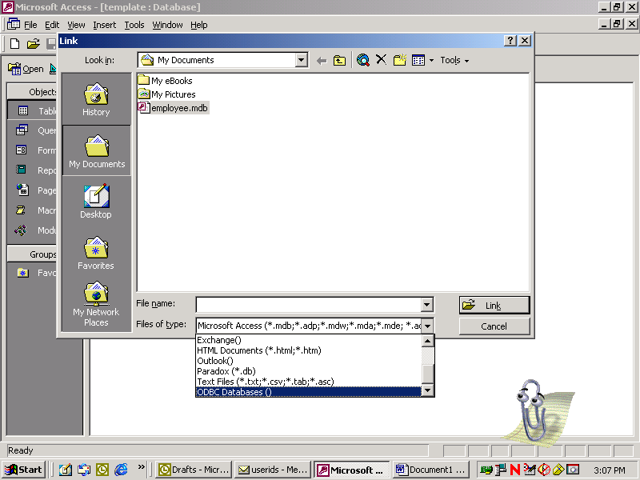

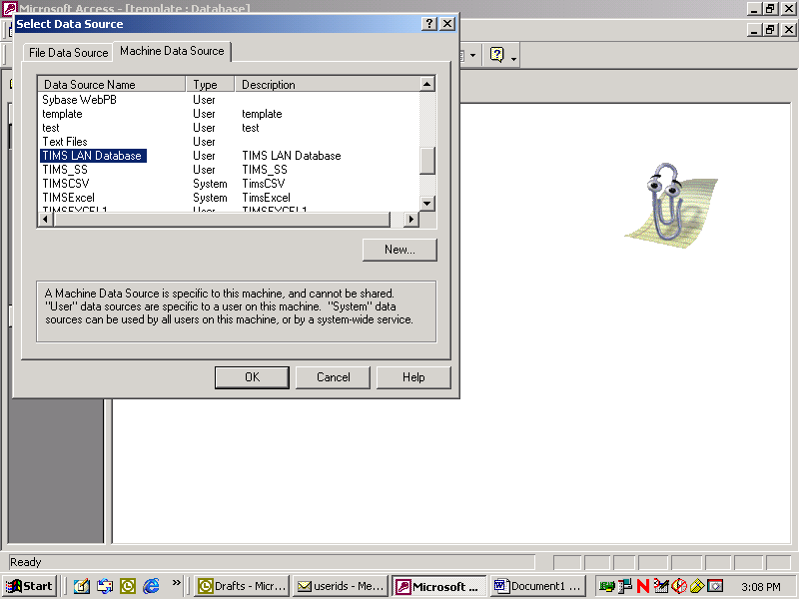

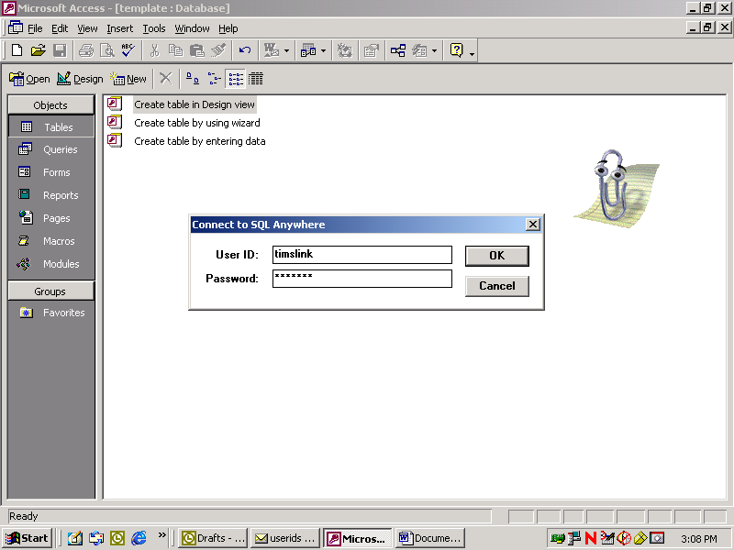

Password is ‘readpwd’

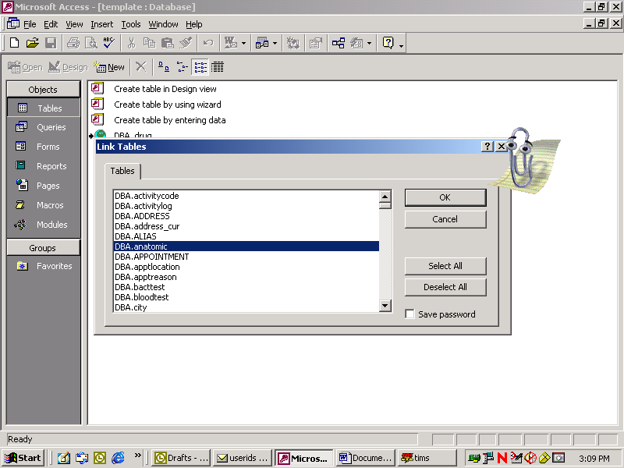

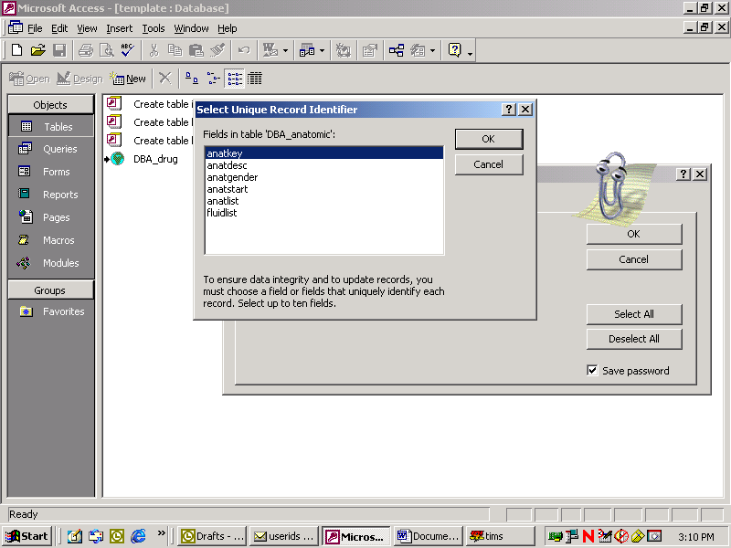

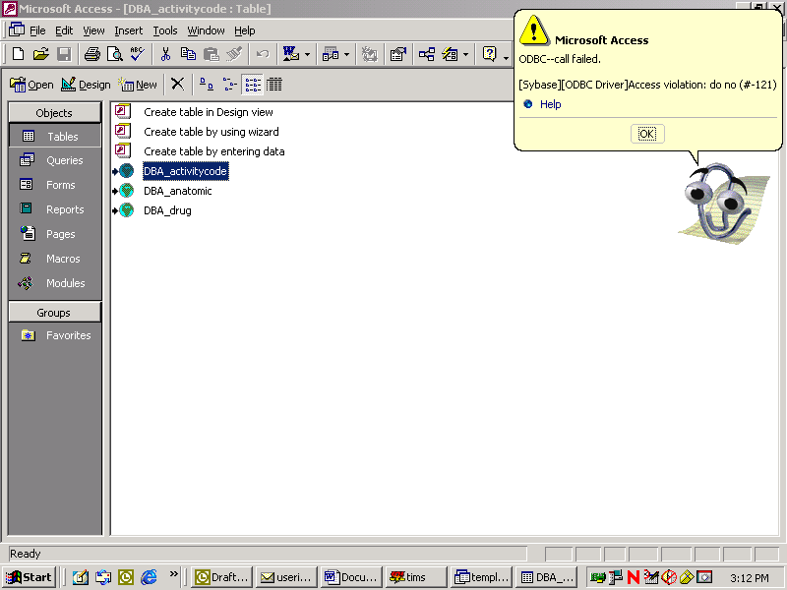

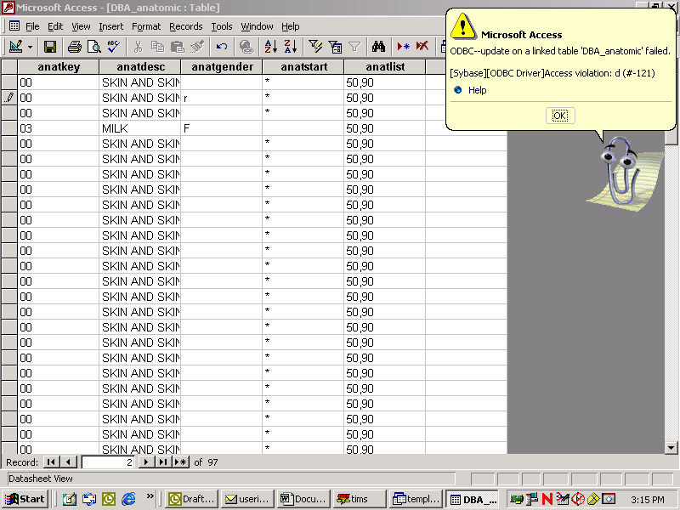

List of tables that user ‘timslink’ has access to:

"ADDRESS"
"ALIAS"
"anatomic"
"APPOINTMENT"
"apptlocation"
"apptreason"
"bacttest"
"bloodtest"
"CLIENT"
"city"
"contact"
"county"
"datadictionary"
"diagnosis"
"dictionarytable"
"disposition"
"drug"
"drugsusceptibility"
"ENROLLMENT"
"EPISODE"
"exportfile"
"exposuresite"
"facility"
"FIPS"
"followup1"
"followup2"
"growth"
"history"
"hivtest"
"hospital"
"interview"
"jobcategory"
"laboratory"
"language"
"majorsite"
"NATION"
"physical"
"position"
"prescription"
"recdosage"
"referral"
"referralreason"
"referralsource"
"relationship"
"request"
"rvct"
"screengroup"
"skintest"
"smear"
"sourcecase"
"species"
"state"
"status"
"Survudv"
"susceptibility"
"therapychange"
"therapyevent"
"UDV_DATA"
"UDV_DATA_WK"
"USERFIELDS_GLOBAL"
"USERFIELDS_LOCAL"
"worker"
"WORKERAPPOINTMENT"
"workerassignment"
"workerlanguage"
"xray"

